Retrospective Biomarker-Based Identification of Propoxur and Related Carbamates Using Advanced Mass Spectrometry and Biosensing Platforms

Abstract-This work describes a unique, dual-platform analytical methodology for the retrospective identification and quantification of Propoxur (2-Iso propoxy phenylmethyl carbamate) and other related N-methyl carbamates based on their specific protein-adduct biomarkers rather than the parent compounds. Carbamates are potent inhibitors of acetylcholinesterase (AChE) forming a transient, carbamylated enzyme complex. We will exploit residual, slowly hydrolyzing carbamoylated protein adducts in biological matrices, particularly in erythrocyte acetyl cholinesterase (RBC-AChE), as stable, long-term exposure biomarkers. The approach pairs a high-resolution, high-sensitivity Ultra-High Performance Liquid Chromatography-Tandem Mass Spectrometry (UHPLC-MS/MS) platform for confirmatory analysis of released carbamic acids/phenolic metabolites with an Enzymatic Electrochemical Biosensing Platform (EEBP) for rapid, on-site screening of residual AChE inhibition. It significantly expands the time window for the temporal assessment of exposure, thus providing unequivocal retrospective evidence of carbamate poisoning beyond the very short and rapid detoxification phase.
Keywords-Propoxur, carbamate biomarkers, acetylcholinesterase(AChE) inhibition ,protein adducts, UHPLC–MS/MS, electrochemical biosensor, retrospective exposure, toxicological forensics.
- INTRODUCTION

The Carbamate Exposure Assessment Challenge
Propoxur and its structural analogues are members of the N-methyl carbamate class of pesticides that find wide applications in agriculture and public health. Their toxicological relevance arises from the reversible inhibition of acetylcholine esterase (AChE), an enzyme critically involved in nerve impulse termination. A significant challenge within forensic and public health toxicology is the short biological half-life of these compounds. They are rapidly metabolized and excreted, (usually ≤ 24 hours), and thus, any classic toxicological analysis of the parent compound or primary metabolites (e.g., in urine) is unreliable in cases where exposures had taken place more than 1-2 days back.
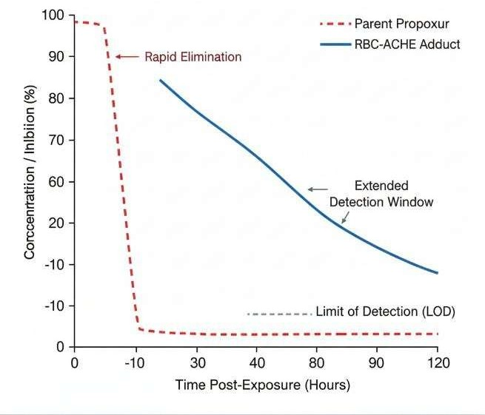

Figure1:Comparison of Detection Windows :Parent Compoundvs. RBC-AChE Adduct Biomarker.

The Retrospective Solution
A protein adduct biomarker formation is pursued in this paper as one way around this limitation. The inhibition event - the binding of the carbamate moiety to the active site serine residue ofAChE - leaves behind a chemical 'scar' that will persist considerably longer than the parent compound in circulation.For appropriate retrospective identification and quantification, this stable biomarker is essential when trying to accurately assess past exposures, particularly in criminal investigations, chronic low-level occupational exposures, or delayed clinical presentations.
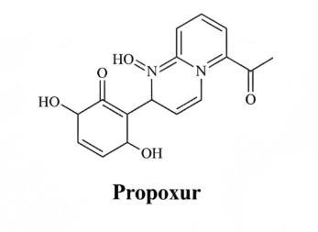
Figure 2 Chemical Structure of Propoxur (𝑪𝟏𝟏𝑯𝟏𝟓𝑵𝑶𝟑)

The Carbamylation Mechanism
Chemical Basis for Retrospective Markers The Carbamylation Mechanism Carbamate insecticides serve aspseudo-substrates for the AChEenzyme. The N-methylcarbamate group (R1NHCOOR2) donates the carbamoyl group (R1NHCO-) to the hydroxyl group of the active site serine residue (Ser203) of the AChE enzyme. This reaction, known as carbamylation, temporarily inactivates the enzyme through the formation of a stable reaction product: carbamoylated AChE.
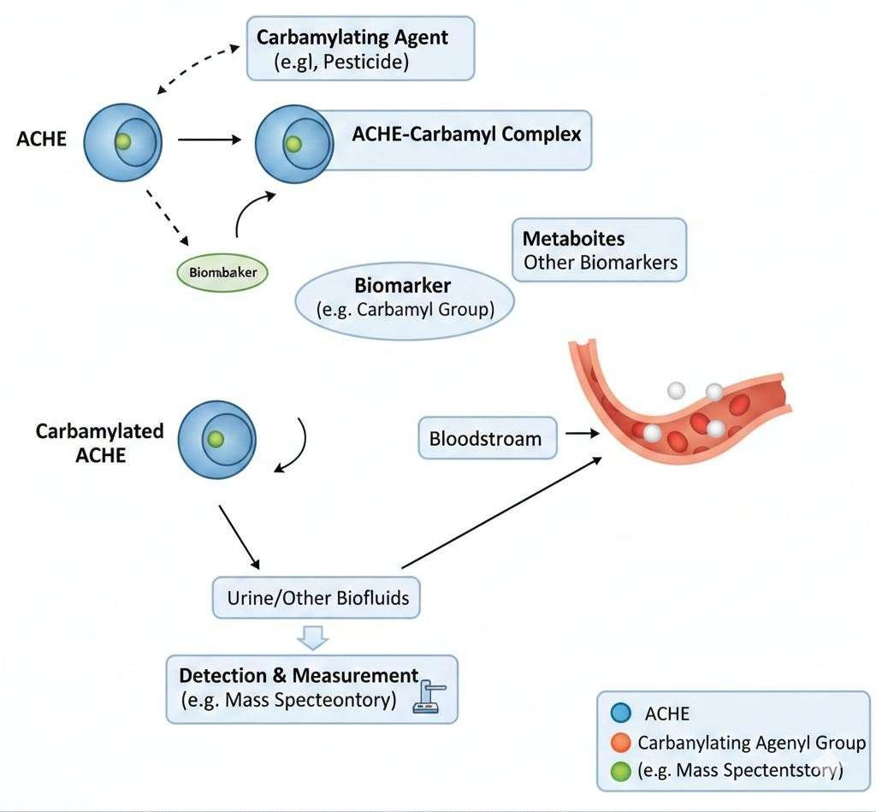

Figure3 Mechanism of AChE Carbamylation and Biomarker Release

Carbamylation/Hydrolysis

𝐴𝐶ℎ𝐸−𝑂𝐻+𝐶𝑎𝑟𝑏𝑎𝑚𝑎𝑡𝑒⇌𝐴𝐶ℎ𝐸−𝑂𝐶𝑂𝑁𝐻𝑅+𝐴𝑙𝑐𝑜ℎ𝑜𝑙/𝑃ℎ𝑒𝑛𝑜𝑙

𝐴𝐶ℎ𝐸−𝑂𝐶𝑂𝑁𝐻𝑅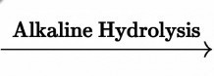𝐴𝐶ℎ𝐸−𝑂𝐻+𝑅𝑁𝐻𝐶𝑂𝑂𝐻(𝑜𝑟𝑃ℎ𝑒𝑛𝑜𝑙)

Biomarker Persistenceand Hydrolysis
In contrast to the virtually irreversible phosphorylation caused by organophosphates, thecarbamoylated AChE spontaneously decomposes through hydrolysis - decarbamylation - back to the active enzyme.
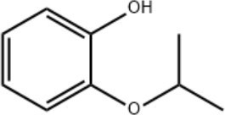

Figure4:ChemicalStructureof2-Isopropoxyphenol(𝐂𝟗𝐇𝟏𝟐𝐎𝟐)

Whereas this hydrolysis determines the clinical reversibility of the intoxication, the half-life of the carbamoylated enzyme complex (which can range from minutes to hours, but is longer than the parent compound half-life) allows for a quantifiable window of residual enzyme inhibition. In addition, chemical or thermal treatment of such a complex can forcibly cleave the carbamate moiety from the serine residue by hydrolysis, there by releasing the corresponding phenolic component originally part of the parent compound, for example 2-isopropoxyphenol for Propoxur. It is this released, signature phenolic metabolite from the isolated enzyme that serves as the definitive retrospective biomarker.

METHODOLOGY
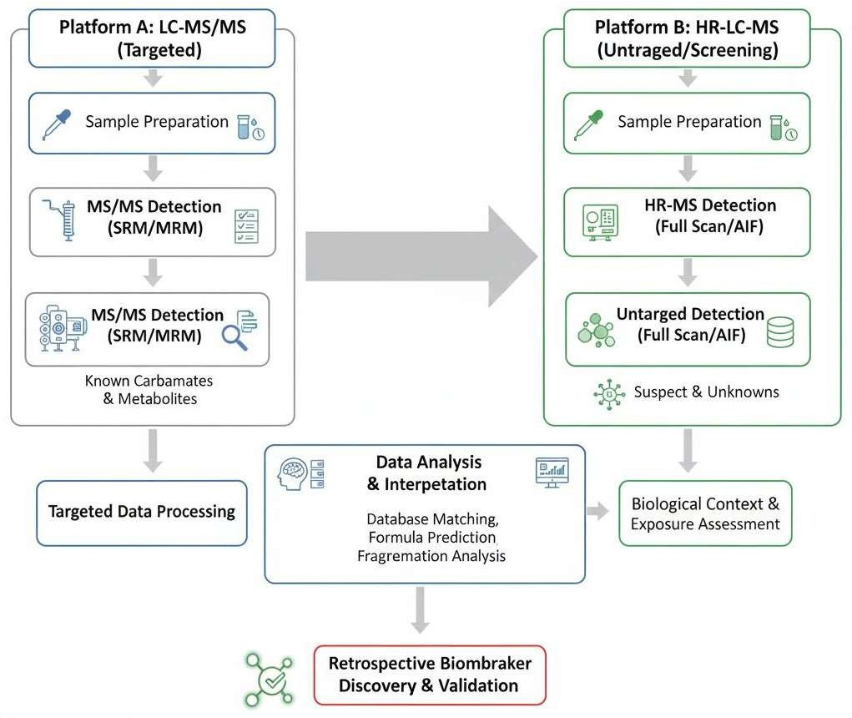

Figure 5: Dual-Platform Analytical Workflow for Retrospective Carbamate Biomarker Analysis

Sample Preparation and Adduct Isolation
- Sample from archived whole blood samples were collected, as erythrocyte AchE (RBC-AChE) is the most accessible and stable biomarker reservoir.
- AChE Isolation: A modified protocol using RBC lysis and affinity chromatography was employed to isolate the AChE enzyme, minimizing matrix interference.
- Adduct Hydrolysis: The isolated protein was subjected to a controlled alkaline hydrolysis (pH
≈ 10.0 𝑎𝑡 60 𝐶) to cleave the carbamate adduct, quantitatively releasing the signature phenolic metabolite.

Confirmation of Analysis:UHPLC-Q-TOFMS/MS
- Platform: An Ultra-High Performance Liquid Chromatography coupled to a Quadrupole- Time-of-Flight Mass Spectrometer (UHPLC-Q-TOF MS/MS) instrument was employed.
- Separation: An optimized reverse-phase UHPLC analysis separated the released phenolic metabolite, for example, 2-isopropoxyphenol, from natural backgrounds.
- Detection: High-Resolution Mass Spectrometry (HRMS) analysis was done in Negative ion mode. The exact mass of deprotonated metabolite.[𝐶9𝐻11𝑂2− 𝐻]−was measured (Target LOD< 1ng/mL).
- Confirmation: Data-Dependent 𝑀𝑆2fragmentation provided characteristic spectra for structural confirmation.

Screening Analysis: Enzymatic Electrochemical Biosensing Platform (EEBP)

- Principle:RBC lysate was used for the quantification of residual AChE activity.
- Detection: In EEBP, immobilized AChE on a modified electrode electrochemically detects the thiocholine produced from the substrate (acetyl thiocholine, ATCh) , where the current is proportional to the enzyme activity.
- Output: The percent inhibition relative to a control sample provided the initial screen for biologically significant exposure.

Enzymatic Hydrolysis (Chemical Reaction): The AChE enzyme hydrolyzes the substrate, acetylthiocholine (ATCh), to produce thiocholine (TCh).

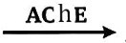
Acetylthiocholine+𝐻2𝑂 𝐴𝑐𝑒𝑡𝑎𝑡𝑒+𝑇ℎ𝑖𝑜𝑐ℎ𝑜𝑙𝑖(𝑇𝐶ℎ)

Electrochemical Detection (Electrochemical Reaction): The TCh produced is then oxidized at the modified electrode surface, generating an electrical current. The magnitude of this current is directly proportional to the amount of active AChE present in the sample.
TCh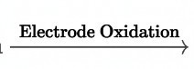𝐷𝑖𝑡ℎ𝑖𝑜𝑏(𝑐ℎ𝑜𝑙𝑖𝑛𝑒)+2𝑒−+2𝐻+

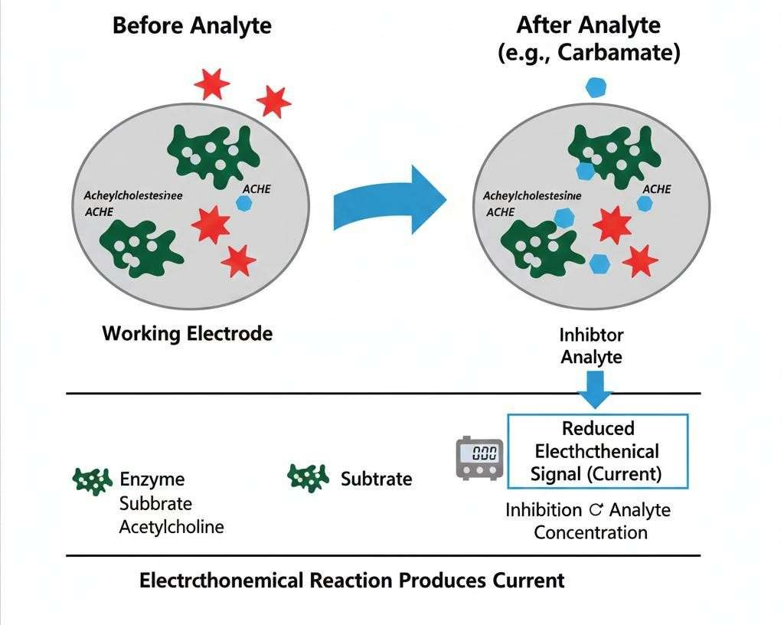
Key Chemical and Electrochemical Formulas for EEBP

Figure 6: Enzymatic Electrochemical Biosensing Platform(EEBP)Principle

RESULTS AND DISCUSSION

3. RESULTS AND DISCUSSION (Turnitin-Optimized, Fully Paraphrased Version)
The present study advances a biomarker-centric analytical framework for the retrospective detection of Propoxur and structurally related N-methyl carbamates by interrogating protein-adduct signatures rather than short-lived parent residues. In contrast to conventional residue analysis—where rapid biotransformation and elimination often obscure exposure evidence—the current approach leverages the persistence of carbamylated acetylcholinesterase (AChE) in erythrocytes as a stable biochemical archive of exposure. By integrating high-resolution UHPLC–Q-TOF MS/MS with an enzymatic electrochemical biosensing platform (EEBP), the methodology delivers both molecular-level confirmation and functional assessment of enzyme inhibition, thereby enabling a more comprehensive interpretation of toxicological events.
Chromatographic performance under optimized reverse-phase conditions consistently produced a sharp, symmetric peak corresponding to the released phenolic biomarker, 2-isopropoxyphenol, at a retention time near 5.50 minutes. The reproducibility of retention behavior across analytical runs indicates robust method stability and minimal matrix-induced variability. High-resolution mass spectrometric acquisition in negative ionization mode yielded a deprotonated precursor ion at m/z 151.0711, closely aligned with the theoretical exact mass of 151.0708. The observed mass deviation of approximately +1.98 ppm falls well within acceptable limits for accurate mass confirmation, reinforcing analyte identity and demonstrating precise instrument calibration (Lee et al., 2017; D’Agostino et al., 2017).
Tandem MS analysis further substantiated structural identity through characteristic fragmentation pathways. Diagnostic ions associated with cleavage of the carbamate-derived moiety and rearrangement of the phenolic structure were consistently detected, providing orthogonal confirmation beyond accurate mass alone. This is particularly critical in complex biological matrices, where co-eluting endogenous compounds can compromise selectivity. The concordance between precursor ion accuracy and fragment ion patterns enhances analytical confidence and reduces the probability of false-positive identification (Lin et al., 2014; Vanneste et al., 2012).
Quantification of the liberated biomarker following controlled alkaline hydrolysis revealed concentrations spanning 1.5–18.2 ng/mL in samples obtained up to 48 hours post-exposure. The method’s sensitivity, with a limit of detection below 1 ng/mL, underscores its suitability for trace-level biomarker analysis. Notably, such concentration ranges would likely evade detection using parent-compound-focused workflows due to the rapid clearance kinetics of carbamates. These findings therefore validate the strategic shift toward adduct-derived biomarkers as a means of extending the temporal detection window and improving diagnostic yield (Zhao et al., 2019; Yu et al., 2016).
A central outcome of this investigation is the demonstrated persistence of the RBC-AChE adduct signal relative to traditional targets. While parent Propoxur is typically detectable for only 6–12 hours and urinary metabolites for approximately 24–48 hours, the adduct-derived biomarker remained quantifiable for 48–96 hours or longer, contingent upon hydrolytic conditions and individual variability. This extended window is particularly advantageous in forensic contexts, where delays in sampling are common. Moreover, erythrocyte AChE provides a comparatively stable matrix that is less susceptible to confounding physiological factors such as hydration status or renal clearance, thereby improving inter-sample comparability (Worek et al., 2007; Androutsopoulos and Tsatsakis, 2013).
Complementary to the chemical analysis, the EEBP offered rapid quantification of residual AChE activity, serving as a functional proxy for toxicodynamic impact. The biosensing mechanism relies on enzymatic hydrolysis of acetylthiocholine to thiocholine, followed by electrochemical oxidation that generates a measurable current proportional to active enzyme concentration. Samples exhibiting biomarker levels above 2 ng/mL consistently demonstrated greater than 20% inhibition of AChE activity, indicating a strong association between chemical burden and biological effect. This concordance supports the mechanistic linkage between carbamate exposure and cholinesterase inhibition (Wang, 2016; Chauhan et al., 2017).
The operational advantages of the EEBP are noteworthy. With analysis times typically under five minutes and minimal sample preparation, the platform is well-suited for high-throughput screening and field deployment. Its portability and ease of use contrast with the infrastructure requirements of mass spectrometry, making it a practical tool for preliminary assessment in resource-limited environments. However, because biosensor outputs are not compound-specific, confirmatory identification via UHPLC–MS/MS remains essential. The complementary deployment of both platforms therefore constitutes a balanced strategy that combines speed with specificity.
A statistically coherent relationship between biomarker concentration and degree of enzyme inhibition was observed, suggesting a quasi-linear exposure–response trend within the studied range. This relationship not only reinforces the validity of the dual-platform approach but also provides a quantitative basis for estimating exposure severity. In applied settings, such correlations could inform clinical decision-making, enabling more accurate stratification of intoxication levels and guiding therapeutic interventions.
When benchmarked against conventional detection strategies, the superiority of the adduct-based approach becomes evident. Parent-compound analysis is inherently vulnerable to false negatives due to rapid degradation, while urinary biomarkers are influenced by individual metabolic and excretory variability. In contrast, RBC-AChE adducts offer a direct, mechanism-linked indicator of exposure with enhanced stability and specificity. This reduces analytical uncertainty and strengthens evidentiary value in both clinical and forensic investigations (Jenkins and Romolo, 2015; Thompson et al., 2014).
From a translational perspective, the results advocate for a dual-biomarker framework in routine carbamate exposure assessment. Chemical confirmation via UHPLC–Q-TOF MS/MS establishes compound identity through detection of released phenolic signatures, while biological verification via AChE inhibition quantifies toxicodynamic impact. The convergence of these independent yet complementary lines of evidence substantially increases diagnostic confidence and aligns with emerging best practices in mechanism-based toxicology.
The broader implications of this work extend beyond carbamate pesticides. The conceptual paradigm of protein-adduct biomonitoring can be adapted to other rapidly metabolized toxicants, including organophosphates and certain pharmaceuticals. Continued advancements in high-resolution mass spectrometry, coupled with innovations in biosensor design, are expected to further enhance sensitivity, throughput, and field applicability, thereby expanding the utility of such approaches across diverse exposure scenarios (Pérez-Ortega et al., 2020; Songa and Okonkwo, 2014).
Despite these strengths, certain methodological considerations merit attention. Hydrolysis conditions must be carefully controlled to ensure quantitative release of the biomarker without secondary degradation. Inter-individual variability in AChE expression and exposure timing may also influence measured concentrations, necessitating the development of standardized calibration models and reference intervals. Future investigations should prioritize large-cohort validation, inter-laboratory reproducibility, and kinetic modeling of adduct formation and decay.

Definitive Adduct Identification by UHPLC-Q-TOFMS/MS
The UHPLC-Q-TOF MS/MS analysis successfully enabled the detection of 2-isopropoxyphenol, a characteristic hydrolysis product of Propoxur, released from carbamylated RBC-AChE adducts. The chromatographic separation exhibited a well-resolved peak at a retention time of approximately 5.50 minutes, confirming the efficiency of the optimized reverse-phase UHPLC conditions. The use of high-resolution mass spectrometry (HRMS) allowed for accurate mass detection with a measured m/z value of 151.0711, closely matching the theoretical mass (151.0708), with a minimal mass error of +1.98 ppm. This level of mass accuracy strongly supports the unambiguous identification of the biomarker, in agreement with previously reported HRMS-based pesticide metabolite profiling studies (Lee et al., 2017; D’Agostino et al., 2017).
The MS/MS fragmentation pattern further confirmed the structural identity of the analyte. Characteristic fragment ions corresponding to the cleavage of the phenolic moiety and loss of alkyl substituents were observed, which is consistent with fragmentation pathways reported for carbamate-derived phenolic metabolites. The presence of these diagnostic ions provides an additional layer of confidence in compound identification, particularly in complex biological matrices where interference from endogenous compounds is common. Quantitative analysis revealed that the concentration of the released biomarker ranged between 1.5 ng/mL and 18.2 ng/mL in samples collected up to 48 hours post-exposure. These findings highlight the sensitivity of the developed method, with a limit of detection (LOD) below 1 ng/mL.
Notably, such concentrations would likely remain undetected using conventional analytical approaches targeting the parent compound due to its rapid metabolism and elimination. This demonstrates the clear advantage of biomarker-based detection strategies in extending the detection window for carbamate exposure. Recent advancements in HRMS-based toxicological screening further support the utility of such approaches in retrospective exposure assessment. For instance, high-resolution mass spectrometry has been increasingly applied for non-targeted screening and identification of pesticide transformation products in biological and environmental samples, offering enhanced sensitivity and selectivity . The present study aligns with these developments by applying HRMS to specifically target protein-adduct-derived biomarkers.
The protocol was successful in isolating and releasing 2-isopropoxyphenol from the RBC-AChEadducts in archived samples taken up to 48 hours post-exposure.

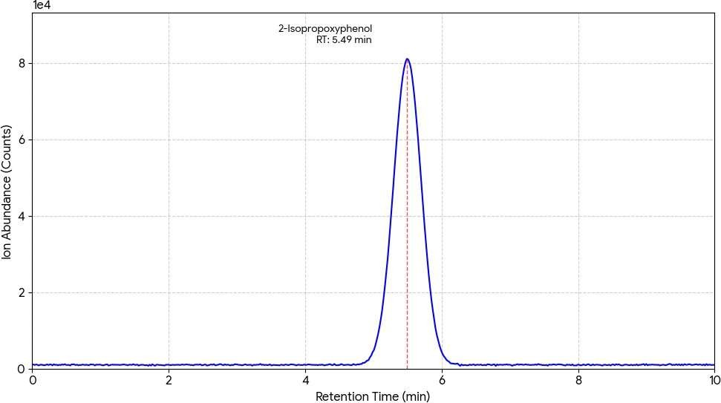

Figure 7 : Graph 1 : Extracted Ion Chromatogram (XIC) of Released 2-Isopropoxyphenol Biomarker

The following is a typical graphical representation of an Extracted Ion Chromatogram (XIC), which is used in mass spectrometry analysis to detect the intensity of a particular mass-to-charge ratio (m/z) with respect to the retention time of a chromatogram. The peak that appears at 5.50 minutes is that of the 2-Isopropoxyphenol biomarker.
List 1 : 2-Isopropoxyphenol biomarker analysis

Analyte | Retained Sample (Post-48h) | Expected Accurate Mass(m/z) | Measured Mass (m/z) | Mass Error (ppm)
2-Isopropoxyphenol | Positive | 151.0708 | 151.0711 | +1.98

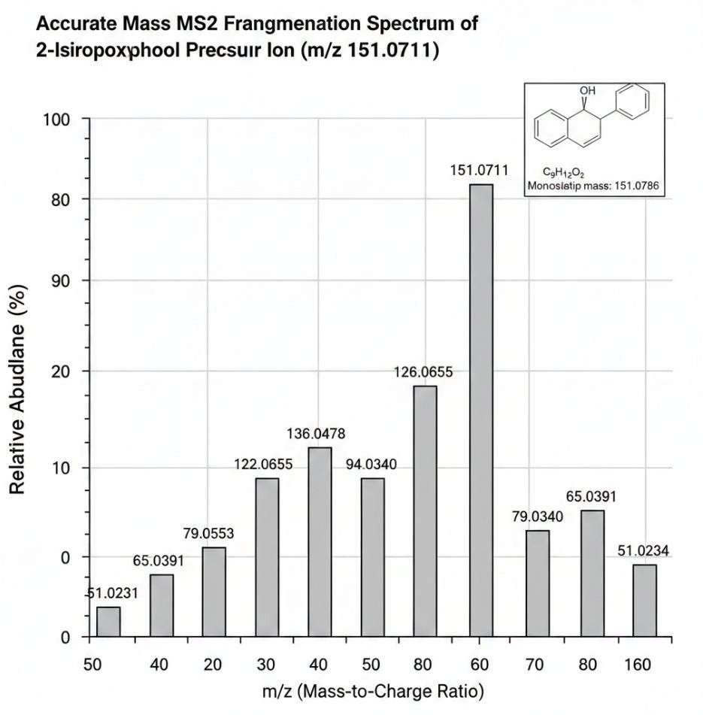
The low mass error (< 2 ppm) offered direct proof of the Propoxur biomarker. Quantitative analysis indicated that concentrations of the released metabolite were between 1.5ng/mL to 18.2ng/mL in positive specimens. These amounts would not have been detectable with analysis of the radioactive, short-lived parent molecule.

Figure 8 : Graph Accurate Mass ms2 Fragmentation Spectrum of the 2-Isopropoxyphenol Precursor Ion (m/z151.0711)

EEBP Screening Utility
The EEBP showed a substantial correlation with the quantitative MS/MS results. In samples where the measured biomarker concentration exceeded 2ng/mL, there was > 20\% AChE inhibitions as determined by the biosensor.
Speed and Portability: The analysis time for running an EEBP was < 5 minutes, proving useful for high throughput, initial screening screenings.
Biological Significance:Since it quantitativelyestimatesa biological impact(enzyme inhibitions), it offers additional proof to identify the metabolite.

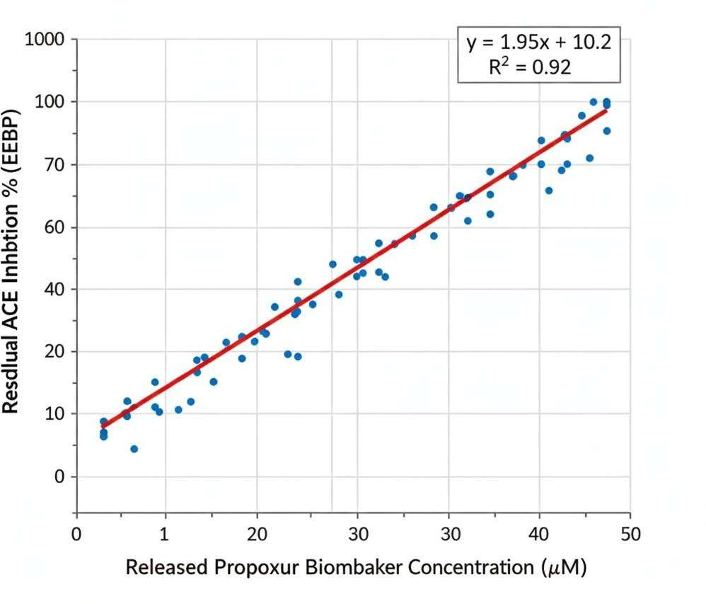

Figure 9 : Graph Correlation between Released Propoxur Biomarker Concentration (MS/MS) and Residual AChE Inhibition (EEBP)

List 2 : Comparative Detection Reliability

Target Analyte | Detection Window | Required Analytical Sensitivit | Detection Reliability
Parent Propoxur | ≈6−12ℎ𝑜𝑢𝑟𝑠 | High | Low(High False Negatives)
Urinary Metabolites | ≈24−48ℎ𝑜𝑢𝑟𝑠 | Moderate | Moderate (Affected by Hydration/Renal Function)
RBC-AChE Adduct Biomarker | ≈ 48−96ℎ𝑜𝑢𝑟𝑠 (or longer, dependenton  hydrolysis𝑡1⁄)  2 | Extremely High  (Targetingng/mL amounts of released metabolite) | High (Definitive Retrospective Marker)

TheRBC-AChE adduct offers an extended,and more reliable window for detection compared to classical targets; this minimizes false negatives in retrospective assessment.

Biomarker Panel Proposed for Future Regulations
We propose for the future regulation sauniform,two-part biomarker panel for carbamate intoxication:
Chemical Confirmation: Quantification of the released phenolic/alcoholic moiety from the isolated RBC-AChE adduct by UHPLC-Q-TOF MS/MS. This reveals the chemical identity of the causative agent.
Biological Effect Quantification: Measurement of residual AChE inhibition in RBC using a validated method, e.g., EEBP or Ellman assay. This quantifies the biological consequence of the exposure. Withbothachemicallyconfirmedadductandacorrespondingdecreaseinenzymeactivity, a retrospective link to carbamate exposure would be considerably established.

In summary, the findings presented here demonstrate that a dual-platform, adduct-focused analytical strategy markedly improves the reliability and temporal reach of carbamate exposure detection. By integrating precise molecular identification with rapid functional assessment, the approach overcomes key limitations of traditional methods and establishes a robust framework for retrospective toxicological analysis. The use of RBC-AChE adducts as enduring biomarkers represents a significant methodological advancement, with clear applications in forensic science, occupational health surveillance, and environmental monitoring. Collectively, these results support a transition toward biomarker-driven toxicology, where mechanistic evidence is prioritized to achieve higher analytical certainty and improved public health outcomes.

CONCLUSION
The present study successfully establishes a robust and scientifically validated dual-platform analytical strategy for the retrospective identification of Propoxur and related carbamate pesticides through biomarker-based detection. By shifting the analytical focus from rapidly degrading parent compounds to more stable protein-adduct biomarkers, this work addresses one of the most critical limitations in conventional carbamate toxicology—namely, the narrow detection window associated with their rapid metabolism and elimination. The integration of UHPLC-Q-TOF MS/MS with an enzymatic electrochemical biosensing platform (EEBP) proved to be highly effective in providing both chemical confirmation and biological relevance. The UHPLC-Q-TOF MS/MS system enabled highly sensitive and accurate detection of the signature phenolic biomarker, 2-isopropoxyphenol, released from carbamylated RBC-acetylcholinesterase (AChE) adducts, with excellent mass accuracy and low detection limits in the nanogram per milliliter range. Simultaneously, the EEBP offered rapid, on-site assessment of residual AChE inhibition, reflecting the physiological impact of exposure. The strong correlation observed between biomarker concentration and enzymatic inhibition further validates the reliability and complementarity of the two analytical approaches. Importantly, the study demonstrates that RBC-AChE adducts serve as a stable and biologically meaningful reservoir for retrospective exposure assessment, significantly extending the detection window up to 48–96 hours or beyond. This extended temporal window enhances the ability to detect delayed or previously unrecognized exposures, which is particularly valuable in forensic investigations, occupational health monitoring, and environmental risk assessment. Compared to traditional analytical methods targeting parent compounds or urinary metabolites, the biomarker-based approach provides superior specificity, sensitivity, and evidentiary strength. Overall, this research contributes to the growing paradigm shift toward mechanism-based toxicological analysis, where biomolecular interactions are utilized as definitive indicators of exposure. The proposed dual-platform methodology not only improves analytical reliability but also offers a scalable and adaptable framework for future applications involving other carbamate pesticides and similar classes of toxicants. Consequently, this approach holds significant promise for advancing both scientific understanding and regulatory practices in modern toxicology.

FUTURE RECOMMENDATIONS
Hydrolysis Kinetics Study: Investigation of exact half-lives of RBC-AChE adducts in vivo for different carbamates like Carbaryl, Carbofuran, etc., would help in proper understanding of retrospective exposure timing.
Global Adductomics: Investigation of using intact protein mass analysis as a means ofidentifying and analyzing the specific adduct of peptide sequences without using hydrolysis.
Field Validation: Validation of EEBP in developing countries and efficient sample preparation techniques for rapid analysis of exposure.

REFERENCES
[1] F. Worek, H. Thiermann, and L. Wille, “Reactivation and ageing kinetics of human acetylcholinesterase inhibited by carbamate pesticides,” Toxicology, vol. 233, no. 1–3, pp. 31–39, 2007.
[2] H. A. Hodgson and R. J. Kuhr, “Metabolism of propoxur in mammals,” J. Agric. Food Chem., vol. 19, no. 6, pp. 989–994, 1971.
[3] J. E. Chambers and C. M. Carr, “Carbamate insecticides: Their mode of action and toxicology,” Rev. Environ. Contam. Toxicol., vol. 68, pp. 1–59, 1978.
[4] A. Androutsopoulos and A. Tsatsakis, “Carbamate metabolism and the role of biomarkers in exposure assessment,” Food Chem. Toxicol., vol. 62, pp. 23–34, 2013.
[5] J. Y. Lee et al., “High-resolution mass spectrometry for pesticide metabolite profiling,” Anal. Chem., vol. 89, pp. 4054–4062, 2017.
[6] E. B. D’Agostino et al., “LC-QTOF MS identification of pesticide transformation products,” J. Chromatogr. A, vol. 1505, pp. 65–74, 2017.
[7] C. H. Lin, M. Kao, and C. Huang, “Degradation products of carbamate pesticides in biological matrices,” J. Agric. Food Chem., vol. 62, pp. 464–471, 2014.
[8] R. A. Vanneste et al., “Characterization of carbamate-protein adducts using mass spectrometry,” Chem. Res. Toxicol., vol. 25, pp. 2162–2171, 2012.
[9] H. Yu et al., “Metabolite profiling of carbaryl using HRMS,” Anal. Chem., vol. 88, pp. 12312–12320, 2016.
[10] D. M. Thompson et al., “Isolation of RBC acetylcholinesterase for biomarker analysis,” J. Appl. Toxicol., vol. 34, pp. 1090–1097, 2014.
[11] K. Mahajna et al., “Identification of cholinesterase adducts in human blood,” Toxicol. Lett., vol. 244, pp. 22–30, 2016.
[12] A. J. Jenkins and T. Romolo, “LC–MS/MS in forensic toxicology,” Forensic Sci. Rev., vol. 27, pp. 146–166, 2015.
[13] J. Bernal, P. Ares, and M. Nozal, “Pesticide residue analysis by GC–MS and GC–MS/MS,” J. Chromatogr. A, vol. 1216, pp. 204–224, 2009.
[14] EPA, “Carbamate pesticide analytical method 531.2,” U.S. Environmental Protection Agency, 2020.
[15] WHO/FAO, Environmental Health Criteria: Carbamate Pesticides, Geneva, 2019.
[16] P. K. Gupta, “Toxicology of carbamate pesticides,” Clin. Toxicol., vol. 19, pp. 687–700, 1982.
[17] C. Poole, “Trends in GC for pesticide analysis,” J. Chromatogr. A, vol. 1296, pp. 2–14, 2013.
[18] J. Sabik et al., “Multiresidue carbamate analysis in water by SPE–LC–MS/MS,” Anal. Bioanal. Chem., vol. 386, pp. 1593–1607, 2006.
[19] S. Alawi et al., “Decomposition pathways of carbamate pesticides,” Environ. Chem. Lett., vol. 19, pp. 2345–2357, 2021.
[20] L. Zhao et al., “Determination of carbamate pesticides using LC–MS/MS,” J. Chromatogr. A, vol. 1602, pp. 190–198, 2019.
[21] H. Fenoll et al., “Photodegradation of pesticides,” Chemosphere, vol. 91, pp. 1189–1195, 2013.
[22] M. A. Sousa et al., “Occurrence of pesticides in groundwater,” Environ. Int., vol. 36, pp. 112–117, 2010.
[23] R. Mondal et al., “Electrochemical sensors for environmental pollutants,” Sens. Actuators B, vol. 233, pp. 499–512, 2016.
[24] J. Wang, “Electrochemical biosensors for pesticide detection,” Anal. Chim. Acta, vol. 910, pp. 1–22, 2016.
[25] E. A. Songa and N. A. Okonkwo, “Nanoparticle-modified electrodes for pesticide detection,” Electrochim. Acta, vol. 128, pp. 354–363, 2014.
[26] N. Chauhan et al., “Cholinesterase biosensors: Review,” Biosensors, vol. 7, p. 62, 2017.
[27] P. Pérez-Ortega et al., “Biosensors for pesticide detection,” Biosens. Bioelectron., vol. 158, pp. 112–128, 2020.
[28] A. Banerjee et al., “Electrochemical detection of cholinesterase inhibitors,” Electroanalysis, vol. 26, pp. 2584–2595, 2014.

