A Generalized Quadrature Rule using Anti-Gaussian Techniques

Abstract:
We propose a novel generalized quadrature rule ${SM}_{15}(f)$ by combining the Anti-Lobatto 4-point rule and the Anti-Gauss 3-point rule through a generalized quadrature technique. A comprehensive convergence analysis of the proposed rule has been carried out, along with the derivation of suitable error estimates. The analysis demonstrates that the proposed rule ${SM}_{15}(f)$ provides significantly higher accuracy than its constituent rules in numerical integration frameworks. The theoretical results are further validated through extensive numerical experiments on a variety of test integrals, which confirm the reliability, stability, and precision of the proposed method. The study highlights the substantial improvement in computational efficiency and accuracy achieved by ${SM}_{15}(f)$, establishing it as an effective and powerful tool for high-precision numerical integration.
Keywords:
Generalised quadrature technique, Anti-Gauss 3-point rule, Anti-Lobatto 4-point rule, Error Analysis, ${SM}_{15}(f)$.
AMS Subject Classification: 65D30; 65D32
- Introduction
Numerical integration plays a fundamental role in numerical analysis for approximating definite integrals. These rules provide systematic and efficient techniques for numerical integration, where the effectiveness of a quadrature rule is largely determined by its degree of precision. In general, a higher degree of precision leads to greater computational accuracy and improved numerical performance. To enhance the approximation of definite integrals, several researchers have developed different mixed-type quadrature rules [4,7,8], which have significantly advanced the field of numerical integration and motivated further research in this direction.
In recent years, S. K. Mohanty and R. B. Dash introduced a generalized quadrature technique [5,6] for constructing higher-precision quadrature rules by suitably combining existing lower-precision rules. Their work primarily focused on closed-type quadrature rules for definite integrals and established an effective framework for improving computational accuracy in numerical integration.
Motivated by the pioneering contributions of Mohanty and Dash [5,6,11], together with the concept of Anti-Gaussian quadrature introduced by D. P. Laurie [3], the present paper proposes a new generalized quadrature rule, denoted by ${SM}_{15}(f)$ . The proposed rule is formulated using the generalized quadrature technique by combining the Anti-Lobatto 4-point rule, the Anti-Gauss 3-point rule, and the Gauss–Legendre 3-point rule. The resulting quadrature rule achieves enhanced precision, accuracy, and computational efficiency for the numerical evaluation of definite integrals.
The paper is organized into six sections. Section 1 presents the introduction, while Section 2 discusses the preliminary concepts and existing results. Section 3 is devoted to the formulation of the proposed generalized quadrature rule. In Section 4, the error analysis and convergence properties are established. Section 5 provides numerical verification through various test examples, and Section 6 concludes the paper with results, observations, and possible future research directions. The proposed quadrature rule represents a significant advancement toward the development of highly accurate and efficient numerical integration techniques.

- Preliminaries
In this section, we provide a brief overview of the Generalized Quadrature technique and discuss the foundational rules available in the existing literature.
2.1 Generalized Quadrature technique
Quadrature rule of higher precision formed out by using n-rules of lower precision, $n∈N, n≥2$ is known as a generalized quadrature rule [5,6].
Given ${SR}_{n}$ as the Generalized Quadrature Rule of higher precision, constructed by combining the lower precision quadrature rules $R_{1},R_{2},R_{3,}….R_{n}$ while satisfying the SR-Conditions [5,6], it can be expressed as follows:
A quadrature rule of higher precision constructed by combining $n$-rules of lower precision, where $n∈N$and $n≥2$, is known as a generalized quadrature rule [5,6].
Let $SR_{n}$denote the generalized quadrature rule of higher precision obtained by suitably combining the lower-order quadrature rules $R_{1},R_{2},R_{3},…,R_{n}$, provided that they satisfy the required SR-conditions [5,6]. Under these conditions, the constructed rule is expressed as a linear combination of the given component rules with appropriately chosen coefficients, ensuring cancellation of lower-order error terms and enhancement of the overall degree of precision.
Thus, the generalized quadrature rule can be written in the form:
$$SR_{n}(f)=\sum_{i=1}^{n}{a_{i}}R_{i}(f),$$where $a_{i}$are constants determined by the SR-conditions so as to maximize the degree of accuracy of the resulting quadrature formula.
Thus we can write,
${SR}_{n}$= ${a_{1}R}_{1}+{a_{2}R}_{2}+{a_{3}R}_{3}+…+{a_{n}R}_{n}; \sum_{i=1}^{n}{a_{i}}=1$ (1)
​where $a_{1},a_{2},a_{3},…a_{4}$ are n-number of rational coefficients that can be obtained by making the rule ${SR}_{n}$ exact for all polynomials of degree up to ${dR}_{n}$ + 2. The truncation error due to the rule (10) is given by
$E{SR}_{n}$= ${a_{1}ER}_{1}+{a_{2}ER}_{2}+{a_{3}ER}_{3}+…+{a_{n}ER}_{n}$ (2)
Assuming this error vanishes for all polynomials of degree upto $d{SR}_{n}$.
we get the values of $a_{1},a_{2},a_{3},…a_{4}$. Using the values of $a_{i}'s$ on (1), we can obtain the desired generalized quadrature rule.
  - Anti-Gaussian 3-point rule
The concept introduced by D. P. Laurie [3] provides an effective procedure for constructing an Anti-Gaussian quadrature rule corresponding to a given Gaussian quadrature rule. In particular, the Anti-Gaussian rule associated with the Gauss 2-point quadrature rule is designed in such a way that, when combined with the Gaussian rule, it improves the approximation of definite integrals and provides better error estimation. The Gauss 2-point quadrature rule exactly integrates all polynomials of degree at most three, whereas the corresponding Anti-Gaussian rule is formulated to compensate for the higher-order error terms that are not captured by the Gaussian rule.
The Anti-Gaussian quadrature rule plays an important role in numerical integration because it complements the Gaussian quadrature rule by reducing the influence of errors arising from higher-degree polynomial components. More specifically, it is particularly effective for polynomial terms that are orthogonal to those integrated exactly by the Gaussian rule [1,8,11]. As a result, the combined use of Gaussian and Anti-Gaussian quadrature rules leads to improved numerical stability, higher precision, and more reliable approximation of definite integrals.
Motivated by these advantageous properties, the present work incorporates the following Anti-Gaussian quadrature rule in the construction of the proposed generalized quadrature formula.
$a{GL}_{3}(f)=\frac{1}{13}\left[5f\left(-\sqrt{\frac{13}{5}}\right)+16f\left(0\right)+5f\left(\sqrt{\frac{13}{5}}\right)\right]$ (3)
Applying Taylor’s Theorem [1],
$a{GL}_{3}(f)=2\left[f\left(0\right)+\frac{1}{3!}f^{''}\left(0\right)+\frac{13}{9×5!}f^{iv}\left(0\right)+\frac{169}{675×6!}f^{vi}\left(0\right)++\frac{{(13)}^{3}}{3×8!×(1{5)}^{3}}f^{viii}\left(0\right)+\frac{2×{(13)}^{4}}{10!×(1{5)}^{5}}f^{x}\left(0\right)+…\right]$ (4)
Due to Taylor [1],
$I\left(f\right)=2\left[f\left(0\right)+\frac{1}{3!}f^{''}\left(0\right)+\frac{1}{5!}f^{iv}\left(0\right)+\frac{1}{7!}f^{vi}\left(0\right)+\frac{1}{9!}f^{viii}\left(0\right)+\frac{1}{11!}f^{x}\left(0\right)…\right]$ (5)
Theorem 2.1
If $f(x)$ is sufficiently differentiable on the interval [−1,1] the truncation error due to the rule $a{GL}_{3}(f)$ can be expressed as:
$Ea{GL}_{3}(f)=-\frac{1}{135}f^{iv}\left(0\right)-\frac{1016}{7!×675}f^{vi}\left(0\right)-\frac{6432}{9!×{(15)}^{3}}f^{viii}\left(0\right)+….$
Proof:
The truncation error due to $a{GL}_{3}(f)$ is given by
$Ea{GL}_{3}(f)=I\left(f\right)-a{GL}_{3}(f)$ (6)
Using equations (4) and (5) in equation (6), we obtain:
$Ea{GL}_{3}(f)=-\frac{1}{135}f^{iv}\left(0\right)-\frac{1016}{7!×675}f^{vi}\left(0\right)-\frac{6432}{9!×{(15)}^{3}}f^{viii}\left(0\right)+….$ (7)
This completes the proof.
  - Anti-Lobatto 4- Point rule
Using the concept described in Section 2.2, we construct the Anti-Lobatto 4-point rule $aL_{4}(f)$ based on the Lobatto 3-point rule $L_{3}(f)$ as follows:
$L_{3}\left(f\right)=\frac{1}{3}\left[f\left(-1\right)+4f\left(0\right)+f(1)\right]$
$aL_{4}\left(f\right)=\frac{1}{9}\left[10f\left(-\sqrt{\frac{2}{5}}\right)+10f\left(\sqrt{\frac{2}{5}}\right)-\left\{f\left(-1\right)+f\left(1\right)\right\}\right]$ (8)
Applying Maclaurin’s series expansion on (8), we get
$aL_{4}\left(f\right)=2f\left(0\right)+\frac{2}{3!}f^{''}\left(0\right)+\frac{2}{3×5!}f^{iv}\left(0\right)-\frac{2}{25×6!}f^{vi}\left(0\right)-\frac{93}{5^{3}}\frac{1}{9!}f^{viii}\left(0\right)-\frac{561}{9×5^{4}}\frac{2}{10!}f^{x}\left(0\right)$ (9)
Theorem 2.2
If $f(x)$ is sufficiently differentiable on the interval [−1,1] the truncation error due to the rule $aL_{4}(f)$ can be expressed as:
$EaL_{4}\left(f\right)=\frac{4}{3×5!}f^{iv}\left(0\right)+\frac{64}{25×7!}f^{vi}\left(0\right)+\frac{436}{5^{3}×9!}f^{viii}\left(0\right)+\frac{7864}{5^{4}×11!}f^{x}(0)….$
Proof:
The truncation error due to $aL_{4}\left(f\right)$ is given by
$EaL_{4}\left(f\right)=I\left(f\right)-aL_{4}\left(f\right)$ (10)
Using equations (9) and (5) in equation (10), we obtain:
$EaL_{4}\left(f\right)=\frac{4}{3×5!}f^{iv}\left(0\right)+\frac{64}{25×7!}f^{vi}\left(0\right)+\frac{436}{5^{3}×9!}f^{viii}\left(0\right)+\frac{7864}{5^{4}×11!}….$ (11)
This completes the proof.
- Formulation of the Generalized Rule
From Theorems 2.1 and 2.2, the degree of precision of the rule $a{GL}_{3}(f)$ and $aL_{4}\left(f\right)$ is 3.
By definition of the SR-condition [5,6], the quadrature rules $a{GL}_{3}(f)$, $aL_{4}\left(f\right)$ satisfy the SR-conditions.
By applying the generalized quadrature technique to the above rules, we can create a more accurate quadrature rule of order 3, as explained in Theorem 3.1 below.
From Theorems 2.1 and 2.2, it follows that the quadrature rules $a{GL}_{3}(f)$, and $aL_{4}\left(f\right)$ each possess a degree of precision equal to three. Further, according to the definition of the SR-condition given in [5,6], both quadrature rules $a{GL}_{3}(f)$ and $aL_{4}\left(f\right)$ satisfy the required SR-conditions. Therefore, by applying the generalized quadrature technique to these two rules, a new quadrature rule of higher accuracy and improved computational efficiency can be constructed. The formulation of the resulting generalized quadrature rule of order two is presented in Theorem 3.1 below.
Theorem 3.1
If $f(x)$ is sufficiently differentiable on the interval [−1,1], the Generalised quadrature rule ${SM}_{15}\left(f\right)$ is given by ${SM}_{15}\left(f\right)=\frac{1}{5}\left[3 a{GL}_{3}\left(f\right)+2 aL_{4}(f)\right]$and truncation error due to the rule ${ESM}_{15}\left(f\right)=\frac{1}{5}\left[3 Ea{GL}_{3}\left(f\right)+2 EaL_{4}(f)\right]$.
Proof: The generalized quadrature rule ${SM}_{15}\left(f\right)$ constructed using $R_{1}\left(f\right)=a{GL}_{3}\left(f\right), R_{2}\left(f\right)=aL_{4}\left(f\right)$ is expressed as follows:
${SM}_{15}(f)=\left[a_{1}a{GL}_{3}\left(f\right)+a_{2}aL_{4}\left(f\right)\right]$, $a_{1}+a_{2}=1$ (12)
The truncation error due to ${SM}_{15}(f)$ is given by
$E{SM}_{15}(f)=\left[a_{1}Ea{GL}_{3}\left(f\right)+a_{2}EaL_{4}\left(f\right)\right]$ (13)
Using (7), (11) and (13)
$E{SM}_{15}\left(f\right)=a_{1}\left\{-\frac{1}{135}f^{iv}\left(0\right)-\frac{1016}{7!×675}f^{vi}\left(0\right)-\frac{6432}{9!×{(15)}^{3}}f^{viii}\left(0\right)+…. \right\}+a_{2}\left\{\frac{4}{3×5!}f^{iv}\left(0\right)+\frac{64}{25×7!}f^{vi}\left(0\right)+\frac{436}{5^{3}×9!}f^{viii}\left(0\right)+\frac{7864}{5^{4}×11!}…. \right\}$ (14)
We choose $a_{1}$, $a_{2}$ in such a way that the rule ${SM}_{15}(f)$ becomes exact for all polynomial of degree upto 5. From the error term,
we have $\frac{a_{1}}{135}-\frac{4a_{2}}{3×5!}=0$ (15)
On solving (12) and (15), we get $a_{1}=\frac{3}{5}$ and $a_{2}=\frac{2}{5}$ .
Using the value of $a_{1}$ and $a_{2}$ on (12) and (13), we get
${SM}_{15}\left(f\right)=\frac{1}{5}\left[3 a{GL}_{3}\left(f\right)+2 aL_{4}(f)\right]$
and $E{SM}_{15}\left(f\right)=\frac{1}{5}\left[3 Ea{GL}_{3}\left(f\right)+2 EaL_{4}(f)\right]$ (16)
This completes the proof.
- Error Analysis
The following theorems provide the error analysis of the proposed quadrature rule and establish the necessary bounds and conditions required to ensure the accuracy and reliability of the numerical approximations.
Theorem 4.1
If $f(x)$ is sufficiently differentiable on the interval [-1, 1], the truncation error for ${SM}_{15}(f)$ is expressed as: ${ESM}_{15}\left(f\right)=\frac{136}{1125×7!}f^{vi}\left(0\right)+….$
Proof: Using equations (7), (11), and (16), we obtain the result.
Theorem 4.2
The absolute truncation error from the constructed Generalized ${SM}_{15}\left(f\right)$ rule is smaller than that of the individual constituent rules.
Proof: From (7) and Theorem 4.1, we get that ${|ESM}_{15}\left(f\right)|≤|Ea{GL}_{3}(f)|$.
From (11) and Theorem 4.1, we get that ${|ESM}_{15}\left(f\right)|≤|EaL_{4}\left(f\right)|$.
This completes the proof.

- Numerical Verification
The approximate values obtained using the proposed Generalized Quadrature Rule ${SM}_{15}\left(f\right)$ and its constituent quadrature rules are presented in Table 1. Table 2 displays the corresponding absolute truncation errors for various test integrals, providing a comparative assessment of the accuracy and performance of the different quadrature
Table 1: Approximate values of five test integrals computed using the constituent quadrature rules and the proposed generalized quadrature rule ${SM}_{15}\left(f\right)$ .
Integral | $$a{GL}_{3}(f)$$ | $$aL_{4}\left(f\right)$$ | $${SM}_{15}\left(f\right)$$
$$I_{1}=\int_{0}^{\frac{π}{4}}{\frac{dx}{1+\sin{x}}}dx$$ | 0.586099494501151 | 0.585312554524271 | 0.585784718510399
$$I_{2}=\int_{0}^{1}{\cos^{3}x}dx$$ | 0.643316733200435 | 0.642188963375257 | 0.642865625270364
$$I_{3}=\int_{1}^{2}{\frac{dx}{e^{x}-1}}dx$$ | 0.314104502435285 | 0.311973586848312 | 0.313252136200495
$$I_{4}=\int_{0}^{1}{\sin{\sqrt{x}}}dx$$ | 0.5952914771446 | 0.620554639145339 | 0.605396741944895

Table 2: Comparison of the absolute truncation error values for various rules and the proposed rule.
Integral | Exact Value | $$|Ea{GL}_{3}(f)|$$ | $$|EaL_{4}\left(f\right)|$$ | $${|ESM}_{15}\left(f\right)|$$
$$I_{1}$$ | 0.585786437626905 | 3.130569$×{10}^{-4}$ | 4.73883$×{10}^{-4}$ | 1.719116$×{10}^{-6}$
$$I_{2}$$ | 0.642863239277578 | 4.534939$×{10}^{-4}$ | 6.742759$×{10}^{-4}$ | 2.3859927$×{10}^{-6}$
$$I_{3}$$ | 0.313261687518223 | 8.428149$×{10}^{-4}$ | 1.2881$×{10}^{-3}$ | 9.551317$×{10}^{-6}$
$$I_{4}$$ | 0.602337357879514 | 7.045881$×{10}^{-3}$ | 1.82173$×{10}^{-2}$ | 3.05938$×{10}^{-3}$

5.2 Graphical Comparison of Errors Due to Different Rules
Based on the data presented in Table 2, the corresponding two-dimensional (2D) and three-dimensional (3D) graphical representations have been constructed for each of the considered integrals. These figures visually illustrate the behaviour of the approximation errors and allow a clear comparison of the performance of the proposed and existing quadrature rules. The 2D plots highlight the variation of absolute errors across different methods, while the 3D surfaces provide a more comprehensive view of the error distribution and its relative magnitude. Together, these graphical illustrations effectively support the numerical results reported in Table 2 and further demonstrate the accuracy and superiority of the proposed method.
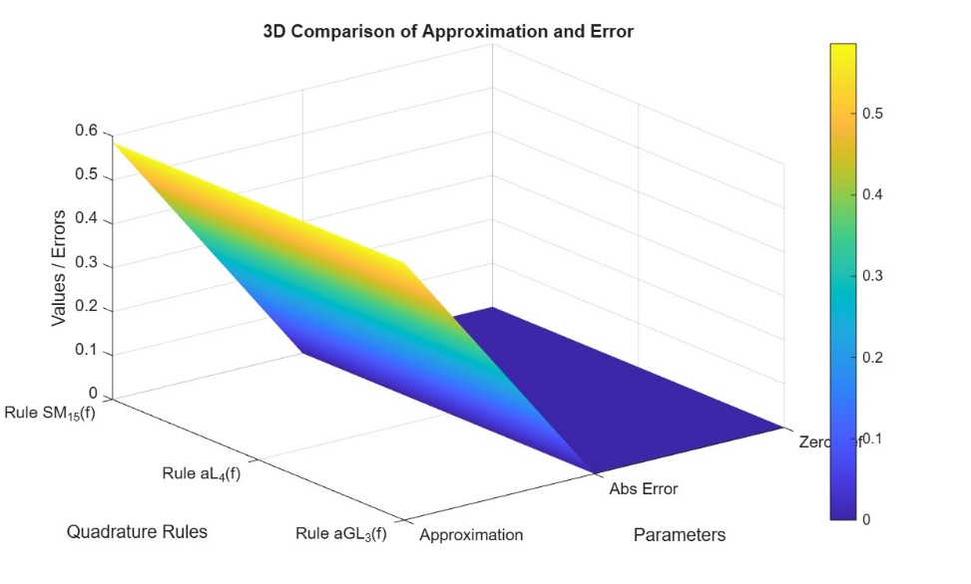
Figure 1(a): Presents the three-dimensional (3D) visualization of the error comparison among the considered quadrature rules for the integral $I_{1}(f)$.
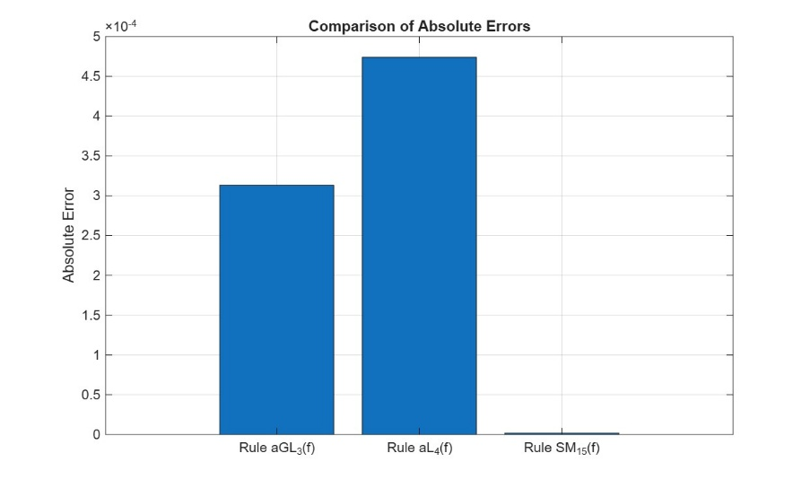
Figure 1(b): Presents the three-dimensional (3D) visualization of the error comparison among the considered quadrature rules for the integral $I_{1}(f)$.
Remark 1: For the integral $I_{1}(f)$, the truncation error introduced by the Anti-Gaussian 3-point rule and the Anti-Lobatto 4-point rule becomes noticeable from the 4th decimal place onward, indicating a moderate level of accuracy in these methods. In contrast, the proposed Generalized Quadrature Rule $SM_{15}(f)$exhibits significantly improved precision, with the error appearing only from the 6th decimal place. This clearly demonstrates that the constructed rule provides a higher degree of accuracy and better numerical stability compared to its constituent methods for the given integral.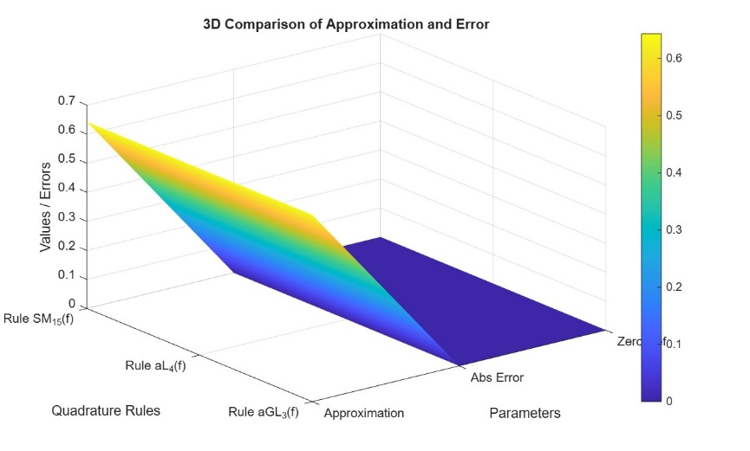
Figure 2(a): Presents the three-dimensional (3D) visualization of the error comparison among the considered quadrature rules for the integral $I_{2}(f)$.
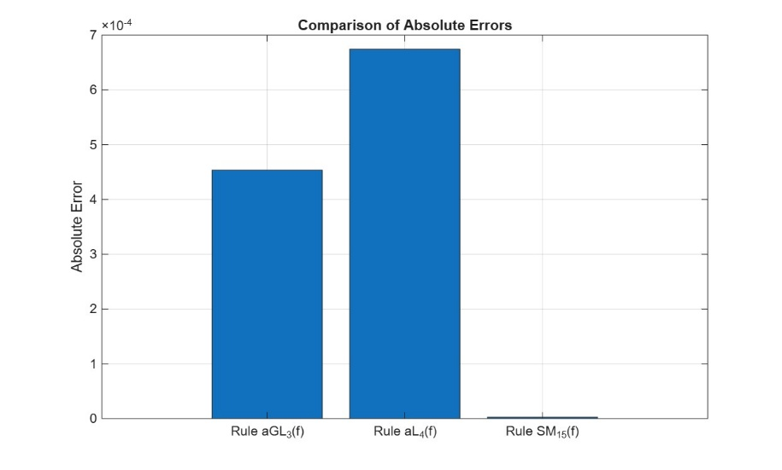
Figure 2(b): Presents the three-dimensional (2D) visualization of the error comparison among the considered quadrature rules for the integral $I_{2}(f)$.
Remark 2: For the integral $I_{2}(f)$, the truncation error associated with both the Anti-Gaussian 3-point rule and the Anti-Lobatto 4-point rule is observed to begin from the 4th decimal place, indicating comparable accuracy levels for these two basic quadrature schemes. However, the proposed Generalized Quadrature Rule $SM_{15}(f)$demonstrates a marked improvement in accuracy, with the error initiating only from the 6th decimal place. This clearly indicates that the constructed rule yields a more refined and precise approximation for $I_{2}(f)$, thereby outperforming its constituent quadrature rules in terms of numerical accuracy.
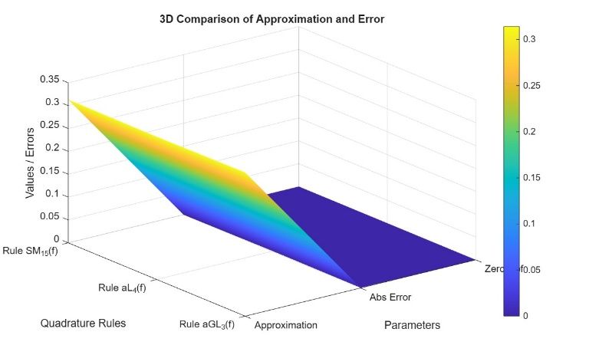
Figure 3(a): Presents the three-dimensional (3D) visualization of the error comparison among the considered quadrature rules for the integral $I_{3}(f)$.
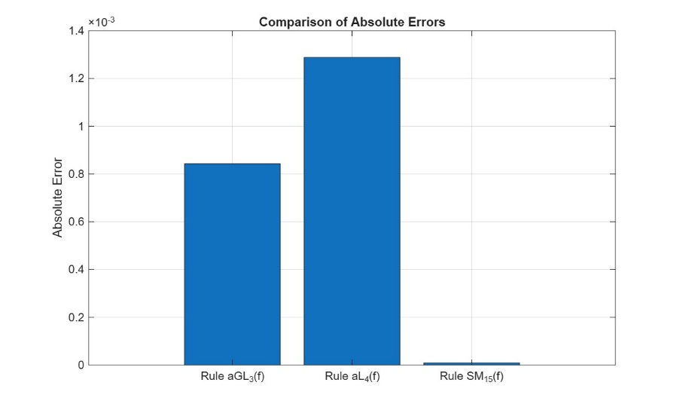
Figure 3(b): Presents the three-dimensional (2D) visualization of the error comparison among the considered quadrature rules for the integral $I_{3}(f)$.
Remark 3: For the integral $I_{3}(f)$, the truncation error associated with the Anti-Gaussian 3-point rule begins from the 4th decimal place, whereas the Anti-Lobatto 4-point rule shows a comparatively higher error, initiating from the 3rd decimal place. This indicates that, for this particular integral, the Anti-Gaussian rule performs slightly better than the Anti-Lobatto rule, though both exhibit noticeable deviation at relatively earlier decimal positions. In contrast, the proposed Generalized Quadrature Rule $SM_{15}(f)$shows a significantly improved level of accuracy, with the error beginning only from the 6th decimal place. This clearly demonstrates the superior performance and enhanced precision of the constructed rule over its component methods for $I_{3}(f)$.
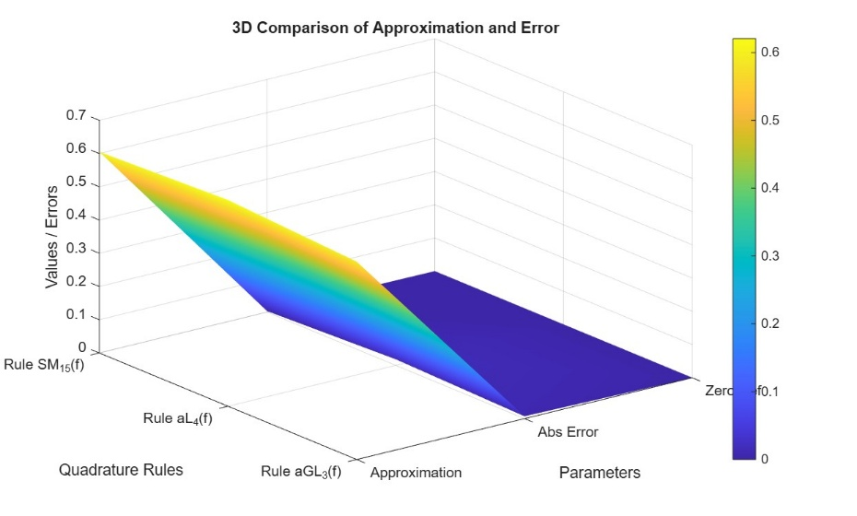
Figure 4(a): Presents the three-dimensional (3D) visualization of the error comparison among the considered quadrature rules for the integral $I_{4}(f)$.
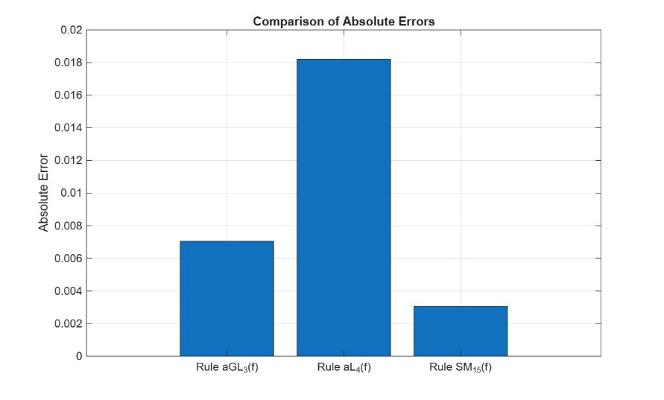
Figure 4(b): Presents the three-dimensional (2D) visualization of the error comparison among the considered quadrature rules for the integral $I_{4}(f)$.
Remark 4: For the integral $I_{4}(f)$, the truncation error associated with the Anti-Gaussian 3-point rule begins from the 3rd decimal place, while the Anti-Lobatto 4-point rule exhibits comparatively larger deviation, with the error initiating from the 2nd decimal place. This indicates a relatively lower accuracy of both classical schemes for this integral. In comparison, the proposed Generalized Quadrature Rule $SM_{15}(f)$also shows error starting from the 3rd decimal place; however, the magnitude of the error is significantly smaller than that of the other two methods. This clearly reflects that, even in cases where the order of accuracy appears similar, the constructed rule provides a much more refined and stable approximation for $I_{4}(f)$.
- Conclusion
The theoretical analysis, supported by numerical results presented in the tables, clearly indicates that the proposed quadrature rule consistently outperforms the basic quadrature rules in both analytical formulation and practical implementation. It is observed that the proposed method yields significantly smaller approximation errors, thereby ensuring improved accuracy and reliability in numerical integration.
In this study, a new generalized quadrature rule of precision five has been successfully developed, marking a notable advancement in the field of numerical analysis. The construction is achieved by an effective combination of the anti-Gauss 3-point rule and the anti-Lobatto 4-point rule. This hybrid approach enhances the overall degree of precision by appropriately utilizing the strengths of the constituent rules while maintaining a balanced computational structure.
Consequently, the proposed quadrature rule not only achieves higher accuracy but also preserves computational efficiency and simplicity. Hence, it serves as a robust and efficient numerical tool for obtaining precise approximations of definite integrals, and it is expected to be highly useful in a wide range of problems arising in applied mathematics, scientific computation, and engineering applications.

Declaration:
The author hereby declares that the manuscript is original and has not been published or submitted elsewhere for publication. All sources of information used in the preparation of this article have been duly acknowledged.
Competing of Interest:
The author declares that there is no conflict of interest regarding the publication of this article.
References
- K.E. Atkinson (2012) An Introduction to Numerical Analysis, Wiley Student edition, New Delhi.
- S. Conte, C.de Boor (1980) Elementary Numerical analysis, Mc-Graw Hill.
- D. P. Laurie (1996) Anti Gaussian quadrature formulas, Mathematics of computation, A.M.S., Vol.-65(214), pp-739-747.
- J. Ma, M. Rokhlin, S. Wandzura (1996) Generalized Gaussian quadrature rules for systems of arbitrary functions, SIAM Journal on Numerical Analysis, Vol.33, pp.971-996.
- S.K. Mohanty, R.B. Dash (2022) A Generalized Quartic Quadrature Based Adaptive Scheme, International Journal of Applied and Computational Mathematics, Vol.8, pp.1–25. https://doi.org/10.1007/s40819-022-01405-2
- S.K. Mohanty, R.B. Dash (2024) A Generalized Quadrature of Order Four for Analytic Functions, International Journal of Computing Science and Mathematics, Vol.19(3), pp.285–298. https://DOI.10.1504/IJCSM.2024.137846.
- S.K. Mohanty, R.B. Dash (2021) A quadrature rule of Lobatto-Gaussian for Numerical integration of Analytic functions, Numerical Algebra, Control and Optimization, Vol.12, pp.1–14. https://doi.10.3934/naco.2021031
- S.K. Mohanty (2021) A triple mixed quadrature rule based adaptive scheme for analytic functions, Nonlinear Func. Analysis and Applications, Vol-26, pp.935-947.
htt https://doi.org/10.22771/nfaa.2021.26.05.05
- S.K. Mohanty, R.B. Dash (2022) A triangular Quadrature for numerical integration of analytic functions, Palestine Journal of Mathematics, Vol.11, pp.53–61.
- S.K. Mohanty and R.B. Dash (2022) On A New Mixed Quadrature Based Adaptive Integration Scheme for Analytic Functions, Journal of The Orissa Mathematical Society, Vol.41(01-02), pp.55-74.
- S.K. Mohanty (2024) A Generalized Quadrature Specifically Designed for Numerical Integration of Indefinite Integrals, Annals of Pure and Applied Mathematics, Vol-30(2), pp.121-128. DOI: http://dx.doi.org/10.22457/apam.v30n2a04952
- J.D. Philip, R. Philip (1984) Methods of Numerical Integration, Academic Press, Inc., Orlando, FL.

