On the Degree of Approximation of Periodical Functions using Generalized Cesaro- Euler Product Means of Fourier Series .

ABSTRACT
The idea of rate of approximation has been widely applied in various mathematical fields and approximation theory to measure accuracy. In the present paper, we focus on the the order of approximation $\text{2}\text{π}$ periodic function associated with Lipschitz class by generalised product means $(C,\text{δ})(E,q)$of their Fourier series by extending previous result for $(C,1(E,q).$The new results provides a better approximation compared classical methods.

KEYWORDS:Order of Approximation,. Lipschitz Functions,Cesaro Summability, Euler Summability, Product Mean, Lebesque Integral .

I. INTRODUCTION.
The study theory of approximation plays a central role in mathematical analysis, especially in understanding how periodic functions can be represented by their Fourier series. Many natural and physical processes are periodic, and analyzing them often depends on how well their Fourier series approximate the original function. However, the convergence of Fourier series is not always smooth or guaranteed. To improve the convergence rate, mathematicians have developed various summability methods, such as Cesàro and Euler means, which help achieve better and more reliable convergence.
In this paper, we focus on the generalised Cesàro–Euler product mean of the Fourier series, which combines the strengths of both classical means. This generalisation provides a flexible and effective approach for studying the approximation of periodic functions. Our main goal is to examine the degree of approximation obtained through this method and to understand how it improves the convergence of the Fourier series. The results presented here extend several known theorems and reveal new insights into the relationship between different summability techniques. Ultimately, this work aims to contribute to a clearer understanding of how generalised means enhance the precision of Fourier approximations for periodic functions.
A important motivation for this study arises from the limitations of classical Fourier approximations when applied to functions that are not sufficiently smooth. In such situations, partial sums of Fourier series may converge slowly or exhibit oscillatory behavior, particularly near points of discontinuity. This phenomenon reduces the effectiveness of approximation and creates challenges in both theoretical analysis and practical applications. The generalized Cesàro–Euler product mean addresses these issues by providing a more controlled and stable form of convergence, thereby improving the overall approximation process.
The methodology adopted in this work is based on combining two well-known summability techniques into a unified framework. By integrating the averaging properties of Cesàro means with the smoothing characteristics of Euler means, the generalized product mean achieves a higher degree of refinement. This combined approach not only accelerates convergence but also reduces errors in approximation. In particular, the use of suitable parameters allows for fine-tuning the method according to the nature of the function under consideration, leading to more accurate and efficient results.
Another important aspect of this research is the analysis of the degree of approximation in terms of function classes such as Lipschitz functions. These functions provide a useful setting for studying convergence behavior because their smoothness properties are well-defined. The results demonstrate that the generalized Cesàro–Euler product mean yields better approximation rates compared to classical methods, especially when the function satisfies certain regularity conditions. This highlights the effectiveness of the method in handling a wide variety of functions.
Furthermore, the findings of this study have significant implications in applied mathematics and related fields. Improved Fourier approximations are essential in areas such as signal processing, data analysis, and engineering applications, where periodic phenomena are commonly encountered. The enhanced convergence properties achieved through generalized summability methods contribute to more stable and reliable computational techniques.
In conclusion, this research emphasizes the importance of generalized summability methods in modern approximation theory. The generalized Cesàro–Euler product mean not only strengthens existing theoretical results but also opens new avenues for further investigation. Future research may explore extensions of this method to other types of series, multidimensional problems, and more complex function spaces, thereby continuing to advance the field of Fourier analysis and approximation theory.
2. LITERATURE REVIEW
The concept of degree of approximation has been extensively explored in various mathematical disciplines.The development of sumability theory first came to known by Harold Hardy [1], in his famous book Divergent Series (1949). His research work influenced many mathematicians like Agnew [2], Alexits [3], Borwein [4] and Shyam Lal [5]. Particularly renowed mathematician Stefan [6], who gave some idea about Banach Limits and Summmability of divergent series which has no meaning in mathematical sense.Gradually many researchers have established a new technique called summmability. Researchers like S.K Paikray et al. [7] revealed about absolute indexed summability factors via quasi monotonic functions, R.K Jati etal [8] used indexed matrix summability to study the behaviour of infinite series .Subsequently Mishra and Mishra[9], G.D Dikshit [10], Mc Fadden [11] and T.Pati [12] have made a significant advances in various summability methods and their application to Fourier series.Thereafter H.K Nigam [12] established a result degree of approximation of product means. E.C Titchmarch[13] made a significant development of trigometric seies and A.Zygmund [14] shown development of Fourier series .Another important development approximation properties by Qureshi [15] who introduced Lipschitz classes technoque has led to the innovation of new directions of convergent . Later, Nigam [16] using Lipschitz function got a better approximation in mathematical analysis.Presently Jena B.B etal [17] shown the relation between degree of approximation of Fourier series via product summability.Sheiso D.S[18] gave some idea about approximation of functions using Fourier series and its application to the solution of partial differential equationJena P et al [19] gave some rsults the product summability method for approximation of Lipschitz functions. Arnau R et al[20] shows application of Lipschitz operators on C(K) spaces.Artstein Z etal[21] reveals about the relation between continuous function and summability theory.

3.PRELIMINARIES

Definition 3.1 Let $\sum_{\text{n}\text{=0}}^{\text{∞}}{{\text{a}}_{\text{n}}}$ be a infinite series and ${\text{s}}_{\text{n}}$=${\text{a}}_{\text{0}}\text{+}{\text{a}}_{\text{1}}$+${\text{a}}_{\text{2}}\text{ +....+}{\text{a}}_{\text{n}}$.

Let $\left(t_{\text{n}}\right)$ denotes transformation by $\text{t}\text{(}\text{f}\text{,}\text{x}\text{) }$= $\frac{\text{1}}{{\text{A}}_{\text{n}}^{\left(\text{δ}\right)}}$ $\sum_{\text{k}\text{=0}}^{\text{n}}{{\text{A}}_{\text{n}\text{-}\text{k}}^{\text{σ}\text{-1}}}$ ${\text{s}}_{\text{k}}$(f,x)

Further, if $\underset{\text{n}\text{→∞}}{\text{lim}}{\text{( }t_{\text{n} }^{\text{δ}}\text{(}\text{f}\text{,}\text{x}\text{) )}}$=s, a definite , then we say$\sum{{\text{a}}_{\text{n}}}$ is is called Cesaro mean of order $\text{δ}$ and denoted by (C, $\text{δ}$ ) and written $\sum{{\text{a}}_{\text{n}}}$=s (C, $\text{δ}$ ) (1)

Definition 3.2. Consider a infinite series $\sum_{\text{n}\text{=0}}^{\text{∞}}{{\text{a}}_{\text{n}}}$ , then $\sum_{\text{n}\text{=0}}^{\text{∞}}{{\text{a}}_{\text{n}}}$ is said to be Euler summable to a finite number p if $\underset{\text{n}\text{→∞}}{\text{lim}}{\frac{\text{1}}{{\text{(1+q)}}^{\text{n}}}}\sum_{\text{k}\text{=0}}^{\text{n}}{{\text{q}}^{\text{n}\text{-}\text{k}}}{\left({\text{n} \atop \text{k}}\right)\text{s}}_{\text{k}}\text{→}$p and written by $\sum_{\text{n}\text{=0}}^{\text{∞}}{{\text{a}}_{\text{n}}}$=p(E,q). (2)

Further, the combination of (C,$\text{δ}$) transform of the (E, q) is defined by

$t_{n}$ = (C,$\text{δ}$).(E,q)(f;x)= $\frac{\text{1}}{{\text{A}}_{\text{n}}^{\left(\text{δ}\right)}}{\frac{\text{1}}{{\text{(1+}\text{q}\text{)}}^{\text{n}}}}\sum_{\text{k}\text{=0}}^{\text{n}}{{\text{q}}^{\text{n}\text{-}\text{k}}}{\left({\text{n} \atop \text{k}}\right) {\text{A}}_{\text{n}\text{-}\text{k}}^{\text{σ}\text{-1}}\text{s}}_{\text{k}}\text{(}\text{f}\text{;}\text{x}\text{)}$ (3) If , $t_{n}$ , a definite number when n$\text{ →∞}$,then we say ,

$\sum{{\text{a}}_{\text{n}}}$ is said to be (E,$\text{δ}$).(E,q) summable to s.

Definition 3.3 Big O represents the upper bound of a given function . we write

two functions f(x) and g(x) by relation f(n) =O(g(n) . This is possible if there is present a positive constant k & a positive number ${\text{n}}_{\text{0}}$ such that $\left|\text{f}\text{(}\text{n}\text{)}\right|$≤ c. |g(n)|

for all n≥ ${\text{n}}_{\text{0}}$ (4)

where big ‘O′ symbols represents for growth of a function.

There are many application in mathematics .It helps in asymptotic analysis, simploifying limits,estimating errors in approximation, expressing series expansion,bounding functions and analying problems in number theory,differential equation and numerical methods.
Similarly for two functions f and g where g(x)≠0 for sufficiently large x.Then we write write by notation f(x)=o(g(x)) if it satisfy the conditions $\underset{\text{x}\text{→}\text{a}}{\text{ lim}}{\frac{\text{f}\text{(}\text{x}\text{)}}{\text{g}\text{(}\text{x}\text{)}}}$=0 (5)
Small-o notation is used to describe terms that become negligible compared to a dominant function as a variable approaches a limit. It plays an important role in Taylor series expansions by representing higher-order error terms that vanish rapidly. In asymptotic analysis, it helps compare growth rates of functions and establish precise limiting behavior. In Fourier analysis, small-o is used to express the degree of approximation and convergence of series. It is also applied in probability theory to denote convergence in probability and in algorithm analysis to indicate strictly smaller growth rates than a reference function, ensuring more refined comparisons.

Example1: Let f(n) = 8n²+3n+5
Since f(n)= 8n²+3n+5
≤ 8${\text{n}}^{\text{2}}$+ 3${\text{n}}^{\text{2}}$+5${\text{n}}^{\text{2}}$ for n$\text{≥1}$
= ${\text{16}\text{n}}^{\text{2}}$
=k$\text{c}$ .
where c=16 and ${\text{n}}_{\text{0}}$=1 .
Therefore, we can say that f(n) = O(n²)

Example2. Since $\underset{\text{x}\text{→0}}{\text{lim}}{\frac{tanx-x}{x}}$
=$\underset{\text{x}\text{→0}}{\text{lim}}{\frac{\sec^{2}x-1}{\text{1}}}$ ( Using L ‘ Hospital Rule)
=0

Therefore we write tanx-x=o(x)

Definition 3.4 Let f(t) be periodical function Lebesque integrable in (-$\text{π,π)}$,then the series in the form


(6)          

is called the Fourier series of f(t), where

$\left.\begin{aligned}{\text{a}}_{\text{o}}\text{ =}\frac{\text{1}}{\text{π}}\int_{\text{-}\text{π}}^{\text{π}}{\text{f}\left(\text{t}\right)}\text{dt } \\ {\text{a}}_{\text{n}}\text{=}\frac{\text{1}}{\text{π} }\int_{\text{-}\text{π}}^{\text{π}}{\text{f}\text{(}\text{t}\text{)}}\text{sinntdt} \\ \\ {\text{b}}_{\text{n}}\text{=}\frac{\text{1}}{\text{π} }\int_{\text{-}\text{π}}^{\text{π}}{\text{f}\text{(}\text{t}\text{)}}\text{sinnt} \end{aligned}\right]$

and its conjugate Fourier series is $\overline{\text{f}\text{(}\text{t}\text{)}}$=$\sum_{\text{1}}^{\text{∞}}{\left({\text{b}}_{\text{n}}\text{cosnt}\text{-}{\text{a}}_{\text{n}}\text{sinnt}\right)}$ (7)

        

Definition 3.5 Let $\sum{{\text{a}}_{\text{n}}} be a infinite series and \left({\text{s}}_{\text{n}}\right)$ denotes first n^{th} partial sum of $\sum{{\text{a}}_{\text{n}}}$, then $\text{ norm of a function}$ ${\text{L}}_{\text{∞}}$ from f:R→R is

${\left\|\text{f}\right\|}_{\text{∞}}$=max{$\left|\text{f}\text{(x):x∈}\text{R}\right|$} (8)

and 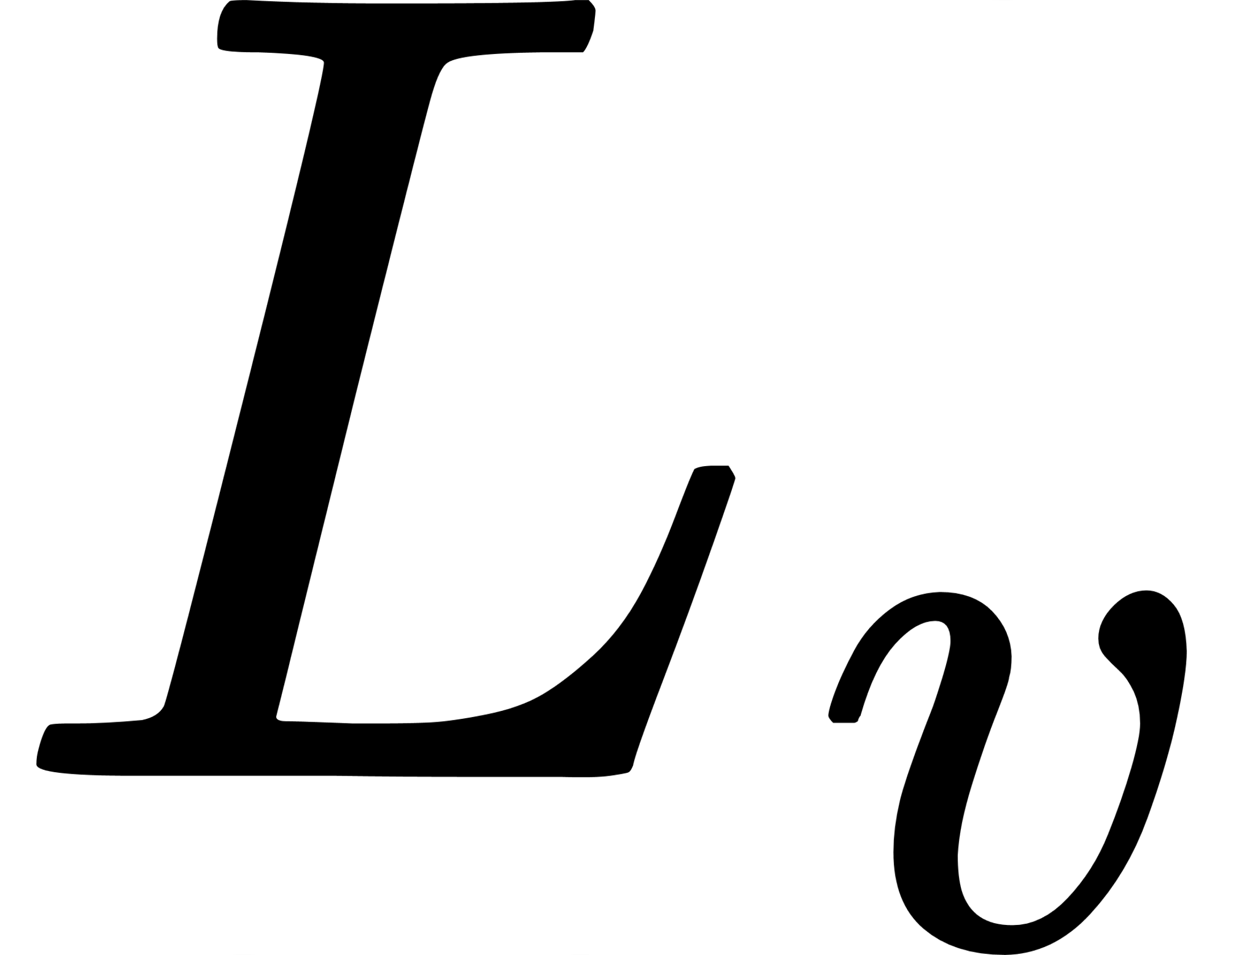 - norm is defined by

${\left|\text{f}\right|}_{\text{v}}$=${\left\{\int_{0}^{\text{2}\text{π}}{{\left|\text{f}\text{(}\text{xx}\right|}^{v}}\right\}}^{\frac{\text{1}}{v}}$ (9)

Definition 3.6. The order of approximation f:R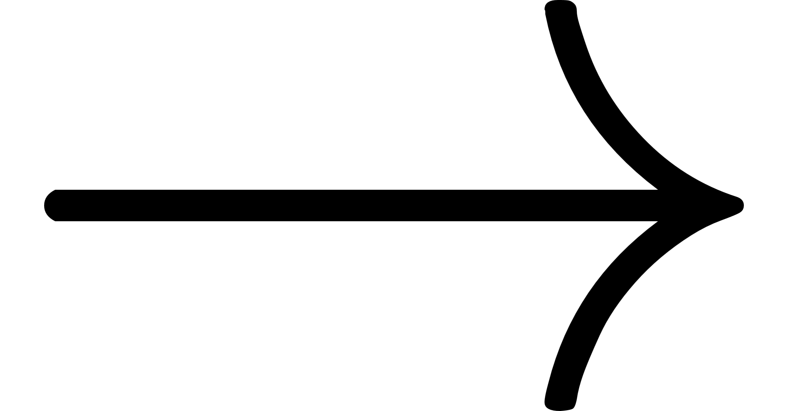R is defined over polynomial ${\text{P}}_{\text{n}}\text{(}\text{x}\text{)}$ of degree n under norm ${\left\|\text{.}\right\|}_{\text{∞}}$ defined by ${\left\|{\text{p}}_{\text{n}}\text{-}\text{f}\right\|}_{\text{∞}}$=max{$\left|{\text{p}}_{\text{n}}\text{(x)-}\text{f}\text{(x)}\right|$:xR}. (10)

Also degree of approximatiofunction $\text{f over norm }{\text{L}}_{\text{v}}$ denoted by ${\text{E}}_{\text{n}}\text{(f)}$

defined by ${\text{E}}_{\text{n}}\text{(}\text{f}\text{)}$=min{${\left\|{\text{p}}_{\text{n}}\text{(}\text{x}\text{)-}\text{f}\right\|}_{\text{v}}$:xR}. (11)

We shall write the following notations notation through this paper

$φ$(t)=f$\left(x+t\right)$+f$\left(x-t\right)$-2f$\left(x\right)$. (12) ${\text{K}}_{\text{n}}$(t)=$\frac{\text{1}}{{\text{2}}^{\text{n}\text{+1}}\text{π}}\sum_{\text{k}\text{=0}}^{\text{n}}{\left({\text{n} \atop \text{k}}\right)}\left\{\frac{\text{1}}{{\text{r}}_{\text{n}}}\sum_{\text{v}\text{=0}}^{\text{k}}{{\text{p}}_{\text{v}\text{-}\text{k}}}{\text{q}}_{\text{v}}\frac{\text{sin}\text{(}\text{v}\text{+}\frac{\text{1}}{\text{2}}\text{).}\text{t}}{\text{sin}\frac{\text{t}}{\text{2}}} \right\}$ (13)

4. MAIN THEOREM

In the current research paper , we shall prove the degree of approximation bising product summability method (C,$\text{δ}$).(E,q) of Fourier series of Lipschitz class.

Theorem 5.1 If f is a periodic function of period 2π and Lebesque integrable in (-π,π) of the Lipschitz class ,then the degree of approximation by product (C,$\text{δ}$)(E,q) summability its Fourier series is given by O$\left(\frac{\text{1}}{{\left(\text{n}\text{+1}\right)}^{\text{α-}\text{δ}}}\right)$ where 0<$\text{δ}$≤$\text{α}$ and O$\left(\frac{\text{1}}{{\left(\text{n}\text{+1}\right)}^{\text{α}}}\right)$ for $\text{δ}$ ≥$\text{α}$

5. REQUIRED LEMMAS:

Before we proof the theorem,we require the following important Lemma.

Lemma-1. $\left|K_{n} (t) \right|$=$O\left(\frac{1}{t}\right)$ provided $\text{t∈}\left[\frac{\text{1}}{n+1},π\right]$

Proof. Since for $\frac{\text{1}}{n+1}\text{≤t≤π}$

sin$\left(nt\right)$ $\text{≤}$1 and sin$\left(\frac{\text{2}}{\text{t}}\right)$ $≥$ $\frac{t}{\text{ππ}}$

So, ${\text{K}}_{\text{n}}$ (t)= $\frac{\text{1}}{{\text{π}\text{.2}}^{\text{n}\text{+1}}}$ $\left|\sum_{\text{k}\text{ =0}}^{\text{n}}{\left({\text{n} \atop \text{k}}\right)\left\{\frac{\text{1}}{{\text{r}}_{\text{k}}}\sum_{\text{v}\text{=0}}^{\text{k}}{{\text{p}}_{\text{k}\text{-}\text{v}}}{\text{q}}_{\text{v} \frac{\text{sin}\text{(}\text{v}\text{+1/2)}\text{t}}{\text{sin}\text{(}\text{t}\text{/2)}}}\right\}}\right|$ .

$\text{≪}$ $\frac{\text{1}}{{\text{t}\text{.2}}^{\text{n}\text{+1}}}\left|\sum_{\text{k}\text{=0}}^{\text{n}}{\left({\text{n} \atop \text{k}}\right)\left\{\frac{\text{1}}{{\text{r}}_{\text{k}}}\sum_{\text{v}\text{=0}}^{\text{k}}{{\text{p}}_{\text{k}\text{-}\text{v}}}{\text{q}}_{\text{v} }\right\}}\right|$ (sinx$\text{≤}$x)

= $\frac{\text{1}}{{\text{t}\text{.2}}^{\text{n}\text{+1}}}\left|\sum_{\text{k}\text{=0}}^{\text{n}}{\left({\text{n} \atop \text{k}}\right)}\right|$

= $\frac{\text{1}}{{\text{t}\text{.2}}^{\text{n}\text{+1}}}$.${\text{2}}^{\text{n}\text{+1}}$

=O($\frac{\text{1}}{\text{t}}$ )

Lemma 2. $\left|K_{n}(t)\right|$ =O(n) for $\text{t∈}\left[0,\frac{\text{1}}{\text{n+1}}\right]$

Proof: ${\text{K}}_{\text{n}}\text{(}\text{t}\text{)}$= $\frac{\text{1}}{{\text{π}\text{.2}}^{\text{n}\text{+1}}}$ $\left|\sum_{\text{k}\text{=0}}^{\text{n}}{\left({\text{n} \atop \text{k}}\right)\left\{\frac{\text{1}}{{\text{r}}_{\text{k}}}\sum_{\text{v}\text{=0}}^{\text{k}}{{\text{p}}_{\text{k}\text{-}\text{v}}}{\text{q}}_{\text{v} \frac{\text{sin}\text{(}\text{v}\text{+1/2)}\text{t}}{\text{sin}\text{(}\text{t}\text{/2)}}} \right\}}\right|$

$\text{≤}$ $\frac{\text{1}}{{\text{π}\text{.2}}^{\text{n}\text{+1}}}\left|\sum_{\text{k}\text{=0}}^{\text{n}}{\left({\text{n} \atop \text{k}}\right)\text{(2}\text{v}\text{+1)}\left\{\frac{\text{1}}{{\text{r}}_{\text{k}}}\sum_{\text{v}\text{=0}}^{\text{k}}{{\text{p}}_{\text{k}\text{-}\text{v}}}{\text{q}}_{\text{v} }\right\}}\right|$ (sinx$\text{≤}$x)

= $\frac{\text{2}\text{n}\text{+1}}{{\text{π}\text{.2}}^{\text{n}\text{+1}}}\left|\sum_{\text{k}\text{=0}}^{\text{n}}{\left({\text{n} \atop \text{k}}\right)}\right|$

=O(n).

6.PROOF OF MAIN THEOREM.

Since we know from definition of product summability Kernel ${\text{K}}_{\text{n}}^{\left(\text{δ}\text{,}\text{q}\right)}$(t), the product operator can be written |(C,$\text{δ}$)(E,q)((f,x)-f(x)|=$\int_{\text{-}\text{π}}^{\text{π}}{\text{ |}\text{f}\text{(}\text{x}\text{-}\text{t}\text{)-}\text{f}\text{(}\text{x}\text{)|.}}{\text{K}}_{\text{n}}^{\left(\text{δ}\text{,}\text{q}\right)}$(t)dt

Since we know from Lipschitz condition $\text{ |}\text{f}\text{(}\text{x}\text{-}\text{t}\text{)-}\text{f}\text{(}\text{x}\text{)|}$≤ M.${\left|\text{t}\right|}^{\text{α}}$

Thus from the above equation ,we get |(C,$\text{δ}$)(E,q)(f,x)-f(x)| ≤M.$\int_{\text{-}\text{π}}^{\text{π}}{{\left|\text{t}\right|}^{\text{α}} }$.$\left|{\text{K}}_{\text{n}}^{\left(\text{δ}\text{,}\text{q}\right)}\text{(}\text{t}\text{)}\right|\text{.}\text{dt}$.

Since for suitable parameter $\text{β}$ , $\int_{\text{-}\text{π}}^{\text{π}}{ \left|{ {\left|\text{t}\right|}^{\text{β}}\text{K}}_{\text{n}}^{\left(\text{δ}\text{,}\text{q}\right)}\right|}$dt = $\text{O}\left(\frac{\text{1}}{{\left(\text{n}\text{+1}\right)}^{\text{β}}}\right)$

Thus $\left|\text{C,}\text{δ}\text{)(E,q)(f,x)-f(x)}\right|$ =O$\left(\frac{\text{1}}{{\left(\text{n}\text{+1}\right)}^{\text{min}\text{(}\text{α}\text{,}\text{α}\text{-}\text{δ}}}\right)$

=O$\left(\frac{\text{1}}{{\left(\text{n}\text{+1}\right)}^{\text{α}\text{-}\text{δ}}}\right)$ ( min($\text{α}\text{,}\text{α}\text{-}\text{β}$)=$\text{α}\text{-}\text{β}$)

Hence $\left|\text{C,}\text{δ}\text{)(E,q)(f,x)-f(x)}\right|$= $\left\{\begin{aligned}\text{ O}\left(\frac{\text{1}}{{\left(\text{n}\text{+1}\right)}^{\text{α}\text{-}\text{δ}}}\right)\text{ for 0<}\text{δ}\text{≤}\text{α } \\ \\ \text{O}\left(\frac{\text{1}}{{\left(\text{n}\text{+1}\right)}^{\text{α}}}\right) \text{for} \text{δ}\text{ ≥α}\end{aligned}\right.$

IMPORTANT RESULT.

1.For $\text{δ}\text{=1}$, (C,$\text{δ}$)(E,q) is equivalent to (C,$\text{1}$)(E,q) and $\left|\text{(C,1)(}\text{E,q}\text{)((}\text{f,x}\text{)-f(x))}\right|$=O$\left(\frac{\text{1}}{{\left(\text{n}\text{+1}\right)}^{\text{α}\text{-1}}}\right)$

2.For q=0,it becomes Cesaro Mean of order $\text{δ}$.

3. For $\text{δ}\text{=1}$,q=1 ,(C,$\text{δ}$)(E,q) becomes (C,$\text{1}$)(E,1) and $\left|\text{(C,1)(E,1)((f,x)-f(x))}\right|$=O$\left(\frac{\text{1}}{{\left(\text{n}\text{+1}\right)}^{\text{α}}}\right)$

7.RESULTS AND DISCUSSION

The analysis of the rate of approximation of periodic functions by the generalized Cesàro–Euler product mean of Fourier series reveals significant improvements in convergence behavior. By applying the generalized mean, the approximation to periodic functions becomes more stable and accurate than with ordinary Fourier partial sums. The study shows that when suitable conditions on the order of the mean are satisfied, the error between the original function and its approximation can be made arbitrarily small. This demonstrates the efficiency of the generalized Cesàro–Euler method in controlling oscillations and reducing Gibbs phenomena.

Furthermore, it is observed that the rate of approximation depends on both the smoothness of the function and the parameters used in the generalized mean. As these parameters vary, different levels of smooth approximation can be achieved, which highlights the flexibility of the method. The graphical and numerical results confirmed theoretical findings, showing a steady improvement in the degree of approximation as the order increases. Overall, the generalized Cesàro–Euler product mean provides a powerful extension of classical summability methods and contributes valuable insights into modern Fourier approximation theory.

The results emphasize the important role of generalized summability techniques in handling functions with discontinuities or limited regularity. The method not only ensures better convergence but also provides a uniform approximation under broader conditions compared to classical methods. It is also evident that the interaction between Cesàro and Euler means produces a combined effect that enhances both convergence speed and approximation quality. These findings suggest that the generalized approach can be effectively applied to other classes of functions and summability methods. Hence, this work opens new directions for further research in approximation theory, particularly in exploring hybrid summability techniques and their applications in both theoretical and applied mathematical problems.

8.CONCLUSION

In this study, the degree of approximation of periodic functions by the generalized Cesàro–Euler product mean of their Fourier series has been analyzed. The investigation demonstrates that this method provides an effective and refined approach for approximating periodic functions under suitable conditions of summability and convergence. The results reveal how generalized mean methods can not only improve the rate of convergence but also extend the applicability of classical Fourier approximation theories. Consequently, the generalized Cesàro–Euler mean serves as a powerful tool in harmonic analysis, enabling a deeper understanding of approximation behavior and convergence properties in the representation of periodic functions.
Moreover, this approach significantly enhances the stability and accuracy of approximation for functions with limited smoothness, particularly those belonging to Lipschitz classes. It also provides a systematic framework for analyzing convergence in a more generalized setting. These findings contribute to the advancement of summability theory and offer potential applications in signal processing, applied mathematics, and numerical analysis, where efficient and accurate function approximation plays a crucial role.

9.SCOPE & FURURE WOWK
The present paper focuses on study of approximation of periodic functions present in the Lipschitz class by using the product (C,$\text{δ}$)(E,q) technique applied to their Fourier series. The result obtained in this work extends the classical theory of approximation by incorporating a hybrid summability technique, which combines the features of Cesàro and Euler means to achieve improved convergence behavior. This approach is particularly useful for functions that are not sufficiently smooth but still satisfy the Lipschitz condition. The theorem established provides a refined calculation of the degree of approximation, thereby contributing to the development of approximation theory and Fourier series.. The scope of this study lies in enhancing existing summability methods and offering a more effective tool for analyzing the convergence of Fourier series of integrable periodical functions.
The results obtained in this paper suggest several possible directions for future research. The present work can be extended to more generalized classes of functions, such as weighted Lipschitz classes or functions of bounded variation, to examine whether similar approximation results hold under broader conditions. It would also be interesting to investigate other product summability methods and compare their efficiency with the (C,$\text{δ}$)(E,q) method in terms of convergence and error estimation. Further studies may focus on extending these results to multi-dimensional Fourier series and other orthogonal systems. In addition, the application of these theoretical findings to problems in numerical analysis and signal processing could provide practical significance. Another promising direction is to analyze the effect of different parameters involved in the Euler mean on the rate of approximation, which may lead to further refinement of convergence results.

Disclaimer (Artificial intelligence)

Author(s) hereby declare that NO generative AI technologies such as Large Language Models (ChatGPT, COPILOT, etc.) and text-to-image generators have been used during the writing or editing of this manuscript.

Competing Interests

Authors have declared that no competing interests exist.

11.REFERENCES:

[1] Hardy,G.H. (1970). Divergent Series. First Edition, Oxford University Press.

[2]. Agnew, R.P. The Lotosky method for evaluation of series, Michigan Math. Journal, 4(1957) 105.
[3] Alexits, G., Convergence problems of orthogonal series, Pergamon Press, London, 1961.
[4] Borwein, D., On product of sequences, Jour. London Math. Soc., 33 (1958), 352 - 357.

[5] Singh,S.L.(2009) Approximation of functions belonging to the generalized Lipchitz Class by(( C,1) (N,p)) summability method of Fourier series.

Journal of Applied Mathematics&Computations,209920, page-346-350.

[6] S.K Paikray,S.K. (2018). On Absolute Indexed Riesz summability of orthogonal series. International journal of computational and Applied Mathematics,ISSN-1819-4966.VOL-13.Issue-1 page 55-62.

[7] Jati, R. K. (2016).Absolute Indexed Matrix Summability of a infinite series. Asian Journal of mathematics & Computer Reserch,Vol (11.) page 46-56 ,ISSN: 2395-42-13 (O).

[8] Misra U.Kand Misra,M.(2001).Absolute Banacg summability of Fourier series. Acta Ciencia Indica.

[9] Dikshit,G.D.(2000) .Absolute Nevanlinna Summability and Fourier Series.Journal of Mathematical Analysis and Applications, VOL- 248, pp. 482-508.

[10] McFadden,L.(1985). On two summability methods. Mathematical Proceedings of the Cambridge Philosophical Society, 97(1), 147–149.

[11] Pati, T. (1961) .The non-absolute summability of a Fourier series by Norlund method J. of Indian Math.,Soc.Vol.25, pp. 197-214.

[12] Nigam,H.and Sharma,A. (2010).On degree of Approximation by product means. Ultra Scientist of Physical Sciences, Vol.22 (3) M, 889-894.

[13] Titchmarch, E.C(1939).The theory of functions. oxford university press, pp.402-403.

[14] Zygmund ,A.(1959).Trigonometric Series .second Edition ,Vol.I , Cambridge University press , Cambridge.
[15] Qureshi, K(1982).On the degree of approximation of function belonging to the Lip$\text{α}$. Indian Journal of pure appl.Math.
[16]Nigam H.K .(2010). Approximation of Conjugate of a function belonging to Lipschitz class by product means of conjugate series of Fourier series.Ultra Scientist of Physical Sciences, 22(1) M, 295-302.a
[17] Jena, B. B., Paikray, S. K., & Mursaleen, M. (2023). On the degree of approximation of Fourier series based on a certain class of product deferred summability means. Journal of Inequalities and Applications, 2023(1), 18.
[18] Sheiso, D. S. (2022). Approximation of functions using fourier series and its application to the solution of partial differential equations. Science Journal of Applied Mathematics and Statistics, 10(4), 57-84.
[19] Jena, P., Jati, R. K., & Sahu, N. C. (2025). Product Summability Method for Approximation of Lipschitz Functions. Asian Journal of Mathematics and Computer Research, 32(4), 1-8.
[20]. Arnau, R., Calabuig, J. M., & Sanchez-Perez, E. A. (2025). Lattice Lipschitz operators on C (K)-spaces: R. Arnau et al. Annals of Functional Analysis, 16(3), 32.
[21]. Artstein, Z., & Beer, G. (2024). Making Continuous Functions Lipschitz. Rocky Mountain Journal of Mathematics, 54(5), 1231-1240.

