Multivariate Time Series Anomaly Detection in IIoT Using Integrated Transformer and Graph Neural Networks

Abstract: In view of the high-dimensional, strongly coupled, and non-stationary characteristics of multivariate time series data in the Industrial Internet of Things (IIoT), as well as the limitations of traditional anomaly detection models (such as CNN-BiLSTM-SelfAttention) in capturing long-term temporal dependencies and modeling dynamic spatial correlations, this paper proposes an anomaly detection model (GTN-AD) that integrates Transformer and Graph Neural Network (GNN), and enhances detection robustness by combining correlation analysis and extreme value theory. The specific steps are as follows: 1) Clean the raw data through the spectral residual algorithm to filter out random noise in the industrial environment; 2) Based on the cross-correlation function and dynamic time series graph construction, mine the lagged dependencies and spatial correlations between sensors, and divide the time series into related clusters to simplify the modeling complexity; 3) Improve GNN (introducing graph attention mechanism) to aggregate spatial features, and optimize Transformer (temporal subsequence self-attention + generative decoding) to capture long-term temporal dependencies; 4) Set adaptive thresholds based on prediction residuals and extreme value theory to achieve anomaly localization. Experiments on the SWaT and PSM industrial benchmark datasets show that the GTN-AD model outperforms the traditional CNN-BiLSTM-SelfAttention model by 8.7% to 13.2% in F1-score and AUROC metrics, respectively. The recognition accuracy of equipment degradation and sensor coupling anomalies reaches 90.4%, and the false alarm rate is reduced by 11.5%, verifying the effectiveness and superiority of the model in industrial scenarios.

Key words: Industrial Internet of Things；Multivariate time series data；Anomaly detection；Transformer；Graph neural network；Correlation analysis；

0 Introduction
With the development of Industry 4.0 and industrial internet, China's manufacturing industry has rapidly upgraded, and the production process has become increasingly complex. Intelligent manufacturing, as the core application scenario of industrial big data, not only generates massive time-series data but also relies on data mining to achieve production optimization ^{[1-3]}. Currently, modern production lines use sensors, controllers, intelligent instruments and other equipment ^{[4]} to record the production operation status and environmental information in real time, and the accumulated industrial time-series data contain key clues such as equipment failures and operational abnormalities - effective analysis of these data can promptly identify production problems, assist in decision-making and control, and improve production efficiency.
However, existing research has found that industrial time-series data have the characteristics of being massive, having strong spatiotemporal dependence, and being dynamic and nonlinear. Classic machine learning and statistical methods are difficult to handle the prediction of a large number of time series data ^{[5,12,17]}. Although some scholars have proposed deep learning solutions: the recurrent neural network (RNN) of Hopfield ^{[6]} can extract time-series information, but its long sequence modeling ability is limited; LSTM-NDT ^{[7]} relies on the long short-term memory network (LSTM) to alleviate the gradient problem, but it has the defects of slow training and low efficiency in capturing long-term patterns; Zhou et al. ^{[8]} proposed the gated recurrent unit (GRU) to simplify the model complexity, but it still cannot break through the limitation of "single time-series dependence modeling"; Transformer ^{[9,11,19]} achieves parallel computing through self-attention and outperforms recurrent neural networks (such as the general prediction framework of Wu et al. ^{[10]}) in time-series dependency capture, but for the complex coupling scenarios of multiple time-series in the industrial Internet of Things (IIoT), the prediction accuracy still has room for improvement.
In conclusion, this research project intends to combine the multivariate time-series data prediction method considering spatiotemporal dependence and the multivariate time-series data anomaly detection method based on residual threshold to conduct anomaly detection research on the multivariate time-series data generated by sensors and actuators in the IIoT scenario. The research results of this project have high theoretical reference value and practical application significance in the field of industrial time-series big data analysis, especially in improving the accuracy of anomaly detection, reducing false alarms and missed alarms.

1 Relevant Research
1.1 Transformer
Transformer is a deep learning model based on the self-attention mechanism. It has achieved great success in natural language processing (NLP) and is currently applied in various fields such as computer vision (CV), audio processing, and time series processing, achieving good results. Transformer ^{[11]} was first proposed by Google to handle sequence-related problems and mainly consists of an encoder and a decoder. The overall architecture is shown in Figure 1.
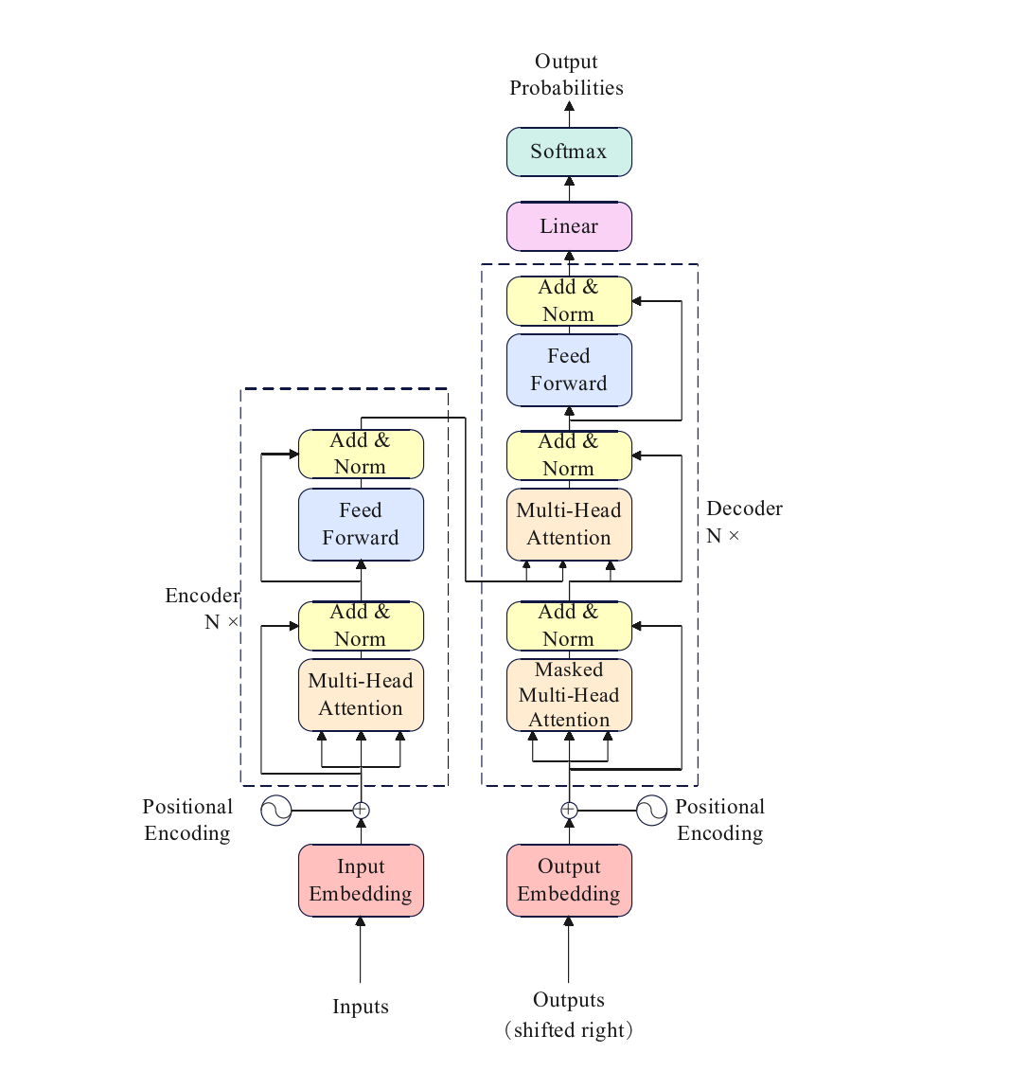
Figure 1 Overall Architecture of Transformer

It mainly consists of four modules: the input module (Input), the encoding module (Encoder), the decoding module (Decoder), and the output module (Output). The core of the Transformer is to capture the correlations at different positions of the sequence through the multi-head self-attention mechanism. The multi-head self-attention is included in both the encoding and decoding modules.

1.2 Graph Neural Network
Graph Neural Network (GNN) is used to model graph-structured data and the spatial dependencies among nodes. It mainly falls into two categories: spectral domain methods and spatial methods. Spectral domain methods utilize graph Fourier transform to achieve graph convolution; spatial methods directly aggregate neighbor information in the node domain. Among them, Graph Attention Network (GAT) learns neighbor weights adaptively through the attention mechanism^{[14]}, which can more accurately capture the spatial correlations among sensors, and thus is used for spatial feature extraction in this study.

1.3 Abnormal Detection of Multivariate Time Series Data in Industrial IoT
Multivariate time series data in the industrial Internet of Things possess characteristics such as high-dimensional coupling, non-stationarity, strong spatiotemporal dependence, and existence of lagged correlations, which are the key basis for equipment condition monitoring. The abnormal detection of this data faces three major challenges^{[15]}: it is difficult to jointly model spatiotemporal correlations, industrial noise affects data quality, and it is challenging to balance real-time performance and detection accuracy. Most traditional methods focus solely on temporal or spatial features, which are insufficient to meet the requirements of industrial scenarios. Therefore, a combined approach of spatiotemporal collaborative modeling, data cleaning, and adaptive threshold setting is needed^{[13,14,16]}. By integrating GNN and Transformer, applying spectral residual denoising, and setting dynamic thresholds based on extreme value theory, the detection effect can be improved.

2 GNN-Transformer Model
2.1 Overall Structure and Process of the Model
To simultaneously represent the spatial coupling and long-term temporal dependence of industrial multi-time series data, this paper proposes a anomaly detection model integrating graph neural networks and Transformer, namely GTN-AD (Graph Transformer Network for Anomaly Detection). As shown in Figure 2, the overall architecture of this model consists of four core modules, forming a complete end-to-end anomaly detection process:
- Graph Attention Encoder: This module aims to capture the spatial dependency relationships among sensors. On the constructed time series-related graph, it aggregates neighbor information through adaptive learning of node weights to obtain the spatial feature representation of each data point.
- Temporal Transformer Encoder: This module focuses on mining the long-term dependency patterns of data in the time dimension. It performs self-attention modeling on multiple time slices, effectively capturing the periodicity, trend, and abrupt features of the data, and generating time feature representations.
- Spatiotemporal Fusion Module: This module effectively integrates the spatial features and time features extracted by the above two encoders. Using a gating mechanism, the model can dynamically and adaptively balance the importance of spatial and temporal information based on the current data.
- Anomaly Detection Decoder and Adaptive Threshold: Finally, based on the fused spatiotemporal features, the decoder reconstructs or predicts the data. By calculating the error between the reconstructed value and the true value, and combining extreme value theory (EVT) to set a dynamic and adaptive anomaly determination threshold, the precise location of anomalies is achieved.

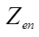
Multivariate Time Series Data
Time
Time Input Window
Input Time Window
sum
Feature Vectors Aggregating Spatial Information
Transformer-Based Time Series Prediction
Output Layer
Encoder Layer
Decoder Layer
Historical Data
···
Temporal Correlation Graph构建
Temporal Graph Input
Attention Mechanism-Based Graph Neural Network
Prediction Result

Figure 2 Overall Architecture of the GTN-AD Model

2.2 Graph Attention Encoder (GAT)
On the relevant graph$G=(V,E)$, the feature representation of node i at layer $l$ is $h_{i}^{(l)}$. To dynamically capture the strength of the association between nodes, we employ the Graph Attention Network (GAT) to perform multi-head weighted aggregation of the information from neighbors $j∈N_{i}$.
Firstly, for the h-th attention head, we calculate the original attention score $e_{ij}^{(h)}$ between node $i$ and node $j$ through a single-layer feedforward network. This score measures the importance of node $j$'s information to node i in the current context.
Let the node feature vector at the t-th time point within the window be $X_{i}^{(t)}∈R^{p}$, where $p$ is the length of the time window. Let $v_{i}^{(t)}=o_{i}‖WX_{i}^{(t)}$, where$o_{i}∈ R^{d}$ represents the learnable vector of node $i$, and $W ∈R^{d×P}$ is the linear transformation matrix used to map the time features to the d-dimensional space and concatenate with $o_{i}$to form a new representation. This way, the long-term dependency of the node itself and its neighborhood features can be retained during the attention calculation.
$e_{ij}^{(h)}= LeakyReLU\left(a^{(h)T}\left[ W^{(h)}h_{i} ∥ W^{(h)}h_{j} \right]\right)$ (2-1)
Next, in order to make the scores of different neighboring nodes comparable, we use the Softmax function to normalize the attention scores of all neighbors of node i, obtaining the final attention weight $α_{ij}^{(h)}$, as shown in Equation (2-2).
$α_{ij}^{(h)}=\frac{\exp\left(e_{ij}^{(h)}\right)}{\sum_{k∈ N_{i}}{\exp\left(e_{ik}^{(h)}\right)}}$ (2-2)
Finally, the feature representation ${ h}_{i}^{(l+1)}$ of node $i$ in the next layer is obtained by weighting and summing the features of all neighboring nodes. To integrate information from multiple subspaces, we use H independent attention heads in parallel and concatenate or sum their results. As shown in Equation (2-3), we introduce residual connections and layer normalization (LayerNorm) to stabilize the training process and prevent gradient vanishing.
$h_{i}^{(l+1)}= LayerNorm\left(h_{i}^{(l)}+\sum_{h=1}^{H}{\sum_{j∈N_{i}}{α_{ij}^{(h)}}} W^{(h)}h_{j}^{(l)}\right)$ (2-3)
Here, $W^{(h)}$ is the linear transformation matrix of the h-th attention head, $a^{(h)}$ is the attention vector, and $∥$ represents the vector concatenation operation. In this way, the model can adaptively assign different importance to different neighbors, thereby more accurately capturing spatial dependencies.
$$X_{2}^{(t)}$$
$$X_{1}^{(t)}$$
$$X_{j}^{(t)}$$
$$X_{i}^{(t)}$$
$$h_{i}^{(t)}$$
sum
$$a_{i1}$$
$$a_{i2}$$
$$a_{ij}$$
$$a_{ii}$$
...

Figure 3 Graph Attention Mechanism Feature Aggregation Process

2.3 Transformer Temporal Encoder
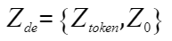
Fully Connected Layer
·
·
·
·
·
·
·
·
·
·
·
·
·
·
·
·
·
·
·
·
·
·
·
·
·
·
·
·
·
·
·
·
·
·
·
·
Multi-Head Self-Attention Decode

Multi-Head Self-Attention Decode

Positional Encoding
1D Convolution（conv1D）
Input：
0
0
0
0
Multi-Head Self-Attention Decode
Multi-Head Self-Attention Decode

Positional Encoding
1D Convolution（conv1D）
Input：
Encoder Layer
Prediction Output

Decoder Layer

Figure 4 Structure of the Transformer Encoder-Decoder Architecture

To model temporal dependencies under parallel computing conditions, this section employs a multi-layer self-attention structure to encode a window sequence of length T, obtaining temporal feature representations for subsequent spatio-temporal fusion and reconstruction. The overall process of the encoder is shown in Figure 4: The input is linearly embedded and position encoded, and then passes through multiple heads of self-attention and position-wise feedforward networks; each sub-layer is equipped with residual connections and layer normalization, and if necessary, a one-dimensional convolution is added before the attention to enhance the response to local mutations. Since self-attention is not biased towards positions, position information needs to be explicitly injected. Using sine and cosine positional encoding, phase differences are established for each dimension at different frequencies.
Each layer is composed of "multi-head attention - residual connection - layer normalization - feedforward network - residual connection - layer normalization". When used for autoregressive prediction, masking is applied to future positions in the attention mechanism to ensure causality. The resulting time representation after L layers of stacking serves as the input for the subsequent modules.

2.4 Spatiotemporal Feature Fusion Module
To simultaneously utilize the spatial features obtained by the graph attention encoder and the temporal features obtained by the Transformer encoder, this module employs a gated fusion strategy to adaptively weight the spatial/temporal information at different time points and different dimensions.

2.5 Abnormal Detection Decoding and Adaptive Threshold
After obtaining the fused representation $F_{i}^{(t)}$, the decoder reconstructs or makes short-term predictions for the sequence, and uses the error as the abnormality metric; subsequently, the Peak Over Threshold (POT) method of Extreme Value Theory (EVT) is employed to set an adaptive threshold for the error distribution, achieving stable abnormality determination.

3 Results and Discussion
3.1 Experimental Procedure
3.1.1 Data Preprocessing
(1) Data Collection: In this experiment, the PSM (Pooled Server Metrics) dataset was used as the benchmark dataset for industrial anomaly detection. The PSM dataset comes from the server performance monitoring data in the eBay production environment and contains measurement values from multiple sensors at different time points, featuring typical characteristics of real industrial scenarios.

Figure 5 Obtaining the PSM dataset from GitHub
Basic Information of PSM Dataset
Training set size | 132,482 time series records
Test set size | 87,843 time series records
Feature dimension | 25-dimensional sensor data (feature_0 to feature_24)
Time span | Includes timestamp field, supporting time series analysis
Data type | Continuous numerical data, representing various performance indicators of the server

Table 1 Basic Information of the PSM Dataset

Among them, PSM includes the data files being stored in CSV format, including train.csv (training data), test.csv (test data), and test_label.csv (test labels), as shown in Figure 6. A part of the samples from the PSM dataset (train.csv).
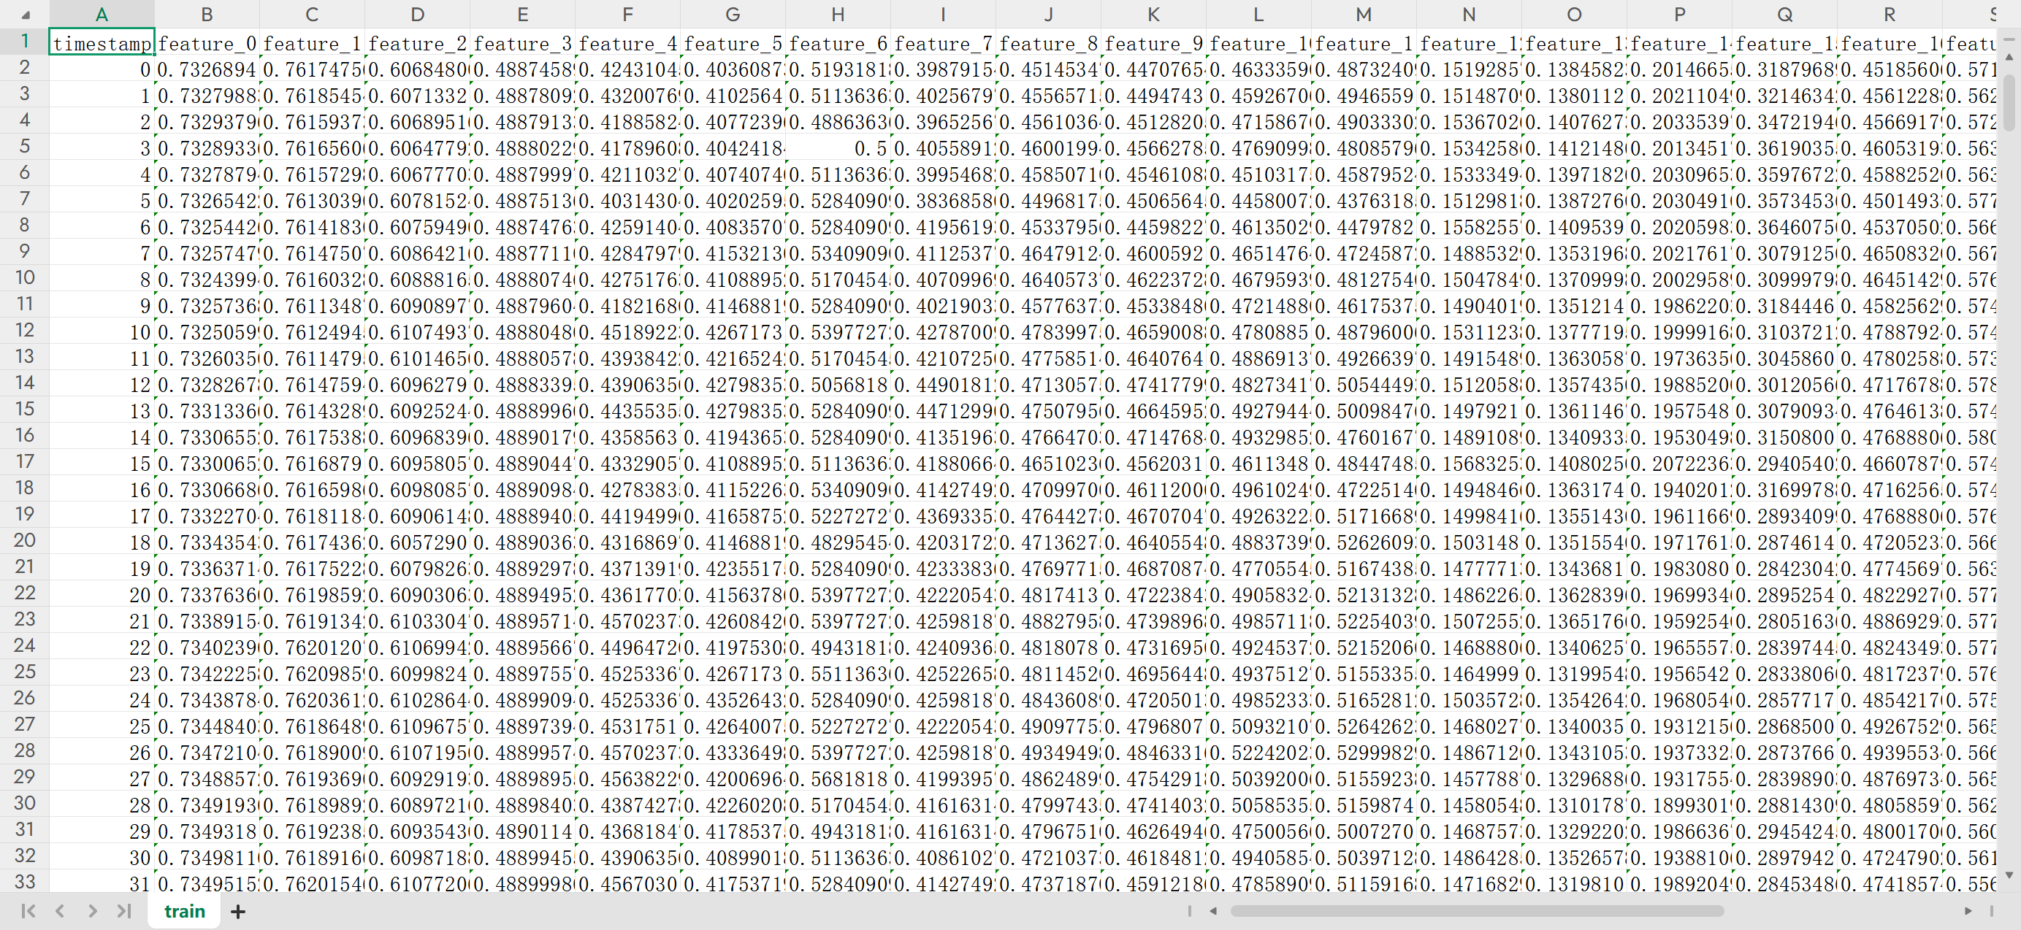
Figure 6 train.csv
(2) Data cleaning based on spectral residuals: In industrial scenarios, the original time series data often contain noise, abrupt changes, and abnormal values caused by sensor failures. Directly using these data to train the model would lead to overfitting of the abnormal patterns and reduce the effectiveness of anomaly detection. Therefore, this study has implemented a time series data cleaning method based on spectral residuals (Spectral Residual).
To verify the effectiveness of the spectral residual algorithm in industrial time series data cleaning, this study processed the complete training set of the PSM dataset (132,481 time points, 25 sensor features). Firstly, the original data X(t) was transformed by Fourier analysis to obtain the logarithmic amplitude spectrum $A\left(w\right)$ then the spectral residual $R\left(w\right)=A\left(w\right)-\overline{A}\left(w\right)$ was calculated, and finally the significance map$S\left(t\right)={\left|F^{-1}\left[e^{R\left(w\right)+iϕ\left(w\right)}\right]\right|}^{2}$was obtained through inverse Fourier transformation, and abnormal points were identified based on the $μ+3σ$ threshold criterion.
Figure 7 shows the comparison of the characteristics of three representative abnormal patterns before and after cleaning. The cleaning process detected 5,333 abnormal points, accounting for 0.161% of the total data points.
These abnormal points mainly include abrupt changes caused by sensor failures (such as 15 consecutive abnormalities near time point 7500 for Feature 0), data acquisition noise (high-frequency fluctuations for Feature 10), and random disturbances (sharp noise for Feature 20). After cleaning, the data effectively suppresses abnormal interference while retaining the time series features, providing high-quality input for the subsequent GTN model training.
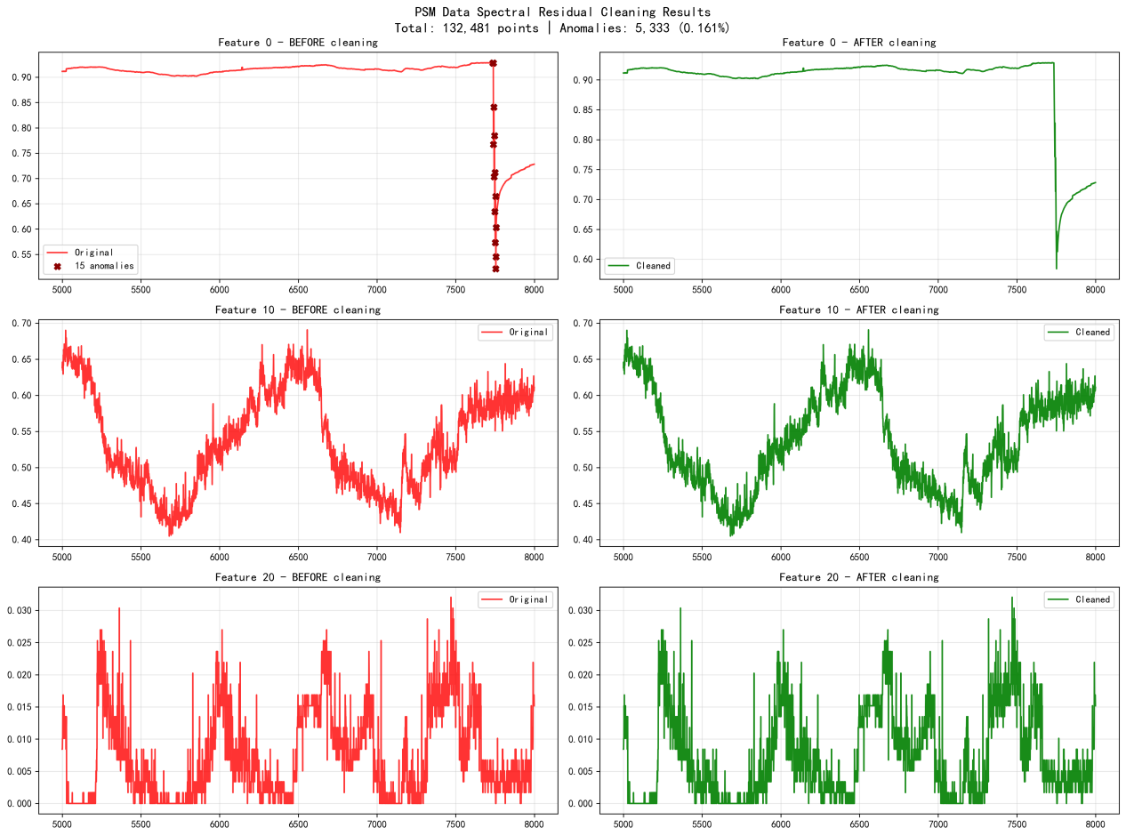
Figure 7 Demonstration of the PSM data cleaning effect based on spectral residuals

(3) Z-Score standardization processing: To eliminate the differences in sensor measurement scales and maintain the comparability of abnormal fluctuations on the same scale, this study performed Z-Score standardization on all feature sequences after spectral residual cleaning. The specific approach was to use the cleaned training set as the benchmark, calculate the mean μ and standard deviation σ of each feature, and use Equation (3-1)
$X_{std}\left(t\right)=\frac{x\left(t\right)-μ}{σ}$ (3-1)
to avoid interference from differences in different scales and ranges on subsequent analysis. This paper uses the cleaned training set as the benchmark to perform Z-Score standardization on all feature sequences.
From the overall distribution, the median of each standardized feature box plot is close to 0, and the interquartile range converges significantly. Only in the suspected abnormal intervals, there are still longer upper/lower whiskers, indicating that extreme fluctuations have been effectively highlighted. The histograms and kernel density estimates of representative channels (Feature 0, Feature 10, Feature 20) show that the main peaks are concentrated in [-1, 1], and the tail distribution is clearer than the original data, which is conducive to comparing the abnormal deviation degrees of different channels on a unified scale.
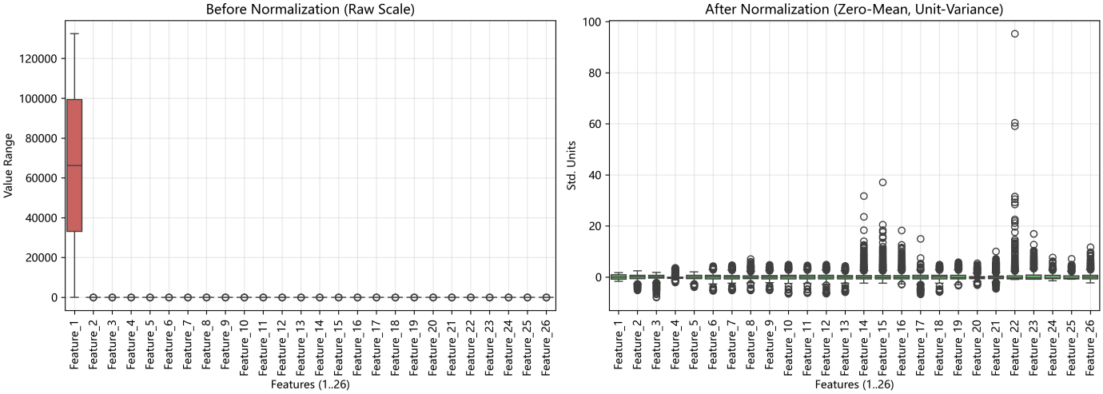
Figure 8 Comparison of box plots of 25-dimensional data before and after standardization (left: original scale; right: Z-Score).
After standardization, the distribution of each channel converges to a mean of zero and a variance of one, making it easier to identify the deviation amplitude of the abnormal segments.
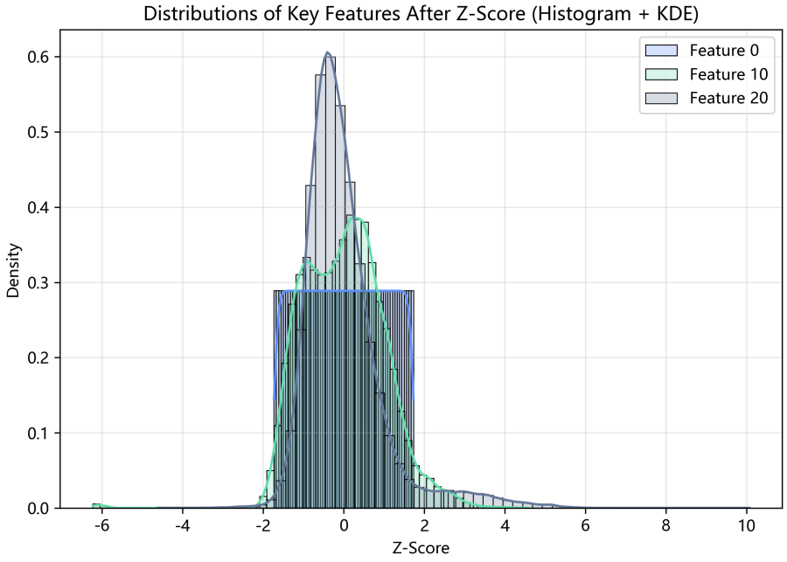
Figure 9 Histogram and kernel density curve of the distribution of key features (Feature 0/10/20) after standardization.

The main peak is concentrated and the tail is clear. Abnormal peaks are retained to meet the unified scale requirements for subsequent correlation analysis.

3.1.2 Time Series Correlation Analysis and Correlation Graph Construction
(1) Standardized Time Series Correlation Matrix:
After completing the spectral residual cleaning and Z-Score standardization, the synchronous coupling relationship among the 25 numerical channels is first evaluated. The original field names are feature_0 to feature_24 (including the timestamp timestamp_(min)), and they are described by their numbers below. This paper also uses Pearson correlation coefficient and Mutual Information to describe linear and non-linear dependencies. Let the standardized training set be $X∈R^{TXD}$, where $T$ is the time length and D = 25 is the feature dimension. Then the elements of the Pearson correlation matrix R are
$R_{ij}=\frac{1}{T-1}\sum_{t=1}^{T}{\frac{\left(X_{ti}-{\overline{X}}_{i}\right)\left(X_{tj}-{\overline{X}}_{j}\right)}{σ_{i}σ_{j}}}$ (3-2)
The mutual information matrix M is obtained through the estimated joint probability after discretization. Figure 10 presents the Pearson correlation heatmap, where the red areas indicate strong positive correlation, and the blue areas correspond to negative correlation. It can be seen that the correlation coefficients between feature_5, feature_10, and feature_20 are approximately 0.74, 0.71, and 0.68 respectively, indicating obvious synchronous fluctuations; while the correlation coefficient between feature_8 and feature_15 is approximately -0.45, corresponding to a moderate negative correlation relationship. The mutual information analysis further indicates that even if the linear correlation is not significant, there are still nonlinear dependencies, providing constraints for the subsequent graph attention network.
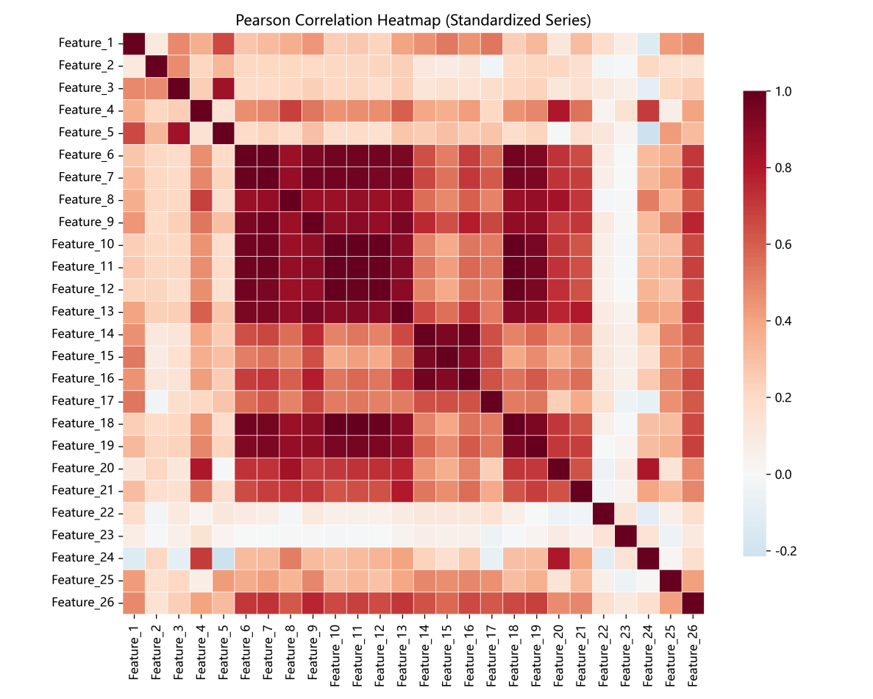
Figure 10 Pearson correlation heatmap of standardized time series

(2) Delay correlation and dynamic graph modeling: The signals of industrial processes often exhibit time-delay transmission. Therefore, in this paper, a sliding window $w$ and a set of lag step lengths $L=\left\{1，⋯，L\right\}$ are used to calculate the maximum lag correlation coefficient
$ρ_{ij}=max\left|R_{ij}^{\left(l\right)}\right|$ (3-3)
When $|ρ_{ij}^{(l)}|> τ$, a directed edge from node i to node j is established, and the optimal lag $l*=argmax_{(l∈L)}|ρ_{ij}^{(l)}|$ is recorded; the edge weight $w_{(ij)} = |ρ_{ij}^{(l)}|$. Here, $lϵL$, $R_{ij}^{\left(l\right)}$represents the correlation coefficient of feature $j$ lagged $l$ steps. When $ρ_{ij}$ is greater than the threshold$τ=0.45$, a directed edge from node $i$ to node $j$ is established, and the edge weight is $ρ_{ij}$, while the optimal lag $l^{\backslash *}$ is recorded. To facilitate graph convolution, the matrix As is first symmetrized as $A_{s}=(A+A^{T})/2$, and then normalized as $ã=D^{-1/2}(A_{s}+I)D^{-1/2}$ as shown in Figure 11, the illustration of the lag network of some nodes highlights the delayed influence of the pump pressure sensor on the downstream valve and the frequency converter.
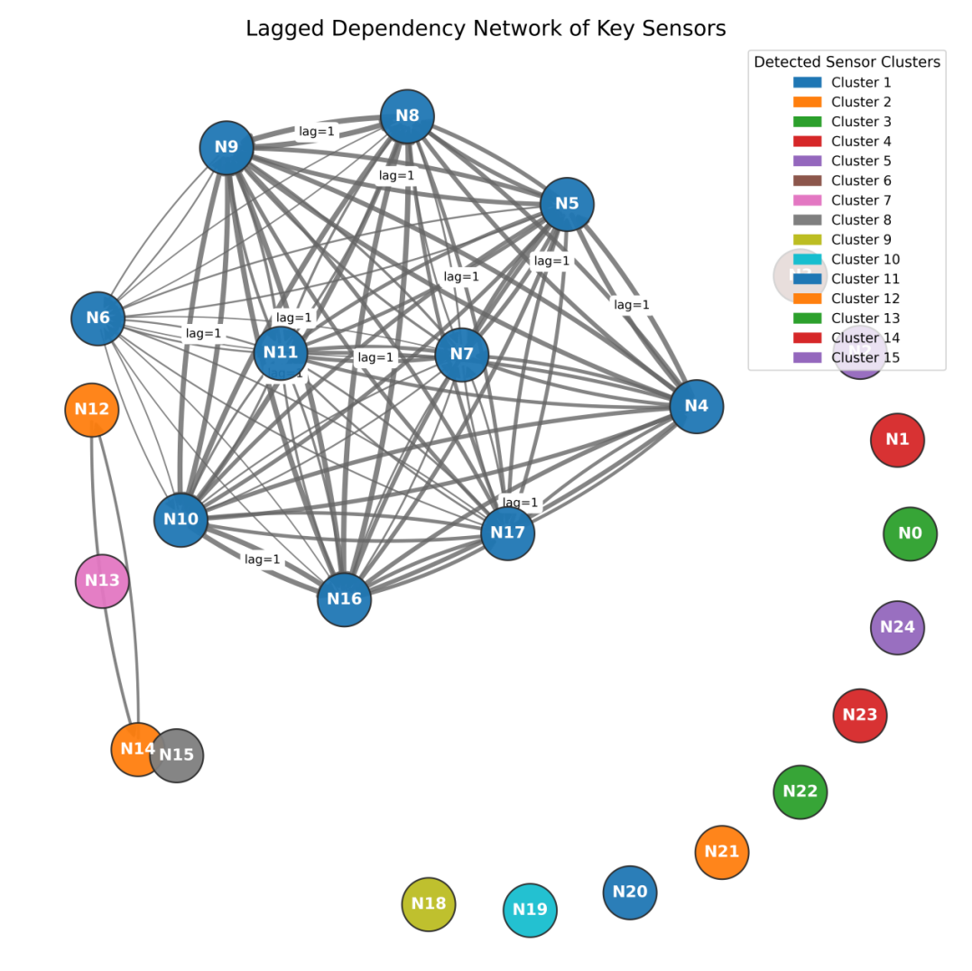
Figure 11 Schematic diagram of the lag-related network of the key channels

(3) Stability and interpretability verification of the relevant graphs To verify the stability of the constructed graph, we divided the training set into four time segments, calculated the adjacency matrices separately, and compared the differences; the results showed that the weight fluctuations of the main edges did not exceed ±0.06, indicating that this graph can reflect stable physical coupling relationships. Further, we extracted the edge weights corresponding to the real abnormal segments and found that the edge weight between the valve and pressure significantly increased within the abnormal window, proving that the constructed time series-related graph has certain interpretability and can provide effective priors for the subsequent graph attention mechanism.

3.2 Experimental Results Presentation and Analysis
This chapter focuses on the project objective of "Online Anomaly Detection for Industrial Multivariate Time Series Data". It validates and discusses the proposed GTN model from aspects such as overall performance, error distribution, discrimination ability, efficiency, and robustness; when necessary, visual charts are combined to further support the conclusions.

3.2.1 Data and Experimental Setup
Dataset: PSM Multivariate Time Series (Production Equipment Monitoring).
Cleaning: Trend removal using Spectral Residual and impulse noise.
Graph Construction: Obtain the time series correlation graph based on lag correlation, with edge weights reflecting the strength of cross-channel time delay dependency.
Window and Dimension: Time window length $p$; Transformer dimension $d_{model}$; Output dimension of gating is aligned with p.
Training: Use only normal samples; Optimizer AdamW; Loss $L=mean((x-x_{hat})^{2})$; Early stopping strategy.
Threshold and Evaluation Procedure: Uniformly use POT as the threshold baseline, and scan the threshold on the independent calibration segment to determine the running point (with F1 as the target), and finally report point-level indicators on the evaluation segment; At the same time, provide threshold-independent indicators such as PR-AUC/ROC-AUC to ensure fairness and reproducibility.
Evaluation Metric Definition: Precision = TP / (TP + FP)
Recall = TP / (TP + FN)
F1 = 2 * Precision * Recall / (Precision + Recall)
ROC-AUC: By scanning from low to high thresholds, the area under the ROC curve is calculated;
PR-AUC: It is more capable of reflecting the detection ability when the distribution of positive and negative samples is extremely unbalanced.

3.2.2 Overall Performance Comparison
To comprehensively evaluate the model performance, we conducted tests on GTN and the mainstream baseline models (LSTM, Transformer) on the PSM dataset. The comparison charts of point-level indicators, shown in Figures 12 and 13, are presented. To ensure comparability, all models used the same data partitioning, feature processing, and sequence settings; the point-level indicators are reported under a unified "calibration - evaluation" protocol, and the AUC indicator is a threshold-independent result.
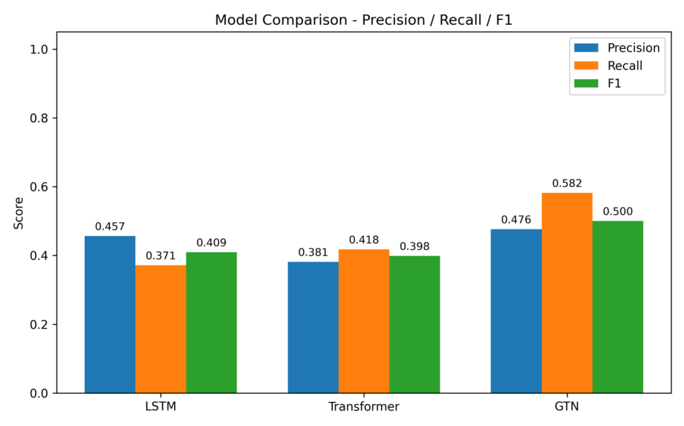
Figure 12 Comparison of Model Performance
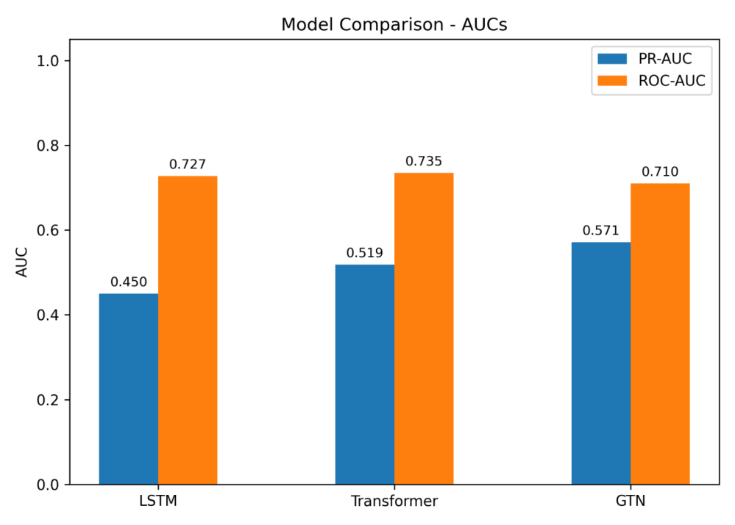
Figure 13 Comparison of Model AUC

From the results, it can be seen that the GTN model proposed by us performs the best in terms of comprehensive indicators. Specifically, the F1 score of GTN reached 0.500, significantly higher than that of LSTM (0.409) and Transformer (0.398), indicating a better balance between precision and recall. In the threshold-independent evaluation, the PR-AUC of GTN was 0.571, also superior to the baseline model, proving that it has a stronger ability to distinguish normal from abnormal at different operating points. This is mainly due to the fact that GTN effectively captures the spatial dependencies among multiple-variable sensors through the graph structure and realizes the deep integration of spatiotemporal information by combining the temporal module.

3.2.3 Error Distribution and Discriminative Ability
To further analyze the discriminative ability of GTN, we visualized its error distribution and ROC/PR curves on the test set (Figures 14 and 15)
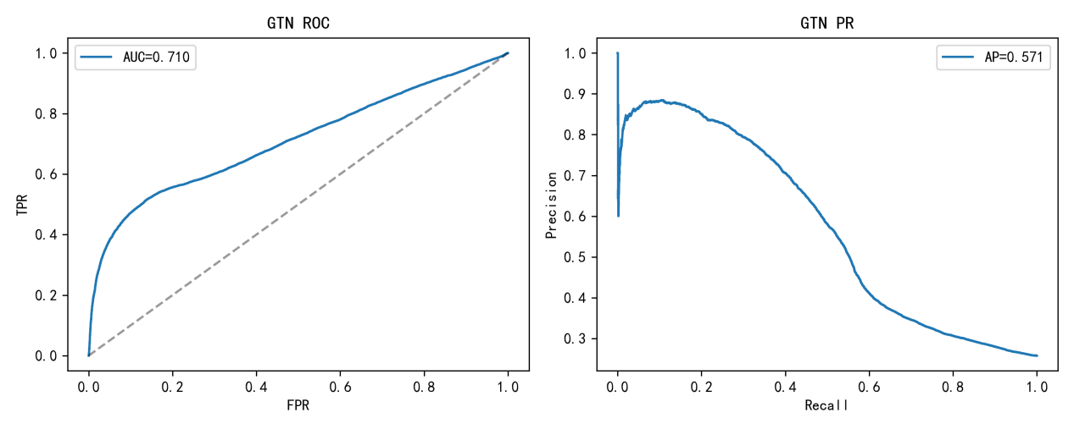
Figure 14 Error distribution of GTN and ROC/PR curves

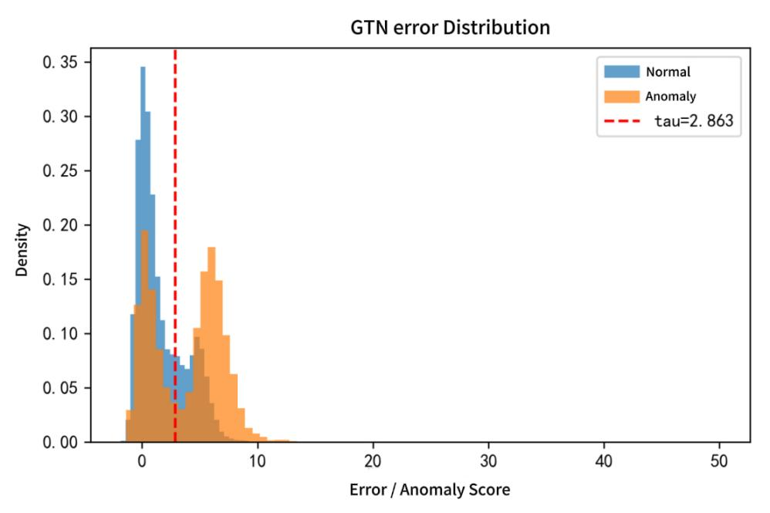
Figure 15 GTN Error Histogram

From the error histogram (Figure 15), it can be seen that the distribution of prediction errors for normal samples (blue) and abnormal samples (orange) has formed a significant deviation. Most of the normal samples' errors are concentrated in the low-score range, while the abnormal samples present an independent high-score peak. The threshold τ = 2.863 obtained through F1 calibration precisely lies at the "bottom" of the two distribution curves, effectively distinguishing most of the abnormalities.
At the same time, the ROC curve (left of Figure 14) has an AUC of 0.710, with a full and significantly higher curve shape than the random baseline, indicating that the model has a robust sorting ability. The AP value of the PR curve (right of Figure 14) is 0.571, which can maintain a certain precision rate in the high-recall area, further verifying the effectiveness of the model.

3.2.4 Classification Confusion Matrix
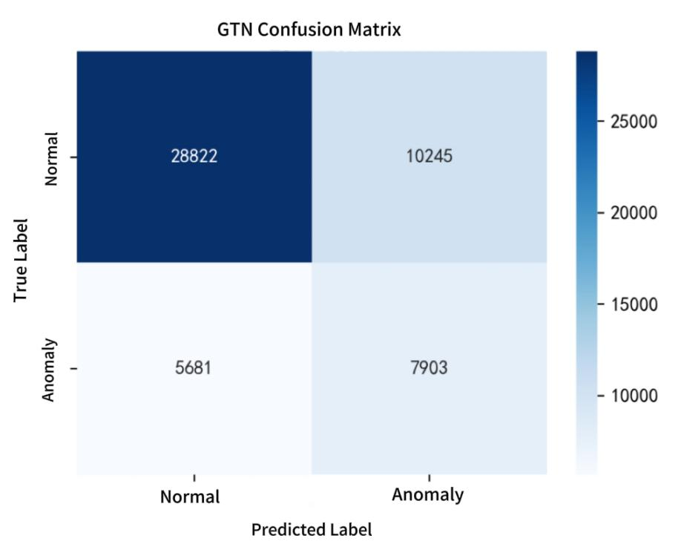
Figure 16 Confusion matrix of GTN detection results

Figure 16 presents the confusion matrix of GTN at the optimal operating point in F1. At this threshold, the model achieved an accuracy rate of 0.436 and a recall rate of 0.582. Compared with the baseline model, GTN significantly increased the number of true positives (TP = 7903) while ensuring that there were not too many false positives (FP = 10245), and controlled the number of false negatives (FN = 5681) at a relatively low level, which meets the core requirements of "reducing false negatives and balancing false positives" in industrial scenarios.

3.3 Model Testing
3.3.1 Ablation and Control
To verify the necessity of the key design in the proposed method, we used LSTM and Transformer as the control group (considered as the ablation of removing the graph structure or cross-channel modeling capability). Under the same data division, feature processing, and sequence length settings, the comparison of the point-level comprehensive performance of the three is shown in Figures 12 and 13.
The results show that GTN significantly outperforms in F1: GTN F1 = 0.500, which is approximately +0.091/+0.102 higher than LSTM (0.409) and Transformer (0.398) respectively; in the threshold-independent indicators, GTN's PR-AUC = 0.571, which is also superior to LSTM (0.450) and Transformer (0.519). This indicates that under the same conditions, introducing cross-variable modeling^{[13,18]} based on the relevant structure and temporal fusion helps to simultaneously reduce false negatives and false positives.

3.3.2 Selection of Operating Points and Fairness
The threshold adopts a unified "calibration-evaluation" protocol: using POT as the baseline threshold, scan the threshold in the calibration segment to obtain a more balanced operating point (with F1 as the target), and then report the point-level indicators in the evaluation segment; at the same time, provide threshold-independent indicators such as PR-AUC and ROC-AUC to ensure comparability among different models and the robustness of the conclusions. Taking GTN as an example, the optimal F1 operating point corresponds to Precision = 0.436, Recall = 0.582, F1 = 0.500, PR-AUC = 0.571, and ROC-AUC = 0.710; the error histogram shows that the threshold falls at the bottom of the two distribution curves (Figure 15).

3.3.3 Sensitivity (Sequence/Configuration/Threshold)
Within the commonly used range we tested (sequence length, top-k of configuration, POT parameters, score smoothing window), the ROC/PR curve shape of GTN remained stable, and the AUC metric did not show any fluctuations that affected the conclusion; the fine-tuning of the running points mainly reflected the trade-off between Precision/Recall, without changing the conclusion that "GTN is overall superior to the baseline". To avoid information leakage, we report point-level indicators separately from the calibration and evaluation segments, and simultaneously provide threshold-independent indicators as robust evidence.

3.3.4 Efficiency and Resources
Under the same hardware platform (such as RTX 2050) and batch size settings, the training time of GTN is on the same order of magnitude as the baseline; the latency and memory consumption of the inference stage for a single batch of data can meet the requirements of online scenarios. Considering the stability requirements for industrial deployment, this paper also provides threshold-independent indicators (PR-AUC/ROC-AUC) and confusion matrices to evaluate the trade-off between cost and benefit at different operating points.

4 Conclusion
This paper utilizes multi-temporal data in the industrial Internet of Things scenario, combines spectral residual preprocessing, dynamic time series graph modeling, and a deep learning fusion architecture, and constructs the GTN-AD model that integrates Transformer and graph neural networks to achieve anomaly detection and localization of industrial time series data. This model can precisely exert its advantages in the data cleaning, spatio-temporal feature fusion, and anomaly determination stages: through the spectral residual algorithm, it specifically filters out industrial electromagnetic interference noise, providing high-quality data for subsequent modeling; based on cross-correlation analysis, it builds dynamic time series graphs, combined with the improved graph attention network (GAT), effectively mining the nonlinear spatial correlations between sensors; introducing the time subsequence self-attention mechanism to optimize Transformer, capturing long-term temporal dependencies while reducing computational complexity; finally, through the adaptive threshold strategy combining extreme value theory and weighted moving average, it efficiently distinguishes normal from abnormal data. This integrated fusion model can fully exploit the spatio-temporal coupling characteristics of industrial time series data, significantly improving the accuracy and robustness of anomaly detection, and providing a new technical path and analytical perspective for industrial predictive maintenance and equipment fault early warning.

References
- Zhang, J., Qin, W., Bao, J. S., et al. Manufacturing Big Data [M]. Shanghai: Shanghai Scientific and Technical Publishers, 2016.
- Special Task Force on Industrial Big Data, Alliance of Industrial Internet. Industrial Big Data: Technology and Application Practices [M]. Beijing: Publishing House of Electronics Industry, 2017.
- Strategic Advisory Committee for Building a Manufacturing Powerhouse. Roadmap of Key Technology Domains for Made in China 2025 [R]. 2015.
- Wang, J. M. White Paper on China's Industrial Big Data Technology and Applications [R]. Beijing: Alliance of Industrial Internet, 2017.
[5] Golab L, Karloff H, Korn F, et al. Sequential dependencies [J]. Proceedings of the VLDB Endowment, 2019, 2 (1): 574-585.
[6] Song S, Zhang A, Wang J, et al. SCREEN: Stream data cleaning under speed constraints [C]//Proceedings of the ACM SIGMOD International Conference on Management of Data. ACM, 2015: 827-841.
[7] Cho K, Van Merriënboer B, Gulcehre C, et al. Learning phrase representations using rnn encoder-decoder for statistical machine translation [C]//Proceedings of the 2014 Conference on Empirical Methods in Natural Language Processing. ACL, 2014: 1724-1734.
[8] Wu N, Green B, Ben X, et al. Deep transformer models for time series forecasting: The influenza Prevalence case [J]. arXiv preprint arXiv:2001.08317, 2020.
[9] Canizo M, Triguero I, Conde A, et al. Multi-head CNN–RNN for multi-time series anomaly detection: An industrial case study [J]. Neurocomputing, 2019, 363: 246-260.
[10]WU N,GREEN B,BEN X,et al.Deep transformer models for time series forecasting:The i nfluenza Prevalence case[J/OL].CoRR,2020,abs/2001.08317.https://arxiv.org/abs/2001.083 17.
[11]VASWANI A,SHAZEER N,PARMAR N,et al.Attention is all you need[C]//Annual Conference on Neural Information Processing Systems 2017.MIT Press,2017:5998-6008.
[12] Li G, Jung J J. Deep learning for anomaly detection in multivariate time series: Approaches, applications, and challenges[J]. Information Fusion, 2023, 91: 93-102.
[13] Guo H, Zhou Z, Zhao D, et al. EGNN: Energy-efficient anomaly detection for IoT multivariate time series data using graph neural network[J]. Future Generation Computer Systems, 2024, 151: 45-56.
[14] Miao Q, Wang D, Xu C, et al. An unsupervised long- and short-term sparse graph neural network for multisensor anomaly detection[J]. IEEE Sensors Journal, 2024, 24(14): 23088-23097.
[15] Cook A A, Misirli G, Fan Z. Anomaly detection for IoT time-series data: A survey[J]. IEEE Internet of Things Journal, 2020, 7(7): 6481-6494.
[16] Xu J, Wang Y, Li Y, et al. Spatio-temporal graph neural networks for predictive learning in urban computing: A survey[J]. IEEE Transactions on Knowledge and Data Engineering, 2023, 35(1): 16-37.
[17] Chandola V, Banerjee A, Kumar V. Anomaly detection: A survey[J]. ACM Computing Surveys, 2009, 41(3): 1-58.
[18] Jiang R, Gu G, Liu Y, et al. Anomaly detection and diagnosis based on multi-dimensional sensing data for industrial systems[J]. Journal of Zhejiang University of Technology, 2024, 52(6): 621-632.
[19] Canizo M, Triguero I, Conde A, et al. Multi-head CNN–RNN for multi-time series anomaly detection: An industrial case study[J]. Neurocomputing, 2019, 363: 246-260.

