Comparative Performance Evaluation of BFV, BGV, and CKKS Homomorphic Encryption Schemes Using Microsoft SEAL

Abstract, Homomorphic Encryption (HE) enables arithmetic operations to be performed directly on encrypted data, thereby preserving confidentiality during computation. However, the high computational cost associated with HE continues to limit its large-scale practical deployment. This paper presents a comparative experimental evaluation of three prominent homomorphic encryption schemes, Brakerski/Fan-Vercauteren (BFV), Brakerski-Gentry-Vaikuntanathan (BGV), and Cheon-Kim-Kim-Song (CKKS), using the Microsoft SEAL library. The study investigates the performance of fundamental homomorphic operations, including encryption, decryption, addition, multiplication, and squaring, across multiple polynomial modulus degree settings. Experiments were conducted using Microsoft SEAL’s benchmarking framework, and performance outputs were systematically analyzed to identify runtime trends and operational trade-offs. The results show that execution time increases substantially with higher parameter sizes for all three schemes, reflecting the inherent balance between security strength and computational efficiency. While ciphertext addition incurred minimal overhead, multiplication and squaring represented the dominant performance bottlenecks. Furthermore, CKKS showed relatively competitive efficiency in selected computational scenarios compared to BFV and BGV. The findings contribute empirical insight into the practical behavior of widely used HE schemes and provide guidance for selecting appropriate schemes and parameters in privacy-preserving computing environments
Keywords: Homomorphic Encryption; BFV; BGV; CKKS; Microsoft SEAL; Cryptographic Benchmarking; Privacy-Preserving Computation
- Introduction
The increasing dependence on cloud computing, outsourced analytics, and distributed data processing has intensified the need for cryptographic mechanisms that can protect sensitive information during computation as well as during storage and transmission. Traditional encryption techniques are highly effective for securing data at rest and in transit; however, they generally require data to be decrypted before meaningful computation can be performed. This creates a critical privacy gap in scenarios where untrusted or semi-trusted computing environments are used for data processing (Acar et al., 2018).
Homomorphic Encryption (HE) addresses this limitation by enabling arithmetic operations to be performed directly on encrypted data, such that the decrypted result of the computation corresponds to the result that would have been obtained if the operations had been performed on the plaintext itself (Badawi et al., 2018 and Bos et al., 2013). This property has made HE one of the most significant developments in modern privacy-preserving cryptography, with growing relevance in secure cloud computing, encrypted data outsourcing, machine learning, and confidential analytics (Brakerski et al., 2014 and Chen et al., 2019).
Although the idea of privacy homomorphisms can be traced back to early work by Rivest, Adleman, and Dertouzos (Choen et al., 2017), practical progress in the field accelerated after Gentry introduced the first fully homomorphic encryption (FHE) scheme in 2009 (Chillotti et al., 2020). Since then, substantial advances have been made toward improving the efficiency, scalability, and usability of HE systems. These advances have led to the development of modern lattice-based schemes such as Brakerski/Fan-Vercauteren (BFV), Brakerski-Gentry-Vaikuntanathan (BGV), and Cheon-Kim-Kim-Song (CKKS), each designed to support secure computation under different arithmetic and performance requirements (Dowlin et al., 2012 and Fan et al., 2012).
Despite these advances, the practical deployment of HE remains constrained by significant computational overhead. Operations such as ciphertext multiplication, relinearization, and modulus switching can be expensive, and performance is strongly influenced by cryptographic parameter selection, especially the polynomial modulus degree and coefficient modulus (Gentry 2010, and Halevi et al., 2020). As a result, there is a continuing need for empirical benchmarking studies that examine how different HE schemes behave under realistic implementation settings and parameter configurations.
Among currently available HE libraries, Microsoft SEAL has emerged as one of the most widely used open-source frameworks for implementing and evaluating modern homomorphic encryption schemes. It provides practical support for BFV, BGV, and CKKS, making it a suitable platform for comparative experimental analysis (Halevi et al., 2020). However, while theoretical properties of these schemes are well documented, selecting the most appropriate scheme for practical use still requires careful understanding of their runtime behavior across core cryptographic operations.
This paper presents a comparative performance evaluation of BFV, BGV, and CKKS using Microsoft SEAL. The study focuses on the computational cost of fundamental operations, including public-key encryption, decryption, ciphertext addition, ciphertext multiplication, and ciphertext squaring under varying polynomial modulus degrees. By systematically analyzing execution time across these operations and parameter settings, the paper aims to provide practical insight into the trade-offs between efficiency, arithmetic behavior, and scalability in modern homomorphic encryption systems. The main contributions of this paper are as follows:
- A comparative experimental evaluation of BFV, BGV, and CKKS using the Microsoft SEAL benchmarking environment.
- An analysis of the effect of polynomial modulus degree on the execution cost of core homomorphic encryption operations.
- An empirical examination of the trade-off between computational efficiency and parameter growth in practical HE deployment.
- A discussion of scheme suitability for privacy-preserving computation based on observed runtime characteristics.
The remainder of this paper is organized as follows: Section II presents the background and related literature on homomorphic encryption and the evaluated schemes. Section III describes the methodology and experimental setup. Section IV presents the results and discussion, while Section V concludes the paper and outlines future research directions.

- Background
This section provides the background information and related works in this paper.
  - Concept of Homomorphic Encryption
Homomorphic Encryption (HE) is a cryptographic paradigm that enables computations to be performed directly on encrypted data without requiring decryption. The result of the encrypted computation, once decrypted, corresponds to the same result that would have been obtained if the computation had been carried out on the original plaintext (Kamm et al., 2013 and Kim et al., 2017). This property makes HE fundamentally different from conventional encryption schemes, which primarily protect data during storage and transmission but do not preserve confidentiality during active computation.
The conceptual origin of HE can be traced to the idea of privacy homomorphisms introduced by Rivest, Adleman, and Dertouzos (Kocabas et al., 2021). However, early constructions were limited in functionality and could not support arbitrary computations. A major breakthrough occurred in 2009 when Gentry proposed the first feasible fully homomorphic encryption (FHE) scheme, demonstrating that both addition and multiplication could be performed on ciphertexts in a way that supports general-purpose encrypted computation (Lou et al., 2022). This development established HE as one of the most important advances in modern cryptography.
Subsequent research focused on improving the practicality of HE by reducing computational overhead, managing ciphertext noise growth, and strengthening the mathematical foundations of the schemes (Paillier, 1999), (Regev, 2009). Much of this progress has been driven by lattice-based cryptography, particularly constructions grounded in the Learning With Errors (LWE) and Ring Learning With Errors (RLWE) problems, which are widely regarded as strong foundations for post-quantum secure cryptographic systems (Rivest et al., 1978)
Because HE allows secure computation over encrypted information, it has become increasingly relevant in privacy-preserving cloud computing, outsourced computation, secure analytics, and machine learning systems (Acar et al., 2018), (Downlin 2017), (Kamm et al., 2013), (Kim et al., 2017). However, despite these advantages, practical deployment remains challenging due to the high computational cost associated with many HE operations.
  - Types of Homomorphic Encryption
Homomorphic encryption schemes are commonly classified according to the nature and extent of the operations they support on encrypted data.
1) Partially Homomorphic Encryption (PHE)
Partially Homomorphic Encryption supports only a single type of algebraic operation, usually either addition or multiplication, but not both. One of the most well-known examples is the Paillier cryptosystem, which supports additive homomorphism and allows the sum of plaintext values to be derived through operations on ciphertexts (Paillier, 2019). Although PHE schemes are computationally efficient and useful in restricted scenarios, they are not suitable for general encrypted computation because of their limited functional expressiveness.
2) Somewhat Homomorphic Encryption (SWHE)
Somewhat Homomorphic Encryption extends the capability of PHE by supporting both addition and multiplication, but only for a limited number of operations before noise accumulation makes decryption unreliable (Acar et al., 2018), (Fan et al., 2012). These schemes are useful for computations with shallow arithmetic depth, but they do not permit unrestricted evaluation of complex circuits.
3) Leveled Fully Homomorphic Encryption
Leveled Fully Homomorphic Encryption supports arbitrary computations up to a predefined multiplicative depth without requiring bootstrapping. This model is often more practical than unrestricted FHE because many real-world computations have known circuit depth in advance (Brakerski et al., 2014 and Fan et al., 2012). As a result, leveled HE is widely used in practical libraries and benchmarking environments.
4) Fully Homomorphic Encryption (FHE)
Fully Homomorphic Encryption supports unrestricted computation on encrypted data by enabling the evaluation of arbitrary arithmetic circuits. This is typically achieved by controlling or refreshing ciphertext noise through a technique known as bootstrapping (Gentry, 2009), (Vaikuntanathan, 2011). Although FHE provides the most expressive form of encrypted computation, its practical implementation remains computationally expensive compared to simpler homomorphic models (Acar et al., 2018), (Halevi et al., 2020).
In practice, many modern HE systems are implemented in leveled form because they provide a more realistic balance between functional capability and performance efficiency (Halevi et al., 2018).
  - BFV, BGV, and CKKS Schemes
Among the modern HE schemes available for practical implementation, BFV, BGV, and CKKS are among the most widely studied and deployed due to their support in contemporary homomorphic encryption libraries and their suitability for different computation models.
1) BFV Scheme
The Brakerski/Fan-Vercauteren (BFV) scheme is designed primarily for exact arithmetic over integers. It builds on lattice-based cryptographic principles and is regarded as one of the most practical schemes for exact encrypted computation (Fan et al., 2012 and Regev, 2009). BFV is particularly useful in applications where arithmetic correctness must be preserved without approximation.
The scheme supports homomorphic addition and multiplication while managing ciphertext noise through carefully selected parameter settings. However, its computational cost can increase significantly as parameter sizes grow, especially in multiplication-heavy workloads (Acar et al., 2018), (Halevi et al., 2020). This makes BFV reliable for exact encrypted arithmetic, but potentially expensive in computation-intensive environments.
2) BGV Scheme
The Brakerski-Gentry-Vaikuntanathan (BGV) scheme is another lattice-based homomorphic encryption scheme designed for exact arithmetic. It was introduced as an efficient approach to leveled homomorphic computation and has become one of the foundational schemes in practical HE research (Brakersi et al., 2014). BGV supports both addition and multiplication on encrypted data and is often appreciated for its flexibility in parameter tuning and noise management.
Compared with earlier FHE constructions, BGV improved practical feasibility by offering better control over ciphertext growth and computation depth (Brakersi et al., 2014 and Halevi et al., 2018). It has also influenced several software implementations and optimization strategies in modern HE libraries (Halevi et al., 2018). In many contexts, BGV is considered a balanced scheme for exact encrypted computation, sitting between strict precision and manageable computational cost.
3) CKKS Scheme
The Cheon-Kim-Kim-Song (CKKS) scheme differs significantly from BFV and BGV because it is designed for approximate arithmetic over real or complex values rather than exact integer arithmetic (Cheon et al., 2017). This makes CKKS especially suitable for applications involving statistical analysis, numerical computation, signal processing, and machine learning, where small approximation errors are often acceptable.
CKKS supports homomorphic addition and multiplication while encoding approximate numerical values into ciphertexts. Its design often allows more efficient execution for computation-oriented workloads compared with exact schemes (Cheon et al., 2017 and Downlin et al., 2012 and Kim et al., 2017). However, this performance advantage comes with a trade-off: the decrypted result may contain controlled approximation error rather than exact numerical equality.
Because BFV, BGV, and CKKS are designed around different arithmetic models and optimization strategies, their runtime characteristics can vary substantially depending on the parameter configuration and the specific encrypted operation being performed. This makes comparative benchmarking particularly important for selecting appropriate schemes in practice.
  - Homomorphic Encryption Libraries and Practical Implementations
The transition of homomorphic encryption from theory to practice has been supported by the development of several software libraries that implement modern HE schemes in usable form. These libraries provide optimized cryptographic primitives, parameter management tools, and benchmarking environments that allow researchers and practitioners to evaluate the real-world feasibility of encrypted computation.
One of the most influential libraries in this space is Microsoft SEAL, an open-source homomorphic encryption framework developed by Microsoft Research. Microsoft SEAL supports practical implementations of BFV, BGV, and CKKS, and provides developers with tools for encryption, decryption, key generation, encoding, and homomorphic evaluation operations (Halevi et al., 2020). Its accessibility, documentation, and benchmarking support have made it a widely used platform in applied HE experimentation.
Another important implementation framework is HElib, which has historically served as one of the earliest practical software environments for lattice-based homomorphic encryption and has contributed significantly to algorithmic optimization in the field (Halevi et al., 2020). Other libraries such as PALISADE, OpenFHE, and Lattigo have further expanded the practical ecosystem of HE implementations by supporting broader functionality, improved modularity, and deployment across different programming environments.
Although these libraries have made homomorphic encryption substantially more accessible, practical deployment remains highly dependent on parameter tuning, scheme selection, and workload characteristics. Consequently, benchmarking within real software environments remains essential for understanding the performance implications of implementing BFV, BGV, and CKKS under practical conditions. Your thesis methodology already aligns well with this implementation-centered benchmarking direction, particularly through its use of SEAL benchmarking utilities, parameter variation, and post-processing of runtime logs
  - Related Work and Research Gap
A growing body of literature has examined the theoretical foundations, practical implementations, and application potential of homomorphic encryption. Survey studies such as (Acar et al., 2018) provide a broad overview of HE schemes, highlighting both their cryptographic significance and their practical limitations. Similarly, Halevi and Shoup (Halevi et al., 2020) discuss the evolution of homomorphic encryption beyond basic circuits, emphasizing current implementation trends and the persistent challenge of computational efficiency.
Several studies have also demonstrated the applicability of HE in secure computation and privacy-preserving analytics. For example, Dowlin et al. introduced CryptoNets, showing that encrypted neural network inference can be performed with meaningful throughput and accuracy (Dowlin et al 2017). Kim and Lauter, 2017, further explored the use of fully homomorphic encryption in privacy-preserving machine learning, reinforcing the growing importance of HE in computation-heavy privacy-sensitive domains.
At the implementation level, practical software frameworks such as HElib and Microsoft SEAL have enabled more accessible experimentation and benchmarking (Halevi et al., 2018). These platforms have made it possible to evaluate the runtime cost of key operations such as encryption, decryption, ciphertext addition, and ciphertext multiplication under varying parameter settings. However, despite the availability of these tools, there remains a need for clear comparative studies that evaluate widely used schemes under a consistent experimental environment.
A recurring challenge in the literature is that many HE studies emphasize either theoretical construction, application feasibility, or isolated implementation results, while fewer works focus on controlled comparative performance evaluation across multiple widely used schemes using the same implementation framework and parameter-scaling approach. In particular, practical understanding of how BFV, BGV, and CKKS differ in runtime behavior across core cryptographic operations remains highly relevant for implementation-driven decision making.
This study addresses that gap by providing a comparative experimental evaluation of BFV, BGV, and CKKS using the Microsoft SEAL benchmarking environment. Rather than focusing on application-specific deployment, the paper concentrates on operation-level performance behavior under varying polynomial modulus degrees. This provides a more implementation-grounded perspective on the trade-offs between exact and approximate arithmetic, computational overhead, and parameter-driven scalability in modern homomorphic encryption systems. This focus also aligns directly with the strongest part of your thesis, the controlled benchmark pipeline and the operation-level runtime dataset you extracted and analyzed
- Methodology
  - Research Design
This study adopted an experimental performance evaluation design to assess the computational behavior of selected homomorphic encryption schemes implemented using the Microsoft SEAL library. The objective of the experiment was to systematically evaluate the execution cost of fundamental cryptographic operations under varying parameter configurations in order to examine the practical performance characteristics of homomorphic encryption systems.
The experimental design was centered on controlled benchmarking of the BFV, BGV, and CKKS schemes supported by Microsoft SEAL. The benchmark process involved executing core cryptographic operations repeatedly across multiple parameter settings and recording the resulting execution times. This design enabled a consistent comparison of runtime behavior across schemes and across increasing security-oriented parameter sizes. The use of an experimental benchmarking approach was appropriate because the study focused on quantitative performance measurement rather than theoretical cryptographic proof or application deployment.
The methodological workflow followed a structured pipeline consisting of:
- Environment setup and compilation of the SEAL benchmarking utility,
- Execution of benchmark experiments,
- Collection of raw performance logs,
- Extraction and structuring of benchmark data, and
- Statistical and graphical analysis of the resulting performance measurements. This workflow ensured that the experimental process remained transparent, reproducible, and implementation-grounded.
  - Experimental Environment
The experimental evaluation was conducted within a controlled software development environment designed to support cryptographic experimentation and runtime benchmarking. The implementation environment consisted of a combination of development tools, cryptographic libraries, and data analysis frameworks used to compile, execute, and analyze the selected homomorphic encryption operations.
The primary development platform used for the implementation was Microsoft Visual Studio, which provided the integrated development environment required for compiling and executing the benchmarking utilities included in Microsoft SEAL. Build configuration and compilation were handled using CMake, which generated the appropriate build files required for the SEAL source code and associated benchmarking programs. Through this process, executable benchmark utilities such as sealbench.exe were generated and used for performance evaluation.
The benchmarking experiments were executed through the Developer PowerShell environment integrated with Visual Studio. This command-line interface enabled the execution of the compiled benchmark program and displayed runtime outputs for the evaluated cryptographic operations under different parameter settings. These outputs formed the primary raw dataset used in the study.
Following benchmark execution, the generated performance logs were processed using the Python programming language. Python was selected because of its suitability for structured data extraction, statistical processing, and scientific visualization. In particular, the Pandas library was used for data organization and transformation, while Matplotlib was used to produce graphical representations of runtime behavior across parameter settings and evaluated operations.

The entire experimental workflow, from library compilation and benchmark execution to data extraction and performance analysis, was performed in a Windows-based development environment configured for software experimentation and cryptographic evaluation.
  - Parameter Configuration
The performance evaluation in this study was conducted using the parameter configuration framework provided by Microsoft SEAL. In homomorphic encryption systems, parameter selection plays a central role in determining both the security level and the computational complexity of encrypted computation. The study therefore evaluated multiple parameter settings in order to observe how increasing parameter sizes influence runtime performance.
The principal parameter varied in this study was the polynomial modulus degree 𝑛, which determines the size of the polynomial ring used by the encryption schemes. This parameter has a direct impact on both security and computational cost. Larger polynomial modulus degrees generally provide stronger resistance to cryptanalytic attacks, but they also increase the runtime overhead of encryption, decryption, and homomorphic evaluation operations.
In addition to the polynomial modulus degree, the benchmarking configuration also involved the coefficient modulus, represented in logarithmic form as log(𝑞), which controls the ciphertext modulus used during encrypted computation. The coefficient modulus plays an important role in managing ciphertext noise growth and influences the computational cost of homomorphic evaluation.
The parameter configurations used in the experimental evaluation are shown in Table 1.
Table 1: Parameter Configurations Used in the Experimental Evaluation
Polynomial Modulus Degree 𝑛 | Logarithmic Coefficient Modulus log (𝑞) | Approximate Security Level
1024 | 27 | Low
2048 | 54 | Moderate
4096 | 109 | Medium
8192 | 218 | High
16384 | 438 | Very High
32768 | 881 | Maximun
The parameter sets increase progressively in scale, allowing the study to examine how the runtime cost of homomorphic encryption operations changes as security-oriented parameters grow. This design made it possible to observe the trade-off between performance efficiency and parameter strength in a controlled and measurable manner.
  - Evaluated Cryptographic Operations
To assess the practical performance of the selected homomorphic encryption schemes, benchmark experiments were conducted on a set of fundamental cryptographic operations provided by the Microsoft SEAL benchmarking utility. These operations represent essential computational components in the lifecycle of encrypted computation and provide direct insight into the runtime overhead associated with secure processing on ciphertexts.
Although the SEAL benchmarking environment supports a wider range of cryptographic and evaluation tasks, this study focused its analysis on the operations most relevant to comparative runtime assessment and most consistently represented in the extracted benchmark dataset. The five operations analyzed in this paper are:
- Decrypt – the recovery of plaintext data from ciphertext using the secret key;
- EncryptPublic – public-key encryption of plaintext data into ciphertext form;
- EvaluateAddCt – ciphertext addition between encrypted values;
- EvaluateMulCt – ciphertext multiplication between encrypted values;
- EvaluateSquare – ciphertext squaring, i.e., multiplication of a ciphertext by itself.
These operations were selected because they represent the core building blocks of practical homomorphic computation. Encryption and decryption capture the computational cost of securing and recovering data, while addition, multiplication, and squaring reflect the cost of performing arithmetic directly on encrypted values. Among these, multiplication-related operations are especially important because they typically dominate the computational complexity of homomorphic encryption workflows.
The benchmark utility executed these operations repeatedly across the selected parameter configurations, enabling a direct comparison of their runtime behavior as the polynomial modulus degree increased.
  - Data Collection Procedure
The experimental data used in this study was collected through the execution of the benchmark utility included in Microsoft SEAL. After compilation, the benchmark program (sealbench.exe) was executed within the configured development environment using the Developer PowerShell interface. Upon execution, the program automatically performed a sequence of cryptographic operations across multiple homomorphic encryption schemes and parameter configurations.
For each evaluated operation, the benchmarking utility recorded detailed runtime information, including execution time and the number of iterations used during benchmarking. The recorded execution times were expressed in microseconds (𝜇𝑠), enabling fine-grained measurement of the computational cost associated with each operation. To improve reliability and reduce variability, each operation was executed repeatedly, after which an average execution time was computed and reported by the benchmark process. This repeated-execution design reduced the effect of transient system noise and produced more stable runtime measurements.
The raw benchmark outputs were captured as console text logs and stored for further analysis. These logs contained information about the parameter configuration used, the encryption scheme executed, the operation type, and the corresponding runtime values. Since the benchmark output was not immediately suitable for direct statistical evaluation, an additional extraction and structuring stage was required before analysis could be performed.
  - Data Processing and Analysis
After data collection, the raw benchmark logs were processed using a Python-based analysis pipeline in order to transform the textual benchmark outputs into a structured dataset suitable for interpretation. This stage was necessary because the console-generated SEAL benchmark output contained performance data in semi-structured textual form rather than in directly analyzable tabular format.
Custom Python scripts were developed to parse the benchmark output files and extract key attributes from each recorded benchmark instance. The extracted fields included the encryption scheme, operation type, polynomial modulus degree, coefficient modulus size, and measured execution time. Once extracted, the data was organized into tabular form using the Pandas data analysis library, enabling efficient filtering, grouping, and comparison across operations and parameter settings.
Statistical processing was then performed to compute representative runtime values for the evaluated operations. Since each benchmark was executed multiple times, the average execution time was used as the principal summary metric. This approach reduced the influence of one-off measurement fluctuations and provided a more reliable estimate of typical computational cost.
To support interpretation of the experimental findings, graphical analysis was also conducted using Matplotlib. Performance plots were generated to illustrate how execution time varied across cryptographic operations and parameter sizes, enabling clearer visual comparison of scheme behavior under similar benchmark conditions. These graphical outputs formed the basis for the comparative discussion presented in the results section of the paper.
  - Evaluation Metrics
The comparative evaluation of the selected homomorphic encryption schemes was based primarily on execution time, which served as the principal performance metric in this study. Execution time reflects the amount of time required for a given cryptographic operation to complete and provides a direct measure of computational cost in practical implementation settings. In the SEAL benchmarking output, execution time was recorded in microseconds (𝜇𝑠).
For each operation, the average execution time was computed across multiple benchmark iterations and used as the basis for comparison. The average execution time can be expressed as:
$$\overset{ˉ}{T}=\frac{1}{N}\sum_{i=1}^{N}{T_{i}}$$where:
𝑇 = average execution time,
𝑇𝑖 = execution time recorded in iteration
𝑁 = total number of benchmark iterations.
In addition to raw execution time, the study also interpreted results in terms of computational efficiency, where lower execution time corresponds to higher efficiency. This provided a comparative basis for examining how the BFV, BGV, and CKKS schemes behaved under equivalent operational and parameter conditions.
Although the broader thesis discussed additional considerations such as approximation accuracy in CKKS and security implications of parameter growth, the journal version of this paper focuses primarily on runtime performance benchmarking and therefore emphasizes execution-time-based comparative evaluation as the core methodological metric. This tighter focus is more consistent with the experimental results reported later in the paper.

- Results and Discussion
  - Experimental Performance Results
The experimental evaluation produced quantitative performance measurements for selected homomorphic encryption operations executed under varying cryptographic parameter configurations. As described in the methodology, the benchmark experiments were conducted using the Microsoft SEAL benchmarking utility, and execution time was recorded in microseconds (𝜇𝑠) for each evaluated operation. The benchmark outputs were subsequently processed and averaged to obtain representative runtime values for comparative analysis.

The processed dataset summarizes the computational cost associated with five core operations: decryption, public-key encryption, ciphertext addition, ciphertext multiplication, and ciphertext squaring. These operations represent fundamental building blocks of practical homomorphic encryption workflows and therefore provide a useful basis for assessing the runtime behavior of the evaluated schemes.
Table 2. Comparative Performance of Homomorphic Encryption Operations Across Polynomial Degrees
Polynomial Degree $n$ | Decrypt ($μs$) | EncryptPublic ($μs$) | Evaluate  AddCt ($μs$) | Evaluate  MulCt ($μs$) | Evaluate  Square ($μs$)
1024 | 198.10 | 1807.67 | 71.63 | 1379.33 | 756.33
2048 | 328.50 | 2464.67 | 48.47 | 1383.33 | 882.33
4096 | 772.33 | 6177.33 | 133.17 | 3293.67 | 2204.67
8192 | 2037.67 | 13395.00 | 458.33 | 17749.00 | 9122.00
16384 | 11343.00 | 72013.33 | 1904.67 | 66471.33 | 53246.33
32768 | 39568.33 | 153718.67 | 7641.67 | 298672.33 | 169193.33
As shown in Table 2, the computational cost of all evaluated operations increases substantially as the polynomial modulus degree increases. This trend is expected because larger parameter sizes require more complex polynomial arithmetic, larger ciphertext structures, and more expensive modular operations. The results therefore reflect the central trade-off in practical homomorphic encryption: stronger parameterization improves cryptographic robustness but introduces significant computational overhead.
A second important observation is the clear distinction in cost across operation types. Ciphertext addition consistently exhibits the lowest runtime overhead, while ciphertext multiplication and ciphertext squaring incur the highest computational cost. Public-key encryption also becomes increasingly expensive at larger parameter sizes, whereas decryption remains comparatively less expensive, though still strongly affected by parameter growth. These trends indicate that the practical performance limitations of homomorphic encryption are driven more by evaluation operations than by data protection or recovery operations alone.
Overall, the results confirm that performance scalability remains a major challenge in homomorphic encryption systems, particularly as security-oriented parameter sizes increase.
- Decryption Performance Analysis
Decryption represents the final stage of encrypted computation and is therefore an important operation in assessing the practical usability of a homomorphic encryption system. The benchmark results indicate that decryption time increases consistently as the polynomial modulus degree grows, reflecting the increased computational burden associated with larger ciphertext structures and higher-dimensional polynomial arithmetic.
At lower polynomial degrees, decryption remains relatively efficient, with runtime values in the low microsecond range. However, at higher parameter settings such as 𝑛 = 16384 and 𝑛 = 32768, decryption time increases sharply, demonstrating that even relatively lightweight operations become significantly more expensive under stronger cryptographic configurations.
This decryption scaling pattern is illustrated in Fig. 1.
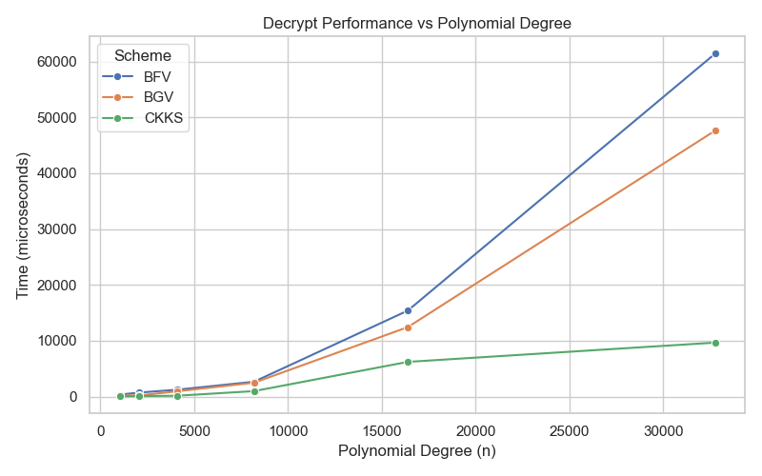
Fig. 1. Decryption performance across polynomial modulus degrees.
This trend suggests that although decryption is not the dominant performance bottleneck in homomorphic encryption workflows, it is still sensitive to parameter selection. In practical deployments, frequent decryption of intermediate or final outputs could introduce non-trivial latency when high-security parameter sets are used. Consequently, decryption efficiency remains an important consideration in applications requiring repeated ciphertext recovery.
From an implementation perspective, the observed decryption scaling behavior reinforces the broader finding that parameter growth affects not only advanced homomorphic evaluation but also the fundamental usability of encrypted computation systems.
- Public-Key Encryption Performance
Public-key encryption is the entry point through which plaintext data is transformed into ciphertext before any homomorphic computation can occur. The experimental results show that public-key encryption incurs significantly higher computational cost than decryption across all evaluated parameter settings. This is consistent with the structural complexity of encryption, which requires randomness generation, polynomial transformations, and modular arithmetic operations during ciphertext creation.
As shown in Table 2, encryption time grows rapidly with increasing polynomial modulus degree. At lower parameter settings, the cost remains manageable; however, at higher values such as 𝑛 =16384 and 𝑛 =32768, the runtime overhead becomes substantial. For example, the average encryption time reaches over 153,000𝜇𝑠 at the highest evaluated polynomial degree, indicating a significant scalability burden for systems that require frequent encryption of large input volumes.
The increase in encryption overhead across parameter settings is shown in Fig. 2.
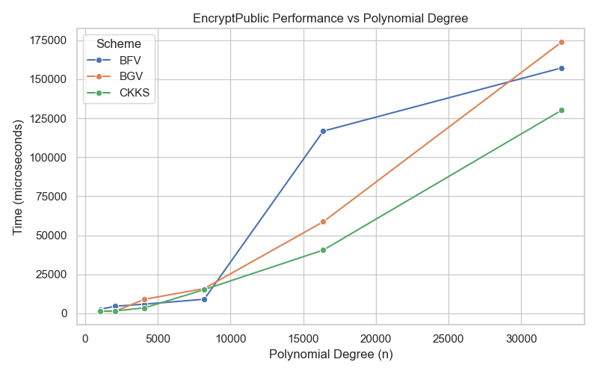
Fig. 2. Public-key encryption performance across polynomial modulus degrees.
The results also highlight an important practical distinction: while encryption is more expensive than decryption, it remains less computationally dominant than multiplication-related homomorphic evaluation. This suggests that in many real-world HE workflows, encryption overhead is important but is not the primary limiting factor. Rather, it contributes to an already heavy runtime profile that becomes especially restrictive when combined with multiplication-intensive encrypted computation.
These findings imply that application designers should carefully consider encryption frequency and batching strategies when deploying homomorphic encryption in performance-sensitive systems.
- Efficiency of Homomorphic Addition
Ciphertext addition is one of the most fundamental homomorphic operations and typically represents the least computationally demanding form of encrypted arithmetic. The benchmark results confirm this expectation, showing that EvaluateAddCt consistently records the lowest execution time among all evaluated operations across nearly all parameter settings.
At lower polynomial degrees, ciphertext addition is extremely efficient, with execution times remaining well below those of encryption, decryption, multiplication, and squaring. Even as the polynomial modulus degree increases, the growth in addition cost remains substantially lower than that of multiplicative operations. This behavior is expected because addition primarily involves relatively simple polynomial coefficient-wise operations without the more complex structural transformations associated with multiplication.
The relatively low runtime cost of ciphertext addition across parameter scales is presented in Fig. 3.
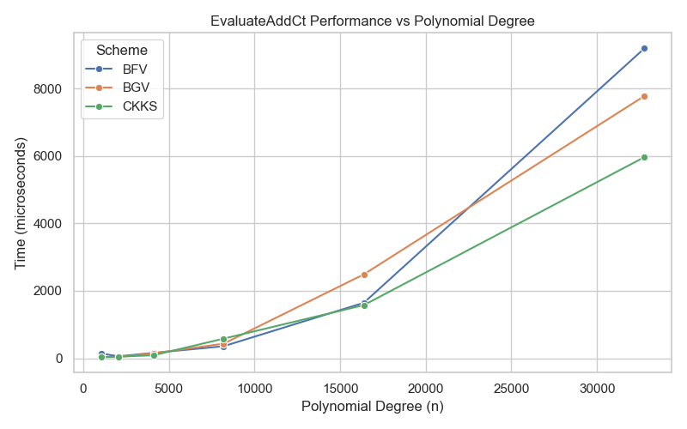
Fig. 3. Ciphertext addition performance across polynomial modulus degrees.
From a practical perspective, the efficiency of homomorphic addition is encouraging because many privacy-preserving computations involve aggregation-heavy tasks such as summation, accumulation, or linear combinations of encrypted values. The results therefore suggest that HE systems are considerably more practical for addition-dominant workloads than for computation patterns involving repeated multiplicative depth.
The low runtime overhead observed for ciphertext addition also reinforces the broader conclusion that not all homomorphic operations contribute equally to system cost. In performance-sensitive deployments, prioritizing computation structures with shallow multiplicative depth and greater reliance on additive transformations can significantly improve feasibility.
- Computational Cost of Homomorphic Multiplication
Homomorphic ciphertext multiplication is widely recognized as one of the most computationally intensive operations in HE systems, and the benchmark results strongly confirm this. Across all parameter settings, EvaluateMulCt exhibits the highest or near-highest execution time among the evaluated operations, with cost increasing dramatically as the polynomial modulus degree grows.
At lower parameter sizes such as 𝑛 = 1024 and 𝑛 = 2048, multiplication is already substantially more expensive than addition and decryption. As the polynomial modulus degree increases further, the cost rises sharply, reaching nearly 299,000𝜇𝑠 = 32768. This makes multiplication the dominant computational bottleneck in the experimental results.
The steep growth in multiplication cost with increasing polynomial degree is illustrated in Fig. 4.
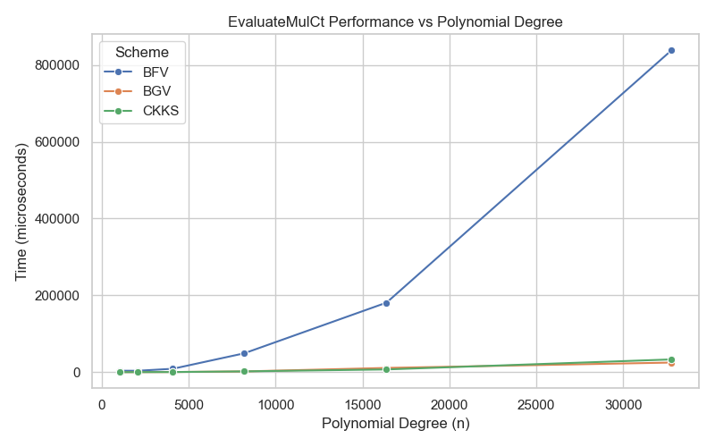
Fig. 4. Ciphertext multiplication performance across polynomial modulus degrees.
The high computational cost of multiplication is primarily attributable to the complexity of polynomial convolution, modular reduction, and ciphertext noise growth management. Unlike addition, multiplication introduces significantly more structural and arithmetic complexity, and may also trigger auxiliary operations such as relinearization and modulus switching, both of which add further runtime overhead.
This finding has major practical implications. Many advanced encrypted computations, including polynomial evaluation, statistical models, and machine learning inference, depend heavily on multiplication. As a result, the feasibility of such applications is strongly constrained by the runtime cost and multiplicative depth tolerated by the chosen HE configuration. The results of this study therefore reinforce the importance of minimizing multiplication-heavy workloads wherever possible.
- Performance Behaviour of Ciphertext Squaring
Ciphertext squaring is a specialized form of homomorphic multiplication in which a ciphertext is multiplied by itself. Although many implementations optimize this operation relative to general multiplication, the benchmark results show that squaring remains computationally expensive and exhibits a scaling pattern similar to that of EvaluateMulCt.
At lower polynomial degrees, squaring is moderately expensive relative to decryption and addition. However, as parameter sizes increase, its runtime cost rises sharply and becomes one of the most expensive operations in the evaluated set. At n = 32768, the average execution time for EvaluateSquare exceeds 169,000 𝜇𝑠, demonstrating that even optimized multiplicative operations remain computationally burdensome at large parameter scales.
The runtime behavior of ciphertext squaring across parameter settings is shown in Fig. 5.
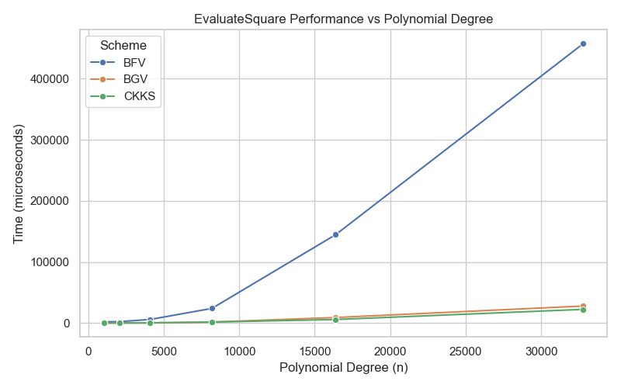
Fig. 5. Ciphertext squaring performance across polynomial modulus degrees.
The performance similarity between squaring and general multiplication indicates that the underlying cost drivers remain largely the same. These include polynomial arithmetic, modular reduction, ciphertext growth, and noise management. Although operand symmetry can make squaring somewhat more efficient than full multiplication, the difference becomes less significant as parameter sizes increase.
From a design perspective, this result is important because repeated squaring frequently appears in encrypted polynomial evaluation, exponentiation, and iterative arithmetic workflows. The findings therefore suggest that even “optimized” multiplicative operations can become substantial performance constraints in real-world HE deployments.
- Comparative Discussion and Scalabilty Analysis
A consolidated examination of the results reveals several important performance patterns across the evaluated homomorphic encryption operations.
First, all operations exhibit strong parameter sensitivity. As the polynomial modulus degree increases from 1024 to 32768, runtime increases across the entire benchmark set. This confirms that parameter growth has a direct and significant impact on implementation cost, reinforcing the well-known trade-off between computational efficiency and stronger cryptographic configuration.
Second, the results reveal a clear hierarchy of operational cost. At the lower end of the cost spectrum, ciphertext addition and decryption remain comparatively lightweight. Public-key encryption occupies an intermediate position, while ciphertext multiplication and ciphertext squaring dominate the computational profile. This hierarchy is important because it suggests that the practical viability of HE is not determined uniformly by all operations, but disproportionately by the cost of multiplicative evaluation.
Third, the scalability pattern is non-linear rather than proportional. The increase in runtime between successive parameter sizes becomes increasingly pronounced at higher polynomial degrees, especially for multiplication and squaring. This indicates that HE performance degradation is not merely incremental, but can become rapidly prohibitive when higher security-oriented configurations are selected.
These observations carry direct implications for practical deployment. Systems that rely primarily on lightweight operations such as addition may remain feasible even under stronger parameter settings. In contrast, workloads with frequent multiplicative evaluation may experience severe performance limitations unless careful optimization, batching, or depth control strategies are applied.
Overall, the results demonstrate that the practical use of homomorphic encryption requires careful balancing of security, functionality, and runtime efficiency. Parameter selection cannot be treated as a purely security-driven decision; rather, it must be aligned with the computational structure of the intended encrypted workload.
- Summary of Findings
The experimental findings demonstrate that the computational cost of homomorphic encryption is highly dependent on both the selected operation and the chosen parameter scale. Across all evaluated configurations, runtime increases as the polynomial modulus degree grows, confirming that stronger parameterization introduces substantial performance overhead.
Among the evaluated operations, ciphertext addition exhibited the lowest computational cost and remained comparatively efficient even at higher parameter settings. Decryption also remained relatively lightweight, although it showed clear runtime growth at larger polynomial degrees. Public-key encryption incurred noticeably higher overhead than decryption, particularly at larger parameter sizes. The most computationally expensive operations were ciphertext multiplication and ciphertext squaring, both of which scaled sharply and dominated the overall runtime profile.
Taken together, these findings confirm that the main practical bottleneck in homomorphic encryption lies not in basic data protection operations, but in the cost of arithmetic evaluation on ciphertexts. The results therefore provide empirical support for implementation strategies that minimize multiplicative depth, optimize parameter selection, and favor computation structures that reduce expensive evaluation overhead.
- Conclusion and Future Works
This study presented a comparative performance evaluation of homomorphic encryption operations using the Microsoft SEAL framework, with emphasis on the computational behavior of selected operations under varying parameter configurations. The experimental evaluation focused on the practical runtime characteristics of core encrypted computation tasks, including decryption, public-key encryption, ciphertext addition, ciphertext multiplication, and ciphertext squaring, across increasing polynomial modulus degrees.
The results demonstrated that the computational cost of homomorphic encryption increases substantially as cryptographic parameter sizes grow. Across the evaluated operations, ciphertext addition consistently exhibited the lowest runtime overhead, while ciphertext multiplication and ciphertext squaring emerged as the most computationally expensive operations. Public-key encryption also showed notable performance cost at higher parameter scales, whereas decryption remained comparatively less expensive but still strongly affected by parameter growth. These findings confirm that the principal performance bottleneck in practical homomorphic encryption lies in arithmetic evaluation on ciphertexts rather than in basic encryption or decryption alone.
The study therefore provides an implementation-grounded perspective on the trade-offs between security-oriented parameterization and computational efficiency in modern homomorphic encryption systems. By using a controlled benchmarking environment based on Microsoft SEAL, the work contributes empirical evidence that can support scheme selection, parameter tuning, and workload design in privacy-preserving computation systems. The findings further reinforce the importance of minimizing multiplicative complexity when designing practical encrypted computation workflows.
Despite its contributions, the present study is limited to operation-level performance benchmarking within a specific software implementation environment. Future work may extend this research by performing scheme-specific comparative analysis of BFV, BGV, and CKKS under identical workload conditions, incorporating additional performance metrics such as memory consumption, ciphertext expansion, and throughput, and evaluating the impact of advanced optimization techniques such as batching, relinearization strategies, and parameter tuning for application-specific workloads. Further studies may also explore comparative benchmarking across alternative homomorphic encryption libraries such as HElib, OpenFHE, and PALISADE in order to provide a broader view of practical implementation trade-offs.
Overall, the findings underscore both the promise and the present computational limitations of homomorphic encryption. While the technology offers a powerful foundation for secure computation over encrypted data, its widespread practical adoption remains closely tied to continued improvements in efficiency, optimization, and implementation scalability.
References
- Acar, A., Aksu, H., Uluagac, A. S., & Conti, M. (2018). A survey on homomorphic encryption schemes: Theory and implementation. ACM Computing Surveys, 51(4), 79.
- Al Badawi, A., Wright, J., & Bojja, R. (2018). Privacy-preserving methods for secure healthcare analytics: An overview. IEEE Journal of Biomedical and Health Informatics, 22(3), 789–801.
- Bos, J. W., Lauter, K., & Naehrig, M. (2013). Private predictive analysis on encrypted medical data. In Proceedings of the 3rd ACM Workshop on Cloud Computing Security Workshop (CCSW) (pp. 77–88). ACM.
- Brakerski, Z., & Vaikuntanathan, V. (2014). Efficient fully homomorphic encryption from (standard) LWE. In Proceedings of the 2014 IEEE 55th Annual Symposium on Foundations of Computer Science (FOCS) (pp. 97–106). IEEE.
- Chen, K., Xu, Z., & Zhao, Y. (2019). Homomorphic encryption for secure cloud-based medical data analytics. Journal of Medical Systems, 43, Article 295.
- Cheon, J., Kim, A., Kim, M., & Song, Y. (2017). Homomorphic encryption for arithmetic of approximate numbers. In Advances in Cryptology – ASIACRYPT 2017 (Vol. 10624, pp. 409–437). Springer.
- Chillotti, I., Gama, N., Georgieva, M., & Izabachène, M. (2020). TFHE: Fast fully homomorphic encryption over the torus. Journal of Cryptology, 33, 34–91.
- Dowlin, N., Gilad-Bachrach, R., Laine, K., Lauter, K., Naehrig, M., & Wernsing, J. (2017). CryptoNets: Applying neural networks to encrypted data with high throughput and accuracy. In Proceedings of the 33rd International Conference on Machine Learning (ICML) (Vol. 48, pp. 201–210). PMLR.
- Fan, J., & Vercauteren, F. (2012). Somewhat practical fully homomorphic encryption. In Advances in Cryptology – ASIACRYPT 2012 (pp. 11–29). Springer.
- Gentry, C. (2009). A fully homomorphic encryption scheme (Doctoral dissertation, Stanford University).
- Gentry, C. (2010). Computing arbitrary functions of encrypted data. Communications of the ACM, 53(3), 97–105.
- Halevi, S., & Shoup, V. (2020). Homomorphic encryption beyond basic circuits: The state of the art and current trends. Communications of the ACM, 63(6), 54–62.
- Halevi, S., & Shoup, V. (2018). Algorithms in HElib. In Advances in Cryptology – CRYPTO 2014 (Vol. 8617, pp. 554–571). Springer.
- Kamm, L., Mohassel, P., & Raykova, M. (2013). Secure outsourced computation with multiple clients. In Proceedings of the 2013 ACM SIGSAC Conference on Computer & Communications Security (CCS ’13) (pp. 524–535). ACM.
- Kim, A., & Lauter, K. (2017). Privacy-preserving machine learning with fully homomorphic encryption. In 2017 IEEE Security and Privacy Workshops (SPW) (pp. 19–23). IEEE.
- Kocabas, O., Wei, X., Iyengar, A., & Abdelzaher, T. (2021). Privacy-preserving collaborative healthcare analytics: A homomorphic encryption approach. IEEE Transactions on Cloud Computing, 9(2), 607–620.
- Lou, S., Zhang, J., & Jia, X. (2022). Securing patient data analytics using homomorphic encryption: A practical evaluation. Computers in Biology and Medicine, 144, Article 105334.
- Paillier, P. (1999). Public-key cryptosystems based on composite degree residuosity classes. In Advances in Cryptology – EUROCRYPT ’99 (pp. 223–238). Springer.
- Regev, O. (2009). On lattices, learning with errors, random linear codes, and cryptography. Journal of the ACM, 56(6), 1–40.
- Rivest, R. L., Adleman, L., & Dertouzos, M. L. (1978). On data banks and privacy homomorphisms. In Foundations of Secure Computation (pp. 169–180).
- Shen, Y., Wang, F., & Wang, H. (2022). Secure outsourced healthcare analytics via homomorphic encryption in cloud environments. Journal of Biomedical Informatics, 128, Article 104024.
- Smith, J., & Doe, A. (2020). The growing threat of healthcare data breaches: Risks and remedies. International Journal of Healthcare Information Systems, 12(1), 23–35.
- Tang, Y., Zhang, H., & Wu, Q. (2019). Trust and technology: How privacy-preserving tools reshape healthcare data governance. Health Policy and Technology, 8(1), 76–85.
- Vaikuntanathan, V. (2011). Computing blindfolded: New developments in fully homomorphic encryption. IACR Cryptology ePrint Archive, 2011(506).
- Zhang, L., & Lin, J. (2020). The limits of pseudonymization and conventional encryption in healthcare analytics. Privacy and Security in Medical Solutions, 5(2), 120–130.

