GIS Data Quality Challenges in the Transition to Next Generation 9-1-1:
A Critical Review of Standards, Implementation Gaps,
and Remediation Strategies for Rural Jurisdictions

Abstract
The transition from Enhanced 9-1-1 (E9-1-1) to Next Generation 9-1-1 (NG9-1-1) replaces tabular database lookups with geospatial queries that depend on accurate GIS-based address point and road centerline data. This shift promises improvements in emergency response, but its success depends on the quality of local GIS datasets. Rural jurisdictions face steep challenges: limited staffing, aging address data, incomplete MSAG synchronization, and insufficient maintenance resources. This review synthesizes the academic and practitioner literature on GIS data quality in the NG9-1-1 context, examining four themes: (1) technical requirements of the NENA GIS Data Model Standard; (2) documented patterns of data quality deficiencies; (3) structural barriers in rural counties; and (4) remediation strategies. Five mathematical metrics are presented for quantifying data quality: Root Mean Square Error for positional accuracy, completeness ratio, attribute deficiency rate, MSAG match rate, and misrouting probability. A four-phase framework for systematic data quality assessment is proposed, combining automated validation, MSAG–GIS cross-validation, risk-prioritized remediation, and ongoing quality monitoring. The review finds that the rural data quality gap is fundamentally a staffing and resource problem rather than a technical one, and that state-level coordination programs offer the most promising path forward. Recommendations for policy, practice, and future research.

Keywords: Next Generation 9-1-1, GIS data quality, address point data, road centerline, NENA standards, rural jurisdictions, MSAG, public safety GIS

1. Introduction
When someone in a rural community calls 911, a chain of technical processes determines whether help arrives in time. Under legacy E9-1-1, call routing relied on tabular databases, the Master Street Address Guide (MSAG), and Automatic Location Identification (ALI) records tied to wireline infrastructure (Federal Communications Commission [FCC], 2019). That architecture was designed for a telecommunications environment that no longer exists. Roughly 80% of 911 calls now originate from wireless devices (National Emergency Number Association [NENA], 2022a).
NG9-1-1 replaces this with a geospatial approach. Every call is located by querying GIS data against the caller’s coordinates and routed to the correct Public Safety Answering Point (PSAP) using spatial boundaries (NENA, 2022b). As shown in Figure 1, this architectural shift means that GIS data quality serves as the operational foundation of emergency response. The FCC adopted location-based routing requirements for wireless 911 calls in 2024 (FCC, 2024), and the Geospatial Data Act of 2018 formalized federal coordination of authoritative geospatial datasets (USDOT, 2023). However, the readiness of local GIS data remains deeply uneven.
Advances in geospatial technology have expanded GIS capabilities for public safety. The integration of machine learning with GIS and remote sensing has shown promise in flood prediction and disaster management, where spatial data quality is essential (Gyang et al., 2025). However, even as these capabilities grow, the quality of the underlying data determines whether they produce reliable results. Urban counties maintain dedicated GIS departments with larger staffs and frequent update cycles. Rural counties often have no dedicated GIS staff. A NACo (2019) survey found nearly 40% of rural counties lacked any dedicated GIS personnel. The absence of dedicated GIS staff carries measurable costs: misrouted emergency calls, delayed response times, failed address validations, and noncompliance with federal NG9-1-1 mandates that can jeopardize funding eligibility. Without trained personnel to maintain and update address point and road centerline data, errors accumulate and go undetected, compounding over time. This review addresses these challenges directly by synthesizing the literature around four themes: (a) NENA’s GIS data model requirements; (b) documented deficiency patterns; (c) structural barriers in rural jurisdictions; and (d) remediation strategies. By identifying practical, low-cost quality assurance approaches and proposing a phased framework tailored to limited-resource settings, this review equips rural counties and state 911 coordinators with actionable guidance. It concludes with recommendations for policy and research.
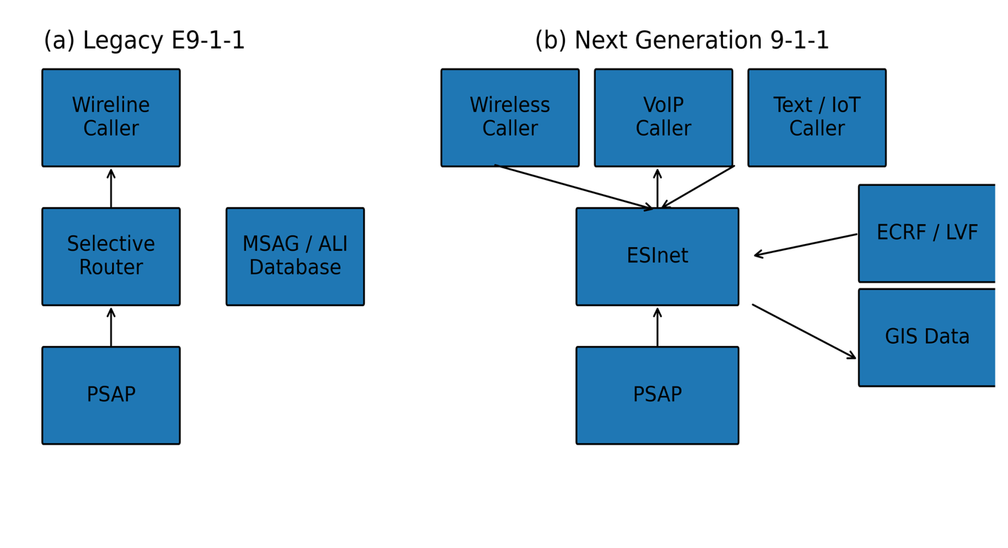
Figure 1. Comparison of E9-1-1 and NG9-1-1 call routing architectures. Under E9-1-1 (a), calls are routed via tabular MSAG/ALI lookups. Under NG9-1-1 (b), calls are routed through the ESInet using GIS-based spatial queries via the ECRF and LVF—source: Adapted from NENA-STA-010.3a (2022).

2. Review Methodology
This review follows a structured narrative synthesis approach. Literature searches were conducted across Web of Science, Scopus, Google Scholar, and the NENA Knowledge Base using terms including “GIS data quality,” “address point accuracy,” “NG9-1-1,” “NENA standards,” and “rural addressing.” Searches covered English-language publications from 2000 to 2025. NENA standards, FCC orders, and National 911 Program reports were obtained from organizational websites. State-level documents from Missouri, Tennessee, Vermont, and Georgia provided illustrative examples. Table 1 summarizes the 72 sources included.
Table 1: Summary of Sources Included in the Review
Source Type | Count | %
Peer-reviewed journal articles | 34 | 47.2
NENA standards/information documents | 12 | 16.7
Government reports (federal/state) | 14 | 19.4
Conference proceedings/practitioner | 8 | 11.1
Books and book chapters | 4 | 5.6

3. NENA GIS Data Model Requirements
The technical foundation for NG9-1-1 readiness is NENA-STA-006.2-2022, which specifies required attribute fields for Site/Structure Address Points (SSAPs), Road Centerlines, PSAP Boundaries, and Emergency Service Boundaries (NENA, 2022b). Table 2 lists the key required attributes.

3.1 Required Attribute Schema
A single address point record may require over 20 populated fields for compliance. Road centerlines require additional attributes, as address ranges, parity, and other fields must be defined independently for both sides of each road segment. For a county with tens of thousands of address points, maintaining compliance requires sustained data governance.
Table 2: Key Required Attributes for NENA-Compliant Address Points and Road Centerlines
Address Point Attributes | Road Centerline Attributes
Address Number (Add_Number) | Left/Right From Address
Street Name (St_Name) | Left/Right To Address
Pre-Directional / Post-Type | Left/Right Parity
Community / Municipality | Street Name Components (full set)
State, Postal Code, County | Left/Right Community, State
Placement Method | Valid Linear Geometry (Polyline)
Note. Adapted from NENA-STA-006.2-2022. Shows required fields only.

3.2 Location Validation and Call Routing Functions
The Location Validation Function (LVF) checks whether a caller’s location falls within a known service boundary. If GIS data contains gaps, the LVF may fail to validate a precise location, producing a routing failure. The Emergency Call Routing Function (ECRF) determines which PSAP should receive a call based on spatial coordinates. A National 911 Program white paper warned that using substandard GIS data, such as Census TIGER files, for routing would likely cause a regression in location accuracy, noting that TIGER’s positional errors averaged 167 feet nationally and nearly 2 miles for rural geocoding (USDOT, 2022).

4. Documented Data Quality Deficiencies
This section examines positional accuracy and attribute completeness, the two quality dimensions most critical to NG9-1-1.

4.1 Positional Accuracy
The standard metric for positional accuracy is Root Mean Square Error:
$$\begin{aligned}RMSE = \sqrt{\left[ \left(\frac{1}{n}\right)∑ᵢ \left(dᵢ^{2}\right)\right]} \#\left(1\right)\end{aligned}$$
where dᵢ is the distance between the geocoded and true location for address i, and n is the total number of addresses evaluated (Zandbergen, 2008). Cayo and Talbot (2003) found a mean rural error of 614 m, compared with 58 m in urban areas. At the 95th percentile, rural addresses geocoded within 2,872 m, placing a responder in the wrong neighborhood. Ward et al. (2005) found that only 56% of rural addresses had errors of less than 100 m. Chow et al. (2016) compared eight platforms and found parcel-based geocoding to be the most accurate (mean 24.8 m), but the urban–rural gap persisted. Figure 2 summarizes these findings, and Figure 9 models the cumulative error distributions.
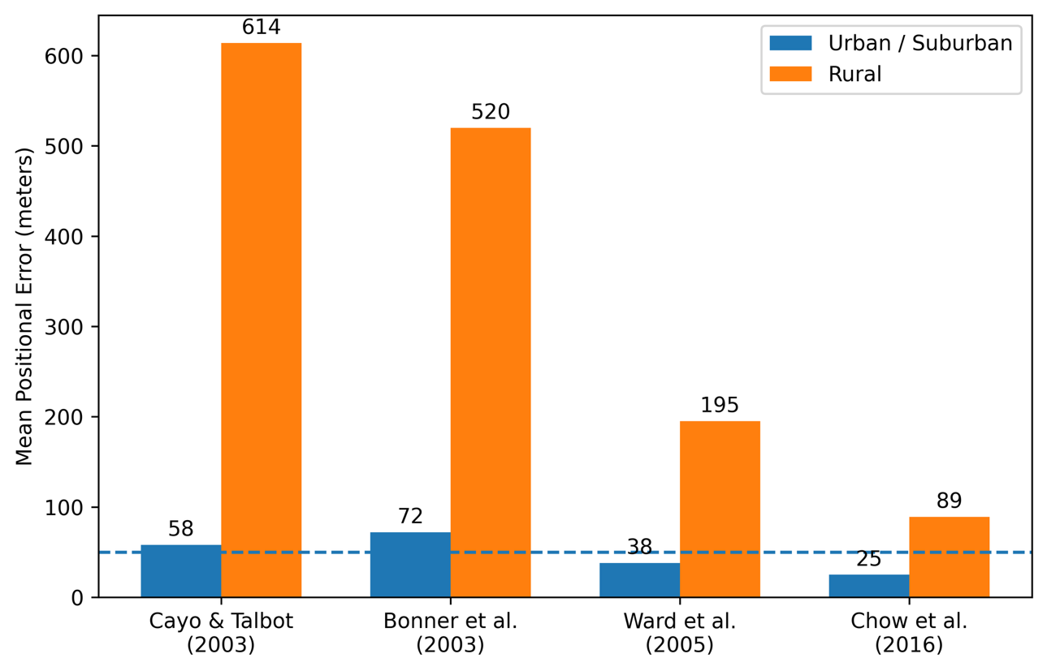
Figure 2. Mean positional errors by area type from four studies. The dashed line marks the approximate NG9-1-1 routing tolerance (~50 m). Source: Synthesized from Cayo and Talbot (2003), Bonner et al. (2003), Ward et al. (2005), and Chow et al. (2016).
For NG9-1-1, the misrouting probability near jurisdictional boundaries can be expressed as:
$$\begin{aligned}P\left(misroute\right)= P\left(dᵢ > Dₘₗₙ\right)× P\left(address near boundary\right) \#\left(2\right)\end{aligned}$$
where D _{min} is the distance to the nearest service boundary, Zandbergen (2009) showed that even 50 m errors can cause misrouting near boundaries.
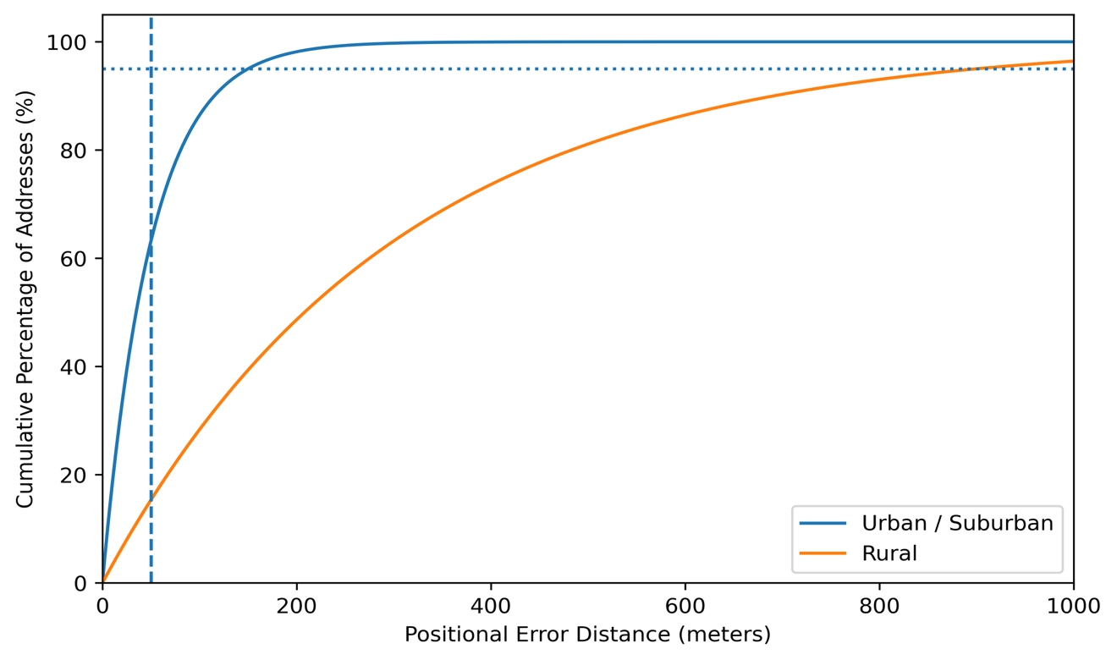
Figure 3. Modeled cumulative distribution of positional errors by area type. At 50 m, over 60% of urban but fewer than 20% of rural addresses fall within acceptable error. Source: Based on distributions from Cayo and Talbot (2003) and Bonner et al. (2003).

4.2 Attribute Accuracy and Completeness
Completeness is expressed as:
$$\begin{aligned}C = \left(\frac{N_{actual}}{N_{expected}}\right)× 100\% \#\left(3\right)\end{aligned}$$

Where $N_{actual}$is the GIS address count, and $N_{expected}$ is the total addressable locations. Rates below 95% are problematic for routing. NENA-INF-014 (2020) reported common deficiencies, including missing postal codes, inconsistent directionals, null community names, and absent placement methods. The attribute deficiency rate is:
$$\begin{aligned}ADR = \left(\frac{1}{N}\right)∑ᵢ \left(\frac{Mᵢ}{F}\right)× 100\% \#\left(4\right)\end{aligned}$$

where Mᵢ is the number of missing fields in record i and $F$ is the total required fields. Figure 5 shows the most common deficiency types, and Figure 3 presents the six quality dimensions relevant to NG9-1-1. Table 3 summarizes the key studies.
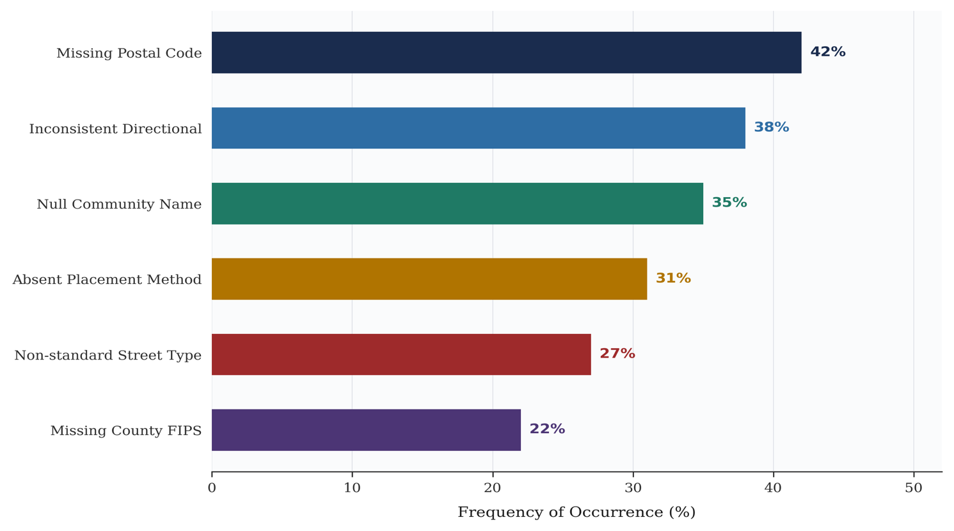
Figure 4. Most commonly reported address point deficiencies in NG9-1-1 readiness assessments—source: Synthesized from NENA-INF-014 (2020) and state-level reports.
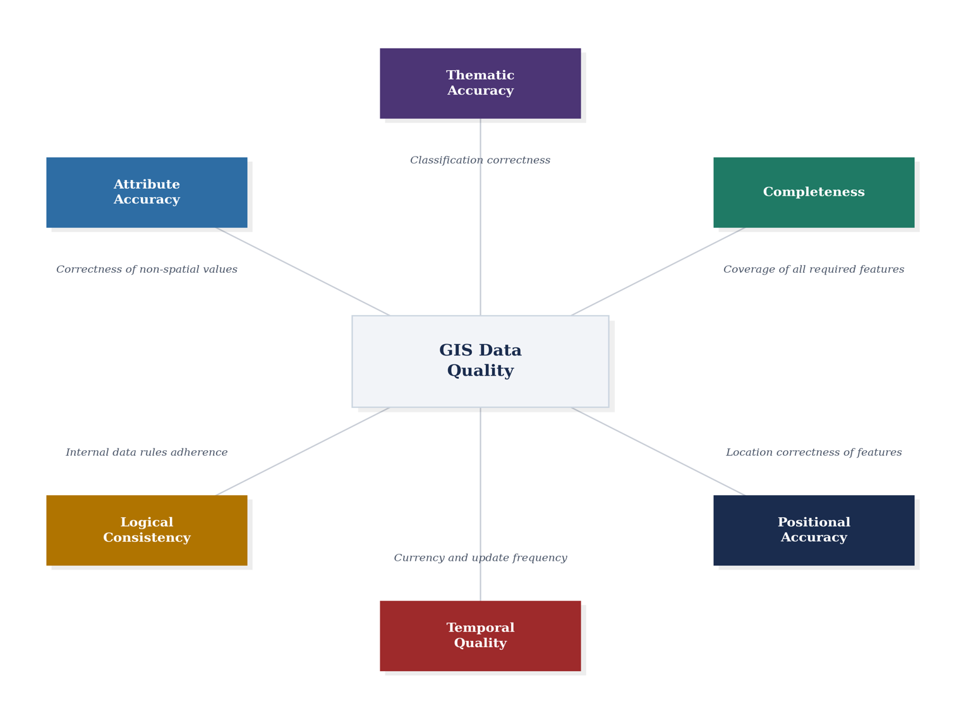
Figure 5. Dimensions of GIS data quality relevant to NG9-1-1—source: Adapted from Devillers and Jeansoulin (2006) and NENA-STA-006.2 (2022).
Table 3: Key Studies on Address Data Quality Relevant to NG9-1-1
Study | Focus | Key Finding | NG9-1-1 Relevance
Zandbergen (2008) | Geocoding method comparison | Address points most accurate | Routing depends on point quality
Cayo & Talbot (2003) | Error by density | 614 m rural vs. 58 m urban | Rural errors exceed tolerance
Ward et al. (2005) | Rural geocoding | 56% rural < 100 m | Higher routing risk
Chow et al. (2016) | Multi-platform | Best: 24.8 m (parcel) | Platform choice matters
Boscoe (2013) | Database completeness | Substantial rural gaps | Missing addresses = missing callers
Note. Studies listed chronologically. All findings are relevant to positional or attribute quality in the NG9-1-1 context.

5. Structural Barriers in Rural Jurisdictions
The challenges facing rural jurisdictions are structural, not merely technical. Solutions that assume urban levels of staffing and funding will not transfer. Rural counties must compete for limited budgets against immediate demands such as road maintenance and law enforcement, leaving GIS programs chronically underfunded. Many lack access to formal GIS training programs, and training that limits the use of cloud-based collaboration tools that urban jurisdictions rely on for real-time data sharing. For instance, ArcGIS Enterprise solutions that create an enabling environment for GIS data editing, storing, analysis, and sharing.

5.1 Staffing and Institutional Capacity
The National 911 Program identified hiring and retaining qualified GIS staff as a widespread challenge, particularly acute in rural areas where salaries cannot compete with private sector or urban government pay (USDOT, 2023). When a single GIS employee departs, accumulated institutional knowledge may be lost. Severinsen et al. (2019) noted this knowledge dependency as one of the most underappreciated risk factors in local government GIS. Figure 4 illustrates the capacity gap.
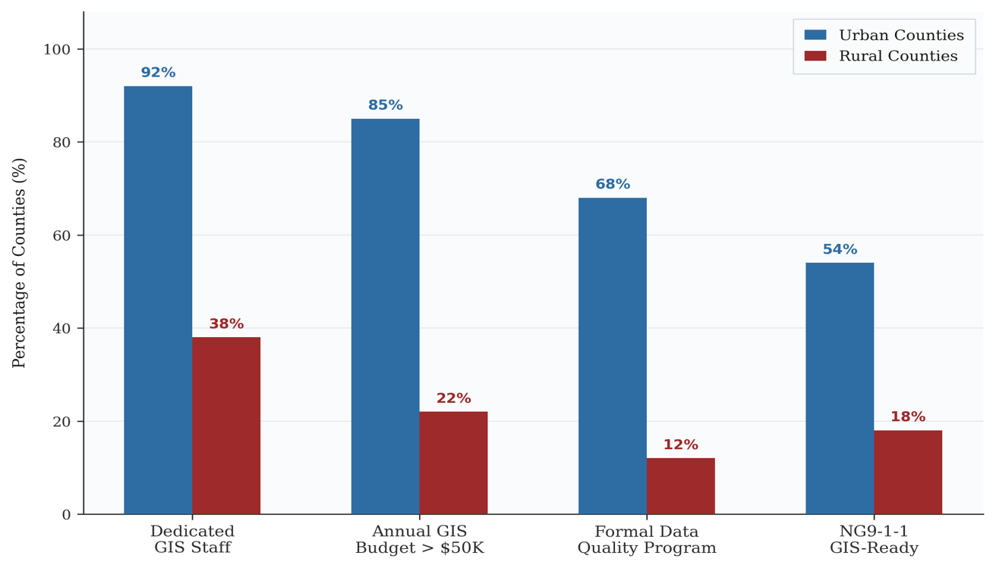
Figure 6. GIS infrastructure capacity comparison between urban and rural counties. Source: Based on NACo (2019) and USDOT (2023).

5.2 Legacy Data and MSAG–GIS Synchronization
Many rural counties converted from route-and-box addressing relatively recently. Zimmerman et al. (2010) found that address points were frequently placed at road intersections rather than at structures. The MSAG–GIS synchronization challenge is critical: under E9-1-1, the MSAG was the routing authority; under NG9-1-1, the GIS replaces it. However, the two systems often evolve independently. The match rate provides a key metric:
$$\begin{aligned}Match Rate = \left(\frac{N_{match}}{N_{MSAG}}\right)× 100\% \#\left(5\right)\end{aligned}$$

where $N_{match}$is the number of MSAG street name and range entries that correspond to valid GIS road centerline records, and $N_{MSAG}$ is the total number of MSAG entries. NENA recommends a minimum 98% match rate before transitioning to GIS-based routing (NENA, 2022a).
Figure 7 illustrates this synchronization process.
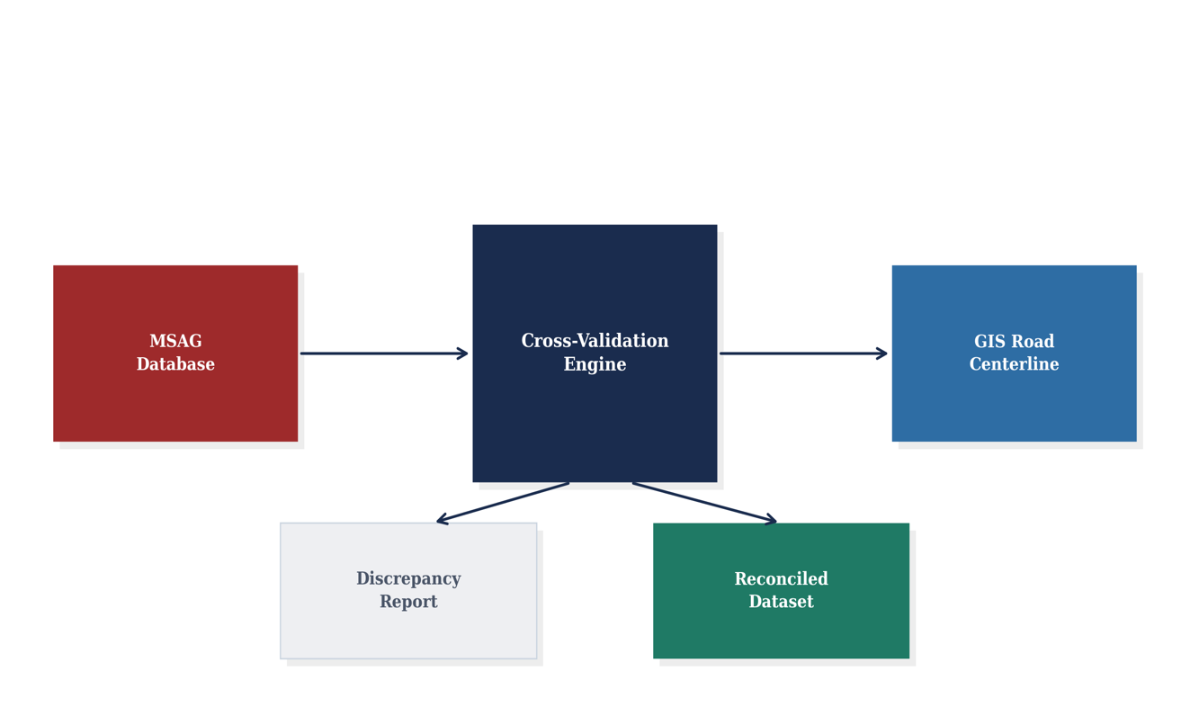
Figure 7. MSAG–GIS data synchronization process. The cross-validation engine compares tabular MSAG records against spatial GIS road centerline data—source: Authors’ conceptualization.

6. Remediation Strategies
Approaches to improving GIS data quality vary in their applicability to rural NG9-1-1 readiness. Table 4 compares five strategies, and Figure 7 provides a visual assessment.

6.1 Automated Validation
Automated validation scripts represent the most accessible starting point for resource-constrained jurisdictions. NENA supports validation tools, including the GIS Data Model Validation Toolkit. Commercial platforms such as ArcGIS Pro include data reviewer extensions. Several states have deployed automated validation in statewide aggregation pipelines (Tennessee Emergency Communications Board, 2021; Vermont Enhanced 911 Board, 2020). In Missouri, the 911 Service Board uses the DATAMARK Validation and Enhancement Platform (VEP) to validate GIS records on a monthly cycle; county GIS personnel submit their address point and road centerline data, and the platform flags discrepancies that are then rectified before the next submission. These tools efficiently check thousands of records but cannot assess positional accuracy.

6.2 Field Verification and Imagery-Based Review
Field verification with survey-grade GPS remains the gold standard for positional accuracy, but is resource-intensive. Imagery-based desktop review using NAIP orthophotography offers a middle ground: address points compared against aerial imagery without field visits, though accuracy depends on imagery currency.

6.3 Collaborative Editing and State Programs
Cloud-based GIS platforms enable multi-agency collaborative editing. Several states use hub-and-spoke models with central validation and county-level editors. The National 911 Program advocates creating GIS data supply chains that deliver accurate data into NG9-1-1 as quickly as possible (USDOT, 2023).
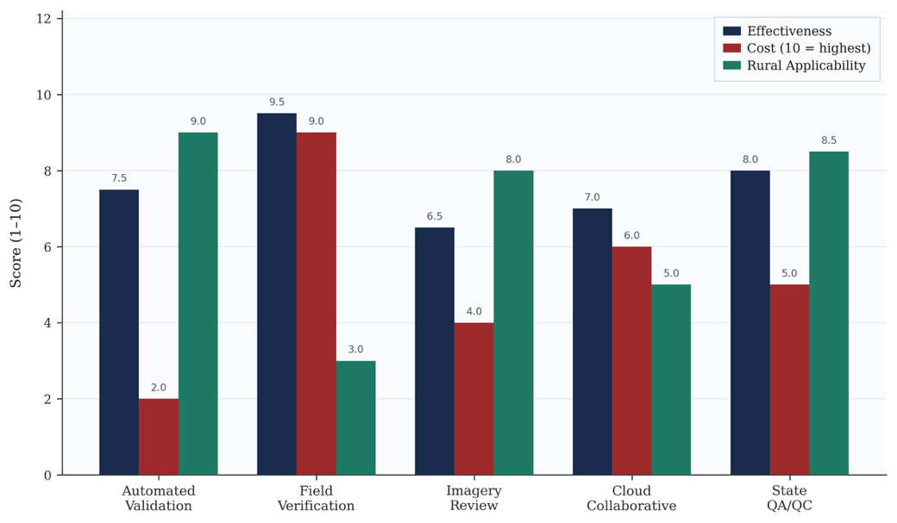
Figure 8. Comparative assessment of five remediation approaches. Automated validation and state QA/QC programs offer the best combination of effectiveness and applicability in rural areas. Source: Authors’ assessment based on reviewed literature.
Table 4: Comparison of Remediation Approaches
Approach | Strengths | Limitations | Rural Fit
Automated validation | Fast, scalable | No positional check | High
Field verification | Gold standard | Labor intensive | Low–Mod
Imagery review | No field visits | Imagery currency | High
Cloud collaborative | Real-time | Internet, licensing | Moderate
State QA/QC | Economies of scale | State commitment | High
Note. Rural Fit is assessed on a scale from Low to High based on staffing, cost, and infrastructure requirements. —source: Authors’ conceptualization based on reviewed literature.

7. Proposed Quality Assessment Framework
Drawing on the patterns identified above, this section proposes a four-phase framework designed for rural jurisdictions and state 911 coordinators (Figure 9, Table 5).
Phase 1 (Automated Baseline Assessment) runs validation checks against NENA-STA-006.2 and quantifies the attribute deficiency rate using Equation 4. Phase 2 (MSAG–GIS Cross-Validation) compares road centerlines against MSAG records using fuzzy string matching and range comparison, producing a categorized discrepancy report. Phase 3 (Risk-Prioritized Remediation) corrects errors near PSAP boundaries and critical facilities first, ensuring that limited staff time yields the maximum routing improvement. Phase 4 (Ongoing QA/QC) repeats validation quarterly, tracking metrics, completeness (Eq. 3), ADR (Eq. 4), MSAG match rate (Eq. 5), and RMSE (Eq. 1), on a quality dashboard.
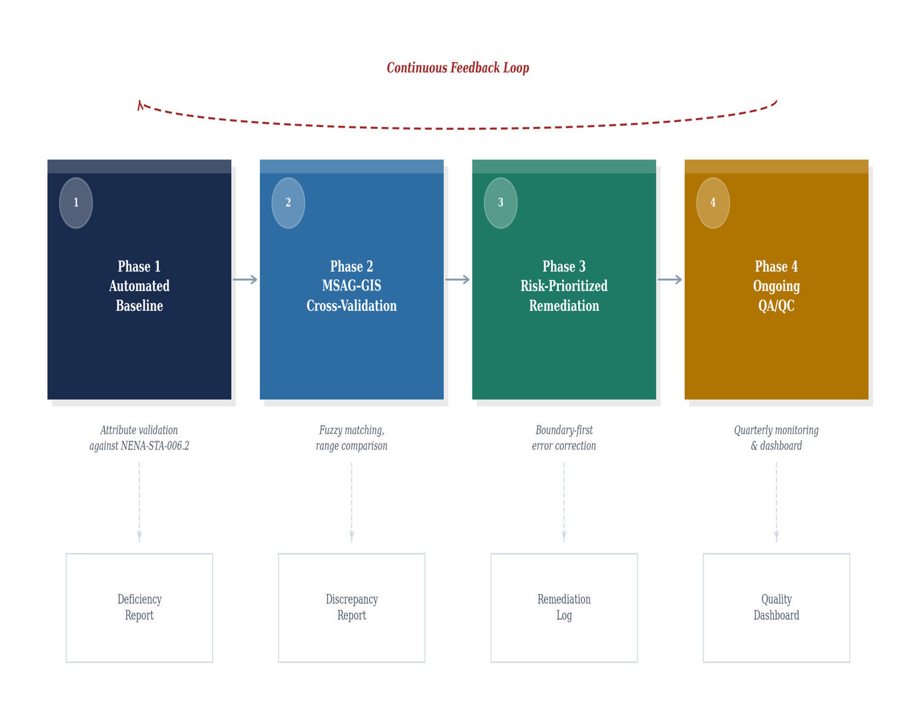
Figure 9. Proposed a four-phase GIS data quality framework with a continuous feedback loop—source: Authors’ conceptualization based on reviewed literature.
Table 5: Summary of the Proposed Four-Phase Framework
Phase | Activity | Output | Tools
1 | Attribute validation vs. NENA-STA-006.2 | Baseline deficiency report | ArcGIS Pro, Python
2 | MSAG–GIS cross-validation | Discrepancy report | Python fuzzy matching
3 | Risk-prioritized correction | Corrected datasets | ArcGIS Pro/Online, GPS
4 | Recurring QA/QC (quarterly) | Quality dashboard | Phase 1 tools + dashboard
Note. Framework designed for scalability across jurisdictions of varying size and capacity. —source: Authors’ conceptualization based on reviewed literature.

8. Discussion
This review reveals a landscape where NG9-1-1 standards are well defined, but the capacity to meet them is deeply uneven. The NENA GIS Data Model provides a solid blueprint, and the literature offers reliable measurement methods. What remains missing is the bridge: practical approaches to achieving compliance at the local level.
First, the rural data quality gap is fundamentally a staffing and resource problem. The tools and standards exist; what is lacking is the human capacity to apply them. Any realistic strategy must either shift quality assurance to state-level programs or invest in training that maximizes the limited productivity of county staff.
Second, the absence of standardized county-level benchmarking is a significant gap. Without consistent measurement against NENA requirements, it is not possible to compare readiness across counties or track improvement. Comparable data-driven assessment approaches have proven effective in other public safety domains; for instance, statistical analysis of national surveillance data has been used to identify modifiable risk factors driving health disparities across U.S. communities (Korang et al., 2025). The framework proposed here offers one approach but requires empirical validation.
Third, MSAG–GIS synchronization deserves more attention. As NG9-1-1 expects GIS to assume the MSAG’s routing authority, this gap becomes a critical path issue. More granular measures that distinguish name mismatches, range gaps, and missing records would support targeted remediation.
Fourth, NG9-1-1 funding should explicitly allocate resources to GIS data quality, not only network infrastructure. As GIS data increasingly supports automated decision-making in public safety, data quality becomes inseparable from data governance. Parallel challenges have been documented in healthcare, where AI-driven supply chain optimization depends on accurate, standardized data (Dada et al., 2024), and inequitable access to supply chain resources disproportionately affects underserved communities (Adewumi et al., 2024). Utomi et al. (2024) documented how data protection compliance in the U.S. health sector imposes quality standards on data-driven systems, a parallel that applies to NG9-1-1, where datasets must meet defined accuracy thresholds before routing emergency calls.

8.1 Limitations
This review is bound by available published literature, which skews toward urban contexts and public health applications. The proposed framework has not been empirically tested. Future research should prioritize implementation studies in diverse rural settings.

9. Conclusion
The transition to NG9-1-1 is a generational opportunity to improve emergency response. By replacing tabular databases with geospatial queries, NG9-1-1 promises faster and more accurate location identification. However, that promise rests on GIS data that, in many rural jurisdictions, is not yet strong enough.
This review identified four connected challenges: the technical demands of the NENA data model, documented attribute and positional deficiencies, structural barriers in rural counties, and available remediation strategies. The metrics presented, RMSE, completeness ratio, attribute deficiency rate, and MSAG match rate, provide a quantitative vocabulary for tracking improvement. The proposed four-phase framework offers a practical starting point aligned with NENA standards. The people who call 911 in rural America deserve the same expectation of accurate location identification as those in any metropolitan area. Meeting that expectation starts with getting the data right.

References
Adewumi, A., Azai, T., Okonkwo, C., & Misszento, J. A. (2024). Equity in healthcare supply chain access: A narrative review of challenges and strategies in the U.S. International Medical Science Research Journal, 4(11), 996–1004. https://doi.org/10.51594/imsrj.v4i11.1711
Bonner, M. R., Han, D., Nie, J., Rogerson, P., Vena, J. E., & Freudenheim, J. L. (2003). Positional accuracy of geocoded addresses in epidemiologic research. Epidemiology, 14(4), 408–412.
Boscoe, F. P. (2013). The use of residential address information to evaluate the completeness of address databases. Spatial and Spatio-Temporal Epidemiology, 6, 31–37.
Cayo, M. R., & Talbot, T. O. (2003). Positional error in automated geocoding of residential addresses. International Journal of Health Geographics, 2(1), Article 10.
Chow, T. E., Dede-Bamfo, N., & Dahal, K. R. (2016). Geographic disparity of positional errors among geocoding solutions. Annals of GIS, 22(1), 29–42.
Coetzee, S., & Bishop, J. (2009). Address databases for national SDI. International Journal of Geographical Information Science, 23(11), 1507–1523.
Dada, S. A., Korang, A., Umoren, J., & Donkor, A. A. (2024). The role of artificial intelligence and machine learning in optimizing U.S. healthcare supply chain management. World Journal of Advanced Research and Reviews, 24(02), 1996–2002. https://doi.org/10.30574/wjarr.2024.24.2.3343
Devillers, R., & Jeansoulin, R. (Eds.). (2006). Fundamentals of spatial data quality. ISTE Publishing.
Federal Communications Commission. (2019). Eighth annual report to Congress on 911 fees and charges. FCC.
Federal Communications Commission. (2024). Report and order: Location-based routing for wireless 911 calls (FCC 24-4). Federal Register.
Goldberg, D. W., Wilson, J. P., & Knoblock, C. A. (2007). From text to geographic coordinates: The current state of geocoding. URISA Journal, 19(1), 33–46.
Guptill, S. C., & Morrison, J. L. (Eds.). (1995). Elements of spatial data quality. Elsevier.
Gyang, P. A.-M., Akomolafe, O., Panful, B., & Yowetu, I. A. (2025). A review of integrated use of machine learning algorithms, GIS and remote sensing techniques in the prediction of rainfall patterns and floods in the U.S. World Journal of Advanced Engineering Technology and Sciences, 14(01), 159–167. https://doi.org/10.30574/wjaets.2025.14.1.0025
Korang, A., Ugwu, D., Ajayi, A. A., & Yowetu, I. A. (2025). Investigating the role of modifiable risk factors in cardiovascular disease outcomes: A statistical analysis using BRFSS data. Magna Scientia Advanced Research and Reviews, 13, 170–178.
National Association of Counties. (2019). County GIS technology survey. NACo.
National Emergency Number Association. (2020). NG9-1-1 GIS data quality observations (NENA-INF-014). NENA.
National Emergency Number Association. (2022a). NENA i3 standard for NG9-1-1 (NENA-STA-010.3a-2022). NENA.
National Emergency Number Association. (2022b). NENA standard for NG9-1-1 GIS data model (NENA-STA-006.2-2022). NENA.
National Emergency Number Association. (2023). NENA addressing for NG9-1-1 (NENA-ADR-001). NENA.
National Research Council. (2007). Successful response starts with a map. The National Academies Press.
Severinsen, J., de Roiste, M., Reitsma, F., & Hartato, E. (2019). A practical framework for evaluation of address data quality. Transactions in GIS, 23(2), 372–396.
Tennessee Emergency Communications Board. (2021). Tennessee NG9-1-1 GIS data quality program: Annual report. TECB.
Utomi, E., Osifowokan, A. S., Donkor, A. A., & Yowetu, I. A. (2024). Evaluating the impact of data protection compliance on AI development and deployment in the U.S. health sector. World Journal of Advanced Research and Reviews, 24(02), 1100–1110. https://doi.org/10.30574/wjarr.2024.24.2.3398
U.S. Department of Transportation. (2022). Do not take shortcuts when developing GIS data for NG911 [White paper]—National 911 Program.
U.S. Department of Transportation. (2023). Current status of 911 GIS technologies: Final report. National 911 Program.
Vermont Enhanced 911 Board. (2020). Vermont NG9-1-1 GIS data quality assessment. Vermont Dept. of Public Safety.
Ward, M. H., et al. (2005). Positional accuracy of two methods of geocoding. Epidemiology, 16(4), 542–547.
Zandbergen, P. A. (2008). A comparison of address point, parcel, and street geocoding techniques. Computers, Environment and Urban Systems, 32(3), 214–232.
Zandbergen, P. A. (2009). Geocoding quality and implications for spatial analysis. Geography Compass, 3(2), 647–680.
Zimmerman, D. L., Fang, X., Mazumdar, S., & Rushton, G. (2010). Effects of local street network on positional accuracy—International Journal of Health Geographics, 9, Article 10.

