Morphogenetic and Hairy Root Induction Responses in various Explants of Justicia adhatoda
ABSTRACT
Justicia adhatoda is an important medicinal plant widely utilised in rural healthcare systems for the treatment of various ailments. Its leaves contain bioactive pyrroloquinazoline alkaloids, notably vasicine and vasicinone, which are responsible for its therapeutic properties. The plant exhibits significant pharmacological activities, including expectorant, antiseptic, antiperiodic, and anthelmintic effects. In vitro plant tissue culture techniques offer valuable approaches for the controlled production and enhancement of secondary metabolites. Methods such as callus culture, cell suspension culture, and hairy root culture can be effectively employed to manipulate growth conditions and increase the yield of desired bioactive compounds. In the present study we report an efficient somatic embryogenesis and their histochemical analysis, plant regeneration, Induction of hairy roots using Agrobacterium rhizogene ATCC15834, harboring agropine-type plasmid pRiA4b and A4 strains from various explants of Justicia adhatoda. Hairy root suspensions were analyzed by HPLC and relative amount of the vasicine yield was estimated to be 8mg/gDW.

Keywords: Justicia adhatoda pyrroloquinazoline alkaloid, Vasicine, somatic embryogenesis, hairy root cultures, Agrobacterium rhizogenes
INTRODUCTION
Justicia adhatoda, formerly known as Adhatoda zeylanica, belongs to the family Acanthaceae and is commonly referred to as Vasaka in Sanskrit and Malabar nut in English. It is an evergreen perennial shrub that typically attains a height of up to 2 metres (Fig. 1). The leaves are rich in pyrroloquinazoline alkaloids, with vasicine and vasicinone being the principal bioactive constituents. During the COVID-19 pandemic, research involving extracts of Adhatoda vasica demonstrated notable anti-hypoxic properties, which were shown to alleviate severe airway inflammation associated with an exaggerated hypoxic response in treatment-resistant asthmatic mice (Atish G et al., 2021).
Vasicinone may be used to develop a new therapeutic agent against oxidative stress induced lung cancer (Tapan et al, 2018). Indiscriminate harvesting of medicinal plants may ultimately lead to their extinction in natural habitats (Barone et al., 2019). In addition to seasonal variability, a large proportion of plant-derived alkaloids are difficult to synthesise chemically. Consequently, biotechnological strategies, particularly plant tissue culture, have emerged as valuable supplements to conventional agriculture for the industrial production of bioactive secondary metabolites (Ramachandra Rao and Ravishankar, 2002; Biswas, 2023). Various in vitro culture systems, including callus cultures, cell suspension cultures, and hairy root cultures, can be effectively manipulated to enhance both the production and yield of secondary metabolites (Gantait et al., 2020). In addition, biotechnological approaches such as micropropagation and somatic embryogenesis offer significant advantages for the conservation and large-scale propagation of rare and economically important medicinal plants (Thiruvengadam et al., 2013). Somatic embryogenesis, in particular, represents an efficient alternative to direct and indirect regeneration, enabling the production of true-to-type plants. It also facilitates gene transfer into totipotent cells, thereby supporting the regeneration of stable transgenic plants (Maheswaran and Williams, 1986; Cabrera-Ponce et al., 1996; Ravishankar Rai and Mc Comb, 2002; Khatri & Joshee, 2024).
The primary objective of the present study was to optimise culture media composition and plant growth regulator concentrations for callus and cell suspension development, as well as to initiate hairy root cultures using Agrobacterium rhizogenes. Leaf and petiole explants cultured on Murashige and Skoog (MS) and Gamborg (B5) media supplemented with different combinations of auxins and cytokinins exhibited callus induction within 12 and 16 days, respectively. Hairy root cultures are of considerable interest due to their rapid growth and ability to proliferate without the requirement for exogenous auxin supplementation (Zheng, 2025). They often do not require light for incubation and are characterised by genetic stability, which ensures consistent metabolite production. Owing to these advantages, several root-derived plant products previously considered unsuitable for cell culture-based production are now being revisited using hairy root culture technology. In the present study, in vitro-grown shoots and callus of Justicia adhatoda were infected with Agrobacterium rhizogenes strains 15837 and A4 to induce hairy root formation.

MATERIALS AND METHODS
Establishment of callus cultures:
Justicia adhatoda was raised in the botanical garden, Department of Botany, Osmania University, Hyderabad, India. Young leaves and petioles from 1-yr- old plants were surface sterilized with 0.1%Mercuric chloride for 5 minutes and the explants were washed thoroughly with sterile distilled water three times. For callus initiation , explants were transferred onto 15X2.5cm test tubes containing 15ml of Murashige and Skoog(MS) medium(1962) or Gamborg (B5) medium (Gamborg et al.,1976) supplemented with 2,4-D(2.20μM - 18.00μM..),IAA( 2.22 μM ),IBA( 4.92μM ,9.85μM ,19.70μM), NAA( 5.30μM ,10.75μM ,21.50μM) 6-BA( 2.22μM ,4.40μM ,8.80μM),KN(2.35μM,4.65μM,9.30μM) either alone or in combinations, 2% sucrose and solidified with 0.8% agar. To initiate callus, explants were grown on different combinations of growth regulators: 5.3-21.5 μM naphthaleneacetic acid (NAA)+ 2.2 and 4.4 μMBA; 4.9 μM IBA (indole-3-butyric acid) + 2.2 μM benzyladenine (BA); KN+2,4-D +BA (each at 2.2 μM) with or without 22.8 μM IAA. The effects of NAA (21.5 μM) in the presence of IBA (4.9 and 19.7 μM) and BA (2.2 and 8.8 μM) or KN (9.3 μM), (4.5-13.0 μM) 2,4-D+Kn (2.3- 9.3 μM) and NAA (10.7-21.5 μM) in combination with 4.4 μM BA were also tested for somatic embryogenesis. 21.5 μM NAA+IBA (19.7 μM) +4.4 μM BA and 9.3 μM KN for shoots and roots (Table-2) The cultures were maintained under cool white, fluorescent light with 16hrs photoperiod (30μE m⁻²s⁻¹) at 25±2⁰C. The pH of the medium was adjusted to 5.7 with 1N NaOH before autoclave.
Each treatment comprised 20–30 replicates, with each replicate containing two explants. All experiments were conducted in duplicate to ensure reproducibility. The frequency of callus induction was calculated as the percentage of explants that produced callus relative to the total number of explants cultured. Callus cultures were sub-cultured at 20-day intervals onto Murashige and Skoog (MS) medium supplemented with 10.7 μM naphthalene acetic acid (NAA) and 4.4 μM benzyladenine (BA), as this combination maintained callus vigour over extended culture periods. In addition, cotyledonary embryos developed into complete plantlets on MS medium.

Induction of Hairy Root Cultures:

Agrobacterium rhizogenes strain ATCC15834, harboring agropine-type plasmid pRiA4b and A4 strains, were used for hairy root induction. The bacteria were maintained on yeast, mannitol broth (YMB) agar medium and are sub cultured at four-week intervals. Slight incisions were made to in vitro developed shoots and callus using a needle and are co-cultured with 24 hours old bacterial cultures and were kept under dark for a period of two days in Half-strength MS basal medium solidified with 0.8% agar. The explants were rinsed with sterile distilled water for 3 times, (care should be taken while handling with callus) transferred to full strength MS basal medium containing 500mg/l Cefotaxime (Hi-media) and incubated in dark. After about 3 weeks, explants regenerating hairy roots at the infected sites were observed and are sub cultured again into MS basal medium containing the above antibiotic. Bacteria were eliminated after fourth subculture. The axenic hairy roots were cut and inoculated on hormonal free MS liquid medium containing 3% sucrose and cultured at 25⁰ C on an orbital shaker at 110 rpm in the dark. Hairy roots are sub cultured for every 16 days. Fresh weight was taken by removing the medium completely absorbing on to the tissue paper. Samples were oven dried and extracted for vasicine and analyzed by HPLC.
Histological study
Callus cultures of somatic embryos at different developmental stages were used for histological study. Somatic embryos were fixed in acetic acid: alcohol (1:3), then dehydrated in ethanol-xylol series, embedded in paraffin wax, sectioned at 10 μm thicknesses and stained with haematoxylin. Photographs were taken. (Ramakrishna D and Shasthree, 2016).

RESULTS AND DISCUSSION

The composition of nutrient medium is an important factor for successful initiation and establishment of cell and tissue cultures, where each type of explants requires a different formulation (Narayana Swamy, 1977& Jayapaul et al, 2005). In the present study, when leaf and petiole explants were cultured on MS and Gamborg’s media supplemented with various combinations of auxins and cytokinins, callus formation was observed in 12 and 16 days respectively. (Fig-2a, b, c & d). The percent frequency of callus initiation from leaf and petiole explants is presented in Table-1. Out of the two media tested, the frequency of callus initiation was 62% in MS medium containing 4.5 μM 2, 4-D and 2.3 μM KN. However, the frequency decreased to 30-40% on Gamborg’s medium (Table-1). The response from the leaves was better in both MS (72%) and B5 (58%) media when a combination of 10.7 μM NAA and 4.4 μM/l BA was used. Plant growth regulators play a decisive role in somatic embryogenesis and plant regeneration, with the frequency of somatic embryo induction being strongly influenced by the type, combination, and concentration of growth regulators, as well as photoperiodic conditions (Comlekcioglu et al., 2009; Ramakrishna et al., 2016). Gibberellic acid (GA₃) has also been reported to be essential for the induction of somatic embryogenesis from leaf explants of Citrullus colocynthis.
In the present study, somatic embryos, shoots, roots, or in some cases only roots were observed in conjunction with callus formation on media supplemented with different combinations of plant growth regulators, namely 2,4-D (4.5 μM) + kinetin (KN) (2.3 μM), NAA (5.3 μM) + BA (2.2 μM), IBA (4.9 μM) + BA (2.2 μM), and NAA (21.5 μM) + IBA (19.7 μM) + KN (9.3 μM) (Table 2). All developmental stages of somatic embryogenesis, including globular, heart, torpedo, and cotyledonary stages, were observed on compact embryogenic callus. These stages were either separated individually (Fig. 3b) or analysed histochemically, and representative images of globular, heart-shaped, and torpedo-stage embryos were documented (Figs. 4a–4c).
Germinated somatic embryos developed into well-formed shoots and roots on basal medium (Fig. 5a), ultimately resulting in complete in vitro plant regeneration (Fig. 5b). The germination of somatic embryos and their successful conversion into plantlets represent critical steps in efficient plant regeneration systems. The promotive effects of 6-benzylaminopurine (BAP) and kinetin on shoot induction and elongation have been previously documented (Park, Y. W., 2025). Furthermore, large-scale production of somatic embryos using automated bioreactor systems offers significant potential for the sustainable production of medicinal plant biomass and pharmacologically active compounds (Pasternak, 2024).

Induction of Hairy Root Cultures of Justicia adhatoda:
The ability of Agrobacterium rhizogenes to induce hairy roots in a range of host plants has led to studies on it as a source of root-derived pharmaceuticals (Flores et al., 1999). Hairy roots are induced by transfer of T-DNA from plasmid of Agrobacterium rhizogenes (Petit et al., 1983; Ambros et al., 1986; Park & Facchini, 2000) to host tissue, resulting in root formation by virtue of auxin synthesis genes coded by bacterial DNA. The Ri plasmid of Agrobacterium rhizogenes also elicits the synthesis of opines such as agropine or mannopine. The transformed nature of the roots is genetically checked by opine detection or southern analysis. There are many reports on genetically transformed root cultures of plants to produce valuable phytochemicals such as alkaloids, naphthoquinones, pigments, steroids and thiophenes (Rhodes et al., 1990; 1994; Croes et al., 1994; Subroto&Doran, 1994; Bonhomme et al., 2000; Shi&Kintzios, 2003. Urquiza-Lopez, 2025). In 2024, Shvets et al. demonstrated that A4 and 15834 strains show superior performance compared to other strains.
Hairy root cultures were initiated from leaf derived callus and in vitro shoots of Justicia adhatoda on MS basal medium by infecting the explants with strains of Agrobacterium rhizogene 15834 and A4. Of these strains ATCC15834, harboring agropine-type plasmid pRiA4b showed positive response on different explants. (Fig-6 a & b). In MS basal medium, the cultures started growing exponentially after four-days of initial lag period and reached the stationary phase within 18 days of incubation. The roots grew in basal media with more lateral branching. These axenic roots were maintained by frequent sub culturing (Fig-6c). Vasicine was estimated by using HPLC (Fig-7). These suspensions are further used to enhance vasicine by using various elicitation techniques.
HPLC Analysis:

Vasicine content in samples was determined by High Performance Liquid Chromatography i.e. isocratic mode with methanol and water as mobile phase (shimadzu-LC- 6A and a recorder CR3A).All chromatograms were obtained using a 25cm-ODS, C18 column with a particle size of 5µM. The solvents used were de-ionized water and HPLC grade methanol and 20µl was injected into the C18 column with a flow rate of 0.7 ml/min and a run time of 12 min. The peak absorbance was recorded at 298nm.Chromatograms of standard Vasicine and sample extracts of hairy root suspensions were obtained and calculated the relative amount of the vasicine yield and was found 8mg/gDW.
Discussion
Morphogenetic and hairy root induction in Justicia adhatoda depends on various explant types and phytohormones. Nodal explants showed better shoot regeneration, while leaf and petiole explants favored callus and hairy root induction from callus. Cytokinin Benzyl amino purine was more effective than kinetin for shoot proliferation. Hairy roots induced by Agrobacterium rhizogenes (A4and 15834) showed successful transformation and varied with strain efficiency. These results indicate the importance of explant selection and support the use of hairy roots for pharmaceutically important compound Vasicine.

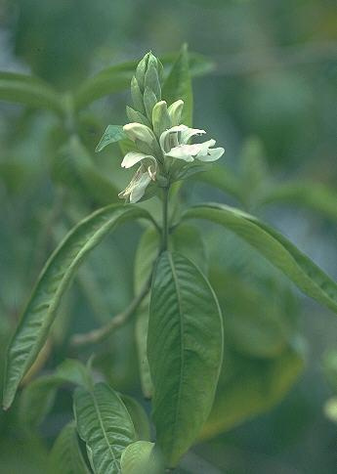
Fig-1. Justicia adhatoda Plant

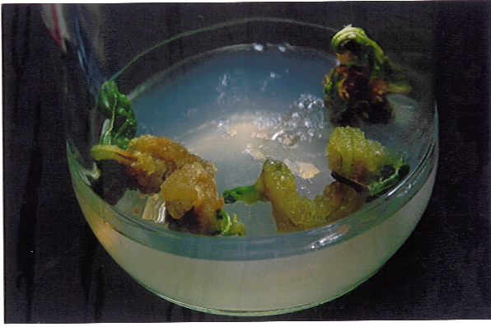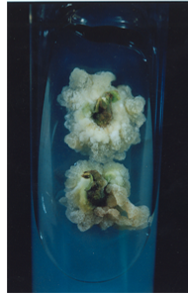

Fig-2a: Petiole callus Fig-2b: Leaf callus
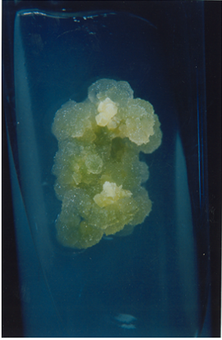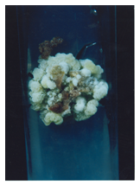

Fig-2c&d-Different stages of callus

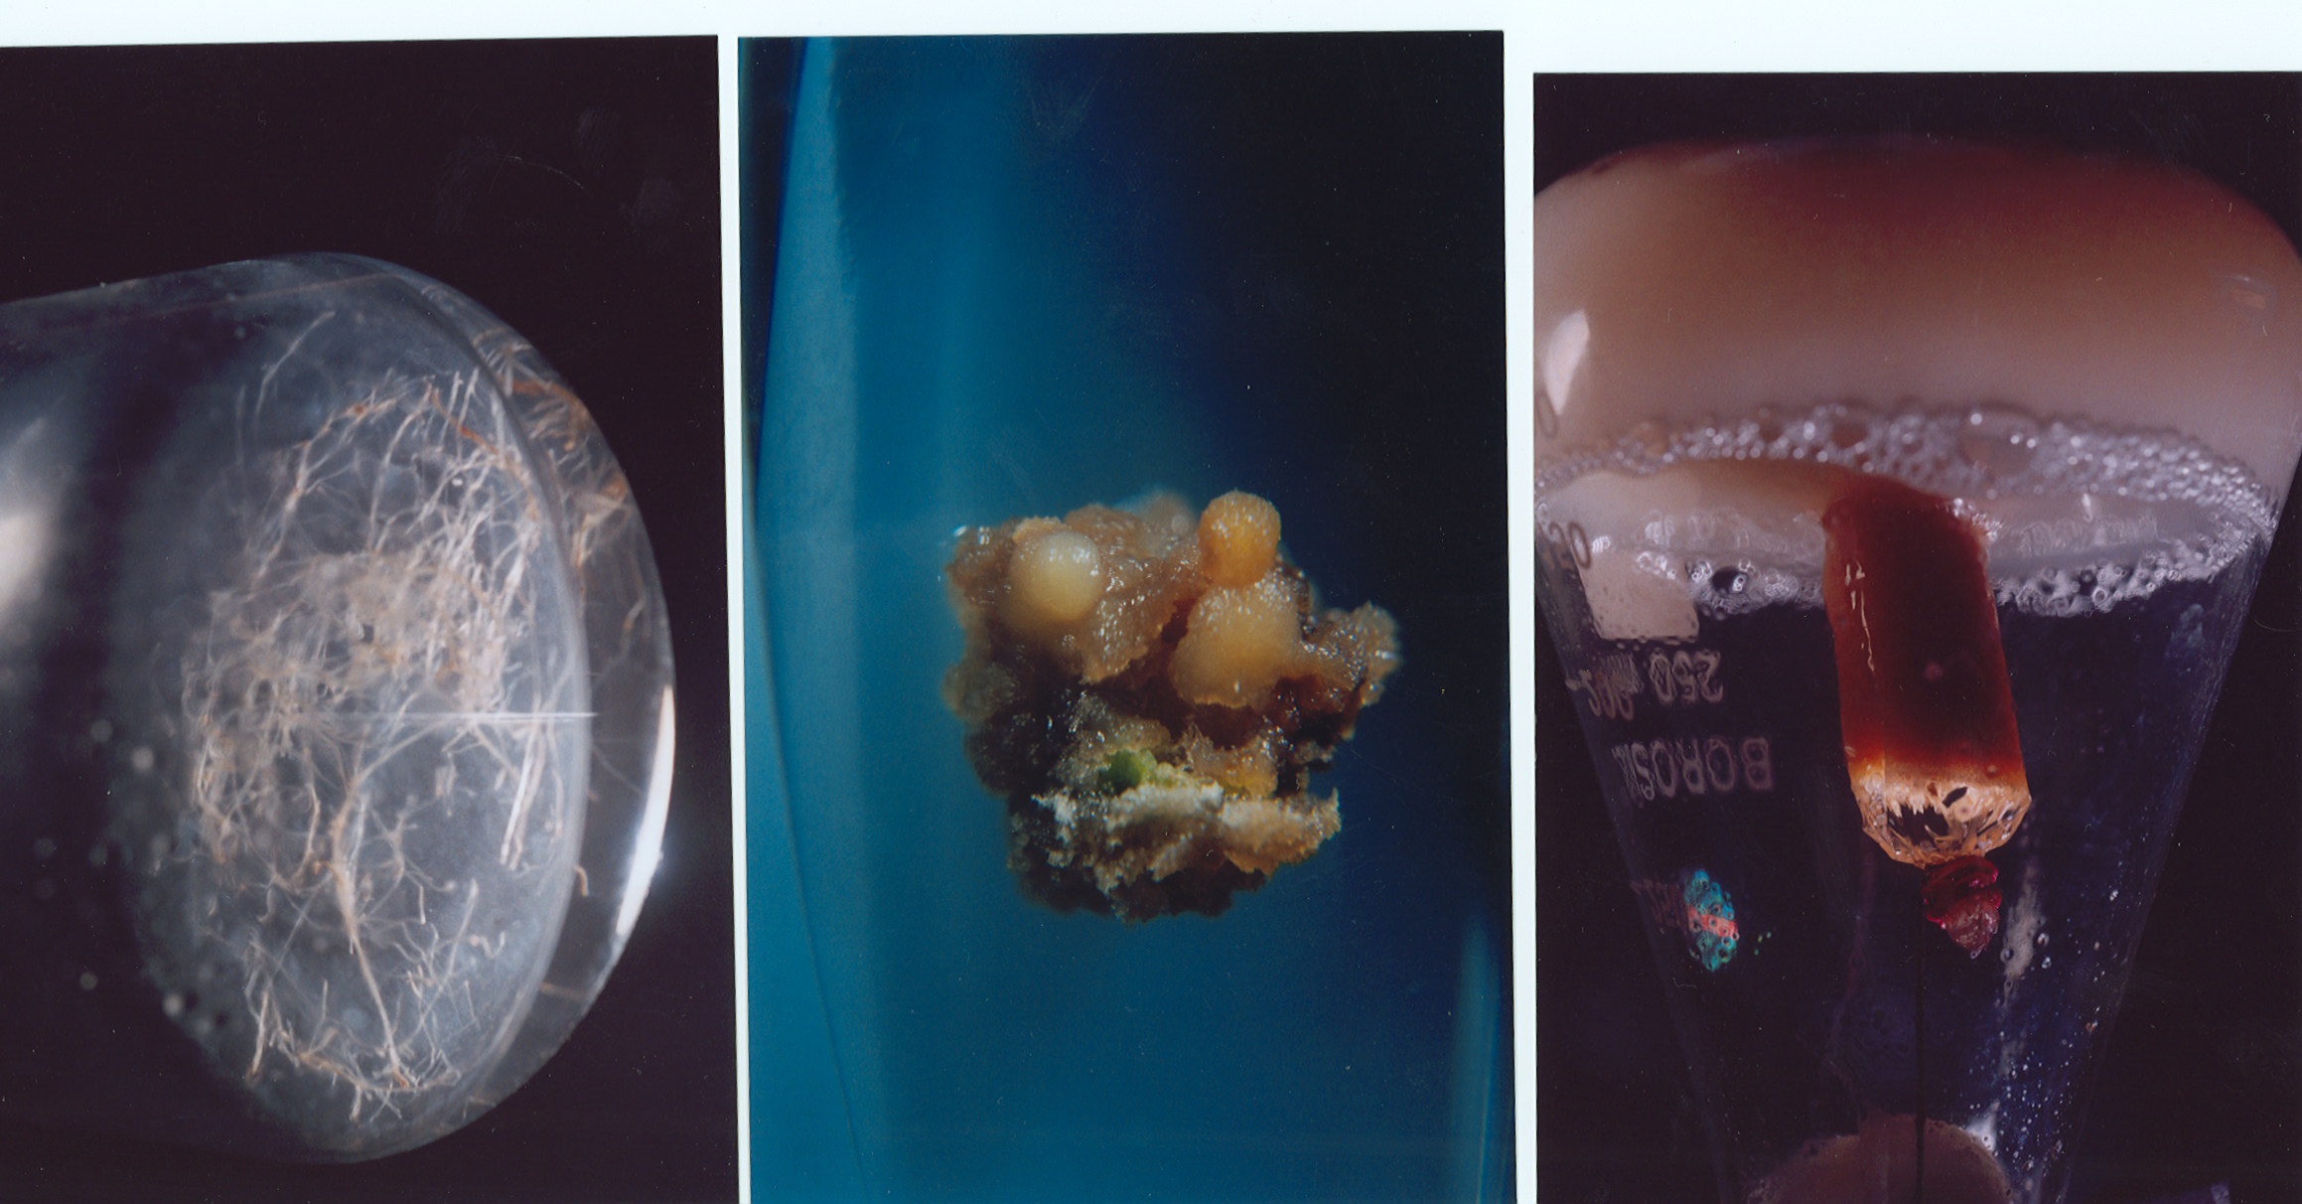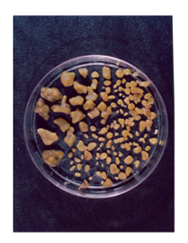
Fig-3a Somatic embryos on callus. Fig-3b Separated Somatic embryos

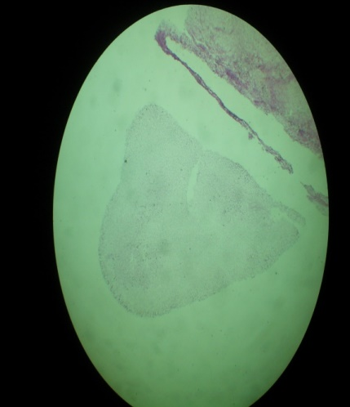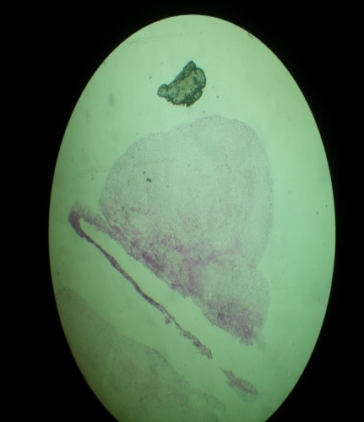

Fig-4a

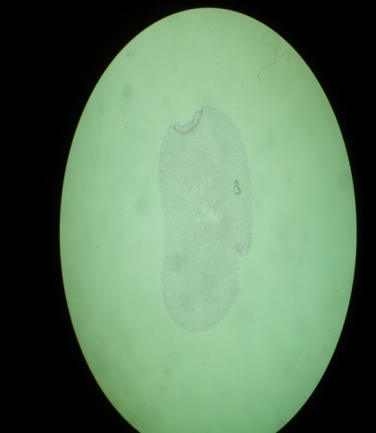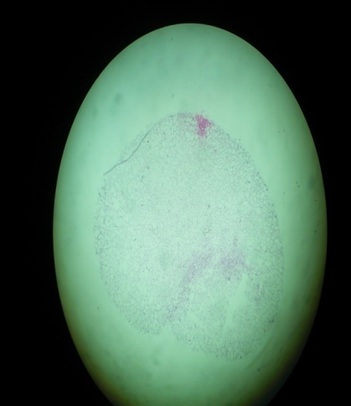

Fig-4b
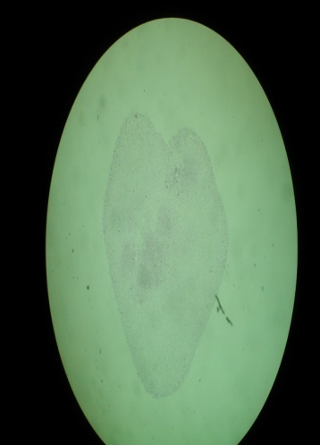
Fig-4c

Fig-(4a,4b,4c).Histochemical studies showing Torpedo, Globular and Heart shaped embryos in Justicia adhatoda

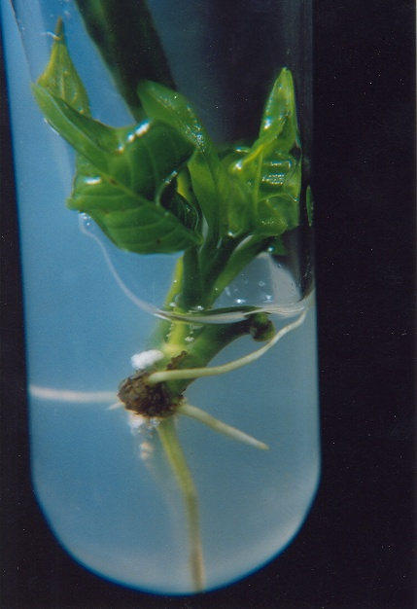

Fig-5a. Initiation of shooting and Rooting in Justicia adhatoda.
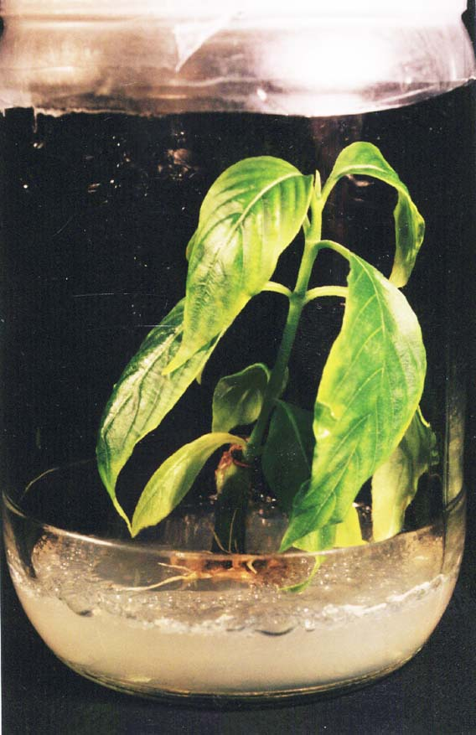

Fig-5b. Invitro grown plant of Justicia adhatoda

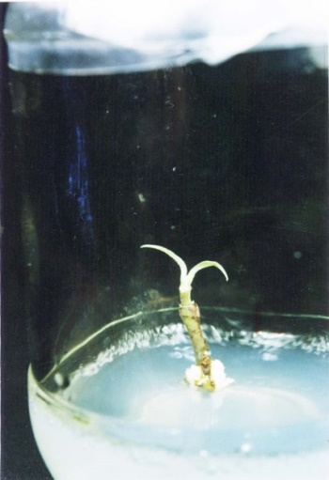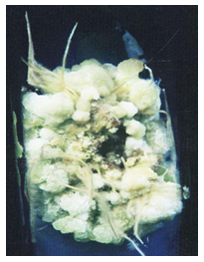

Fig6a: Hairy roots from Shoot tips 6b. Hairy roots from callus

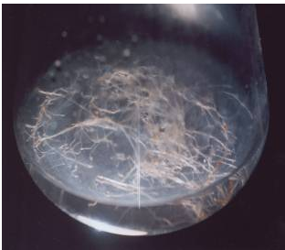
Fig6c: Hairy roots in suspension

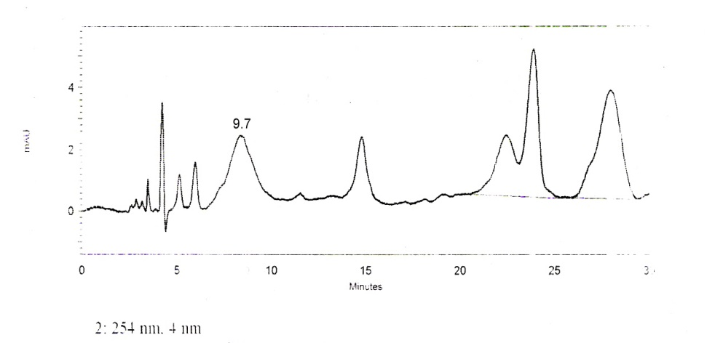

Fig 7. HPLC analysis of Vasicine yield (8.mg/gDW) in the Hairy
root suspension cultures of Adhatoda zeylanica

Table-1. Influence of Phytohormones on Biomass yield in the Callus cultures of
Justicia adhatoda.

Hormonal concentration μM | Explant | MS | B5
Hormonal concentration μM |  | F.W D.W | F.W D.W
2.2μM 2,4-D |  | ----- | -----
4.5μM 2,4-D | Petiole | 3.210±0.2 0.301±0.02 | 1.235±0.1 0.112±0.3
2.2μM NAA |  | ----- | -----
4.5μM NAA | Petiole | 4.351±0.3 0.362±0.01 | 1.408±0.2 0.102±0.01
4.5μM 2,4-D+2.3μM Kn | Petiole | 6.675±0.2 0.481±0.02 | 1.523±0.3 0.134±0.01
4.5μM 2,4-D+4.6μM Kn | Petiole | 10.370±0.3 1.106±0.1 | 4.909±0.2 1.359±0.03
9.0μM 2,4-D+4.6μM Kn | Petiole | 9.274 ±0.2 0.982±0.04 | 1.756±0.3 0.201±0.1
13.0μM 2,4-D+9.3μM Kn | Petiole | 6.333±0.3 0.733±0.02 | 3.201±0.1 0.783±0.02
5.3μM NAA+2.2μM 6-BA | Leaf | 5.444±0.1 1.302±0.1 | 3.224±0.2 0.879±0.07
10.7μM NAA+4.4μM 6-BA | Leaf | 7.445±0.5 1.498±0.03 | 3.009±0.5 0.678±0.04
4.9μM IBA+2.2μM 6-BA | Leaf | 5.342± 0.2 1.231±0.02 | 4.021±0.3 1.341±0.03
4.5μM 2,4-D+4.6μM Kn+2.2μM 6-BA | Leaf | 4.980±0.3 1.007±0.02 | 3.642±0.2 0.765±0.02
18.0μM 2,4-D+9.3μM Kn+22.8μM IAA | Leaf | 6.104±0.1 0.552±0.1 | 1.966±0.1 0.221±0.06
21.5μM NAA+4.9μM IBA+2.2μM 6-BA | Leaf | 6.251± 0.2 0.463±0.03 | 1.356±0.5 0.321±0.01
21.5μM NAA+19.7μM IBA+8.8μM 6-BA | Leaf | 5.213± 0.2 0.692±0.04 | 3.432± 0.2 0.364±0.02
21.5μM NAA+19.7μM IBA+9.3μM Kn | Leaf | 6.991±0.3 1.034±0.01 | 2.098±0.3 0.421±0.08
*F.W = Fresh weight.
*D.W = Dry weight

Table-2. Effect of hormones on Callus induction frequency (CIF) and extent of callus proliferation.

Hormonal concentration μM | Frequency of callus induction (%) |  | Extent of callus proliferation |  | Observation
Hormonal concentration μM | MS | B5 | MS | B5 | MS | B5
2.2μM 2,4-D | ----- | ----- | ----- | ----- | No Callus | No Callus
4.5μM 2,4-D | 35 (P) | 30 (P) | + | + | Callus | Callus
2.2μM NAA | ----- | ----- | ----- | ----- | No Callus | No Callus
4.5μM NAA | 38 (P) | 28 (P) | + | + | Callus | Callus
4.5μM 2,4-D+2.3μM Kn | 62 (P) | 40 (P) | + + | + | S.Embryos,  Callus | Callus
4.5μM 2,4-D+4.6μM Kn | 60 (P) | 40 (P) | + + | + + | Callus | Callus
9.0μM 2,4-D+4.6μM Kn | 45 (P) | 42 (P) | + + + | + | Callus | Callus
13.0μM 2,4-D+9.3μM Kn | 57 (P) | 38 (P) | + + | + | S.Embryos,  Callus | Callus
5.3μM NAA+2.2μM 6-BA | 68 (L) | 52 (L) | + + | + | Callus | Callus
10.7μM NAA+4.4μM 6-BA | 76 (L) | 58 (L) | + + + | + | S.Embryos,  Callus | Callus
4.9μM IBA+2.2μM 6-BA | 62 (L) | 47 (L) | + + | + | Callus | Callus
4.5μM 2,4-D+4.6μM Kn+2.2μM 6-BA | 27 (L) | 23 (L) | + | + | Callus | Callus
18.0μM 2,4-D+9.3μM Kn+22.8μM IAA | 47 (L) | 47 (L) | + + | + | Callus | Callus
21.5μM NAA+4.9μM IBA+2.2μM 6-BA | 52 (L) | 31 (L) | + | + | Callus | Callus
21.5μM NAA+19.7μM IBA+8.8μM 6-BA | 58 (L) | 32 (L) | + + | + | Callus | Callus
21.5μM NAA+19.7μM IBA+9.3μM Kn | 72 (L) | 62 (L) | + + + | + + | Shoots, Roots, Callus | Callus
+ = Moderate L = Leaf derived callus; + + = High P = Petiolar callus; + + + = Profuse S.Embryos = Somatic embryos

Key Message: In Justicia adhatoda induction of callus with suitable hormone concentration achieved somatic embryos of various stages and was studied by histochemical analysis. Regeneration of plant, Cell suspensions and hairy roots were obtained from callus and are standardized. This further helped us to enhance the vasicine content in the cells by immobilization, permeabilization and precursor feeding.

CONCLUSIONS
Tissue culture protocols for several medicinal plants were established, and this enabled the analysis of callus/cell suspension extracts for the presence of different classes of secondary products. The present study showed that callus induction, somatic embryogenesis and hairy root cultures are affected by plant growth regulators and culture conditions. Germination of somatic embryos and its conversion into regenerated plantlets were crucial steps for the successful plant regeneration is achieved. Cell suspensions and hairy roots initiation are standardized. These standardized protocols facilitate genetic studies, extraction and isolation of pharmacologically important compounds vasicine and vasicinone from callus\cell suspension cultures and hairy roots of Justicia adhatoda.
After perusal of the present study and above-mentioned facts one can assess the importance of plant tissue culture techniques, not only in the biosynthesis of economically important phytochemicals, but also in the conservation of medicinal plants.

Funding This work was not supported by any internal or external funding resources. The research was not funded by the producing company rather it was funded by personal efforts of the author.

Conflict of interest The authors declare that they do not have any conflict of interest.The products used for this research are commonly and predominantly use products in our area of research and country. There is absolutely no conflict of interest between the authors and Producers of the products because we do not intend to use these products as an avenue for any litigation but for the advancement of knowledge.

Disclaimer (Artificial intelligence)

Author(s) hereby declare that NO generative AI technologies such as Large Language Models (ChatGPT, COPILOT, etc.) and text-to-image generators have been used during the writing or editing of this manuscript.

REFERENCES

- Ambros PF, Matzke AJM and Matzyke MA.1986: Localization of Agrobacterium rhizogenes T-DNA in plant chromosomes by in situ hybridization. EMBO J.5:2073

- Atish G, Dhwani D, Sadasivan Kannan, Lipasa P and Ritu Rani.2021: Adhatoda vasica attenuates inflammatory and hypoxic responses in preclinical mouse models: potential for repurposing in Covid-19-like conditions. Respiratory Research Volume 22, Article number: 99

- Barone RP, Knittel DK, Ooka JK, Porter LN, Smith NT and Owens DK 2019. The production of plant natural products beneficial to humanity by metabolic engineering. Curr.Plant.Biol. 24:100121.doi: 10.1016/j.cpb.2019.100121

- Biswas, D., Chakraborty, A., Mukherjee, S., & Ghosh, B. (2023). Hairy root culture: A potent method for improved secondary metabolite production of Solanaceous plants.FrontiersinPlantScience,14,1197555. https://doi.org/10.3389/fpls.2023.1197555

- Bonhomme V, Laurain-Mattar D, Lacoux J, Fliniaux M and Jacquin-Dubreuil A.2000: Tropane alkaloid production by hairy roots of Atropa belladonna obtained after transformation with Agrobacterium rhizogenes 15834 and Agrobacterium tumefaciens containing rol A, B, C genes only. J Biotechnol.81:151-158.

- Cabrera-Ponce JL, Vegas-Garcia A, Herrera-Estrella L. Regeneration of transgenic papaya plants via somatic embrogenesis induced by Agrobacterium rhizogenes. In vitro Cell Dev Biol Plant. 1996; 32:86–90. doi: 10.1007/BF02823136

- Comlekcioglu N, Mendi YY, Eldogan S, Unek C. Effects of different combinations and concentrations of growth regulators and photoperiod on somatic embryogenesis of Cucumis melo var. flexuosus. Afr J Biotechnol. 2009;8(22):6228–6232. doi: 10.5897/AJB09.1214.

- Croes AF, Jacobs JMR, Arroo RRJ and Willems GJ.1994: Thiophene biosynthesis in Tagetes roots: molecular versus metabolic regulation. Plant Cell Tissue Org Cult 38:159-165.

- Flores HE, Viavanco JM and Loyola-Vorgas M.1999: Radicle biochemistry: The biology of root-specific metabolism. Trends Plant Sci, 4:220-226.

- Gamborg OL, Murashige T, Thorpe TA and Vasil IK.1976: Plant tissue media. In vitro Plant. 12:473-478.

- Gantait S, Mitra M and Chen JT 2020. Biotechnological interventions for ginsenosides production. Biomolecules 10:538. doi: 10.3390/biom10040538

- Jayapaul, K., Kavi Kishore, P.B. and Reddy, K.J. 2005. Production of pyrroloquinazoline alkaloid from leaf and petiole-derived callus cultures of Adhatoda zeylanica. In Vitro Cell.Dev.Biol.41: 682-685

- Khatri, P., & Joshee, N. (2024). Somatic embryogenesis and plant regeneration in peanut(ArachishypogaeaL.).PLOSONE. https://doi.org/10.1371/journal.pone.0315060

- Maheswaran G, Williams EG. Direct secondary somatic embryogenesis from immature embryos of Trifolium repens culture in vitro. Ann Bot. 1986; 57:109-117.

- Murashige T and Skoog F.1962: A revised medium for rapid growth and bioassays with tobacco tissue cultures.Physiol.Plant,15:473-497.

- Narayanaswamy S, editor, 1977: Regeneration of plants from tissue cultures. In: Applied and Fundamental Aspects of Plant Cell Tissue and Organ Culture, Reinert J and Baja YPS, editors, Springer-Verlag, Heidelberg-New York, pp.178-248.

- Park, Y. W. (2025). Effect of cytokinins on the regeneration and proliferation traits in plant tissue culture. Journal of Plant Biotechnology, 52(1), 91–100.
- Park SU and Facchini PJ.2000:Agrobacterium rhizogenes mediated transformation of opium poppy, Papaver somnifarum and California poppy, Eschscholzia californica Cham, root cultures. J Exp Botany.51:1005-1016.
- Pasternak, T., Moubayidin, L., & Benkova, E. (2024). Plant growth regulation in cell and tissue culture in vitro. International Journal of Molecular Sciences, 25(16), 8912. https://doi.org/10.3390/ijms25168912
- Petit A, David C, Dahl GA, Ellis JG, Guyon P, Casse-Delbast F, Tempe J. 1983: Opine concept: plasmids in Agrobacterium rhizogenes cooperate for opine degradation. Mol Gen Genet;190:204-14.

- Ramakrishna D and Shastrhee T, 2016. High efficient somatic embryogenesis development from leaf cultures of Citrullus colocynthis (L) Schrad for generating true type clones. Physiol Mol Biol Plants. 22(2); 279-285. Doi; 10.1007/312298-016-0357-2
- Ramachandra Rao S and Ravishankar GA.2002: Plant cell cultures: Chemical factories of secondary metabolites. Biotechnology Advances.20:101-153.

- Ravishankar Rai V, Mc Comb J, 2002. Direct somatic embryogenesis from mature embryos of sandalwood. Plant Cell Tissue Organ Culture.60:65-70. Doi; 10.1023/A;1015037920529.

- Rhodes MJC, Parr AJ, Gillette A and Arid ELH.1994:Influence of exogenous hormones on the growth and secondary metabolite formation in transformed root cultures. Plant Cell Tissue Org Cult.38:143-151.

- Rhodes MJC, Robins RJ, Hamill JD, Parr AJ, Hilton MG and Walton MJ.1990: Properties of transformed root cultures in Char wood, B.V, Rhodes MJC, editors, Secondary products from Plant tissue culture, Oxford Scientific Publications, 201: 2225.
- Shvets, D. Y., Berezhneva, Z. A., Musin, K., & Kuluev, B. R. (2024). Effect of rol genes of the A4, 15834, and K599 strains of Agrobacterium rhizogenes on root growth and antioxidant system of transgenic tobacco plants under abiotic stress. Russian Journal of Plant Physiology.

- Shi HP and Kintzios S.2003: Genetic transformation of Pueraria phaseoloides with Agrobacterium rhizogenes and puerarin production in hairy roots. Plant Cell Rep.21:1103-1107.

- Subroto AM and Doran PM. 1994: Production of steroidal alkaloids by hairy roots of
- Solanum aviculare and the effect of gibberlic acid. Plant Cell Tissue Org. Cult. 38: 93-102.Tapan Dey, Prachuriya Dutta, Prasenjit Manna, Jatin Kalita, Hari Prasanna Deka, Alak
- kumar and Balagopalan Unni.2018:Anti-Proliferative Activities of Vasicinone On Lung Carcinoma Cells Mediated via Activation of Both Mitochondria-Dependent andIndependentPathway.BiomolTher(Seoul):26(4):409.16.Doi.10.4062/biomoither.2017.

- Thiruvengadam M, Jeyakumar JJ, Kamaraj M, Lee YJ and Chung IM, 2013. Plant regeneration through somatic embryogenesis from suspension cultures of gherkin (Cucumis anguria L.) Aust J Crop Sci. 7(7):969–977.

- Urquiza-López, A., Bazaldúa, C., Cardoso-Taketa, A. T., & Villarreal, M. L. (2025). Compounds from medicinal plants produced in hairy root and transgenic hairy root cultures: A review. PeerJ, 13, e19967. https://doi.org/10.7717/peerj.19967

- Widholm JM 1972: The Use of Fluorescein Diacetate and Phenosafranine for
Determining Viability of Cultured Plant Cells .Stain Technology Vol 47.pp189-194.

- Zheng, Y. P. (2025). Visual analysis of research progress and trend on hairy roots. Frontiers in Plant Science, 16, 1580007. https://doi.org/10.3389/fpls.2025.1580007

