Original Research Article
Analysis of genetic diversity of banana cultivars using simple sequence repeat markers

ABSTRACT
Genetic variations and relationships among fifteen important banana cultivars were evaluated using 15 Simple Sequence Repeat (SSR) primers. The result indicated that MAOCEN 12 had the highest number of alleles (5) and resulted the highest polymorphism among all the tested markers. Three markers, namely Ma 1-27, Ma 3-103 and Ma Gss 160 exhibited monomorphism. The polymorphism percentage was recorded in the range 0.0-100.0 % in all the used markers. Eighty (80.0%) per cent of the tested markers were found to be polymorphic in nature. The polymorphic information content (PIC) value varied from 0.00-0.374. The heterozygosity index (HI) and marker index (MI) ranged from 0-0.498 and 0-0.021, respectively. The resolving power (RP) ranged from 0.0-1.142 and discriminating power (DP) varied from 0.0- 1.0. The UPGMA cluster analysis of the banana cultivars were also done by using Dice’s coefficient and dendrogram was constructed. The tree distance in the dendrogram was 0.000-0.278. The fifteen banana cultivars were grouped into two major clusters. The tetraploid banana cultivar FHIA-01 formed one major cluster and rest all the diploid and triploid banana cultivars in another cluster. This study identified genetically dissimilar groups within the fifteen banana cultivars that revealed their evolutionary background. The outcome of the experiment will be helpful for germplasms management and planning for future crop improvement programmes in banana.
Key words: Banana, SSR, Genetic variation, Polymorphism, Dendogram
Introduction
Banana (Musa spp. L.) is one of the most important fruit crops globally, serving as a staple food for millions and a significant source of income for farmers in tropical and subtropical regions. This fruit is a rich source of carbohydrates, vitamins, and minerals. It plays a crucial role in food security and economic stability, particularly in developing countries. The two most widespread ancestors of present-day edible bananas under the genus Musa were M. acuminata Colla and M. balbisiana Colla. The M. acuminata Colla was found to be wild in the Malayan region and diploid in nature (2n=22). The later one, i.e., M. balbisiana Colla was believed to have originated from the Indian subcontinent and tetraploid in nature (2n=44) (Chandel and Agarwal, 2000). The species M. acuminata Colla has the parthenocarpic traits. Edible bananas originating from the inter- and intra-specific hybridization between these two species (Ashalatha et al., 2005). Based on the genetic combining ability, a huge spectrum of bi-specific genomic groups was developed. Considering M. acuminata Colla contributed to A-genome and M. balbisiana Colla contributed to B-genome, the present-day edible bananas ranging from diploid (AA and AB), triploid (AAA, AAB and ABB) to tetraploid (AAAA and AABB) (Uma et al., 2005).
Maintenance and preservation of banana genetic resources are highly significant for sustainable food security. Since, there is a constant threat of losing the existing gene pool due to ever-increasing population pressure and global climate change. Therefore, to conserve the existing gene pool of a commercially important crop, evaluation and characterization of the existing varietal resources should be considered as the primary task (Dinesh and Veena, 2015). Assessment of plant genetic diversity determines their capacity to adapt to rapid climatic changes. It also indicates all the genetic characteristics within a species and forms the basis for evolutionary processes. Population with a higher degree of variation exhibits more fitness for the environment. Therefore, understanding the genetic diversity within a crop species provides fundamental information for sustainable agriculture, conservation efforts and effective future breeding programs (Rafael, 2025).
Analysis of genetic diversity using molecular markers assesses the genetic variation within different genotypes at DNA sequences among the individuals (Rafael, 2025). Further, molecular markers in genetic diversity analysis are very effective due to their co-dominance, morphological neutrality, abundance, development stage, tissue and environmental independent expression. There are different types of markers used for analysis of the genetic diversity of crops, such as RADP (Random Amplified Polymorphic DNA), RFLP (Restricted Fragment Length Polymorphism), ISSR (Inter Simple Sequence Repeats) and SSR (Simple Sequence Repeats) The SSR markers are also called micro satellite markers, used for molecular characterization of the crops. Molecular markers, particularly Simple Sequence Repeats (SSRs), emerged as powerful and reliable tools for assessing genetic variation, identifying unique genotypes, and elucidating phylogenetic relationships among cultivars (Das et al., 2024; Pillay and Tripathi, 2007). SSR markers were highly polymorphic, co-dominant inheritance, extensive genome coverage, and high transferability to related species, making them ideal for DNA fingerprinting and genetic diversity analysis in complex polyploid crops like banana (Ravishankar et al., 2013; Reshmi et al., 2011). This study aimed to analyse the genetic relationships and diversity levels among banana cultivars, contributing to a robust understanding of the available genetic resources.
Materials and Methods
Fifteen (15) banana genotypes were selected for the genetic diversity analysis (Table 1 and Fig.1). Young leaf samples were taken for genetic diversity analysis, stored at 4°C right away, then at -20 °C for short-term use and -80 °C for long-term storage. The DNA was extracted using a modified CTAB method (Doyle and Doyle, 1990). The DNA quality and quantity were assessed through the utilization of a UV spectrophotometer (NABI, Microdigital) and agarose gel electrophoresis. Ten (10) µl of stock DNA was mixed with 90.0 µl of milli-Q water to dilute the samples to working concentrations. A 10 µl reaction mixture comprising Go Taq Green Master mix, forward and reverse primers, nuclease-free water, and 1 µl of genomic DNA (50 ng/µl) was used for the Polymerase Chain Reaction (PCR). A three-minute initial denaturation at 94°C was followed by 35 cycles of denaturation at 94°C for 30 seconds, annealing at 45–60°C, and extension at 72°C for 30 seconds. The PCR program ended with a final extension at 72°C for 10 minutes. Initially, fifteen SSR primers were chosen for examination. Using 1X TAE buffer and Ethidium bromide, 3% agarose gel electrophoresis was used to visualize PCR products and evaluate DNA quality. The gels were run at 75V for 45–60 minutes and examined under a UV transilluminator. In the bio-informatic analysis of SSR data, the Online Marker Efficiency Calculator (iMEC) was used to calculate parameters like the number of total alleles (NTA), number of polymorphic alleles (NPA), polymorphism percentage (PP), heterozygosity index (HI), polymorphic information content (PIC), marker index (MI), discriminating power (DP), and resolving power (RP). Based on Dice's similarity coefficient and the Unweighted Pair Group Method with Arithmetic Mean (UPGMA), which uses binary scoring (1 for presence, 0 for absence), genetic analysis and dendrogram construction were carried out using DARWIN 6.0 software. Three markers showed monomorphism and were eliminated, leaving only the 12 polymorphic markers for the final dendrogram construction.
Table 1: Banana genotypes taken for the experiment
Sl. No. | Genotype | Genomic group | Sl. No. | Genotype | Genomic group
1. | Rajapuri | ABB | 9. | Manua | AB
2. | Manohar | BB | 10. | Chini Champa | AAB
3. | FHIA-01 | AAAB | 11. | Monthan | ABB
4. | CO-1 | AAB | 12. | Grand Naine | AAA
5. | Malbhog | AAB | 13. | Hill Banana | ABB
6. | Pisang Awak | ABB | 14. | Dwarf Cavendish | AAA
7. | Agniswar | AAA | 15. | Lal Kela | AAA
8. | Amrit Sagar | AAB

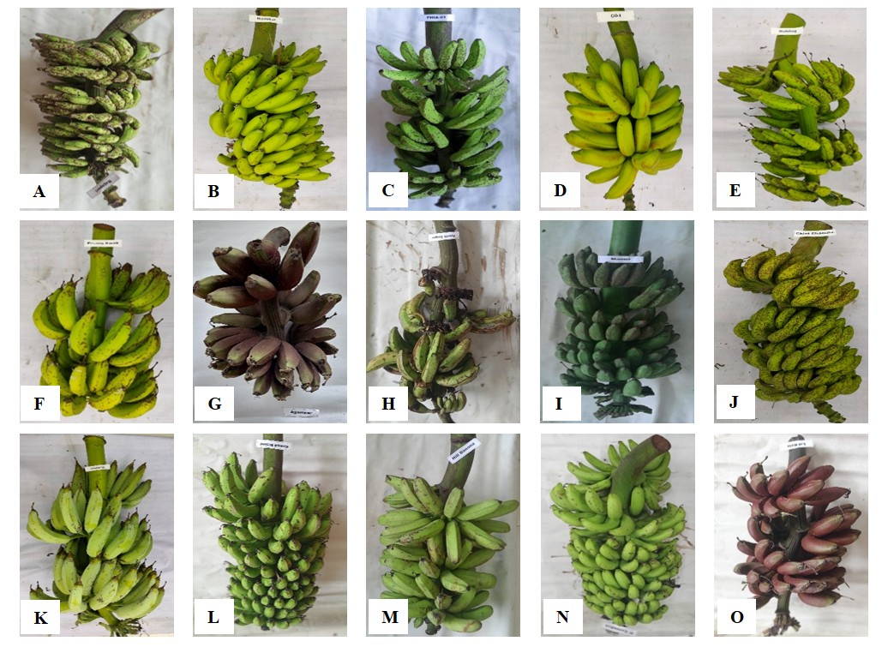 Fig. 1: Harvested banana bunch of different banana genotypes. A: Rajapuri, B: Manohar, C: FHIA-01, D: CO-1, E: Malbhog, F: Pisang Awak, G: Agniswar, H: Amrit Sagar, I: Manua, J: Chini Champa, K: Monthan, L: Grand Naine, M: Hill Banana, N: Dwarf Cavendish, O: Lal Kela
Table 2: List of SSR primers selected for genetic diversity analysis
SSR Name | Primer
AGMI 67-68 | F= ATACCTTCTCCCGTTCTTCTTC  R= TGGAAACCCAATCATTGATC
AGMI 93-94 | F= ACAACTAGGATGGTAATGTGTGGAA  R= GATCTGAGGATGGTTCTGTTGGAGTG
Ma 1-17 | F= AGGCGGGGAATCGGTAGA  R= GGCGGGAGACAGATGGAGT
Ma 3-103 | F= TCGCCTCTCTTTAGCTCTG  R= TGTTGGAGGATCTGAGATTG
Ma 1-27 | F= TGAATCCCAATTTGGTCAAG  R= CAAAACACTGTCCCCATCTC
MAOCEN 12 | F= GCAAGAAAGAACGAGAAGGAAA  R= GTGGGGAGGGAGGCATAG
MAOCEN 13 | F= GCTGCTATTTTGTCCTTGGTG  R= CTTGATGCTGGGAATCTGG
Ma_GSS98 | F= GTCATCGTCGGGAGAGAGAG  R= CAGTTCAAGCTCAAACTCAAGTG
Ma_GSS102 | F= AGATGGCAGAAGGGGAGATT  R= AGGGTCAGCTTCCATCTGAA
Ma_GSS105 | F= TGTCATCTTGTTCTGCTCTGC  R= AAATAAGCCCCCAAAGGAAT
Ma_GSS160 | F= GACCATGCATGTCAATTTTCA  R= ATCCTCAGCTCTTTGCTTGC
Ma_GSS164 | F= CAGCTCCTCCGTCACAAACT  R= TTCAAACCTCGCACCAATTC
Ma_GSS190 | F= AGGAGGAGAGCACCAGGAG  R= TCGATCCAACGGTTGTAGTTC
Ma_GSS203 | F= CATCGAGACCTTTTCCTGCT  R= CGAATGATCGATGACGGATT
Ma_GSS213 | F= CCTCGCAGCTAAACCTCACT  R= ACCGGTAGCTAACCCCGTAG
Results and Discussion
The greatest total alleles (NTA) count was recorded in MAOCEN 12 with 5 alleles, showing excellent genetic diversity detecting capabilities. High NTA means this marker might capture a large range of genetic variation, making it useful for population diversity research (Wang, 2005). The lowest NTA (1) was noted in Ma 3-103, Ma 1-27, and Ma_GSS160, indicating inadequate allelic diversity. Such markers are less useful in detecting polymorphism and may be unsuitable for thorough genetic mapping. For NPA, MAOCEN 12 and Ma_GSS164 ranked the highest (5 and 4 polymorphic alleles respectively), showing substantial polymorphism potential. Markers like Ma 3-103 and Ma 1-27 had NPA = 0, suggesting no polymorphic allele. This could be owing to the conserved character of the targeted genetic areas. The rest of the other markers showed a 100% polymorphism percentage (PP), indicating the overall genetic heterogeneity of the data set. High PP is reported to be desirable for differentiating genotypes in molecular breeding (Crouch, 1999; Jonah et al., 2011). Ma 3-103 and Ma 1-27 had 0% PP, implying these loci were monomorphic in the examined population. Such markers might still be relevant for identification or verification in clonal populations but not be ideal for genetic diversity analysis in bananas. The greatest heterozygosity index (HI) of 0.489 was recorded in numerous markers (e.g., Ma_GSS213, Ma_GSS98), suggesting balanced allele distribution. The lowest HI (0.0) registered in monomorphic markers like Ma 3-103. The highest PIC value was 0.374 in Ma_GSS164, demonstrating ability to detect polymorphisms more efficiently (Serrote et al., 2020). Therefore, Ma_GSS164 might be more useful for banana genetic diversity studies. The lowest PIC (0.0) occurred in markers with no polymorphism, directly correlating PIC to variability existence. The Marker Index (MI) peaked at 0.021 (Ma_GSS203), suggesting strong efficiency in detecting polymorphism. Higher MI reflects stronger marker informativeness and efficient in analyzing the genetic diversity by differentiating the genotypes (Das and Baisakh, 2025). Several markers recorded MI = 0.0, implying they made no useful contribution to diversity evaluation. The Discriminating Power (DP) was highest (1.0) for Ma_GSS102, suggesting it perfectly differentiated between genotypes. The lowest DP (0.0) occurred in non-polymorphic markers, showing little ability to discriminate genotypes. The Resolving Power (RP) achieved its highest (1.142) in MAOCEN 12 and Ma_GSS164, exhibiting substantial genotype differentiation. RP was modest (0.0) in monomorphic markers. The combination of high HI and high DP in Ma_GSS213 makes it both diversified and discriminatory. MAOCEN 13 demonstrated good DP (0.934) despite only 2 alleles, suggesting that even low NTA markers can have great discriminatory potential. Ma_GSS98 had moderate PIC and HI but nevertheless achieved good DP, making it adaptable in applications. AGMI 93-94 had the highest DP among the AGMI markers (0.842), demonstrating its outstanding discrimination ability in that group. Ma_GSS203 balanced moderate HI (0.459) with a high RP (0.714), making it efficient in both diversity and resolution. Overall, the analysis of marker efficiency parameters revealed that Ma_GSS164 was the most efficient locus, with 4 total alleles and 4 polymorphic alleles, polymorphic information content (PIC) of 0.374, heterozygosity index (HI) of 0.489, marker index (MI) of 0.731, discriminating power (DP) of 0.731, and resolving power (RP) of 1.142. These values suggest superior informativeness, great allele diversity, level of variation between individuals and strong capacity to discriminate genotypes (Prevost and Wilkinson, 1999).
Table 3: Marker efficiency parameters
Sr. No. | SSR Locus | TmºC | PIC | NTA | NPA | % PP | HI | MI | DP | RP
1. | AGMI 67-68 | 52ºC | 0.324 | 2 | 2 | 100 | 0.408 | 0.020 | 0.505 | 0.571
2. | AGMI 93-94 | 47ºC | 0.365 | 4 | 4 | 100 | 0.481 | 0.013 | 0.842 | 0.428
3. | Ma 1-17 | 56ºC | 0.369 | 3 | 3 | 100 | 0.489 | 0.019 | 0.682 | 0.285
4. | Ma 3-103 | 57ºC | 0.0 | 1 | 0 | 0.0 | 0.0 | 0.0 | 0.0 | 0.0
5. | Ma 1-27 | 57ºC | 0.0 | 1 | 0 | 0.0 | 0.0 | 0.0 | 0.0 | 0.0
6. | MAOCEN 12 | 46ºC | 0.369 | 5 | 5 | 100 | 0.489 | 0.019 | 0.677 | 1.142
7. | MAOCEN 13 | 51ºC | 0.324 | 2 | 2 | 100 | 0.408 | 0.008 | 0.934 | 0.571
8. | Ma_GSS98 | 50ºC | 0.369 | 3 | 3 | 100 | 0.489 | 0.019 | 0.682 | 0.285
9. | Ma_GSS102 | 55ºC | 0.123 | 2 | 2 | 100 | 0.132 | 0.006 | 1.0 | 0.142
10. | Ma_GSS105 | 57ºC | 0.369 | 2 | 2 | 100 | 0.489 | 0.019 | 0.682 | 0.285
11. | Ma_GSS160 | 53ºC | 0.0 | 1 | 0 | 0.0 | 0.0 | 0.0 | 0.0 | 0.0
12. | Ma_GSS164 | 48ºC | 0.374 | 4 | 4 | 100 | 0.489 | 0.018 | 0.731 | 1.142
13. | Ma_GSS190 | 57ºC | 0.0 | 2 | 2 | 100 | 0.0 | 0.0 | 0.0 | 0.0
14. | Ma_GSS203 | 52ºC | 0.353 | 2 | 2 | 100 | 0.459 | 0.021 | 0.604 | 0.714
15. | Ma_GSS213 | 52ºC | 0.369 | 2 | 2 | 100 | 0.489 | 0.014 | 0.835 | 0.857
TmºC = Annealing Temperature; PIC = Polymorphic Information Content; NTA = Number of total alleles; NPA = Number of polymorphic alleles; % PP = Per cent polymorphism; HI = Heterozygosity Index; MI = Marker Index; D P = Discriminating Power; RP = Resolving Power
A hierarchical dendrogram that graphically depicts the genetic relationships and clustering patterns was produced by analysing molecular markers across a wide range of banana cultivars (Fig. 2). A scale bar at the bottom of the dendrogram indicates the genetic distance, which was calculated using the Unweighted Pair Group Method with Arithmetic Mean (UPGMA) clustering algorithm. The maximum observed genetic distance between the varieties under study is represented by values close to 0.1 on this scale, which shows the degree of dissimilarity. The banana genotypes are broadly classified into two clusters. The first cluster contains FHIA-01 while the second cluster is further classified into three clusters. The three separate genetic sub-clusters were identified by the dendrogram, indicating the different levels of relatedness between the banana varieties. The varieties Pisang Awak, Manua, Amrit Sagar, CO-1, Manohar, and Rajapuri made up the first major sub-cluster. Particularly between Manohar and Rajapuri, as well as between Amrit Sagar and CO-1, this cluster was distinguished by exceptionally short branch lengths. A high level of genetic similarity and close relatedness between these varieties were indicated by the short genetic distances (less than 0.02 on the scale bar). It implies that they might be closely related landraces with a recent common ancestor or that they might be members of the same genomic group (Govindaraj et al., 2015). The pairing of Amrit Sagar and CO-1 suggested that these two are closely related cultivars. Malbhog, Grand Naine, Monthan, Hill Banana, Dwarf Cavendish, Lal Kela, Agniswar, and Chini Champa were members of the second sub-cluster. In comparison to the first sub-cluster, this cluster had longer internal branch lengths, indicating a higher level of genetic diversity (He et al., 2024). Since Grand Naine is a subgroup of the Cavendish-type bananas, the grouping of varieties like Grand Naine and Dwarf Cavendish is in line with their known genetic background (Palkar et al., 2012). Despite having a common ancestor with the Cavendish group, the other members of this cluster, like Agniswar and Chini Champa, have more noticeable genetic distances from one another, suggesting that they were evolutionary divergent. This grouping, which includes both popular commercial cultivars and regional landraces, accounts for a sizable amount of the diversity of cultivated bananas and demonstrates the genetic diversity found in traditional breeding stocks. The most striking result of the dendrogram is the position of the variety FHIA-01. It forms a single-variety cluster and is connected to the rest of the banana germplasm by a remarkably long branch, joining the main trunk at a genetic distance approaching 0.1. This result suggests that 'FHIA-01' was the most genetically unique variety in the panel. Since, this cultivar originated as a hybrid and is strongly supported by its significant genetic distance from all other conventional and traditional varieties. It is well known that "FHIA" varieties were the result of intricate breeding initiatives designed to introduce desired characteristics from a variety of wild banana accessions (Whiley, 1996). A basis for streamlining the administration of banana germplasm collections is provided by the discovery of genetically unique clusters and sub-clusters. To guarantee effective use of resources and space, the very similar varieties of Cluster I could be given priority for redundancy checks. On the other hand, the distinctive genetic profile of 'FHIA-01' and the more varied varieties of Cluster II are essential for preserving a wide genetic base. The significance of both in situ and ex situ conservation efforts for both traditional cultivars and distinctive hybrids is further highlighted by the distinct genetic clusters. The distinctive genetic profiles of landraces like those in Cluster I must be maintained to prevent genetic erosion and serve as a reservoir of diversity for future crop improvement, even though cultivars like "Grand Naine" are widely used.
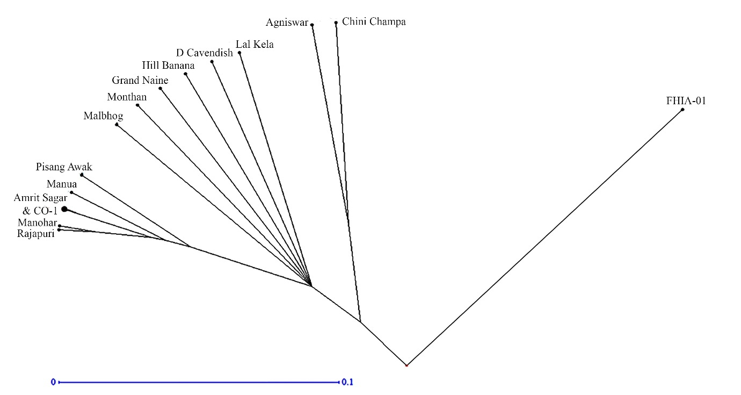
Fig. 2: Dendrogram of banana cultivars genotypes derived by hierarchical UPGMA method.
Conclusion
Two broad clusters of 15 banana genotypes were formed by UPGMA cluster analysis. FHIA-01 was the only genotype present in the first cluster. The second cluster was further divided into three clusters representing three phylogenetic origins. Closely related cultivars of banana like Amrit Sagar, CO-1, Manohar, and Rajapuri were closely clustered indicating their ancestry. Further, Grand Naine and Dwarf Cavendish were grouped in accordance with their known Cavendish genomic background. These findings offer important insights for managing germplasm, evaluating redundancy, and planning future improvement programs for bananas.
Disclaimer (Artificial intelligence)

Author(s) hereby declare that NO generative AI technologies such as Large Language Models (ChatGPT, COPILOT, etc.) and text-to-image generators have been used during the writing or editing of this manuscript.
REFERENCES
Ashalatha, C. H., Teo, T., Schwarzacher, T., & Pat, H. H. (2005). Genome classification of banana cultivars from South India using IRAP markers. Euphytica, 144, 285–290. https://link.springer.com/article/10.1007/s10681-005-7321-2
Chandel, K. P. S., & Agarwal, A. (2000). Genetic resources of banana in India: Collection, in-vitro conservation and characterization. In H. P. Singh & K. L. Chadha (Eds.), Banana: Improvement, production and utilization (pp. 128–135). ICAR-National Research Centre for Banana. https://www.cabidigitallibrary.org/doi/full/10.5555/19941601690
Crouch, J. H., Crouch, H. K., Constandt, H., Van Gysel, A., Breyne, P., Van Montagu, M., Jarret, R. L., & Ortiz, R. (1999). Comparison of PCR-based molecular marker analyses of Musa breeding populations. Molecular Breeding, 5(3), 233–244. https://link.springer.com/article/10.1023/A:1009649521009
Das, S. C., Debnath, P., Krishnamurthy, A., Paul, P., Saha, S., Podder, D., Ravishankar, K. V., Durai, P., Saraswati, M. S., & Subbaraya, U. (2024). Genetic diversity analysis of banana using SSR markers. Indian Journal of Horticulture, 81(1), 68–74.
Das, T. R. & Baisakh, B. (2025). SSR-marker assisted evaluation of genetic diversity in green gram [Vigna radiata (L.) Wilcezk]. Legume Research, 48(7), 1110-1116. doi: 10.18805/LR-5151
Dinesh, M. R., & Veena, G. L. (2015). Biodiversity of fruit crops. In M. R. Dinesh (Ed.), Fruits Breeding (pp. 17–37). New India Publishing Agency.
Doyle, J. J., & Doyle, J. L. (1990). A rapid total DNA preparation procedure for fresh plant tissue. Focus, 12, 13–15.
Govindraj, M., Vetriventhan, M., & Srinivasan, N. (2015). Importance of genetic diversity assessment in crop plants and its recent advances: An overview of its analytical perspectives. Genetics Research International, 431487. https://doi.org/10.1155/2015/431487
He, S., Yuan, C., Zhang, P., Wang, H., Luo, D., & Dai, X. (2024). Study on the characteristics of genetic diversity of different populations of Rhododendron pudingense based on microsatellite markers. BMC Plant Biology, 24, 77. https://doi.org/10.1186/s12870-024-04759-5
Jonah, P. M., Bello, L. L., Lucky, O., Midau, A., & Moruppa, S. M. (2011). The importance of molecular markers in plant breeding programmes. Global Journal of Science Frontier Research, 11(5), 5–12.
Palkar, S. S., Patel, N. L., Mhetre, D. A., & Mandalik, G. D. (2012). Effect of high-density planting on the growth and development characters of banana (Musa paradisiaca L.) cv. Grand Naine. International Journal of Agricultural Sciences, 8(1), 201–204.
Pillay, M., & Tripathi, L. (2007). The use of molecular markers for the characterization of banana germplasm. African Journal of Biotechnology, 6(14), 1640–1647.
Prevost, A. & Wilkinson, M. J. (1999). A new system of comparing PCR primers applied to ISSR fingerprinting of potato cultivars. Theoretical and Applied Genetics, 98, 107–112. https://doi.org/10.1007/s001220051046
Rafael, M. D. (2025). Genetic diversity in plants: Foundations for adaptation, evolution, and conservation. International Research Journal of Plant Science, 16(38), 1–2.
Ravishankar, K. V., Raghavendra, K. P., Athani, V., Rekha, A., Sudeepa, K., Bhavya, D., Srinivas, V., & Ananad, L. (2013). Development and characterization of microsatellite markers for wild banana (Musa balbisiana). Journal of Horticultural Science & Biotechnology, 88, 605–609.
Reshmi, V., Saji, K. V., & Seeni, P. S. (2011). Genetic diversity in Indian banana cultivars based on SSR markers. Indian Journal of Biotechnology, 10(2), 209–215.
Serrote, C. M. L., Reiniger, L. R. S., Silva, K. B., Rabaiolli, S. M. D. S. & Stefanel, C. M. (2020). determining the polymorphism information content of a molecular marker. Gene, 726, 144175. https://doi.org/10.1016/j.gene.2019.144175
Uma, S., Saravanaperumal, S. A., Saraswathi, M. S., Durai, P., Sharma, T. V. R. S., Singh, B. D., Selvarajan, R., & Sathiamoorthy, S. (2005). Studies on the origin and diversification of Indian wild banana (Musa balbisiana) using arbitrarily amplified DNA markers. Journal of Horticultural Science & Biotechnology, 80, 575–580.
Wang, J. (2005). Estimation of effective population sizes from data on genetic markers. Philosophical Transactions of the Royal Society B: Biological Sciences, 360(1459), 1395–1409.
Whiley, A. W. (1996). Banana Musa sp. ‘Goldfinger’ syn. FHIA-01. Plant Varieties Journal, 9, 16–17.

