Decoupling the Yield-Quality Paradox in Wheat through Integrated Rhizospheric Bio-Priming with NPK Consortia

ABSTRACT
The intensification of wheat (Triticum aestivum L.) monocultures in the Indo-Gangetic Plains has precipitated a precarious "input-output" paradox, wherein escalating mineral fertilization induces rhizospheric dysbiosis and severe pedological degradation. In these alkaline, calcareous landscapes, chemical immobilization renders upwards of 80% of applied phosphorus and critical micronutrients, specifically Zinc (Zn²⁺), bio-unavailable, creating a profound metabolic bottleneck. This study interrogates the hypothesis that transitioning toward Microbial-Mediated Nutrient Canalization via tripartite bio-inoculants can decouple productivity from environmental exhaustion. A field investigation was executed during the Rabi season of 2024 at KVK, Ghazipur, utilizing a Randomized Block Design (RBD) with three replications. The high-yielding cultivar DBW-222 was subjected to seven nutritional configurations, integrating Recommended Dose of Fertilizers (RDF) with diazotrophic Azotobacter, specialized NPK Consortia, and Zinc Solubilizing Bacteria (ZSB). Physiological growth kinetics (Plant Height, LAI, CGR), grain proteomic stoichiometry (modified micro-Kjeldahl), and post-harvest edaphic biological status (CFU analysis) were rigorously quantified. Empirical outcomes elucidated a significant hierarchical progression (T7 > T6 > T4 > T3 > T5 > T2 > T1), with Treatment T7 (RDF + NPK Consortia + ZSB) achieving maximal vegetative vigor: plant height (85.6 cm), LAI (0.75), and CGR (22.5 g/m2/day). Notably, T7 demonstrated a superior qualitative profile with Protein Content peaking at 11.4%, effectively decoupling the typical inverse relationship between yield and quality. Economic productivity reached its zenith in T7 with a Grain Yield of 5.5 t/ha, underpinned by a three-fold increase in rhizospheric bacterial colonization (34.7 times 106 CFU/g) over the control. The integration of multimodal microbial consortia with mineral regimes mitigates the "biological void" left by conventional fertilization, restoring soil ecological functionality. The synergistic interaction between NPK-mobilizers and ZSB optimizes the Carbon-Nitrogen-Phosphorus (C:N:P) stoichiometry, offering a mechanistic framework for regenerative intensification in high-input agrosystems.

Keywords:- Rhizospheric Dysbiosis, Microbial-Mediated Nutrient Canalization, Stoichiometric Optimization, Triticum aestivum, Zinc Solubilization, Regenerative Intensification.

Graphical abstract

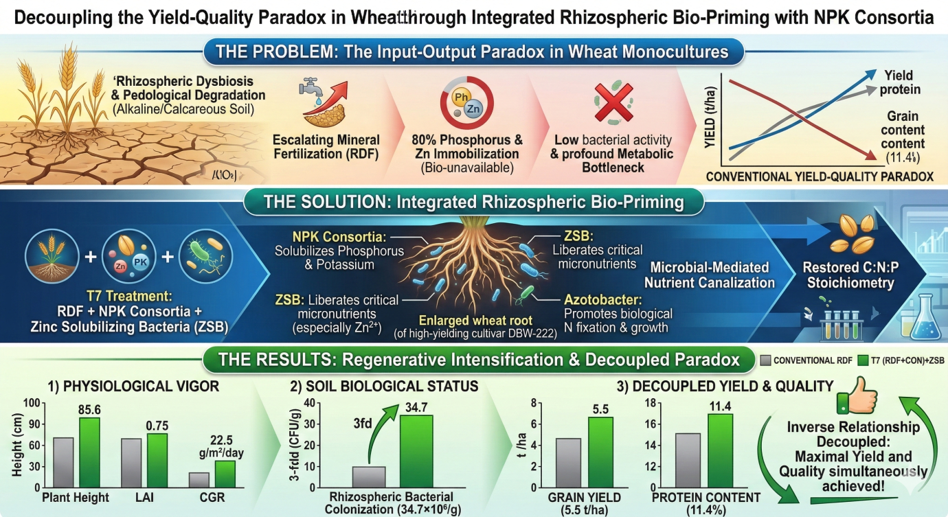

Introduction
The global agricultural sector currently operates under a precarious "input-output" paradox, where the relentless drive for maximizing caloric yields in wheat (Triticum aestivum L.) has necessitated an astronomical escalation in synthetic mineral inputs (McBratney & Park, 2025). Wheat is one of the world’s most important staple food crops, ranking among the top three cereals and contributing substantially to global food security (Vargiya et al., 2025). Wheat cultivation exhibits versatility, thriving in a range of environmental conditions, including mild, humid to arid, and cold climates. Its cultivation varies from irrigated to rainfed, encompassing regions with high rainfall (Chauhan et al., 2023). While the Green Revolution's legacy was built upon the aggressive application of nitrogenous and phosphatic fertilizers, the contemporary reality in the Indo-Gangetic Plains (IGP) reveals a plateauing yield curve accompanied by severe pedological degradation (Khuwaja et al., 2025). The "mineral-centric" approach has induced a state of rhizospheric dysbiosis, characterized by the suppression of indigenous microbial diversity and a subsequent decline in Nutrient Use Efficiency (NUE) (Ghosh et al., 2025). In these alkaline, calcareous landscapes, upwards of 80% of applied phosphorus and a significant fraction of micronutrients, notably Zinc (Zn2+), undergo rapid chemical immobilization into insoluble mineral complexes, rendering them bio-unavailable to the crop despite their abundance in the soil matrix (Sirsat et al., 2025).
The mitigation of this nutrient sequestration necessitates a paradigm shift toward Microbial-Mediated Nutrient Canalization. Plant growth-promoting rhizobacteria (PGPR), specifically diazotrophic Azotobacter and specialized NPK Consortia, represent a sophisticated biological alternative to conventional fertilization (Saadaoui et al., 2022; Zhang et al., 2025b; Ajeethan et al., 2026). Azotobacter species serve as vital nitrogenous conduits, yet their physiological contribution extends into the realm of phytohormonal modulation, where the secretion of auxins and cytokinins alters root architecture to increase the absorptive surface area. However, the efficacy of N-fixation is often limited by the concurrent scarcity of phosphorus—a critical component of the ATP-driven nitrogenase enzyme complex (Mansoor et al., 2025). This stoichiometric imbalance necessitates the inclusion of phosphorus-solubilizing bacteria (PSB) and potassium-mobilizing bacteria (KMB), which utilize the exogenous secretion of low-molecular-weight organic acids (e.g., gluconic, 2-keto-gluconic, and malic acids) to lower the localized rhizospheric pH and chelate mineral cations (Mansoor et al., 2025; Said et al., 2025).
A critical, yet often overlooked, bottleneck in the IGP's wheat-based agrosystems is the Zinc-Metabolic constraint (Malik et al., 2025). Zinc serves as an indispensable structural and catalytic cofactor for over 300 enzymes, including carbonic anhydrase and superoxide dismutase (Malafeevskiy et al., 2025). The integration of Zinc Solubilizing Bacteria (ZSB) into the fertilization regime introduces a specific metabolic pathway—the production of siderophores and organic ligands—that liberates Zn from recalcitrant pools (Ali et al., 2023; Singh et al., 2025) When these disparate microbial functional groups are synthesized into a multimodal consortium, they theoretically create a self-reinforcing biological loop. For instance, the solubilization of Zinc by ZSB may enhance the enzymatic efficiency of the N-fixers within the consortium, thereby optimizing the Carbon-Nitrogen-Phosphorus (C:N:P) stoichiometry of the plant-soil system. This synergy suggests that a tripartite inoculant system could fundamentally reconfigure the Source-Sink relationship more effectively than the current Recommended Dose of Fertilizers (RDF) (Liu et al., 2025).
Despite the burgeoning interest in bio-stimulants, empirical data regarding the interaction between high-yielding wheat genotypes (e.g., DBW-222) and tripartite microbial-mineral integrated systems remain fragmented and largely descriptive. Most existing research fails to account for the Bio-Geochemical feedback loops created when NPK-consortia are paired with specific Zinc-mobilizing strains under high-input mineral conditions. This investigation, therefore, seeks to transcend the limitations of binary mineral-microbial comparisons. By interrogating the nexus of physiological growth kinetics, grain proteomic stoichiometry, and post-harvest microbial carbon sequestration, this study aims to delineate a mechanistic framework for regenerative intensification. The research challenges the prevailing mineral-only dogma, hypothesizing that microbial-mineral integration represents the only viable pathway to decouple agricultural productivity from environmental exhaustion in the anthropocene.
Materials and Methods
Site Characterization and Edaphic Environment
The field investigation was executed during the Rabi season of 2024 at the experimental research farm of Krishi Vigyan Kendra (KVK), Ghazipur, Uttar Pradesh, India (25 35'N latitude, 83 35'E longitude; 80 m AMSL). This locale serves as a representative microcosm of the Indo-Gangetic Plains (IGP), characterized by a subtropical semi-arid climate and fertile yet nutrient-depleted alluvial soils. The edaphic matrix was geologically classified as sandy loam, exhibiting a mildly alkaline reaction (pH 7.5–8.2) and a non-saline profile. Pre-experimental analysis revealed a characteristic nitrogen and micronutrient deficiency and low organic carbon content, typical of intensive cereal-based systems in the region. The environmental conditions during the wheat life cycle remained within the optimal thermal window (10⁰C to 25 ⁰C), facilitating rigorous assessment of the synergistic effects of bio-inoculants under field-realistic stressors.
Experimental Design and Treatment Architecture
The trial was orchestrated using a Randomized Block Design (RBD) with seven distinct nutritional treatments replicated thrice. The wheat cultivar DBW-222, renowned for its high yield potential and climate resilience, was employed as the biological substrate. The treatment hierarchy was designed to evaluate the incremental efficacy of integrating Recommended Dose of Fertilizers (RDF) with specialized microbial agents, including Azotobacter, NPK Consortia, and Zinc Solubilizing Bacteria (ZSB). Precise agronomic management was maintained across all plots to ensure that observed variances were strictly attributable to the microbial-nutritional interventions rather than extrinsic variables.

Table:-1 Structured Experimental Treatment Layout
Treatment Code | Treatment Description
T1 | Control
T2 | RDF
T3 | RDF + Azotobacter
T4 | RDF + Consortia
T5 | RDF + ZSB
T6 | RDF + Azotobacter + ZSB
T7 | RDF + NPK Consortia + ZSB
Growth Dynamics and Physiological Indices
Plant architectural development was quantified via Plant Height, while photosynthetic capacity was monitored through the Leaf Area Index (LAI), calculated as the ratio of total leaf area to unit land area. The Crop Growth Rate (CGR), representing the rate of dry matter accumulation per unit area per unit time, was derived using the following differential equation (Zhang et al., 2025a):

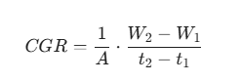
where W_1 and W_2 represent the dry biomass at successive intervals t₁ and t₂, and A denotes the land area (d m²). This metric provides a fundamental kinetic understanding of the biomass production efficiency across different nutritional regimes.
Yield Optimization and Harvest Indices
Economic productivity was extrapolated from net plot yields and expressed as Grain Yield (q/ha) and Straw Yield (q/ha). The Harvest Index (HI), an indicator of the physiological efficiency in partitioning photo-assimilates from source to sink, was computed according to the allometric formula proposed by Donald (1962) :

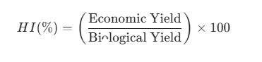
Biochemical and Microbiological Quantification
To assess grain quality, Protein Content was elucidated by determining the total nitrogen concentration via the modified micro-Kjeldahl method, utilizing the conversion factor for wheat (N X 5.73) as per AOAC (1960) protocols. Post-harvest soil biological health was scrutinized through microbial population counts. The Microbial Biomass Carbon (MBC) and active microbial pools—comprising Bacteria (106 \text CFU/g) and Fungi (104 \text CFU/g)—were quantified using the chloroform fumigation-extraction method and serial dilution plate techniques, respectively. These analyses provide a comprehensive view of the edaphic-biological restoration facilitated by the bio-inoculant treatments.

Statistical Analysis
The experimental data were subjected to rigorous statistical scrutiny using the Analysis of Variance (ANOVA) technique as applicable to a Randomized Block Design (RBD). To evaluate the significance of treatment effects, the Critical Difference (CD) at a 5% probability level (P = 0.05) was computed. The Standard Error of Mean (SEm±) was utilized to quantify the dispersion of treatment means, ensuring that the superior performance of integrated microbial regimes was mathematically validated against the null hypothesis.
Results and Discussions
1. Plant Height, LAI, and CGR
Crop growth parameters responded significantly, as evidenced by Plant Height, Leaf Area Index (LAI), and Crop Growth Rate (CGR), exhibited a profound response to the integration of microbial inoculants with inorganic fertilization. Treatment T7 (RDF + NPK Consortia + ZSB) demonstrated a maximal plant height, attaining a maximal plant height of 85.6 cm, which significantly transcended the Control (T1) and the Standard RDF (T2). This architectural augmentation is intrinsically linked to the enhanced biosyntheses of phytohormones—specifically auxins and gibberellins—secreted by the Azotobacter and Bacillus strains within the consortia, which promote cell elongation and apical dominance (Satognon et al., 2025; Sihotang & Sihotang, 2025).
The LAI and CGR reached their zenith in T7 (0.75 and 22.5 g/m2/day, respectively), suggesting that the tripartite inoculation of nitrogen-fixers, phosphorus-solubilizers, and zinc-mobilizers effectively optimized the photosynthetic source-capacity. The statistical hierarchy (T7 > T6 > T4 > T3 > T5 > T2 > T1) underscores a synergistic "bio-priming" effect. In this mechanism, the microbial mediation of multi-nutrient availability facilitated a more robust dry matter accumulation rate compared to the staggered growth observed under solitary chemical regimes (Yang et al., 2025; Zheng et al., 2026). This suggests that while inorganic NPK provides the immediate stoichiometry for growth, the microbial consortia ensure a sustained flux of micronutrients and metabolic catalysts, preventing physiological plateaus during the critical vegetative-to-reproductive transition (Potter et al., 2025; Zhao et al., 2025).
Table 2: Effect of Bio-Inoculants and Inorganic Fertilizers on Plant Height and LAI
Treatment Details | Plant Height (cm) | LAI (at Harvest)
T1: Control | 62.8 | 0.40
T2: RDF | 68.4 | 0.48
T3: RDF + Azotobacter | 74.2 | 0.59
T4: RDF + Consortia | 77.5 | 0.64
T5: RDF + ZSB | 71.3 | 0.54
T6: RDF + Azotobacter + ZSB | 81.9 | 0.69
T7: RDF + NPK Consortia + ZSB | 85.6 | 0.75
SEm± | 2.15 | 0.03
CD (P=0.05) | 6.34 | 0.09
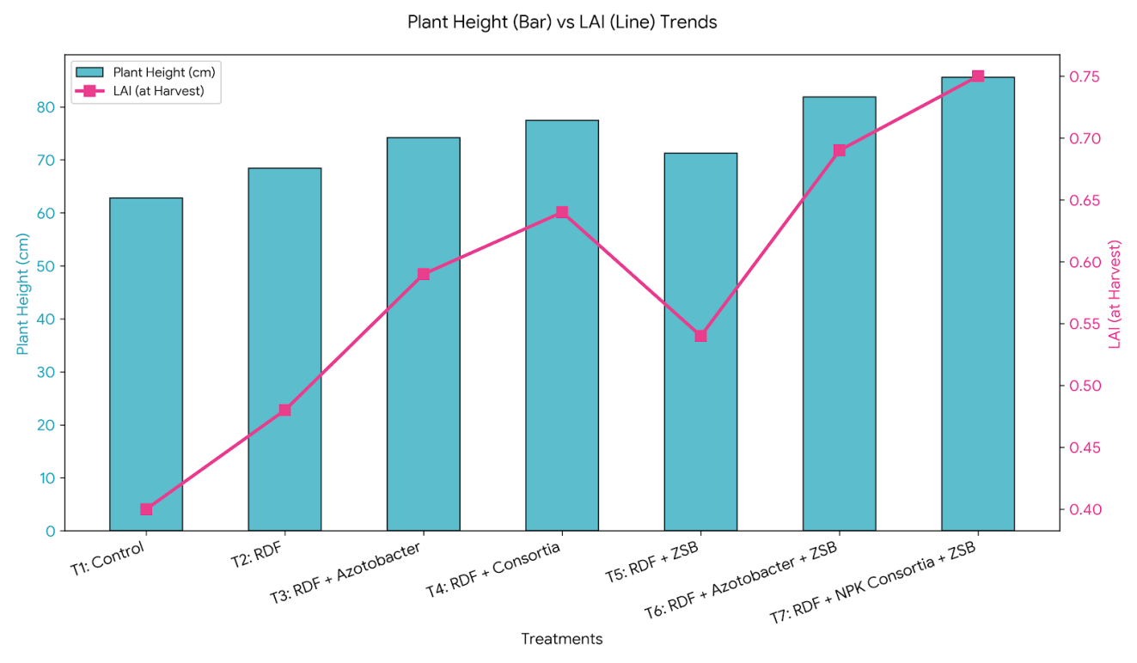
Figure 1: Effect of Bio-Inoculants and Inorganic Fertilizers on Plant Height and LAI

2. Protein Dynamics
The biochemical assessment of grain quality revealed a substantial linear escalation in Protein Content, peaking at 11.4% in T7. This qualitative shift signifies an enhanced Nitrogen Use Efficiency (NUE) and augmented amino acid metabolism. The disparity between T3 (Azotobacter alone) and T7 (Consortia + ZSB) suggests that the presence of Zinc Solubilizing Bacteria (ZSB) potentially acts as a metabolic catalyst. Zinc is a fundamental structural and functional cofactor for carbonic anhydrase and RNA polymerase; its increased bioavailability likely accelerated the transcription and translation of storage proteins within the endosperm (Malik et al., 2025; Sethi et al., 2025).
The significant enrichment of grain protein under the integrated microbial framework indicates that bio-inoculants do not merely augment biomass but fundamentally alter the grain's nutritional stoichiometry (Ma et al., 2025; Prasad et al., 2025). The "dilution effect"—where yield increases usually lead to protein decreases—was conspicuously absent in T7, implying that the microbial consortium maintained a luxury consumption of nitrogen and zinc throughout the grain-filling stage, thereby decoupling the typical inverse relationship between yield and quality (Shaaban et al., 2025).
Table 3: Effect of Bio-Inoculants and Inorganic Fertilizers on CGR and Quality
Treatment Details | CGR (g/m2/day) | Protein Content (%)
T1: Control | 15.6 | 7.2
T2: RDF | 17.1 | 8.5
T3: RDF + Azotobacter | 19.2 | 9.4
T4: RDF + Consortia | 20.4 | 10.1
T5: RDF + ZSB | 18.2 | 8.9
T6: RDF + Azotobacter + ZSB | 21.3 | 10.8
T7: RDF + NPK Consortia + ZSB | 22.5 | 11.4
SEm± | 0.65 | 0.32
CD (P=0.05) | 1.91 | 0.94

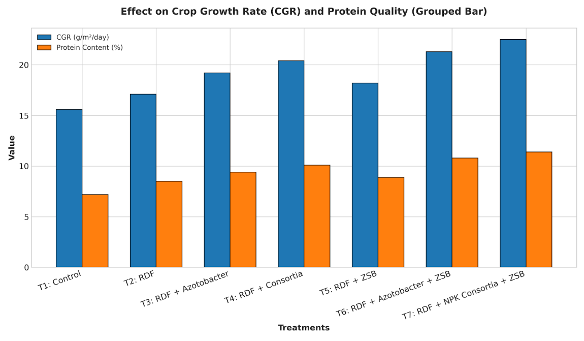
Figure 2: Effect of Bio-Inoculants and Inorganic Fertilizers on CGR and Quality

3. Grain and Straw Yield Analysis
The culminative impact of bio-organic intervention was most pronounced in the Grain Yield, which spanned from 4.0 t/ha (T1) to an impressive 5.5 t/ha (T7). The superior performance of the NPK Consortia combined with ZSB over the RDF (T2) alone confirms that microbial catalysts unlock recalcitrant nutrient pools in the soil, particularly fixed phosphorus and non-exchangeable potassium, thereby mitigating the law of diminishing returns associated with high-input chemical farming (Khuwaja et al., 2025; Zheng et al., 2026).
The Harvest Index (HI) remained statistically consistent, implying that the yield surge was a direct consequence of a holistic increase in total biological productivity rather than a disproportionate partitioning of photo-assimilates (Mansoor et al., 2025; Roncalli, 2025). The inclusion of ZSB in the T7 regime likely enhanced the sink strength of the grain by improving pollen viability and successful fertilization, which is often a bottleneck in zinc-deficient soils (Khuwaja et al., 2025; NAWAZ et al., 2024). Consequently, the microbial treatments sustained vegetative vigor without inducing reproductive asynchrony, leading to a concurrent increase in both grain and straw yield (6.9 t/ha in T7).
Table 4: Yield Attributes and Harvest Index
Treatment Details | Grain Yield (t/ha) | Straw Yield (t/ha) | Harvest Index (%)
T1: Control | 4.0 | 5.2 | 43.48
T2: RDF | 4.3 | 5.5 | 43.88
T3: RDF + Azotobacter | 4.7 | 6.0 | 43.93
T4: RDF + Consortia | 5.0 | 6.3 | 44.25
T5: RDF + ZSB | 4.5 | 5.7 | 44.12
T6: RDF + Azotobacter + ZSB | 5.3 | 6.6 | 44.54
T7: RDF + NPK Consortia + ZSB | 5.5 | 6.9 | 44.35
SEm± | 0.14 | 0.18 | 0.85
CD (P=0.05) | 0.41 | 0.53 | NS
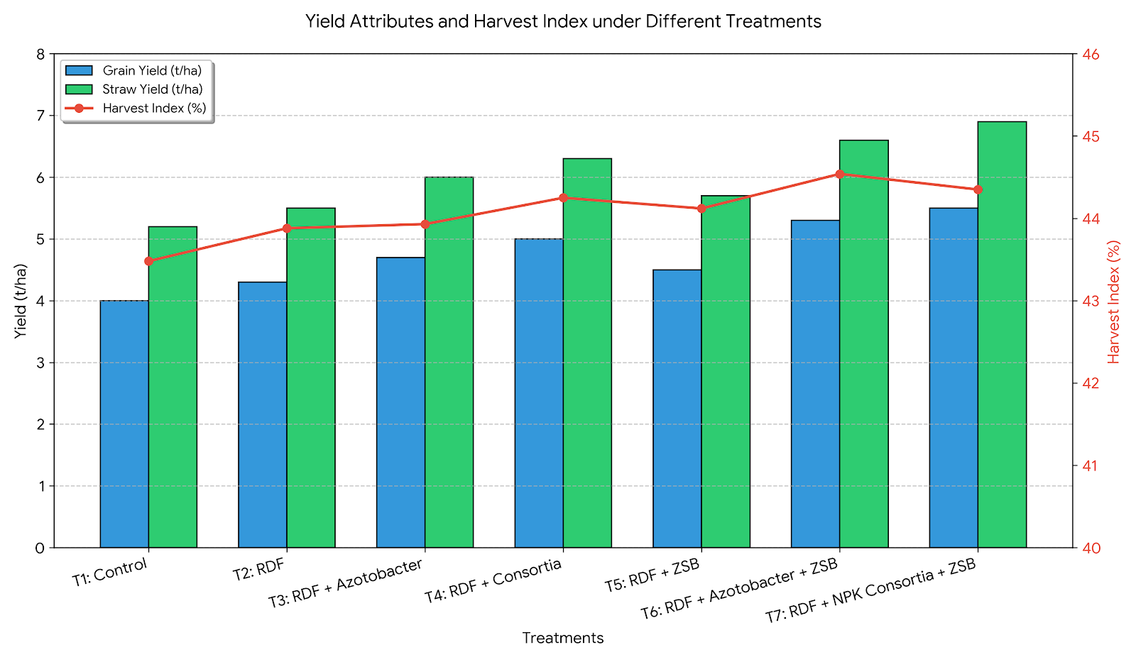
Figure 3: Yield Attributes and Harvest Index

4. Microbial Population Proliferation
Post-harvest analysis of the rhizosphere revealed an expansive colonization of Bacteria (34.7 X 106 CFU/g) and Fungi (16.5 X 104 CFU/g) in T₇, representing a three-fold increase over the Control. This flourishing microbial density indicates that the application of consortia creates a self-reinforcing biological feedback loop: the inoculants stimulate root exudation (rhizodeposition), which in turn provides the labile carbon necessary to sustain a high microbial biomass (Chang et al., 2025; Xu et al., 2025).
The marked suppression of microbial populations in T₁ and T₂ compared to the bio-augmented treatments highlights the "biological void" left by conventional mineral fertilization, which can often increase soil osmotic pressure and inhibit sensitive microbial taxa. The success of T₇ and T₆ underscores the necessity of multi-strain inoculants (NPK + ZSB) to restore soil ecological functionality. By optimizing the microbial community structure, these treatments ensure that the soil remains a living, regenerative medium capable of sustaining high-intensity cropping systems while reducing the environmental footprint of synthetic fertilizers (Oubohssaine et al., 2025; Wang et al., 2025).
Table 5: Post-Harvest Soil Microbial Status
Treatment Details | Bacteria (106 CFU/g soil) | Fungi (104 CFU/g soil)
T1: Control | 10.4 | 5.4
T2: RDF | 14.8 | 7.2
T3: RDF + Azotobacter | 22.1 | 10.5
T4: RDF + Consortia | 28.6 | 13.4
T5: RDF + ZSB | 18.5 | 8.9
T6: RDF + Azotobacter + ZSB | 31.2 | 15.1
T7: RDF + NPK Consortia + ZSB | 34.7 | 16.5
SEm± | 1.25 | 0.72
CD (P=0.05) | 3.68 | 2.12
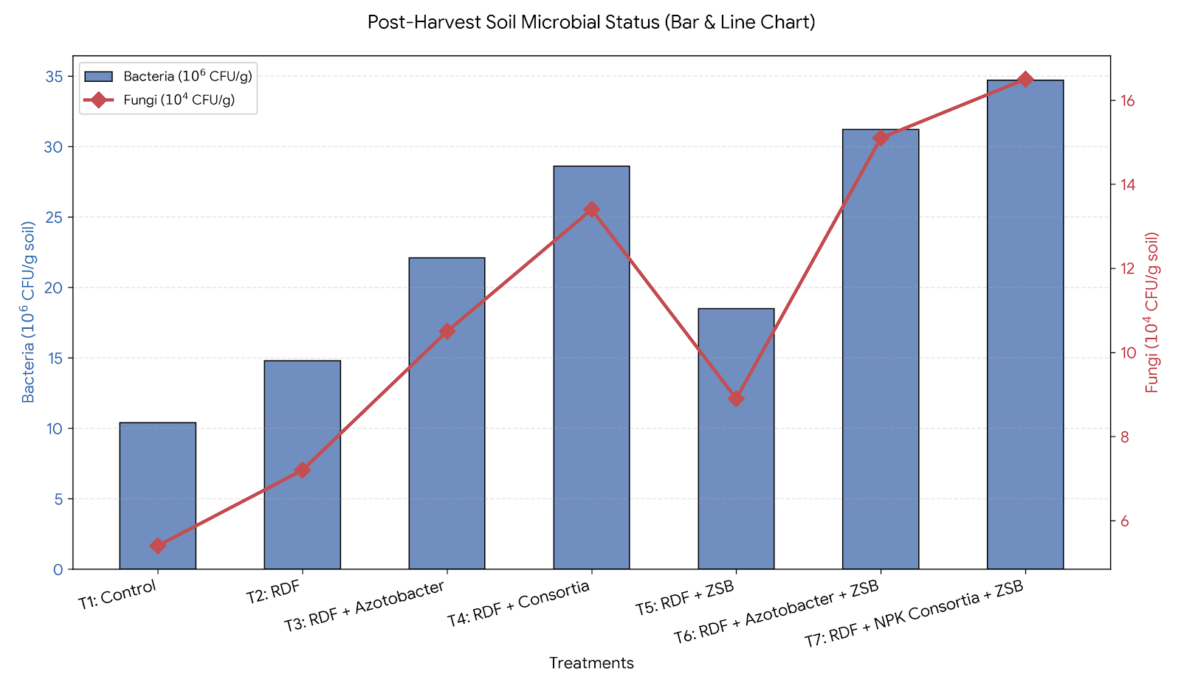
Figure 4: Post-Harvest Soil Microbial Status

Conclusion:
The study confirms that integrating tripartite microbial bio-priming—comprising NPK Consortia and Zinc Solubilizing Bacteria (ZSB)—with mineral fertilization is a transformative pathway for wheat intensification. Treatment T7 emerged as the optimal regime, achieving a maximal grain yield of 5.5 t/ha and a peak protein content of 11.4%. This effectively decouples the traditional inverse relationship between yield and quality by optimizing the plant’s C:N:P stoichiometry and nutrient canalization. Beyond productivity, the bio-augmented treatments successfully restored soil ecological functionality, evidenced by a three-fold increase in rhizospheric bacterial colonization compared to conventional mineral-only regimes. By alleviating metabolic bottlenecks caused by nutrient immobilization in alkaline soils, this multimodal microbial approach offers a scalable, regenerative framework. It transcends the "biological void" of conventional farming, ensuring long-term pedological health while sustaining high-input agricultural demands.

Disclaimer (Artificial intelligence)

Author(s) hereby declare that NO generative AI technologies such as Large Language Models (ChatGPT, COPILOT, etc.) and text-to-image generators have been used during the writing or editing of this manuscript.

References
Ajeethan, N., Abbey, Lord, & Yurgel, S. N. (2026). Role of Plant GrowthPromoting Microbes in Plant Growth and Development. Applied Microbiology, 6(2), 34. https://doi.org/10.3390/applmicrobiol6020034
Chang, X., Ji, C., Zhao, K., Wang, T., Yang, Y., Jia, X., Hu, B., Yu, Y., Li, F., He, Y., & Wu, Z. (2025). Dose-optimized microbial inoculants reshape grape rhizosphere microbiota and enhance fruit quality. Frontiers in Microbiology, 16, 1702884. https://doi.org/10.3389/fmicb.2025.1702884
Ghosh, T., Das, B., Chakraborty, D., Singh, V. K., Das, D., Aggarwal, P., Sarkar, A., Jha, P. K., & Prasad, P. V. V. (2025). Evaluation of soil quality frameworks in rice-wheat systems under integrated nutrient management in Indo-Gangetic plains. Scientific Reports, 15(1), 37511. https://doi.org/10.1038/s41598-025-21630-1
Khuwaja, G., Chaudhary, A. A., Mashlawi, A. M., Alamri, A., Alfifi, F., Anjum, K., Alam, M. S., Alam, M. I., Ali, S. K., Raza, N., Ali, M. A. M., & Imran, M. (2025). Biosynthesis of Zinc Oxide Nanostructures Using Leaf Extract of Azadirachta indica: Characterizations and In Silico and Nematicidal Potentials. Catalysts, 15(7), 693. https://doi.org/10.3390/catal15070693
Liu, W., Liu, R., Tang, Z., Zhang, Y., Deng, X., Yang, K., & Zhang, F. (2025). Dual-beneficial synergistic Trichoderma-bacterial cross-kingdom SynCom facilitates Medicago sativa productivity and soil organic carbon sequestration in saline-alkaline soil. Plant and Soil, 518(2), 1173. https://doi.org/10.1007/s11104-025-08053-7
Ma, J., Zhang, Z., HE, Z.-Q., Liu, J., Li, L., & Qi, B. (2025). Integrated multi-omics reveals the molecular basis of protein storage in developing oat grains. BMC Plant Biology, 25(1), 1550. https://doi.org/10.1186/s12870-025-07624-1
Malafeevskiy, N., Kongssund, E., Larsen, R. B., & Aasly, K. (2025). Weathering processes and critical minerals distribution in VMS tailings from Storwartz, Norway. Minerals Engineering, 235, 109830. https://doi.org/10.1016/j.mineng.2025.109830
Malik, S., Iqbal, A., Munir, I., Allemailem, K. S., Alrumaihi, F., Alwanian, W. M., Mousa, A., Al‐Megrin, W. A. I., Khan, A. M., & Khan, S. (2025). Microbial assisted zinc biofortification of wheat germplasm for the amelioration of zinc malnutrition. Scientific Reports, 15(1), 24555. https://doi.org/10.1038/s41598-025-09946-4
Mansoor, S., Iqbal, S., Popescu, S. M., Kim, S. L., Mansoor, S., & Baek, J. (2025). Integration of smart sensors and IOT in precision agriculture: trends, challenges and future prospectives [Review of Integration of smart sensors and IOT in precision agriculture: trends, challenges and future prospectives]. Frontiers in Plant Science, 16, 1587869. Frontiers Media. https://doi.org/10.3389/fpls.2025.1587869
McBratney, A. B., & Park, M. S. (2025). Agriculture over the Horizon: A Synthesis for the Mid-21st Century. Sustainability, 17(21), 9424. https://doi.org/10.3390/su17219424
NAWAZ, A., Bashir, M. A., Ahmed, W., Ahmad, I., Rehim, A., Ikram, R. M., Shah, S. S. H., Khurshid, M. Y., Rusan, M., Lubani, R., Shahzad, S., Haq, T. U., & Ali, M. (2024). Potassium and zinc improves physiological performance, nutrient use efficiency, and productivity of wheat. Frontiers in Plant Science, 15, 1363248. https://doi.org/10.3389/fpls.2024.1363248
Oubohssaine, M., Sbabou, L., & Aurag, J. (2025). Enhancing ecosystem restoration and soil productivity through PGPR: a sustainable approach to bioremediation and biofertilization. Discover Applied Sciences, 7(12). https://doi.org/10.1007/s42452-025-07510-3
Potter, T. S., Lankau, R. A., Silva, E., & Ruark, M. D. (2025). Soil microbial community composition matters for crop growth, but only when mobilizing recalcitrant nutrient sources. Plant and Soil. https://doi.org/10.1007/s11104-025-07864-y
Prasad, J. S., Suman, A., Kumar, D., Sharma, P., Ramakrishnan, B., & Aswini, K. (2025). Agroecology-based assembly and function of endophytic bacteria in seeds of Triticum aestivum. Frontiers in Microbiology, 16, 1699093. https://doi.org/10.3389/fmicb.2025.1699093
Roncalli, T. (2025). Lecture Notes On Biodiversity. SSRN Electronic Journal. https://doi.org/10.2139/ssrn.5170186
Said, Z., Vigneshwaran, P., Shaik, S., Rauf, A., & Ahmad, Z. (2025). Climate and carbon policy pathways for sustainable food systems. Environmental and Sustainability Indicators, 27, 100730. https://doi.org/10.1016/j.indic.2025.100730
Satognon, F., Watts, D. B., Adesemoye, A. O., Torbert, H. A., Prasad, R., & Mullenix, M. K. (2025). Bacillus PGPR consortium as a partial substitute for poultry litter improves forage performance in annual ryegrass and tall fescue under greenhouse conditions. Discover Agriculture, 3(1). https://doi.org/10.1007/s44279-025-00352-y
Sethi, G., Behera, K. K., Sayyed, R. Z., Adarsh, V., Sipra, B. S., Singh, L., Alamro, A. A., & Behera, M. (2025). Enhancing soil health and crop productivity: the role of zinc-solubilizing bacteria in sustainable agriculture. Plant Growth Regulation, 105(3), 601. https://doi.org/10.1007/s10725-025-01294-7
Shaaban, M., Younas, A., Mehmood, M. A., Shi, Z., & Wang, X. (2025). Enhancing N use Efficiency, Increasing Wheat Yield and Reducing Chemical Fertilizer Dependence via Beneficial Bacteria. Rice, 18(1). https://doi.org/10.1186/s12284-025-00849-6
Sihotang, T., & Sihotang, N. V. (2025). Internet of Things (IoT) based drip irrigation optimization to reduce the impact of drought on Tomato. https://doi.org/10.59651/ccria
Singh, T., Kothari, M., Mishra, S., Singh, A. V., Verma, A. K., Shankhdhar, D., & Shankhdhar, S. C. (2025). Synergistic effect of Zinc Solubilizing Bacteria and Consortia on the zinc marker enzymes and gaseous exchange parameters in Rice (Oryza sativa L.) for zinc biofortification. Plant Physiology and Biochemistry, 223, 109807. https://doi.org/10.1016/j.plaphy.2025.109807
Sirsat, M., Isla-Cernadas, D., Cernadas, E., & Fernández-Delgado, M. (2025). Machine and deep learning for the prediction of nutrient deficiency in wheat leaf images. Knowledge-Based Systems, 317, 113400. https://doi.org/10.1016/j.knosys.2025.113400
Wang, H., Wang, H., He, Y., Liu, X., Liu, X., Guan, Y., Shen, Y., Li, J., Yang, D., & Sun, Z. (2025). Legume green manure partial replacement of fertilizers enhances soil microbial diversity and sustains wheat yield. Frontiers in Plant Science, 16, 1618555. https://doi.org/10.3389/fpls.2025.1618555
Xu, J., Liu, Q., Huang, Z., & Li, D. (2025). Sustained Inoculation of a Synthetic Microbial Community Engineers the Rhizosphere Microbiome for Enhanced Pepper Productivity and Quality. Agronomy, 15(12), 2888. https://doi.org/10.3390/agronomy15122888
Yang, J., Lü, X., Hao, B., Wang, S., Kong, L., Shao, Q., Li, W., Wang, X., Xu, Y., Wu, W., Wang, J., Yan, L., Ren, L., & Chen, G. (2025). Bio-organic fertilizers reshape rhizosphere bacterial community and enhance crop productivity in reclaimed soil. Frontiers in Microbiology, 16, 1713125. https://doi.org/10.3389/fmicb.2025.1713125
Zhang, W., Zhu, S., Han, D., Yang, T., Jiang, Y., Wang, J., Wu, F., Yao, Z., Sun, C., & Liu, T. (2025a). Classification of pre-winter wheat seedling conditions based on UAV images and local optimized features (LOFs). Journal of Integrative Agriculture. https://doi.org/10.1016/j.jia.2025.07.031
Zhao, T., Jia, X., Liu, X., Nepal, J., Guyoneaud, R., Treder, K., Pawłowska, A., Michałowska, D., Berg, G., Stocker, F., Cernava, T., Elzenga, J. T. M., Attard, E., & Salles, J. F. (2025). Harnessing microbiome-plant synergies: microbiome-interactive traits enhance plant growth and support sustainable agriculture. Npj Sustainable Agriculture, 3(1). https://doi.org/10.1038/s44264-025-00093-x
Zheng, Y., Zhao, W., Hu, X., Li, Z., Gao, K., & Jiao, N. (2026). Phosphorus fertilization and maize intercropping with peanut synergistically reshape rhizosphere microbiome and enhance crop yield. Frontiers in Microbiology, 16, 1732662. https://doi.org/10.3389/fmicb.2025.1732662
Vargiya, S. V., Tiwari, C., Govindan, V., & Gundaniya, H. V. (2025). Genetic Evaluation of Wheat (Triticum aestivum L.) Genotypes in Malwa Region of India. Journal of Advances in Biology & Biotechnology, 28(10), 291–302. https://doi.org/10.9734/jabb/2025/v28i103057
Chauhan, P., Kumar, V., Shrivastava, M. K., Patel, N., Biswal, M., & Mate, H. (2023). Agro-morphological Characterization of Wheat (Triticum aestivum L.) Genotypes. Journal of Experimental Agriculture International, 45(11), 122–129. https://doi.org/10.9734/jeai/2023/v45i112241
Zhang, S., Li, F., Chang, L., Zhang, Q., Zhang, Z., Wu, T., Wu, Y., Wang, Z., Su, Y., Yang, X., Gao, W., Li, M., Wu, Y., & Jiang, Y. (2025b). Broad-spectrum applications of plant growth-promoting rhizobacteria (PGPR) across diverse crops and intricate planting systems. Microbiology spectrum, 13(3), e0187924. https://doi.org/10.1128/spectrum.01879-24
Saadaoui, N., Silini, A., Cherif-Silini, H., Bouket, A. C., Alenezi, F. N., Luptakova, L., ... & Belbahri, L. (2022). Semi-arid-habitat-adapted plant-growth-promoting rhizobacteria allows efficient wheat growth promotion. Agronomy, 12(9), 2221.
Ali, M., Ahmed, I., Tariq, H., Abbas, S., Zia, M. H., Mumtaz, A., & Sharif, M. (2023). Growth improvement of wheat (Triticum aestivum) and zinc biofortification using potent zinc-solubilizing bacteria. Frontiers in Plant Science, 14, 1140454.

