Research Article
CORRELATION OF SCHOOL-BASED ALBENDAZOLE MASS DRUG ADMINISTRATION ON MALARIA AND SOIL TRANSMITTED HELMINTHS CO-INFECTION IN SCHOOL-AGED CHILDREN

Abstract
Background: Malaria and Soil-Transmitted Helminth (STH) infections present a significant public health challenge in endemic regions, often occurring together and worsening health outcomes. This cross-sectional study examined the prevalence of the co-infection among school-aged children in the Unwana Community, Ebonyi State, and showed the effects of school-based Albendazole Mass Drug Administration (MDA).
Methods: A total of 249 pupils from three constituencies in the community were sampled between June and August 2025. Malaria was diagnosed using Rapid Diagnostic Tests (RDTs), while STH infections were identified in stool samples using standard techniques. Data on MDA receipt, socio-economic factors, and preventive measures were gathered through a questionnaire. Additionally, health center records on community MDA were collected.
Results: The overall prevalence of infections was 38.6% (n=96) for malaria, 36.5% (n=91) for STH, and 7.2% (n=18) for co-infection. The STHs identified included Ascaris lumbricoides, Trichuris trichiura, and hookworm. A. lumbricoides had the highest prevalence at 16.5% (n=41). Double STH infections included A. lumbricoides-hookworm (2.4%, n=6), A. lumbricoides-T. trichiura (2.8%, n=7), and T. trichiura-hookworm (1.2%, n=3). Significant associations were found between malaria, STH infections, and demographics of the school children (P<0.05); however, there was no association between co-infection and demographics of the children (P>0.05). Not receiving Albendazole in school was identified as the only significant factor influencing malaria-STH co-infection (Adjusted Odds Ratio=3.760, P=0.042). Analysis of health center records revealed inconsistencies in community-level Albendazole MDA, with only the U.C.P.S 2 constituency receiving doses in 2021, 2022, and 2023.
Conclusion: The prevalence of co-infection indicates an ongoing public health challenge within the community. Additionally, the significant risk factor identified for malaria and STH co-infection suggests that implementing school-based mass drug administration (MDA) could be a more effective strategy for controlling STH among school-aged children in Unwana.

Keywords: Malaria, Soil-transmitted helminthes, Co-infection, School children, Albendazole, Mass Drug Administration

INTRODUCTION
Plasmodium falciparum is the primary species responsible for malaria in sub-Saharan Africa, causing the vast majority of infections and severe cases. It is known as the deadliest human malaria parasite, responsible for most mortality in the region. Other species, such as P. malariae and P. ovale, are present less frequently. According to various facts and statistics, Nigeria is one of the ten countries that account for 66% of malaria cases worldwide (MMV, 2025; WHO, 2025). In 2025, Nigeria faced a substantial malaria burden, reporting over 24 million cases in the first nine months, with cases peaking during the rainy season (BEACON, 2025). Additionally, Nigeria is one of three countries in the African Region that contribute to half of all malaria-related deaths, accounting for 31.9% of mortality in the region (MMV, 2025).
Soil-transmitted helminth (STH) infections, including Ascaris lumbricoides, Trichuris trichiura, Ancylostoma duodenale, and Necator americanus, are endemic in Nigeria, with worm burdens ranging from 13.2% to 80.9% across the six geopolitical zones of the country (Oyeyemi & Okunlola, 2023; Sangare et al., 2025). While STH infections can affect individuals of any age, preschool-aged and school-aged children (SAC) are particularly vulnerable (Usang et al., 2025). In cases of single infections, symptoms for malaria and STH can vary significantly. Malaria may present with mild fever and chills, but can escalate to severe cases resulting in organ failure and death. On the other hand, mild STH infections may show no symptoms, but severe cases can lead to anemia, vitamin A deficiency, malnutrition, loss of appetite, and stunted growth (Eshofonie et al., 2025).
In many regions of the African continent, STH—specifically A. lumbricoides, T. trichiura, and hookworms—share the same geographic distribution as the malaria-causing parasite. While there has been significant research on the patterns and distribution of single infections of malaria and STH among vulnerable school-age children, there is still limited understanding of the associated patterns and risk factors for co-infections in African communities. Therefore, it is essential to define the spatial relationship between P. falciparum and various helminths to gain a better understanding of their interactions. Such co-infections can exacerbate health issues, such as anemia, and may lead to negative outcomes, including learning disabilities and higher dropout rates among children (Brooker et al., 2007; Eshofonie et al., 2025).
Early diagnosis and prompt treatment are crucial for controlling malaria among children. For STH, community-based and school-based mass drug administration (MDA) are used to eliminate these infections (Mogaji et al., 2023). In Nigeria, albendazole is typically administered to at-risk children living in endemic areas through school-based MDA, owing to the relative ease of access to children in poor rural areas through schools and the cost-effectiveness of school-based deworming (Anderson et al., 2013). The albendazole mass drug administration (MDA) program in Ebonyi State is currently ongoing. A report from the Ezza North Local Government Area (LGA) indicates that 725,443 doses of albendazole were distributed between 2014 and 2017, which coincides with the period when the MDA began in the region (Elom et al., 2020). Previous studies have shown a high prevalence of both malaria and STHs in the Unwana community (Odimkamnoro et al., 2017; Nworie et al., 2022). As the albendazole MDA is currently being implemented in the state, this study intends to investigate its impact on the prevalence of STHs in Unwana. Additionally, it is essential to examine how this program affects the co-infection rates of malaria and STHs, given that both diseases are common in the community. The study will also evaluate the effectiveness of the school-based albendazole MDA program.

METHODOLOGY
Description of Study Area
The study was conducted in the Unwana community, located in the Afikpo North Local Government Area of Ebonyi State, Nigeria. This community spans approximately 190 square kilometers and is situated at a latitude of 5.053° N and a longitude of 7.056° E. The vegetation in Unwana features a combination of open grassland and tropical rainforest. The main occupation of the residents is farming, as the climate supports the cultivation of crops such as rice, yams, and cassava. The Unwana community is divided into four constituencies: Ndemyi, Amagu, Uhuetiti, and Amaekwu (Ndukwe et al., 2020). Map 1 displays a map of Afikpo North LGA, highlighting the location of the Unwana community.

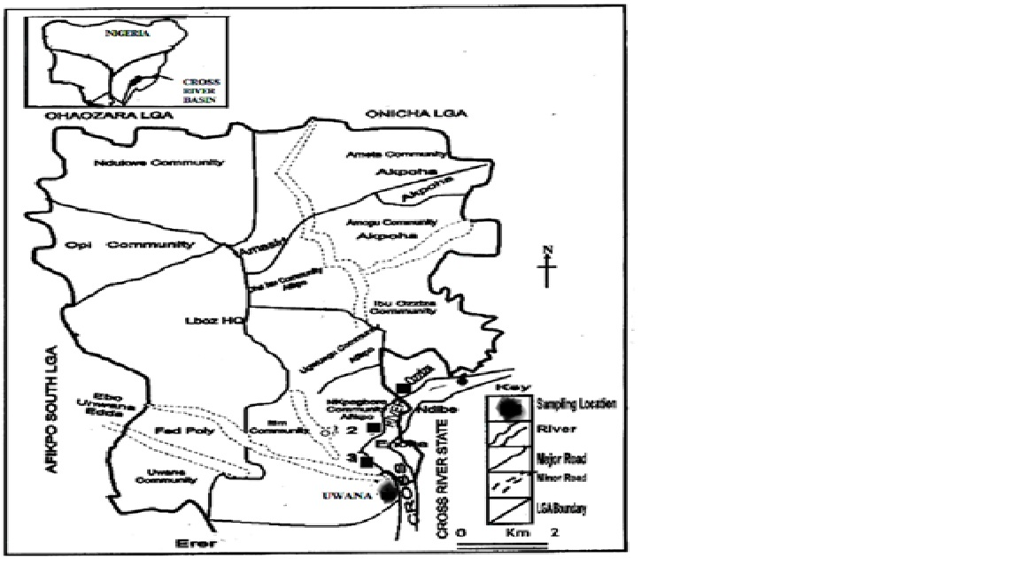
Map 1: Map of Afikpo North Local Government Area, Ebonyi State, depicting the Unwana Community. Modified from: Uneke & Nwani (2013)
Study Population and Sample Size Determination: The study population included primary school children aged 3 to 15 years who attended public primary schools in the Ndemyi (Lady Olayinka Ibiam Memorial Primary School- L.O.I.M.P.S), Amagu (Unwana Community Primary School I- U.C.P.S1), and Uhuetiti (Unwana Community Primary School 2-U.C.P.S. 2) constituencies of the Unwana Community, located in the Afikpo North Local Government Area (LGA) of Ebonyi State. This age group was selected because the children are currently receiving mass drug administration (MDA) of albendazole in the Local Government Area (LGA) and are also at risk of malaria infection. Students who received albendazole in the past six months were excluded from the study. The sample size was determined as shown below:
Using the formula $n=\frac{Z^{2}×P\left(1-P\right)}{e^{2}}$
Where:
n=Z is the score that corresponds to 1.96 for a 95% confidence interval.
P = Estimated prevalence of malaria and STH co-infection is 9.49%, as reported by Nwakaogor et al. (2024).
e = Margin error of 5%.
Therefore $n=\frac{Z^{2}×P\left(1-P\right)}{e^{2}}=\frac{3.8416×0.0949×0.9051}{0.0025}=131.988≈132$
Study design: The study was a cross-sectional analysis conducted from June to August 2025. Three community schools in the Unwana constituencies were sampled, and children from grades 1 to 6 were randomly selected to participate. The students were categorized into two groups for statistical analysis: Junior Primary includes grades 1 to 3, while Senior Primary covers grades 4 to 6.
Data Collection
Rapid Diagnostic Test for Malaria Screening: This procedure was conducted as outlined by Nwele et al. (2022) using the Rapid Diagnostic Test kit (RDT; SD Bioline Malaria AG P.F/PAN kit, Standard Diagnostics, Seoul, Korea). Initially, the participant's fingertip was cleaned and allowed to air dry. A sterile lancet was then used to prick the cleaned finger, and a drop of blood was collected using a capillary device. This drop of blood was placed in the lower well of the RDT (Rapid Diagnostic Test) kit. Next, two drops of buffer solution were added to the blood in the lower well. After waiting fifteen minutes, the results were interpreted according to the manufacturer's instructions and the guidelines provided by the World Health Organization.
Collection of stool samples: Children were taught how to collect stool samples at home before being given universal containers for the collection process. The pupils were instructed to bring their stool specimens by 8:00 AM the following day. Upon their return, the sample bottles containing the specimens were labeled with identification numbers, sex, age, and grade level of pupil. They were then placed in a cold box with ice packs for immediate transportation to the Biology Laboratory of the Department of Biology at Alex Ekwueme Federal University, Ndufu-Alike, Ikwo (AEFUNAI).
Screening of stool samples for soil-transmitted helminthes: The stool samples were analyzed using wet mount and formol-ether concentration techniques, as described by Imakwu et al. (2020). To prepare the wet mount, a drop of 8.5% physiological saline was placed at one end of a clean slide, while a drop of iodine was placed at the other end. A small portion of the stool specimen was mixed with saline using a syringe, while another portion was effectively combined with iodine solution. Each sample was covered with a cover slip and examined under a microscope to check for intestinal parasites, larvae, ova, or cysts. Observations were conducted using X10 and X40 objectives, with the condenser iris properly adjusted to achieve optimal contrast.
In the Formol-Ether Concentration Technique, one gram of each fecal specimen was emulsified in approximately 7 ml of 10% formalin saline using a centrifuge tube. The emulsified feces were strained through a sieve into a beaker. The suspension was labeled and placed into a glass centrifuge tube, to which approximately 3 ml of diethyl ether was added. The tube was stoppered and shaken vigorously for one minute, then centrifuged at 3,000 rpm for five minutes. After centrifugation, the layer of fecal debris was gently detached from the side of the tube using an applicator stick. The sediment was effectively mixed, and a drop was placed on a clean glass slide. After covering it with a cover slip, we confidently examined it under the microscope using the 10x and 40x objectives.
Assessment of MDA History and Risk Factors: Data was collected through a semi-structured questionnaire that obtained information on the demographic characteristics of school children. The questionnaire also included inquiries about the history of albendazole collection in schools, the utilization of insecticide-treated nets, and environmental factors that could pose risks for both infections.
Health Centre Records on Community Collection of Albendazole: The Health Centres in the Unwana Community were visited, and records of community participation in the reception of albendazole were obtained.
Ethical Approval: Ethical permission was obtained from the Public Health Division of the Nkagbogu Health Centre in Unwana Community, Afikpo North LGA, Ebonyi State. Approval was also secured from the head teachers of three schools, along with consent from their respective Parent-Teacher Association (PTA) chairpersons, to collect samples from students. Informed consent was obtained from the parents of the schoolchildren before the sample collection.
Statistical Analysis: This analysis was conducted using IBM’s SPSS version 25.0. Descriptive statistics were employed to summarize the frequencies and percentages of the demographic data collected, as well as the environmental determinants of infection in the locality. The Chi-Square Test was utilized to examine the association between the prevalence of malaria, soil-transmitted helminths (STH), and malaria-STH co-infection with the demographic characteristics of school children. Logistic regression was performed to identify the factors that increase the risk of school children contracting malaria, STH, and malaria-STH co-infection. The logistic regression results were presented as adjusted odds ratio, their 95% confidence interval and their level of significance. Records of community participation in albendazole mass drug administration (MDA) were analyzed from 2021 to 2023 and represented in bar charts. Results were deemed significant at p < 0.05.
RESULTS
Description of Study Population
A total of 249 primary school pupils were sampled in Unwana, Afikpo North LGA. Among them, 129 (51.8%) were male, and 120 (48.2%) were female. The pupils were divided into three age groups. Children aged 3–6 years accounted for 32 (12.9%) of the sample, while those aged 7–10 years made up the majority with 144 (57.8%). Pupils aged 11–15 years comprised 73 (29.3%). In terms of class levels, 115 pupils (46.2%) were in junior primary (classes 1–3), while 134 pupils (53.8%) were in senior primary (classes 4–6). Regarding school attendance, 119 pupils (47.8%) attended Lady Olayinka Ibiam Memorial Primary School (L.O.I.M.P.S), 74 pupils (29.7%) attended Unwana Community Primary School I (U.C.P.S. 1), and 56 pupils (22.5%) attended Unwana Community Primary School II (U.C.P.S. 2), as shown in Table 1.

Table 1: Demographic Characteristics of School Children
Description of school children | Number sampled | Percent (%)
Total | 249 | 100
Gender
Male | 129 | 51.8
Female | 120 | 48.2
Age group (Years)
3-6 | 32 | 12.9
7-10 | 144 | 57.8
11-15 | 73 | 29.3
Class grade
Jnr, Primary (1-3) | 115 | 46.2
Senior primary (4-6) | 134 | 53.8
School attended (Constituency)
L.O.I.M.P.S (Ndemyi) | 119 | 47.8
U.C.P.S.1 (Amagu) | 74 | 29.7
U.C.P.S 2 (Uhuetiti) | 56 | 22.5

Overall Prevalence of Malaria, Soil-transmitted Helminths (STH) and malaria-STH Co-infection
Among a sample of 249 pupils, 96 (38.6%) tested positive for malaria, and 91 (36.5%) tested positive for STH infection. Co-infection of malaria and STH was observed in 18 pupils (7.2%), while 231 (92.8%) were negative for both infections (Figure 1).
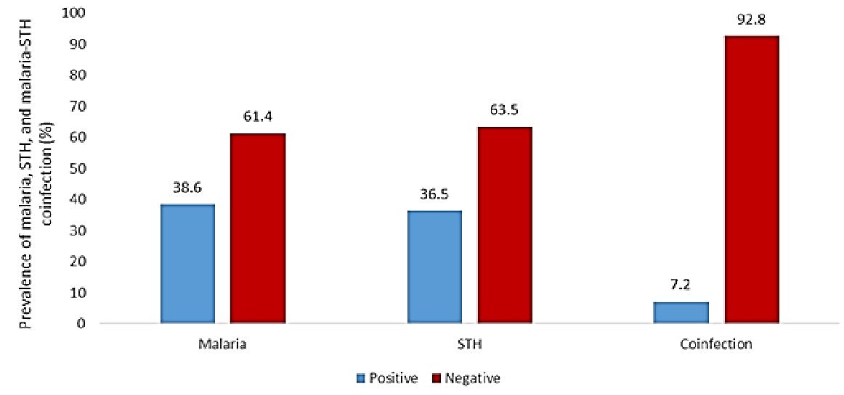
Figure 1: Overall prevalence of malaria, STH, and malaria-STH co-infection among primary school children in the Unwana Community

Prevalence of Single and Double Infections Caused by Soil-Transmitted Helminths
Out of the total number of individuals infected with STH, which accounted for 36.5% (n=91), the specific infections were as follows: 41 individuals (16.5%) tested positive for single infections of A. lumbricoides, 14 individuals (5.6%) had single infections of T. trichiura, and 19 individuals (7.6%) were infected with hookworm (Figure 2). Additionally, double infections of STH were observed in 7 individuals (2.85%) who had both A. lumbricoides and T. trichiura, 3 individuals (1.2%) with T. trichiura and hookworm, and 6 individuals (2.4%) who had both A. lumbricoides and hookworm infections (Figure 3).

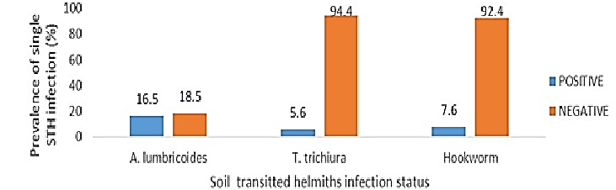
Figure 2: Prevalence of Single Soil-Transmitted Helminth infections among School Children in the Unwana Community

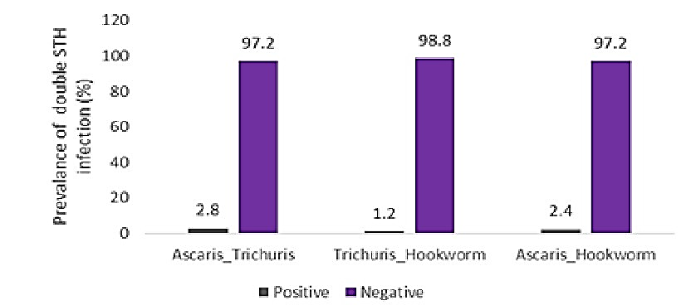

Figure 3: Prevalence of double Soil-Transmitted Helminth infections among School Children in Unwana Community

Prevalence of Malaria, STH, and Malaria-STH Co-infection in Relation to Demographics
Overall, malaria prevalence was higher among females (44.2%) than among males (33.3%), although the difference was not statistically significant (P>0.05). Pupils aged 3–6 years and those aged 7–10 years demonstrated higher malaria prevalence rates (43.8% each) than their counterparts aged 11–15 years (26.0%), showing a significant difference (P<0.05). Among different school classes, junior primary pupils exhibited a notably higher prevalence (47.0%) compared to senior primary pupils (31.3%) (P<0.05). Across the schools, prevalence rates were similar: L.O.I.M.P.S reported 40.3%, U.C.P.S 1 had 36.5%, and U.C.P.S 2 recorded 37.5%, with no significant difference observed (P>0.05).
The prevalence of STH infections was observed to be 37.2% in males and 35.8% in females, with no statistically significant difference (P>0.05). Among different age groups, pupils aged 7–10 years exhibited the highest STH prevalence at 41.7%, followed by those aged 11–15 years at 32.9%, and 3–6 years at 21.9%. However, these differences were not statistically significant (P>0.05). Senior primary pupils showed a slightly higher prevalence (39.6%) compared to junior primary pupils (33.0%), although this difference was also not statistically significant (P>0.05). In terms of school-specific prevalence, there were significant differences noted (P<0.05): L.O.I.M.P.S recorded 26.9%, U.C.P.S 1 had 39.2%, and U.C.P.S 2 demonstrated the highest rate at 53.6%.
Malaria and STH co-infection rates were recorded at 6.2% in males and 8.3% in females, with no statistically significant difference (P>0.05). By age group, the highest co-infection prevalence was observed in children aged 7–10 years at 9.0%, followed by those aged 11–15 years at 5.5%, and 3–6 years at 3.1%, all showing no significant differences (P>0.05). Among school classes, senior primary students had a slightly higher co-infection rate of 8.2% compared to junior primary students at 6.1%, but this difference was not significant (P>0.05). Across various schools, co-infection prevalence was observed as follows: L.O.I.M.P.S at 5.9%, U.C.P.S 1 at 8.1%, and U.C.P.S 2 at 8.9%, with no significant differences noted (P>0.05), as shown in Table 2.

Table 2: Prevalence of malaria, STH, and malaria-STH co-infection in relation to demographics
Demography of pupils | Number  sampled | Malaria  n (%) | STH  n (%) | Co-infection  n (%)
Gender
Male | 129 | 43(33.3) | 48(37.2) | 8(6.2)
Female | 120 | 53(44.2) | 43(35.8) | 10(8.3)
P value |  | 0.091 | 0.895 | 0.627
Age grade(years)
3-6 | 32 | 14(43.8) | 7(21.9) | 1(3.1)
7-10 | 144 | 63(43.8) | 60(41.7) | 13(9.0)
11-15 | 73 | 19(26.0) | 24(32.9) | 4(5.5)
P value |  | 0.033** | 0.081 | 0.400
Child’s class
Junior primary | 115 | 54(47.0) | 38(33.0) | 7(6.1)
Senior primary | 134 | 42(31.3) | 53(39.6) | 11(8.2)
P value |  | 0.013** | 0.295 | 0.627
Schools
L.O.I.M.P.S | 119 | 48(40.3) | 32(26.9) | 7(5.9)
U.C.P.S 1 | 74 | 27(36.5) | 29(39.2) | 6(8.1)
U.C.P.S 2 | 56 | 21(37.5) | 30(53.6) | 5(8.9)
P value |  | 0.852 | 0.002** | 0.723
**Significant association between prevalence of malaria, STH, and co-infection and demographic variable
Factors affecting Malaria-STH co-infection prevalence among primary school children in the community
The adjusted odds ratio (AOR) of factors affecting the prevalence of the co-infection among primary school pupils indicated that not taking albendazole (AOR=3.760, 95% CI=1.047-13.502, P=0.042) was the only significant factor influencing malaria and STH co-infection prevalence in the study area (Table 3).
Table 3: Factors affecting prevalence of malaria-STH co-infection among the primary school pupils
Factors | AOR | 95% CI | P value
Gender
Male | Reference
Female | 0.781 | 0.275-2.216 | 0.642
Age group
3-6 | 1.082 | 0.080-14.626 | 0.953
7-10 | 0.436 | 0.112-1.695 | 0.231
11-15 | Reference
Grade group
Junior primary | 1.730 | 0.500-5.991 | 0.387
Senior primary | Reference
Name of school
L.O.I.M.P.S | Reference
U.C.P.S. 1 | 0.902 | 0.246-3.307 | 0.877
U.C.P.S 2 | 1.051 | 0.266-4.143 | 0.944
Sources of drinking water
Stream | 1.146 | 0.421-3.120 | 0.790
Borehole | Reference
Drainage
Yes | Reference
No | 0.996 | 0.350-2.832 | 0.994
ITN
Yes | Reference
No | 0.739 | 0.251-2.175 | 0.582
Did you receive albendazole in school?
Yes | 3.287 | 0.991-10.903 | 0.052
No | 3.760 | 1.047-13.502 | 0.042**
Don’t know | Reference

**Significant factor contributing to malaria-STH co-infection among school children in Unwana community

Community Record of Albendazole Mass Drug Administration (MDA)
Records of albendazole distribution across the three study constituencies showed variations in timing, frequency, and age-group participation. In Ndemyi, where L.O.I.M.P.S is located, health centre records showed that community reception of albendazole MDA was in 2021, specifically in January, March, and April. The 12–23 months age group received the highest number of doses during these months (Figure 4). In Amagu, where the U.C.P. S 1 is situated, community distribution also occurred in 2021, with the 24–59 months age group receiving more albendazole than the younger group. The peak distribution was recorded in May 2021, as shown in Figure 5. In Uhuetiti constituency, where U.C.P. S 2 is located, community albendazole MDA took place over three years from the health centre records—2021 (January, February, March, April, June), 2022 (March), and 2023 (March). With children aged 12–23 months, who received the most doses (Figure 6).

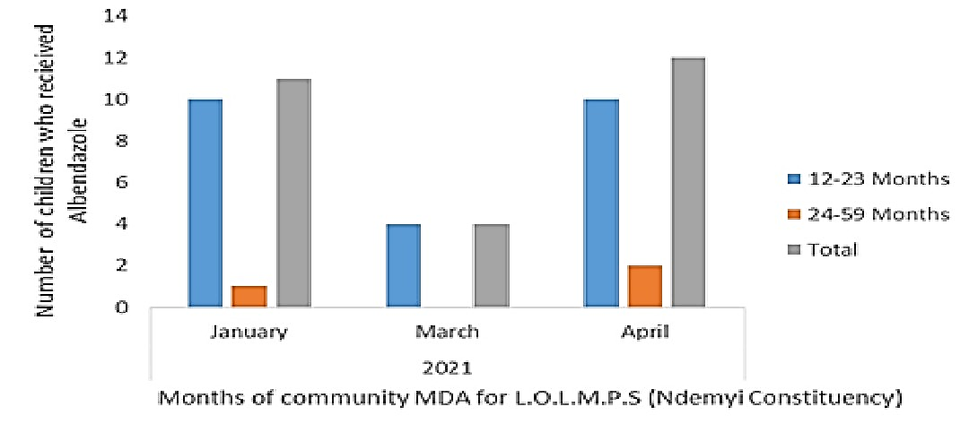
Figure 4: Community albendazole MDA record of Ndemyi constituency, where L.O.I.M.P.S is located

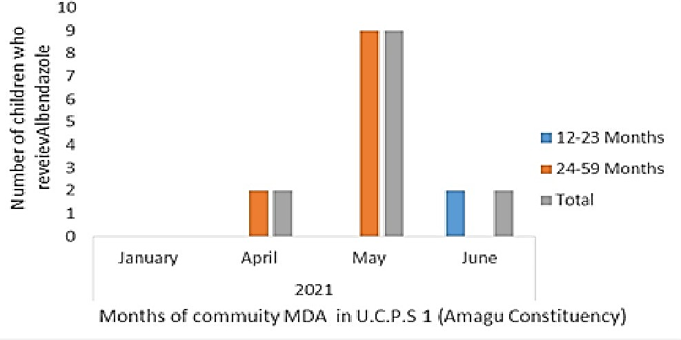
Figure 5: Community albendazole MDA record of Amagu constituency, where U.C.P.S.1 is located

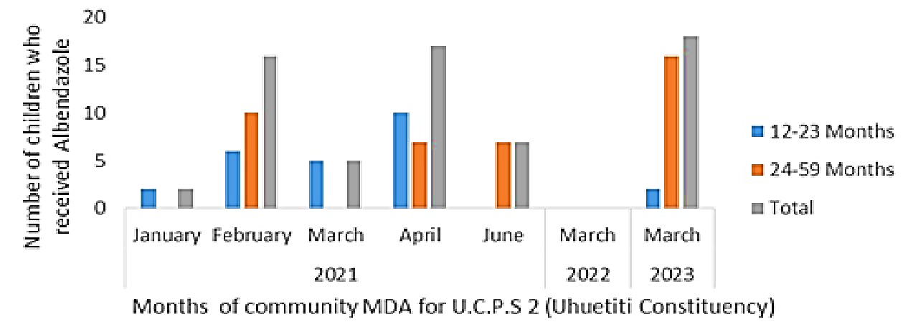
Figure 6: Community albendazole MDA record of Uhuetiti constituency, where U.C.P.S.2 is located

DISCUSSION
The prevalence rates exceeding 30% for both malaria and soil-transmitted helminths (STH) indicate that these infections pose a significant public health concern in the area. This suggests that various factors contributing to the transmission of both malaria and STH are present within the community (Duguma et al., 2025). The prevalence of STH in this study was slightly higher than the 31.8% reported by Nworie et al. (2022), indicating that the ongoing mass drug administration (MDA) has not significantly impacted the prevalence of STH among children. This finding also contradicts the report by Nwakaogor et al. (2024), which documented a prevalence of 38.23% for malaria and 17.44% for STH in a co-infection study involving school children under 15 years old in Awka North LGA, Anambra State.
The rate of malaria and STH co-infection in this study indicates a low risk of co-infection within the community. This finding suggests that there is a small group of primary school children in Unwana at an increased risk of experiencing the harmful consequences associated with both malaria and STH co-infection (Ngasala et al., 2019). The 7.2% prevalence recorded in this study is lower than the 9.4% prevalence reported among under-15 schoolchildren in Awka North LGA, Anambra State, by Nwakaogor et al. (2024). However, it is higher than the 1.07% prevalence found among children in Sokoto Metropolis (Mohammed et al., 2023).
The highlights from the STHs recovered suggest a significant lack of access to clean water, poor sewage management, and inadequate handwashing practices in the community, all of which contribute to the fecal-oral transmission of infections. Ineffective sewage management may have resulted in soil contamination, leading to hookworm infections in children who walk barefoot (Imalele et al., 2023). In a study conducted in Kwara State, the STHs identified included Ascaris, Hookworm, and Trichuris (Amaechi et al., 2016). The occurrence of double infections, such as Ascaris-Trichuris, Trichuris-Hookworm, and Ascaris-Hookworm, highlights shared transmission routes, where eggs from human feces contaminate the soil. This situation underscores significant environmental risk factors, including the prevalence of walking barefoot and a lack of clean water and hygiene (WHO, 2023). The prevalence of double STH infections found in this study was lower than the 14.04% reported for Ascaris-Hookworm co-infection and the 7.3% noted for Ascaris-Trichuris co-infection by Dada-Adegbola et al. (2013), as well as the 28.8% reported for Ascaris-Trichuris co-infection by Mulu et al. (2013).
The significant association between single malaria infections and younger age groups suggest that younger children are more vulnerable to malaria because they have not yet developed the clinical immunity that older children acquire through repeated exposure. This makes them more susceptible to infection (WHO, 2018). This finding aligns with the report from Njua-Yafi et al. (2016), which indicated that younger children experienced more malaria attacks than older children. The observed association between the high prevalence of STH and the UCPS2 primary school, where albendazole was not frequently distributed to students, suggests that school-based mass drug administration (MDA) is a crucial strategy for reducing parasite burden. Schools that skip anthelmintic distribution, such as albendazole, are likely to experience higher prevalence and intensity of STH infections. Interestingly, these results contrast with findings from a trial conducted in Vietnam, which showed that community-based interventions were more effective than school-based interventions for controlling hookworm infections (Dyer et al., 2023). However, another study conducted in Zimbabwe demonstrated that a school-based deworming program, along with prompt malaria treatment, was effective in reducing co-infections of malaria and helminths in primary school children (Midzi et al., 2011).
The lack of a significant association between the demographic characteristics of study participants and malaria-STH co-infection suggests that factors such as environmental and behavioral influences may be stronger predictors of co-infection than demographic factors. This finding contrasts with previous research on malaria-STH co-infection, which identified certain demographic characteristics, such as sex and age, as significant predictors of co-infection (Afolabi et al., 2021; Meñe et al., 2023).
Students in the Unwana community who are missing doses of albendazole in school indicate a high prevalence of STHs. A similar study conducted in Zimbabwe by Midzi et al. (2011) showed that the lack of anti-helminthic treatment between the 12-month and 33-month follow-up surveys of a school-based albendazole and praziquantel program led to a significant increase in co-infection rates of STHs and schistosomes. Specifically, the rates rose from 3.3% at the 12-month follow-up to 10.7%, which was slightly above the baseline level of 10.3%. This suggests that the discontinuation of school-based interventions may be a risk factor for ongoing malaria-STH co-infection.
Records from the community health center indicate that albendazole was available at the center in the Uhuetiti constituency, where UCPS2 is located, during the years 2021, 2022, and 2023. However, despite its availability, health center records show that children in the Uhuetiti constituency received the drug for only a few months in 2021 and only in March in both 2022 and 2023. Major factors contributing to the low uptake of MDA in community-based interventions include a lack of education on albendazole and widespread concerns about the potential adverse effects of MDA (Forson et al., 2024; Sangare et al., 2025).
CONCLUSION
In conclusion, there is a moderate prevalence of malaria and STH infections among primary school children in Unwana. A significant risk factor for malaria-STH co-infection in these children is missing the administration of albendazole during school-based mass drug administration (MDA). Therefore, it is essential to emphasize consistent school-based deworming programs, along with improved community education and malaria prevention strategies, to reduce the burden of these parasites among school children in Unwana.
Limitation of study
The main limitation encountered in this study was the reluctance of the Unwana community members to cooperate with the research team. This hesitation arose when students took consent letters home, primarily due to concerns that materials collected from their bodies could be used for harmful purposes. However, the tension was eased because one of our team members is from the community and speaks the local dialect fluently.

COMPETING INTERESTS DISCLAIMER:
Authors have declared that they have no known competing financial interests OR non-financial interests OR personal relationships that could have appeared to influence the work reported in this paper.

Disclaimer (Artificial intelligence)

Author(s) hereby declare that NO generative AI technologies such as Large Language Models (ChatGPT, COPILOT, etc.) and text-to-image generators have been used during the writing or editing of this manuscript.

REFERENCES
- MMV. (2025). Malaria facts & statistics 2025. Medicines for Malaria Venture. https://www.mmv.org/malaria/about-malaria/malaria-facts-statistics-2025
- WHO (2025). Malaria. https://www.who.int/news-room/fact-sheets/detail/malaria. Accessed April 11, 2026.
- BEACON. (2025). BEACON. Malaria, Nigeria. https://beaconbio.org/en/report/?reportid=49d5fef2-0098-460d-971a-3079b6ff5560&eventid=6345032e-d68c-4068-80b5-b3aed91f64eb
- Oyeyemi, O. T., & Okunlola, O. A. (2023). Soil-transmitted helminthiasis (STH) endemicity and performance of preventive chemotherapy intervention programme in Nigeria (in year 2021). Scientific Reports, 13(1), 10155. https://doi.org/10.1038/s41598-023-37402-8
- Sangare, M., Coulibaly, Y. I., Diabate, A. F., Dolo, H., Koureichi, M. M., Diarra, D., Duguay, C., Stephens, M., Diakité, M., Kulkarni, M. A., Nutman, T. B., & Krentel, A. (2025). Factors associated with low coverage in mass drug administration for schistosomiasis in mobile populations in Mali: A cross-sectional study. BMC Infectious Diseases, 25, 1240. https://doi.org/10.1186/s12879-025-11626-7
- Usang, A. U., Imalele, E. E., Effanga, E. O., Ukoha, U. K., & Eleng, I. E. (2025). Soil-transmitted helminth infections and nutritional indices among children (5-9 years) and adolescents (10-12 years) in Calabar, Nigeria. BMC Public Health, 25(1), 1. https://doi.org/10.1186/s12889-024-21210-4
- Eshofonie, F., Johnson, O., & Gayawan, E. (2025). Co-morbidity of malaria and soil-transmitted helminths in Nigeria: A joint Bayesian modelling approach. Infectious Diseases of Poverty, 14(1), 28. https://doi.org/10.1186/s40249-025-01276-x
- Brooker, S., Akhwale, W., Pullan, R., Estambale, B., Clarke, S. E., Snow, R. W., & Hotez, P. J. (2007). Epidemiology of Plasmodium-helminth co-infection in Africa: populations at risk, potential impact on anemia and prospects for combining control. The American Journal of Tropical Medicine and Hygiene, 77(6 Suppl), 88–98. https://pmc.ncbi.nlm.nih.gov/articles/PMC2637949/
- Mogaji, H. O., Okoh, H. I., Lawal, A. M., Ojo, K. H., Marcus, A. J., Aaron, N. O., Adeleye, D. R., Olamiju, F. O., & Ekpo, U. F. (2023). A Post-Lockdown Assessment of Albendazole Treatment Coverage in Mass Drug Administration Campaigns Implemented Before and During COVID-19 Pandemic in Ekiti, Southwest Nigeria. International Journal of Public Health, 68, 1605510. https://doi.org/10.3389/ijph.2023.1605510
- Anderson, R. M., Truscott, J. E., Pullan, R. L., Brooker, S. J., & Hollingsworth, T. D. (2013). How Effective Is School-Based Deworming for the Community-Wide Control of Soil-Transmitted Helminths? PLoS Neglected Tropical Diseases, 7(2), e2027. https://doi.org/10.1371/journal.pntd.0002027
- Elom, M. O., Usanga, V. U., Uhuo, C. A., Nwiboko, U. J., & Egwu, S. N. (2020). Status of urogenital schistosomiasis and soil-transmitted helminthiasis co-infection among pupils in a rural setting of Ebonyi State, Nigeria. Nigerian Journal of Parasitology, 41(1), 68–74. https://doi.org/10.4314/njpar.v41i1.11
- Nworie, O., Okeke A. Frank, Ilang, D.C., Chukwu K.S., Ozor, A.U., & IgbokweEkwerike, C. (2022). Prevalence of Geohelminths among Primary School Pupils in Unwana and Akpoha Communities of Afikpo, Ebonyi State, Nigeria. Nigerian Journal of Microbiology, 36(2), 6317-6322. Retrieved 11 April 2026, from https://www.nsmjournal.org.ng/full_paper.php?id=39/
- Odikamnoro, O. O., Ikeh, I. M., Okoh, F. N., Ebiriekwe, S. C., Nnadozie, I. A., Nkwuda, J. O., & Asobie, G. C. (2018). Incidence of malaria/typhoid co-infection among adult population in Unwana community, Afikpo north local government area, Ebonyi State, Southeastern Nigeria. African Journal of Infectious Diseases, 12(1), 33–38. https://doi.org/10.21010/ajid.v12i1.6
- Ndukwe, M. K., Igara, C. E., & Idara, A. E. (2020). Assessment of Toxic and Essential Trace Metals in Unwana Borehole Water in Afikpo North, Ebonyi State. Asian Journal of Physical and Chemical Sciences, 19–24. https://doi.org/10.9734/ajopacs/2020/v8i330118
- Uneke, B. I., & Nwani, C. D. (2013). Reproductive dynamics and virtual population analysis (vpa) of Tilapia zilli (PERCIFORMES: CICHLIDAE) in a tropical flood river basin. Nigerian Journal of Fisheries, 10(1_2), 642–652. https://fisonjournal.org.ng/index.php/njf/article/view/228
- Nwakaogor, G. U., Ikpeze, O. O., & Ngenegbo, U. C. (2024). Prevalence of Malaria and Intestinal Helminth Co-Infections Among Children of Age Under 15 Years in Isuaniocha Community Awka North LGA Anambra State Nigeria. South Asian Journal of Parasitology, 7(2), 72–85. https://journalsajp.com/index.php/SAJP/article/view/173
- Nwele, D. E., Onyali, I. O., Iwueze, M. O., Elom, M. O., & Uguru, O. E. S. (2022). Malaria Endemicity in the Rural Communities of Ebonyi State, Nigeria. Parasites, Hosts and Diseases, 60(3), 173–179. https://doi.org/10.3347/kjp.2022.60.3.173.
- Imakwu, C. A., Ozougwu, J. C., Eyo, J. E., Okeke, O. P., Amana, G. U., Eziuzor, S. C., Ekeleme, J. E., & Aniekwe, M. I. (2020). Prevalence and Intensity of Intestinal Helminths among Pregnant Women Attending Antenatal Clinic in Ebonyi State Nigeria. Asian Journal of Pregnancy and Childbirth, 3(1), 141–153. https://doi.org/10.9734/ajpcb/2020/v3i134.
- Duguma, T., Assefa, S., Tesfaye, T., & Alemayehu, B. (2025). Malaria and Soil-Transmitted Helminth Co-Infection and Its Association With Anemia Among Pregnant Women Visiting Mizan–Tepi University Teaching Hospital, Southwest Ethiopia. The Canadian Journal of Infectious Diseases & Medical Microbiology, 2025, 3997614. https://doi.org/10.1155/cjid/3997614
- Ngasala, B., Matata, F., Mwaiswelo, R., & Mmbando, B. P. (2019). Anemia among Schoolchildren with Malaria and Soil-Transmitted Helminth Coinfections after Repeated Rounds of Mass Drug Administration in Muheza District, Tanzania. The American Journal of Tropical Medicine and Hygiene, 101(5), 1148–1155. https://doi.org/10.4269/ajtmh.19-0362
- Mohammed, K., Iduh, M. U., & Muhammed, S. (2023). Epidemiology of Malaria Parasite and Intestinal Helminths among Children Attending Specialist Hospital and Maryam Abacha Women and Children Hospital in Sokoto Metropolis. South Asian Journal of Research in Microbiology, 15(2), 12–19. https://doi.org/10.9734/sajrm/2023/v15i2282
- Imalele, E. E., Offiong Effanga, E., & Ukam Usang, A. (2023). Environmental contamination by soil-transmitted helminths ova and subsequent infection in school-age children in Calabar, Nigeria. Scientific African, 19, e01580. https://doi.org/10.1016/j.sciaf.2023.e01580
- Amaechi, E. C., Nwadike, C. C., Musa, A. L., Ohaeri, C. C., Ukpai, O. M., & Ejike, B. U. (2016). Malaria and soil-transmitted helminthes coinfection in a rural community of Kwara State, North Central Nigeria. Brazilian Journal of Biological Sciences, 3(6), e234–e234. https://doi.org/10.21472/bjbs.030609
- WHO. (2023). Helminth control in school-age children: A guide for managers of control programmes. First edition. https://www.who.int/publications/i/item/9789241548267
- Dada-Adegbola, H. O., Oluwatoba, O. A., & Falade, C. O. (2013). Asymptomatic malaria and intestinal helminth co-infection among children in a rural community in Southwest Nigeria. MalariaWorld Journal, 4, 18. https://doi.org/10.5281/zenodo.10928310
- Mulu, A., Legesse, M., Erko, B., Belyhun, Y., Nugussie, D., Shimelis, T., Kassu, A., Elias, D., & Moges, B. (2013). Epidemiological and clinical correlates of malaria-helminth co-infections in southern Ethiopia. Malaria Journal, 12(1), 227. https://doi.org/10.1186/1475-2875-12-227
- WHO. (2018). Children and malaria: Treating and protecting the most vulnerable. Medicines for Malaria Venture. https://www.mmv.org/newsroom/news-resources-search/children-and-malaria-treating-and-protecting-most-vulnerable
- Njua-Yafi, C., Achidi, E. A., Anchang-Kimbi, J. K., Apinjoh, T. O., Mugri, R. N., Chi, H. F., Tata, R. B., Njumkeng, C., Nkock, E. N., & Nkuo-Akenji, T. (2016). Malaria, helminths, co-infection and anaemia in a cohort of children from Mutengene, south western Cameroon. Malaria Journal, 15(1), 69. https://doi.org/10.1186/s12936-016-1111-2
- Dyer, C. E. F., Ng-Nguyen, D., Clarke, N. E., Hii, S. F., Nguyen, H. Q., Nguyen, V.-A. T., Nguyen, T. V., Nguyen, T. V., Ngo, T. T., Herath, H. M. P. D., Wand, H., Coffeng, L. E., Marshall, J. C., Gray, D. J., Anderson, R. M., Clements, A. C. A., Kaldor, J. M., Traub, R. J., & Vaz Nery, S. (2023). Community-wide versus school-based targeted deworming for soil-transmitted helminth control in school-aged children in Vietnam: The CoDe-STH cluster-randomised controlled trial. The Lancet Regional Health: Western Pacific, 41, 100920. https://doi.org/10.1016/j.lanwpc.2023.100920
- Midzi, N., Mtapuri-Zinyowera, S., Sangweme, D., Paul, N. H., Makware, G., Mapingure, M. P., Brouwer, K. C., Mudzori, J., Hlerema, G., Chadukura, V., Mutapi, F., Kumar, N., & Mduluza, T. (2011). Efficacy of integrated school based de-worming and prompt malaria treatment on helminths -Plasmodium falciparum co-infections: A 33 months follow up study. BMC International Health and Human Rights, 11, 9. https://doi.org/10.1186/1472-698X-11-9
- Afolabi, M. O., Ale, B. M., Dabira, E. D., Agbla, S. C., Bustinduy, A. L., Ndiaye, J. L. A., & Greenwood, B. (2021). Malaria and helminth co-infections in children living in endemic countries: A systematic review with meta-analysis. PLOS Neglected Tropical Diseases, 15(2), e0009138. https://doi.org/10.1371/journal.pntd.0009138
- Meñe, G. R., Mpina, M. G., Lopelo, A., Nyakarungu, E. L., Bijeri, J. R., Elo, A. M. E., Ondo, F. A., Garcia, G. A., Phiri, W. P., Ali, A. M., Agobé, J. C. D., Adegnika, A. A., & Abdulla, S. M. (2023). Effects of Age, Gender and Soil-Transmitted Helminth Infection on Prevalence of Plasmodium Infection among Population Living in Bata District, Equatorial Guinea. Tropical Medicine and Infectious Disease, 8(3), 149. https://doi.org/10.3390/tropicalmed8030149
- Forson, A. O., Ayeh-Kumi, P. F., Mohammed, A. R., Sraku, I. K., Myers-Hansen, G. A., & Afrane, Y. A. (2024). Knowledge, Perceptions, Challenges and opportunities in achieving sustainable coverage of mass drug administration towards the control and elimination of Schistosomiasis and Soil Transmitted Helminths in hard-to-reach communities of Ghana. PLOS Neglected Tropical Diseases, 18(11), e0012664. https://doi.org/10.1371/journal.pntd.0012664.

