Perception of Green Infrastructure as a tool for Storm Water Management in Port Harcourt Municipality, Rivers State, Nigeria

ABSTRACT
The study assessed the public perception of green infrastructure as a tool in the management of storm water in Port Harcourt municipality. This research was necessitated by the inability of the natural drainage channels to drain runoff water due to the increasing use of paved and impermeable surfaces in the study area.as well as to understand the knowledge base of the residents of the study area on the technology of green infrastructure. The study adopted the survey method for the collection of primary data. Also, secondary data were collected from various sources including published and unpublished sources. Data collected were analyzed using the descriptive method of data analysis where data were presented in tables. The major findings of the research was that the residents in the study area are not aware of the use of green infrastructure to manage storm water. The study recommended that flood prone areas should be identified and mapped for green infrastructure interventions. Furthermore, awareness and public enlightenment campaigns should be launched to create awareness on the benefits of green infrastructure and how members of the public can contribute to its implementation and maintenance. The study concluded that public engagement and participation are pivotal to using green infrastructure installation as a tool to the effectively manage storm water in the study area.

Keywords: Perception, Green Infrastructure, Tool, Storm Water and Management

- INTRODUCTION
There is an increasing global need to manage storm water in the urban spaces. This is occasioned by increasing urbanization and proliferation of impervious surfaces, which reduces the ability of the land to absorb and infiltrate rainfall (Ahiablame et al., 2012). This often leads to an increase in storm water runoff, which can contribute to flooding, erosion, and pollution of nearby water bodies (Zhou, 2014). Green infrastructure (GI) is an emerging technology with the capacity to sustainably manage urban storm water through the use of vegetated systems and landscape features (Tzoulas et al., 2007).

While the green infrastructure is a geographical network that sustains biological processes and preserves the continuity of natural systems within an urban space. ." This network, which is made up of plants, soil systems, water bodies, and semi-natural features, is intended to provide ecosystem services in addition to aesthetic or recreational uses. Storm water management uses the technology of Green infrastructure to restore distorted elements of the urban hydrological cycle (Fletcher et al., 2015).
The traditional gray infrastructure systems collect and transport storm water by means of pipe networks away from metropolitan areas. This strategy frequently interferes with natural infiltration processes, restricts groundwater recharge, and lessens the cyclical role of water within ecosystems, even though it may temporarily manage surface runoff. However, green infrastructure, attempts to replicate natural hydrological processes in order to control, delay, and retain storm water inside the urban environment. (Ahiablame et al., 2012).

The rapid urbanization in Rivers State has led to increased surface runoff and frequent flooding events, especially during the rainy season (Deeyah & Kianen , 2025) Port Harcourt has a tropical climate with average annual precipitation around 2,400 mm, the majority of which falls between April and October (Vivian & Arobo 2024).

Port Harcourt has undergone rapid population growth and spatial expansion in recent decades. The city's population increased from just over 200,000 in the 1960s to over 1 million by 2006 (Collins, 2014). Construction of residential houses, commercial buildings, parking lots, paved roads and streets increases the impervious cover in a watershed and reduces infiltration (Nwokaeze,, et al, 2025).
There has been significant land-use changes in Port Harcourt metropolis' due to rapid urbanization. Studies show that built-up areas have grown significantly, surpassing 39% as at 2022 and reaching 52% in 2024. Wetland and vegetation have declined as a result of this growth, which mostly affects Obio-Akpor and Port Harcourt LGAs. (Regina & Dollah 2024)

Green infrastructure may provide an effective approach to manage storm water in Port Harcourt. GI techniques aim to restore the natural hydrologic processes of infiltration, evapotranspiration, and reuse (Fletcher et al., 2015). Strategies include rain gardens, bio-swales, permeable pavements, green roofs, and street trees (Ahiablame et al., 2012). Modelling studies for Port Harcourt show GI could significantly reduce surface runoff and improve storm water retention (Key benefits include reduced flood risk, improved water quality, groundwater recharge, urban greening, and climate change resilience (Zhou, 2014).

There are also implementation barriers around maintenance, funding, policy, and public acceptance that must be addressed (Fletcher et al., 2015). Overall, GI promises to sustainably manage urban storm water in Port Harcourt, but further research and demonstration projects are critical. The aim of the study was to assess the efficiency of green infrastructure in managing storm water in Port Harcourt municipality.

Statement of the Problem
Rapid urbanization and poor drainage infrastructure in Port Harcourt, Nigeria have led to increased flooding, causing significant economic losses and risks to human health and safety. Port Harcourt has undergone rapid population growth and spatial expansion in recent decades, with built-up areas now covering over 50% of the city's land area. This proliferation of impervious surfaces has overwhelmed the natural drainage capacity and existing storm water infrastructure. The topography is flat with limited natural drainage, while existing drains are undersized, poorly integrated, and suffer from lack of maintenance. During the rainy season, intense precipitation events lead to recurrent urban flooding across Port Harcourt, especially in densely built-up areas with inadequate drainage. Flood waters often stagnate for prolonged periods, blocking roads, damaging property and infrastructure, disrupting economic activities, and increasing risks of waterborne diseases. Climate change projections indicate rainfall extremes will increase for Port Harcourt in the future. There is an urgent need for sustainable storm water management solutions to increase drainage capacity and mitigate increasing flood hazard across Port Harcourt. Also, research specific to Port Harcourt is still limited.

Overview of Green Infrastructure Technologies

Green infrastructure is the network of natural environmental components and green and blue spaces, within and between cities, towns, and villages, which provides ecosystem services. Parks, rivers, street trees, gardens, hedgerows, and urban woodland are all parts of the green infrastructure. Green infrastructure also contributes to the overall, wider urban ecological infrastructure with such features as living roofs, green elements of sustainable drainage, and constructed wetlands for water treatment, all of which provide ecosystem services for human well-being. Well-planned green infrastructure combines the ecosystem services that contribute to human well-being and to wildlife habitat protection and biodiversity.
Green infrastructure encompasses a range of decentralized technologies and practices that use natural processes to capture and treat storm-water near its source. Major types of GI studied and implemented in Port Harcourt include bio-retention systems, permeable pavements, green roofs, vegetation buffers, infiltration trenches, and storm-water wetlands (Olumuyiwa et al, 2021).
The National Planning Policy Framework defines green infrastructure as:
"A network of multi-functional green and blue spaces and other natural features, urban and rural, which is capable of delivering a wide range of environmental, economic, health and wellbeing benefits for nature, climate, local and wider communities and prosperity."
Green infrastructure network may include conversant landscapes like street trees, parks, gardens, wildlife areas, waterways, bio retention system and sustainable drainage systems which benefit man and the environment
Bio retention systems are systems designed to treat and filter large areas of storm-water runoff as part of a treatment train. The filtered storm water is collected in pipes below the systems and flows through to the storm water system, natural waterways or detention basins. It removes excess pollutants and nutrients from runoff thereby filtering water and improving its quality. (River Sand, 2020)
Permeable pavement is a type of pavement with a porous surface that is composed of concrete, open pore pavers or asphalt with an underlying stone reservoir. Also considered as green pavement, it allows water to run through it rather than accumulate on it or run off of it. The precipitation and water get stored in the reservoir from where it slowly infiltrates the soil below or is drained via a drain tile. The stone or gravel acts as a natural filter and clears the water of pollutants.( Green Blue Urban 2017)
Other GI practices like urban tree planting, vegetated filter strips, and storm-water wetlands have also been implemented around Port Harcourt to control and treat runoff near its

Performance of Green Infrastructure

In addition to runoff control, GI provides water quality benefits through contaminant removal from storm-water. Research on bio infiltration columns filled with soils native to Port Harcourt found significant reductions in heavy metals like lead, copper, and zinc.
Vegetation influences both the hydrologic and pollutant-removal performance of bio-retention cells for green infrastructure storm-water management in the built environment (Claire et,al. 2018).

Overall, GI shows strong potential for integrated and decentralized storm-water management in Port Harcourt, but long-term field studies are needed.

Specific Objectives:
- Identify the available green infrastructure in the study area;
- Ascertain the impact of different green infrastructure installations on storm-water runoff reduction in Port Harcourt municipality;
- Identify the effects of uncontrolled storm-water in the study area and
- Assess public perception about green infrastructure technologies in residential areas of Port Harcourt municipality-

Materials and methods
Study Area
Rivers State, one of Nigeria’s thirty-six (36) states was created in1967 from the then Eastern Region by Decree No 19 of 1967 with Port Harcourt as the capital. It was named after the many rivers that surrounded its territory. It was once referred to as the Oil Rivers Protectorate due to its role in the trades of the last two centuries. The state is rich in hydrocarbon, hence accounts for
the huge part of the nation’s foreign exchange. It also, accounts for over 48% of the crude oil produced offshore and 100% of liquefied natural gas. Rivers State is economically significant, hence, the name “Treasure Base of the Nation”. Rivers State is bounded on the South by the Atlantic Ocean, to the North , Abia Imo and Anambra States, to the East by Akwa Ibom State, and to the West by Bayelsa and Delta states. It has a relatively plain topography with several networks of rivers and tributaries such as the New Calabar River, Bonny, Orashi and others. The State has a population of 5,185,420 million people. Port Harcourt municipality is the capital city of Rivers State and the first centre of business activities in the state. It is one of the core areas and is located on the Eastern part of the State. It lies approximately 4º 42’ North and 4º 47’. It is bounded by Obio/ Akpor local Government Area at the North, Okirika at the North East to the South by the Bonny River and Its topography is relatively flat with about 3.3m above sea level. It covers a land mass of about 360 km²

Port Harcourt Municipality is characterized by its location in Niger Delta region of southern Nigeria. This area is a part of the expensive River Niger flood plain, situated approximately 52 kilometers from the Gulf of Guinea. The terrain of Port Harcourt municipality is predominantly low-lying, with an average elevation of about 12 meters above sea level. This low elevation is typical of delta regions and makes the area prone to flooding, especially during heavy rainfall or tidal surges. While the landscape is mostly flat, it is not entirely uniform. Some areas exhibit slightly undulating terrain, creating gentle slope and minor elevations. Natural levees along river banks from slightly raised areas, adding subtle variation to the otherwise flat topography. One of the defining features of Port Harcourt LGA's topography is its intricate network of waterways. The area is interlaced with numerous creeks, rivers, and tributaries, with the Bonny River being the most prominent. It flows along the western edge of the LGA. Other significant water bodies include the New Calabar River, Okpoka Creek, and Amadi Creek. These waterways not only shape the landscape but also play crucial roles in local transportation, fishing, and act as natural drainage systems. As one moves towards the southern parts of the LGA, the landscape transitions into coastal plains and mangrove swamps. The coastal plains are low-lying areas that gradually slope towards the sea, while mangrove swamps dominate the tidal zones. These mangrove areas are characterized by dense vegetation adapted to brackish water conditions and serve as natural buffers against coastal erosion.

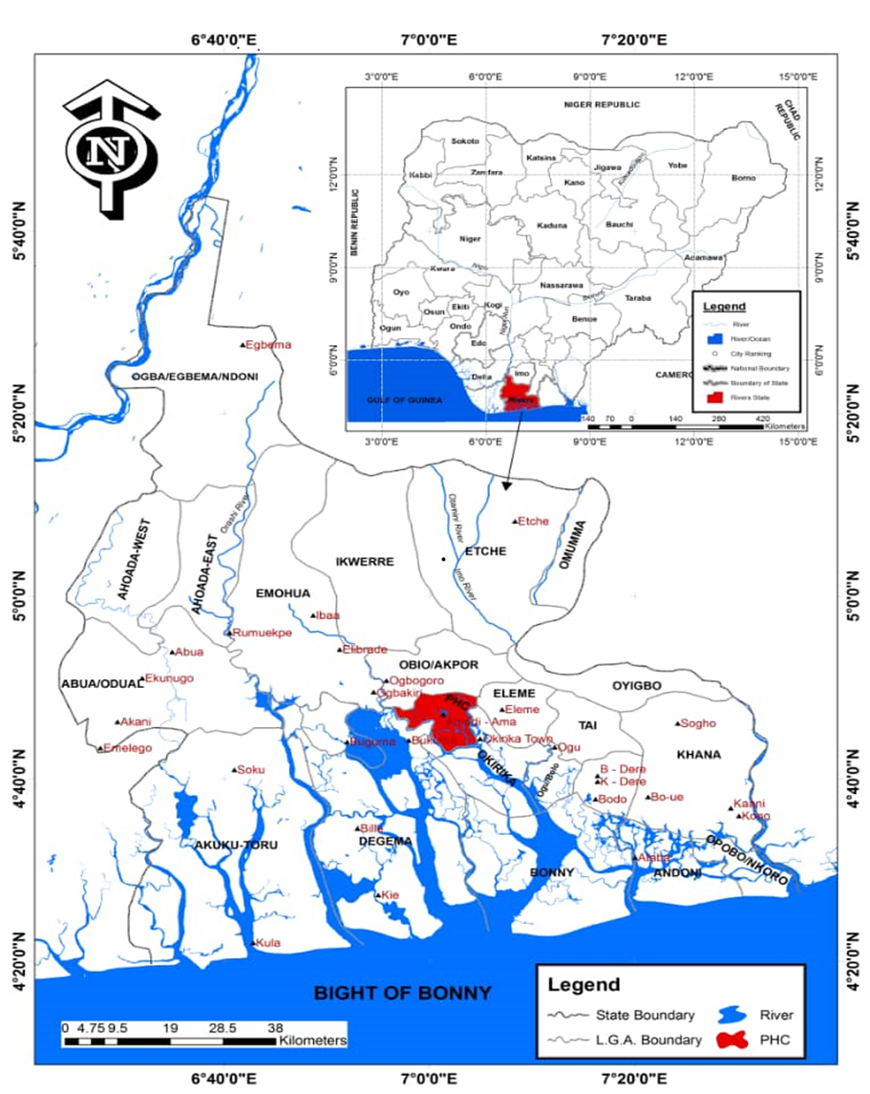
Map of Rivers State Showing Port Harcourt Local Government area verged red

Geographical Location

Source: Adapted from Edokpa et al., 2019

Procedures
The study adopted a cross-sectional survey with a simple random sampling method using both primary and secondary data. The study listed thirty-two (32) communities and six (6) communities were purposively selected, the sample size of 170 respondents were selected at random from the community based on the population of the community. Data were randomly collected from identified, listed heads of households with the use of close and open-ended questionnaire. Data were analyzed using the descriptive method of data analysis and information presented in tables.

Results and Discussion

Availability of green infrastructure
The study indicated that green infrastructure is available in the study area with a representation of 46.47% which is significant, although this value may not represent the mode of the distribution. On the contrary, the mode of the distribution 53.53% opposed the availability of green infrastructure in the study area. The argument as to whether green infrastructure is available or not in the study area is critical. This is because, it brings to bare the common man’s level of understanding of the concept of the subject matter in relation to maintaining a healthy balance within the human environment. Going by the definition of green infrastructure as put forward by the Association of Town Planners: “Green infrastructure is a network of multi-functional green space and other green features, urban and rural, which can deliver quality of life and environmental benefits for communities.” In the words of the American Rivers ( 2026). “Green infrastructure is an approach to water management that protects, restores, or mimics the natural water cycle. Green infrastructure is effective, economical, and enhances community safety and quality of life.” According to them, it means planting trees and restoring wetlands, rather than building a costly new water treatment plant. It means choosing water efficiency instead of building a new water supply dam. It means restoring floodplains instead of building taller levees. Again, the Devon County Council (2026) defined green infrastructure as a “term used to describe the network of natural spaces and corridors in a given area. Green infrastructure assets include open spaces such as parks and gardens, allotments, woodlands, fields, hedges, lakes, ponds, playing fields, coastal habitats, as well as footpaths, cycleways or rivers.” The definitions above suggest that green infrastructure can be natural or manmade and is required to maintain a healthy balance and requires protection and maintenance. The question is how can the people protect what they do not know or understand. The implication of this is that a good number of persons in the study area do not know what a green infrastructure is , this leaves a responsibility with the researcher and the government to embark on enlightenment campaign to educate the people on the green infrastructure.

Table 1: Availability of green infrastructure
 | Availability | No | %
 | Yes | 79 | 46.47
 | No | 91 | 53.53
 | Total | 170 | 100

Source: Researchers field work, 2025

Type of Green infrastructure installation in study area
The study further x-rayed on the type of green infrastructure available in the study area and indicated that 53% of the respondents affirmed the non-existence of any type of green infrastructure installation in the study area whereas 28% indicated the availability of urban trees canopy. Furthermore, 12% and 7% confirmed the availability of permeable pavement and bio-wales respectively. The percentage of nonexistence of any type of green infrastructure in the study area area leaves a doubt in one’s mind as to the physical appearance of the town. Port Harcourt municipality was once the Nigeria’s garden city. This was because it was characterized by lots of green infrastructure installation forming a beautiful scenery. This is a wake up call for government and individual to begin to embark on green installation, not just to beautify but to manage storm water in the study area.

Table 2: Type of Green infrastructure installation in your area?
Type | No | %
Rain gardens | Nil | Nil
Bios-wales | 12 | 7
Permeable pavements | 20 | 12
Urban tree canopies | 47 | 28
None | 91 | 53
Total | 170 | 100
Source: field survey 2025

Impact of green Infrastructure installation
Green infrastructure is generally known and used to reduce storm-water or manage storm water all over the world, however, only 8% of the respondents in this study are certain that green infrastructure can reduce storm water runoff. Existing literatures have shown that green infrastructure is a veritable tool in reducing storm water. The remaining 92% are in between divergent opinion regarding how effective green infrastructure installation can be in managing storm water. This study has unfolded a very vital issue of ignorance and lack of awareness on the part off the residence of the study area. Education on this note is very crucial and fundamental.

Table 3: How effective are the different types of green infrastructure installations at reducing storm-water runoff in your area?
Effectiveness | No | %
Very | 14 | 8
Most likely | 58 | 34
Not sure | 98 | 58
Total | 170 | 100
Source: field survey 2025

Effect of Uncontrolled Storm Water in the Study Area
The effect of storm water is damaging and far reaching. The study identified flooding as one most felt effect of uncontrolled storm water. 96% of the respondents agreed to this. Other effects include pollution, erosion and property damage thereby validating existing literature.

Table 4.: What is the effect of uncontrolled storm-water discharge in your Area?
Effect | No | %
Flooding | 96 | 56
Erosion | 20 | 12
Property Damage | 4 | 3
Pollution | 50 | 29
Total | 170 | 100
Source: field survey 2025

Available storm water management programme

The study identified that there is no obvious management programme to manage storm water runoff in the study area. This is validated by the outcome of the interview where 75 of the respondents agreed that there is no programmes in place to combat the issue of flooding in the area that is occasioned by storm water.

Table 5: Is there any storm-water management program in your area?
Any management program | No | %
Yes | 45 | 26
No | 125 | 74
Total | 170 | 100
Source: field survey 2025

The study identified that a lot of the residents in the study area are not familiar with the concept of green infrastructure. This accounted for 80% response during the interview. However, they expressed willingness to support the implantation of any green infrastructure installation initiative

Table 6: Are you familiar with the term " Green Infrastructure"?
Familiar with the term, green infrastructure | No | %
Yes | 34 | 20
No | 136 | 80
Total | 170 | 100
Source: field survey 2025

Table 7: Would you support the implementation of green infrastructure in your neighborhood?
Support | No | %
Yes | 97 | 57
No | 73 | 43
Total |  | 100
Source: field survey 2025

CONCLUSION, RECOMMENDATION

Conclusion
The main focus of this study was to assess the efficiency of green infrastructure in the management of storm water in Port Harcourt municipality. This research was necessitated by the inability of the natural drainage channels to drain runoff water due to the increasing use of paved and impermeable surfaces thus causing flash flooding during raining seasons in the study area.

The main objectives of the study included: identification of the available green infrastructure in the study area, ascertaining the impact of different green infrastructure installations on storm-water runoff reduction in Port Harcourt municipality, identification of the effects of uncontrolled storm-water in the study area and assessing the public perception about green infrastructure technologies in residential areas of Port Harcourt municipality. The study adopted the survey method for the collection of primary data. Also, secondary data were collected from various sources including published and unpublished sources. Data collected were analyzed using the descriptive method of data analysis where data were presented in tables. The study found out that the common people in the study area are not conversant with the technology of the green infrastructure and are not also aware of the use of green infrastructure to manage storm water. However, willingness to welcome and participate in any initiative to adopt the green infrastructure installation to manage storm water. On this premise, the study concludes that public enlightenment campaign on green infrastructure should be organized by the relevant agencies in the state and municipality

Recommendation
Based on the findings of this study, the following recommendations are made:

- Mapping and assessment of flood-prone areas should be conducted to identify priority locations for green infrastructure interventions. This should be followed by the development of a master plan that outlines specific green infrastructure projects, their locations, and implementation timelines.
- The local government should establish a dedicated Green Infrastructure Task Force from relevant professionals to oversee the planning, implementation, and monitoring of green infrastructure projects across the municipality..

- Public awareness and education campaigns should be launched to inform residents about the benefits of green infrastructure and how they can contribute to its implementation and maintenance. This could include workshops, school programs, and community events focused on green infrastructure.

- Capacity building programs should be developed for local professionals, including architects, engineers, and landscape designers, to enhance their skills in green infrastructure design and implementation. Partnerships with local universities and technical institutions could facilitate this knowledge transfer.

- Again the government through the relevant agencies should implement pilot projects in different neighborhoods to demonstrate the effectiveness of various green infrastructure solutions. These pilot projects should be closely monitored and evaluated to provide data for future scaling up.

Disclaimer (Artificial intelligence)
Author(s) hereby declare that NO generative AI technologies such as Large Language Models (ChatGPT, COPILOT, etc.) and text-to-image generators have been used during the writing or editing of this manuscript.

REFERENCE

Abam, T.K.S. (2001). Regional hydrological research perspectives in the Niger delta. Hydrological Sciences Journal, 46(1), 13-25.
Ahiablame, L. M., Engel, B. A., & Chaubey, I. (2012). Effectiveness of low impact development practices: literature review and suggestions for future research. Water, air, and soil pollution, 223(7), 4253-4273.
American Rivers (2026). What is green Infrastructure, https://www.americanrivers.org, accessed on the 31st of March 2026
Claire P. M; Carol K. W & Gregory H. L. (2018). Emerging investigator series: The Role of Vegetation in Bio-retention for Storm-water Treatment in the Built Environment: Pollutant Removal, Hydrologic Function, and Ancillary Benefits. Environ. Sci.: Water Res. Technol., 2018,4,592-612 https://doi.org/10.1039/C7EW00511C.
Collins H. W.(2014).Residential Development Dynamics in Port Harcourt Metropolis:
Implication for Efficient Urban Planning. Journal of Environment and Earth Science www.iiste.org Vol. 4, No.6, 2014.

Devon County Council (2026). What is Green Infrastructure and why is it important. https://www.devon.gov.uk accessed on the 30th of March 2026
Deeyah, C. L. & Kianen, B (2925). Impact of Urban Flooding on Residential Property
Investment in Rumuokwachi Community Obio/Akpo Local Government Area of Rivers State, Nigeria. International Journal of Innovative Environmental Studies Research 13(1):68-82, Jan.-Mar., 2025
Edokpa D, Diagi B, Nwaerema P (2019) An Assessment of Ground Level Criteria Pollutant Concentrations in Port Harcourt City, Nigeria. Int J Pollut Res: IJPR-111
Fletcher, T. D., Shuster, W., Hunt, W. F., Ashley, R., Butler, D., & Viklander, M. (2015). SUDS, LID, BMPs, WSUD and more–The evolution and application of terminology surrounding urban drainage. Urban Water Journal, 12(7), 525-542.
Green Blue Urban (2017).permeable Pavement. Pros and cons. https://greenblue.com/gb/permeable-pavement-the-pros-and-cons-you-need-to-know/. Assessed on the 13th April 2026.

Natural England (2026). Green Infrastructure Framework
Nwokaeze, E.C., Okonny, A.D., & Visigah, K.P. (2025). Building Encroachment on the Ntawogba Stormwater Drainage Servitude in Port Harcourt City, Nigeria. European Journal of Theoretical and Applied Sciences, 3(1), 312-320. DOI: 10.59324/ejtas.2025.3(1). 28
Olumuyiwa B. A; Ayodele E. I; Tobi E. M, Olawale O. O,(2021). Urban green infrastructure in Nigeria: A review. Scientific African, Volume 14, 2021,
Regina A. & Dollah O. C (2024). Analysis Of Land Use And Land Cover Changes In Port Harcourt Metropolis Using Geospatial Techniques. IOSR Journal of Environmental Science Toxicology and Food Technology 18(9):38-44 DOI:10.9790/2402-1809013844
River sand PTY limited (2020) Understanding Bio retention Systems. https://www.riversands.com.au/understanding-bioretention-systems. Accessed, 13th April 2026
Tzoulas, K., Korpela, K., Venn, S., Yli-Pelkonen, V., Kaźmierczak, A., Niemela, J., & James, P. (2007). Promoting ecosystem and human health in urban areas using Green Infrastructure: A literature review. Landscape and urban planning, 81(3), 167-178.
Vivian N. O & Arobo R. C A. (2024) Patterns and Variability of Rainfall and Temperature in Port Harcourt Metropolis, Rivers State, Nigeria . IJRES, 11(3), 138-142, 2024.\

.

