Original Research Article

Correlation and Regression Analyses of Particulate Matter Concentrations and Microbial Loads in Air at some Secondary Schools in Port Harcourt Rivers State Nigeria

ABSTRACT
This study assessed the relationship between particulate matter (PM₁, PM₂.₅, PM₄, PM₇, and PM₁₀) and airborne microbial load (bacteria and fungi) in school environments within Port Harcourt, Nigeria. Particulate concentrations were measured using aeroset handheld particle counter 531S, while microbial loads were determined with passive settle plate method using 9 cm diameter petri dishes and expressed as CFU/m³. Correlation and regression analyses were applied to evaluate associations under dry and wet conditions.Results showed moderate positive correlations between bacterial load and fine particles, particularly PM₁ (r = 0.5287), PM_{2.5} (r = 0.4430), PM₇ (r = 0.4238) in the wet season. Fungal load exhibited stronger associations with coarse particles PM₄ (r = 0.6487) and PM₇ (r = 0.7007), especially during the dry season. Regression analysis indicated weak and non-significant relationships between bacteria and PM (R² = 0.088 and 0.104 for PM₁ and PM_{2.5} respectively; R² = 0.01, 0.006, 0.015 for PM₄, PM₇, PM₁₀ respectively) while fungi showed moderate relationships with PM₇ being statistically significant (p < 0.05) and R² = 0.427 and 0.456 for PM₄ and PM₇ respectively.The study demonstrates that coarse particulate matter plays a more significant role in fungal distribution than bacterial transport and highlights the importance of considering both biological and non-biological pollutants in school air quality assessments.
Keywords: Correlation, Regression, Particulate Matter, Microbial Loads, Port Harcourt, Nigeria

INTRODUCTION
Air quality has emerged as a critical environmental and public health concern in urban centres worldwide, particularly in rapidly industrializing cities where anthropogenic activities intensify atmospheric pollution. In Port Harcourt, Rivers State, Nigeria, this concern has become especially pronounced due to persistent emissions from industrial operations, vehicular traffic, gas flaring, and recurrent soot episodes. These factors contribute to elevated levels of airborne particulate matter (PM) and bioaerosols, creating a complex pollution profile that poses significant risks to human health. Within this context, indoor environments—especially schools—have gained increasing attention, as they represent microenvironments where vulnerable populations, particularly children and adolescents, spend substantial portions of their day (Dick & Wekhe, 2020; Yakubu, 2017; Stanley & Bamidele, 2022).
The significance of indoor air quality in educational settings cannot be overstated. Students typically spend between 7 and 8 hours daily within classroom environments, making them highly susceptible to prolonged exposure to both chemical and biological pollutants. Poor indoor air quality has been associated with a range of adverse outcomes, including respiratory infections, allergic reactions, reduced cognitive performance, and overall discomfort, all of which can negatively impact learning and academic achievement (Dick & Wekhe, 2020; Yakubu, 2017; Stanley & Bamidele, 2022). Consequently, understanding the composition and determinants of indoor air pollutants in schools is essential for safeguarding student health and optimizing educational outcomes.
Microbial air quality, a key component of indoor environmental quality, has been extensively studied in schools across Rivers State. Evidence indicates that classrooms often harbour high concentrations of airborne microorganisms, with bacterial counts ranging from approximately 4.8×10³ to 4.66×10⁴ colony-forming units per cubic metre (CFU/m³), and fungal counts reaching up to about 2.6×10⁴ CFU/m³ (Dick & Wekhe, 2020; Ezinwanne & Loveth, 2023; Stanley & Bamidele, 2022). These values frequently exceed recommended guidelines, raising concerns about potential health implications. The microbial communities identified in these environments commonly include genera such as Bacillus, Staphylococcus, Escherichia, Aspergillus, Penicillium, and Mucor, many of which are associated with respiratory diseases, opportunistic infections, and allergic responses (Dick & Wekhe, 2020; Ezinwanne & Loveth, 2023; Stanley & Bamidele, 2022). The prevalence of these microorganisms is often linked to environmental and behavioural factors such as overcrowding, inadequate ventilation, poor sanitation, and high occupant density, all of which facilitate the accumulation and dispersion of bioaerosols within enclosed spaces.
While microbial contamination presents one dimension of indoor air pollution, particulate matter represents another critical and often interrelated component. Studies conducted in Port Harcourt and its surrounding local government areas have consistently reported elevated concentrations of particulate matter across various size fractions, including PM₁, PM_{2.5}, and PM₁₀. Notably, indoor PM levels in school environments are frequently higher than outdoor levels, suggesting the influence of indoor sources and resuspension processes. Reported indoor PM_{2.5} concentrations in secondary schools range from approximately 18.5 to 24.5 µg/m³, with PM₁₀ levels in some cases exceeding national regulatory limits (Awolo. et al., 2026; Ideriah. et al., 2025). These elevated concentrations are attributed to multiple sources, including dust resuspension from classroom activities, infiltration of outdoor pollutants, and contributions from nearby anthropogenic activities.
At a broader scale, the air quality situation in Port Harcourt is further complicated by seasonal and meteorological factors. During the dry season, reduced humidity and increased wind activity promote the suspension and transport of fine particles, leading to higher PM concentrations. Additionally, local sources such as unpaved roads, industrial emissions, and gas flaring significantly contribute to the atmospheric burden of particulate matter (Yakubu, 2017; Akanji et al., 2024; Abuchi et al., 2025; Ideriah. et al., 2025). These environmental dynamics not only influence outdoor air quality but also affect indoor environments through infiltration and deposition processes, thereby linking external pollution sources with indoor exposure risks (Osuji et al., 2020; Eduk et al., 2018; Ugwa et al., 2024; Tamunopiriye & Taylor, 2023).
Despite the growing body of literature on both microbial air quality and particulate matter in Port Harcourt, existing studies have largely examined these components in isolation. Investigations focusing on classroom microbial loads have provided valuable insights into bacterial and fungal concentrations but often lack concurrent measurements of particulate matter (Dick & Wekhe, 2020; Ezinwanne & Loveth, 2023; Stanley & Bamidele, 2022). Conversely, studies assessing particulate matter concentrations in school environments frequently do not incorporate microbiological analyses (Awolo. et al., 2026; Ideriah. et al., 2025). This fragmented approach limits the ability to fully understand the interactions between particulate matter and airborne microorganisms, particularly given that particles can act as carriers or substrates for microbial growth and transport.
Furthermore, while some studies in the wider Port Harcourt region have employed correlation and regression analyses to explore relationships between air pollutants, meteorological variables, and health outcomes, there remains a notable gap in research examining the statistical relationship between particulate matter and microbial loads in indoor school environments (Osuji et al., 2020; Tamuno-Owunari et al., 2024; Eduk et al., 2018; Akanji et al., 2024). Understanding this relationship is crucial, as it may reveal whether elevated particulate matter levels contribute to increased microbial concentrations, thereby compounding health risks for exposed populations.
In this context, a study focusing on the correlation and regression analyses of particulate matter concentrations and airborne microbial loads in secondary schools in Port Harcourt is both timely and necessary. By simultaneously measuring PM fractions (PM₁–PM₁₀) and microbial counts, such a study can provide empirical evidence on the extent to which these variables are interrelated. Statistical analyses can help identify whether higher particulate matter levels are significantly associated with increased bacterial and fungal loads, and whether these relationships are influenced by factors such as ventilation, occupancy, and environmental conditions. The development of predictive models based on these relationships would further enhance the capacity for risk assessment and inform targeted interventions aimed at improving indoor air quality.
Ultimately, this study is justified by the urgent need to address the “double burden” of air pollution in Port Harcourt, characterized by both chemical and biological contaminants. Secondary school students represent a particularly vulnerable population due to their prolonged exposure and developmental sensitivity. By bridging the existing knowledge gap between particulate matter and microbial air quality, this research will contribute to evidence-based strategies for creating healthier learning environments, reducing exposure risks, and improving both health and educational outcomes in the region.

MATERIALS AND METHODS
Study Area
Port Harcourt Local Government Area, Rivers State, Nigeria which is located in latitudes 4°51´ 30˝ N and 4° 57´ 30˝ N and longitudes 6°50´ 00˝ E and 7°00´ 00˝ E. PortHarcourtisfoundinthesub-equatorialregion.Ithasatropicalclimatewithameantemperatureof30°C, arelative humidityof80%-100%,andameanyearlyrainfallofabout2,300mm(Nyeche and Ndukwu, 2018).Tropical rainforest is found in the inland part of Rivers State and mangrove swamps towards the coast of the Atlantic Ocean.
The vegetation representsthemostluxuriant,themostcomplex andthemostdiverseterrestrialecosystemtheworldhasknown (Nyeche and Ndukwu, 2018). Unfortunately, muchoftherainforesthasbeendestroyedasaresultoffarming,commerciallumberingandurbanization;ironicallythesevegetal coversaresupposedtoserveassinktopollutants,whereintheyaredepleted and pollutionlevelsareprojectedtobeonthehigh.
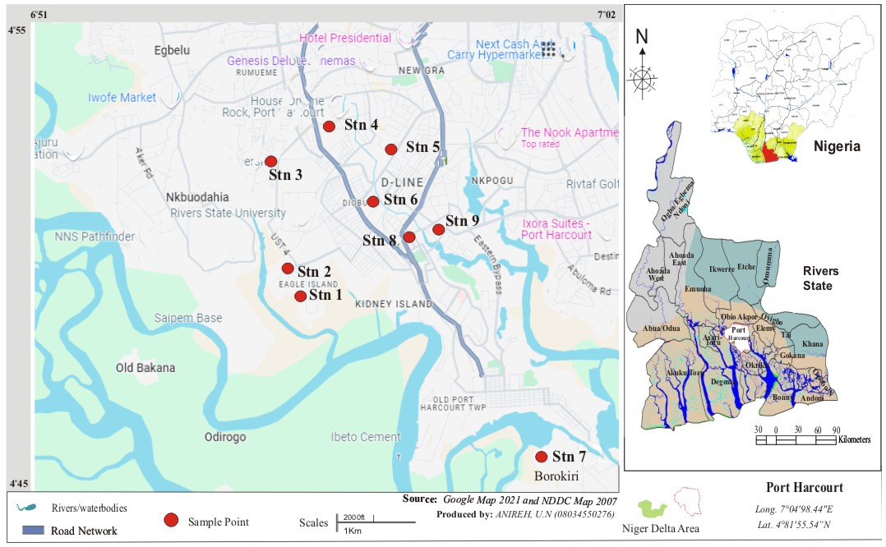
Map .1 Study Area Showing Sampling School Locations

Sampling Procedure for Particulates
A hand-held digital aerocet Handheld Particle Counter 531S was used to measure PM₁, PM_{2.5,} PM_{4,} PM_{7,} and PM₁₀at the study area. The equipment was pre-calibrated before usage for quality assurance purposes. At each station, the monitor was switched on and allowed to stabilize for five minutes. It was held up in an open space with a consideration of the average height of a human. Each reading was recorded when the equipment stabilized and switched off thereafter.

Sampling Procedure and Determination of Microbiological Contentin Air
Bacteria and fungi measurement was done by passive air sampling technique: the settle plate method using 9 cm diameter Petri dishes was used. The sampling height was approximated to human breathing zone which was 1m above the floor and at the center of sampling spots. Bacteria and fungi were collected on an autoclaved 2% nutrient agar and 4% SabouroadAgar respectively using 9cm diameter petri dishes. To obtain the appropriate surface density for counting and to determine the load with respect to time of exposure, the sampling times were set at 30, 60, 90 min. After exposure the samples were taken to the laboratory and incubated at 37 °C for 24 h for bacteria and at 25 °C for 3 days for fungi. Colony forming units (CFU) were enumerated, CFU/ m3 was determined, taking into account the following equation described by (Gutarowskaet. al., 2015; Borrego, et al., 2010).
N = 5a x10⁴ (bt)⁻¹
Where N=microbial CFU/m3 of indoor air;
a=number of colonies per Petri dish;
b=dish surface (cm²);
t=exposure time (min). Then, identification of isolates will be done according to standard methods. (Cheesbrough, 1996).

RESULTS AND DISCUSSION
Correlation Between Microbiological Loads and Particulate Matter in the PHALGA Area
Dry-season bacterial loads presented in Table 1 show a moderate positive correlation with PM₁ Wet (r = 0.5287) and PM₁ Dry (r = 0.3090), suggesting that ultra-fine particulates play a role in bacterial transport. Bacterial_Load_Wet correlates strongly with PM_{2.5} Wet (r = 0.4430) and PM₇ Wet (r = 0.4238), indicating that fine and coarse particles enhance microbial aerosolization during rainfall. Fungal_Load_Dry shows strong positive correlations with PM₄ Dry (r = 0.6487) and PM₇ Dry (r = 0.7007), demonstrating that fungal spores attach effectively to mid-range coarse particulates in the dry season. Fungal_Load_Wet displays a highly negative correlation with PM₁ Wet (r = –0.3266) and PM_{2.5} Wet (r = –0.0417), suggesting that fine particles inhibit wet-season fungal survival. PM classes exhibit extremely strong internal correlations, such as PM₇ Wet with PM₁₀ Wet (r = 0.9831) and PM₇ Dry with PM₁₀ Dry (r = 0.9796), confirming shared emission sources. Overall, bacterial aerosols respond more positively to particulate matter than fungal aerosols, with the strongest microbial–particle coupling occurring under dry conditions.
Table 1: Correlation Between Microbiological Loads and Particulate Matter inPort Harcourt Local Government Area
 | Bacterial_Load_Dry | Fungal_Load_Dry | Bacterial_Load_Wet | Fungal_Load_Wet | PM1 Wet | PM1 Dry | PM2.5 Wet | PM2.5 Dry
Bacterial_Load_Dry | 1
Fungal_Load_Dry | -0.3508543 | 1
Bacterial_Load_Wet | 0.8151334 | -0.3348955 | 1
Fungal_Load_Wet | -0.4198553 | 0.9716987 | -0.4169085 | 1
PM1 Wet | 0.5286681 | -0.2950766 | 0.0549172 | -0.3265702 | 1
PM1 Dry | 0.3090033 | -0.0599559 | -0.0174122 | -0.0805848 | 0.8457146 | 1
PM2.5 Wet | 0.2361732 | -0.0343677 | 0.4429887 | -0.0417409 | -0.4198917 | -0.6122011 | 1
PM2.5 Dry | 0.1432584 | 0.1084862 | -0.1682383 | 0.1533768 | 0.6501398 | 0.8899102 | -0.4496519 | 1
PM4 Wet | 0.303493 | 0.3389862 | 0.3955949 | 0.2753076 | -0.2984277 | -0.4939082 | 0.8345844 | -0.3851402
PM4 Dry | 0.0883668 | 0.6486798 | -0.1598612 | 0.604647 | 0.3254061 | 0.3723506 | -0.2502143 | 0.3882101
PM7 Wet | 0.1948083 | -0.1013616 | 0.423774 | -0.1082559 | -0.4364483 | -0.5475206 | 0.9527723 | -0.3315336
PM7 Dry | 0.080025 | 0.700736 | -0.1486095 | 0.6264705 | 0.2590224 | 0.2494248 | -0.160339 | 0.2289671
PM10 Wet | 0.175095 | -0.102112 | 0.448358 | -0.1133802 | -0.4368181 | -0.472914 | 0.9174577 | -0.2589278
PM10 Dry | 0.0664019 | 0.7147438 | -0.1192689 | 0.6222562 | 0.1614799 | 0.1201709 | 0.0036235 | 0.12141
 | PM4 Wet | PM4 Dry | PM7 Wet | PM7 Dry | PM10 Wet | PM10 Dry
Bacterial_Load_Dry
Fungal_Load_Dry
Bacterial_Load_Wet
Fungal_Load_Wet
PM1 Wet
PM1 Dry
PM2.5 Wet
PM2.5 Dry
PM4 Wet | 1
PM4 Dry | 0.2769014 | 1
PM7 Wet | 0.7360538 | -0.307564 | 1
PM7 Dry | 0.3873225 | 0.9739666 | -0.2575211 | 1
PM10 Wet | 0.6582143 | -0.3684655 | 0.9831421 | -0.3277686 | 1
PM10 Dry | 0.5305086 | 0.92498 | -0.0904535 | 0.9795695 | -0.1666246 | 1

Regression Between Bacteria and Particulate Matter (PM)
The regression analysis between airborne bacteria and particulate matter fractions (PM₁, PM_{2.5}, PM₄, PM₇, and PM₁₀) in schools in Port Harcourt revealed generally weak relationships. Bacteria showed a positive association with PM₁ (slope = 1549.17) and PM_{2.5} (slope = 991.49), but the low coefficients of determination (R² = 0.088 and 0.104, respectively) indicate limited explanatory power. Similarly, PM₄, PM₇, and PM₁₀ exhibited very weak positive relationships (R² = 0.010, 0.006, and 0.015), suggesting negligible influence on bacterial concentrations. All p-values for these models (p > 0.39) indicate that the relationships are not statistically significant. The weak positive slopes suggest that increases in particulate matter may slightly elevate bacterial counts, but the effect is inconsistent. Overall, particulate matter does not appear to be a strong predictor of airborne bacterial levels in the studied school environments.
Regression Between Fungiand Particulate Matter (PM)
The regression analysis between fungi and particulate matter revealed stronger relationships compared to bacteria. PM₄ and PM₇ showed moderate positive associations with fungi (slopes = 83.55 and 46.02) and relatively high R² values (0.427 and 0.456, respectively). Notably, PM₇demonstrated a statistically significant relationship (p = 0.046), indicating its influence on fungal concentrations. PM₁₀ also showed a moderate positive relationship (R² = 0.392), though not statistically significant (p = 0.071). In contrast, PM₁ showed a weak negative relationship (slope = -184.40, R² = 0.031). These results suggest that coarse particulate fractions may play a more important role in fungal dispersion than finer particles.
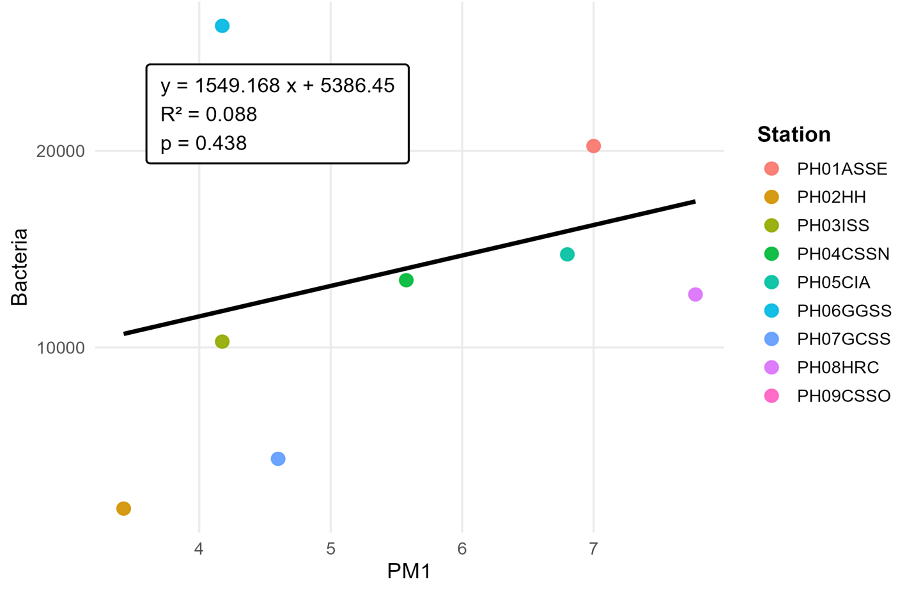
Fig. 1. Regression between Bacteria Load and PM₁

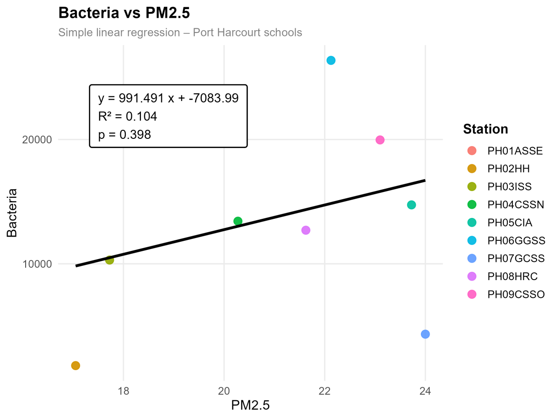
Fig. 2. Regression between Bacteria Load and PM_{2.5}

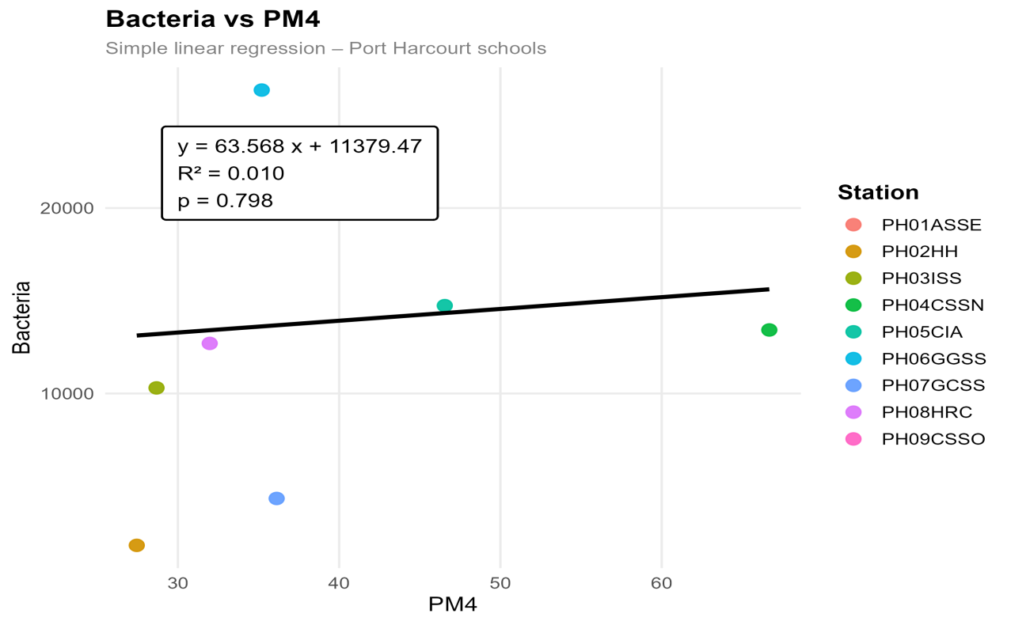
Fig. 3. Regression Between Bacteria Load and PM₄
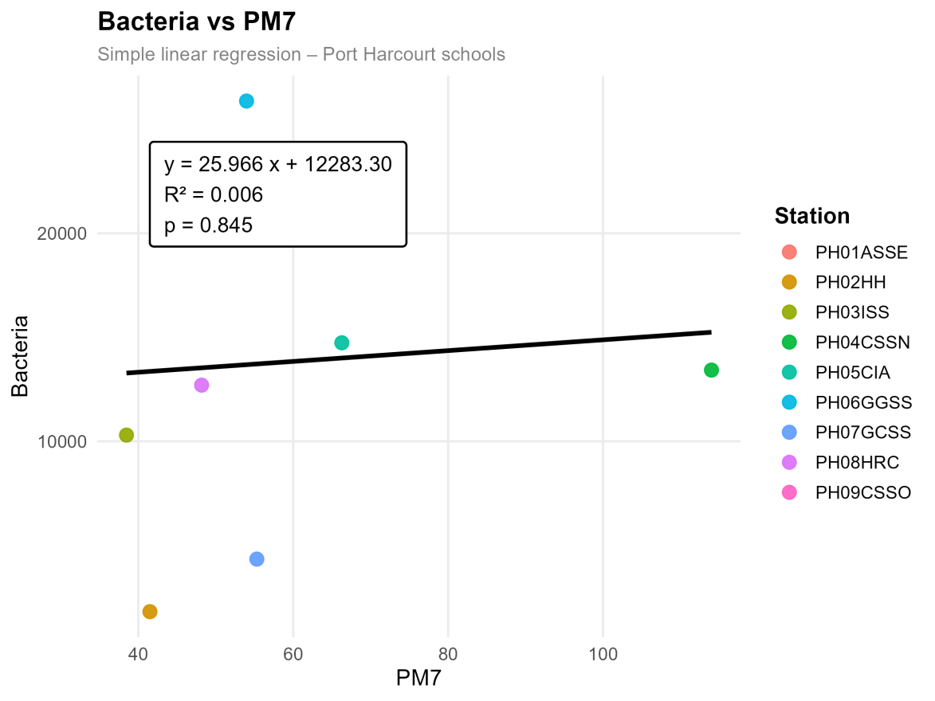
Fig.4. Regression between Bacteria Load and PM₇

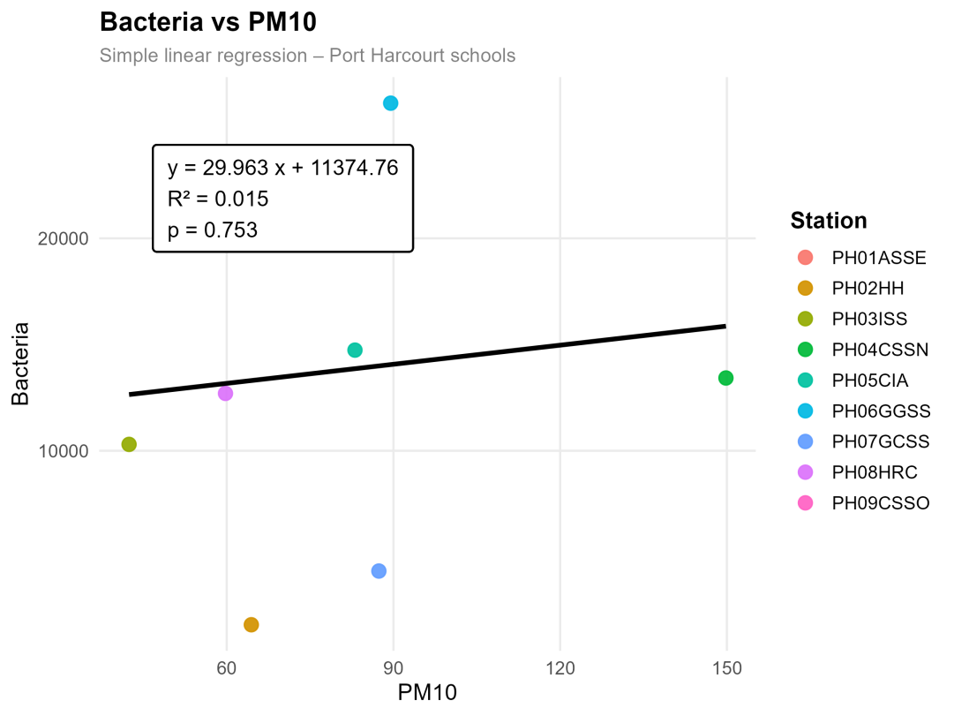
Fig. 5. Regression between Bacteria Load and PM₁₀
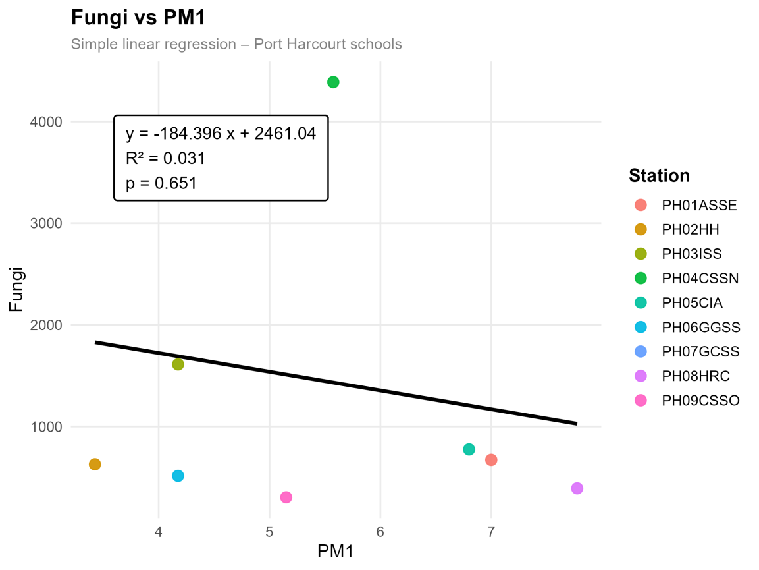
Fig. 6. Regression between FungiLoad and PM₁

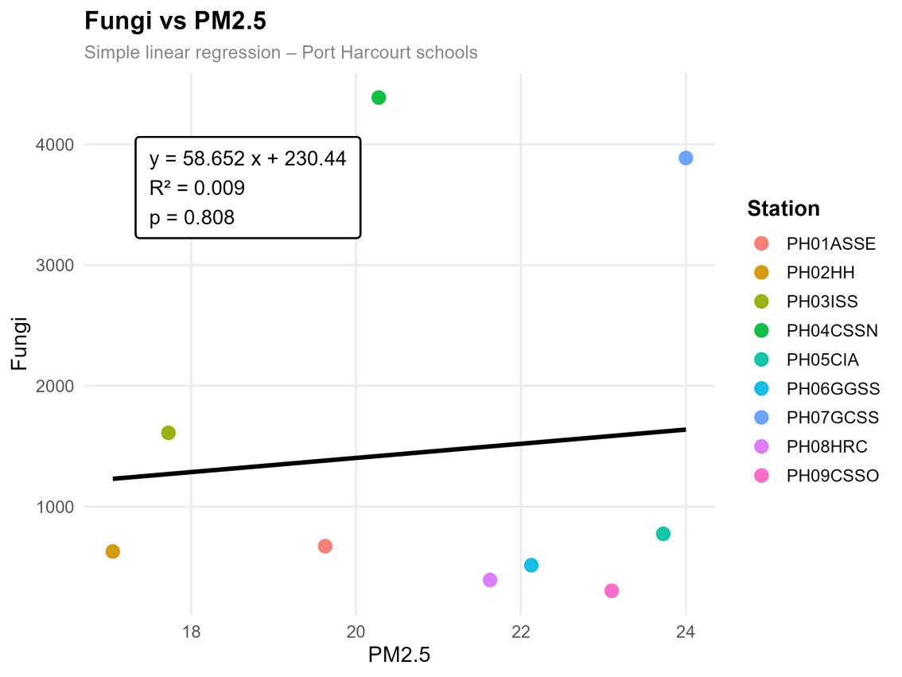
Fig. 7. Regression between FungiLoad and PM_{2.5}
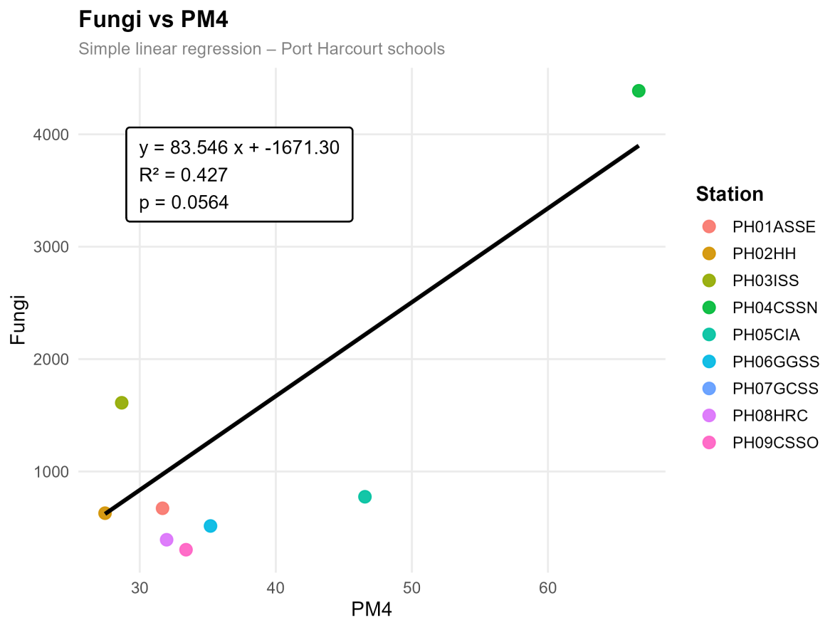
Fig. 8. Regression between FungiLoad and PM₄
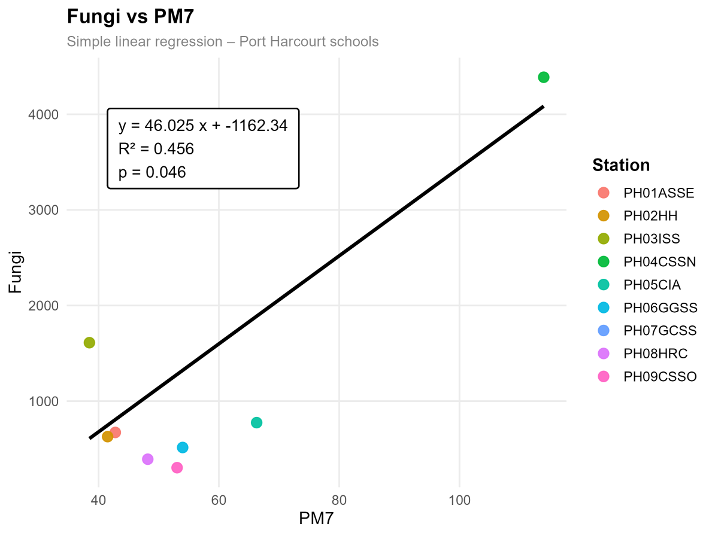
Fig. 9. Regression between FungiLoad and PM₇

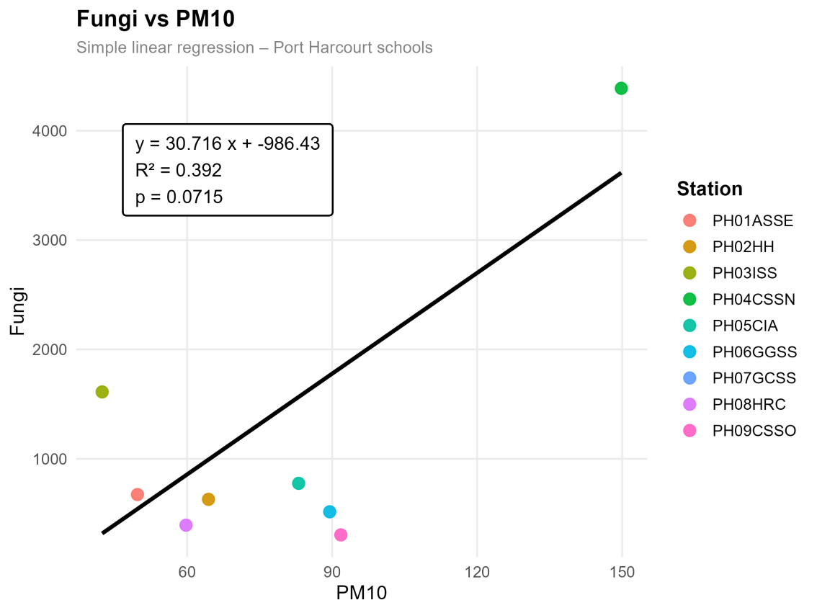
Fig. 10. Regression between FungiLoad and PM₁₀
The findings from this present study in Port Harcourt reveal a complex and size-dependent interaction between particulate matter (PM) and airborne microbial loads, which both align with and contrast existing global evidence. The correlation analysis showed that bacterial loads exhibited moderate positive relationships with fine particles, particularly PM₁ Wet (r = 0.5287) and PM₁ Dry (r = 0.3090), as well as PM_{2.5} Wet (r = 0.4430) and PM₇ Wet (r = 0.4238). These results indicate that finer particles contribute to bacterial transport, especially under wet conditions. This pattern aligns with findings from Mashhad, Iran, where Ziaei et al. (2025) reported a very strong positive correlation between bacteria and PM_{2.5} (r = 0.9184), and with Graz, Austria, where Haas et al. (2013) observed that mesophilic bacteria were positively correlated with all particle counts. Similarly, in a dental clinic study in Iran, Mirhoseini et al. (2021) found “good” positive correlations between bacteria and PM₁, PM_{2.5} and PM₁₀, suggesting that particulate matter can serve as a proxy for bacterial presence. However, despite these positive correlations in the present study, regression results showed very weak predictive relationships, with low coefficients of determination such as R² = 0.088 for PM₁ and R² = 0.104 for PM_{2.5}, and non-significant p-values (p > 0.39). This contrasts with stronger predictive relationships reported in some global studies and suggests that, in Port Harcourt schools, particulate matter alone does not strongly control bacterial concentrations.
This weak regression outcome is consistent with findings from Chania, Greece, where Raisi et al. (2013) reported generally weak correlations between microbial loads and PM (R² < 0.3), with even negative trends observed in some cases. Similarly, in ICUs in Lebanon, AlRayess et al. (2022) found no statistically significant relationship between bacterial load and PM_{2.5} or PM₁₀, emphasizing that other factors such as occupancy and human activity were stronger predictors (model R² = 0.77). The present study therefore aligns with these findings by demonstrating that although bacteria may increase slightly with PM, the relationship is weak and inconsistent, indicating that environmental and human factors likely play a more dominant role in determining bacterial aerosol levels in classrooms.
In contrast to bacteria, fungal loads in the present study showed stronger and more distinct relationships with particulate matter, particularly under dry conditions. Fungal-Load-Dry exhibited strong positive correlations with PM₄ Dry (r = 0.6487) and PM₇ Dry (r = 0.7007), while regression analysis further confirmed moderate predictive relationships with PM₄ (R² = 0.427) and PM₇ (R² = 0.456), with PM₇ showing statistical significance (p = 0.046). These results indicate that mid-sized and coarse particles play a significant role in fungal dispersion. This finding strongly aligns with results from Jeddah, Saudi Arabia, where Alghamdi et al. (2014) reported a significant correlation between microbial loads and PM₁₀ (r = 0.57, P ≤ 0.05), and with construction-site studies in Austria by Haas et al. (2025), where coarse particles were positively associated with fungal genera such as Cladosporium. Additionally, in Beijing, China, Yan et al. (2016) found that fungal community composition was significantly influenced by PM₁₀ (p < 0.01), further supporting the importance of coarse particles in fungal ecology.
However, the present study also revealed contrasting behaviour for fungi in the wet season, where Fungal_Load_Wet showed negative correlations with PM₁ Wet (r = –0.3266) and PM_{2.5} Wet (r = –0.0417). This suggests that finer particles may inhibit fungal survival or dispersion under humid conditions. This observation aligns with findings from Chania, Greece, where Raisi et al. (2013) reported that both bacteria and fungi decreased with increasing PM mass, and that fungal relationships with fine particles were often weak or negative. Similarly, global meta-analysis evidence from Hiwar et al. (2021) indicated that fungal associations with indoor air quality parameters are generally weak and inconsistent compared to bacteria. These parallels reinforce the idea that fungal aerosols are more sensitive to environmental conditions and particle size distribution than bacterial aerosols.
Another important similarity between the present study and global findings is the strong internal correlation among PM fractions. The extremely high correlations observed between PM₇ Wet and PM₁₀ Wet (r = 0.9831) and between PM₇ Dry and PM₁₀ Dry (r = 0.9796) indicate shared emission sources and similar atmospheric behaviour. This is consistent with observations from Mediterranean environments reported by Raisi et al. (2013), where strong relationships among PM size fractions were also documented. Such strong inter-PM relationships suggest that variations in particle size classes are often driven by common sources such as dust resuspension, combustion processes, and traffic emissions.
Overall, the present study both aligns with and diverges from global evidence. It aligns in showing that bacteria generally have positive but weak relationships with particulate matter, while fungi exhibit stronger associations with coarse particles. It also supports the widely reported variability and context-dependence of PM–microbe interactions. However, it contrasts with studies reporting very strong bacterial–PM correlations (e.g. r = 0.9184 in Mashhad) by demonstrating weak and non-significant regression relationships in a school environment. This suggests that in Port Harcourt classrooms, microbial dynamics are influenced by a combination of particulate matter, environmental conditions, and human activity, rather than PM alone.

CONCLUSION
This study revealed that particulate matter has a limited influence on airborne bacterial load but a more pronounced effect on fungal distribution, particularly through coarse particles (PM₄ and PM₇). Seasonal variation influenced these relationships, with stronger associations observed during the dry season.
The weak association between PM and bacteria suggests that indoor factors such as ventilation and occupancy may be more important determinants. In contrast, fungal dispersion is significantly influenced by particulate matter.
These findings underscore the need for improved indoor air quality management in schools, including better ventilation and pollution control. Integrated monitoring of particulate and microbial pollutants is recommended to reduce potential health risks among school children.

Disclaimer (Artificial intelligence)

Author(s) hereby declare that NO generative AI technologies such as Large Language Models (ChatGPT, COPILOT, etc.) and text-to-image generators have been used during the writing or editing of this manuscript.

REFERENCES
- Abuchi, F. L., Otugo, V. N., &Tasie, N. N. (2025). Spatiotemporal comparison of particulate matter pollution in Port Harcourt and Kano using Clarity Node-S measurements. Global Journal of Earth and Environmental Science. https://doi.org/10.31248/gjees2024.203
- Akanji, A. R., Francis, M. O., &Akintola, A. F. (2024). Air quality trends and pollution analysis in Nigerian cities using time series methods. International Journal of Advanced Statistics and Probability. https://doi.org/10.14419/w5rj1f64
- Alghamdi, M. A., Shamy, M., Redal, M. A., Khoder, M., Awad, A. H., &Elserougy, S. (2014). Microorganisms associated particulate matter: A preliminary study. Science of the Total Environment, 479–480, 109–116. https://doi.org/10.1016/j.scitotenv.2014.02.006
- Alghamdi, M. A., Shamy, M., Redal, M. A., Khoder, M., Awad, A. H., &Elserougy, S. (2014). Microorganisms associated particulate matter: A preliminary study. Science of the Total Environment, 479–480, 109–116. https://doi.org/10.1016/j.scitotenv.2014.02.006
- AlRayess, S., Sleiman, A., Alameddine, I., Fayad, A. A., Matar, G. M., & El-Fadel, M. (2022). Airborne bacterial and PM characterization in intensive care units: Correlations with physical control parameters. Air Quality, Atmosphere & Health, 15(10), 1869–1880. https://doi.org/10.1007/s11869-022-01222-y
- Awolo, S. N., Ideriah, T. J. K., Konne, J. L., &Akinfolarin, M. O. (2026). Assessment of indoor and outdoor particulate matter concentrations in air at some secondary schools in Port Harcourt Local Government Area, Rivers State, Nigeria. Journal of Applied Chemical Science International, 17(1), 15–25. https://doi.org/10.56557/jacsi/2026/v17i110146
- Borrego, C., Monteiro, A., Ferreira, J., Moraes, M. R., Carvalho, A., Ribeiro, I., ... & Moreira, D. M. (2010). Modelling the photochemical pollution over the metropolitan area of Porto Alegre, Brazil. Atmospheric Environment, 44(3), 370-380.
- Cheesbrough, E. (1996). The ins and outs of MPEG. Accesibleenlíneaen: http://www. rcc. ryerson. ca/rta/brd038/papers/1996/mpeg1. htm [Fecha de consulta: 16/6/2003.
- Dick, A. A., &Wekhe, C. (2020). Microbial indoor air quality in a secondary school in Port Harcourt City, Rivers State, Nigeria. Journal of Applied Sciences and Environmental Management, 24(7), 1289–1292. https://doi.org/10.4314/jasem.v24i7.24
- Eduk, A., Leo, C., Andrew, A., &Mudiaga, C. (2018). Prediction and modeling of dry seasons air pollution changes using multiple linear regression model: A case study of Port Harcourt and its environs, Niger Delta, Nigeria. International Journal of Environment, Agriculture and Biotechnology, 3(3), 264–355. https://doi.org/10.22161/ijeab/3.3.25
- Ekhator, O. C., Orish, F. C., Nnadi, E., Ogaji, D., Isuman, S., &Orisakwe, O. E. (2023). Impact of black soot emissions on public health in Niger Delta, Nigeria: Understanding the severity of the problem. Inhalation Toxicology, 36(5), 314–326. https://doi.org/10.1080/08958378.2023.2297698
- Ezinwanne, U., &Okoro, C. L. (2023). Investigation of bioaerosols and the microbiological indoor air quality in an urban nursery school in Port Harcourt, Nigeria. Journal of Advances in Biology & Biotechnology. https://doi.org/10.9734/jabb/2023/v26i3622
- Gutarowska, B., Skóra, J., & Pielech-Przybylska, K. (2015). Evaluation of ergosterol content in the air of various environments. Aerobiologia, 31(1), 33-44.
- Haas, D., Galler, H., Luxner, J., Zarfel, G., Buzina, W., Friedl, H., Marth, E., Habib, J., &Reinthaler, F. F. (2013). The concentrations of culturable microorganisms in relation to particulate matter in urban air. Atmospheric Environment, 65, 215–222. https://doi.org/10.1016/j.atmosenv.2012.10.031
- Haas, D., Galler, H., Luxner, J., Zarfel, G., Buzina, W., Friedl, H., Marth, E., Habib, J., &Reinthaler, F. F. (2013). The concentrations of culturable microorganisms in relation to particulate matter in urban air. Atmospheric Environment, 65, 215–222. https://doi.org/10.1016/j.atmosenv.2012.10.031
- Haas, D., Pikal, S. R., Galler, H., Habib, J., Moser, T., Ofner-Kopeinig, P., &Schalli, M. (2025). Particulate matter and airborne microorganisms in a construction site in Graz, Austria. Atmospheric Environment, 344, 121025. https://doi.org/10.1016/j.atmosenv.2024.121025
- Haas, D., Pikal, S. R., Galler, H., Habib, J., Moser, T., Ofner-Kopeinig, P., &Schalli, M. (2025). Particulate matter and airborne microorganisms in a construction site in Graz, Austria. Atmospheric Environment. https://doi.org/10.1016/j.atmosenv.2024.121025
- Hiwar, W., King, M. F., Shuweihdi, F., Fletcher, L. A., Dancer, S. J., &Noakes, C. J. (2021). What is the relationship between indoor air quality parameters and airborne microorganisms in hospital environments? A systematic review and meta-analysis. Indoor Air. https://doi.org/10.1111/ina.12846
- Ideriah, T. J. K., Abere, T. E., Gobo, A. E., Iyama, W. A., &Awolo, S. N. (2025). Assessment of outdoor and indoor air quality in some secondary schools in Oyigbo Local Government Area, Rivers State, Nigeria. International Journal of Research and Innovation in Applied Science. https://doi.org/10.51584/ijrias.2025.100800161
- Ideriah, T. J. K., Dick-Williams, U. G., Gobo, A. E., Dollah, O. C., &Awolo, S. N. (2025). Ambient air particulate matter levels in some industrial communities in Rivers State, Nigeria. Journal of Global Ecology and Environment, 21(4), 1–12. https://doi.org/10.56557/jogee/2025/v21i49759
- Mirhoseini, S., Koolivand, A., Bayani, M., Sarlak, H., Moradzadeh, R., Ghamari, F., &Sheykhan, A. (2021). Quantitative and qualitative assessment of microbial aerosols in different indoor environments of a dental school clinic. Aerobiologia, 37, 217–224. https://doi.org/10.1007/s10453-020-09679-z
- Nyeche, V. W., Obafemi, A. A., &Ndukwu, B. C. (2018). Assessment of climate change resilience strategies in some selected Industrial areas in Rivers State, Nigeria.
- Osuji, L. C., Obafemi, A. A., &Onojake, M. C. (2020). Forecasting and modeling of wet seasons air quality changes using multiple linear regression model in Port Harcourt and its environs, Niger Delta, Nigeria. International Journal of Environment, Agriculture and Biotechnology.
- Raisi, L., Aleksandropoulou, V., Lazaridis, M., &Katsivela, E. (2013). Size distribution of viable, cultivable, airborne microbes and their relationship to particulate matter concentrations and meteorological conditions in a Mediterranean site. Aerobiologia, 29, 233–248. https://doi.org/10.1007/s10453-012-9276-9
- Raisi, L., Lazaridis, M., & Katsivela, E. (2013). Relationship between airborne microbial and particulate matter concentrations in the ambient air at a Mediterranean site. Global NEST Journal. https://doi.org/10.30955/gnj.000694
- Stanley, H. O., & Bamidele, I. F. (2022). Microbial assessment of indoor air quality of selected institutions in Rivers State, Nigeria. International Journal of Pathogen Research. https://doi.org/10.9734/ijpr/2022/v10i230244
- Tamuno-Owunari, P., Briggs, N., Ebhuoma, O., &Ebhuoma, E. (2024). The impact of particulate matter (PM₂.₅) pollution on respiratory health in Eleme and Port Harcourt Local Government Areas of Rivers State from 2015–2019. International Journal of Research and Scientific Innovation. https://doi.org/10.51244/ijrsi.2024.11120031
- Tamunopiriye, I. N., & Taylor, O. E. (2023). A random forest regressor model for forecasting air quality index from particulate matters. International Journal of Computer Science and Mobile Computing, 12(10), 57–70. https://doi.org/10.47760/ijcsmc.2023.v12i10.006
- Tamunopiriye, I. N., & Taylor, O. E. (2023). A random forest regressor model for forecasting air quality index from particulate matters. International Journal of Computer Science and Mobile Computing, 12(10). https://doi.org/10.47760/ijcsmc.2023.v12i10.006
- Ugwa, C., Adesope, O., &Numbere, A. (2024). Seasonal variation of air pollutants concentration around Port Harcourt Metropolis, Rivers State, Nigeria. Environmental Monitoring and Pollution Studies. https://doi.org/10.70726/emps.2024.101006
- Yakubu, O. (2017). Particle (soot) pollution in Port Harcourt Rivers State, Nigeria—Double air pollution burden? Understanding and tackling potential environmental public health impacts. Environments, 5(1), 2. https://doi.org/10.3390/environments5010002
- Yan, D., Tao, Z., Su, J., Zhao, L., Wang, H., Fang, X., Zhang, Y., Liu, H., & Yu, L. (2016). Diversity and composition of airborne fungal community associated with particulate matters in Beijing during haze and non-haze days. Frontiers in Microbiology, 7. https://doi.org/10.3389/fmicb.2016.00487
- Yan, D., Tao, Z., Su, J., Zhao, L., Wang, H., Fang, X., Zhang, Y., Liu, H., & Yu, L. (2016). Diversity and composition of airborne fungal community associated with particulate matters in Beijing during haze and non-haze days. Frontiers in Microbiology, 7. https://doi.org/10.3389/fmicb.2016.00487
- Zhang, J. P., Zhu, T., Zhang, Q. H., Li, C. C., Shu, H. L., Ying, Y., ... & Yi, B. Q. (2012). The impact of circulation patterns on regional transport pathways and air quality over Beijing and its surroundings. Atmospheric Chemistry and Physics, 12(11), 5031-5053.
- Ziaei, S., Sarkhosh, M., Saeidi, M., &Sarkhoshkalat, M. (2025). Public health implications of bacterial and fungal bioaerosol concentrations in outdoor air. Scientific Reports, 15. https://doi.org/10.1038/s41598-025-08196-8

