Corrosion Inhibition of Dialium guineense Leaf Extract on Mild Steel in 1M HCl using electrochemical and theorietical studies

.
ABSTRACT

Mild steel is highly susceptible to corrosion in acidic media, leading to significant material degradation in industrial applications. Plant-based extracts like Dialium guineense offer an eco-friendly and cost-effective alternative for corrosion inhibition. The current work employed electrochemical tests to assess how well Dialium guineense leaf extract (DGLE) prevented mild steel (MS) from corroding in a 1M HCl solution. Surface analysis was done using atomic force microscopy (AFM) and scanning electronic microscopy (SEM-EDX). The chemical makeup of DGLE extract was examined using FTIR. Density functional theory (DFT) and molecular dynamics (MD) simulation were used to computationally investigate the inhibitory efficiency of DGLE. Using the MD modeling approach, the adsorption energies of the DGLE components on the Fe (110) plan were determined, and a relationship between the adsorption energy and the energy gaps was found. The electrochemical measurements showed that corrosion inhibition rose with increasing inhibitor concentration, reaching a moderate inhibition efficiency of 95.08% at 500 mg/L. DGLE compounds behaved as mixed-type inhibitors, according to polarization curves and the adsorption process followed Temkin isotherm. The adsorption of the chemicals in the extract was verified by SEM-EDX and AFM analysis of the corroded steel surface. Chemical quantum calculations were used to identify the primary components of the electronic properties of the natural extract, which also explained adsorption modalities and interactions between inhibitors and metal surfaces.

Keywords: AFM, DFT, Dialium guineense leaf extract, EIS, Mild Steel, SEM-EDX

- INTRODUCTION
Metals such as aluminium, zinc, and mild steel are naturally occurring solid materials extracted from the Earth that are inherently susceptible to corrosion. This degradation process compromises both their structural performance and aesthetic quality. Consequently, it is essential to develop effective strategies to significantly mitigate the rate of corrosion. In many contexts, metal corrosion is perceived as a practical challenge, as it ultimately necessitates the periodic replacement of equipment. [1-2]. Due to their inherent qualities, such as rigidity, ductility, tensile strength, conductivity of heat and electricity, etc., these three metals are commonly utilized as general-purpose engineering construction materials [3-5]. In addition to the financial expense, corrosion-related environmental pollutants and safety hazards are taken into consideration. Stricter corrosion control regulations are now necessary due to the growth of industrial sectors including nuclear power production and offshore oil and gas extraction. It should be noted that corrosion issues will arise in the majority of alternative energy production systems in the future. in order to reduce metal corrosion, this innovative study will employ sustainable and inexpensive inhibitors derived from natural plant leaf extracts, such as Aspilia africana, Chromolena odorata, Newbouldia leavis, Dennettia tripetala, Dialium guineense, and Vitex doniana are plentiful, renewable, and biodegradable plant For example, [6], in a study combining computational modelling with experimental investigation, examined the inhibitory performance of Newbouldia laevis extract on copper corrosion in aqueous acidic media under the influence of a magnetic field, employing the gravimetric method. The findings indicated that the magnetic field may function as a dipole, supplying the necessary charges to suppress copper corrosion in aggressive environments, thereby demonstrating effective inhibition. In a related study, [7] explored the corrosion inhibition of aluminium in hydrochloric and sulphuric acid solutions using Newbouldia laevis leaf extract, relying exclusively on gravimetric analysis.

An inhibition efficiency of 95.03% was achieved when Newbouldia laevis leaf extract was employed as a corrosion inhibitor in acidic media. Furthermore, [8] reported that the phytochemical constituents of Aspilia africana (AA) exhibited strong adsorption onto the aluminium surface, resulting in notable inhibition performance, as demonstrated in their study on aluminium alloy AA3003 corrosion in hydrochloric acid.

In another study, [9] assessed the inhibitory effect of Rosmarinus officinalis essential oil, obtained via hydrodistillation, on steel corrosion in 0.5 M H₂SO₄ using both weight loss and electrochemical polarisation techniques. The results indicated a marked reduction in corrosion rate, attributed to the adsorption of the oil on the metal surface, thereby impeding the corrosion process. The inhibition efficiency increased with oil concentration, reaching 61% at 1 g L⁻¹. Polarisation curves revealed that the oil predominantly functioned as a cathodic inhibitor, while its efficiency remained relatively stable with increasing temperature. Chemical characterisation was conducted using capillary gas chromatography and GC–MS analysis.

Similarly, [10] employed weight loss measurements, electrochemical impedance spectroscopy, linear polarisation, and potentiodynamic polarisation techniques to investigate the corrosion inhibition of mild steel in hydrochloric and sulphuric acid solutions using Murraya koenigii leaf extract. Thermodynamic analysis indicated strong interactions between the inhibitor molecules and the mild steel surface, confirming the extract’s effectiveness in both media.

In a related investigation, [11] examined the corrosion inhibition of mild steel in HCl and HNO₃ solutions using acid extracts of Vernonia amygdalina (VA) via the weight loss method. The findings showed that the corrosion rate increased with acid concentration but decreased with increasing inhibitor concentration. The extract acted as an adsorption inhibitor, with a spontaneous, exothermic, and predominantly physical adsorption mechanism consistent with the Langmuir adsorption isotherm.

Further work by [12] explored the inhibitive, thermodynamic, and adsorption properties of ethanol extracts of Vernonia amygdalina in 0.4 M HNO₃ solutions. The inhibition efficiency decreased with increasing temperature and immersion time, but improved with higher extract concentrations. The adsorption process was found to be spontaneous, exothermic, and governed by physical adsorption.

Torres et al. [13] investigated the effect of aqueous extracts of spent coffee grounds on the corrosion of carbon steel in 1 mol L⁻¹ HCl, demonstrating that the adsorption behaviour of the extract components followed the Langmuir adsorption isotherm. In another study, [14] synthesised four environmentally benign corrosion inhibitors derived from vanillin and evaluated their performance on carbon steel in 1 M HCl using both gravimetric and electrochemical techniques. The inhibition efficiencies were found to depend on both inhibitor concentration and molecular structure.

Additionally, [15] examined the corrosion inhibition properties of aqueous bitter leaf extract on aluminium alloy in 0.5 M hydrochloric acid using the weight loss method. The study considered the effects of temperature, immersion time, and inhibitor concentration, revealing that the presence of the extract significantly reduced the corrosion rate across all tested concentrations.
The anti-corrosion activities found in these plant extracts could be attributed to the presence of compounds such as isoprenoids, alkaloids, flavonoids, and others. The existence of organic compounds containing nitrogen (N), oxygen (O), phosphorus (P), and sulfur (S) atoms, which have a protective effect and potential to inhibit corrosion, is linked to the effectiveness of organic green corrosion inhibitors (OGCIs) in preventing material degradation [16-20]. According to reports, these elements' corrosion inhibition efficiency increases in the following order: phosphorus is the most effective, oxygen is less effective, and nitrogen is less effective than sulfur [21]. At the metal-solution interface, organic green corrosion inhibitors (OGCIs) exhibit their inhibitory activity through either chemisorption or physisorption. In order to create a dense barrier coating, this procedure entails moving water molecules across the surface [6]. It has also been noted that a lone pair and the π-electrons in organic green corrosion inhibitors (OGCIs) molecules engage with the metal's vacant d-orbitals to form a coordinate covalent connection [8]. The creation of a p-d bond increases the adsorption of chemicals on a metal surface. This happens when an iron atom's vacant 3d orbital and π-electrons overlap [9-10]. This phenomenon is caused by the existence of N, O, and S atoms as well as their organic structure double bonds [12-13]. Furthermore, we found that for a comprehensive understanding of the adsorption mechanism between the inhibitor compounds and metal surface, computational techniques such as the quantum mechanical method (DFT) in conjunction with Monte Carlo (MC) and molecular dynamics (MD) simulations have also been widely employed. It also describes the physical and chemical consequences of the inhibitors' structural makeup and shows how DGLE compounds behave when adsorbed on a metal surface [22–25]. The use of DGLE as an efficient anti-corrosion inhibitor for mild steel in 1M HCl solution is the novel part of this study. Additionally, these leaves are weeds.
Therefore, it is anticipated that DGLE will offer a better way to optimize corrosion inhibitors, which will be more affordable, easily accessible, biodegradable, and environmentally friendly. For tropical African Nations like Nigeria in particular, the results of this study will be crucial for both economic gain and environmental sustainability. Thus, the goal of this study is to investigate the corrosion inhibition of eco-friendly DGLE on mild steel corrosion in 1M HCl medium. To our best knowledge and judging from our literature review, there is no reported work on the use of DGLE, as a corrosion inhibitor for mild steel in 1M HCl medium. Again, Electrochemical tests (OCP, EIS and PDP) and morphological characterisation measurements (SEM-EDX and AFM) are not commonly reported simultaneously in a single research article hence justifying the essence of the work been used to assess the protective impact of DGLE in conjunction with theoretical research (DFT, MC, and MD).

2. material and methods
2.1 Material preparations
Electrodes made from MS sheets were used in corrosion tests. The rectangular steel strips (2 x 3 x 0.1 cm) were exposed to a working surface of 1 cm² and were constituted of 0.36 wt% C, 0.27 wt% Si, 0.66 wt% Mn, 0.02 wt% S, 0.21 wt% Cr, 0.015 wt% P, 0.06 wt% Al, 0.02 wt% Mo, 0.22 wt% Cu and 98.165 wt % Fe.
The samples were ground and polished with emery papers (400 – 3000). Consequently, the samples were degreased with ethanol and washed with distilled water, dried in an oven and kept in a disccator for electrochemical measurements..
The plant leaves was collected from Nnamdi Azikiwe University, Awka and identified as Dialium guineese at the Department of Botany. The leavess were washed with distilled water, air-dried and later pulverized. 500g of pulverized sample was subjected to the Soxhlet extraction process with ethanol as solvent. After complete extraction, The test solution was prepared as previously described in [23].
37% analytical-grade HCl was diluted with double-distilled water to create the 1 M HCl solution Mild steel submerged in a 1 M hydrochloric acid solution was subjected to electrochemical experiments. The extract was added to the corrosive medium to create the experimental solutions before each test. Every test was run three times to guarantee the accuracy of the findings.

2.1.2 Surface analysis
A Quantra 450 type scanning electron microscope was used to examine the surface morphology of mild steel (MS) with and without DGLE following a 8-hour exposure to 1 M HCl. EDX technical examinations were used to supplement this analysis. The in-depth examination was equally carried using AFM.

2.1.3 FTIR
The presence of different functional groups and aromatic groups in the Dialium gunineese leaf extract is determined by FT-IR analysis. The example pallet was created by blending concentrated DGLE with KBr. A Shimadzu FTIR 8400S spectrophotometer operating at a frequency of 400–4000 cm⁻¹ was used to analyze this material.

2.2 Methodology
2.2.1 Electrochemical measurements
To ensure that all three electrodes were completely submerged, a 50 mL amount of 1M HCl was placed inside a Pyrex glass chamber. Every test was conducted at room temperature without stirring, with the exception of those examining temperature effects. Electrochemical measurements (EIS and potentiodynamic polarization curves) were carried out using a PGZ 100 potentiostat workstation and Voltamaster 4 software. EIS and potentiodynamic curves were used to examine the corrosion behavior of mild steel in a 1 M HCl solution, both with and without inhibitors. Electrochemical measurements were made after the MS working electrode region, which was completely submerged in the test solution, was allowed to reach a stable open circuit potential (E_{OCP}) for 40 minutes. Tafel graphs were made by scanning the voltage from -800 mV to -100 mV vs SCE at a rate of 0.5 mV/s. Starting with a less positive possibility, the electrode potential ± 10 mV in relation to the open circuit potential was recorded in order to determine linear resistance polarization. All studies were carried out after allowing the potential at E_{OCP} to settle for half an hour. Equation 1 was used to calculate the inhibitive performance ηTafel (%) [24-26] .

$η_{PDP}=\frac{i_{corr }^{0}-i_{corr}}{i_{corr}^{0}}×100$ (1)

Where $i_{corr}^{0}$ is the corrosion current density without the inhibitor, and $i_{corr}$ the corrosion current density in the presence of inhibitor.

Using the aforementioned workstation and a 10 mV alternating current signal at 10⁵ Hz to 10⁻¹ Hz, EIS experiments were carried out at the E_{OCP} potential. EIS diagrams were displayed using Nyquist plots. With the help of ZiveZman 2.3 software, these plots were modified to simulate the interaction between the metal and the solution using an analogous electrical circuit. The most representative data were chosen for graphical representation after each inhibitor concentration was examined electrochemically three times [27-28]. Equation 2 was used to calculate the EIS inhibiting performance, or η_{EIS}.

$η_{EIS}=\frac{R_{ct}-R_{ct}^{0}}{R_{ct}} ×100$ (2)

Where $R_{ct} R_{ct}^{0}$are the polarization resistance to charge transfer in the presence and in the absence of molecules that inhibit polarization, respectively.

2.3 Computational techniques
2.3.1 DFT evaluation
In addition to calculation and experimental studies, a wide range of ab initio quantum chemical techniques have been used to determine the molecular structure and inhibition efficiency [29-31]. The Dmol3 software from the BIOVIA package was used in this investigation to perform ab initio calculations of the inhibitor DGLE utilizing the density functional theory (DFT) method [32-33]. Geometry was optimized using the GGA (Generalized Gradient Approximation), where functionals rely on the M-06L and the DNP (Double Numerical Basis Set polarization function) [34–27]. For the SCF (self-consistent field), a convergence criterion of less than 1e⁻⁵ kcal/mol was applied. The energy minima were confirmed by a vibrational analysis, which also showed that the data contained no negative frequencies [38]. Additionally, structural stability in an aqueous media (water) was achieved using the COSMO (Conductor-like Screening Model) model.[39]. The highest occupied molecular orbital (E_{HOMO}), lowest unoccupied molecular orbital (E_{LUMO}), energy gap (∆E_{gap}), ionization potential (I), electron affinity (A), electronegativity (χ), global hardness (η), global softness (σ), chemical potential (µ), global electrophilicity (ω), net electrophilicity (Δω±), Electroaccepting-power (ω⁺), Electrodonating- power (ω⁻), fraction of transferred electrons (ΔN_{Fe}), energy from Inhibitor to Metals (Δψ), and back donation (ΔE_{back-donation}) were then assessed. The interrelations were provided by Equations (3–16) below [30-36]:

$I= {-E}_{HOMO}$ (3)

$A={-E}_{LUMO}$ (4)

${∆E}_{gap}=E_{LUMO}-E_{HOMO }$ (5)

$χ=\left(\frac{I+A}{2}\right)$ (6)

$η=\left(\frac{1-A}{2}\right)$ (7)

$μ=\left[\frac{-\left(I+A\right)}{2}\right]$ (8)

$σ=\left(\frac{1}{η}\right)$ (9)
$ω=\left(\frac{χ^{2}}{2η}\right)$ (10)
$ω^{+}=\frac{{\left(I+3A\right)}^{2}}{\left[16×\left(I-A\right)\right]}$ (11)
$ω^{-}=\frac{{\left(3I+A\right)}^{2}}{\left[16×\left(I-A\right)\right]}$ (12)
${∆ω}^{±}=\left[ω^{+}-\left({-ω}^{-}\right)\right]$ (13)
${∆N}_{Fe}=\frac{\left(χ_{Fe}-χ_{inh}\right)}{2\left(η_{Fe}+η_{inh}\right)}$ (14)

$Δψ=\frac{{\left(χ_{Fe}-χ_{inh}\right)}^{2}}{4\left(η_{Fe}+η_{inh}\right)}$ (15)
$Δ_{back-donation}=-\left(\frac{η}{4}\right)$ (16)

Where χ_{Fe} is the work function (4.81 eV mol⁻¹) of the iron surface [Fe (110)] and is the absolute hardness of the iron (= 0 eV mol⁻¹).

2.3.2 Atomistic models
Atomistic simulations, such as Monte Carlo (MC) and Molecular Dynamic (MD) simulations, were utilized to better understand how the DGLE interacted with the Fe-substrate. These methods are related to the BIOVIA package's COMPASS II (Condensed Phase Optimized Molecular Potential II) forcefield [37–38]. Steel Fe (110) was the most stable substrate, according to reviews of the literature. [40–42]. The interaction between the surface of mild steel and the DGLE in the corrosive environment of the simulation was simulated using a 10-atom-thick layer unit cell of Fe (110). The slab model's dimensions were 25.031 Å x 25.031Å x 12.213 Å. On the metal axis, a 30 Å vacuum layer was added, containing 1 DGLE molecule, 1,000 water molecules (H₂O), 8 chloride (Cl₄), and 8 hydronium (H3O+) ions [42]. The simulation boxes' shape was optimized using the Forcite module before the MD step (energy convergence tolerance of 1×10⁻⁵ kcal/mol; atom-based summation approach used for electrostatic and Van der Waals interaction with cutoff distance of 12 Å, spline width of 1, and buffer of 0.3). MD was performed using the (NVT) canonical ensemble at 293K [43–45] with a simulation time step of 0.000001 ns and a simulation duration of 0.3ns [46, 47].

- results and discussion
  - Instrumental analysis
3.1.1 FTIR
Functional groups, aromaticity, and unsaturation in the phytochemicals of DGLE extract were determined using the FT-IR technique. A decrease in absorance (%) upon adsorption of certain chemical elements at the steel surface is shown by the difference between the before and after in Figure 1. The acquired spectra confirm the existence of C-O stretching at 411.75 cm⁻¹, OH stretching at 3643.04, and C = O bending at 1610.61 cm⁻¹, indicating the presence of aromatic and heteroatoms in the sample. The individual peaks found in DGLE are related to different functional groups. These heteroatoms can readily form coordinate bonds by donating their non-bonding electrons to iron's empty d-orbital. Additionally, an aromatic component or molecule can aid in the surface adsorption of inhibitor molecules on the metal surface by using its π-electron.
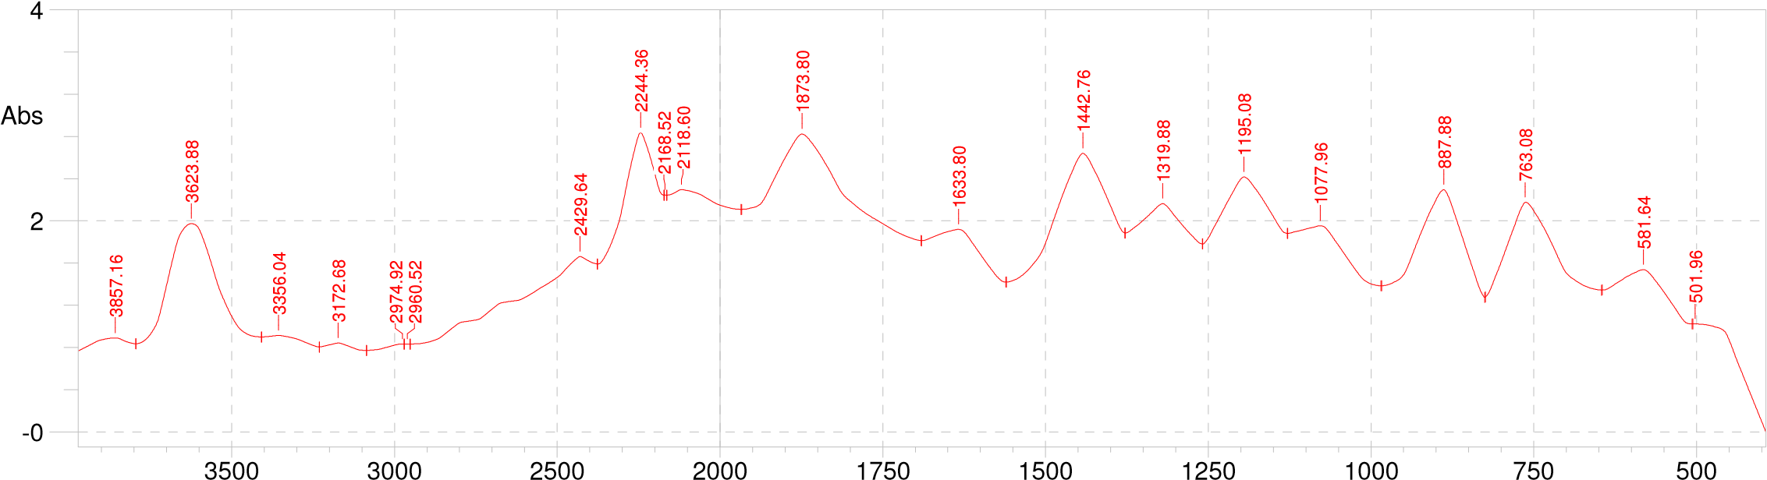
a

b
Fig.1: FTIR Spectrum of Dialium guineense leaf extract (a) before and (b) after the experiment

3.1.2 GC MS Analysis

Chemical characterisation of each plant extract was conducted using a gas chromatography–mass spectrometry system (GCMS-QP2010, Shimadzu). The analytical procedure followed was consistent with the methodologies reported in [13] and [15]. All analyses were performed at the National Research Institute for Chemical Technology (NARICT), Zaria.

The gas chromatography–mass spectrometry (GC–MS) technique integrates the separation capability of gas chromatography with the identification power of mass spectrometry, enabling the detection of individual constituents within complex mixtures. During the GC phase, the plant extract components were thermally volatilised and separated as they passed through a column under the flow of an inert carrier gas. Upon elution, the separated compounds entered the mass spectrometer, where they were identified based on the mass-to-charge ratio of their ionised molecular fragments.

3.1.3 Surface Examinations
3.1.3.1 SEM-EDX and AFM
To learn more about the corrosion morphology of mild steel before and after 8 hours of immersion in 1 M HCl solution with and without DGLE at 293 K, we performed surface examination on the studied MS samples using scanning electron microscopy (SEM) in combination with energy dispersive spectroscopy (EDX). The mild steel sample immersed in 1M HCl without inhibitor is shown in Fig. 2 (a), which shows that the metal surface was severely corroded with more pits and fractures. Following immersion in 1M HCl with DGLE, Fig. 2(b), the metal specimen showed a significant improvement with fewer cracks and pits than the blank solution due to the formation of an inhibitive layer on the mild steel surface.
The specimen's surface EDX analysis in blank medium reveals a significant concentration of iron, while the quantities of Mn, Ni, Cr, and Mo either vanish or decrease Fig. 3(a). The EDX spectra of the inhibitory sample show the presence of the atoms (C, N, and O) that comprise the tested chemical DGLE, suggesting that an organic component is present on the metal surface Fig. 3(b).
Furthermore, AFM investigation was performed on the corroded and inhibited surface images displayed in Fig. 4. In contrast to the inhibited surface, which was covered by inhibitor components and resulted in a smoothing of the surface to a mean diameter of 65.44 nm with coverage of 71.51%, the defects are very evident in the corroded surface without inhibition, which gave a mean diameter of 155.4 nm with coverage of 19.56%.

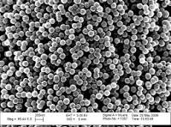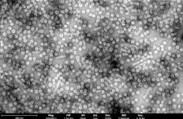
a
b

Fig. 2. SEM images of (a) Blank (b) with DGLE

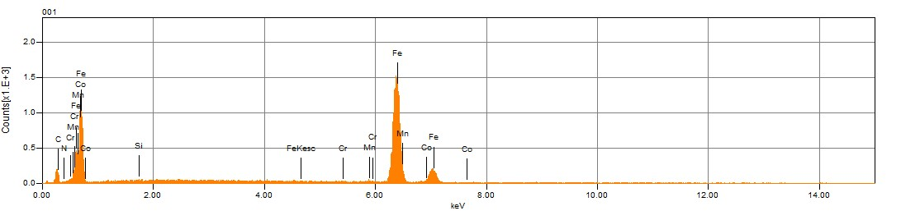
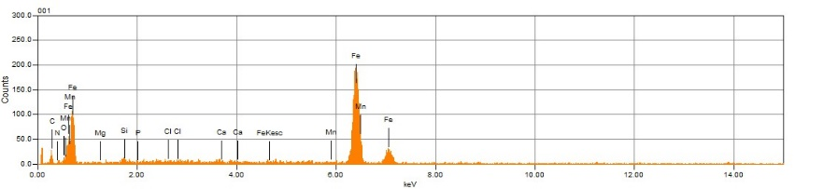
b
a

Fig. 3. EDX plots of (a) without (b) with DGLE

The number of particles dropped from 525 to 141 following inhibition with 500 mg/L of extract, as seen in Figs. 4(a and b), where the particle distribution was examined using AFM for in-depth surface characterization. Additionally, from Figs. 4(a and b), the surface view profile revealed a drop in mean height from 430.2 nm to 131.4 nm following inhibition

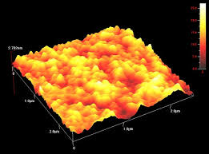
b
a

Fig. 4. AFM images for MS surface in (a) without and (b) with inhibitor.

3.2. Electrochemical Considerations
3.2.1 Electrochemical impedance
Electrochemical impedance analysis was used to investigate the DGLE corrosion inhibition impact on MS in 1M HCl. Fig. 5(a) shows the fitting circuit for the displayed data, in Table 1.

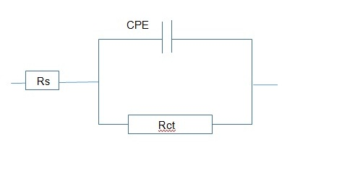
a
Fig. 5(a): OCP circuit

As seen in Figs. 5 (b) and (c), the Nyquist and bode diagrams are created following an hour of immersion of mild steel coupons in the corrosive fluids while Fig 5(d) shows the existence of the same kind of phase at all concentrations. The double layer capacitance (Cdl) and charge transfer resistance (Rct) are arranged in parallel. Table 1 demonstrates that the Rct value rises and the Cdl value falls with an increase in DGLE concentration. The lowest impedance value in this experiment was 10.15 Ω.cm², and the greatest Cdl value was 3.6×10⁻⁴F cm⁻² when there was no inhibitor. Subsequently, Rct values rise from 94.22 to 260.08 Ω.cm² when the inhibitor concentration is increased from 100 mg/l to 400 mg/l, while Cdl values fall from 2.6×10⁻⁴ to 8.5 ×10⁻⁵µF cm⁻². Because of the gradual increase, the DGLE was readily adsorbed on the surface of mild steel after adding a maximum concentration of 500mg/l maximum Rct 260.03 Ω.cm², and lower Cdl value 6.02×10⁻⁵ µF cm⁻². The highest corrosion inhibition efficiency rating at that point was 95.08 percent. The better corrosion resistance of mild steel in 500 mg/l of the inhibitor solution is demonstrated by the phase angle 650 maximum at 2.3 log freq for 500 mg/l compared to the blank 510 lower at 1.4 log freq condition [41-43].

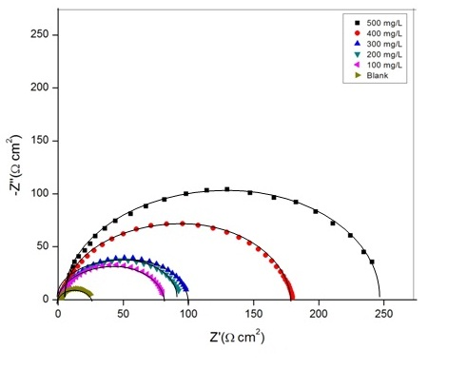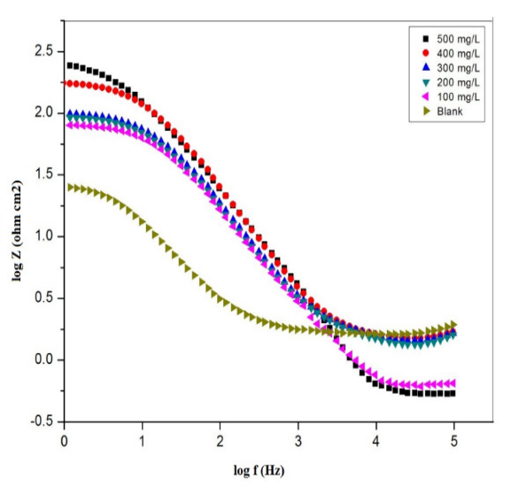
c
b
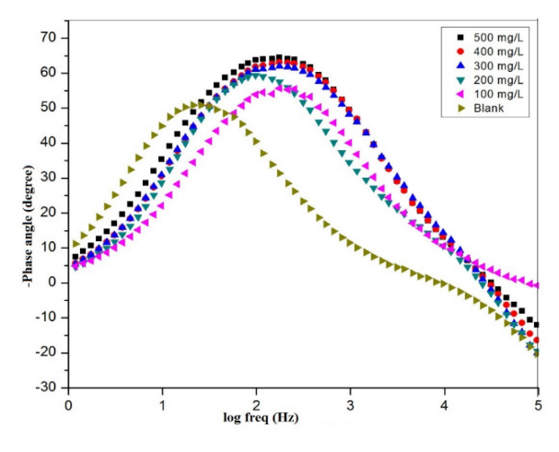
d
Fig. 6: Mild steel in 1M HCl without and with varying concentrations of DGLE, (a) fitted circuit, at 298 K (b) Nyquist, (c) Bode, and (d) phase plots,

Table 1: EIS parameters for mild steel in 1M HCl at various DGLE concentrations.
 | Concentration of inhibitor (mg/l) | Rct (Ω cm²) | Cdl (F cm⁻²) | Efficiency (IE %)
 | 0 | 10.15 | 3.6×10⁻⁴ | 0
 | 100 | 94.22 | 2.6×10⁻⁴ | 78.74
 | 200 | 108.31 | 2.4×10⁻⁴ | 80.43
 | 300 | 120.46 | 2.1×10⁻⁴ | 86.41
 | 400 | 196.05 | 8.5×10⁻⁵ | 92.54
 | 500 | 260.48 | 6.0×10⁻⁵ | 95.08

3.2.2 Potentiodynamic polarization (PDP) analysis
The anodic and cathodic polarization activity of mild steel coupons in a corrosive solution at various DGLE concentrations is shown in Fig. 6. Table 2 highlighted the various corrosion properties and inhibition efficiency. By extending the linear segments of the anodic and cathodic curves to the point where they connect with their associated corrosion potentials, the corrosion current densities were calculated. The Tafel graphs show that both the anodic and cathodic branches' current densities fall when DGLE is present. The current densities for different doses of DGLE decrease with increasing inhibitory concentration, reaching a maximum efficiency value of 90.02% at 500 mg/l. This behavior suggests that the metal dissolution at the anode and the hydrogen gas release at the cathode are effectively suppressed by the inhibitor. The observed differences in the anodic and cathodic branches lend credence to this. [43-45]. As the concentration of DGLE varies, so do the Tafel slopes of the anodic and cathodic branches (βa and βc). At a concentration of 100 mg/l, the inhibitor has the greatest impact on the release of hydrogen gas at the cathode, as seen by a total shift to the right of the Tafel slope. The Tafel slope moves in the direction of the center at a concentration of 200 mg/l. The largest shift to the left-hand side of the Tafel slope indicates that the most notable alteration in the iron dissolving process takes place at a concentration of 300 mg/l on the anode. Additionally, the Tafel slope moves to the cathodic side between 400 and 500 mg/l. This suggests that in a 1M HCl acid solution, the DGLE acts as a mixed-type corrosion inhibitor. The difference in corrosion potential (E_{corr}) values, specifically 40 mV (0.583-0.662), which is lower than the crucial value of 85 mV as reported in earlier research [42, 43], further confirmed the mixed corrosion inhibitor nature.

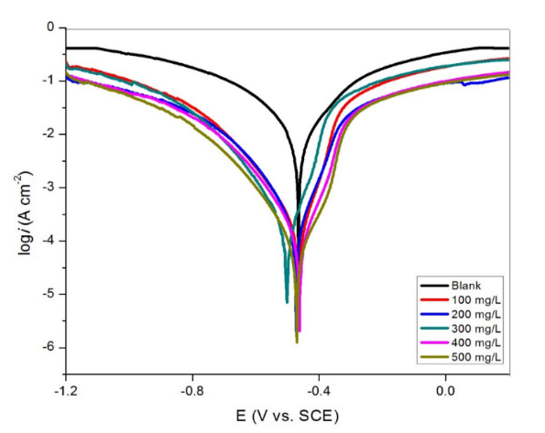
Fig. 7: Tafel plots for mild steel without and with various concentrations of DGLE.

Table 2: Polarization parameters for mild steel in 1M HCl acid without and with different concentrations of DGLE.
Inhibitor concentration (mg/l) | E_{corr}  (V vs. SCE) | I_{corr}  (μA cm⁻²) | β_{a}  (mV/dec) | -β_{c}  (mV/dec) | Efficiency  (IE %)
0 | -0.654 | 1000.20 | 150.06 | 154.52 | 0
100 | -0.712 | 216.01 | 144.15 | 124.35 | 79.59
200 | -0.583 | 124.30 | 62.30 | 110.05 | 80.65
300 | -0.721 | 122.10 | 45.01 | 109.27 | 82.61
400 | -0.662 | 79.04 | 54.29 | 104.09 | 88.15
500 | -0.507 | 57.16 | 64.27 | 105.32 | 90.02

3.3. Quantum mechanics modeling results
3.3.1 Molecular Electrostatic Potential and Frontier Molecular Orbital
Since the frontier molecular orbital (FMOs) hypothesis is widely recognized as a critical instrument for determining molecular activity and predicting the path of chemical processes, it is the most important technique for researchers. [46-47]. The molecular orbital energies of the molecule's highest occupied molecular orbital (HOMO) and lowest unoccupied molecular orbital (LUMO) are linked to the frontier molecular orbitals. The compound's interactions with other species are controlled by these orbitals. Previous researches has shown that corrosion-resistant materials' interfacial attachment is caused by a donor-acceptor process [42, 46]. This mechanism results in bonding coordination by transferring electrons from the electron-rich re]gions of the inhibitor to the electron-poor regions of the metal atoms, such as the vacant d orbitals of the Fe atoms. The inhibitor may also steal electrons from metal sites that are rich in electrons, such as occupied orbitals. The HOMO and LUMO determine the extent of interfacial charge-sharing or donor-acceptor interactions. Furthermore, the HOMO diagram displays portions of the molecule with a strong propensity to transfer electrons to electrophilic species, whereas the LUMO diagram displays regions of the molecule with a strong propensity to receive electrons from nucleophilic species. The HOMO and LUMO distribution of a DGLE from quantum mechanics modeling at the DFT/Dmol3 approach is shown graphically in Fig. 8. The HOMO of the DGLE inhibitor is primarily focused on a benzene ring and one of the nitrogen atoms, as this figure makes evident. On the other hand, LUMO happens on two N atoms, one O atom, and the carbon atoms of the aromatic rings. The molecular electrostatic potential (MEP) of the title chemical was examined and shown in Fig. in order to investigate the electron density of our inhibitor in an acidic media. The compound's rich (blue, orange, or yellow) and poor (blue-colored) electron density regions can be found using this tool; neutral portions are represented by the color green [47]. In the DGLE, regions of diminished electron density are predominantly localised on the carbon and hydrogen atoms, whereas areas of elevated electron density are chiefly associated with the benzene ring, as well as the oxygen and nitrogen atoms. Phytochemical constituents present in the ethanolic leaf extract of Dialium guineense were characterised using gas chromatography–mass spectrometry (GC–MS), with a total run time of 40 minutes. The analysis enabled the identification of active compounds, along with their respective retention times (RT), molecular formulae, molecular weights, and relative concentrations. However, owing to space constraints, the detailed GC–MS data are not presented here.

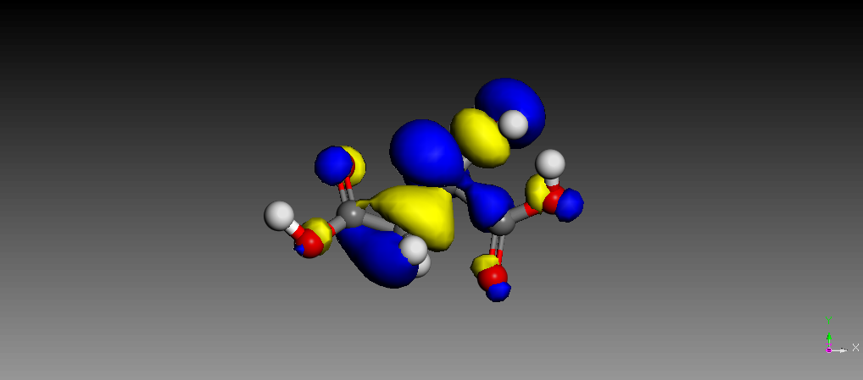
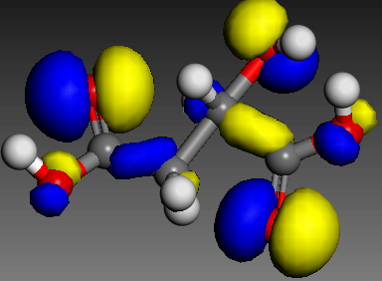

b
a

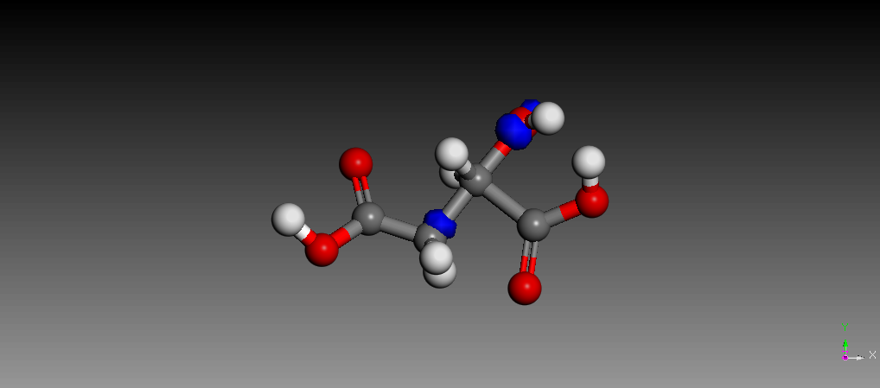
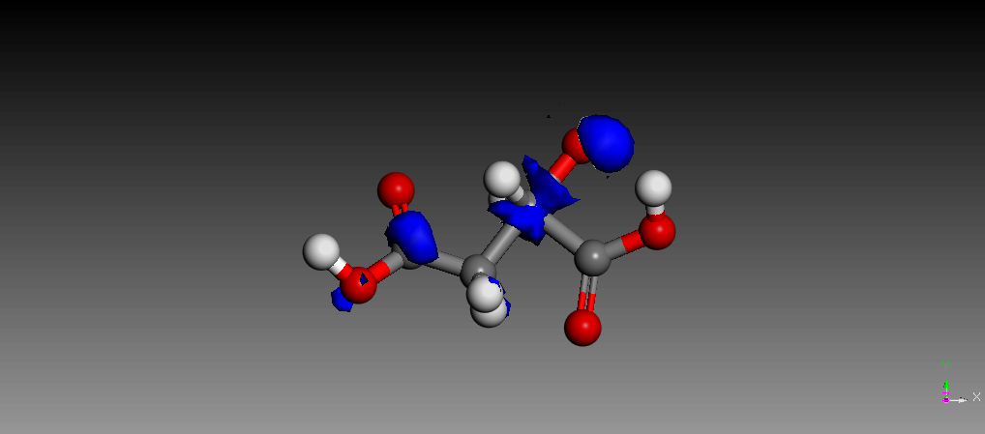

c
d

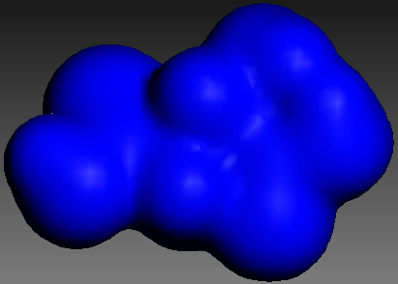

e

Fig. 8: Frontier molecular orbitals and Molecular Electrostatic Potential images of DGLE.
- HOMO (b) Lumo (c) Nucleophilic F(+) (d) Electrophilic F(-) (e) Electron

3.3.2. Quantum chemical descriptors
The protective mechanism and the reported protective efficacy of the title molecule were supported by the calculation of quantum chemical characteristics of DGLE (Table 3). The higher energy of the highest occupied molecular orbitals (E_{HOMO}) inhibitor compounds enhances their capacity to donate electrons to the metal's vacant d-orbital, hence accelerating the adsorption process and creating a better corrosion prevention mechanism.[48, 53]. In contrast, the lowest unoccupied molecular orbital (E_{LUMO}) values are consistent with the inhibitor molecules' propensity to receive electrons from the metal surface. As the E_{LUMO} value drops, the metal surface's tendency to accept electrons rises. In this case, DGLE has a high E_{HOMO} (-5.849 eV) and a low ELUMO (-0.696 eV), which corresponds to enhanced corrosion prevention efficacy as DGLE adsorption onto the metal surface increases (Table 3). Moreover, great inhibitory efficiency is associated with a low gap energy (∆E_{gap}) value. DGLE's exceptional anti-corrosion properties are demonstrated by its lowest ∆E_{gap} (5.153 eV) measurement. Global softness (σ) and global hardness (η) are important properties for assessing the stability and reactivity of a molecule [49]. DGLE is very reactive and may both transport and absorb electrons during DGLE-metal interactions, as demonstrated by its high value (0.511 eV⁻¹) and low value (2.001 eV) in our current analysis (Table 3). Generally speaking, the proportion of electrons transferred (∆NFe) was correlated with the molecule's chemical activity following electron donation [50].

Table 3: Calculated chemical descriptors and Fukui parameters
Chemial descriptors values (ev)
E_{HOMO} -5.849
E_{LUMO} -0.696
ΔE_{gap} -5.153
I ‘ 5.012
A 0.694
𝞆 3.241
µ -3.210
σ (ev⁻¹) 0.511
η 2.001
ω⁻ 3.812
ω⁺ 0.614
ω± 0.667
ΔΨ 0.012
ΔE_{back-donation} -0.432
ΔN_{Fe} 0.064

The DGLE under consideration has a positive and lower ΔNFe (0.064eV) value than 3.8, as shown in Table 3, suggesting that it can interact with the metallic surface by donating electrons into an empty d-orbital of the metal surface. In order to assess a compound's capacity to accept-donate electrons, some scientists have recently looked at the Electrodonating (ω-) and Electroaccepting (ω+) powers [51]. It is significant to remember that an efficient electron donor process is indicated by a high of ω+, while an efficient electron absorber system is indicated by a low value of ω-. With a value of ω+ = 0.614 eV and a value of 3.812 eV in ω−, the calculations at DFT/Dmol3 showed that DGLE had a larger propensity to receive and donate a charge. A molecule of DGLE had the largest Δω± (0.667eV), indicating a higher liquid electrophilicity (Table 3). Energy from Inhibitor to Metals (Δ$ψ$) is another global energy quantum-chemical descriptor that evaluates the strength of the interaction between the inhibitor and the metallic surface. A detailed examination of Table 3 reveals that the DGLE has a substantial Δ$ψ$ value (0.015 eV). If the value of ∆E_{back-donation} (-0.432 eV) is smaller than zero, a compound acquires charge and electron back-donation from the compound is both energetically suitable. MAC can be used to identify inhibitory adsorption zones that can be utilized to develop novel inhibitors. The inhibitor chemicals and the metal surface interact in a way that maximizes the positive effect on the atoms with the highest negative burden. The MAC of the DGLE molecule is shown in Figure 9. The heteroatoms (O/N) exhibit the most negative charges of the DGLE , suggesting that these centers interact with the Fe-surface and have the highest electron density [43, 54].

3.4. Atomistic simulations
3.4.1 Results of Atomistic simulations
MC and MD simulations were used to simulate the adsorption of DGLE on the Fe-surface under hostile conditions Fig. 8 shows side views of the DGLE equilibrium adsorption onto Fe (110) in the aqueous phase using MC/MD simulations. The DGLE's tendency to adsorb onto the metal surface is revealed by these atomic simulation observations, indicating the inhibitor's potential to shield the metal surface from corrosive species. Additionally, the molecular skeleton of the inhibitor material is parallel to the Fe-surface in both the top and side views of adsorbed DGLE (Fig. 8). Upon closer inspection, the DGLE inhibitor's aromatic ring has taken on a completely flat orientation. The benzene ring and O/N atoms seem to be the main adsorption sites for the inhibitors, according to the MC/MD simulations. The adsorption energy (E_{ads}) is a crucial metric for assessing the efficacy of corrosion inhibitors; lower E_{ads} values suggest more contacts between the inhibitor and the metal surface. Therefore, better corrosion inhibition capabilities are indicated by higher negative E_{ads} values [52, 53]. With low E_{ads} the DGLE interacts significantly with the Fe surface. The adsorption kinetics of DGLE on a metal surface can be tracked and examined using MD simulations. One way to make sure that components have as little energy as feasible is to keep an eye on the temperature changes that take place during the MD simulation run. The temperature drift is negligible, indicating the effectiveness of our system's MD. The ability of the DGLE compound to stop a metal from corroding in an acidic environment is precisely determined by the kind of connections that are made at the level of the adsorbate-substrate contact [52, 54]. This was accomplished by utilizing the radial distribution function (RDF) to identify the type of DGLE/metal interaction. While the RDF peak of an atom and the surface between 1 and 3.2 indicates that chemisorption has taken place, RDF graphs of greater distances (> 3.2) are projected to indicate that physisorption has occurred. This result implies that the main process by which the DGLE is chemically adsorbed onto the Fe-surface is O atom contact. Due to its exceptional ability to attract and transfer electrons from and to the metal surface, the inhibitor seems to have a great affinity for the metal surface and protects metal surfaces.

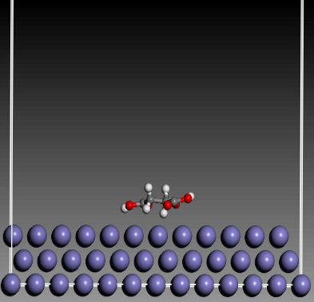
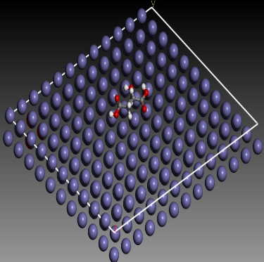
b
a

Fig . 9: Side and Top view of the snapshot from molecular dynamics model.

3.5 Comparison between MD simulation and theoretical results
The link between the adsorption energies (E_{ads}) and the energy gaps of the inhibitors under investigation is depicted in Fig. 10. The energy gap of the protonated inhibitor molecules and the adsorption energy (E_{ads}), represented by blue-filled circles, have a strong linear association with a correlation coefficient (R2) of 0.9998. These findings provide compelling evidence for the ratability of the DFT method employed in our investigation to forecast the inhibitor molecule's reactivity and anticorrosive characteristics.

Fig. 10: Comparison between the calculated energy gaps (ΔE_{gap}) computed using the DFT method and the adsorption energy calculated by the Molecular dynamic simulation.

3.6 Adsorption Studies and effect of Inhibitor Concentrations
Table 2 demonstrates that as the concentration of DGLE increased, the corrosion current density decreased. Several adsorption isotherms, including Langmuir (Eq. 17), kinetic-thermodynamic (Eq. 18), Freundlich (Eq. 19), and Temkin (Eq. 20) [46, 47], can be used to depict the behavior of inhibitor concentration as a function of surface coverage; these are shown in Fig. 10

$\frac{C}{θ}=\frac{1}{K}+C$ (17)
$ln\left(\frac{θ}{1-θ}\right)=lnK+xlnC$ (18)

$lnθ=lnK+nlnC$ (19)

$θ=\frac{1}{2a}lnK-\frac{1}{2a}lnC$ (20)

b
a

Temkin Kinetic-thermodynamic

d
c

Langmuir Freundlich

Fig. 10: Adsorption isotherms of DGLE on mild steel surface.

Where C is the concentration of DGLE, K is the adsorption constant, and x is a constant related to the adsorbed molecule. X value greater than 1 is implies formation of a multilayer on the surface of the metal whereas x value less than implies formation of a single inhibitor molecule occupying multiple active sites. Lastly, n and a represent the Temkin and Freundlich constants, respectively. The appropriateness of the adsorption model was assessed by calculating the correlation coefficient's value (R²). For Langmuir, kinetic-thermodynamic, Freundlich, and Temkin, the average correlations of the data were 0.9908, 0.9904, 0.9902, and 0.860, respectively. This indicates that the Temkin model provides the best fit for adsorption followed by Freundlich, Langmuir and Kinetic-thermodynamic models respectively. Table 4 compiled the Temkin adsorption model results. The stronger the binding of the inhibitor to the metal surface, the higher the K value. K values are related to the heat of adsorption by Eq. 21 [46, 47]:

Table 4: Adsorption coefficients of Temkin for DGLE on mild steel surface.

T(K) | K (L/ML) | ΔG_{ads} (KJ/mol) | ΔH_{ads} (KJ/mol) | ΔS_{ads} (J/mol.K) | n | R²
303 | 0.25 | -14.12 | -38.52 | -5.24 | 0.381 | 0.9903
343 | 0.07 | -11.83 | -45.31 | -6.10 | 0.572 | 0.9912
Average | 0.16 | -12.96 | -41.92 | -5.67 | 0.477 | 0.9908

$K=\frac{5}{55.5}e^{-\frac{{∆G}_{ads}}{RT}}$ (21)

The stability of the adsorption process can be ascertained using the ΔG_{ads} value. For dimensional consistency, the molar concentration of water in the solution is 55.5, which is translated to mg/L. Table 4 shows that the average Gibbs free energy of adsorption (ΔG_{ads}) is -12.96 kJ/mol. The ΔG_{ads} values fell within the physical adsorption range. Van't Hoff (Eq. 22) and Eq. 23 were used to calculate ΔH_{ads} and ΔSads. Fig. 6 illustrates how these equations were drawn. According to conventional wisdom, heat is drawn during the adsorption process, which lowers its entropy and adds a negative sign to its heat [46].

$lnK=\frac{{-H}_{ads}}{RT}+constant$ (22)

${∆G}_{ads}={∆H}_{ads}-{T∆S}_{ads}$ (23)

3.7 Kinetics studies and Influence of temperature

The corrosion current density rose as the temperature rose, as Table 2 illustrates. The Arrhenius equation (Eq. 24) and the transition state equation (Eq. 25) can be used to illustrate temperature behavior, however the Figure can not displayed here due to lack of space. The slope and intercept of Equations (24 and 25) have been used to calculate kinetic parameters including activation energy (E_{a}), frequency factors (A), enthalpy of activation (ΔH), and entropy of activation (ΔS) [43]. The results are presented in Table 5.

$CR=Ae^{-\left(\frac{E_{a}}{RT}\right)}$ (24)

$CR=\left(\frac{RT}{Nh}\right)e^{\left(\frac{∆S}{R}\right)}e^{\left(\frac{-∆H}{RT}\right)}$ (25)

Where N, R and h are Avogadro’s number, Plank’s constant and gas constant respectively.

Table 5: Arrhenius and transition-state parameters for the corrosion of mild steel in inhibited and uninhibted
Corrosive HCl solution

C (mg/l) |  | Ea (KJ/mol) | ΔH (KJ/mol) | ΔS (J/mol/K)
 | Blank | 21.84 | 25.2473.54 | -151.82
 | 100 | 30.16 | 55.23 | 61.38
 | 200 | 35.23 | 60.15 | 75.41
 | 300 | 40.05 | 65.45 | 78.21
 | 400 | 45.32 | 70.04 | 80.34
 | 500 | 52.56 | 73.63 | 80.50

The activation parameters changed when an inhibitor was added to the corrosive solution, as Table 5 illustrates. The minimum energy needed for a compound to go through a chemical reaction is called the activation energy (E_{a}) [41–44]. When an inhibitor is present, E_{a} is higher, indicating that a DGLE layer has formed on the metal surface and that the barrier has increased. An electrostatic adsorptive layer was created by an increase in activation energy that coincided with a physical adsorption process. This theory is supported by the inhibitory efficacy decreasing with increasing temperature. ΔH_{ads} has comparable behavior to Ea. In the absence of an inhibitor, negative values for ΔS suggest an activated complex, suggesting the existence of an association step instead of a dissociation phase during the transition from reactant to active complex [42–46] .

- Conclusion
DGLE is a unique natural inhihibitor was developed in this work.The title molecule was characterized using Fourier transform infrared (FT-IR) spectroscopy. Additionally, DGLE has a significant corrosion-inhibiting effect for mild steel in 1 M HCl, and the inhibitory effectiveness increases as the inhibitor concentration increases, according to electrochemical techniques (open circuit potential (OCP), potentiodynamic polarization (PDP), and electrochemical impedance spectroscopy (EIS)). EIS experiments show that DGLE functions as a mixed type inhibitor, with an inhibitory efficacy of 95.08% at 500 mg/l. Also, DGLE exhibits respectable inhibitory action throughout the temperature range studied. By creating a robust protective layer, DGLE decreased the deterioration of mild steel, according to SEM/EDX research. Fuethermore, Tthe AFM investigation explains why surface roughness decreases as DGLE content rises. Furthermore, the modeling simulations derived from electronic quantum mechanics (DFT) calculations, molecular dynamics (MD), and Monte Carlo (MC) simulations emphasized the interfacial adsorption and subsequent corrosion-resistant layer development of inhibiting DGLE over the mild steel surface, which validates the experimental findings. Thermodynamic characteristics suggested a physisorption mechanism, and the adsorption process of DGLE followed the Temkin isotherm.

AcknowledgEments

The authors sincerely acknowledge the support of Tertiary Education Trust Fund (TETFUND), fror funding this research through Ref (TETFUND/DESS/UNIZIK/AWKA/IBR/2025/VOL.1).

Disclaimer (Artificial intelligence)
Author(s) hereby declare that NO generative AI technologies such as Large Language Models (ChatGPT, COPILOT, etc.) and text-to-image generators have been used during the writing or editing of this manuscript.

References
[1] Onyenanu, et al, (2022), Corrosion Inhibition potentials of A. mossambicensis and E. sonchifolia Leaves' Extracts on Aluminuium in Alkaline Media: Insights from Gravimetric and Electrochemical Studies, Chemistry Africa, https://doi.org /10.1007/s42250-022-00531-0

[2] Trethewey, K. R. & Chamberlain, J., (1995). Corrosion for science and Engineering, 2nd Edition, Longman Group Limited, England.

[3] Olivia, et al, 2023, Corrosion inhibition of mild steel bars by biosurfuctants produced by Penicillium citrinum, IOP Conference series: Earth and environment science. doi.org/10.1088/1755-1315/1135/1/012057

[4] Singh, et al, 2025, A sustainable and green method for controlling acidic corrosion on mild steel using leaves of Araucaria heterophylla. Sci Rep, 15(1), doi: 10.1038/s41598-025-86352-w.

[5] Radha, et al, 2024, Experimental study on corrosion inhibition of mild steel using Mukia maderaspatana leaves extract as green inhibitor, Surf. Sci. Tech. 2(27). https://doi.org/10.1007/s44251-024-00056-3

[6] Okeoma, (2015), Computational and Experimental studies on the inhibitive effects of Newbouldia laevis extract and magnetic fields on copper corrosion in aqueous acidic media. International letter of Chemistry, Physics and Astronomy, 54, 135-142.
[7] Nnanna, et al, (2012). Inhibition of Newbouldia leavis Leaf Extract of the Corrosion of Aluminium in HCL and H₂S0₄ Solutions. Scholars Research Library, 4(1): 207-217.
[8] Nwabanne, J. T. and Okafor, V. N. (2011). Inhibition of the corrosion of mild steel in acidic medium by Vernonia amygdalina: Adsorption and Thermodynamic study. Journal of Emerging Trends in Engineering and Applied Science (JETEAS) 2(4): 619 - 625.
[9] Nagm, et al, (2012). Gravimetric and electrochemical evaluation of environmentally friendly nonionic corrosion inhibitors for carbon steel in 1 M HCl. Corrosion Science 65, 94-103.
[10] Ndibe, et al, (2011). Corrosion inhibition of mild steel by acid extraction of Vernonia amygdalina in HCl and HNO₃. EJEAFChe, 10(9), 2847 – 2860.
[11] Emembolu, et al, (2020), Evaluation of the corrosion inhibitory effect of Napoleonaea imperalis leaf extract on mild steel in 1.3 M H2SO4 medium, Journal of Bio- and Tribo- corrosion, 6(128), 1-15. https://doi.org/10.1007/s40735-020-00422-2

[12] Ibezim, et al, (2026), Synergistic of corrosion inhibitory effects od rice and African bread fruit husks extract on mild steel in HNO3 Medium, UNIZIK Journal of Engineering and Applied Sciences 5(1), 2964-2971.
[13] El Ouariachi, et al, (2010). Adsorption properties of Rosmarinus of ficinalis oil as green corrosion inhibitors on C38 steel in 0.5M H₂SO₄. Acta Metal. Sin. (Engl. Lett.), 23 (1), 13 – 20.
[14] Abdulwahab, M., Kasim, A., Bello, K. A. and Gaminana, J. O. (2012). Corrosion inhibition of multi-component aluminium alloy in hydrochloric acid solution by aqueous extract of bitter Leaf (Verninia amygdalina) powder.

[15] Ali, et al, 2022, Plant extracts as sustainable and green corrosion inhibitors for p]rotection of ferrous metals in corrosive media: A mini review. Corrosion communications, 25-38. Doi.org/10.1016/j.corcom.2022.03.002

[16] Bhoomika, et al, 2024, Plant extracts as green corrosion inhibitors for different kinds of steel: A review, Heliyon, 10(14), https://doi.org/10.1016/j.heliyon.2024.e33748.

[17] Emembolu, et al, 2021, Electrochemical and statistical study of the inhibition effect of T. conophorum leaf extract on aluminium corrosion in acidic medium, Safety in Extreme Environments. https:/doi.org/10.1007/s42797/-021-00040-2

[18] Norbaayah, et al, 2021, A Review on Plants and Biomass Wastes as Organic Green Corrosion Inhibitors for Mild Steel in Acidic Environment, Metals, 11(7), 1062; https://doi.org/10.3390/met11071062

[19] Abdurrahman, S. Y., Gaya, U. I., Kwalli, S. A., & Sa’idu, Y. (2021). Corrosion inhibition of ethanol extract of Moringa oleifera leaves on aluminium in 1m sulphuric acid solution. International Journal of Biology and Pharmacy Research Archive, 01(01), 014–023.

[20] Al Otaibi N, Hammud HH., 2021, Corrosion Inhibition Using Harmal Leaf Extract as an Eco-Friendly Corrosion Inhibitor, Molecules. 26(22):7024. doi: 10.3390/molecules26227024.

[21] Okafor, et al, (2025), Mechanistic insights into mild steel corrosion inhibition in alkaline media using synthesized ionic liquid, Results in Surfaces and Interfaces, 20 (100581), https://doi.org/10.1016/j.rsurfi.2025.100581

[22] Fouda, A.EA.S., El-Dossoki, F.I., Atia, M.F. et al., (2025), Contribution to the corrosion inhibition of aluminum by aqueous extract of Moringa oleifera in 2 M HCl. Discov Chem Eng 5, 1 . https://doi.org/10.1007/s43938-025-00074-z

[23] Emembolu, L.N. & Onukwuli, O. D., (2019), Corrosion inhibitive efficacy of natural plant extracts on zinc in 0.5 M HCl solution, The pharmaceutical and chemical journal, 6(2): 62-70.

[24] Meena, et al., (2024), Euphorbia neriifolia extracts as green corrosion inhibitors for aluminium in hydrochloric and nitric acid media. Discov Mater 4, 102 . https://doi.org/10.1007/s43939-024-00157-8

[25] Almahdy, M. S., Molouk, A. F., El-Hossiany, A., & Fouda, A. E. A. S. (2023). Electrochemical studies of erica arborea extract as a green corrosion inhibitor for C-steel in sulfuric acid medium. Biointerface Res Appl Chem, 13(5), 472.

[26] Mahmoud N. EL-Haddad, A.S. Fouda, 2025, Investigating Xanthium spinosum extract as an eco-friendly corrosion inhibitor for Aluminium in acidic environments: A green approach to metal protection, Results in Chemistry,102136 DOI:10.1016/j.rechem.2025.102136

[27] Attia, E. M., Elazabawy, O. E., Hassan, N. S., & Hyba, A. M. (2020). Potentiodynamic study on the corrosion inhibition of carbon steel in formation water by potato peel extract. IJARP, 4(3), 79-84.

[28] Emembolu, etal, 2024, Corrosion Inhibition Performance of Brachystegia eurycoma Leaf Extract on Mild Steel in Acid Media, Journal of Engineering Research and Reports, 26(6), 83-102. DOI: 10.9734/JERR/2024/v26i61164

[29] Al-Amiery, et al, (2022), Experimental and theoretical study on the corrosion inhibition of mild steel by nonanedioic acid derivative in hydrochloric acid solution. Sci Rep, 12, 4705 https://doi.org/10.1038/s41598-022-08146-8

[30] Singh, et al, (2013), Theoretical Approach to the Study of Some Plant Extracts as Green Corrosion Inhibitor for Mild Steel in Hcl Solution. Orient J Chem, 29(1).

[31] Bi-lan, et al, (2023), Experimental and theoretical study on corrosion inhibition and adsorption performance of Ipomoea batatas L. leaf extract for mild steel, Arabian Journal of Chemistry, doi: 10.1016/j.arabjc.2023.105410

[32] Fatma, et al, (2019), Corrosion inhibition of mild steel in acidic solution by leaves and stem extract of Acacia nilotica, Desalination and Water Treatment, doi: 10.5004/dwt.2019.24681

[33] Kumari, et al, (2026), Corrosion mitigation of mild steel in acid media using a potential hydrazide derivative; experimental and theoretical investigation. Arab Journal of Basic and Applied Sciences, 33(1), 32–50. https://doi.org/10.1080/25765299.2025.2611463

[34] Didam, et al, (2025), Green corrosion inhibition of mild steel in acidic media using Wahlenbergia riparia extractgravimetric via CCD-RSM, electrochemical and surface analyses, Results in Chemistry, https://doi.org/10.1016/j.rechem.2025.102596

[35] Boudalia, (2023), Experimental and Theoretical Tests on the Corrosion Protection of Mild Steel in Hydrochloric Acid Environment by the Use of Pyrazole Derivative, Materials 16(2), 678; https://doi.org/10.3390/ma16020678

[36] Pourmohseni M, Rashidi A, Karimkhani M., (2024), Preparation of corrosion inhibitor from natural plant for mild stil immersed in an acidic environmental: experimental and theoretical study. Sci Rep, 14(1):7937. doi: 10.1038/s41598-024-58637-z.

[37] Sajadi, et al, (2022), Experimental and theoretical investigation of mild steel corrosion control in acidic solution by Ranunculus arvensis and Glycine max extracts as novel green inhibitors, Heliyon, https://doi.org/10.1016/j.heliyon.2022.e10983

[38] Arthur and Abechi, (2019), Corrosion inhibition studies of mild steel using Acalypha chamaedrifolia leaves extract in hydrochloric acid medium. SN Appl. Sci. 1, 1089 (2019). https://doi.org/10.1007/s42452-019-1138-4

[39] Solmaz, et al, (2024), Comprehensive Experimental and Theoretical Study on the Adsorption and Corrosion Inhibition Efficiency of Pyronin B for Mild Steel Protection in HCl Solution , the journal of physical chemistry C, 128(51), https://pubs.acs.org/journal/jpccck?ref=breadcrumb

[40] Alan Miralrio and Araceli Espinoza, (2020), Plant Extracts as Green Corrosion Inhibitors for Different Metal Surfaces and Corrosive Media: A Review, processes, DOI: 10.3390/pr8080942

[41] Omran, et al, (2022), Optimization of mild steel corrosion inhibition by water hyacinth and common reed extracts in acid media using factorial experimental design. Green Chemistry Letters and Reviews, 15(1), 216–232. https://doi.org/10.1080/17518253.2022.2032844

[42] Mahdi, et al, (2022), Corrosion Inhibition of Mild Steel in Hydrochloric Acid Environment Using Terephthaldehyde Based on Schiff Base: Gravimetric, Thermodynamic, and Computational Studies, Molecules, 27(15):4857. doi: 10.3390/molecules27154857.

[43] Hency Thacker and Vijay Ram,( 2025), Green corrosion inhibitors derived from plant extracts and drugs for mild steel in acid media: A review, Results in Surfaces and Interfaces, DOI: 10.1016/j.rsurfi.2024.100364

[44] Barbu, et al, (2025), Critical Review Regarding the Application of Plant Extracts as Eco-Friendly Corrosion Inhibitors—A Sustainable Interdisciplinary Approach. Molecules, 30, https://doi.org/10.3390/molecules30183722

[45] R Holla,et al, (2024), Plant extracts as green corrosion inhibitors for different kinds of steel: A review. Heliyon, 10(14):e33748. doi: 10.1016/j.heliyon.2024.e33748.

[46] Jyothi and Rathidevi, (2017), Experimental and theoretical investigation on corrosion inhibition of mild steel in sulphuric acid by Coccinia indica leaves extract, RASAYAN Journal of Chemistry, 10(4):1253-1260, DOI:10.7324/RJC.2017.1041924

[47] Hjouji, et al, (2024), Green corrosion inhibition of mild steel in acidic media using Datura stramonium seed extract: A study for sustainable engineering applications, Chinese Journal of Chemical Engineering, https://doi.org/10.1016/j.cjche.2024.10.040

[48] Sabiha, et al, (2025), Investigating the Adsorption and Corrosion Protection Efficacy and Mechanism of Marjoram Extract on Mild Steel in HCl Medium. Molecules, https://doi.org/10.3390/molecules30020272

[49] Bin, et al, (2013), Experimental and theoretical study of corrosion inhibition of 3-pyridinecarbozalde thiosemicarbazone for mild steel in hydrochloric acid, Corrosion science, https://doi.org/10.1016/j.corsci.2013.04.044

[50] El Amri , et al, (2025), Synthesis characterisation and analysis of the corrosion resistance of a new epoxy resin onto mild steel in the presence of hydrochloric acid: practical and theoretical points of view,Canadian Metallurgical Quarterly,65,373 - 393, doi:10.1080/00084433.2025.2457306

[51] Mourad, et al, (2025), Comprehensive evaluation of tetraglycidyldiphenylcarbazide as a corrosion inhibitor for mild steel: an electrochemical and theoretical approach, The European Physical Journal Plus, DOI: 10.1140/epjp/s13360-025-07004-6
[52] Hsissou, et al, (2023), A Combined Experimental and Computational (DFT, RDF, MC and MD) Investigation of Epoxy Resin as a Potential Corrosion Inhibitor for Mild Steel in a 0.5 M H2SO4 Environment, Polymers,15, doi: 10.3390/polym15081967.

[53] Shahini, et al, (2021), Superior inhibition action of the Mish Gush (MG) leaves extract toward mild steel corrosion in HCl solution: Theoretical and electrochemical studies. Journal of Molecular Liquids, 332, 115876.

[54] Anupama, et al, (2016), Electrochemical and computational aspects of surface interaction and corrosion inhibition of mild steel in hydrochloric acid by Phyllanthus amarus leaf extract (PAE). Journal of Molecular Liquids, 216, 146-155.

