Original Research Article
EFFECTS OF DIETARY OLIVE OIL (OLEA EUROPAEA) SUPPLEMENTATION ON GROWTH PERFORMANCE AND HAEMATOLOGICAL PARAMETERS OF JUVENILE CLARIAS GARIEPINUS
Abstract
This study assessed the impacts of dietary Olea europaea (olive) oil on the growth performance and haematological parameters of juvenile Clarias gariepinus. Five dietary treatments with three replicates each were randomly assigned to 150 juveniles whose mean weight ranged from 10.22 to 11.78 g. The juveniles were fed experimental diets for 56 days. A commercial diet (control), a basal diet devoid of olive oil, and basal diets supplemented with 10 g/kg, 20 g/kg, and 30 g/kg of olive oil comprised the treatments. One-way ANOVA was used to examine growth performance and haematological parameters. Growth indices and some haematological parameters showed significant differences (P < 0.05) between treatments. Fish fed the commercial diet performed better in terms of growth, while moderate level of olive oil inclusion enhanced certain physiological indicators, indicating that the diet significantly influenced their overall health and growth performance compared to other treatments. The findings therefore demonstrate that dietary supplementation of olive oil affects growth performance and haematological parameters of C. gariepinus with moderate levels of inclusion exhibiting positive physiological outcomes. Olive oil can thus be a promising source of natural lipids in aquafeeds and an alternative to synthetic growth promoters in aquaculture nutrition.
KEYWORDS: Dietary, Growth Performance, Haematological Indices, Olea europaea, Clarias gariepinus
Introduction
African catfish (Clarias gariepinus) is among the most significant aquaculture species in an aquarium environment across the world and the African continent because of its high fecundity, fast reproduction rate, and tolerance to varied environmental factors as well as its willingness to feed on a variety of feeds (Bawa, 2024). The species is massively cultivated in Africa, Nigeria notably, where it offers major food security, job opportunities, and income to small and big scale fish farmers (Imade & Odum, 2024). Its adaptation to low quality of water, high stock density, and diseases make it an ideal species to use in intensive aquaculture systems (Dawood et al., 2022). Nonetheless, sustainability and profitability of C. gariepinus production is highly contingent on the best nutrition and the effective utilization of feeds, which directly corroborate growth performance, health condition, and production efficiency (Tacon & Metian, 2015). Since aquaculture is rapidly growing to keep up with the growing animal protein demand throughout the world, the enhancement of feed quality and nutritional profiles has become a key concern in fish production systems (Liu et al., 2024). In aquaculture, the feed is the highest cost of operation, and it consumes a significant percentage of the cost of production (Food and Agriculture Organization, 2022). Thus, it is critical to create nutritionally balanced and economical nutrition that improves growth performance and sustains fish health with minimum environmental pollution (Naylor et al., 2021). The contemporary focus of aquaculture nutrition lays on the use of functional feeds that supplement the growth aspect in addition to enhancing physiological activities, immune, and resistance to stress and diseases (Onomu & Okuthe, 2024).
Dietary lipids are important to fish nutrition as a significant source of concentrated energy and essential fatty acids needed to support optimal physiological functions (Carr et al., 2023). Lipids also contain energy that is roughly twice as much as a protein and carbohydrate and hence spares dietary protein to be used in growth instead of energy metabolism (Khadim et al., 2025). The essential fatty acids in fish contribute to the preservation of cell membrane structure, metabolic functions, to reproductive performance, and immune activity (Carr et al., 2023). Also, palatability of the feeds is affected by dietary lipids, nutrient uptake and general effectiveness in growth. Lipid sources that are added to fish diets have a pronounced impact on fish health, body composition, and metabolic performance and the choice of lipid sources is a critical aspect in the development of aquaculture feed application (Liu et al., 2025). Plant-based sources of lipids have received growing consideration in aquaculture in the recent years because of the availability, cost-effectiveness and health benefits. Olive oil has become one of the most promising dietary supplements due to its high concentration of monounsaturated fatty acids and especially oleic acid, and the presence of bioactive compounds, including polyphenols and antioxidants (Hazreen-Nita et al., 2022). These bioactive molecules have been reported to have anti-inflammatory, antimicrobial, and antioxidant effects that can be used to boost fish growth, physiological performance, and withstand oxidative stress (Assar et al., 2023). The use of olive-based products in aquafeeds has thus been considered as a viable functional nutritional approach to enhance the health and productivity of fish (Zancan et al., 2025; Balbuena-Pecino et al., 2022). Past research has shown the positive influence of olive based supplements in aquaculture diets. According to Ispir et al. (2024), diets supplemented with olive leaf extract in rainbow trout (Oncorhynchus mykiss) enhanced growth rate, Haematological characteristics, and tolerance to Yersinia ruckeri, which serves as evidence that olive leaf extract can be used as a functional dietary additive. Likewise, as found by Zemheri-Navruz et al. (2019), the juvenile common carp (Cyprinus carpio) supplemented with olive leaf extract exhibited superior Haematological outcomes, such as elevated levels of red blood cells, hemoglobin, and other values indicating the health of the blood. These results indicate that compounds of olive origin could have beneficial impacts on the physiology of fishes by enhancing nutrient exploitation, boosting immune capacity, and enhancing general health.
Although promising outcomes have been observed in other fish species, little information is available on the impact of olive oil supplementation especially on Clarias gariepinus. Considering the economic value of this species and the increased demand in the use of functional dietary lipid feeds, which can stimulate growth and physiological efficacy, there is a need to explore the possible advantages of olive oil as a diet lipid source in African catfish farming. Knowing its impacts on growth performance and Haematological reactions could be a good clue in enhancing feed efficiency, improving fish health, as well as enhancing sustainable aquaculture practice. Thus, the purpose of the study is to determine the impacts of olive oil supplementation on the growth and Haematological responses of Clarias gariepinus.
Materials and Methods
Study Area
This study was carried out in the Department of Fisheries, Forestry and Wildlife, College of Agriculture, Federal University of Agriculture, Zuru (FUAZ), Kebbi State, Nigeria. The institution is located within the Sudan–Savanna agro-ecological zone of north-western Nigeria, between latitudes 10.84° N and 11.84° N and longitudes 4.45° E and 6.00° E, with an elevation of about 350–400m above sea level (Bello, 2014). Zuru is situated in the south-eastern part of Kebbi state, which falls within the tropical climatic region of the country that is characterized by marked wet and dry seasons, thus fitting into the Sudan–Savanna zone of Nigeria (Usman et al., 2025).

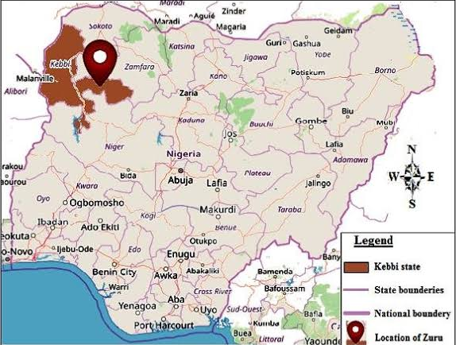
Image 1 Map of the Study Area
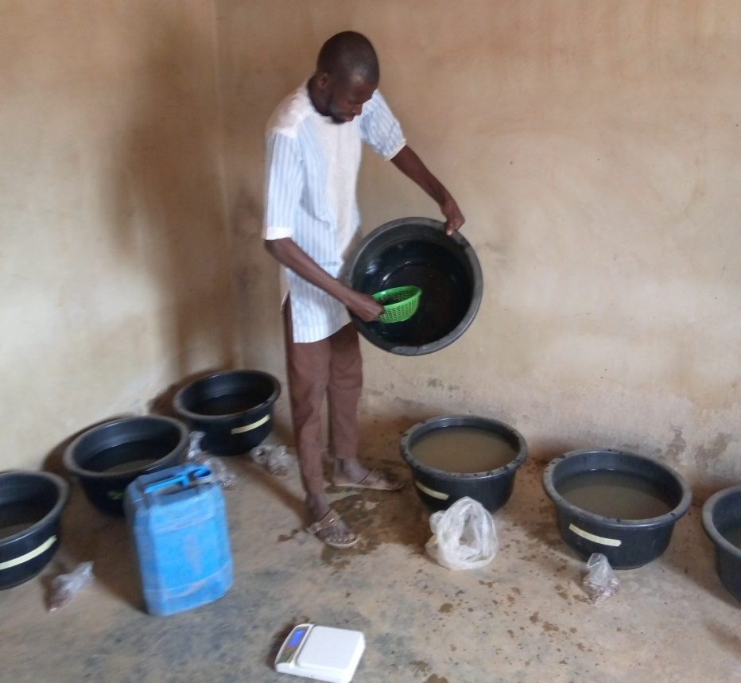
Image 2 Experimental Site
Acquisition of Experimental Fish
A total of 150 Clarias gariepinus juveniles of approximately equal body weight (10.22 g to 11.78 g) were obtained from Labana Farm, Aleiro, Kebbi state. The juveniles were transported to Federal University of Agriculture Zuru in an open, ventilated 25 litres container filled with water. The juveniles were acclimatized for two weeks to allow them to recover from all forms of stress, adapt to their new environment, and ensure that there was no infection from the source (Obaroh & Achionye-N, 2011; Odioko et al., 2016).
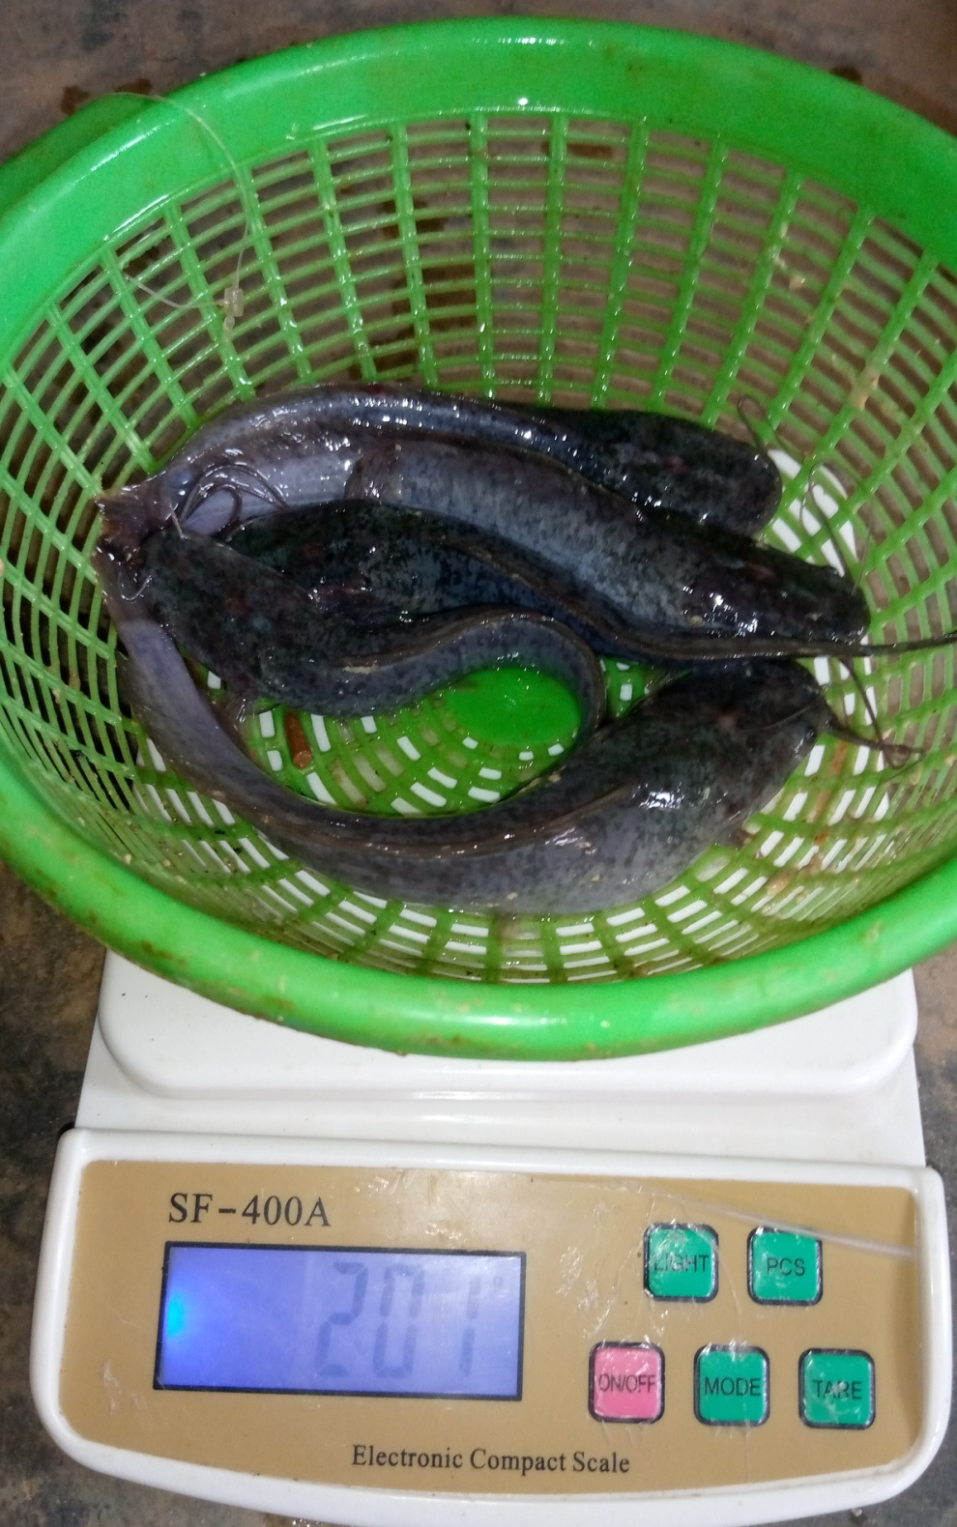
Image 3 : Image of Experimental Fish
Sources of Feed Ingredients
Feed ingredients used in formulating the diets include fish meal (Danish), soy beans, groundnut cake (protein source), maize and wheat bran (energy source), vitamin premix, lysine, methionine and salt (gari as a binder). Olive oil was used as a lipid source. All the ingredients were purchased at Agro-tech Sokoto except olive oil which was purchased at herbal chemist Zuru and were milled into a fine mixture.
Preparation of Experimental Diets
Basal diets of 40% crude protein (Pearson square method) were prepared using the above ingredients. LP-2 without olive oil, 10g/kg (LP-3), 20g/kg (LP-4) and 30g/kg (LP-5) were added. The appropriate quantities of ingredients in each diet was weighed and mixed thoroughly using a cleaned and washed pounding stick. Each diet was further mixed with warm water. The mixed dough was pelletized using a hand pelletizer with 2mm diameter size. The pelleted feeds were sun-dried and stored until the commencement of the feeding trial
Table 1: Composition of the Experimental Diet (g/kg)
Ingredients | 0g/kg O. Oil | 10g/kg O. Oil | 20g/kg O. Oil | 30g/kg O. Oil
Fish Meal | 287 | 287 | 287 | 287
Soybean meal | 287 | 287 | 287 | 287
Groundnut | 191 | 191 | 191 | 191
Maize | 105 | 100 | 95 | 90
Wheat bran | 105 | 100 | 95 | 90
Olive oil | 0 | 10 | 20 | 30
Premix | 5 | 5 | 5 | 5
Methionine | 5 | 5 | 5 | 5
Lysine | 5 | 5 | 5 | 5
Salt | 10 | 10 | 10 | 10
Total | 1000g | 1000g | 1000g | 1000g
Key: O.= Olive
Experimental Design
After the acclimatization period, 150 juvenile C. gariepinus were stocked at a density of 10 fish per bowl in 15 plastic bowls with a 60 L capacity. The experiment consisted of five treatments with three replicates per each treatment. Treatment 1: the control fed with a commercial diet (LP-1), treatment 2: fed a diet without olive oil (LP-2), treatment 3: with 10g/kg of olive oil (LP-3), treatment 4: with 20g/kg of olive oil (LP-4) and treatment 5: with 30g/kg. Experimental fish were fed at 5% body weight per day, divided into two feeding periods at 9:00am and 5:00pm as described by Obaroh & Nzeh (2013); Omitoyin (2010) for 8 weeks. The water in the bowls was changed regularly to maintain water quality and ensure the well-being of the fish (Okomoda, 2016).
Determination of Growth Performance
The body weights were recorded on weekly basis by weighing some of the fish in each of the five (5) experimental groups. Fish were randomly selected and placed on a field weighing balance. Weights were taken in triplicate. The growth performance parameters were calculated using the formulas described by Rahman & Arifuzzaman (2021).
Weight Gained Mean weight gain (g) = Final mean weight – Initial mean weight (g)

Percentage Weight Gained
PWG = Final weight – Initial mean weight × 100
Initial body weight
Specific Growth Rate (SGR)
SGR (%day⁻¹) = ln (W2​) − ln (W1​)​×100
t
Feed conversion Ratio (FCR)
FCR = feed fed (g)
Weight gain (g)
Fish Survival Rate
SR (%) = (Final number of fish / Initial number of fish) ×100
Haematological Analysis
Blood Sample Collection
At the conclusion of the experiment, three fish from each treatment group were randomly selected and blood was collected using 2 ml disposable syringes via cardiac puncture. The needle was inserted at a right angle to the vertebral column, and blood was gently drawn and immediately transferred into tubes containing anticoagulant. Samples were gently mixed to prevent clotting this procedure follows the cardiac puncture method described by Muhammed et al. (2019) for teleost fish.
Determination of packed cell volume (PCV)
Determination of packed cell volume (PCV) was performed using the microhematocrit centrifuge technique: blood was loaded into approximately two-thirds of heparinized capillary tubes, one end was sealed by flame, and samples were centrifuged at around 12,000 rpm for about 5 minutes. The packed red cell volume was then quantified using a microhematocrit reader, following the protocol described by Witeska et al. (2022).
Determination of hemoglobin (Hb)
The hemoglobin (Hb) concentration was determined using the cyanmethemoglobin method as described by Enyidi & Asuquo (2024). A 0.02 ml volume of blood was added to 5 ml of Drabkin’s reagent, thoroughly mixed, and left to stand for 10 minutes at room temperature to allow the formation of cyanmethemoglobin. The mixture was then transferred to a cuvette and analyzed spectrophotometrically at a wavelength of 540 nm. The absorbance values were used to calculate Hb concentration in g/dl using standard hematology procedures.
Determination of white (WBC) and red blood cells (RBC)
White blood cell (WBC) and red blood cell (RBC) counts were performed using the Neubauer hemocytometer after diluting blood samples with Hayem’s solution; WBCs were counted in the corner squares, and RBCs in the central squares following the protocol outlined by Bojarski et al. (2022).
Mean Corpuscular Hemoglobin (MCH)
The mean corpuscular hemoglobin (MCH) is the average amount of hemoglobin present in a single red blood cell, calculated by dividing the total hemoglobin by the total number of red blood cells. It is determined by collecting a blood sample and analyzing it using an automated hematology analyzer, which measures both the hemoglobin concentration and the total number of red blood cells in the sample. The analyzer then automatically calculates the MCH value using the formula: MCH = Total Hemoglobin (g) / Total Red Blood Cells (millions) (Liess, 2025).
Mean Corpuscular Volume (MCV)
The MCV refers to the average volume of a single red blood cell. It is calculated by dividing the total volume of packed red blood cells (PCV) by the total number of red blood cells. To determine MCV, a blood sample is collected and processed using an automated hematology analyzer. The analyzer measures the PCV using the micro-hematocrit centrifuge method and counts the total number of red blood cells. The MCV value is then calculated automatically by the analyzer using the formula: MCV = PCV (%) / Total Red Blood Cells (millions) (Liess, 2025).
Data Analysis
The data were presented in mean and standard deviation of three replications per treatment. One way ANOVA was used to compare the differences between treatments and Duncan Multiple Range test in SPSS software was used to separate significant means at p < 0.05.
Results
Growth Parameters of the Experimental Fish
The growth parameters are presented in Table 2. The highest mean weight gained (91.08±0.29g) was observed in LP-1 (Control), while the least (37.35±0.29g) was in LP-2. The highest percentage weight gain (798.87±0.29%) was observed in LP-1, while the least (327.08±0.29%) was in LP-5. The highest specific growth rate (1.52±0.13% day⁻¹) was observed in LP-1, while the least (0.62±0.29% day⁻¹) was in LP-2. The highest fish survival rate (81.08±0.29) was observed in LP-1, while the least (32.12±0.29) was in LP-3. The highest food conversion ratio (6.86±0.29) was obtained in LP-5, while the least (3.16±0.29) was in LP-1. The results showed no significant difference P > 0.05 on the Initial weight between the control and other treatment groups. However, the results showed significant differences (P<0.05) on Final Weight, Mean Final Weight Gain, Percentage Weight Gain, Specific Growth Rate, Survival Rate and Food Conversion Ratio across all the groups.
Table 2: Growth Parameters of the Experimental Fish
Parameters | LP-1 | LP-2 | LP-3 | LP-4 | LP-5
IW (g)  FW (g)  MWG (g) | 11.42±0.37ª  102.67±8.62e  91.08±0.29e | 10.48±1.06ª  48.00±19.08ª  37.35±0.29ª | 10.83±1.09ª  63.00±15.09^{c}  52.00±0.29^{c} | 10.22±0.98ª  81.00±8.54^{d}  70.61±0.29^{d} | 11.78±2.28ª  50.33±5.51^{b}  38.38±0.29^{b}
PWG (%) | 798.87±0.29e | 358.02±0.50^{b} | 481.39±0.29^{c} | 692.39±0.29^{d} | 327.08±0.29ª
 | 1.52±0.13e | 0.62±0.29ª | 0.87±0.29^{c} | 1.18±0.29^{d} | 0.64±0.29^{b}
  SGR (% day⁻¹)
SR | 81.08±0.29e | 62.33±0.29^{c} | 35.12±0.29ª | 64.54±0.29^{d} | 46.89±0.29^{b}
FCR | 3.16±0.29ª | 6.38±0.28^{c} | 4.99±0.29^{b} | 3.62±0.29ª | 6.86±0.29^{c}
n=3, values were expressed as mean ± standard deviation. Value with different superscript along the column shows significant difference at P<0.05. Key: IW= Initial Weight, FW= Final Weight, MWG= Mean Weight Gain, PWG= Percentage Weight Gain, SGR= Specific Growth Rate, SR= Survival Rate, FCR= Food Conversion Ratio, LP-1= fish fed with commercial diet, LP-2= fish fed diet without Olive oil, LP-3= fish fed diet with 10g/kg Olive oil, LP-4= fish fed diet with 20g/kg Olive oil, LP-5= fish fed diet with 30g/kg Olive oil.
Haematological Indices of the Experimental Fish
The haematological indices of the experimental fish are presented in Table 3. The highest white blood cell count (6.13±2.32x10⁹/L) was observed in LP-2, while the least (4.49±0.57x10⁹/L) was observed in LP-3. The highest red blood cell (4.98±0.29x10⁹/L) was observed in LP-1, while the least (2.23±0.29x10⁹/L) was in LP-2. The highest Haemoglobin (6.90±1.65g/dL) was observed in LP-3, while the least (4.80±1.35g/dL) was in LP-2. The highest packed cell volume (25.35±5.78%) was observed in LP-4, while the least (21.80±6.49%) was in LP-2. The highest mean corpuscular volume (77.90±0.50fL) was observed in LP-5, while the least (73.30±4.65fL) was observed in LP-3. The highest mean corpuscular haemoglobin (28.23±0.96 pg) was observed in LP-5, while the least (23.27±1.56Pg) was observed in LP-1. The results showed no significant differences (P>0.05) on the white blood cell counts, packed cell volume and mean corpuscular volume between the control and other groups. There was significant difference (P<0.05) on the results of red blood cell counts among the groups. There was significant difference (P<0.05) on the result of Haemoglobin between the LP-4 and other treatment groups. However, the results showed significant differences (P<0.05) on mean corpuscular haemoglobin between groups fed with commercial diet and fish fed a diet without olive oil and the other groups fed diets with different olive oil concentrations.
Table 3: Haematological Indices of the Experimental Fish
Parameters | LP-1 | LP-2 | LP-3 | LP-4 | LP-5
WBC(x10⁹/L) | 4.90±0.10 | 6.13±2.32 | 4.49±0.57 | 4.77±0.21 | 4.80±0.46
RBC(x10⁹/L) | 4.98±0.29^{c} | 2.23±0.29ª | 4.57±0.29^{c} | 4.74±0.87^{c} | 3.43±0.29^{b}
Hb (g/dL) | 5.47±0.78ª | 4.80±1.35ª | 6.90±1.65ª | 5.50±1.02^{b} | 5.47±0.71ª
PCV (%) | 22.27±3.04 | 21.80±6.49 | 24.50±3.06 | 25.53±5.78 | 23.83±04.98
MCV (fL)  MCH (Pg) | 74.60±0.50  23.27±1.56ª | 75.60±1.11  23.63±0.90ª | 73.30±4.65  26.30±0.90^{b} | 76.30±6.42  27.23±1.06^{b} | 77.90±0.50  28.23±0.96^{b}
n=3, values were expressed as mean ± standard deviation. Value with different superscript along the column shows significant difference at P<0.05. Key: WBC= White Blood Cell, RBC= Red Blood Cell, Hb= Haemoglobin, PCV= Packed Cell Volume, MCV= Mean Corpuscular Volume, MCH= Mean Corpuscular Haemoglobin, LP-1= fish fed with commercial diet, LP-2= fish fed diet without Olive oil, LP-3= fish fed diet with 10g/kg Olive oil, LP-4= fish fed diet with 20g/kg Olive oil, LP-5= fish fed diet with 30g/kg Olive oil.
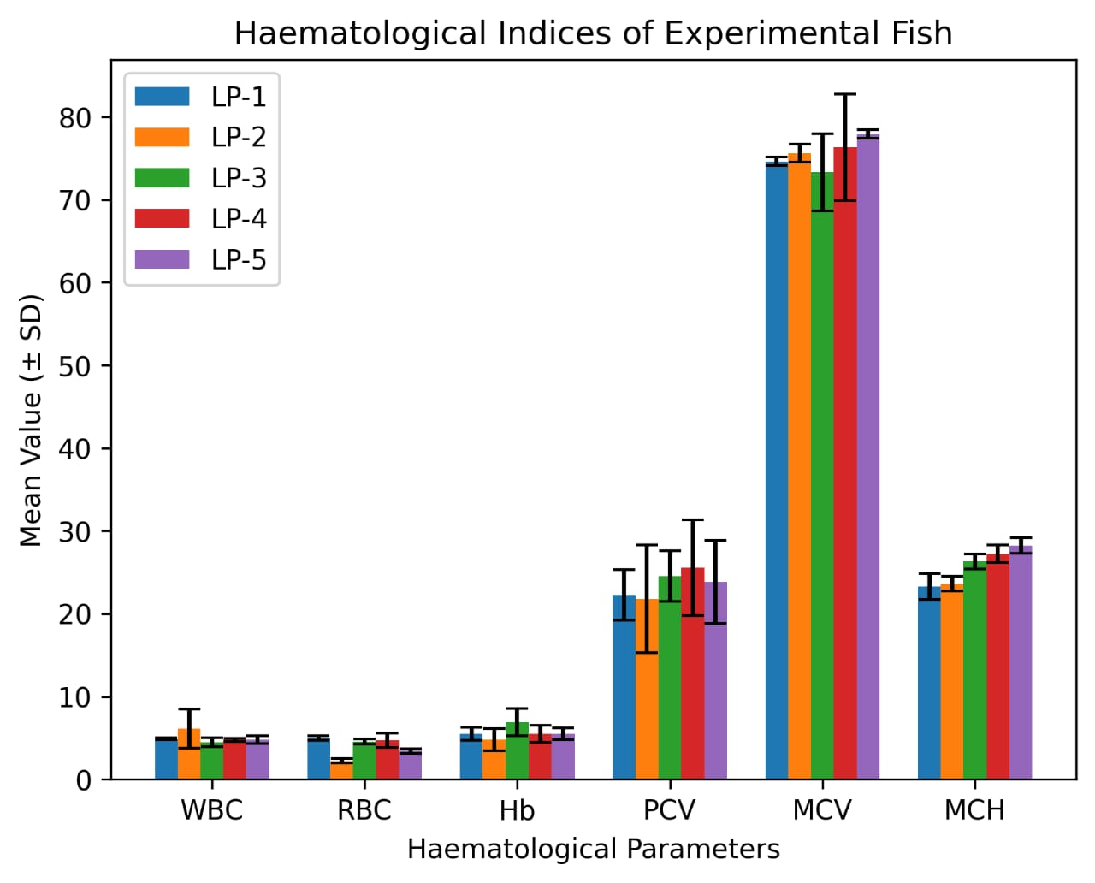
Figure 1: Haematological Indices of Experimental Fish
Key: WBC= White Blood Cell, RBC= Red Blood Cell, Hb= Haemoglobin, PCV= Packed Cell Volume, MCV= Mean Corpuscular Volume, MCH= Mean Corpuscular Haemoglobin, LP-1= fish fed with commercial diet, LP-2= fish fed diet without Olive oil, LP-3= fish fed diet with 10g/kg Olive oil, LP-4= fish fed diet with 20g/kg Olive oil, LP-5= fish fed diet with 30g/kg Olive oil.
Discussion
This study revealed significant variation in growth parameters among the fish fed with varying concentrations of olive oil (LP-1 to LP-5). Initial weight (IW) and final weight (FW) were relatively consistent across the groups, with only slight differences observed. However, mean weight gain (MWG) and percentage weight gain (PWG) demonstrated notable differences across the groups. Fish fed with commercial diets (LP-1) displayed significantly higher MWG and PWG compared to those on olive oil-supplemented diets (LP-2 to LP5) (P < 0.05). Similar findings were also reported by Lima et al. (2023), who compared a commercial diet with diets supplemented with different levels of Soybean oil in Nile tilapia (Oreochromis niloticus). However, the current study demonstrated a positive correlation between the concentration of olive oil in the diet and several growth parameters, indicating an increased in mean weight gain (MWG), percentage weight gain and specific growth rate (SGR) with higher levels of olive oil in the diet as identified in LP-3, LP-4 and LP-5 than in the LP-2 (fish fed diet without olive oil). This finding is consistent with the findings of Sáez-Royuela et al. (2022) who documented a significant improvement in growth performance and whole-body composition in juvenile tench (tinca tinca) when fish oil was replaced with a blend of vegetable oils. Additionally, Dernekbaşı et al. (2021) found that replacing fish oil with vegetable oils in rainbow trout (Oncorhynchus mykiss) diets led to enhanced growth performance, nutritional quality and fatty acids profiles. Survival rate (SR) and feed conversion ratio (FCR) displayed significant variations across the dietary groups. Fish fed with the commercial diet (LP-1) exhibited the higher survival rate, while the group fed with 20g/kg (LP-3) and the group fed with 30g/kg (LP-5) of olive oil showed the lowest SR and higher FCR (P < 0.05). This indicates that adding moderate olive oil in the diets (as in LP-4) may not have a substantial effect on survival rate of C. gariepinus. This finding corroborates the report of Dernekbaşı et al. (2021), who reported no substantial effects on survival rate when replacing fish oil with alternative oils in aquaculture diets. The presence of monounsaturated fatty acids like oleic acid, which improve lipid metabolism and energy utilization in fish, may be responsible for the enhanced growth performance observed in fish fed diets containing olive oil.
The haematological indices noted in this study give support to the physiological effect of olive oil supplementation in Clarias gariepinus. White blood cell (WBC) counts were much higher in the non- LP-2, indicating potential immune stress, while the addition of olive oil (LP-3 to LP-5) stabilized the WBC count as in the commercial diet (LP-1) group. This is consistent with the observations of Karimi & Namazikho (2022), who found that the partial substitution of fish oil by plant-based oils enhanced immune related Haematological parameters of African catfish. Red blood cell (RBC) counts were highest in the commercial diet and moderate olive oil groups, while LP-2 recorded the lowest, indicating that olive oil at moderate levels may enhance erythropoiesis, consistent with findings by Alami et al. (2024) in rainbow trout. The hemoglobin (Hb) and packed cell volume (PCV) were significantly higher in fish nourished with moderate amounts of olive oil, which is assumed to have increased oxygen demands; this finding is validated by İspir et al. (2024) who reported high indexes of increased hemoglobin and hematocrit in fish fed with diets containing olive leaf extract. Also, the mean corpuscular volume (MCV) and mean corpuscular hemoglobin (MCH) were more likely to increase with the addition of olive oil, indicating a positive impact on red cell size and hemoglobin, which is consistent with Sokooti et al. (2021) who showed that olive-derived supplements positively affected Haematological indices in common carp.
Conclusion
The present study has shown that dietary supplementation with the Olea europaea (olive) oil affects the haematological condition and the growth performance of juvenile Clarias gariepinus. It was observed that fish fed the commercial diet had the best growth performance, but that the addition of olive oil in the formulated diets led to increased growth indices and blood parameters relative to the basal diet without olive oil. Specifically, moderate levels of inclusion, 20 g/kg in particular, demonstrated better relative feed utilization, survival, and positive haematological responses including increased red blood cell count, haemoglobin level, and packed cell volume that are indicators of good physiological status in fish. This may be attributed to monounsaturated fatty acids and other bioactive compounds in olive oil such as oleic acid and other natural antioxidants which can increase metabolic efficiency, decrease oxidative stress and improve immune activity. Accordingly, olive oil may be regarded as a positive natural lipid supplement in aquafeeds and potentially a sustainable substitute for synthetic growth promoters in aquaculture nutrition.
Ethical Approval
All fish experiments were conducted in compliance with recognized standards for the care and use of aquatic animals in research.
Disclaimer (Artificial intelligence)
Author(s) hereby declare that NO generative AI technologies such as Large Language Models (ChatGPT, COPILOT, etc.) and text-to-image generators have been used during the writing or editing of this manuscript.
References
Alami, S., Jorjani, S., Ghelichi, A, & Ghiasvand, Z. (2024). Effects of partial replacement of fish oil by vegetable oil and animal fat on Haematological and serum biochemical parameters, antioxidant capacity, lipase activity and intestine histology of rainbow trout (Oncorhynchus mykiss). International Aquatic Research, 16(2): 157–167. https://doi.org/10.22034/iar.2023.1982365.1415
Assar, D. H., Ragab, A. E., Abdelsatar, E., Salah, A. S., Salem, S. M. R., Hendam, B. M., Al Jaouni, S., Al Wakeel, R. A., AbdEl-Kader, M. F., & Elbialy, Z. I. (2023). Dietary Olive Leaf Extract Differentially Modulates Antioxidant Defense of Normal and Aeromonas hydrophila-Infected Common Carp (Cyprinus carpio) via Keap1/Nrf2 Pathway Signaling: A Phytochemical and Biological Link. Animals: an open access journal from MDPI, 13(13), 2229. https://doi.org/10.3390/ani13132229
Balbuena-Pecino, S., Montblanch, M., García-Meilán, I., Fontanillas, R., Gallardo, Á., Gutiérrez, J., Navarro, I., & Capilla, E. (2022). Hydroxytyrosol-rich extract from olive juice as an additive in gilthead sea bream juveniles fed a high-fat diet: Regulation of somatic growth. Frontiers in physiology, 13, 966175. https://doi.org/10.3389/fphys.2022.966175
Bawa, D. Y. (2024). Biology and Fisheries of Clarias gariepinus in Nigerian Inland Waters: Review. African Journal of Environment and Sustainable Development, 2(2), 11-17. https://www.openjournals.ijaar.org/index.php/ajesd/article/view/547
Bello, M. N. (2014). Analysis of land use–land cover changes in Zuru and its environment of Kebbi State, Nigeria using remote sensing and geographic information system technology. Journal of Geoscience and Environmental Studies, 2(1), 6–15. Retrieved from https://jges.thebrpi.org/journals/jges/Vol_2_No_1_June_2014/6.pdf
Bojarski, B., Medkova, D., Hollerova, A., Szała, L., Stonawski, B., & Chmurska-Gąsowska, M. (2022). Common carp (Cyprinus carpio) blood cell stability in Hayem’s solution for manual WBC and RBC counts. Folia Biologica (Kraków), 70(3): 113–117. https://doi.org/10.3409/fb\70-3.13
Carr, I., Glencross, B., & Santigosa, E. (2023). The importance of essential fatty acids and their ratios in aquafeeds to enhance salmonid production, welfare, and human health. Frontiers in Animal Science, 4: 1147081. https://doi.org/10.3389/fanim.2023.1147081
Dawood, M. A. O., Noreldin, A. E. & Sewilam, H. (2022). Blood biochemical variables, antioxidative status, and histological features of intestinal, gill, and liver tissues of African catfish (Clarias gariepinus) exposed to high salinity and high-temperature stress. Environ Sci Pollut Res 29, 56357–56369. https://doi.org/10.1007/s11356-022-19702-0
Dernekbaşı, S., Parlak Akyüz, A., & Karayücel, İ. (2021). Effects of total replacement of dietary fish oil by vegetable oils on growth performance, nutritional quality and fatty acid profiles of rainbow trout (Oncorhynchus mykiss) at optimum and high temperature conditions. Ege Journal of Fisheries and Aquatic Sciences, 38(2): 237–246. https://doi.org/10.12714/egejfas.38.2.14
Enyidi, U. D., & Asuquo, P. (2024). Effects of plant oil extracts on the digestibility, hematobiochemistry, and hematology of Clarias gariepinus. Journal of Basic and Applied Zoology 85: 61. https://doi.org/10.1186/s41936-024-00416-3
Food and Agriculture Organization of the United Nations. (2022). The State of World Fisheries and Aquaculture 2022. Towards Blue Transformation. Rome, FAO. https://doi.org/10.4060/cc0461en
Hazreen-Nita, M. K., Abdul Kari, Z., Mat, K., Rusli, N. D., Sukri, S. A. M., Harun, H. C., Lee, S. W., Rahman, M. M., Norazmi-Lokman, N. H., Nur-Nazifah, M., Firdaus-Nawi, M., & Dawood, M. A. O. (2022). Olive oil by-products in aquafeeds: Opportunities and challenges. Aquaculture Reports, 22: 100998. https://doi.org/10.1016/j.aqrep.2021.100998
Imade, O. S., & Odum, E. E. B. (2024). Cost efficiency of catfish (Clarias gariepinus) production under various systems in Delta State, Nigeria. J. Agribus. Rural Dev., 1(71), 35–43. http://dx.doi.org/10.17306/J.JARD.2024.01726
İspir, Ü., Kırıcı, M., & Özcan, M. (2024). Effect of dietary supplementation with olive leaf extract on growth performance, Haematological parameters and resistance against Yersinia ruckeri in rainbow trout (Oncorhynchus mykiss). Hydrobiological Research, 2(2): 21–29. https://doi.org/10.5281/zenodo.12796963
Karimi, R., & Namazikho, L. (2022). Effects of partial substitution of fish oil with palm and rapeseed oils on growth performance, Haematological parameters, and oxidative stress biomarkers in African catfish (Clarias gariepinus) juveniles. Aquaculture Nutrition, 28(2): 425–436. https://doi.org/10.1111/anu.13187
Khadim, S., Fatima, M., Shah, S. Z. H., Azmat, H., & Rashid, M. A. (2025). Protein sparing by dietary lipids in the diets of Pangasianodon hypophthalmus: an appraisal of growth, body composition, digestive enzymes, and metabolic responses. Fish Physiology and Biochemistry, 51(4), 134. https://doi.org/10.1007/s10695-025-01542-7
Liess, B. D. (2025). Mean Corpuscular Hemoglobin (MCH): Overview. Medscape. Available from: https://emedicine.medscape.com/article/2054497-overview
Lima, F. R. dos S., Apoliano, M. L. da S., Cavalcante, D. de H., & Sá, M. V. do C. (2023). Dietary supplementation with soybean oil has not favored the tilapia growth in BFT tanks submitted to feeding restriction. Acta Scientiarum Animal Sciences, 45(1): e59439. https://doi.org/10.4025/actascianimsci.v45i1.59439
Liu, T., Dong, F., Sun, Y., Su, H., Zheng, P., Chen, Q., Han, T., & Wang, J. (2025). Effect of Dietary Lipid Level on Growth Performance, Feed Utilization, and Body Composition of Juvenile Kelp Grouper Epinephelus moara. Fishes, 10(6), 244. https://doi.org/10.3390/fishes10060244
Liu, W. D., Wang, X. Y., & Chen, L. Q. (2024). Optimizing feed formulations for enhanced growth and environmental sustainability in common carp aquaculture. International Journal of Aquaculture, 14(5): 249–256. https://doi.org/10.5376/ija.2024.14.0025
Muhammed, D., Izzet, B. S., Bayram, S., & Soner, A. (2019). Practices for drawing blood samples from teleost fish." North American Journal of Aquaculture, 81(2): 119–125. https://doi.org/10.1002/naaq.10077
Naylor, R. L., Hardy, R. W., Buschmann, A. H., Bush, S. R., Cao, L., Klinger, D. H., Little, D. C., Lubchenco, J., Shumway, S. E., & Troell, M. (2021). A 20-year retrospective review of global aquaculture. Nature 591, 551–563. https://doi.org/10.1038/s41586-021-03308-6
Obaroh, I. O., & Achionye-N, G. C. (2011). Effects of crude extract of Azadirachta indica leaves at controlling prolific breeding in Oreochromis niloticus (Linnaeus, 1758). Asian Journal of Agricultural Research, 5(4): 277–282. https://doi.org/10.3923/ajar.2011.277.282
Obaroh, I. O., & Nzeh, G. C. (2013). Antifertility effect of some plant leaf extracts on the prolific breeding of Oreochromis niloticus. Academic Journal of Interdisciplinary Studies. 2: 87–94. https://doi.org/10.5901/ajis.2013.v2n12p87
Odioko, E. A., Ajakaiye, A. F., & Ikusemoran, E. M. (2016). Comparison of growth performance of African catfish (Clarias gariepinus) fed with different standard feeds. International Journal of Fisheries and Aquatic Studies, 8(5): 394–397. Available on: https://www.researchgate.net/publication/345768541\_International\_Journal\_of\_Fisheries\_and\_Aquatic\_Studies\_2020\_85\_394-397\_Comparison\_of\_growth\_performance\_of\_African\_catfish\_Clarias\_gariepinus\_fed\_with\_different\_standard\_feed](https://www.researchgate.net/publication/345768541_International_Journal_of_Fisheries_and_Aquatic_Studies_2020_85_394-397_Comparison_of_growth_performance_of_African_catfish_Clarias_gariepinus_fed_with_different_standard_feed
Okomoda, V. T., Tiamiyu, L. O., & Iortim, M. (2016). The effect of water renewal on growth of Clarias gariepinus fingerlings. Croatian Journal of Fisheries, 74(1): 25–29. https://doi.org/10.1515/cjf-2016-0005
Omitoyin, B. O. (2010). Effect of food type and feeding frequency on the growth and survival of Clarias gariepinus fry. Journal of Agriculture and Environment, 6(1&2): 1–8. Available from: https://www.ajol.info/index.php/jagrenv/article/view/236530
Onomu, A. J., & Okuthe, G. E. (2024). The Role of Functional Feed Additives in Enhancing Aquaculture Sustainability. Fishes, 9(5), 167. https://doi.org/10.3390/fishes9050167
Rahman, M. H., & Arifuzzaman, M. (2021). An experiment on growth performance, specific growth rate (SGR) and feed conversion ratio (FCR) of Rohu (Labeo rohita) and Tilapia (Oreochromis niloticus) in tank based intensive aquaculture system. International Journal of Aquaculture and Fisheries Science, 7(4): 35–41. https://doi.org/10.17352/2455-8400.000071
Sáez-Royuela, M., García, T., Carral, J. M., & Celada, J. D. (2022). Fish oil replacement by a blend of vegetable oils in diets for juvenile tench (Tinca tinca Linnaeus, 1758): Effects on growth performance and whole-body composition. Animals, 12(9): 1113. https://doi.org/10.3390/ani12091113
Sokooti, R., Chelemal, D. M., & Javaheri, B. M. (2021). Effects of olive leaf extract (Olea europaea Leccino) on growth, haematological parameters, immune system, and carcass composition in common carp (Cyprinus carpio). Aquaculture Research, 52(1): 2415–2423. https://doi.org/10.1111/are.15091
Tacon, A. G. J., & Metian, M. (2015). Feed matters: Satisfying the feed demand of aquaculture. Reviews in Fisheries Science & Aquaculture, 23(1), 1–10. https://www.tandfonline.com/doi/full/10.1080/23308249.2014.987209
Usman, L., Saidu, A. M., & Yahaya, S. B. (2025). Appraisal of soil erosion in Zuru Metropolis, Kebbi State, Nigeria. Mediterranean Environmental Research & Sustainable Development, 5(2), 115–127. Retrieved from https://mediterraneanpublications.com/mejedir/article/view/606
Witeska, M., Kondera, E., Ługowska, K., & Bojarski, B. (2022). Haematological methods in fish – not only for beginners. Aquaculture, 547: 737498. https://doi.org/10.1016/j.aquaculture.2021.737498
Zancan, T. D., Monserrat, J. M., Martins, V. G., & Tesser, M. B. (2025). Effects of Olive Leaf (Olea europaea) Phenolic Extract on Zootechnical Parameters, Centesimal Composition, and Biochemical Parameters of Nile Tilapia (Oreochromis niloticus) Juveniles. Animals, 15(20), 2935. https://doi.org/10.3390/ani15202935
Zemheri-Navruz, F., Acar, Ü., & Yılmaz, S. (2019). Dietary supplementation of olive leaf extract increases haematological, serum biochemical parameters and immune related genes expression level in common carp (Cyprinus carpio) juveniles. Fish and Shellfish Immunology, 89: 672–676. https://doi.org/10.1016/j.fsi.2019.04.037

