Review Article
Proteomic Approaches in Fish Biology: Insights into Aquaculture, Stress Responses, and Disease – A Mini-Review
Abstract:
The aquaculture industry faces significant challenges in achieving sustainable fish production amid growing demand. Proteomics, a cutting-edge omics technology, is revolutionizing fish health research by delivering molecular insights into pathogen identification, immune responses, and adaptations to environmental stress. Advanced mass spectrometry-based methods, such as matrix-assisted laser desorption/ionization time-of-flight mass spectrometry (MALDI-TOF MS), enable detailed characterization of any fish or aquatic product's proteome, accelerating the analysis of molecular mechanisms in complex aquatic environments. Over the past decade, omics technologies have gained traction in aquaculture, enhancing selective breeding programs through proteomic profiling of proteins linked to disease resistance, growth performance, and metabolic efficiency. This paves the way for precision aquaculture. A comprehensive review reveals that proteomics facilitates examination of key fish traits, identification of molecular markers for health and welfare, and promotion of sustainable development—ultimately ensuring the safety and quality of aquatic food products.
Key words: Aquaculture, Environment monitoring, Proteomics Techniques

1.Introduction
Global food and nutritional security relies heavily on fisheries and aquaculture. In 2020, aquaculture contributed a substantial 87.5 million tonnes to the world's 178 million tonnes of aquatic animal production (FAO, 2022). In India, inland fisheries account for 75% of total fish production, with a marked shift from capture fisheries to aquaculture over the past two and a half decades. Over the last decade, proteomics has emerged as a key discipline in aquaculture, advancing the sector's goals of scaling production while ensuring high-quality, sustainable products. Proteomic changes occur across fish life stages, underscoring the role of signaling events in adapting to dynamic environments. Advanced proteomics can map detailed proteomes, revealing key proteins in disease mechanisms and host-microbial interactions. Earlier techniques have supported applications in developmental biology, toxicology, environmental monitoring, disease, health, and proteome profiling using gel-based and label-free methods (Nissa et al., 2021). Label-free proteomics offers superior consistency, peptide identification confidence, quantification accuracy, and proteome coverage via mass spectrometry (MS), enabling multiplexed analysis of complex samples (Nissa et al., 2021; Ma et al., 2020; Zecha et al., 2019). Label-based approaches include TMT (tandem mass tag), ICAT (isotope-coded affinity tag), metabolomics, SILAC (stable isotope labeling of amino acids in cell culture), and spiking synthetic labeled peptides (Nissa et al., 2021). In fisheries, TMT-based proteomics has identified fillet quality markers, fish parasites, toxicity responses, stress, and metabolic pathways (Wang et al., 2023; Fan et al., 2022; Wu et al., 2022; Xiang et al., 2020).
2. Proteomic Approaches in Aquaculture
Proteomic techniques in aquaculture rely on fundamental methods for protein separation, identification, and quantification, supporting both functional and expression proteomics (Monti et al., 2005). Expression proteomics quantifies proteome or sub-proteome changes across samples, revealing proteins in biological pathways or those altered by disease, toxins, or stressors (Bradley et al., 2009). Affinity-based techniques, such as immunoprecipitation, exploit ligand-binding properties to isolate target proteins and their interactors from total extracts (Monti et al., 2009). A standard workflow encompasses sample preparation, protein separation, digestion, and identification. Key methods include mass spectrometry (MS), protein microarrays, chromatography, and gel electrophoresis (Vadivel, 2015). Proteins are commonly separated via polyacrylamide gels using one-dimensional (1-DE) or two-dimensional electrophoresis (2-DE) (Vadivel, 2015).1-DE: This robust method suits complex samples. For instance, 1-DE (10% acrylamide) with label-free quantification detected ~3,000 proteins in rainbow trout liver during Aeromonas salmonicida infection (Causey et al., 2018).2-DE: The gold standard for gel-based profiling, it separates hundreds of proteins per gel by isoelectric point (pI) in the first dimension and molecular weight in the second (Meleady, 2018).
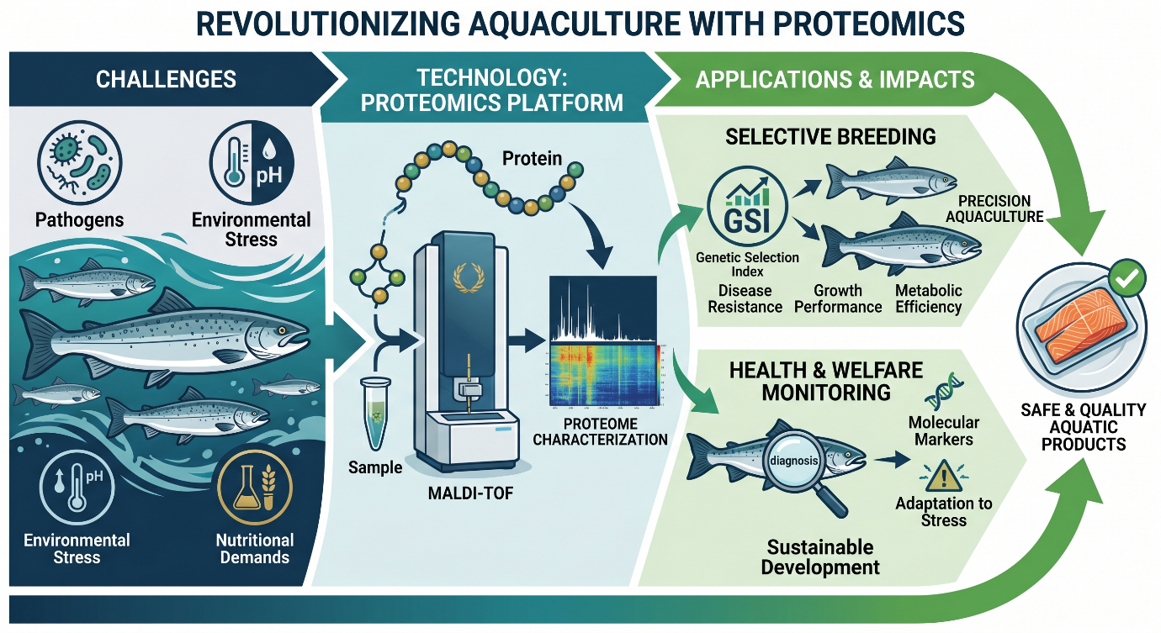
Fig 1: Overview for a typical proteomic fish experiment
3. Mass Spectrometry in Proteomic Workflows
Mass spectrometry (MS) serves as the cornerstone for protein identification and quantification in proteomics, generating raw data from ionized analytes separated by mass-to-charge (m/z) ratio (Urban, 2016). A typical MS system includes an ionization source, mass analyzer, and detector. In HPLC-MS/MS setups, analytes from HPLC are ionized (e.g., via electrospray ionization [ESI] or matrix-assisted laser desorption/ionization [MALDI]) before analysis. These soft ionization methods produce protonated peptides, with MALDI favoring singly charged ions for rapid m/z separation (Singhal et al., 2015). MALDI-TOF Applications: This technique excels in aquatic proteomics for its speed, robustness, high throughput, and cost-effectiveness—ideal alternatives to traditional methods despite MS's high upfront costs (Dieme et al., 2014). It supports bacterial/species identification in aquaculture settings.

Targeted Proteomics and Quantification
Targeted proteomics offers immunoassay alternatives, precisely detecting fish/food proteins and peptides with high specificity, reproducibility, and accuracy (Manes & Nita-Lazar, 2018). It bridges systems biology across omics fields, aiding biomarker discovery in stress or disease.
Bioinformatics and Data Analysis
Bioinformatics is integral from raw MS data processing to interpretation, enabling multi-omics integration for biological insights (Prasanna-Mohanty et al., 2019). Search engines like Sequest, Comet, X!Tandem, Mascot, and MaxQuant (Andromeda) match spectra against databases derived from fish genomes/transcriptomes—NCBI holds sequences for 331 fish species, including 24 aquaculture ones (Ting et al., 2015).
Biomonitoring and Practical Applications
MS supports biomonitoring by profiling protein extracts varying in hydrophobicity, pI, aromaticity, and molecular weight, informing ELISA for seafood allergies (Bose et al., 2021). Standardized protocols extract/digest peptides from marine biomass (e.g., salmon, tilapia, shrimp) for feed analysis (Colatriano et al., 2015; Leduc et al., 2020). Protein fingerprinting (peptide mass fingerprinting) assesses structural similarities via MS, enhanced by bioinformatics and dynamic vibration analysis (Cue et al., 2014; Niessner et al., 2019). It elucidates protein-protein interactions under environmental stress, as in H₂O₂-mediated inhibition of algae (Scenedesmus obliquus) metabolism (Zhang et al., 2022).
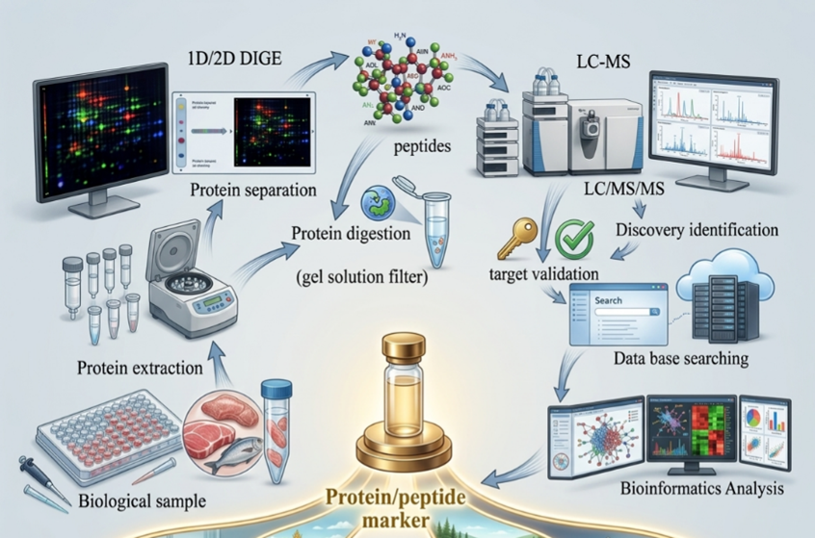
Fig 2: Schematic overview for a typical proteomic experiment
Protein extraction and separation, which might be 1D/2DE/DIGE, are performed on biological material after they have been homogenized. Protein digestion utilizing a filter-based, gel-based, or solution-based approach is the following stage. To collect targeted or discovery data, protein digests (peptides) are put via liquid chromatography tandem mass spectrometry (LC-MS/MS). To find and measure the identified peptides and put them together to form proteins, the raw data is analyzed utilizing databases. The discovery of proteins is followed by functional analysis utilizing protein networks and pathways, where a novel hypothesis is developed or shown to comprehend biology. A specific route, protein, or peptide marker for a certain condition is found and used for a variety of purposes in aquaculture and fisheries.
4. Proteomics in Fisheries and Aquaculture
Proteomics analyses the entire set of proteins in organisms, revealing how they respond to environmental, nutritional, and health factors. In fisheries and aquaculture—where production grows faster than any other food sector—proteomics addresses key challenges like ensuring farmed fish match wild counterparts in quality, welfare, and safety. It shifts focus from model species to food fishes, supporting sustainable nutrient sources like omega-3 fatty acids (DHA and EPA).
5.Proteomics tackles three core areas in aquatic research:
Aquatic Food Business: Identifies biomarkers for fish freshness, quality, pathogens, allergens, and hazards. It detects functional changes in nutrient-rich proteins, verifies species labeling to prevent fraud (e.g., EU standards), and differentiates sex or commercial sources (Piñeiro et al., 2003; Kayvanshokooh et al., 2009; Martínez et al., 2009).
Aquatic Natural Products Development: Supports welfare, nutrition, health, productivity, and safety via targeted (specific proteins) and discovery (broad profiling) approaches. It links genomic data from NGS to protein functions, aiding new species evaluation and breeding (Abdelrahman et al., 2017; Carrera et al., 2020; Rodrigue et al., 2012).
Challenges and Future Directions: Many aquatic genomes remain incomplete, limiting omics predictions. Proteomics bridges this by studying protein dynamics post-genomics. Future needs include refining tools for emerging species, integrating with NGS for causal gene identification, and scaling for global food security (Fiorella et al., 2021; Hicks et al., 2016). Proteomics, the large-scale study of proteins, plays a pivotal role in fisheries and aquaculture, addressing challenges in aquatic food production, environmental monitoring, and natural product development. With aquaculture expanding faster than other food sectors, ensuring farmed fish match wild quality is crucial amid factors like stress and nutrition. While model species aided basic biology, focus now targets food fishes for nutrition and security, leveraging proteomics for welfare, health, productivity, safety, and quality (Rodrigue et al., 2012; Carrera et al., 2020).
Key applications span three domains: In the aquatic food business, proteomics identifies biomarkers for freshness, pathogens, allergens, and hazards; verifies species labeling against fraud (e.g., EU standards); and differentiates sex or sources (Piñeiro et al., 2003; Kayvanshokooh et al., 2009; Martínez et al., 2009). Environmental monitoring uses it to analyze microalgae and aquatic waste responses to stressors like pollutants, heavy metals, microplastics, antimicrobials, bacteria, and viruses (Hicks et al., 2016). For natural products, it evaluates new species growth, links NGS genomes to protein functions, and enhances sustainable techniques from algae to fish (Abdelrahman et al., 2017; Fiorella et al., 2021). Targeted and discovery proteomics improve fish physiology, but incomplete genomes demand refined omics integration. Over 20 years, its use has surged, promising traceability, safety, and innovation for global nutrient sustainability.

Table 1. Applications of target protein identification in fishes
S.No | Aim of Study | Species (Tissues) | Technique | Number of Proteins | Full Reference
1 | Proteomic analysis of blood plasma reveals changes in immune- and stress-associated proteins following hormonal stimulation of carp males | Common carp (blood plasma) | MALDI TOF/TOF MS, MS/MS, RT-qPCR | 44 | Dietrich MA, et al. (2021).
2 | Acclimation to cold and warm temperatures is associated with differential expression of male carp blood proteins involved in acute phase and stress responses, and lipid metabolism | Common carp (blood plasma) | MALDI TOF/TOF | 47 | Dietrich MA, et al. (2018).
3 | Proteome Analysis of Whole-Body Responses in Medaka Experimentally Exposed to Fish-Killing Dinoflagellate Karenia mikimotoi | Medaka (whole body) | Mass spectrometry (likely LC-MS/MS) | 35 | Kwok CSN, et al. (2021). ​
4 | Proteomics Analysis of Liver Tissue of Labeo rohita | Labeo rohita (liver) | ESI-MS, MASCOT | 42 | Goswami S, et al. (2015).
5 | Physiological Responses to Acute Heat Stress in Rohu, Labeo rohita: Insights from Liver Proteomics | Labeo rohita (liver) | Mass spectrometry (likely MALDI TOF/TOF or LC-MS/MS) | 44 | Badhe MR, et al. (2024).
6 | Identification of proteins differentially expressed in the gills of grass carp (Ctenopharyngodon idella) after hypoxic stress by two-dimensional gel electrophoresis analysis | Grass carp (gills) | 2-DE, LC-MS/MS | 6 | Xu ZN, et al. (2019).
7 | MS-based proteomic analysis of cardiac response to hypoxia in the goldfish (Carassius auratus) | Goldfish (Carassius auratus) (heart/cardiac) | MALDI MS/MS | 12 | Imbrogno S, et al. (2019).
8 | Proteomic analysis of muscle tissue from rainbow trout (Oncorhynchus mykiss) fed dietary β-glucan | Oncorhynchus mykiss (muscle) | 2-DE, MALDI TOF/TOF MS | 8 | Ghaedi G, et al. (2016).

6.Conclusion
Sustainable aquaculture demands advanced tools like omics platforms (genomics, transcriptomic, proteomics) to explore fish traits and identify welfare biomarkers. This review evaluates proteomics as a powerful approach to address safety, quality, nutrition, health, and disease in aquaculture. Despite limited database integration for most species, studies on model and food fishes reveal its potential: elucidating biological pathways, tackling key challenges, and pinpointing biomarkers. Discovery and targeted proteomics provide high-sensitivity methods for food authenticity, traceability, and allergen detection in fisheries products. As primary functional macromolecules, proteins enable comprehensive analysis of environmental and aquaculture impacts on safety/quality via diverse sample preparation techniques—from simple to advanced. Proteomics poised to transform the food sector; this review urges intensified research. Integrating it with other omics will propel the blue revolution forward.
CONFLICT OF INTERESTS
The authors declare no conflict of interest
ETHICS APPROVAL
Not applicable
Disclaimer (Artificial intelligence)
Author(s) hereby declare that NO generative AI technologies such as Large Language Models (ChatGPT, COPILOT, etc.) and text-to-image generators have been used during the writing or editing of this manuscript.

6.Reference
- Abdelrahman, H., ElHady, M., Alcivar-Warren, A., Allen, S., Al-Tobasei, R., Bao, L., Beck, B., Blackburn, H., Bosworth, B., Buchanan, J., … Zhou, T. (2017). Aquaculture genomics, genetics, and breeding in the United States: Current status, challenges, and priorities for future research. BMC Genomics, 18, Article 191. https://doi.org/10.1186/s12864-017-3557-1
- Badhe, M. R., Kumar, A., & Das, A. (2024). Physiological responses to acute heat stress in Rohu, Labeo rohita: Insights from liver proteomics. Journal of Thermal Biology, 119, 103765.
- Bradley, B. P., Kalampanayil, B., & O'Neill, M. C. (2009). Protein expression profiling. In Methods in molecular biology (Vol. 519, pp. 455–468). Humana Press. https://doi.org/10.1007/978-1-59745-281-6_30
- Carrera, M., Pazos, M., & Gasset, M. (2020). Proteomics-based methodologies for the detection and quantification of seafood allergens. Foods, 9(9), Article 1134. https://doi.org/10.3390/foods9091134
- Colatriano, D., & Walsh, D. A. (2015). An aquatic microbial meta-proteomics workflow: From cells to tryptic peptides suitable for tandem mass spectrometry-based analysis. Journal of Visualized Experiments, 2015(105), e52827. https://doi.org/10.3791/52827
- Cue, X., Li, S. C., He, L., & Li, M. (2014). Fingerprinting protein structures effectively and efficiently. Bioinformatics, 30(7), 949–955. https://doi.org/10.1093
- Dietrich, M. A., Adamek, M., Steinhagen, D., Nynca, J., & Ciereszko, A. (2021). Proteomic analysis of blood plasma reveals changes in immune- and stress-associated proteins following hormonal stimulation of carp males. Comparative Biochemistry and Physiology Part D: Genomics and Proteomics, 38, 100819.
- Dietrich, M. A., Nynca, J., Białowąs, H., & Ciereszko, A. (2018). Acclimation to cold and warm temperatures is associated with differential expression of male carp blood proteins involved in acute phase and stress responses, and lipid metabolism. Fish Physiology and Biochemistry, 44(5), 1257–1273.
- FAO. (2020). The state of world fisheries and aquaculture 2020: Sustainability in action. Food and Agriculture Organization of the United Nations. https://doi.org/10.4060/ca9229en
- Fiorella, K. J., Okronipa, H., Baker, K., & Heilpern, S. (2021). Contemporary aquaculture: Implications for human nutrition. Current Opinion in Biotechnology, 70, 83–90. https://doi.org/10.1016/j.copbio.2020.12.007
- Gao, P., Mohd Noor, N. Q. I., & Shaarani, S. M. (2022). Current status of food safety hazards and health risks connected with aquatic food products from the Southeast Asian region. Critical Reviews in Food Science and Nutrition, 62(13), 3471–3489.
- Goswami, S., Kothari, D. C., & Sadhukhan, R. (2015). Proteomics analysis of liver tissue of Labeo rohita. Proceedings of the National Academy of Sciences, India Section B: Biological Sciences, 85(2), 413–420.
- Ghaedi, G., Keyvanshokorlouei, M., & Salati, A. P. (2016). Proteomic analysis of muscle tissue from rainbow trout (Oncorhynchus mykiss) fed dietary β-glucan. Iranian Journal of Veterinary Research, 17(4), 245–251.
- Hicks, D. T. (2016). Seafood safety and quality: The consumer's role. Foods, 5(4), Article 71.
- Imbrogno, S., Mazza, R., Filice, M., & Cerra, M. C. (2019). MS-based proteomic analysis of cardiac response to hypoxia in the goldfish (Carassius auratus). Journal of Comparative Physiology B, 189(4), 415–428.
- Kwok, C. S. N., Leung, P. T. Y., & Wong, C. K. C. (2021). Proteome analysis of whole-body responses in medaka experimentally exposed to fish-killing dinoflagellate Karenia mikimotoi. Aquatic Toxicology, 234, 105896.
- Keyvan Shokooh, S., Kal Bassi, M. R., Hossein Khani, S., & Vaziri, B. (2009). Comparative proteomics analysis of male and female Persian sturgeon (Acipenser persicus) gonads. Animal Reproduction Science, 111(2-4), 361–368.
- Leduc, A., Fournier, V., & Henry, J. (2020). A standardized, innovative method to characterize the structure of aquatic protein hydrolysates. Heliyon, 6(5), Article e04170.
- Ma, C., Wang, W., Wang, Y., Sun, Y., Kang, L., Zhang, Q., & Jiang, Y. (2020). TMT-labelled quantitative proteomic analyses on the longissimus dorsi to identify the proteins underlying intramuscular fat content in pigs. Journal of Proteomics, 213, Article 103630.
- Mahanty, A., Mohanty, S., & Mohanty, B. P. (2017). Dietary supplementation of curcumin augments heat stress tolerance through upregulation of Nrf-2-mediated antioxidative enzymes and Hsps in Puntius sophore. Fish Physiology and Biochemistry, 43(4), 1131–1141. https://doi.org/10.1007/s10695-017-0358-z
- Manes, N. P., & Nita-Lazar, A. (2018). Application of targeted mass spectrometry in bottom-up proteomics for systems biology research. Journal of Proteomics, 189, 75–90. https://doi.org/10.1016/j.jprot.2018.02.008
- Meleady, P. (2018). Two-dimensional gel electrophoresis and 2D-DIGE. In Methods in molecular biology (Vol. 1664, pp. 3–14). Humana Press. https://doi.org/10.1007/978-1-4939-7268-5_1
- Monti, M., Cozzolino, M., Cozzolino, F., Vitiello, G., Tedesco, R., Flagiello, A., & Pucci, P. (2009). Puzzle of protein complexes in vivo: A present and future challenge for functional proteomics. Expert Review of Proteomics, 6(2), 159–169. https://doi.org/10.1586/epr.09.7
- Monti, M., Orrù, S., Pagnozzi, D., & Pucci, P. (2005). Interaction proteomics. Bioscience Reports, 25(1-2), 45–56. https://doi.org/10.1007/s10540-005-2847-z
- Niessen, K. A., Xu, M., George, D. K., Chen, M. C., Ferré-D'Amaré, A. R., Snell, E. H., Cody, V., Pace, J., Schmidt, M., & Markelz, A. G. (2019). Protein and RNA dynamical fingerprinting. Nature Communications, 10(1), Article 1026.
- Nissa, M. U., Pinto, N., Parkar, H., Goswami, M., & Srivastava, S. (2021). Proteomics in fisheries and aquaculture: An approach for food security. Food Chemistry, 127, Article 108125.
- Piñeiro, C., Barros-Velázquez, J., Vázquez, J., Figueras, A., & Gallardo, J. M. (2003). Proteomics as a tool for the investigation of seafood and other marine products. Journal of Proteome Research, 2(2), 127–135.
- Prasanna-Mohanty, B., Mohanty, S., Mitra, T., Mahanty, A., Ganguly, S., & Singh, S. (2019). Omics technology in fisheries and aquaculture. Advances in Fish Research, 1, 1–30. https://www.researchgate.net/publication/329830959
- Singhal, N., Kumar, M., Kanaujia, P. K., & Virdi, J. S. (2015). MALDI-TOF mass spectrometry: An emerging technology for microbial identification and diagnosis. Frontiers in Microbiology, 6, Article 791. https://doi.org/10.3389/fmicb.2015.00791
- Ting, Y. S., Egertson, J. D., Payne, S. H., Kim, S., MacLean, B., Käll, L., Morris, N., Ellis, R., & MacCoss, M. J. (2015). Peptide-centric proteome analysis: An alternative strategy for the analysis of tandem mass spectrometry data. Molecular & Cellular Proteomics, 14(9), 2301–2307. https://doi.org/10.1074/mcp.O114.047035 **
- Urban, P. L. (2016). Quantitative mass spectrometry: An overview. Philosophical Transactions of the Royal Society A: Mathematical, Physical and Engineering Sciences, 374(2068), Article 20150382. https://doi.org/10.1098/rsta.2015.0382
- Vadivel, A. K. A. (2015). Gel-based proteomics in plants: Time to move on from the tradition. Frontiers in Plant Science, 6, Article 369. https://doi.org/10.3389/fpls.2015.00369
- Wang, X., & Sun, B. J. M. (2023). Metabolic proteins with crucial roles in Edwardsiella tarda antioxidative adaptation and intracellular proliferation. mBio, 8(2), Article e00391-23.
- Wu, X., Gu, X., Xue, M., Ge, C., & Liang, X. J. (2022). Proteomic analysis of hepatic fibrosis induced by a high starch diet in largemouth bass (Micropterus salmoides). Comparative Biochemistry and Physiology Part D: Genomics and Proteomics, 43, Article 101007.
- Xiang, Q.-Q., Gao, Y., Li, Q.-Q., Ling, J., & Chen, L.-Q. (2020). Proteomic profiling reveals the differential toxic responses of the gills of common carp exposed to nanosilver and silver nitrate. Journal of Hazardous Materials, 394, Article 122562.
- Xu, Z. N., Wang, G. X., Nie, P., & Zou, P. F. (2019). Identification of proteins differentially expressed in the gills of grass carp (Ctenopharyngodon idella) after hypoxic stress by two-dimensional gel electrophoresis analysis. Fish & Shellfish Immunology, 86, 629–637.
- Zecha, J., Satpathy, S., Kanashova, T., Avanessian, S. C., Kane, M. H., Clauser, K. R., Mertins, P., Carr, S. A., Kuster, B., & Clauser, K. R. (2019). TMT labeling for the masses: A robust and cost-efficient, in-solution labeling approach. Journal of Proteome Research, 18(7), 1468–1478. https://doi.org/10.1021/acs.jproteome.9b00462
- Zhang, H., Zong, R., He, H., & Huang, T. (2022). Effects of hydrogen peroxide on Scenedesmus obliquus: Cell growth, antioxidant enzyme activity and intracellular protein fingerprinting. Chemosphere, 287(Pt. 1), Article 132185. https://doi.org/10.1016/j.chemosphere.2021.132185

