New Records and Distribution of Menemerus Jumping Spiders (Araneae: Salticidae) in Odisha, India

Abstract
Jumping spiders or Salticids are the most predatory and dominant spider group, they are found all over the world. Their presence indicates the healthy condition of the ecosystem. The present study indicates a new distributional record of a jumping spider species, Menemerus nigli Wesołowska & Freudenschuss, 2012, which has been recorded from Kokasara block of Kalahandi district of Odisha state. A total of eight adult specimens of this species have been collected by hand-picking method, in which three males and five females were recorded. The characteristics of the specimens analyzed were matched with the literature of Menemerus species to find similarities. This is the first hand report on this species from Odisha state. This study is very important on spider diversity and biogeography in Odisha state which will be helpful in understanding the ecological value in the future.

Keywords: Distribution, Menemerus nigli, jumping spider, Salticids, Spider, Odisha.

Introduction
The jumping spiders or salticids are a distinct group of spiders being medium sized, modern and highly predatory spider (Backwall, 1841) belonging to the family Salticidae. These are terrestrial, air-breathing strange and fantastic spiders that are found all over the world (Singh et al., 2023). This is the largest family of all spider families, comprises 6,955 jumping spider species belonging to 694 genera (WSC, 2026).

The genus Menemerus Simon, 1868 belongs to the tribe Chrysillini of the family Salticidae. Based on existing literature, 63 species of Menemerus have been recorded worldwide (WSC, 2026). In India, only eight species of Menemerus have been recorded, which are found across various states (Singh et al., 2023). Menemerus nigli Wesołowska & Freudenschuss, 2012 has been recorded in Pakistan, India, Thailand, and Brazil (WSC, 2026). This species has been recorded in only two states of India: West Bengal (Chatterjee et al., 2017) and Chhattisgarh (Nayak et al., 2025c). There are no records of its occurrence in any other state. This species was first recorded in 2017 from West Bengal, where only males were recorded (Chatterjee et al., 2017); subsequently, females of this species were recorded in the Gariaband district of Chhattisgarh state (Nayak et al., 2025c). Identifying Menemerus nigli based solely on its morphological patterns is extremely difficult; this species can be identified only by examining its genitalia. Detailed descriptions of its genitalia are provided in Mariante & Hill, (2020); Ali et al., (2018) and Sajid et al., (2023) which are highly helpful for identifying this species.

Odisha is a state of immense significance from the perspective of biodiversity, boasting a remarkable diversity of spiders (Nichat et al., 2024b). Various distinct species of spiders are found within this state (Choudhury et al., 2019). In terms of spider diversity, Odisha is a relatively well-explored region, where a substantial amount of data regarding its spider fauna has already been recorded (Nayak et al., 2025b). In the present study, a species of jumping spider M. nigli has been recorded in the state of Odisha; this species had never been recorded here prior to this. This study provides evidence of the presence of this species within the state, thereby adding another species to Odisha’s spider checklist.
Material and Methods
Kalahandi is a district in the state of Odisha, located in the western part of the state. The Kokasara block is situated in the southwest of this district. In this study, eight specimens of a jumping spider species were collected from the Kokasara Block of the Kalahandi District in Odisha. Specimens were collected from three sites within the block: one site is Majhiguda village—an agricultural area characterized by a high density of shrub vegetation; the second site is Kokasara—an urban area; and the third site is Polka Dongor—an area featuring extremely dense tree and shrub vegetation. The collected specimens comprise three males and five females. Specimens of this species were collected from house walls and tree bark using the hand-picking method, based on direct visual observation. The collected specimens were preserved in 70% ethanol for morphological examination. The morphological examination of the specimens focused on body pattern, epigyne, pedipalp, chelicerae structure and eye configuration. In male specimens, particular focus is placed on the structure of the male genital pedipalps, whereas in females, the focus is on the epigyne. In the case of spiders, the genitals hold great significance, as species identification is based precisely on their structure. The specimens were examined under a Stereozoom microscope. Potassium hydroxide was used to examine the female genitalia and to remove hair from the ventral surface of abdomen to clear visual illustration. These specimens have been deposited in the Department of Zoology at Govt. D.B. Girls P.G. College, Raipur. The live photograph of the spider has been captured by a Realme C71 features a 13MP AI main rear and a 5MP front mobile camera. All data regarding species identification has been retrieved from the websites of ResearchGate, Google Scholar, and the World Spider Catalog.

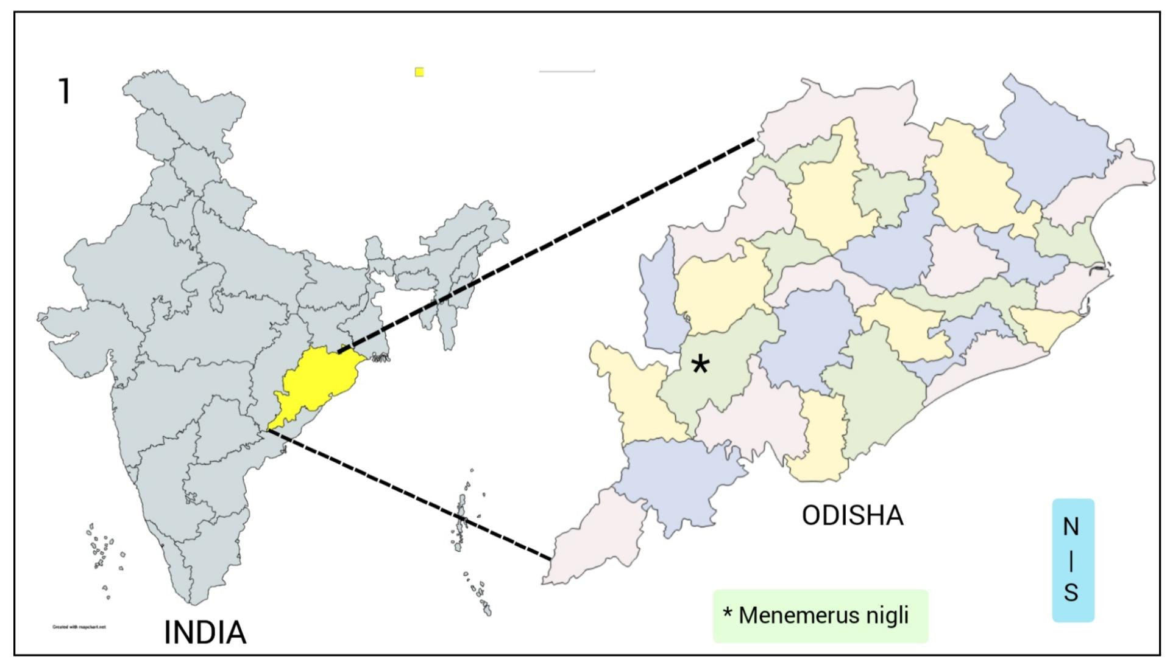
Figure 1: The map represents the new distribution of jumping spider species in Odisha state.

Result and Discussion
The present research reports a new distributional record for the jumping spider species Menemerus nigli, which has been recorded in the state of Odisha for the first time. This article provides a detailed explanation of the species' new distribution and morphology. During the course of the study, both male and female specimens of this species were recorded. A comprehensive description of this species is provided below.

Taxonomy
Salticidae Blackwall, 1841
Menemerus Simon, 1868
Menemerus nigli Wesołowska & Freudenschuss, 2012
(Figure 2-21)

Specimen Details
Menemerus nigli Wesołowska & Freudenschuss, 2012: Total 8 specimens (3 adult male and 5 adult female specimens) were collected from the Kokasara block of Kalahandi district, Odisha. 1 male and 2 females from Majhiguda village (19°40'45"N 82°40'37"E, elevation 301.71 m), on 15. xi. 2025. 2 males and 1 female collected from Kokasara (19° 40 '06"N 82° 39' 43"E, 311.35 m) on 01.vi.2025. 2 females were collected from Polka Dongor of Kokasara block (19° 40 '08"N 82° 41' 18"E, 318.83 m) on 28. ix. 2025. All collected specimens are adults. The collected specimens were preserved by 70% ethanol in small vials and deposited in the lab of Zoology in Govt. D. B. Girls P. G. College Raipur, Chhattisgarh, India.

Morphological characteristics
Female Body: The cephalothorax is slightly smaller than the abdomen (fig. 2). It features a white stripe on its lateral sides, which is thicker at the rear and gradually narrows towards the front (fig. 3). The carapace is completely covered in hairs. The sternum is oval-shaped. The pedipalps are slender and fully hairy (fig. 10). Orange hairs are located on the lateral side of the anterior median eyes (fig. 8). The clypeus is narrow. The chelicerae are short and black in color (fig. 9). They have few tiny, long hairs. The fangs are short and black. The abdomen is large and covered with hair. Leg I is slightly shorter in length compared to the other legs. Leg IV is the longest. Hairs are present on all segments of all the legs.

Epigyne: The epigyne is irregularly rounded in shape. A transverse epigyne groove is present in the posterior region, where hairs are absent, whereas white hairs are present in the anterior region, projecting posteriorly (fig. 11). The posterior margin is wide and the anterior margin is narrow.

Male Body: The carapace is rectangular in shape and tapers to a point posteriorly, extending beyond the pedicel. The central region is brown, while a black line runs along each lateral side from back to front, appearing thicker at the rear and becoming narrower towards the front (fig. 15). A white stripe is present on both lateral sides (fig. 12). The anterior median eyes are the largest in size and are black in color. The anterior median eyes are covered with orange-colored hairs (fig. 16). The clypeus region is narrow and bears white hairs (fig. 17). On the lateral side of the central region of the carapace, there is a black ring-like structure connected by a small horizontal black strip. The sternum is oval-shaped and covered with small hairs. The entire carapace is covered with brown and light black hairs. The chelicerae are thick, short, and large in size, and are dark black in color (fig. 17). Small cteni are present on them. The basal part of the fangs is black and thick, while the apex is orange, cylindrical, and pointed. They curve inward. Leg I is the thickest and strongest. Legs I and II project forward. Leg III is straight, whereas Leg IV projects backward. All legs are covered with fine hairs. The abdomen is slightly smaller than the cephalothorax and is entirely covered with brown and black hairs. The ventral area is pale brown in color, and the density of small hairs is very sparse. The spinnerets are present at the terminal end of the abdomen.

Pedipalp: The anterolateral tibial apophysis is black, short, and conical in shape (fig. 18); it is situated almost at the very base, near the pedipalp bulb (fig. 21). The cymbium is S-shaped or spiral-shaped and is completely covered with hairs on its dorsal surface (fig. 18). The bulb is thick, blackish-brown, and swollen. The sperm duct is thickened and curved downwards in its upper region. The embolus is small and cylindrical. The median apophysis is not fully visible(fig. 18).
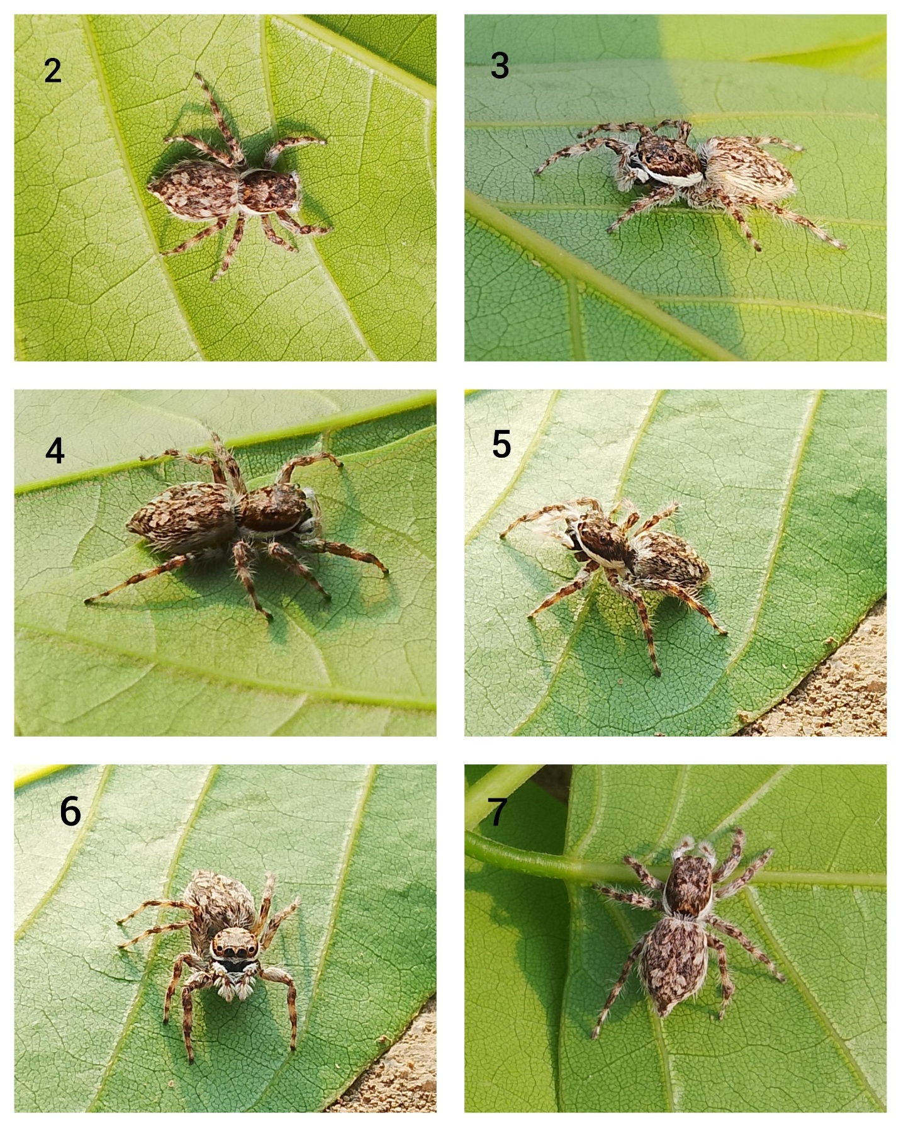
Figure 2-7: Habitus- Menemerus nigli Wesołowska & Freudenschuss, 2012 (adult female); 2- Dorsal view, 3- Anterolateral view, 4 & 5- Lateral view, 6- Anterior view, 7- posterior view.

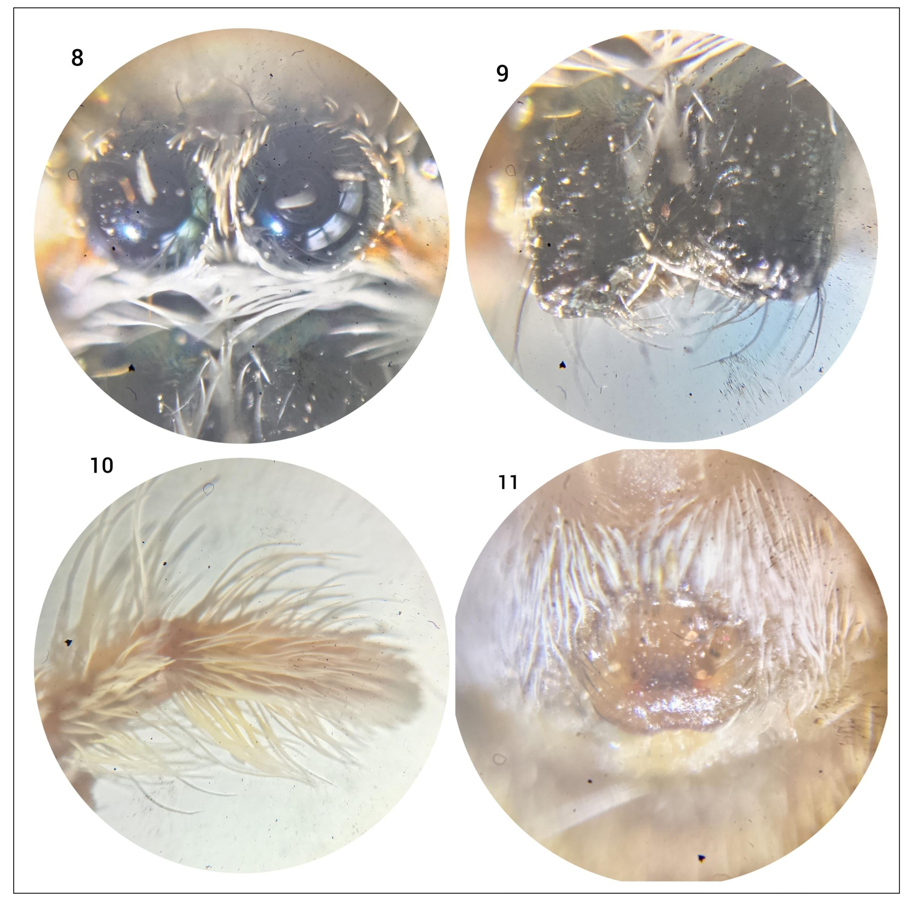
Figure 8-11: M. nigli Wesołowska & Freudenschuss, 2012 (adult female); 8- Anterior Median Eye, 9- Chelicerae, 10- Pedipalp without bulb, 11- Epigyne of female species.

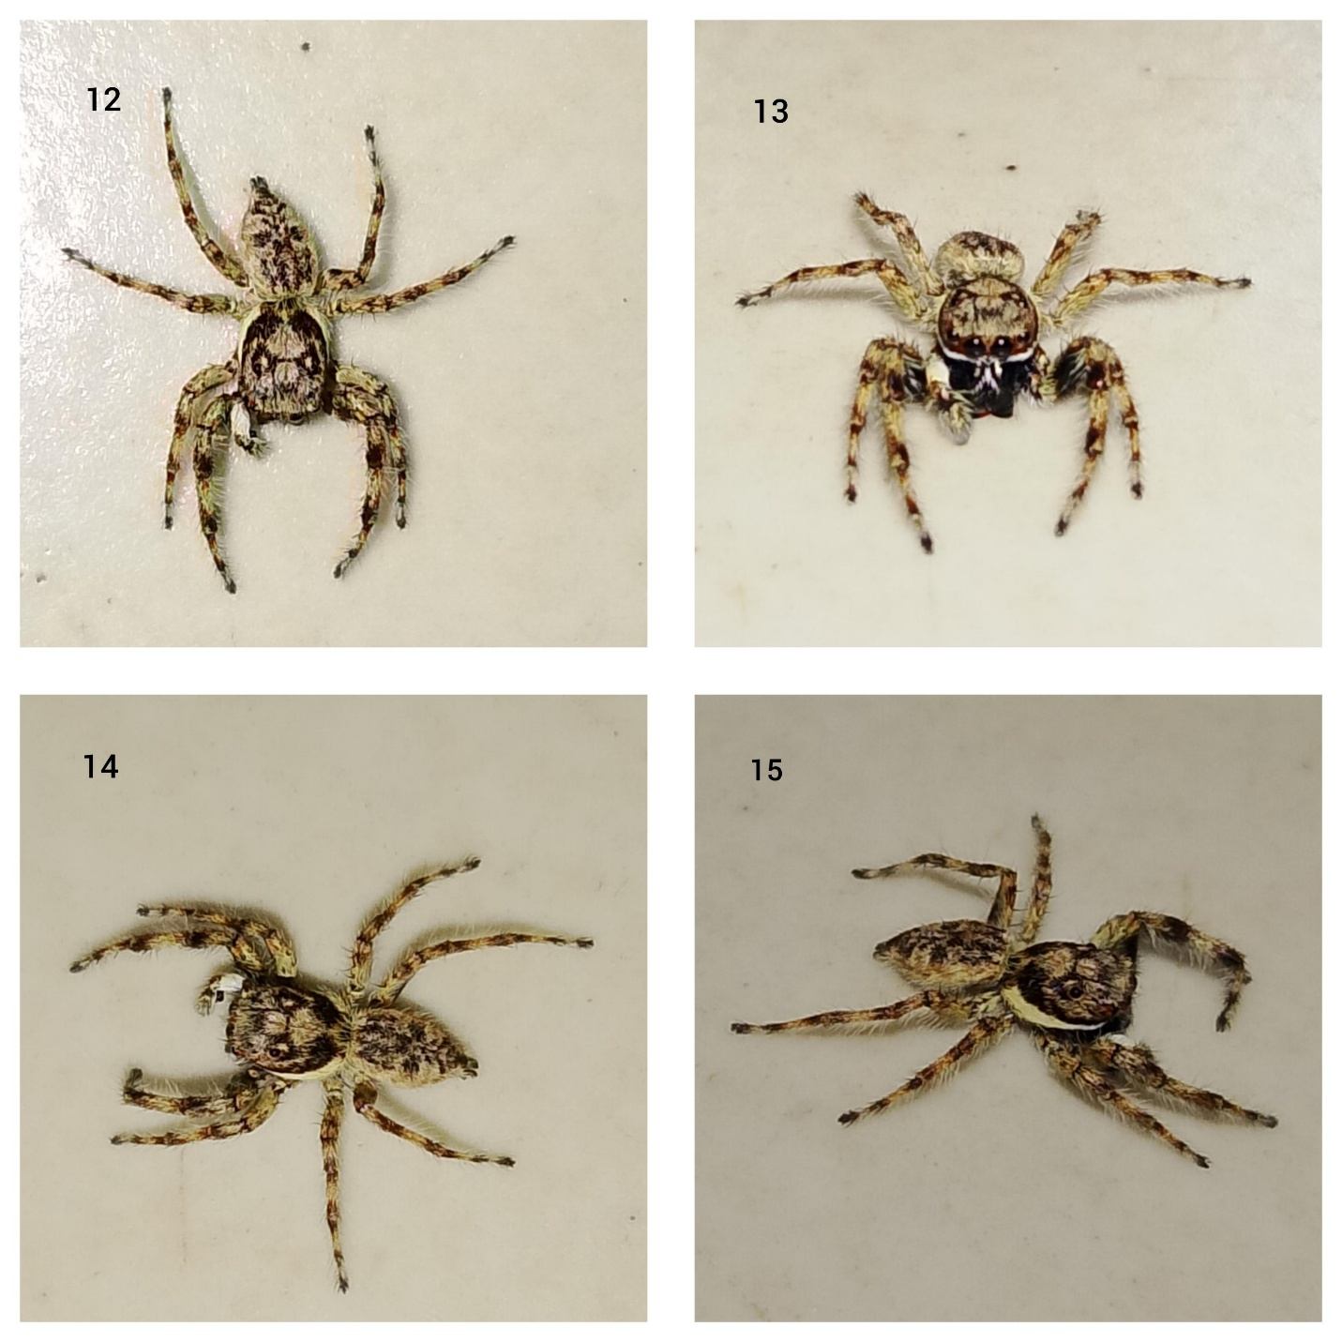
Figure 12-15: Habitus- M. nigli (adult male); 12- Anterodorsally view; 13- Anterior view with eye configuration; 14- Dorsal view; 15- Lateral view

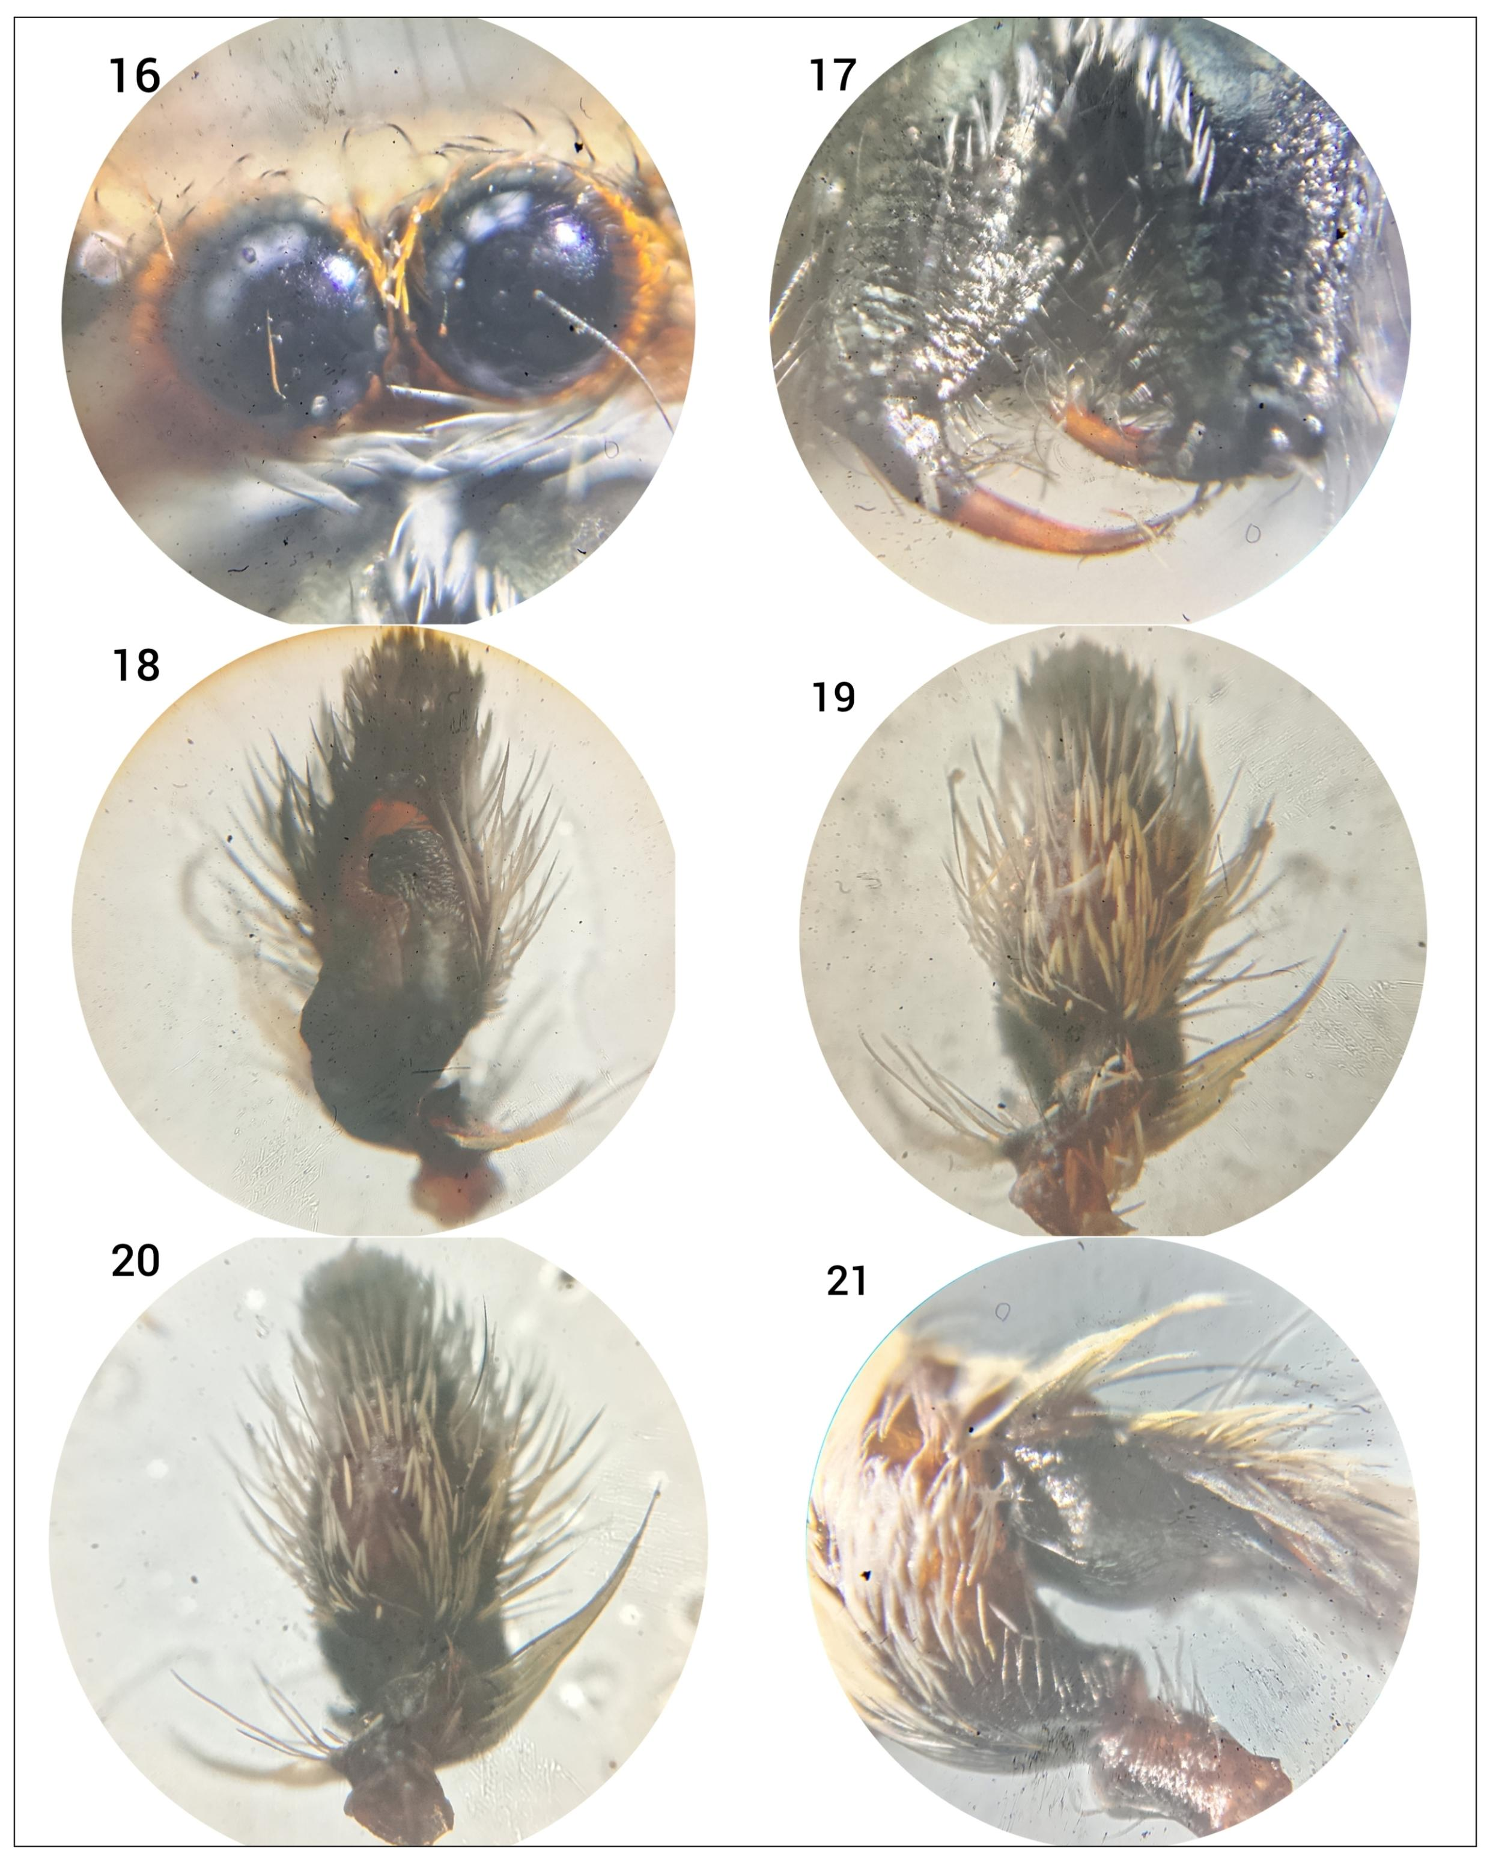
Figure 16-21: M. nigli (adult male); 16- Anterior Median Eye and Clypeus, 17- Chelicerae with fangs, 18- Pedipalp ventral view, 19- Pedipalp dorsal view, 20- Pedipalp Anterolateral view, 21- Pedipalp with all tibial segments.

Diagnosis
The identification of this species was carried out by morphologically examining the genitalia of the specimen, based on photographs of the genitalia provided in the published literature (pp. 110, fig. 1-4) (Chatterjee et al., 2017) and the females specimen was identified by (Mariante & Hill, 2020).

Habitat
Menemerus nigli Wesołowska & Freudenschuss, 2012 are found on the walls of buildings and on small plants. They remain active both during the day and at night. They hide by camouflaging themselves against the walls of these buildings.

Global Distribution
Pakistan, India, Thailand. Introduced to Brazil (WSC, 2026).

Indian Distribution
West Bengal (Chatterjee et al., 2017), Chhattisgarh (Nayak et al., 2025c).

Eight specimens of a jumping spider species named Menemerus nigli Wesołowska & Freudenschuss, 2012 have been collected from the Kokasara block of the Kalahandi district in the state of Odisha, comprising three adult males and five adult females. This species has been recorded in the state of Odisha for the first time. Before this, two species of this genus Menemerus fulvus and Menemerus bivittatus had already been recorded. With the discovery of this species, there are now a total of three species of the genus Menemerus found in the state. This species had previously been recorded in only two states of India, West Bengal and Chhattisgarh, but now Odisha has become the third state where this species has been recorded.
The record of this species will enable researchers to conduct further studies on it in the future. This species will aid in gaining a better understanding of the diversity of jumping spiders within the state of Odisha. Furthermore, this species holds ecological significance, as it plays a crucial role in pest control. This species is found on the walls of houses or other buildings, where it preys on resting mosquitoes, houseflies, and other insects, thereby helping to keep pest and insect populations in check.
This study records both male and female spiders of this species, thereby comprehensively exploring their morphological differences. The presence of both males and females indicates that their population within the state is substantial. This collection was conducted within a single block of the state, rather than across different areas. Consequently, this study cannot conclusively determine whether or not these items are found in other regions of the state.
Identifying this species poses significant difficulties because, morphologically, M. nigli appears virtually identical to M. fulvus. However, in this research article, both individuals, male and female, are described with live photographs, which will be highly helpful in making comparisons with other salticid spider species, especially the genus Menemerus.

Conclusion
Eight specimens of Menemerus nigli (comprising three adult males and five adult females) were collected from the Kokasara Block of the Kalahandi District in Odisha. This species has been recorded in the state of Odisha for the first time. Two species of this genus have already been recorded in this state, making this the third species to be documented. This article reports on the discovery of a new locality for this species. Particular emphasis was placed on the examination of the genitalia during the identification process, as this species bears a striking morphological resemblance to other species within the same genus; consequently, identification based solely on external morphology is extremely difficult.

Disclaimer (Artificial Intelligence)
Author(s) hereby declare that NO generative AI technologies such as Large Language Models (ChatGPT, COPILOT, etc) and text-to-image generators have been used during the writing or editing of this manuscript.
Competing Interests
Authors have declared that no competing interests exist.
References
Ali, P. A., Maddison, W. P., Zahid, M. & Butt, A. (2018). New chrysilline and aelurilline jumping spiders from Pakistan (Araneae, Salticidae). ZooKeys 783: 1-15. doi: 10.3897/zookeys.783.21985
Benhacene, R., Adjami, Y., Benotmane, K. H., Hadiby, R. & Ouakid, M. L. (2024). Spider (Araneae: Araneomorphae) diversity in Annaba Province, northeastern Algeria. Acta Zoológica Lilloana 68(2): 485-500. Doi: 10.30550/j.azl/1986
Berretima, W., Kherbouche-Abrous, O., Doumandji, S. & Azarkina, G. N. (2025). New data and a checklist of the jumping spiders (Aranei: Salticidae) of Algeria. Arthropoda Selecta 34(1): 64-76. Doi: 10.15298/arthsel.34.1.06
Blackwall, J. (1841). The difference in the number of eyes with which spiders are provided proposed as the basis of their distribution into tribes; with descriptions of newly discovered species and the characters of a new family and three new genera of spiders. Transactions of the Linnean Society of London 18(4): 601-670. doi: 10.1111/j.1095-8339.1838.tb00210.x
Chatterjee, S., Caleb, J. T. D., Tyagi, K., Kundu, S. & Kumar, V. (2017). First report of Menemerus nigli (Araneae: Salticidae) from India. Halteres 8: 109-111. doi: 10.5281/zenodo.1133147
Choudhury S. R, Siliwal M, Das S. K. (2019). Spiders of Odisha: a preliminary checklist. Journal of Threatened Taxa, 11(9): 14144-14157.
Choudhury S. R, Siliwal M, Das S. K, Giroti Amritsar. (2021). Description of a new genus and five new Species of Tube-dwelling spider family Segestriidae (Araneae: Synspermiata) from Odisha, India. Zootaxa, 4963(1): 91-114
Haddad, C. R. & Wesołowska, W. (2024). On some new and poorly-known Chrysillini from arid western South Africa (Araneae, Salticidae). African Invertebrates 65(2): 127-159. Doi: 10.3897/AfrInvertebr.65.136083
Mariante, R. M. & Hill, D. E. (2020). First report of the Asian jumping spider Menemerus nigli (Araneae: Salticidae: Chrysillini) in Brazil. Peckhamia 205.1: 1-21.
Nayak J., Sori P., Sahu L., Bharti D. (2025a). A new observational record of jumping spider (Aranae: Salticidae: Aelurillini: Aelurillina) Stenaelurillus metallicus Caleb & Mathai, 2016 in Chhattisgarh, India . International Journal of Biology Research 10(1) 19-21. https://www.biologyjournal.in/assets/archives/2025/vol10issue1/10007-1740555118544.pdf
Nayak, J., Warte, H. K., Sahu, L., & Rajanikant. (2025b). First description of a crab spider species Stiphropus sangayus Barrion & Litsinger, 1995 (Araneae: Araneomorphae: Thomisidae) in Odisha, India. International Journal of Zoology, Environment, and Life Sciences, 2(3), 7–10. https://doi.org/10.70604/ijzels.v2i3.73
Nayak J., Warte H. K., Sori P. & Sahu L. (2025c). Study on Jumping Spiders (Aranae: Araneomorphae: Salticidae) Diversity in Shraddha Public School Campus Gariaband, Chhattisgarh, India. International Journal Of Latest Technology In Engineering, Management & Applied Science : 14 (3): 350- 353 DOI : https://doi.org/10.51583/IJLTEMAS.2025.140300037
Nayak, J., Warte, H. K., Sahu, L., & Singh, L. (2026a). New distribution of two cobweb (Araneae: Theridiidae Sundevall, 1833) spiders in Chhattisgarh State, India. Asian Journal of Research in Zoology, 9(1), 1–9. https://doi.org/10.9734/ajriz/2026/v9i1235
Nayak, J., Nichat, A. R., Harris, K. K., Warte, H. K., & Sahu, L. (2026b). Distributional Records of a Salticid Spider Species Epocilla aura (Dyal, 1935) (Araneae: Salticidae) in Different Districts of Chhattisgarh State, India. Asian Journal of Research in Zoology, 9(2), 1–8. https://doi.org/10.9734/ajriz/2026/v9i2260
Nayak, J., `Nichat, A. R., Harris, K. K., Warte, H. K., & Chaure, M. (2026c). First Record of a Crab Spider (Araneae: Thomisidae) Species of Genus Strigoplus Simon, 1886 in Chhattisgarh State, India. BIONATURE, 46(1), 218–225. https://doi.org/10.56557/bn/2026/v46i12104
Nichat, A. R., Harris, K. K., Nayak, J., Kashyap, L., & Pawar, V. (2026a). Cyrtophora moluccensis Doleschall, 1857 (Arachnida: Araneae: Araneidae): First report in Chhattisgarh state of India. BIONATURE, 46(1), 55–63. https://doi.org/10.56557/bn/2026/v46i12091
Nichat, A. R., , Harris, K. K., Nayak, J., Majumdar, M., Warte, H. K., Sona, V., & Kumar, R. (2026b). First record of two Argyrodes Simon, 1864 (Araneae: Theridiidae) species from Chhattisgarh, India. Journal of Applied Life Sciences International, 29(1), 159–165. https://doi.org/10.9734/jalsi/2026/v29i1758
Nichat A. R., Warte H. K., Nayak J., (2024a). Spider diversity (Arachnida: Aranae) in Deobhog region Gariyaband Chhattisgarh India : International Journal of Innovation and Science and Engineering : 11 (8) : 39 – 45 https://ijiset.com/vol11/v11s8/IJISET_V11_I08_03.pdf
Nichat A. R., Warte HK., Shaffi S. A. & Nayak J., (2024b). A study of biodiversity of spider species (Arachnida : Aranae : Araneomorphae) in kokasara region, Kala-handi, Odisha, India : African Journal of Biological Sciences : 6 (15) : 9550- 9560. https://doi.org/10.48047/AFJBS.6.15.2024.9550-9560
Nichat A. R., Harris K.K., Warte H.K., Dubey M., Sori P. & Nayak J. (2025a). Spiders Diversity in North East Gariaband Forest Regions of Chhattisgarh, India. Uttar Pradesh Journal of Zoology, 46(4):119-127. DOI:https://doi.org/10.56557/upjoz/2025/v46i44808
Nichat, A. R., Nayak, J., Sori, P., & Warte, H. K. (2025b). Description of new jumping spider species Epocilla aura (Aranae: Salticidae: Chrysillini) from Gariaband district, ChhattisgarhState, India. International Research Journal of Biological Sciences, 14(2), 1–4. http://www.isca.in
Pupin, G. B. & Brescovit, A. D. (2023). The alien synanthropic Salticidae in Brazil (Araneae). Iheringia, Série Zoologia 113(e2023002): 1-16. doi: 10.1590/1678-4766e2023002
Quevedo-Ortiz, G. & Pinilla Rosa, M. (2024). Aportación al conocimiento aracnológico (Araneae) del noreste y sureste de la península ibérica. Revista Ibérica de Aracnología 44: 175-177.
Roy, T. K., Saha, S. & Raychaudhuri, D. (2016). A treatise on the jumping spiders (Araneae: Salticidae) of tea ecosystem of Dooars, West Bengal, India. World Scientific News 53(1): 1-66.
Schäfer, M. (2022). Ein Beitrag zur Springspinnenfauna (Araneae: Salticidae) der Kanarischen Inseln mit der Erstbeschreibung von Euophrys arnograbollei spec. nov. Arachnologische Mitteilungen 64: 57-72. Doi: 10.30963/aramit6408
Sajid, M., Zahid, M., Butt, A., Khan, M. T., Shah, M., Attaullah, S., Khan, M. I. & Ahmad, R. (2023). Faunistic and DNA barcoding of the recorded spiders (Araneae: Gnaphosidae, Hersiliidae and Salticidae) from Lower Dir (Pakistan). International Journal of Agriculture and Biology 29(1): 23-30. doi: 10.17957/IJAB/15.1999
Seyfulina, R. R., Azarkina, G. N. & Kartsev, V. M. (2020). A contribution to the knowledge of jumping spiders from Thailand (Aranei: Salticidae). Arthropoda Selecta 29(1): 87-96. doi: 10.15298/arthsel.29.1.07
Simon, E. (1868). Monographie des espèces européennes de la famille des Attides (Attidae Sundewall. - Saltigradae Latreille). Annales de la Société Entomologique de France (4) 8: 11-72, 529-726, pl. 5-7.
Singh, R., Verma, A. K., Singh, B. B., & Singh, G. (2023). Spider fauna of India. Nature Light Publications. Pp. 1-562. ISBN- 978-81-959483-4-5
Tripathi, R., Jangid, A. K., Siliwal, M., Dutta, S. & Sudhikumar, A. V. (2021). First record of Menemerus marginatus (Kroneberg, 1875) (Araneae: Salticidae: Chrysillini) from India. Peckhamia 231.1: 1-7.
Trotta, A. (2005). Introduzione al ragni italiani (Arachnida Araneae). Memorie della Società Entomologica Italiana 83: 3-178. Doi: 10.4081/memorieSEI.2004.3
Wesołowska, W. & Freudenschuss, M. (2012). A new species of Menemerus from Pakistan (Araneae: Salticidae). Genus 23(3): 449-453.
Wesołowska, W., Russell-Smith, A. & Danflous, S. (2026). The jumping spiders (Araneae: Salticidae) from the southwestern region of Central African Republic. Zootaxa 5743(1): 1-74. Doi: 10.11646/zootaxa.5743.1.1
World Spider Catalog (2026). World Spider Catalog. Version 27. Natural History Museum Bern, online at http://wsc.nmbe.ch, accessed on {22/02/2026}. doi: 10.24436/2
Yin, C. M., Peng, X. J., Yan, H. M., Bao, Y. H., Xu, X., Tang, G., Zhou, Q. S. & Liu, P. (2012). Fauna Hunan: Araneae in Hunan, China. Hunan Science and Technology Press Changsha, 1590 pp.

