Case report

Romiplostim-Responsive Thrombocytopenia in a Dog with Ancylostoma caninum Infection: A Case Report

.
ABSTRACT

Ancylostoma caninum, a blood-feeding gastrointestinal nematode, is a well-established cause of anemia and hypoproteinemia in dogs. In addition to blood loss, Ancylostoma infections may induce thrombocytopenia by secreting antithrombotic peptides. A 1-year-old Doberman breed male dog was presented to the Referral Veterinary Polyclinic, IVRI with lethargy and melena. Hematologic evaluation revealed moderate thrombocytopenia. Fecal examination confirmed a heavy burden of Ancylostoma caninum eggs and larvae. Comprehensive diagnostic work-up including PCR, serum biochemistry, and abdominal ultrasonography failed to identify alternative causes for the thrombocytopenia. The dog was treated with fenbendazole and praziquantel for 3 days, but platelet count failed to improve. Subsequently, Romiplostim was administered @ 5 µg/Kg subcutaneously once along with prednisolone @ 0.5mg/Kg IM. This regimen resulted in a rapid and sustained increase in platelet count, with normalization achieved by day 5 (platelet count 146 × 10³ cells/mm³). Clinical signs resolved completely, with no relapse observed during a four-week follow-up. This case highlights a novel presentation of romiplostim-responsive thrombocytopenia associated with Ancylostoma caninum infection, likely mediated by antithrombotic peptides and immune mechanisms.

Keywords: Ancylostoma caninum, Canine parasitic disease, Hookworm platelet inhibitors, Refractory thrombocytopenia, Romiplostim, Thrombocytopenia, Hematochezia, Thrombocytopenia, Antithrombotic peptides

1. INTRODUCTION

Parasitic nematodes are responsible for widespread infections in their hosts including companion animals and humans. Ancylostoma caninum is a hematophagous intestinal nematode recognized for causing zoonotic ancylostomiaisis across various mammalian hosts, including humans (Nezami et al., 2023).
A.caninum is the principal cause of canine hookworm disease in most tropical and subtropical areas of the world and is considered the most pathogenic of the dog hookworms. Many researchers has always raised zoonotic concerns regarding this parasite and dogs being the commonly raised pet animals by humans raises the chances of household exposure of Ancylostoma caninum to humans as was reported by Jung et al. (2020) in a human case of enteritis.Thus, the control and treatment of the cases of Ancylostoma caninum infection is important for welfare of dogs as well as pet owners.

1

Ancylostoma caninum has been called a “voracious blood sucker” and can pose severe health problems for puppies like severe anemia, hypoproteinemia, bloody diarrhea, weight loss, and life-threatening blood loss (Birchad and Sherding, 2005). A. caninum are voracious blood suckers and consumes 0.01 to 0.09 ml of blood per worm per day (Jubb et al., 2016) thus inducing hypoproteinemia and anemia. A human study by Del Valle et al. (2003) reported that a powerful platelet inhibitor family, called hookworm platelet inhibitors (HPI), has been isolated from soluble extracts of adult A.caninum in humans.
Antithrombotic peptides, A.caninum coagulant peptide (AcAP5,AcAP2), the coagulation factor and prothrombin activity inhibitors, are secreted by A.caninum (Mieszczanek et al., 2004), and thus can result in decrease in platelet count. In the work carried out by Silva et al. (2010), it was observed that 45% of dogs infected by Ancylostoma spp., had thrombocytopenia, indicating that parasitism by this type of parasite can be included in the differential diagnosis of thrombocytopenia.
Romiplostim is a peptibody, antibody heavy chain containing a therapeutic peptide, with human immunoglobulin IgG1 Fc domain covalently linked at each of its two C-terminals to two 14-amino-acid peptides, that bind to and stimulate the thrombopoietin receptor (Bussel et al., 2009), after binding with thrombopoietin receptor, it rapidly leads to phosphorylation, resulting in activation of the Janus kinase/signal transducers and activators of transcription (JAK-STAT) pathway, which leads to increased proliferation and decreased apoptosis of megakaryocytes, thus increase in platelet count (Kuter, 2010).
This case report describes romiplostim-responsive thrombocytopenia associated with Ancylostoma caninum infection in dog and highlights two main important points, Ancylostoma caninum, apart from hypoproteinemia and anemia, may also lead to thrombocytopenia in dogs and Romiplostim can be considered a promising therapeutic agent in severe or non-responsive cases of thrombocytopenia, highlighting the novelty of this clinical case management. And this can change the treatment perspective for cases like these in the veterinary community.The use of Romiplostim in Ancylostoma caninum infection

The objective of this case study was to evaluate the platelet stimulating property of Romiplostim in Ancylostoma caninum infections in dogs.

2. PRESENTATION OF CASE

A 1-year-old Doberman male dog was presented to Referral Veterinary Polyclinic, Indian Veterinary Research Institute with the primary complaint of hematochezia and lethargy since a week. The animal had a normal appetite and there was no history of vomition or diarrhea. Clinical examination revealed no significant alteration in vitals. The dog was normothermic with the temperature of 101 F, mucous membranes were moist pink and popliteal lymph nodes were of normal size. The resting heart rate was 89 bpm. Upon fecal examination, oval thin shelled Ancylostoma caninum eggs were seen under low power microscope and on gross observation, hematochezia with parasitic larvae were seen.
Haemato-biochemical evaluation revealed that all the parameters were normal except platelet count which was significantly decreased to 80,000 cells/c.mm. A comprehensive diagnostic investigation was performed to determine the underlying cause of the thrombocytopenia. The workup included infectious disease testing for Ehrlichia spp., Anaplasma spp., and Babesia spp., complete serum biochemical profiles, and thorough abdominal ultrasonographic evaluation. These investigations did not identify any concurrent infectious processes, metabolic abnormalities, or structural lesions that could explain the reduced platelet count. Importantly, PCR testing for hemoprotozoan pathogens was found to be negative, effectively ruling out active vector-borne infections as a contributing factor.

Additionally, ultrasonography revealed enlarged jejunal lymph nodes and dilated duodenal lacteals, but no evidence of splenic pathology, neoplasia, or internal hemorrhage. The dog was treated with Fenbendazole and Praziquantel for 3 days, and no parasitic larvae were seen in faeces thereafter but platelet count failed to improve (Table 1). Subsequently, Romiplostim was administered @ 5 μg/Kg SC OD, along with Prednisolone @ 0.5mg/Kg IM once, considering its thrombopoietic effect. The dog was kept under observation and complete hematology was performed 48 hours of Romiplostim administration and normal thrombocyte count was observed (217×10³ /c.mm). Details of hematological parameters are depicted in Table 1

Table 1: Pre and post treatment changes in the hematology parameters

S.No | Parameters | Pre treatment | After treatment with Fenbendazole and praziquantel | After treatment with Rombiplostim
1. | Haemoglobin (g/dl) | 16.2 | 14 | 13.7
2. | Packed Cell Volume (%) | 48 | 43 | 38
3. | Total Erythrocyte Count (/c.mm) | 7.02 × 10⁶ | 7.02 × 10⁶ | 6.02× 10⁶
4. | Total Leukocyte Count (/c.mm) | 16.5 × 10⁶ | 17.5 × 10⁶ | 16.5 × 10⁶
5. | Neutrophils (%) | 71 | 71 | 70
6. | Lymphocytes (%) | 21 | 24 | 22
7. | Monocytes (%) | 08 | 05 | 05
8. | Platelets (/c.mm) | 80 × 10³ | 41 × 10³ | 217 × 10³

4. DISCUSSION

Ancylostoma caninum is a blood-feeding parasitic nematode in dogs that primarily causes anemia and low protein levels; Thrombocytopenia, while documented, occurs less commonly. This case describes a young dog with severe A.caninum infection associated with low platelet counts that persisted despite successful deworming treatment but showed marked improvement following romiplostim therapy. The mechanisms underlying hookworm-related thrombocytopenia appear to be complex and multifaceted. Adult hookworms produce various anticoagulant and antiplatelet compounds, including hookworm platelet inhibitors (HPI), AcAP5, and AcAPc2, which interfere with platelet function and clotting processes to enable sustained blood consumption (Del Valle et al., 2003). A study by Ferraz et al. (2023) has shown that a notable percentage of dogs infected with Ancylostoma species develop thrombocytopenia, along with anemia and eosinophilia.
In the present case, a thorough diagnostic investigation ruled out other common causes of low platelet counts, including vector-borne diseases, metabolic disturbances, cancer, splenic pathology, and internal bleeding. While anthelmintic treatment successfully eradicated the parasite infection, platelet levels continued to fall, indicating that eliminating the parasite was not adequate to correct the blood abnormality. This persistent decline suggests the involvement of a secondary immune-related or bone marrow suppression process initiated by parasite components.
Romiplostim functions as a thrombopoietin receptor agonist that enhances megakaryocyte development and platelet generation (Bussel et al., 2021).After receiving a single subcutaneous injection along with a low dose of prednisolone, the patient demonstrated rapid platelet count recovery and full clinical resolution. The quick and durable response suggests that insufficient platelet production, rather than continued platelet loss, was the primary issue, and underscores the value of thrombopoietin receptor agonists in certain cases of treatment-resistant thrombocytopenia linked to infections.
A case report on refractory amegakaryocytic immune mediated thrombocytopenia in a dog by Polydoros et al. (2021), has revealed complete clinical and hematological remission in an immune mediated amegakaryocytic thrombocytopenic dog eight days after initiation of romiplostim therapy, administered at cumulative dose of 15 μg/Kg, subcutaneously, in two sessions one week apart, with no signs of relapse of thrombocytopenia thirty-eight months later. Thus, implying that Romiplostim is a promising therapeutic option for thrombocytopenic dogs.
Multiple similar cases have been reported in humans where Romiplostim effectively normalized the platelet counts in thrombocytopenic patients. Baldini et al. (2012) reported a case of refractory secondary immune mediated thrombocytopenia in a patient affected by serous ovarian carcinoma which favourably responded to Romiplostim administration.

4. Conclusion

This case represents an unusual presentation of thrombocytopenia associated with Ancylostoma caninum infection in a canine patient that responded favourably to romiplostim treatment. The continuation of low platelet counts following successful antiparasitic intervention points to a complicated disease process involving both parasite-secreted antithrombotic substances and potentially immune-mediated or bone marrow dysfunction. Romiplostim demonstrated efficacy in achieving rapid platelet count restoration, indicating its potential role as a supplementary therapy in cases of persistent thrombocytopenia related to parasitic disease. Awareness of this clinical presentation is important for appropriate diagnostic recognition and therapeutic management in comparable situations.
Though the platelet-stimulating property of romiplostim was demonstrated in this case, it is based on a single animal. Therefore, additional cases are required to clearly establish the role of romiplostim in refractory thrombocytopenia in dogs, which represents a key limitation of this case study.

Disclaimer (Artificial intelligence)

Author(s) hereby declare that NO generative AI technologies such as Large Language Models (ChatGPT, COPILOT, etc.) and text-to-image generators have been used during the writing or editing of this manuscript.

References
Nezami, R., Blanchard, J., & Godoy, P. (2023). Compte rendu: The canine hookworm Ancylostoma caninum: A novel threat for anthelmintic resistance in Canada. The Canadian Veterinary Journal, 64(4), 372–378.

Jung, B. K., Lee, J. Y., Chang, T., Song, H., & Chai, J. Y. (2020). Rare case of enteric Ancylostoma caninum hookworm infection, South Korea. Emerging Infectious Diseases, 26(1), 181.

Birchard, S. J., & Sherding, R. G. (2005). Saunders manual of small animal practice (3rd ed.). Amsterdam: Elsevier Health Sciences.

Jubb, K. V. F., Kennedy, P. C., & Palmer, N. (2016). Alimentary system, Chapter 1. In Pathology of domestic animals (Vol. 2, p. 214).

Del Valle, A., Jones, B. F., Harrison, L. M., Chadderdon, R. C., & Cappello, M. (2003). Isolation and molecular cloning of a secreted hookworm platelet inhibitor from adult Ancylostoma caninum. Molecular and Biochemical Parasitology, 129(2), 167–177.

Mieszczanek, J., Harrison, L. M., Vlasuk, G. P., & Cappello, M. (2004). Anticoagulant peptides from Ancylostoma caninum are immunologically distinct and localize to separate structures within the adult hookworm.

Silva, B. J. D. A., Freire, I. M. A., Da Silva, W. B., & Do Amarante, E. E. (2010). Avaliação das alterações hematológicas nas infecções por helmintos e protozoários em cães (Canis lupus familiaris, Linnaeus, 1758). Neotropical Helminthology, 4(1), 37–48.

Bussel, J. B., Kuter, D. J., Newland, A., De Wolf, J. T., Wasser, J., Chang, P., et al. (2009). Long-term efficacy and safety of romiplostim for the treatment of patients with chronic immune thrombocytopenia (ITP): 5-year update from an open-label extension study. Blood, 114(22), 681.

Kuter, D. J. (2010). Biology and chemistry of thrombopoietic agents. Seminars in Hematology, 47(3), 243–248. WB Saunders..

Ferraz, A., Ongaratto, R. F., Barwaldt, E. T., De Almeida Capella, G., Foster, I. B., Dallmann, P. R. J., et al. (2023). Hematological parameters of dogs infected by Ancylostoma spp. Scire Salutis, 13(1), 44–48.

Bussel, J. B., Soff, G., Balduzzi, A., Cooper, N., Lawrence, T., & Semple, J. W. (2021). A review of romiplostim mechanism of action and clinical applicability. Drug Design, Development and Therapy, 15, 2243–2268.

Polydoros, T., Ioannidi, O. M., Korsavvidis, I., Stefanidis, S., Antoniadis, T., & Mylonakis, M. E. (2021). Romiplostim as adjunctive treatment of refractory amegakaryocytic immune thrombocytopenia in a dog. Topics in Companion Animal Medicine, 42, 100488.

Baldini, S., Fambrini, M., Carrai, V., Rigacci, L., Alterini, R., & Bosi, A. (2012). Romiplostim overcomes refractory secondary immune thrombocytopenia in a patient affected by serous ovarian carcinoma. International Cancer Conference Journal, 1(4), 239–242.

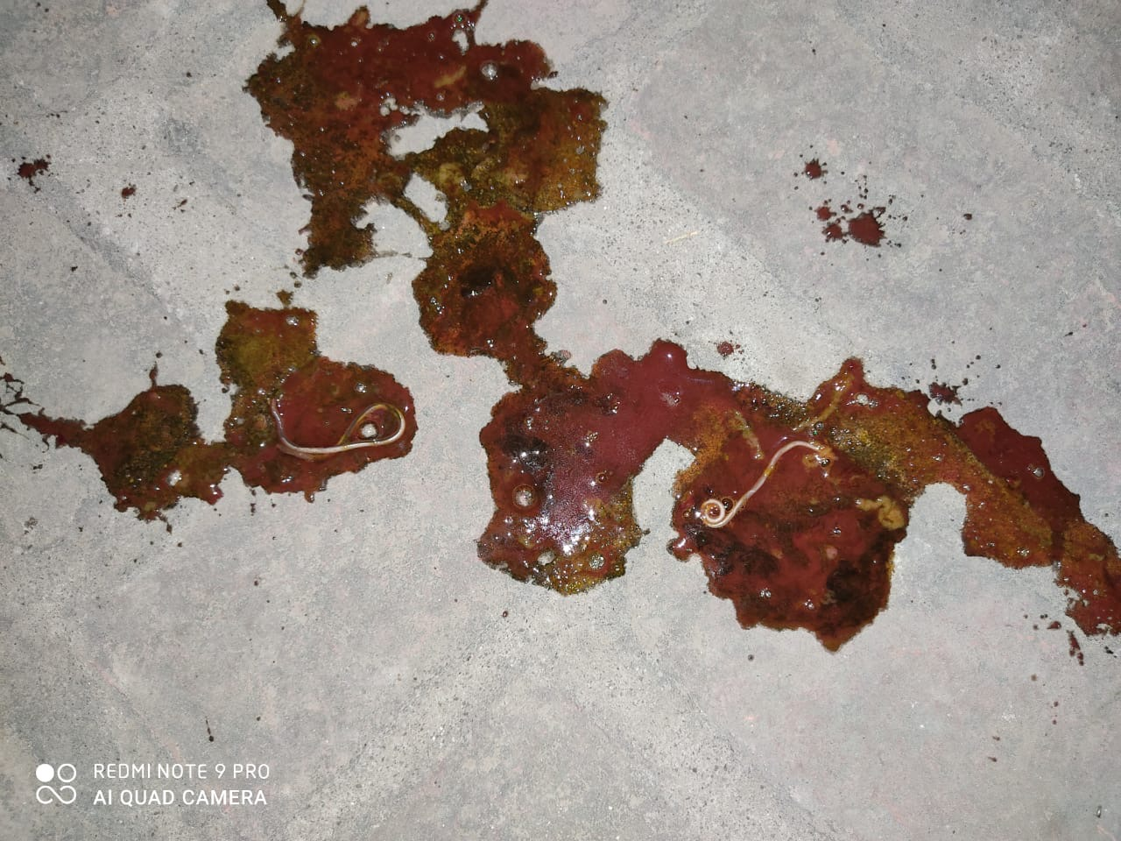
Fig1.: Hematochezia with parasitic larvae

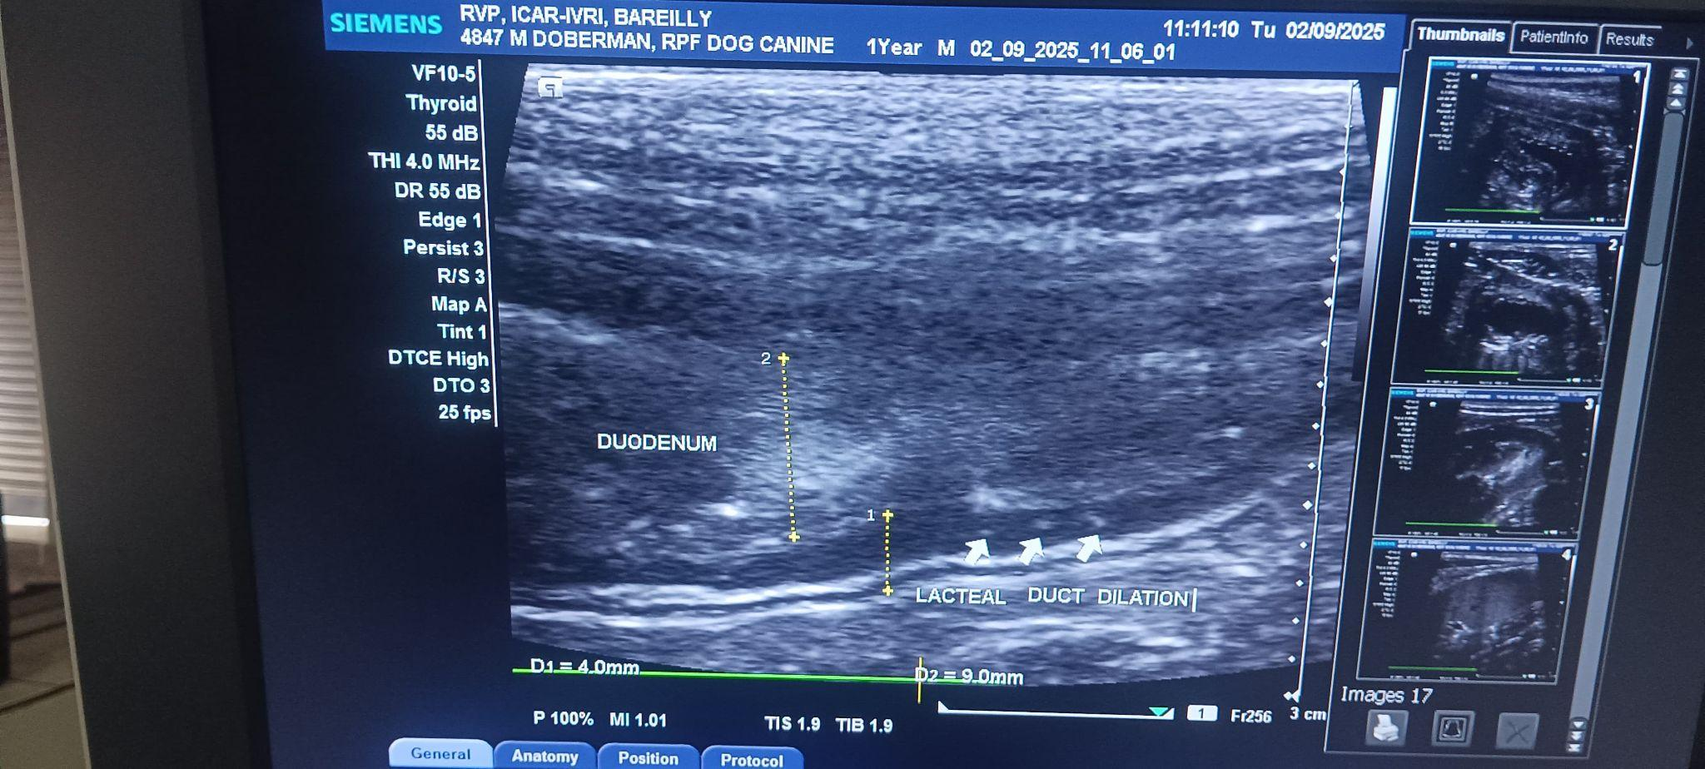
Fig 2. : Dilated lacteal duct

Fig 3. : Enlarged jejunal lymph nodes

