A mini-review on Infant Microbiome: Inheritance, Development and Programmed Susceptibility to Contemporary Diseases

.
ABSTRACT

The infant microbiome is one of the most active and biologically important ecosystems in human physiology. The colonisation by microbes starts at birth and can even precede delivery, and then the process of ecological succession is extremely regulated in the initial months and years of life. This is a critical developmental period that overlaps with key immune developmental stages, metabolic programming, and neurodevelopmental stages, indicating that microbial exposures in infancy may have far-reaching and long-term effects on human health. The early microbial communities are conditioned by a variety of determinants such as mode of delivery, maternal microbiota, and breastfeeding, exposure to antibiotics, environmental hygiene, and more general lifestyle factors related to urbanisation.

There is growing evidence that disturbances during early colonisation of microbes, also known as microbial symbiosis, can alter the path of physiological development of the host. Babies born through caesarean delivery, exposed to antibiotics early in life or reared in much sanitised homes often have distorted microbial composition and slow development of commensal populations that are beneficial. These disruptions can disrupt the immune education and metabolic signalling pathways, which are typically set up during host-microbe interactions. Therefore, there has been an increasing body of evidence showing that early-life symbiosis is linked to an increased risk of acquiring various non-communicable diseases in adulthood, such as asthma, allergic disorders, obesity, autoimmune diseases, and some neuro-developmental disorders.

This review summarises existing information about vertical microbial transmission, ecological succession of microbial communities in infancy, and the molecular pathways of host-microbe crosstalk. It also examines the ways in which disturbances in microbial colonization at this developmental period can predispose one to disease susceptibility in adulthood. The study of such initial microbial dynamics could provide the possibility of preventive measures that would help to maintain long-term health.

Keywords: infant , Microbiome, Human, Foods

1. INTRODUCTION

There is an incredible number of trillions of microorganisms that live in the human organism and create a very complex ecological community, the microbiome. This microbial consortia is diverse; it includes bacteria, viruses, fungi and archaea; all of them play an essential role on host physiology by participating in the essential body processes like nutrient catabolism, vitamin production, and energy balance. In addition, these organisms control the delicate balancing of the immunological pathways and provide immunity against invasions by pathogens. Through continuous bargaining with the host tissues, the microbiome maintains physiological homeostasis and by implication, wellbeing^{1,2}.
Though the initial studies of the microbiome as an antecedent were mostly done on adult communities, the current studies have increasingly shifted their focus to the early stages of human development. New evidence highlights the fact that infancy is a critical developmental transition point where microbial colonisation begins and infant ecosystems increasingly advance. It is at this vital period that the process of microbiota shaping in concert with the ontogenetically immature immune system coordinates the programming of immunological tolerance and the strengthening of host defence systems. These primordial host microbe form the foundation on which immunological reactivity and metabolic control³.
As a result, the formation of microbial consortia in infancy is currently recognized as a relevant predictor of health outcomes in the long term. Alterations of early colonisation events have the capacity to tune the vulnerability to a continuum of chronic diseases, and thus increase the urgency to clarify the developmental dynamics of the microbiome during this developmental phase.The recent decades have been characterized by a worldwide epidemiological and lifestyle revolution, as the epidemiology of immune-mediated and metabolic diseases, such as allergic disease, asthma, autoimmune pathology, obesity, and inflammatory bowel disease, has been rising. The increased urbanization, widespread use of antibiotics, limited exposure to microorganisms in the environment, smaller family size, formula feeding, and increased cesarean section have significantly changed patterns of microbial exposure in the early stages of life³. These social transformations have led to the development of the hygiene hypothesis, which assumes that a lack of microbial exposure in infancy affects the normal development of immune systems. In addition to the complementary conceptual frameworks, e.g., loss of ancestral microbial diversity impairs immune regulation^{4,5}.
The infant microbiome is not a random community of organisms but an ecological succession that is predictable. Immediately after birth, pioneer colonizers which are mainly facultative anaerobic bacteria including Enterobacteriaceae and Streptococcus spp. predominate in the neonatal gut⁶. These groups use up the remaining oxygen in the intestinal environment, creating the anaerobic environment that promotes the growth of obligate anaerobes. This is followed by the proliferation of beneficial genera such as Bifidobacterium, Bacteroides and members of the Clostridia class especially in breast infants, where human milk oligosaccharides selectively promote their growth⁷.
Many perinatal factors mediate this colonization pattern. Mode of delivery is a form of vaginally born infants pick up microbiota that is similar to that of the maternal vagina and intestines, and cesarean-delivered babies commonly carry skin-related microorganisms. There is also a further effect of feeding practices on microbiome composition, where breastfeeding promotes diversity and the generation of immune-modulatory metabolites, including short-chain fatty acids. Exposure to antibiotics in pregnancy or early infancy may cause changes in microbial succession, reduce diversity and slow down ecosystem stabilization^{8,9}.
At about the age of three, the gut microbiome of the child has reached a composition and functional capacity that is almost similar to that of adults. Microbial signals interact with host immune cells in this critical period of development and mediate T-cell differentiation, immune tolerance, mucosal barrier development and metabolic signaling pathways. Alterations that happen in this vulnerable time, which is usually called dysbiosis, can cause impairment of immune education and epithelial barrier integrity, which can predispose people to chronic illness later in life^{10,11}.
Newer literature highlights that microbiome development in early-life is a determinant of health that can be modified. The promotion of breastfeeding, responsible antibiotic stewardship, optimization of maternal health and future microbial-targeted therapies can be used to reestablish a healthy microbial exposure pattern. A careful study of the active interaction between the initial microbial colonization and host development provides vital information on disease prevention and makes the microbiome a key component of precision medicine with the goal of boosting long-term human health.^{12,13}

2. Microbial Inheritance: The Infant Microbiome.
2.1. Prenatal Influences

Over a number of decades, the sterile-womb hypothesis has been the canonical model of microbiology and developmental biology, which states that the intrauterine environment is sterile and that colonization only occurs after birth. However, this old dogma has been subject to a great deal of questioning, considering the reports of research on the existence of microbial DNA in placental tissue, amniotic fluid, and fetal membranes. These observations have generated a lot of academic controversy over the possibility of prenatal exposure to microbes and its possible contribution to early immune priming. However, the use of such data has been contentious, mostly due to the issues of contamination in the sampling and sequencing procedures. In this respect, the current evidence still upholds the idea that the extensive and consistent microbial colonization mainly begins during the delivery¹⁴.

However, the prenatal stage has an indirect yet a strong effect on the infant microbiome. Physiological and environmental factors of the mother, including diet, metabolic conditions, exposure to antibiotics during pregnancy, hormonal changes, and the structure of the maternal gut, vaginal, and oral microbiota, have a significant influence on the microbial inoculum to which the neonate is exposed during and soon after birth. In addition to this, maternal immune mediators and microbial metabolites are able to cross the placental barrier, thus influencing immune development of the fetus even prior to birth¹⁵.

A combination of these prenatal factors determines the biological environment under which the first microbial colonization occurs. In turn, although the establishment of microorganisms in large amounts is largely a perinatal phenomenon, maternal well-being and the microbial ecology during pregnancy are key determinants that shape the early-infancy microbiome and subsequent developmental patterns of the infant immune system¹⁶.
2.1.1 Mode of Delivery
One of the key factors of early colonization is the mode of delivery as showing in figure¹⁷:
- Vaginal delivery: Infants get microbes that are similar to the maternal vaginal and faecal microbiota such as Lactobacillus and Bacteroides.
- Caesarean section: The skin and environmental taxa are predominant colonizers of the infants; Staphylococcus, Corynebacterium.
Cesarean birth has been linked to risks of asthma, type 1 diabetes, obesity, and celiac disease¹⁸.

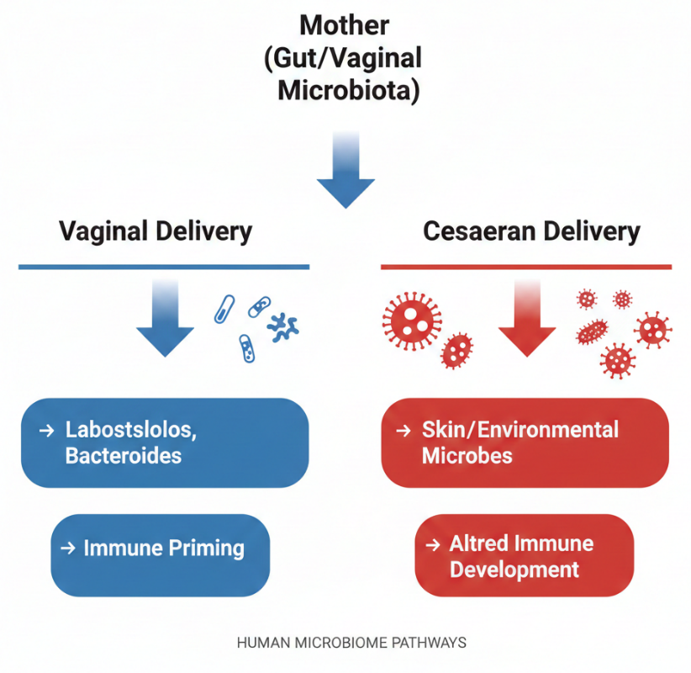
Figure 1. Showing Microbial Transmission Pathways at Birth

2.2. Early-Life Ecological Succession:
2.2.1.Breast milk and Human Milk Oligosaccharides (HMOs).
Breast milk is a very complex biological fluid, which not only provides the necessary nutrients but a variety of commensal microorganisms and bioactive molecules, which actively shape the maturing infant microbiome. This unique combination of microbial communities, immunomodulatory components, antimicrobial peptide, and growth-promoting substances is essential in the creation of a salutary intestinal milieu in the formative stages of life. Human milk oligosaccharides (HMOs), a structurally varied group of complex carbohydrates, which are mostly inaccessible to the infant but are selective substrates of particular intestinal microorganisms, are among the most salient components of breast milk¹⁹.

HMOs have a strong prebiotic effect, whereby they selectively promote the growth of species of good bacteria, especially Bifidobacterium species like Bifidobacterium longum subsp. HMOs also play a role in the development of a gut microbiota with a preponderance of saccharolytic bacteria that can produce short-chain fatty acids (SCFA) through this targeted enrichment. These microbial metabolites, in particular, acetate and butyrate, are critical in the maintenance of the health of the intestines. SCFAs increase the integrity of epithelial barriers, strengthen mucosal defensive systems, and regulate immune reactions by promoting regulatory T cell (Tregs) differentiation and proliferation, which promotes immune tolerance and homeostasis in the early immune system development²⁰.

On the other hand, infants fed with formulae generally exhibit different microbial profile with higher total microbial diversity but with weakened preeminence of Bifidobacterium groups. This transition usually results in changes in metabolic products such as changes in SCFA production and an increase in the proportion of facultative anaerobic bacteria²¹.
2.2.2.Solid Foods
At the stage of weaning, the introduction of solid food is a significant ecological shift in the infant gut microbiome. This is the period of the gradual transition of a milk-based diet to a more heterogeneous composition of dietary substances, such as complex carbohydrates, plant fibers, proteins, and lipids. As a result, there are significant shifts in the compositional and functional changes of the gut microbial ecosystem. Among the most noticeable aspects of this change, there is a substantial increase in microbial diversity, and the growth of taxa of bacteria with the ability to break down complex polysaccharides and dietary fibers ²².

In this phase, microbial communities start to assume a more adult-like structure, where the proportion of bacterial groups like *Bacteroides*, *Ruminococcus* and *Prevotella* is prominent, and which are known to be highly active in the metabolism of plant-derived carbohydrates. These bacteria help to ferment dietary fibers and synthesize short-chain fatty acids (SCFA) acetate, propionate, and butyrate that are vital in the preservation of intestinal health and metabolism²³.

There is empirical evidence that the composition and diversity of early infant nutrition play a major role in the maturation of the immune system. Dietary diversity may facilitate microbial diversity and functional stability in the gut ecosystem by exposure to diverse dietary elements. The microbial diversity of such nature is beneficial to immune education by enabling an equal response to immune reactions and tolerance to dietary and environmental antigens. Thus, prenatal nutritional exposures in the weaning phase are regarded as the key factors of immunological health and disease predispositions in adulthood.²⁴.
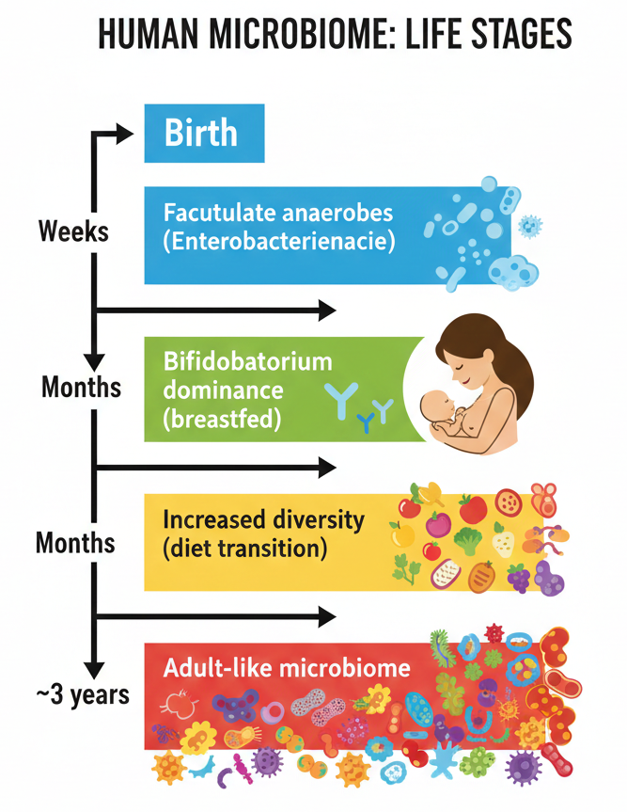
Figure 2. Showing Developmental Timeline of the Infant Microbiome

2.3.Host-Microbe crosstalk mechanisms.

2.3.1.Immune Programming
In infancy, the exposure to microbes is critical in the development of the innate and adaptive immune system. Microbial-associated molecular patterns (MAMPs) interact with pattern recognition receptors (PRRs), such as toll-like receptors (TLRs), thus, mediating the immune tolerance²⁵.

2.3.2.SCFAs promote²⁶:
- Accelerated Tregs (Tregs) growth.
- Attenuation of pro-inflammatory cytokines production.
- Development of the mucosal barrier integrity.

2.3.3.Metabolic Programming
The metabolites of microbes have significant impacts on energy regulation, fatness, and insulin tolerance in the host. The animal studies that are germ-free show an increase in immune reactivity and metabolic abnormalities, indicating the essentialness of the microbiota²⁷.
2.3.4.Neurodevelopmental Interactions
The gut-brain axis connects microbial messages to neural development via vagal connections, immune mediators, and microbial metabolites. Dysbiosis in early-life has been associated with altered neurodevelopmental conditions and stress reactions but the cause-effect relationship is yet to be clearly determined²⁸.

3.The Modern Disease and Dysbiosis.
3.2.Allergic and Autoimmune Disorders.
Reduced microbial diversity and slower colonization by Bacteroides and Clostridia species are related to an increased risk of asthma and food allergies. As a result of early antibiotic exposure, Tregs fail to mature, so that immune tolerance may be undermined²⁹.

3.3.Obesity and Metabolic Syndrome.
Infant exposure to antibiotics is associated with childhood obesity. This correlation may be caused by disparities in energy harvest and tone of inflammation mediated by microbiota³⁰.
Potential studies have shown that there are changes in microbial patterns in the pre-seroconversion phase in vulnerable youth that show genetic predisposition. Reduced butyrate-producing bacteria can degrade the immune system³¹.
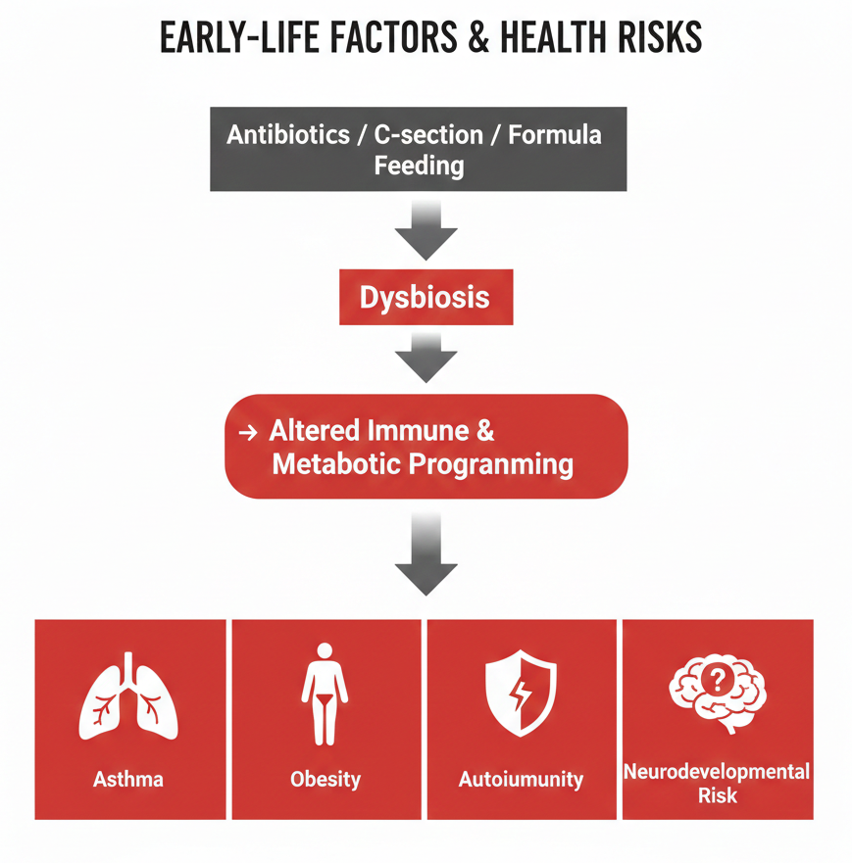
Figure 3. Showing Early-Life Perturbations and Disease Risk

4.Influences of the Environment and Society.
The diversity of microbial life is restricted by urbanisation, smaller family sizes, decreased contact with the outdoors and dietary restrictions through processed foods, and additional manipulation of microbial reservoirs by the use of agricultural antibiotics and environmental pollution. Old hypothesis states that, minimal contact with environmental microbes of the ancient ancestor plays a role in the immune system being dysregulated³².
.
5.Prevention and Treatment Interventions.
5.1.Maternal Interventions
The prevention of unnecessary antibiotic use, optimisation of maternal diet and microbiome in pregnancy is a background measure³³.
5.2.Microbiome Restoration

The transfer of vaginal microbes to the vagina is being studied and fecal microbiota transplantation (FMT), in some cases, is a new restorative intervention³⁴.
5.3.Specific Probiotics and Synbiotics.
Bacterial supplementation Precision microbial supplementation, based on host genetics and environment, is a future of personalised microbiome therapeutics³⁵.
5.4.Policy and Public Health
Indentured public health needs are the promotion of breastfeeding, the stewardship of antibiotics, or the promotion of safe exposure to microbes in the environment³⁶.

6.Discussion
Infant microbiome can be thought of as a dynamic developmental organ that plays a key role in immune development, metabolic control and the overall physiological homeostasis. At an early age, microorganism colonization of the mucosal surface is closely associated with immune system education, which promotes tolerance to commensal taxa at the expense of defensive response to invasive pathogens³⁷. Short-chain fatty acids and regulate epithelial barrier integrity, nutrient metabolism, and inflammatory signalling, which are microbial-derived metabolites. Therefore, the consequences of the first microbial colonization include both short-term effects of neonatal adaptation and long-term health outcomes, which survive into adulthood³⁸.
An expanding body of epidemiological and experimental evidence shows that there are strong links between microbial patterns in early life and predisposition to a number of chronic diseases such as allergies, asthma, and inflammatory bowel disease. However, the discipline still struggles with the issue of the difference between association and causation. Microbial perturbations have often been observed in healthy and diseased cohorts using observational studies, but whether these perturbations are causal drivers or epiphenomena of disease processes is an unsolved question which should be interrogated more rigorously³⁹.
The latest scientific discoveries have contributed greatly to the causation inference techniques. Temporal datasets that can be used to interrelate microbial succession with developmental and clinical outcomes over time are now available with longitudinal birth cohort studies. These designs allow early microbial signature identification, which occurs before the manifestation of the disease⁴⁰. Besides, the multi-omics strategies, such as metagenomics, metabolomics, transcriptomics and proteomics, allow functional interrogation of microbial ecosystems, as opposed to depending on taxonomic composition alone. Further insights into the role of defined microbial communities or isolated strains in the direct regulation of immune responses and metabolic signalling pathways have been provided by mechanistic validation in germ-free and gnotobiotic animal models⁴¹.
In spite of these steps, there are a number of research gaps that are still critical. Future studies should define the temporal caps on the effects of environmental exposures or medical interventions on microbial colonisation that are maximal and long-lasting. More focus is also necessary on the strain-level microbial functionality because closely related strains may have different immunomodulatory or metabolic functions. Moreover, genetic background and epigenetic control have a significant impact on microbiome composition and responsiveness, which highlights the need to develop combined host-microbe interaction models⁴².
The second significant issue is the safety and ethical concerns of deliberate microbiome modulation in infancy in the long term. Modern ways of life, characterized by over-hygiene, changes in diet, exposure to antibiotics and changes in birth practices, may interfere with historical patterns of microbial inheritance that in the past formed the basis of immune resistance. The knowledge of these disruptions offers a conceptual framework that can be used to deal with the global epidemic of chronic non-communicable diseases. Finally, it will be necessary to integrate ecological knowledge, clinical creativity, and community health policy in order to come up with safe microbiome-targeted approaches that can support health in future generations⁴³.

7.Conclusion
Infant microbiome is becoming recognized as a key health determinant during the human lifespan.
Primary colonization of the microbial environment is an expression of a complex interaction between maternal microbial inheritance, environmental exposure, dietary habits and sociocultural determinants.
This is a highly sensitive period of development, where host microbe interactions coordinate immune development, metabolic development, and neurodevelopment.
Events during this phase like overuse of antibiotics, caesarean birth, reduced breastfeeding, and reduced exposure to microbes in the environment can destabilize microbial diversity and stability, increasing vulnerability to immune mediated, metabolic and neurological diseases characteristic of most modern societies.
Maintaining microbial diversity and promoting physiological colonization patterns by using evidence-based maternal and infant healthcare practices are promising preventive medicine interventions.
As the study of microbiomes progresses, ecological understanding will be needed to combine with clinical practice and the policy to protect the microbiome integrity, and improve the long-term health outcomes of future generations.

ETHICAL APPROVAL: It is not applicable.

DISCLAIMER(ARTIFICIAL INTELLIGENCE): Author(s) hereby declares that NO generative AI technologies such as Large Language Models (ChatGPT, COPILOT, etc) and text-to-image generators have been used during writing or editing of this manuscript.

COMPETING INTERESTS: Authors have declared that no competing interests exist.
References

- Dominguez-bello, m. G. Et al. Delivery mode shapes the acquisition and structure of the initial microbiota across multiple body habitats in newborns. Proc. Natl acad. Sci. Usa 107, 11971–11975 (2010).
- Yatsunenko, t. Et al. Human gut microbiome viewed across age and geography. Nature 486, 222–227 (2012).
- Arrieta, m.-c. Et al. Early infancy microbial and metabolic alterations affect risk of childhood asthma. Sci. Transl. Med. 7, 307ra152 (2015).
- Stewart, c. J. Et al. Temporal development of the gut microbiome in early childhood from the teddy study. Nature 562, 583–588 (2018).
- Vatanen, t. Et al. Genomic variation and strain-specific functional adaptation in the human gut microbiome during early life. Nat. Microbiol. 4, 470–479 (2019).
- Shao, y. Et al. Stunted microbiota and opportunistic pathogen colonization in caesarean-section birth. Nature 574, 117–121 (2019).
- Tamburini, s., shen, n., wu, h. C. & clemente, j. C. The microbiome in early life: implications for health outcomes. Nat. Med. 22, 713–722 (2016).
- Korpela, k. Et al. Maternal fecal microbiota transplantation in cesarean-born infants rapidly restores normal gut microbial development. Cell 183, 324–334 (2020).
- Laursen, m. F. Et al. Breastmilk-promoted bifidobacteria produce aromatic lactic acids in the infant gut. Nat. Microbiol. 6, 1367–1382 (2021).
- Henrick, b. M. Et al. Bifidobacteria-mediated immune system imprinting early in life. Cell 184, 3884–3898 (2021).
- Yassour, m. Et al. Strain-level analysis of mother-to-child bacterial transmission during the first few months of life. Cell host microbe 24, 146–154 (2018).
- Ferretti, p. Et al. Mother-to-infant microbial transmission from different body sites shapes the developing infant gut microbiome. Cell host microbe 24, 133–145 (2018).
- Rothschild, d. Et al. Environment dominates over host genetics in shaping human gut microbiota. Nature 555, 210–215 (2018).
- Torow, n. & hornef, m. W. The neonatal window of opportunity: setting the stage for life-long host–microbial interaction. Trends Immunol. 39, 605–615 (2018).
- Durack, j. & lynch, s. V. The gut microbiome: relationships with disease and opportunities for therapy. J. Exp. Med. 216, 20–40 (2019).
- Heintz-Buschart, a. Et al. Integrated multi-omics of the human gut microbiome in a case study of familial type 1 diabetes. Nat. Med. 22, 860–868 (2016).
- Kostic, A. D. et al. The dynamics of the human infant gut microbiome in development and in progression toward type 1 diabetes. Cell host microbe 17, 260–273 (2015).
- Madan, j. C. Et al. Association of cesarean delivery and formula supplementation with the intestinal microbiome of 6-week-old infants. Jama pediatr. 170, 212–219 (2016).
- Bokulich, n. A. Et al. Antibiotics, birth mode, and diet shape microbiome maturation during early life. Sci. Transl. Med. 8, 343ra82 (2016).
- Blaser, m. J. & falkow, s. What are the consequences of the disappearing human microbiota? Nat. Rev. Microbiol. 7, 887–894 (2009).
- Rautava, s., luoto, r., salminen, s. & isolauri, e. Microbial contact during pregnancy, intestinal colonization and human disease. Nat. Rev. Gastroenterol. Hepatol. 9, 565–576 (2012).
- Bäckhed, f. Et al. Dynamics and stabilization of the human gut microbiome during the first year of life. Cell host microbe 17, 690–703 (2015).
- Arboleya, s. Et al. Establishment and development of intestinal microbiota in preterm neonates. Fems microbiol. Ecol. 79, 763–772 (2012).
- Cox, l. M. Et al. Altering the intestinal microbiota during a critical developmental window has lasting metabolic consequences. Cell 158, 705–721 (2014).
- Robertson, r. C., manges, a. R., finlay, b. B. & prendergast, a. J. The human microbiome and child growth – first 1000 days and beyond. Trends microbiol. 27, 131–147 (2019).
- Moore, R. E. & Townsend, S. D. Temporal development of the infant gut microbiome and implications for immune maturation. Annu. Rev. Microbiol. 78, 215–234 (2024).
- Stewart, C. J., Ajami, N. J. & Petrosino, J. F. Functional maturation of the early-life gut microbiome and host metabolic development. Cell Host Microbe 32, 1021–1034 (2024).
- Robertson, R. C., Mazzoni, A. & Prendergast, A. J. Maternal–infant microbial transmission and immune system programming. Trends Microbiol. 32, 410–423 (2024).
- Vatanen, T., Franzosa, E. A. & Huttenhower, C. Strain-level variation in the infant microbiome and immune education. Nat. Rev. Immunol. 24, 365–378 (2024).
- Madan, J. C., Hoen, A. G. & Hibberd, P. L. Prenatal antibiotic exposure, infant microbiome alteration and allergy risk. Microbiome 12, 144 (2024).
- Shin, J., Lee, S. H. & Kim, Y. Developmental trajectories of gut microbiota across gestational ages in early infancy. Microorganisms 13, 2158 (2025).
- Tarracchini, C. et al. Early-life human gut microbiome atlas reveals conserved colonisation patterns. npj Biofilms Microbiomes 11, 68 (2025).
- Tisza, M. J., Buck, C. B. & Droit, L. Longitudinal bacteriophage–bacteria interactions in the infant gut ecosystem. Nat. Microbiol. 10, 455–467 (2025).
- Stolberg-Mathieu, G. et al. Infant nutrition, metabolome development and gut microbiome maturation in a longitudinal cohort. BMJ Open 15, e094965 (2025).
- García-Mauriño, C. et al. Neonatal gut microbiota composition predicts risk of severe respiratory infections. Lancet Microbe 6, e210–e219 (2025).
- Bottino, G. F. et al. Universal ecological succession patterns in early-life gut microbiomes. Nat. Commun. 16, 5072 (2025).
- Arishi, R. A. et al. Development of the breastfed infant oral microbiome during the first two years of life. Front. Cell. Infect. Microbiol. 15, 1534750 (2025).
- Lynn, D. J., Pulendran, B. & Finlay, B. B. Early antibiotic exposure impairs vaccine responses through microbiome disruption. Nature 629, 102–108 (2025).
- Nieto, P. A., McDonald, J. A. K. & Marchesi, J. R. Early-life gut microbiome signatures associated with childhood chronic disease risk. Gut Microbes 17, 235–248 (2025).
- Adamov, A. et al. Antibiotic-induced deviations in infant gut microbiome developmental trajectories. ISME J. 19, 1221–1234 (2025).
- Yassour, M., Vlamakis, H. & Xavier, R. J. Long-term stability of infant microbiome development and disease prediction. Sci. Transl. Med. 18, eadi2456 (2026).
- Borrego-Ruiz, A. & Borrego, J. J. Early-life microbiome development and lifelong health outcomes. Microbiome Res. Rep. 4, 78–92 (2025).
- Ding, M., Ross, R. P., Dempsey, E., Li, B., & Stanton, C. Infant gut microbiome reprogramming following introduction of solid foods (weaning). Gut Microbes, 17(1), 2571428 (2025).

