Original Research Article
Green Synthesis and Multi-Technique Characterization of Copper Nanoparticles Mediated by Citrus sinensis Peel Essential Oil

Abstract
Background:
Green synthesis of nanoparticles using plant-derived materials has gained increasing attention due to environmental and safety concerns associated with conventional chemical methods. Citrus sinensis essential oil, obtained from agro-waste citrus peels, contains bioactive phytochemicals capable of acting as natural reducing and stabilizing agents. This study aimed to synthesize copper-based nanoparticles via a green route and evaluate their physicochemical properties.
Methods:
Copper nanoparticles were synthesized via a green, biogenic route using Citrus sinensis essential oil. The synthesized nanoparticles were characterized using UV-Visible spectroscopy, Fourier-transform infrared spectroscopy (FTIR), scanning electron microscopy (SEM), X-ray diffraction (XRD), and gas chromatography-mass spectrometry (GC-MS).
Results:
UV-Visible spectroscopy showed a characteristic absorption band at 300-320 nm, indicating nanoparticle formation. FTIR analysis revealed functional groups such as hydroxyl, carbonyl, and aliphatic moieties, confirming phytochemical involvement in reduction and stabilization. SEM images (8000×-10,000×) showed agglomerated clusters with irregular and porous morphology, while the primary particle size was inferred to be nanoscale. XRD patterns exhibited diffraction peaks consistent with nanocrystalline copper-based structures; however, peak broadening and low intensity suggest weak crystallinity and possible phase overlap. GC-MS identified 40 phytochemical constituents, predominantly oxygenated monoterpenes and sesquiterpenes, including cis-(-)-1,2-epoxy-p-menth-8-ene, decanal, D-carvone, and α-copaene, which likely contributed to nanoparticle formation and stabilization.
Conclusion:
Citrus sinensis essential oil serves as an effective biogenic agent for the synthesis of copper-based nanostructures, providing an eco-friendly approach for agro-waste valorization. The characterized properties suggest potential applications in agriculture, environmental management, and vector control; however, further studies are required to validate their biological and functional performance.
Keywords:
Citrus sinensis; copper nanoparticles; green synthesis; essential oil; physicochemical characterization; GC-MS
1. Introduction
The increasing global burden of insect pests and disease vectors has intensified the search for effective, environmentally benign alternatives to synthetic chemical insecticides (Ezeike et al., 2026). Plant-derived bioactive compounds have long been recognized for their insecticidal, repellent, and growth-regulating properties, owing to their structural diversity and ecological compatibility (Ezeike et al., 2016). Secondary metabolites such as terpenoids, phenolics, alkaloids, and flavonoids interfere with insect nervous systems, disrupt metabolic pathways, and impair reproductive capacity, making them valuable tools in vector control and integrated pest management strategies (Isman, 2006; Pavela & Benelli, 2016). Unlike conventional insecticides, plant-based bioactives often exhibit multiple modes of action and reduced non-target toxicity, thereby lowering the risk of resistance development. These bioactive compounds are commonly concentrated in specific plant tissues, particularly those regarded as agricultural residues, which has redirected scientific interest toward the valorization of plant waste materials.
Plant waste, especially agro-industrial by-products such as fruit peels, represents a significant yet underutilized resource rich in biologically active phytochemicals. Citrus processing industries generate millions of tons of peel waste annually, posing environmental disposal challenges while simultaneously offering opportunities for value addition (Sagar et al., 2018). Citrus peels are known to contain high concentrations of essential oils, flavonoids, and limonoids with documented antimicrobial, insecticidal, and antioxidant activities (Bocco et al., 1998; Manthey & Grohmann, 2001). The conversion of such waste into functional materials aligns with circular economy principles and sustainable agriculture, particularly when these bio-resources are harnessed as reducing and stabilizing agents in nanomaterial synthesis. This convergence of waste utilization and functional material development naturally leads to the application of nanotechnology.
Nanoparticles have emerged as a transformative platform in agriculture, medicine, and environmental science due to their unique physicochemical properties, which differ markedly from their bulk counterparts. At the nanoscale, materials exhibit enhanced surface area, altered electronic structure, and improved reactivity, enabling superior biological interactions and functional efficiency (Khan et al., 2019). In pest and vector control, nanoparticles can enhance the stability, bioavailability, and controlled release of active compounds, thereby improving efficacy while minimizing environmental impact (Yin et al., 2023). However, conventional physicochemical synthesis routes often involve toxic reagents and high energy demands, prompting the development of greener synthesis approaches that integrate biological materials, particularly plant-derived substances such as essential oils.
Essential oils are volatile, complex mixtures of lipophilic secondary metabolites predominantly composed of mono- and sesquiterpenes, along with oxygenated derivatives such as alcohols, aldehydes, and esters. These oils play defensive roles in plants and possess well-documented insecticidal, larvicidal, fumigant, and repellent activities (Regnault-Roger et al., 2012). Beyond their biological activity, essential oils function effectively as reducing, capping, and stabilizing agents in nanoparticle synthesis, facilitating eco-friendly fabrication processes (Ahmed et al., 2016). The chemical composition of essential oils not only governs nanoparticle formation but also influences particle morphology, crystallinity, and surface chemistry. Among essential oil-bearing plants, Citrus sinensis has attracted particular scientific interest.
Citrus sinensis (sweet orange), a member of the Rutaceae family, is one of the most widely cultivated citrus species globally, primarily for juice production. Its peel constitutes nearly 40-50% of the fruit mass and is exceptionally rich in essential oils dominated by d-limonene, alongside other bioactive terpenes and phenolic compounds (Fisher & Phillips, 2008; Viuda-Martos et al., 2007). Extracts and essential oils from C. sinensis peels have demonstrated significant insecticidal and larvicidal activity against disease vectors such as Aedes aegypti and Anopheles species, underscoring their relevance in vector management (Ezeonu et al., 2001; El-Akhal et al., 2015). The phytochemical richness of C. sinensis essential oil further supports its application in green nanoparticle synthesis, where plant metabolites mediate nucleation and growth processes (Bortoluz et al., 2026).
In this study, physicochemical characterization refers to the combined analysis of physical attributes (morphology, crystallinity, and particle size) and chemical properties (surface functional groups, optical behavior, and phytochemical composition) of the synthesized nanoparticles using SEM, XRD, FTIR, UV-Visible spectroscopy, and GC-MS. The successful application of nanoparticles synthesized via plant-mediated routes depends critically on comprehensive physicochemical characterization. Techniques such as Fourier-transform infrared spectroscopy (FTIR) enable identification of functional groups responsible for reduction and stabilization, while scanning electron microscopy (SEM) provides insight into particle morphology and size distribution. X-ray diffraction (XRD) reveals crystalline structure and phase purity, optical absorption spectroscopy elucidates electronic transitions and band gap characteristics, and gas chromatography-mass spectrometry (GC-MS) allows detailed profiling of essential oil constituents involved in nanoparticle formation (Iravani et al., 2014). Together, these techniques establish structure-property relationships that are essential for understanding nanoparticle behavior and optimizing their biological functionality.
Despite growing interest in green nanotechnology, there remains a need for systematic studies that integrate phytochemical profiling with detailed physicochemical analysis of essential oil-mediated nanoparticles derived from agro-waste resources. Such investigations not only contribute to sustainable material synthesis but also provide foundational knowledge for future applications in vector control and environmental management. Therefore, this study focuses on the physicochemical characterization of nanoparticles synthesized using Citrus sinensis essential oil, aiming to elucidate the role of citrus-derived bioactive compounds in nanoparticle formation and to establish a scientific basis for their potential application in eco-friendly pest and vector control strategies.
2. Materials and Methods
2.1. Materials
Fresh peels of Citrus sinensis (sweet orange) were obtained from mature fruits collected from a local agricultural source and authenticated by a qualified botanist. The peels were thoroughly washed with distilled water to remove adhering dirt and contaminants and air-dried at room temperature prior to use. All chemicals and reagents used in this study were of analytical grade and used without further purification. Deionized/distilled water was employed throughout the experimental procedures. Glassware was thoroughly cleaned, rinsed with distilled water, and oven-dried before use to avoid contamination during synthesis and analysis.
2.2. Extraction of Citrus sinensis Essential Oil
Essential oil was extracted from the fresh peels of Citrus sinensis using hydrodistillation with a Clevenger-type apparatus, following the procedure described by Zeleke (2022) with slight modification. About 500 g of finely chopped Citrus peels was placed in a 2-liter flask containing 1.5 liters of distilled water and distilled for 3 hours. The distillation process allowed volatile oil components to vaporize along with water vapor, which were subsequently condensed and collected in the calibrated arm of the Clevenger apparatus. The essential oil layer was separated from the aqueous phase, dried over anhydrous sodium sulfate to remove residual moisture, and stored in airtight amber glass vials at 4 °C until further use to prevent oxidative degradation.
2.3. Synthesis of Citrus sinensis Essential Oil-Mediated Copper Nanoparticles
Copper nanoparticles were synthesized via a green (biogenic) synthesis method using Citrus sinensis essential oil as both reducing and stabilizing agent, following a procedure adapted from Naradala et al., 2022 and Rai et al. (2016), with slight modifications. Briefly, 1.0 mL of Citrus sinensis essential oil was emulsified in 49 mL of distilled water and stirred magnetically at 600 rpm for 30 minutes at room temperature to obtain a uniform dispersion. Separately, 50 mL of 1 mM analytical grade copper sulfate pentahydrate (CuSO₄·5H₂O, ≥99% purity, Sigma-Aldrich or equivalent supplier) solution was freshly prepared using distilled water. The essential oil dispersion was added dropwise to the CuSO₄ solution under continuous stirring. The reaction mixture was maintained at 70 °C and stirred for 2 hours, during which a gradual color change from light blue to dark brown was observed, indicating the reduction of Cu²⁺ ions and the formation of copper nanoparticles mediated by phytochemical constituents of the essential oil. Upon completion of the reaction, the mixture was allowed to cool to room temperature and centrifuged at 10,000 rpm for 15 minutes to separate the synthesized nanoparticles. The obtained pellet was washed three times with distilled water to remove residual ions and unbound phytochemicals. No calcination step was applied; nanoparticles were oven-dried at 60 °C to preserve phytochemical capping and prevent oxidation.
2.4. Physicochemical Characterization
2.4.1 UV-Visible Spectroscopy
The optical properties and preliminary confirmation of nanoparticle formation were investigated using UV-Visible spectroscopy, following the method described by Rai et al. (2016) with minor modifications. A colloidal suspension of the synthesized nanoparticles was prepared by dispersing 2 mg of the dried nanoparticle powder in 5 mL of distilled water, followed by ultrasonication for 10 minutes to ensure uniform dispersion. UV-Vis absorbance spectra were recorded using a UV-Visible spectrophotometer in the wavelength range of 200-800 nm at room temperature, with a spectral resolution of 1 nm. Measurements were performed using quartz cuvettes (1 cm path length), and distilled water was used as the reference blank. The formation of copper nanoparticles was confirmed by the appearance of a characteristic absorption band in the visible region, attributed to surface plasmon resonance (SPR) arising from collective oscillation of conduction band electrons. Changes in peak position and intensity were used to assess the optical behavior and stability of the synthesized nanoparticles.
2.4.2. Fourier-Transform Infrared Spectroscopy (FTIR)
Fourier-transform infrared (FTIR) spectroscopy was employed to investigate the surface functional groups associated with the synthesized Citrus sinensis essential oil-mediated nanoparticles and to elucidate the phytochemical moieties involved in their stabilization. The analysis was conducted following the method described by Iravani (2011), with slight modifications. The synthesized nanoparticles were collected, thoroughly washed with distilled water, and dried prior to analysis. The dried nanoparticle sample was finely ground using an agate mortar and pestle. Approximately 2 mg of the nanoparticle powder was homogeneously mixed with 100 mg of spectroscopic-grade potassium bromide (KBr) and compressed into a transparent pellet using a hydraulic press. FTIR spectra were recorded using an FTIR spectrometer over a wavenumber range of 4000-400 cm⁻¹, with a spectral resolution of 4 cm⁻¹ and 32 scans per sample to enhance spectral clarity. The obtained spectra were analyzed to identify characteristic absorption bands corresponding to functional groups such as hydroxyl (-OH), carbonyl (C=O), aromatic (C=C), and aliphatic (C-H) moieties.
2.4.3. Scanning Electron Microscopy (SEM)
The surface morphology and particle size distribution of the synthesized Citrus sinensis essential oil-mediated nanoparticles were examined using scanning electron microscopy (SEM), following the method reported by Khan et al. (2019) with minor modifications. A small quantity of the dried nanoparticle sample was gently dispersed onto a carbon-coated aluminum stub and allowed to adhere under vacuum. To minimize surface charging and improve image resolution, the sample was sputter-coated with a thin layer of gold to a thickness of approximately 5 nm. SEM analysis was carried out at an accelerating voltage of 10-15 kV, and micrographs were recorded at varying magnifications.
2.4.4. X-Ray Diffraction (XRD)
X-ray diffraction (XRD) analysis was carried out to determine the crystalline structure, phase composition, and average crystallite size of the synthesized Citrus sinensis essential oil-mediated nanoparticles, following the method described by Cullity and Stock (2001) with minor modifications. The dried nanoparticle powder was gently ground to ensure homogeneity and mounted onto a sample holder for analysis. XRD measurements were performed using an X-ray diffractometer equipped with Cu Kα radiation (λ = 1.5406 Å), operating at an accelerating voltage of 40 kV and a current of 30 mA. Diffraction patterns were recorded over a 2θ range of 20°-80° with a step size of 0.02° and a scanning rate of 2° min⁻¹ at room temperature. The obtained diffraction peaks were indexed by comparison with standard reference patterns from the Joint Committee on Powder Diffraction Standards (JCPDS) database to identify the crystalline phases present. The average crystallite size (D) of the nanoparticles was estimated using the Debye-Scherrer equation:
$$D=\frac{Kλ}{βcos θ}$$
where K is the shape factor (0.9), λ is the X-ray wavelength, β is the full width at half maximum (FWHM) of the diffraction peak (in radians), and θ is the Bragg diffraction angle.
2.4.5. Gas Chromatography-Mass Spectrometry (GC-MS)
Gas chromatography-mass spectrometry (GC-MS) analysis was employed to identify phytochemical constituents adsorbed on the surface of the synthesized Citrus sinensis essential oil-mediated nanoparticles, following the method described by Philip (2010) with slight modifications. This analysis was conducted to elucidate the bioactive compounds from the essential oil involved in nanoparticle capping and stabilization. For GC-MS analysis, 10 mg of the dried nanoparticle sample was dispersed in 5 mL of analytical-grade n-hexane and sonicated for 15 minutes to desorb surface-bound organic compounds. The mixture was then centrifuged at 8,000 rpm for 10 minutes, and the clear supernatant was collected and filtered through a 0.22 µm syringe filter prior to injection. GC-MS analysis was performed using a GC-MS system equipped with a capillary column. Helium was used as the carrier gas at a constant flow rate of 1.0 mL min⁻¹. The injector temperature was maintained at 250 °C, and the oven temperature was programmed from 60 °C (held for 2 min) to 280 °C at a rate of 10 °C min⁻¹, with a final hold of 10 minutes. Mass spectra were recorded in electron ionization (EI) mode at 70 eV, with a mass scan range of m/z 40-600. The detected compounds were identified by comparing their mass spectra with those available in the National Institute of Standards and Technology (NIST) mass spectral library and by matching calculated retention indices with literature values. The identified phytochemicals were considered indicative of essential oil constituents associated with the nanoparticle surface and responsible for stabilization during the green synthesis process.
2.5. Data Analysis
Analytical outputs were processed using specialized software: OMNIC for FTIR, ImageJ for SEM analysis, OriginPro for XRD data visualization, and ChemStation for GC-MS analysis.

3. Results
3.1. Optical Absorption Analysis of Citrus sinensis Peel Essential Oil-Mediated Copper Nanoparticles
The absorption peak at ~300-320 nm corresponds to surface plasmon resonance (SPR) arising from the collective oscillation of conduction band electrons, which is characteristic of copper nanoparticles and falls within the range reported for nanoscale Cu-based materials synthesized via green routes (Figure. 1). The relatively sharp and well-defined nature of the absorption peak suggests a narrow size distribution and good dispersion stability of the nanoparticles within the colloidal system. Furthermore, the absence of multiple or broadened peaks indicates minimal polydispersity and limited aggregation at the optical level. The gradual decline in absorbance across the visible region (400-800 nm) further supports the optical stability of the nanoparticles and suggests effective capping and stabilization by phytochemical constituents present in the Citrus sinensis essential oil. The observed optical behavior is consistent with previous reports on plant-mediated synthesis of copper nanoparticles, where absorption bands in the range of 280-350 nm are indicative of nanoscale particle formation.

Figure. 1: Optical Absorption Spectrum of Citrus sinensis essential oil-mediated copper nanoparticles
3.2. FTIR Analysis of Citrus sinensis Peel Essential Oil-Mediated Copper Nanoparticles
The FTIR spectrum of the synthesized Citrus sinensis essential oil-mediated copper nanoparticles revealed several characteristic absorption bands, indicating the presence of phytochemical functional groups associated with nanoparticle surface stabilization (Figure 2). The broad band observed around 3387 cm⁻¹ is attributed to O-H stretching vibrations of hydroxyl groups, suggesting the involvement of phenolic or alcoholic compounds in capping the nanoparticles. Absorption peaks in the region of 2922-2852 cm⁻¹ correspond to aliphatic C-H stretching vibrations, indicative of terpene-based organic moieties adsorbed on the nanoparticle surface. The prominent band near 2100-2000 cm⁻¹ may be associated with C≡C or C≡N stretching vibrations, while peaks observed around 1650-1550 cm⁻¹ are characteristic of C=O stretching and aromatic C=C vibrations, implying the presence of carbonyl- and aromatic-containing phytochemicals. Additional absorption bands in the range of 1278-1020 cm⁻¹ are assigned to C-O and C-O-C stretching vibrations, further supporting the role of oxygenated functional groups in nanoparticle stabilization.
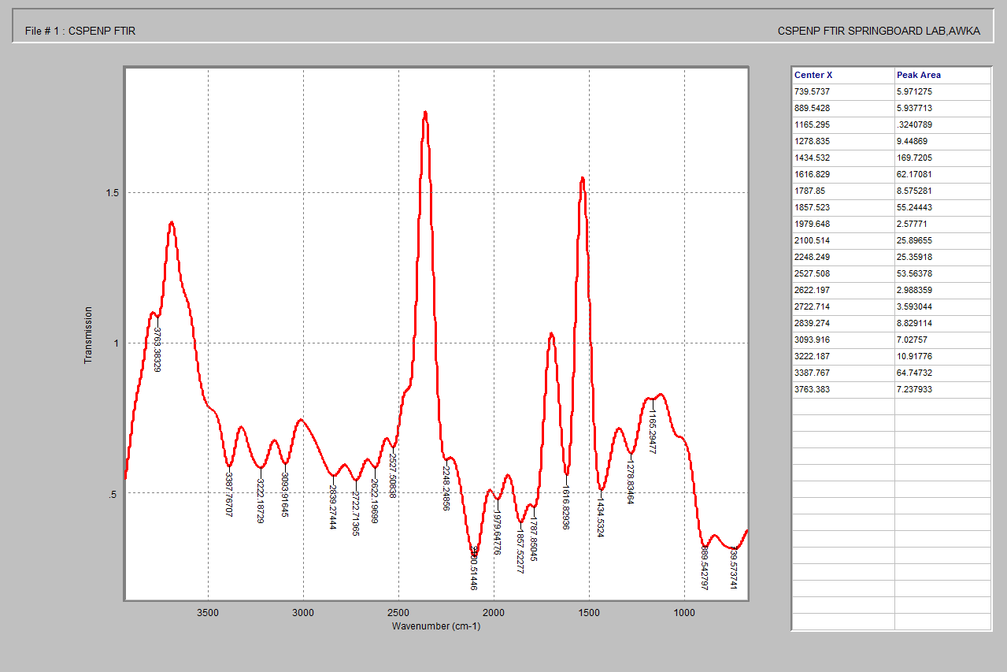
Figure 2: FTIR spectrum of the synthesized Citrus sinensis essential oil–mediated copper nanoparticles
3.3. SEM Analysis of Citrus sinensis Peel Essential Oil-Mediated Copper Nanoparticles
The SEM micrographs of the synthesized Citrus sinensis essential oil-mediated copper nanoparticles recorded at 8000× and 10,000× magnifications reveal an irregular, non-spherical morphology characterized by agglomerated nanoparticulate clusters forming a porous, sponge-like surface structure (Figure 3). At lower magnification (8000×), the nanoparticles appear as densely packed aggregates with heterogeneous shapes, suggesting significant particle-particle interactions during nucleation and growth, with agglomerate sizes ranging approximately from 10 to 50 µm. The larger sizes observed in SEM correspond to agglomerated clusters, while the primary nanoparticle size is inferred to be in the nanometer range based on surface features and supported by XRD-derived crystallite size. Higher magnification imaging (10,000×) provides clearer insight into the surface texture, showing rough, flaky, and interconnected nanostructures with visible voids, indicative of organic capping and stabilization by phytochemical constituents from the essential oil. Although individual nanoparticles are not distinctly resolved due to agglomeration, the fine surface features suggest primary particle sizes in the nanometer range, estimated to be approximately 20-80 nm, which is consistent with the crystallite size (8-10 nm) obtained from XRD analysis.
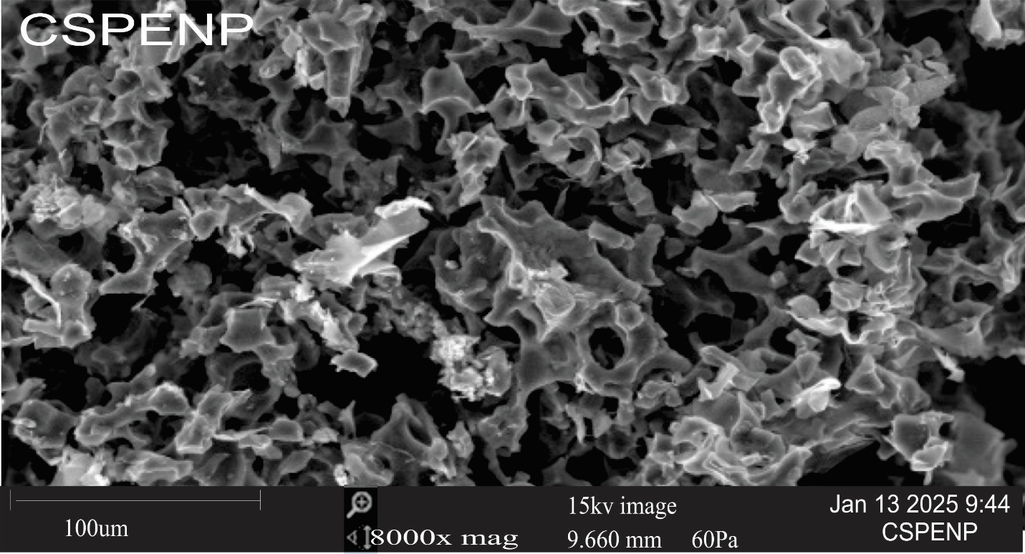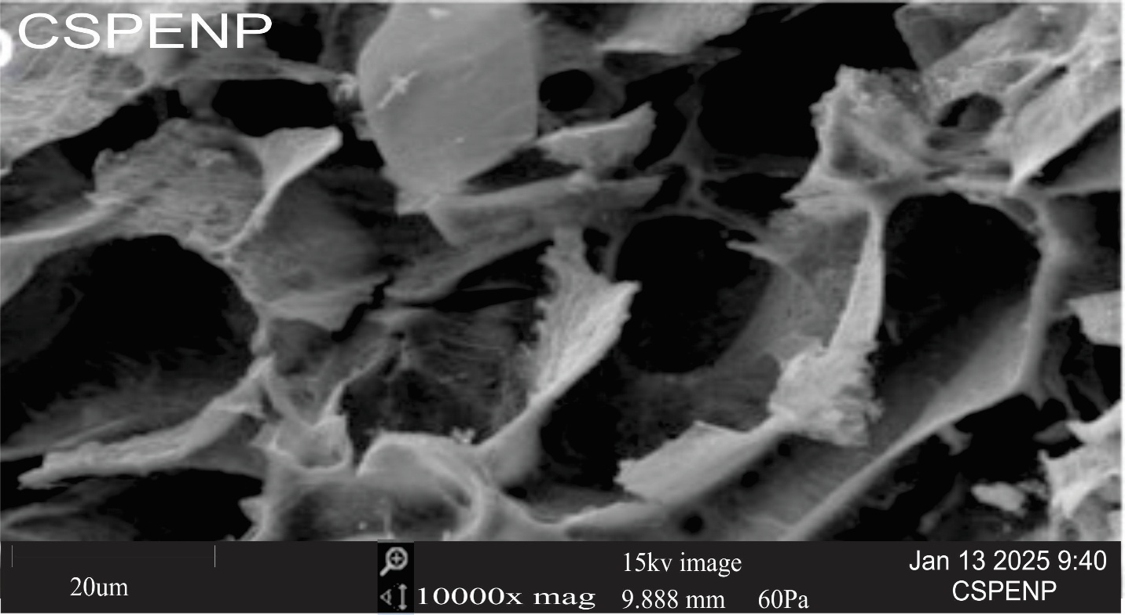
Figure 3: SEM micrographs of the synthesized Citrus sinensis essential oil-mediated copper nanoparticles recorded at 8000× and 10,000× magnifications respectively
3.4. XRD Analysis of Citrus sinensis Peel Essential Oil-Mediated Copper Nanoparticles
The X-ray diffraction (XRD) pattern of the synthesized Citrus sinensis essential oil-mediated copper nanoparticles exhibits distinct diffraction peaks indexed to the (001), (101), (111), and (122) crystallographic planes, indicating the formation of nanocrystalline copper-based structures (Figure 4). The prominent peaks observed in the 2θ range of approximately 40°-50° are characteristic of copper-based nanostructures and suggest successful formation of copper-containing phases via the green synthesis route. The diffraction peaks were tentatively matched with standard JCPDS reference patterns for copper oxide phases; however, definitive phase identification was limited due to peak broadening, low intensity, and possible phase overlap. The relatively broad nature of the diffraction peaks suggests nanoscale crystallite dimensions, consistent with particle size reduction at the nanoscale and possible lattice strain induced by phytochemical capping agents. This was quantitatively supported by Debye-Scherrer analysis of the most intense (101) peak at 2θ ≈ 45°, which yielded an average crystallite size of approximately 8-10 nm. This nanoscale size range indicates a high surface-to-volume ratio, typically associated with enhanced reactivity and biological activity. Furthermore, the elevated background intensity and slight peak broadening imply the presence of amorphous organic residues from Citrus sinensis essential oil adsorbed on the nanoparticle surface, which may contribute to stabilization and prevent excessive particle agglomeration.

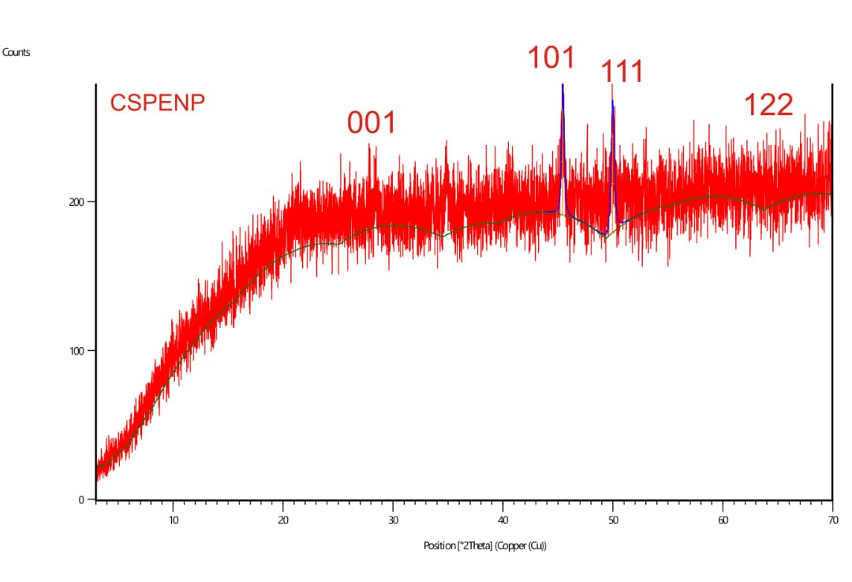
Figure 4: X-ray diffraction (XRD) pattern of the synthesized Citrus sinensis essential oil-mediated copper nanoparticles
3.5. Bioactive constituents in Citrus sinensis peel essential oil incorporated into copper nanoparticles
The GC-MS analysis of Citrus sinensis essential oil of copper nanoparticles revealed a complex mixture of oxygenated monoterpenes, sesquiterpenes, aldehydes, alcohols, and esters, confirming its rich phytochemical profile (Table 1). The dominant constituents included cis-(-)-1,2-Epoxy-p-menth-8-ene (10.73%), decanal (9.23%), D-carvone (7.87%), α-copaene (6.01%), and tricyclic sesquiterpenes such as (1R,2S,6S,7S,8S)-8-isopropyl-1-methyl-3-methylenetricyclodecane derivatives (6.29% and 3.47%). Oxygenated compounds such as α-terpineol, citral, carveol, and octadienal derivatives are known for their strong reducing potential, facilitating the conversion of Cu²⁺ ions to Cu⁰ nanoparticles, while sesquiterpenes and long-chain fatty acid esters contribute to effective surface capping and stabilization. The presence of hydroperoxides and aldehydes further supports nucleation and growth control during nanoparticle formation.
Table 1: Bioactive compounds identified in Citrus sinensis peel essential oil incorporated into copper nanoparticles
S/N | Bioactive Constituents | Molecular Formula | Molecular Weight | Retention Time | Percentage (%)
1 | cis-(-)-1,2-Epoxy-p-menth-8-ene | C₁₀H₁₆O | 125 | 2.445 | 10.73
2 | 6-Octenal, 3,7-dimethyl-, (R)- | C₁₀H₁₈O | 154 | 2.485 | 1.36
3 | 1-Nonanol | C₉H₂₀O | 144 | 2.549 | 0.78
4 | Bicyclo[3.3.0]oct-2-en-7-one, 6-methyl- | C₉H₁₂O | 136 | 2.618 | 1.04
5 | 2-Isopropenyl-5-methylhex-4-enal | C₁₀H₁₆O | 152 | 2.647 | 0.80
6 | .alpha.-Terpineol | C₁₀H₁₈O | 154 | 2.716 | 2.07
7 | Decanal | C₁₀H₂₀O | 156 | 2.739 | 9.23
8 | 1H-Indene, 1-ethylideneoctahydro-, trans- | C₁₁H₁₈ | 150 | 2.768 | 2.95
9 | Limonene | C₁₀H₁₆ | 136 | 2.797 | 0.97
10. | 2-Cyclohexen-1-ol, 2-methyl-5-(1-methylethenyl)-, cis | C₁₀H₁₆O | 152 | 2.849 | 4.34
11 | Carveol | C₁₀H₁₆O | 152 | 2.912 | 2.15
12 | 2,6-Octadienal, 3,7-dimethyl-, (Z) | C₁₀H₁₆O | 152 | 2.947 | 1.81
13 | D-Carvone | C₁₀H₁₄O | 150 | 2.999 | 7.87
14 | Citral | C₁₀H₁₆O | 152 | 3.097 | 2.93
15 | 1-Cyclohexene-1-carboxaldehyde, | C₁₀H₁₄O | 150 | 3.172 | 2.72
16 | (2S,4R)-p-Mentha-[1(7),8]-diene 2- 2-hydroperoxide | C₁₀H₁₆O₂ | 168 | 3.235 | 1.15
17 | Oxirane, decyl- | C₁₂H₂₄O | 184 | 3.281 | 1.36
18 | 7-Propylidene-bicyclo[4.1.0]heptan | C₁₀H₁₆ | 136 | 3.316 | 1.80
19 | (3R,6R)-3-Hydroperoxy-3-methyl-6-(prop-1-en-2-yl)cyclohex-1-ene | C₁₀H₁₆O₂ | 168 | 3.391 | 1.82
20 | 2,6,10-Dodecatrien-1-ol, 3,7,11-trimethyl-, (Z, E) | C₁₅H₂₆O | 222 | 3.460 | 1.14
21 | .alpha.-ylangene | C₁₅H₂₄ | 204 | 3.581 | 0.87
22 | 2,6-Dimethyl-3,5,7-octatriene-2-ol, ,E,E | C₁₀H₁₆O | 152 | 3.610 | 1.31
23 | 1,3,6,10-Dodecatetraene, 3,7,11-trimethyl-, (Z, E) | C₁₅H₂₄ | 204 | 3.703 | 1.21
24 | .alfa.-Copaene | C₁₅H₂₄ | 204 | 3.749 | 6.01
25 | (1R,2S,6S,7S,8S)-8-Isopropyl-1-methyl-3-methylenetricyclo[4.4.0.02,7]decane-rel- | C₁₅H₂₄ | 204 | 3.818 | 6.29
26 | Dodecanal | C₁₂H₂₄O | 184 | 3.841 | 1.93
27 | 1H-Benzocycloheptene, 2,4a,5,6,7,8,9,9a-octahydro-3,5,5-trimethyl-9-methylene | C₁₅H₂₄ | 204 | 3.881 | 0.66
28 | Caryophyllene | C₁₅H₂₄ | 204 | 4.014 | 2.44
29 | (1R,2S,6S,7S,8S)-8-Isopropyl-1-methyl-3-methylenetricyclo[4.4.0.02,7]decane-rel | C₁₅H₂₄ | 204 | 4.055 | 3.47
30 | Humulene | C₁₅H₂₄ | 204 | 4.199 | 0.86
31 | .gamma.-Muurolene | C₁₅H₂₄ | 204 | 4.297 | 0.61
32 | Germacrene D | C₁₅H₂₄ | 204 | 4.343 | 2.31
33 | .alpha.-Muurolene | C₁₅H₂₄ | 204 | 4.418 | 2.51
34 | Dodecanoic acid, methyl ester | C₁₃H₂₆O₂ | 214 | 4.464 | 0.40
35 | 1-Isopropyl-4,7-dimethyl-1,2,3,5,6,8a-hexahydronaphthalene | C₁₅H₂₄ | 204 | 4.545 | 5.41
36 | Dodecanoic acid, ethyl ester | C₁₄H₂₈O₂ | 228 | 4.833 | 0.38
37 | Hexadecanoic acid, methyl ester | C₁₇H₃₄O₂ | 270 | 6.887 | 0.35
38 | m-Camphorene | C₂₀H₃₂ | 272 | 7.095 | 0.40
39 | Dibutyl phthalate | C₁₆H₂₂O₄ | 278 | 7.152 | 2.88
40 | Hexadecanoic acid, ethyl ester | C₁₈H₃₆O₂ | 284 | 7.291 | 0.71

4. Discussion
The successful spectroscopic, microscopic, and chromatographic characterization of Citrus sinensis essential oil-mediated copper nanoparticles underscores the viability of plant-driven green synthesis as an eco-friendly alternative to conventional chemical and physical methods. The observed optical behavior consistent with surface plasmon resonance aligns with widespread reports that plant-mediated copper nanoparticles exhibit distinctive UV-visible absorption features due to nanoscale electronic transitions, a hallmark of successful nanoparticle formation without harsh reducing agents (Luque-Jacobo et al., 2023). Such optical signatures not only confirm nanoparticle synthesis but also suggest increased surface reactivity, which is central to applications ranging from catalysis to antimicrobial activity.
The identification of multiple phytochemical functional groups on the nanoparticle surface through FTIR analysis supports the dual role of essential oil constituents as both reducing and stabilizing agents. Similar findings in other plant-mediated copper nanoparticle systems show that phytochemicals such as terpenoids, aldehydes, and alcohols provide electrons for metal ion reduction and persist on the nanoparticle interface to prevent uncontrolled aggregation (Luque-Jacobo et al., 2023; Asghar and Asghar, 2020). The presence of these organic caps is especially relevant for reducing environmental and biological toxicity, a key advantage over conventional synthetic routes that often require toxic surfactants (Luque-Jacobo et al., 2023).
Surface morphology revealed by SEM indicates that the nanoparticles form irregular, agglomerated structures, a common feature of biosynthesized copper nanoparticles by Tahir et al. (2022) and Priya et al. (2023). Such morphology often reflects the complex interplay between phytochemical capping agents and metal nuclei during growth, influencing surface area and reactive sites. High surface roughness and agglomeration can be advantageous for catalytic or antimicrobial applications by increasing the effective contact area between nanoparticles and target microbes or pollutants, consistent with reports of potent biological activity in similar biosynthesized nanoparticles (Tahir et al., 2022; Priya et al. 2023).
The X-ray diffraction (XRD) pattern of the synthesized nanoparticles exhibits broad and relatively low-intensity diffraction peaks, indicating a predominantly nanocrystalline to weakly crystalline structure rather than a highly ordered bulk crystalline phase. The observed peak broadening is a well-established characteristic of nanoscale materials and is attributed to reduced crystallite size and possible lattice strain effects associated with green synthesis routes.
The diffraction features are consistent with copper-based nanostructures, and the presence of oxide-related characteristics suggests that the nanoparticles are most likely copper oxide (CuO/Cu₂O) or mixed copper oxide phases, which commonly form due to surface oxidation of metallic copper under aqueous and atmospheric conditions during plant-mediated synthesis (Luque-Jacobo et al., 2023; Lakhani et al., 2025). However, due to the broadness and limited resolution of the peaks, definitive phase identification remains tentative in the absence of full JCPDS matching or Rietveld refinement.
This observation aligns with recent reports indicating that plant-mediated synthesis of copper nanoparticles frequently yields oxide forms such as CuO or Cu₂O due to rapid surface oxidation during synthesis and post-synthesis exposure to air (Luque-Jacobo et al., 2023; Lakhani et al., 2025). Although the crystallinity is weak, it is still comparable to other green synthesis studies where broad diffraction peaks are commonly observed and attributed to nanoscale effects rather than amorphous structure.
Quantitative analysis using the Debye–Scherrer equation yielded an average crystallite size of approximately 8–10 nm, further confirming the nanometric nature of the synthesized material. These findings are consistent with previous reports where plant-mediated synthesis produces nanocrystalline copper-based oxides with broadened but discernible diffraction features, reinforcing the effectiveness of green synthesis routes in producing nanoscale materials (Katta & Lank, 2024; Chelly et al., 2021).
GC-MS analysis revealed a complex suite of bioactive essential oil constituents, including monoterpenes, sesquiterpenes, aldehydes, and oxygenated compounds. These phytochemicals are known not only for their biological activities; such as insecticidal, antioxidant, and antimicrobial effects but also for their chemical functionalities that facilitate nanoparticle synthesis (Antonio-Pérez et al., 2023). The synergy between these naturally abundant compounds and the copper core suggests that the resulting nanoparticles could inherit both the physicochemical advantages of metal nanostructures and the bioactivity of essential oil compounds, positioning them for applications in sustainable pest/vector control and agricultural protection.
The role of phytochemicals in nanoparticle stabilization observed in this study is consistent with recent findings where plant-derived metabolites such as terpenoids, aldehydes, and alcohols function as both reducing and capping agents in green synthesis systems. For instance, copper oxide nanoparticles synthesized using Rosmarinus officinalis extract exhibited similar functional group involvement, confirming the universal role of plant secondary metabolites in nanoparticle formation (Moroda et al., 2025). Furthermore, recent studies have highlighted that plant-mediated synthesis routes not only enhance nanoparticle stability but also improve their biological functionality due to surface-bound bioactive compounds (Usman et al. 2024). The slight variations in morphology and aggregation patterns observed between studies may be attributed to differences in phytochemical composition, extraction methods, and reaction conditions, which are known to influence nucleation kinetics and particle growth. This aligns with recent reviews emphasizing that synthesis parameters and plant source variability significantly determine the physicochemical characteristics and application potential of green-synthesized copper nanoparticles (Bin Mobarak et al., 2025).
This study demonstrate that essential oil-mediated copper nanoparticles combine environmentally benign synthesis with structural and functional attributes advantageous for real-world applications. Compared to other plant extract systems that report antimicrobial, larvicidal, and catalytic properties of biosynthesized copper nanoparticles (Tahir et al., 2022; Priya et al. 2023; Luque-Jacobo et al., 2023), the present study supports a growing consensus that green nanotechnology can contribute meaningfully to public health, agricultural sustainability, and environmental remediation. By minimizing toxic reagents and harnessing bioactive plant waste peels, this approach aligns with circular economy principles and provides a compelling model for eco-responsible nanomaterial production.
5. Conclusion
Copper-based nanoparticles were successfully synthesized using Citrus sinensis essential oil via a green and eco-friendly approach and characterized using multiple analytical techniques. UV-Visible spectroscopy revealed a characteristic surface plasmon resonance band at 300-320 nm, indicating nanoparticle formation. FTIR analysis identified key functional groups, including hydroxyl, carbonyl, and aliphatic moieties, confirming the role of phytochemicals in reduction and surface stabilization. XRD analysis indicated the formation of nanocrystalline copper-based structures, with an average crystallite size of approximately 8-10 nm, although peak broadening suggests weak crystallinity and possible phase overlap. SEM observations showed agglomerated clusters, while the primary particle size was inferred to be within the nanoscale range. The findings demonstrate that Citrus sinensis essential oil is an effective biogenic agent for the synthesis of copper-based nanostructures, highlighting the potential of citrus agro-waste as a sustainable resource for environmentally benign nanomaterial production. The physicochemical properties of the synthesized nanoparticles suggest potential applications in agriculture, environmental management, and vector control. However, further studies are required to experimentally validate their biological efficacy and functional performance in real-world applications.
6. Limitations of the Study
This study has several limitations. The phase composition of the synthesized nanoparticles could not be definitively established due to broad XRD peaks, making it difficult to distinguish between Cu, CuO, and Cu₂O phases without advanced refinement techniques. SEM analysis revealed significant agglomeration, limiting accurate determination of individual particle size and morphology; higher-resolution techniques such as TEM or DLS were not employed. Although GC-MS identified phytochemical constituents, their specific mechanistic roles in nanoparticle reduction and stabilization were not quantitatively determined. In addition, the study focused solely on physicochemical characterization and did not include functional evaluations such as antimicrobial or larvicidal assays to validate potential applications. Furthermore, synthesis parameters (e.g., pH, reaction kinetics, and long-term stability) were not systematically optimized, and the use of a single plant source may limit generalizability. Future studies should address these aspects to enhance understanding and application of the synthesized nanoparticles.

Ethical Statement

Ethical clearance for this study was obtained from the Nnamdi Azikiwe University Animal Research Ethics Committee (Approval Reference: NAU/AREC/2024/0093; Date of Approval: 31 July 2024).

Declaration of Competing Interest

The authors declare no competing interests.
Disclaimer (Artificial intelligence)

Author(s) hereby declare that NO generative AI technologies such as Large Language Models (ChatGPT, COPILOT, etc.) and text-to-image generators have been used during the writing or editing of this manuscript.
References
- Ezeike, K.A., Danga, S.P.Y., Ezenwa, C.V., Chukas, C.F., Ogudu, E. O, Nwosu C. M, EbenebeIjeoma, R. Chukwunwejim, C. N, Oli, A.N, Esimone, C.O. (2026). Urban evolution of insecticide resistance and susceptibility patterns of Anopheles coluzzii in Southeastern Nigeria: implications for malaria vector control. Malarial Journal 25:86; https://doi.org/10.1186/s12936-025-05760-5
- Ezeike, A.K., Nukenine E.N., Danga S.P.Y., and Esimone C.O., (2016), Larvicidal effect of lantana camara and Ocimum gratissimum leaves extracts and their isolates against Aedes aegypti larvae (diptera: culicidae). Journal of Mosquito Research; 6(23): 1-10. https://doi:10.5376/jmr.2016.06.0023
- Isman M. B. (2006). Botanical insecticides, deterrents, and repellents in modern agriculture and an increasingly regulated world. Annual Review of Entomology, 51, 45–66. https://doi.org/10.1146/annurev.ento.51.110104.151146
- Pavela, R., & Benelli, G. (2016). essential oils as ecofriendly biopesticides? challenges and constraints. Trends in plant science, 21(12), 1000–1007. https://doi.org/10.1016/j.tplants.2016.10.005
- Sagar, N. A., Pareek, S., Sharma, S., Yahia, E. M., & Lobo, M. G. (2018). Fruit and Vegetable Waste: Bioactive Compounds, Their Extraction, and Possible Utilization. Comprehensive Reviews in food Science and Food Safety, 17(3), 512–531. https://doi.org/10.1111/1541-4337.12330
- Bocco, A., Cuvelier, M. E., Richard, H., & Berset, C. (1998). Antioxidant activity and phenolic composition of citrus peel and seed extracts. Journal of Agricultural and Food Chemistry, 46(6), 2123–2129. https://doi.org/10.1021/jf9709562
- Manthey, J. A., & Grohmann, K. (2001). Phenols in citrus peel byproducts. Concentrations of hydroxycinnamates and polymethoxylated flavones in citrus peel molasses. Journal of Agricultural and Food Chemistry, 49(7), 3268–3273. https://doi.org/10.1021/jf010011r
- Khan, I., Saeed, K. and Khan, I. (2019) Nanoparticles: properties, applications and toxicities. Arabian Journal of Chemistry; 12, 908-931.
https://doi.org/10.1016/j.arabjc.2017.05.011
- Yin, J., Su, X., Yan, S., & Shen, J. (2023). Multifunctional nanoparticles and nanopesticides in agricultural application. Nanomaterials (Basel, Switzerland), 13(7), 1255. https://doi.org/10.3390/nano13071255
- Regnault-Roger, C., Vincent, C., & Arnason, J. T. (2012). Essential oils in insect control: low-risk products in a high-stakes world. Annual Review of Entomology, 57, 405–424. https://doi.org/10.1146/annurev-ento-120710-100554
- Ahmed, S., Ahmad, M., Swami, B. L., & Ikram, S. (2016). A review on plants extract mediated synthesis of silver nanoparticles for antimicrobial applications: A green expertise. Journal of advanced Research, 7(1), 17–28. https://doi.org/10.1016/j.jare.2015.02.007
- Fisher, K., & Phillips, C. A. (2008). Potential antimicrobial uses of essential oils in food: Is citrus the answer? Trends in Food Science & Technology, 19(3), 156–164. https://doi.org/10.1016/j.tifs.2007.11.006
- Viuda-Martos, M., Ruiz-Navajas, Y., Fernández-López, J., & Pérez-Álvarez, J. A. (2007). Chemical composition of the essential oils obtained from some spices widely used in Mediterranean region. Acta Chimica Slovenica, 54, 921–926.
- Ezeonu, F. C., Chidume, G. I., & Udedi, S. C. (2001). Insecticidal properties of volatile extracts of orange peels. Bioresource Technology, 76(3), 273–274. https://doi.org/10.1016/s0960-8524(00)00120-6
- El-Akhal, F., El Ouali Lalami, A., & Guemmouh, R. (2015). Larvicidal activity of essential oils of Citrus sinensis and Citrus aurantium (Rutaceae) cultivated in Morocco against the malaria vector Anopheles labranchiae (Diptera: Culicidae). Asian Pacific Journal of Tropical Disease, 5(9), 672–676. https://doi.org/10.1016/S2222-1808(15)60815-5
- Bortoluz, J., Jacquot, A. J. P., Colissi, L. C., Sartori, P., Beltrami, L. V. R., Guégan, R., Machado, G., Roesch-Ely, M., Crespo, J. S., & Giovanela, M. (2026). Green synthesis of copper oxide nanoparticles using Citrus sinensis leaves: Effects of experimental parameters, antimicrobial evaluation and development of chitosan composites. Nanomaterials, 16(6), 369. https://doi.org/10.3390/nano16060369
- Iravani, S., Korbekandi, H., Mirmohammadi, S. V., & Zolfaghari, B. (2014). Synthesis of silver nanoparticles: chemical, physical and biological methods. Research in Pharmaceutical Sciences, 9(6), 385–406.
- Zeleke, Z. Z. (2022). Extraction of essential oil from lemon and orange peel by Clevenger apparatus:
Comparative GC-MS analysis of chemical composition, from Debre Berehan Market town Amahara Region Ethiopia. Ann Biotechnol; 5(1): 1026
- Naradala, J., Allam, A., Tumu, V. R., & Rajaboina, R. K. (2022). Antibacterial activity of copper nanoparticles synthesized by Bambusa arundinacea leaves extract. Biointerface Research in Applied Chemistry, 12(1), 1230–1236. https://doi.org/10.33263/BRIAC121.12301236
- Rai, M., Ingle, A. P., Birla, S., Yadav, A., & Santos, C. A. (2016). Strategic role of selected noble metal nanoparticles in medicine. Critical reviews in microbiology, 42(5), 696–719. https://doi.org/10.3109/1040841X.2015.1018131
- Iravani, S. (2011). Green synthesis of metal nanoparticles using plants. Green Chemistry, 13(10), 2638–2650. https://doi.org/10.1039/C1GC15386B
- Cullity, B. D., & Stock, S. R. (2001). Elements of X-ray diffraction (3rd ed.). Upper Saddle River: Prentice Hall.
- Philip, D. (2010). Green synthesis of gold and silver nanoparticles using Hibiscus rosa sinensis. Physica E: Low-dimensional Systems and Nanostructures, 42(5), 1417–1424. https://doi.org/10.1016/j.physe.2009.11.081
- Luque-Jacobo, C. M., Cespedes-Loayza, A. L., Echegaray-Ugarte, T. S., Cruz-Loayza, J. L., Cruz, I., de Carvalho, J. C., & Goyzueta-Mamani, L. D. (2023). biogenic synthesis of copper nanoparticles: a systematic review of their features and main applications. Molecules (Basel, Switzerland), 28(12), 4838. https://doi.org/10.3390/molecules28124838
- Asghar, M. A., & Asghar, M. A. (2020). Green synthesized and characterized copper nanoparticles using various new plants extracts aggravate microbial cell membrane damage after interaction with lipopolysaccharide. International Journal of Biological Macromolecules, 160, 1168–1176. https://doi.org/10.1016/j.ijbiomac.2020.05.198 (Retraction published Int J Biol Macromol. 2025 Jul; 318(Pt 3): 145695. https://doi:10.1016/j.ijbiomac.2025.145695
- Tahir, A., Quispe, C., Herrera-Bravo, J., Iqbal, H., ul Haq, Z., Anum, F., Javed, Z., Sehar, A., & Sharifi-Rad, J. (2022). Green synthesis, characterization and antibacterial, antifungal, larvicidal and anti-termite activities of copper nanoparticles derived from Grewia asiatica L. Bulletin of the National Research Centre, 46, 188. https://doi.org/10.1186/s42269-022-00877-y
- Priya, M., Venkatesan, R., Deepa, S., Sana, S. S., Arumugam, S., Karami, A. M., Vetcher, A. A., & Kim, S. C. (2023). Green synthesis, characterization, antibacterial, and antifungal activity of copper oxide nanoparticles derived from Morinda citrifolia leaf extract. Scientific Reports, 13(1), 18838. https://doi.org/10.1038/s41598-023-46002-5
- Lakhani, K.G., Hamid, R., Motamedi, E. and Marviya, G.V. (2025). A review on plant metabolite-mediated nanoparticle synthesis: sustainable applications in horticultural crops. Front. Nanotechnol. 7:1545413. https://doi:10.3389/fnano.2025.1545413
- Katta, A., & Lank, S. (2024). Biogenic synthesis of silver nanoparticles from mangrove leaf extracts: Characterization and biological applications. International Journal of Creative Research Thoughts, 12(9), 315–319.
- Chelly, S., Chelly, M., Zribi, R., Gdoura, R., Bouaziz-Ketata, H., & Neri, G. (2021). Electrochemical detection of dopamine and riboflavine on a screen-printed carbon electrode modified by AuNPs derived from Rhanterium suaveolens plant extract. ACS Omega, 6(36), 23666–23675. https://doi.org/10.1021/acsomega.1c00793
- Antonio-Pérez, A., Durán-Armenta, L. F., Pérez-Loredo, M. G., & Torres-Huerta, A. L. (2023). Biosynthesis of Copper Nanoparticles with Medicinal Plants Extracts: From Extraction Methods to Applications. Micromachines, 14(10), 1882. https://doi.org/10.3390/mi14101882
- Moroda, M. D., Deressa, T. L., Tiwikrama, A. H., & Chala, T. F. (2025). Green synthesis of copper oxide nanoparticles using Rosmarinus officinalis leaf extract and evaluation of its antimicrobial activity. Next Materials, 7, Article 100337. https://doi.org/10.1016/j.nxmate.2024.100337
- Usman, O., Mohsin Baig, M.M., Ikram, M. et al. (2024). Green synthesis of metal nanoparticles and study their anti-pathogenic properties against pathogens effect on plants and animals. Sci Rep 14, 11354. https://doi.org/10.1038/s41598-024-61920-8
- Bin Mobarak, M., Sikder, M. F., Muntaha, K. S., Islam, S., Rabbi, S. M. F., & Chowdhury, F. (2025). Plant extract-mediated green-synthesized CuO nanoparticles for environmental and microbial remediation: A review covering basic understandings to mechanistic study. Nanoscale Advances, 7, 2418–2445. https://doi.org/10.1039/D5NA00035A

