Original Research Article
In-Silico Evaluation and Docking of Herbal and Synthetic Antimicrobials Targeting Catalase in Edwardsiella spp.

Abstract
Edwardsiellosis, caused by Edwardsiella tarda and E. piscicida of the Enterobacteriaceae family, is a common disease affecting catfish. The adverse effects of antibiotics on health have led to a shift in research toward alternative strategies such as targeted drugs, vaccination, and the development of disease-resistant stocks. Bioinformatics offers a modern approach to identifying and analysing virulence proteins and their interactions with drugs and herbal compounds. Catalase, a protein that reduces hydrogen peroxide into oxygen and water, is a key virulence factor in E. tarda and E. piscicida. Virulent protein sequences were retrieved from the UniProt database and analyzed for their structure and function. Characterization of virulent protein catalase of E. tarda and E. piscicida revealed that these proteins have favourable solubility and structural stability, and were hydrophilic, and partially thermostable. Homology models of these proteins were built using SWISS-MODEL, validated, and found to be of good quality. The predicted 3D structures were used as receptors in docking studies (AutoDock and HEX) with 175 antibacterial herbal compounds. The Z-scores of the models indicated acceptable quality. Docking results identified lutein (Amaranthus viridis), isoginkgetin (Cyperus rotundus), and sciadopitysin (Cyperus rotundus) as the top compounds against E. tarda. For E. piscicida, lutein, ginkgetin (Cyperus rotundus), and isoginkgetin were most effective. These herbal compounds, characterized by low binding free energy, demonstrate the potential to control Edwardsiellosis in aquaculture. This preliminary study highlights promising alternatives to antibiotics, but further validation through in vitro and in vivo trials is necessary.
Keywords: Fish disease, Edwardsiellosis, Catalase, Homology modelling, molecular docking

1. INTRODUCTION
Aquaculture is currently the world’s fastest-growing food sector, greatly supporting the nutritional requirement, food security and country’s economy (Sudheesh et al. 2012; FAO 2024). The total aquatic animal production has reached 185 million tonnes, with aquaculture contributing 94.4 million tonnes (FAO 2024). Disease is a major concern affecting the growth of aquaculture. Among diseases, several bacterial infections in fish species, such as Aeromonas septicemia, Edwardsiellosis, Columnaris, Streptococcosis, and vibriosis, were very common and reported globally (Irshath et al. 2023).
Edwardsiellosis is an acute to chronic systemic disease leading to enormous economic losses of cultured seawater and freshwater fish species (Pakingking and Nguyen 2022). Outbreaks of Edwardsiellosis have been reported across numerous countries and regions, threatening the aquaculture industry (Janda and Duman 2024; Lu et al. 2025). It is caused by the genus Edwardsiella, which comprises five species viz., Edwardsiella tarda, E. piscicida, E. anguillarum, E. ictaluri, and E. hoshinae, infecting a wide range of hosts (Buján et al. 2018). The fish pathogenic E. tarda and E. piscicida are gram-negative bacteria of the Enterobacteriaceae family infecting wide range of fishes (Sakai et al. 2007; Noor et al. 2017; Janda and Duman 2024). Later, all the fish-pathogenic isolates were re-assigned as E. anguillarum and E. piscicida (Shao et al. 2015; Buján et al. 2018). In fish, Edwardsiellosis characterized by exophthalmia, ascites, hernia, and severe lesions of the internal organs (Pakingking and Nguyen 2022). These pathogens cause significant mortality and financial losses in wild and cultured fish species worldwide (Noor et al. 2017; Reichley et al. 2017; Esteve and Alcaide 2022).
The virulence factors of Edwardsiella spp. enhance bacterial survival and pathogenesis in hosts (Park et al. 2012). Although not fully understood, this process is believed to be multifactorial. It reportedly secreted adhesins, degradative enzymes, and type III and VI secretion systems (Navarro-Garcia et al. 2019). Several virulence-associated proteins have been identified, including catalase, TTSS regulator (esrB), glutamate decarboxylase (gadB), Citrate lyase ligase (citC), putative killing factor (mukF), pstS, Fimbrial operon (fimA), isor, astA, ompS2, pstC, qseC, edwI, Hemolysin A (hlyA), DNA gyrase (gyrB), ssrB and NanA (Jin et al. 2012; Moustafa et al. 2016; Armwood et al. 2022; Vishnupriya et al. 2024).
Among those virulence proteins, catalase that facilitates the breakdown of hydrogen peroxide into oxygen and water is one of the most significant in Edwardsiellosis infection. In addition to its antioxidant function, catalase proteins contribute to physiological fitness and play a role in pathogenesis and bacterial survival within macrophages and fish in vivo (Xiao et al. 2012). It is a crucial target in various diseases, and studies on catalase are important for developing effective ways to prevent and treat related diseases (Shahraki et al. 2020; Fang et al. 2023).
The widespread overuse of antibiotics has significantly contributed to the emergence of multidrug- resistant (MDR) strains of E. piscicida and other fish pathogens (Miller and Harbottle 2018, Algammal et al. 2022, Aktar et al. 2026), many of which carry various antibiotic resistance genes (ARGs) (Lu et al. 2025). The disease control strategies have advocated alternative, eco-friendly approaches with minimal side effects (Romero et al. 2012, Rocha et al. 2025). Among these, herbal compounds with specific antimicrobial properties have emerged as promising alternatives and can be incorporated as feed supplements (Shakya 2017; Parham et al. 2020; Alem 2024).
Understanding interactions with virulence factors is crucial for the discovery of novel herbal drugs as alternatives to antibiotics. Potent herbal compounds can serve as effective substitutes with minimal or no negative impact on the host and environment (Leung et al. 2012). Given the significance of catalase protein in Edwardsiella pathogenesis, this study emphasized its functional, physicochemical, and secondary structural characteristics and homology modelling of both E. tarda and E. piscicida by in silico analysis. Further, it focuses on the computational analysis and molecular docking of catalase proteins from E. tarda and E. piscicida, intending to evaluate their potential as drug targets against Edwardsiellosis.

2. MATERIALS AND METHODS
Retrieval of protein sequences: The catalase protein sequences were obtained utilizing the Universal Protein Resource (UniProt) database. Two catalase amino acid sequences of E. tarda (Accession number Q8GB51) and E. piscicida (Accession number A0A411GYW0) were obtained in FASTA format along with a host catalase protein for comparison (Pangasianodon hypophthalmus -XP_026774942).
Physicochemical properties characterization: ExPASy ProtParam server (Gasteiger et al. 2005) was employed to determine the physicochemical properties of the selected virulence proteins. Parameters determined included amino acid composition, number of each amino acid, extinction coefficient [EC] (Gill and Von Hippel, 1989), aliphatic index [AI] (Ikai 1980), molecular weight, instability index [II] (Guruprasad et al. 1990), isoelectric point (pI), the total number of positive (Arg+Lys) and negative (Asp+Glu) residues (+R/-R) and grand average hydropathy [GRAVY] (Kyte and Doolittle 1982). The analysis was performed utilizing the FASTA sequence of virulence proteins as input.
Functional analysis: The SOSUI server (Hirokawa et al. 1998) was employed to determine if the protein was soluble or transmembrane. The presence or absence of disulfide bonds, which determines the protein’s stability and functional linkage, their bonding pattern, and the number of cysteine residues, were predicted with the help of the CYS_REC tool. The conserved region of a given protein sequence called the active domains was accessed utilizing the Simple Modular Architecture Research Tool [SMART] (Schultz et al. 1998).
Secondary structure characterization: Secondary structure components of certain catalase proteins, including, alpha helices, beta sheets, beta turns, strands and random coils, were carried out using the Self-Optimized Prediction Method with Alignment (SOPMA) tool (Combet et al. 2000). This tool utilizes a similarity algorithm to predict the secondary structure of all the proteins within the database and optimizes parameters to enhance prediction accuracy.
Homology modelling and validation of the model quality: Homology modelling of the 3D structure of catalase proteins was performed using the SWISS-MODEL server (Waterhouse et al. 2018), which utilizes templates from the Protein Data Bank (PDB). ProSA-web (Sippl 1993; Wiederstein and Sippl 2007), RAMPAGE (Lovell et al. 2003), ERRAT (Colovos and Yeates 1993), and VoroMQA (Olechnovič and Venclovas 2017) tools were employed to assess and predict the accuracy and efficacy of protein structures.
Ligand chemical structures retrieval: Ligands are the compounds selected for docking to the target proteins. Through a comprehensive literature survey, 175 anti-virulent herbal compounds that were previously reported to possess antibacterial, antioxidant, or immunomodulatory properties, particularly those effective in aquaculture or against Gram-negative pathogens, were considered as ligands to dock against the catalase proteins of E. tarda and E. piscicida. Additionally, commercial and FDA-approved aquaculture antibiotic used to treat Edwardsiellosis, such as oxytetracycline, florfenicol, and ormetoprim, were also retrieved to compare with herbal compounds. The three-dimensional chemical structures of the compounds were retrieved from PubChem (https://pubchem.ncbi.nlm.nih.gov/), the chemical database. Their chemical structures were downloaded in Structure data file (SDF) format. Open Babel (O'Boyle et al. 2011), a computer software and a chemical expert system, was utilized in converting the ligands from SDF to PDB.
Molecular Docking: Before docking, a multiple sequence alignment of catalase proteins from E. tarda, E. piscicida, and a fish host (P. hypophthalmus) was carried out to understand the key differences among them using CLUSTALW. Auto Dock Tools 1.5.7 (Morris et al. 2009) and HEX 8.0.0.0 Cuda (Macindoe et al. 2010) software were used to perform molecular docking between the receptor and the ligands. HEX, which predicts protein-ligand docking with a rigid ligand assumption and aligns molecules based on 3D shape, was employed to shortlist 175 herbal compounds for docking with catalase proteins. The interaction between the selected ligands and target proteins was analyzed using MGL Tools and AutoDock with grid dimensions (X, Y, and Z) set to 126 Å and the Lamarckian genetic algorithm for docking simulations. The docking analyses and visualization were carried out using PyMOL version 2.5 Edu. The docking score, interpreted as interaction energy with suitable scaling factors, was used to evaluate ligand binding affinity. The net binding free energy and amino acid interactions between the target virulence protein and ligands retrieved from PubChem were computed and outlined. The optimal ligand for the target protein was determined as the compound with the strongest docking interaction and the lowest net binding free energy. Moreover, the probable toxicity of the specified plant compounds was assessed using in silico ADMET analysis in ADMETlab 2.0 (https://admetmesh.scbdd.com/service/screening/index).

3. RESULTS AND DISCUSSION
Physicochemical properties characterization: The physicochemical characteristics of the catalase proteins from E. tarda and E. piscicida, analyzed using the ExPASy ProtParam tool, were summarized in Table 1. Clearly, there is a difference in physicochemical properties between host and target proteins.
The isoelectric point (pI) indicates the value at zero net charge or when a protein has an equal amount of negative and positive charges. The pI values <7 indicate the protein’s acidic nature (Cleaves, 2014). The computed pI values of Q8GB51 and A0A411GYW0 were 6.21 and 6.91, respectively, confirming their acidic properties. Computing the pI values can assist in protein purification by isoelectric focusing by separating proteins based on their pI on a 2D gel (Łapińska et al. 2017). The total number of positively (Arg+Lys) and negatively charged residues (Asp+Glu) (+R/-R) in the catalase proteins was 58/63 (Q8GB51) and 57/58 (A0A411GYW0). The extinction coefficients of the selected proteins at 280nm were determined to be 48820 M⁻¹ cm⁻¹ (Q8GB51) and 48820 M⁻¹ cm⁻¹ (A0A411GYW0). Proteins' highest UV absorbance was observed at 280 nm due to aromatic tryptophan and tyrosine residues and a small proportion of phenylalanine (Lakowicz, 2013). The computed extinction coefficients facilitate quantitative analyses of protein-protein and protein-ligand interaction in solution. The instability index gauges the protein's capacity to remain stable in a test tube (Ghosh et al. 2017). A protein with an instability index <40 is predicted as stable (Guruprasad et al. 1990; Rodríguez-Ruiz et al. 2019). The instability index of the Q8GB51 (29.64) and A0A411GYW0 (26.71) indicates that both proteins are stable. The aliphatic index (AI) reflects the relative volume occupied by aliphatic side chains such as alanine, valine, isoleucine, and leucine, serving as an indicator of protein thermostability. A higher aliphatic index corresponds to greater thermostability (Ikai 1980; Juibari et al. 2019). The AI values of the Q8GB51 (77.17) and A0A411GYW0 (77.03) indicate that both proteins exhibit partial thermostability. The grand average of hydropathy (GRAVY) measures a protein’s interaction with water, where lower GRAVY values indicate better interaction. The GRAVY values were -0.540 for Q8GB5 and -0.570 for A0A411GYW0. The negative GRAVY value indicates the hydrophilic and polar nature of catalase proteins in this study. The major physicochemical properties of catalase proteins corroborated with earlier reports on fimbrial virulence proteins (fimA, etfB, and etfC) of E. tarda and E. piscicida (Rajeshwar and Abraham 2023 & 2024). The amino acid compositions of selected proteins were tabulated in Table 2.
Functional analysis: The functional characterization of catalase proteins was performed utilizing the SOSUI server to identify their protein types. The analysis revealed that both proteins were soluble, indicating the absence of transmembrane regions similar to the fimbrial proteins of E. tarda and E. piscicida (Rajeshwar and Abraham 2023 & 2024). The CYS_REC tool identified a single cysteine residue in the catalase of E. tarda, whereas no cysteine was found in the E. piscicida catalase protein. Since disulfide bonds contribute to protein stability, their absence suggests that these proteins are not significantly structurally stronger. The functional domain of the catalase protein of E. tarda was identified from the 72nd to the 453rd amino acid, whereas in E. piscicida, it ranged from the 35th to the 416th amino acid. Domains represent conserved structural entities within a given protein sequence (Pevsner 2015). The functional analysis results are tabulated in Table 3
Secondary structure characterization: The secondary structure serves as an intermediary before the protein coils into its three- dimensional tertiary structure. The predicted secondary structure components of catalase proteins accessed using SOPMA are tabulated in Table 4. The outcomes revealed alpha helices and random coils were the predominant secondary structural components, followed by extended strands and beta turns. The alpha helix and extended strand composition contradicts the etfB and etfC proteins of E. tarda but aligns with the fimA protein of E. tarda and E. piscicida (Rajeshwar and Abraham 2023 & 2024). Both catalase proteins lacked other secondary structural components such as Beta bridge, 310 helix, Beta region, Pi helix (Ti), and Ambiguous states.
Homology modelling and validation of the model: Using the SWISS-MODEL server, 3D models of E. tarda and E. piscicida catalase proteins were constructed based on sequence similarity with identified structural templates. This completely automated homology modelling tool, accessible via the ExPASy web server, aligns the target protein sequence with an appropriate template to construct the most accurate structural model. The models built with the best sequence identity, along with functional domains and binding sites, are presented in Fig. 1. This technique leverages the structural similarity between two proteins from the same family with comparable three-dimensional structures. The results of homology modelling were tabulated in Table 5. The predicted models were evaluated for their quality using ProSA, VoroMQA, and ERRAT, and the results are presented in Table 6. The Z scores of Q8GB51 (-7.91) and A0A411GYW0 (-6.77), computed using ProSA, fall within the typical range observed for native proteins of comparable size. Generally, positive values indicate structural issues, while lower values indicate better model quality (Wiederstein and Sippl 2007). The Z-score distributions of proteins determined by X- ray crystallography (light blue) and Nuclear Magnetic Resonance spectroscopy (NMR) (dark blue) based on their length are illustrated in Fig. 2 (C1, C2) (Pathak et al. 2014). Additionally, the ProSA-web server provided residue score plots, where the dominant negative values suggest good quality of models (Fig. 2 (B1, B2)). RAMPAGE tool was used to analyze the stereochemical quality and accuracy of the predicted protein models. The anticipated residue percentages in the favoured and allowed regions are ~98.0% and ~2.0%, respectively (Lovell et al. 2003). Specifically, 97.50% of Q8GB51 and 97.90% of A0A411GYW0 residues were in the favoured region, with minimal contribution from allowed and outlier regions, indicating suitable models (Table 6). A VoroMQA score exceeding 0.4 is indicative of an acceptable model (Olechnovič and Venclova 2017). The VoroMQA scores of catalase proteins of E. tarda and E. piscicida are 0.451 and 0.459, respectively, suggesting acceptable model quality. The overall quality factor computed using ERRAT shows the best quality of the model. The Ramachandran plot, which visualizes the torsional angles - phi (φ) and psi (ψ) - of the amino acid residues in a peptide (Hollingsworth and Karplus, 2010), was generated using the SWISS-MODEL server. The Ramachandran plots of both catalase proteins further validated the RAMPAGE analysis results (Fig. 2 (A1, A2)).
Multiple sequence alignment: The alignment demonstrates a high degree of conservation between the two bacterial catalases, with an alignment score of 97.86%, suggesting that inhibitors targeting one are likely effective against the other. Importantly, significant sequence divergence was observed between bacterial and host catalases, particularly in active site regions. The alignment score between catalases of E. tarda and the host was 36.31%, whereas that between catalases of E. piscicida and the host was 37.86% (Fig. 3). This divergence supports the potential for selective inhibition of bacterial catalases minimizing the risk of off-target effects on the host enzyme.
Molecular docking: Molecular docking has become a significant approach to drug discovery (Meng et al. 2011). In this study, catalase proteins of E. tarda and E. piscicida were considered as receptors. Though molecular docking studies on catalase proteins of different organisms were reported earlier (Jayakanthan et al. 2015; Shahraki et al. 2020; Grodner et al. 2022; Wang et al. 2025), this study forms the first report of in silico and docking studies on catalase protein from fish pathogenic Edwardsiella spp. The three-dimensional structures of the potent herbal compounds were obtained from PubChem, a public repository database of chemical molecules and were used as ligands. Key ligands included asiatic acid, curcumin, allicin, corilagin, phyllanthin, nimbin, lupeol, campesterol, 6-gingerol, and aloin. Herbal compounds were reported to be effective against Edwardsiella tarda, especially the extracts of Calotropis gigantea (Gopalraaj et al. 2023).
These herbal compounds were docked with catalase proteins of E. tarda and E. piscicida using HEX 8.0.0.0 Cuda software, which optimized ligand-receptor binding by generating the most stable conformations with minimal binding free energy. A lower net binding free energy (affinity) indicates stronger docking, signifying the best ligand for the target protein. 175 herbal compounds were screened against catalase proteins of E. tarda and E. piscicida. The top five compounds with the lowest binding free energy (ΔGbind) or E-value for E. tarda catalase were lutein, isoginkgetin, sciadopitysin, ginkgetin, and corilagin. For E. piscicida catalase, lutein, ginkgetin, isoginkgetin, Corilagin, amentoflavone were the top compounds. The catalase protein of E. tarda exhibited the lowest E-value against lutein (- 392.04) from slender amaranth, followed by isoginkgetin (-389.97), sciadopitysin (-386.17), ginkgetin (-383.51), all from nut grass, and corilagin (-379.92) from ink nut. Similarly, the E. piscicida catalase exhibited the least E-value against lutein (-394.964) from slender amaranth, followed by ginkgetin (-386.25), and isoginkgetin (-386.09) from nut grass, corilagin (-379.68) from ink nut, and amentoflavone (-372.82) from nut grass (Table 7). Among the best-docked ligands, the top three ligands were further docked using AutoDock to visualize molecular interactions, interaction distances, and binding residues. Aligning with the results of the HEX tool, all top ligands exhibited strong interactions with the target proteins (Table 8). Moreover, the commercial antibiotics docked using the AutoDock tool with the catalase proteins of target bacterial strains also exhibited a binding interaction, but to a lesser extent compared to the top herbal compounds (Table 9). The binding affinity of herbal compounds against E. tarda and E. piscicida catalase proteins ranged from -5.65 to -7.25 kcal/mol, whereas the commercial antibiotics affinities ranged between -3.51 and -4.21 kcal/mol except oxytetracycline (OTC). OTC showed better affinity of -5.55 and -6.66 kcal/mol against E. tarda and E. piscicida catalase proteins, respectively. The binding sites were numerous in herbal docking compared to commercial antibiotics, indicating a stronger affinity with target virulence proteins. Beyond binding affinity, the interacting sites and the bond distances between the ligand and amino acid play a significant role in molecular docking. Generally, hydrogen bonds with donor-acceptor distances of 2.2–2.5 Å are considered “strong, mostly covalent,” 2.5–3.2 Å as “moderate, mostly electrostatic,” and 3.2–4.0 Å as “weak, electrostatic” (Jeffrey 1997). Additionally, most of the top herbal compounds in docking studies have shown no or lower probable toxicity (Table 10). Lutein is an eye-protective nutrient with antioxidant properties (He et al. 2011). Isoginkgetin was reportedly involved in mRNA splicing and has anti-tumour properties (O'Brien et al. 2008). Ginkgetin is a natural, non-toxic biflavone with versatile pharmacological activity (Adnan et al. 2020). Extracts of nut grass have demonstrated strong antibacterial effects against various gram-negative bacteria, viz., Shigella dysenteriae, Salmonella typhimurium, and Pseudomonas aeroginosa (Permata et al. 2018). A perusal of the literature indicated that corilagin has a role as an antihypertensive agent, a non-steroidal anti-inflammatory drug, and an antioxidant (Zhao et al. 2008). Aligning with the present study, lutein, isoginkgetin, sciadopitysin, and ginkgetin showed better binding affinity against fimbrial proteins (etfB and etfC) of E. tarda in our earlier study (Rajeshwar and Abraham, 2024), making these herbal compounds a multi-target compound against Edwardsiellosis. The docking interactions between the catalase protein of E. tarda, E. piscicida, and ligands such as lutein, isoginkgetin, and ginkgetin were represented pictorially using the PyMOL tool and are depicted in Fig. 4. Similarly, the binding interactions between the catalase proteins of E. tarda and E. piscicida against commercial antibiotics, as predicted by AutoDock and visualized by PyMOL, were depicted in Fig. 5. Overall, the docking results indicated that the tested herbal compounds have better affinity than the commercial antibiotics with the lowest E-value, particularly those derived from nut grass, ink nut, and slender amaranth, hold promise for further exploitation through in vitro and in vivo studies to control Edwardsiellosis in aquaculture. Batista et al. (2026) reported that the phytogenic compounds like thymol and carvacrol decreased the mortality of tilapia infected with E. tarda, with a dosage as high as 0.8 g kg⁻¹ showing equivalent effectiveness to oxytetracycline. Moreover, Goh et al. (2023) reported the applications of phytobiotics to minimize the impact of Edwardsiellosis in aquaculture. Further, the use of two automated docking platforms, HEX and AutoDock, which utilise different underlying algorithms—shape/electrostatic complementarity and Lamarckian genetic algorithm with binding energy estimation, respectively, was used in this study. The convergence of results from both tools provides cross-validation and strengthens the reliability of predicted ligand– protein interactions. Such comparative use of automated pipelines not only minimizes methodological bias but also enhances confidence in the docking efficiency and biological relevance of the findings. Moreover, even though antibiotics can effectively treat infections, they carry risks like toxicity and antimicrobial resistance. Herbal and plant-derived compounds with immunostimulant and antimicrobial properties may offer safer alternatives with a potentially lower impact on the host and environment compared to chemicals or antibiotics. Further, this in-silico analysis and docking studies align with the earlier reports on novel peptides, target identification, and drug screening for vaccine development against Edwardsiellosis (Mahendran et al. 2016; Neema et al. 2011; Neema and Karunasagar 2018; Devi and Jo 2015).
4. CONCLUSION
In conclusion, the results of the present study provide valuable insights into the natural alternatives to antibiotics. The preliminary characterization of the catalase proteins of E. tarda and E. piscicida gathered through in-silico analysis, 3-D structure prediction, and comparative docking studies for herbal drug discovery offers a foundation for future research in potential drug designing, effective dose, mode of action, regulation of genes and the mode of application of the novel herbal compounds against Edwardsiella spp. Importantly, these findings suggest that plant-derived compounds, owing to their multitargeted nature, could serve as novel microbial control agents, thereby reducing the likelihood of resistance development. However, these findings require comprehensive validation through well-designed in-vitro and in-vivo experiments to confirm their efficacy, optimal dosage, and safety profile. Moreover, pilot-scale and field-level trials will be essential to assess their practical application in aquaculture settings for controlling Edwardsiellosis.

CONFLICT OF INTEREST
The authors have no conflicts of interest to declare. All co-authors have seen and agree with the contents of the manuscript and there is no competing interest to report.

DISCLAIMER (Artificial intelligence)
Author(s) hereby declares that NO generative AI technologies such as Large Language Models (ChatGPT, COPILOT, etc.) and text-to-image generators have been used during the writing or editing of this manuscript.
REFERENCES
Adnan, M., Rasul, A., Hussain, G., Shah, M. A., Zahoor, M. K., Anwar, H., ... & Selamoglu, Z. (2020). Ginkgetin: A natural biflavone with versatile pharmacological activities. Food and Chemical Toxicology, 145, 111642. https://doi.org/10.1016/j.fct.2020.111642
Aktar M.T, Prapti B B R, Rahman A, Siddyqua M A, Hossain M T, Siddique M P. 2026. Virulent MDR Edwardsiella tarda from stinging catfish (Heteropneustes fossilis). PLoS One, 21(1), e0340061.
Alem, W. T. (2024). Effect of herbal extracts in animal nutrition as feed additives. Heliyon, 10(3). https://doi.org/10.1016/j.heliyon.2024.e24973
Armwood, A. R., Griffin, M. J., Richardson, B. M., Wise, D. J., Ware, C., & Camus, A. C. (2022). Pathology and virulence of Edwardsiella tarda, Edwardsiella piscicida, and Edwardsiella anguillarum in channel (Ictalurus punctatus), blue (Ictalurus furcatus), and channel× blue hybrid catfish. Journal of fish diseases, 45(11), 1683-1698. https://doi.org/10.1111/jfd.13691
Batista, D. V. V., Jatobá, A., da Silva, A. V., de Souza, A. P., Farias, C. F. S., Lopes, E. M., ... & Mouriño, J. L. P. (2026). Therapeutic efficacy of monoterpenes in Nile tilapia infected with Edwardsiella tarda: A phytogenic alternative to oxytetracycline. Journal of Fish Diseases, 49(2), e70032.
Buján, N., Toranzo, A. E., & Magariños, B. (2018). Edwardsiella piscicida: a significant bacterial pathogen of cultured fish. Diseases of aquatic organisms, 131, 59-71.
Cleaves H J J. 2014. Isoelectric Point. (In) Encyclopedia of Astrobiology, pp. 27-37. Gargaud M, Amils R and Cleaves H J (Eds). Springer, Berlin.
Colovos, C., & Yeates, T. O. (1993). Verification of protein structures: patterns of nonbonded atomic interactions. Protein science, 2(9), 1511-1519. https://doi.org/10.1002/pro.5560020916
Combet, C., Blanchet, C., Geourjon, C., & Deleage, G. (2000). NPS@: network protein sequence analysis. Trends in biochemical sciences, 25(3), 147-150. https://doi.org/10.1016/s0968-0004(99)01540-6
Devi, D. and Jo, R. 2015. Effect of antibiotics on modelled novel outer membrane proteins of Edwardsiella tarda—a fish pathogen. World Journal of Pharmacy and Pharmaceutical Sciences 4(4), 1092-1104.
Esteve, C., & Alcaide, E. (2022). Monitoring the starvation–survival response of Edwardsiella piscicida and E. tarda in freshwater microcosms, at various temperatures. Microorganisms, 10(5), 1043. https://doi.org/10.3390/microorganisms10051043
Fang, X., Cao, J., Tao, Z., Yang, Z., Dai, Y., & Zhao, L. (2023). Hydroxytyrosol attenuates ethanol-induced liver injury by ameliorating steatosis, oxidative stress and hepatic inflammation by interfering STAT3/iNOS pathway. Redox Report, 28(1), 2187564.
FAO, 2024. The state of world fisheries and aquaculture 2024 blue transformation in action. FAO, Rome, 264 pp. https://doi.org/10.4060/cd0683en
Fogelson, S. B., Petty, B. D., Reichley, S. R., Ware, C., Bowser, P. R., Crim, M. J., ... & Griffin, M. J. (2016). Histologic and molecular characterization of Edwardsiella piscicida infection in largemouth bass (Micropterus salmoides). Journal of Veterinary Diagnostic Investigation, 28(3), 338-344. https://doi.org/10.1177/1040638716637639
Gasteiger, E., Hoogland, C., Gattiker, A., Duvaud, S.E., Wilkins, M.R., Appel, R.D. and Bairoch, A., 2005. Protein identification and analysis tools on the ExPASy server, in: Walker, M.J., (Eds.), The Proteomics Protocols Handbook, Humana press, New Jersey, pp. 571-607.
Ghosh, R. (2017). In silico analysis and characterization of fresh water fish ATPases and homology modelling. Annals of Proteomics and Bioinformatics, 1(1), 018-024. https://dx.doi.org/10.29328/journal.apb.1001003
Gill, S. C., & Von Hippel, P. H. (1989). Calculation of protein extinction coefficients from amino acid sequence data. Analytical biochemistry, 182(2), 319-326. https://doi.org/10.1016/0003-2697(89)90602-7
Goh, K. W., Abdul Kari, Z., Wee, W., Zakaria, N. N. A., Rahman, M. M., Kabir, M. A., ... & Wei, L. S. (2023). Exploring the roles of phytobiotics in relieving the impacts of Edwardsiella tarda infection on fish: a mini-review. Frontiers in Veterinary Science, 10, 1149514.
Gopalraaj, J., Shree, K., Swetha, J., Monica, S., Pooja, M. And Manikantan, P., 2023. Selected medicinal herbs as immunity boosters and growth promoters in aquaculture- A systematic review. International Journal of Biology, Pharmacy and Allied Sciences. 12(6), 2720-2738. https://doi.org/10.31032/IJBPAS/2023/12.6.7195
Grodner, B., Napiórkowska, M., & Pisklak, D. M. (2022). Catalase Inhibition by Aminoalkanol Derivatives with Potential Anti-Cancer Activity—In Vitro and In Silico Studies Using Capillary Electrophoresis Method. International Journal of Molecular Sciences, 23(13), 7123.
Guruprasad, K., Reddy, B. B., & Pandit, M. W. (1990). Correlation between stability of a protein and its dipeptide composition: a novel approach for predicting in vivo stability of a protein from its primary sequence. Protein Engineering, Design and Selection, 4(2), 155-161. https://doi.org/10.1093/protein/4.2.155
He, R. R., Tsoi, B., Lan, F., Yao, N., Yao, X. S., & Kurihara, H. (2011). Antioxidant properties of lutein contribute to the protection against lipopolysaccharide-induced uveitis in mice. Chinese Medicine, 6(1), 38. https://doi.org/10.1186/1749-8546-6-38
Hirokawa, T., Boon-Chieng, S. and Mitaku, S., 1998. SOSUI: classification and secondary structure prediction system for membrane proteins. Bioinformatics (Oxford, England), 14(4), 378-379. https://doi.org/10.1093/bioinformatics/14.4.378
Hollingsworth, S. A., & Karplus, P. A. (2010). A fresh look at the Ramachandran plot and the occurrence of standard structures in proteins. Biomolecular concepts, 1(3-4), 271. https://doi.org/10.1515/bmc.2010.022
Ikai, A., 1980. Thermostability and aliphatic index of globular proteins. Journal of Biochemistry. 88(6), 1895-1898. https://doi.org/10.1093/oxfordjournals.jbchem.a133168
Janda, J.M. and Duman, M., 2024. Expanding the spectrum of diseases and disease associations caused by Edwardsiella tarda and related species. Microorganisms, 12(5), 1031. https://doi.org/10.3390/microorganisms12051031
Jayakanthan, M., Jubendradass, R., D’Cruz, S.C. and Mathur, P.P., 2015. A use of homology modeling and molecular docking methods: to explore binding mechanisms of nonylphenol and bisphenol A with antioxidant enzymes. Computational Peptidology. 273-289.
Jeffrey, G. A., 1997. An introduction to hydrogen bonding. Oxford University Press, New York, pp. 303.
Jin, R.P., Hu, Y.H., Sun, B.G., Zhang, X.H. and Sun, L., 2012. Edwardsiella tarda sialidase: pathogenicity involvement and vaccine potential. Fish Shellfish Immunology, 33(3), 514-521. https://doi.org/10.1016/j.fsi.2012.06.002
Juibari, A. D., Ramezani, S., & Rezadoust, M. H. (2019). Bioinformatics analysis of various signal peptides for periplasmic expression of parathyroid hormone in E. coli. Journal of Medicine and Life, 12(2), 184. https://doi.org/10.25122/jml-2018-0049
Kyte, J. and Doolittle, R.F., 1982. A simple method for displaying the hydropathic character of a protein. Journal of Molecular Biology, 157(1), 105-132. https://doi.org/10.1016/0022-2836(82)90515-0
Lakowicz, J.R., 2013. Principles of Fluorescence Spectroscopy. Springer-Verlag, US.
Łapińska, U., Saar, K.L., Yates, E.V., Herling, T.W., Müller, T., Challa, P.K., Dobson, C.M. and Knowles, T.P., 2017. Gradient-free determination of isoelectric points of proteins on chip. Physical Chemistry, Chemical Physics, 19(34), 23060-23067. https://doi.org/10.1039/C7CP01503H
Leung, K.Y., Siame, B.A., Tenkink, B.J., Noort, R.J. and Mok, Y.K., 2012. Edwardsiella tarda–virulence mechanisms of an emerging gastroenteritis pathogen. Microbes and Infection, 14(1), 26-34. https://doi.org/10.1016/j.micinf.2011.08.005
Lovell, S.C., Davis, I.W., Arendall III, W.B., De Bakker, P.I., Word, J.M., Prisant, M.G., Richardson, J.S. and Richardson, D.C., 2003. Structure validation by Cα geometry: ϕ, ψ and Cβ deviation. Proteins: Structure Function Bioinformatics, 50(3), 437-450. https://doi.org/10.1002/prot.10286
Macindoe, G., Mavridis, L., Venkatraman, V., Devignes, M.D. and Ritchie, D.W., 2010. HexServer: an FFT-based protein docking server powered by graphics processors. Nucleic Acids Research 38(suppl_2), W445-W449. https://doi.org/10.1093/nar/gkq311
Mahendran, R., Jeyabaskar, S., Sitharaman, G., Michael, R.D. and Paul, A.V., 2016. Computer-aided vaccine designing approach against fish pathogens Edwardsiella tarda and Flavobacterium columnare using bioinformatics softwares. Drug Design Development and Therapy. 1703-1714. https://doi.org/10.2147/DDDT.S95691
Meng, X.Y., Zhang, H.X., Mezei, M. and Cui, M., 2011. Molecular docking: a powerful approach for structure-based drug discovery. Current Computer-Aided Drug Designing, 7(2), 146-157. https://doi.org/10.2174/157340911795677602
Morris, G. M., Huey, R., Lindstrom, W., Sanner, M. F., Belew, R. K., Goodsell, D. S. and Olson, A. J., 2009. AutoDock4 and AutoDockTools4: Automated docking with selective receptor flexibility. Journal of Computational Chemistry, 30(16): 2785-2791. https://doi.org/10.1002/jcc.21256
Moustafa, E.M., Omar, A.A.E.D. and Abdo, W.S., 2016. Insight into the virulence-related genes of Edwardsiella tarda isolated from cultured freshwater fish in Egypt. World’s Veterinary Journal, (3), 101-109.
Navarro-Garcia, F., Ruiz-Perez, F., Cataldi, Á. and Larzábal, M., 2019. Type VI secretion system in pathogenic Escherichia coli: structure, role in virulence, and acquisition. Frontiers in Microbiology, 10, 1965. https://doi.org/10.3389/fmicb.2019.01965
Neema, M. and Karunasagar, I., 2018. In silico homology modeling and epitope prediction of outer membrane protein OMP W, a potential vaccine candidate against Edwardsiella tarda. International Journal of Current Microbiology and Applied Sciences, 41, 1349-58.
Neema, M., Karunasagar, I. and Karunasagar, I., 2011. In silico identification and characterization of novel drug targets and outer membrane proteins in the fish pathogen Edwardsiella tarda. Open Access Bioinformatics, 37-42. http://dx.doi.org/10.2147/OAB.S15581
Noor El Deen, A. I. E., El-Gohary, M. S., Abdou, M. S., & Adel El-Gamal, M. (2017). Molecular characterization of Edwardsiella tarda bacteria causing severe mortalities in cultured Oreochromis niloticus fish with treatment trials. International Journal of Current Research, 9, 50962-50969.
O'Boyle, N. M., Banck, M., James, C. A., Morley, C., Vandermeersch, T., & Hutchison, G. R. (2011). Open Babel: An open chemical toolbox. Journal of cheminformatics, 3(1), 33. https://doi.org/10.1186/1758-2946-3-33
O'Brien, K., Matlin, A. J., Lowell, A. M., & Moore, M. J. (2008). The biflavonoid isoginkgetin is a general inhibitor of Pre-mRNA splicing. Journal of Biological Chemistry, 283(48), 33147-33154. https://doi.org/10.1074/jbc.M805556200
Olechnovič, K., & Venclovas, Č. (2017). VoroMQA: Assessment of protein structure quality using interatomic contact areas. Proteins: Structure, Function, and Bioinformatics, 85(6), 1131-1145. https://doi.org/10.1002/prot.25278
Parham, S., Kharazi, A.Z., Bakhsheshi-Rad, H.R., Nur, H., Ismail, A.F., Sharif, S., RamaKrishna, S. and Berto, F., 2020. Antioxidant, antimicrobial and antiviral properties of herbal materials. Antioxidants, 9(12), 1309. https://doi.org/10.3390/antiox9121309
Park, S. B., Aoki, T., & Jung, T. S. (2012). Pathogenesis of and strategies for preventing Edwardsiella tarda infection in fish. Veterinary research, 43(1), 67. https://doi.org/10.1186/1297-9716-43-67
Pathak, R., Narang, P., Chandra, M., Kumar, R., Sharma, P. K., & Gautam, H. K. (2014). Homology modeling and comparative profiling of superoxide dismutase among extremophiles: exiguobacterium as a model organism. Indian journal of microbiology, 54(4), 450-458. https://doi.org/10.1007/s12088-014-0482-8
Permata, Y. M. (2018). Total phenolic content and antibacterial activity of nut grass (Cyperus rotundus L.) extract. Indonesian Journal of Pharmaceutical and Clinical Research, 1(1), 28-36. https://doi.org/10.32734/idjpcr.v1i1.202
Pevsner, J., 2015. Bioinformatics and functional genomics. John Wiley & Sons, United States, pp. 1160.
Rajeshwar, B.N. and Abraham, T.J., 2023. Modelling precision characterisation of fimbrial protein (fimA) of Edwardsiella tarda and Edwardsiella piscicida. Bacterial Empire, e526. https://doi.org/10.36547/be.526
Rajeshwar, B.N. and Abraham, T.J., 2024. In silico analysis, modelling and docking studies on the etfB and etfC virulence proteins of the fish pathogen Edwardsiella tarda. Journal of Microbiology and Infectious Diseases, 13(4), 182-182.
Readhead, B., & Dudley, J. (2013). Translational bioinformatics approaches to drug development. Advances in Wound Care, 2(9), 470-489. https://doi.org/10.1089/wound.2012.0422
Reichley, S. R., Ware, C., Steadman, J., Gaunt, P. S., García, J. C., LaFrentz, B. R., ... & Griffin, M. J. (2017). Comparative phenotypic and genotypic analysis of Edwardsiella isolates from different hosts and geographic origins, with emphasis on isolates formerly classified as E. tarda, and evaluation of diagnostic methods. Journal of Clinical Microbiology, 55(12), 3466-3491. https://doi.org/10.1128/JCM.00970-17
Rodríguez-Ruiz, H. A., Garibay-Cerdenares, O. L., Illades-Aguiar, B., Montaño, S., Jiang, X., & Leyva-Vázquez, M. A. (2019). In silico prediction of structural changes in human papillomavirus type 16 (HPV16) E6 oncoprotein and its variants. BMC molecular and cell biology, 20(1), 35. https://doi.org/10.1186/s12860-019-0217-0
Romero, J., Feijoó, C.G. and Navarrete, P., 2012. Antibiotics in aquaculture–use, abuse and alternatives. Health and environment in aquaculture, 159(1), 159-198. https://doi.org/10.5772/28157
Sahoo, P.K., Pradhan, P.K., Sundaray, J.K., Lal, K.K. and Swaminathan, T.R., 2017. Present status of freshwater fish and shellfish diseases in India, in: Proceedings of International Symposium on aquatic Animal Health and Epidemiology for sustainable Asian Aquaculture, ICAR-National Bureau of Fish Genetic Resources, Lucknow, India.
Sakai, T., Iida, T., Osatomi, K., & Kanai, K. (2007). Detection of type 1 fimbrial genes in fish pathogenic and non-pathogenic Edwardsiella tarda strains by PCR. Fish Pathology, 42(2), 115-117.
Schultz, J., Milpetz, F., Bork, P. and Ponting, C.P., 1998. SMART, a simple modular architecture research tool: identification of signaling domains. Proceedings of the National Academy of Sciences 95(11), 5857-5864. https://doi.org/10.1073/pnas.95.11.5857
Shahraki, S., Saeidifar, M., Delarami, H. S., & Kazemzadeh, H. (2020). Molecular docking and inhibitory effects of a novel cytotoxic agent with bovine liver catalase. Journal of Molecular Structure, 1205, 127590.
Shahzad, S., Mateen, S., Kausar, T., Naeem, S. S., Hasan, A., Abidi, M., ... & Moin, S. (2020). Effect of syringic acid and syringaldehyde on oxidative stress and inflammatory status in peripheral blood mononuclear cells from patients of myocardial infarction. Naunyn-Schmiedeberg's Archives of Pharmacology, 393(4), 691-704.
Shakya, S. R. (2017). Effect of herbs and herbal products feed supplements on growth in fishes: A review. Nepal Journal of Biotechnology, 5(1), 58-63. https://doi.org/10.3126/njb.v5i1.18870
Shao, S., Lai, Q., Liu, Q., Wu, H., Xiao, J., Shao, Z., ... & Zhang, Y. (2015). Phylogenomics characterization of a highly virulent Edwardsiella strain ET080813T encoding two distinct T3SS and three T6SS gene clusters: propose a novel species as Edwardsiella anguillarum sp. nov. Systematic and Applied Microbiology, 38(1), 36-47.
Sippl, M. J. (1993). Recognition of errors in three‐dimensional structures of proteins. Proteins: Structure, Function, and Bioinformatics, 17(4), 355-362. https://doi.org/10.1002/prot.340170404
Vishnupriya, V., Swaminathan, T. R., Dharmarathnam, A., Sharma, S. K., & Preena, P. G. (2024). Virulent and Multi-drug-Resistant Edwardsiella Tarda infection in oscar fish: unveiling the threat of mass mortality and AMR dissemination. Current Microbiology, 81(7), 174. https://doi.org/10.1007/s00284-024-03698-6
Wang, M., Wang, X., Sun, J., Nie, Z., He, W., Sai, H., ... & Duan, J. (2025). The interaction between resveratrol and catalase was studied by multispectral method and molecular docking simulation. Journal of Molecular Structure, 1321, 139720. https://doi.org/10.1016/j.molstruc.2024.139720
Waterhouse, A., Bertoni, M., Bienert, S., Studer, G., Tauriello, G., Gumienny, R., Heer, F.T., de Beer, T.A.P., Rempfer, C., Bordoli, L. and Lepore, R., 2018. SWISS-MODEL: homology modelling of protein structures and complexes. Nucleic Acids Research, 46(W1), W296-W303. https://doi.org/10.1093/nar/gky427
Watts, J.E., Schreier, H.J., Lanska, L. and Hale, M.S., 2017. The rising tide of antimicrobial resistance in aquaculture: sources, sinks and solutions. Marine Drugs, 15(6), 158. https://doi.org/10.3390/md15060158
Wiederstein, M. and Sippl, M.J., 2007. ProSA-web: interactive web service for the recognition of errors in three-dimensional structures of proteins. Nucleic Acids Research, 35(suppl_2), W407-W410. https://doi.org/10.1093/nar/gkm290
Xiao, J., Chen, T., Wang, Q. and Zhang, Y., 2012. Comparative analysis of the roles of catalases KatB and KatG in the physiological fitness and pathogenesis of fish pathogen Edwardsiella tarda. Letters in Applied Microbiology, 54(5), 425-432. https://doi.org/10.1111/j.1472-765x.2012.03225.x
Zhao, L., Zhang, S. L., Tao, J. Y., Pang, R., Jin, F., Guo, Y. J., ... & Zheng, G. H. (2008). Preliminary exploration on anti-inflammatory mechanism of Corilagin (beta-1-O-galloyl-3, 6-(R)-hexahydroxydiphenoyl-D-glucose) in vitro. International immunopharmacology, 8(7), 1059-1064. https://doi.org/10.1016/j.intimp.2008.03.003

Table 1. Physicochemical properties of catalase proteins of E. tarda and E. piscicida and host protein computed using ExPASy ProtParam tool
Bacteria with  accession number | Number of  amino acids | Molecular  Weight | pI | +R/-R | EC | II | AI | GRAVY
E. tarda | 552 | 61723.31 | 6.21 | 58/63 | 48820 | 29.64 | 77.17 | -0.540
E. piscicida | 515 | 57696.74 | 6.91 | 57/58 | 48820 | 26.71 | 77.03 | -0.570
P. hypopthalamus | 526 | 59776.24 | 7.70 | 60/61 | 70040 | 27.92 | 63.57 | -0.583

Table 2. Amino acid composition of catalase proteins computed using ExPASy ProtParam tool
S. No. | Amino acid | E. tarda | E. piscicida | P. hypopthalamus
 |  | (%) | (%) | (%)
1. | Alanine | 6.0 | 5.8 | 7.0
2. | Arginine | 4.9 | 5.0 | 6.5
3. | Asparagine | 7.1 | 7.0 | 5.9
4. | Aspartic acid | 7.2 | 7.6 | 7.0
5. | Cysteine | 0.2 | 0.0 | 1.0
6. | Glutamine | 5.6 | 5.4 | 4.6
7. | Glutamic acid | 4.2 | 3.7 | 4.4
8. | Glycine | 6.3 | 6.6 | 6.7
9. | Histidine | 2.2 | 2.5 | 3.0
10. | Isoleucine | 4.3 | 4.1 | 3.2
11. | Leucine | 9.1 | 9.1 | 5.9
12. | Lysine | 5.6 | 6.0 | 5.1
13. | Methionine | 1.8 | 1.4 | 2.7
14. | Phenylalanine | 4.7 | 4.9 | 6.5
15. | Proline | 6.3 | 6.2 | 6.8
16. | Serine | 6.7 | 6.6 | 5.7
17. | Threonine | 7.2 | 7.0 | 5.5
18. | Tryptophan | 0.7 | 0.8 | 1.3
19. | Tyrosine | 3.3 | 3.5 | 4.0
20. | Valine | 6.5 | 6.8 | 7.2

Table 3. Type of proteins identified using SOSUI server and disulfide bridges predicted by CYS_REC program
Bacteria with | Type of | Number | Number of | Functional | domains
accession  number | protein | of  cysteines | SS bonds | Start | End
E. tarda | Soluble | 1 | 0 | 72 | 453
E. piscicida | Soluble | 0 | 0 | 35 | 416

Table 4. Secondary structure elements (%) of catalase protein of Edwardsiella spp. using SOPMA tool
Element | E. tarda (in %) | E. piscicida (in %)
Alpha helix | 28.08 | 33.20
Beta turn | 4.89 | 4.85
Extended strand | 15.40 | 13.79
Random coil | 51.63 | 48.16

Table 5. Homology modelling data of catalase protein of Edwardsiella spp. by SWISS- MODEL accessed via the ExPASy web server
Characteristics | E. tarda | E. piscicida
Template ID | 1m7s.1.A | 1m7s.1.A
Seq. Identity (%) | 76.19 | 78.05
Description | Catalase | Catalase
QMEAN | -1.39 | -1.06
GMQE | 0.76 | 0.84

Table 6. Validation of protein 3D model computed using ProSA, VoroMQA, ERRAT and RAMPAGE
 |  |  |  |  | RAMPAGE
Bacteria  accession | Z  score | VoroMQA | ERRAT | Favoured  region (%) | Allowed  region (%) | Outlier  region (%)
number
E. tarda | -7.91 | 0.451 | 98.574 | 97.50 | 2.50 | 0.00
E. piscicida | -6.77 | 0.459 | 98.469 | 97.90 | 2.10 | 0.00

Table 7. Top 5 herbal compounds with high negative binding energy against catalase proteins of E. tarda and E. piscicida by molecular docking using HEX
Protein and herbal compounds | Common name | Scientific name | E-value
Catalase protein of E. tarda

Lutein | Slender amaranth | Amaranthus viridis | -392.04
Isoginkgetin | Nutgrass | Terminalia chebula | -389.97
Sciadopitysin | Nutgrass | Terminalia chebula | -386.17
Ginkgetin | Nutgrass | Terminalia chebula | -383.51
Corilagin | Ink nut | Terminalia chebulac | -379.92
Catalase protein of E. piscicida
Lutein | Slender amaranth | Amaranthus viridis | -394.964
Ginkgetin | Nutgrass | C. rotundus | -386. 25
Isoginkgetin | Nutgrass | C.rotundus | -386.09
Corilagin | Ink nut | Terminalia chebula | -379.68
Amentoflavone | Nutgrass | C. rotundus | -372.82

Table 8. Summary of molecular docking of catalase proteins of E. tarda and E. piscicida
against top 3 herbal compounds using AutoDock tool
S. No | Catalase protein | Ligand | Affinity  (kcal/mol) | Ligand-Protein interaction | Distances (Å)
1 | E. tarda | Lutein | -7.25 | B:ILE`324:O-:UNL`1:H | 2.0
 |  |  |  | B:PRO`350:O-:UNL`1:H | 2.5
2 | E. tarda | Isoginkgetin | -6.33 | B:ARG`459:O-:UNL`1:H | 2.3
 |  |  |  | B:SER`457:O-:UNL`1:H | 2.8
 |  |  |  | B:GLN`462:N-:UNL`1:O | 3.1
 |  |  |  | SER`272:OG-:UNL`1:O | 3.3
 |  |  |  | B:ASP`268:O-:UNL`1:O | 3.4
 |  |  |  | B:SER`457:O-:UNL`1:O | 3.4
3 | E. tarda | Sciadopitysin | -6.26 | D:HIS`436:O-:UNL`1:O | 3.0
 |  |  |  | D:SER`434:OG-:UNL`1:O | 3.0
 |  |  |  | D:GLY`435:N-:UNL`1:O | 3.2
 |  |  |  | D:SER`434:N-:UNL`1:O | 3.3
 |  |  |  | D:SER`413:OG-:UNL`1:O | 3.3
 |  |  |  | D:SER`434:OG-:UNL`1:O | 3.4
 |  |  |  | D:SER`413:OG-:UNL`1:O | 3.4
 |  |  |  | D:VAL`423:N-:UNL`1:O | 3.5
1 | E. piscicida | Lutein | -6.64 | C:SER`376:CB-:UNL`1:O | 2.7
 |  |  |  | C:SER`376:CB-:UNL`1:O | 3.9
2 | E. piscicida | Isoginkgetin | -5.94 | D:GLN`425:O-:UNL`1:H | 2.7
 |  |  |  | D:SER`424:CA-:UNL`1:O | 3.2
 |  |  |  | D:VAL`235:N-:UNL`1:O | 3.2
 |  |  |  | D:VAL`235:O-:UNL`1:O | 3.4
3 | E. piscicida | Ginkgetin | -5.65 | A:VAL`235:CA-:UNL`1:H | 2.2
 |  |  |  | A:VAL`235:CA-:UNL`1:O | 2.7
 |  |  |  | A:VAL`235:CA-:UNL`1:O | 2.7
 |  |  |  | A:VAL`235:CA-:UNL`1:O | 3.2

Table 9. Summary of molecular docking of catalase proteins of E. tarda and E. piscicida
against commercial antibiotics using AutoDock tool
S. No | Catalase  protein | Ligand | Affinity  (kcal/mol) | Ligand-Protein  interaction | Distances  (Å)
1 | E. tarda | Florfenicol | -4.03 | B:GLN`551:O-:UNL`1:H | 1.9
 |  |  |  | B:GLN`551:N-:UNL`1:O | 3.0
 |  |  |  | B:GLN`478:N-:UNL`1:O | 3.4
 |  |  |  | B:ASP`336:O-:UNL`1:O | 3.5
2 | E. tarda | Ormetoprim | -4.21 | B:ASN`362:O-:UNL`1:H | 2.3
 |  |  |  | B:LYS`418:NZ-:UNL`1:O | 3.
 |  |  |  | B:ASP`364:OD1-  :UNL`1:N | 3.1
 |  |  |  | B:GLU`369:OE2-  :UNL`1:N | 3.2
3 | E. tarda | Oxytetracycline | -5.55 | C:ASP`552:O-:UNL`1:H | 1.7
 |  |  |  | C:GLN`475:OE1-  :UNL`1:O | 2.8
 |  |  |  | C:LYS`473:NZ-:UNL`1:O | 3.0
 |  |  |  | C:GLN`478:N-:UNL`1:O | 3.1
4 | E. piscicida | Florfenicol | -4.21 | C:ASP`515:O-:UNL`1:H | 2.0
 |  |  |  | C:ASP`515:O-:UNL`1:H | 2.5
 |  |  |  | C:GLU`440:N-:UNL`1:O | 3.3
 |  |  |  | C:ASN`442:N-:UNL`1:O | 3.3
 |  |  |  | C:ASN`442:ND2-  :UNL`1:O | 3.5
5 | E. piscicida | Ormetoprim | -3.51 | D:VAL`419:O-:UNL`1:H | 2.2
 |  |  |  | D:LYS`232:O-:UNL`1:H | 2.4
 |  |  |  | D:ARG`422:O-:UNL`1:H | 2.4
 |  |  |  | D:ARG`422:O-:UNL`1:N | 2.9
 |  |  |  | D:TYR`423:O-:UNL`1:N | 3.3
6 | E. piscicida | Oxytetracycline | -6.66 | C:VAL`405:O-:UNL`1:H | 1.8
 |  |  |  | C:VAL`405:O-:UNL`1:H | 2.2
 |  |  |  | C:HIS`399:O-:UNL`1:H | 2.2
 |  |  |  | C:HIS`399:O-:UNL`1:H | 2.2
 |  |  |  | C:ARG`415:NH2-  :UNL`1:O | 2.9
 |  |  |  | C:HIS`399:N-:UNL`1:O | 3.4
Table 10. Toxicological risk assessment based on ADMET predictions of top herbal compounds
Compound | Carcino- genicity | AMES  Toxicity | Skin Sensitization | Respiratory Toxicity | Hepato- toxicity | hERG  Blockers | Eye  Corrosion, irritation
Lutein | - | - | - | Low | Low | - | -
Isoginkgetin | - | - | Low | - | Moderate | - | -
Ginkgetin | - | Low | Low | - | Moderate | - | -
Sciadopitysin | - | Low | Low | - | Moderate | - | -

Fig. 1. Homology modelled 3D structures of catalase protein from (A1) E. tarda (Q8GB51) and (B1) E. piscicida (A0A411GYW0) computed using SWISS MODEL along with functional domains of (A2) E. tarda and (B2) E. piscicida and binding sites of (A3) E. tarda and (B3) E. piscicida catalase proteins.
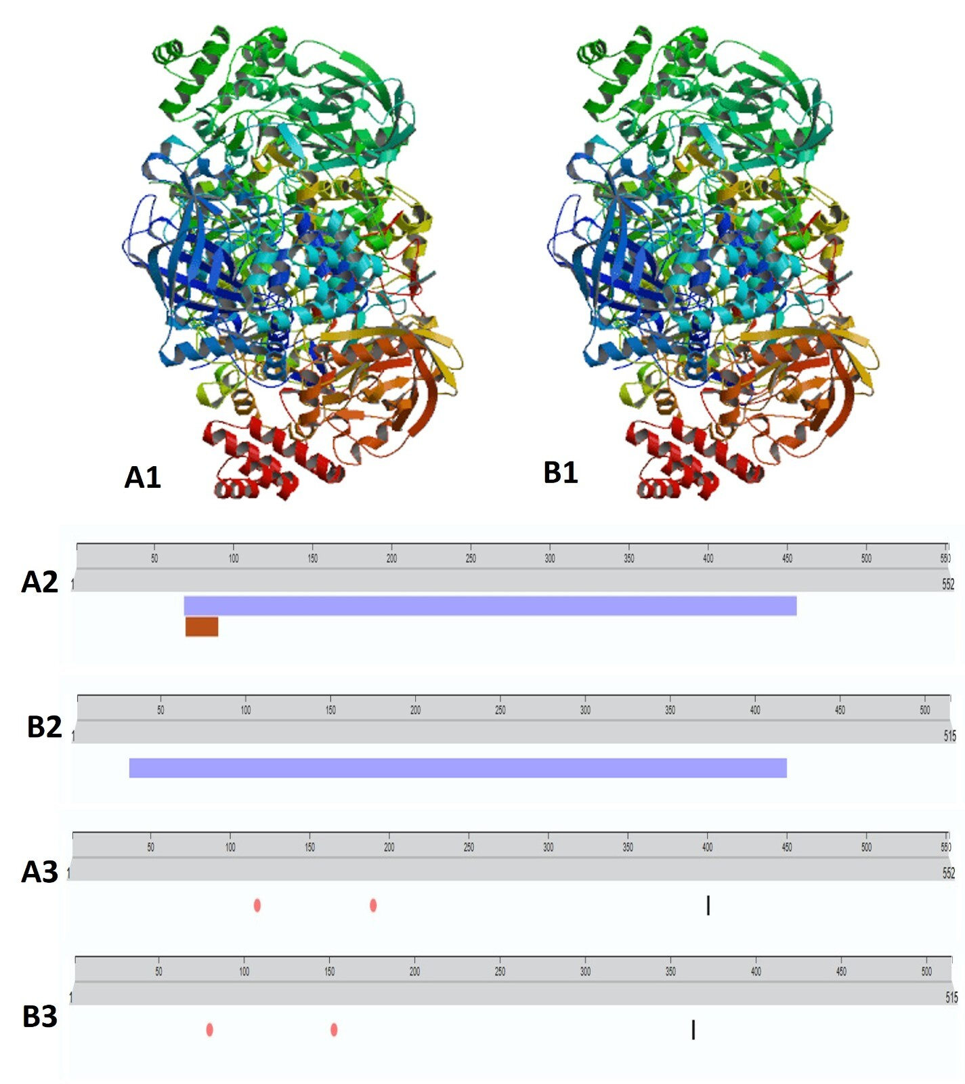

Fig. 2. Ramachandran plot of virulence protein catalase protein of E. tarda (A1) and E. piscicida (A2); ProSA web Z-scores of protein chain in PDB determined by X-ray crystallography (light blue) NMR spectroscopy (dark blue) by their length of E. tarda (B1) and E. piscicida (B2); (c) Plot of residue scores of E. tarda (A1) and E. piscicida (A2) catalase protein.
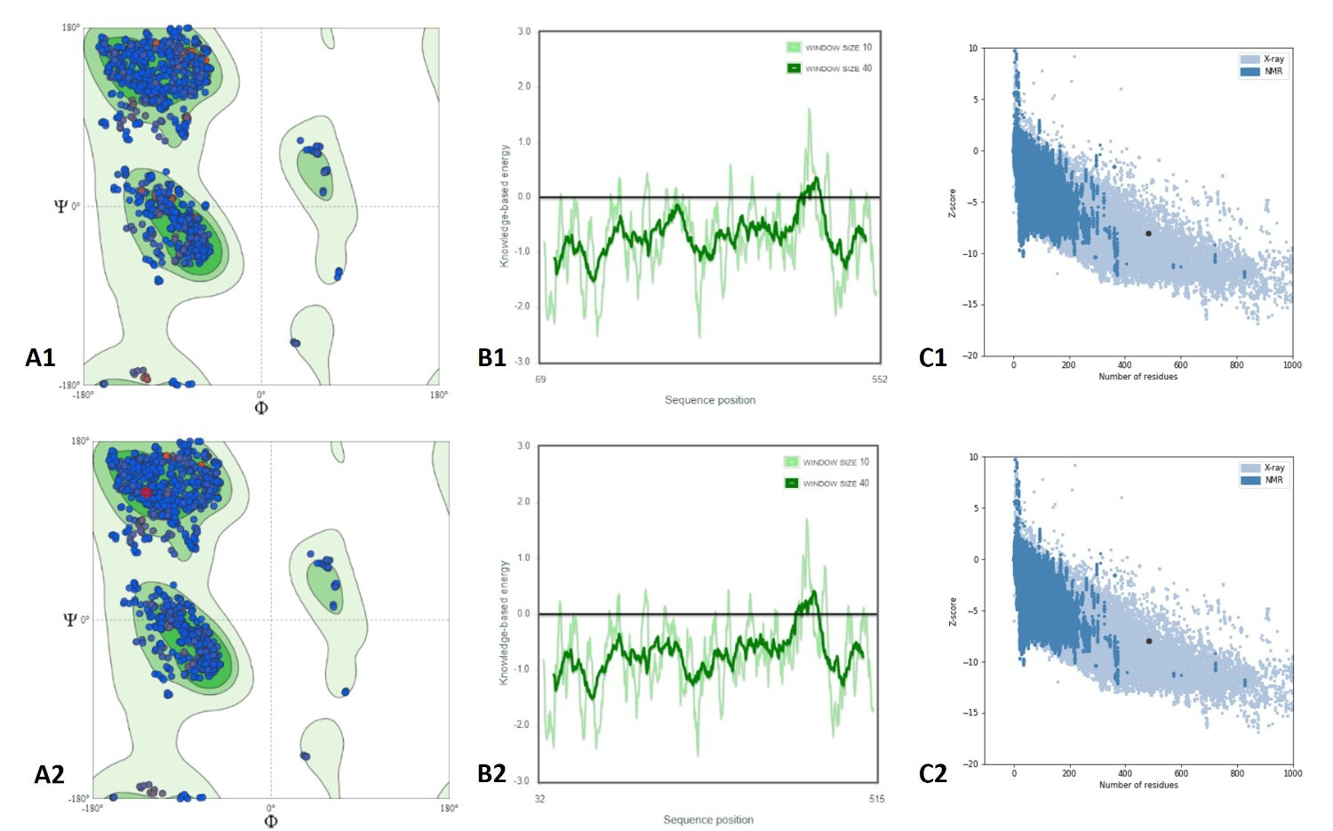

Fig. 3. Multiple sequence alignment of catalase protein of E. tarda and E. piscicida along with the host catalase protein (Pangasianodon hypophthalmus).
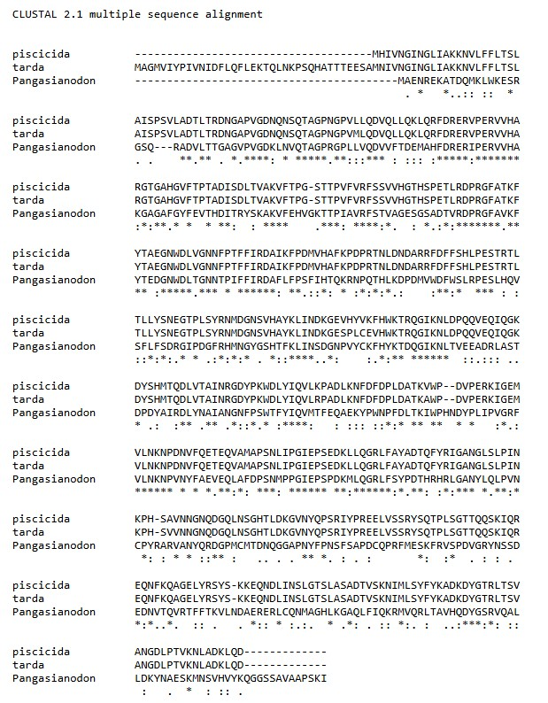

Fig. 4. Protein-ligand interaction of E. tarda virulence protein catalase against herbal ligands lutein (A1), isoginkgetin (A2), sciadopitysin (A3) and E. piscicida catalase against herbal ligands lutein (B1), isoginkgetin (B2), ginkgetin (B3) visualized using the PyMOL tool.
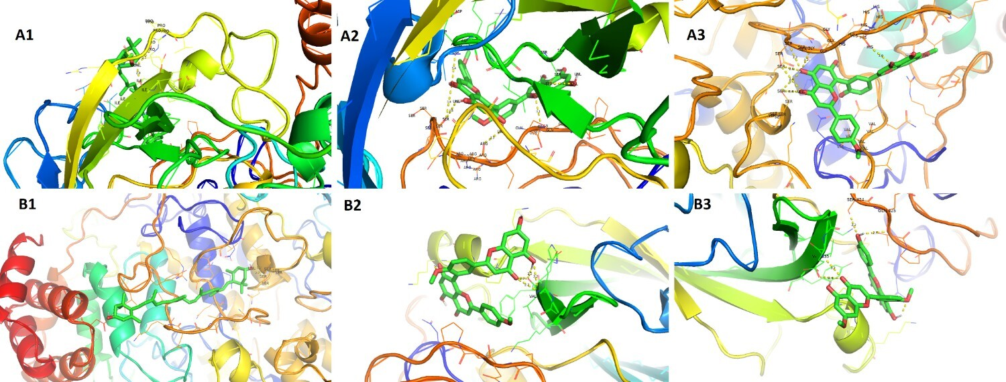

Fig. 5. Protein-ligand interaction of E. tarda virulence protein catalase against commercial antibiotics florfenicol (A1), ormetoprim (A2), oxytetracycline (A3) and E. piscicida catalase against commercial antibiotics florfenicol (B1), ormetoprim (B2), oxytetracycline (B3) visualized using the PyMOL tool.
