Case report
GENERALIZED DEMODICOSIS IN A GERMAN SHEPHERD: A CASE REPORT.

ABSTRACT
Canine demodicosis is a common parasitic dermatological disease caused by excessive proliferation of Demodex mites inhabiting the hair follicles and sebaceous glands of dogs. A one-year-old male German Shepherd dog with severe demodicosis was brought to the RVP- Clinic of the ICAR-Indian Veterinary Research Institute in Izzatnagar, Bareilly, complaining of progressive alopecia, erythema, crusting and recurring skin infections for one to one and a half months. The dog had previously been treated with fluconazole but the lesions recurred. Clinical examination revealed alopecia, skin reddening, and crust formation mainly on muzzle and forelimbs, along with mild pyrexia(104.3°F). Deep skin scraping examination confirmed the presence of numerous cigar-shaped Demodex canis mites with elongated bodies and short stubby legs. Based on these findings, the condition was diagnosed as canine demodicosis and treatment with doramectin was initiated for effective mite control.
Keywords: Canine demodicosis, Demodex canis , skin scraping, alopecia,crusting, doramectin.
1.INTRODUCTION
Demodecosis is a parasitic skin disease caused by over-proliferation of mites belonging to the genus Demodex, which normally inhabit hair follicles and sebaceous glands of mammals (Mueller et al., 2020). Under normal conditions, Demodex mites are considered part of the normal skin microbiota, but immunosuppression or genetic predisposition can lead to uncontrolled mite multiplication and clinical disease (Singh et al., 2019). The disease is most commonly reported in dogs, where it is caused primarily by Demodex canis, though other species such as Demodex injai and Demodex cornei may also be involved that cause greasy truncal dermatitis and facial dermatitis (Mueller et al., 2020). Demodecosis is characterized clinically by alopecia, erythema, scaling, folliculitis, and sometimes secondary bacterial infections, which may progress to severe generalized dermatitis if untreated (Paterson, 2008). Diagnosis is typically based on deep skin scraping, trichography, or skin biopsy, where large numbers of mites can be demonstrated microscopically (Paterson, 2008). Although demodicosis is usually not contagious among adult animals, it represents an important dermatological condition in veterinary medicine due to its chronic course and management challenges (Taylor et al., 2016). Advances in acaricidal therapy, including isoxazoline drugs, have significantly improved the treatment and prognosis of generalized demodecosis in recent years (Mueller et al., 2020).
2.case presentation
A one-year-old male German Shepherd Dog was presented to the RVP-Clinic of ICAR-IVRI, Izzatnagar with a history of alopecia, erythema and recurrent dermatological lesions affecting the muzzle and forelimbs mainly. A detailed case history was obtained from the owner regarding the duration of illness and previous treatment. According to the history provided, the animal had been suffering from recurrent skin lesions for approximately one to one and a half months. The dog had previously been treated with fluconazole, clobetasol propionate and ivermectin along with supportive therapy, which resulted in temporary improvement but the lesions recurred after treatment. (Fig-1-3). A thorough general physical examination was carried out to assess the overall health status of the animal. The parameters evaluated during examination included rectal temperature, heart rate, respiratory rate, mucous membrane colour, capillary refill time, hydration status, pain sensation and general behaviour of the animal. The body condition score and the distribution and severity of skin lesions such as alopecia, erythema, crusting, scaling, and pustules were also carefully evaluated. The rectal temperature was recorded as 104.3°F indicating mild fever. Dermatological examination revealed alopecia, erythema, crusting and thickening of the skin mainly over the muzzle region and forelimbs. Deep skin scrapings were taken from the edges of active lesions for parasitological diagnosis. In order to extract material from the hair follicles where mites live, a drop of liquid paraffin was placed to the afflicted skin, and the region was scraped with a sterile scalpel blade until there was some capillary bleeding. After digestion in 10% KOH , light microscope 10X was used to examine the gathered scrapings after they were placed onto sterile glass slides filled with liquid paraffin. The presence of elongated cigar-shaped mites, which are characteristic of Demodex canis, was used to identify Demodex mites through microscopic examination at both low and high magnification. Based on the clinical findings and microscopic confirmation, treatment was instituted. The therapeutic regimen included injection Fevastin administered at 2 ml intramuscularly twice daily for two days, injection Lincomycin administered at 2 ml intramuscularly once daily for seven days to control secondary bacterial infection and injection ingredientsDoramectin administered at 0.5 ml subcutaneously once weekly for three weeks as systemic acaricidal therapy. Topical treatment with Amitraz lotion at 3ml per litre of water was advised for application over the affected skin areas along with medicated bathing using 2-5% benzoyl peroxide based antiseborrheic shampoo that acts as a cleanser to help flush out the follicles where Demodex mites live, reducing their density. In addition to it nutritional oral liquid supplement of omega-6 and omega-3 fatty acids along with zinc and vitamins A & E was advised for a month twice daily 2 teaspoons to reduce inflammation and promote skin barrier integrity.
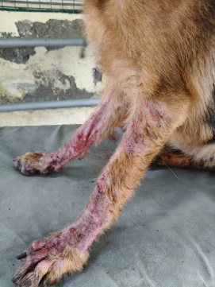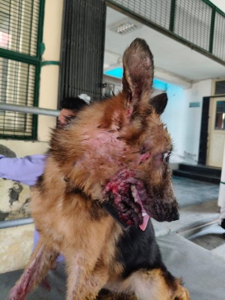
Fig. 1(Erythematous patches in forelimbs) Fig. 2(Erythematous patches around mouth)
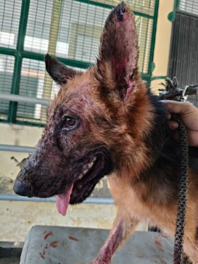
Fig.3(Crusting and scaling around mouth)
DISCUSSION
The affected German Shepherd dog's clinical examination showed significant dermatological lesions, mostly across the muzzle and facial region with extension towards the forelimbs. These lesions were characterized by alopecia, erythema, and crust development. A moderate fever was indicated by the rectal temperature of 104.3°F. The respiration and heart rates were both within the species' typical physiological ranges. Adequate peripheral perfusion was indicated by the pink appearance of the mucosal membranes and the typical capillary refill period of about two seconds. The animal's level of hydration was normal, and aside from a slight discomfort brought on by the skin lesions, no notable behavioral abnormalities were noted. During the assessment, it was discovered that pain perception was normal. When deep skin scrapings were examined under a microscope, several mites with the elongated cigar-shaped bodies typical of Demodex canis were found in the follicular debris (Fig 4 & 5). The diagnosis of widespread demodecosis was validated by the abundance of mites. The dog's dermatological disease was determined to be caused by a severe infestation of Demodex canis based on the clinical signs and parasitological findings. Fig-6 shows the improvement after the effective treatment with Doramectin at dose rate of 200µg/kg body weight for 4 weeks.
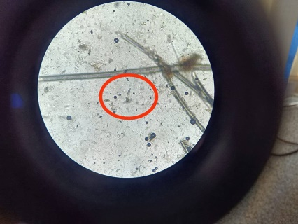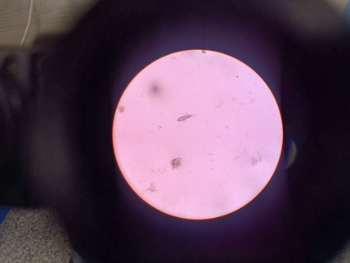
Fig. 4 (Demodex canis mite under 100X) Fig. 5 (Demodex canis mite)

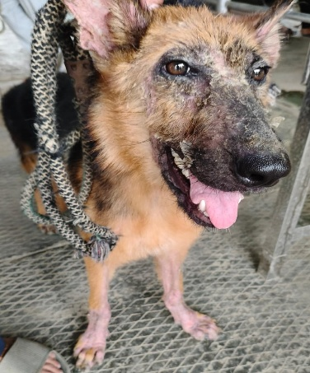
Fig. 6( Recovered lesions after treatment)
Usually the localised form of demodicosis do not change to generalized one, however when the T-cell mediated immunity is impaired, mites proliferate within the hair follicle causing follicular damage and thus lesions spreads to the adjacent areas. Secondary bacterial infections and immunosuppressive factors may promote the progression resulting in widespread generalized lesion. Avoid glucocorticoids, progestogens, ciclosporin, and oclacitinib maleate due to their immunosuppressive effects. These agents may inhibit the host immune response, preventing resolution of Demodex infection or inducing relapses. Avoid use of azole antifungals and ciclosporin, due to potential synergistic toxicosis when administering avermectin.
4.CONCLUSION
German Shepherd Dog brought on by an overabundance of mites from the genus Demodex. Alopecia, erythema, crust development, and raised body temperature were clinical indicators of an active dermatological infection aggravated by subsequent bacterial involvement. Deep skin scraping and microscopic identification of the distinctive cigar-shaped mites of Demodex canis were used to confirm the illness. Effective management of generalized demodecosis requires early diagnosis, proper systemic acaricidal therapy, antibiotic treatment, and supportive care. For afflicted dogs to heal and avoid a recurrence of the illness, appropriate clinical surveillance and dermatological care are crucial.

DISCLAIMER (ARTIFICIAL INTELLIGENCE)
Author(s) hereby declare that NO generative AI technologies such as Large Language Models (ChatGPT, COPILOT, etc) and text-to-image generators have been used during writing or editing of this manuscript.
COMPETING INTERESTS
Authors have declared that no competing interests exist.
References
Mueller, R. S., Bensignor, E., Ferrer, L., Holm, B., Lemarie, S., Paradis, M., and Shipstone, M. A. (2012). Treatment of canine demodicosis: 2011 clinical practice guidelines. Veterinary Dermatology, 23(2), 86–e20.
Mueller, R. S., Rosenkrantz, W., Bensignor, E., Karaś-Tęcza, J., Paterson, T., and Shipstone, M. A. (2020). Diagnosis and treatment of demodicosis in dogs: Clinical practice guidelines. Veterinary Dermatology, 31(1), 4–18.
Singh, S. K., Dimri, U., Sharma, M. C., and Swarup, D. (2019). Demodicosis in animals: A review. Veterinary Parasitology, 269, 1–9.
Paterson, T. (2008). Manual of skin diseases of the dog and cat (2nd ed.). Blackwell Publishing.
Taylor, M. A., Coop, R. L., and Wall, R. L. (2016). Veterinary parasitology (4th ed.). Wiley-Blackwell.
Miller WH, Griffin CE, Campbell KL. (2013). Parasitic skin diseases. Muller & Kirk’s Small Animal Dermatology, 7th ed. St. Louis: Saunders, pp 310-313.

