Forecasting and Explaining Non-Performing Assets in Indian Banking Groups Using Panel Econometrics and Explainable Machine Learning Models

.
ABSTRACT

This study examines the determinants and predictive dynamics of Non-Performing Assets (NPAs) in Indian banking groups using an integrated framework combining panel econometric techniques, machine learning models, and explainable artificial intelligence. The analysis is based on a balanced panel dataset covering the period 1998-2024, incorporating key macroeconomic variables such as credit growth, GDP growth, inflation, and lending interest rates. Panel estimations using Pooled OLS, Fixed Effects, and Random Effects models are conducted, with the Hausman test supporting the Random Effects specification. The results indicate that lending interest rates have a positive and statistically significant impact on NPAs, whereas inflation exhibits a significant negative effect. In contrast, credit growth and GDP growth are found to be statistically insignificant. Diagnostic tests reveal the presence of heteroskedasticity, serial correlation, and cross-sectional dependence, highlighting the persistent and systemic nature of NPAs. To enhance predictive performance, the study employs Linear Regression, Random Forest, and XGBoost models, with XGBoost demonstrating the highest accuracy. SHAP analysis identifies lagged NPAs and interest rates as key drivers. The findings underscore the importance of integrating econometric and data-driven approaches for effective risk assessment and policy formulation in the banking sector.

Keywords: Non-Performing Assets (NPAs), Panel Econometrics, Machine Learning, SHAP, Credit Risk

1. INTRODUCTION

The banking system plays a central role in economic development by channelling funds from savers to investors and supporting productive activities across sectors. In a country like India, where banks dominate the financial landscape, the quality of bank assets becomes a key determinant of financial stability. In this context, the issue of Non-Performing Assets (NPAs) has gained considerable importance, as rising NPAs weaken bank balance sheets, reduce profitability, and limit the capacity of banks to extend fresh credit. This, in turn, can slow down investment and economic growth (Aich et al., 2025; Khalid, 2025).

Over the past few decades, the Indian banking sector has witnessed notable fluctuations in NPAs, with a particularly sharp increase observed during the mid-2010s. This phase exposed several structural weaknesses, including inadequate credit appraisal systems, delayed recognition of stressed assets, and governance-related challenges within banks (Agarwala & Agarwala, 2019; Bhalerao et al., 2022). Although subsequent regulatory measures and institutional reforms have contributed to some improvement in asset quality, the problem of NPAs continues to remain a concern for policymakers and financial institutions.

A large body of empirical research has attempted to identify the factors influencing NPAs. Macroeconomic conditions such as economic growth, inflation, and credit expansion have been widely recognized as important drivers, reflecting the sensitivity of loan performance to broader economic trends (Das, 2025; Ghosh Roy, 2014; Swamy, 2012). At the same time, internal characteristics of banks such as capital adequacy, operational efficiency, and risk management practices have also been found to play a significant role in shaping asset quality (Arhinful et al., 2025; Saeed & Donkoh, 2026). In addition, several studies point to the persistence of NPAs over time, suggesting that past loan performance and cyclical economic conditions influence current levels (Barakat et al., 2024; Dhananjaya & Raj, 2018) .

While conventional econometric methods have provided valuable insights into these relationships, their ability to capture complex and nonlinear interactions is often limited. With the increasing availability of data and advancements in computational tools, machine learning techniques have gained traction in financial risk analysis. Models such as Random Forest and XGBoost are particularly effective in identifying hidden patterns and improving prediction accuracy (David et al., 2024; Huang, 2024; Kristanti et al., 2024). Empirical evidence suggests that these models often outperform traditional approaches in forecasting default risk (Chaudhary, 2021; Kumar & Misra, 2024; Singh & Mohanty, n.d.).

However, a key limitation of machine learning models lies in their lack of transparency, as they are often treated as “black-box” systems. This restricts their usefulness in policy analysis, where interpretability is essential. Recent developments in explainable artificial intelligence, especially SHapley Additive exPlanations (SHAP), address this issue by providing clear insights into how different variables influence model predictions. At the same time, panel econometric techniques continue to offer a strong framework for analyzing both cross-sectional and time-series variations in NPAs, supported by well-established theoretical foundations and diagnostic tools (Sun et al., 2025; Wang et al., 2025).

Given these developments, there is a clear need for an approach that brings together the strengths of econometric methods and machine learning techniques. In this context, the present study adopts an integrated framework combining panel econometrics, machine learning models, and explainable AI to examine the determinants and predictive behavior of NPAs in Indian banking groups. This approach not only improves prediction accuracy but also enhances interpretability, thereby offering a more comprehensive understanding of asset quality dynamics.

2. Literature Review

The existing literature on Non-Performing Assets (NPAs) has developed along several lines, with contributions focusing on macroeconomic influences, bank-level characteristics, and methodological advancements.

A significant portion of the literature emphasizes the role of macroeconomic conditions in determining NPAs. Roy (Ghosh Roy, 2014) shows that economic growth, inflation, and credit expansion are important factors influencing NPAs in India. Similarly, Dash and Kabra (Dash & Kabra, 2010) highlight the impact of economic cycles and macro-financial conditions on asset quality. Rajaraman and Vasishtha (Rajaraman & Vasishtha, 2001) provide further evidence using panel data on public sector banks, indicating that macroeconomic instability and policy-related factors contribute to rising NPAs. Studies conducted in international contexts, such as those by Espinoza and Prasad (Espinoza & Prasad, 2010) and Boudriga et al. (Boudriga et al., 2010), also confirm that macroeconomic conditions and institutional quality play a critical role in shaping non-performing loans.

Another important strand of research focuses on the dynamic nature of NPAs. Mishra et al. (Mishra et al., 2021) find that NPAs tend to persist over time, suggesting that past levels of bad loans significantly influence current outcomes. Dhar and Bakshi [9] similarly observe that loan losses are closely linked to economic cycles and institutional factors. Misra and Dhal (Mishra et al., 2021) provide evidence of the pro-cyclical behavior of NPAs, showing that asset quality typically deteriorates during economic downturns and improves during periods of growth. These findings underline the importance of incorporating dynamic elements into the analysis of NPAs.

In addition to macroeconomic factors, several studies examine the role of bank-specific characteristics. Sareen (Sareen, 2023) identifies factors such as capital adequacy and operational efficiency as key determinants of NPAs. Bawa et al. (Bawa et al., 2019) extend this analysis by using a comprehensive set of financial ratios to explain variations in asset quality. Das et al. (Dash & Kabra, 2010) demonstrate that higher NPAs adversely affect bank profitability, while Gaur and Mohapatra (Gaur & Mohapatra, 2020) highlight the relationship between NPAs, economic growth, and priority sector lending. Together, these studies suggest that both internal management practices and external economic conditions influence NPAs.

Policy-oriented research provides further insights into the structural nature of the NPA problem. Sengupta and Vardhan (Sengupta & Vardhan, 2017) argue that the issue is not purely cyclical but also rooted in institutional weaknesses, including delays in recognizing stressed assets and inefficiencies in credit monitoring systems. This perspective highlights the importance of regulatory and governance reforms in addressing the NPA problem.

More recently, attention has shifted towards the use of machine learning techniques in credit risk assessment. Studies such as Marew et al. (Marew et al., 2022) and Moharil et al. (Moharil et al., 2020) demonstrate that machine learning models can significantly improve prediction accuracy by capturing nonlinear relationships in financial data. However, these models often lack interpretability, which limits their application in decision-making contexts. Chen et al. (Zhong et al., 2024) emphasize the importance of interpretable machine learning, particularly in credit risk modeling.
The growing recognition of the strengths and limitations of both econometric and machine learning approaches has led to increased interest in hybrid methodologies. Mullainathan and Spiess (Mullainathan & Spiess, 2017a) argue that combining these approaches can enhance both predictive performance and analytical rigor. Similarly, Malhotra (Malhotra, 2021) highlights the benefits of integrating econometric and machine learning techniques for improved analysis. From a methodological standpoint, panel econometric models remain widely used, supported by foundational contributions such as Baltagi (Baltagi, 2021) and Wooldridge (Wooldridge, 2021). Diagnostic tools including the Hausman test (Hausman, 1978), Breusch-Pagan test (Breusch & Pagan, 1979), and Pesaran’s test for cross-sectional dependence (Pesaran, 2003) ensure the reliability of econometric results. At the same time, machine learning algorithms such as Random Forest (Breiman, 2001a) and XGBoost (Chen & Guestrin, 2016), along with explainable AI techniques such as SHAP, provide powerful tools for prediction and interpretation.

2.1 Research Gap
Notwithstanding the substantial body of literature on Non-Performing Assets (NPAs), important limitations remain. Existing studies predominantly employ either traditional econometric models or machine learning techniques in isolation, thereby limiting the ability to jointly achieve robust inference and high predictive accuracy. Moreover, the application of explainable artificial intelligence in NPA analysis remains limited, restricting interpretability of data-driven models for policy purposes. In addition, prior research on Indian banking has largely overlooked the simultaneous consideration of dynamic persistence, nonlinear relationships, and cross-sectional interdependencies across bank groups.

Against this backdrop, the present study develops an integrated framework combining panel econometrics, machine learning, and explainable AI to provide a comprehensive and policy-relevant understanding of NPA dynamics.

3. methodology

3.1 Data Structure and Variable Specification
This study employs a balanced panel dataset comprising multiple Indian bank groups observed over a period of 27 years from 1998-2024, resulting in a total of 108 observations. The dependent variable is the ratio of Non-Performing Assets (NPAs), which serves as a proxy for asset quality and financial stability. The explanatory variables include key macroeconomic and banking indicators: credit growth, GDP growth, inflation, and lending interest rate.

The empirical specification is grounded in the standard panel regression framework:
$$NPA_{it}=α+β_{1}CG_{it}+β_{2}GDP_{it}+β_{3}INF_{it}+β_{4}IR_{it}+ϵ_{it} (1)$$
where $i$denotes bank groups and $t$represents time. $CG$, $GDP$, $INF$, and $IR$denote credit growth, GDP growth, inflation, and interest rate respectively.

3.2 Econometric Modeling Framework
To capture both cross-sectional and temporal variations, three panel data models are estimated: Pooled Ordinary Least Squares (Pooled OLS), Fixed Effects (FE), and Random Effects (RE).

3.2.1 Pooled OLS Model
The pooled model assumes homogeneity across cross-sectional units and ignores individual-specific effects:
$$NPA_{it}=α+\sum_{k=1}^{4}{β_{k}}X_{kit}+ϵ_{it} (2)$$While simple, this model may suffer from omitted variable bias due to unobserved heterogeneity.

3.2.2 Fixed Effects Model
The Fixed Effects model controls for time-invariant unobserved heterogeneity by allowing entity-specific intercepts:
$$NPA_{it}=α_{i}+\sum_{k=1}^{4}{β_{k}}X_{kit}+ϵ_{it} (3)$$This approach eliminates bias arising from correlation between regressors and unobserved effects (Wooldridge, 2021).

3.2.3 Random Effects Model
The Random Effects model assumes that individual-specific effects are random and uncorrelated with explanatory variables:
$$NPA_{it}=α+\sum_{k=1}^{4}{β_{k}}X_{kit}+u_{i}+ϵ_{it} (4)$$where $u_{i}$represents the random effect.

3.3 Model Selection: Hausman Test
To determine the appropriate model between Fixed Effects and Random Effects, the Hausman specification test is employed. The null hypothesis states that the Random Effects estimator is consistent and efficient, while the alternative favors Fixed Effects.
The test statistic is defined as:
$$H=({\hat{β}}_{FE}−{\hat{β}}_{RE})^{'}[Var({\hat{β}}_{FE})−Var({\hat{β}}_{RE})]^{−1}({\hat{β}}_{FE}−{\hat{β}}_{RE}) (5)$$A non-significant p-value indicates that the Random Effects model is appropriate (Baltagi, 2021; Hausman, 1978). Recent studies in financial econometrics continue to rely on the Hausman framework for panel model selection (Le Gallo & Sénégas, 2023).

3.4 Diagnostic Testing
To ensure robustness and validity of the econometric results, several diagnostic tests are conducted.
3.4.1 Multicollinearity (VIF)
Variance Inflation Factor (VIF) is used to assess multicollinearity among explanatory variables:
$$VIF_{j}=\frac{1}{1−R_{j}^{2}} (6)$$Values below 5 indicate acceptable levels (Sohil et al., 2021).

3.4.2 Heteroskedasticity (Breusch-Pagan Test)
The Breusch-Pagan test evaluates whether the variance of residuals is constant:
$$BP=n⋅R^{2} (7)$$A significant result indicates heteroskedasticity (Breusch & Pagan, 1979). Robust standard errors are used to correct for this issue.

3.4.3 Serial Correlation (Durbin-Watson Test)
Serial correlation is tested using the Durbin–Watson statistic:
$$DW=\frac{∑(e_{t}−e_{t−1})^{2}}{∑e_{t}^{2}} (8)$$Values significantly below 2 indicate positive autocorrelation (Krämer, 2025).

3.4.4 Cross-Section Dependence (Pesaran CD Test)
The Pesaran CD test evaluates cross-sectional dependence:
$$CD=\sqrt{\frac{2T}{N(N−1)}}\sum_{i<j}{{\hat{ρ}}_{ij}} (9)$$This test is widely used in macro-financial panel studies (Pesaran, 2003).

3.5 Machine Learning Framework
To enhance predictive accuracy, the study incorporates machine learning models alongside econometric approaches.
3.5.1 Models Used
- Linear Regression (baseline model)
- Random Forest (ensemble-based model)
- XGBoost (gradient boosting model)
Random Forest captures nonlinear interactions using multiple decision trees, while XGBoost improves prediction through sequential boosting (Breiman, 2001b; Chen & Guestrin, 2016).

3.5.2 Model Evaluation Metrics
The performance of models is evaluated using:
$$R^{2}=1−\frac{SS_{res}}{SS_{tot}} (10)$$
$$RMSE=\sqrt{\frac{1}{n}∑(y_{i}−{\hat{y}}_{i})^{2}} (11)$$
$$MAE=\frac{1}{n}∑∣y_{i}−{\hat{y}}_{i}∣ (12)$$These metrics provide complementary insights into predictive accuracy.

3.6 Explainable AI (SHAP Analysis)
To interpret machine learning models, SHAP (SHapley Additive exPlanations) is employed. SHAP assigns an importance value to each feature based on its contribution to model predictions:
$$f(x)=ϕ_{0}+\sum_{i=1}^{M}{ϕ_{i}} (13)$$where $ϕ_{i}$represents the contribution of feature $i$ (Lundberg & Lee, 2017). Recent literature highlights SHAP as a powerful tool for interpretable AI in finance (Sinha, 2024).

3.7 Methodological Contribution
The methodology integrates traditional econometric techniques with advanced machine learning and explainable AI approaches. This hybrid framework enables:
- Robust statistical inference
- High predictive accuracy
- Transparent interpretation of results
Such integrated approaches are increasingly recommended in financial risk modeling literature (Acemoglu & Restrepo, 2019; Mullainathan & Spiess, 2017b).

4. results and discussion

4.1 Overview of Analytical Framework
This study investigates the determinants and predictive dynamics of Non-Performing Assets (NPAs) across Indian banking groups using a hybrid framework that integrates panel econometric models, machine learning techniques, and explainable artificial intelligence. The results provide both inferential and predictive insights, offering a comprehensive understanding of banking sector stress.

4.2 Descriptive Statistics and Preliminary Analysis
The descriptive statistics presented in Table 1 provide an overview of the distributional properties of the variables used in the analysis. The NPA ratio exhibits moderate variability across Indian banking groups, reflecting differences in asset quality over the study period. Macroeconomic variables such as credit growth, GDP growth, inflation, and lending interest rates display relatively stable means and standard deviations, indicating a consistent macroeconomic environment.

Table 1. Summary Statistics of Variables
Statistic | NPA | Credit Growth | GDP Growth | Inflation | Lending Interest Rate
Count | 108.000000 | 108.000000 | 108.000000 | 108.000000 | 108.000000
Mean | 5.414815 | 18.481546 | 6.349911 | 6.302907 | 10.587379
Std Dev | 3.687053 | 17.078761 | 2.961096 | 2.737880 | 1.591049
Min | 1.200000 | -8.705361 | -5.777725 | 3.328173 | 8.130000
25% | 2.700000 | 10.174097 | 5.241316 | 4.009436 | 9.454167
50% (Median) | 3.950000 | 16.006179 | 7.410228 | 5.131407 | 10.291667
75% | 7.350000 | 22.774620 | 7.996254 | 8.349267 | 12.083333
Max | 16.000000 | 151.438979 | 9.689592 | 13.230839 | 13.541667

Figure 1 illustrates the temporal evolution of Non-Performing Assets (NPAs) across four major bank groups in India over the study period. A clear declining trend in NPAs is observed across all bank groups during the early 2000s up to around 2008-2009, indicating improved asset quality and stronger credit management practices during this phase. Public Sector Banks and Scheduled Commercial Banks initially exhibit relatively high NPA levels, peaking at around 16% and 14-15% respectively, suggesting higher exposure to stressed assets during the late 1990s and early 2000s. Between 2009 and 2014, NPAs remain relatively stable at lower levels for all bank groups, reflecting a period of relative financial stability. However, a sharp increase in NPAs is evident from 2015 onwards, particularly for Public Sector Banks and Scheduled Commercial Banks. Public Sector Banks show the most pronounced surge, reaching a peak of approximately 14-15% around 2017-2018. This spike can be attributed to factors such as asset quality review exercises, recognition of stressed assets, and macroeconomic challenges. Private Sector Banks and Foreign Banks exhibit comparatively lower and more stable NPA levels throughout the period. Although they also experience an increase during the 2015-2018 phase, the magnitude is significantly lower than that of Public Sector Banks, indicating relatively better risk management and diversified loan portfolios.
Post-2018, a consistent decline in NPAs is observed across all bank groups, suggesting improvements in asset quality, recovery mechanisms, and regulatory interventions. By the end of the study period, NPAs for all bank categories show a downward trajectory, converging toward lower levels, with Foreign and Private Sector Banks maintaining the lowest NPA ratios.

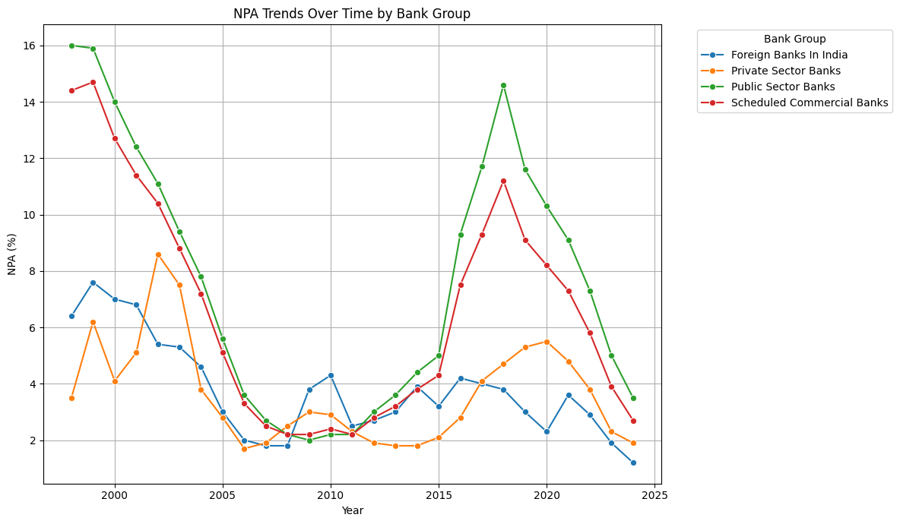
Figure 1. NPA Trends Over Time by Bank Group
The correlation structure among the explanatory variables is illustrated in Figure 2. The heatmap indicates low pairwise correlations, suggesting that the independent variables are not strongly linearly related. Lower intensity values indicate weak correlations, confirming minimal multicollinearity. Most correlation coefficients are close to zero, reinforcing the independence of regressors.
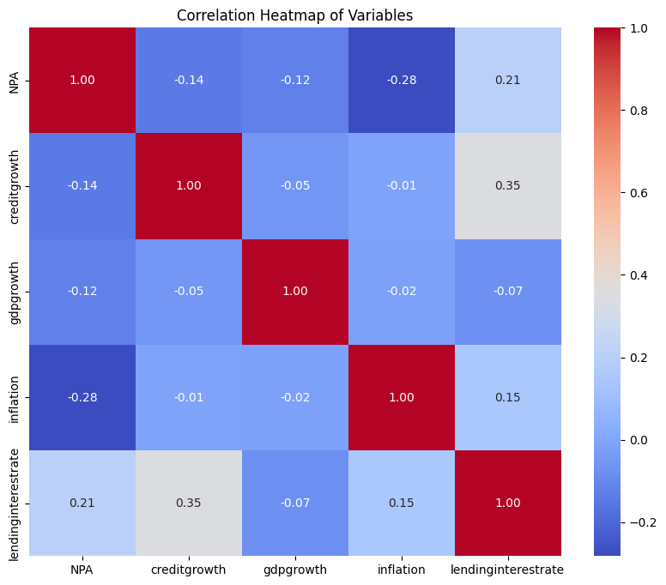
Figure 2. Correlation Heatmap of Variables
This observation is further supported by the Variance Inflation Factor (VIF) results reported in Table 2. The VIF values for all explanatory variables range between 1.00 and 1.17, which is significantly below the commonly accepted threshold of 5 or 10. The constant term exhibits a higher VIF value of approximately 55.79, which is expected and not of concern, as it does not affect the interpretation of explanatory variables.

Table 2. Variance Inflation Factor (VIF) Results
Variable | VIF Value
Constant | 55.7949
Credit Growth | 1.1440
GDP Growth | 1.0063
Inflation | 1.0289
Lending Interest Rate | 1.1737

The low VIF values confirm the absence of multicollinearity among explanatory variables, ensuring that coefficient estimates are stable and reliable. This strengthens the validity of subsequent econometric analysis. The independence of regressors allows for clear interpretation of individual variable effects on NPAs without distortion due to inter-variable dependencies.

4.3 Panel Econometric Results
To examine the determinants of Non-Performing Assets (NPAs), the study employs three panel data models: Pooled Ordinary Least Squares (OLS), Fixed Effects (FE), and Random Effects (RE). The selection of the appropriate model is based on the Hausman specification test.

4.3.1 Model Selection: Hausman Test
The results of the Hausman test are presented in Table 3.

Table 3. Hausman Test Results
Test Statistic | Degrees of Freedom | P-value | Decision
0.0000 | 4 | 1.0000 | Random Effects preferred

The Hausman test yields a test statistic of approximately 0.0000 with a p-value of 1.0000, indicating that the null hypothesis cannot be rejected. This suggests that the Random Effects estimator is consistent and efficient and therefore preferred over the Fixed Effects model. The absence of systematic differences between FE and RE models implies that unobserved bank-specific effects are not correlated with the explanatory variables. Potential endogeneity concerns are partially mitigated through model specification and robustness checks, although they cannot be entirely ruled out.

4.3.2 Random Effects Model Results
The estimated coefficients of the Random Effects model are reported in Table 4.
Table 4. Random Effects Model Results (with Robust Standard Errors)
Main Results
Variable | Coefficient | Std. Error | t-Statistic | P-value
Constant | 1.8980 | 3.1298 | 0.6064 | 0.5456
Credit Growth | -0.0593 | 0.0431 | -1.3753 | 0.1720
GDP Growth | -0.1509 | 0.1023 | -1.4747 | 0.1433
Inflation | -0.4585*** | 0.1450 | -3.1624 | 0.0021
Lending Interest Rate | 0.7991*** | 0.2805 | 2.8483 | 0.0053
Model Statistics
Statistic | Value
Number of Observations | 108
Number of Groups (Banks) | 4
Time Periods | 27
R-squared (Overall) | 0.2221
R-squared (Within) | 0.2440
R-squared (Between) | 0.1460
F-statistic (robust) | 8.0993
Prob (F-statistic) | 0.0000

The Random Effects model reveals several important relationships between macroeconomic variables and NPAs:
The results indicate that inflation exerts a negative and statistically significant effect on NPAs (β = −0.4585, p < 0.01), while lending interest rates have a positive and significant impact (β = 0.7991, p < 0.01). In contrast, credit growth (β = −0.0593) and GDP growth (β = −0.1509) are statistically insignificant, indicating limited short-run explanatory power. The constant term is also insignificant, suggesting the absence of a baseline effect.

4.3.3 Model Fit and Statistical Significance
The Random Effects model exhibits moderate explanatory power, with an overall R² of 0.2221, indicating that about 22% of the variation in NPAs is explained. The within R² (0.2440) suggests slightly higher explanatory power over time within bank groups, while the between R² (0.1460) reflects lower variation across groups. The model is jointly significant, as indicated by the robust F-statistic of 8.0993 (p < 0.01)
4.3.4 Economic Interpretation and Summary of Findings
The results indicate that lending interest rates have a positive and statistically significant effect on NPAs (β = 0.7991), implying that higher borrowing costs increase default risk. In contrast, inflation exerts a negative and significant impact (β = −0.4585), suggesting that it reduces the real debt burden and improves repayment capacity. GDP growth and credit growth are statistically insignificant, indicating that short-term macroeconomic expansion does not directly translate into improved asset quality and that structural factors may play a more dominant role. The model explains a moderate share of variation in NPAs (R² ≈ 0.22), highlighting the importance of financial conditions over aggregate growth in determining credit risk.

4.4. Diagnostic Analysis
Diagnostic tests were conducted to validate key assumptions of the panel model, including multicollinearity, heteroskedasticity, serial correlation, and cross-sectional dependence.

4.4.1 Multicollinearity
Multicollinearity among explanatory variables was assessed using the Variance Inflation Factor (VIF), the results of which are presented in Table 2.
All explanatory variables exhibit low VIF values (1.0063–1.1737), well below critical thresholds, indicating no multicollinearity. The high VIF for the constant term is expected and does not affect inference. These results confirm the stability and reliability of the estimated coefficients.

4.4.2 Heteroskedasticity
The presence of heteroskedasticity was tested using the Breusch–Pagan test, with results reported in Table 5.
Table 5. Breusch-Pagan Test for Heteroskedasticity
Statistic | Value
LM Statistic | 14.5262
LM P-value | 0.0058
F-Statistic | 4.0017
F P-value | 0.0047

The LM p-value of 0.0058 is less than the 5% significance level, leading to the rejection of the null hypothesis of homoskedasticity. This confirms the presence of heteroskedasticity in the residuals. To address this issue, robust standard errors are employed in the Random Effects model, ensuring that statistical inference remains valid despite the presence of heteroskedasticity.

4.4.3 Serial Correlation
Serial correlation in the residuals was examined using the Durbin-Watson statistic, with results summarized in Table 6.
Table 6. Durbin-Watson Test for Serial Correlation
Statistic | Value
Durbin–Watson | 1.0276

The Durbin-Watson statistic is 1.0276, which is significantly below the benchmark value of 2. This indicates the presence of positive serial correlation in the residuals.
A Durbin-Watson value close to 1 indicates positive serial correlation, suggesting that shocks to NPAs persist over time. This temporal dependence implies that error terms are not fully independent, potentially affecting estimator efficiency. However, the use of robust standard errors mitigates inference issues. This supports the inclusion of dynamic specifications.
4.4.4 Cross-Section Dependence
Cross-sectional dependence among bank groups was examined using the Pesaran CD test, with results reported in Table 7.
Table 7: Pesaran Cross-Section Dependence Test
Statistic | Value
CD Statistic | 5.6402
P-value | 0.0000
The Pesaran CD test yields a CD statistic of 5.6402 with a p-value of 0.0000, which is statistically significant at the 1% level. This leads to the rejection of the null hypothesis of cross-sectional independence.

The results reveal significant cross-sectional dependence across banking groups, indicating the presence of systemic interlinkages and spillover effects driven by common macroeconomic shocks. Such dependence implies that shocks to asset quality in one segment may propagate across the banking system, amplifying financial instability. These findings highlight the importance of employing robust estimation strategies and adopting a system-wide perspective in analysis. They also justify the integration of machine learning and explainable AI frameworks to capture complex, non-linear interdependencies that conventional econometric models may overlook.

4.5. Transition to Dynamic Analysis
While the static Random Effects model provides useful insights, it does not capture the dynamic nature of NPAs, particularly their persistence over time. Therefore, the subsequent analysis incorporates lagged dependent variables to examine the temporal behavior and path dependence of NPAs.

4.5.1 Dynamic Behavior and Persistence of NPAs
A key objective of this study is to examine whether Non-Performing Assets (NPAs) exhibit persistence over time. The evidence from both econometric estimation and diagnostic tests strongly supports the presence of dynamic behavior in NPAs.

4.5.2 Evidence of Persistence
The presence of persistence is reflected in multiple results obtained in the analysis: The Durbin–Watson statistic (1.0276) provides evidence of positive serial correlation, indicating persistence in NPAs over time. Concurrently, the presence of significant cross-sectional dependence (CD = 5.6402, p < 0.01) suggests that such persistence is not confined within individual banking groups but also propagates across them. Collectively, these findings underscore the dynamic and interconnected nature of NPAs, highlighting their dependence on past realizations rather than solely on contemporaneous macroeconomic conditions.

4.5.3 Visual Evidence
The persistence of NPAs is further illustrated in Figure 3, which plots lagged NPAs against current NPAs.
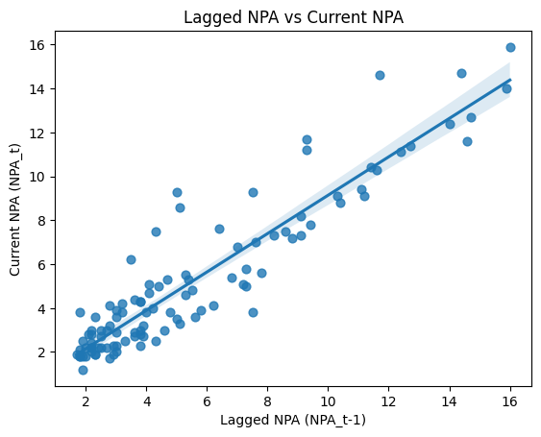
Figure 3. Lagged NPA vs Current NPA

This figure shows the relationship between lagged NPAs and current NPAs. The positive slope indicates persistence in asset quality over time. The scatter plot reveals a strong positive association, indicating that higher NPAs in the previous period are associated with higher NPAs in the current period.

4.5.4 Economic Interpretation of Persistence
The persistence of NPAs reflects underlying structural and institutional rigidities within the banking system. Prolonged legal and administrative recovery processes delay the resolution of stressed assets, while practices such as loan restructuring and evergreening defer the recognition of defaults. Furthermore, weak credit monitoring frameworks contribute to the gradual deterioration of asset quality. Collectively, these factors reinforce the path-dependent nature of NPAs and sustain banking sector vulnerabilities over time.

4.5.5 Link with Diagnostic Results
The persistence of NPAs is reinforced by diagnostic evidence of positive serial correlation (DW = 1.0276) and significant cross-sectional dependence (CD = 5.6402), indicating that asset quality dynamics are both temporally dependent and cross-sectionally interconnected. These findings suggest that NPAs evolve as a path-dependent process, shaped by lagged effects and systemic spillovers across banking groups.

4.5.6 Implications of Persistence for Modelling and Policy
The persistence of NPAs carries significant methodological and policy implications. Temporal dependence suggests that static specifications may inadequately capture the underlying dynamics of asset quality, thereby requiring dynamic models with lag structures for consistent estimation. From a policy perspective, persistence emphasizes the importance of early intervention and timely resolution, as delays can intensify financial stress and reinforce banking sector vulnerabilities. The evidence indicates that NPAs follow a path-dependent process, with shocks exerting prolonged and system-wide effects, underscoring the need for dynamic analytical frameworks and proactive regulatory responses.

4.6. Machine Learning Model Performance
To complement the econometric analysis and enhance predictive capability, this study employs three machine learning models: Linear Regression, Random Forest, and XGBoost. These models are evaluated based on their ability to accurately predict NPAs using macroeconomic and banking variables.

4.6.1 Model Comparison
The performance of the models is summarized in Table 8, which reports key evaluation metrics including R², Root Mean Squared Error (RMSE), and Mean Absolute Error (MAE).
Table 8: Machine Learning Model Performance Comparison
Model | R² | RMSE | MAE
Linear Regression | 0.511955 | 1.994841 | 1.685844
Random Forest | 0.694818 | 1.577459 | 1.380875
XGBoost | 0.700703 | 1.562174 | 1.159511

4.6.2 Interpretation of Results
XGBoost delivers the highest predictive performance (R² = 0.7007) with the lowest RMSE (1.5622) and MAE (1.1595), followed closely by Random Forest (R² = 0.6948), while Linear Regression exhibits lower explanatory power (R² = 0.5120) and higher prediction errors. The superior performance of machine learning models reflects their ability to capture nonlinear relationships, model complex interactions among predictors, and adapt to patterns not easily identified by traditional econometric approaches. These findings suggest that, while econometric models remain valuable for inference, machine learning techniques are more effective for accurate prediction and forecasting of NPAs.

4.6.3 Forecast Accuracy
The predictive accuracy of the best-performing model is further illustrated in Figure 4, which compares actual and predicted NPA values.
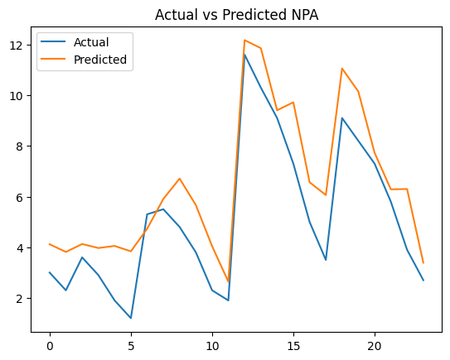
Figure 4. Actual vs Predicted NPA Values
The plot indicates a strong alignment between actual and predicted NPAs, with predictions closely tracking observed trends. Deviations are limited and primarily occur during periods of higher volatility. This close correspondence suggests that the model generalizes well and provides reliable forecasts.

4.6.4 Implications for NPA Forecasting
The findings highlight the practical relevance of machine learning models in NPA forecasting. Random Forest and XGBoost demonstrate superior predictive accuracy compared to traditional approaches and are well-suited for early warning systems due to their ability to capture nonlinear dynamics in financial data. The integration of these techniques enhances predictive performance, underscoring the importance of data-driven approaches in financial risk analysis.

4.7. Explainable AI (SHAP Analysis)
While machine learning models such as Random Forest and XGBoost provide strong predictive performance, they are often considered “black-box” models due to their limited interpretability. To address this limitation, this study employs SHapley Additive exPlanations (SHAP) to interpret model predictions and quantify the contribution of each feature to NPA outcomes.

4.7.1 SHAP Summary Analysis
The overall impact of explanatory variables on model predictions is illustrated in Figure 5.
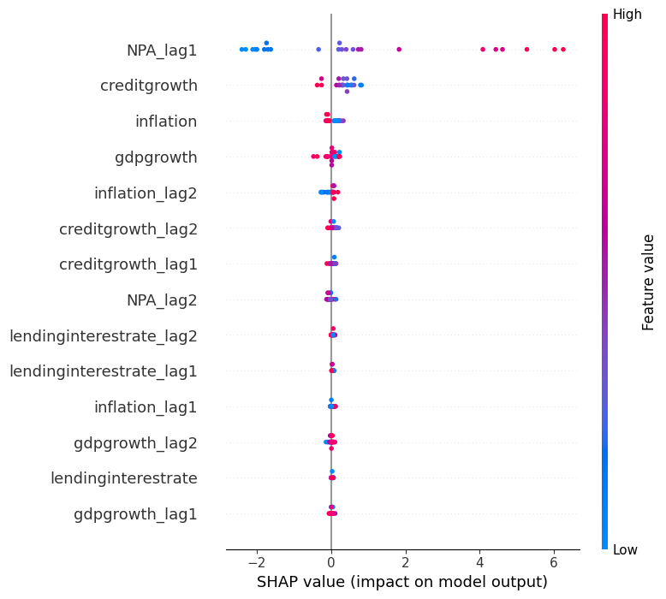
Figure 5. SHAP Summary Plot

The SHAP analysis identifies lagged NPA (NPAₜ₋₁) as the most influential predictor, confirming strong persistence in asset quality. Lending interest rates exhibit a positive contribution to NPAs, while inflation shows a negative effect. Credit growth has a moderate and heterogeneous impact, whereas GDP growth appears relatively less important. The dominance of lagged NPA reinforces the role of dynamic effects, consistent with the econometric findings.

4.7.2 Feature Importance Ranking
To further quantify variable importance, the SHAP feature importance plot is presented in Figure 6.
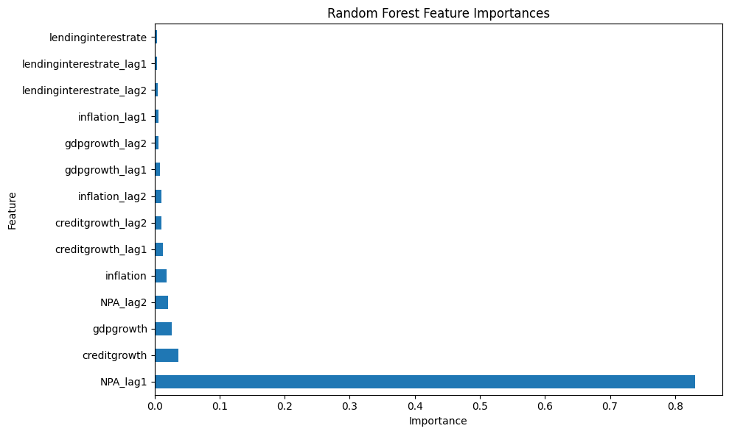
Figure 6. SHAP Feature Importance Plot
This figure ranks the variables based on their average absolute SHAP values, indicating their relative importance in predicting NPAs.
The ranking of variables based on SHAP values is as follows:
- Lagged NPA (highest importance)
- Lending Interest Rate
- Credit Growth
- Inflation
- GDP Growth (lowest importance)

4.7.3 Directional Impact of Variables
SHAP analysis provides both variable importance and directional effects. Higher lagged NPAs and lending interest rates are associated with increased predicted NPAs, while inflation exhibits a negative effect. Credit growth shows heterogeneous impacts, and GDP growth has limited influence. These results are consistent with the econometric findings, offering cross-validation between statistical and machine learning approaches.

4.7.4 Integration with Econometric Findings
A key strength of the analysis is the consistency between SHAP results and panel econometric estimates. Both approaches identify lending interest rates as a key driver of NPAs, confirm the negative role of inflation, and indicate the limited influence of GDP growth. This alignment enhances the robustness and credibility of the findings, demonstrating that machine learning models, when interpreted using SHAP, are not only predictive but also economically meaningful.

4.8. Robustness Analysis
The robustness of the findings is assessed by comparing results across panel econometric models, machine learning approaches, and SHAP-based interpretations. The results show strong cross-model consistency, with inflation exhibiting a negative and significant effect, lending interest rates showing a positive and significant impact, and credit growth and GDP growth remaining statistically insignificant across methods. Machine learning models further reinforce these findings, achieving higher predictive accuracy (R² ≈ 0.69) compared to the econometric model (R² ≈ 0.22), while identifying the same key drivers of NPAs.
Despite differences in predictive performance, the consistency in variable significance and direction indicates that the results are not sensitive to model specification. While econometric models provide interpretability and inference, machine learning models capture nonlinear patterns, and SHAP analysis bridges these approaches by ensuring interpretability of predictive models.
The convergence of evidence across methodologies confirms that the identified determinants of NPAs are stable, reliable, and not driven by model-specific assumptions, thereby strengthening the overall validity of the findings.

4.9. Policy Implications
The findings provide important implications for policymakers, regulators, and financial institutions in managing NPAs. The positive and significant impact of lending interest rates suggests that tighter monetary conditions can elevate default risk, underscoring the need for careful calibration of interest rate policies and incorporation of interest rate sensitivity in credit risk assessment. In contrast, the negative effect of inflation indicates that a stable and moderate inflation environment can ease repayment burdens and support financial stability.
The evidence of persistence in NPAs highlights the importance of early warning systems, continuous monitoring, and timely resolution mechanisms to prevent the accumulation of financial stress. Moreover, significant cross-sectional dependence points to strong interlinkages within the banking system, emphasizing the need for a system-wide regulatory approach, including stress testing frameworks that account for spillover and contagion effects.

The superior predictive performance of machine learning models supports their adoption in risk management for improved forecasting and early detection of credit deterioration. At the same time, the use of explainable AI techniques such as SHAP enhances transparency and interpretability, facilitating informed decision-making and regulatory oversight.
Finally, the limited role of credit growth and GDP growth suggests that expanding credit alone does not ensure improved asset quality, highlighting the importance of risk-based lending and credit quality assessment. Taken together, the results call for an integrated policy framework combining macroeconomic stability, advanced analytical tools, and proactive regulatory strategies to effectively manage NPAs and strengthen financial stability.

5. Conclusion and Future direction

This study examines the determinants and predictive dynamics of Non-Performing Assets (NPAs) in Indian bank groups using an integrated framework that combines panel econometric models, machine learning techniques, and explainable AI. The results consistently show that lending interest rates have a positive and significant impact on NPAs, while inflation exhibits a negative relationship, indicating its role in easing the real debt burden. Credit growth and GDP growth appear to have relatively weaker effects, suggesting that asset quality is influenced more by financial conditions than by overall economic expansion.
Diagnostic tests reveal the presence of heteroskedasticity, serial correlation, and cross-sectional dependence, indicating that NPAs are persistent and influenced by interconnected banking dynamics. Machine learning models, particularly Random Forest and XGBoost, demonstrate superior predictive performance compared to linear regression, highlighting the importance of capturing nonlinear relationships. SHAP-based explainability further confirms the dominance of key variables such as lagged NPAs and interest rates, enhancing interpretability and policy relevance.
However, the analysis is based on aggregated banking group data, which may conceal bank-level heterogeneity in risk exposure and management practices. Future research can
address this limitation by incorporating disaggregated data and additional institutional variables. All things considered, the study underscores the value of integrating econometric and data-driven approaches to better understand and forecast NPAs, offering useful insights for financial stability and risk management.

Competing interests

Authors have declared that no competing interests exist.

References

Acemoglu, D., & Restrepo, P. (2019). Automation and New Tasks: How Technology Displaces and Reinstates Labor. Journal of Economic Perspectives, 33(2), 3–30. https://doi.org/10.1257/jep.33.2.3
Agarwala, V., & Agarwala, N. (2019). A critical review of non-performing assets in the Indian banking industry. Rajagiri Management Journal, ahead-of-print. https://doi.org/10.1108/RAMJ-08-2019-0010
Aich, B. R., Tareque, M., Ahmed, T. T., & Rahman, M. M. (2025). Unveiling the nexus of financial inclusion and political stability for capital market participation in South Asian regions. Borsa Istanbul Review, 25(6), 1101–1115. https://doi.org/https://doi.org/10.1016/j.bir.2025.06.008
Arhinful, R., Mensah, L., Gyamfi, B. A., & Obeng, H. A. (2025). The Impact of Non-Performing Loans on Bank Growth: The Moderating Roles of Bank Size and Capital Adequacy Ratio—Evidence from U.S. Banks. International Journal of Financial Studies, 13(3). https://doi.org/10.3390/ijfs13030165
Baltagi, B. (2021). Econometric Analysis of Panel Data. https://doi.org/10.1007/978-3-030-53953-5
Barakat, H., Elwahab, S., Yassin, N., Ibrahim, S., Ismail, M., & Eldin, N. (2024). Asset quality and banks performance: A panel data analysis of commercial banks. Risk Governance and Control: Financial Markets & Institutions, 14, 111–121. https://doi.org/10.22495/rgcv14i3p11
Bawa, J. K., Goyal, V., Mitra, S. K., & Basu, S. (2019). An analysis of NPAs of Indian banks: Using a comprehensive framework of 31 financial ratios. IIMB Management Review, 31(1), 51–62. https://doi.org/https://doi.org/10.1016/j.iimb.2018.08.004
Bhalerao, N., Singh, A., Yadav, S., Professor, A., Lalji Dayal, L., & Road, C. (2022). Analysis of the Growth of Non-Performing Assets (NPAs) and Factors Influencing the Restructuring of Indian Financial Institutions. International Journal of Advanced Research in Science, Communication and Technology (IJARSCT) International Open-Access, Double-Blind, Peer-Reviewed, Refereed, Multidisciplinary Online Journal, 2(1). www.ijarsct.co.in
Boudriga, A., Boulila Taktak, N., & Jellouli, S. (2010). BANK SPECIFIC, BUSINESS AND INSTITUTIONAL ENVIRONMENT DETERMINANTS OF BANKS NONPERFORMING LOANS: EVIDENCE FROM MENA COUNTRIES. www.erf.org.eg
Breiman, L. (2001a). Random Forests. Machine Learning, 45(1), 5–32. https://doi.org/10.1023/A:1010933404324
Breiman, L. (2001b). Random Forests. Machine Learning, 45(1), 5–32. https://doi.org/10.1023/A:1010933404324
Breusch, T. S., & Pagan, A. R. (1979). A Simple Test for Heteroscedasticity and Random Coefficient Variation. Econometrica, 47(5), 1287–1294. http://www.jstor.org/stable/1911963
Chaudhary, A. (2021). Utilizing Ensemble Learning Models to Forecast Loan Default Risk. SSRN Electronic Journal, 6, 116–122. https://doi.org/10.2139/ssrn.5347553
Chen, T., & Guestrin, C. (2016). XGBoost: A Scalable Tree Boosting System. 785–794. https://doi.org/10.1145/2939672.2939785
Das, S. K. (2025). Drivers of NPAs in Indian Banks: An Empirical Analysis of Bank-specific Determinants. International Journal of Empirical Economics, 04(03), 2550007. https://doi.org/10.1142/S2810943025500076
Dash, M., & Kabra, G. (2010). The Determinants of Non-Performing Assets in Indian Commercial Bank: An Econometric Study. Middle Eastern Finance and Economics, 7, 94–106.
David, D., Wang, J., & Angel, V. (2024). Machine learning algorithms for financial risk prediction: A performance comparison. International Journal of Accounting Research, 9, 1. https://doi.org/10.65453/ijar.v9i2.1226
Dhananjaya, K., & Raj, K. (2018). Non-performing assets (NPAs) and its determinants: a study of Indian public sector banks. Journal of Social and Economic Development, 20. https://doi.org/10.1007/s40847-018-0068-0
Espinoza, R., & Prasad, A. (2010). Nonperforming Loans in the GCC Banking System and Their Macroeconomic Effects. IMF Working Papers, 10. https://doi.org/10.5089/9781455208890.001
Gaur, D., & Mohapatra, D. (2020). The nexus of economic growth, priority sector lending and non-performing assets: case of Indian banking sector. South Asian Journal of Business Studies, ahead-of-print. https://doi.org/10.1108/SAJBS-01-2020-0010
Ghosh Roy, S. (2014). Determinants of Non-Performing Assets in India - Panel Regression. Eurasian Journal of Economics and Finance, 2, 69–78. https://doi.org/10.15604/ejef.2014.02.03.005
Hausman, J. A. (1978). Specification Tests in Econometrics. Econometrica, 46(6), 1251–1271. http://www.jstor.org/stable/1913827
Huang, H. (2024). Technology-Driven Financial Risk Management: Exploring the Benefits of Machine Learning for Non-Profit Organizations. Systems, 12(10). https://doi.org/10.3390/systems12100416
Khalid, F. (2025). Role of banks in the Indian Financial System. International Journal of Innovations in Science Engineering And Management, 127–132. https://doi.org/10.69968/ijisem.2025v4si1127-132
Krämer, W. (2025). Durbin-Watson Test, The (pp. 762–764). https://doi.org/10.1007/978-3-662-69359-9_688
Kristanti, F., Febrianta, M. Y., Salim, D., Riyadh, H. A., Sagama, Y., & Beshr, B. (2024). Advancing financial analytics: Integrating XGBoost, LSTM, and Random Forest Algorithms for precision forecasting of corporate financial distress. Journal of Infrastructure, Policy and Development, 8, 4972. https://doi.org/10.24294/jipd.v8i8.4972
Kumar, G., & Misra, A. (2024). Data Mining Techniques for Predicting the Non-performing Assets (NPA) of Banks in India (pp. 133–150). https://doi.org/10.1007/978-3-031-61037-0_6
Le Gallo, J., & Sénégas, M.-A. (2023). On the Proper Computation of the Hausman Test Statistic in Standard Linear Panel Data Models: Some Clarifications and New Results. Econometrics, 11(4). https://doi.org/10.3390/econometrics11040025
Lundberg, S. M., & Lee, S.-I. (2017). A Unified Approach to Interpreting Model Predictions. In I. Guyon, U. Von Luxburg, S. Bengio, H. Wallach, R. Fergus, S. Vishwanathan, & R. Garnett (Eds.), Advances in Neural Information Processing Systems (Vol. 30). Curran Associates, Inc. https://proceedings.neurips.cc/paper_files/paper/2017/file/8a20a8621978632d76c43dfd28b67767-Paper.pdf
Malhotra, A. (2021). A hybrid econometric–machine learning approach for relative importance analysis: prioritizing food policy. Eurasian Economic Review, 11. https://doi.org/10.1007/s40822-021-00170-9
Marew, R., Getachew, A., Tadele, Y., Ali, N., & Goytom, I. (2022). Machine Learning Models Evaluation and Feature Importance Analysis on NPL Dataset. https://doi.org/10.48550/arXiv.2209.09638
Mishra, A. K., Jain, S., & Abid, M. (2021). Non-performing assets and its determinants in the Indian banking system: An empirical analysis using dynamic panel data models. International Journal of Finance & Economics, 26(4), 5948–5962. https://doi.org/https://doi.org/10.1002/ijfe.2102
Moharil, A., Sonavane, N., Kedia, C., & Anand, M. (2020). To Reduce Gross NPA and Classify Defaulters Using Shannon Entropy. https://doi.org/10.48550/arXiv.2004.14418
Mullainathan, S., & Spiess, J. (2017a). Machine Learning: An Applied Econometric Approach. Journal of Economic Perspectives, 31, 87–106. https://doi.org/10.1257/jep.31.2.87
Mullainathan, S., & Spiess, J. (2017b). Machine Learning: An Applied Econometric Approach. Journal of Economic Perspectives, 31(2), 87–106. https://doi.org/10.1257/jep.31.2.87
Pesaran, H. (2003). Estimation and Inference in Large Heterogenous Panels with Cross Section Dependence. SSRN Electronic Journal. https://doi.org/10.2139/ssrn.385123
Rajaraman, I., & Vasishtha, G. (2001). Non-performing loans of PSU banks: Some panel results. National Institute of Public Finance and Policy, Working Papers. https://doi.org/10.2307/4411688
Saeed, M. M., & Donkoh, E. (2026). Credit risk management, bank-specific factors, and financial performance of banks: Insights from an emerging economy. Social Sciences & Humanities Open, 13, 102523. https://doi.org/https://doi.org/10.1016/j.ssaho.2026.102523
Sareen, R. (2023). Analysis of bank specific factors of non-performing assets of select commercial banks. Asian Journal of Management, 283–292. https://doi.org/10.52711/2321-5763.2023.00046
Sengupta, R., & Vardhan, H. (2017). Non-performing assets in Indian Banks: This time it is different (Numbers 2017–019). https://doi.org/None
Singh, H., & Mohanty, A. (n.d.). Algorithmic Risk or Risk Mitigated? A Comparative Study of Credit-risk Assessment Accuracy Pre- and Post-automation in Indian Commercial Lending. Journal of Contemporary Business Research, 0(0), 3049513X251405596. https://doi.org/10.1177/3049513X251405596
Sinha, R. (2024). Book review: Christoph Molnar. 2020. Interpretable Machine Learning: A Guide for Making Black Box Models Explainable. Metamorphosis: A Journal of Management Research, 23, 92–93. https://doi.org/10.1177/09726225241252009
Sohil, F., Sohail, M., & Shabbir, J. (2021). An introduction to statistical learning with applications in R: by Gareth James, Daniela Witten, Trevor Hastie, and Robert Tibshirani, New York, Springer Science and Business Media, 2013, 41.98, eISBN: 978-1-4614-7137-7. Statistical Theory and Related Fields, 6, 1. https://doi.org/10.1080/24754269.2021.1980261
Sun, W., Wang, Y., Zhang, L., Chen, X. H., & Hoang, Y. H. (2025). Enhancing economic cycle forecasting based on interpretable machine learning and news narrative sentiment. Technological Forecasting and Social Change, 215, 124094. https://doi.org/https://doi.org/10.1016/j.techfore.2025.124094
Swamy, V. (2012). Impact of Macroeconomic and Endogenous Factors on Non Performing Bank Assets. International Journal of Banking and Finance, 9. https://doi.org/10.32890/ijbf2012.9.1.8447
Wang, Y., Wei, W., Liu, Z., Liu, J., Lv, Y., & Li, X. (2025). Interpretable Machine Learning Framework for Corporate Financialization Prediction: A SHAP-Based Analysis of High-Dimensional Data. Mathematics, 13, 2526. https://doi.org/10.3390/math13152526
Wooldridge, J. (2021). Two-Way Fixed Effects, the Two-Way Mundlak Regression, and Difference-in-Differences Estimators.
Zhong, C., Xie, Y., Wang, H., Chen, W., Yang, Z., Zhang, L., Deng, Q., Cheng, T., Li, M., Ju, J., Liu, Y., & Liang, H. (2024). Berberine inhibits NLRP3 inflammasome activation by regulating mTOR/mtROS axis to alleviate diabetic cardiomyopathy. European Journal of Pharmacology, 964, 176253. https://doi.org/10.1016/j.ejphar.2023.176253

