The biological effect of β-1,3-Glucanase enzyme isolated from the yeast Pichia fermentans on the germination and growth of Nigella sativa seedlings

Abstract
The study results showed that moderate concentrations of beta-1,3-glucanase enzyme significantly affected the growth of black cumin seedlings in terms of germination percentage, germination rate, and plant height, and enhanced root system development compared to the control group. The enzyme was also observed to contribute to the activation of plant defenses and increase the accumulation of secondary compounds such as thymoquinone, indicating its role in improving plant health and enhancing its biochemical properties. This suggests the enzyme's potential as a growth promoter in agriculture and plant breeding. Moderate concentrations of the enzyme stimulate plant defense pathways and activate genes involved in the biosynthesis of secondary compounds, thus increasing thymoquinone accumulation. Conversely, high and low concentrations of the enzyme showed an inhibitory effect on compound accumulation. This is attributed to excessive cell wall degradation and impaired cell integrity, which reduces the ability to mount a defense response and activate biosynthetic pathways. Consequently, the genes responsible for producing secondary compounds were not activated.
Keywords: beta-1,3-glucanase enzyme,Thymoquinone accumulation,Nigella sativa
Introduction
The black cumin plant (Nigella sativa L. ) is considered a plant of medicinal and economic importance, as it produces important secondary compounds such as thymoquinone, known for its antioxidant, antimicrobial, and anticancer properties (Isah, 2019). These compounds play a key role in protecting the plant from environmental stress and enhancing its medicinal value. Seedling growth depends on cell wall flexibility and the cells' ability to elongate and divide. Cell wall enzymes, such as beta-1,3-glucanase, play a pivotal role in modifying cell wall components, thus facilitating cell elongation and division and regulating cell growth (Taiz et al., 2015). Beta-1-3 glucanase is an important enzyme that breaks down beta-glucan bonds in the cell wall (Hamann, 2012). In addition, the enzyme can act as an internal stimulator to activate plant defense pathways, which increases the accumulation of secondary compounds such as thymoquinone. The current study aims to investigate the effect of beta-1-3 glucanase on germination percentage and vegetative growth indicators of black cumin seedlings, in addition to its role in promoting the accumulation of secondary compounds such as thymoquinone.

Materials and Methods
The plant tissue culture experiments were conducted in the Plant Tissue Culture Laboratory, Department of Life Sciences, College of Science, University of Mosul. Surface sterilization of seeds and production of sterile seedlings were carried out inside a laminar air flow cabinet. The cabinet's floor and walls were wiped with a sterile cotton swab moistened with 70% ethyl alcohol and the cabinet was run for half an hour before the start of the experiment. The culture media, glassware, and all instruments, as well as the distilled water, were sterilized using a sterilizer at 121°C and a pressure of 1.02 kg/cm² for 20 minutes. The exception was the beta-1,3-glucanase enzyme, which was sterilized by filtration using a 0.22 μm membrane filter and then added to the sterile medium after steam sterilization (Agale et al., 2022).
?????????
RESULTS & DISCUSSION
Preparation of Enzyme Concentrations
The storage solution of the beta-1,3-glucanase enzyme was prepared by dissolving 10 mg of its powder in 100 mL of distilled water to obtain a concentration of 100 mg/L. It was sterilized by passing it through a 0.22 µm membrane filter and added at concentrations of (0.2, 0.4, 0.6) mg/L to sterile MS medium.

Source and Sterilization of Nigella sativa Seeds
Nigella sativa seeds were obtained from the local market of Mosul/Iraq and surface sterilized by immersing them in a 2% sodium hypochlorite (commercial bleach) solution for 10 minutes, then washed thoroughly with sterile distilled water three times/minute (Abed and Taha, 2024). Then the sterilized seeds were planted at a rate of 10 on the surface of solid MS medium (Murashige and Skoog, 1962) in 9 cm diameter dishes containing different concentrations of the enzyme beta 1-3 glucanase (0.0, 0.2, 0.4, 0.6) mg/L. The samples were then kept in the Culture room under dark conditions at a temperature of 24 ± 2 Celsius. After the germination of the seeds (the emergence of the radicle and plumule), which took 5 days, they were transferred to photoperiod conditions of 16 hours of light at an intensity of 2000 lux and 8 hours of darkness.
Measuring the germination rate and indicators of vegetative growth of black cumin seedlings (Nigella sativa L.).
were measured. The percentage of germination and vegetative growth indicators of the resulting seedlings were estimated after 15 days of planting for all treatments as follows:
Seed germination percentage
This was determined by monitoring seed germination daily during the incubation period to calculate the germination percentage (%) and the mean germination time (MGT) using the equation below: (Number of germinated seeds) / (Total number of seeds) = 100% (Shanmugaratnam et al., 2013)

Average Total Plant Height
The total height was estimated using a graduated ruler. The length was measured from the base of the seedling at the surface of the nutrient medium to the tip of the longest leaf, and the values ​​were recorded for each seedling individually.
Average Root Length
The root length of the seedlings was measured by measuring the longest root using a graduated ruler.
Average Shoot Length
The shoot length was measured from the base of the stem to the tip of the growing tip using a graduated ruler, and the length was recorded in centimeters.
Total Fresh Weight
The total fresh weight of the seedlings was estimated. The plants were carefully removed from the nutrient medium, washed with distilled water to remove any residue, and then surface-dried using filter paper. The weight was recorded using a sensitive balance.
Chlorophyll Content Estimation
The chlorophyll content in seedling leaves was determined for all treatments according to the method described by Lichtenthaler (1987). The light absorption of the filtrate was measured at wavelengths of 664.5 and 647 nm using a spectrophotometer. The following equations were used to calculate the amount of chlorophyll:
Chl. a = [12.7(D 664.5)] – [2.79(D 647)] × v / (w × 1000)
Chl. b = [20.7(D 647)] – [4.62(D 664.5)] × v / (w × 1000)
Where:
D = Light density reading of chlorophyll at wavelengths of 664.5 and 647 nm, respectively.
V = Final volume of solution. = Wet weight in grams of the extracted plant tissue
Send feedback.
Extraction of thymoquinone from black cumin seedling leaves and determination of its concentration using High-performance liquid chromatography (HPLC) technology.
The thymoquinone compound was extracted and quantified from the leaves of 15-day-old black cumin seedlings grown in MS medium containing different concentrations of the enzyme (0.0, 0.2, 0.4, 0.6) mg/L. The leaves of the seedlings growing on MS medium containing the enzyme concentrations were separated, dried using an electric air oven at a temperature of 40-45°C, ground in a ceramic mortar to obtain a fine powder, placed in a 50 ml flask, and 10 ml of methanol were added. The samples were mixed using a shaker for 24 hours, followed by filtration through 0.45 microliter filter paper. The samples were dried using an electric air oven at a temperature of 40°C to obtain a dry extract, to which 1.0 ml of methanol was added. The extracts were filtered using special 0.22 micrometer filters supplied by Nova, Teach International, Inc., USA, to obtain a sample ready for examination using an HPLC device.
Preparation of the standard solution of Thymoquinone
The standard solution of the Thymoquinone compound was prepared by dissolving 0.5 mg of standard Thymoquinone powder in 100 ml of aqueous formic acid and methanol solution, and its final concentration became 5 micrograms/ml.

Thymoquinone Concentrations by HPLC
An HPLC apparatus (SYKAM - German) equipped with a double pump was used to separate the active compounds using a mobile phase consisting of aqueous formic acid and methanol in a 60:40 ratio. A 250 mm long, 4.6 mm internal diameter, C18 ODS metal separating column was used, packed with silica granules with a 5.0 µm diameter. The standard sample was prepared at a concentration of 5 mg/L, and 100 µL of each sample was injected into the apparatus at a flow rate of 1.0 mL/min. The determination was performed at 25 °C and a wavelength of 254 nm. The separation process resulted in plotting a peak curve for each sample along with its retention time. The thymoquinone concentration was calculated by comparing the quantitative determination results of the compound in the studied samples for both the retention time and the unknown band area of ​​the samples with the known retention time and standard curve area according to the following equation (Soliman et al., 2000): Thymoquinone concentration (µg mL⁻¹) = ((Sample curve area × Standard substance concentration) / (Standard substance curve area)) × (Dilution times) / (Sample weight)
Effect of beta-1-3 glucanase enzyme concentrations on the physiological indicators of black cumin plants
The results of culturing black cumin seeds on MS medium containing different concentrations of beta-1-3 glucanase enzyme indicate that a concentration of 0.4 mg/L was superior in stimulating a germination rate of 100% after 3 days, while the control treatment of MS medium alone reached 90% after 5 days, and the remaining percentages varied in stimulating germination (Table 1).
Table (1) Effect of different concentrations of beta-1-3 glucanase enzyme on vegetative and root growth indicators and chlorophyll content in black cumin seedlings cultured on MS medium
Parameters (Traits) | Control (0 mg/L) | 0.2 mg/L | 0.4 mg/L | 0.6 mg/L
Germination Percentage (%) | 90 | 80 | 100 | 87
Time to Germination (days) | 5 | 6 | 3 | 4
Total Plant Length (cm) | 8.4 | 8.1 | 10.4 | 10.1
Shoot Length (cm) | 5.9 | 5.3 | 6.6 | 5.8
Root Length (cm) | 2.5 | 2.8 | 4.3 | 3.7
Total Fresh Weight (g) | 234.8 | 219.8 | 334.7 | 224.7
Chlorophyll a Content (mg/g) | 0.85 | 1 | 1.30 | 0.75
Chlorophyll b Content (mg/g) | 0.35 | 0.45 | 0.65 | 0.25
*The values ​​represent the average of 5 replications

Table (1) data also indicates that the 0.4 mg/L concentration of the enzyme, when added to MS medium, was superior in stimulating the physiological vegetative growth indicators of seedlings in terms of the average total plant length, average shoot length, average root length, total fresh weight, and chlorophyll a and b content, which reached 10.4 cm, 6.6 cm, 4.3 cm, 334.7 g, 1.30, and 0.75 mg/g, while the addition of 0.2 mg/L had a negative effect on the indicators, which reached 8.1 cm, 5.3 cm, 2.8 cm, 219.8 g, 1, and 0.45 mg/g respectively. At specific concentrations, the enzyme modifies the beta-glucan-rich components of the plant cell wall, increasing its flexibility and facilitating cell elongation, division, and cellular expansion. This positively impacts growth characteristics such as height, fresh weight, and leaf count, reflecting increased photosynthetic efficiency of chloroplasts, which in turn leads to increased chlorophyll a and b production (Thomas et al., 2000; Perrot et al., 2022). Furthermore, lower concentrations of the enzyme can stimulate defensive and physiological pathways in the plant, leading to improved absorption and metabolic efficiency (Cosgrove, 2005). (Taiz et al., 2017), also indicated that cell wall modifications play a crucial role in promoting plant cell growth and its response to biotic regulators and exogenous enzymes. Conversely, the decrease in growth indicators at a concentration of 0.6 mg/L can be explained by the fact that high concentrations of beta-1,3-glucanase lead to excessive cell wall breakdown, causing impaired plant cell integrity and limiting their ability to divide and grow normally (Leubner-Metzger, 2023). Furthermore, the high concentration may cause physiological stress due to an imbalance between cell wall synthesis and breakdown, thus reducing the efficiency of the plant's vital processes. These results are consistent with the phenomenon of low-dose stimulation and high-dose inhibition, which has been noted in many studies on the use of enzymes or biostimulants in plants, where moderate concentrations have a positive effect while high concentrations have an inhibitory effect on growth (Taiz, et al., 2015).

Estimation of thymoquinone concentration in black cumin seedling leaves grown on MS medium supplemented with different concentrations of beta-1,3-glucanase enzyme, as determined by high-performance liquid chromatography (HPLC).
The results of extracting the thymoquinone compound from the leaves of black cumin seedlings growing on MS medium containing different concentrations of beta 1-3 glucanase enzyme and estimating its content using HPLC technology indicate the presence of the thymoquinone compound in all samples, Table (2), as indicated by the retention time (RT) for each of them, and a time close to the retention time of the standard thymoquinone compound sample, Table (2).

Table (2) Retention time, curve area, and standard thymoquinone concentration of black cumin seedlings cultured in MS medium supplemented with different concentrations of beta-1-3 glucanase enzyme

Samples | Retention Time (min) | Peak Area | Concentration (µg/mL)
MS Medium (Control) | 4.23 | 18744.05 | 47.16
0.2 mg/L Concentration | 4.20 | 21001.65 | 52.84
0.4 mg/L Concentration | 4.28 | 29870.22 | 75.17
0.6 mg/L Concentration | 4.22 | 27455.01 | 69.08
Standard Thymoquinone (Black Seed seedling leaves) | 4.23 | 1987.00 | 5.0

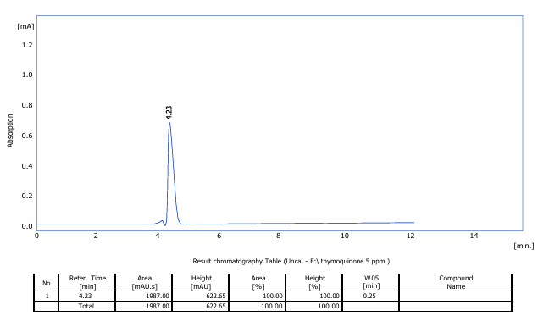
Fig 1AStandard thymoquinone curve
The results indicated that the concentration of 0.4 mg/L of beta-1-3 glucanase enzyme added to MS medium had the largest curve area of ​​29870.22 at a retention time (Rt) of 4.28 minutes (Figure 1D), surpassing the rest of the samples. This was followed by the curve area of ​​a concentration of 0.6 mg/L of 27455.01 with a concentration of 281.4 µg mL-1 (Figure 1E), compared with the rest of the isolates (Figure 1C). The comparison sample with a concentration of 241.6 µg mL-1 recorded a small curve area for thymoquinone, which reached 18744.05 at a retention time of 4.23 minutes (Figure 1B).

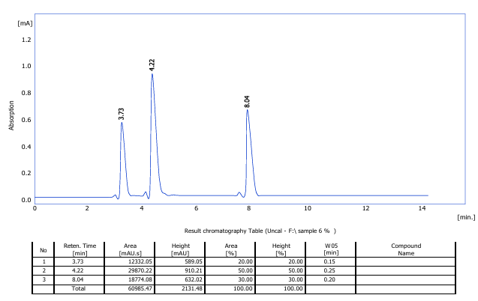
Fig 1B : Thymoquinone comparison curve

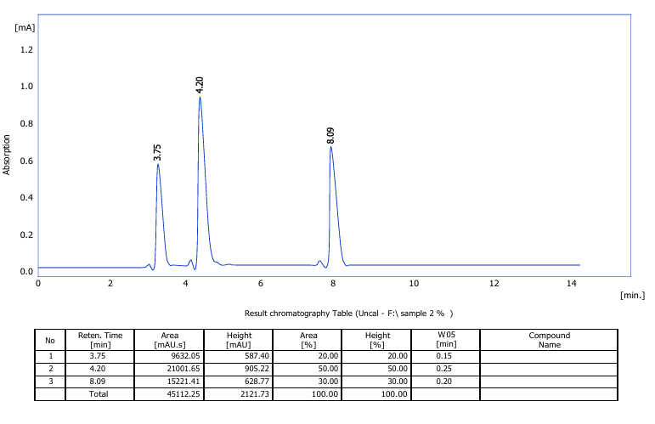
Fig 1C: Thymoketone curve in MS medium supplemented with 0.2 mg/L beta-1-3 glucanase enzyme

Fig 1D : Thymoketone curve in MS medium supplemented with 0.4 mg/L beta-1-3 glucanase enzyme

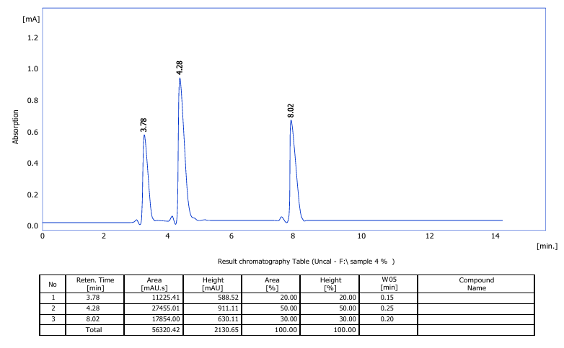
Fig 1E : Thymoketone curve in MS medium supplemented with 0.4 mg/L beta-1-3 glucanase enzyme

Fig 1F : Thymoketone curve in MS medium supplemented with 0.6 mg/L beta-1-3 glucanase enzyme
Figure (1A-F) Thymoquinone curves extracted from black seed seedling leaves using HPLC chromatography technology

The difference in thymoquinone concentration between treatments is attributed to the varying intensity of the seedlings' physiological response to the beta-1,3-glucanase enzyme. Moderate concentrations activate metabolic pathways and stimulate the biosynthesis of secondary compounds, while high concentrations may cause excessive stress that inhibits enzymatic activity or reduces metabolic efficiency, negatively impacting thymoquinone accumulation (Namdeo, 2007). The results showed a clear difference between treatments, with the concentration reaching 75.16 mg/L at the 0.4 mg/L treatment and 52.84 mg/L at the 0.2 mg/L treatment. This increase at this concentration indicates that this level of enzyme contributed to increased thymoquinone accumulation as a secondary compound with a protective role. This aligns with what (Razzaq et al., 2023) indicated: that some secondary compounds accumulate more under the influence of biostimuli due to the activation of synthetic pathways associated with plant defense. In (Isah's, 2019) study, a gradual increase in concentration leads to increased production of secondary compounds up to a certain point before the effect becomes inhibitory when the plant's physiological threshold is exceeded. Therefore, the high thymoquinone concentration of 0.4 mg/L in this study may reflect the seedlings remaining within the limits of positive stimulation, without reaching the level of excessive stress that inhibits it.

??????????

?????????????
References
Abed, A. S., & Taha, A. J. (2024). Biotic and Abiotic Elicitors Induce Biosynthesis and Accumulation of Some Withanolide Compounds in the Callus Culture of Withania somnifera L. Egyptian Journal of Botany, 64(1), 245-256.‏
Agale, P. J., Jadhav, V. A., & Wamane, V. B. (2022). PLANT TISSUE CULTURE: GENERAL TECHNIQUES. International Journal of Scientific Development and Research., 7(11), 909–921.
Cosgrove, D. J. (2005). Growth of the plant cell wall. Nature reviews molecular cell biology, 6(11), 850-861.‏
Hamann, T. (2012). Plant cell wall integrity maintenance as an essential component of biotic stress response mechanisms. Frontiers in plant science, 3, 77.‏
Isah, T. (2019). Stress and defense responses in plant secondary metabolites production. Biological research, 52.‏
Leubner-Metzger, G. (2003). Functions and regulation of β-1, 3-glucanases during seed germination, dormancy release and after-ripening. Seed Science Research, 13(1), 17-34.‏
Lichtenthaler, H.K.(1987). Chlorophyll and carotenoids pigment of photosynthetic biomembrane. Methods Enzymology ,148:350-382.
Murashige, T. and Skoog, F. (1962). A revised medium for rapid growth and bioassay with tobacco tissue culture. Physiol. Plant., 15: 473-479.
Namdeo, A. G. (2007). Plant cell elicitation for production of secondary metabolites: a review. Pharmacogn Rev, 1(1), 69-79.‏
Perrot, T., Pauly, M., & Ramírez, V. (2022). Emerging roles of β-glucanases in plant development and adaptative responses. Plants, 11(9), 1119.‏
Razzaq, A., Zafar, M. M., Ali, A., Ihsan, L., Qadir, F., Khan, M. N., ... & Qiao, F. (2025). Elicitor-mediated enhancement of secondary metabolites in plant species: a review. Frontiers in Plant Science, 16, 1706600.‏
Shanmugaratnam, S., Mikunthan, G., & Thurairatnam, S. (2013). Potential of Withania somnifera Dunal cultivation as a medicinal crop in Jaffna district. American-Eurasian Journal Agriculture and Environment Science, 13(3), 357-361.‏
Soliman, R. M., Salam, R. A. A., Eid, B. G., Khayyat, A., Neamatallah, T., Mesbah, M. K., & Hadad, G. M. (2020). Stability study of thymoquinone, carvacrol and thymol using HPLC-UV and LC-ESI-MS. Acta Pharmaceutica, 70(3), 325-342.‏
Taiz, L., Zeiger, E., Møller, I. M., & Murphy, A. (2017). Fisiologia e desenvolvimento vegetal. Artmed Editora.‏
Taiz, L., Zieger, E., Moller, I. M., & Murphy, A. (2015). Plant Physiology and Development 6th ed. Sinauer Assosiates. Inc. Pub. USA.‏
Thomas, B. R., Inouhe, M., Simmons, C. R., & Nevins, D. J. (2000). Endo-1, 3; 1, 4-β-glucanase from coleoptiles of rice and maize: role in the regulation of plant growth. International Journal of Biological Macromolecules, 27(2), 145-149.‏

