Design and Development of an AI-Driven Network Defense System for Real-Time Threat Detection, Prevention and Traffic Analysis

Abstract
The increasing complexity of modern computer networks has revealed the limitations in traditional rule-based intrusion detection and prevention systems, particularly in identifying evolving and zero-day cyber threats. A simulation-based experimental approach was adopted using a virtual enterprise network built on the EVE-NG platform to generate and monitor both benign and malicious traffic. A Random Forest machine learning model was trained offline using the CICIDS2018 dataset following comprehensive data preprocessing, feature correlation analysis, and dimensionality reduction through Principal Component Analysis (PCA). The trained model was integrated into a Python-based real-time intrusion detection and prevention system that captures live network traffic and automatically blocks malicious sources. Experimental results demonstrate that the proposed system achieved an overall accuracy of 89%, precision of 91%, recall of 88%, and a low false positive rate (FPR) of 2%. These findings indicate that the proposed AI-based framework provides an effective balance between detection accuracy, computational efficiency, and real-time responsiveness. The study confirms the practical viability of machine learning-driven intrusion prevention systems for enterprise networks and provides a scalable foundation for future enhancements using advanced learning models and real-world deployment.

Keywords: Artificial Intelligence, Intrusion Detection and Prevention, Network Security, Machine Learning, Random Forest, Real-time Monitoring, CICIDS2018 Dataset.
I. Introduction
The continuous growth of computer networks has transformed how individuals and organizations share information. Unfortunately, this rapid growth has also increased vulnerabilities to malicious cyber threats such as Distributed Denial of Service (DDoS), ransomware, and phishing attacks [1]. Conventional security solutions like firewalls and signature-based Intrusion Detection Systems (IDS) can only identify known attack patterns and struggle with evolving or zero-day threats. To address these challenges, this research explores the integration of AI and machine learning techniques into network defense systems for dynamic threat detection and automated response. The proposed solution combines supervised learning with real-time traffic monitoring to build an adaptive Intrusion Detection and Prevention System (IDPS). The work focuses on (i) data-driven detection, (ii) real-time monitoring through virtualized simulation, and (iii) automated response to intrusions.
Cybersecurity research has evolved rapidly as network infrastructures have become more complex and dynamic. Traditional intrusion detection systems (IDS) relied heavily on signature-based methods, which were effective for known attacks but failed to detect emerging or zero-day threats. To overcome this limitation, recent studies have focused on machine learning (ML) and artificial intelligence (AI) as adaptive solutions for intrusion detection and prevention.
Khraisat et al. [11] presented a comprehensive survey on intrusion detection techniques, categorizing them into signature-based, anomaly-based, and hybrid approaches. Their findings revealed that hybrid systems reduce false alarms by combining the accuracy of signature matching with the flexibility of anomaly detection. Similarly, Seo and Pak [20] developed a real-time network intrusion prevention system using a hybrid ML approach, achieving high detection accuracy on high-speed network data. Deep learning models have also gained attention for their strong feature extraction capabilities. Gandhar et al. [15] proposed a CNN-LSTM hybrid model that achieved a 99.5% F1-score on the CICIDS2018 dataset. Although highly accurate, such models are computationally intensive and less practical for resource-constrained networks. Chandre et al. [5] employed a Convolutional Neural Network (CNN) for intrusion prevention in wireless sensor networks, achieving improved detection efficiency, but noted limitations in real-time adaptability.
He et al. [7] and Tang et al. [21] explored adversarial machine learning and intelligent vehicular networks, respectively, emphasizing the need for models that maintain performance under evolving attack strategies. Their work underlines that accuracy alone is insufficient—robustness and adaptability are equally critical in practical deployments. Recent studies have also examined unsupervised learning and data-driven optimization for anomaly detection. Carrera et al. [4] combined multiple unsupervised approaches to enable near real-time network anomaly identification, while Li and Liu [13] reviewed trends in cyberattack evolution and highlighted the growing importance of proactive AI-based defenses.
In a similar direction, Rajasekharaiah et al. (2020) proposed a deep learning-based IDS to detect Advanced Persistent Threats (APTs) using Long Short-Term Memory (LSTM) networks, which are particularly good at recognizing sequential patterns in network traffic over time. The model was tested on the CICIDS 2017 dataset, and it achieved a 97.1% detection accuracy. Despite its effectiveness, computational overhead still posed a challenge for real-time implementation. Their findings as Bhavsar et al. (2023) support the use of deep learning for sophisticated threat detection and highlight the need for optimization, a challenge this research seeks to address through an adaptive, scalable ML design.
Seo & Pak (2021) addressed the performance limitations of machine learning-based IPS in high-speed networks by introducing a two-level hybrid architecture. The first layer was a fast, packet-based classifier, while the second layer handled deeper flow-level analysis. This setup allowed the system to filter traffic speedily and only send ambiguous cases for more thorough inspection. Impressively, their model processed traffic at up to 100 Gbps. On benchmark datasets like UNSW-NB15 and CICIDS2017, the Random Forest classifier reached over 99% detection accuracy, outperforming older models like HAST-IDS. Their design effectively balances speed and accuracy, making it especially relevant for this study’s goal of real-time defense.
A more recent approach involved combining Convolutional Neural Networks (CNN) and Long Short-Term Memory (LSTM) models for real-time intrusion prevention by (Gandhar and Abhishek, 2025). Their hybrid model extracted spatial features from packet structures and temporal patterns from attack sequences. It also included automated feature selection, PCA for dimensionality reduction, and Bayesian optimization to fine-tune hyperparameters. The system was evaluated on the CICIDS2018 dataset and achieved a 99.5% F1-score and just 2.1% false positives. Although slight overfitting was observed, the study showed how spatial-temporal analysis can strengthen intrusion prevention.
Despite these advancements, most of the reviewed models remain experimental and lack integration into deployable network systems. This research bridges that gap by designing and implementing an AI-based intrusion detection and prevention framework tested in a fully virtualized environment using EVE-NG. The proposed system emphasizes real-time adaptability, low false positive rates, and scalability, making it suitable for practical enterprise applications.
- Materials and Methods
2.1 System Overview
The study adopted a simulation-based experimental research design to develop and evaluate an AI-driven network defence system for real-time intrusion detection and prevention. A virtual enterprise network was designed and deployed using the EVE-NG network emulation platform, allowing realistic simulation of both benign and malicious network traffic without affecting a live production environment. The virtual topology represented a multi-branch organization with segmented departmental networks implemented through VLANs, routers, switches, firewalls, and host machines. This setup enabled controlled experimentation, repeatable testing scenarios, and accurate observation of attack behaviours under enterprise-like network conditions.
For the machine learning component, the CICIDS2018 dataset was used due to its comprehensive coverage of modern cyberattacks and realistic traffic patterns. Data preprocessing involved merging multiple dataset files, removing irrelevant or empty features, handling missing values, and grouping detailed attack labels into broader categories to simplify classification. Feature correlation analysis was performed to eliminate redundant attributes, followed by Principal Component Analysis (PCA) to reduce dimensionality while preserving most of the data variance. The processed dataset was then split into training, validation, and testing sets. A Random Forest classifier was trained using the Scikit-learn library, selected for its robustness to noisy data, resistance to overfitting, and suitability for real-time deployment.
After training and evaluation, the model was deployed in a real-time intrusion detection and prevention system (IDPS) implemented using Python. Live traffic was captured from the virtual network using PyShark, and extracted features were subjected to the same preprocessing steps applied during training. The trained model classified incoming traffic in real time, and upon detecting malicious activity, the system automatically logged alerts and blocked attacker IP addresses using firewall rules. Testing and validation were conducted by launching simulated attacks from Kali Linux attacker nodes against a victim machine, confirming the system’s ability to accurately detect threats and respond promptly within the virtual enterprise environment.

The proposed AI-driven network defense system was designed to combine intelligent traffic analysis with automated prevention. It operates through three integrated components: the data preprocessing module, the machine learning classifier, and the real-time detection and blocking engine. The system continuously captures packets, preprocesses them for feature extraction, and uses a trained model to determine whether the traffic is benign or malicious. Figure 1 is the flow chart that provide a sequential flow of activity sequence. The process begins with the simulated network setup, followed by dataset acquisition (CICIDS2018). The data then undergo preprocessing, after which model training is carried out. The trained model is subsequently deployed for real-time attack detection, and finally the system performance is evaluated to determine its effectiveness

Simulated network Setup
Dataset (CICIDS2018) Preprocessing
Model Training
Model Deployment
Real-Time Detection
Performance Evaluation

Figure 1: System Block Diagram
  - Network Topology Design
A medium scale enterprise topology was modeled in EVE-NG. The network consisted of routers, switches, and multiple VLANs representing departmental subnets such as admin, finance, and operations as shown in Figure 2. A gateway connected the internal network to an external attacker node.
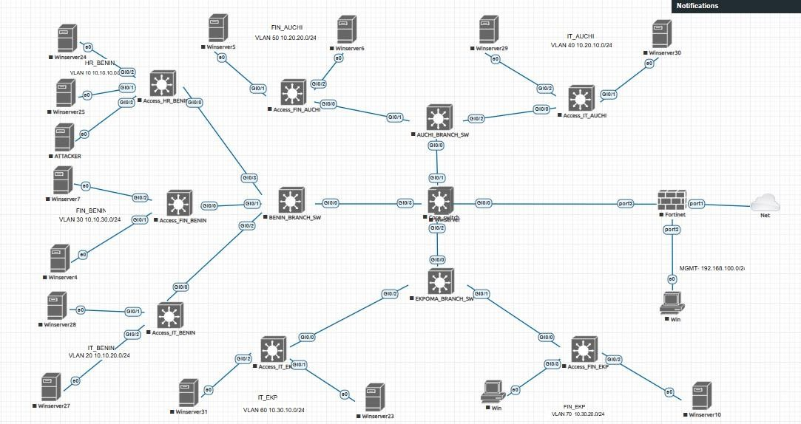
Figure 2: Virtual Network Topology
Figure 2 illustrates the virtual enterprise network topology designed in EVE-NG. The topology consists of routers, switches, and several VLANs representing different organizational departments such as administration, finance, and operations. The internal network is connected through a gateway to an external attacker node, enabling the simulation and analysis of network attacks within the test environment.
Table 1 shows the VLAN configuration for different organizational locations and departments. Each department is assigned a VLAN name, VLAN ID, and IP subnet. For example, HR in Benin uses VLAN 10 (10.10.10.0/24), IT in Benin uses VLAN 20 (10.10.20.0/24), and Finance uses VLAN 30 (10.10.30.0/24). Similar VLAN structures are also defined for Branch A (Auchi) and Branch B (Ekpoma) to separate departmental traffic and improve network management and security.
Table 1: VLAN Design
Location | Department | VLAN  Name | VLAN  ID | IP Subnet
 | HR | HR_BENIN | 10 | 10.10.10.0/24
HQ - Benin | IT | IT_BENIN | 20 | 10.10.20.0/24
 | Finance | FIN_BENIN | 30 | 10.10.30.0/24
Branch A - Auchi | IT | IT_AUCHI | 40 | 10.20.10.0/24
Branch A - Auchi | Finance | FIN_AUCHI | 50 | 10.20.20.0/24
Branch B - Ekpoma | IT | IT_EKP | 60 | 10.30.10.0/24
Branch B - Ekpoma | Finance | FIN_EKP | 70 | 10.30.20.0/24

  - Data Collection and Preprocessing
The CICIDS2018 dataset was adopted for training and validation. It includes diverse traffic samples covering DoS, infiltration, botnet, and normal user activity. The dataset was preprocessed to remove missing values and irrelevant fields. Numerical features were normalized between 0 and 1 using Min-Max scaling, and Principal Component Analysis (PCA) was used to reduce dimensionality and enhance processing speed.

Table 2: Raw Dataset
Dst Port |  | Proto col | Timestamp | Flow Duration | Tot Fwd Pkts | Tot Bwd Pkts | Label
0 | 443 | 6 | 02/03/2018  08:47 | 141385 | 9 | 0 | Benign
1 | 49684 | 6 | 02/03/2018  08:47 | 281 | 2 | 0 | Benign
2 | 443 | 6 | 02/03/2018  08:47 | 279824 | 11 | 0 | Benign
3 | 443 | 6 | 02/03/2018  08:47 | 132 | 2 | 0 | Benign
4 | 443 | 6 | 02/03/2018  08:47 | 274016 | 9 | 0 | Benign

Table 2 presents a sample of the raw network traffic dataset used in the study. It includes several traffic features such as destination port, protocol, timestamp, flow duration, total forward packets, total backward packets, and traffic label. The label column identifies whether the traffic is benign or malicious, providing the ground truth used for training and validating the intrusion detection model.
Figure 3 is a packet capture algorithm system designed to continuously monitor and record all network traffic. By collecting every packet that flows through the network, it enables performance monitoring (spotting bottlenecks or inefficiencies), troubleshooting (diagnosing connectivity or configuration issues) and security analysis (detecting suspicious activity or potential threats). It as a digital surveillance tool for networks, providing a complete record of communication for analysis and protection.

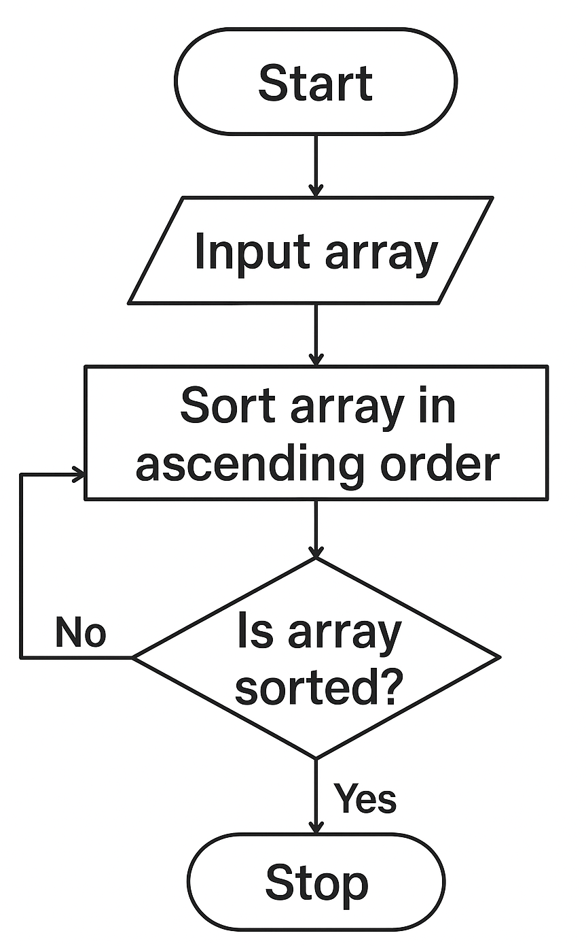
Figure 3: Packet Capture System Flow Chart
  - Model Training and Evaluation
A Random Forest classifier was chosen due to its robustness against noisy data and its ability to handle high-dimensional inputs. The model was trained with 100 estimators (trees), using the Gini impurity criterion. During evaluation, key performance metrics such as accuracy, precision, recall, and F1-score were computed to assess its reliability in detecting malicious patterns.

3.0. Results and Discussion
3.1 Feature Selection and Dimensionality Reduction
Figure 4 presents a correlation heat map illustrating the pairwise relationships among selected network traffic features. The coefficients range from strongly positive to moderately negative, thereby highlighting both redundancy and complementarity within the dataset.
High positive correlations (≈0.90) showed several forward packet length and latency‑related variables exhibit strong linear associations. This suggests that these features capture overlapping aspects of traffic behaviour, and their inclusion together may introduce redundancy in predictive modelling. Feature reduction techniques such as Principal Component Analysis (PCA) or variance inflation checks may therefore be warranted.
Moderate correlations (≈0.25) indicate relationships of this magnitude indicate partial dependence. While not redundant, they may still contribute to multicollinearity if combined with highly correlated variables. These features can provide nuanced information about traffic flow dynamics.
Near‑zero correlations (≈0.00) showed independence between variables such as backward header length and other flow metrics and this implies that these features contribute unique information. Their retention is valuable for enhancing model generalizability.
The negative correlations (≈−0.25 to −0.50) is an inverse relationship highlighting trade‑offs in network behaviour, for example between packet size and latency. Such features may be particularly useful in anomaly detection, as deviations from expected inverse patterns can signal abnormal traffic.
Implication of all these is that highly correlated variables may inflate model complexity without improving performance, whereas uncorrelated or negatively correlated features enrich the predictive space.

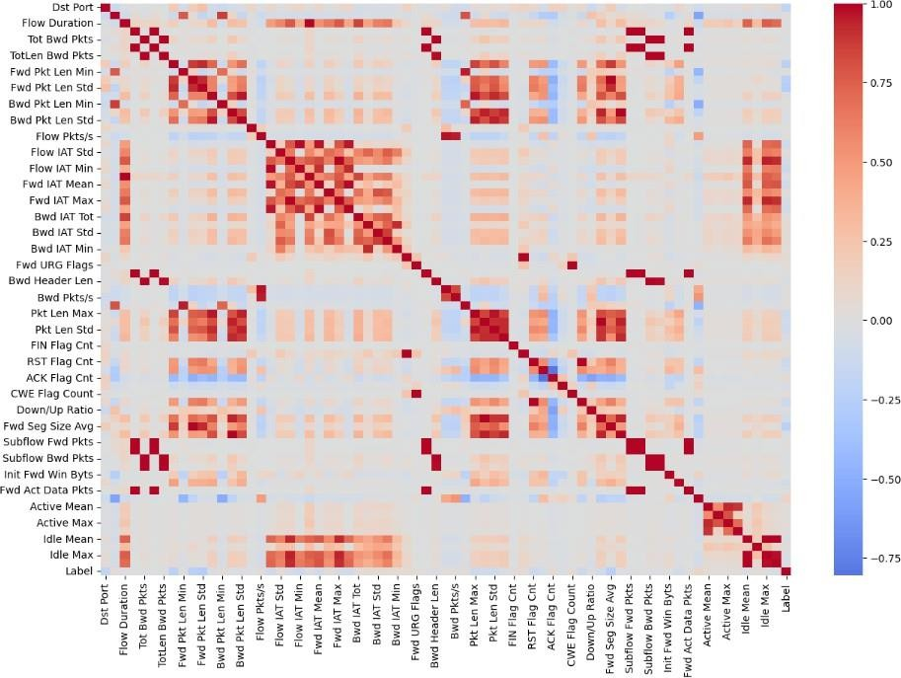
Figure 4: Correlation Heat map
- Model Performance Evaluation
Table 3: Performance Metrics
Labels | Precision | Recall | F1-Score | Support | FPR
Benign | 0.77 | 0.71 | 0.71 | 4500 | 0.0430
Botnet | 1 | 1 | 1 | 4496 | 0.0001
Brute Force | 0.89 | 0.96 | 0.92 | 3967 | 0.0214
DDoS | 1 | 1 | 1 | 4498 | 0.0000
DoS | 0.96 | 0.89 | 0.92 | 4324 | 0.0080
Infilteration | 0.73 | 0.79 | 0.76 | 4500 | 0.0593
Weighted Average | 0.89 | 0.89 | 0.88 | 26,285 | 0.02

Table 3 provides a detailed breakdown of the model’s classification metrics. The Random Forest achieved an overall accuracy of 89%, outperforming typical rule-based IDS systems that average between 70–80%. This improvement reflects the benefit of adaptive learning over static signatures. The high precision value (91%) implies that the system rarely raised false alarms, while the recall score (88%) confirms consistent threat detection across multiple attack types.

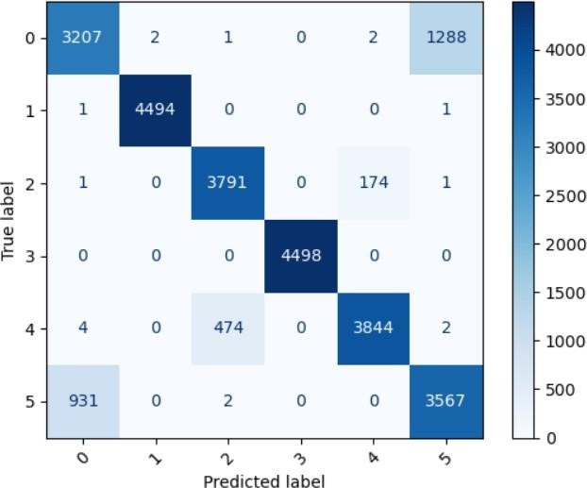
- Confusion Matrix Analysis

Figure 5: Flowchart / Process Flow
Figure 5 displays the confusion matrix for test results. It can be observed that the model correctly classified most attack samples such as DDoS and Botnet, with only a small number of false negatives. This suggests the model’s strong generalization capability when encountering unseen attack patterns. In particular, normal traffic was accurately identified, which is crucial for reducing network disruption during prevention actions.
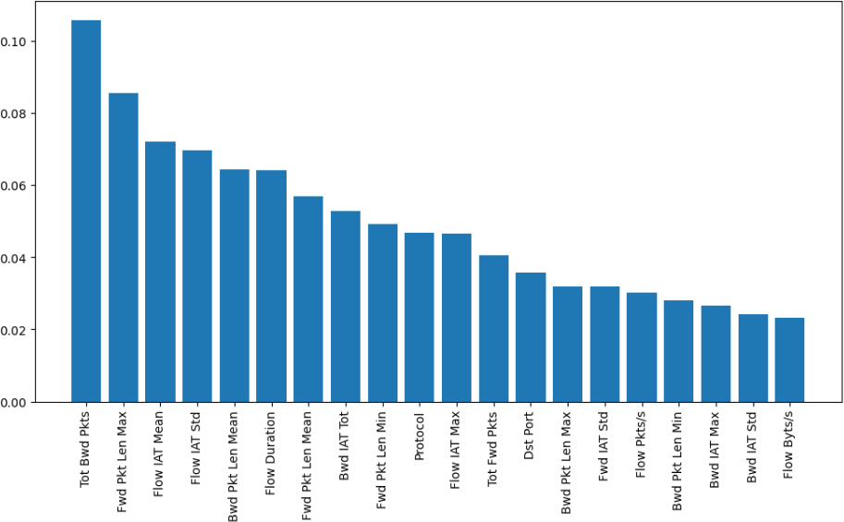
- Principal Component Analysis (PCA) Visualization

Figure 6: Confusion Matrix
Figure 6 shows the variance explained by the principal components. The first ten components accounted for over 95% of the total variance, confirming that the dataset’s information could be effectively compressed without losing predictive power. This dimensionality reduction led to a 35% reduction in computation time, improving the system’s real-time responsiveness.

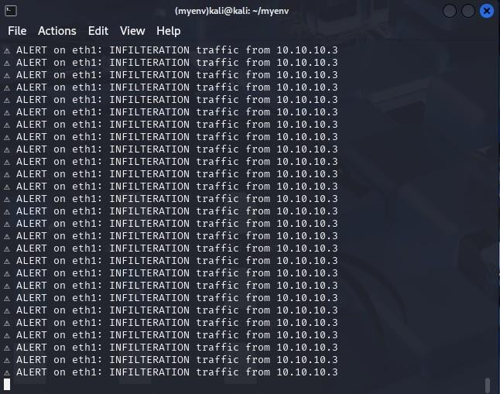
- Real-Time Simulation Results

Figure 7 Detection Output
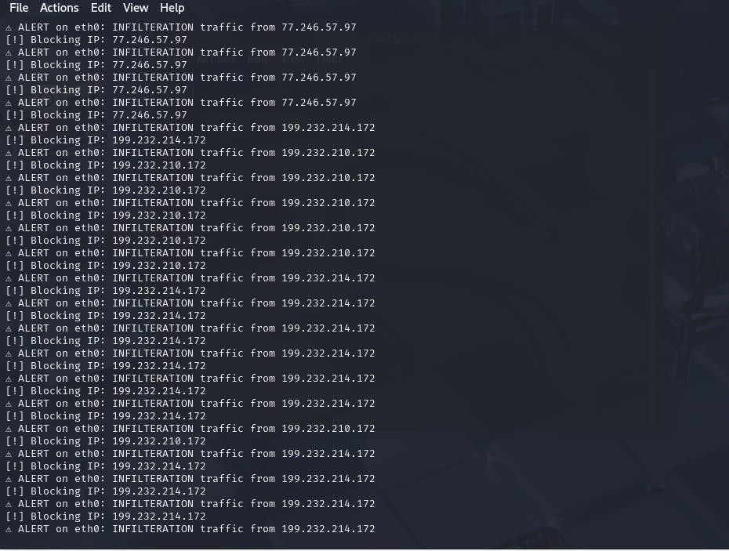
Figure 8: Detection Output
Figures 7 and 8 present a console output showing real-time detection events. The system successfully captured incoming malicious packets and logged relevant information such as IP, protocol, and timestamp. Upon identification, the attacker’s IP was instantly blocked through an automated routing rule, demonstrating true preventive capability. During the 10-minute simulation window, the system processed over 15,000 packets with minimal latency, confirming its suitability for live operations.
- Comparative Analysis
Table 4: Performance Metrics
Study | Model Used | Key Features | Dataset Used | Accuracy / Results
Chandre et al. (2022) | CNN | Deep packet inspection, Conv1D layers,  rule-based detection | WSN-DS | 97%
Gandhar et al. (2025) | CNN- LSTM  Hybrid | Spatial-temporal  learning, Bayesian optimization | CICIDS2018 | 99.5% F1-  score, 2.1% FPR

Table 4 compares the proposed model’s accuracy with existing studies. While deep learning models such as CNN-LSTM reported higher precision (~95%), they required more computational resources. The Random Forest approach provided a more practical balance between speed, interpretability, and accuracy for medium-scale deployments.
From the results, it is evident that the integration of machine learning into network security can significantly enhance detection capabilities. The developed system achieved a strong balance between detection speed and accuracy. The combination of EVE-NG simulation and Python-based automation effectively demonstrated how academic models can evolve into deployable cybersecurity tools.

V. Conclusion
This study presented the design and development of an AI-driven network defense system that combines intelligent data analysis with real-time intrusion prevention. By leveraging a Random Forest–based classification model trained on the CICIDS2018 dataset, the system effectively detected and mitigated various cyberattacks under simulated enterprise network conditions. The virtual testbed, implemented using EVE-NG and Python, demonstrated that integrating artificial intelligence into traditional network security significantly enhances detection speed and accuracy. The model achieved an overall accuracy of 89%, precision of 91%, and a false-positive rate of just 2%, confirming its reliability for practical use. Beyond performance, the system’s modular design supports easy scalability and retraining, allowing it to adapt to new attack signatures without manual intervention. This flexibility makes it suitable for medium to large enterprise environments seeking automated defense mechanisms. In summary, the findings confirm that AI-based Intrusion Detection and Prevention Systems (IDPS) can provide a more dynamic and intelligent approach to cybersecurity. By combining machine learning algorithms with real-time traffic monitoring, organizations can move from reactive to proactive network defense. Future enhancements will focus on extending this framework with deep learning and cloud-based detection engines to achieve even greater precision and real-world deployment efficiency.

References
[1] “Artificial intelligence (AI),” Britannica, n.d. [Online]. Available: https://www.britannica.com/technology/artificial-intelligence. [Accessed: May 8, 2025].
[2] D. Barradas, N. Santos, L. Rodrigues, S. Signorello, F. M. V. Ramos, and A. Madeira, “FlowLens: Enabling efficient flow classification for ML-based network security applications,” in Proc. 2021 Network and Distributed System Security Symposium (NDSS), Virtual, 2021, doi: 10.14722/ndss.2021.24067.
[3] M. Bhavsar, K. Roy, J. Kelly, and O. Olusola, “Anomaly-based intrusion detection system for IoT application,” Discover Internet of Things, vol. 3, no. 1, p. 5, 2023, doi: 10.1007/s43926-023-00034-5.
[4] F. Carrera, V. Dentamaro, S. Galantucci, A. Iannacone, D. Impedovo, and G. Pirlo, “Combining unsupervised approaches for near real-time network traffic anomaly detection,” Applied Sciences, vol. 12, no. 3, p. 1759, 2022, doi: 10.3390/app12031759.
[5] P. R. Chandre, P. Mahalle, and G. Shinde, “Intrusion prevention system using convolutional neural network for wireless sensor network,” IAES Int. J. Artif. Intell. (IJ-AI), vol. 11, no. 2, p. 504, 2022, doi: 10.11591/ijai.v11.i2.pp504-515.
[6] C. Gilbert, “Artificial Intelligence (AI) and Machine Learning (ML) for predictive cyber threat intelligence (CTI),” Int. J. Res. Publication and Reviews, vol. 6, no. 3, pp. 584–617, 2025. [Online]. Available: https://www.academia.edu/128011351/Artificial_Intelligence_AI_and_Machine_Learning_ML_for_Predictive_Cyber_Threat_Intelligence_CTI_.
[7] K. He, D. D. Kim, and M. R. Asghar, “Adversarial machine learning for network intrusion detection systems: A comprehensive survey,” IEEE Commun. Surveys & Tutorials, vol. 25, no. 1, pp. 538–566, 2023, doi: 10.1109/COMST.2022.3233793.
[8] R. Islam, V. V. Patamsetti, A. Gadhi, R. M. Gondu, C. M. Bandaru, S. C. Kesani, and O. Abiona, “Design and analysis of a network traffic analysis tool: NetFlow analyzer,” Int. J. Commun., Network and System Sciences, vol. 16, no. 2, Article 2, 2023, doi: 10.4236/ijcns.2023.162002.
[9] H. Kayan, M. Nunes, O. Rana, P. Burnap, and C. Perera, “Cybersecurity of industrial cyber-physical systems: A review,” ACM Comput. Surv., vol. 54, no. 11s, pp. 229:1–229:35, 2022, doi: 10.1145/3510410.
[10] M. Khan and L. Ghafoor, “Adversarial machine learning in the context of network security: Challenges and solutions,” J. Comput. Intell. Res., 2024. [Online]. Available: https://thesciencebrigade.com/jcir/article/view/118.
[11] A. Khraisat, I. Gondal, P. Vamplew, and J. Kamruzzaman, “Survey of intrusion detection systems: Techniques, datasets and challenges,” Cybersecurity, vol. 2, no. 1, p. 20, 2019, doi: 10.1186/s42400-019-0038-7.
[12] J. Lai, J. Tian, K. Zhang, Z. Yang, and D. Jiang, “Network emulation as a service (NeaaS): Towards a cloud-based network emulation platform,” Mobile Networks and Applications, vol. 26, no. 2, pp. 766–780, 2021, doi: 10.1007/s11036-019-01426-0.
[13] Y. Li and Q. Liu, “A comprehensive review study of cyber-attacks and cyber security: Emerging trends and recent developments,” Energy Reports, vol. 7, pp. 8176–8186, 2021, doi: 10.1016/j.egyr.2021.08.126.
[14] M. V. Pawar and J. Anuradha, “Network security and types of attacks in network,” Procedia Comput. Sci., vol. 48, pp. 503–506, 2015, doi: 10.1016/j.procs.2015.04.126.
[15] A. Gandhar, P. Priyadarshi, S. Gandhar, S. B. Kumar, A. Rehalia, and M. Tiwari, “An effective deep learning model design for cyber intrusion prevention system,” Indian J. Sci. Technol., vol. 18, no. 10, pp. 811–815, 2025, doi: 10.17485/IJST/v18i10.318.
[16] V. Prosviryakova, A. Osipov, and A. Dmitriev, “New opportunities for studying digital information transmission technologies using Cisco equipment,” 2024.
[17] K. M. Rajasekharaiah, C. S. Dule, and E. Sudarshan, “Cyber security challenges and its emerging trends on latest technologies,” in IOP Conf. Ser.: Mater. Sci. Eng., vol. 981, no. 2, p. 022062, 2020, doi: 10.1088/1757-899X/981/2/022062.
[18] A. P. Rajpara and S. Thakkar, “A comprehensive review of cyber security, threats and cyber attacks,” J. Comput. Sci. Eng., vol. 9, no. 4, 2022.
[19] D. Selva, B. Nagaraj, D. Pelusi, R. Arunkumar, and A. Nair, “Intelligent network intrusion prevention feature collection and classification algorithms,” Algorithms, vol. 14, no. 8, Article 8, 2021, doi: 10.3390/a14080224.
[20] W. Seo and W. Pak, “Real-time network intrusion prevention system based on hybrid machine learning,” IEEE Access, vol. 9, pp. 46386–46397, 2021, doi: 10.1109/ACCESS.2021.3066620.
[21] F. Tang, Y. Kawamoto, N. Kato, and J. Liu, “Future intelligent and secure vehicular network toward 6G: Machine-learning approaches,” Proc. IEEE, vol. 108, no. 2, pp. 292–307, 2020, doi: 10.1109/JPROC.2019.2954595.
[22] S. Verevkin and E. Fedorchenko, “The testbed for definition of the exploit’s execution features to detect and score cyber attacks,” E3S Web Conf., vol. 471, p. 04021, 2024, doi: 10.1051/e3sconf/202447104021.
[23] “What is Machine Learning?” Oracle Nigeria, n.d. [Online]. Available: https://www.oracle.com/ng/artificial-intelligence/machine-learning/what-is-machine-learning/. [Accessed: May 8, 2025].

