Original Research Article
Evaluation of variability, heritability and genetic advance for fodder yield and associated traits in maize (Zea mays L.) and teosinte germplasm

Abstract
Maize (Zea mays L.) serves as a crucial fodder crop, as it produces substantial biomass which
is palatable and rich in nutrient content. The research focused on evaluation of genetic
variability, heritability and genetic advance for fodder yield and related traits in 23 maize and
five teosinte accessions grown at Norman E. Borlaug Crop Research Centre of G.B. Pant
University of Agriculture and Technology Pantnagar, Uttarakhand, during Kharif 2024 in a
randomized complete block design with three replications. The analysis of variance (ANOVA) revealed the significant differences among all genotypes for all the traits indicating considerable genetic diversity. The study revealed that the green leaf weight (GLW), dry stem weight (DSW), green stem weight (GSW), green fodder yield (GFY) and dry fodder yield (DFY) showed high phenotypic and genotypic coefficients of variance (PCV and GCV) which indicated that these traits contained high variability and can be selected for enhancing fodder yield. The broad sense heritability was observed high for days to 50% tassel emergence (DTE), days to 50% anthesis, plant height (PH), green fodder yield (GFY), leaf number (LN), leaf area (LA) stem girth (SG) and leaf length (LL). The traits like green leaf weight (GLW), dry stem weight (DSW), and green fodder yield (GFY) exhibited both high heritability and high genetic advance as a percentage of mean showed a strong influence of additive gene action and can be used directly for selection for high fodder biomass production. The study demonstrates that the evaluated maize and teosinte genotypes possess significant genetic potential to enhance fodder yield and its component traits for developing high yielding fodder maize hybrids using specific breeding methods.
Keywords: Maize, Teosinte, Genetic variability, Heritability, Fodder yield

Introduction
Maize (Zea mays L.) is a vital fodder crop popularly known as the “Queen of Cereals” due to its high productivity and versatile utility. It is cultivated for food, feed and industrial purposes across a variety of agro-ecological zones and seasons (Tripathi et al., 2026). Fodder maize has become popular in tropical and subtropical areas due to its rapid growth, large biomass production, palatability, succulent nature, superior digestibility and rich nutrient composition. It plays a crucial role in improving livestock productivity (Vikram et al., 2025). Compared to sorghum and pearl millet, maize fodder is considered safer and superior in quality due to the absence of anti-nutritional factors such as hydrocyanic acid and oxalates.
Hassan AA, Abdikadir M, Hasan M, Azad AK, Hasanuzzaman M. Genetic variability and diversity studies in maize (Zea mays L.) inbred lines. IOSR J Agric Vet Sci. 2018;11(11):69-76.
Teosinte, the wild progenitor of cultivated maize, is a significant source of unexplored genetic diversity. Several teosinte species possess desirable traits such as rapid growth, prolific tillering ability, stress tolerance and high biomass production, which can be effectively utilized in breeding programmes for fodder improvement (Sahoo et al., 2026).
In India, growing livestock population and unpredictable climate have resulted in a substantial shortage of quality fodder. According to IGFRI Vision (2013), the nation has deficits of 44% in concentrate feed, 10.95% in dry fodder, and 35.6% in green fodder. The projected rise in fodder demand by 2050 necessitates the development of high-yielding and nutritionally superior fodder maize varieties.
Genetic variability forms the foundation of any successful breeding programme. The extent and efficacy of selection are determined by the degree of genetic variability. Estimation of genetic parameters such as phenotypic coefficient of variation (PCV), genotypic coefficient of variation (GCV), heritability and genetic advance provides insight into the nature and extent of genetic control governing quantitative traits. High heritability coupled with high genetic advance indicates the predominance of additive gene action and greater scope for improvement through direct selection.
In addition to cultivated maize, wild relatives of maize such as teosinte represent a valuable reservoir of genetic diversity for crop improvement. Introgression of genes from teosinte into maize has been reported to enhance several agronomic traits including biomass production, stress tolerance and adaptation. However, information on the extent of genetic variability for fodder yield and related traits in maize and teosinte materials remains limited. Therefore, evaluation of maize inbred lines, OPVs hybrid along with teosinte accessions can provide useful information regarding the extent of genetic variability available for fodder yield improvement.
Therefore, the present investigation was undertaken to assess the genetic variability, heritability and genetic advance for morphological, physiological and fodder yield traits among maize and teosinte genotypes.
Materials and Methods
Experimental Layout
The present experiment was carried out at the Norman E. Borlaug Crop Research Centre of G.B. Pant University of Agriculture and Technology, Pantnagar, U.S. Nagar, Uttarakhand, located at 243.8 m above mean sea level with coordinates of 29º N latitude and 79.30º E longitude, during the kharif season of 2024 under controlled irrigation and fertilization conditions. The experimental material consisted of a diverse set of 23 maize genotypes including 13 inbred lines, three hybrids and seven open-pollinated varieties (OPVs) along with selected five teosinte accessions (Table 1). The inbred lines represented elite breeding materials commonly used in maize improvement programmes, while hybrids were included to capture heterotic combinations and broader genetic variability. Open-pollinated varieties represented genetically diverse populations. Additionally, teosinte species were including as wild relatives to broaden the genetic base and explore their potential contribution to fodder yield and related traits. The experiment was laid out in a randomized complete block design (RCBD) with three replications. Each genotype in each replication was planted in a single row of 3 m at a spacing of 60 × 20 cm.
Table-1 List of Genotypes
Category | Genotypes | No. of  Genotypes
Inbred lines | LM 13, BML 6, CML 451, CML 563, CAL 159, CAL 1444, KAL 155994, UMI 1200, UMI 1201, ( LM 14 × Teo-25) × LM 14-⨂-⨂-⨂-2, (LM-14 × Teo -29) × LM- 14-⨂-⨂-⨂-1 (Light yellow), (LM-14 × Teo-29) × LM – 14-⨂-⨂-⨂-1Y, ( LM 14 × Teo-25) × LM 14-⨂-⨂-⨂- 2 (Purple plant) | 13
Open-pollinated varieties (OPVs) | CHIK 245, CHIK 248, CHIK 249, CHIK 254, Pant Black Seed Selection-1, Pant Black Seed Selection-2, Pant Black Seed Selection-3 | 7
Hybrids | CML 451 × BML 7, LM 13 × CML 563, LM 13 × KL 15594 | 3
Teosinte species (wild relatives) | Zea parviglumis (EC 941071), Zea diploperennis (EC 944144), Zea mexicana (EC 944152), Zea mexicana. (EC 944153), Zea luxurians (EC 804459) | 5

Observations Recorded
The observations were recorded for following morphological traits: Days to 50% tassel emergence (DTE), Days to 50% anthesis (Anthesis), Days to 50% silking (Silking), Plant height (PH, cm), Number of leaves per plant (LN), Leaf length (LL, cm), Leaf width (LW, cm), Leaf area (LA, cm²), Internodal length (IL, cm), Stem girth (SG, mm), SPAD Value, Green fodder yield (GFY, q ha⁻¹), Green stem weight (GSW, q ha⁻¹), Green leaf weight (GLW, q ha⁻¹), Dry fodder yield (DFY, q ha⁻¹), Dry stem weight (DSW, q ha⁻¹), Dry leaf weight (DLW, q ha⁻¹), Leaf stem ratio (LSR, w/w) calculated as the ratio of dry leaf weight to stem weight.
Statistical Analysis
The analysis of variance (ANOVA) was carried out according to the procedure described by Panse and Sukhatme (1985). Genotypic and phenotypic coefficients of variation were estimated according to Burton (1952). Broad-sense heritability and genetic advance were calculated following Johnson et al.,(1955). Genetic advance as percentage of mean (GAM) was also computed according to Johnson et al.,(1955). All statistical analyses were performed using R software version 4.5.2 with the variability and MASS packages.

RESULTS AND DISCUSSION
Analysis of Variance
The analysis of variance (ANOVA) revealed highly significant differences among genotypes for all the studied traits, indicating the presence of substantial genetic variability in the experimental material (Table 2). The highly significant genotype means squares (p < 0.01) suggest that the observed variation among genotypes was mainly due to genetic differences rather than environmental influence. The presence of such variability among genotypes is a prerequisite for effective selection and genetic improvement in crop breeding programmes. Significant variation among genotypes for morphological and yield related trait has also been reported in earlier studies, confirming the availability of exploitable genetic diversity for improvement of fodder yield and associated traits. Similar findings were reported by Vikram et al., (2025) and Sagar et al., (2025).
Mean performance and descriptive statistics of traits
Descriptive statistics indicated substantial phenotypic diversity among the evaluate genotypes for all the studied traits (Fig.1). DTE recorded a mean value of 62.81days with a range of 53- 74 days, while days to 50% anthesis varied from 57 to 80 days with a mean of 66.68 days. Similarly, days to 50% silking ranged from 59 to 81 days with an average value of 67.92 days, indicating that different genotypes had different flowering behaviours. PH also showed significant variation ranging from 108 to 262.67 cm with a mean value of 189.91 cm, indicating considerable diversity. Similar variability for flowering traits and PH in maize genotypes has also been reported by Prasad et al., (2024). Among the morphological traits, LN varied from 9.67 to 14.67 with a mean value of 11.79, while LL ranged from 44.00 to 91.33 cm with a mean of 60.30 cm. The average LW was 6.13 cm, with a ranged from 3.40 to 9.20 cm. Consequently, LA exhibited a broad range from 114.70 to 463.80 cm² with a mean value of 278.91 cm², indicating considerable variation in canopy architecture among the genotypes. IL ranged from 8.97 to 21.83 cm with an average value of 14.02 cm, whereas SG varied between 8.82 and 22.22 mm with a mean of 16.12mm. SPAD chlorophyll meter readings also showed noticeable variation among genotypes, ranging from 235.80 to 505.00 with a mean value of 372.86, indicating differences in chlorophyll content and photosynthetic efficiency. Similar variability for morphological traits in genotype has been reported by Pavithra et al., (2022). Considerable variation was also observed for yield-related traits.
Table-2 Analysis of variance
Trait | Replication MS (Df -2) | Genotype MS (Df-27) | Error MS (Df-54) | CV (%) | SEm | SEd | CD(5%) | CD (1%)
DTE | 0.226 | 64.529** | 0.819 | 1.44 | 0.522 | 0.739 | 1.48 | 1.97
Anthesis | 0.464 | 103.246** | 0.921 | 1.44 | 0.554 | 0.784 | 1.57 | 2.09
Silking | 3.226 | 100.139** | 1.263 | 1.65 | 0.649 | 0.918 | 1.84 | 2.45
PH | 8.218 | 3824.884** | 91.032 | 5.02 | 5.509 | 7.790 | 15.62 | 20.80
LN | 0.041 | 3.097** | 0.252 | 4.26 | 0.290 | 0.410 | 0.82 | 1.10
LL | 30.485 | 203.396** | 36.127 | 9.97 | 3.470 | 4.908 | 9.84 | 13.10
LW | 0.002 | 3.974** | 0.213 | 7.52 | 0.266 | 0.377 | 0.75 | 1.01
LA | 557.678 | 13053.286** | 1481.214 | 13.80 | 22.220 | 31.424 | 63.00 | 83.90
IL | 0.918 | 26.417** | 0.750 | 6.18 | 0.500 | 0.707 | 1.42 | 1.89
SG | 0.195 | 23.077** | 2.706 | 10.21 | 0.950 | 1.343 | 2.69 | 3.59
SPAD | 346.503 | 11386.216** | 601.211 | 6.58 | 14.156 | 20.020 | 40.14 | 53.45
GFY | 1231.829 | 23381.671** | 913.493 | 13.54 | 17.450 | 24.678 | 49.48 | 65.89
GSW | 130.389 | 15009.646** | 783.485 | 15.63 | 16.161 | 22.854 | 45.82 | 61.02
GLW | 295.713 | 1683.806** | 131.286 | 25.68 | 6.615 | 9.355 | 18.76 | 24.98
DFY | 20.302 | 948.416** | 23.831 | 10.77 | 2.818 | 3.986 | 7.99 | 10.64
DSW | 23.874 | 634.601** | 15.951 | 12.75 | 2.306 | 3.261 | 6.54 | 8.71
DLW | 0.064 | 44.621** | 4.555 | 15.43 | 1.232 | 1.742 | 3.50 | 4.66
LS | 0.027 | 0.075** | 0.010 | 18.26 | 0.057 | 0.081 | 0.16 | 0.22
Df= Degrees of freedom; ‘*’ significant at p ≤ 0.05; ‘**’ significant at p ≤0.01.

GFY ranged from 80.00 to 463.33 q ha⁻¹ with a mean value of 223.20 q ha⁻¹, indicating large differences in biomass production among the genotypes. Similarly, GSW and GLW ranged from 56.30 to 372.96 q ha⁻¹ and 1.11 to 106.67 q ha⁻¹, respectively. DFY ranged from 25.05 to 99.12 q ha⁻¹ with a mean value of 45.34 q ha⁻¹, whereas DSW and DLW ranged from 13.79 to 76.75 q ha⁻¹ and 7.80 to 26.59 q ha⁻¹ respectively. The LSR showed heterogeneity from 0.15 to 0.93 with an average value of 0.54, indicating variation in fodder quality attributes among the genotypes. Comparable variability for fodder yield traits in maize has been reported by Singh et al., (2023). Overall, the wide range observed for most morphological and yield traits indicates the presence of considerable genetic variability among the studied genotypes, which could be effectively utilized for the improvement of fodder yield and its related traits in maize breeding programmes.
Phenotypic and genotypic coefficient of variability
The degree of variability among the examined genotypes for various traits was indicated by
the estimations of the phenotypic coefficient of variation (PCV) and genotypic coefficient of
variation (GCV) shown in Table 3. High estimates of PCV and GCV were observed for GLW
(PCV 57.09%, GCV 50.98%), DSW (PCV 47.57%, GCV 45.83%), GSW (PCV 41.50%, GCV 38.44%), GFY (PCV 41.07%, GCV 38.77%), DFY (PCV 40.19%, GCV 38.72%), DLW (PCV 30.60%, GCV 26.42%) and LSR (PCV 32.75%, GCV 27.19%). The high degree of variability for these attributes suggests the presence of substantial genetic variation and suggests a greater scope for improvement through selection. Comparable results for fodder yield related traits in maize have been reported by Kapoor and Batra (2015) and Ali et al. (2015). Moderate estimates of PCV and GCV were recorded for LA (PCV 26.20%, GCV 22.27%), IL (PCV 21.75%, GCV 20.86%), LW (PCV 19.76%, GCV 18.27%), PH (PCV 19.24%, GCV 18.58%), SG (PCV 19.12%, GCV 16.17%), SPAD value (PCV 17.37%, GCV 16.08%) and LL (PCV 15.90%, GCV 12.38%) indicating the presence of moderate genetic variability among the genotypes. Similar outcomes have also been reported by Singh et al., (2023) and Vikram et al. (2025). Relatively lower estimates of PCV and GCV were observed for DTE (PCV 7.48%, GCV 7.34%), days to 50% anthesis (PCV 8.88%, GCV 8.76%), days to 50% silking (PCV 8.61%, GCV 8.45%) and LN (PCV 9.29%, GCV 8.26%), suggesting comparatively lower variability for these traits. Comparable results were reported by Kapoor (2017) and Borkhatariya et al., (2023). In general, PCV values were slightly higher than the corresponding GCV values for all traits, indicating the influence of environmental factors on trait expression. However, the comparably small variation between PCV and GCV for the
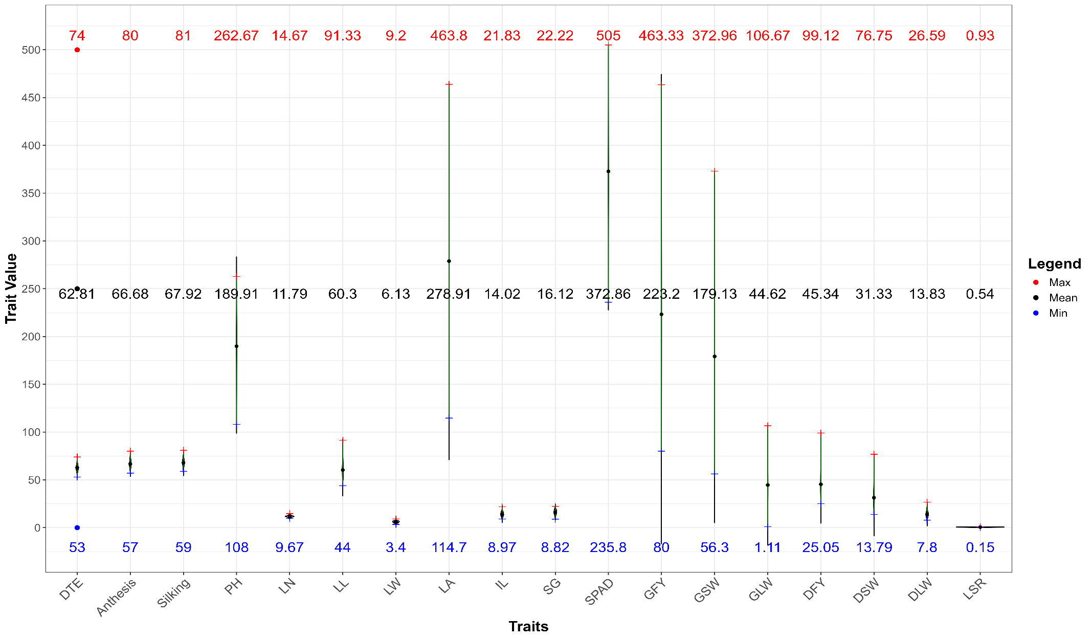
Fig -1 Mean performance and descriptive statistics of trait
majority of traits imply that the observed variability is largely governed by genetic factors with comparatively less environmental influence. Therefore, the presence of considerable genetic variability among the parental maize and teosinte genotypes for most of the studied traits indicates good potential for effective selection and genetic improvement in fodder maize breeding programmes. The wide variability observed may be attributed to the diverse genetic background of the evaluated material, which included cultivated maize inbred lines as well as wild teosinte germplasm. Teosinte species are known to possess unique genetic characteristics such as vigorous growth and high biomass potential, which may enhance variability for fodder-related traits.
Table-3 Estimates of genetic variability parameters
Trait | σ²g | σ²p | GCV (%) | PCV (%) | h² (%) | GA | GAM (%)
DTE | 21.24 | 22.06 | 7.34 | 7.48 | 96.29 | 9.32 | 14.83
Anthesis | 34.11 | 35.03 | 8.76 | 8.88 | 97.37 | 11.87 | 17.80
Silking | 32.96 | 34.22 | 8.45 | 8.61 | 96.31 | 11.61 | 17.09
PH | 1244.62 | 1335.65 | 18.58 | 19.24 | 93.18 | 70.15 | 36.94
LN | 0.95 | 1.20 | 8.26 | 9.29 | 78.98 | 1.78 | 15.11
LL | 55.76 | 91.88 | 12.38 | 15.90 | 60.68 | 11.98 | 19.87
LW | 1.25 | 1.47 | 18.27 | 19.76 | 85.50 | 2.13 | 34.80
LA | 3857.36 | 5338.57 | 22.27 | 26.20 | 72.25 | 108.75 | 38.99
IL | 8.56 | 9.31 | 20.86 | 21.75 | 91.94 | 5.78 | 41.20
SG | 6.79 | 9.50 | 16.17 | 19.12 | 71.50 | 4.54 | 28.16
SPAD | 3595.00 | 4196.21 | 16.08 | 17.37 | 85.67 | 114.32 | 30.66
GFY | 7489.39 | 8402.89 | 38.77 | 41.07 | 89.13 | 168.31 | 75.41
GSW | 4742.05 | 5525.54 | 38.44 | 41.50 | 85.82 | 131.42 | 73.36
GLW | 517.51 | 648.79 | 50.98 | 57.09 | 79.76 | 41.85 | 93.80
DFY | 308.20 | 332.03 | 38.72 | 40.19 | 92.82 | 34.84 | 76.84
DSW | 206.22 | 222.17 | 45.83 | 47.57 | 92.82 | 34.84 | 76.84
DLW | 13.36 | 17.91 | 26.42 | 30.60 | 74.57 | 6.50 | 47.00
LSR | 0.02 | 0.03 | 27.19 | 32.75 | 68.93 | 0.25 | 46.50

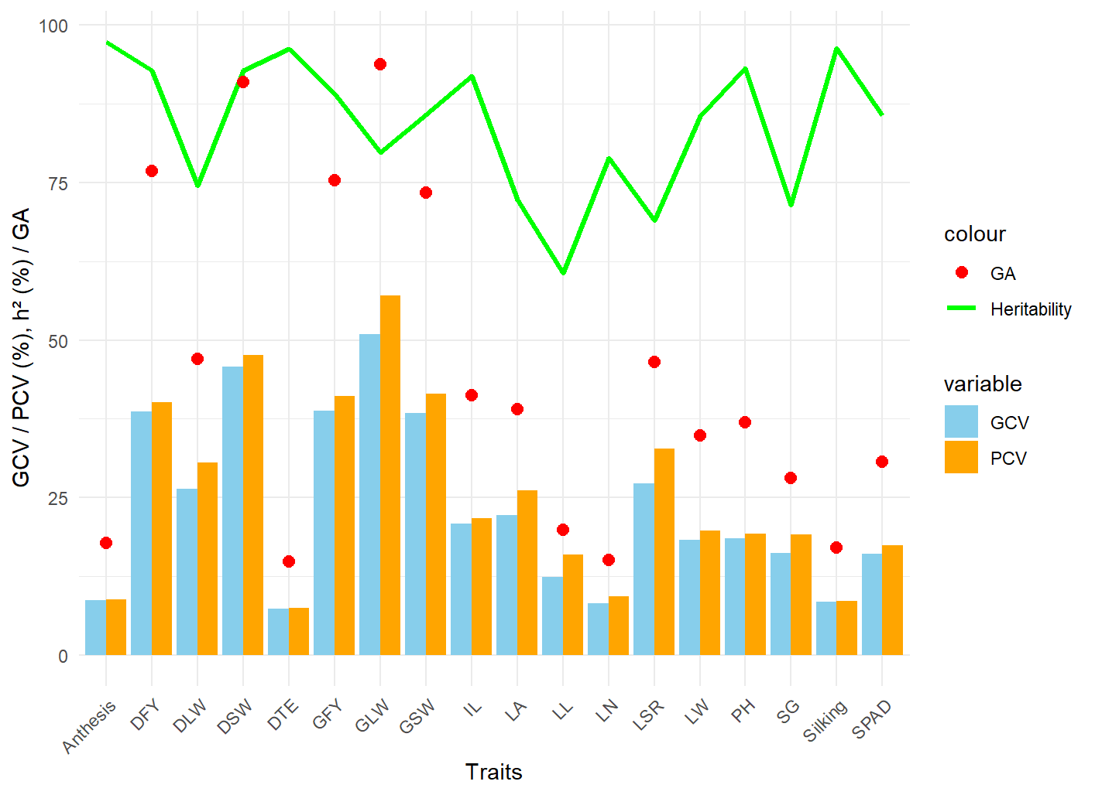
Fig-2 Variability Parameter
Heritability and Genetic Advance
The estimates of heritability (h²) in broad sense along with genetic advance (GA) and genetic advance as percent of mean (GAM) presented in Table 3 provide useful information regarding the nature of gene action controlling different traits. In the present investigation, high heritability estimates were observed for days to 50% anthesis (97.37%), DTE (96.29%), days to 50% silking (96.31%), PH (93.18%), IL (91.94)%, GFY (89.13%), GSW (85.82%), SPAD value (85.67%), LW (85.50%), DFY (92.82%), DSW (92.82%), LN (78.98%), LA (72.25%), SG (71.50%), LL (60.68%), DLW (74.57%) and LSR (68.93%). The high heritability estimates observed for most of the traits indicate that genetic factors predominantly control their expression despite the diverse genetic background of the evaluated materials. This suggests that phenotypic selection would be effective for improving these traits across different types of maize germplasm including inbred lines, hybrids and teosinte-derived materials. Comparable results have been reported by Vikram et al.(2025) for days to 50% anthesis, days to 50% silking, PH, LL, LW, LA, SG and LSR. Kapoor and Batra (2015) for GFY and DFY, Bashir et al., (2024) for days to 50% anthesis, and Pavithra et al., (2022) for PH, GFY and days to 50% silking.
High heritability coupled with high genetic advance as percent of mean was observed for GLW (93.80%), DSW (90.96%), GFY (75.41%), GSW (73.36%), DFY (76.84%), LA (38.99%), LW (34.80%), SPAD value (30.66%), PH (36.94%) and IL (41.20%). This combination indicates the predominance of additive gene action and suggests that improvement through direct selection would be effective for these traits. Similar results have been reported by Kapoor and Batra (2015) and Pavithra et al., (2022) for fodder yield traits in maize. Moderate genetic advance as percent of mean was recorded for SG (28.16%), LL (19.87%), days to 50% anthesis (17.80%), days to 50% silking (17.09%), DTE (14.83%) and LN (15.11%), indicating the involvement of both additive and non-additive gene effects in the inheritance of these characters. Similar results were reported by Vikram et al. (2025), Bashir et al., (2024) and Pavithra et al., (2022). Overall, the results suggest that traits exhibiting high heritability along with high genetic advance could be effectively utilized as selection criteria for improving fodder yield and related traits in maize breeding programmes
Conclusion
The examined genotypes of maize and teosinte for morphological, physiological, and fodder yield parameters showed significant genetic diversity. The presence of significant variation in the experimental material was confirmed by the ANOVA, which showed very significant differences between genotypes for all the examined traits. GLW, DSW, GFY, and DFY all showed high phenotypic and genotypic coefficients of variation, suggesting that these variables have a lot of variability. High heritability coupled with high genetic advance as percent of mean for these characters suggested the predominance of additive gene action and indicated that improvement through direct phenotypic selection would be effective. The inclusion of wild teosinte accessions along with maize inbred lines, open-pollinated varieties (OPVs) and hybrids broadened the genetic base, which contributed to the large variability observed for fodder yield and related traits. Inbred lines identified with superior trait performance can be utilized as parental lines for the development of single- cross hybrids. Open-pollinated varieties, due to their broad genetic base and heterogeneity, may serve as potential testers in top cross breeding programmes for evaluating the combining ability of inbred lines. The performance of existing hybrids in the study provides useful information on heterotic expression and may assist in identifying promising parental combinations for the development of double-cross hybrids. Furthermore, teosinte accessions represent a valuable source of novel genetic variability that can be exploited through introgression to improve fodder yield and related traits in maize. Overall, the superior genotypes and key traits identified in this study provide valuable genetic resources that can be strategically utilized in maize breeding programmes for the development of high-biomass and high-yielding fodder maize hybrids.

References
- Tripathi, A., Chand, N., Sahu, C. K., Ranjan, R., Kiran, R., Singh, A. P., & Chandra, S. (2026). Seasonal variability in thermal indices and heat use efficiency of maize under varietal and nutrient management in Tarai region of Uttarakhand, India. International Journal of Environment and Climate Change, 16(4), 355-374.
- Prasad, Y., Kumar, K., Kumar, R., Kumar, S., Prasash, S., Izhar, T., Ahmad, E., Yadav, N. P., Kumar, S., & Dammame, S. V. (2024). Genetic diversity studies in maize (Zea mays L.) for green fodder yield and its quality traits. International Journal of Advanced Biochemistry Research, 8(6), 111-114. https://doi.org/10.33545/26174693.2024.v8.i6b.1268
- Vikram, H. T., Lakshmana, D., Pattanashetti, S. K., Manjunatha, B., Halingali, B. I., & Sridhara, S. (2025). Multivariate assessment of genetic diversity for fodder yield and related traits in diverse maize germplasm panel. Plant Cell Biotechnology and Molecular Biology, 26(11-12), 211-220. https://doi.org/10.56557/pcbmb/2025/v26i11-1210060
- Sahoo, S., Varalakshmi, S., Singh, P., Singh, N. K., Jaiswal, J. P., & Pant, U. (2026). Wild relatives enhance genetic resources for maize (Zea mays ssp. mays) improvement through diversity analysis. Discover Plants, 3(1), 11.
- Indian Grassland and Fodder Research Institute. (2013). Vision 2050.
- Vikram, H. T., Lakshmana, D., Pattanashetti, S. K., Manjunatha, B., Halingali, B. I., & Sridhar, S. (2025). Assessment of genetic variability for fodder yield and related traits in diverse germplasm panel of maize (Zea mays L.). Journal of Advances in Biology & Biotechnology, 28(12), 1044-1053. https://doi.org/10.9734/jabb/2025/v28i123448
- Panse, V.G. & Sukhatme, P.V. (1985). Statistical Methods for Agricultural Workers. (4th ed.) ICAR.
- Singh, R.K. & Chaudhary, B.D. (1985). Biometrical methods in quantitative analysis. Kalayani Publishers.
- Johnson, H.W., Robinson, H.F. & Cornstock, R.E., (1955). Estimates of genetic and environmental variability in soybeans. Agronomy Journal. 47, 314-318.
- Burton G.H. (1952) Quantitative inheritance in grasses. Proceedings 6th International Grassland Congress,1, 277-283.
- Sagar, W., Sapkal, D., Gawali, K., Rathod, M., & Sarda, A. (2025). Assessment of genetic variability, heritability and genetic parameters for agronomic traits in maize (Zea mays L.) genotypes. International Journal of Research in Agronomy, 8(7), 459-465. https://doi.org/10.33545/2618060X.2025.v8.i7f.3231
- Pavithra, A., Ganesan, K. N., Meenakumari, B., & Sivakumar, S. D. (2022). Genetic studies on green fodder yield and quality traits in fodder maize (Zea mays L.). Electronic Journal of Plant Breeding, 13(2), 432-439.
- Singh, D. P., Jain, M., Goyal, M., & Sandhu, S. (2023). Genetic divergence studies of fodder yield and quality attributing characteristics in promising maize (Zea mays L.) composites. Range Management and Agroforestry, 44(2), 269-277.
- Ali, Q., Ahsan, M., Qasrani, S. A., Ramzan, I., Saif-Ul-Malook, A. S., Shakoor, A., & Mubarik, M. K. (2015). Genetic variability and correlation analysis for various morpho-physiological traits in maize (Zea mays L.) for green fodder yield. American-Eurasian Journal of Agricultural & Environmental Sciences, 15, 1298-1303.
- Kapoor, R., & Batra, C. (2015). Genetic variability and association studies in maize (Zea mays L.) for green fodder yield and quality traits. Electronic Journal of Plant Breeding, 6(1), 233-240.
- Kapoor, R. (2017). Variability and character association studies in fodder maize (Zea mays L.) hybrids. Forage Research, 43(1), 67-69.
- Borkhatariya, T. H., Gohil, D. P., Parmar, D. J., Sondarava, P. M., & Akbari, K. M. (2023). Genetic divergence and principal component analysis for fodder and biochemical traits in fodder maize (Zea mays L.). Pharma Innovation, 2(12), 3008-3015.
- Bashir, M., Khuroo, N. S., Dar, Z. A., Wani, A., Rashid, Z., & Shikar, A. B. (2024). Multivariate analysis of fodder maize (Zea mays L.) germplasm lines under temperate niches. Indian Journal of Plant Genetic Resources, 37(3), 473-481.

