Neurotoxic Effects of Petrochemical and Fertilizer Effluents on the Hippocampal CA3 Region of Wistar Rats: A Histopathological Study

ABSTRACT
Background: Industrial effluents from petrochemical and fertilizer industries contain toxic substances capable of inducing neurotoxicity. However, limited studies have examined their specific effects on hippocampal cytoarchitecture, particularly the CA3 region, which is critical for memory and cognitive function. Methods: This experimental study utilized forty male albino Wistar rats randomly assigned into five groups (n=8). The control group received standard feed and water, while experimental groups were administered 1.5 mL of treated and untreated effluents from Eleme Petrochemical and Notore Chemical Company orally for 28 days. At days 7, 14, 21, and 28, brain tissues were harvested, processed using standard histological techniques, and stained with hematoxylin and eosin for microscopic evaluation of the hippocampus. Results: Histological findings revealed normal hippocampal architecture in the control group. In contrast, effluent-exposed groups exhibited progressive neurodegenerative changes, including neuronal degeneration, vacuolation, hypertrophy, neuroglial infiltration, and necrosis. These alterations were more pronounced in groups exposed to untreated effluents, with severity increasing over time. Conclusion: Exposure to industrial effluents induces significant, time-dependent neurodegenerative changes in the hippocampus, with untreated effluents posing greater toxicity. These findings highlight the need for improved effluent treatment and stricter environmental regulation to mitigate potential neurological risks.
Keywords: Industrial effluents, Hippocampus, Histopathology, Neurotoxicity, Wistar rats, CA3 region

INTRODUCTION
Environmental pollution has emerged as a critical global public health challenge, driven largely by rapid industrialization, urbanization, and the increasing complexity of industrial waste streams. Industrial effluents, particularly those generated from petrochemical and fertilizer production processes, contain a diverse mixture of toxic substances, including heavy metals, hydrocarbons, and other persistent organic pollutants that exceed the assimilative capacity of natural ecosystems (Odutayo et al., 2016; Omran, 2020). The uncontrolled discharge of these effluents into aquatic environments has resulted in significant ecological degradation and widespread human exposure, with substantial implications for environmental and biological health (Allison & Paul, 2018).
Accumulating evidence indicates that environmental pollutants contribute significantly to disease burden, with estimates suggesting that a considerable proportion of global morbidity and mortality is attributable to environmental risk factors (Ajugwo et al., 2014; Akor-Dewu et al., 2012). Industrial wastewater contamination has been linked to a range of adverse health outcomes, including organ toxicity, oxidative stress, and cellular damage (Tsiouri et al., 2015). In developing regions, where regulatory enforcement may be limited, the discharge of untreated or inadequately treated effluents into water bodies remains a persistent concern, leading to deterioration in water quality and increased risk of exposure to toxicants.
Among the various organ systems affected by environmental toxicants, the central nervous system is particularly vulnerable due to its high metabolic demand, lipid-rich composition, and limited regenerative capacity. The hippocampus, a critical brain region involved in learning and memory, is especially sensitive to toxic insults. Histologically, the CA3 region plays a central role in synaptic integration and neuronal signalling, making it highly susceptible to structural disruption following exposure to neurotoxic agents.
Previous experimental studies have demonstrated that exposure to industrial effluents induces significant neurodegenerative changes in brain tissues. For instance, a recent study by Okoseimiema and Uahomo (2025) reported that both treated and untreated industrial effluents caused progressive neuronal degeneration, vacuolation, and vascular alterations in the cerebellar cortex of Wistar rats, with untreated effluents exhibiting more severe neurotoxic effects. These findings highlight the persistence of toxic constituents even after treatment and underscore the need for further investigation into region-specific brain vulnerability.
Despite these advances, there remains a paucity of studies specifically examining the histopathological effects of industrial effluents on the hippocampus, particularly the CA3 region, which is essential for cognitive processing and memory consolidation. Furthermore, comparative assessments of effluents from different industrial sources, such as petrochemical and fertilizer industries, remain limited, despite their distinct chemical compositions and potential differential toxicity.
Therefore, this study aimed to investigate the histopathological effects of treated and untreated effluents from Eleme Petrochemical Company and Notore Chemical Company on the hippocampal cytoarchitecture of male albino Wistar rats. Using a controlled experimental design, the study specifically assessed structural alterations in the CA3 region of the hippocampus following oral exposure over a 28-day period. By providing detailed histological evidence of neuronal and cellular changes, this study contributes to the growing body of knowledge on environmental neurotoxicity and informs strategies for improved industrial waste management and public health protection.

MATERIALS AND METHODS
Study design
This study employed an experimental laboratory-based design to evaluate the histopathological effects of treated and untreated industrial effluents from Eleme Petrochemical Company and Notore Chemical Company on the hippocampal cytoarchitecture of male albino Wistar rats. The study focused on assessing structural alterations in the hippocampus over a 28-day exposure period, with tissue evaluations conducted at multiple time points (days 7, 14, 21, and 28).
Study Area and Effluent Sources
Industrial effluent samples were obtained from two major facilities in Rivers State, Nigeria. Effluents from Eleme Petrochemical Company were collected from discharge points within Eleme, while effluents from Notore Chemical Company were obtained from discharge sites along the Okoro River in Okrika. These sites are characterized by continuous industrial discharge, making them relevant for evaluating environmental neurotoxicity.
Effluent Collection and Preservation
Effluent samples were collected directly from discharge outlets using pre-treated containers suitable for laboratory analysis and biological exposure. The samples were collected in plastic containers and transported to the laboratory under controlled conditions. The pH of the effluents was measured at the point of collection, and all samples were stored in a refrigerator to preserve their physicochemical integrity prior to administration.
Experimental Animals
A total of forty (40) male albino Wistar rats (Rattus norvegicus) with an average body weight of approximately 185 g were used for this study. The animals were obtained from the Animal House of the Faculty of Basic Medical Sciences, University of Port Harcourt, Nigeria. The rats were housed in clean, well-ventilated cages under standard laboratory conditions, with free access to standard pellet diet and water throughout the experimental period. The animals were acclimatized for a period of two weeks prior to the commencement of the experiment to allow adaptation to the laboratory environment and reduce stress-induced variability.
Experimental Design and Grouping
The animals were randomly assigned into five groups of eight rats each as follows:
Table 1. Experimental Design
Group | Identification | Rats | Treatment/Exposure
Group 1 | Control | 8 | Received standard feed and water only
Group 2 | Treated Petrochemical Effluent | 8 | Administered 1.5 mL of treated petrochemical effluent
Group 3 | Untreated Petrochemical Effluent | 8 | Administered 1.5 mL of untreated petrochemical effluent
Group 4 | Treated Notore Chemical Effluent | 8 | Administered 1.5 mL of treated Notore chemical effluent
Group 5 | Untreated Notore Chemical Effluent | 8 | Administered 1.5 mL of untreated Notore chemical effluent

Effluent Administration
Effluents were administered orally at a dose of 1.5 mL per rat using an oral gavage technique to ensure accurate and consistent delivery. The administration was performed once daily for a period of 28 days.
Sample Collection
At predetermined time points (days 7, 14, 21, and 28), a minimum of three rats from each group were anesthetized using diethyl ether and sacrificed. The brains were carefully excised, and the hippocampus was identified and isolated for histological evaluation.
Histological Processing and Examination
The harvested brain tissues were fixed in 10% buffered formaldehyde at 4°C. Following fixation, tissues were processed using standard paraffin embedding techniques, including dehydration, clearing, infiltration, and embedding. Sections of approximately 5 µm thickness were obtained using a microtome and mounted on glass slides. The sections were stained using hematoxylin and eosin (H&E) following established histological protocols. Histological examination focused on the CA3 region of the hippocampus to assess structural integrity, neuronal morphology, and pathological alterations such as neuronal degeneration, vacuolation, hypertrophy, necrosis, and neuroglial infiltration.
Microscopy and Photomicrography
Stained sections were examined under a light microscope at ×400 magnification. Representative photomicrographs were captured to document histopathological changes across experimental groups and time points.
Methods of Data Analysis
Data analysis was based on qualitative histopathological assessment. Tissue sections were systematically examined to evaluate cellular architecture, neuronal integrity, and morphological alterations in the hippocampus. Observations were compared across experimental groups and time points to identify patterns of neurodegeneration associated with effluent exposure. Representative photomicrographs were used to support interpretation of findings.
Ethical Considerations
Ethical approval for the study was obtained from the Research Ethics Committee of the University of Port Harcourt prior to commencement. All experimental procedures were conducted in accordance with established guidelines for the care and use of laboratory animals to ensure humane treatment throughout the study

RESULTS
Hippocampus of Wistar Rats (Control)
The photomicrographs of Plate 1 showed the hippocampus of the control Wistar rats. Results revealed that before exposure to the petrochemical and Notore chemical effluents, distinct neurons in the CA3 region were observed. Granule cells were seen in the dentate gurus and the blood capillaries had no distortion.
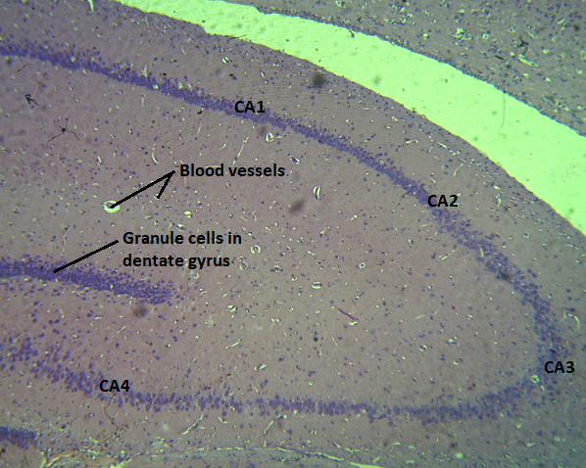 | 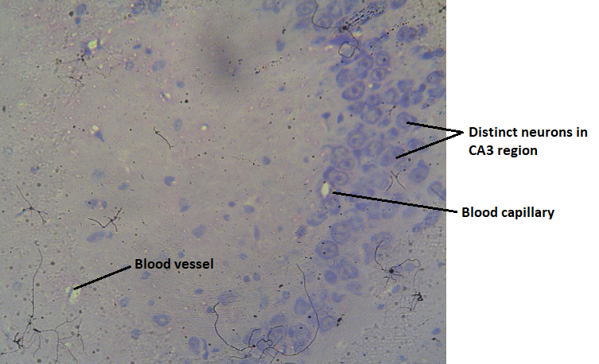
Plate 1: Photomicrograph (x400 H&E Stain) CA3 of the hippocampus of the control Wistar rats
Effect of Treated Petrochemical on the Histology of the Hippocampus of Wistar Rats
The photomicrographs from Plate 2 depict the progressive histopathological changes in the CA3 region of the hippocampus following exposure to treated effluent from a petrochemical source over various time points. On Day 7, mild degeneration of neurons and vacuolation are observed. By Day 14, more pronounced hypertrophy and degeneration of neurons are evident, along with an increase in infiltrating neuroglia. This trend continues with significant neuroglial infiltration and vacuolation by Day 21, culminating in marked degeneration of pyramidal neurons and extensive vacuolation within the CA3 region by Day 28.
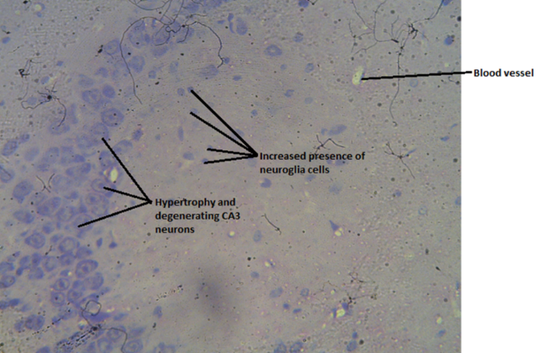 | 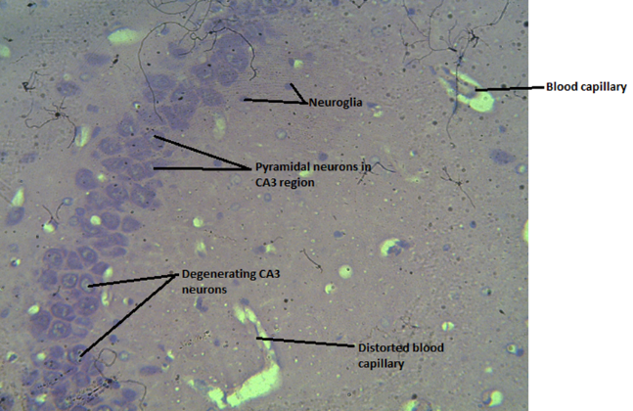
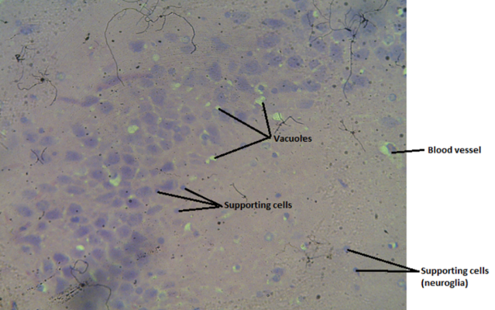 | 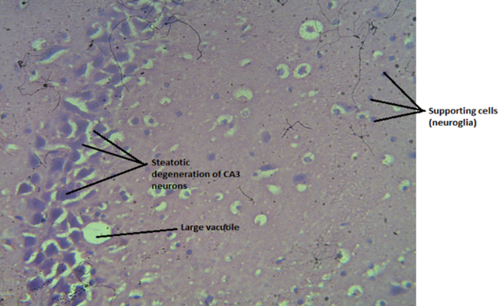
Plate 2: Photomicrograph (x400 H&E Stain) CA3 of the Hippocampus exposed to treated effluent from Petrochemical showing Day 7, Day 14, Day 21 and Day 28

Effect of Untreated Petrochemical on the Histology of the Hippocampus of Wistar Rats
The photomicrographs in Plate 3 reveal the progressive damage to the CA3 region of the hippocampus following exposure to untreated petrochemical effluent over time. On Day 7, there is evident degeneration of neurons and the presence of vacuolation. By Day 14, neuronal degeneration increases, accompanied by infiltration of neuroglia and the presence of blood capillaries. This trend of degeneration and neuroglial infiltration continues on Day 21, and by Day 28, severe neuronal degeneration (steatosis) is observed, along with marked vacuolation, cellular necrosis, and further neuroglial infiltration.

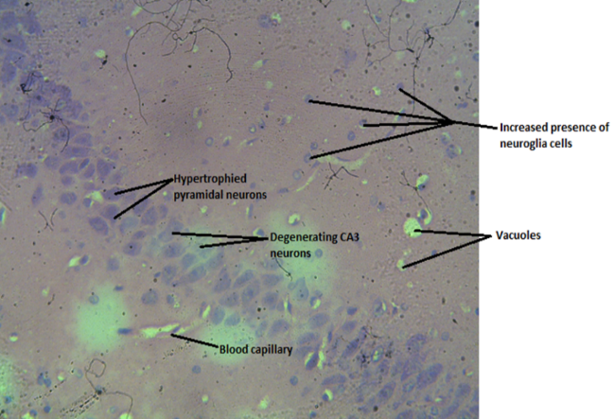 | 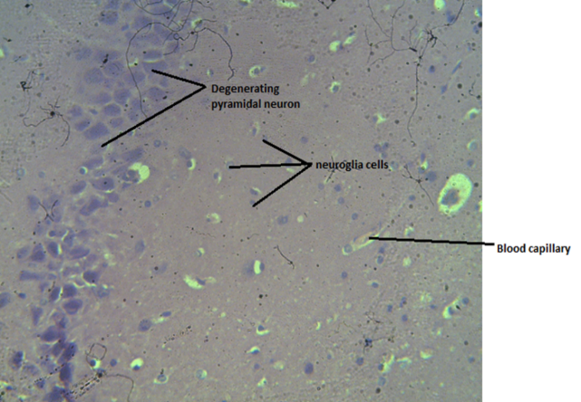
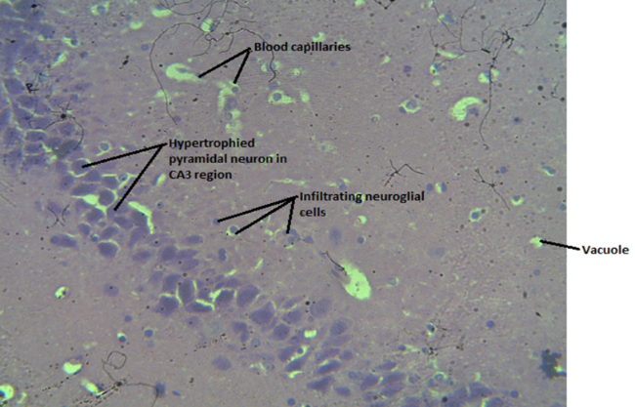 | 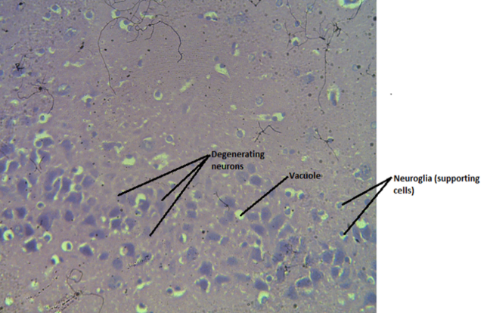
Plate 3: Photomicrograph (x400 H&E Stain) CA3 of the Hippocampus exposed to untreated effluent from Petrochemical showing Day 7, Day 14, Day 21 and Day 28

Effect of Treated Effluent from Notore on the Histology of the Hippocampus of Wistar Rats
The photomicrographs in Plate. 4 detail the histopathological effects of exposure to treated effluent from Notore on the CA3 region of the hippocampus over time. On Day 7, the image shows several degenerating CA2 neurons, along with vacuolations and infiltration of neuroglial cells. By Day 14, there is mild distortion of pyramidal neurons in the CA2 and CA3 regions, accompanied by neuroglial infiltration and the presence of blood capillaries. This progression continues on Day 21, where hypertrophied neurons with pockets of degeneration are observed, along with several congested blood capillaries. By Day 28, severe degeneration of pyramidal neurons is evident, with numerous neuroglial cells and vacuoles present in the CA3 region.
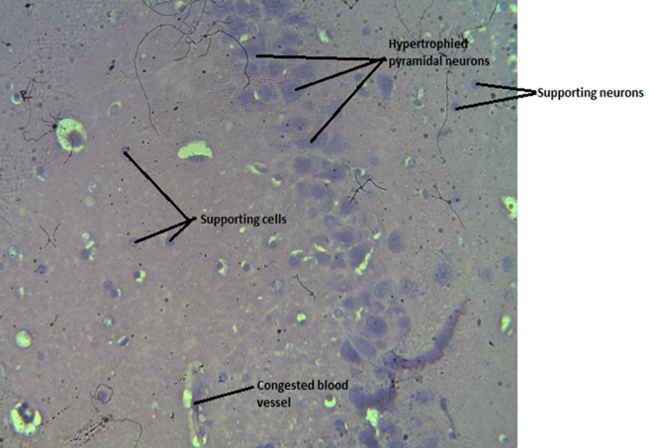 | 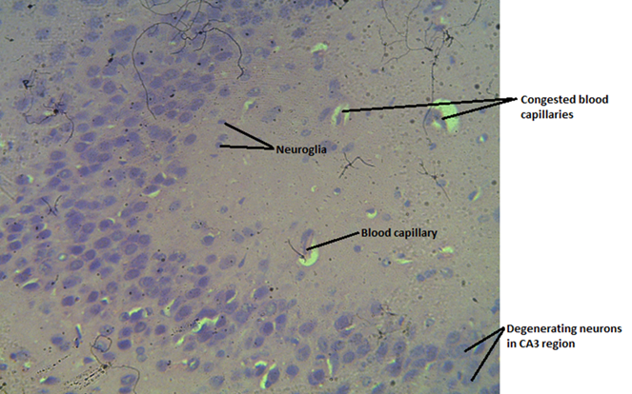
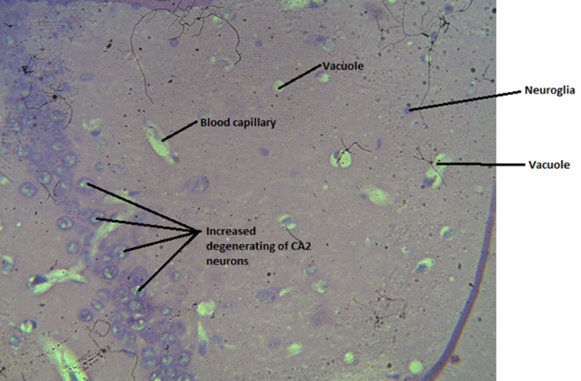 | 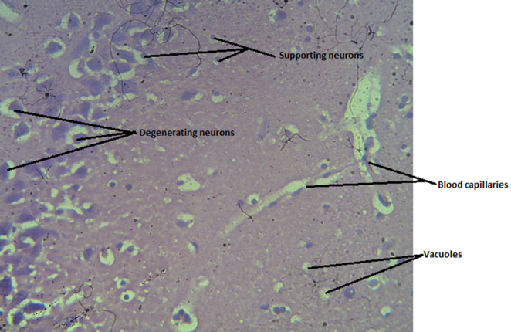
Plate 4: Photomicrograph (x400 H&E Stain) CA3 of the Hippocampus exposed to treated effluent from Notore Company showing Day 7, Day 14, Day 21 and Day 28

Effect of Untreated Effluent from Notore on the Histology of the Hippocampus of Wistar Rats
The photomicrographs presented in Plate 5 demonstrate the progressive neurodegenerative effects of exposure to untreated effluent from Notore. Day 7 and Day 14, both days show hypertrophy and degeneration of pyramidal neurons accompanied by a notable presence of supporting cells. By Day 21, the damage escalates significantly, with severe degeneration and necrosis of CA3 neurons observed. on the CA3 region of the hippocampus over a 28-day period. The images provide a clear visualization of the damage inflicted on hippocampal neurons and supporting cells as exposure time increases.
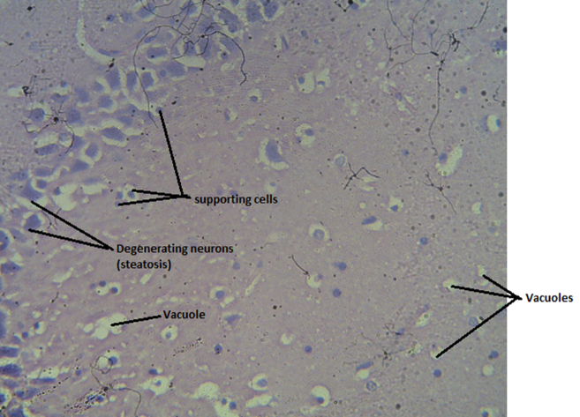 | 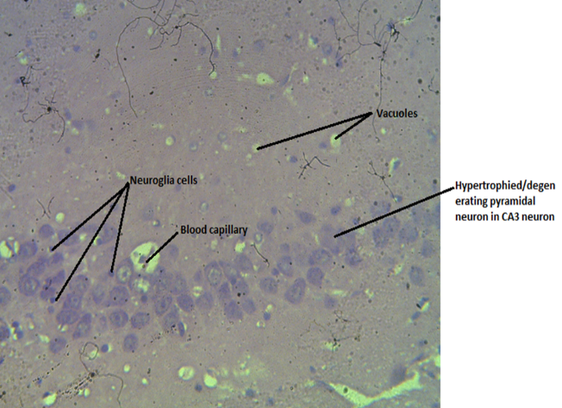
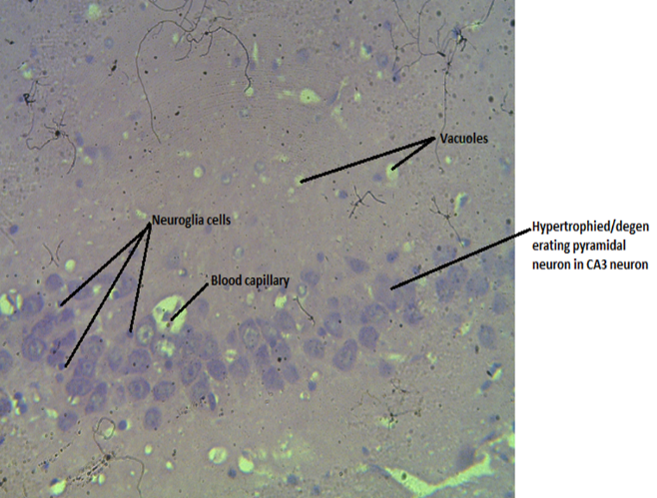 | 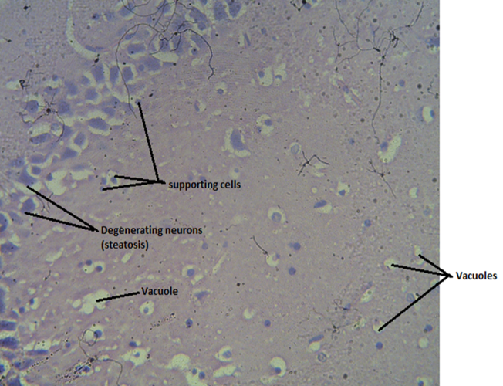
Plate 5: Photomicrograph (x400 H&E Stain) CA3 of the Hippocampus exposed to untreated effluent from Notore Company showing Day 7, Day 14, Day 21 and Day 28

DISCUSSION
The present study investigated the histopathological effects of treated and untreated industrial effluents from Eleme Petrochemical and Notore Chemical Company on the hippocampal cytoarchitecture of male albino Wistar rats, with particular emphasis on the CA3 region. The findings demonstrated that exposure to both treated and untreated effluents resulted in progressive neurodegenerative changes, characterized by neuronal degeneration, vacuolation, hypertrophy of pyramidal neurons, neuroglial infiltration, and, in more advanced stages, cellular necrosis. Notably, these alterations were time-dependent and more severe in animals exposed to untreated effluents, indicating a cumulative and dose-related neurotoxic effect.
The normal cytoarchitecture observed in the control group, including well-defined pyramidal neurons, intact granule cells, and undistorted vascular structures, confirms that the observed pathological changes in the experimental groups were attributable to effluent exposure rather than baseline structural variability. This provides a reliable internal reference for interpreting treatment-induced alterations in hippocampal morphology.
Exposure to treated petrochemical effluent resulted in gradual but progressive histopathological changes, beginning with mild neuronal degeneration and vacuolation at day 7, and advancing to pronounced neuroglial infiltration and pyramidal neuron degeneration by day 28. These findings suggest that although treatment processes may reduce the concentration of toxic constituents, residual contaminants remain sufficient to induce cellular stress and structural disruption in sensitive brain regions. Similar patterns of neuronal degeneration and glial activation have been reported in studies examining exposure to industrial pollutants, where oxidative stress and inflammatory responses are key mediators of neurotoxicity (Arukwe et al., 2012; Patel et al., 2016). Vacuolation observed in this study further supports the presence of cellular injury and metabolic dysfunction, as previously associated with toxicant-induced neuronal damage (Kaur et al., 2017).
In contrast, untreated petrochemical effluent produced more severe and rapid neurodegenerative changes, including marked neuronal degeneration, extensive vacuolation, neuroglial infiltration, and cellular necrosis by day 28. The presence of necrosis and pronounced structural disorganization indicates irreversible neuronal injury, likely resulting from higher concentrations of toxic substances such as heavy metals and hydrocarbons. These findings are consistent with previous reports demonstrating that untreated industrial effluents exert significant cytotoxic effects on neural tissues, leading to widespread neuronal loss and neuroinflammatory responses (Uboh et al., 2010; Tchounwou et al., 2012). The progressive worsening of histological damage over time highlights the cumulative nature of neurotoxicity associated with sustained exposure.
Similarly, exposure to treated effluent from Notore Chemical Company induced progressive hippocampal damage, with early-stage neuronal degeneration and neuroglial infiltration observed by day 7, and severe pyramidal cell degeneration and vascular congestion evident by day 28. The presence of congested blood capillaries suggests possible disruption of microvascular integrity and impaired cerebral perfusion, which may exacerbate neuronal injury. Although the severity of damage was comparatively lower than that observed with untreated effluent, the persistence of significant histopathological alterations underscores the incomplete removal of neurotoxic constituents during treatment processes. This aligns with findings from previous studies indicating that treated industrial effluents may still retain biologically active toxicants capable of inducing neuroinflammation and neuronal damage (Egbujo et al., 2015; Agbara et al., 2018).
The most severe histopathological changes were observed in animals exposed to untreated Notore effluent, where early neuronal degeneration progressed to extensive necrosis, vacuolation, and pronounced neuroglial infiltration by day 28. These findings suggest a high neurotoxic burden associated with untreated effluent exposure, leading to substantial disruption of hippocampal architecture. The observed neuroglial proliferation likely represents a reactive response to neuronal injury, reflecting activation of intrinsic repair and inflammatory pathways. Similar observations have been reported in studies investigating environmental neurotoxicity, where untreated effluents induce early neuronal stress followed by progressive degeneration and cell death (Adewale et al., 2016; Olajide, 2019; Balali-Mood et al., 2021).
Importantly, the findings of this study are consistent with and extend the work of Okoseimiema and Uahomo (2025), who reported progressive neuronal degeneration, vacuolation, and vascular alterations in the cerebellar cortex of Wistar rats following exposure to treated and untreated industrial effluents. While their study focused on the cerebellum, the present study demonstrates that similar neurotoxic effects also occur in the hippocampus, particularly within the CA3 region. This suggests that industrial effluents exert widespread neurotoxic effects across multiple brain regions, reinforcing the concept of global central nervous system vulnerability to environmental pollutants. Furthermore, the observation that treated effluents still induced measurable neurodegenerative changes in both studies highlights the limitations of current effluent treatment processes in eliminating neurotoxic risk.
Mechanistically, the observed histopathological changes may be attributed to oxidative stress, accumulation of heavy metals, disruption of neuronal membranes, and activation of neuroinflammatory pathways. These processes can lead to mitochondrial dysfunction, impaired synaptic signalling, and eventual neuronal apoptosis or necrosis. The hippocampus, due to its high metabolic activity and role in synaptic plasticity, is particularly susceptible to such insults, which may have implications for cognitive function and memory processing.
The broader implications of these findings are significant, particularly for populations residing near industrial discharge sites. Chronic exposure to contaminated water sources may predispose individuals to neurodegenerative conditions and cognitive impairments over time. The demonstration of progressive and region-specific brain damage underscores the urgent need for stricter environmental regulations, improved wastewater treatment technologies, and continuous monitoring of industrial effluent discharge.
Despite providing valuable insights, this study is limited by its reliance on histopathological assessment without accompanying molecular or biochemical analyses to elucidate underlying mechanisms of toxicity. Additionally, extrapolation of findings from animal models to human populations should be approached with caution. Future studies should incorporate biomarkers of oxidative stress, neuroinflammation, and apoptosis, as well as functional assessments, to provide a more comprehensive understanding of effluent-induced neurotoxicity.
CONCLUSION
This study demonstrates that exposure to both treated and untreated effluents from Eleme Petrochemical and Notore Chemical Company induces progressive neurodegenerative changes in the hippocampal CA3 region of Wistar rats, with untreated effluents causing more severe damage. The persistence of neuronal degeneration, vacuolation, and neuroglial infiltration even in treated effluent groups highlights the inadequacy of current treatment processes in fully eliminating neurotoxic contaminants. These findings underscore the urgent need for strengthening industrial wastewater treatment protocols to ensure effective removal of neurotoxic substances before environmental discharge. Regulatory agencies should enforce stricter compliance monitoring and periodic evaluation of effluent quality, particularly in regions with high industrial activity. Additionally, routine environmental and biological surveillance should be implemented for communities residing near discharge sites to mitigate long-term health risks. Further research integrating molecular biomarkers is recommended to elucidate mechanisms of toxicity and support evidence-based environmental health policies.
Disclaimer (Artificial Intelligence)
Authors hereby declare that NO generative AI technologies such as Large Language Models (ChatGPT, COPILOT, etc.) and text-to-image generators have been used during the writing or editing of this manuscript.
Consent
It is not applicable.
Ethical Approval
The study was carried out in adherence to ethical guidelines set by the National Institute of Health (NIH) for the ethical treatment of animals in research. The study was approved by the Research Ethics Committee of the University of Port Harcourt, Rivers State, Nigeria before commencement of the study.
Competing Interests
Authors have declared that no competing interests exist.
REFERENCES
Adewale, O. B., Onasanya, A., Anadozie, S. O., Abu, M. F., Akintan, I. A., Ogbole, C. J and Fadaka, A. O (2016). Evaluation of acute and subacute toxicity of aqueous extract of Crassocephalum rubens leaves in rats. Journal of Ethnopharmacology, 188 (2016), pp. 153-158, https://doi.org/10.1016/j.jep.2016.05.003
Agbara, G. I., Haruna, B. Chibuzo, E. C. and Agbara, H. N. (2018). Physiochemical, microbial and sensory properties of moi-moi as affectecd by processing method. International Journal of Food Science and Nutrition 3(5): 86-92.
Ajugwo, A. O., Teddy, C., Adias, K. A., Johnson, K. & Clement, U. N. (2014). Reduced haematological indices mechanics and fuel attendants in Elele Nigeria. Am J Med Biol. 1 (1-4).
Akor-Dewu, M. B, Ayo, O. J. Andrew, R. C., Mabrouk, M. M. & Adelaiye, A. (2012). Comparative Study of Haematological Cardiorespiratory Parameters in Women Exposed to Biomass or Fuels. American International Journal of Contemporary Research 2, (8), 257-263.
Allison, T. A & Paul, C. W (2014). Histological based Biomonitoring: A Baseline Ecotoxicological Evaluation OF New-Calabar River using Chrysichthys Nigrodigitatus. International Journal of Environment and Pollution Research. 2 (3), 17-41
Arukwe, Augustine & Eggen, Trine & Moeder, Monika. (2012). Solid waste deposits as a significant source of contaminants of emerging concern to the aquatic and terrestrial environments - A developing country case study from Owerri, Nigeria. The Science of the total environment. 438C. 94-102. 10.1016/j.scitotenv.2012.08.039.
Balali-Mood, M., Naseri, K., Tahergorabi, Z., Khazdair, M. R., & Sadeghi, M. (2021). Toxic mechanisms of five heavy metals: Mercury, lead, chromium, cadmium, and arsenic. Frontiers in Pharmacology, 12, 643972. https://doi.org/10.3389/fphar.2021.643972
Egbujo CN, Sinclair D, Borgmann-Winter KE, Arnold SE, Turetsky BI, Hahn C-G (2015) Molecular evidence for decreased synaptic efficacy in the postmortem olfactory bulb of individuals with schizophrenia. Schizophr Res 168:554–562.
Kaur, S., Seema G., Bela G., Kaur, J. (2017). Correlation between Cut-off Level of Tissue Transglutaminase Antibody and Marsh Classification. Middle East J Dig Dis. 9 (3): 178 –179. doi: 10.15171/mejdd.2017.72
Odutayo F. O. I, Oyetade O. B., Esan E. B., & Adaramola F. B. (2016). Effects of Industrial Effluent on the Environment using Allium Cepa and Zea Mays as bioindicators. International Journal of Environment and Pollution Research, 4 (3), 28-39. www.eajournals.org
Okoseimiema, S. C., & Uahomo, P. O. (2025). Comparative analysis of treated and untreated industrial effluents on cerebellar architecture in Wistar rats: Assessing neurotoxic impact and structural alterations. International Neuropsychiatric Disease Journal, 22(2), 22–32. https://doi.org/10.9734/indj/2025/v22i2472
Olajide, A. O. (2019). assessment of heavy metals concentration in road-side fast foods in Ibadan Oyo state, Nigeria. International Journal of Scientific and Engineering Research, 10(2), 1341-1349.
Omran, B. (2020). Facing Lethal Impacts of Industrialization via Green and Sustainable Microbial Removal of Hazardous Pollutants and Nanobioremediation. 10.1007/978-981-15-5901-3_7.
Patel, V., Dan Chisholm, Rachana Parikh, Fiona J Charlson, Louisa Degenhardt, Tarun Dua, Alize J Ferrari, Steve Hyman, Ramanan Laxminarayan, Carol Levin, Crick Lund, María Elena Medina Mora, Inge Petersen, James Scott, Rahul Shidhaye, Lakshmi Vijayakumar, Graham Thornicroft, Harvey Whiteford (2016). Addressing the burden of mental, neurological, and substance use disorders: key messages from Disease Control Priorities, The Lancet, 387 (10028), 1672-1685.
Tchounwou, P. B., Yedjou, C. G., Patlolla, A. K., & Sutton, D. J. (2012). Heavy metal toxicity and the environment. Experientia Supplementum, 101, 133–164. https://doi.org/10.1007/978-3-7643-8340-4_6
Tsiouri, Vasiliki, Konstantinos E. Kakosimos, and Prashant Kumar. "Concentrations, sources and exposure risks associated with particulate matter in the Middle East Area—a review." Air Quality, Atmosphere & Health 8.1 (2015): 67-80.
Uboh E. F., Okonb E. I., Ekong B. M. Effect of aqueous extract of Psidium guajava leaves on liver enzymes, histological integrity and HematologicalIndices in rats. Gastroenterology Research. 2010;3(1):32–38. https://doi.org/10.4021/gr2010.02.174w

