Carbon Sequestration and Climate Regulation in the Amazon Rainforest: Environmental and Public Health Implications

ABSTRACT
The Amazon Rainforest stores an estimated 150–200 petagrams of carbon in its biomass and soils, making it the largest terrestrial carbon reservoir on Earth. This review assesses the Amazon’s role in regulating global and regional climate, examines emerging evidence on the weakening of its carbon sink function, and evaluates the environmental and public health consequences of ongoing forest degradation.
Drawing on research from 2015 to 2025, we analyze carbon sequestration processes, hydrological functions, including the “flying rivers” system, and feedback mechanisms driving parts of the southeastern Amazon toward a shift from carbon sink to carbon source. We also consider methodological differences in biomass estimation, particularly across remote sensing approaches, and their implications for carbon accounting.
In addition, we highlight the health impacts of deforestation, including respiratory illness from wildfire smoke, heat-related illness, the spread of vector-borne diseases such as malaria and dengue, and risks to food and water security. We also assess current policy frameworks, including the Paris Agreement, REDD+, and national conservation laws.
Overall, we argue that the Amazon is essential to planetary health, and that protecting it will require stronger and more effective governance, not just incremental changes to existing policies.
Keywords: Amazon Rainforest; carbon sequestration; climate regulation; deforestation; public health; biodiversity; tipping point; planetary health.

1. Introduction
Atmospheric carbon dioxide (CO₂) concentrations, which remained below 280 parts per million (ppm) throughout the Holocene, have now exceeded 420 ppm, a threshold not observed in the geological record for at least three million years [1].
This rapid accumulation of greenhouse gases drives contemporary climate change, manifesting in rising temperatures, shifting precipitation regimes, intensifying extreme weather, and accelerating sea-level rise [2]. Forests perform an irreplaceable role in moderating atmospheric CO₂ accumulation, yet their capacity to sustain this function is being systematically eroded by land-use change and anthropogenic warming.
Among the world’s forested biomes, the Amazon Rainforest stands paralleled. Spanning approximately 5.5 million km² across nine South American nations, roughly 60% within Brazil, the Amazon supports an estimated 390 billion individual trees representing more than 16,000 species [3]. Its soils and living biomass collectively store 150–200 Pg of carbon. Beyond carbon storage, the Amazon regulates regional water systems, supports moisture recycling on a continental scale, and protects globally significant biodiversity [4]. However, it now faces profound and escalating threats.
Since the 1970s, approximately 17–20% of the original biome has been cleared, an area roughly equivalent to France and Germany combined, with deforestation accelerating markedly in the late 2010s [5, 6]. Land conversion for cattle ranching and soy agriculture, illegal logging, and increasingly severe drought and wildfire events are systematically eroding the forest's carbon sequestration capacity. Gatti et al. [7] showed that much of the southeastern Amazon has shifted from a carbon sink to a carbon source, a transition not predicted by pre-2010 ecosystem models.
The implications of Amazon degradation extend far beyond atmospheric chemistry. When forests are lost, it harms the health of hundreds of millions of people by polluting the air, spreading disease, disrupting water supply, and reducing food production.
While planetary health frameworks [8] increasingly recognize the link between ecosystem and human health, they are still often overlooked in policy discussions, especially those that treat the Amazon mainly as a carbon store rather than a system that supports life in many ways. This review assesses the Amazon’s role in carbon sequestration and climate regulation, as well as its environmental and public health impacts. It consolidates current evidence on carbon dynamics, reviews the drivers and consequences of forest degradation, evaluates associated health burdens, and assesses policy limitations, before outlining priorities for research and governance.

2. Conceptual Framework
Understanding the Amazon’s role in climate regulation and human health requires frameworks that can bring different processes together. In this review, we use three complementary approaches: the ecosystem services framework, which explains how forests support human well-being; the carbon cycle science, which measures how carbon is stored and exchanged; and the planetary health framework, which highlights the link between ecosystem health and human health. Together, these approaches present the Amazon not merely as an object of conservative sentiment, but as a living system , whose decline has real and measurable consequences.

2.1 The Ecosystem Services Framework
Ecosystem services are the direct and indirect contributions of ecosystems to human survival and quality of life, acting as the bridge between ecological functions (like nutrient cycling) and human well-being [9]. The Millennium Ecosystem Assessment [10] categorized these into four types: provisioning services (food, water, raw materials); regulating services (climate regulation, water purification, disease regulation); cultural services (spiritual, recreational, and aesthetic values); and supporting services (nutrient cycling, soil formation, primary production). The Amazon delivers services across all four categories at globally significant scales. Regulating services, particularly carbon sequestration, precipitation recycling, and temperature buffering, are the primary focus of this review, as they underpin both global climate stability and the health of populations far beyond the biome's boundaries. A key feature of ecosystem services is that they are not linear. The benefits they provide do not increase simply with the size of the ecosystem but depend on factors such as structural complexity, species diversity, and connections within water systems. Forests that appear intact on satellite images may still be degraded, with higher tree mortality, lower canopy density, or changes in species composition. Such forests provide fewer services than intact old-growth forests.
This difference between forest extent and forest integrity is important for understanding the Amazon’s true carbon and climate role. It also highlights a limitation of policy approaches that rely only on satellite-based measures of deforestation.

2.2 Carbon Sequestration: Key Concepts
Carbon sequestration is the process by which carbon dioxide (CO₂) is removed from the atmosphere and stored in natural systems such as plants, soils, oceans, and rocks. In ecosystems, this mainly occurs through photosynthesis, where plants convert CO₂ into organic matter. This carbon is then stored in plant tissues, transferred to the soil as plants decompose, or released back into the atmosphere through respiration and burning [11].
Four key metrics guide carbon analysis in this review. Gross primary productivity (GPP) refers to the total carbon fixed by photosynthesis over time. Net primary productivity (NPP) accounts for plant respiration by subtracting it from GPP. Net ecosystem production (NEP) goes further by also subtracting respiration from other organisms; when NEP is positive, the ecosystem is storing carbon. Net biome production (NBP) is the most relevant for policy, as it includes carbon losses from disturbances such as fires, deforestation, and logging, giving the overall carbon balance of a landscape.
A forest may show positive NEP under stable conditions but still become a net carbon source at the NBP level if emissions from disturbances exceed carbon uptake. This pattern has been observed in the southeastern Amazon by Gatti et al. [7]. As a result, NBP is the key metric for understanding atmospheric CO₂ trends and national greenhouse gas budgets.

2.3 Climate Regulation and Biogeophysical Feedbacks
Forests exert regulatory influence on the global carbon cycle through both biogeochemical pathways (carbon uptake and storage) and biogeophysical pathways that operate independently yet interact with carbon dynamics. High-canopy tropical forests maintain low surface albedo and high evapotranspiration, producing net cooling effects substantially diminished when forests are replaced by pasture or bare soil [12]. This biogeophysical forcing is spatially distinct from, and additive to, the radiative forcing associated with CO₂ emissions from deforestation. This is a distinction frequently absent from carbon-centric policy discussions.
The planetary health framework, articulated by the Rockefeller Foundation–Lancet Commission [8], defines planetary health as the achievement of the highest attainable standard of health, well-being, and equity through the judicious management and restoration of natural systems. This framework explicitly recognizes that health outcomes are determined not only by biomedical and socioeconomic factors but also by the integrity of ecological systems that regulate climate, water, food production, and infectious disease dynamics. The Amazon occupies a central position within this framework: its degradation constitutes a planetary health emergency, and the metrics by which its fate is evaluated must incorporate human health endpoints alongside atmospheric CO₂ concentrations and biodiversity indices.

3. Carbon Sequestration in the Amazon

3.1 Biomass Carbon Storage: Estimates and Uncertainties
Precise quantification of Amazon aboveground biomass has proven methodologically contentious, and the divergence between major remote sensing approaches represents one of the most consequential unresolved uncertainties in global carbon accounting.
Saatchi et al., using airborne LiDAR calibrated with extensive ground-based forest plots, estimated Amazon aboveground carbon density at approximately 150–180 megagrams of carbon per hectare (Mg C ha⁻¹) [13]. In contrast, Baccini et al. [14], using passive microwave remote sensing from the MODIS Vegetation Continuous Fields product, produced estimates that differed by about 20–40 Pg C at the pan-tropical scale. This gap is equivalent to several years of global fossil fuel emissions and remains unresolved despite subsequent cross-validation efforts [15].

The sources for this divergence are analytically methodical. LiDAR methods obtain great accuracy at plot scale. However, they do not permit automatic field calibration and, when extrapolated to basin-wide estimates, carry uncertainties. Methods based on passive microwave approaches have almost total spatial coverage, but at high-value biomass levels. They saturate and systematically underestimate carbon in dense old-growth forests in the central and western Amazon, which are the old-growth forests with the highest carbon stocks per hectare. Adjustments to NASA's GEDI LiDAR, Landsat time series, and ground measurement data [13] show estimations for the Amazon’s aboveground biomass converging to 60-80 Pg C, albeit with a lot of uncertainty for wetlands and western Amazon. For this review, we use the synthesis estimate of 150–200 Pg C total for Amazon carbon stocks, including soils. We recognize that the numbers indicate clear uncertainty, rather than a false indication of precision.

Spatial heterogeneity in carbon stocks across the basin reflects these methodological distinctions, with particularly dense carbon concentrations in the western and central Amazon (Figure 1). The largest trees, that is, those exceeding 70 cm stem diameter, disproportionately dominate carbon stocks, accounting for up to 50% of aboveground biomass despite representing only a small fraction of stem density. This structural dependence renders the forest's carbon storage particularly vulnerable to selective logging and drought-induced mortality, both of which preferentially affect the largest individuals.

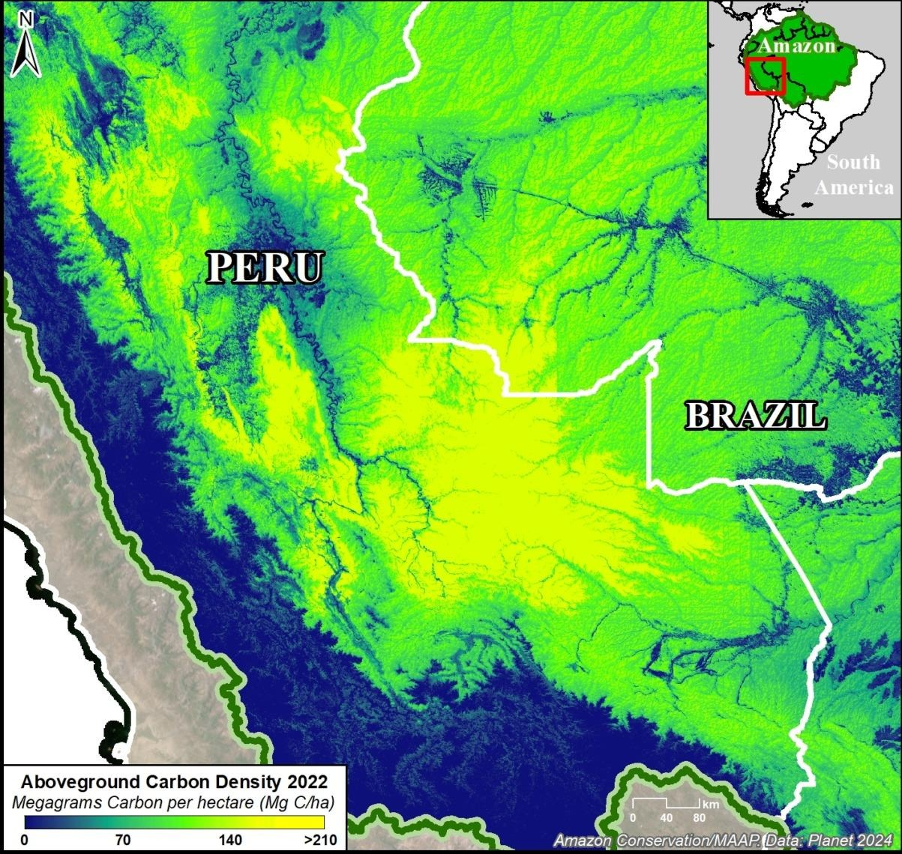
Figure 1: Map of Amazon basin aboveground carbon density (Mg C ha⁻¹) derived from GEDI spaceborne LiDAR, illustrating spatial heterogeneity in carbon stocks across subregions.

3.2 Soil Carbon Reservoirs
Soil organic carbon (SOC) is the most significant element within the earthly carbon reservoir. The Amazon, especially the Oxisols and Ultisols, sequester between 47 and 75 Pg C within the top meter of soil. There is a lot of uncertainty about the estimates, especially in the western Amazon peat-forming environments. Draper et al. [16] found large organic-rich peat deposits in the Pastaza-Marañon Foreland Basin, which contains about 3.14 Pg C. This is more than the total aboveground biomass of the entire United Kingdom. This deposit had not been previously considered in continental carbon stock assessments. Similar findings have been reported in the region [17].

Peat stocks are uniquely vulnerable. Under warming and drought conditions, the water table stabilizing peat carbon can drop, exposing organic matter to aerobic decomposition and generating rapid, difficult-to-reverse CO₂ and methane emissions. On a broader scale, rising temperatures linked to climate change are expected to increase microbial activity in soils, which can speed up the breakdown of soil organic carbon (SOC) and release more carbon into the atmosphere [18]. This creates a positive feedback that may further drive warming. However, the extent to which temperature affects soil carbon decomposition in tropical forests is still not well understood, and this uncertainty directly affects predictions of how Amazon soil carbon will respond to future climate change.

3.3 Carbon Flux and the Declining Sink
The Amazon fixes approximately 2.5 Pg C yr⁻¹ through gross primary productivity, one of the highest GPP values of any biome globally. Long-term forest inventory studies indicated that old-growth forests functioned as a consistent, if modest, carbon sink throughout much of the late twentieth century, accumulating an estimated 0.4–0.5 Pg C yr⁻¹ [19, 20]. Hubau et al. [19] documented a significant declining trend in this sink driven by increasing tree mortality outpacing biomass growth, attributed in part to drought stress and CO₂ fertilization effects approaching saturation in nutrient-limited old-growth stands.
The most consequential recent development in Amazon carbon science is the direct atmospheric evidence of a net source signal. Gatti et al. [7], using vertical aircraft profiles of CO₂ and carbon monoxide collected across the basin between 2010 and 2018, demonstrated that the northeastern Amazon remained a net carbon sink while the southeastern Amazon, most severely affected by deforestation and fire, had transitioned to a net carbon source, emitting approximately 0.19 Pg C yr⁻¹ more than it absorbed. This finding carries particular weight because it constitutes a direct atmospheric measurement of the basin's altered metabolic state, not a modeled projection. The source signal in the southeast was three times larger than expected from deforestation emissions alone, indicating that standing forest degradation through fire, drought, and edge effects was generating carbon losses invisible to satellite-based deforestation monitoring. Subsequent analysis by Qin et al. [5] quantified that forest degradation, distinct from outright clearing, may account for up to 40% of total Amazon carbon loss, confirming the scale of this systematically undercounted process.

4. Climate Regulation Functions of the Amazon

4.1 Rainfall Generation and the Flying Rivers
One of the Amazon's most consequential functions is generating and sustaining the moisture flows that determine rainfall patterns across much of South America. Through evapotranspiration, Amazon trees collectively release approximately 20 billion tonnes of water into the atmosphere each day, generating massive airborne moisture fluxes, the so-called flying rivers or rios voadores, that transport moisture westward and southward across the continent [21]. Nobre et al. [22] and Zemp et al. [23] demonstrated that large-scale deforestation significantly reduces evapotranspiration flux, diminishes moisture recycling efficiency, and reduces rainfall downwind by 15–30%. Rain-fed agriculture in southern Brazil and Argentina, depends critically on continued Amazon hydrological function.

4.2 Regional and Global Temperature Control
The dense evergreen canopy of the Amazon has a low surface albedo (about 0.12–0.15) and high evapotranspiration, which helps cool the land through strong latent heat fluxes. As a result, deforested areas are typically 1–3°C warmer than intact forests, with the greatest differences observed during the dry season [24]. This warming is further increased by broader regional effects of deforestation [25].
At the global level, the Amazon’s role as a carbon sink means that protecting the forest helps limit the buildup of atmospheric CO₂. The IPCC Sixth Assessment Report estimates that tropical deforestation accounts for about 10–12% of total human-driven greenhouse gas emissions [2].

4.3 Carbon Sink Versus Carbon Source Dynamics
Recent observations have changed how we understand the Amazon’s carbon balance. The findings of Gatti et al. [7] show that the forest is no longer a uniform carbon sink. Instead, it is a mix of areas that absorb carbon and areas that release it, with this pattern largely shaped by the level and location of human disturbance.
This variation has important implications for governance. Conservation efforts are often planned at the national level, which can overlook specific regions where the shift from carbon sink to source is most advanced.

4.4 Feedback Loops and Tipping Point Dynamics
The Amazon is shaped by several self-reinforcing climate feedbacks, the most well-known being the fire–deforestation–drought cycle. Deforestation reduces rainfall by weakening moisture recycling, which intensifies dry seasons. Drier conditions increase the risk of fire, which kills trees and releases carbon. The resulting forest degradation further reduces rainfall, reinforcing the cycle [26]. This process underpins the tipping point hypothesis. Recent studies show that the forest’s ability to recover from disturbance has declined since the early 2000s, suggesting that it may be approaching a critical threshold [27].
The idea of a tipping point, however, requires careful interpretation. Lovejoy and Nobre [26] proposed that at around 20–25% deforestation, the Amazon could shift from forest to savanna through self-reinforcing processes. While widely cited, this estimate is based mainly on models rather than direct observations. These models differ in how they represent key processes such as evapotranspiration and fire, leading to uncertainty. In practice, the threshold is not fixed but depends on factors such as where deforestation occurs, the extent of climate change, and the level of forest degradation.
Other studies support a more variable picture. Zemp et al. [23] found that feedback-driven forest loss may begin between 20% and 40% deforestation under current climate trends, with different
outcomes under alternative emission scenarios. Evidence from past climates also shows that the Amazon has undergone major vegetation changes under similar levels of warming, suggesting that large shifts can occur without a single clear threshold. This does not reduce the urgency highlighted by later work from Lovejoy and Nobre [28], but it suggests that policy should focus on sustained precaution rather than relying on a fixed “safe” limit. Modeling studies further show that these risks are non-linear and vary across regions [3].
As shown in Figure 2, the southeastern Amazon already shows signs consistent with early tipping dynamics, including reduced rainfall, more frequent fires, higher tree mortality, and a shift toward net carbon release. Whether this represents the early stages of an irreversible transition or a reversible phase of degradation will depend on near-term land-use and climate policies. Current models cannot resolve this with certainty, which strengthens the case for precaution.

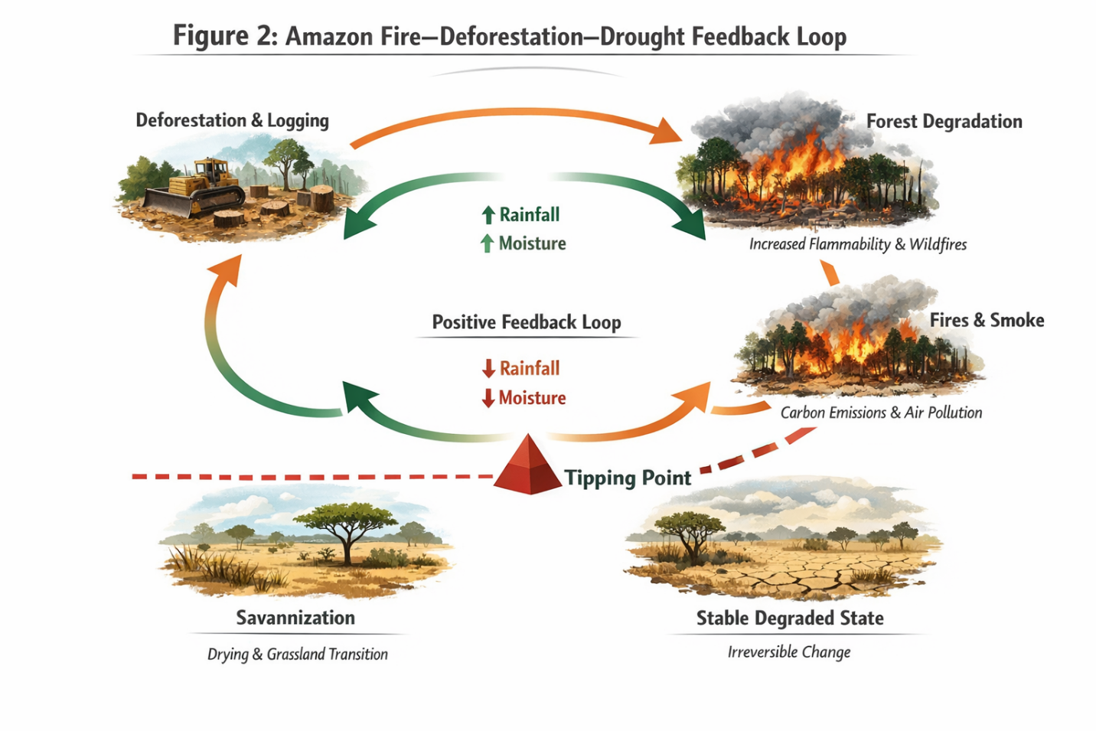
Figure 2. Conceptual diagram of the Amazon fire–deforestation–drought feedback loop, illustrating self-reinforcing degradation dynamics and conditions under which tipping-point transitions may occur. Consistent with Lovejoy and Nobre [26, 28] and Zemp et al. [23].

5. Drivers of Degradation

5.1 Deforestation for Agriculture and Cattle Ranching
Agriculture and cattle ranching account for about 80% of deforestation in the Amazon [29]. The expansion of soybean farming, largely driven by global demand for animal feed, has contributed to both direct and indirect forest loss, especially along the southern and eastern edges of the Amazon.
A key driver is the cattle–soy system, where land is first cleared for cattle grazing and later converted to soybean production. This allows deforestation to be officially recorded as cattle-related, even though it ultimately supports soy supply chains.
The 2006 soy moratorium helped reduce deforestation directly linked to soy. However, it may have shifted pressure to other land uses or to nearby regions such as the Cerrado biome [30].

5.2 Illegal Logging
Selective logging affects a much larger area than complete forest clearing. Asner et al. estimated that it impacts about 12,000–19,000 km² of the Brazilian Amazon each year, a scale that could double official deforestation figures when more sensitive remote sensing methods are used. These methods can detect subtle canopy damage that standard Landsat monitoring often misses. Recent studies support this, showing that long-term forest degradation affects a greater area than outright deforestation [31].
Logged forests also become more vulnerable over time. They experience higher tree mortality, drier conditions, and a buildup of flammable debris, making them more prone to fires. This increased fire risk can persist for 20–30 years after logging.

5.3 Wildfires
Fire is simultaneously a consequence and a driver of Amazon degradation. In the absence of drought and fragmentation, the humid Amazon interior is highly resistant to fire ignition. However, as deforestation creates forest edges and logged areas accumulate dry fuel loads, ignition sources increasingly escape into adjacent intact forest. Recent fire seasons highlight this growing vulnerability. In 2019, more than 100,000 fire alerts were recorded in Brazil, and severe fire activity continued from 2020 to 2023. These patterns show that the Amazon–Cerrado region is becoming more prone to large-scale fires as deforestation increases [32, 33].

5.4 Climate Change
Climate change interacts with land-use change to create compounding threats. Rising temperatures increase evaporative demand, effectively extending the meteorological dry season. The severe droughts of 2005, 2010, and 2015–2016 produced widespread tree mortality and forest carbon losses that transiently converted the Amazon into a net carbon source [34]. Under high-emission scenarios, modeling projections indicate that by the mid-twenty-first century, large portions of the eastern Amazon may experience conditions outside the observed climatological envelope of the current forest, creating conditions conducive to climate-driven dieback even in the absence of direct deforestation [35].

5.5 Interaction Effects and the Compound Degradation Footprint
The drivers discussed above do not act independently, a critical point often missed when deforestation is reported as a single figure. As shown by Lapola et al. [4], their interactions create a much larger combined impact than any single driver alone. Deforestation creates forest edges that dry out nearby areas; drier forests are more vulnerable to fire; fires leave behind debris that increases the risk of further burning; degraded forests are more sensitive to drought; and drought increases tree death in ways not captured by standard deforestation models.
Current estimates suggest that degraded but still standing forests may account for an additional 10–15% of the biome, beyond the 17–20% that has already been cleared. Thus, bringing the total compromised area above 30% in the most affected regions [5]. Figure 3 below illustrates the structural and systemic drivers of Amazon degradation, including commodity markets, infrastructure expansion, and land tenure insecurity, consistent with prior analyses [29, 30].

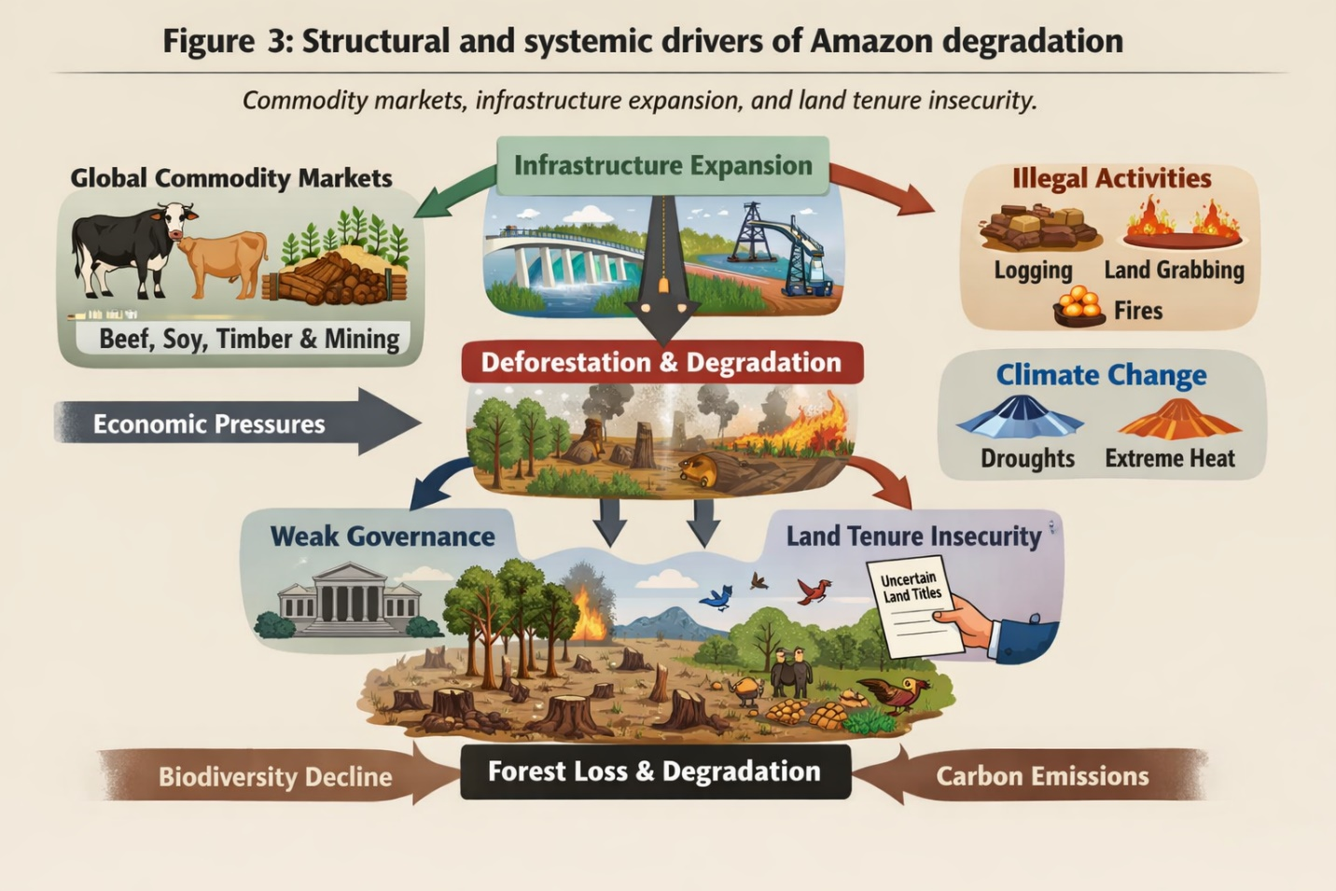
Figure 3. Structural and systemic drivers of Amazon degradation, including commodity markets, infrastructure expansion, and land tenure insecurity. Consistent with Curtis et al. [29] and Nepstad et al. [30].

Figure 4 presents an integrated representation of Amazon degradation dynamics, combining a multi-level conceptual framework of interacting drivers with temporal trends in deforestation.
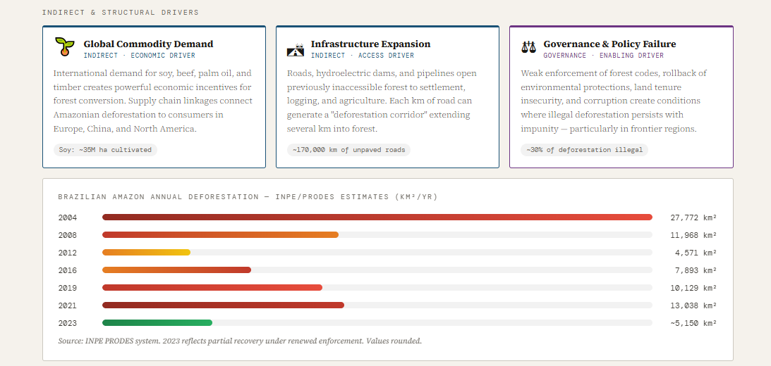
Integrated representation of Amazon degradation dynamics. (A) Multi-level framework of direct anthropogenic pressures, indirect structural drivers, governance failures, and climate feedbacks contributing to Amazon degradation. (B) Annual deforestation (km²) in the Brazilian Amazon (2008–2023), showing a marked decline following PPCDAm implementation, a sharp resurgence during 2019–2022, and renewed reduction under the Luiz Inácio Lula da Silva administration. The conceptual framework is consistent with Lapola et al. [4] and Lovejoy and Nobre [26], while deforestation data are sourced from Instituto Nacional de Pesquisas Espaciais (INPE PRODES) [6].

6. Environmental Consequences

6.1 Loss of Biodiversity
The Amazon harbors an estimated 10% of all species on Earth, including approximately 40,000 plant species, 1,300 bird species, and 3,000 freshwater fish species [36]. Functional diversity underpins ecosystem processes including decomposition, nutrient cycling, seed dispersal, and pollination. The loss of large-bodied frugivores such as tapirs and large primates, which disperse the seeds of many carbon-dense tree species, may produce lagged but significant effects on forest structure and carbon storage not yet fully quantified. Modeling studies suggest that continued deforestation at current rates could drive 20–40% of Amazonian species to extinction or local extirpation by the end of the twenty-first century.

6.2 Increased Greenhouse Gas Emissions
Forest clearance and degradation release carbon stored in living biomass and soils. Brazilian Amazon deforestation alone was responsible for approximately 0.2–0.4 Pg C yr⁻¹ of net carbon emissions during the peak deforestation period of the late 1990s and 2000s [37]. Deforestation also releases methane (CH₄) and nitrous oxide (N₂O), respectively 80 and 265 times more potent than CO₂ on a 20-year timescale. As documented in Sections 3 and 4, the transition of the southeastern Amazon to a net carbon source signals that these emissions now exceed the region's biological carbon uptake, independently of direct deforestation accounting, further amplified by deforestation-induced regional climate change, which reduces carbon storage in remaining forests [25].

6.3 Disruption of Hydrological Cycles
Deforestation reduces evapotranspiration, diminishes moisture recycling, and decreases the reliability and total volume of precipitation over downwind agricultural regions [21]. At the watershed scale, forest clearing increases peak flows during the wet season while reducing dry-season base flows, because forested soils moderate these extremes far more effectively than compacted pasture soils. The Amazon River and its tributaries supply approximately 20% of all freshwater discharged into the world's oceans, and the ecological integrity of this freshwater system supports the livelihoods of millions of riparian communities.

6.4 Risk of Tipping Point and Savannization
As analyzed in Section 4.4, the tipping point hypothesis proposes that sustained deforestation could trigger a biome-scale transition to a savanna-like state. Given that current deforestation stands at 17–20% and that degradation affects a further 10–15% of the original biome area, the Amazon may be approaching conditions under which tipping dynamics become difficult to arrest. Such a transition would release hundreds of petagrams of carbon over decades and permanently alter the hydrological regime of South America with globally extending consequences. The precautionary logic is compelling: given the irreversibility of a potential transition and the magnitude of its consequences, the cost–benefit calculus overwhelmingly favors preventive action even in the presence of significant scientific uncertainty about the precise threshold location.

7. Public Health Implications
The planetary health framework [8] provides the organizing structure for understanding the public health dimensions of Amazon degradation. The following sections examine four principal pathways through which forest loss and climate disruption translate into measurable human health consequences.

7.1 Air Quality and Respiratory Disease
Wildfire smoke ranks among the most significant environmental health hazards generated by Amazon deforestation. Burning forests release particulate matter (PM₂.₅ and PM₁₀), ozone precursors, carbon monoxide, and polycyclic aromatic hydrocarbons. PM₂.₅ penetrates deep into the bronchial tree and alveoli, inducing inflammatory responses associated with acute respiratory infections, asthma exacerbations, chronic obstructive pulmonary disease, and cardiovascular disease [38]. A 12% increase in respiratory hospital admissions per interquartile range increase in PM₂.₅ concentration has been documented in Brazilian municipalities affected by biomass burning smoke [39]. This estimate should be treated as context-specific rather than broadly generalizable.
A comprehensive systematic review by Pesquero et al. [40] linked smoke exposure during the 2019 fire season to an estimated 2,195 premature deaths and over 3,600 hospital admissions in the Brazilian Legal Amazon. These estimates were derived from concentration-response functions calibrated on urban air pollution epidemiology, which may not perfectly characterize the particle composition generated by biomass burning. This introduces uncertainty into the mortality estimates. Despite these methodological bounds, the epidemiological signal is consistent across multiple independent studies: elevated PM₂.₅ during Amazon fire seasons is associated with measurable increases in respiratory and cardiovascular morbidity across a wide geographic area, including urban centers thousands of kilometers from fire sources.

7.2 Heat and Climate Stress
The biophysical temperature effects of deforestation, combined with background anthropogenic warming, are driving significant increases in thermal stress across Amazonian and adjacent regions. Surface temperatures over deforested landscapes can exceed those of intact forest by 3–5°C during dry-season afternoons [24]. Heat-related illness encompasses a spectrum from heat exhaustion to life-threatening heat stroke; sustained elevated temperatures also increase the risk of acute kidney injury, cardiovascular strain, and preterm birth [41]. The Lancet Countdown on Health and Climate Change has documented increasing heat exposure and associated health burdens globally, with tropical agricultural regions among the most severely affected [42]. Occupational heat exposure is a particular concern for agricultural workers and artisanal miners on the Amazon frontier.

7.3 Infectious Diseases
Deforestation has a major impact on the spread of vector-borne diseases by changing the habitats of both animal hosts and insect vectors [43]. In the Amazon, malaria is closely linked to forest loss. The main mosquito vector, Anopheles darlingi, thrives in sunlit, slow-moving water common in deforested areas, but is rarely found in the shaded, fast-flowing streams of intact forests. A systematic review by Tucker Lima et al. [44] found that a 10% increase in deforestation was associated with a 3.3% rise in malaria cases, a pattern supported by several independent studies.
Dengue fever presents a distinct epidemiological pattern. Rising temperatures shorten the time needed for the virus to develop within mosquitoes and increase mosquito survival and biting rates. Messina et al. [45] project that climate change alone could significantly increase the number of people at risk of dengue in South America by 2050, with the Amazon among the most affected regions. Other diseases of concern include leishmaniasis, yellow fever, Chagas disease, and leptospirosis. For example, outbreaks of sylvatic yellow fever in southeastern Brazil between 2016 and 2018 led to over 700 confirmed cases and 260 deaths, highlighting the health risks linked to forest loss and disruption of wildlife habitats [46].

7.4 Food and Water Security
Continued Amazon deforestation beyond 20–25% could reduce dry-season rainfall in Brazil's agricultural heartland by 20–30%, with potentially severe consequences for agricultural productivity in a region accounting for approximately 8–9% of global agricultural exports [47]. These projections carry the inherent uncertainties of coupled vegetation–atmosphere simulations and should be read as indicative of order-of-magnitude risk rather than precise predictions. For the approximately 35 million residents of the Amazon basin, many of whom are subsistence farmers, indigenous community members, or riparian population, forest degradation manifests as reduced availability of wild-caught fish, loss of non-timber forest products supplementing nutritional intake, and declining agricultural yields from reduced soil fertility, pollinator loss, and erratic rainfall.
Water security is equally under threat. Extreme low-water events observed in 2015–2016 and again in 2023, when the Amazon River reached its lowest recorded levels at several gauge stations disrupted river transport, contaminated municipal water supplies, and killed millions of fish, a critical protein source for urban and rural Amazonians alike.

8. Policy and Governance

8.1 International Frameworks: Adequacy and Structural Limitations
The Paris Agreement provides the primary international legal architecture for governing climate change and, by extension, tropical forest conservation. Its temperature goals, limiting warming to well below 2°C with efforts directed toward 1.5°C, require cessation of net deforestation by mid-century and substantial enhancement of terrestrial carbon sinks [2]. REDD+ (Reducing Emissions from Deforestation and Forest Degradation), integrated into Article 5 of the Agreement, provides a framework for compensating tropical forest nations for measurable, reportable, and verifiable reductions in deforestation emissions relative to national reference levels.
A critical appraisal reveals structural limitations not adequately addressed by incremental reform. Nationally Determined Contributions (NDCs) under the Paris Agreement are nationally self-determined and non-binding in their ambition trajectories; no enforcement mechanism compels countries to meet their stated targets, and aggregate NDCs submitted as of 2023 remain insufficient to achieve the 1.5°C goal [2]. REDD+ has been plagued by credibility failures. West et al. [48] published a systematic assessment of Amazon REDD+ projects certified under the Verified Carbon Standard, finding that the vast majority of credited emission reductions could not be validated against satellite-based counterfactuals. This suggests systematic over-crediting that renders the mechanism ineffective as a carbon abatement instrument. This constitutes a governance failure allowing corporations to claim emissions offsets without delivering real-world abatement, potentially deferring the structural economic transformations that genuine decarbonization requires.
The fundamental political economy of deforestation is not addressed by either framework. Deforestation is driven by domestic land tenure dynamics, agricultural commodity pricing, enforcement capacity, and political interests largely impervious to international financial incentives of the magnitude currently available. Brazil's Action Plan for the Prevention and Control of Deforestation (PPCDAm) achieved a 70% reduction in annual deforestation during 2004–2012 through strong domestic political will and institutional investment, not primarily through REDD+ revenue [30, 49]. The subsequent collapse of this achievement during 2019–2022 illustrated that governance architecture is the binding constraint, not the availability of conservation finance instruments. International frameworks are necessary but far from sufficient conditions for Amazon protection.

8.2 National Conservation Policies
Brazil's PPCDAm remains perhaps the most consequential tropical forest conservation policy in history, contributing to a reduction in Amazon deforestation from approximately 27,700 km² in 2004 to approximately 4,500 km² in 2012 through command-and-control enforcement, protected area expansion, and agricultural sector agreements [30, 49]. The Lula administration, returning to office in 2023, re-committed to zero illegal deforestation by 2030, a target whose credibility will be evaluated against INPE deforestation monitoring data over the coming years [6]. Other Amazon nations exhibit diverse governance trajectories; Colombia, Peru, Ecuador, and Bolivia face varying tensions between conservation commitments and extractive economic pressures, underscoring the need for a Pan-Amazonian governance framework aligning incentives across all nine sovereign nations sharing the biome.

8.3 Indigenous Peoples as Rights-Holders and Conservation Agents
A substantial body of evidence demonstrates that indigenous territories are among the most effective conservation mechanisms available in the Amazon, with deforestation rates inside formally recognized indigenous lands typically 2–10 times lower than in adjacent unprotected areas. However, framing indigenous territories primarily as carbon storage assets or conservation instruments is ethically incomplete and scientifically limiting.
The IPBES Global Assessment and the IPCC's Sixth Assessment Report both explicitly recognize indigenous and local ecological knowledge as a distinct and legitimate knowledge system contributing to the long-term sustainability of managed landscapes over millennia. Indigenous communities in the Amazon are not passive beneficiaries of conservation policies but active land stewards with sophisticated management practices and territorial governance systems that have demonstrably maintained forest integrity. Research has shown that indigenous territories and conservation units together protect approximately 52% of the Brazilian Amazon, reflecting active stewardship rather than mere geographic remoteness.
Strengthening indigenous territorial rights is simultaneously a matter of human rights under international law (ILO Convention 169 and the UN Declaration on the Rights of Indigenous Peoples), a public health imperative for the communities involved, and a cost-effective climate mitigation strategy. Policy discussions framing indigenous land protection purely in instrumental conservation terms, without acknowledging the rights dimension and autonomous governance capacity of indigenous peoples, are not only incomplete but risk reproducing patterns of exclusion that have historically undermined conservation effectiveness.

8.4 Carbon Credit Systems: Promise and Credibility Crisis
Voluntary carbon markets have grown substantially, with global transactions reportedly reaching approximately two billion US dollars in 2021. The theoretical logic is sound: allow corporations to finance verified avoided deforestation by purchasing carbon credits, creating revenue streams for forest conservation. The empirical record is, however, deeply problematic. West et al. [48] identified systematic over-crediting in major Amazon REDD+ projects, attributable to methodological problems in establishing credible baselines and accounting for spatial leakage. (the displacement of deforestation pressure to areas outside project boundaries). These findings do not imply that carbon markets are irredeemable, but they indicate that the current architecture of voluntary carbon certification is insufficient for a mechanism intended to contribute meaningfully to global decarbonization targets. Reforms needed include independent satellite-based monitoring of credited projects, standardized methodologies for leakage accounting, and mandatory benefit-sharing mechanisms directing carbon revenue to forest-dependent communities.

9. Mitigation, Adaptation, and Future Directions

9.1 Sustainable Land Use and the Intensification Pathway
Deforestation can be substantially reduced without sacrificing agricultural productivity through spatially efficient intensification of existing agricultural land rather than frontier expansion. Brazil's Forest Code, requiring landholders in the Legal Amazon to maintain 80% of their property in native vegetation as a Legal Reserve, provides a statutory framework for limiting agricultural expansion into intact forest. Rigorous implementation could reduce deforestation substantially while accommodating increased production on existing land. Integrated crop–livestock–forestry systems offer a promising model for reconciling agricultural production with forest maintenance, improving soil quality and maintaining carbon stocks above those achievable under monoculture pasture regimes.

9.2 Reforestation, Natural Regeneration, and Carbon Recovery
Brazil has committed to restoring 12 million hectares of native vegetation by 2030 under the Paris Agreement. Natural regeneration allowing cleared or degraded land to recover through spontaneous succession is increasingly recognized as cost-effective and ecologically superior to active planting where appropriate conditions exist. Chazdon et al. estimated that natural regeneration across tropical Latin America could sequester approximately 8.48 Pg C over 40 years at minimal cost; realizing this potential requires clear and secure land tenure and policies rendering regeneration economically competitive with continued agricultural use.
The Lula government's 2023 commitment to zero illegal deforestation, if implemented with the institutional rigor that characterized PPCDAm's peak years, could substantially slow the source-signal expansion documented by Gatti et al. [7]. Early INPE monitoring data from 2023 showed a significant reduction in deforestation rates from the 2022 peak [6], suggesting that political will translates into measurable outcomes on a timescale of one to two years. Whether this trajectory can be sustained through electoral cycles and under the economic pressures of agricultural expansion remains the central policy question for Amazon conservation over the next decade.

9.3 Climate Adaptation for Forest Ecosystems and Human Communities
Given that significant warming is already locked in by existing atmospheric concentrations, adaptation strategies are urgently needed alongside mitigation. For forest ecosystems, this includes protecting hydrologically important riparian zones as refugia during drought events, maintaining landscape connectivity to enable species range shifts, and managing fire risk through early-warning systems. For human communities, health adaptation measures include strengthening vector surveillance and control programs, building early-warning systems for wildfire smoke events, improving heat stress monitoring and occupational health protections for agricultural workers, and investing in water treatment and storage infrastructure in municipalities vulnerable to hydrological disruption. Indigenous community health systems, often poorly resourced relative to their geographic footprints, require particular investment.

9.4 Research Priorities
Key research priorities include: improved mapping of forest degradation using integrated data streams from GEDI, Sentinel-1 SAR, and time-series spectral analysis, to resolve fundamental uncertainty in total compromised Amazon area; longitudinal epidemiological studies linking Amazon environmental change to human health outcomes using well-defined exposed and unexposed populations and prospective designs, moving beyond cross-sectional ecological correlations; improved characterization of peat carbon stocks and their vulnerability to climate and land-use change in the western Amazon; social science research on the institutional and political economy determinants of deforestation enforcement; and systematic assessment of the distributional consequences of carbon market and REDD+ instruments, to ensure conservation finance reaches forest-dependent communities rather than primarily benefiting landowners and intermediaries.

10. Conclusion
The Amazon Rainforest is simultaneously the world's most important terrestrial carbon reservoir, the engine of regional and continental hydrological cycles, the repository of an extraordinary fraction of Earth's biological diversity, and a foundational determinant of human health and well-being for hundreds of millions of people. The scientific evidence reviewed here establishes that the Amazon is not a remote wilderness of merely aesthetic value but a critical planetary systems regulator whose degradation carries consequences of genuinely global magnitude and whose functional integrity is actively deteriorating.
The landmark finding by Gatti et al. [7] that the southeastern Amazon has transitioned from net carbon sink to net carbon source represents not an abstract atmospheric measurement but a metabolic verdict on two decades of accelerating land-use change and warming. The potential for a biome-scale tipping point uncertain in its precise location but credible in mechanism and potentially catastrophic in implications [3, 27] demands precautionary governance commensurate with the irreversibility of the risk, not a wait-and-see posture contingent on further scientific resolution of threshold uncertainty.
The public health dimensions are equally compelling. The convergence of worsening air quality from wildfire smoke, rising temperatures, expanding ranges of malaria and dengue, and threats to food and water security creates a compounding burden of disease falling most heavily on populations least responsible for historical greenhouse gas emissions: indigenous communities, frontier settlers, agricultural workers, and the urban poor across South America.
Reversing these trajectories requires action across specific domains. International financial institutions and high-income countries must expand and enforce climate finance commitments tied to verified conservation outcomes. Agricultural commodity traders and their financial backers must remove deforestation from supply chains at a scale and speed that exceeds current voluntary initiatives. The governments of Brazil and other Amazon nations must maintain robust, politically insulated deforestation monitoring and enforcement systems across electoral cycles, invest in indigenous land demarcation as both a rights obligation and a conservation strategy, and reform Forest Code implementation to maximize the forest cover it legally requires.
The Amazon is a global commons whose benefits are planetary but whose stewardship challenges are local and national. Its degradation is accelerating, with impacts already evident in atmospheric CO₂ levels, regional climate patterns, and health outcomes across South America. The window for effective preventive action is narrowing. The cost of required action is large but finite. The cost of continued inaction is not.

References
[1] Lindsey R. Climate change: atmospheric carbon dioxide [Internet]. NOAA Climate.gov. 2024 [cited 2024 Apr]. Available from: https://www.climate.gov/news-features/understanding-climate/climate-change-atmospheric-carbon-dioxide
[2] IPCC. Climate change 2023: synthesis report. Contribution of working groups I, II and III to the sixth assessment report of the intergovernmental panel on climate change. Geneva: IPCC; 2023. doi:10.59327/IPCC/AR6-9789291691647
[3] Crowther TW, Glick HB, Covey KR, et al. Mapping tree density at a global scale. Nature. 2015;525(7568):201-205. doi:10.1038/nature14967
[4] Lapola DM, Pinho P, Quesada CA, Strassburg BB, Rammig A, Kruijt B, et al. The drivers and impacts of Amazon forest degradation. Science. 2023;379(6630):eabp8622. doi:10.1126/science.abp8622
[5] Qin Y, Xiao X, Wigneron JP, Ciais P, Brandt M, Fan L, et al. Carbon loss from forest degradation exceeds that from deforestation in the Brazilian Amazon. Nat Clim Chang. 2021;11(5):442-8. doi:10.1038/s41558-021-01026-5
[6] INPE. PRODES: annual deforestation reports [Internet]. Instituto Nacional de Pesquisas Espaciais; 2023 [cited 2024 Jan]. Available from: http://www.obt.inpe.br/OBT/assuntos/programas/amazonia/prodes
[7] Gatti LV, Basso LS, Miller JB, Gloor M, Gatti Domingues L, Cassol HLG, et al. Amazonia as a carbon source linked to deforestation and climate change. Nature. 2021;595(7867):388-93. doi:10.1038/s41586-021-03629-6
[8] Whitmee S, Haines A, Beyrer C, Boltz F, Capon AG, Dias BF, et al. Safeguarding human health in the Anthropocene epoch: report of The Rockefeller Foundation-Lancet Commission on planetary health. Lancet. 2015;386(10007):1973-2028. doi:10.1016/S0140-6736(15)60901-1
[9] Ferraro KM, Ferraro AL, Lundgren E, Sommer NR. The use and abuse of ecosystem service concepts and terms. Biological Conservation. 2025;308:111218. doi:10.1016/j.biocon.2025.111218
[10] Reid WV, Mooney HA, Cropper A, Zurek M, et al. Ecosystems and human well-being: synthesis. Washington (DC): Island Press; 2005. Available from: https://www.millenniumassessment.org/documents/document.356.aspx.pdf
[11] Damien J. Farrelly, Colm D. Everard, Colette C. Fagan, Kevin P. McDonnell, Carbon sequestration and the role of biological carbon mitigation: A review, Renewable and Sustainable Energy Reviews, Volume 21, 2013, Pages 712-727, ISSN 1364-0321. doi.org/10.1016/j.rser.2012.12.038.
[12] Bonan GB. Forests, climate, and public policy: a 500-year interdisciplinary odyssey. Annu Rev Ecol Evol Syst. 2016;47:97-121. doi:10.1146/annurev-ecolsys-121415-032359
[13] Saatchi SS, Harris NL, Brown S, Lefsky M, Mitchard ETA, Salas W, et al. Benchmark map of forest carbon stocks in tropical regions across three continents. Proc Natl Acad Sci USA. 2011;108(24):9899-904. doi:10.1073/pnas.1019576108
[14] Baccini A, Walker W, Carvalho L, Farina M, Sulla-Menashe D, Houghton RA. Tropical forests are a net carbon source based on aboveground measurements of gain and loss. Science. 2017;358(6360):230-4. doi:10.1126/science.aam5962
[15] Mitchard ETA. The tropical forest carbon cycle and climate change. Nature. 2018;559(7715):527-34. doi:10.1038/s41586-018-0300-2
[16] Draper FC, Roucoux KH, Lawson IT, Mitchard ETA, Honorio Coronado EN, Lahteenoja O, et al. The distribution and amount of carbon in the largest peatland complex in Amazonia. Environ Res Lett. 2014;9(12):124017. doi:10.1088/1748-9326/9/12/124017
[17] Dargie GC, Lewis SL, Lawson IT, Mitchard ETA, Page SE, Bocko YE, et al. Age, extent and carbon storage of the central Congo Basin peatland complex. Nature. 2017;542(7639):86-90. doi:10.1038/nature21048
[18] Nottingham AT, Meir P, Velasquez E, Turner BL. Soil carbon loss by experimental warming in a tropical forest. Nature. 2020;584(7820):234-7. doi:10.1038/s41586-020-2566-4
[19] Hubau W, Lewis SL, Phillips OL, Affum-Baffoe K, Beeckman H, Cuni-Sanchez A, et al. Asynchronous carbon sink saturation in African and Amazonian tropical forests. Nature. 2020;579(7797):80-7. doi:10.1038/s41586-020-2035-0
[20] Gatti LV, Gloor M, Miller JB, Doughty CE, Malhi Y, Domingues LG, et al. Drought sensitivity of Amazonian carbon balance revealed by atmospheric measurements. Nature. 2014;506(7486):76-80. doi:10.1038/nature12957
[21] Smith C, Baker JCA, Spracklen DV. Tropical deforestation causes large reductions in observed precipitation. Nature. 2023;615(7951):270-5. doi:10.1038/s41586-022-05690-1
[22] Nobre CA, Sampaio G, Borma LS, Castilla-Rubio JC, Silva JS, Cardoso M. Land-use and climate change risks in the Amazon and the need of a novel sustainable development paradigm. Proc Natl Acad Sci USA. 2016;113(39):10759-68. doi:10.1073/pnas.1605516113
[23] Zemp DC, Schleussner CF, Barbosa HMJ, Hirota M, Montade V, Sampaio G, et al. Self-amplified Amazon forest loss due to vegetation-atmosphere feedbacks. Nat Commun. 2017;8:14681. doi:10.1038/ncomms14681
[24] Mildrexler DJ, Zhao M, Running SW. A global comparison between station air temperatures and MODIS land surface temperatures reveals the cooling role of forests. J Geophys Res Biogeosci. 2011;116(G3):G03025. doi:10.1029/2010JG001486
[25] Li Y, Brando PM, Morton DC, Lawrence DM, Yang H, Randerson JT. Deforestation-induced climate change reduces carbon storage in remaining tropical forests. Nat Commun. 2022;13(1):1964. doi:10.1038/s41467-022-29601-0
[26] Lovejoy TE, Nobre C. Amazon tipping point. Sci Adv. 2018;4(2):eaat2340. doi:10.1126/sciadv.aat2340
[27] Boulton CA, Lenton TM, Boers N. Pronounced loss of Amazon rainforest resilience since the early 2000s. Nat Clim Chang. 2022;12(3):271-8. doi:10.1038/s41558-022-01287-8
[28] Lovejoy TE, Nobre C. Amazon tipping point: last chance for action. Sci Adv. 2019;5(12):eaba2949. doi:10.1126/sciadv.aba2949
[29] Curtis PG, Slay CM, Harris NL, Tyukavina A, Hansen MC. Classifying drivers of global forest loss. Science. 2018;361(6407):1108-11. doi:10.1126/science.aau3445
[30] Nepstad D, McGrath D, Stickler C, Alencar A, Azevedo A, Swette B, et al. Slowing Amazon deforestation through public policy and interventions in beef and soy supply chains. Science. 2014;344(6188):1118-23. doi:10.1126/science.1248525
[31] Matricardi EAT, Skole DL, Costa OB, Pedlowski MA, Samek JH, Miguel EP. Long-term forest degradation surpasses deforestation in the Brazilian Amazon. Science. 2020;369(6509):1378-82. doi:10.1126/science.abb3021
[32] Libonati R, Geirinhas JL, Silva PS, Russo A, Rodrigues JA, Belem LBC, et al. Assessing the role of compound drought and heatwave events on unprecedented 2020 wildfires in the Pantanal. Environ Res Lett. 2022;17(1):015005. doi:10.1088/1748-9326/ac462e
[33] Barlow J, Berenguer E, Carmenta R, Franca F. Clarifying Amazonia's burning crisis. Glob Chang Biol. 2020;26(2):319-21. doi:10.1111/gcb.14872
[34] Feldpausch TR, Phillips OL, Brienen RJW, Gloor E, Lloyd J, Lopez-Gonzalez G, et al. Amazon forest response to repeated droughts. Glob Biogeochem Cycles. 2016;30(7):964-82. doi:10.1002/2015GB005133
[35] Duffy PB, Brando P, Asner GP, Field CB. Projections of future meteorological drought and wet periods in the Amazon. Proc Natl Acad Sci USA. 2015;112(43):13172-7. doi:10.1073/pnas.1421010112
[36] ter Steege H, Pitman NCA, Killeen TJ, Laurance WF, Peres CA, Guevara JE, et al. Estimating the global conservation status of more than 15,000 Amazonian tree species. Sci Adv. 2015;1(10):e1500936. doi:10.1126/sciadv.1500936
[37] Pearson TRH, Brown S, Murray L, Sidman G. Greenhouse gas emissions from tropical forest degradation: an underestimated source. Carbon Balance Manag. 2017;12(1):3. doi:10.1186/s13021-017-0072-2
[38] Burnett RT, Chen H, Szyszkowicz M, Fann N, Hubbell B, Pope CA 3rd, et al. Global estimates of mortality associated with long-term exposure to outdoor fine particulate matter. Proc Natl Acad Sci USA. 2018;115(38):9592-7. doi:10.1073/pnas.1803222115
[39] Reddington CL, Butt EW, Ridley DA, Artaxo P, Morgan WT, Coe H, et al. Air quality and human health improvements from reductions in deforestation-related fire in Brazil. Nat Geosci. 2015;8(10):768-71. doi:10.1038/ngeo2535
[40] Pesquero CR, Blainski E, de Oliveira RA, Silva GSA, Moraes ACF, Canales PB, et al. Smoke exposure and health consequences of the 2019 Amazon fires: a systematic review. Cad Saude Publica. 2022;38(9):e00144221. doi:10.1590/0102-311XEN144221
[41] Poirier B, Gao C, St Denis BG, Auger N. Preterm birth and heat stress: an emerging public health concern in the context of climate change. Environ Health Perspect. 2023;131(4):045002. doi:10.1289/EHP11024
[42] Watts N, Amann M, Arnell N, Ayeb-Karlsson S, Belesova K, Boykoff M, et al. The 2019 report of The Lancet Countdown on health and climate change: ensuring that the health of a child born today is not defined by a changing climate. Lancet. 2019;394(10211):1836-78. doi:10.1016/S0140-6736(19)32596-6
[43] Patz JA, Daszak P, Tabor GM, Aguirre AA, Pearl M, Epstein J, et al. Unhealthy landscapes: policy recommendations on land use change and infectious disease emergence. Environ Health Perspect. 2004;112(10):1092-8. doi:10.1289/ehp.6877
[44] Tucker Lima JM, Vittor A, Desai S, Valle D. Does deforestation promote or inhibit malaria transmission in the Amazon? A systematic literature review and critical appraisal of current evidence. Philos Trans R Soc B. 2017;372(1722):20160125. doi:10.1098/rstb.2016.0125
[45] Messina JP, Brady OJ, Golding N, Kraemer MUG, Wint GRW, Ray SE, et al. The current and future global distribution and population at risk of dengue. Nat Microbiol. 2019;4(9):1508-15. doi:10.1038/s41564-019-0476-8
[46] Figueiredo PO, Fumagalli MJ, Oliveira Dos Santos BI, Orsi RH, Catao-Dias JL, Romano AP, et al. Yellow fever virus reemergence in southern Brazil: virus and phylogeographic dynamics and ecologic drivers. J Virol. 2019;93(18):e01826-18. doi:10.1128/JVI.01826-18
[47] Oliveira LJC, Costa MH, Soares-Filho BS, Coe MT. Large-scale expansion of agriculture in Amazonia may be a no-win scenario. Environ Res Lett. 2013;8(2):024021. doi:10.1088/1748-9326/8/2/024021
[48] West TAP, Börner J, Sills EO, Kontoleon A. Overstated carbon emission reductions from voluntary REDD+ projects in the Brazilian Amazon. Proc Natl Acad Sci USA. 2020;117(39):24188-94. doi:10.1073/pnas.2004334117
[49] Assuncao J, Gandour C, Rocha R. DETERring deforestation in the Amazon: environmental monitoring and law enforcement. Am Econ J Appl Econ. 2023;15(2):125-56. doi:10.1257/app.20200196
[50] Harris NL, Gibbs DA, Baccini A, Birdsey RA, de Bruin S, Farina M, et al. Global maps of twenty-first century forest carbon fluxes. Nat Clim Chang. 2021;11(3):234-40. doi:10.1038/s41558-020-00976-6

