Original Research Article

Correlation and Regression Analyses of Particulate Matter Concentrations and Microbial Loads in Air at some Secondary Schools in Port Harcourt Rivers State Nigeria

ABSTRACT
This study assessed the relationship between particulate matter (PM₁, PM₂.₅, PM₄, PM₇, and PM₁₀) and airborne microbial load (bacteria and fungi) in school environments within Port Harcourt, Nigeria. Particulate concentrations were measured using aeroset handheld particle counter 531S, while microbial loads were determined with passive settle plate method using 9 cm diameter petri dishes and expressed as CFU/m³. Correlation and regression analyses were applied to evaluate associations under dry and wet conditions. Results showed moderate positive correlations between bacterial load and fine particles, particularly PM₁ (r = 0.5287), PM_{2.5} (r = 0.4430), PM₇ (r = 0.4238) in the wet season. Fungal load exhibited stronger associations with coarse particles PM₄ (r = 0.6487) and PM₇ (r = 0.7007), especially during the dry season. Regression analysis indicated weak and non-significant relationships between bacteria and PM (R² = 0.088 and 0.104 for PM₁ and PM_{2.5} respectively; R² = 0.01, 0.006, 0.015 for PM₄, PM₇, PM₁₀ respectively) while fungi showed moderate relationships with PM₇ being statistically significant (p < 0.05) and R² = 0.427 and 0.456 for PM₄ and PM₇ respectively. The study demonstrates that coarse particulate matter plays a more significant role in fungal distribution than bacterial transport and highlights the importance of considering both biological and non-biological pollutants in school air quality assessments.
Keywords: Correlation, Regression, Particulate Matter, Microbial Loads, Port Harcourt, Nigeria

INTRODUCTION
Indoor and outdoor environmental air quality at schools can be characterized by: 1) insufficient ventilation, especially in winter; 2) infrequent and inadequate cleaning of indoor surfaces and 3) a large number of students per classroom area and volume, with constant re-suspension of particles from room surfaces along with suspension of soil material due to the activity of the children (Janssen et al.,2003). As a result, particulate matter (PM) concentrations in classrooms are about six times higher than outdoor air (Oeder et al., 2012). On an equal weight base, indoor air PM₁₀ has been shown to be toxicologically more active than outdoor PM₁₀, with the main difference being the higher concentration of organic and silicate particles in indoor air (Oeder et al., 2012).Due to its importance, several studies have been conducted to assess the particulate matter (PM₁₀, PM_{2.5} and ultrafine particles) in indoor environments of schools concerning their concentrations and chemical composition (Blondeau et al., 2005, Fromme et al., 2008; Zhang and Zhu, 2012).
Health implications due to atmospheric particles pollution have been shown by epidemiological studies where correlations were found between particles concentration and number of deaths from cancer, cardiovascular and respiratory diseases (Pope et al., 2002). Evidence on the increase of hospital admissions due to respiratory and cardiovascular diseases caused by particulate air pollution has also been shown (Middleton et al., 2008). Associations between air pollutants and illness-related absences in school children (Park et al., 2002), suggest that air pollution is closely linked to daily activities, particularly of school-aged children. Higher numbers of children suffering from bronchial hyperresponsiveness, positive allergic sensitization to common allergens or both were identified in schools close to motorways with heavy traffic than in schools near motorways with low traffic (Janssen et al., 2003).
One of the most vulnerable population groups to PM are children, due to their greater inhalation rate per body weight, and their-not fully developed immunological system (Thurston, 2017). In addition to the health effects happening after PM inhalation, systematic early exposure to PM could lead to the development of diseases in future stages of the children (Khalili et al., 2018;Liu et al.,2018). In order to evaluate children exposure to PM, outdoor levels are usually used as input for risk assessment (Ghosh et al., 2018; Liu et al., 2018). However, most of the children exposure to PM occurs in indoor environments, where children spend around 90% of their time (Matz et al., 2015; Martins et al., 2025).This environment has special characteristics regarding indoor air quality, due the combination of classroom-specific PM sources and the influence from outdoor environments (Mohammadyanet al., 2017).
High amounts of airborne micros are caused by asthma and allergic rhinitis, hypersensitivity pneumonitis and patient building syndrome. However, the health problems they create are not limited to allergic diseases alone; bioaerosols and their by-products are known to cause infection and toxic effects. (Ayanbimpeet al., 2010). In the case of pathogenic biological objects and non-biological compounds having the same sources and coexistence of the fine dusts in the indoor environment with bioaerosols, asthma crises and allergic are triggered. So, in studies of human health air quality, non-biological contaminant concentrations are often measured along with biological concentrations. Hence, less attention is paid to microbial pollution in Nigeria mostly in Niger Delta Regions were most industrial and illegal refinery activities are of increase daily.
In school environments, poor ventilation, overcrowding, and the age of buildings further contribute to poor indoor air quality, exacerbating health risks for students. Additionally, outdoor environmental conditions surrounding school areas, including pollution from nearby industrial activities and traffic emissions, can significantly impact the air quality within classrooms and playgrounds (Wargockiet al., 2020).

Apart from the fact that microorganisms in the air can be pathogenic to human, the components of these airborne microorganisms such as endotoxins, mycotoxins, and glucans may also have a strong health influence on humans, especially in specific settings. One of the major concerns about airborne microorganisms is the ability of these microbial agents to stimulate allergic and/or inflammatory reactions. In addition to the impact of airborne microorganisms in dust clouds on ecosystems health, they can also have a direct effect on health of human through pathogenesis. Susceptible individuals that get exposed to cellular components of air microbes such as pollen, fungal allergens, and lipopolysaccharide (LPS) can lead to the development of sensitivities such as asthma with prolonged exposure.Evidence abound to show that the protracted exposure to the spores of airborne fungi and bacteria could eventually lead to series of allergic reactions (Edwards et al., 2012; Mensah-Attipoe and Toyinbo, 2019; Stetzenbach, 2007).
Bioaerosols undergo daily and seasonal changes depending on environmental factors, and human activities (Rossi et al., 2020). PM bound with airborne pollen and fungal spores (Gliksonet al., 1995) could alter their biological and morphological characteristics. Physical, chemical and biological compositions of suspended dust may be changed depending on dust source, whether it originated from desert or dried wetland (Soleimani et al., 2013).
Less information is available on microbial community associated PM. However, few studies have been directed to investigate the factors affecting microorganisms associated non-biological particles and their health effects. A number of studies provide interesting information pertinent to evaluate bioaerosols in contributing to health effects associated with exposures to ambient PM (Stevanovic and Nikic, 2006). Health responses may be enhanced when chemical and biological constituents of particulate matter are combined together (USEPA, 2004).
The purposes of the present study were to 1) gain information on the microbial community associated with particulate matter (PM_{1,} PM_{2.5},PM_{4,} PM₇ &PM₁₀)with particular focus on bacterial and fungi, and 2) determine relationships between microbial content (bacteria and fungi) and PM air pollutants using statistical variables.

MATERIALS AND METHODS
Study Area
Port Harcourt Local Government Area, Rivers State, Nigeria which is located in latitudes 4°51´ 30˝ N and 4° 57´ 30˝ N and longitudes 6°50´ 00˝ E and 7°00´ 00˝ E. Port Harcourt is found in the sub-equatorial region. It has a tropical climate with a mean temperature of 30°C, a relative humidity of 80 % - 100 %, and a mean yearly rainfall of about 2,300 mm (Nyeche and Ndukwu, 2018). Tropical rainforest is found in the inland part of Rivers State and mangrove swamps towards the coast of the Atlantic Ocean.
The vegetation represents the most luxuriant, the most complex and the most diverse terrestrial ecosystem the world has known (Nyeche and Ndukwu, 2018). Unfortunately, much of the rain forest has been destroyed as a result of farming, commercial lumbering and urbanization; ironically these vegetal covers are supposed to serve as sink to pollutants, wherein they are depleted and pollution levels are projected to be on the high.
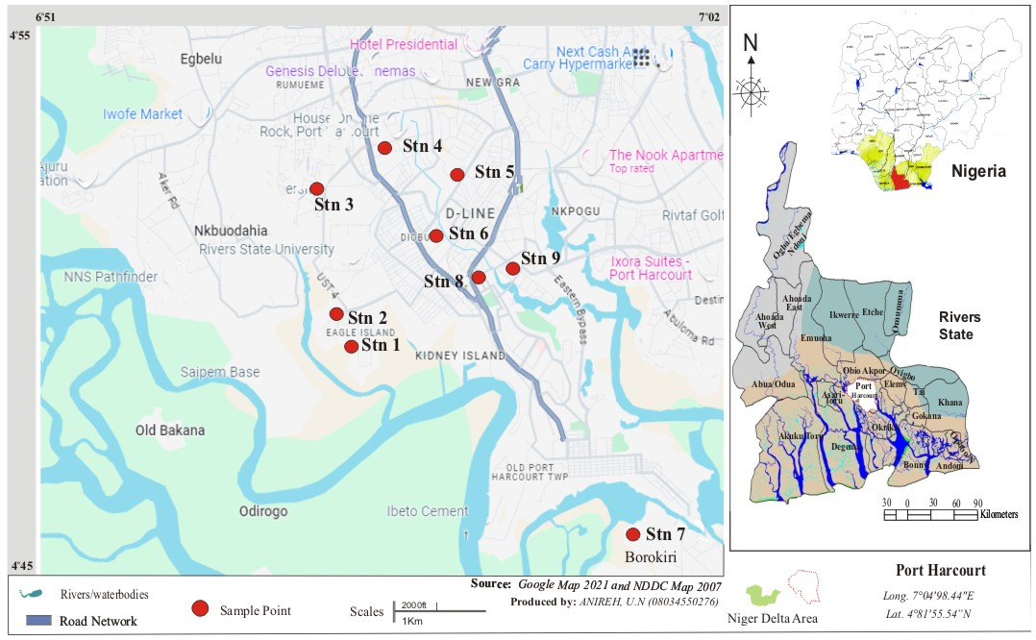
Map .1 Study Area Showing Sampling School Locations

Sampling Procedure for Particulates
A hand-held digital aerocet Handheld Particle Counter 531S was used to measure PM₁, PM_{2.5,} PM_{4,} PM_{7,} and PM₁₀ at the study area. The equipment was pre-calibrated before usage for quality assurance purposes. At each station, the monitor was switched on and allowed to stabilize for five minutes. It was held up in an open space with a consideration of the average height of a human. Each reading was recorded when the equipment stabilized and switched off thereafter.

Sampling Procedure and Determination of Microbiological Content in Air
Bacteria and fungi measurement was done by passive air sampling technique: the settle plate method using 9 cm diameter Petri dishes was used. The sampling height was approximated to human breathing zone which was 1m above the floor and at the center of sampling spots. Bacteria and fungi were collected on an autoclaved 2% nutrient agar and 4% Sabouroad Agar respectively using 9cm diameter petri dishes. To obtain the appropriate surface density for counting and to determine the load with respect to time of exposure, the sampling times were set at 30, 60, 90 min. After exposure the samples were taken to the laboratory and incubated at 37 °C for 24 h for bacteria and at 25 °C for 3 days for fungi. Colony forming units (CFU) were enumerated, CFU/ m3 was determined, taking into account the following equation described by (Gutarowska et. al., 2015; Borrego, et al., 2010).
N = 5a x10⁴ (bt)⁻¹
Where N=microbial CFU/m3 of indoor air;
a=number of colonies per Petri dish;
b=dish surface (cm²);
t=exposure time (min). Then, identification of isolates will be done according to standard methods. (Cheesbrough, 1996).

RESULTS AND DISCUSSION
Correlation Between Microbiological Loads and Particulate Matter in the PHALGA Area
Dry-season bacterial loads presented in Table 1 show a moderate positive correlation with PM₁ Wet (r = 0.5287) and PM₁ Dry (r = 0.3090), suggesting that ultra-fine particulates play a role in bacterial transport. Bacterial_Load_Wet correlates strongly with PM_{2.5} Wet (r = 0.4430) and PM₇ Wet (r = 0.4238), indicating that fine and coarse particles enhance microbial aerosolization during rainfall. Fungal_Load_Dry shows strong positive correlations with PM₄ Dry (r = 0.6487) and PM₇ Dry (r = 0.7007), demonstrating that fungal spores attach effectively to mid-range coarse particulates in the dry season. Fungal_Load_Wet displays a highly negative correlation with PM₁ Wet (r = –0.3266) and PM_{2.5} Wet (r = –0.0417), suggesting that fine particles inhibit wet-season fungal survival. PM classes exhibit extremely strong internal correlations, such as PM₇ Wet with PM₁₀ Wet (r = 0.9831) and PM₇ Dry with PM₁₀ Dry (r = 0.9796), confirming shared emission sources. Overall, bacterial aerosols respond more positively to particulate matter than fungal aerosols, with the strongest microbial–particle coupling occurring under dry conditions.
Table 1: Correlation Between Microbiological Loads and Particulate Matter in Port Harcourt Local Government Area
 | Bacterial_Load_Dry | Fungal_Load_Dry | Bacterial_Load_Wet | Fungal_Load_Wet | PM1 Wet | PM1 Dry | PM2.5 Wet | PM2.5 Dry
Bacterial_Load_Dry | 1
Fungal_Load_Dry | -0.3508543 | 1
Bacterial_Load_Wet | 0.8151334 | -0.3348955 | 1
Fungal_Load_Wet | -0.4198553 | 0.9716987 | -0.4169085 | 1
PM1 Wet | 0.5286681 | -0.2950766 | 0.0549172 | -0.3265702 | 1
PM1 Dry | 0.3090033 | -0.0599559 | -0.0174122 | -0.0805848 | 0.8457146 | 1
PM2.5 Wet | 0.2361732 | -0.0343677 | 0.4429887 | -0.0417409 | -0.4198917 | -0.6122011 | 1
PM2.5 Dry | 0.1432584 | 0.1084862 | -0.1682383 | 0.1533768 | 0.6501398 | 0.8899102 | -0.4496519 | 1
PM4 Wet | 0.303493 | 0.3389862 | 0.3955949 | 0.2753076 | -0.2984277 | -0.4939082 | 0.8345844 | -0.3851402
PM4 Dry | 0.0883668 | 0.6486798 | -0.1598612 | 0.604647 | 0.3254061 | 0.3723506 | -0.2502143 | 0.3882101
PM7 Wet | 0.1948083 | -0.1013616 | 0.423774 | -0.1082559 | -0.4364483 | -0.5475206 | 0.9527723 | -0.3315336
PM7 Dry | 0.080025 | 0.700736 | -0.1486095 | 0.6264705 | 0.2590224 | 0.2494248 | -0.160339 | 0.2289671
PM10 Wet | 0.175095 | -0.102112 | 0.448358 | -0.1133802 | -0.4368181 | -0.472914 | 0.9174577 | -0.2589278
PM10 Dry | 0.0664019 | 0.7147438 | -0.1192689 | 0.6222562 | 0.1614799 | 0.1201709 | 0.0036235 | 0.12141
 | PM4 Wet | PM4 Dry | PM7 Wet | PM7 Dry | PM10 Wet | PM10 Dry
Bacterial_Load_Dry
Fungal_Load_Dry
Bacterial_Load_Wet
Fungal_Load_Wet
PM1 Wet
PM1 Dry
PM2.5 Wet
PM2.5 Dry
PM4 Wet | 1
PM4 Dry | 0.2769014 | 1
PM7 Wet | 0.7360538 | -0.307564 | 1
PM7 Dry | 0.3873225 | 0.9739666 | -0.2575211 | 1
PM10 Wet | 0.6582143 | -0.3684655 | 0.9831421 | -0.3277686 | 1
PM10 Dry | 0.5305086 | 0.92498 | -0.0904535 | 0.9795695 | -0.1666246 | 1

Regression Between Bacteria and Particulate Matter (PM)
The regression analysis between airborne bacteria and particulate matter fractions (PM₁, PM_{2.5}, PM₄, PM₇, and PM₁₀) in schools in Port Harcourt revealed generally weak relationships. Bacteria showed a positive association with PM₁ (slope = 1549.17) and PM_{2.5} (slope = 991.49), but the low coefficients of determination (R² = 0.088 and 0.104, respectively) indicate limited explanatory power. Similarly, PM₄, PM₇, and PM₁₀ exhibited very weak positive relationships (R² = 0.010, 0.006, and 0.015), suggesting negligible influence on bacterial concentrations. All p-values for these models (p > 0.39) indicate that the relationships are not statistically significant. The weak positive slopes suggest that increases in particulate matter may slightly elevate bacterial counts, but the effect is inconsistent. Overall, particulate matter does not appear to be a strong predictor of airborne bacterial levels in the studied school environments.
Regression Between Fungi and Particulate Matter (PM)
The regression analysis between fungi and particulate matter revealed stronger relationships compared to bacteria. PM₄ and PM₇ showed moderate positive associations with fungi (slopes = 83.55 and 46.02) and relatively high R² values (0.427 and 0.456, respectively). Notably, PM₇ demonstrated a statistically significant relationship (p = 0.046), indicating its influence on fungal concentrations. PM₁₀ also showed a moderate positive relationship (R² = 0.392), though not statistically significant (p = 0.071). In contrast, PM₁ showed a weak negative relationship (slope = -184.40, R² = 0.031). These results suggest that coarse particulate fractions may play a more important role in fungal dispersion than finer particles.
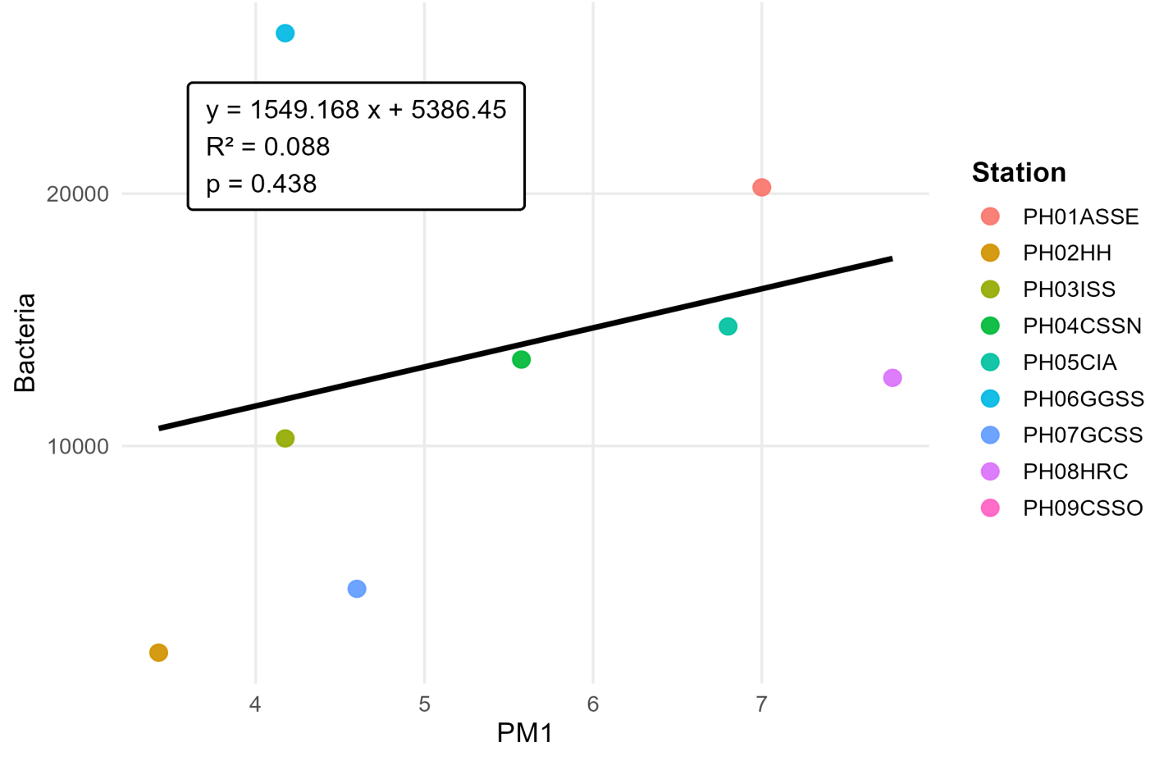
Fig. 1. Regression between Bacteria Load and PM₁

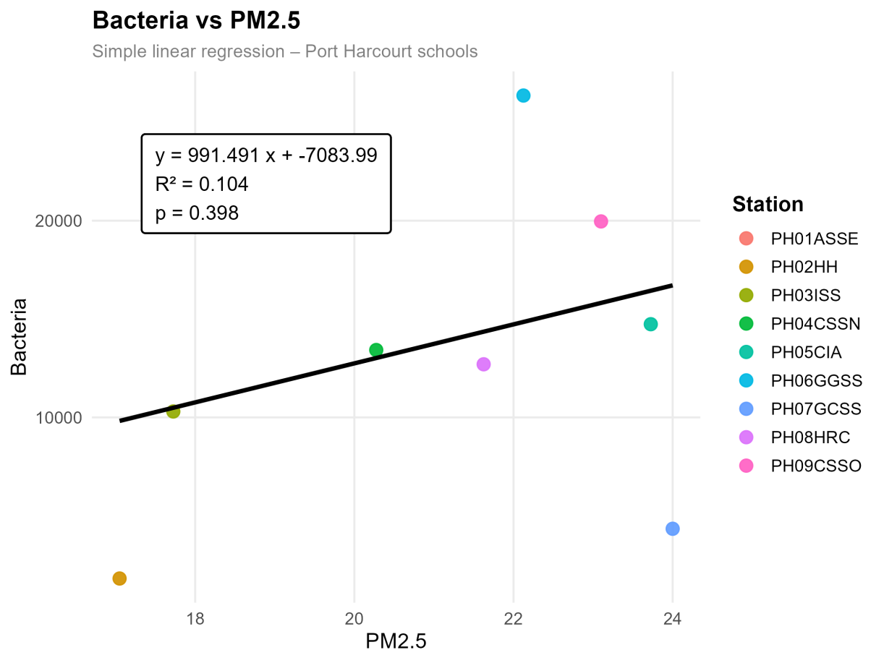
Fig. 2. Regression between Bacteria Load and PM_{2.5}

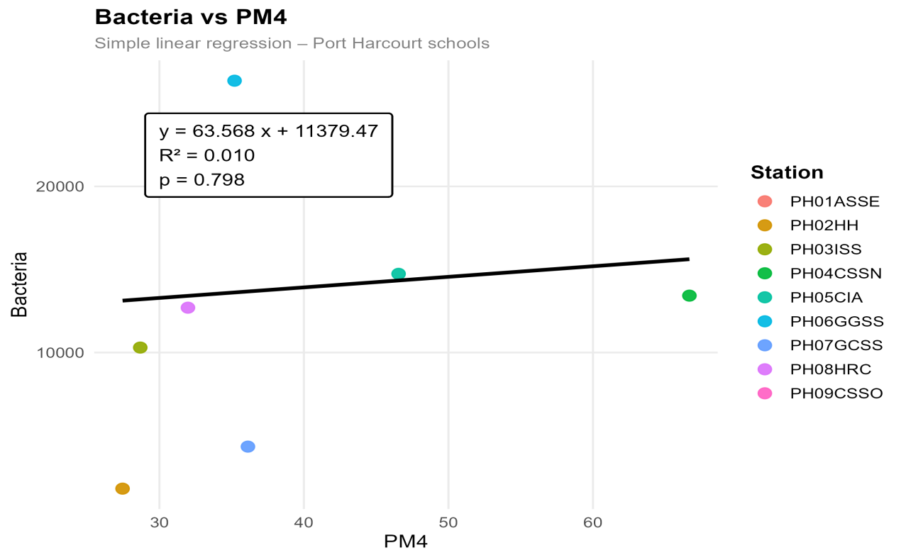
Fig. 3. Regression Between Bacteria Load and PM₄
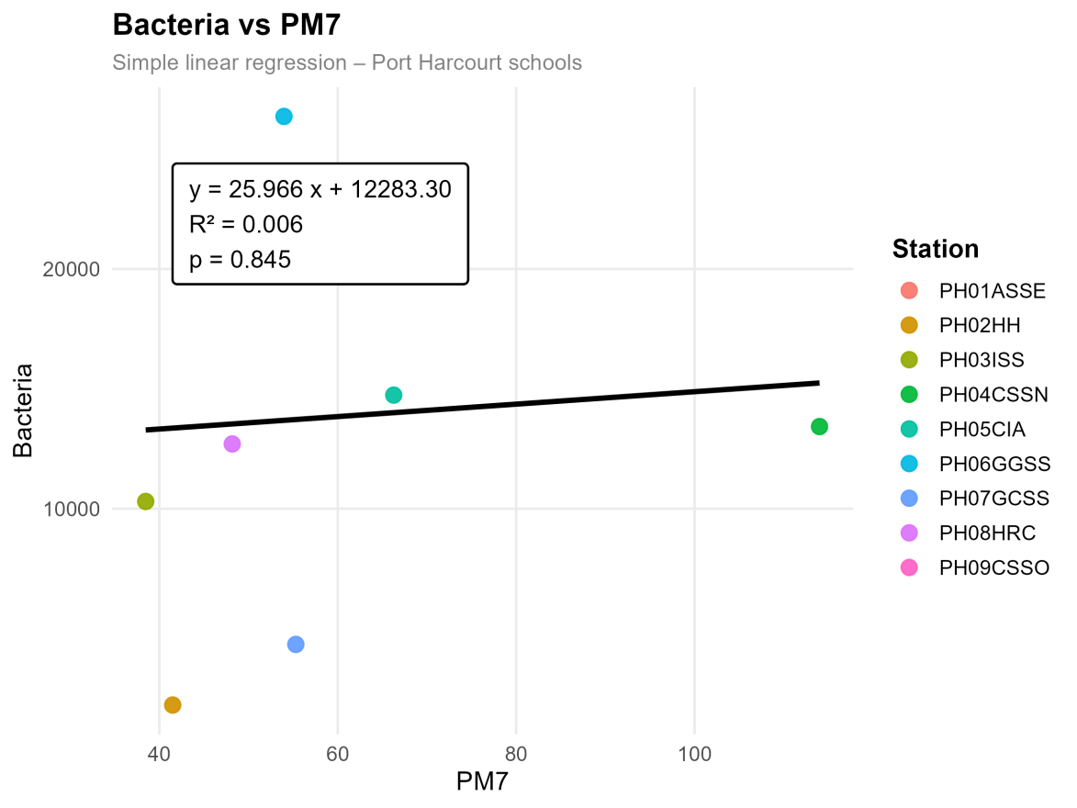
Fig.4. Regression between Bacteria Load and PM₇

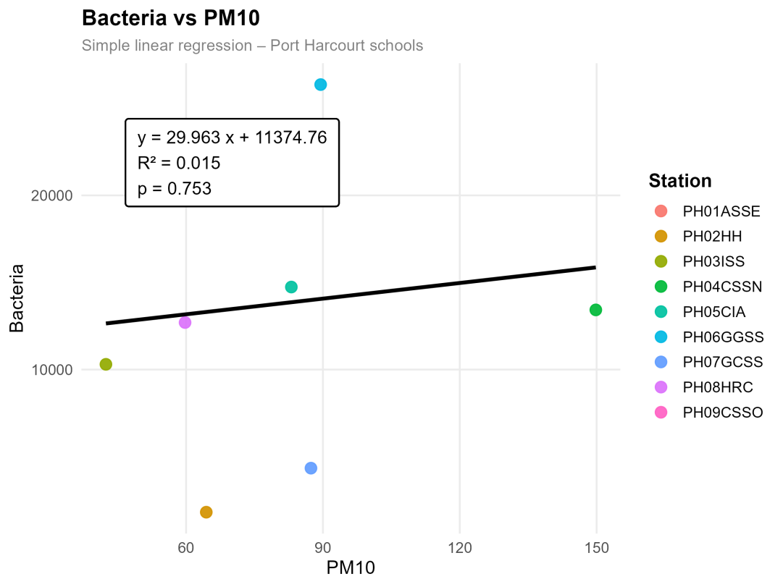
Fig. 5. Regression between Bacteria Load and PM₁₀
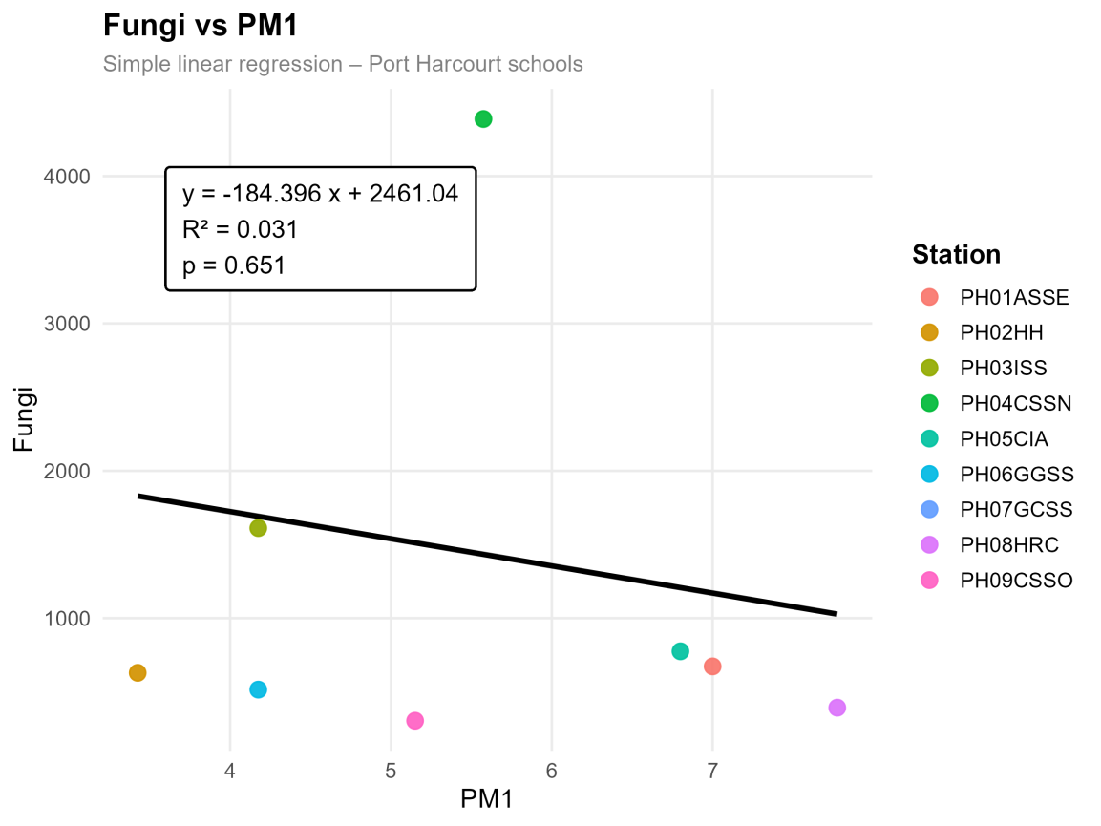
Fig. 6. Regression between FungiLoad and PM₁

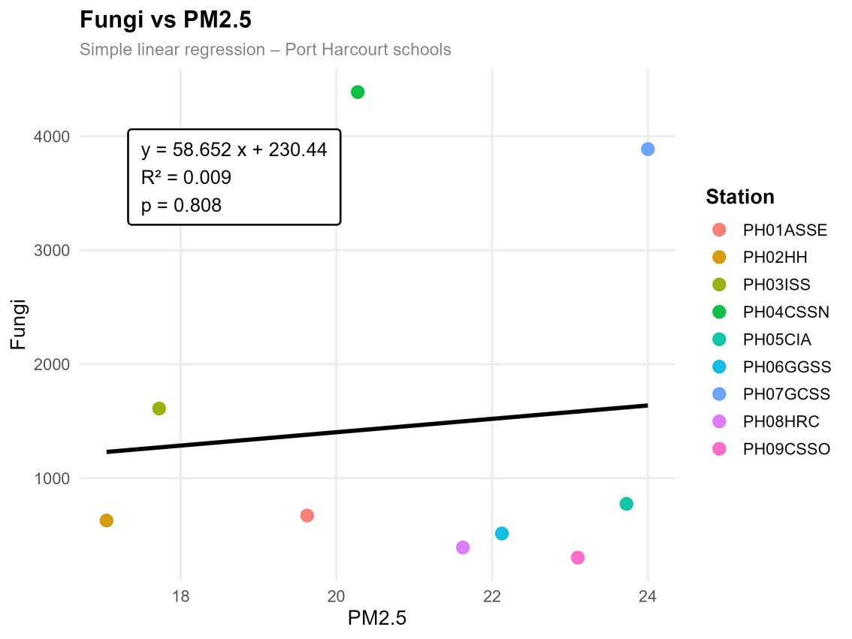
Fig. 7. Regression between FungiLoad and PM_{2.5}
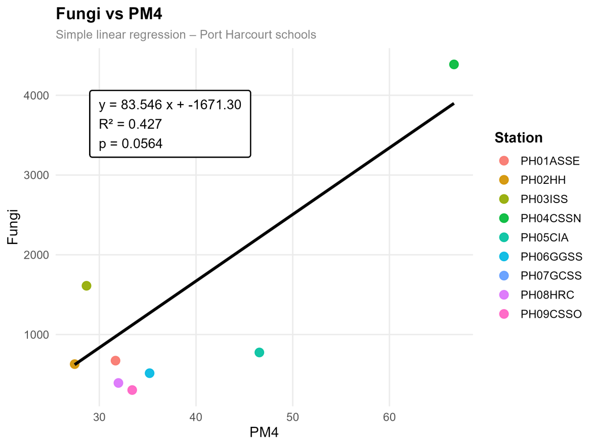
Fig. 8. Regression between FungiLoad and PM₄
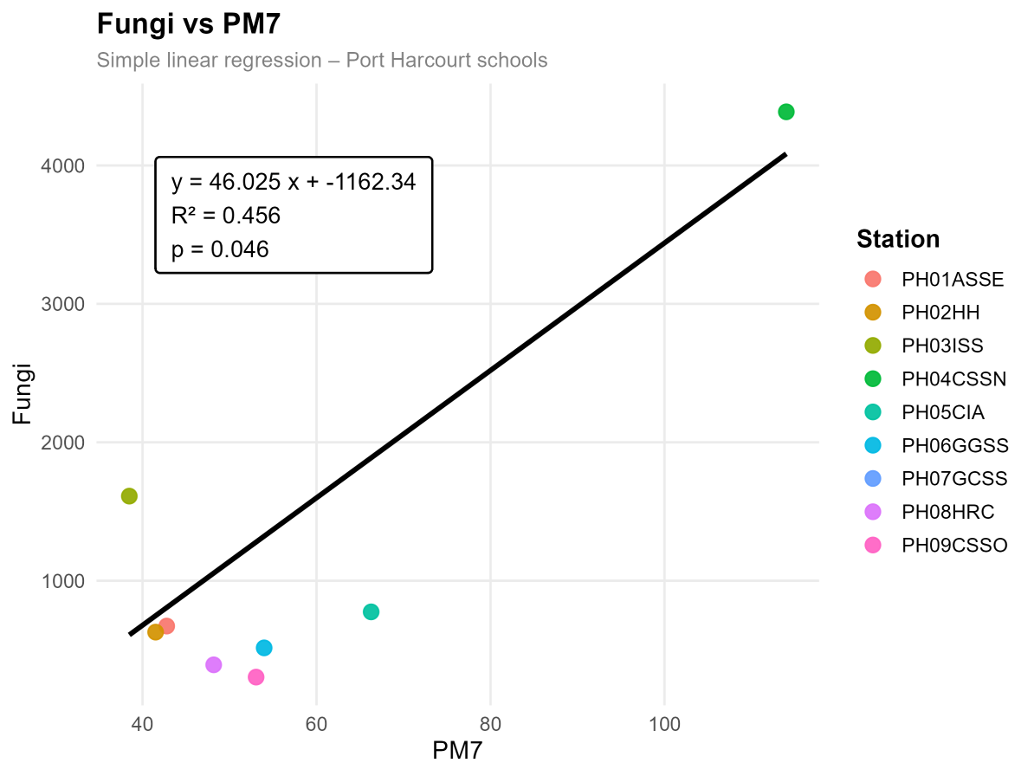
Fig. 9. Regression between FungiLoad and PM₇

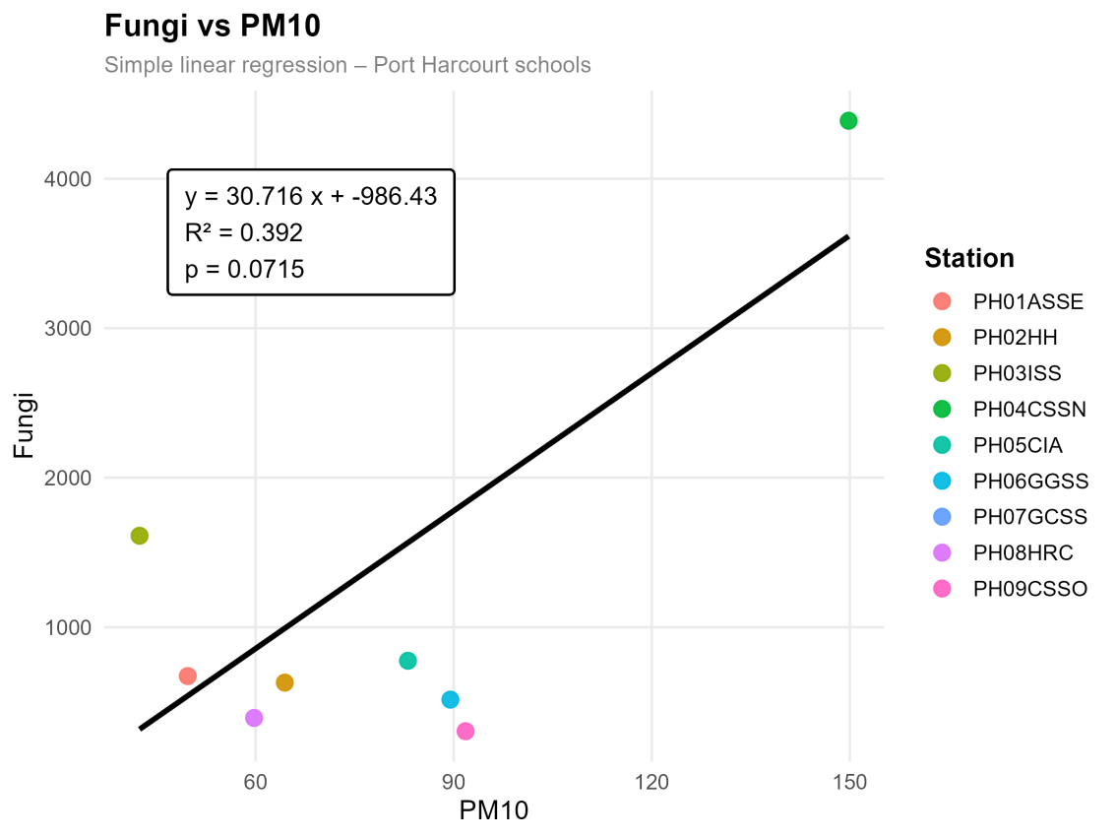
Fig. 10. Regression between FungiLoad and PM₁₀

CONCLUSION
This study revealed that particulate matter has a limited influence on airborne bacterial load but a more pronounced effect on fungal distribution, particularly through coarse particles (PM₄ and PM₇). Seasonal variation influenced these relationships, with stronger associations observed during the dry season.
The weak association between PM and bacteria suggests that indoor factors such as ventilation and occupancy may be more important determinants. In contrast, fungal dispersion is significantly influenced by particulate matter.
These findings underscore the need for improved indoor air quality management in schools, including better ventilation and pollution control. Integrated monitoring of particulate and microbial pollutants is recommended to reduce potential health risks among school children.

REFERENCES
Ayanbimpe, G. M., Wapwera, S. D., &Kuchin, D. (2010). Indoor air mycoflora of residential dwellings in Jos metropolis. African Health Sciences, 10(2), 172.
Blondeau, P., Iordache, V., Poupard, O., Genin, D., & Allard, F. (2005). Relationship between outdoor and indoor air quality in eight French schools. Indoor air, 15(1).
Borrego, C., Monteiro, A., Ferreira, J., Moraes, M. R., Carvalho, A., Ribeiro, I., ... & Moreira, D. M. (2010). Modelling the photochemical pollution over the metropolitan area of Porto Alegre, Brazil. Atmospheric Environment, 44(3), 370-380.
Cheesbrough, E. (1996). The ins and outs of MPEG. Accesibleenlíneaen: http://www. rcc. ryerson. ca/rta/brd038/papers/1996/mpeg1. htm [Fecha de consulta: 16/6/2003.
Edwards, J. H., &Langpap, C. (2012). Fuel choice, indoor air pollution and children's health. Environment and Development Economics, 17(4), 379-406.
Fromme, H., Diemer, J., Dietrich, S., Cyrys, J., Heinrich, J., Lang, W., ... &Twardella, D. (2008). Chemical and morphological properties of particulate matter (PM10, PM2. 5) in school classrooms and outdoor air. Atmospheric Environment, 42(27), 6597-6605.
Ghosh, A., Pramanik, P., Banerjee, K. D., Roy, A., Nandi, S., & Saha, S. (2018, November). Analyzing correlation between air and noise pollution with influence on air quality prediction. In 2018 IEEE International Conference on Data Mining Workshops (ICDMW) (pp. 913-918). IEEE.
Glikson, M. S. R. W. C. A. A., Rutherford, S., Simpson, R. W., Mitchell, C. A., & Yago, A. (1995). Microscopic and submicron components of atmospheric particulate matter during high asthma periods in Brisbane, Queensland, Australia. Atmospheric Environment, 29(4), 549- 562.
Gutarowska, B., Skóra, J., & Pielech-Przybylska, K. (2015). Evaluation of ergosterol content in the air of various environments. Aerobiologia, 31(1), 33-44.
Janssen, N. A., Brunekreef, B., van Vliet, P., Aarts, F., Meliefste, K., Harssema, H., & Fischer, P. (2003). The relationship between air pollution from heavy traffic and allergic sensitization, bronchial hyperresponsiveness, and respiratory symptoms inDutch schoolchildren. Environmental health perspectives, 111(12), 1512.
Khalili, R., Bartell, S. M., Hu, X., Liu, Y., Chang, H. H., Belanoff, C., ... & Vieira, V. M. (2018). Early-life exposure to PM2. 5 and risk of acute asthma clinical encounters among children in Massachusetts: a case-crossover analysis. Environmental Health, 17(1), 20.
Liu, W., Shen, G., Chen, Y., Shen, H., Huang, Y., Li, T., ... & Wong, M. (2018). Air pollution and inhalation exposure to particulate matter of different sizes in rural households using improved stoves in central China. Journal of Environmental Sciences, 63, 87-95.
Martins, C., Cavaleiro Rufo, J., Fonseca, H., Padrão, A., Baptista, L. C., Santos, M. P., ... & Ribeiro, A. I. (2025). Movement behaviours, air pollution and health in school-aged children: a cross-sectional study to guide the co-creation of healthier environments–the MOVE-AIR project. BMJ open, 15(8), e097388.
Matz, C. J., Stieb, D. M., & Brion, O. (2015). Urban-rural differences in daily time-activity patterns, occupational activity and housing characteristics. Environmental Health, 14(1), 88.
Mensah-Attipoe, J., &Toyinbo, O. (2019). Fungal growth and aerosolization from various conditions and materials. In Fungal infection. IntechOpen.
Middleton, D. R., Jones, A. R., Redington, A. L., Thomson, D. J., Sokhi, R. S., Luhana, L., & Fisher, B. E. A. (2008). Lagrangian modelling of plume chemistry for secondary pollutants in large industrial plumes. Atmospheric Environment, 42(3), 415-427.
Mohammadyan, M., Alizadeh-Larimi, A., Etemadinejad, S., Latif, M. T., Heibati, B.,
Yetilmezsoy, K., & Dadvand, P. (2017). Particulate air pollution at schools: Indoor- outdoor relationship and determinants of indoor concentrations. Aerosol and Air QualityResearch, 17(3), 857-864.
Nyeche, V. W., Obafemi, A. A., &Ndukwu, B. C. (2018). Assessment of climate change resilience strategies in some selected Industrial areas in Rivers State, Nigeria.
Oeder, S., Dietrich, S., Weichenmeier, I., Schober, W., Pusch, G., Jörres, R. A., ... &Buters, J. T. M. (2012). Toxicity and elemental composition of particulate matter from outdoor and indoor air of elementary schools in Munich, Germany. Indoor air, 22(2), 148-158.
Pope Iii, C. A., Burnett, R. T., Thun, M. J., Calle, E. E., Krewski, D., Ito, K., & Thurston, G. D. (2002). Lung cancer, cardiopulmonary mortality, and long-term exposure to fine particulate air pollution. Jama, 287(9), 1132-1141.
Rossi, R., Ceccato, R., & Gastaldi, M. (2020). Effect of road traffic on air pollution. Experimental evidence from COVID-19 lockdown. Sustainability, 12(21), 8984.
Soleimani, Z., Goudarzi, G., Naddafi, K., Sadeghinejad, B., Latifi, S. M., Parhizgari, N.& Shahsavani, A. (2013). Determination of culturable indoor airborne fungi during normal and dustevent days in Ahvaz, Iran. Aerobiologia, 29(2), 279-290.
Stetzenbach, L. D. (2007). Airborne bacteria in indoor environments. Sampling and Analysis of Indoor Microorganisms, 123-32.
Stevanović, S., & Nikić, D. (2006). Exposure to air pollution and development of allergic rhinitis and asthma. Medicine and Biology, 1371, 114-118.
Thurston, G. D., Kipen, H., Annesi-Maesano, I., Balmes, J., Brook, R. D., Cromar, K.,& Brunekreef, B. (2017). A joint ERS/ATS policy statement: what constitutes an adverse health effect of air pollution? An analytical framework. European Respiratory Journal, 49(1).
United State Environmental Protection Agency (US EPA), (2004). Exposure Assessment Tools by Routes.
Wargocki, P., Porras-Salazar, J. A., Contreras-Espinoza, S., &Bahnfleth, W. (2020). The relationships between classroom air quality andchildren’sperformancein school. Building and Environment, 173, 106749.
Zhang, J. P., Zhu, T., Zhang, Q. H., Li, C. C., Shu, H. L., Ying, Y., ... & Yi, B. Q. (2012). The impact of circulation patterns on regional transport pathways and air quality over Beijing and its surroundings. Atmospheric Chemistry and Physics, 12(11), 5031-5053.

