Original Research Article

From Moult to Molecule: DNA-Based Non-invasive Identification of Snake from Shed Skin in Agro-ecosystems of Dahiyar, Bihar

Abstract
The non-invasive sampling technique is becoming of great significance in the genetic studies of wildlife especially many reptile species which are difficult to access or due to legal protection. Shed snake skin is a relatively available, generally accessible and offers more ethical source of DNA. Despite the fact that reptile ecdysis does result in the formation of a keratinized tissue with relatively low endogenous DNA yield, methodological advances now enable high-quality extraction to be used in identifying the species, performing population genetic surveys and even next-generation sequencing (NGS). In this study, we combine results of published research regarding DNA extraction, PCR amplification, mitochondrial barcoding on shed snake skin. Reported COI-based DNA barcoding success often exceeds 70–90% for appropriately preserved shed samples, while recent work demonstrates that with enhanced extraction (pre-digestion, extended lysis), shed skins can yield DNA comparable to tissue for genomic applications. Importantly, in many rural landscapes, villagers-including farmers who frequently encounter snakes in agricultural fields and often experience immediate fear and uncertainty. In such contexts, DNA-based identification from shed skins provides a practical tool to determine whether the encountered species is venomous or a harmless farmer-friendly species, thereby reducing conflict. Lastly, we discuss the use of shed skins in citizen science, forensic use, and conservation monitoring. All of these emphasize the fact that moulted snake skin is a highly potent and mostly unexploited resource in the context of contemporary conservation genomics.
Keywords: Shed skin, exuviae, non-invasive sampling, DNA barcoding, COI, GenBank, conservation genetics.

1. Introduction
Genetic tools have now become essential to biodiversity analysis, delimiting of species and conservation planning but many species of reptiles cannot be easily obtained for DNA utilization studies. Snakes, in particular are commonly challenging to hunt due to their cryptic, nocturnal, fossorial, arboreal habits. They are also often venomous taxa, and many are becoming legally endangered or threatened. Conventional sampling (blood, tissue biopsy, scale clipping) can be obtrusive or it can demand permits that cannot be obtained by large-scale or citizen-science programs due to animal ethics and wildlife protection act restrictions. Non-invasive sampling thus forms a promising alternative. Shed skin (ecdysed epidermis), which snakes periodically leave behind during growth, is readily available both in the field and in captive environments and also can be obtained through public participation.
Host cells are found in exuviae embedded in layers of keratin (Bricker et al. 1996) and initial studies had shown that workable genomic DNA could be obtained on reptile skins using simple procedures (Fetzner 1999). In the past 20 years, significant advances have been made in the application of the shed skin in mitochondrial barcoding, microsatellites, population genetics, and most recently in NGS usage (e.g., GBS and WGS) (Khedkar et al. 2016; Brekke et al. 2023; Fu et al. 2023). Mitochondrial cytochrome c oxidase subunit I has been extensively applied in DNA barcoding, due to high level of variability of the sequence across species, as well as the existence of regions which bind the primers. This is further improved with a global representation in BOLD and GenBank reference databases. Other mitochondrial markers-cytochrome b (Cytb), 12S, and 16S-further complement COI in resolving taxonomic questions, detecting cryptic species and addressing cases of incomplete lineage sorting or introgression (Laopichienpong et al. 2016).
The utility of shed skin for snake species identification is now well-established. It is reported in Taiwanese (Tsai and Mao 2017), Thai (Laopichienpong et al. 2016) North American (Brekke et al. 2023; Fu et al. 2023) and Indian studies (Rajpoot, A et al. 2021; Bhaskar, R et al., 2022). In rural environments, with shed skins being commonly found near the farm by workers, who regularly come across snakes in farmland, it is common that the immediate response of the villagers is fear and uncertainty when such sheds have been discovered; in this case, DNA-based identification based on the shed skin is a useful tool to either decide whether the observed species is dangerous or non-dangerous and is friendly to the farmer, which helps to avoid gratuitous conflict. This is especially important in densely populated agricultural areas like Dahiyar in Bihar where human-snake contacts are generally observed in crop fields, irrigation canals, and storing grain complexes.
With the ever-growing sequencing technology and the decreasing costs, shed skin provides a chance to increase the size of genomic collections of reptile species-most of which are still underrepresented in genetic libraries. This article also summarizes the procedures, issues and uses of shed-skin DNA in conservation genetics based on published literature. The workflow is formed by DNA extraction, sequencing, species assignments and is tested on conservation, genome science, and forensics implications. This review will be useful to researchers and wildlife agencies interested in the adoption of non-invasive procedures in genetic study of snakes.

2. Materials and Methods

2.1 Sample Collection and Preservation
In a general faunal survey conducted on 22nd November 2025 by the Zoological Survey of India, Gangetic Plains Regional Centre, Patna, the faunal survey team member, Mr. Sanjay Kumar found a seemingly fresh and dry shed snake skin in the agricultural fields of Dahiyar, Bihar (Figure.1). The Voucher skin was deposited at the NZC repository of Zoological Survey of India, Gangetic Plains Regional Centre, Patna. The sample is collected without any cross contamination through the use of gloves and sterile forceps when handling samples and placed them in sterile dry paper envelopes and stored it in dry ice containing specimen sample boxes until transported to the lab and stored at -20°C until DNA extraction and PCR.
Shed snake skins are often found in various habitats, however, the appropriateness of the snake skin to offer any molecular study is dependent on the environmental and preservative conditions. Fresh, intact and dry skins are usually the most valuable sources of DNA to be used in subsequent analyses like PCR amplification and genomic sequencing (Fetzner 1999; Tsai and Mao 2017). Conversely, long-term exposure to the environment, especially to wet conditions, can facilitate the growth of microbes, which can compromise DNA or prevent amplification in the course of molecular treatment (Fu et al. 2023). Thus, to combat the tendency to damage the shed skin in storage, instructions were given to use the recommended collection methods like removing them in dry paper envelopes instead of using plastic bags that hold moisture as a preservative and use of desiccants like silica gel to store the shed skin temporarily. To store it in the long-run, it is frozen at -20 degC, particularly when it will be needed for next-generation sequencing (NGS). Also, cross contamination was reduced to minimal chances through the use of gloves and sterile forceps when handling samples. They were all standardized protocols of collecting shed skins with the emphasis of dry collection, no washing of samples, and labeling with date, locality, and habitat information and optional photographic documentation of the snake that was observed (Brekke et al. 2023).
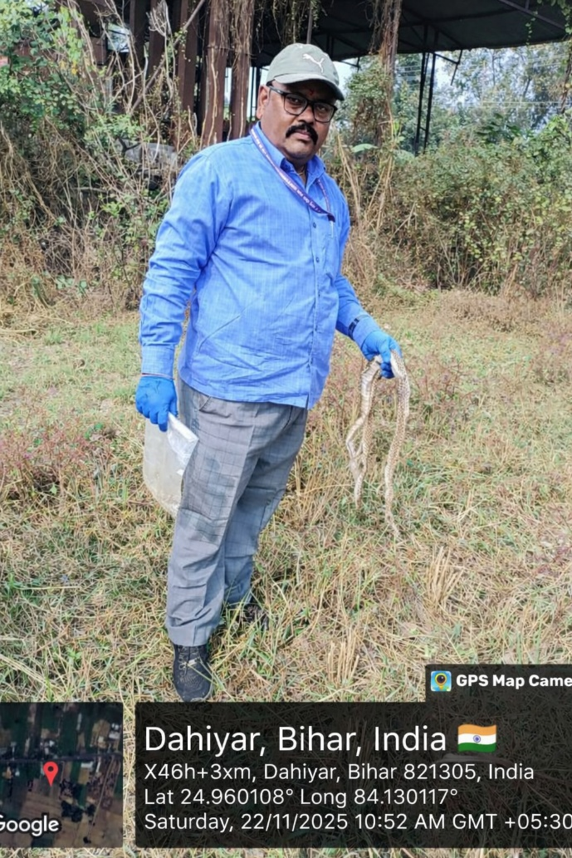
(Figure.1). Field collection of shed snake skin by Mr. Sanjay Kumar, a member of the faunal survey team, at Dahiyar, Bihar, along with recording of the location details.
2.2 DNA Extraction Methods

The DNA was extracted using the DNeasy Blood and Tissue Kit (QIAGEN) according to the manufacturer protocols with slight modifications. The extraction was done with about 50 mg of shed skin. DNA was extracted out of the shed skin using the standard protocol with a long incubation duration of 48h to ensure that the keratinized material is digested effectively. An alternate and improved extraction protocol using a pre-digestion step was then used, based on Fu et al. (2023) to enhance the yield and quality of DNA obtained from shed skin.

For the modified procedure, the process of pre-digestion was carried out for approximately 50 mg of shed skin in a mixture of 360 mL of Buffer ATL, 400 mL Buffer AL, and 40 mL Proteinase K, and the incubation at 56 °C was performed for 30-60 min. Once the shed skin was pre-digested, the sample was then moved into a sterile plastic culture dish and rinsed using the 1x phosphate-buffered saline (PBS) in order to eliminate any possible contaminants. The sample was then cutdown to smaller fragments and further digested again in a lysis buffer containing 360 mL of Buffer ATL, 400 mL of Buffer AL, and 40 mL of Proteinase K at 56°C over 48 h. The sample was centrifuged at 14,000rpm for 3 min after digestion and the supernatant was collected carefully. Half a volume of ethanol (96-100%) was put in this supernatant and vortexed at a rate of 30s. This mixture was then loaded on a DNeasy mini spin column in a 2 mL collection tube and centrifuged at 12,000 rpm for 1 min after which flow through was discarded.

The column was then washed using 500 mL Buffer AW1 and centrifuging at 12,000 rpm for 1 min and the flow-through was discarded. The second washing was done by the addition of 500 mL of Buffer AW2 and centrifuging at 14,000 rpm for 3 min to make sure that all the contaminants were removed. The spin column was subsequently placed to a new 1.5 mL microcentrifuge tube and 50-100 mL Buffer AE added in the middle of the membrane to spin the DNA. The incubation of the column was done at 25 °C at for 1 h and centrifugation done at 12,000 rpm of 1 min to elute the purified genomic DNA.

2.3. Agarose Gel Electrophoresis for DNA Quality Check

The quantity and quality of the DNA isolated was checked using agarose gel electrophoresis. 1µl of 6X gel-loading buffer (0.25% bromophenol blue, 30% sucrose in TE buffer pH-8.0) was added to 5µl of DNA. The sample was loaded to 0.8% agarose gel prepared in 0.5X TBE (Tris-Borate-EDTA) buffer containing 0.5 µg/ml ethidium bromide. Electrophoresis was performed with 0.5X TBE as electrophoresis buffer at 75 V until bromophenol dye front has migrated to the bottom of the gel. The gels were visualized in a UV transilluminator (Genei) and the image was checked for DNA quality under UV light using Gel documentation system (Bio-Rad), before PCR.
2.4. PCR amplification and Sequencing quality control
The standard COI barcode is amplified (∼648 bp) using the Folmer primer pair LCO1490/HCO2198 as a first approach (Folmer et al., 1994; Hebert et al., 2003). The PCR amplification was carried out in a PCR thermal cycler. PCR reactions (25 µL) contained standard reagents: Taq polymerase, buffer, MgCl², dNTPs, primers (0.2–0.5 µM), template DNA (1 µL), and thermal cycling followed published standard protocols optimized to minimize nonspecific amplification (Folmer et al., 1994; Geller et al., 2013). Negative and positive controls were also used. COI gene was amplified with the BigDye Terminator v3.1 Cycle sequencing Kit (Applied Biosystems) following manufactures protocol and sequenced in ABI 3500 DNA Analyzer (Applied Biosystems). The sequence quality was checked using Sequence Scanner Software v1 (Applied Biosystems). Sequence alignment and required editing of the obtained sequences were carried out using Geneious Pro v5.1 (Drummond et al., 2010).

3. Results
3.1. Database searches and taxonomic assignment
COI sequence obtained were queried against NCBI nucleotide databases using BLASTn (Ratnasingham & Hebert, 2007; Altschul et al., 1990, Zheng et al. 2000) with the core nucleotide BLAST database consists of GenBank, EMBL, DDBJ, PDB, RefSeq sequences. The queries recorded species level identity and taxonomic assignment to Ptyas mucosa (Linnaeus, 1758), commonly known as the Oriental rat snake or Indian rat snake with top matches, percent identity, query coverage, and taxonomic concordance. The commonly followed standard barcode assignment thresholds: ≥98–99% COI similarity typically supports species-level assignment for many animal groups (including this case study), while 95–97% indicates likely congeneric affinity and <95% usually indicates higher-level (family/order) identification or a gap in reference sampling (Hebert et al., 2003, 2004., Ratnasingham & Hebert, 2013).
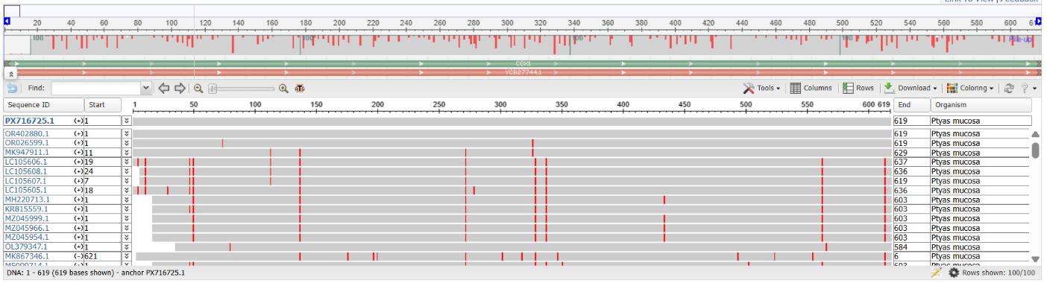
Fig. 2. Non-invasive Molecular Identification of the Indian Rat Snake (Ptyas mucosa) from Shed Skin in Agro-ecosystems Using NCBI BLAST and Multiple Sequence Alignment Analyses

3.2. NCBI / GenBank deposition
Obtained DNA barcode sequence and relevant metadata are prepared and submitted to GenBank according to their submission guidelines and policies for voucher and metadata (sample origin, collection details) with BLAST results and accession number PX716725 (Benson et al., 2013; Ratnasingham & Hebert, 2007) are included. A high-quality COI consensus sequence (619 bp barcode) was obtained from the shed skin eluted DNA sample after successful PCR attempt, with sequence quality meeting standard barcoding thresholds, including the absence of in-frame stop codons and full bidirectional coverage. A BLASTn search against NCBI GenBank returned a single-species top hit with 100 % pairwise identity and 100 % query coverage (Hebert et al., 2003; Ratnasingham & Hebert, 2007). Secondary matches were limited to congeners with lower percent identity (≤97 %), further supporting the top assignment, and no substantive conflicts, such as top hits to different genera in the databases were detected.
The analysis of P. mucosa sequence used the Neighbor-Joining method to study the mitochondrial cytochrome c oxidase I (COI) gene which occurs frequently in DNA barcoding studies. Phylogenetic trees built using the Neighbor-Joining approach as one of the prevalent techniques allowed researchers to extract evolutionary relations from sequence genetic distances. The phylogenetic research demonstrated that P. mucosa belongs to the (Chordata; Vertebrata; Lepidosauria; Squamata; Serpentes; Colubroidea) Colubridae family with confirmed genetic proximity to other Ptyas species (Figure.3). The phylogenetic tree obtained through this analysis displayed strong branches that exhibited proper clustering of sequences from P. mucosa from other specimen sequence deposits of the same taxa. DNA barcoding studies supported by mitochondrial COI gene sequences proved effective in determining evolutionary relationships of P. mucosa as well as its taxonomic identification.
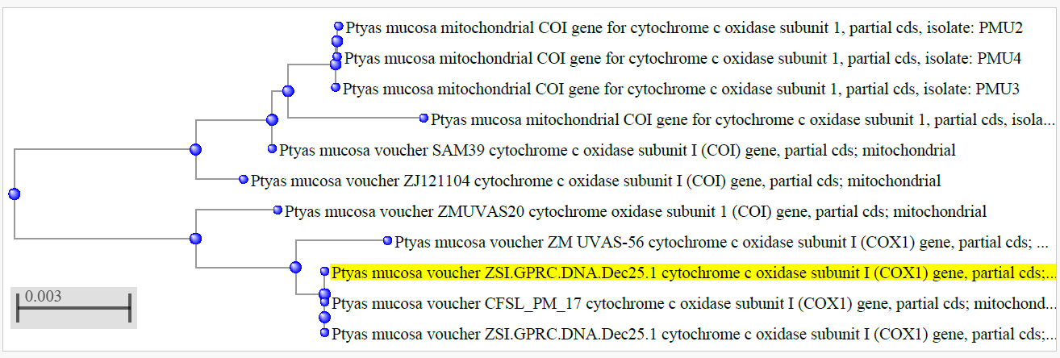
Figure.3. DNA Barcoding-Based Molecular Phylogenetic Analysis of the Indian Rat Snake (Ptyas mucosa) Using the Mitochondrial COI Gene and Neighbour-Joining Method
4. Discussion
Snakes shedding their outer epidermal layer is a periodically occurring physiological process called ecdysis where the outer layer of the skin, which is already keratinized, is cast off as a whole smooth sheet called exuviae or shed skin. These shed skins are available from various natural habitats and in captivity and are a rich biological resource to study with DNA markers.
Non-invasive sampling methods have gained more significance in wildlife genetics especially when the animals sampled are difficult to access or the task of collecting blood or tissues may be inconveniencing or ethically limited. In studies of reptiles shed skins would be particularly handy since they can be collected in the wild or even on captured animals without any stress or injury to the animals. These samples have remaining epithelial cells that maintain genomic DNA that can be used to conduct a molecular analysis, such as PCR amplification and sequencing (Fu et al., 2023).
The introduction of the DNA barcoding methods has also increased the value of shed skins as a method of species identification. DNA barcoding involves the utilization of standardized short genetic markers, usually the mitochondrial genes like cytochrome c oxidase subunit I (COI) to assign species identity against reference databases. It has been extensively adopted in identifying species, biodiversity census, and phylogenetic studies of an extensive variety of taxa. COI gene is found to be useful in DNA barcoding in snakes to separate close species and identify cryptic species (Bhaskar et al., 2022). A number of studies have indicated that it is possible to obtain high-quality DNA on snake shed skin using the molecular identification. Recently, in Bangladesh, genomic DNA of skin exuviates was amplified successfully using COI primers to identify numerous snake species including Boiga ochracea, Ptyas mucosa, Lycodon aulicus, Naja naja, Daboia russelii, and Python molurus (Islam et al., 2022).
In another study from Arignar Anna Zoological Park, Vandalur, Guindy National Park, Chennai, and Amirthi Zoological Park, Vellore, Tamil Nadu used shed skins as a valuable source of DNA to identify the species and analyze their phylogenetic relationships The molecular analysis of captivated snake populations has been carried out in terms of cytochrome b (CYT b) and 12S rRNA as mitochondrial markers for identification through DNA samples taken on shed snakes. The concentrations of extracted DNA in such studies were 250 ng/uL to 1600 ng/uL, proving that shed skin can contain enough genomic DNA to be used in PCR amplification and sequencing. The similarity values of BLAST searches in the NCBI GenBank database were 99-100 per cent, thus making it possible to identify the species at the species level (Sivapushanam et al., 2022).
Shed-skin DNA has also been proven to be reliable in large-scale genetic studies. An example is a study examining the applicability of reptile shed skin as a source of genomic sequencing revealed that DNA isolated on the skin sheds of the corn snake (Pantherophis guttatus) provided the same quality DNA as did DNA on conventional tissue samples. The analysis established that shed skins can be utilized to identify by PCR methods as well as high-throughput genomic sequencing, though cautious using methods are needed to reduce bacterial contamination (Fu et al., 2023).
Outside of taxonomic discovery, DNA utilized on shed skins has significant uses in population genetics, phylogenetics and conservation biology. Notably, in most rural environments, especially in the farming areas where the number of encounters between man and snake is very high, villagers and farmers tend to be immediately scared and not sure of what to do when they see a snake. The reason behind this response is significantly due to the fact that it has been difficult to identify between the species that are poisonous and those that are not, through the brief visual observation within a short period of time particularly in situations where the encounter between them is sudden, and either in the crop fields, irrigation channels, and storage sites. This often results in random killing of snakes when most of them have positive ecological functions, such as eating rodents and other agricultural pests, which are natural predators. In this regard, the use of DNA-based species identification of sheds skins (exuviae) is a very useful non-invasive method of ensuring the identity of snakes, without the inconvenience of having to capture or handle the organism. Molecular methods including mitochondrial COI DNA barcoding can easily identify the species with sloughed skin fragments where the researchers and wildlife authorities can conclude whether the species found is a venomous or harmless species that is friendly to the farmers. Shed skin DNA has already been used successfully in multiple studies and is gradually being seen as a viable method of monitoring biodiversity, identifying species, and conserving awareness of these in rural settings (Khedkar et al., 2016; Tsai and Mao, 2017; Fu et al., 2023). This method can contribute to community education, curtail killing of snakes due to fear and cohabitation between rural communities and valuable snake species that can help in maintaining agricultural pests through a peaceful co-existence.
Non-invasive samples enable researchers to acquire genetic data in very huge populations without disrupting natural populations of extensive geographic regions. It can be especially useful in the case of threatened reptile species, where genetic tracking can be used to determine population structure, gene flow, and evolutionary patterns (Brekke et al., 2023).
Wildlife forensic work is another application which can enable the authorities to establish the species source of the seized materials and reinforce law enforcement activities against the illicit wildlife trafficking (Kanthaswamy, S. 2024). However, there are some challenges associated with the use of shed skins to perform DNA analysis in spite of these advantages. The DNA can be degraded by the ultraviolet radiation, microbial activity or long term exposure to moisture as a result of environmental exposure. Also, it is possible to be contaminated by bacteria since shed skins are in contact with environmental microorganisms following shedding. Nonetheless, newer developments in DNA extraction procedures, such as pre-digestion and purification techniques, have greatly enhanced the quantity as well as the quality of DNA in shed skin (Fu et al., 2023).
5. Conclusion
A combination of non-invasive sampling with molecular identification methodologies has provided new opportunities in studies of reptiles for the past few decades. Shed skins are highly accessible and morally acceptable source of DNA that may be utilized in identifying a species, performing a phylogenetic tree, investigations in population genetics, and wildlife forensic studies. Molecular techniques like mitochondrial DNA barcoding enable one to identify species accurately even using small bits of exuviae so that the capturing and disturbance of living organisms are eliminated. The application of shed-skin-derived DNA will be a valuable addition to herpetological and biodiversity conservation efforts as genetic reference databases keep growing. This application is specifically useful in man-made landscapes where snakes are often found. As reported in this study, one of the most ubiquitous non-poisonous snakes in South Asia, the Ptyas mucosa which is often referred to as the Indian rat snake, is often found in farming fields, village periphery, and grain depositories where it has a significant ecological impact as a rodent predator. This species is not dangerous to humans, but in most cases, it is confused with a poisonous snake because it is very large and defensive. Generally, in most of the rural settings, villagers or the farmers who most frequently come across snakes when engaged in their farming business are expected to feel instant fear and confusion when they meet a snake in their harvest fields or in irrigation systems. This has made harmless snakes like the Oriental rat snake to be killed due to fear of being attacked by the venomous species.
Molecular identification using shed skins could be a useful and informative resource in such circumstances. The DNA on exuviae from the agricultural field can be used to confirm the identification of the species of the snake and very useful for the affirmation of whether the local snake is a venomous snake or a harmless and friendly predator that serves the farmer by eliminating rodents in the natural environment. Non-invasive molecular tools can thus be beneficial to scientific research, as well as the alleviation of human-snake conflict and coexistence in rural ecosystems by enhancing species identification and increasing public awareness.

References
- Altschul, S. F., Gish, W., Miller, W., Myers, E. W., & Lipman, D. J. (1990). Basic local alignment search tool. Journal of Molecular Biology, 215(3), 403–410. doi:10.1016/S0022-2836(05)80360-2.
- D.A. Benson, M. Cavanaugh, K. Clark, I. Karsch-Mizrachi, D.J. Lipman, J. Ostell, E.W. Sayers. (2013). GenBank. Nucleic Acids Res., 41 (D1) (2013), pp. 36-42, 10.1093/nar/gks1195.
- Bhaskar, R., Sharon, E. A. Chandika, R. G. and Ganesh, S. R. (2022). Genetic documentation of snake species using non-invasive sampling and non-toxic DNA isolation method: Genetic documentation of snake. Journal of Wildlife and Biodiversity, 7(4), 117–126. https://doi.org/10.5281/zenodo.7048818.
- Brekke, T.D., Shier, L., Hegarty, M.J. et al.(2023). Shed skin as a source of DNA for genotyping-by-sequencing (GBS) in reptiles. Conservation Genet Resour 15, 117–124 . https://doi.org/10.1007/s12686-023-01310-w.
- Drummond AJ, Ashton B, Buxton S, Cheung M, Cooper A, Heled J, Kearse M, Moir R, Stones-Havas S, Sturrock S, Thierer T and Wilson A. (2010). Geneious v5.1, Available from http://www.geneious.com.
- Fetzner J. W., Jr (1999). Extracting high-quality DNA from shed reptile skins: a simplified method. BioTechniques, 26(6), 1052–1054. https://doi.org/10.2144/99266bm09.
- Folmer, O., Black, M., Hoeh, W., Lutz, R., & Vrijenhoek, R. (1994). DNA primers for amplification of mitochondrial cytochrome c oxidase subunit I from diverse metazoan invertebrates. Molecular Marine Biology and Biotechnology, 3(5), 294–299.
- Fu, Y., Zhuang, Y., Luo, S.-J., & Xu, X. (2023). An Enhanced Method for the Use of Reptile Skin Sheds as a High-Quality DNA Source for Genome Sequencing. Genes, 14(9), 1678. https://doi.org/10.3390/genes14091678.
- Geller, J., Meyer, C., Parker, M., & Hawk, H. (2013). Redesign of PCR primers for mitochondrial cytochrome c oxidase subunit I for improved amplification of metazoan COI. Molecular Ecology Resources, 13(5), 851–861. doi:10.1111/1755-0998.12138.
- Hebert, P. D. N., Cywinska, A., Ball, S. L., & deWaard, J. R. (2003). Biological identifications through DNA barcodes. Proceedings of the Royal Society B: Biological Sciences, 270(1512), 313–321. doi:10.1098/rspb.2002.2218.
- Hebert, P. D. N., Stoeckle, M. Y., Zemlak, T. S., & Francis, C. M. (2004). Identification of Birds through DNA Barcodes. PLOS Biology, 2(10), e312. doi:10.1371/journal.pbio.0020312.
- Islam, Nafisa & Sajib, Abu & Ahmed, Md Sagir. (2022). Molecular identification of snakes from cast-off skin. Herpetology Notes. 15. 699-709.
- Kanthaswamy, S. (2024) Review: Wildlife forensic genetics—Biological evidence, DNA markers, analytical approaches, and challenges. Animal Genetics, 55, 177–192. Available from: https://doi.org/10.1111/age.13390.
- Khedkar T, Sharma R, Tiknaik A, Khedkar G, Naikwade BS, Tetsuzan Benny Ron T, David Haymer. (2016). DNA barcoding using skin exuviates can improve identification and biodiversity studies of snakes. Mitochondrial DNA. doi: 10.3109/19401736.2014.905830.
- Laopichienpong, N., Muangmai, N., Supikamolseni, A., Twilprawat, P., Chanhome, L., Suntrarachun, S., Peyachoknagul, S., & Srikulnath, K. (2016). Assessment of snake DNA barcodes based on mitochondrial COI and Cytb genes revealed multiple putative cryptic species in Thailand. Gene, 594(2), 238–247. https://doi.org/10.1016/j.gene.2016.09.017.
- Rajpoot, A., Kumar, V. P., Bahuguna, A., & Rasaily, S. S. (2021). Preliminary genetic documentation of snake species through shed skin from Uttarakhand, India: A non-invasive genetic sampling approach. Journal of wildlife and Biodiversity, 5(1), 81-91.
- Ratnasingham, S., & Hebert, P. D. (2013). A DNA-based registry for all animal species: the barcode index number (BIN) system. PloS one, 8(7), e66213. https://doi.org/10.1371/journal.pone.0066213
- Ratnasingham, S., & Hebert, P. D. N. (2007). BOLD: The Barcode of Life Data System (www.barcodinglife.org). Molecular Ecology Notes, 7(3), 355–364. doi:10.1111/j.1471-8286.2007.01678.x.
- Sivapushanam, Karthy, Abinaya Nadarajan, Vaishnavi Chandramouli, Kanchana Rangasamy, and Debasis Jana. 2022. “Molecular Identification of Captive Snakes from Their Shed Skin Using Cyt B & 12s RRNA Markers”. Journal of Applied Life Sciences International 25 (4):45-51. https://doi.org/10.9734/jalsi/2022/v25i430302.
- Tsai, T. S., & Mao, J. J. (2017). Species Identification of Shed Snake Skins in Taiwan and Adjacent Islands. Zoological studies, 56, e38. https://doi.org/10.6620/ZS.2017.56-38.
- Zheng Zhang, Scott Schwartz, Lukas Wagner, and Webb Miller (2000), "A greedy algorithm for aligning DNA sequences", J Comput Biol 2000; 7(1-2):203-14.

