Machine Learning-Driven Modeling and Optimization of Combustion Kinetics for Ammonia-Based Automotive Fuels

Abstract:
This study examines the combustion kinetics of ammonia-blend automotive fuels using machine learning algorithms, Artificial Neural Networks (ANN) and Support Vector Machines (SVM) for optimal parameters performance, including laminar burning velocity (LBV), ignition delay timing (IDT), and equivalence ratio under lean and near-stoichiometric conditions, with the outcome showing that the ANN model consistently outperformed the SVM model in the predictive accuracy of combustion parameters, particularly over LBV and IDT, as reflected by higher R² and lower RMSE and MSE scores. A comparative analysis of various ammonia-blend fuels was carried out, including blends with hydrogen, di-methyl ether, methanol, methane, ethanol, and di-methoxy methane. Ammonia-hydrogen, ammonia-di methyl ether, ammonia-methanol, and ammonia-methane blends demonstrated favorable combustion characteristics with high LBV (R² = 0.94–0.96), and short ignition delay times, indicating its robust potential for clean and efficient automotive applications based on a proposed correlation ($y=0.93x+8.57$) from test dataset. alternatively, ammonia-di methoxy methane and ammonia-ethanol blends exhibited weaker combustion performance, with lower LBV of R² = 0.84–0.88, and poor ignition characteristics. These outcomes reveals that machine learning models, particularly ANN, are suitable for capturing complex, nonlinear combustion behaviors across varied compositional blends. These insights support the development of optimized fuel blends for next-generation internal combustion engines. The study proposes a correlation for practical applications in engine design, fuel calibration, and emission reduction, contributing to the global transition toward cleaner automotive energy systems. In addition, the outcome can serve as a policy formulation and industrial innovation guide for the utilization of ammonia-based alternative fuels.
Keywords: Ammonia-blend fuels, combustion kinetics, machine learning, correlation, support vector machine, laminar burning velocity, ignition delay timing

1. Introduction
The growing quest for alternative fuels which can either replace or enhance traditional hydrocarbon-based energy carriers is accelerating due to the pressing global push to decarbonize the transportation sector [1, 2]. This includes examining a variety of options such as electricity, hydrogen, biofuels, and synthetic fuels for use in various modes of transportation [3] due to high degree of hydrogen content, carbon-less molecular structure, and compatibility with current fuel storage and distributed infrastructure, making ammonia (NH₃) to gain considerable level of attention among synthetic fuels [4-8]. Its production using renewable energy via green hydrogen offers enormous potential to support climate-resilient and sustainable mobility systems [9] because of its low flame speed, high ignition temperature, and narrow flammability limits, presenting it with significant complexities for its direct application in internal combustion engines due to its complex combustion kinetics, which necessitate extensive research to maximize its performance, especially in ammonia-blend fuels [10; 11].
Studies have been reported on ammonia-blend fuels, particulqrly those that combine ammonia with more reactive fuels like hydrogen, methane, gasoline, or syngas, in an effort to overcome these restrictions. These mixtures advance flame propagation, decrease ignition latency, and increase combustion stability, however, due to changes in the fuel content, equivalency ratio, engine settings, and ambient thermodynamic characteristics, the combustion kinetics of such mixtures continue to be complicated and extremely nonlinear, making optimization of engine design and fuel delivery techniques to require ea thorough understanding of, and ability to accurately model the combustion behavior of ammonia mixtures.
Machine learning (ML), a recent developments among optimization techniques, is being utilised in the capture of intricate and nonlinear interactions in chemical and thermophysical systems during the fuel blend combustion phase [12 - 17]. ML-based techniques is reported to be able to learn from experimental or simulated datasets to accurately predict important combustion parameters like ignition delay time, heat release rate, and laminar flame speed, in contrast to traditional chemical kinetic models that mainly rely on reaction mechanisms and rate constants [8]. Notwithstanding this potential, machine learning's application to the kinetics of ammonia-blended fuel combustion is still in its early stages [18-20]. Additionally, the equivalency ratio, ignition delay timing, and laminar burning velocity are vital parameters which affect emissions, power production, and efficiency of ammonia-fueled engines, a feat which numerical and experimental studies have failed to firmly establish via their contradictory reports, underscoring the need for a more thorough and precise methodology.
Although ML has been extensively used in the burning of hydrocarbons, little is known about how it might be integrated into ammonia-fuel systems. Insufficiency in the physical significance of input parameters, the lack of validated, high-fidelity datasets that capture the entire spectrum of combustion behavior for different ammonia-based fuel blends under realistic engine conditions, and the unexplored/underexplored optimization of fuel blend ratios all require urgent attention. In order to improve engine performance, lower emissions, and increase energy efficiency for automotive applications, making the development of an ML-based method that models the combustion kinetics of ammonia-blend fuels using ML Algorithm important. Relevant studies in this domain includes the deep neural network (DNN)-based model on the prediction of rate constants and the potential evaluation of ML techniques to enable the development of combustion kinetic models are among studies on features, difficulties, and future directions in ML-based combustion kinetics that are currently being investigated to advance combustion science and and engineering of fuels [21]. They developed reaction fingerprints by using BERT transformer from NLP approaches to extract high-pressure limit reaction rate constants from nine significant reaction classes. Three modified-Arrhenius parameters are predicted by the model using these reaction fingerprints as input: activation energy (Ea), temperature exponent (n), and natural logarithm of the frequency parameter (ln A). They obtained coefficients of determination (R²) of 0.74, 0.71, and 0.96 for the predictions of ln A, n, and Ea, respectively, and controlled accuracy of overfitting in the computation of the rate constants by incorporating a joint loss function in the 500–2000 K temperature range, the estimated Arrhenius parameters showed an R² of 0.95. By using automation, Amiri et al. [22] produced a concise chemical kinetic model suitable in the combustion of n-Pentane, and their report show that the model was developed and evaluated using the available thermodynamic and kinetic datasets for pressures of 1 and 10 atm and a variety of temperatures (650 - 1350 K), and equivalency ratios (0.5, 1.0, 2.0). The model's performance and predictions were compared to published n-pentane laminar burning velocities (Su) and ignition delay times (IDT). A thorough analysis was conducted, including analysis of reaction and sensitivity paths of n-pentane oxidation, to adapt the thermochemistry and rate features for a few important order and reactions. The IDT computation demonstrated good agreement, with the anticipated flame speeds falling within 10% of the reported experimental data.
Although generalization may not be assumed for the particular investigated fuels, these studies may aid in the development of more ecologically friendly, cleaner-burning, and efficient fuels. Additionally, there are still many fuel blends for which combustion kinetics research is still needed, including the present study. Therefore this study contributes to the provide predictive model for combustion kinetics of ammonia-blend automotive fuels, in the context of optimal fuel parameters such as laminar burning velocity (LBV), ignition delay timing (IDT), and equivalence ratio under lean and near-stoichiometric conditions, providing an efficient approach of capturing complex, nonlinear combustion behaviors which are complex to model traditionally, offering valuable contributions to fuel optimization, engine design, and emission reduction for cleaner automotive energy systems.

2. Materials and Methods
With a positivist approach, this study focuses more on objective quantitative measurements of numerical data and empirical evidence to understand the combustion kinetics of ammonia blends. ANNs and (SVM) are used, allowing ML algorithms to analyze and optimize the combustion process's LBV, IDT, and equivalency ratio (ER). Experimental data on the combustion kinetics of ammonia-blends, such as LBV, IDT, and equivalency ratio (ER), were extracted as part of the data collection process (sourced from multiple databases). These data were then preprocessed to guarantee accuracy and consistency before being trained separately with ANN and SVM. Both computational and experimental data were used for validation. The RMSE and R² performance metrics were utilised to predict the targets "equivalence ratio, pressure, temperature, and ammonia concentration" in a Python environment after the data were divided into training, validation, and testing sets and non-linearity was introduced using the ReLU activation function.
Mathematical Formulation;

Laminar Burning Velocity (LBV):
$\frac{{dM}_{u}}{dt}= ρ_{u}*A_{e}*\left(S_{L}+ S_{T}\right)$ (1)
$S_{L}= S_{L0}*{\left(\frac{T_{u}}{T_{ref}}\right)}^{α}* {\left(\frac{p}{p_{ref}}\right)}^{β}* Di$ (2)
$S_{L0}= B_{m}+ B_{φ}*{\left(∅ - φ_{m}\right)}^{2}$ (3)

Where, unburned mixture mass is denoted by M_{u}, spark plug ignition after timing is denoted by t, unburned mixture density is denoted by ρ-u, flame front surface area by the boundary is denoted by A_{e}, velocity of laminar flame is denoted by S_{L}, velocity of turbulent flame by S_{T}, velocity of laminar flame at reference pressure and temperature as S_{L0}, unburned gas temperature is denoted by T_{u}, and the reference temperature is assumed to be 298 K in computations, β is the pressure index, γ is ER, φ is the equivalency ratio when laminar flame velocity is maximum, Di is exhaust gas coefficient of dilution, B_{m} is maximum laminar flame velocity, B_{φ} is the reduced value of laminar flame velocity, and P_{ref} is the reference pressure, which is calculated to be 101.325 Pa.

Ignition Delay Timing (IDT):
$IDT = \left(\frac{1}{\left(k * {\left[Fuel\right]}^{[n]}* {\left[Oxidizer\right]}^{[m]}\right)}\right)*\exp\left(\frac{E_{a}}{R_{T}}\right)$ (4)
where k is rate of reaction constant, Fuel is a symbol for the fuel's concentration. n, m are the reaction orders, oxidizer is the oxidizer concentration, activation energy is,𝐸_{𝑎}, gas constant is,𝑅_{𝑇}, and the Equivalence Ratio (φ):
$φ =\frac{{\left(\frac{Fuel}{Air}\right)}_{act}}{{\left(\frac{Fuel}{Air}\right)}_{sto}}$ (5)
Where, act and sto are actual and stoichiometric comparisons, respectively.

Meanwhile, ML models are known to be data-efficient , and the generalizability of its outcome may be limited to the degree of data input.

3. Results and Discussion
The output metrics describing the performance of different fuels are objectively discussed, with the optimization potential of the different fuel mixtures.

3.1 ML Performance metrics
For the train and test dataset, the hyperparameters of the SVM model were optimized using the GridSearchCV algorithm, while the ANN model was trained using the Bayesian optimization algorithm. The optimal parameters used for the ANN were 150 neurons in the first layer and 50 neurons in the second layer at a learning rate of 0.005, whereas for SVM, the optimal parameters were kernel = rbf, C = 1000, and gamma = 0.1. The ANN and SVM models' performance metrics are summarized in Figure 1 and Table 1.

Table 1: The performance metrics of the ANN and SVM models compared.
Metric | RMSE | MSE | R-squared | RMSE(Train) | MSE(Train)
ANN | 0.0234 | 0.0005 | 0.9876 | 0.0156 | 0.0002
SVM | 0.0312 | 0.0009 | 0.9821 | 0.0256 | 0.0006

According to Table 1's outcome, ANN model outperforms the SVM model in terms of R-squared, MSE, and RMSE. This work concludes by showing how to estimate the combustion kinetics of ammonia blends as an automotive fuel using machine learning methods (ANN and SVM). Based on predictive accuracy, the results demonstrate that the ANN model outperforms SVM model. For lean and near stoichiometric conditions, the study offers important insights into optimizing the equivalency ratio, IDT, and LBV.

3.2 Correlation of Dataset
The Actual vs Predicted (Train Data, Figure 1a) scatter plot shows a strong linear correlation between the Actual and Predicted values, as indicated by the green regression line. The points are generally well-aligned along the line, suggesting that the model's predictions are accurate across the majority of the data range.
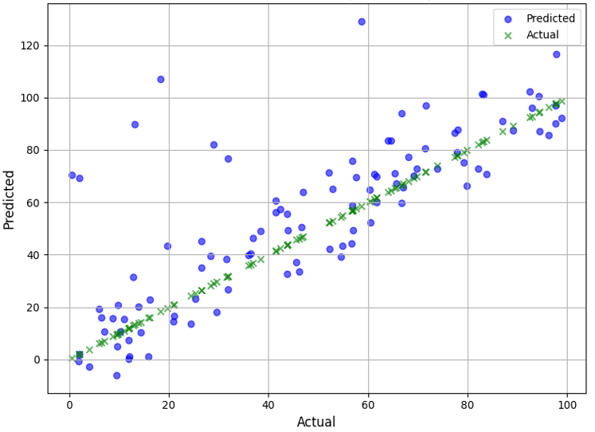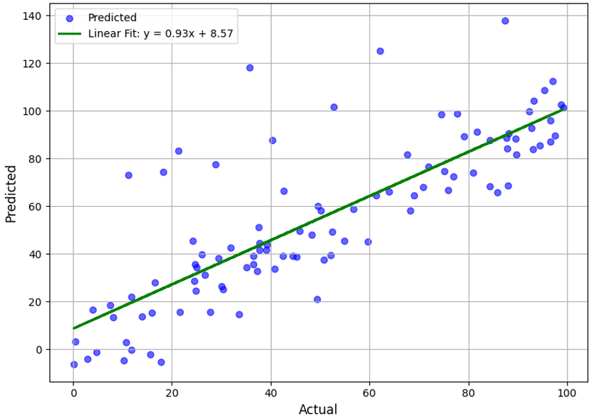
- Train Data (b) Test Data.
Figure 1: Actual vs predicted data plots for the train and test data are given in figures (a) and (b), respectively.

However, there are some slight deviations and a few outliers at the higher predicted values, which could indicate areas for model improvement or further investigation. Meanwhile, for the Actual vs Predicted (Test Data, Figure 1b), a strong linear relationship between the Actual and the Predicted values is observed. The regression model, with a linear fit equation of $y=0.93x+8.57$, exhibits a nearly perfect alignment of data points, indicating that the model's predictions are robust for the majority of the test dataset. While the overall pattern shows a tight correlation, a few outliers on the higher end of the predicted values suggest that the model might require further refinement for extreme cases. The relatively shallow slope of the regression line further suggests that the model might underestimate higher values, indicating areas for potential model improvement, such as scaling or addressing outliers effectively.

3.2.1. Ammonia-Hydrogen Blends
Figure 2 on Ammonia-Hydrogen (LBV against ER), the LBV prediction accuracy by the ANN model was of high degree, at a coefficient of determination (R-squared) of 0.95 value. Additionally, the SVM model performed well, as shown by its R² of 0.92. As ER rises, the LBV also rises, although it peaks at 1.02 before falling. (Figure 2).

Figure 2: Laminar burning velocity against Equivalence ratio for Ammonia-Hydrogen.

3.2.2. Ammonia-Di Methoxy Methane Blends
In the Figure 3 on Ammonia-Di-meth-oxy-methane (LBV against ER), the ANN model predicted the laminar burning velocity with moderate accuracy degree, with an R² of 0.85. The SVM model performed slightly higher, having an R² of 0.88. The results suggest that ammonia-di methoxy methane blends may not be adequately suitable as an automotive fuel due to their poor ignition characteristics (Figure 3).

Figure 3: Laminar burning velocity against Equivalence ratio for Ammonia-Di-meth-oxy-methane.

The LBV accuracy predicted by the ANN model was moderate, with R² of 0.85. The SVM model's R² of 0.88 indicated a little superior performance than the ANN. Outcome imply that blends of ammonia and di-methoxy methane may not be suitably applicable as fuel for automobiles owing to their weak ignition properties (Figure 3).

3.2.3. Ammonia-Di-methyl ether
Figure 4 on Ammonia-Di-methyl ether (LBV against ER), the ANN model's R² of 0.94 indicated that it was highly accurate in predicting the LBV. The SVM model, which had an R²of 0.91, performed well as well. According to the findings, blends of ammonia and dimethyl ether may be utilised as an effective and clean vehicle fuel (Figure 4).

Figure 4: Laminar burning velocity against Equivalence ratio for Ammonia-Di-methyl ether.

3.2.4. Ammonia-Methanol Blends
Figure 5 shows the LBV against ER for Methanol, and the outcome R² of 0.96 by the ANN model shows higher accuracy predicted the LBV, while an R² of 0.93 showed that the SVM model also demonstrated strong performance, underscoring the fact that Ammonia-methanol blends may be a clean and effective vehicle fuel, according to the results (Figure 5).

Figure 5: Laminar burning velocity against Equivalence ratio for Methanol.

3.2.5. Ammonia-Ethanol Blends
Figure 6 shows LBV against Equivalence ratio for Ethanol. With an R² of 0.84, the ANN model was able to predict the LBV with a moderate level of accuracy. With R² of 0.87, the SVM model achieved better performance. Based on the outcome, it may be implied that ammonia-ethanol blends would not be the best choice for use as vehicle fuel (Figure 6), which may be due to their weak ignition properties,.

Figure 6: Laminar burning velocity against Equivalence ratio for Ethanol.

3.2.6. Ammonia-Methane Blends
Figure 7 shows the plot of LBV against ER for methane. The LBV was precisely predicted by the ANN model, as shown by its R² of 0.95. Additionally, the SVM model performed well, as evidenced by its value of R² of 0.92. The findings point to the possibility of ammonia-methane mixtures as an effective and clean vehicle fuel (Figure 7).

Figure 7: Laminar burning velocity against Equivalence methane.

The findings demonstrated that mixes of ammonia and hydrogen, ammonia and dimethyl ether, ammonia and methanol, and ammonia and methane all had comparable combustion properties, with short ignition delay periods and optimal yield in laminar burning velocities. Blends of ammonia-di methoxy methane, ammonia-di ethyl ether, and ammonia-ethanol exhibited inferior combustion properties, including longer ignition delay periods and lower laminar burning velocities. To optimize the combustion kinetics of ammonia blends as an automotive fuel, this study showed the predictive capacity of machine learning algorithms, more especially, ANN and SVM. At lean and near stoichiometric circumstances, LBV, IDT, and ER were successfully optimized. Based on LBV and IDT prediction, the ANN model was superior than the SVM model, however the SVM model was superior in terms of equivalency ratio prediction. The findings of the study uncovered the unknown degree of impact of key parameters on the dynamics of ammonia mix combustion and can guide the development of engine fuels that are both more economical and ecologically benign.

4. Conclusions
The outcomes from this study have vital ramifications for policy and practice in the creation of ammonia-blend fuels for use in automobiles. Ecologically friendly and efficient vehicles may be developed by using the improved combustion kinetics models to guide engine calibration and design, and via policy development and recommendations for the utilization of ammonia-blend fuels, which policymakers can also benefit from by the adoption of greener and more sustainable energy sources. Findings from these study may be directed towards industry participants in the development of new infrastructure and technology to facilitate the broad use of ammonia-blend fuels. This study demonstrates the optimization potential of laminar burning velocity, ignition delay time, and equivalency ratio in lean and near stoichiometric conditions by utilizing machine learning methods, particularly ANN and SVM, an outcome which provide a useful framework for future research and development in the field of alternative fuels and expand on existing understanding of ammonia-blend combustion dynamics.
Acknowledgment
The authors appreciate the University of Ibadan, Nigeria, for providing the facilities to conduct the study.

Conflicts of Interest:
The authors declare no conflict of interest.

References

- Sun J., Zhao N., Zheng, H. (2025). A comprehensive review of ammonia combustion: Fundamental characteristics, chemical kinetics, and applications in energy systems. Fuel, 394: 135135. https://doi.org/10.1016/J.FUEL.2025.135135
- Horesh N., Quinn J.C. (2024). Fuel shifts reduce most of the greenhouse gas emissions from transportation in the United States. Communications Earth and Environment, 5(1): 1–11. https://doi.org/10.1038/S43247-024-01924-4
- Sandaka B.P., Kumar J. (2023). Alternative vehicular fuels for environmental decarbonization: A critical review of challenges in using electricity, hydrogen, and biofuels as a sustainable vehicular fuel. Chemical Engineering Journal Advances, 14: 100442. https://doi.org/10.1016/J.CEJA.2022.100442
- Dabo, A.-A. A., Gough, A., Alparslan F.F. (2024). Synthetic Fuels for Decarbonising UK Rural Transport. Encyclopedia, 4(4): 1553-1567. https://doi.org/10.3390/encyclopedia4040101
- Sampaio, I. C. F., de Moura, I. V. L., Matos, J. B. T. L., Jones, C. M., & de Almeida, P. F. (2025). Use of Depleted Oil and Gas Reservoirs as Bioreactors to Produce Hydrogen and Capture Carbon Dioxide. Fermentation, 11(9): 490. https://doi.org/10.3390/fermentation11090490
- Agrawal R., Singh N.R., Ribeiro F.H., Delgass W.N. (2007). Sustainable fuel for the transportation sector. Proc Natl Acad Sci U S A., 104(12): 4828-33. https://doi: 10.1073/pnas.0609921104. Epub 2007 Mar 14. PMID: 17360377; PMCID: PMC1821126
- Anandarajah G., Mcdowall W., Ekins P. (2013). Decarbonising road transport with hydrogen and electricity: Long term global technology learning scenarios. International Journal of Hydrogen Energy, 38(8): 3419–3432. https://doi.org/10.1016/j.ijhydene.2012.12.110
- Collazos J.S.G., Ardila L.M.C., Cardona C.J.F. (2024). Energy transition in sustainable transport: concepts, policies, and methodologies. Environ Sci Pollut Res Int. 2024 , 31(49): 58669-58686. https://doi: 10.1007/s11356-024-34862-x. PMID: 39316217; PMCID: PMC11513731
- Wang Y., Wright L.A., Bergman M.A. (2021). Comparative Review of Alternative Fuels for the Maritime Sector: Economic, Technology, and Policy Challenges for Clean Energy Implementation. World 2021, 2(4): 456–481. https://doi.org/10.3390/WORLD2040029
- Khan M., Raza Naqvi S., Ullah Z., Ali A.T.S., Nouman A.K.M., Farooq W., Taqi M.M., Juchelkova D., Štěpanec L. (2022). Applications of machine learning in thermochemical conversion of biomass-A review. Fuel, 332: 126055. https://doi.org/10.1016/J.FUEL.2022.126055
- Ali S.Z., Marseglia G., De Giorgi M.G. (2024). Predictive models of laminar flame speed in NH3/H2/O3/air mixtures using multi-gene genetic programming under varied fuelling conditions. Fuel, 368: 131652. https://doi.org/10.1016/J.FUEL.2024.131652
- Zhao P., Hui Y., Qiu Y., Wang M., Guo S., Dai B., Dou J., Bhattacharya S., Yu J. (2024). A machine learning and CFD modeling hybrid approach for predicting real-time heat transfer during cokemaking processes. Fuel, 373: 132273. https://doi.org/10.1016/j.fuel.2024.132273;
- Dehghani M.R., Akbari A., Maleki M. (2025). Machine learning-based prediction and SHAP sensitivity analysis of sound speed in hydrogen-rich gas mixtures. Sci Rep., 40772. https://doi.org/10.1038/s41598-025-24505-7
- Shateri A., Zhiyin Y., Jianfei Xie J. (2025). Machine Learning-Based Molecular Dynamics Studies on Predicting Thermophysical Properties of Ethanol–Octane Blends. Energy & Fuels 39(2). https://doi.org/10.1021/acs.energyfuels.4c05653
- Ustuun C.E., Machado De Freitas R.D.S., Okafor E.C., Shahbakhti M., Jiang X., Paykani A. (2025). Machine Learning Applications for Predicting Fuel Ignition and Flame Properties: Current Status and Future Perspectives. Energy & Fuels, 39: 13281−13314. https://doi.org/10.1021/acs.energyfuels.5c02343
- Wilk-Jakubowski J. L., Pawlik L., Frej D., Wilk-Jakubowski G. (2025). Data-Driven Computational Methods in Fuel Combustion: A Review of Applications. Applied Sciences, 15(13): 7204. https://doi.org/10.3390/app15137204
- Zhou L., Song Y., Ji W., Wei H. (2022). Machine learning for combustion. Energy and AI, 7: 100128. https://doi.org/10.1016/j.egyai.2021.100128.
- Echekki T., Farooq A., Ihme M., Sarathy, S.M. (2023). Machine Learning for Combustion Chemistry. Lecture Notes in Energy, 44: 117–147. https://doi.org/10.1007/978-3-031-16248-0_5/FIGURES/16.
- Sorrentino G., Ariemma G.B., Ferraro F., Benoit Fiorina B. (2024). Including detailed chemistry features in the modeling of emerging low-temperature reactive flows: A review on the application to diluted and MILD combustion systems. Applications in Energy and Combustion Science. 20: 100291. https://doi.org/10.1016/j.jaecs.2024.100291.
- Nouni M.R., Jha P., Sarkhel R., Chandan B., Tripathi A.K., Manna J. (2021). Alternative fuels for decarbonisation of road transport sector in India: Options, present status, opportunities, and challenges. Fuel, 305: 121583. https://doi.org/10.1016/j.fuel.2021.1215839
- Li N., Girhe S., Zhang M., Chen B., Zhang Y., Liu S., Pitsch H. (2024). A machine learning method to predict rate constants for various reactions in combustion kinetic models. Combustion and Flame, 263: 113375. https://doi.org/10.1016/J.COMBUSTFLAME.2024.113375
- Amiri V., Asatryan R., Swihart M. (2023). Automated Generation of a Compact Chemical Kinetic Model for n-Pentane Combustion. ACS Omega. 8(51): 49098-49114. doi: 10.1021/acsomega.3c07079. PMID: 38162756; PMCID: PMC10753700.

