Protective Antioxidant Effects of Azadirachta indica Extract in Retina Tissue of a Diabetic Rat Model.

ABSTRACT:

Aims: The present study aimed to evaluate the protective antioxidant effects of ethanol leaf extract of Azadirachta indica (A.I) leaves in the retina of streptozotocin (STZ)-induced diabetic rats.
Study design: This research was an experimental, randomized, controlled in vivo study
Place and Duration of Study: Department of Biochemistry, Lead City university, Ibadan, Nigeria, between September 2024 and July 2025.
Methodology: Diabetes was induced in male Wistar rats by a single intraperitoneal injection of STZ (55 mg/kg). Diabetic rats received daily oral A.I leaf extract at 200 or 400 mg/kg for 21 days. Metformin (7 µg/kg) served as positive control, with untreated diabetic (negative control) and non-diabetic groups. Retinal homogenates were assayed for malondialdehyde (MDA), reduced glutathione (GSH), superoxide dismutase (SOD) activity, catalase (CAT) activity, and total protein using standard colorimetric/kit methods. Fasting blood glucose (FBG) was monitored. Data were analyzed by one-way ANOVA followed by Tukey's post hoc test (P < 0.05).
Results: Streptozotocin-induced diabetes (n = 5 per group) significantly increased retinal malondialdehyde (MDA) from 2.115 ± 0.03175 to 2.292 ± 0.00354 μM and reduced total protein from 29.30 ± 1.68 to 17.95 ± 1.68 mg/g tissue (P = .01). Antioxidant markers also declined, including glutathione (GSH) (1.594 ± 0.4791 to 0.6349 ± 0.1350 mM), superoxide dismutase (SOD) (0.02875 ± 0.00984 to 0.002622 ± 0.00016 U/mg), and catalase (CAT) (6.179 ± 0.505 to 1.615 ± 0.684 U/mg) (P = .01). Treatment with Azadirachta indica (200 mg/kg) reduced MDA to 2.069 ± 0.01343 μM and restored SOD (0.02957 ± 0.01220 U/mg) and CAT (4.083 ± 0.812 U/mg) toward control levels (P = .02 vs. diabetic), with partial recovery of GSH (0.6979 ± 0.02581 mM) and total protein (25.22 ± 2.21 mg/g tissue). The 400 mg/kg dose showed moderate effects, while metformin produced comparable improvements across all parameters. No significant differences were observed among treatment groups (P > .05).
Conclusion: Ethanol extract of A.I leaves exerts robust antioxidant protection in the diabetic retina by attenuating lipid peroxidation, restoring enzymatic and non-enzymatic antioxidant defenses, and preserving retinal protein integrity. These findings support its potential as an affordable natural therapeutic agent for mitigating oxidative stress in early diabetic retinopathy, warranting further mechanistic, dose-optimization, and translational studies.

Keywords: Azadirachta indica, Diabetic retinopathy, Oxidative stress, Streptozotocin, Antioxidant enzymes.

1. INTRODUCTION

Diabetes mellitus (DM) is a highly prevalent and heterogeneous metabolic disorder characterized by dysregulation of insulin secretion and action, resulting in chronic hyperglycemia as its primary hallmark. Prolonged uncontrolled hyperglycemia serves as a major risk factor for secondary complications affecting the cardiovascular, renal, neurological, and ocular systems. Among these, diabetic retinopathy (DR) stands out as one of the most common microvascular complications of the retina, driven by sustained high glucose levels, and remains a leading cause of non-hereditary blindness in working-age adults worldwide (Teo et al., 2021, and Thomas et al. 2019).
The precise mechanisms underlying DR progression are multifaceted and not fully elucidated, but extensive evidence implicates oxidative stress a state of imbalance between reactive oxygen species (ROS) production and antioxidant defenses as a central contributor to its pathogenesis (Kowluru and Chan 2007). Hyperglycemia triggers excessive ROS generation through pathways such as glucose autoxidation, polyol pathway flux, protein kinase C (PKC) activation, advanced glycation end-product (AGE) formation, hexosamine pathway. Under normal conditions, ROS are neutralized by antioxidant enzymes including superoxide dismutase (SOD), catalase (CAT), and glutathione peroxidase (GPx). However, chronic hyperglycemia augments ROS while suppressing these enzymes, leading to oxidative damage to biomacromolecules like nucleic acids, proteins, and lipids (Kang and Yang, 2020; Calderon et al., 2017) This manifests as lipid peroxidation with accumulation of malondialdehyde (MDA), mitochondrial DNA impairment, faulty electron transport chain components, further ROS amplification, and mitochondrial membrane leakage that promotes apoptosis in retinal pericytes and endothelial cells. The retina is particularly vulnerable due to its high polyunsaturated fatty acid content, elevated oxygen consumption, and glucose oxidation rates compared to other tissues. Oxidative alterations appear early in DR and are not fully reversed by glycemic control alone (Kang and Yang, 2020; Haydinger et al., 2023). Despite advances in glycemic management, oxidative stress–mediated retinal damage in diabetic retinopathy remains insufficiently controlled, and existing therapeutic strategies do not adequately prevent early retinal neurodegeneration, particularly in resource-limited settings.
Achieving consistent metabolic regulation in diabetic patients remains challenging, necessitating alternative or adjunctive strategies to halt ocular complications. Natural antioxidants have demonstrated efficacy in mitigating early DR progression. For instance, green tea polyphenols and curcumin have restored SOD and CAT activities in diabetic rat retinas, protected capillaries from basement membrane thinning, and reduced inflammatory markers (Chandrasekaran, and Madanagopalan, 2022, and Kumar et al., 2012). Similarly, lutein combined with docosahexaenoic acid normalized MDA and GPx levels while preserving ganglion cell numbers and nuclear layer integrity in diabetic animal models (Arnal et al., 2009). Given these limitations, plant-derived antioxidants represent a promising, cost-effective therapeutic approach for targeting oxidative stress in diabetic retinopathy.
Azadirachta indica (A.I), a member of the Meliaceae family, is a versatile medicinal tree widely used in traditional African and Indian ethnomedicine for managing diabetes and related disorders (Vidhya et al., 2022). In Nigeria and other parts of sub-Saharan Africa, neem leaves, bark, and seeds are commonly employed in folk remedies for hyperglycemia, inflammation, and metabolic imbalances (Frimpong et al., 2024, and Christian et al., 2020). Pharmacological investigations have confirmed neem's hypoglycemic, anti-inflammatory, and potent antioxidant properties, attributed to bioactive compounds such as nimbolide, azadirachtin, flavonoids, limonoids, and gallic acid (Sarkar et al. 2021; Alzohairy, 2016). Preclinical studies in streptozotocin (STZ)-induced diabetic models have shown neem extracts reduce systemic lipid peroxidation, restore antioxidant enzymes (SOD, CAT, GPx), and improve redox balance in various tissues (Mohammed et al., 2023 and Gupta et al., 2016). Notably, nimbolide a key neem constituent has ameliorated STZ-induced diabetic retinopathy in rats by enhancing retinal antioxidants (SOD, GST, GSH/GSSG ratio), reducing oxidative stress markers, increasing retinal thickness and cell counts, and inhibiting inflammatory pathways like TLR4/NF-κB ( Shu and Wei, 2021).
In sub-Saharan Africa, including Nigeria, DR prevalence remains high, with pooled estimates around 25–36% among diabetic individuals (overall pooled 25.5% in sub-Saharan Africa, with variations such as in East Africa about 32%, West Africa approximately 27%; Nigeria-specific pooled about 21.3%), driven by poor glycemic control and limited screening (Teo et al., 2021, and Achigbu et al., 2021). Conventional DR management (e.g., anti-VEGF therapy, laser) is effective but constrained by cost, accessibility, and incomplete early neuroprotection in resource-limited settings. Thus, affordable natural agents like neem hold promise as adjuncts (Teo et al., 2021). However, despite these promising findings, there is limited data on the direct effects of ethanol leaf extract of A.I on retinal oxidative stress parameters, particularly with emphasis on dose-dependent responses in retinal tissue. This represents a critical gap in understanding its therapeutic potential in diabetic retinopathy. However, despite these promising findings, there is limited data on the direct effects of ethanol leaf extract of A.I on retinal oxidative stress parameters, particularly with emphasis on dose-dependent responses in retinal tissue. This represents a critical gap in understanding its therapeutic potential in diabetic retinopathy.
To the best of our knowledge, detailed evaluations of ethanol leaf extract of A.I on retinal antioxidant status in STZ-induced diabetic retinopathy are limited, particularly with direct retinal tissue focus on dose-dependent effects. Therefore, this study was designed to evaluate the dose-dependent protective effects of ethanol leaf extract of A.I on retinal oxidative stress biomarkers in streptozotocin-induced diabetic rats, with specific focus on lipid peroxidation, antioxidant enzyme activity, and tissue integrity. Therefore, the present study investigated the protective antioxidant effects of ethanol extract of A.I leaves on retinal tissue in streptozotocin-induced diabetic rats. Key markers assessed included malondialdehyde (MDA) for lipid peroxidation, reduced glutathione (GSH), superoxide dismutase (SOD) activity, catalase (CAT) activity, and total protein concentration as an indicator of tissue integrity.

2. material and methods

2.1 Leaf Extract
Powdered leaves of A.I were macerated in ethanol (1 L per 150 g powder) for 72 hours at room temperature with periodic agitation. The mixture was filtered through Whatman No. 1 paper and concentrated under reduced pressure at 40–45 °C using a rotary evaporator. The resulting crude ethanol extract was stored at 4 °C and used at doses of 200 and 400 mg/kg body weight.
2.2 Study Design
Diabetes was induced in male Wistar rats (9–10 weeks old, average body weight 150 g) by a single intraperitoneal injection of streptozotocin (STZ, 55 mg/kg body weight), freshly prepared in ice-cold 0.1 M citrate buffer (pH 4.5). Hyperglycemia was confirmed 72 h after injection by measuring fasting blood glucose levels from the tail vein using an Accu-Chek glucometer. Rats with fasting blood glucose greater than 150 mg/dL were considered diabetic and enrolled in the study. Non-diabetic rats served as normal controls. Diabetic rats (8 per group) were randomly divided into the following groups: untreated diabetic rats, diabetic rats treated with ethanol leaf extract of A.I at 200 mg/kg (low dose), diabetic rats treated with ethanol leaf extract of A.I at 400 mg/kg (high dose), and diabetic rats treated with metformin at 7 µg/kg (standard control). All treatments were administered by oral gavage twice daily for 21 days. Non-diabetic controls received distilled water only. Fasting blood glucose was monitored every 3 days throughout the study using Accu-Chek® glucometer, with the device calibrated before each use to ensure accuracy and sensitivity. At the end of the 21-day treatment period, rats were euthanized, eyes were enucleated, retinas were dissected, rinsed in ice-cold phosphate-buffered saline (PBS), blotted dry, weighed, homogenized in PBS (1:9 w/v), centrifuged at 10,000 rpm for 15 min at 4 °C, and the supernatants were stored at −80 °C until biochemical analysis. All procedures followed the Guide for the Care and Use of Laboratory Animals, the ARVO Statement for the Use of Animals in Ophthalmic and Vision Research, and were approved by the Institutional Animal Ethics Committee.
2.3 Biochemical Assays
2.3.1 Total Protein Concentration
Protein content was determined by a modified Biuret method (Gornall et al., 1949). Samples were diluted four-fold (20 µL sample + 80 µL distilled water). Biuret reagent (300 µL) was added, and mixtures were incubated at room temperature for 30 min. Absorbance was read at 540 nm against a reagent blank. Concentrations were calculated from a bovine serum albumin standard curve and adjusted for dilution.
2.3.2 Determination of Antioxidants
Malondialdehyde (MDA), Glutathione (GSH) Superoxide dismutase (SOD), and Catalase (CAT), were estimated using commercially available assay kits from Elabscience.
2.4 Statistical Analysis
The results are expressed as mean ± standard deviation (SD). Group comparisons were performed by one-way analysis of variance (ANOVA) followed by Tukey’s post hoc test using GraphPad Prism software (version 10.6.2). Statistical significance was set at P < 0.05.

3. results and discussion

Effect of Azadirachta indica on Fasting Blood Glucose (FBG)
FBG levels were significantly elevated in all diabetic groups at baseline compared with the control group (P < 0.005). Treatment with A.I (200 and 400 mg/kg) and metformin significantly reduced FBG compared with the untreated diabetic group by the end of the study (P < 0.05). No significant differences were observed among the treatment groups (P > 0.05) (Fig. 1).
Effect of Azadirachta indica on Retinal Total Protein concentration
Retinal total protein concentration in the control group was 29.30 ± 1.68 mg/g tissue. Treatment with A. indica at 200 mg/kg (25.22 ± 2.21 mg/g tissue) and 400 mg/kg (22.54 ± 0.68 mg/g tissue), and metformin (22.64 ± 1.81 mg/g tissue), significantly increased protein compared with the untreated diabetic group (17.95 ± 1.68 mg/g tissue) (P < 0.05). No significant differences were observed among treatment groups (P > 0.05) (Fig. 1).
Effect of Azadirachta indica on Retinal Malondialdehyde (MDA) concentration
Retinal MDA concentration was significantly elevated in the untreated diabetic group (2.292 ± 0.00354 μM) compared with the control group (2.115 ± 0.03175 μM) (P < 0.05). Treatment with A.I at 200 mg/kg significantly reduced MDA to 2.069 ± 0.01343 μM compared with the diabetic group (P < 0.05), restoring levels similar to control. The 400 mg/kg dose (2.211 ± 0.04296 μM) and metformin (2.130 ± 0.01524 μM) also lowered MDA (P < 0.05), with no difference between 200 mg/kg and metformin (P > 0.05) (Fig. 1).
Effect of Azadirachta indica on Retinal Glutathione (GSH) concentration
Treatment with A.I at 200 mg/kg (0.6979 ± 0.02581 mM) and 400 mg/kg (0.7240 ± 0.1648 mM), and metformin (0.8365 ± 0.05199 mM), increased retinal GSH compared with the untreated diabetic group (0.6349 ± 0.1350 mM) (P < 0.05). GSH remained lower than in the control group (1.594 ± 0.4791 mM). No significant differences were observed among treatment groups (P > 0.05) (Fig. 1).
Effect of Azadirachta indica on Retinal Superoxide dismutase (SOD) activity
Retinal SOD activity in the untreated diabetic group was significantly reduced (0.002622 ± 0.00016 U/mg) compared with the control group (0.02875 ± 0.00984 U/mg) (P < 0.05). Treatment with A.I at 200 mg/kg (0.02957 ± 0.01220 U/mg) and metformin (0.03286 ± 0.01205 U/mg) significantly increased SOD activity compared with the diabetic group (P < 0.05), restoring levels similar to control. The 400 mg/kg dose showed no significant difference from the diabetic group. No differences were observed among treatment groups (P > 0.05) (Fig. 1).
Effect of Azadirachta indica on Retinal Catalase (CAT) activity
Treatment with A.I at 200 mg/kg (4.083 ± 0.812 U/mg), 400 mg/kg (5.444 ± 0.617 U/mg), and metformin (5.734 ± 1.485 U/mg) significantly increased retinal CAT activity compared with the untreated diabetic group (1.615 ± 0.684 U/mg) (P < 0.05), restoring levels similar to the control group (6.179 ± 0.505 U/mg). No significant differences were observed among treatment groups (P > 0.05) (Fig. 1).

3.1 Discussion

Diabetes mellitus is a chronic metabolic disorder characterized by persistent hyperglycemia, which inflicts progressive damage on multiple organ systems, with the retina being one of the most vulnerable targets due to its microvascular and neuronal sensitivity (Donthula and Daigavane 2024). Sustained high glucose levels trigger excessive reactive oxygen species (ROS) production in retinal cells, overwhelming endogenous antioxidant defenses and initiating a cascade of oxidative stress, lipid peroxidation, protein damage, and neurodegeneration central to diabetic retinopathy (DR) pathogenesis (Kang and Yang, 2020; Mimura and Noma, 2025).
In the present study, untreated diabetic rats exhibited persistent hyperglycemia throughout the experimental period, confirming successful streptozotocin induction. Treatment with ethanol extract of A.I leaves (200 and 400 mg/kg) and metformin significantly lowered fasting blood glucose compared with the untreated diabetic group (P < 0.05), with comparable efficacy across treatments. This antihyperglycemic effect aligns with prior evidence that neem preparations may offer protection to pancreatic β-cells, enhance GLUT4-mediated glucose uptake, inhibit intestinal glucosidases, and suppress hepatic glucose output (Ezeigwe et al., 2020. and Yarmohammadi, et al., 2021).
The significant loss of retinal total protein observed in untreated diabetes reflects oxidative modification of proteins, increased proteolysis, and disruption of protein homeostasis, an early structural consequences of sustained ROS exposure. Both doses of the extract and metformin partially preserved retinal protein content, with the lower (200 mg/kg) dose producing the most consistent restoration toward control values. This protective effect on retinal protein integrity aligns with the broader role of antioxidants in limiting oxidative damage to synaptic and structural proteins, thereby helping to maintain retinal architecture and function in the early stages of diabetic retinopathy (Kowluru and Mishra 2015; Rossino and Casini, 2019).
Lipid peroxidation, as indicated by elevated malondialdehyde (MDA), represents a sensitive downstream consequence of unchecked ROS in the diabetic retina. The 200 mg/kg dose of the extract and metformin effectively suppressed MDA accumulation to levels comparable to those in non-diabetic controls, indicating robust inhibition of lipid peroxidation. In contrast, the higher 400 mg/kg dose showed a weaker suppressive effect. This non-monotonic dose-response pattern is consistent with hormetic or biphasic responses frequently observed with complex botanical extracts, where moderate concentrations optimize antioxidant activity while higher levels may trigger mild pro-oxidant effects, competitive interactions among phytoconstituents, or altered bioavailability (Pingali et al., 2020, and Barreiro-Sisto et al., 2021)
The depletion of retinal GSH in diabetes reflects severe oxidative burden and compromised thiol-based defense. Although all treatments showed a trend toward higher GSH, recovery remained partial and non-significant within the 21-day treatment window. This limited restoration is consistent with the slower kinetics of GSH pool replenishment, which often requires prolonged exposure, direct precursor supply (e.g., cysteine), or strong Nrf2-dependent activation of glutathione synthesis pathways (Lizzo et al., 2022; Moreno-Sánchez et al., 2018; Mizuno etal., 2011).
Treatment with A.I extract produced a dose-dependent modulation of antioxidant enzyme activities in diabetic animals. Notably, the lower dose (200 mg/kg) was more effective in restoring superoxide dismutase (SOD) activity to levels comparable with the control group, whereas the higher dose (400 mg/kg) failed to elicit a significant improvement. This suggests a possible optimal therapeutic window for SOD normalization, beyond which increasing the dose does not confer additional benefit. In contrast, catalase (CAT) activity was significantly enhanced by both extract doses, as well as by metformin, with all treatments restoring CAT to control-equivalent levels. The uniform improvement in CAT activity indicates a robust antioxidative response that appears less dose-sensitive than SOD (Skourtis et al., 2020; El-Beltagy et al., 2021; Ezeigwe 2020).
These findings suggest that administration of A.I ethanol extract ameliorated oxidative stress in the retinal tissue.
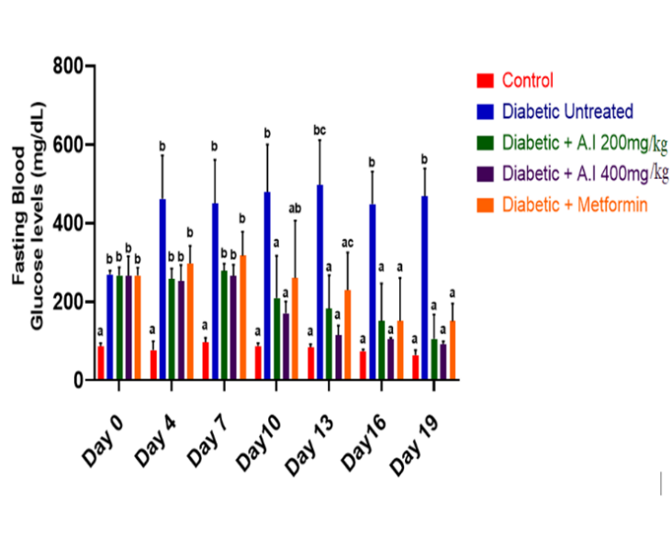
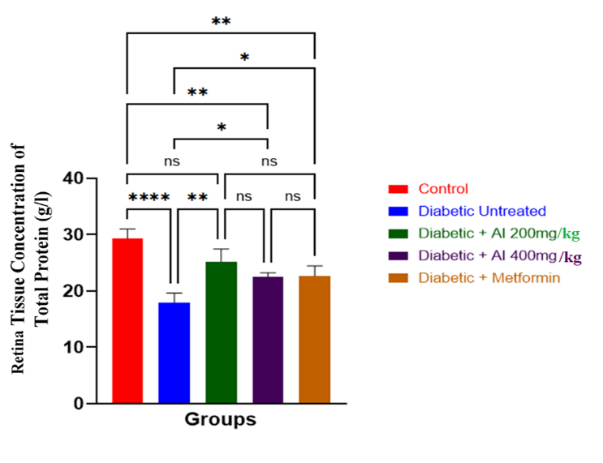
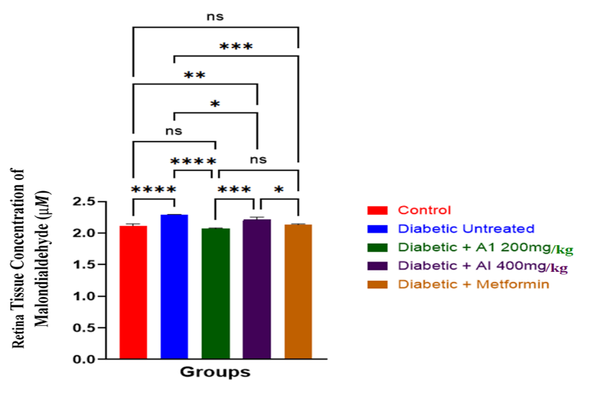
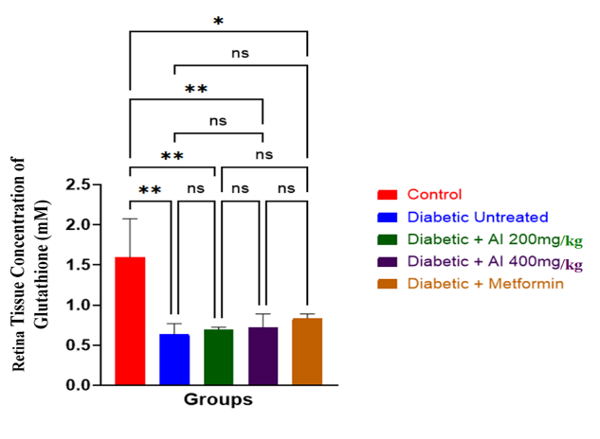
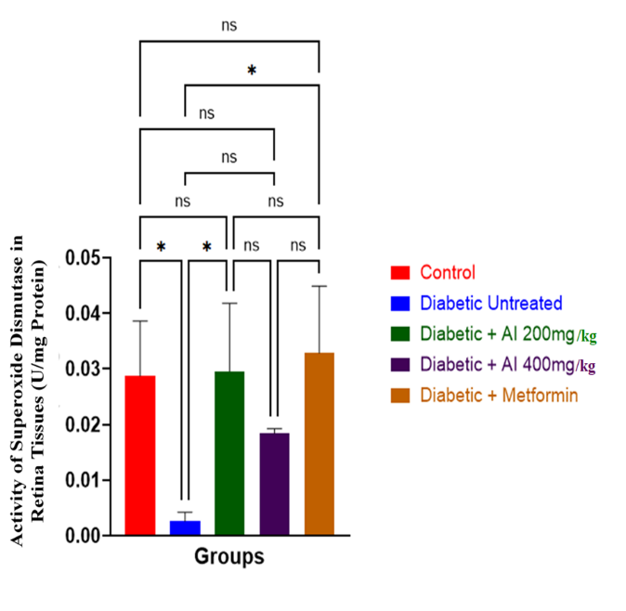
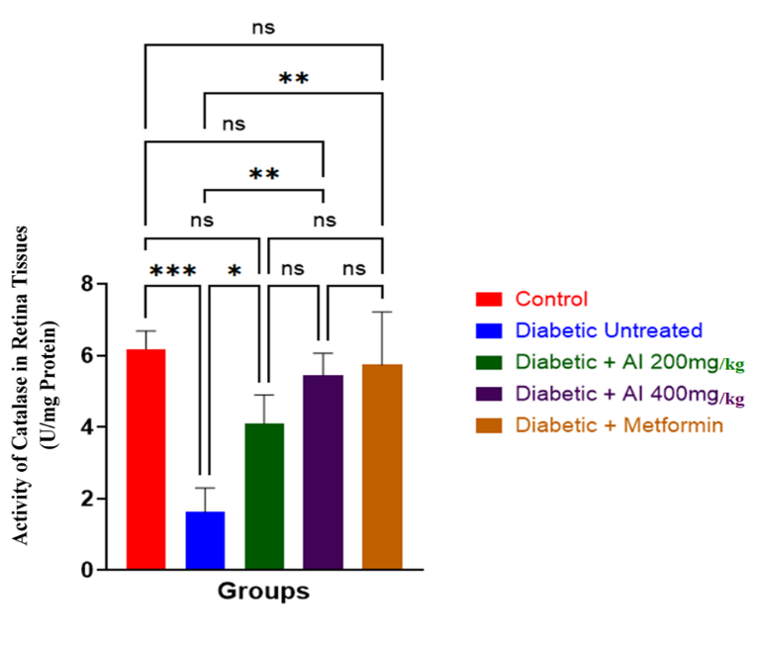

Fig. 1. Effect of A.I treatment on Fasting blood glucose levels (A), oxidative stress and antioxidant parameters: Retinal tissue total protein concentration (B), superoxide dismutase (SOD) activity (C), catalase (CAT) activity (D), malondialdehyde (MDA) concentration (E), and glutathione (GSH) concentration (F).
Data are expressed as mean ± SD (n = 5). *, p < 0.05; **, p < 0.01; ***, p < 0.001; ****, p < 0.0001; ns, not significant.

4. Conclusion

To the best of current knowledge, this study provides novel evidence on the effects of ethanol leaf extract of A.I on retinal oxidative stress markers in a streptozotocin-induced diabetic retinopathy model. The findings demonstrate that A.I, particularly at 200 mg/kg, effectively restores antioxidant enzyme activities (SOD and CAT), reduces lipid peroxidation (MDA), and partially improves glutathione levels, indicating enhanced redox balance in diabetic retinal tissue. The observed dose-dependent response suggests that neem phytochemicals may modulate protective pathways, potentially involving Nrf2-mediated antioxidant signaling, to counteract oxidative stress and interrupt early retinal damage. Despite these promising outcomes, further studies are required to elucidate the precise molecular mechanisms, determine optimal dosing strategies, and evaluate long-term efficacy and safety. Additionally, investigations involving isolated bioactive compounds and combination therapies may help refine its therapeutic potential. Overall, A.I extract represents a promising, cost-effective adjunct for mitigating oxidative stress in diabetic retinopathy, particularly in resource-limited settings; however, clinical validation through well-designed randomized controlled trials remains essential.

Ethical approval

All procedures followed the Guide for the Care and Use of Laboratory Animals, the ARVO Statement for the Use of Animals in Ophthalmic and Vision Research, and were approved by the Institutional Animal Ethics Committee

References
Teo, Z. L, Tham, Y. C, Yu, M., Chee, M. L, Rim, T. H. et al. (2021). Global prevalence of diabetic retinopathy and projection of burden through 2045: systematic review and meta-analysis. Ophthalmology, 128(11), 1580-91. doi: 10.1016/j.ophtha.2021.04.027.
Thomas, R. L., Halim, S., Gurudas, S., Sivaprasad, S, Owens, D. R (2019). IDF Diabetes Atlas: A review of studies utilising retinal photography on the global prevalence of diabetes related retinopathy between 2015 and 2018. Diabetes Research and Clinical Practice, 157, 107840. doi: 10.1016/j.diabres.2019.107840.
Kowluru, R. A, & Chan, P. S. (2007). Oxidative stress and diabetic retinopathy. Journal of diabetes research, 2007(1), 043603. doi: 10.1155/2007/43603.
Kang, Q, & Yang, C. (2020). Oxidative stress and diabetic retinopathy: Molecular mechanisms, pathogenetic role and therapeutic implications. Redox biology, 37, 101799. doi: 10.1016/j.redox.2020.101799.
Calderon, G. D, Juarez, O. H, Hernandez, G. E, Punzo, S. M, & De la Cruz Z.D. (2017). Oxidative stress and diabetic retinopathy: development and treatment. Eye, 31(8), 1122-30. doi: 10.1038/eye.2017.64.
Haydinger, C. D., Oliver, G. F., Ashander, L. M, Smith , J. R. (2023). Oxidative Stress and Its Regulation in Diabetic Retinopathy. Antioxidants (Basel, Switzerland), 12(8), 1649. doi: 10.3390/antiox12081649.
Chandrasekaran, P. R., & Madanagopalan, V. G. (2022). Role of Curcumin in Retinal Diseases-A review. Graefe's Arch Clin Exp Ophthalmol, 260(5), 1457–1473. doi: 10.1007/s00417-021-05542-0.
Kumar, B., Gupta, S. K., Nag, T. C, Srivastava S, Saxena, R. (2012). Green tea prevents hyperglycemia-induced retinal oxidative stress and inflammation in streptozotocin-induced diabetic rats. Ophthalmic research, 47(2), 103–108. doi: 10.1159/000330051.
Arnal E, Miranda M, Johnsen-Soriano S, Alvarez-Nölting R, Díaz-Llopis M, Araiz J, et al. (2009). Beneficial effect of docosahexanoic acid and lutein on retinal structural, metabolic, and functional abnormalities in diabetic rats. Current eye research, 34(11), 928-38. doi: 10.3109/02713680903205238.
Vidhya R. U., Anita, M., Bhuminathan S, Sadhana K. (2022). Known data on the therapeutic use of Azadiracta indica (neem) for type 2 diabetes mellitus. Bioinformation, 18(2), 82–87. doi: 10.6026/97320630018082.
Frimpong, E. K., Thembane, N., Hlatshwayo, S., Ngcobo, M., Gqaleni, N. (2024). Indigenous Medicinal Plants Used in the Management of Diabetes in Africa: 5 Years (2019-2024) in Perspective. Plants (Basel, Switzerland), 13(14), 1898. doi: 10.3390/plants13141898.
Christian, E. O., Onyeaghana, O. C., Ngozi, N. N, Olivia, O. O, Okwukwe, E. P, Ann, O. E, et al. (2020). Evaluation of the effects of Azadirachta indica leaf on haematology, lipid profile, body weight and organ-system functions of streptozotocin-induced diabetic male rats. African Journal of Biochemistry Research, 14(3), 57-71. doi.org/10.5897/AJBR2020.1087
Sarkar, S., Singh, R. P., Bhattacharya G. (2021). Exploring the role of Azadirachta indica (neem) and its active compounds in the regulation of biological pathways: an update on molecular approach. 3 Biotech, 11(4), 178. doi: 10.1007/s13205-021-02745-4.
Alzohairy, M. A. (2016). Therapeutics Role of Azadirachta indica (Neem) and Their Active Constituents in Diseases Prevention and Treatment. Evidence-based complementary and alternative medicine : eCAM, 2016, 7382506. doi: 10.1155/2016/7382506.
Mohammed, A., Kumar, R., Ashfaq, F., Alsayegh, A. A., Al Areefy, A. A. E. H., Khan, M. I., & Rizvi, S. I. (2023). Young and mature leaves of Azadirachta indica (neem) display different antidiabetic and antioxidative effects. Egyptian Journal of Basic and Applied Sciences, 10(1), 316-328.
Gupta, N. K., Srivastva, N., Bubber, P., & Puri, S. (2016). The antioxidant potential of Azadirachta indica ameliorates cardioprotection following diabetic mellitus-induced microangiopathy. Pharmacognosy Magazine, 12(Suppl 3), S371. doi: 10.4103/0973-1296.185772.
Shu, X., Hu, Y., Huang, C., & Wei, N. (2021). Nimbolide ameliorates the streptozotocin-induced diabetic retinopathy in rats through the inhibition of TLR4/NF-κB signaling pathway. Saudi Journal of Biological Sciences, 28(8), 4255-4262. doi: 10.1016/j.sjbs.2021.06.039.
Achigbu, E. O., Agweye, C. T., Achigbu, K. I., & Mbatuegwu, A. I. (2021). Diabetic retinopathy in sub-Saharan Africa: a review of magnitude and risk factors. Nigerian Journal of Ophthalmology, 29(1), 3-12.
Gornall, A. G., Bardawill, C. J., David, M. M. (1949). Determination of serum proteins by means of the biuret reaction. J. biol. Chem, 177(2), 751-766.
Donthula, G., & Daigavane, S. (2024). Diabetes Mellitus and Neurovascular Pathology: A Comprehensive Review of Retinal and Brain Lesions. Cureus, 16(10). doi: 10.7759/cureus.70611
Mimura, T., & Noma, H. (2025). Oxidative Stress in Diabetic Retinopathy: A Comprehensive Review of Mechanisms, Biomarkers, and Therapeutic Perspectives. Antioxidants, (Basel), 14(10), 1204.
Ezeigwe, O. C., Ezeonu, F. C., Okani, C. O., Onwusulu, D. N., & Onuegbu, M. E. (2020). Aqueous extract of Azadirachta indica leaves favorably alters the course of streptozotocin-induced diabetes in rats: A comparative prospective cohort study. Biomedical Research and Therapy, 7(7), 3877-3889.
Yarmohammadi, F., Mehri, S., Najafi N, Salar Amoli S, Hosseinzadeh H. (2021). The protective effect of Azadirachta indica (neem) against metabolic syndrome: A review. Iranian journal of basic medical sciences, 24(3), 280–292. doi: 10.22038/ijbms.2021.48965.11218
Kowluru, R. A., & Mishra, M. (2015). Oxidative stress, mitochondrial damage and diabetic retinopathy. Biochimica et Biophysica Acta (BBA)-Molecular Basis of Disease, 1852(11), 2474-2483. doi: 10.1016/j.bbadis.2015.08.001.
Rossino, M. G., & Casini, G. (2019). Nutraceuticals for the Treatment of Diabetic Retinopathy. Nutrients, 11(4), 771. doi: 10.3390/nu11040771
Pingali, U., Ali, M. A., Gundagani, S., & Nutalapati, C. (2020). Evaluation of the effect of an aqueous extract of Azadirachta indica (Neem) leaves and twigs on glycemic control, endothelial dysfunction and systemic inflammation in subjects with type 2 diabetes mellitus–a randomized, double-blind, placebo-controlled clinical study. Diabetes, Metabolic Syndrome and Obesity, 4401-4412.
Barreiro-Sisto, U., Fernández-Fariña, S., González-Noya, A. M., Pedrido, R., & Maneiro, M. (2024). Enemies or allies? Hormetic and apparent non-dose-dependent effects of natural bioactive antioxidants in the treatment of inflammation. International Journal of Molecular Sciences, 25(3), 1892. doi: 10.3390/ijms25031892.
Lizzo, G., Migliavacca, E., Lamers, D., Frézal, A., Corthesy, J., Vinyes-Parès, G., ... & Gut, P. (2022). A randomized controlled clinical trial in healthy older adults to determine efficacy of glycine and N-acetylcysteine supplementation on glutathione redox status and oxidative damage. Frontiers in aging, 3, 852569. doi: 10.3389/fragi.2022.852569
Moreno-Sánchez, R., Marín-Hernández, Á., Gallardo-Pérez, J. C., Vázquez, C., Rodríguez-Enríquez, S., & Saavedra, E. (2018). Control of the NADPH supply and GSH recycling for oxidative stress management in hepatoma and liver mitochondria. Biochimica et Biophysica Acta (BBA)-Bioenergetics, 1859(10), 1138-1150. doi: 10.1016/j.bbabio.2018.07.008.
Mizuno, K., Kume, T., Muto, C., Takada-Takatori, Y., Izumi, Y., Sugimoto, H., & Akaike, A. (2011). Glutathione biosynthesis via activation of the nuclear factor E2–related factor 2 (Nrf2)–antioxidant-response element (ARE) pathway is essential for neuroprotective effects of sulforaphane and 6-(methylsulfinyl) hexyl isothiocyanate. Journal of pharmacological sciences, 115(3), 320-328. doi: 10.1254/jphs.10257fp
Skourtis, G., Krontira, A., Ntaoula, S., Ferlemi, A. V., Zeliou, K., Georgakopoulos, C., ... & Pharmakakis, N. (2020). Protective antioxidant effects of saffron extract on retinas of streptozotocin-induced diabetic rats. Romanian journal of ophthalmology, 64(4), 394. doi: 10.22336/rjo.2020.61
El-Beltagy, A. E. F. B., Saleh, A. M., Attaallah, A., & Gahnem, R. A. (2021). Therapeutic role of Azadirachta indica leaves ethanolic extract against diabetic nephropathy in rats neonatally induced by streptozotocin. Ultrastructural pathology, 45(6), 391-406. doi: 10.1080/01913123.2021.1988015.
Ezeigwe, O. (2020). Antidiabetic property and antioxidant potentials of ethanol extract of Azadirachta indica leaf in streptozotocin-induced diabetic rats. The Bioscientist Journal.

