Corrosion Inhibition of Plant Leaf Extract on Mild Steel in Acidic medium using electrochemical and theorietical studies.

.
ABSTRACT

The ability of Dialium guineense leaf extract (DGLE) to resist corrosion can protect mild steel used in industries. In order to prepare for corrosion tests, a weight reduction research was carried out after the steel had been cleaned. This method was confirmed by electrochemical impedance spectroscopy (EIS) and Tafel studies. The DGLE accurately followed Langmuir's adsorption isotherm. Density functional theory (DFT) and molecular dynamics (MD) simulation were used to computationally investigate the inhibitory efficiency of the key components of DGLE. Both the local chemical reactivity in terms of Fukui functions and the global chemical reactivity descriptors were calculated and discussed. Using the MD modeling approach, the adsorption energies of the DGLE components on the Fe (110) plan were determined, and a strong link between the adsorption energy and the energy gaps was found. When DGLE was increased from 100 to 500 mg/l in the acid solution, the inhibition efficiency increased to almost 93% at 500 mg/l. According to the atomic force microscope (AFM) measurements, the average surface roughness of steel was reduced by 117.89 nm due to the DGLE's superior corrosion resistance.

Keywords: AFM, DFT, Dialium guineense leaf extract, EIS, Mild Steel, SEM-EDX

- INTRODUCTION (Arial,
Metals, such as Aluminum, Zinc, and mild steel, are solid substances derived from the mother earth that corrode. Corrosion of metals causes loss of both functional integrity and attractive appearance; therefore, it is necessary to devise measures that will drastically reduce the rate of corrosion. corrosion of metals is often regarded as an inconvenience because it necessitates a change of equipment over time [1-2]. Due to their inherent qualities, such as rigidity, ductility, tensile strength, conductivity of heat and electricity, etc., these three metals are commonly utilized as general-purpose engineering construction materials [3-5]. In addition to the financial expense, corrosion-related environmental pollutants and safety hazards are taken into consideration. Stricter corrosion control regulations are now necessary due to the growth of industrial sectors including nuclear power production and offshore oil and gas extraction. It should be noted that corrosion issues will arise in the majority of alternative energy production systems in the future. in order to reduce metal corrosion, this innovative study will employ sustainable and inexpensive inhibitors derived from natural plant leaf extracts, such as Aspilia africana, Chromolena odorata, Newbouldia leavis, Dennettia tripetala, dialium guineense, and Vitex doniana are plentiful, renewable, and biodegradable plant. The anti-corrosion activities found in these plant extracts could be attributed to the presence of compounds such as isoprenoids, alkaloids, flavonoids, and others. The existence of organic compounds containing nitrogen (N), oxygen (O), phosphorus (P), and sulfur (S) atoms, which have a protective effect and potential to inhibit corrosion, is linked to the effectiveness of organic green corrosion inhibitors (OGCIs) in preventing material degradation [6-10]. According to reports, these elements' corrosion inhibition efficiency increases in the following order: phosphorus is the most effective, oxygen is less effective, and nitrogen is less effective than sulfur [11]. At the metal-solution interface, organic green corrosion inhibitors (OGCIs) exhibit their inhibitory activity through either chemisorption or physisorption. In order to create a dense barrier coating, this procedure entails moving water molecules across the surface [6]. It has also been noted that a lone pair and the π-electrons in organic green corrosion inhibitors (OGCIs) molecules engage with the metal's vacant d-orbitals to form a coordinate covalent connection [8]. The creation of a p-d bond increases the adsorption of chemicals on a metal surface. This happens when an iron atom's vacant 3d orbital and π-electrons overlap [9-10]. This phenomenon is caused by the existence of N, O, and S atoms as well as their organic structure double bonds [12-13]. Furthermore, we found that for a comprehensive understanding of the adsorption mechanism between the inhibitor compounds and metal surface, computational techniques such as the quantum mechanical method (DFT) in conjunction with Monte Carlo (MC) and molecular dynamics (MD) simulations have also been widely employed. It also describes the physical and chemical consequences of the inhibitors' structural makeup and shows how DGLE compounds behave when adsorbed on a metal surface [34–36]. The use of DGLE as an efficient anti-corrosion inhibitor for mild steel in 1m HCl solution is the novel part of this study. Additionally, these leaves are weeds. Therefore, it is anticipated that these inhibitors will offer a better way to optimize corrosion inhibitors, which will be more affordable, easily accessible, biodegradable, and environmentally friendly. For tropical African Nations like Nigeria in particular, the results of this study will be crucial for both economic gain and environmental sustainability. The goal of this study is to comprehend how MS corrodes in a 1 M HCl environment when Dialium guineense leaf extract (DGLE) is used as a corrosion inhibitor. Electrochemical tests (OCP, EIS and PDP) and morphological characterisation measurements (SEM/EDX and AFM) have all been used to assess the protective impact of this molecule in conjunction with theoretical research (DFT, MC, and MD).

2. material and methods
2.1 Material preparations
Electrodes made from ms sheets were used in corrosion tests. the rectangular steel strips (2 x 3 x 0.1 cm) were exposed to a working surface of 1 cm² and were constituted of 0.36 wt% C, 0.27 wt% Si, 0.66 wt% Mn, 0.02 wt% S, 0.21 wt% Cr, 0.015 wt% P, 0.06 wt% Al, 0.02 wt% Mo, and 0.22 wt% Cu.
The samples were ground and polished with emery papers (400 – 3000). Consequently, the samples were degreased with ethanol and washed with distilled water, dried and kept in a disccator for electrochemical measurements..
The plant leaves was collected from Nnamdi Azikiwe University, Awka and identified as Dialium guineese at the Department of Botany. The leavess were washed with distilled water, air-dried and later pulverized. 500g of pulverized sample was subjected to the Soxhlet extraction process with ethanol as solvent. After complete extraction, The test solution was prepared as previously described in [14].
37% analytical-grade HCl was diluted with double-distilled water to create the 1 M HCl solution Mild steel submerged in a 1 M hydrochloric acid solution was subjected to electrochemical experiments. The extract was added to the corrosive medium to create the experimental solutions before each test. Every test was run three times to guarantee the accuracy of the findings.

2.1.2 Surfsce analysis
A Quantra 450 type scanning electron microscope was used to examine the surface morphology of mild steel (MS) with and without DGLE following a 8-hour exposure to 1 M HCl. EDX technical examinations were used to supplement this analysis.

2.1.3 FTIR
The presence of different functional groups and aromatic groups in the Dialium gunineese leaf extract is determined by FT-IR analysis. The example pallet was created by blending concentrated DGLE with KBr. A Shimadzu FTIR 8400S spectrophotometer operating at a frequency of 400–4000 cm⁻¹ was used to analyze this material.

2.2 Methodology
2.2.1 Electrochemical measurements
To ensure that all three electrodes were completely submerged, a 50 mL amount of molar HCl was placed inside a Pyrex glass chamber. Every test was conducted at room temperature without stirring, with the exception of those examining temperature effects. Electrochemical measurements (EIS and potentiodynamic polarization curves) were carried out using a PGZ 100 potentiostat workstation and Voltamaster 4 software. EIS and potentiodynamic curves were used to examine the corrosion behavior of mild steel in a 1 M HCl solution, both with and without inhibitors. Electrochemical measurements were made after the MS working electrode region, which was completely submerged in the test solution, was allowed to reach a stable open circuit potential (E_{OCP}) for 40 minutes. Tafel graphs were made by scanning the voltage from -800 mV to -100 mV vs SCE at a rate of 0.5 mV/s. Starting with a less positive possibility, the electrode potential ± 10 mV in relation to the open circuit potential was recorded in order to determine linear resistance polarization. All studies were carried out after allowing the potential at E_{OCP} to settle for half an hour. Equation 1 was used to calculate the inhibitive performance ηTafel (%) [15-17] .

$η_{PDP}=\frac{i_{corr }^{0}-i_{corr}}{i_{corr}^{0}}×100$ (1)

Where $i_{corr}^{0}$ is the corrosion current density without the inhibitor, and $i_{corr}$ the corrosion current density in the presence of inhibitor.

Using the aforementioned workstation and a 10 mV alternating current signal at 10⁵ Hz to 10⁻¹ Hz, EIS experiments were carried out at the E_{OCP} potential. EIS diagrams were displayed using Nyquist plots. With the help of ZiveZman 2.3 software, these plots were modified to simulate the interaction between the metal and the solution using an analogous electrical circuit. The most representative data were chosen for graphical representation after each inhibitor concentration was examined electrochemically three times [18-19]. Equation 2 was used to calculate the EIS inhibiting performance, or η_{EIS}.

$η_{EIS}=\frac{R_{ct}-R_{ct}^{0}}{R_{ct}} ×100$ (2)

Where $R_{ct} R_{ct}^{0}$are the polarization resistance to charge transfer in the presence and in the absence of molecules that inhibit polarization, respectively.

2.3 Computational techniques
2.3.1 DFT evaluation
In addition to calculation and experimental studies, a wide range of ab initio quantum chemical techniques have been used to determine the molecular structure and inhibition efficiency [20, 21]. The Dmol3 software from the BIOVIA package was used in this investigation to perform ab initio calculations of our inhibitor DGLE utilizing the density functional theory (DFT) method [22-23]. Geometry was optimized using the GGA (Generalized Gradient Approximation), where functionals rely on the M-06L and the DNP (Double Numerical Basis Set polarization function) [24–25]. For the SCF (self-consistent field), a convergence criterion of less than 1e⁻⁵ kcal/mol was applied. The energy minima were confirmed by a vibrational analysis, which also showed that the data contained no negative frequencies [26]. Additionally, structural stability in an aqueous media (water) was achieved using the COSMO (Conductor-like Screening Model) model.[27]. The highest occupied molecular orbital (E_{HOMO}), lowest unoccupied molecular orbital (E_{LUMO}), energy gap (∆E_{gap}), ionization potential (I), electron affinity (A), electronegativity (χ), global hardness (η), global softness (σ), chemical potential (µ), global electrophilicity (ω), net electrophilicity (Δω±), Electroaccepting-power (ω⁺), Electrodonating- power (ω⁻), fraction of transferred electrons (ΔN_{Fe}), energy from Inhb to Metals (Δψ), and back donation (ΔE_{back-donation}) were then assessed. The interrelations were provided by Equations (3–16) below [20-26]:

$I= {-E}_{HOMO}$ (3)

$A={-E}_{LUMO}$ (4)

${∆E}_{gap}=E_{LUMO}-E_{HOMO }$ (5)

$χ=\left(\frac{I+A}{2}\right)$ (6)

$η=\left(\frac{1-A}{2}\right)$ (7)

$μ=\left[\frac{-\left(I+A\right)}{2}\right]$ (8)

$σ=\left(\frac{1}{η}\right)$ (9)
$ω=\left(\frac{χ^{2}}{2η}\right)$ (10)
$ω^{+}=\frac{{\left(I+3A\right)}^{2}}{\left[16×\left(I-A\right)\right]}$ (11)
$ω^{-}=\frac{{\left(3I+A\right)}^{2}}{\left[16×\left(I-A\right)\right]}$ (12)
${∆ω}^{±}=\left[ω^{+}-\left({-ω}^{-}\right)\right]$ (13)
${∆N}_{Fe}=\frac{\left(χ_{Fe}-χ_{inh}\right)}{2\left(η_{Fe}+η_{inh}\right)}$ (14)

$Δψ=\frac{{\left(χ_{Fe}-χ_{inh}\right)}^{2}}{4\left(η_{Fe}+η_{inh}\right)}$ (15)
$Δ_{back-donation}=-\left(\frac{η}{4}\right)$ (16)

Where χ_{Fe} is the work function (4.81 eV mol⁻¹) of the iron surface [Fe (110)] and is the absolute hardness of the iron (= 0 eV mol⁻¹).

2.3.2 Atomistic models
Atomistic simulations, such as Monte Carlo (MC) and Molecular Dynamic (MD) simulations, were utilized to better understand how the DGLE interacted with the Fe-substrate. These methods are related to the BIOVIA package's COMPASS II (Condensed Phase Optimized Molecular Potential II) forcefield [27–28]. Steel Fe (110) was the most stable substrate, according to reviews of the literature. [40–42]. The interaction between the surface of mild steel and the DGLE in the corrosive environment of the simulation was simulated using a 10-atom-thick layer unit cell of Fe (110). The slab model's dimensions were 25.031 Å x 25.031Å x 12.213 Å. On the metal axis, a 30 Å vacuum layer was added, containing 1 DGLE molecule, 1,000 water molecules (H₂O), 8 chloride (Cl₄), and 8 hydronium (H3O+) ions [42]. The simulation boxes' shape was optimized using the Forcite module before the MD step (energy convergence tolerance of 1×10⁻⁵ kcal/mol; atom-based summation approach used for electrostatic and Van der Waals interaction with cutoff distance of 12 Å, spline width of 1, and buffer of 0.3). MD was performed using the (NVT) canonical ensemble at 293K [38–40] with a simulation time step of 0.000001 ns and a simulation duration of 0.3ns [36, 37].

- results and discussion
  - Instrumental analysis
3.1.1 FTIR
Functional groups, aromaticity, and unsaturation in the phytochemicals of DGLE extract were determined using the FT-IR technique. A decrease in absorance (%) upon adsorption of certain chemical elements at the steel surface is shown by the difference between the before and after in Figure 1. The acquired spectra confirm the existence of C-O stretching at 411.75 cm⁻¹, OH stretching at 3643.04, and C = O bending at 1610.61 cm⁻¹, indicating the presence of aromatic and heteroatoms in the sample. The individual peaks found in DGLE are related to different functional groups. These heteroatoms can readily form coordinate bonds by donating their non-bonding electrons to iron's empty d-orbital. Additionally, an aromatic component or molecule can aid in the surface adsorption of inhibitor molecules on the metal surface by using its π-electron.
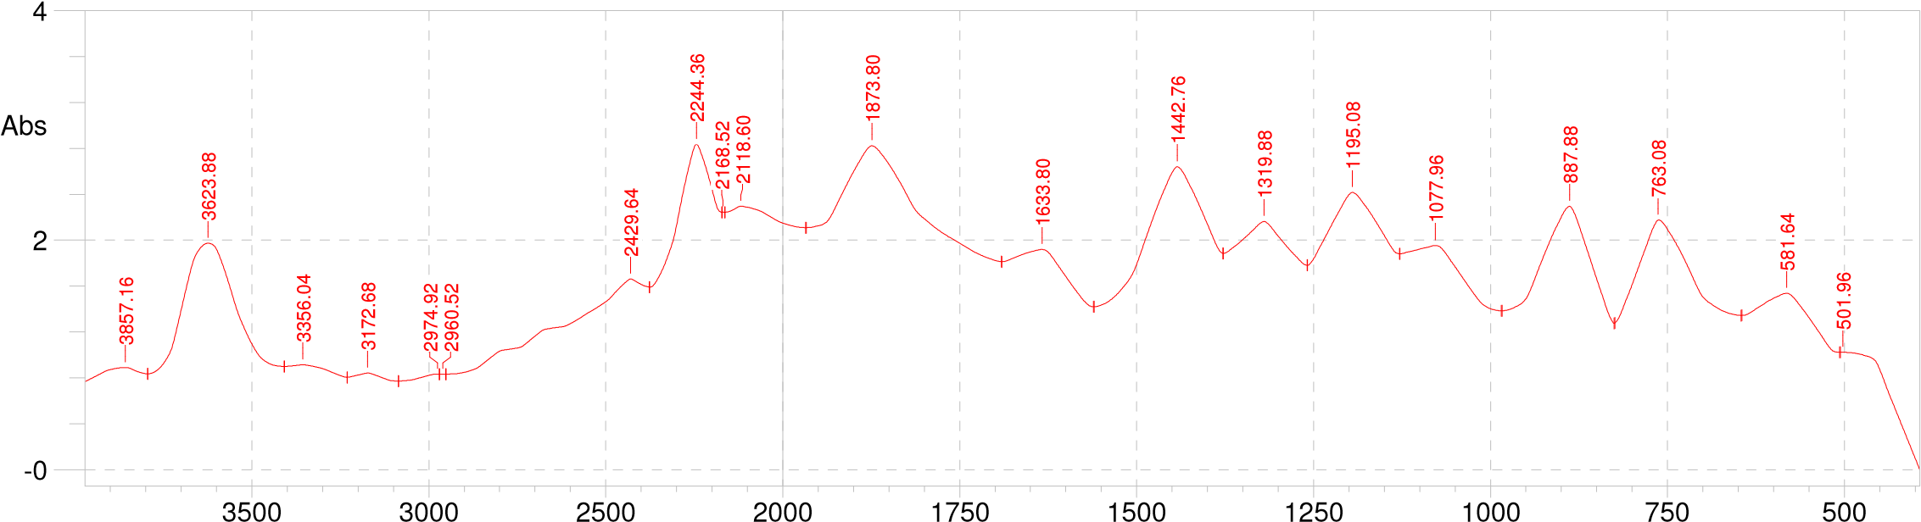
a

b
Fig.1: FTIR Spectrum of Dialium guineense leaf extract (a) before and (b) the experiment

3.1.2 Surface Examinations
3.1.2.1 SEM-EDX and AFM
To learn more about the corrosion morphology of mild steel before and after 8 hours of immersion in 1 M HCl solution with and without DGLE at 293 K, we performed surface examination on the studied MS samples using scanning electron microscopy (SEM) in combination with energy dispersive spectroscopy (EDX). The mild steel sample immersed in 1M HCl without inhibitor is shown in Fig. 2 (a), which shows that the metal surface was severely corroded with more pits and fractures. Following immersion in 1M HCl with DGLE, Fig. 2(b), the metal specimen showed a significant improvement with fewer cracks and pits than the blank solution due to the formation of an inhibitive layer on the mild steel surface.
The specimen's surface EDX analysis in blank medium reveals a significant concentration of iron, while the quantities of Mn, Ni, Cr, and Mo either vanish or decrease Fig. 3(a). The EDX spectra of the inhibitory sample show the presence of the atoms (C, N, and O) that comprise the tested chemical DGLE, suggesting that an organic component is present on the metal surface Fig. 3(b).
Furthermore, AFM investigation was performed on the corroded and inhibited surface images displayed in Fig. 4. In contrast to the inhibited surface, which was covered by inhibitor components and resulted in a smoothing of the surface to a mean diameter of 65.44 nm with coverage of 71.51%, the defects are very evident in the corroded surface without inhibition, which gave a mean diameter of 155.4 nm with coverage of 19.56%.

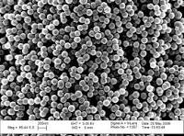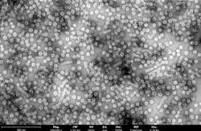
a
b

Fig. 2. SEM images of (a) Blank (b) with DGLE

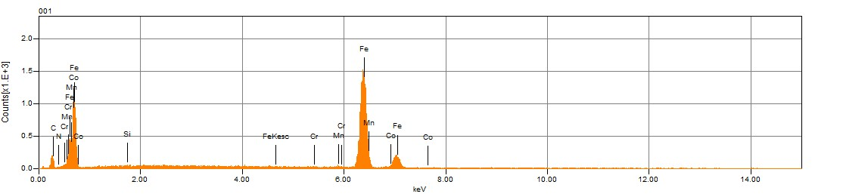
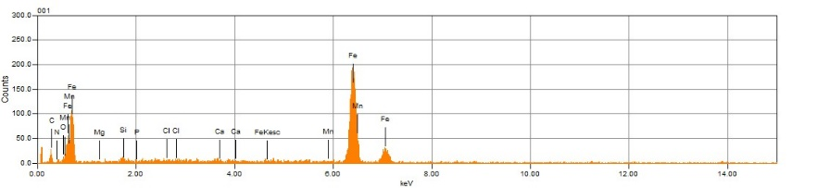
b
a

Fig. 3. EDX plots of (a) without (b) with DGLE

The number of particles dropped from 525 to 141 following inhibition with 500 m/L of extract, as seen in Figs. 4a and b, where the particle distribution was examined using AFM for in-depth surface characterization. Additionally, as Figs. 4a and b illustrate, the surface view profile revealed a drop in mean height from 430.2 nm to 131.4 nm following inhibition

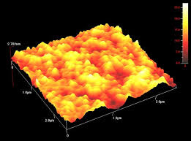
b
a

Fig. 4. AFM images for MS surface in (a) without and (b) with inhibitor.

3.2. Electrochemical Considerations
3.2.1 Electrochemical impedance
Electrochemical impedance analysis was used to investigate the DGLE corrosion inhibition impact on MS in 1M HCl. Fig. 5(a) shows the fitting circuit for the displayed data, in Table 1.

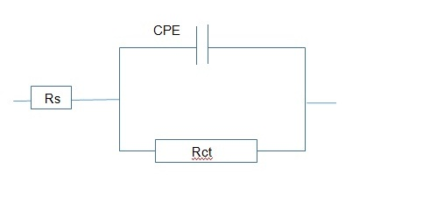
a
Fig. 5(a): OCP circuit

As seen in Figs. 5 (b) and (c), the Nyquist and bode diagrams are created following an hour of immersion of mild steel coupons in the corrosive fluids while Fig 5(d) shows the existence of the same kind of phase at all concentrations. The double layer capacitance (Cdl) and charge transfer resistance (Rct) are arranged in parallel. Table 1 demonstrates that the Rct value rises and the Cdl value falls with an increase in DGLE concentration. The lowest impedance value in this experiment was 10.15 Ω.cm², and the greatest Cdl value was 3.6×10⁻⁴F cm⁻² when there was no inhibitor. Subsequently, Rct values rise from 94.22 to 260.08 Ω.cm² when the inhibitor concentration is increased from 100 mg/l to 400 mg/l, while Cdl values fall from 2.6×10⁻⁴ to 8.5 ×10⁻⁵µF cm⁻². Because of the gradual increase, the DGLE was readily adsorbed on the surface of mild steel after adding a maximum concentration of 500mg/l maximum Rct 260.03 Ω.cm², and lower Cdl value 6.02×10⁻⁵ µF cm⁻². The highest corrosion inhibition efficiency rating at that point was 95.08 percent. The better corrosion resistance of mild steel in 500 mg/l of the inhibitor solution is demonstrated by the phase angle 650 maximum at 2.3 log freq for 500 mg/l compared to the blank 510 lower at 1.4 log freq condition [31-33].

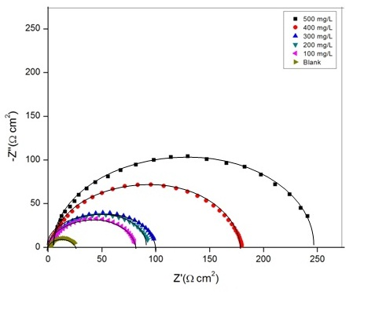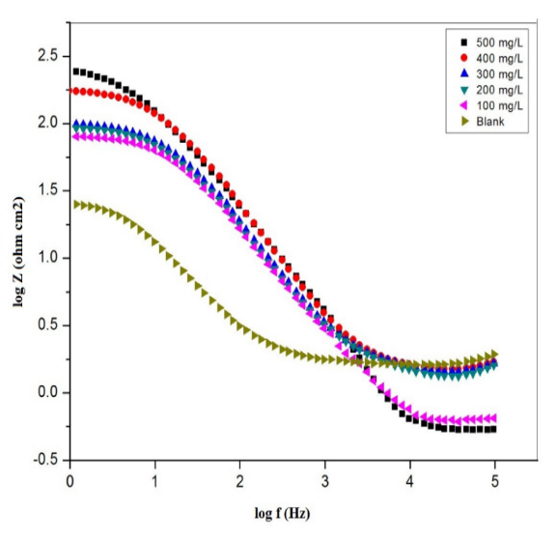
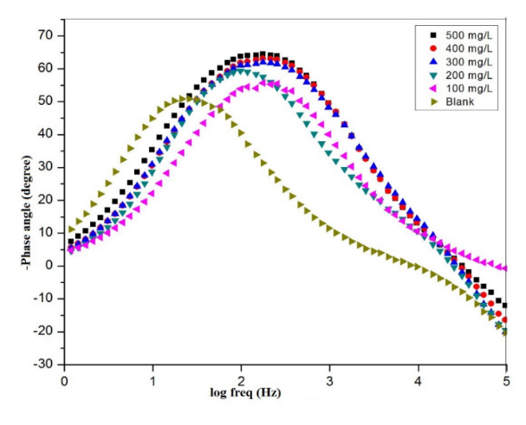
d
Fig. 6: Mild steel in 1M HCl without and with varying concentrations of DGLE, (a) fitted circuit, at 298 K (b) Nyquist, (c) Bode, and (d) phase plots,

Table 1: EIS parameters for mild steel in 1M HCl at various DGLE concentrations.
 | Concentration of inhibitor (mg/l) | Rct (Ω cm²) | Cdl (F cm⁻²) | Efficiency (IE %)
 | 0 | 10.15 | 3.6×10⁻⁴ | 0
 | 100 | 94.22 | 2.6×10⁻⁴ | 78.74
 | 200 | 108.31 | 2.4×10⁻⁴ | 80.43
 | 300 | 120.46 | 2.1×10⁻⁴ | 86.41
 | 400 | 196.05 | 8.5×10⁻⁵ | 92.54
 | 500 | 260.48 | 6.0×10⁻⁵ | 95.08

3.2.2 Potentiodynamic polarization (PDP) analysis
The anodic and cathodic polarization activity of mild steel coupons in a corrosive solution at various DGLE concentrations is shown in Fig. 6. Table 2 highlighted the various corrosion properties and inhibition efficiency. By extending the linear segments of the anodic and cathodic curves to the point where they connect with their associated corrosion potentials, the corrosion current densities were calculated. The Tafel graphs show that both the anodic and cathodic branches' current densities fall when DGLE is present. The current densities for different doses of DGLE decrease with increasing inhibitory concentration, reaching a maximum efficiency value of 90.02% at 500 mg/l. This behavior suggests that the metal dissolution at the anode and the hydrogen gas release at the cathode are effectively suppressed by the inhibitor. The observed differences in the anodic and cathodic branches lend credence to this. [33-35]. As the concentration of DGLE varies, so do the Tafel slopes of the anodic and cathodic branches (βa and βc). At a concentration of 100 mg/l, the inhibitor has the greatest impact on the release of hydrogen gas at the cathode, as seen by a total shift to the right of the Tafel slope. The Tafel slope moves in the direction of the center at a concentration of 200 mg/l. The largest shift to the left-hand side of the Tafel slope indicates that the most notable alteration in the iron dissolving process takes place at a concentration of 300 mg/l on the anode. Additionally, the Tafel slope moves to the cathodic side between 400 and 500 mg/l. This suggests that in a 1M HCl acid solution, the DGLE acts as a mixed-type corrosion inhibitor. The difference in corrosion potential (E_{corr}) values, specifically 40 mV (0.583-0.662), which is lower than the crucial value of 85 mV as reported in earlier research [32, 33], further confirmed the mixed corrosion inhibitor nature.

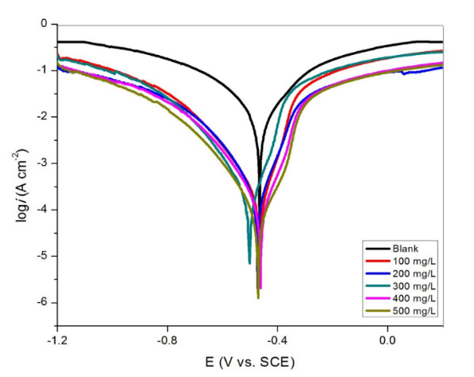
Fig. 7: Tafel plots for mild steel without and with various concentrations of DGLE.

Table 2: Polarization parameters for mild steel in 1M HCl acid without and with different concentrations of DGLE.
Inhibitor concentration (mg/l) | E_{corr}  (V vs. SCE) | I_{corr}  (μA cm⁻²) | β_{a}  (mV/dec) | -β_{c}  (mV/dec) | Efficiency  (IE %)
0 | -0.654 | 1000.20 | 150.06 | 154.52 | 0
100 | -0.712 | 216.01 | 144.15 | 124.35 | 79.59
200 | -0.583 | 124.30 | 62.30 | 110.05 | 80.65
300 | -0.721 | 122.10 | 45.01 | 109.27 | 82.61
400 | -0.662 | 79.04 | 54.29 | 104.09 | 88.15
500 | -0.507 | 57.16 | 64.27 | 105.32 | 90.02

3.3. Quantum mechanics modeling results
3.3.1 Molecular Electrostatic Potential and Frontier Molecular Orbital
Since the frontier molecular orbital (FMOs) hypothesis is widely recognized as a critical instrument for determining molecular activity and predicting the path of chemical processes, it is the most important technique for researchers. [40-41]. The molecular orbital energies of the molecule's highest occupied molecular orbital (HOMO) and lowest unoccupied molecular orbital (LUMO) are linked to the frontier molecular orbitals. The compound's interactions with other species are controlled by these orbitals. Previous researches has shown that corrosion-resistant materials' interfacial attachment is caused by a donor-acceptor process [42, 36]. This mechanism results in bonding coordination by transferring electrons from the electron-rich re]gions of the inhibitor to the electron-poor regions of the metal atoms, such as the vacant d orbitals of the Fe atoms. The inhibitor may also steal electrons from metal sites that are rich in electrons, such as occupied orbitals. The HOMO and LUMO determine the extent of interfacial charge-sharing or donor-acceptor interactions. Furthermore, the HOMO diagram displays portions of the molecule with a strong propensity to transfer electrons to electrophilic species, whereas the LUMO diagram displays regions of the molecule with a strong propensity to receive electrons from nucleophilic species. The HOMO and LUMO distribution of a DGLE from quantum mechanics modeling at the DFT/Dmol3 approach is shown graphically in Fig. 8. The HOMO of the DGLE inhibitor is primarily focused on a benzene ring and one of the nitrogen atoms, as this figure makes evident. On the other hand, LUMO happens on two N atoms, one O atom, and the carbon atoms of the aromatic rings. The molecular electrostatic potential (MEP) of the title chemical was examined and shown in Fig. in order to investigate the electron density of our inhibitor in an acidic media. The compound's rich (blue, orange, or yellow) and poor (blue-colored) electron density regions can be found using this tool; neutral portions are represented by the color green [42]. For the DGLE, the low electron density distribution is concentrated on the -C and -H atoms, whereas the high electron density is concentrated on the benzene ring, oxygen, and nitrogen atoms.

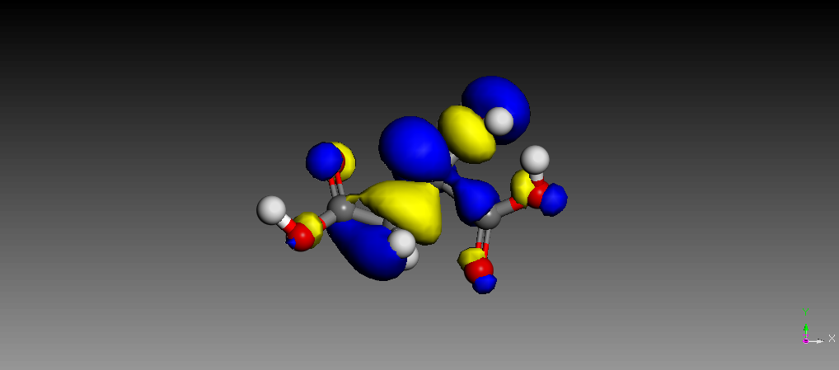
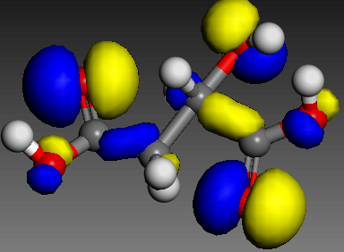

b
a

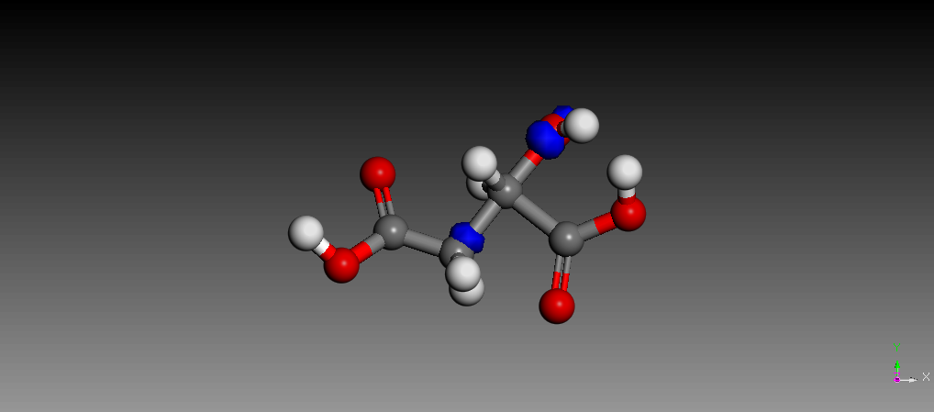
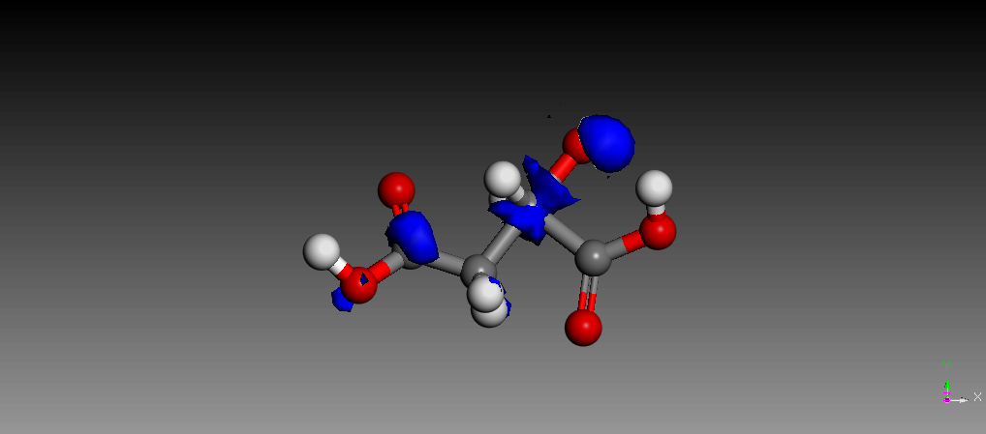

c
d

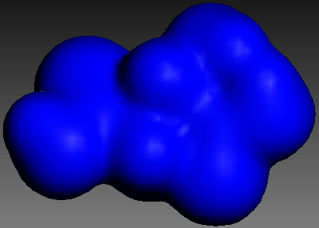

e

Fig. 8: Frontier molecular orbitals and Molecular Electrostatic Potential images of DGLE.
- HOMO (b) Lumo (c) Nucleophilic F(+) (d) Electrophilic F(-) (e) Electron density

3.3.2. Quantum chemical descriptors
The protective mechanism and the reported protective efficacy of the title molecule were supported by the calculation of quantum chemical characteristics of DGLE (Table 3). The higher energy of the highest occupied molecular orbitals (E_{HOMO}) inhibitor compounds enhances their capacity to donate electrons to the metal's vacant d-orbital, hence accelerating the adsorption process and creating a better corrosion prevention mechanism.[43]. In contrast, the lowest unoccupied molecular orbital (E_{LUMO}) values are consistent with the inhibitor molecules' propensity to receive electrons from the metal surface. As the E_{LUMO} value drops, the metal surface's tendency to accept electrons rises. In this case, DGLE has a high E_{HOMO} (-5.849 eV) and a low ELUMO (-0.696 eV), which corresponds to enhanced corrosion prevention efficacy as DGLE adsorption onto the metal surface increases (Table 3). Moreover, great inhibitory efficiency is associated with a low gap energy (∆E_{gap}) value. DGLE's exceptional anti-corrosion properties are demonstrated by its lowest ∆E_{gap} (5.153 eV) measurement. Global softness (σ) and global hardness (η) are important properties for assessing the stability and reactivity of a molecule [43]. DGLE is very reactive and may both transport and absorb electrons during DGLE-metal interactions, as demonstrated by its high value (0.511 eV⁻¹) and low value (2.001 eV) in our current analysis (Table 3). Generally speaking, the proportion of electrons transferred (∆NFe) was correlated with the molecule's chemical activity following electron donation [40].

Table 3: Calculated chemical descriptors/parameters
Chemial descriptors values (ev)
E_{HOMO} -5.849
E_{LUMO} -0.696
ΔE_{gap} -5.153
I ‘ 5.012
A 0.694
𝞆 3.241
µ -3.210
σ (ev⁻¹) 0.511
η 2.001
ω⁻ 3.812
ω⁺ 0.614
ω± 0.667
ΔΨ 0.012
ΔE_{back-donation} -0.432
ΔN_{Fe} 0.064

The DGLE under consideration has a positive and lower ΔNFe (0.064eV) value than 3.8, as shown in Table 3, suggesting that it can interact with the metallic surface by donating electrons into an empty d-orbital of the metal surface. In order to assess a compound's capacity to accept-donate electrons, some scientists have recently looked at the Electrodonating (ω-) and Electroaccepting (ω+) powers [43]. It is significant to remember that an efficient electron donor process is indicated by a high of ω+, while an efficient electron absorber system is indicated by a low value of ω-. With a value of ω+ = 0.614 eV and a value of 3.812 eV in ω−, the calculations at DFT/Dmol3 showed that DGLE had a larger propensity to receive and donate a charge. A molecule of DGLE had the largest Δω± (0.667eV), indicating a higher liquid electrophilicity (Table 3). Energy from Inhibitor to Metals (Δ$ψ$) is another global energy quantum-chemical descriptor that evaluates the strength of the interaction between the inhibitor and the metallic surface. A detailed examination of Table 3 reveals that the DGLE has a substantial Δ$ψ$ value (0.015 eV). If the value of ∆E_{back-donation} (-0.432 eV) is smaller than zero, a compound acquires charge and electron back-donation from the compound is both energetically suitable. MAC can be used to identify inhibitory adsorption zones that can be utilized to develop novel inhibitors. The inhibitor chemicals and the metal surface interact in a way that maximizes the positive effect on the atoms with the highest negative burden. The MAC of the DGLE molecule is shown in Figure 9. The heteroatoms (O/N) exhibit the most negative charges of the DGLE , suggesting that these centers interact with the Fe-surface and have the highest electron density [43].

3.4. Atomistic simulations
3.4.1 Results of Atomistic simulations
MC and MD simulations were used to simulate the adsorption of DGLE on the Fe-surface under hostile conditions Fig. 8 shows side views of the DGLE equilibrium adsorption onto Fe (110) in the aqueous phase using MC/MD simulations. The DGLE's tendency to adsorb onto the metal surface is revealed by these atomic simulation observations, indicating the inhibitor's potential to shield the metal surface from corrosive species. Additionally, the molecular skeleton of the inhibitor material is parallel to the Fe-surface in both the top and side views of adsorbed DGLE (Fig. 8). Upon closer inspection, the DGLE inhibitor's aromatic ring has taken on a completely flat orientation. The benzene ring and O/N atoms seem to be the main adsorption sites for our inhibitors, according to the MC/MD simulations. The adsorption energy (E_{ads}) is a crucial metric for assessing the efficacy of corrosion inhibitors; lower E_{ads} values suggest more contacts between the inhibitor and the metal surface. Therefore, better corrosion inhibition capabilities are indicated by higher negative E_{ads} values [41]. With low E_{ads} the DGLE interacts significantly with the Fe surface. The adsorption kinetics of DGLE on a metal surface can be tracked and examined using MD simulations. One way to make sure that components have as little energy as feasible is to keep an eye on the temperature changes that take place during the MD simulation run. The temperature drift is negligible, indicating the effectiveness of our system's MD. The ability of the DGLE compound to stop a metal from corroding in an acidic environment is precisely determined by the kind of connections that are made at the level of the adsorbate-substrate contact [39]. This was accomplished by utilizing the radial distribution function (RDF) to identify the type of DGLE/metal interaction. While the RDF peak of an atom and the surface between 1 and 3.2 indicates that chemisorption has taken place, RDF graphs of greater distances (> 3.2) are projected to indicate that physisorption has occurred. This result implies that the main process by which the DGLE is chemically adsorbed onto the Fe-surface is O atom contact. Due to its exceptional ability to attract and transfer electrons from and to the metal surface, the inhibitor seems to have a great affinity for the metal surface and protects metal surfaces.

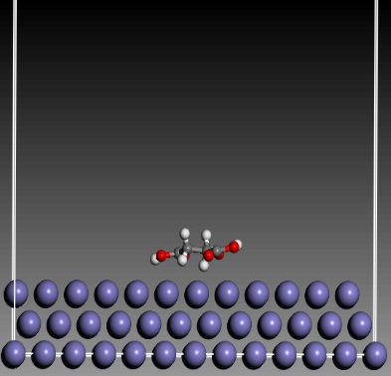
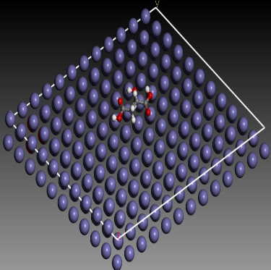
b
a

Fig . 9: Top and side view of the snapshot from molecular dynamics model.
3.5 Comparison between MD simulation and theoretical results
The link between the adsorption energies (E_{ads}) and the energy gaps of the inhibitors under investigation is depicted in Fig. 10. The energy gap of the protonated inhibitor molecules and the adsorption energy (E_{ads}), represented by blue-filled circles, have a strong linear association with a correlation coefficient (R2) of 0.9998. These findings provide compelling evidence for the ratability of the DFT method employed in our investigation to forecast the inhibitor molecule's reactivity and anticorrosive characteristics.

Fig. 10: Comparison between the calculated energy gaps (ΔE_{gap}) computed using the DFT method and the adsorption energy calculated by the Molecular dynamic simulation.

- Conclusion
DGLE is a unique natural inhihibitor that we developed in this work.The title molecule was characterized using Fourier transform infrared (FT-IR) spectroscopy. Additionally, DGLE has a significant corrosion-inhibiting effect for mild steel in 1 M HCl, and the inhibitory effectiveness increases as the inhibitor concentration increases, according to electrochemical techniques (open circuit potential (OCP), potentiodynamic polarization (PDP), and electrochemical impedance spectroscopy (EIS)). EIS experiments show that DGLE functions as a mixed type inhibitor, with an inhibitory efficacy of 90.03% at 500 mg/l. Again, DGLE exhibits respectable inhibitory action throughout the temperature range studied. By creating a robust protective layer, DGLE decreased the deterioration of mild steel, according to SEM/EDX research. Fuethermore, Tthe AFM investigation explains why surface roughness decreases as DGLE content rises. Furthermore, the modeling simulations derived from electronic quantum mechanics (DFT) calculations, molecular dynamics (MD), and Monte Carlo (MC) simulations emphasized the interfacial adsorption and subsequent corrosion-resistant layer development of inhibiting DGLE over the mild steel surface, which validates the experimental findings.

Consent (where ever applicable)
Not Applicable

Ethical approval (where ever applicable)
The study does not require ethical approval.
The study did not involve any animal or human data or tissue

References
[1] Onyenanu, et al, (2022), Corrosion Inhibition potentials of A. mossambicensis and E. sonchifolia Leaves' Extracts on Aluminuium in Alkaline Media: Insights from Gravimetric and Electrochemical Studies, Chemistry Africa, https://doi.org /10.1007/s42250-022-00531-0

[2] Trethewey, K. R. & Chamberlain, J., (1995). Corrosion for science and Engineering, 2nd Edition, Longman Group Limited, England.

[3] Olivia, et al, 2023, Corrosion inhibition of mild steel bars by biosurfuctants produced by Penicillium citrinum, IOP Conference series: Earth and environment science. doi.org/10.1088/1755-1315/1135/1/012057

[4] Singh, et al, 2025, A sustainable and green method for controlling acidic corrosion on mild steel using leaves of Araucaria heterophylla. Sci Rep, 15(1), doi: 10.1038/s41598-025-86352-w.

[5] Radha, et al, 2024, Experimental study on corrosion inhibition of mild steel using Mukia maderaspatana leaves extract as green inhibitor, Surf. Sci. Tech. 2(27). https://doi.org/10.1007/s44251-024-00056-3

[6] Ali, et al, 2022, Plant extracts as sustainable and green corrosion inhibitors for p]rotection of ferrous metals in corrosive media: A mini review. Corrosion communications, 25-38. Doi.org/10.1016/j.corcom.2022.03.002

[7] Bhoomika, et al, 2024, Plant extracts as green corrosion inhibitors for different kinds of steel: A review, Heliyon, 10(14), https://doi.org/10.1016/j.heliyon.2024.e33748.

[8] Emembolu, et al, 2021, Electrochemical and statistical study of the inhibition effect of T. conophorum leaf extract on aluminium corrosion in acidic medium, Safety in Extreme Environments. https:/doi.org/10.1007/s42797/-021-00040-2

[9] Norbaayah, et al, 2021, A Review on Plants and Biomass Wastes as Organic Green Corrosion Inhibitors for Mild Steel in Acidic Environment, Metals, 11(7), 1062; https://doi.org/10.3390/met11071062

[10] Abdurrahman, S. Y., Gaya, U. I., Kwalli, S. A., & Sa’idu, Y. (2021). Corrosion inhibition of ethanol extract of Moringa oleifera leaves on aluminium in 1m sulphuric acid solution. International Journal of Biology and Pharmacy Research Archive, 01(01), 014–023.

[11] Al Otaibi N, Hammud HH., 2021, Corrosion Inhibition Using Harmal Leaf Extract as an Eco-Friendly Corrosion Inhibitor, Molecules. 26(22):7024. doi: 10.3390/molecules26227024.

[12] Okafor, et al, (2025), Mechanistic insights into mild steel corrosion inhibition in alkaline media using synthesized ionic liquid, Results in Surfaces and Interfaces, 20 (100581), https://doi.org/10.1016/j.rsurfi.2025.100581

[13] Fouda, A.EA.S., El-Dossoki, F.I., Atia, M.F. et al., (2025), Contribution to the corrosion inhibition of aluminum by aqueous extract of Moringa oleifera in 2 M HCl. Discov Chem Eng 5, 1 . https://doi.org/10.1007/s43938-025-00074-z

[14] Emembolu, L.N. & Onukwuli, O. D., (2019), Corrosion inhibitive efficacy of natural plant extracts on zinc in 0.5 M HCl solution, The pharmaceutical and chemical journal, 6(2): 62-70.

[15] Meena, et al., (2024), Euphorbia neriifolia extracts as green corrosion inhibitors for aluminium in hydrochloric and nitric acid media. Discov Mater 4, 102 . https://doi.org/10.1007/s43939-024-00157-8

[16] Almahdy, M. S., Molouk, A. F., El-Hossiany, A., & Fouda, A. E. A. S. (2023). Electrochemical studies of erica arborea extract as a green corrosion inhibitor for C-steel in sulfuric acid medium. Biointerface Res Appl Chem, 13(5), 472.

[17] Mahmoud N. EL-Haddad, A.S. Fouda, 2025, Investigating Xanthium spinosum extract as an eco-friendly corrosion inhibitor for Aluminium in acidic environments: A green approach to metal protection, Results in Chemistry,102136 DOI:10.1016/j.rechem.2025.102136

[18] Attia, E. M., Elazabawy, O. E., Hassan, N. S., & Hyba, A. M. (2020). Potentiodynamic study on the corrosion inhibition of carbon steel in formation water by potato peel extract. IJARP, 4(3), 79-84.

[19] Emembolu, etal, 2024, Corrosion Inhibition Performance of Brachystegia eurycoma Leaf Extract on Mild Steel in Acid Media, Journal of Engineering Research and Reports, 26(6), 83-102. DOI: 10.9734/JERR/2024/v26i61164

[20] Al-Amiery, et al, (2022), Experimental and theoretical study on the corrosion inhibition of mild steel by nonanedioic acid derivative in hydrochloric acid solution. Sci Rep, 12, 4705 https://doi.org/10.1038/s41598-022-08146-8

[21] Singh, et al, (2013), Theoretical Approach to the Study of Some Plant Extracts as Green Corrosion Inhibitor for Mild Steel in Hcl Solution. Orient J Chem, 29(1).

[22] Bi-lan, et al, (2023), Experimental and theoretical study on corrosion inhibition and adsorption performance of Ipomoea batatas L. leaf extract for mild steel, Arabian Journal of Chemistry, doi: 10.1016/j.arabjc.2023.105410

[23] Fatma, et al, (2019), Corrosion inhibition of mild steel in acidic solution by leaves and stem extract of Acacia nilotica, Desalination and Water Treatment, doi: 10.5004/dwt.2019.24681

[24] Kumari, et al, (2026), Corrosion mitigation of mild steel in acid media using a potential hydrazide derivative; experimental and theoretical investigation. Arab Journal of Basic and Applied Sciences, 33(1), 32–50. https://doi.org/10.1080/25765299.2025.2611463

[25] Didam, et al, (2025), Green corrosion inhibition of mild steel in acidic media using Wahlenbergia riparia extract: gravimetric via CCD-RSM, electrochemical and surface analyses, Results in Chemistry, https://doi.org/10.1016/j.rechem.2025.102596

[26] Boudalia, (2023), Experimental and Theoretical Tests on the Corrosion Protection of Mild Steel in Hydrochloric Acid Environment by the Use of Pyrazole Derivative, Materials 16(2), 678; https://doi.org/10.3390/ma16020678

[27] Pourmohseni M, Rashidi A, Karimkhani M., (2024), Preparation of corrosion inhibitor from natural plant for mild stil immersed in an acidic environmental: experimental and theoretical study. Sci Rep, 14(1):7937. doi: 10.1038/s41598-024-58637-z.

[28] Sajadi, et al, (2022), Experimental and theoretical investigation of mild steel corrosion control in acidic solution by Ranunculus arvensis and Glycine max extracts as novel green inhibitors, Heliyon, https://doi.org/10.1016/j.heliyon.2022.e10983

[29] Arthur and Abechi, (2019), Corrosion inhibition studies of mild steel using Acalypha chamaedrifolia leaves extract in hydrochloric acid medium. SN Appl. Sci. 1, 1089 (2019). https://doi.org/10.1007/s42452-019-1138-4

[30] Solmaz, et al, (2024), Comprehensive Experimental and Theoretical Study on the Adsorption and Corrosion Inhibition Efficiency of Pyronin B for Mild Steel Protection in HCl Solution , the journal of physical chemistry C, 128(51), https://pubs.acs.org/journal/jpccck?ref=breadcrumb

[31] Alan Miralrio and Araceli Espinoza, (2020), Plant Extracts as Green Corrosion Inhibitors for Different Metal Surfaces and Corrosive Media: A Review, processes, DOI: 10.3390/pr8080942

[32] Omran, et al, (2022), Optimization of mild steel corrosion inhibition by water hyacinth and common reed extracts in acid media using factorial experimental design. Green Chemistry Letters and Reviews, 15(1), 216–232. https://doi.org/10.1080/17518253.2022.2032844

[33] Mahdi, et al, (2022), Corrosion Inhibition of Mild Steel in Hydrochloric Acid Environment Using Terephthaldehyde Based on Schiff Base: Gravimetric, Thermodynamic, and Computational Studies, Molecules, 27(15):4857. doi: 10.3390/molecules27154857.

[34] Hency Thacker and Vijay Ram,( 2025), Green corrosion inhibitors derived from plant extracts and drugs for mild steel in acid media: A review, Results in Surfaces and Interfaces, DOI: 10.1016/j.rsurfi.2024.100364

[35] Barbu, et al, (2025), Critical Review Regarding the Application of Plant Extracts as Eco-Friendly Corrosion Inhibitors—A Sustainable Interdisciplinary Approach. Molecules, 30, https://doi.org/10.3390/molecules30183722

[36] R Holla,et al, (2024), Plant extracts as green corrosion inhibitors for different kinds of steel: A review. Heliyon, 10(14):e33748. doi: 10.1016/j.heliyon.2024.e33748.

[37] Jyothi and Rathidevi, (2017), Experimental and theoretical investigation on corrosion inhibition of mild steel in sulphuric acid by Coccinia indica leaves extract, RASAYAN Journal of Chemistry, 10(4):1253-1260, DOI:10.7324/RJC.2017.1041924

[38] Hjouji, et al, (2024), Green corrosion inhibition of mild steel in acidic media using Datura stramonium seed extract: A study for sustainable engineering applications, Chinese Journal of Chemical Engineering, https://doi.org/10.1016/j.cjche.2024.10.040

[39] Sabiha, et al, (2025), Investigating the Adsorption and Corrosion Protection Efficacy and Mechanism of Marjoram Extract on Mild Steel in HCl Medium. Molecules, https://doi.org/10.3390/molecules30020272

[40] Bin, et al, (2013), Experimental and theoretical study of corrosion inhibition of 3-pyridinecarbozalde thiosemicarbazone for mild steel in hydrochloric acid, Corrosion science, https://doi.org/10.1016/j.corsci.2013.04.044

[41] El Amri , et al, (2025), Synthesis characterisation and analysis of the corrosion resistance of a new epoxy resin onto mild steel in the presence of hydrochloric acid: practical and theoretical points of view,Canadian Metallurgical Quarterly,65,373 - 393, doi:10.1080/00084433.2025.2457306

[42] Mourad, et al, (2025), Comprehensive evaluation of tetraglycidyldiphenylcarbazide as a corrosion inhibitor for mild steel: an electrochemical and theoretical approach, The European Physical Journal Plus, DOI: 10.1140/epjp/s13360-025-07004-6
[43] Hsissou, et al, (2023), A Combined Experimental and Computational (DFT, RDF, MC and MD) Investigation of Epoxy Resin as a Potential Corrosion Inhibitor for Mild Steel in a 0.5 M H2SO4 Environment, Polymers,15, doi: 10.3390/polym15081967.

