Original Research Article
Association between growth and yield attributes with biomass-carbon accumulation in medium to old aged Mahua trees in South Gujarat

Abstract
Mahua is an important timber and Non-Timber Forest Products of India that provide environmental, nutritional and socioeconomic security among the rural people. Many tribal communities, recognizing this tree as religious and aesthetic importance. Flowers, fruits and seeds and their products are of commercial importance. In fact, as per FSI report, Mahua is one of the top ranked species of trees outside forest based on total growing stock. The present study aims to understand the relationship between growth and yield parameters among medium to old aged trees of Mahua, and to develop a regression equation for estimation of volume of standing Mahua trees. Accordingly, trees located in Limbarpada, Sidumber and Pipalkhed natural stands in South Gujarat have been used for recording biometric observation. Result shows that a strong positive association between growth and yield attributes was recorded in Mahua. Moreover, DBH was strongly associated with tree volume. Further, four regression equations using models were tested; among them, power model: V= aD^{b} was found to be the best fitted equation. Hence, it is suggested to use volumetric equation i.e., V= 0.00009*D^{2.4663} (R² = 0.939 & RMSE of 0.830) for estimation of medium to old aged Mahua trees in South Gujarat condition. The volume generated from this equation can be used for estimation of biomass and carbon stock of Mahua trees.

Keywords: Biomass, Carbon accumulation, Growth, Madhuca longifolia var. latifolia; Regression equation
1. Introduction
Mahua (Madhuca longifolia var. latifolia Roxb. A. Chev.; Family-Sapotaceae) is one of the important timber-yielding tree species of India as well as a major non-timber forest product. Mahua provides an environmental, nutritional and socioeconomic stability among the rural people. Even this tree species has religious and aesthetic value in the ethos of many tribal communities. Large numbers of mahua trees are found in the northern, central and southern part of peninsular India (Patel and Naik, 2010). As per FSI report, Mahua tree ranked third in terms of growing stock (85.23 M m³) having 4.37 per cent of total growing stock of TOF, Trees Outside Forest (ISFR, 2023).
In Gujarat, Mahua trees can be seen in forest areas and non-forest areas like revenue, community and agricultural lands (Hegde et al., 2018). Local communities engaged in the collection of various mahua resources like flowers, fruits and seeds (Gupta et al., 2024, Hegde et al., 2026). Among many traditional uses of flower, fruit and seed of Mahua, seed butter or seed oil also have potential use in biodiesel production (Kumar et al., 2017; Hegde et al., 2019; Hegde et al., 2026). There is a need to screen the better genotypes of mahua for higher seed yield and oil content (Hegde et al., 2019). Hence, the College of Forestry, Navsari Agricultural University, Navsari, Gujarat, screened 30 high yielding genotypes in different natural population for quality attributes. In this study, the volume of all those 30 individuals was estimated using growth attributes and then used for reckoning volumetric equations with different regression models.
Volumetric equations are crucial tools in forestry for estimating tree biomass and carbon stocks without destroying the trees. Moreover, use of sophisticated instruments for measurement of height and Mid diameter, assures more accuracy while determining standing tree volume (Chaudhari et al., 2025; Gunaga et al., 2026). In fact, development of species-specific allometric equations through non-destructive method can provide an accuracy of standing tree volume using either DBH alone or in combination with height (Dereje Egeta et al., 2023; Gunaga et al., 2026), which is then converted to biomass and carbon. Hence, species specific regression equation can help in estimating carbon stock of individual tree, plantation, and forest, which is critical for selling carbon credits through carbon projects/programmes.
2. Methodology
The present study was carried out in the College of Forestry, Navsari Agricultural University, Navsari, Gujarat. In order to assess the growth and yield attributes, tree growth parameters were recorded by visiting three different natural populations of Mahua (Madhuca longifolia var. latifolia) in South Gujarat. Study site includes Limbarpada (Latitude of 20°45′38″N; Longitude 73°15′25″E), Sidumber (Latitude of 20°31′13″N; Longitude of 73°14′44″E), and Pipalkhed (Latitude of 20°39′51″N; Longitude of 73°16′14″ E) and they were mapped with geo-coordinates using GPS (Hegde et al., 2024).
In the study, purposive sampling was done by considering the criteria of high yielding genotypes for genetic improvement experiment. In each natural population, 10 such medium to old aged Mahua trees were identified and their growth parameters such as height (measured using Haglof Electronic Clinometer), Girth at Breast Height (GBH, measured using girth tape), Mid diameter (measured using Criterion RD Dendrometer), crown height (measured using Clinometer), crown length (measured using Clinometer), crown diameter (measured using measurement tape) were recorded. Then, DBH was estimated by the formula $DBH (cm)= {GBH (cm)}/π$. Further, form quotient, basal area and volume was determined using the following standard formulae (Gunaga et al., 2023).
$$Form quotient (FQ)= \frac{Mid Diameter (cm)}{DBH (cm)}$$
$$Basal area \left(m^{3}\right)=π\left(\frac{D^{2}}{4}\right)$$
$$Volume \left(m^{3}\right)=Basal area x H x FQ$$
Where $π$=3.14, D= DBH in cm, H = Height of the tree (m), FQ= Form quotient (unitless)

Biomass of standing tree was estimated by multiplying volume into wood density of Mahua (i.e., 636 kg per m³). For wood density estimation, wooden core samples drawn using increment borer from five Mahua trees located in the NAU Campus were used and the mean value of these samples was taken for biomass assessment (wood density= 636 ± 57 kg/m³). While for carbon stock estimation, biomass value (kg per tree) was multiplied with a conversion factor of 0.48 as per IPCC (2001).
The data were subjected to analysis using statistical software viz., GRAPES (General Rshiny Based Analysis Platform Empowered by Statistics developed by Gopinath et al., 2020) and MS excel. Simple Pearson’s correlation analysis was done for correlation study. Further, regression equations with different models were developed using DBH as an independent variable and Volume as a dependent variable. The regression equations were finally established based on the coefficient of determination (R²) and root mean square error (RMSE) values. RMSE value was estimated using the following formula in the MS Excel.
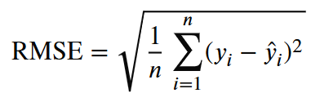
Where, “∑” is sum of the residuals squared, “y_{i}” is the actual (or observed) value, $"_{yi}^{^}"$ is the predicted value, and “n” is total number of observations (counts).

3. Results
Growth attributes
Among thirty high fruit yielding trees measured, tree height ranged from 8.30 to 25.70 m with mean height of 17.47 m, while DBH ranged from 25.48 to 114.78 cm with mean value of 68.19 cm. Mid diameter of 30 trees ranged from 12.50 to 52.83 cm with mean value of 32.70 cm (Table 1). The form quotient is determined to correct the volume of the standing tree into cylindrical form and the estimated FQ value ranged from 0.33 to 0.69 with mean FQ of 0.49. The positive growth trend was noticed between DBH with height and mid diameter, while FQ showed negative trend with DBH (Fig. 1a to 1c).
Table 1. Tree growth characteristics of naturally grown Mahua trees in South Gujarat
Parameters | Height (m) | DBH (cm) | Mid dia | Form Quotient
Min | 8.30 | 25.48 | 12.50 | 0.33
Max | 25.70 | 114.78 | 52.83 | 0.69
Mean | 17.47 | 68.19 | 32.70 | 0.49
SD (±) | 4.25 | 22.20 | 10.84 | 0.09

Fig. 1. Relationship between DBH with tree height (a), mid diameter (b), and form quotient (c) in Mahua

Crown diameter, crown length and crown height were measured for all the studied trees, where crown diameter ranged from 5.10 to 16.50 m, crown length from 4.10 to 19.70 m and crown height from 3.40 to 10.30 m (Table 2).
Table 2. Crown characteristics of naturally grown Mahua trees in South Gujarat
Parameters | Crown Diameter (m) | Crown Length (m) | Crown Height (m)
Min | 5.10 | 4.10 | 3.40
Max | 16.50 | 19.70 | 10.30
Mean | 11.28 | 11.26 | 5.87
SD (±) | 2.54 | 4.33 | 1.65

Yield attributes
Yield parameters such as volume, biomass and carbon stock of standing trees were measured. Basal area of trees ranged from 0.05 to 1.03 m² with mean basal area of 0.40 m². Volume of standing tree ranged from 0.24 to 11.87 m³ with biomass of 149.46 to 7547.60 kg per tree with overall mean biomass of 2295.71 kg per tree. Carbon stock of standing trees was also estimated and it ranged between 71.74 and 3622.85 kg per tree with an overall mean of 1101.94 kg carbon per tree.
Biomass and carbon stock data shows that Mahua is one of the promising tree species of the natural forest genetic resources and their growth was good. Being a tall and bigger tree, Mahua play a potential role in sequestering atmospheric carbon into wood biomass, where a tree having mean height of 17 m and DBH of 68 cm may occupy basal area of about 0.40 m² and yielded about 2295 kg biomass and 1101 kg carbon content (Table 1 and 3).
Table 3. Volume, biomass and carbon stock in naturally grown Mahua trees in South Gujarat
Parameters | Basal area  (m²) | Volume  (m³) | Biomass  (kg per tree) | Carbon stock  (kg per tree)
Min | 0.05 | 0.24 | 149.46 | 71.74
Max | 1.03 | 11.87 | 7547.60 | 3622.85
Mean | 0.40 | 3.61 | 2295.71 | 1101.94
SD (±) | 0.24 | 2.72 | 1730.84 | 830.80

Correlation between growth and yield attributes
In the present study, to understand the relationship between growth parameters and yield parameters, a Pearson’s correlation was attempted and a correlogram was developed using GRAPES statistical software.
There was a positive auto-correlation among growth attributes as well as yield attributes in Mahua (Fig. 1). DBH showed a strong positive correlation with tree height (r=0.801), mid diameter (r=0.841), basal area (r=0.980), as well as yield parameters such as volume, biomass, and carbon stock (r=0.914). Further, DBH also showed positive correlation with crown diameter (r=0.573) and crown length (r= 0.701); however, it was non-significant with crown height. Similar strong positive relationship was also recorded in tree height and mid diameter with the rest of the biometric and yield parameters (Fig. 2), except crown height. Therefore, DBH and height can be considered as important parameters for estimation of standing volume in Mahua.
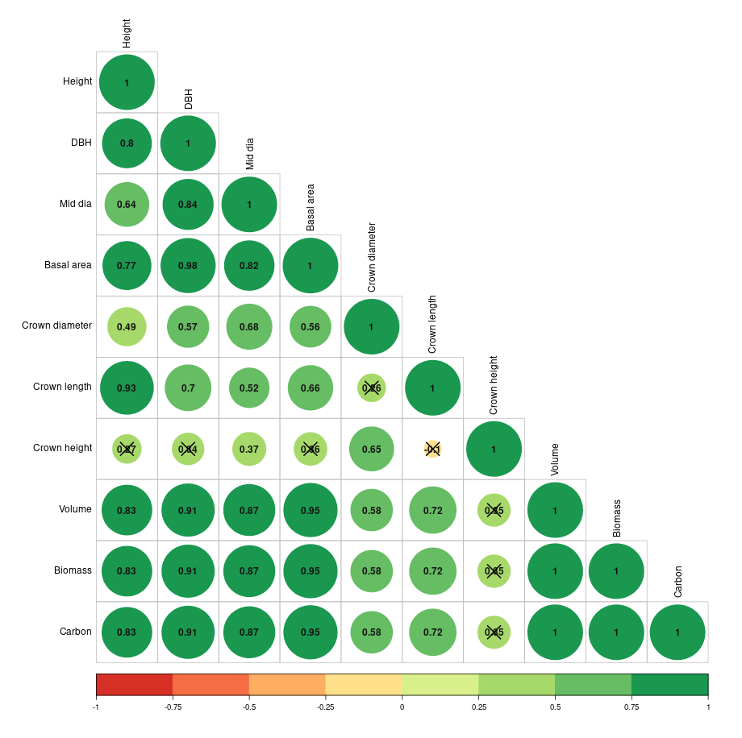
Fig. 2. Correlation between growth and crown attributes with yield parameter in Mahua [The ‘X’ mark indicating non-significant correlation between tested two parameters; while circle of the color indicating the level of significance from lower (red shade) to higher (green shade)]

Development of regression equation
By looking into the correlation data, based on 30 datasets, scatter plot was made between DBH and volume using different regression models viz., linear [V₁ = a + b D], power (V₂ = a D^{b}), logarithm [V₃ = a + b ln(D)], and quadratic polynomial [V₄ = a + b D + c D²]. Further, regression equations were developed using above models and presented in Table 4. Here, ‘D’ represents DBH and ‘a’ represents intercept, ‘b & c’ represents coefficients. Graphical form of all these above regression models is presented in Fig. 3.
Table 4. Regression models for Volume (V) based on DBH (D)
Regression Models |  | Intercept | Coefficient |  | R² | RMSE
 |  | a | b | c
Linear | V = a+bD | -4.028 | 0.112 | -- | 0.834 | 1.10
Power | V= a D^{b} | 0.00009 | 2.4663 | -- | 0.939 | 0.83
Logarithmic | V= a + b ln (D) | -22.238 | 6.2099 | -- | 0.711 | 1.45
Quadratic | V= a+bD+cD² | 0.8549 | -0.0491 | 0.0012 | 0.904 | 0.83

Fig. 3. Relationship between DBH with Volume by following different regression models in Mahua

Result shows that there was a strong positive association between DBH and volume at four tested models (Table 4). The details of volumetric equations developed in the study are given below:
V₁ = -4.028 + 0.112*D…………………… (Volume based on linear model)
V₂ = 0.00009 * D^{2.4663} …………………... (Volume based on power model)
V₃ = -22.238 + 6.2099 * ln(D) …………… (Volume based on logarithm model)
V₄ = 0.8549 - 0.0491*D + 0.0012 * D² …... (Volume based on quadratic model)

Among these four equations, Power and Quadratic models have shown higher R² values of 0.939 and 0.904, respectively. Similarly, RMSE values of these two equations were comparatively less i.e., 0.83 than the rest of the two equations, which shows the RMSE value of 1.10 to 1.45 indicating poor accuracy (Table 4). Therefore, the power model regression equation V = 0.00009*D^{2.4663} can be used to determine the volume of standing Mahua trees.
Further, in the study, the same power model was again used to obtain a regression model for biomass and carbon stock using DBH. The relationship between these two parameters are given in Fig. 4 and 5. The developed regression equation for biomass i.e., B = 0.0569*D^{2.4663} (R² = 0.939) can be used to assess the biomass of standing tree using DBH data. Whereas for carbon stock estimation, C=0.0273*D^{2.4663} (R² = 0.939) can be used. Later, using these equations, data on volume, biomass and carbon stock of trees belonging to different diameters were worked out and presented in Table 5 for easy understanding in Mahua. For example, a Mahua tree having 50 cm diameter can yield about 1.39 m³ volume, 882 kg biomass and 423 kg carbon; while other tree having 75 cm diameter can yield about 3.79 m³ volume, 2396 kg biomass and 1150 kg carbon in Mahua (Table 5).
Fig. 4. Relationship between DBH with Biomass and Carbon stock in Mahua

Table 5. Local volume/biomass/carbon table prepared using developed equations at different Diameters in Mahua
DBH | Estimated  Volume using  V=0.00009*D^{2.4663} | Estimated  Biomass using  B = 0.0569x^{2.4663} | Estimated  Carbon stock using  C = 0.0273x^{2.4663}
(cm) | (m³) | (kg per tree) | (kg per tree)
25 | 0.252 | 160 | 77
30 | 0.396 | 250 | 120
35 | 0.579 | 366 | 176
40 | 0.804 | 508 | 244
45 | 1.075 | 680 | 326
50 | 1.394 | 882 | 423
55 | 1.764 | 1115 | 535
60 | 2.186 | 1382 | 663
65 | 2.663 | 1684 | 808
70 | 3.197 | 2022 | 970
75 | 3.791 | 2396 | 1150
80 | 4.445 | 2810 | 1348
85 | 5.161 | 3263 | 1566
90 | 5.943 | 3757 | 1803
95 | 6.791 | 4293 | 2060
100 | 7.706 | 4872 | 2338

4. Discussion
Mahua is one of the important timber-yielding and major non-timber forest products yielding tree species of India which provide an environmental, nutritional and socioeconomic stability among rural people. Large numbers of mahua trees are found in northern, central and southern part of peninsular India (Patel and Naik, 2010). As per FSI report, Mahua tree ranked third in terms of growing stock (85.23 M m³) having 4.37% of total growing stock of tree outside forest (TOF, ISFR, 2023). In Gujarat, Mahua can be seen in forest areas and non-forest areas like revenue, community and agricultural lands. Apart from its direct valuables, ecosystem services of individual species need to be documented for socioeconomic consideration. Among several ecosystem services, carbon sequestration is one that play vital role on mitigating climate change. Development of data base on biomass and carbon accumulation of different tree species make an important role on climate change mitigation as well as carbon credit programmes in the country. In the present study, relationship between growth and yield parameter was worked out and then established volumetric equation using different regression models. Among the tested equations, power model i.e., V= aD^{b} was found to be the best fit equation for estimating volume of standing trees using DBH. This equation could be more applicable for local use of Mahua trees having 8 to 25 m height and 25 to 150 cm DBH in South Gujarat condition. Gupta et al. (2025) estimated the average stem biomass per tree across three different diameter classes and found that on an average a tree of Mahua yield biomass of 0.161 Mg, 0.506 Mg, and 1.26 Mg, respectively in 1-30 cm, 30-50 cm and >50 cm diameter classes. Similarly, it also yields about 0.076 Mg, 0.24 Mg, and 0.59 Mg carbon per tree, respectively. They also reported positive correlation between tree DBH and carbon sequestration in Mahua. In the FSI report (ISFR, 2023), volumetric equation for Madhuca longifolia was given for Gujarat state where V = 0.074069-1.230020*D+7.726902*D² (D= DBH). This equation was compared here with actual volume calculated in the study; however, the RMSE value worked out between these two equations was found to be 1.05.
Local volumetric equations have been developed for Eucalyptus spp. (Behera et al., 2022), Casuarina spp. (Gunaga et al., 2023), Melia dubia (Thakur et al., 2021), Teak clones (Chaudhari et al., 2025), Albizia procera (Dash et al., 2025), Acacia auriculiformis (Gunaga et al., 2026) in South Gujarat condition. All these reports show that there was a strong positive association between DBH with volume. Such species wise information would helpful in assessing standing tree volume as well as biomass-carbon accumulation, in fact such data may be supportive in carbon credit projects (Gunaga et al., 2023) as well as assessment of CO₂ sequestration as a part of ecosystem services (Gupta et al., 2025).

5. Conclusion
Study shows that there was a strong positive association between growth and yield attributes in Mahua. Among the four tested regression equations, power model: V= aD^{b} recorded to be the best fitted equation for estimating volume of standing Mahua trees using diameter. Data shows that there is a scope for developing some more regression equations using both Height and DBH parameters with large data samples. Equation as well as tables of volume, biomass and carbon given in Table 5 can provide an idea or help in quick assessment of standing Mahua trees using DBH. The study suggested to use volumetric equation V = 0.00009 * D^{2.4663} for estimation of standing medium to old aged Mahua trees in South Gujarat condition.

Competing Interests
Authors have declared that no competing interests exist.

References
Behera, L. K., Gunaga, R. P., Mehta, A. A., Sinha, S. K. & Patel, D. P. (2022). Development of volumetric equation for Eucalyptus (Eucalyptus spp.). In: Report of Forestry sub-committee of NAU presented in 18th Combined Joint AGRESCO held at JAU, Junagadh, Gujarat, pp. 29-40.
Chaudhari, N. K., R. P. Gunaga, S. A. Huse, N. S. Thakur, R. L. Sondarva and J. B. Bhusara (2025). Biomass and carbon storage potential of teak clonal seed orchards: Implication for climate change mitigating. Indian Journal of Agroforestry 27(4), 26-34.
Dash, M. K., R. P. Gunaga, J. B. Bhusara, R. L. Sondarva, L. K. Behera, S. K. Sinha & S. A. Huse (2025). Growth, volume, biomass, and carbon storage potential of Albizia procera across different girth classes. Indian Journal of Forestry, 48(1), 48-51.
Dereje Egeta, Mesele, N., Mehari, A., Abeje, E., Sinke, M. & Tamiru, L. (2023). Species-specific allometric equations, biomass expansion factor and wood density of native tree species in the Dry Afromontane Forest of Ethiopia. International Journal of Forestry Research, 11. https://doi.org/10.1155/2023/5572048
Gopinath, P. P., Parsad, R., Joseph, B. & Adarsh, V. S. (2020). GRAPES: General Rshiny Based Analysis Platform Empowered by Statistics. DOI: 10.5281/zenodo.4923220
Gunaga, R. P., Behera, L. K., Sinha, S. K., Mehta, A. A., Thakur, N. S., Garde, Y. A., Bhusara, J. B. & Sondarva, R. L. (2023). Development of volumetric equation and volume table for Casuarina species. Indian Journal of Ecology 50(5), 1368-1372.
Gunaga, R. P., Behera, L. K., Sinha, S. K., Tandel, M. B., Hegde, H. T., Thakur, N. S., Bhusara, J.B. & Sondarva, R. L. (2026). Regression models for estimating volume of standing Acacia auriculiformis trees in South Gujarat, India. Journal of Global Ecology and Environment, 22(1), 165–174. https://doi.org/10.56557/jogee/2026/v22i110327
Gupta, A., Sanwal, N., Sharma, N., Sahu, J. K. & Kheto, A. (2024). Dynamics of functional and physiochemical properties of Madhuca longifolia flower juice under Saccharomyces cerevisiae fermentation. Food and Humanity, 2, 100244. https://doi.org/10.1016/j.foohum.2024.100244.
Gupta, G., Singh, K., Kumar, A., Nasir, M., Dobriyal, M. & Singh, G. (2025). Quantitative assessment of ecosystem services provided by mahua (Madhuca longifolia) (L.) J.F. Macbr. (Sapotaceae) in trees outside forest of India. Forestist, 75, 0060, doi:10.5152/ forestist.2025.24060.
Hegde, H. T., R. P. Gunaga & N. S. Thakur (2019). Current trends and future prospects for utilization of mahua resources. Van Sangyan, 6(2), 7-11.
Hegde, H. T., R. P. Gunaga, J. B. Bhusara, R. L. Soundarva & N. S. Thakur (2026). Usufruct of mahua (Madhuca longifolia var. latifolia Roxb. A. Chev.) resources for livelihood enrichment of local communities. International Journal of Economic Plants, 13(2), 01-06.
Hegde, H. T., R. P. Gunaga, N. S. Thakur, S. K. Jha & M. J. Dobriyal (2018). Population structure and regeneration of Mahua (Madhuca longifolia var. latifolia (Roxb.) A. Chev.) in disturbed and undisturbed sites. Indian Journal of Ecology, 45(4), 724-727.
Hegde, H. T., R. P. Gunaga, S. K. Sinha & N. S. Thakur (2024). Within population variation for tree growth and seed oil content of Mahua (Madhuca longifolia var. latifolia (Roxb.) A. Chev.) in south Gujarat. Research Report of Forestry sub-committee, 20th Combined Joint AGRESCO Meeting of SAU’s & KU of Gujarat held during May 15-17, 2024 through online video conference, AAU, Anand, pp. 139-153.
IPCC (2001). Climate Change 2001: Impacts, Adaptation and Vulnerability, Intergovernmental Panel on Climate Change (IPCC), Cambridge University Press, Cambridge, UK.
ISFR (2023). India State of Forest Report-2023, Forest Survey of India, Ministry of Environment, Forest & Climate Change, Dehradun, 160 pp. https://fsi.nic.in/forest-report-2023.
Kumar, V. M., Veeresh, A. B. & Kumar, R. P., 2017. Producing biodiesel from crude Mahua oil by two steps of transesterification process. Australian Journal of Mechanical Engineering, 17(1), 2–7. DOI: 10.1080 /14484846.2017.1412243.
Patel, M. & Naik, S.N. (2010). Flowers of Madhuca indica J. F. Gmel.: Present status and future perspectives. Indian Journal of Natural Products and Resources, 1(4), 438–443.
Thakur, N. S., R. P. Gunaga, H. T. Hegde, R. S. Chauhan, D. C. Bhuva & J. B. Bhusara (2021). Development of biomass and volume models of Melia dubia Cav. for early establishment. Indian Journal of Ecology, 48(3), 698-701.

