Role of Environmental Impact Assessment in Wildlife Conservation Outside Protected Areas in the Face of Development Interventions

Abstract

Environmental Impact Assessment (EIA) evaluates environmental impacts of proposed projects and policies to identify, predict, and mitigate their potential negative effects. In Uganda, home to exceptional biodiversity with over 18,783 recorded species of flora and fauna, ranks among the top 10 biodiverse countries globally. Despite robust legal framework, legislative conflicts may undermine protection of species outside protected areas. This study assessed the role of EIA in conservation of wild fauna outside the protected zones in Orom East Sub-County, Karega District, Uganda. The project area was delineated, habitats with potential impacts were mapped, relevant literature was reviewed, and direct observations, track-and-sign surveys, and acoustic monitoring were conducted. The surveys identified 61 distinct species across the following six taxonomic classes: insecta (Formica spp, Acrididae, Stomoxys spp, Simuliidae, Papilio spp), Aves (Apalis k, Ploceus s, Colius s, Lamprotornis a, Columba l), Reptilia (Stigmochelys p, Python s, Bitis a, Bitis g, Naja h), Amphibia (Sclerophrys g, Amietia a, Phrynobatrachus spp), Mammalia (Lepus spp, Phacochoerus a, Loxodonta a, and Papio a). The Shannon Diversity Index was 2.05, indicating a well-balanced and fairly diverse ecological community. Potential impacts of the project development (habitat loss and fragmentation, pollution, invasive species introduction, barriers to mobility, alteration of water flow, mortality, disturbance, and stress) were assessed as minor. Nonetheless, to mitigate cumulative long-term effects of ecosystem disruptions, population declines, the study recommends habitat restoration, creation of wildlife corridors, pollution control and waste management, invasive species management, enhanced monitoring and adaptive management, community engagement and education, collaboration with conservation authorities, and regular audits and reporting of mitigation effectiveness.

Key words: Environment, diversity impact, and development

INTRODUCTION

Environmental Impact Assessment (EIA) serves as an essential mechanism for assessing the potential environmental effects of proposed development initiatives, strategies, or policies prior to decision-making. Its purpose is to identify, forecast, and address both the beneficial and adverse impacts of development on individuals, properties, and ecosystems (NEMA, 2022). Emerging in the middle of the 20th century, EIA has adapted in response to the growing global concern over environmental degradation and the pressing need for sustainable development (Bhatt, 2023).
The 1972 Stockholm Conference and the 1992 Rio Earth Summit sparked global dedication to environmental conservation, leading to initiatives like Agenda 21, which encourages the incorporation of environmental factors into development strategies (UNSD, 2011). These significant events highlighted the importance of finding equilibrium between economic advancement and ecological health, a core tenet of sustainable development. Environmental Impact Assessment (EIA) functions as a critical tool for achieving this equilibrium by integrating environmental management principles into the project planning and approval procedures.
In the context of biodiversity conservation, Environmental Impact Assessments (EIA) are especially important in regions or areas not formally protected. Although a significant portion of worldwide conservation initiatives concentrates on protected areas (PAs), wildlife in nations like Uganda frequently flourishes in unprotected regions such as wetlands, forests, woodlands, and agricultural lands, which are increasingly affected by infrastructure development and changes in land use.
Uganda is known for its extraordinary biodiversity, encompassing more than 18,783 documented species of plants and animals, which ranks it among the top ten most biodiverse countries in the world (CBD, 2018; TE, 2025). This rich biodiversity is sustained by a range of ecosystems, such as tropical rainforests, savanna grasslands, wetlands, and montane environments (Pomeroy et al., 2002). A large portion of this biodiversity exists outside officially designated protected areas, particularly in regions managed under various mandates and ownership structures such as customary, freehold, leasehold, and public land. This fragmentation creates significant challenges for conservation bodies like the Uganda Wildlife Authority (UWA), which primarily oversees wildlife in protected areas.
The legal and institutional structure regulating Uganda’s biodiversity presents both chances and limitations. Although the Constitution of Uganda (2005, as amended) highlights the importance of sustainable natural resource management for both current and future generations, it also recognizes the rights of landowners to have complete control over their land. This combination has led to greater land-use transformation and conflicts between humans and wildlife, particularly in ecologically valuable but unprotected areas.
Section 47(2) of Uganda's National Environment Act (2019) requires the use of Strategic Environmental Assessments (SEAs) and ecological impact assessments (EIAs) for projects that are anticipated to have significant cumulative environmental impacts. Based on this legislation, an EIA was carried out in Orom East Sub-County to investigate the potential consequences of a proposed development intervention on local animals and ecosystems involving the construction and operation of access roads and associated facilities within the designated area, was evaluated for its ecological implications. The project encompasses land clearing, grading, establishment of service corridors, and limited construction activities that may temporarily alter existing habitats.
The Shannon Diversity Index (H’ = 2.05) indicates a well-structured and relatively diverse ecological community, characterized by a balanced distribution of species and indicating a well-balanced and fairly diverse ecosystem resilience (Sharashy, 2022). The environmental assessment established that the potential impacts of the intervention such as habitat alteration and fragmentation, localized pollution, potential introduction of invasive species, temporary barriers to wildlife movement, modification of surface water drainage patterns, increased mortality risks, and disturbance-related stress, are minor in magnitude and largely reversible when appropriate safeguards are implemented.

Nonetheless, comprehensive mitigation and monitoring measures have been proposed to safeguard wildlife populations and maintain ecological integrity throughout the project’s lifecycle. These measures aim to prevent cumulative, long-term degradation of habitat quality and to ensure that wildlife movement, breeding, and foraging patterns remain unaffected by the development.

The study followed a thorough procedure that included stakeholder meetings with indigenous people and local wildlife experts, field-based animal and habitat assessments impact analysis (direct, indirect, and cumulative), and the creation of feasible mitigation measures.
This paper presents findings from that EIA and explores the broader role of environmental assessment in conserving wildlife outside protected areas. By focusing on a real-world case in Orom East regarding the prospective extension of the aforementioned road, it highlights how EIA can serve as a bridge between development and conservation in rural Uganda, where legal protection is often weak or absent.

MATERIALS AND METHODS
To assess the potential impacts of proposed development interventions on wildlife in Orom East Sub-county, a combination of spatial analysis, literature review, and community engagement was employed. The methodology was designed to ensure that the Environmental Impact Assessment (EIA) effectively identifies ecological risks and informs conservation strategies, particularly for biodiversity existing outside protected areas.
The project area was delineated using GPS mapping and GIS software to accurately capture the spatial extent of the proposed road revamp and access routes (totaling approximately 6.5 km). The mapping focused on identifying adjacent ecologically sensitive habitats, such as wetlands, savanna grasslands, woodlands, bushlands, and riparian corridors. Habitat boundaries were overlaid with planned development footprints to anticipate zones of ecological disruption. This delineation formed the basis for targeted field assessments and impact zoning.
The project is located in Orom East Sub-county, part of the newly created Karenga District in the Karamoja sub-region of northeastern Uganda. The district covers an area of approximately 3,193 square kilometers, sharing an international border with South Sudan to the north, and domestic boundaries with Kitgum District to the west, Kotido District to the south, and Kaabong District to the east. The geography is dominated by semi-arid savanna landscapes characterized by rolling plains, rocky hills, and isolated escarpments, with portions of the sub-county extending into the Kidepo Valley National Park, one of Uganda’s most biodiverse and scenic protected areas.
The area experiences semi-arid climatic conditions, receiving an average annual rainfall of approximately 800 millimeters, concentrated in a single rainy season from April to October. The dry season, lasting from November to March, is marked by high evapotranspiration and water scarcity (MWE, 2025). These conditions shape vegetation composition and land use, favoring pastoralism and extensive grazing systems. However, the semi-arid terrain and erratic rainfall present significant challenges for infrastructure development, water management, and crop farming.
According to Uganda Bureau of Statistics (UBOS, 2023) projections, Karenga District has an estimated population of 73,100 residents, comprising 36,000 males and 37,100 females, yielding a population density of 22.89 persons per square kilometer. The main ethnic groups include the Karimojong, Acholi, and Mening, alongside a smaller population of South Sudanese residents concentrated around Karenga Town, which serves as a key administrative and commercial center.
The local economy is primarily subsistence-based, relying on pastoralism and smallholder farming. Livestock rearing, particularly cattle, goats, and sheep, is both a cultural identity and an economic livelihood, although recurrent challenges such as cattle rustling and prolonged droughts periodically undermine productivity. Farming activities center on maize, sorghum, and beans, grown mainly for household consumption, reflecting the region’s semi-nomadic traditions and low mechanization levels.
Tourism forms a growing economic pillar, supported by Kidepo Valley National Park, which attracts both domestic and international visitors and provides employment opportunities in hospitality, guiding, and craft enterprises within Karenga Town. Additionally, government programs such as the Parish Development Model (PDM) and Emyooga have been introduced to strengthen the transition toward a market-oriented local economy, though wildlife-induced crop damage remains a persistent challenge in communities bordering the park.
The district’s social infrastructure is gradually improving. The Education and Sports Department oversees 24 primary schools-20 governments-aided and four community-managed—under the Universal Primary Education (UPE) program (KDLG, 2023). Water access stands at approximately 95% in neighboring Kapedo Sub-county, with 418 domestic water points serving 54,138 people, though 98 are currently non-functional. Health services face challenges associated with zoonotic diseases such as brucellosis, prevalent among pastoralist communities. Recent investments, including an 8 billion Ugandan shilling secondary school project launched in 2019, reflect ongoing efforts to enhance education and public health services (MWE, 2025).
To ensure systematic and representative coverage of the project area: sampling was conducted at 500-meter intervals along the 6.5 km project corridor. At each sampling point, data were collected within a 15-meter buffer on either side of the road. Additionally, 1 square kilometer plots were established in representative habitat types (such as, woodland, grassland, wetland edges) to assess species diversity and relative abundance.
This sampling design ensured spatial coverage and facilitated comparisons across different habitat types and disturbance gradients. This helped to generate statistically meaningful data on wildlife distribution and abundance across microhabitats, supporting impact prediction and conservation planning.
The project is situated in Orom East Sub-county, specifically in Akrumo Parish, within Locomo Central, where development activities involve the revamping and extension of Locomo Road and the creation of additional access routes, collectively covering approximately 6.5 kilometers. This intervention is located within a landscape dominated by open savanna grasslands and open woodlands, the majority of which lies on community-managed land.
The area also contains two isolated wetlands, each fed by a seasonal stream and river, respectively. These wetlands serve as important microhabitats for various species, especially during the dry season. The ecological composition of the region reflects a tropical savanna climate (World Atlas, 2024), characterized by distinct wet and dry seasons. Daily average temperatures range between 25°C and 35°C.
The rainy seasons occur from March to May and more substantially from August to November, with annual rainfall estimated between 500 and 800 mm. In contrast, the dry seasons extending from December to February and June to July are marked by prolonged periods of hot, arid conditions, often leading to water scarcity and increased stress on vegetation and wildlife.
Topographically, the area is varied, with Lucomo Hill marking a prominent feature whose slopes are covered by bushlands, shrublands, and scattered woodlands. Additionally, riparian vegetation is present along the seasonal watercourses, offering important ecological corridors and refuge for wildlife, particularly in the dry season when other habitats become inhospitable.
Given the ecological diversity of this unprotected landscape, and its role as a functional habitat for wildlife, the proposed development necessitates a thorough Environmental Impact Assessment. This ensures that conservation priorities are integrated into infrastructure planning particularly in areas such as Orom East Sub-county, where biodiversity persists outside formal protected areas but remains equally vulnerable.
A comprehensive literature review was conducted to gather existing data on local wildlife, habitat types, and previous conservation assessments in the region. Sources included peer-reviewed articles, government reports, biodiversity databases and publications from the Uganda Wildlife Authority (UWA) and Wildlife Conservation Society (WCS). This secondary data review provided a baseline understanding of species richness, conservation status, habitat preferences, and known threats informing the impact assessment and guiding the development of context-appropriate mitigation strategies.
Structured consultations were conducted with local community members, particularly individuals with traditional ecological knowledge (TEK) and experience with local wildlife. These interactions helped identify key species occurring in the area, their seasonal movement patterns, and hotspots for human-wildlife interactions, such as crop raiding or habitat encroachment. The consultation process also promoted community inclusion in conservation planning, enhancing local ownership of mitigation actions and increasing the likelihood of long-term biodiversity stewardship outside protected area boundaries.
To evaluate the potential impacts of the Locomo Road development on local wild animals outside protected areas, a range of selective, non-invasive field methods were employed. These methods were designed to provide reliable data on classes of wild animals’ presence, distribution, and activity patterns, forming the basis for impact analysis and conservation recommendations within the Environmental Impact Assessment (EIA) framework.
Visual and auditory surveys were conducted along designated transect walks parallel to the proposed road alignment. The researcher and the local guides systematically walked these transects, recording all visible or audible wildlife (mammals, birds, and reptiles) encountered during the survey period. This method provided real-time insights into species actively using the project area and helped identify habitat preferences and activity hotspots. To establish a baseline of actively visible and audible species that may be directly affected by construction and habitat alteration.
Track and sign identification was employed as a non-invasive technique to detect and monitor wildlife that may not be easily observed directly. This included documentation of: Footprints and tracks, Scat (feces), Burrows, nests, and dens, Claw or rubbing marks on trees, feeding signs (such as, browsing, diggings), Evidence of human-wildlife conflict, such as hunting traps or carcasses. This method was particularly effective in identifying nocturnal, cryptic, or low-density species, and contributed critical information about species movement, habitat use, and anthropogenic pressures within the area. This helped to supplement observational data with indirect evidence of wildlife presence and detect human activities that may pose threats to species outside protected areas.
Acoustic monitoring was carried out using a mobile phone as a sound recording device to capture bird calls and other wildlife vocalizations during morning and evening hours. These recordings were used to identify bird species through call recognition, document the presence of soniferous species (those that communicate via sound), monitor species richness and habitat usage patterns over time. This method proved especially valuable for detecting shy, arboreal, or canopy-dwelling birds, and was a key component of biodiversity assessment in riparian and woodland habitats. The purpose was to assess avian diversity, detect hard-to-see species, and understand how project noise and habitat changes may affect acoustic communication and behavior.

RESULTS AND INTERPRETATION
  - Wildlife Species Composition and Diversity

The biodiversity of the project area comprises a range of species across different taxa; insects, birds, reptiles, amphibians, and mammals. These species play critical roles in maintaining ecological balance, contributing to ecosystem services such as pollination, seed dispersal, and predator-prey dynamics. Understanding the composition and diversification of wildlife species within a given ecosystem is essential for conservation and management planning.
This assessment serves as a foundation for further ecological research and informs conservation strategies aimed at maintaining the integrity and diversity of the wildlife populations within the project area.
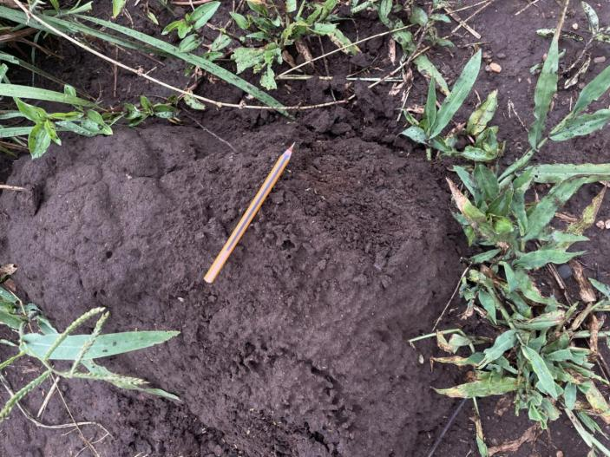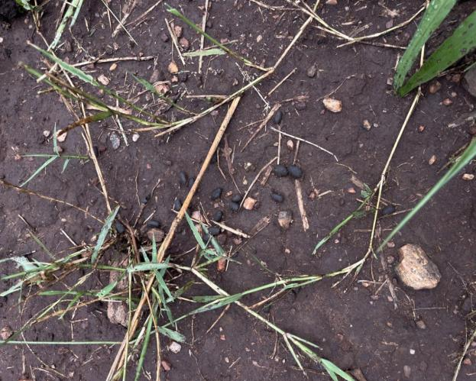
Plate 1: Termite Mond and Fecal Components of Antelopes sign of animal activity (Source: Field data 2024)
  - Conservation Status of the Species Identified
A species is placed in this category based on the likelihood of its extinction. Depending on the national and international scales at which a species is evaluated, its conservation status may vary (IFAW, 2023). The Uganda National Red List criteria serve as the national classification standard for species, while the IUCN Red List Categories and Criteria serve as the international standard for species at risk of extinction. However, as the national status is implemented in accordance with the IUCN principles, IUCN Red List Categories and Criteria were used for the purpose of this project to facilitate the categorization of the animal species that were identified within the project region. Each species' current status is provided in accordance with the IUCN Red List of each species, which is given according to the IUCN Red List of Threatened Species (IUCN 2015).
  - Project Area Species Evenness and Richness
An essential component of assessing biodiversity is determining the evenness and richness of species within the study region, which is represented by the data provided.
The term "species richness" describes the variety of species found in the project region (Pyron, 2010). 10 distinct species classifications are included in the data, encompassing a wide range of fauna birds, reptiles, amphibians, butterflies, flies, grasshoppers, ants, termites, centipedes, and mammals.
Species Evenness: This describes the degree to which individuals of various species are dispersed equally.
The assessment of the local fauna was facilitated by using frequency counts, percentages, and the Shannon index method for biodiversity assessment as indicated below:
Shannon Index Formula:
$$Hi=-\sum_{i=1}^{s}{pi×1n\left(pi\right)}$$
H′ is the Shannon Diversity Index.
S is the total number of species classes.
pi​ is the proportion of each species class.
Table 1: Project Area Species Evenness and Richness
SN | Species Class | Count(ni) | Percentage (%) | Species Proportionality (pi)​ | pi​×ln(pi)
1 | Butterly | 6 | 9.8 | 0.0984 | 0.2282
2 | Flies | 4 | 6.6 | 0.0656 | 0.1787
3 | Grasshoppers | 8 | 13.1 | 0.1311 | 0.2664
4 | Ants | 8 | 13.1 | 0.1311 | 0.2664
5 | Termites | 1 | 1.6 | 0.0164 | 0.0673
6 | Centipedes | 1 | 1.6 | 0.0164 | 0.0673
7 | Birds | 15 | 24.6 | 0.2459 | 0.3445
8 | Reptiles | 4 | 6.6 | 0.0656 | 0.1787
9 | Amphibians | 3 | 4.9 | 0.0492 | 0.1482
10 | Mammals | 11 | 18 | 0.1803 | 0.3089
 | Total | 61 | 100
Source: Field 2024
Following the findings in table 1, in this instance, birds make up the largest percentage of the species composition (24.6%), followed by ants and grasshoppers (13.1% each) and mammals (18%). With a combined 1.6% of all species, termites and centipedes have the lowest representation. With 10 distinct species classes identified, the biodiversity assessment conducted in the project region indicates a modest level of species richness. Mammals and birds make up 18% and 24.6% of all species, respectively, and are the most major categories within the local fauna (fauna). In spite of this, species evenness suggests a somewhat unequal distribution, with termites and centipedes among the underrepresented groups.
Shannon Diversity Index (H'): The computed value is 2.0546. This number falls within the moderate biodiversity range (usually 1.5 to 3.5), indicating a well-balanced ecosystem with somewhat diverse species that are not perfectly distributed.
Species Evenness: The occurrence of higher proportions for some species groups (for instance, birds and mammals) than others (for instance, termites and centipedes) indicates that, while variety exists, it is not evenly distributed. Some species dominate the ecosystem, resulting in modest evenness and the presence of multiple habitats (savanna, forests, wetlands) supports a range of ecological functions, enhancing ecosystem resilience.
The project area is made up of a variety of habitats, the most common of which are open savanna grasslands, however there are also woods and wetland habitats present. These habitats perform essential ecological functions such as seed dispersal, reducing the effects of drought and floods, nutrient cycling and movement, waste detoxification and breakdown, pest control in cultivation, biodiversity preservation, soil generation and preservation, reviving soil fertility, regulating disease-carrying organisms, protecting soil from erosion, safeguarding watersheds, streams, and rivers, pollinating crops and natural vegetation, providing aesthetic beauty, and serving as wildlife habitat (USDA, 2024) among other functions. Implying that the ecosystem is relatively stable but could be vulnerable to disturbances that disproportionately affect dominant species.
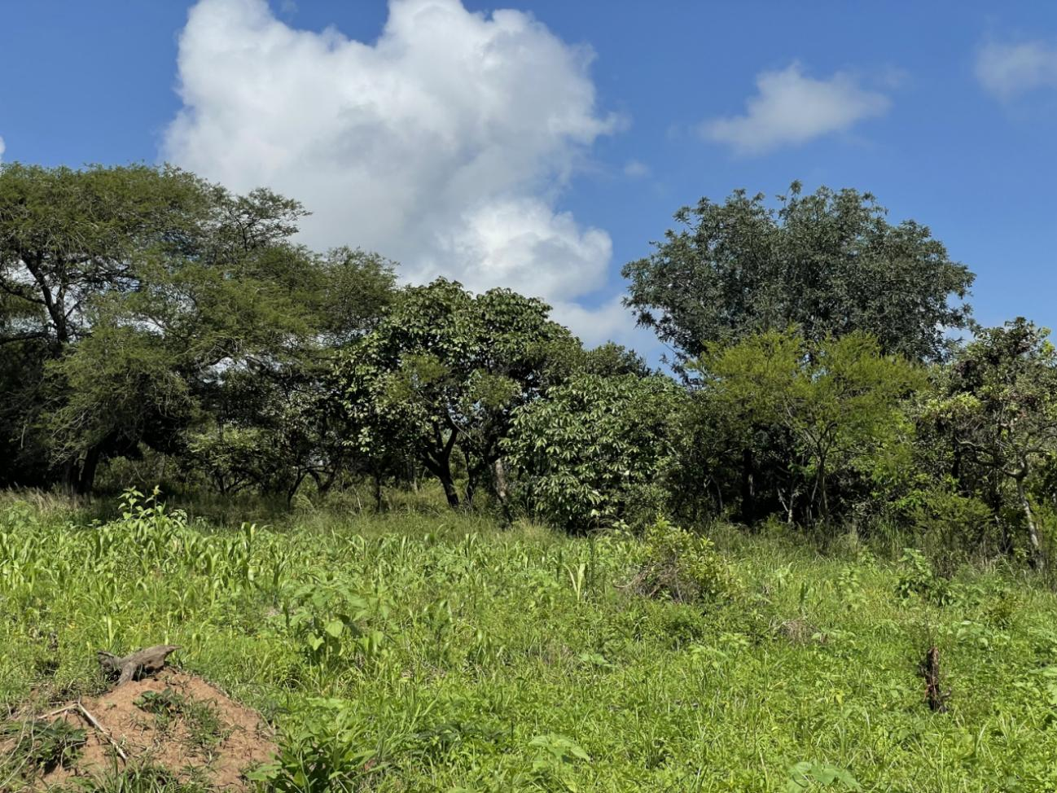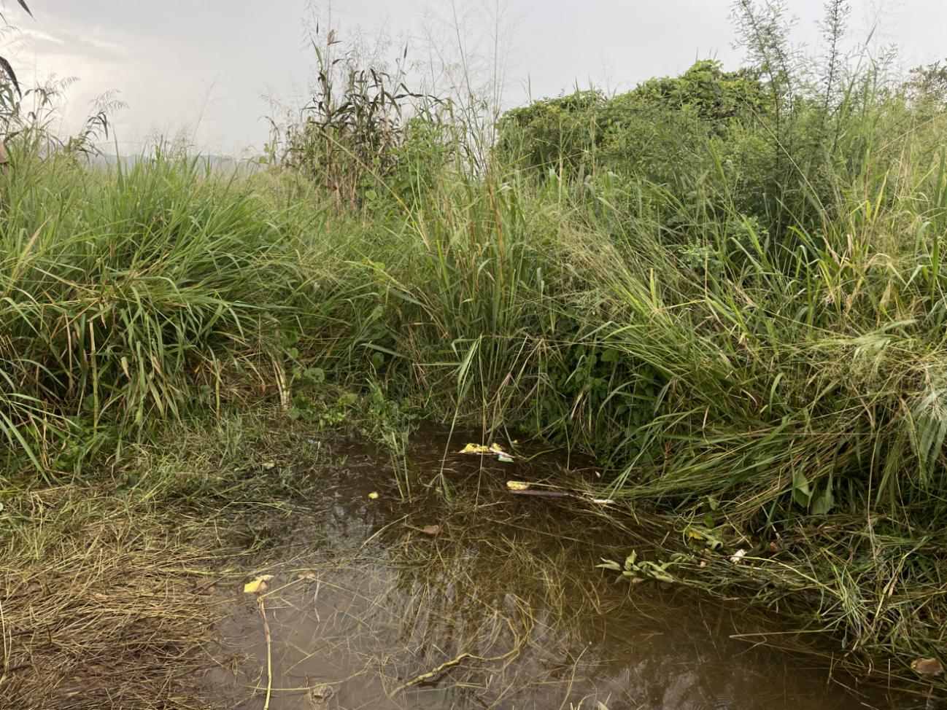
Plate 2: Showing an open grassland, woodland, and stream of water
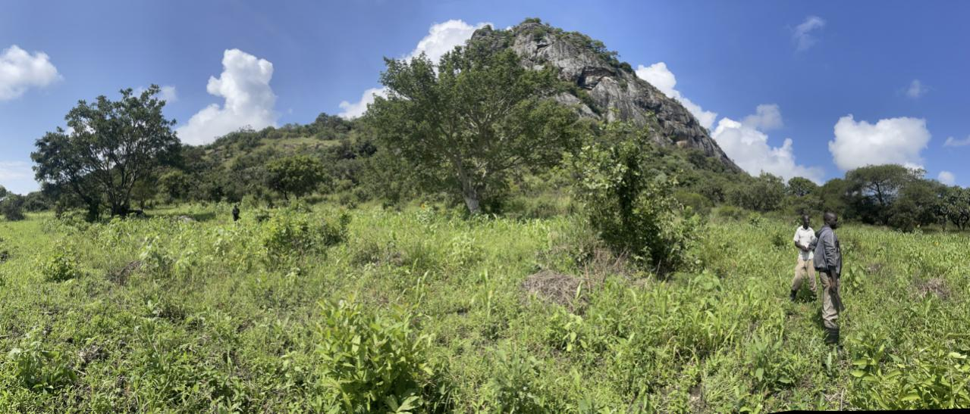
Plate 3: Open Savanna Grassland being assessed by the expert
  - Potential impacts of Development Project on Local Wildlife
This section describes a few of the project's most likely detrimental effects on the local wildlife, such as habitat loss and fragmentation, conflicts between people and wildlife, pollution, changes to the air and water systems, obstructions to movement, higher mortality rates, and the introduction of invasive species.

34.1 Habitat Loss and Fragmentation
Habitats can continually be reduced to smaller, more isolated areas by roads. Fragmentation can make it harder for wildlife to move around, restrict their access to supplies, and make them more vulnerable to predators. Additionally, it can obstruct migratory paths, which can result in population decreases, and remove vegetation, which can directly destroy wildlife habitats. As a result, there may be less space available for animals to breed, dwell, and feed (IFAW, 2024). Because a large portion of the land is owned by the community and used for agricultural, this negative impact is of MINOR significance.
    - Pollution and Environmental Degradation
Roads have the potential to bring contaminants that contaminate soil and water bodies, such as pesticides, heavy metals, and oil from cars and construction equipment. The health of wildlife will suffer as a result, especially aquatic species and those that depend on clean water sources. Consequently, dust from traffic and construction sites can suffocate flora and worsen air quality, which can affect animals that depend on plants for food or cover. Additionally, habitat degradation may result from this due to soil erosion. This will only have temporary effect thus it will have a big influence.
3.4.3 Invasive Species Introduction
Roads can introduce alien species through construction materials and vehicular activity, or they can act as corridors for the spread of invasive species. Ecosystems can be harmed, habitats altered, and native creatures outcompeted by invasive species. This adverse impact is of MINOR significance.
    - Obstacle to Animal Mobility
Roads can physically impede an animal's ability to move, especially for those species that are apprehensive to enter new or open areas. Populations may become isolated as a result, decreasing genetic diversity and raising the possibility of local extinctions. Because of the light, noise, and human presence around highways, some species may avoid these regions, which reduces the amount of their suitable habitat. This has a negligible detrimental effect this is attributed to the combination of animal behavioral adaptations, habituation, and evolutionary shifts allowing certain species to live with certain consequences of human expansion.
    - Increased Human-Wildlife Conflicts
Building new roads and extending existing ones can make it easier for people to access areas that were previously inaccessible to wildlife, which can boost poaching, hunting, and the illegal trade in wildlife. This may increase the strain on already threatened species. Because of their close proximity to roadways, wildlife can have more interactions with people, which can occasionally result in conflicts like animal crimes or crop raids. This has a negligible detrimental effect.
    - Alteration of Water Flow and Wetlands
Roads will change the way that water flows naturally, which could cause wetlands to dry up or cause man-made ponds to form. These alterations may affect species like frogs, birds, butterflies, and others that rely on particular hydrological conditions for reproduction or sustenance. Aquatic species may not always be able to migrate freely between culverts and bridges, which can result in isolated populations and a decrease in genetic diversity. This is a negative impact of MINOR significance.
    - Mortality
The increased possibility of roadkill is one of the ways that roads most directly affect animals. When animals try to cross roadways, they can get hit by cars, which can result in a high death rate, especially for species that move slowly or cross roads regularly, such snakes, snails, and leopard tortoises. Population dynamics can be upset by increased mortality, especially if breeding adults or young animals are disproportionately impacted. This is a negative impact of MINOR significance.
    - Disturbance and Stress
Noise from construction sites and continuous traffic can impede wildlife's ability to communicate, mate, and engage in foraging behaviors. Certain species, like birds, may move away from noisy roadways, which would cause the local population to dwindle. Roadside artificial lighting can interfere with nocturnal animals' ability to navigate, hunt, and breed. By putting prey species at greater risk of predation, it can also change the dynamics between predators and prey. This negative effect is of MINOR importance.
  - Cumulative and Long-Term Impacts of the Project
Ecosystem Disruption: When road extensions are added to other land-use modifications, the cumulative effects can cause more extensive disruptions to the environment, such as changed food webs, decreased ecosystem services, and changes in species composition. Due to the Project Area's proximity to two protected regions (Kidepo Valley National Park and Forest Reserve), where animals may migrate, and the land's communal ownership and predominant agricultural use, these negative effects are of MINOR consequence.
Long-Term Population Declines: Over time, habitat loss, fragmentation, and higher mortality rates can have a negative impact on animal populations, especially for species that have poor rates of reproduction or specific habitat requirements. Since no species with poor reproduction rates were found, these negative effects are of MINOR consequence.

MITIGATION MEASURES
The mitigating measures and standards for each identified impact have been mostly defined by the corresponding wildlife risks. The mitigation requirements are developed based on the likelihood and severity of the impact.
  - Habitat Loss and Fragmentation
To mitigate this impact, the project proponent will provide habitat restoration and revegetation. This will be accomplished by planting native trees, bushes, and grass as GREEN BELTS alongside the road. Where possible, the proponent should develop isolated meadows beside the road to provide habitat for insects, amphibians, and reptiles. Regarding the gorge, the project proponent will create a wildlife corridor by installing overpasses (green bridges) for humans.
  - Invasive Species Introduction
Mitigation against this impact, the project proponent will ensure that there is implementation of adaptive management practices that allow for changes in invasive species management strategies based on monitoring results and new information. boot and equipment cleaning stations, revegetation with Native Species, which helps to outcompete the invasive species, conduct pre-construction surveys of invasive species, and develop an invasive species management plan tailored to project-specific risks.
  - Pollution and Environmental Degradation
Mitigation against this impact, the project proponent will ensure that there is a revegetation around the project site, establish measures for waste management such as incineration for wastes that cannot be recycled, composting of the organic wastes, recycling, and, where possible, implementing Extended Producer Responsibility. Design landfills with liners and leachate collection systems to prevent pollutants from leaching into the soil. In case of severe contamination of the stream, there will be soil washing and excavation.
  - Mortality
Mitigation against this impact, the project proponent will ensure that there are wildlife conservation awareness campaigns for the project workers and communities through using information panels as well as driving at a minimal speed of 30 km/h.
  - Increased Human-Wildlife Conflicts
Mitigation against this impact: the project proponent will ensure that there are the following measures put in place: Acoustic deterrents, such as using noise-making devices like sirens, bells, or bioacoustics to deter mammals like elephants, establish community-based patrols to monitor and manage elephant and other large mammal movements. These patrols can help alert Uganda Wildlife Authority and the community.
  - Barrier to Movement
To mitigate this impact, the project proponent will ensure stray animals are relocated to the nearby protected areas by liaising with UWA in the area.

  - Disturbance and Stress
To mitigate this impact, the project proponent will ensure there is delineation of work zones, wildlife awareness training for all project personnel, restrict access to sensitive wildlife areas by using signage. Restricted Working Hours, use selective clearing to minimize habitat alteration, maintain riparian buffers and replanting of native vegetation, and create features that mimic natural habitats to reduce long-term stress on wildlife.
  - Cumulative and Long-Term Impacts of the Project
To mitigate these impacts, the project proponent will ensure there is an environmental management plan with a structured approach to managing the environmental impacts of a project.

DISCUSSIONS
  - Wildlife Species Composition and Diversification
The study found that the project area hosts diverse species across various taxa insects, birds, reptiles, amphibians, and mammals, all vital to ecosystem functions like pollination, seed dispersal, and predator-prey dynamics. This aligns with Berra (2022), who emphasizes that Earth's rich biodiversity results from evolutionary processes, with each species playing a unique and essential role. Species diversity, defined by both the number and relative abundance of species, is fundamental to maintaining healthy and resilient ecosystems.
The study identified key species in the project area, the African Savanna Elephant (Loxodonta africana), Black and White Colobus Monkey (Colobus guereza), and Red-tailed Colobus Monkey (Cercopithecus ascanius schmidti), which are listed as Vulnerable or Endangered, underscoring the need for focused conservation efforts. The prevalence of insect species such as butterflies and ants further highlights their vital roles in pollination and decomposition. This aligns with CBD (2025), which emphasizes that greater biodiversity enhances ecosystem stability, resilience to disturbances, and the provision of essential services like clean air, water, food security, and climate regulation demonstrating biodiversity's critical value to both nature and humanity.
The study revealed that mammals and birds make up 18% and 24.6% of the local fauna, respectively, emphasizing their ecological importance in the project area. This aligns with Frank et al. (2022), who highlight birds’ global adaptability and value as indicators of species-environment relationships. Ants also play key ecosystem roles, such as bioturbation, due to their abundance and distribution (Schultheiss et al., 2022 and Felipe, 2024). Mammals, particularly large carnivores and herbivores, shape ecosystems by influencing prey behavior and vegetation structure (Lacher et al., 2019). Their cascading trophic effects and use of varied habitats make them strong indicators of habitat quality (Kasahun et al., 2021), reinforcing the need for integrative conservation strategies that consider the ecological roles of multiple species groups.
The study found that centipedes comprised 1.6% of the species recorded in the project area, underscoring their role in soil biodiversity. This aligns with findings by Senessa and Temesgen (2024), who emphasized that factors such as agroecology, deforestation, overgrazing, and crop types influence soil invertebrate populations, such as termites and centipedes. Microhabitat characteristics particularly soil moisture, phosphorus levels, and acidity play a key role in centipede distribution. For instance, T. nepalensis thrives in moist soils (25.8%–30.5%) but shows reduced densities in areas with low phosphorus and high acidity. These findings highlight the importance of conserving soil biodiversity through informed forest and land management practices.
The study recorded a Shannon Diversity Index (H') of 2.0546, indicating moderate biodiversity-suggesting a reasonably balanced ecosystem with diverse, though unevenly distributed, species. This aligns with Selene (2015), who noted that the Shannon Index reflects both species richness and evenness, making it a key tool for assessing ecosystem health. According to Gizachew (2022), such moderate values can be shaped by factors like habitat loss, climate change, pollution, invasive species, and overexploitation, which may reduce species diversity and abundance over time.
The study revealed that species evenness in the project area is modest, with certain groups like birds and mammals occurring in higher proportions than others, such as termites and centipedes. This uneven distribution suggests some species dominate the ecosystem, though the presence of diverse habitats (savanna, forests, wetlands) supports a wide range of ecological functions, enhancing overall resilience. Rosie (2024) supports this, noting that species distribution is shaped by interactions such as competition and predation, along with biotic and abiotic factors like soil type and resource availability. These complex interactions define ecosystem structure and the ecological niches within it.
  - Potential impacts of Development interventions on Wildlife
The study revealed that habitat fragmentation caused by roads reduces wildlife movement, limits access to essential resources, and increases vulnerability to predation. It can obstruct migratory routes and destroy vegetation, resulting in habitat loss and reduced space for breeding, shelter, and feeding. Mohammed et al. (2016) support these findings, noting that land fragmentation hinders mobility, isolates populations, and restricts dispersal, potentially leading to inbreeding, reduced genetic diversity, and population declines. While fencing and land-use changes further disrupt connectivity between parks and pastoral lands, the overall impact is considered of minor significance due to the community-based agricultural use of much of the land.
Roads can introduce pollutants such as pesticides, heavy metals, and oil into soil and water, harming wildlife-particularly aquatic species. Dust from traffic and construction degrades air quality and vegetation, affecting species that rely on plants for food and cover. Additionally, soil erosion and the spread of invasive species can further disrupt ecosystems and reduce biodiversity. However, the impact is considered of minor significance due to the limited scale of affected areas, the potential for natural recovery, and the ability to manage invasive species through monitoring and control. This aligns with Mubashar and Salma (2016), who highlight pollution and invasive species as key drivers of biodiversity loss and ecosystem disruption.
New and extended roads increase human access to remote wildlife areas, potentially boosting poaching, hunting, and illegal trade. They also raise the risk of human-wildlife conflicts, such as crop raids and animal crimes. However, this impact is considered negligible in severity because such incidents are infrequent, occur in limited zones, and can be mitigated through community awareness, patrols, and wildlife management strategies.
Roads can disrupt natural water flow, drying wetlands or creating artificial ponds, which affects species dependent on specific hydrological conditions. Poorly designed culverts may isolate aquatic populations, reducing genetic diversity. While such changes can lead to habitat loss, decreased biodiversity, and increased invasive species dominance (Obed and Innocent, 2024), the overall impact is considered of minor significance due to its limited scale and the potential for effective mitigation through proper planning and infrastructure design.
The study found that roadkill is a direct and frequent impact of roads on wildlife, particularly affecting slow-moving species like snakes, snails, and leopard tortoises. High mortality rates from vehicle collisions can disrupt population dynamics, especially when breeding adults or juveniles are affected. This aligns with Animal Ethics (2025), which emphasizes that mortality patterns significantly influence population stability. However, the impact is considered of minor significance due to its localized nature and the potential for mitigation through measures like signage and wildlife crossings.
The study revealed that noise from construction and traffic can disrupt wildlife communication, mating, and foraging, causing species like birds to abandon noisy areas. Artificial lighting along roads also affects nocturnal animals by disrupting navigation, hunting, and breeding. These disturbances can alter predator-prey dynamics and reduce local populations. According to the European Environmental Agency (2025), chronic noise exposure can cause behavioral changes, physiological stress, and reduced reproductive success. It can also weaken immune systems and lead to habitat avoidance. Despite these effects, the overall impact is considered of minor significance due to its localized and manageable nature.
  - Cumulative and Long-Term Impacts of the Development Interventions
Ecosystem disruption can result from road extensions combined with other land-use changes, leading to altered food webs, reduced ecosystem services, and shifts in species composition. The proximity of the project area to Kidepo Valley National Park and a forest reserve increases the risk of ecological disturbance due to potential wildlife movement. This aligns with Nancy et al. (2017), who note* that development-driven cumulative effects can reduce biodiversity and alter ecosystem structure, affecting wildlife resilience and resource availability. However, because the land is communally owned and primarily used for agriculture, the cumulative impact is considered of minor consequence.
Habitat loss, fragmentation, and increased mortality can negatively affect wildlife, particularly species with low reproductive rates or specialized habitat needs. This is supported by the World Conservation Society (2023), which highlights that development projects can lead to long-term Cwildlife declines and biodiversity loss by disrupting habitats and increasing competition for resources. However, since no such vulnerable species were identified in the area, these impacts are considered of Minor Consequence.
  - Mitigation Measures
The study found that mitigation measures and standards for identified impacts are primarily guided by associated wildlife risks, with requirements determined by the likelihood and severity of each impact. As supported by IAIA (2002), mitigation in Environmental Impact Assessment (EIA) involves actions designed to reduce, avoid, or compensate for potential adverse environmental effects, based on the outcomes of the impact assessment.
    - Habitat Loss and Fragmentation
To address habitat loss, the study found that the project proponent will implement habitat restoration through the planting of native vegetation: trees, bushes, and grasses as green belts along the road. Additionally, isolated meadows will be established where possible to support insects, amphibians, and reptiles. For the gorge area, a wildlife corridor will be created using green bridges (overpasses) for human use, facilitating ecological connectivity. These measures are supported by Ugwu et al. (2019), who emphasize that mitigating habitat loss and fragmentation requires avoiding, minimizing, and compensating for impacts through strategies such as restoration and connectivity enhancements.
    - Invasive Species Introduction
The study emphasized that mitigation of invasive species impacts will involve adaptive management practices, allowing strategies to evolve based on monitoring results and emerging information. Key measures include installing boot and equipment cleaning stations, revegetating with native species to suppress invasives, conducting pre-construction invasive species surveys, and developing a project-specific invasive species management plan. These actions are in tandem with FAO (2003), which highlights the importance of identifying how invasive species may be introduced or spread through project activities such as material transport, equipment use, or landscape alteration.
    - Pollution and Environmental Degradation
To mitigate pollution and degradation, the project will implement site revegetation and comprehensive waste management, such as incineration, composting, recycling, and Extended Producer Responsibility. Landfills will be designed with liners and leachate systems to prevent soil contamination. In cases of severe stream pollution, soil washing and excavation will be conducted. These measures are in line with IAIA (2002), emphasizing the importance of minimizing or eliminating adverse environmental impacts. Mitigation strategies will be guided by the severity, scope, and likelihood of potential effects.
    - Mortality
The study indicated that mitigation will include wildlife conservation awareness campaigns for workers and local communities, using information panels and enforcing a speed limit of 30 km/h. This approach aims to reduce wildlife-vehicle collisions and promote conservation. This is supported by Filippe et al. (2017), who found that lower speed limits significantly decrease the risk of wildlife collisions, particularly during peak activity periods.
    - Increased human-wildlife conflicts
The study revealed that, to mitigate human-wildlife conflict, the project will implement acoustic deterrents such as sirens and bioacoustics to discourage large mammals like elephants. It will also establish community-based patrols to monitor wildlife movements and alert the Uganda Wildlife Authority. These proactive measures aim to reduce conflict and ensure safety. This aligns with WWF (2019), which emphasizes integrating conflict mitigation into development plans through deterrents, community involvement, and strategic monitoring.

    - Disturbance and Stress
The study revealed that to mitigate disturbance and stress on wildlife, the project will delineate work zones, provide wildlife awareness training for personnel, and restrict access to sensitive areas using signage. Additional measures include limiting working hours, selective clearing, maintaining riparian buffers, replanting native vegetation, and creating habitat-like features to reduce long-term stress. These actions consistent with EPD (2023), which highlights the importance of minimizing adverse impacts as a core element of Environmental Impact Assessment (EIA).
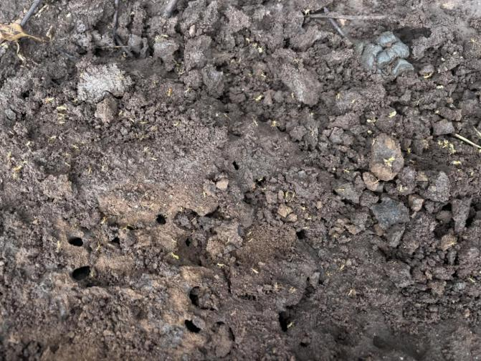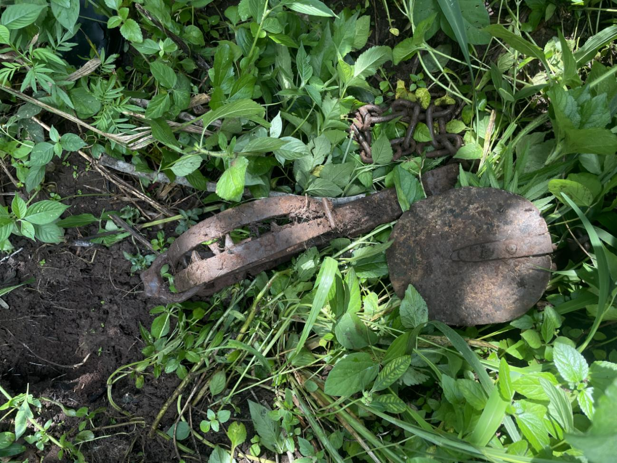
Plate 4: Feces of an antelope Plate 5: Trap used for hunting large mammals

CONCLUSION
This study has demonstrated that the project area hosts a moderately diverse and ecologically significant assemblage of wildlife species, such as vulnerable or endangered. The recorded Shannon Diversity Index of 2.0546 indicates a reasonably healthy ecosystem, though species evenness suggests a dominance of certain groups such as birds and mammals over others like invertebrates. The presence of key taxa such as large mammals, pollinators, and soil invertebrates reinforces the ecological complexity and functional importance of the area.
Despite the ecological value of the region, the identified impacts of road development and associated land-use changes are largely of minor significance, owing to the limited spatial scale, potential for natural recovery, and available mitigation strategies. However, cumulative effects, particularly habitat fragmentation, wildlife mortality, pollution, and invasive species introduction, require careful, ongoing management. The study also highlights the importance of using a combination of non-invasive methods such as visual observations, acoustic monitoring, and track/sign surveys, supported by spatial tools like GIS and species checklists, to effectively assess biodiversity and guide conservation efforts.
The proximity to protected areas like Kidepo Valley National Park adds ecological sensitivity to the landscape, necessitating a balance between infrastructure development and conservation imperatives. Findings from this assessment provide a solid foundation for aligning environmental management practices with national and international biodiversity commitments.

RECOMMENDATIONS
To promote biodiversity conservation while enabling sustainable development in the project area, the following recommendations are made:
Biodiversity considerations should be fully integrated into local and regional planning policies. Environmental Impact Assessments (EIAs) should require comprehensive biodiversity baselines, such as species checklists, acoustic surveys, and habitat quality assessments, as prerequisites for development approvals. Road projects should incorporate green infrastructure elements—such as wildlife corridors, green bridges, and culverts to maintain ecological connectivity.
Institutions should prioritize long-term ecological monitoring using a combination of traditional field methods and modern technologies such as remote sensing, DNA sampling, GPS/GIS mapping, and acoustic sensors. Emphasis should be placed on monitoring changes in species composition, abundance, and movement patterns to inform adaptive management strategies.
Degraded habitats should be rehabilitated through the planting of native vegetation, restoration of riparian buffers, and creation of microhabitats to support diverse fauna. Active management of invasive species should include early detection systems, equipment hygiene protocols, and community reporting mechanisms.
Local communities should be involved in biodiversity protection through education programs, participatory wildlife monitoring, and incentive-based conservation initiatives such as eco-tourism and conservation agriculture. Training for project personnel in wildlife sensitivity and environmental stewardship should also be mandated.
Mitigation measures should include speed limits, road signage, acoustic deterrents, and restrictions on nighttime construction activities to reduce wildlife mortality and disturbance. Specific zones should be designated as sensitive habitats with limited human access to reduce stress on vulnerable species.
Multi-stakeholder collaboration among government agencies, conservation NGOs, academic institutions, and local communities should be institutionalized to harmonize development goals with biodiversity conservation and to share data, tools, and best practices.
By implementing these recommendations, stakeholders can ensure that the ecological integrity of the project area is preserved while accommodating necessary infrastructure development, thereby contributing to national conservation goals and global biodiversity targets.

REFERENCES

Animal Ethics. (2025). Population dynamics and animal suffering. https://www.animal-ethics.org/population-dynamics
Ann, C. (2020). Sclerophrys gutturalis.
Arthur, C. (2020). Sylvicapra grimmia, bush duiker.
Bera, B. (2022). Species diversity: Components, importance, threats and conservation.
BirdLife International. (2016). Amadina fasciata. The IUCN Red List of Threatened Species, 2016, e.T22719927A94651784. https://doi.org/10.2305/IUCN.UK.2016-3.RLTS.T22719927A94651784.en
BirdLife International. (2016). Corvinella corvina. The IUCN Red List of Threatened Species, 2016, e.T22705103A94000483. https://doi.org/10.2305/IUCN.UK.2016-3.RLTS.T22705103A94000483.en
BirdLife International. (2017). Apalis karamojae. The IUCN Red List of Threatened Species, 2017, e.T22713830A118853621. https://doi.org/10.2305/IUCN.UK.2017-3.RLTS.T22713830A118853621.en
BirdLife International. (2017). Lagonosticta rubricata. The IUCN Red List of Threatened Species, 2017, e.T22731403A111147608. https://doi.org/10.2305/IUCN.UK.2017-1.RLTS.T22731403A111147608.en
BirdLife International. (2018). Euplectes franciscanus. The IUCN Red List of Threatened Species, 2018, e.T22719181A131991350. https://doi.org/10.2305/IUCN.UK.2018-2.RLTS.T22719181A131991350.en
BirdLife International. (2018). Numida meleagris. The IUCN Red List of Threatened Species, 2018, e.T22679555A132052202. https://doi.org/10.2305/IUCN.UK.2018-2.RLTS.T22679555A132052202.en
BirdLife International. (2018). Passer swainsonii. The IUCN Red List of Threatened Species, 2018, e.T22718237A131883133. https://doi.org/10.2305/IUCN.UK.2018-2.RLTS.T22718237A131883133.en
Bhatt, R. P. (2023). Environmental impact assessment system and process in developing countries. School of Science and Engineering, Atlantic International University. https://doi.org/10.4236/oje.2023.1312059
Center for Biological Diversity. (2025). The elements of diversity.
El Badry Fadl, E. (2021). The role of environmental impact assessment in achieving sustainable development.
Environmental Protection Department. (2023). Technical memorandum on environmental impact assessment process.
Ugwu, E. I., Ekeleme, A. C., Okolie, S. T. A., Ibe, O. P., Chieke, C. F., Ibearugbulem, H. O., Omeje, M., Awoyera, P. O., & Ede, A. N. (2019). Mitigating biodiversity destruction of infrastructural projects through environmental impacts assessment. International Journal of Sustainable Built Environment, 8(1), 155–164.
Food and Agriculture Organization. (2003). Global overview of the management of the invasive species. FAO.
Food and Agriculture Organization. (2023). Elephant conservation action plan for Uganda. FAOLEX.
Felidae Conservation Fund. (2024). Serval. https://www.felidaefund.org/
Fillipe, C., Sarah, M. S., Antonio, M., & Rui, L. (2017). Methods to monitor and mitigate wildlife mortality in railways. Ecological Engineering, 106, 30–40.
Frank, A. L. S., Marius, S., Adrian, M. D., & Elliot, T. M. (2022). Seasonal species richness of birds on the world's islands and its geographical correlates. Global Ecology and Biogeography, 31(3), 401–413.
Gizachew, G. (2022). Spatial-temporal and factors influencing the distribution of biodiversity: A review. Ecology and Evolution, 12(6), e8867.
International Association for Impact Assessment. (2002). Mitigation and impact management. https://www.iaia.org/uploads/pdf/IAIAMitigation.pdf
International Fund for Animal Welfare. (2024). How habitat fragmentation affects animals. https://www.ifaw.org/
Javaid, D. N., Shakoor, A., Deepali, S., & Jatinder, J. (2025). Distribution and abundance of a soil centipede, Tygarrup nepalensis Shinohara, 1965 in a moist temperate forest in Northwest Himalaya. Journal of Environmental Biology, 46(1), 112–120.
Kassahun, A., Belete, T., Abel, F., Tewodros, K., & Alemneh, A. (n.d.). Diversity and habitat association of medium and large mammals in Gibe Sheleko National Park, Southern Ethiopia. Ecology and Evolution. https://doi.org/10.1002/ece3.8000
Mark, P. (2010). Characterizing communities. https://www.ecology.org/communities
Mohammed, Y. S., Joseph, O. O., Shem, C. K., Ogeli, M., Robin, S. R., & de Leeuw, J. (2016). Effects of extreme land fragmentation on wildlife and livestock population abundance and distribution. Pastoralism, 6, 25.
Mubashar, H., & Salma, B. (2016). Wildlife in the perspective of environmental degradation: A review. International Journal of Environmental Sciences, 7(1), 101–110.
Murchison Falls National Park. (2024). Murchison Falls National Park animals/wildlife in Murchison Falls National Park. https://www.murchisonfallsnationalpark.com/
Obed, N., & Innocent, N. (2024). The effects of wetland degradation on ecological species. African Journal of Ecology, 62(1), 55–66.
Pereira, F. P. R. (2024). Two sides of the same coin? Ants are ecosystem engineers and providers of ecosystem services. Ecological Entomology, 49(1), 10–22.
Robert, S. C. C., Felix, E., & Amanda, E. B. (2020). Ecological distinctiveness of birds and mammals at the global scale. Global Ecology and Conservation, 24, e00970. https://doi.org/10.1016/j.gecco.2020.e00970
Rosie. (2024). How biotic and abiotic factors affect species distribution. https://www.environmentinsight.org/
Selene, O. B. (2015). Shannon-Weaver Diversity Index.
Senessa, D., & Temesgen, M. (2024). Mound abundance, the livelihood impacts and determinant factors of termites in Meta Robi district, central Ethiopia. Environmental and Sustainability Indicators, 20, 100250.
Seydack, A. H. W. (2015, December 18). Potamochoerus larvatus. The IUCN Red List of Threatened Species. https://www.iucnredlist.org/species/41775/44140997
Sharashy, O. (2022). Application of Shannon and Simpson diversity index to study plant biodiversity on coastal rocky ridges habitats with reference to census data in the Ras El-Hekma and Omayed area on the western coastal region of Egypt. Journal of Pure & Applied Sciences, 21(1), 41–45. https://doi.org/10.51984/jopas.v21i1.1578
Steve, A. (2024). Marsh frog guide: Species range, how they arrived in the UK, and what they sound like. https://www.natureuk.org/marsh-frog-guide
United States Department of Agriculture. (2024). Ecosystem services from national grasslands (p. 2). https://www.usda.gov/
Valley, M., Gavrilov, T. B., & Golubeva, A. V. B. (2023). Metabolic rate, sleep duration, and body temperature in evolution of mammals and birds: The influence of geological time of principal groups divergence. Evolutionary Biology, 50(3), 183–199.
World Wildlife Fund. (2019). Human-wildlife mitigation. https://www.worldwildlife.org/
Ministry of Water and Environment. (2025). Karenga District – Uganda water supply atlas. https://
Karenga District Local Government. (2023, May 4). Production & marketing.
Karenga District Local Government. (2019, June 16). About us

