Original Research Article

Diversity, Composition and Threats Caused by Anthropogenic Activities on Riparian Vegetation Across Agro-ecosystem Landscapes of Bhadra River

ABSTRACT
Riparian areas are the unique areas which are adjacent water body. These transitional zones play a vital role in maintaining water quality and regulating hydrological processes. The current study focuses on the downstream agro-ecosystem landscapes of the Bhadra River, aiming to develop a comprehensive checklist of riparian flora. It examines the tree species diversity, composition and richness of Riparian area from January to May 2025. The study also emphasis to assesses anthropogenic disturbances affecting riparian vegetation in the study area. Random plots were laid on both the sides of Agroecosystem riparian areas of downstream Bhadra river. A total of 48 tree species belonging to 24 families were recorded from the riparian agroecosystem zones of the Bhadra River dominated by the Family Fabaceae. IVI analysis reveals that Albizia saman, Pongemia pinnata, Leucaena leucocephala and Eucalyptus as dominant contributors to the vegetation structure. Restoration of native riparian vegetation is therefore critical, not only for the conservation of river morphology and associated aquatic habitats but also for the maintenance of essential ecosystem services.
Keywords: Anthropogenic, Bhadra, Conservation, Dominance, Habitat, Riparian, Trees

- INTRODUCTION

The word ‘riparian’ is derived from Latin word riparius meaning land adjacent to the water body (Naiman and Decamps 1997). Vegetation in riverine zones are generally differentiated by unique characters than terrestrial ecosystem (Amitha 2003) and high species richness (Naiman et al., 1993; Murray and Stauffer 1995). They provides major environmental services through trapping sediments, nutrients and pollutants from agricultural and urban runoff, besides maintaining aquatic biodiversity (Naiman and Decamps 1997). These zones serve as the transitional areas between the aquatic and the terrestrial environment ( Zaimes et al., 2010). They consist of riverbed, banks, vegetation, land adjacent to floodplains and are crucial for maintaining the water quality in aquatic ecosystems (Maraseni and Mitchel 2016). Riparian areas have received much attention in the recent years (Scott et al., 2009), due to their role in providing many ecosystem services such as preventing soil erosion, minimizing floods, enhancing wildlife corridor, habitat for endemic species and many. They are recognized as key stone ecosystems because of some unique habitats highly influenced by water (Goebel et al., 2003). Riparian forests are also recognized as a critically and functionally dominant component of a terrestrial landscape (Tabacchi et al., 1998). These unique landscapes across the world generally promote mechanized agriculture and animal husbandry (Burkhart et al., 1994; Dudgeon 2000). The use of riparian zones for agriculture is a predominant along the river banks which affects the ecology and ecosystem services and interfere with ecological functions of wetlands (Gopal et al., 2002). The intense usage of riparian zones for agricultural activities have caused much spatial variations in the native species richness, composition and productivity (Aguiar and Ferreira 2005; An et al., 2002; Corbacho et al., 2003; Gopal et al., 2002; Smakhtin and Anputhas 2006). These disturbances also lead to the biodiversity loss (Sultana et al., 2014) polluting the streams and eventually affect the hydrological cycles which in turn impacts human livelihood activities in the downstream by accelerating floods in case of heavy rainfalls and decreased water availability during summer (Barthelemy et al., 2015).

MATERIALS AND METHODS

  - Study area

Bhadra River is a tributary of the River Tungabhadra, originates from “Gangamula” near Varaha Hills of Western Ghats, Karnataka (India; 13˚21 to 14˚0 N Latitude and 75˚26 to 75˚41 E Longitude), and it is impounded at a distance of 1708 m² called Bhadra reservoir (Shahnawaz et al., 2010). The study area was the Riparian areas of downstream below the Lakkavalli dam to Kudli, Sangama Shivamogga Karnataka (72 km in length), where the stream joins Tunga River to form Tungabhadra as a single stream and flows further.

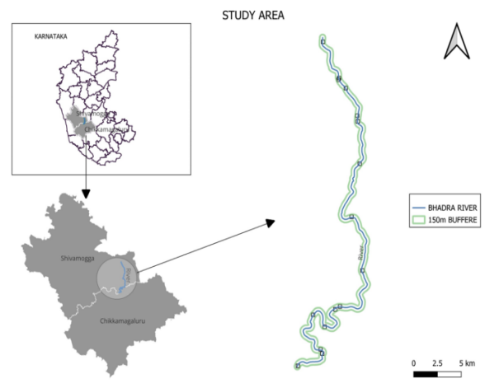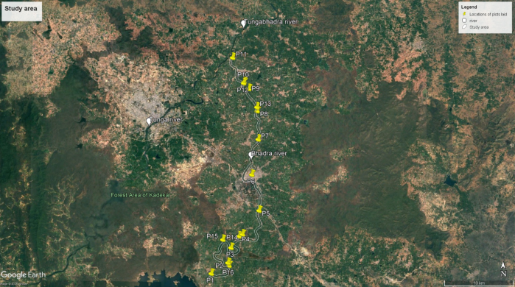
Fig 1.Study area map Fig 2 . Google earth image of study area with GPS locations of the plots

2.2 Methodology

2.2.1 Sampling design (vegetation analysis): Random plots were laid on both the sides of agro-ecosystem riparian areas of downstream Bhadra. Total of 16 plots were sampled from January to May 2025, at each plot a belt transect of 100x50m was laid and floristic assessment was done using quadrant of 20 m × 20 m (4 at each corner of a transect and 1 in the center) Total number of individuals (> 30 cm in girth at breast height or GBH) was recorded in each sampling plot following the methodology of Chikkahuchaiah et al., 2016 . The total area sampled was 8 Hectares and the tree species were identified using Forest trees of central western ghats A pictorial field manual; Karnataka state medicinal plant authority and Forest plants of Nilgiris A pictorial field manual key stone foundation.
For vegetation analysis density, abundance, frequency, species richness and basal area per 0.5 hectare were estimated to measure the structure and diversity of the riparian vegetation. The relative frequency, relative density, relative dominance (relative basal area), and importance value index (IVI) were calculated for tree Species of agro-ecosystem areas of downstream Bhadra river Shannon - Wiener Index (H′) was used to calculate the species diversity ,Simpson Index to measure dominance and species similarity index to calculate the similarity of Riparian vegetation along the Bhadra River upstream and downstream of the urban centre Bhadravati (Bray-Curtis cluster analysis - single link) The value of Bray Curtis similarity index varies between 0 and 100 %, where 100 means the two sites have the same composition.

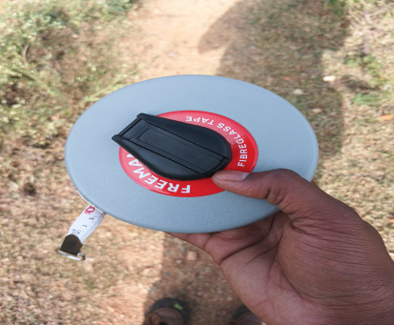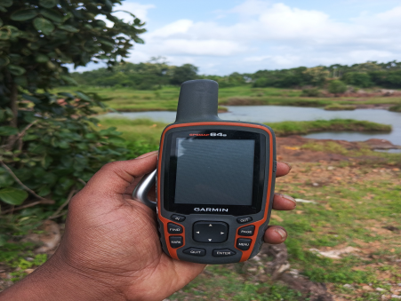
Fig 3. Measuring tape Fig 4. GPS Device Fig 5.Range Finder

2.2.2 Sampling design (tree documentation): 5000 m2 (100 m × 50 m) size belt transect was laid(16 random sites). Subjected to floristic assessment using a quadrant of 20 m × 20 m (4 at each corner of a transect and 1 in the center). Total number of individuals (> 30 cm in girth at breast height or GBH) was recorded in each sampling plot.
2.2.3 Data analysis: For vegetation analysis density, abundance, frequency, species richness and basal area per 0.5hectar were estimated to measure the structure and diversity of the riparian vegetation. The relative frequency, relative density, relative dominance (relative basal area), and importance value index (IVI) were calculated. Shannon - Wiener Index (H′) was used to calculate the species diversity. Simpson Index to measure dominance. Species similarity index (Bray-Curtis cluster analysis - single link) The value of Bray Curtis similarity index varies between 0 and 100 %, where 100 means the two sites have the same composition by using Excel and Past software.

2.2.4 Formulae and calculations
Simpson diversity: D=1−∑(Pi)²
Where, Pi indicates the proportion of individuals from species i in the community,
Shannon diversity index: H = -Σ(pi * ln(pi))
Where, H is the Shannon Diversity Index, pi is the proportion of individuals of each species in the community.
Basal area: Basal area= C2 / 4π, where C=gbh
Importance value index =Relative frequency + Relative dominance +Relative density

RESULTS AND DISCUSSION

Vegetation characteristics: A total of 48 tree species belonging to 24 families were recorded from the riparian agroecosystem zones of the Bhadra River (Table 1) dominated by the Family Fabaceae (Graph 1) Among these, 37 species i.e 78% were native and 11 species i.e 22% were non-native (Graph 2 and 3). The data reveals significant variation in ecological dominance, species distribution and abundance across the study area. The total number of individuals recorded was 463, with Albizia saman (84 individuals), Pongamia pinnata (55 individuals), and Leucaena leucocephala (33 individuals) contributing the highest numbers. Some species like Albizia saman occurred in all 16 grids while other species were limited to 1 or 2 grids, disclosing the changes in species distribution.

Graph 1: Showing the number of species

Graph 2 : Nativity of riparian tree species Graph 3: Habitat of species

Species accumulation and sampling adequacy: The species accumulation curve presented in Graph 4 displays the relationship between the number of plots sampled and the recorded number of tree species along the riparian buffers of Bhadra river. The curve shows in initial plots the number of new species discovered increased for every sampling plot and a clear saturation was seen in further plots for 48 species beyond which no new species were recorded. this ensures that the sampling effort was adequate to document the full extent of tree species diversity in the studied riparian agro-ecosystems.

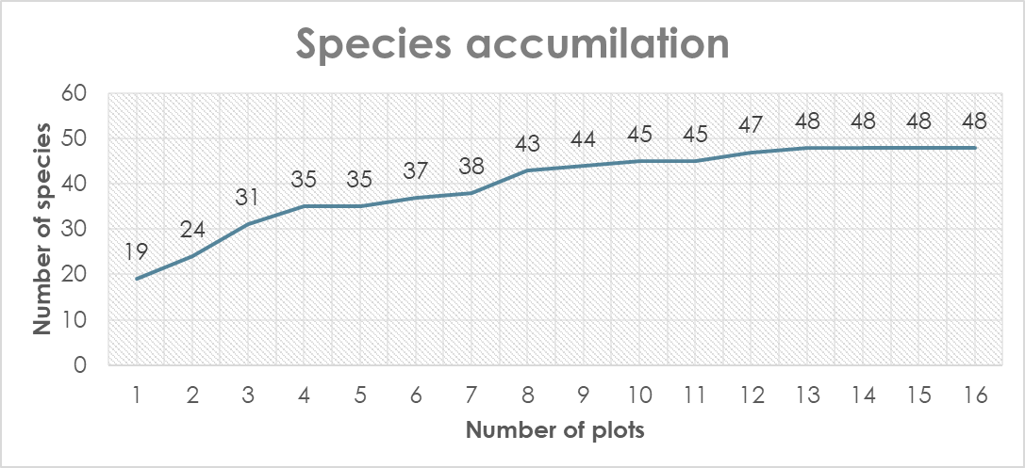
Graph 4 : Showing species accumulation in plots laid in the Riparian vegetation of Bhadra river

Density and Dominance: The highest density was observed for Albizia saman (5.25), followed by pongemia pinnata (3.44) and Leucaena leucocephala (2.06), indicating their consistent dominance in the study area. specially, Albizia saman which is an exotic species with high frequency (100%) and abundance (5.25), also holds the largest basal area (821.6), suggesting its aggressive colonization in riparian zones of Bhadra river. Albizia saman, Pongemia pinnata, and Tamarindus indica also exhibited the highest frequency (100%) (Graph 5). Species such as Ficus religiosa, Azadirachta indica, and Syzygium cumini showed wide frequency ranges (≥62.5%), showing adaptive nature to both riparian and non-riparian habitats.

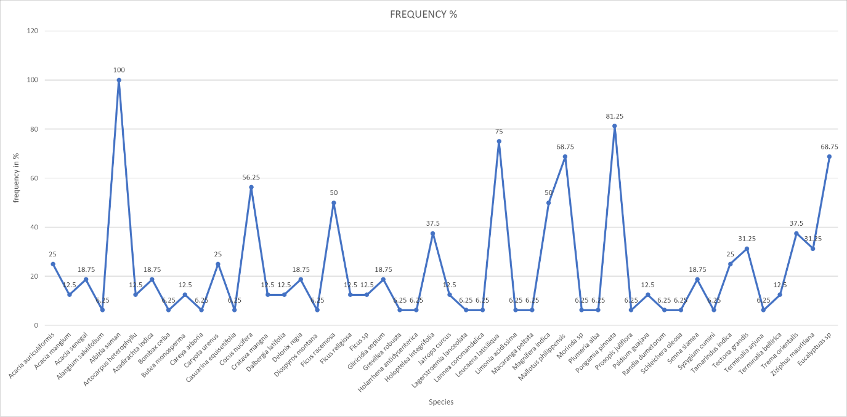
Graph 5: Frequency of species in the study area

IVI analysis reveals that, Albizia saman (66.18), Pongemia pinnata (30.14), Leucaena leucocephala (35.81) and Eucalyptus (18.32) are the dominant contributors to the vegetation structure. In contrast, the species with the lowest IVI was Syzygium cumini, with an IVI of 0.82, in spite of being native and ecologically important riparian species (Table 2).

Table 1. Checklist of riparian tree species in agroecosystem zones of Bhadra River

Sl. No. | Species | Common Name | Family | Nativity | Habitat
1 | Acacia auriculiformis | Ear pod wattle | Fabaceae | Exotic | Both
2 | Acacia mangium | Black wattle | Fabaceae | Exotic | Both
3 | Acacia senegal | Gum acacia | Fabaceae | Native | Both
4 | Alangium salviifolium | Ankola | Alangiaceae | Native | Both
5 | Albizia saman | Rain tree | Fabaceae | Exotic | Non-riparian
6 | Artocarpus heterophyllus | Jack fruit | Moraceae | Native | Non-riparian
7 | Azadirachta indica | Neem | Meliaceae | Exotic | Both
8 | Bombax ceiba | Cotton tree | Malvaceae | Native | Both
9 | Butea monosperma | flame of the forest | Fabaceae | Native | Non-riparian
10 | Careya arborea | Kavala | Lecythidaceae | Native | Both
11 | Caryota urens | Toddy palm | Arecaceae | Native | Both
12 | Casuarina equisetifolia | Costal she oak | Casuarinaceae | Exotic | Both
13 | Cocus nucifera | Coconut tree | Arecaceae | Exotic | Non-riparian
14 | Crateva magna | Bipatri | Capparaceae | Native | Riparian
15 | Dalbergia latifolia | Beete | Fabaceae | Native | Both
16 | Delonix regia | Gulmohar | Fabaceae | Exotic | Non-riparian
17 | Diospyros montana | Jagalkanti | Ebenaceae | Native | Both
18 | Ficus racemosa | Atti mara | Moraceae | Native | Both
19 | Ficus religiosa | Arali mara | Moraceae | Native | Both
20 | Ficus sp | _ | Moraceae | Native | Both
21 | Gliricidia sepium | Gobbarad gida | Fabaceae | Exotic | Both
22 | Grevillea robusta | Silver oak | Proteaceae | Exotic | Non-riparian
23 | Holarrhena antidysenterica | Kodasiga | Apocynaceae | Native | Both
24 | Holoptelea integrifolia | Chirabilva | Ulmaceae | Native | Both
25 | Jatropha curcas | Physic nut | Euphorbiaceae | Exotic | Non-riparian
26 | Lagerstroemia lanceolata | Nandi | Lythraceae | Native | Both
27 | Lannea coromandelica | Indian ash tree | Anacardiaceae | Native | Both
28 | Leucaena leucocephala | Subabul | Fabaceae | Exotic | Both
29 | Limonia acidissima | Wood apple | Rutaceae | Native | Both
30 | Macaranga peltata | Chandada | Euphorbiaceae | Native | Riparian
31 | Mangifera indica | Mango | Anacardiaceae | Native | Both
32 | Mallotus philippensis | Kunkum tree | Euphorbiaceae | Native | Both
33 | Morinda sp | Indian mulberry | Rubiaceae | Native | Both
34 | Plumeria alba | Deva kanagale | Apocynaceae | Exotic | Exotic
35 | Pongamia pinnata | Honge | Fabaceae | Native | Both
36 | Prosopis juliflora | Bellari jali | Fabaceae | Exotic | Both
37 | Psidium guajava | Common guava | Myrtaceae | Exotic | Both
38 | Randia dumetorum | Madanphal | Rubiaceae | Native | Both
39 | Schleichera oleosa | Kusum tree | Sapindaceae | Native | Non-riparian
40 | Senna siamea | Kassod tree | Fabaceae | Exotic | Non-riparian
41 | Syzygium cumini | Indian blackberry | Myrtaceae | Native | Both
42 | Tamarindus indica | Tamrind,Hunase mara | Fabaceae | Native | Exotic
43 | Tectona grandis | Teak,saguvani | Lamiaceae | Native | Riparian
44 | Terminalia arjuna | Holematti | Combretaceae | Native | Riparian
45 | Terminalia bellirica | Baheda | Combretaceae | Native | Both
46 | Trema orientalis | Indian charcoal tree | Cannabaceae | Native | Both
47 | Ziziphus mauritiana | Borehannina mara | Rhamnaceae | Native | Both
48 | Eucalyptus sp. | Nilgiri | Myrtaceae | Exotic | Both

Table 2. Species with top IVIs

Sl no. | Species | Common name | Family | Nativity | Habitat | Individuals | No of grids | Species presence | Density | IVI
1 | Albizia saman | Rain tree | Fabaceae | Exotic | Non riparian | 84 | 16 | 16 | 5.25 | 66.1
2 | Leucaena latisiliqua | Subabul | Fabaceae | Exotic | Riparian | 33 | 16 | 12 | 2.06 | 35.8
3 | Pongamia pinnata | Honge | Fabaceae | Native | Both | 55 | 16 | 13 | 3.44 | 30.1
4 | Eucalyptuas sp | Nilgiri | Myrteceae | Exotic | Non riparian | 30 | 16 | 11 | 1.88 | 18.3
5 | Mallotus philippensis | Kunkum tree | Euphorbiaceae | Native | Both | 28 | 16 | 11 | 1.88 | 16.1
6 | Cocus nucifera | Coconut tree | Arecaceae | Native | Non riparian | 38 | 16 | 9 | 2.38 | 14.5
7 | Magnifera indica | Mango | Anacardiaceae | Native | Both | 19 | 16 | 8 | 1.19 | 9.9
8 | Ficus racemosa | Atti mara | Moraceae | Native | Both | 11 | 16 | 8 | 0.69 | 7.3
9 | Tamarindus indica | Tamrind,Hunase mara | Fabaceae | Exotic | Both | 12 | 16 | 4 | 0.75 | 6.9

The Shannon-Wiener Diversity index was calculated for the data which showed a value of 3.1094 Indicating a moderate species richness in the study area and the Simpson diversity value was found to be 0.928 disclosing a high level of diversity in riparian areas of Bhadra river. Riparian vegetation along the Bhadra River upstream and downstream of the urban centre Bhadravati, Results showed contrasting species diversity the eight plots before the city exhibited a mean dominance(D) of approximately 0.1366, Simpson 0.863, Shannon 2.244, and evenness 0.8241, showing a balanced vegetation structure. In contrast, the eight downstream plots after the city showed a slightly higher average dominance (0.1600), lower Simpson (~0.8396) and Shannon (~2.0403), with evenness increased to 0.8681. These trends indicate that urban influence may have reduced species richness and diversity downstream. Such patterns align with broader findings showing urbanization often elevates dominance and suppresses both richness and diversity in riparian zones, often due to habitat degradation, altered hydrology, and non-native species intrusion. The reduced species richness and elevated dominance are often due to the habitat degradation and non-native species intrusion (Table 4).

Table 3. Diversity indices of each plots

Plots | No. of species | Individuals | Dominance | Simpson Diversity | Shannon Diversity | Evenness
Plot 1 | 19 | 48 | 0.06771 | 0.9323 | 2.806 | 0.8706
Plot 2 | 12 | 27 | 0.1139 | 0.8861 | 2.311 | 0.8403
Plot 3 | 17 | 37 | 0.07378 | 0.9262 | 2.714 | 0.8877
Plot 4 | 20 | 49 | 0.122 | 0.878 | 2.558 | 0.6452
Plot 5 | 7 | 26 | 0.2663 | 0.7337 | 1.553 | 0.6748
Plot 6 | 10 | 25 | 0.152 | 0.848 | 2.078 | 0.7986
Plot 7 | 9 | 18 | 0.1358 | 0.8642 | 2.091 | 0.8993
Plot 8 | 11 | 24 | 0.1389 | 0.8611 | 2.167 | 0.7935
Plot 9 | 3 | 4 | 0.375 | 0.625 | 1.04 | 0.9428
Plot 10 | 12 | 25 | 0.1104 | 0.8896 | 2.332 | 0.8579
Plot 11 | 10 | 26 | 0.1331 | 0.8669 | 2.144 | 0.8537
Plot 12 | 9 | 30 | 0.1289 | 0.8711 | 2.122 | 0.9271
Plot 13 | 12 | 45 | 0.1062 | 0.8938 | 2.348 | 0.8716
Plot 14 | 9 | 26 | 0.1361 | 0.8639 | 2.091 | 0.8993
Plot 15 | 8 | 29 | 0.1605 | 0.8395 | 1.954 | 0.8823
Plot 16 | 8 | 24 | 0.1528 | 0.8472 | 1.966 | 0.8926
Average | 11 | 28.9375 | 0.148336875 | 0.8516625 | 2.1421875 | 0.84608125

Table 4. Interpretation of Diversity indices values

Plots | Abundance and Richness | Shannon and Simpson (Diversity) | Evenness | Conclusion
1,3,13 | High | Very high | High | Highly diverse and balanced vegetation structures
2,6,7,8,10,11,12,14,15 and 16 | Moderate | Moderate diversity | Moderate | Moderately diverse with some dominant species
4 and 5 | Moderate to high | Lower Shannon diversity index | Low dominance of species | Potential disturbance and imbalanced vegetation structures
9 | Very low | Very low | High but only among 3 species | Dominated by very few taxa indicating complete imbalanced community structure

Species similarity index (Bray-Curtis cluster analysis - single link)
The value of Bray Curtis similarity index was calculated by dividing the study area on the bases of moderate pollution of the stream after the urban centre Bhadravati due to discharge of effluents from industries, in addition to that indiscriminate use of river water for various domestic activities (Shivashankar and Venkataramana 2015) i.e.8 plots before the city and 8 plots after the city. The similarity index value was found to be 72% with 35 species in the first 8 plots and 31 species after 8 plots having 24 species in common (Graph 6 ,7 and Table 5).

Table 5. Similarity index upstream and downstream of the urban centre

No. of Species in first 8 Plots | No. of Species after 8 Plots | Common Species in Both
35 | 31 | 24
Bray Curtis Similarity Index= | 0.72 / 72%

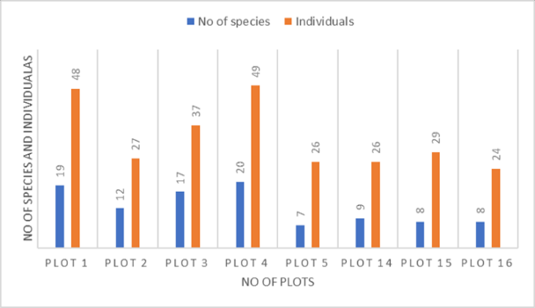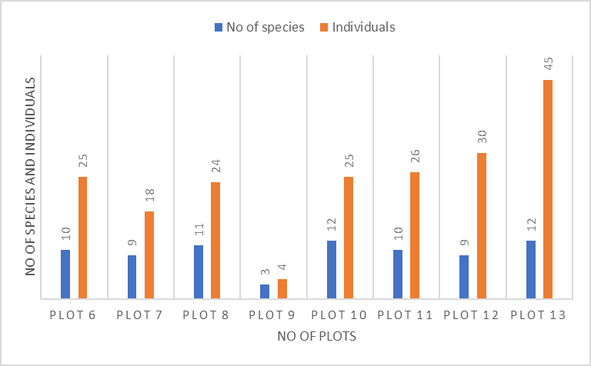

Graph 6 and 7 : showing number of species and individuals before and after Bhadravati city

- pinnata and Albizia saman which are deciduous tree species which are more dominant in the riparian forest than any other riparian species. They are the pioneer species which often replaces the dominant native riparian species and initiates secondary succession in riparian areas. With the availability of water, fast growth rate and seed dispersal, the species have rapidly invaded the riparian zones and have led to displacement of native riparian species. Several studies have demonstrated that a decline in native riparian tree species can directly impact the richness and diversity of avian species (Arizmendi et al., 2008; Edward et al., 2008; Hinojosa 2006; Villasenor 2006). Domination of plantation species with top IVIs, confirmed a large extent of agricultural encroachments and anthropogenic activities in the riparian landscapes of downstream Bhadra river (Graph 1 and 8). The dominance of P. pinnata and Albizia saman is an unfavourable trend of a naturally balanced riparian ecosystems because these species perform very few ecological functions tan native riparian species.

Graph 8: Importance value index of tree species of riparian vegetation of Bhadra river

The analysis of 16 riparian plots (each 100 × 50 m) along the Bhadra River unfolds a clear pattern in vegetation diversity. Plots with higher species richness (e.g.,1, 3, 13) which show higher Simpson and Shannon values, indicting both relative even distribution of individuals and greater number of species, whereas plot no 9, with only 4 individuals and 3 species has a very low Shannon and Simpson values signalling dominated by one species and very low diversity. Most plots are with the values around 0.79–0.90, reflecting moderate-to-high balance, while plots 4 and 5 decline (~0.65–0.67), indicating low moderate richness and domination of few species. Thus, by combining the values of richness, Shannon and Simpson diversities and evenness allow to distinguish between structurally balanced plots versus those influenced by dominance of few species (Table 3,4 and 5).

Threats caused by anthropogenic activities

- Agricultural encroachments: The riparian areas of Bhadra river area mainly used for Areca nut and palm plantations ,majority of people along the banks of the stream depends on agriculture. Expansion of agricultural activities along the riparian corridor have led to a decline in these riparian and evergreen species in the study area (Chikkahuchaiah et al., 2016). And in some places the riparian buffers are completely eliminated and replaced with plantations which can result in flooding in cases of heavy rainfalls.
- Livestock grazing in riparian zones: livestock grazing is one of the major threats for riparian buffers excessive livestock grazing creates a suitable niche for P. pinnata to become dominant because it is less palatable to livestock (Daniel and Hegde 2007). livestock grazing was observed in majority of study sites . field data reveals overgrazing in riparian zones leads to evident ecological alterations, resulting in impacting bank stability and increased Vulnerability to river bank erosion. The study showed a noticeable reduction in native riparian plant species diversity, collectively Emphasize the negative impacts of Uncontrolled livestock grazing on riparian ecosystem quality and hydrological stability
- Sand mining: Sand mining was reported in all most all the sites. It is also, a threat to the existence of native species, as it interferes with the flow of surface water, which is an indispensable requirement to retain soil moisture for their germination of seeds. Sand mining can eventually contribute to change in stream morphology. The findings reveal that sand mining within riparian buffers considerably alters the physical and ecological integrity of river systems.

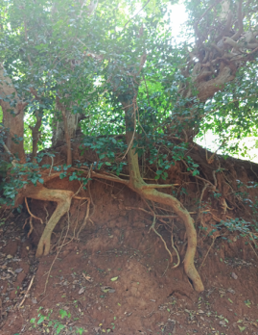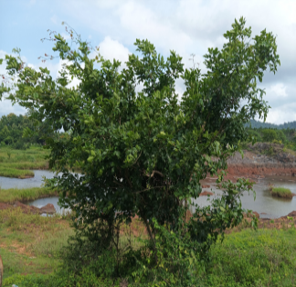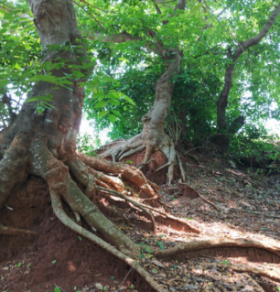

Fig 6. Regeneration of P.pinnata
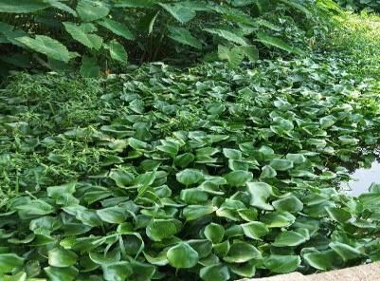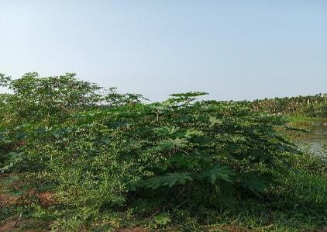
Fig 7. Invasive species
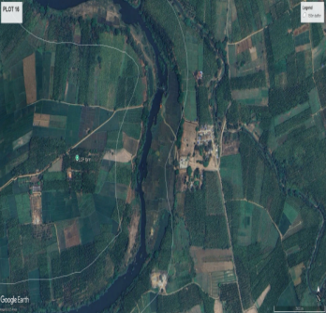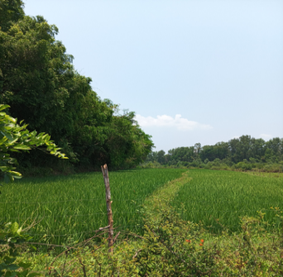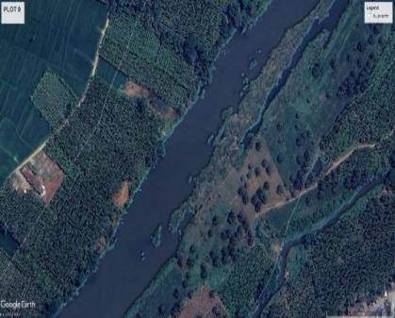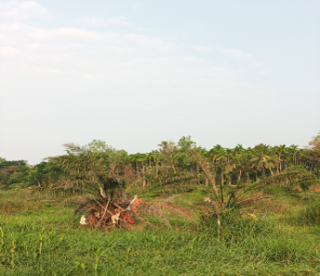
Fig 8. Showing agriculture encroachment
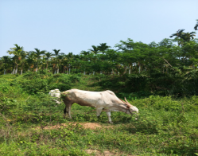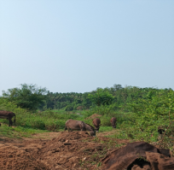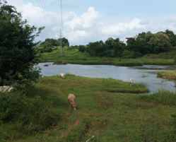
Fig 9. Showing Livestock grazing
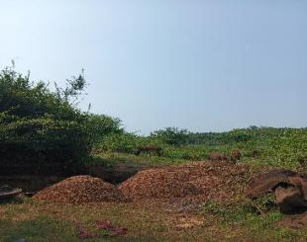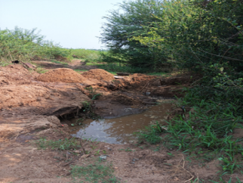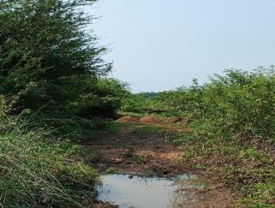
Fig 10. Showing sand mining

- CONCLUSION

The study highlights noticeable variations in riparian vegetation structures, which are largely driven by anthropogenic pressures within the riparian buffers of agro-ecosystem landscapes of Bhadra river. Among the tree species recorded, Pongamia pinnata and Albizia saman are the non-riparian species which exhibited the highest value of Importance Value Indices (IVIs), showing their dominance in the study area. we can clearly understand that these species have out competed native riparian species such as Terminalia arjuna and Syzygium cumini which are highly adapted for riverine ecosystem and perform some unique functions like regulating hydrology of rivers, stabilizing river banks by controlling erosion, and supporting both aquatic and terrestrial biodiversity. The dominance of non-riparian or semi riparian species reflects a shift from native species ecological assemblages towards human-induced plant communities, a trend that comprises the ecosystem stability and resilience of riverine ecosystems. Healthy riparian buffers in agro-ecosystem areas of rivers play a very crucial role in sediment sustainability, bank stabilization, checking agricultural runoff and also provides habitat connectivity. These services especially in riparian areas adjacent to agricultural dependent communities are very pivotal for stability of aquatic biodiversity and maintaining water quality, which directly influences the well-being and livelihoods of local communities. Considering the current problems like increasing climate change and over-exploitation of natural resources, riparian buffers in India need urgent conservation attention. Government authorities in collaboration with stakeholders and scientific institutions should develop conservation strategies such as ecological monitoring and public awareness. unnoticed expansion of agricultural activities in riparian buffers is leading to intense habitat fragmentation and degradation. In conclusion protection and restoration of riverine vegetation along rivers like Bhadra is essential for conservation of biodiversity, sustaining ecosystem services and improving the adaptive capacity of riparian landscapes.

Reference

Aguiar, F. C. & M. T. Ferreira. (2005). Human disturbed landscapes: effects on composition and integrity of riparian woody vegetation in the Tagus River basin, Portugal. Environmental Conservation. 32: 30-41.

Amitha Bachan, K. H. (2003). Riparian Vegetation along the Middle and Lower Zones of the Chalakkudy River, Kerala, India. Limnological Association of Kerala, Iringalakkuda. Project Report. Kerala Research Programme on Local Level Development, CDS, Thiruvananthapuram. DOI: 10.13140/RG.2.2.30174.69448.

An, S., X. Cheng, S. Sun, Y. Wang & J. Li. (2002). Composition change and vegetation degradation of riparian forests in the altai plain, NW China. Plant Ecology. 164: 75-84.
Arizmendi, M. C., P. Davila, A. Estrada & E. Figueroa. (2008). Riparian mesquite bushes are important for bird conservation in tropical arid Mexico. Journal of Arid Environments. 72: 1146-1163.
Barthelemy, Y., S. Patrice, Y. Salifou, M. R. Jeanne & H. Victor. (2015). Floristic diversity of Piliostigma associations in relation to latitudinal gradient, soil and climate variables in Burkina Faso, West Africa. Tropical Ecology. 56: 57-76.
Burkhart, M. R., S. L. Oberle, M. J. Hewitt & J. Picklus. (1994). A framework for regional agro-ecosystems characterization using the national resources inventory. Journal of Environmental Quality. 23: 866-874.
Chikkahuchaiah Sunil, Rayasamudra Kalegowda Somashekar and Badenahally Chikkarangappa Nagaraja. (2016). Diversity and composition of riparian vegetation across forest and agro ecosystem landscapes of river Cauvery, southern India. Tropical Ecology 57(2): 343-354.
Corbacho, C., J. M. Sanchez & E. Costillo. (2003). Patterns of structural complexity and human disturbance of riparian vegetation in agricultural landscapes of a Mediterranean area. Agriculture, Ecosystems and Environment. 95: 495-507.
Daniel, J. N & N. G. Hegde. (2007). Tree-borne oilseeds in agroforestry. D. M. Hegde (ed.) Proceedings of the National Seminar on Changing Global Vegetable Oils Scenario: Issues and Challenges before India. Indian Society of Oil seeds Research, Hyderabad, India. Pp. 263-276.
Dudgeon, D. (2000). The ecology of tropical Asian rivers and streams in relation to biodiversity conservation. Annual Review of Ecology Systematics. 31: 239-263.
Edward, P. G., K. Hucklebridge, O. Hinojosa-Huerta, L. N. Pamela & J. Pitt. (2008). Reconciling environmental and flood control goals on an arid-zone river: case study of the limitrophe region of the lower Colorado river in the United States and Mexico. Environmental Management. 41: 322-335.

Goebel, P. C., B. J. Palik & K. S. Pregitzer. (2003). Plant diversity contributions of riparian areas in water sheds of the Northern Lake States, USA. Ecological Applications. 13: 1595-1609.
Gopal, B., U. Goel, M. Chauhan, R. Bansal & S. C. Khuman. (2002). Regulation of Human Activities along Rivers and Lakes. Background Document for the proposed notification on River Regulation Zone. Prepared for National River Conservation Directorate, Ministry of Environment and Forest, Government of India.
Hinojosa-Huerta, Osvel Mario. (2006). Birds, water and saltcedar: Strategies for riparian restoration in the Colorado River delta. The University of Arizona ProQuest Dissertations and Theses, 3219732.

Maraseni, T. N. & C. Mitchell. (2016). An assessment of carbon sequestration potential of riparian zone of Condamine Catchment, Queensland, Australia. L and use policy. 54: 139 – 146.

Murray. N. L. & Stauffer. D. F. (1995). Non game bird use of habitat in central Appalachian riparian forests. J. Wild Manage. 59(1): 78–89.

Naiman, R. J., & Decamps, H. (1997). The ecology of the interfaces; riparian zones. Annual Review of Ecology and Systematics. 28, 621–658.
Naiman, R. J., H. Decamps, & M. E. McClain. (2005). Riparia. Elsevier. Cambridge. Mass.
Naiman. R. J., Décamps. H., Pollock. M. (1993). The role of riparian corridors in maintaining regional biodiversity. Ecol Appl. 3(2):209–212.

Scott, M. L., P. L. Nagler, E. P. Glenn, C. Valdes-Casillas, J. A. Erker, E. W. Reynolds, P. B. Shafroth, E. Euduardo Gomez-Limon & C. L. Jones. (2009). Assessing the extent and diversity of riparian ecosystems in Sonora, Mexico. Biodiversity Conservation 18: 247-269.

Shahnawaz. A, M. Venkateshwarlu, D. S. Somashekar & K. Santosh. (2010). Fish diversity with relation to water quality of Bhadra River of Western Ghats (INDIA). Environmental Monitoring Assessment. 161:83–91.
Shivashankar. P & Venkataramana. G.V. (2015). Seasonal Fluctuations of Water Quality Parameters in Selected Points of Bhadra River, Karnataka, India. International Journal of Innovative Research in Science, Engineering and Technology. 4(2): 219-224.
Smakhtin, V. U. & M. Anputhas. (2006). An Assessment of Environmental Flow Requirements of Indian River Basins. IWMI Research Report N 107, Colombo, Sri Lanka. 293-328.

Sultana, A., M. S. Hussain & D. K. Rathore. (2014). Diversity of tree vegetation of Rajasthan, India. Tropical Ecology. 55: 403-410.

Tabacchi, E., L. C. David, R. Hauer, G. Pinay & A. Marie. (1998). Development, maintenance and role of riparian vegetation in the river landscape. Fresh Water Biology. 40: 497-516.

Villasenor-Gomez, J. F. (2006). Habitat Use and the Effects of Disturbance on Wintering Birds Using Riparian Habitats in Sonora, Mexico. Dissertation, University of Montana, Missoula.

Zaimes, G.N., V. Iakovoglou, D. Emmanouloudis & D. Gounaridis. (2010). Riparian areas of Greece: their definition and characteristics. Journal of Engineering Science and Technology Review. 3(1): 176–183.

