Original Research Article

Parasitic contamination of urban surface waters in Ouagadougou and surrounding area, Burkina Faso: an underestimated public health risk

.
ABSTRACT

Aims: Urbanization in African cities has led to significant public health challenges, largely attributable to inadequate sanitation infrastructure. Poor surface water quality is the source of the spread of communicable diseases. The present study investigated the parasite contamination in surface waters within the city of Ouagadougou and the surrounding area.
Study design: A parasitological study was conducted on six water bodies in the city of Ouagadougou and the surrounding area, from May 2023 to June 2024.
Methodology: Water samples were collected during the rainy and dry seasons. A multiparameter device was used to measure the pH, temperature, electric conductivity, and total dissolved solids (TDS) of water. Samples were subjected to microscopic examination after the modified Bailenger method, and the modified Ziehl–Neelsen technique. The prevalence of parasites was compared by site and season using chi-squared test. The effect of physico-chemicals parameters on parasite occurrence was assessed by Sperman’s correlation test.
Results: A total of 84 water samples were collected. Nine parasitic species were identified, including Giardia intestinalis (55.9 %), Cryptosporidium spp (50 %), Entamoeba histolytica/Entamoeba dispar (23.8%), Entamoeba coli (4.7%), Fasciola hepatica (7.1%), Schistosoma haematobium (2.3%), Ascaris lumbricoides (10.7%), Trichuris trichiura (1.1%), and Trichomonas hominis (3.5%). Parasite prevalence was positively correlated with water conductivity, TDS, temperature, and seasonal variation.
Conclusion: These findings highlighted a substantial level of parasitic contamination in the surface waters in Ouagadougou and the surrounding area, which poses a significant public health risk.

Keywords: Parasite – Contamination – Surface water – Public health – Ouagadougo
1. INTRODUCTION

The urbanization phenomenon resulting from the demographic explosion and rapid expansion of African cities has increased the demand for water, thereby placing considerable pressure on surface water resources (Dahani & Compaore, 2021). These surface waters, including ponds and backwaters, have always served as sources of water supply, even predating modernization. Due to population growth in urban areas, these surface waters are polluted by untreated domestic and industrial wastewater. In the city of Ouagadougou, environmental and sanitation issues are major problems. In particular, wastewater disposal is still very basic. The combination of this wastewater and the substandard hygiene conditions experienced by the population has been identified as a significant source of microbial contamination of surface waters. (Mbouombouo et al., 2019). Given that these waters serve as a breeding ground for waterborne diseases, it is evident that they pose a significant risk to human and animal health. In general, the parasite transmission cycle begins with the excretion of cysts, oocysts, or eggs by an infected person or animal. These parasitic forms persist in the environment and can contaminate water and food. Parasitic intestinal diseases are caused by helminths or protozoa, which infest humans through skin or ingestion of contaminated water or food.... The diseases can cause diarrhoea, the onset of which is linked to hygiene levels, socio-economic status, eating habits, and climatic factors (Mbouombouo et al., 2020,,Nono & Bilong, 2012). In addition, environmental factors significantly influence the transmission of intestinal protozoan (Cociancic et al., 2021). The transmission of intestinal parasites is generally considered to be “mediated by the environment”, which suggests that they are particularly sensitive to the changes that occur in it (Eisenberg et al., 2007).
Previous studies have already demonstrated the presence of these parasites in African aquatic environments. Mbouombouo et al., (2020) identified eight helminth species, with the most prevalent being Strongyloides larvae and Ascaris lumbricoides eggs in Cameroon, and Mbouombouo et al., (2019) revealed the presence of coccidia in surface water, with a predominance of Cryptosporidium spp. in terms of intensity. Clément et al., (2023) found a parasite presence rate of 67.2% in pipe water in the capital city of Côte d’Ivoire. They identified helminths and protozoa. In Burkina Faso, Kpoda et al., (2015) found a parasite presence in irrigated water in the city of Ouagadougou; they found five species of helminths and three species of protozoa.
Nevertheless, we note that in Burkina Faso, efforts are being made to better understand bacterial contamination through microbial contamination of surface water (Maiga & Sama, 1990;,Cecchi et al., 2004,,Konkobo et al., 2023). However, there is a lack of recent data on parasite contamination. Quantitative control of the presence of parasites is important for effective management of water quality (Ongerth, 2013). Given the precarious state of sanitation in the city of Ouagadougou, and considering the large quantities of directly infectious oocysts and cysts of parasites excreted with human and animal feces, surface water contamination is significant and is thought to be the source of infections associated with these parasites in humans. Field studies are therefore essential to understand these parasites and to establish control measures (Savioli et al., 2006). The aim of this study is therefore to investigate the contamination of surface water in the city of Ouagadougou and the surrounding area by parasites.

2. material and methods

2.1 Study sites and period
The water samples were collected from six key reservoirs in the city of Ouagadougou, from June 2023 to May 2024. The selected sites include: the reservoir n°1, the reservoir n°2, the reservoir n°3 located in Ouagadougou (Tanghin1, Tanghin2, Tanghin3), and the reservoirs of Loumbila, Boulmiougou, and Yamtenga (Figure 1). These locations were chosen based on their significance in providing drinking water, water used for human activities such as fishing, market gardening, construction of housing and roads, laundry, and swimming. The water from some of these reservoirs (Loumbila reservoir) is treated and distributed as drinking water for the population.
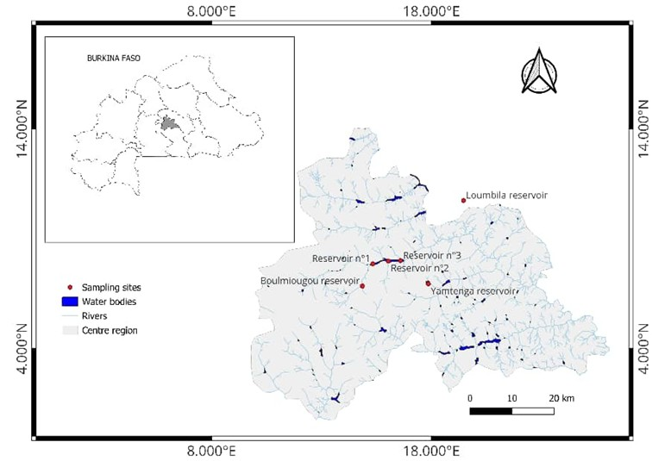
Figure 1: Map of the city of Ouagadougou showing collection sites

2.2 Surface water sampling
Water samples were collected following season: the rainy season (June - October), and the dry season (November – May), which can be divided into two periods: the cold period (November - February), and the hot period (March - May). Four water samples of 5 liters each were taken at each site (Kpoda et al., 2015), two upstream and two downstream. These samples were transported in cool boxes to the laboratory for parasite analysis.
Before each sample was taken, the physicochemical parameters, including temperature, pH, electrical conductivity, and TDS (Total Dissolved Solids), were measured in situ using a multi-parameter instrument.

2.3 Laboratory processing
Once in the laboratory, the water samples are emptied into containers and decanted for at least 24 hours to allow sedimentation of heavier particles and organisms. Then 4.5L (90%) of the supernatant were discarded. The remainder was subjected to microscopic analysis, first in the fresh state, then using the modified Bailenger method (R. M. Ayres & Duncan, 1997),(Kpoda et al., 2015), to identify helminths eggs and protozoan cysts, and finally the modified Ziehl-Neelsen stain (R. M. Ayres & Duncan, 1997), which is specific for detecting Cryptosporidium and other coccidia by microscopy. The parasites were identified using these documents (WHO, 2019); (Des & Ménagères, 2012); (M. Ayres et al., 1996). For fresh analysis, a drop of the centrifugation pellet was taken and observed under a microscope at a magnification of 20X. This method was used to quickly identify cysts and vegetative forms of parasites.
For the Bailenger method, after initial centrifugation of the samples contained in tubes, the centrifugation pellet was suspended in its volume of acetoacetic buffer at pH 4.5, and the whole mixture was centrifuged at 1500g for 15 minutes. After centrifugation, each sample contained distinct phases, including a pellet containing the heavy debris, in particular helminth eggs and larvae, and protozoan cysts. Above the pellet was the clear buffer. The upper part was discarded. A drop of the sediment was taken with a Pasteur pipette and placed on a slide for microscopic examination after being covered with a coverslip, at 40x magnification. The ether and zinc steps were omitted, as their absence has no significant influence on the results (Kpoda et al., 2015).
For Ziehl-Neelsen staining modified by Henriksen and Pohlenz (1981), in order to detect cryptosporidia, smears were made from the sediment obtained using the Bailenger method and dried in the open air. They were then fixed in methanol for 5 minutes and air-dried. The smear slides were then immersed in Ziehl's fuchsin (a reagent prepared in the laboratory) for one hour. After rinsing with water, they were decolorized with 2% sulfuric acid solution for 20 seconds. Another rinse with water followed this decolorization, then the slides were immersed in a methylene blue solution for 5 minutes, followed by a final rinse with water. They were then dried and observed under an optical microscope with a ×100 immersion objective. The oocysts appear colored red or fuchsia pink on a blue background(R. M. Ayres & Duncan, 1997),(Mouheb, 2018),(Kasmi et Saidouni, 2016).

2.4 Statistical analysis
The presence and number of each parasite species identified were recorded according to sampling sites. Statistical analysis was performed using Python 3.10. The chi-square test and Pearson test were used to compare the prevalence obtained with a significance level of 5% for a confidence interval (CI) of 95% (p<0.05 S; p>0.05 NS). Spearman's correlation test was used to analyze the correlations between temperature, pH, TDS, conductivity and parasites

3. results

3.1 Sampling effort
A total of 84 water samples were collected for analysis. Of these, 16 were collected from each reservoir of Boulmiougou, Loumbila, and reservoir n°1 of Ouagadougou. Twelve samples were collected in each from three reservoirs (n°2, n°3 dam of Ouagadougou and in Yamtenga reservoir).

3.2 Occurrence of parasites in surface waters
Nine parasitic species were observed and identified. Both protozoan cysts or oocysts and helminth eggs were detected (Figure 2). Giardia duodenale/intestinalis and Cryptosporidium spp. were found at all of the visited sites. Entamoeba histolytica/Entamoeba dispar was found in five of the six sites visited, while the other parasites were detected in two sites, except Trichuris trichiura, which was only identified in Yamtenga. Overall, the proportion of parasites in the study sites was 90%. Giardia duodenale was the most prevalent parasite at 55.9%, followed by Cryptosporidium spp. at 50%. Trichuris trichiura was the least prevalent parasite, at 1.1% (Table 1).

Table 1: Parasite occurrence in surface water in the city of Ouagadougou and around
Parasites | Parasites species | Occurrence%
Protozoan | G. duodenalis/intestinalis | 55.9
Protozoan | Cryptosporidium spp. | 50
Protozoan | E. hystolitica/E. dispar | 23.8
Protozoan | E. coli | 4.7
Protozoan | T. hominis | 3.5
Helminths | A. lombricoide | 10.7
Helminths | F. hepatica | 7.1
Helminths | S. haematobium | 2.3
Helminths | T. trichiura  Other helminth species eggs | 1.1  15.4

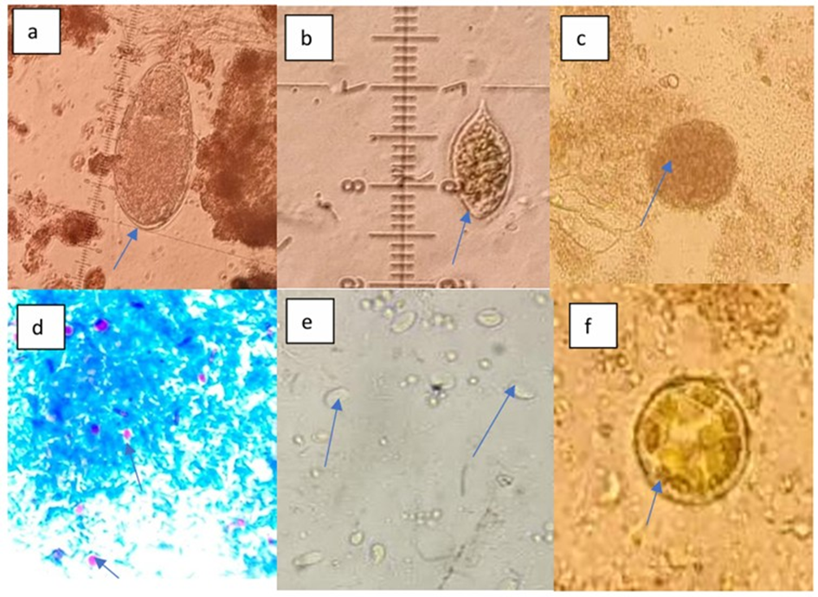
Figure 2: Microscopic observation of parasites (indicated by blues arrows) (a) eggs of Fasciola hepatica, (b) eggs of Schistosoma haematobium, (c) eggs of Ascaris lumbricoides, (d) Oocysts of Cryptosporidium spp., (e) cysts of Giardia intestinalis, and (f) cyst of Entamoeba coli.

3.3 Spatial distribution and abundance of parasites
Parasites were present at all sites, but Cryptosporidium spp. and G. duodenale were the most abundant. The abundance of other parasites was almost insignificant. G. duodenale was the most prevalent parasite at all sites except the Loumbila and Ouagadougou Reservoir 1 (Figure 3)

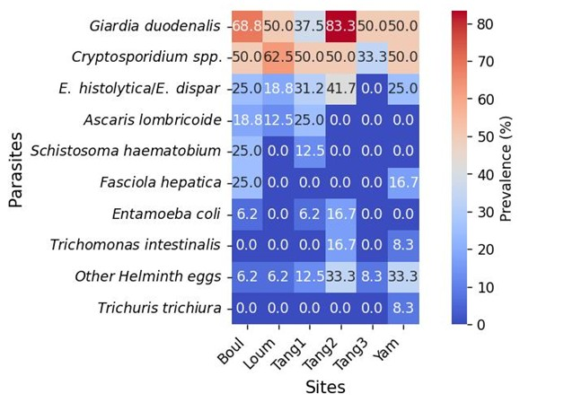
Figure 3: Distribution of the parasite frequencies by site

3.4 Prevalence of parasites according to the seasons
The highest prevalence of parasites was recorded during the rainy season and the hot period of the dry season. Spearman’s correlation test showed that a statistically significant difference was found between the prevalence of G. intestinalis (p=.035), E. histolytica/E. dispar (p<.001), A. lumbricoides (p=.027), S. haematobium (p=.0003), F. hepatica (p=.0003), and T. hominis (p=.020) and season. Seasonal variations affect the prevalence of parasites in surface water (Figure 4).
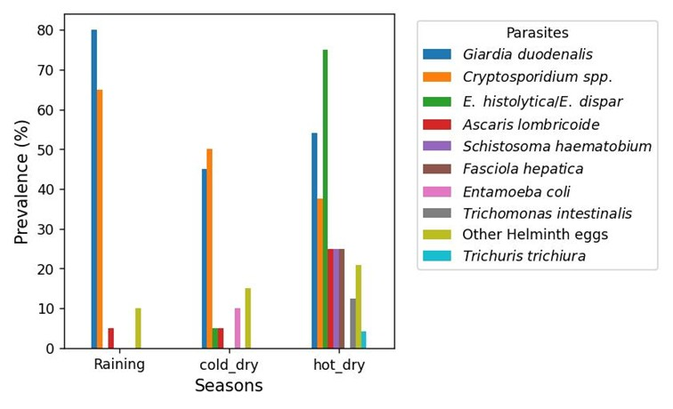
Figure 4: Distribution of parasite proportions by season

3.5 Variation in physico-chemical parameters by collection site and season
The results of this study show that temperatures are generally higher during the hot and rainy seasons. At the Yamtenga reservoir, the average temperature during the hot season is the highest, ranging from 32 to 35 °C. The Tanghin n°2 and Boulmiougou dam lakes have more stable temperatures, while at Loumbila and Yamtenga, the temperature variation is more pronounced.
As for pH, it is mostly alkaline at all sites (above 7) with a few neutral values (7-7.5). The Tanghin 1 reservoir has a very high pH during the rainy season (above 9). The general trend is that it is slightly higher during the rainy season than during other seasons.
Regarding conductivity, the Tanghin1 and Boulmiougou reservoirs have the highest conductivity (above 600 µS/cm). Loumbila has the lowest conductivity (approximately 50–90 µS/cm). In general, conductivity decreases slightly during the rainy season. TDS is correlated with electrical conductivity, with higher values at Tanghin1 and Boulmiougu. These results are shown in figure5.

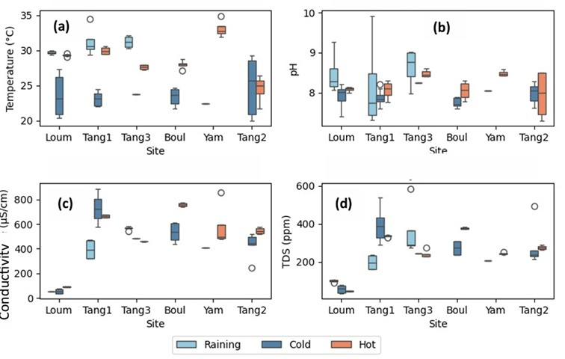
Figure 5: Variation in temperature (a), pH (b), conductivity (c) and TDS (d) according to site and season

3.6 Influence of physical and chemical parameters on the presence of parasites
Spearman's correlation test shows that physical and chemical parameters influence the presence of certain parasites. There is a positive correlation between temperature, conductivity, TDS, and E. histolytica/E. dispar parasite with 0.34, 0.28, and 0.26 correlation coefficients, respectively, between conductivity, TDS, and Schistosoma eggs, with 0.40 and 0.37 coefficient correlation, respectively, between conductivity, TDS, and Fasciola eggs, with 0.35 and 0.25 coefficient correlation, respectively, and a negative correlation between temperature and E. coli with -0.29 coefficient correlation. The results are plotted in figure 6, with yellow squares indicating significant correlations.
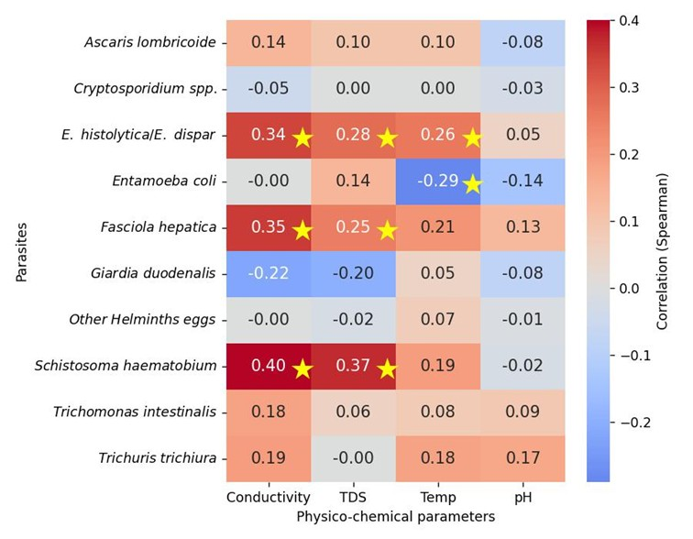
Figure 6: Correlations between parasites and physico-chemical parameters

4. DISCUSSION
Demographic pressure and the absence of adequate sanitation measures in the African urban areas are main factors of surface waters contamination by chemical products and pathogens. This study assessed the level of parasitic contamination in 6 water reservoirs in the city of Ouagadougou. The results indicated that the water bodies visited were heavily contaminated by diverse parasites. A total of nine parasite species were observed, including five protozoa and 4 helminths. Giardia intestinalis and Cryptosporidium spp were found in all study sites, with the highest prevalence at 55.9% and 50%, respectively. This prevalence of G. intestinalis is lower than that found by LeChevallier et al., (1991) and Bataiero et al. (2019), which were 81.2% and 83%, respectively. For Cryptosporidium, a prevalence of 66.67% was reported in Ghana by Sampson et al., (2017). LeChevallier et al., (1991) found a prevalence of 87%, and Bataiero et al., (2019) found 37.5% in the same type of water. In the Middle East and North Africa, a meta-analysis highlighted the presence of 24.5% for Cryptosporidium and 37.7% for Giardia in the different categories of water, wastewater and surface water, which are the most contaminated (Ben et al., 2024). Higher Giardia and Cryptosporidium prevalences of 73% and 60%, respectively, were found in Austria (Cervero-Aragó et al., 2021). However, according to a meta-analysis, the overall prevalence of Cryptosporidium in all types of water worldwide between 1983 and 2019 was 36%, of which 25.7% was found in treated water and 40.1% in untreated water (Taghipour et al., 2021). Recently, in Türkiye, a prevalence of 7.7% of E. histolytica/E. dispar was found in several types of water (drinking water, well water, spring water, wastewater and surface water) by Candan et al., (2024), compared to 23.8% in the present study. Eduardo et al., (2024) found 34.37% of Ascaris spp and 5.20% of Trichuris in surface water. These figures exceed the prevalence rates shown in the present study. Mbouombouo et al., (2020) provided empirical evidence for the presence of helminth eggs in surface waters, exhibiting variable levels of density. The findings indicate that parasites are distributed extensively in the environment, particularly in water, and to varying degrees depending on the sampling site, the country, and the analysis methods employed. The findings can be attributed to the role of surface water as a receptor for wastewater, which is defined as liquid waste comprising human and animal excrement. Additionally, run-off water plays a significant role in the transportation of various types of waste with elevated pollution loads. Run-off water from agricultural land that has been treated with manure, for example, has the potential to contaminate local surface waters. (Innes et al., 2020,,Lamb et al., 2018)
The prevalence of these parasites varied seasonally. Indeed, a statistically significant difference was found between the prevalence of G. duodenalis, E. histolytica/E. dispar, A. lumbricoides, S. haematobium, F. hepatica, and T. hominis, and the season. The hot dry period of the dry season and the rainy season are the periods with the highest presence rate. With regard to G. intestinalis, the highest prevalence and parasite densities were recorded during the rainy season. This phenomenon can be attributed to the fact that during this period, significant quantities of waste and parasites are drained into water reservoirs by run-off water. These results are consistent with those reported by Ryu & Abbaszadegan, (2008), who observed a higher prevalence during the rainy season due to runoff water.. Seasonality has an impact on the variation of physical and chemical parameters. During the rainy season, surface waters undergo dilution due to rainfall, leading to a decrease in conductivity/TDS and an increase in pH. Higher temperatures during the hot season are due to a possible increase in mineralization.
A subsequent analysis of the results indicates that there are no statistically significant differences between parasite occurrence by site, although in some sites, G. intestinalis appears to be more prevalent. E. histolytica/E. dispar was positively correlated with electrical conductivity and TDS. These results are in line with those obtained by El-tantawy et al., (2016), who had observed a significant correlation between electrical conductivity and total dissolved solids and the prevalence of the parasites studied (Cryptosporidium, Giardia, and Entamoeba histolytica); However, in the present study, no correlation was found between the prevalence of Giardia spp. and the physico-chemical parameters measured. The presence of Schistosoma and Fasciola eggs was found to be correlated with conductivity and TDS. Electrical conductivity and total dissolved solids (TDS) are significantly linked, as if they were two sides of the same coin. Total dissolved solids (TDS) are comprised of mineral products that have dissolved in water. The dissolved bodies in question are derived from a variety of sources, including urban wastewater and industrial units (MDH, 2005). This phenomenon elucidates the high rate of water contamination by parasites. A positive correlation was identified between E. histolytica/E. dispar and temperature. The elevated prevalence observed during the hot period of the dry season, when temperatures are also high, can explain this observation. The lack of correlation between pH and the presence of parasites is noteworthy, despite this parameter being an indicator of water quality. Ehsan, (2015) had already highlighted this lack of correlation with G. intestinalis and Cryptosporidium spp. parasite densities.
The health risks associated with surface water contamination arise from the fact that parasites excreted by infected human and animal hosts, contaminate surface water as a result of anthropogenic pressures such as wastewater discharge, runoff water, agricultural runoff, animal waste, and human activities around reservoirs. Human exposure could occur indirectly through the consumption of inadequately treated drinking water or contaminated food. The most exposed populations are riparian communities, users of water reservoirs, and vulnerable groups. The movement of water and people can create a greater dynamic of exposure to parasites
This study has limitations. One limitation is that we could have used cartridge filtration, IMS, and IFA with molecular biology techniques, which are currently the standard approaches, and are much more sensitive and specific than microscopy. In addition, for microscopy, Lugol's solution would have made our parasites more visible and easier to detect.

5. CONCLUSION

The present study reveals that parasites heavily contaminate surface waters in and around the city of Ouagadougou. Indeed, the overall parasite occurrence recorded was 90%, with nine parasite species detected. Cryptosporidium spp. and G. intestinalis were the most prevalent, with 50% and 55.9%, respectively, and were found in all study sites. The prevalence of certain parasites varies according to season. Parasite occurrence was correlated with physico-chemical parameters such as temperature for E. histolytica/E. dispar and E. Coli; Electrical conductivity and TDS for E. histolytica/E. dispar, Schistosoma, and Fasciola eggs.
The presence of parasites in surface waters, as revealed in this study, poses a health risk for the population in permanent contact with these waters through the many anthropogenic activities they carry out. In addition, parasites such as G. intestinalis and Cryptosporidium spp. are known to be resistant to the usual disinfectants.
These results are a wake-up call and lay the groundwork for an effective fight against waterborne parasitic infections. Further studies on the viability of eggs, cysts, and oocysts, microbiological analysis of treated drinking water, and molecular characterization of the most widespread parasitic species and subspecies would greatly contribute to assessing the health risks associated with their presence in surface waters, thus enabling a more effective fight against the proliferation of parasitic infections in Burkina Faso

Competing interests

The author(s) declared no potential conflicts of interest concerning the research, authorship, and/or publication of this article

References

Ayres R.M., Duncan M., (1996). Analysis of wastewater for use in agriculture techniques.
Ayres, R. M., & Duncan, D. (1997). Manuel des techniques de laboratoire en parasitologie et bactériologie. Published online 1997
Bataiero M. O., Araujo R. S., Nardocci A. C., Matté M. H., Sato M. I. Z., Lauretto M. S., & Razzolini M. T. P. (2019). Quantification of Giardia and Cryptosporidium in surface water: A risk assessment and molecular characterization. Water Science and Technology: Water Supply, 19(6), 1823–1830. https://doi.org/10.2166/ws.2019.059
Ben L., Abdelaziz S., & Ahmed A. (2024). Waterborne Cryptosporidium species and Giardia duodenalis in resources of MENA: A systematic review and meta-analysis. Journal of water Health. 22(8), 1491–1515. https://doi.org/10.2166/wh.2024.107
Candan C., Karatepe M., & Karatepe B. (2024). Entamoeba histolytica in Different Water Sources of Niğde Province of Turkey. Acta Parasitologica. 2024;69:1517–1521. Published 2024.
Cecchi P., Zerbo P., Berger C., & Zongo, F. (2004). Existe-t-il un risque de toxicité associé aux proliférations de cyanobactéries dans le réservoir de Loumbila ? Journées Scientifiques Du Groupe Des Ecoles EIER - ETSHER - Ouagadougou, 1, 1–5.
Cervero-Aragó S., Desvars-Larrive A., Lindner G., Sommer R., Häfeli I., & Walochnik J. (2021). Surface waters and urban brown rats as potential sources of human-infective cryptosporidium and giardia in Vienna, Austria. Microorganisms, 9(8). https://doi.org/10.3390/microorganisms9081596
Clément K. A., Karim T., Sery G. B., Fiacre-tanguy N. A., Tiacoh N. G., Karidja Y. O., Nina A. L., Ako A. Béranger, Bosson V., & Henriette A., Coulibaly K.J. and Toure A. O., (2023). Parasitological Quality Evaluation of Pipe Waters in Abidjan, the Capital City of Côte d’Ivoire. The Open Parasitology Journal.1–11. https://doi.org/10.2174/18744214-v11-e230420-2022-5
Cociancic P., Edith S., Garraza M., Lorena M., & Teresa G. (2021). Intestinal parasites in child and youth populations of Argentina: Environmental factors determining geographic distribution. Revista Argentina de Microbiología, 53(3), 225–232. https://doi.org/10.1016/j.ram.2020.11.004
Dahani, I., & Compaore, G. (2021). Ville durable : Ouagadougou , capitale du Burkina Faso en Afrique. Issaka D., Georges C., To cite this version : HAL Id : hal-03359473.
Organisation Mondiale de la Santé. (2012), Directives oms pour l’utilisation sans risque des eaux usées des excreta. Iv.
Eduardo, D., Santos, O., Alexandra, Y., Zapata, U., Aguilar, C., Sánchez, G., Libia, H., Chandillo, E., Myriam, B., López, C., Cristina, M., López, B., & Ortiz, C. (2024). Occurrence of parasites in waters used for crops irrigation and vegetables from the Savannah of Bogotá , Colombia. Environmental Science and Pollution Research, 31(23), 33360–33370. https://doi.org/10.1007/s11356-024-33088-1
Ehsan, M. A. (2015). Water-borne transmission of Cryptosporidium and Giardia in Belgium and Bangladesh. January 2015. https://biblio.ugent.be/publication/6536637
Eisenberg, J. N. S., Desai, M. A., Levy, K., Bates, S. J., Liang, S., Naumoff, K., & Scott, J. C. (2007). Environmental Determinants of Infectious Disease: A Framework for Tracking Causal Links and Guiding Public Health Research. Environmental determinants of infectious disease;1216(8), 1216–1223. https://doi.org/10.1289/ehp.9806
El-tantawy, S. A., Mashaly, M. I., & El-awady, M. E. (2016). Ecological Studies on Water-borne Parasites at Dakahlia. Journal of Environmental Science. 45(1), 63–73.
Innes, E. A., Chalmers, R. M., Wells, B., & Pawlowic, M. C. (2020). A One Health Approach to Tackle Cryptosporidiosis. Trends in Parasitology, 36(3), 290–303. https://doi.org/10.1016/j.pt.2019.12.016
Kasmi et Saidouni, (2016). Étude de la prévalence des protozooses intestinales diagnostiquées au sein du laboratoire de parasitologie-mycologie du CHU de Tlemcen.
Konkobo, F. A., Diao, M., Roamba, N. E., Dakuyo, R., Savadogo, P. W., & Dicko, M. H. (2023). Optimisation du pouvoir épuratoire des graines de Moringa oleifera dans le procédé de potabilisation des eaux au Burkina Faso. Optimization of the purification capacity of Moringa oleifera seeds in the water purification process in Burkina Faso . Sciences Naturelles et Appliquées 42(1) 89-108.
Kpoda, N. W., Oueda, A., Stéphane, Y., Somé, C., Cissé, G., Maïga, A. H., & Kabré, G. B. (2015). Physicochemical and parasitological quality of vegetables irrigation water in Ouagadougou city. Afrique Journal of Microbiology Research. 9(5), 307–317. https://doi.org/10.5897/AJMR2014.7295
Lamb, J. B., Willis, B. L., Fiorenza, E. A., Couch, C. S., Howard, R., Rader, D. N., True, J. D., Kelly, L. A., Ahmad, A., Jompa, J., & Harvell, C. D. (2018). Plastic waste associated with disease on coral reefs. Science, 359(6374), 460–462. https://doi.org/10.1126/science.aar3320
LeChevallier, M. W., Norton, W. D., & Lee, R. G. (1991). Occurrence of Giardia and Cryptosporidium spp. in surface water supplies. Applied and Environmental Microbiology, 57(9), 2610–2616. https://doi.org/10.1128/aem.57.9.2610-2616.1991
Maiga, A. H., & Sama, M. B. (1990). Filtration Lente Sur Sable : Épuration Physico-Chimique Et Décontamination Bacteriologique. 25–36. Published online 1990.
Mbouombouo, M., Ajeagah, G., Ndjama, J., Tchakala, I., Gnon, B., Enah, D., & Yogback, G. (2019). Dynamic abundance of oocysts in the mezam watershed in Bamenda (Northwest region, Cameroon). Bulletin de La Societe de Pathologie Exotique, 112(2), 61–70. https://doi.org/10.3166/bspe-2019-0079
Mbouombouo, M., Ajeagah, G., Tchakala, I., Enah, D., Kodom, T., Hoekou, Y. P., & Gnon, B. (2020). Biodynamique des œufs et larves d’helminthes dans les eaux de surface de Bamenda, Région du Nord-Ouest, Cameroun : impact sanitaire et influence des paramètres physico-chimiques. Afrique Science;16(December 2017), 55–68. http://www.afriquescience.net
Moussa, D.H.M. (2005). Caractéristiques physico-chimiques, bactériologiques et impact sur les eaux de surface et les eaux souterraines, BAMAKO-Mali. Published online; 1–135.
Mouheb, T. A. I. T. (2018). Étude épidémiologique des coccidies intestinales opportunistes dans l'Algerois. Université d’Alger 1 - Benyoucef BENKHEDDA Faculté de Médecine d’Alger. Published online 2018.
Lehman, L. G., Nono, L. K., & Bilong, C. F. B. (2012). Diagnostic des parasitoses intestinales à l’aide de la microscopie à fluorescence. Médecine d'Afrique Noire, 59(7): 377-380. Published online 2012.
Ongerth, J. E. (2013). ICR SS protozoan data site-by-site: A picture of Cryptosporidium and Giardia in U.S. surface water. Environmental Science and Technology, 47(18), 10145–10154. https://doi.org/10.1021/es4027503
Ryu, H., & Abbaszadegan, M. (2008). Long-term study of Cryptosporidium and Giardia occurrence and quantitative microbial risk assessment in surface waters of Arizona in the USA. Journal of Water and Health, 6(2), 263–273. https://doi.org/10.2166/wh.2008.030
Sampson, A., Owusu-ansah, E. J., Mills-robertson, F. C., Ayi, I., Abaidoo, R. C., Hald, T., & Permin, A. (2017). Microbial Risk Analysis Probabilistic quantitative microbial risk assessment model of farmer exposure to Cryptosporidium spp . in irrigation water within Kumasi. Microbial Risk Analysis, 6(June), 1–8. https://doi.org/10.1016/j.mran.2017.06.001
Savioli, L., Smith, H., & Thompson, A. (2006). Giardia and Cryptosporidium join the “Neglected Diseases Initiative.” Trends in Parasitology, 22(5), 203–208. https://doi.org/10.1016/j.pt.2006.02.015
Taghipour, A., Khazaei, S., Ghodsian, S., Shajarizadeh, M., Olfatifar, M., Foroutan, M., et al., (2021). Global prevalence of Cryptosporidium spp. in cats: A systematic review and meta-analysis. Research in Veterinary Science, 137, 77–85. https://doi.org/10.1016/j.rvsc.2021.04.015
WHO. (2019). Bench aids for the diagnosis of intestinal parasites.

