Dynamics of Leopard Occupancy and Detection Amid Human Disturbance and Habitat Fragmentation in Gautala-Autramghat Wildlife Sanctuary, Maharashtra, Western India

Abstract
Understanding the occupancy and distribution of elusive species like the leopard (Panthera pardus) is critical for effective wildlife conservation, particularly in fragmented landscapes with substantial human activity. Leopard occupancy and detection probabilities were modelled based on ecological and anthropogenic variables, including human disturbance, livestock presence, proximity to roads, habitat fragmentation, and distance to water sources. The mixed deciduous forest significantly enhanced occupancy, with a beta coefficient ($\hat{β}$= 1.65), while fragmented habitats ($\hat{β}$ = -0.67) and livestock presence ($\hat{β}$ = -0.22) negatively impacted occupancy and detection. Detection probability was further reduced by human and livestock presence. Roads and scrubland had no significant effect on occupancy. We estimated a naïve occupancy rate of 0.75, with a model-averaged occupancy (ψ̂) of 0.69, covering approximately 179.4 km². These findings underscore the need for a landscape-level approach to manage human disturbance and habitat fragmentation amid increasing demands for natural resources. Prioritizing the conservation of deciduous forests is essential. By examining factors that affect occupancy, this study provides valuable guidance for conservation aimed at reducing human-wildlife conflict. The results offer critical insights for safeguarding leopard populations and their ecosystems in similar landscapes worldwide, highlighting the importance of proactive habitat management.
Keywords
Conservation, Ecology, Panthera pardus, PRESENCE, Protected areas
Introduction
Leopards, as part of the Panthera genus, are one of the most adaptable big cats globally, displaying remarkable resilience in various habitats(Stein et al. 2024). Found across Africa, Asia, and parts of the Middle East, they have adjusted to environments ranging from dense forests and grasslands to mountainous regions. However, the increasing overlap between human populations and leopard habitats intensifies human-wildlife conflict, an issue exacerbated by expanding urbanisation, deforestation, and habitat fragmentation. This conflict poses one of the major challenges for wildlife conservation, as leopards, like other large carnivores, often prey on livestock, leading to economic losses for rural communities(Akrim et al. 2023; Jacobson et al. 2016; Stein et al. 2024). The result is a strained relationship between humans and these predators, often culminating in retaliatory killings and loss of biodiversity(Athreya et al. 2019). In retaliation, they are frequently killed or captured, further reducing their population. Other threats include poaching for skins and body parts, roadkill due to expanding road networks, and depletion of prey species, which exacerbates their dependency on livestock(Athreya et al. 2020; Mondol et al. 2015; Quintana et al. 2022). These factors combined pose severe challenges to the long-term survival of leopards across the globe. The territory of the leopard has shrunk to 25 to 37% of its historical range(Jacobson et al. 2016).
In India, leopards are widely distributed across the country, from the Himalayas to the Western Ghats and the forests of Central India(Qureshi et al. 2024). The Indian leopard (Panthera pardus fusca), listed as “Vulnerable” in the IUCN Red List, faces multiple threats, with habitat loss and fragmentation being among the most significant. Protected areas play a crucial role in the conservation of the Indian leopard by providing safe habitats free from the pressures of human encroachment, poaching, and habitat destruction(Webb et al. 2020). These areas serve as refuges where leopards can thrive, maintain stable populations, and access sufficient prey, reducing their need to venture into human-dominated landscapes, where they are often involved in conflict(Jacobson et al. 2016). Furthermore, protected areas like wildlife sanctuaries and national parks ensure the preservation of critical habitats that support not only leopards but also the diverse ecosystems on which they depend. By maintaining biodiversity and ecological balance, protected areas contribute significantly to the long-term survival of the species (Webb et al. 2020).
Despite the vital role protected areas play in conserving leopards, several factors within these zones can still compromise their well-being and most Asian countries may not be able to meet future biodiversity targets on Protected areas(Farhadinia et al. 2022). Human activity, even in officially protected regions, often persists in the form of illegal logging, livestock grazing, and encroachment, tourist pressure (including pilgrimages inside the forests) which can degrade leopard habitats and reduce prey availability(Maan & Chaudhry, 2019). In many cases, protected areas are surrounded by densely populated regions, leading to frequent human-leopard interactions and conflict as leopards venture beyond the boundaries in search of prey. Additionally, infrastructure development, such as roads cutting through or near protected areas, increases the risk of roadkill and fragments habitats, further isolating populations. The influx of tourists into protected areas can disturb leopards' natural behaviours, while also contributing to habitat degradation(Maan & Chaudhry, 2019).
Management and enforcement within protected areas can often be inconsistent due to inadequate funding and insufficient manpower, which hampers effective wildlife monitoring and protection. Although India has uniform rules and regulations governing protected areas, the focus on management and conservation varies significantly across the country. Some protected areas receive priority attention, particularly those that are home to charismatic species capable of attracting tourism revenue, where conservation laws are enforced more rigorously. In contrast, other protected areas suffer from weaker management and enforcement, lacking the resources and attention afforded to those with high-profile species. These discrepancies limit the overall effectiveness of protected areas in serving as secure habitats for leopards and ensuring their long-term survival.
The Gautala Autramghat Wildlife Sanctuary (GAWLS) presents a microcosm of these broader trends. Located in the Eastern ranges of the Western Ghats, the sanctuary provides a refuge for leopards but is surrounded by agricultural lands where human-leopard conflicts are not uncommon (TNN, 2022). The leopard has been the only apex predator in the GAWLS for the last 80 years and plays a crucial role in shaping the ecosystem (The Economic Times, 2021). This study represents the first systematic assessment of leopard occupancy and habitat associations in GAWLS, a protected area in Maharashtra that remains understudied and data deficient. Unlike previous research focused on larger, well-known tiger reserves, this work offers insights from a relatively small, fragmented, and human-influenced landscape where conservation efforts for carnivores are often overlooked. By applying occupancy modelling to a challenging terrain with low detection probabilities, this study provides baseline data critical for long-term monitoring, informs evidence-based habitat management, and emphasises the role of non-flagship species conservation in lesser-known sanctuaries. The findings also contribute to understanding how leopards persist in mixed-use landscapes, which is increasingly important in the context of expanding human pressures across India.
Given the need to better understand how leopards use space in multi-use landscapes, our study aims to (1) estimate the probability of leopard occupancy across GAWLS, (2) examine how ecological and anthropogenic factors such as human disturbance, livestock presence, habitat types such as forests, scrublands, and grasslands influencing the leopard, and (3) how habitat fragmentation, proximity to water bodies, and the presence of roads, human settlements influencing the leopard.
By employing an occupancy modelling framework that incorporates detection probability, we aim to provide insights into the factors shaping leopard habitat use, which will contribute to the understanding of their spatial distribution in human-dominated landscapes. This analysis will serve as a valuable source for monitoring shifts in leopard occupancy over time, offering crucial baselines for conservation planning.
Materials and Methods
Study Area
The Gautala-Autramghat Wildlife Sanctuary (GAWLS), located in the Western Ghats of Maharashtra, India (Fig. 1), extends across the Chhatrapati Sambhajinagar (Aurangabad) and Jalgaon districts. Geographically situated at 20°19'57.0" N and 75°08'27.0" E, the sanctuary lies within the Satmala and Ajanta hill ranges, with a landscape characterized by small plateaus and plains. GAWLS was formally declared a sanctuary covering 260.6 km² in 1986. Later, in 2016, the Ministry of Environment, Forest and Climate Change designated an eco-sensitive zone of 483.45 km², which includes a one-kilometre area around the sanctuary boundary (Ministry of Environment, Forest and Climate Change Notification, New Delhi, 9 December 2016).

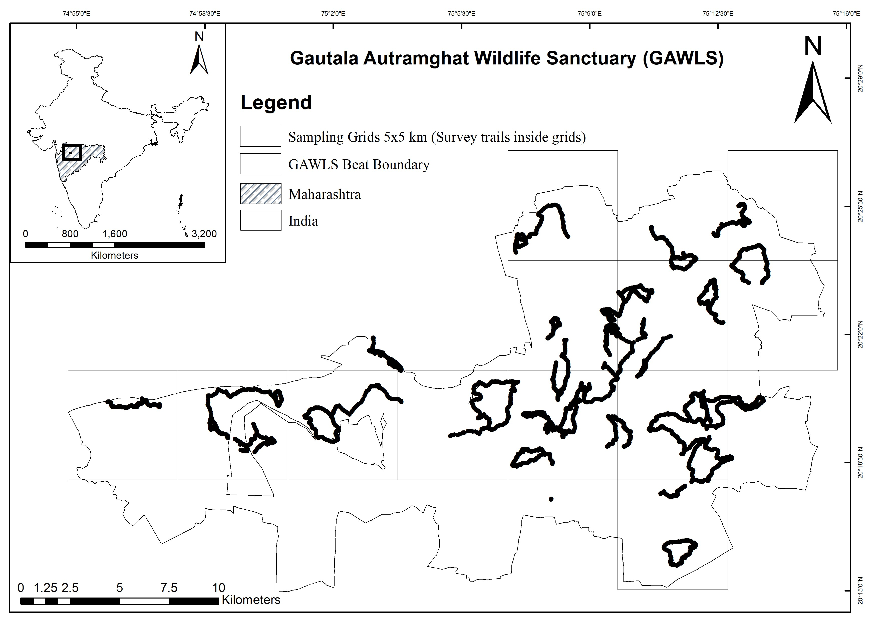
Fig. 1 Map of the GAWLS study area displaying 25 sq. km sampling grids
The sanctuary's habitat is primarily composed of dry deciduous forests, grasslands, and scrublands, dominated by key flora species such as teak (Tectona grandis), Indian Sandalwood (Santalum album), Palash (Butea monosperma), Dhamorda (Anogeissus latifolia), and Tembhurni/Tendu (Diospyros melanoxylon)(Pawar & Mule, 2025a, 2025c). Despite the variety of mammal species that inhabit the area, there has yet to be a detailed scientific study documenting them. The region is also surrounded by agricultural land, with local communities relying on the sanctuary for grazing, timber, and grass collection. The GAWLS is characterized by a mean annual rainfall of 719.3 mm, with temperatures ranging from 11.9°C to 42.7°C(IMD, 2005). The sanctuary's altitude varies between 355 and 888 meters above sea level, contributing to its diverse ecological landscape. The sanctuary is intersected by four road networks, including the National Highway NH 52, Maharashtra State Highway 178, and two district roads, facilitating transportation across the landscape. This road infrastructure impacts both the sanctuary's ecological balance and the movement patterns of its wildlife. The Maharashtra Forest Department has organized the sanctuary into three ranges and 30 beats, with over 70 villages located in and around the eco-sensitive zone. The leopard population at GAWLS is predicted to be increased(Chinchkhede, 2015). Additionally, the area faces frequent water scarcity during the summer due to its drought-prone nature, impacting both wildlife and human activities.
Study Design
The GAWLS encompasses approximately 260 km², providing a substantial area for comprehensive wildlife monitoring. The home range of the Indian leopard (Panthera pardus fusca) varies widely across diverse habitats, including forests, grasslands, human-dominated areas, and protected areas. Ensuring independent sampling sites and maintaining geographic closure necessitates that the area of each sampling unit be larger than the average home range of the species studied. This approach minimises the risk of individuals moving between sampling units, which could violate assumptions of independence and closure, thereby ensuring the reliability of the data collected for robust model predictions(MacKenzie et al. 2002). In some protected areas, male leopards typically maintain home ranges of 16 to 18 km²(Ram et al. 2024; Zehra, 2014), highlighting their territorial behaviour and spatial requirements, with an overall average range of 14.5 km²(Snider et al. 2021), reflecting considerable individual variability and overlap. To facilitate systematic sampling, GAWLS was divided into 12 sampling grids of 25 km² or 5x5 km (Qureshi et al. 2024), aligning with the known home range of the Indian leopard. This structured grid design enhances survey consistency and improves the precision of ecological evaluations. The sampling grids were prepared using ArcGIS 10.8. The 25 km² sampling grids served as the primary spatial units for conducting leopard sign surveys. This grid size was selected based on reported estimates of leopard home ranges in similar semi-arid and human-dominated landscapes, where male home ranges can range from 6 to 90 km² (Odden et al. 2014; Snider et al. 2021; Thapa et al. 2021). However, we acknowledge that home ranges are often irregular and seasonally variable, especially in fragmented landscapes, and may not align perfectly with uniform grid boundaries. Therefore, the 25 km² grid represents a sampling resolution rather than a biologically exact home range proxy. Each grid was surveyed using line transects totalling 16 km to detect indirect signs of leopard presence.
Field survey and covariates
We did a sign survey within 12 grids covering almost the entire area of GAWLS (260 km²), thus it reflects true occupancy or proportion of area occupied by a leopard. The survey team consisted of 2-3 trained personnel having experience of 5-10 years from the forest department, including the authors. The sign survey was conducted on foot from October 2023 to December 2023. The reconnaissance survey was conducted in October 2023 for the overall study area and survey planning. The actual sign surveys were carried out in November and December 2023. We carried out grid-wise sign surveys in the first half of each day (7 AM to 1 PM) and covered all grids one by one. The team recorded the presence and absence of leopards through indirect signs such as pugmarks, scats and direct sightings. We focused on the trails, roads and riverbeds for maximum detection. The road data were limited to national highways and district roads. Smaller roads, forest trails, and village paths were not included due to a lack of reliable spatial data. As a result, the road variable represents only major, high-traffic paved roads and does not capture potential positive or negative effects of minor travel routes used by leopards. The GPS locations (Fig. 1), human presence, livestock presence, distance to nearby water body and settlement were also recorded simultaneously. We only recorded fresh signs and photographed them for correct identification. We ignored the uncertain signs to avoid false detections. We sampled 16 km transects in each sampling grid on two consecutive days, and the 16 km trail was broken down into 16 spatial replicates of 1 km. These 1 km segments were treated as spatial replicates(Gubbi et al. 2020; Karanth et al. 2004; MacKenzie et al. 2006). The detection and non-detection of leopards were recorded as “1” and “0” respectively. To maximise the detection probability, we carried out the field survey during dry seasons from October 2023 to December 2023. The climatic factors, such as rain, fog, and cloud cover, were minimal during the season.
Key factors potentially influencing the occupancy (ψ) of leopards were identified, incorporating insights from previous studies. We hypothesised that human disturbance would have a negative impact on large carnivores like leopards across the sampling sites(Harihar & Pandav, 2012; Karanth et al. 2011). Similarly, livestock presence was expected to negatively affect occupancy, as it often serves as a proxy for human influence(Karanth et al. 2011; Pudyatmoko, 2017). In contrast, we anticipated a positive relationship between leopard occupancy and various habitat types, such as mixed deciduous forests, scrublands, and grasslands(Borah et al. 2016). Habitat fragmentation was considered likely to have a detrimental effect on leopard populations and occupancy rates(Quintana et al. 2022; Stein et al. 2020). Additionally, we hypothesised that proximity to water sources would positively influence leopard occupancy, especially in semi-arid regions like GAWLS(Chaudhary et al. 2020). Lastly, we factored in the negative impact of roads, particularly highways and district roads, on leopard occupancy(Thapa et al. 2021). The detection probability (p) of leopards was also integrated into the models. It was anticipated that livestock presence, human disturbance, and proximity to roads would negatively impact leopard detection, as these factors could limit visible signs or reduce leopard activity in these areas.
We collected the covariates data in the field, as variables collected in the field better explain the relation than remotely sensed data(Harihar & Pandav, 2012). The survey team recorded the direct and indirect signs with the covariates such as habitat types like mixed deciduous forest, grassland and scrub by observing the habitat where signs were found. For each 5 × 5 km grid, the presence or absence of mixed deciduous forest and other habitat types was noted during field surveys. This binary classification was used as a covariate in the occupancy models. We did not quantify the exact proportion or spatial extent of these forests within each grid, which may influence the precision of habitat–occupancy relationships.
Other covariates such as human presence were recorded considering the vehicle trails, lopping, and nearby tourist places were recorded for that same sign’s location (Fig. 2). The livestock presence was recorded by observing the livestock grazing and their dung piles (Fig. 2). Other covariates such as distance to waterbody, and distance to human habitation, habitat fragmentation, distance to metalled roads were measured using Google Earth using the sign’s location. We plotted the sampling unit grids on Google Earth and examined each grid closely for the measurements. Distance to water body was calculated as the Euclidean distance from the centre point of each 1-km sampling segment to the nearest edge of a perennial or seasonal water body, using GIS layers. While leopards are known to use riparian zones surrounding water sources, the width and structure of riparian vegetation were not separately measured or included as covariates due to data limitations.
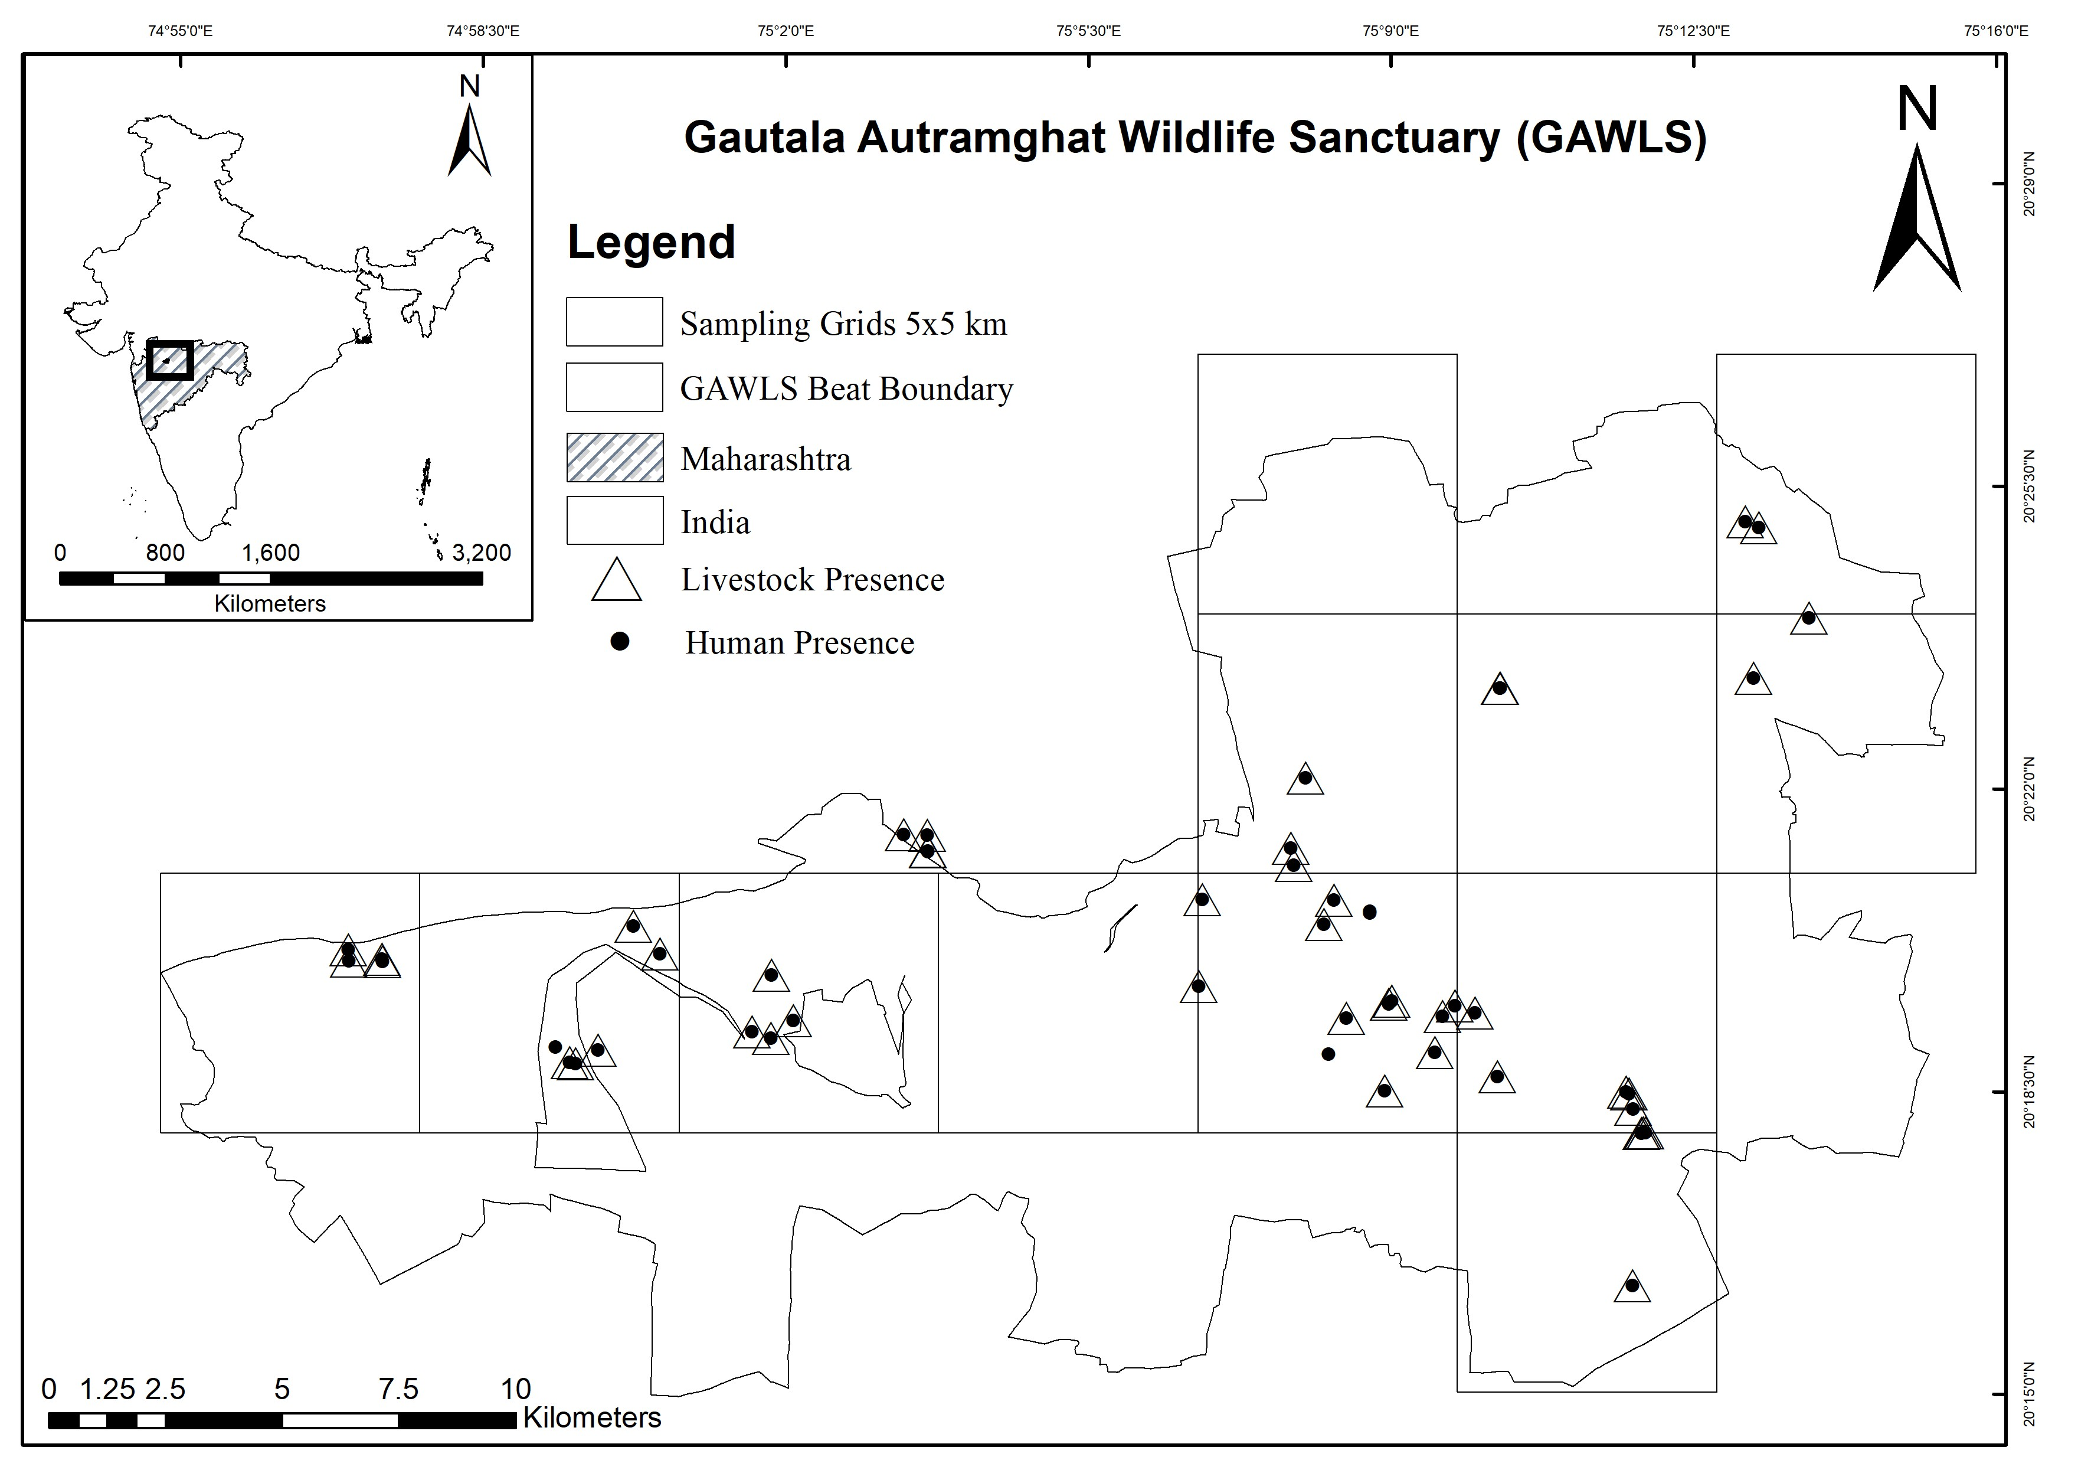
Fig. 2 The geographic coordinates of human and livestock presence recorded at sites where leopards were detected in GAWLS.
The habitat fragmentation, human presence, and livestock presence were recorded as “1” and “0” for presence and absence, respectively. Fragmentation was defined as the proportion of non-forest (e.g., agriculture, settlement, or scrub) area within each 1-km buffer surrounding the transect segment. There are many points where continuous forest patches are absent and used as bridal paths and for vehicles. Forest division referred to the administrative forest management unit in which each grid or transect segment was located. GAWLS spans multiple forest divisions (e.g., Aurangabad, Jalgaon), and this variable was used to account for potential differences in management intensity, protection measures, or disturbance levels across divisions.
We recorded the survey tracks using Garmin GPSMAP 76CSx and plotted these tracks on Google Earth and measured the covariate distances. For each sampling grid, we visually scanned for metalled roads, cropland, and the proportion of natural habitat inside the sampling grid on Google Earth. The fragmentation of the sampling grid was recorded in terms of the presence of roads, forest patches due to the presence of agricultural or village areas, and tapered boundaries of natural habitat by visually scanning the area using Google Earth. The natural habitats were identified through visual interpretation of satellite imagery dated 20th December 2022 using Google Earth, focusing on vegetation cover, land features, and signs of minimal human intervention.
The covariates, expressed in different units, were normalised to ensure comparability. The covariates, expressed in different units, were normalised to ensure comparability. Specifically, covariates were transformed to have a mean of “0” and a standard deviation of “1” before analysis, standardising their scales. Only those covariates that were not of Boolean data type underwent normalisation using the PRESENCE 2.13.47 program(Hines, 2006). This approach was essential to assign equal weight to all variables, preventing larger numerical values from disproportionately influencing the model.
All site and segment-level covariates were selected for occupancy modelling based on prior ecological knowledge of leopard habitat use, relevance in previous studies, and data availability for GAWLS. These included ecological variables, anthropogenic variables, and topographic features. Before model fitting, we assessed multicollinearity among covariates using Pearson correlation; no pair of covariates exceeded r > 0.7, indicating acceptable independence. The final set of covariates was retained based on ecological interpretability and lack of strong intercorrelation.
Data analysis and occupancy modelling
Naive occupancy was calculated by dividing the number of sampling grids where the species was detected by the total number of grids surveyed within the study area. Occupancy modelling for GAWLS was conducted using the program PRESENCE version 2.13.47(Hines, 2006). A single-season correlated detection model was applied to estimate occupancy.
The standard occupancy model assumes independent detection of signs across successive spatial replicates. However, since leopards can cover distances greater than 1 km, this assumption of statistical independence is violated in the standard model(MacKenzie et al. 2017). To address this, two additional parameters (θ, θ₁) are introduced. The parameter θ represents the probability that the species is locally present given it was absent in the previous sample, while θ₁ indicates the probability that the species is locally present given it was detected in the previous sample(Hines et al. 2010). We evaluated both the standard occupancy models (MacKenzie et al. 2002) and the correlated detection models (Hines et al. 2010) without covariates to determine the best fit for our analysis(Karanth et al. 2011b). Model selection was based on Akaike Information Criterion (AIC) values (Burnham & Anderson, 2002). The single-season correlated detection model (Hines et al. 2010) performed better, with an AIC value of 207.64, compared to the standard occupancy model, and all further analyses were conducted using the single-season correlated detections model (Hines et al. 2010). To assess the influence of various covariates on detection probability (p) and site use probability (ψ), we employed occupancy modelling guided by AIC values. This approach allowed us to select the best-fitting model that accurately describes the field data, ensuring that the most informative set of covariates is used to describe the observed patterns in detection and site use probabilities(Burnham & Anderson, 2002).
We calculated Spearman's correlation coefficients among the predictor variables to assess the strength and direction of their relationships. Variables with correlations greater than 70% were removed to mitigate multicollinearity, ensuring the predictors used in the model remained independent and reliable. We employed 1000 bootstrap resamples to assess the stability and reliability of the model estimates. This resampling approach helps account for variability in the data, providing more robust confidence intervals for the parameters.
We developed 28 a priori models based on 10 ecologically meaningful variables with different meaningful combinations of variables that affect the occupancy and detection probability. Several models were tested, and their performance was assessed using AIC, AIC difference (∆ AIC), model weight (w), number of parameters (k), overdispersion (Ĉ), and P-values. To evaluate model adequacy, we conducted a goodness-of-fit (GOF) test using 100 parametric bootstraps in the program Presence. The resulting GOF p-value and overdispersion parameter (ĉ) were used to assess the reliability of the occupancy models. A p-value greater than 0.05 was interpreted as indicating no significant lack of fit, while ĉ values close to 1 were considered indicative of minimal overdispersion. Since Presence does not provide 95% confidence intervals for all model parameters, we instead reported standard errors, along with ĉ and GOF p-values as measures of uncertainty and model fit (Table 1). Models were interpreted cautiously in light of these diagnostics (Burnham & Anderson, 2002).
The global model was defined using all 10 covariates as follows:
Global [$\hat{ψ}$(mxf+sr+gr+fr+dw+hd+lv+r),θ₀(.),θ₁(.),p(hd+r+lv),θ₀pi(.)]
Where, mxf = mixed deciduous forest, sr = scrub, gr = grassland, fr = fragment, dw = distance to a waterbody, lv = livestock, r = road, and hd = human distarbance
Table 1: Role of covariates on the detection probability of leopard signs (Pls) over 1 km replicates. Covariates influencing the occurrence probability of leopard from the global model [$\hat{ψ}$ (Global) = mxf+sr+gr+fr+dw+stt+cr+r+lv+hp].
Model | AIC | ∆ AIC | w | k | Model Likelihood | $$\hat{c}$$ | GOF p-value
$\hat{ψ}$(Global),θ₀(.),θ₁(.),p(lv),θ₀pi(.) | 213.70 | 0 | 0.2547 | 12 | 1 | 0.97 | 0.55
$\hat{ψ}$(Global),θ₀(.),θ₁(.),p(hd),θ₀pi(.) | 213.83 | 0.13 | 0.2386 | 12 | 0.9371 | 1.06 | 0.26
$\hat{ψ}$(Global),θ₀(.),θ₁(.),p(hd+r),θ₀pi(.) | 214.50 | 0.8 | 0.1707 | 13 | 0.6703 | 1.00 | 0.44
$\hat{ψ}$(Global),θ₀(.),θ₁(.),p(lv+hd),θ₀pi(.) | 214.75 | 1.05 | 0.1506 | 13 | 0.5916 | 0.99 | 0.49
$\hat{ψ}$(Global),θ₀(.),θ₁(.),p(),θ₀pi(.) | 215.84 | 2.14 | 0.0873 | 12 | 0.343 | 1.04 | 0.79
$\hat{ψ}$(Global),θ₀(.),θ₁(.),p(r),θ₀pi(.) | 217 | 3.3 | 0.0489 | 12 | 0.192 | 0.99 | 0.68
$\hat{ψ}$(Global),θ₀(.),θ₁(.),p(lv+hd+r),θ₀pi(.) | 217.04 | 3.34 | 0.0479 | 14 | 0.1882 | 1.03 | 0.38
$\hat{ψ}$(Global),θ₀(.),θ₁(.),p(lv+r),θ₀pi(.) | 224.42 | 10.72 | 0.0012 | 13 | 0.0047 | 1.02 | 0.38
Note: $\hat{ψ}$ = model averaged estimated leopard occupancy, r = road, lv = livestock, hd = human disturbance, AIC = Akaike Information Criterion, ∆ AIC = difference in AIC value between the top model and the focal model, w = AIC weight, k = number of the model parameter, Model likelihood = −2 logarithm of the likelihood function evaluated at maximum, p = replicate level detectability, pi = , θ₀ = the probability that the species is present locally, given the species was not present in the previous sample, and θ₁ = the probability that a species is present locally, given it was present at the previous sample, (·) = parameters are held constant, + = covariates modelled additively, ĉ (c-hat) = overdispersion estimate; ĉ ≈ 1 indicates good model fit, GOF p-value = From bootstrap test, p > 0.05 indicates adequate model fit
The parameters of the spatial dependence model at the replicate level (θ, θ₁) were held constant(Karanth et al. 2011). We also considered the possibilities of replicate-level factors of detection probability. Some covariates or other factors might impact the abundance and the detection probability of leopards. We identified covariates such as human disturbance (hd), livestock presence (lv), and road (r) to build the global model. These covariates helped to identify suitable model structures. The replicate level covariates were kept constant while $\hat{ψ}$ was different for the structure of the top covariate model for sampling unit-wise occupancy. After that, the covariate-wise modelling was performed to improve the model performance and only those covariates were retained which were best fit with other covariates. We considered the different logical combinations of covariates that explain the occupancy probability of the leopard. From a priori model, the multi-covariate models were considered significant. From the developed global models, we selected top models based on delta AIC values < 2. The grid-specific occupancy was measured by averaging the top models (MacKenzie et al. 2006, 2017). In occupancy modelling, where occupancy probability is the outcome, the beta coefficient for each covariate represents its effect on the log odds of occupancy.
Results
The research team traversed 192 km along a randomly selected trail, documenting a total of 62 detections of Indian leopards. The sign encounter rate for leopards across GAWLS was 0.33 signs per kilometre. Leopard signs were observed in 9 out of the 12 surveyed grids, resulting in a naive occupancy rate of 0.75 for GAWLS. Human disturbances were recorded in 8 sampling units (66%), while livestock presence was noted in 6 sampling units (50%). Habitat fragmentation, resulting from roads, local transport routes, agricultural land, and villages, affected 7 sampling units (58%). The vegetation types observed included mixed deciduous forest in 6 sampling units (50%), shrubland in 8 sampling units (66%), and grassland in 4 sampling units (33%). The estimated leopard occupancy was calculated to cover an area of 179.4 km² (SE = 28.6 km²), or 69% of the surveyed region (Table 5).
The livestock presence (lv), road (r), and human disturbance (hd) were used as a detection covariate to measure detection probability, highlighting their influence on the likelihood of detecting leopards in the study area. These additive effects showed that the detection of leopards decreases where there is a livestock presence and human disturbances. The road has negligible negative impact on the detection of leopards (Table 2).
Table 2: Model-wise estimates of beta coefficient ($β$) for covariates determining the detection probability of leopard from the global model, [$\hat{ψ}$ (Global) = mxf+sr+gr+fr+dw+stt+cr+r+lv+hp].
Model | $\hat{β}$0 ($\hat{β}0(\hat{SE}$)) | $$\hat{β}hd$$  ($\hat{β}hp (\hat{SE}$)) | $$\hat{β}lv$$  ($\hat{β}lv (\hat{SE}$)) | $\hat{β}r$ ($\hat{β}r (\hat{SE}$))
$\hat{ψ}$(Global),θ₀(.),θ₁(.),p(lv),θ₀pi(.) | 0.91 (0.07) | - | -0.78 (0.27) | -
$\hat{ψ}$(Global),θ₀(.),θ₁(.),p(hd),θ₀pi(.) | 0.92 (0.09) | -0.88 (0.19) | - | -
$\hat{ψ}$(Global),θ₀(.),θ₁(.),p(r+hd),θ₀pi(.) | 0.92 (0.10) | -0.84 (0.23) | - | -0.07 (0.14)
$\hat{ψ}$(Global),θ₀(.),θ₁(.),p(lv+hd+),θ₀pi(.) | 0.93 (0.08) | -0.02 (0.48) | -0.75 (0.41) | -
Note: $\hat{ψ}$ = model averaged estimated leopard occupancy, r = road, lv = livestock, hd = human disturbance, p = replicate level detectability, θ₀ = the probability that the species is present locally, given the species was not present in the previous sample, and θ₁ = the probability that a species is present locally, given it was present at the previous sample, (·) = parameters are held constant, + = covariates modelled additively, $\hat{β}$ = Estimated beta coefficient
We used these models where detection was influenced by covariates to estimate the occupancy ($\hat{ψ}$) for further analysis. Top models based on delta AIC values < 2 after model averaging were selected (Table 3).
Table 3: Role of covariates in determining the occupancy probability of Leopard in GAWLS, build on Pls estimates from Table 1
Model | AIC | ∆ AIC | AIC Weight | k | Model Likelihood | $$\hat{c}$$ | GOF p-value
$\hat{ψ}$(mxf+r),θ₀(.),θ₁(.),p(lv), θ₀pi(.) | 207.28 | 0 | 0.1441 | 4 | 1 | 1.10 | 0.12
$\hat{ψ}$(mxf),θ₀(.),θ₁(.),p(lv), θ₀pi(.) | 207.64 | 0.36 | 0.1204 | 3 | 0.8353 | 1.00 | 0.46
$\hat{ψ}$(mxf+dw),θ₀(.),θ₁(.),p(lv), θ₀pi(.) | 207.75 | 0.47 | 0.1139 | 5 | 0.7906 | 1.09 | 0.14
$\hat{ψ}$(mxf+dw+lv),θ₀(.),θ₁(.),p(lv), θ₀pi(.) | 208.52 | 1.24 | 0.0775 | 5 | 0.5379 | 1.08 | 0.16
$\hat{ψ}$(mxf+dw),θ₀(.),θ₁(.),p(lv+hp+r), θ₀pi(.) | 208.57 | 1.29 | 0.0756 | 7 | 0.5247 | 1.04 | 0.20
$\hat{ψ}$(mxf+sr),θ₀(.),θ₁(.),p(lv+hp+r), θ₀pi(.) | 208.82 | 1.54 | 0.0667 | 7 | 0.463 | 1.09 | 0.26
$\hat{ψ}$(mxf+hd),θ₁(.),θ1(.),p(lv+hd), θ₀pi(.) | 209.07 | 1.79 | 0.0589 | 5 | 0.4086 | 1.06 | 0.22
$\hat{ψ}$(mxf+dw+fr),θ₁(.),θ1(.),p(lv+r), θ₀pi(.) | 209.23 | 1.95 | 0.0543 | 6 | 0.3772 | 1.02 | 0.33
$\hat{ψ}$(mxf+dw),θ₁(.),θ1(.),p(lv+hd+r+fr), θ₀pi(.) | 209.94 | 2.66 | 0.0381 | 8 | 0.2645 | 1.01 | 0.16
$\hat{ψ}$(mxf+gr),θ₁(.),θ1(.),p(lv+hd+r), θ₀pi(.) | 210.08 | 2.8 | 0.0355 | 6 | 0.2466 | 1.05 | 0.34
Note: $\hat{ψ}$ = model averaged estimated leopard occupancy, mxf = mixed deciduous forest, sr = scrub, gr = grassland, fr = fragment, dw = distance to a waterbody, r = road, lv = livestock, hd = human disturbance, AIC = Akaike Information Criterion, ∆ AIC = difference in AIC value between the top model and the focal model, w = AIC weight, k = number of the model parameter, Model likelihood = −2 logarithm of the likelihood function evaluated at maximum, p = replicate level detectability, θ₀ = the probability that the species is present locally, given the species was not present in the previous sample, and θ₁ = the probability that a species is present locally, given it was present at the previous sample, (·) = parameters are held constant, + = covariates modelled additively, ĉ (c-hat) = overdispersion estimate; ĉ ≈ 1 indicates good model fit, GOF p-value = From bootstrap test, p > 0.05 indicates adequate model fit
We also estimated the sampling-wise occupancy of leopards ($\hat{ψ}$) across GAWLS (Fig. 3). Detection probability was determined based on the top-ranking model. As expected, human disturbances (hd) demonstrated a negative effect on detection probability (beta = -0.88, SE = 0.19). Similarly, livestock presence (lv) exhibited a strong negative impact on leopard detection (beta = -0.78, SE = 0.27). Contrary to our hypothesis, roads (r) had an almost neutral effect on leopard detection in GAWLS (Table 2). We also examined the impacts of detection covariates on the occupancy probability of leopards (Table 4).
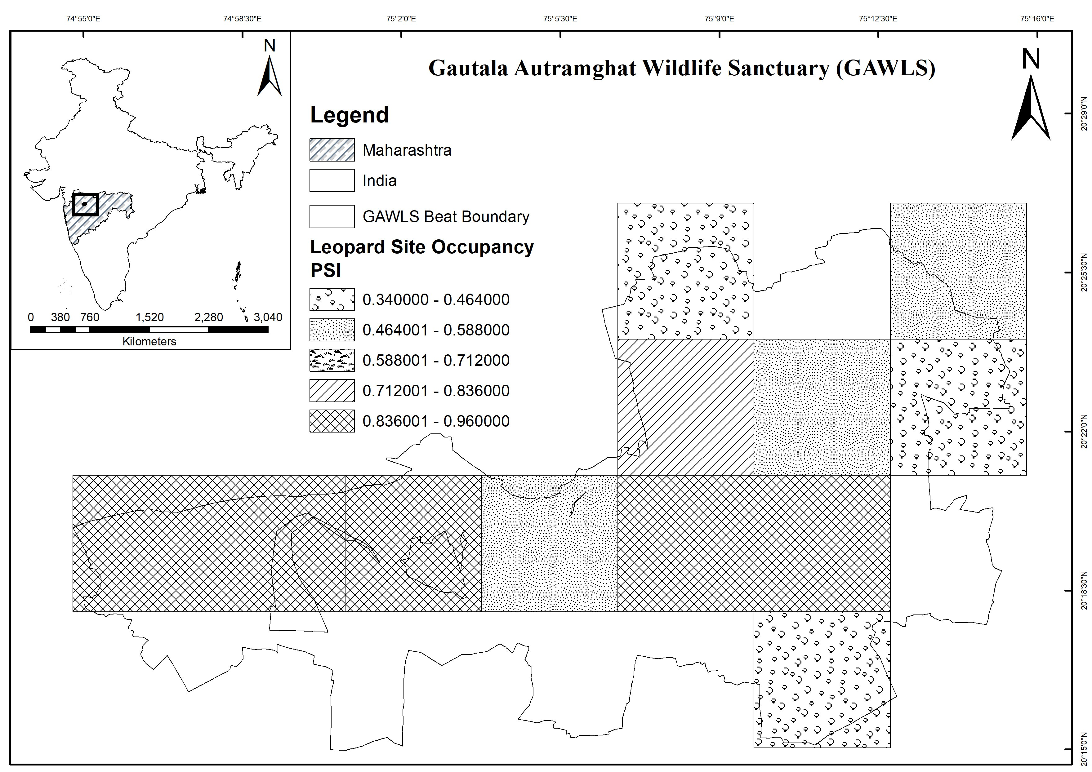
Fig. 3 Site-specific occupancy probability of leopards in GAWLS
Mixed deciduous forest (mxf) showed a consistent positive association with leopard occupancy across all models, with the first model showing $\hat{β }$mxf = 0.94 (SE = 0.45). This effect was stronger in later models, reaching $\hat{β }$mxf = 1.65 (SE = 0.69) and $\hat{β }$mxf = 1.83 (SE = 0.76), indicating its significant positive role in supporting leopard presence (Table 4). The distance to waterbodies (dw) similarly exhibited a positive association, with occupancy estimates ranging from $\hat{β }$dw = 0.16 (SE = 0.33) to $\hat{β }$dw = 0.38 (SE = 0.47), suggesting that proximity to water sources slightly enhances leopard occupancy probabilities. Human disturbance (hd) presented a mildly negative effect on occupancy, with an estimated coefficient of $\hat{β }$hd = -0.16 (SE = 0.43), indicating a slight reduction in occupancy probability where disturbances are higher. Livestock presence (lv) was slightly negatively associated with occupancy, with an estimate of $\hat{β }$lv = -0.22 (SE = 0.55) (Table 4), suggesting a modest decrease in leopard occupancy in areas with higher livestock density.
Table 4: Estimates of the beta coefficients (β) for covariates determining leopard occupancy in GAWLS. The selected models having AIC difference of less than 2
Model | $\hat{β}$0 ($\hat{β}0(\hat{SE}$)) [CI]) | $\hat{β }$mxf ($\hat{β}mxf(\hat{SE}$) [CI]) | $$\hat{β}dw$$  ($\hat{β}dw (\hat{SE}$)[CI]) | $$\hat{β}hd$$  ($\hat{β}hd (\hat{SE}$)[CI]) | $\hat{β}fr$ ($\hat{β}fr (\hat{SE}$)) [CI]) | $\hat{β}r$ ($\hat{β}r (\hat{SE}$)[CI]) | $\hat{β}$sr ($\hat{β}sr(\hat{SE}$)[CI]) | $$\hat{β}lv$$  ($\hat{β}lv (\hat{SE}$)[CI])
$\hat{ψ}$(mxf+r), θ₀(.),θ₁(.),p(lv), θ₀pi(.) | 1.89 (0.42) [1.07-2.71] | 0.94 (0.45) [0.05-1.83] | - | - | - | -0.08 (0.27) [-0.61-0.45] | - | -
$\hat{ψ}$(mxf), θ₀(.),θ₁(.),p(lv), θ₀pi(.) | 1.90 (0.54) [0.84-2.96] | 0.71 (0.30) [0.12-1.30] | - | - | - | - | - | -
$\hat{ψ}$(mxf+dw), θ₀(.),θ₁(.),p(lv), θ₀pi(.) | 1.91 (0.53) [0.87-2.95] | 1.65 (0.69) [0.29-3.01] | 0.17 (0.29) [-0.40-0.74] | - | - | - | - | -
$\hat{ψ}$(mxf+dw+lv), θ₀(.),θ₁(.),p(lv), θ₀pi(.) | 1.91(0.56) [0.81-3.01] | 1.40 (0.98) [-0.52-3.32] | 0.38 (0.47) [-0.54-1.30] | - | - | - | - | -0.22 (0.55) [-1.30-0.86]
$\hat{ψ}$(mxf+dw), θ₀(.),θ₁(.),p(lv+hp+r), θ₀pi(.) | 1.89 (0.51) [0.89-2.89] | 1.83 (0.76) [0.34-3.32] | 0.16 (0.33) [-0.49-0.81] | - | - | - | - | -
$\hat{ψ}$(mxf+sr), θ₀(.),θ₁(.),p(lv+hp+r), θ₀pi(.) | 1.92 (0.53) [0.88-2.96] | 1.60 (0.55) [0.52-2.68] | - | - | - | - | -0.07 (0.41) [-0.87-0.73] | -
$\hat{ψ}$(mxf+hd),θ₁(.),θ1(.),p(lv+hd), θ₀pi(.) | 1.94 (0.53) [0.90-2.98] | 0.97 (0.47) [0.05-1.89] | - | -0.16 (0.43) [-1.00-0.68] | - | - | - | -
$\hat{ψ}$(mxf+dw+fr),θ₁(.),θ1(.),p(lv+r), θ₀pi(.) | 1.96 (0.58) [0.82-3.10] | 1.18 (0.58) [0.04-2.32] | - | - | -0.67 (0.44) [-1.53-0.19] | - | - | -
Note: $\hat{ψ}$ = model averaged estimated leopard occupancy, mxf = mixed deciduous forest, sr = scrub, fr = fragment, dw = distance to waterbody, r = road, lv = livestock, hd = human disturbance, p = replicate level detectability, θ₀ = the probability that the species is present locally, given the species was not present in the previous sample, and θ₁ = the probability that a species is present locally, given it was present at the previous sample, (·) = parameters are held constant, + = covariates modelled additively, $\hat{β}$ = Estimated beta coefficient, CI = confidence of interval

Together, these findings underscore the significant role of specific habitat types, water availability, and minimal human disturbance in supporting leopard occupancy across the study landscape. The presence of roads (r) appeared to have no significant impact on leopard occupancy within the study area, while fragmented habitats (fr) demonstrated a notably negative influence, with $\hat{β }$fr = -0.67 (SE = 0.44) in the final model, suggesting that habitat fragmentation strongly undermines suitable occupancy. Scrubland (sr) did not appear to impact occupancy probabilities. Furthermore, nearby cropping areas and grasslands were not part of the top occupancy model and demonstrated no influence on leopard occupancy.
Our study showed that the 69% area of GAWLS is estimated to be occupied by leopards (Table 5).
Table 5: Estimated parameters, including θ, θ₁, ψ, and naive occupancy values
Pr(leopard present on segment/sample unit occupied and leopard not present on previous segment: [$\hat{θ }$ ($\hat{θ }(\hat{SE}$))] | 0.71 (0.30)
Pr(species present on segment/sample  unit occupied and species present on previous segment): [$\hat{θ }$₁( $\hat{θ }$₁ $(\hat{SE}$))] | 0.76 (0.15)
Pr (the total fraction of the area occupied by leopards in GAWLS),  that is, $\hat{ψ}$ (̂$\hat{SE}$($\hat{ψ}$)) | 0.69 (0.11)
Naïve occupancy | 0.75
Note: $\hat{ψ}$ = model averaged estimated leopard occupancy, θ₀ = the probability that the species is present locally, given the species was not present in the previous sample, and θ₁ = the probability that a species is present locally, given it was present at the previous sample
Discussion
The present study is the first-ever survey on carnivores to study leopard occupancy of GAWLS. The estimated probability of leopard site use within the study area establishes an important reference point that can be used to monitor shifts in leopard distribution over time. This baseline will facilitate future assessments of how ecological and anthropogenic changes impact their spatial patterns. Our research focused on leopard occupancy patterns and various covariates influencing these dynamics. The presence and abundance of leopards are closely tied to habitat quality and human disturbances.
The clear preference of Indian leopards for mixed deciduous forests underscores the critical need to conserve and restore these habitats within GAWLS. Representing nearly 50% of the sampling units in the study area, mixed deciduous forests play a pivotal ecological role (Table 4). This forest type consistently emerged as the strongest predictor of leopard occupancy, with statistically significant positive effects and confidence intervals that did not overlap zero. The structural complexity of mixed deciduous forests moderate canopy cover, dense understory, and relatively lower levels of human disturbance likely provides favourable conditions for leopard movement, concealment, and access to prey. These findings strongly support our initial hypothesis (see covariates section) and reinforce the importance of prioritizing the protection and management of mixed deciduous forest zones to sustain suitable leopard habitat. It is important to note that in this study, mixed deciduous forest was recorded only in terms of presence/absence at the grid scale, without estimating its proportion or spatial distribution. This approach limits the ability to fully capture habitat heterogeneity within grids. Future studies that incorporate finer-scale habitat mapping using remote sensing or GIS-based forest cover data would provide more detailed insights into how the extent and configuration of mixed deciduous forest, along with water availability and human presence, jointly influence leopard occupancy.
For other covariates, the results must be interpreted with caution. Although human disturbance was widespread in the sanctuary (recorded in 66% of sampling units), its estimated effect on leopard occupancy was negative but statistically uncertain, as reflected in wide confidence intervals (Table 4). This indicates that, while human activity has the potential to displace leopards (Carter et al. 2015), our data do not provide strong statistical support for such an effect in GAWLS. Similarly, the proximity to water sources showed positive coefficient values (β = 0.16–0.17), but these too were accompanied by wide confidence intervals. This suggests a possible ecological link between leopards and water availability (Rostro-García et al. 2024), yet the strength of this relationship remains inconclusive in our study.
The role of roads also requires nuanced interpretation. Although four roads, including a national highway (NH-52) with continuous industrial traffic, cross GAWLS, our results indicated no significant effect of roads on leopard occupancy. This finding aligns with some recent studies reporting limited or context-dependent impacts of highways on leopards (McKaughan et al. 2024; Naidenko et al. 2021). A likely explanation is that leopards in GAWLS may temporally adjust their movement, using major roads mainly during low-traffic hours such as nighttime or early morning, as documented in other studies (Carter et al. 2015). This behavioural flexibility could mask detectable occupancy-level impacts. Moreover, our analysis only incorporated major highways and did not consider unpaved or low-use trails, which leopards are known to prefer for movement, particularly during the monsoon season. The absence of these finer-scale features and temporal use patterns may have obscured more subtle relationships between road type, traffic volume, and leopard habitat use. Future studies integrating camera trap or telemetry data, combined with detailed road classifications and traffic monitoring, will be essential to understand when and how leopards interact with different road networks in semi-arid landscapes.
Water bodies are vital landscape features because they not only provide hydration for leopards but also attract diverse prey species that depend on these resources for drinking and foraging (Rostro-García et al. 2024). In drought-prone regions like GAWLS, scarcity of water can reduce prey abundance and intensify competition among predators (West et al. 2024). Although our models produced slightly positive coefficients for proximity to water, the wide confidence intervals (Table 4), suggesting that the statistical evidence for a strong relationship is limited. Nevertheless, the ecological role of water sources in semi-arid systems cannot be discounted, and future studies with more targeted sampling may be able to clarify their contribution to leopard occupancy.
The GAWLS supports a diverse assemblage of wild prey species that likely sustain leopard populations. The most abundant species were Northern plains grey langur (Semnopithecus entellus, 19.96/km²) and wild boar (Sus scrofa, 9.02/km²), followed by nilgai (Boselaphus tragocamelus, 8.82/km²), peafowl (Pavo cristatus, 3.14/km²), Indian hare (Lepus nigricollis, 2.29/km²), and blackbuck (Antilope cervicapra, 1.11/km²) (Pawar & Mule, 2025b). Livestock presence was hypothesised to negatively affect leopard distribution by competing with wild herbivores for forage and by increasing the risk of human–wildlife conflict. In GAWLS, the majority of livestock observed during surveys were cattle, with smaller numbers of goats and sheep present around forest fringes. While cattle dominate in terms of biomass, goats and sheep are more vulnerable to leopard predation due to their size and herding practices, particularly when grazed inside or adjacent to forest patches. Our study used overall livestock presence as a covariate, which may have masked these qualitative differences in leopard response to livestock distribution. While our estimates suggested a negative relationship between livestock density and leopard occupancy, the effect was statistically uncertain due to large standard errors (Table 4). A plausible explanation for this pattern is that leopards preferentially exploit abundant wild prey populations in forested habitats, largely avoiding livestock-dominated areas where the risk of human retaliation is higher. This contrasts with studies from regions where wild prey is scarce, and leopards rely more heavily on livestock to persist (Karanth et al. 2011; Pudyatmoko 2017). The observed pattern in GAWLS thus reflects a context-dependent avoidance of high-livestock areas, balancing prey availability and conflict risk. Future studies integrating systematic prey surveys with occupancy modeling could provide a more detailed understanding of how prey abundance and diversity influence leopard habitat use.
Fragmentation is another key concern for large carnivores. In our study, 58% of sampling units were classified as fragmented, and the coefficients for this variable were negative. However, the confidence intervals again spanned zero (Table 4), indicating that the statistical support for fragmentation as a limiting factor in leopard occupancy was weak. Nonetheless, previous research shows that habitat fragmentation can disrupt ecological interactions, reduce genetic connectivity, and hinder species’ adaptive capacity (Quintana et al. 2022). Restoration strategies aimed at reconnecting fragmented habitats remain important for biodiversity conservation, even if our dataset could not conclusively capture their effect on leopard distribution.
Finally, detection probabilities were modelled with human disturbance and livestock as covariates, but these factors also showed high uncertainty. While disturbance and livestock are well-recognized challenges for leopard conservation, our results caution against over-interpreting their statistical effects in GAWLS. Instead, we suggest that management strategies should continue to account for these pressures, while future research incorporates larger sample sizes, seasonal effects, and finer-scale habitat features to better capture the complexity of leopard–human–habitat interactions.
Mixed deciduous forest emerged as the only consistently significant factor influencing leopard occupancy in GAWLS, with positive effects supported by narrow confidence intervals. Other variables, including distance to water, livestock presence, and human disturbance, appeared in some top-ranked models but their effects were statistically uncertain due to wide confidence intervals and small ΔAIC values. While these covariates may represent ecologically meaningful trends, they require further investigation with larger datasets and refined methods. Our study, based on sign surveys, provides valuable baseline insights into leopard habitat use, though individual identification was not possible and the limited number of grids (n = 12) may have affected the precision of estimates. Nonetheless, the selected grids encompassed the major habitat types and human-use areas across GAWLS. Field observations also confirmed leopard presence in adjacent agricultural landscapes, suggesting broader use of the matrix outside the sanctuary. Future studies should extend to these fringe areas to better understand leopard ecology and inform conflict mitigation in human-dominated zones. Despite these limitations, this research represents the first systematic assessment of leopard occupancy in Gautala Autramghat Wildlife Sanctuary and establishes a foundation for long-term monitoring and conservation planning. Incorporating technologies such as camera traps and applying spatially explicit capture–recapture (SECR) models will further enhance detection accuracy and allow more robust estimates of leopard density and movement patterns in the region.
Conflict of interest
The authors declare no competing interests.
References
Akrim, F. Khursheed, N. Belant, J. L. Mehmood, T. Mahmood, T. Rafique, A. Qasim, S. Mushtaq, A. Aslam, S. Subhani, Z. A. Habib, U. Hashmi, S. A. Aslam, A. & Munawar, N. 2023. Patterns, costs, and drivers of livestock depredations by leopards in rural settlements of Pakistan. Global Ecology and Conservation, 46, e02564. https://doi.org/10.1016/J.GECCO.2023.E02564
Athreya, V. Isvaran, K. Odden, M. Linnell, J. D. C. Kshettry, A. Krishnaswamy, J. & Karanth, U. K. 2020. The impact of leopards Panthera pardus on livestock losses and human injuries in a human-use landscape in Maharashtra, India. PeerJ, 20203, e8405. https://doi.org/10.7717/PEERJ.8405/SUPP-1
Athreya, V. Odden, M. Linnell, J. Krishnaswamy, J. & Karanth, U. 2019. A cat among the dogs: leopard Panthera pardus diet in a human-dominated landscape in western Maharashtra, India. Oryx, 501, 156–162. https://doi.org/10.1017/S0030605314000106
Borah, J. Jena, J. Yumnam, B. & Puia, L. 2016. Carnivores in corridors: estimating tiger occupancy in Kanha–Pench corridor, Madhya Pradesh, India. Regional Environmental Change, 161, 43–52. https://doi.org/10.1007/S10113-015-0904-0/FIGURES/3
Burnham, K. P. & Anderson, D. R. 2002. Model Selection and Multimodel Inference. A practical information - theoretic approach. In Model Selection and Multimodel Inference. Springer New York. https://doi.org/10.1007/B97636
Carter, N. Jasny, M. Gurung, B. & Liu, J. 2015. Impacts of people and tigers on leopard spatiotemporal activity patterns in a global biodiversity hotspot. Global Ecology and Conservation, 3, 149–162. https://doi.org/10.1016/J.GECCO.2014.11.013
Chaudhary, R. Zehra, N. Musavi, A. & Khan, J. A. 2020. Evaluating the effect of ecological and anthropogenic variables on site use by sympatric large carnivores in Gir protected area, Gujarat, India. Wildlife Biology, 20204. https://doi.org/10.2981/WLB.00696
Chinchkhede, N. 2015, May 6. Officials on a high note after waterhole census at Gautala. Times of India. https://timesofindia.indiatimes.com/city/aurangabad/officials-on-a-high-note-after-waterhole-census-at-gautala/articleshow/47169283.cms
Farhadinia, M. S. Waldron, A. Kaszta, Ż. Eid, E. Hughes, A. Ambarlı, H. Al- Hikmani, H. Buuveibaatar, B. Gritsina, M. A. Haidir, I. Islam, Z. ul, Kabir, M. Khanal, G. Koshkin, M. A. Kulenbekov, R. Kubanychbekov, Z. Maheshwari, A. Penjor, U. Raza, H. … Macdonald, D. W. 2022. Current trends suggest most Asian countries are unlikely to meet future biodiversity targets on protected areas. Communications Biology 2022 5:1, 51, 1–9. https://doi.org/10.1038/s42003-022-04061-w
Gubbi, S. Sharma, K. & Kumara, V. 2020. Every hill has its leopard: patterns of space use by leopards Panthera pardus in a mixed use landscape in India. PeerJ, 8:e10072. https://doi.org/10.7717/peerj.10072
Harihar, A. & Pandav, B. 2012. Influence of Connectivity, Wild Prey and Disturbance on Occupancy of Tigers in the Human-Dominated Western Terai Arc Landscape. PLOS ONE, 77, e40105. https://doi.org/10.1371/JOURNAL.PONE.0040105
Hines, J. E. 2006. PRESENCE- Software to estimate patch occupancy and related parameters 2.13.47. USGS-PWRC. http://www.mbr-pwrc.usgs.gov/software/presence.html
Hines, J. E. Nichols, J. D. Royle, J. A. MacKenzie, D. I. Gopalaswamy, A. M. Kumar, N. S. & Karanth, K. U. 2010. Tigers on trails : occupancy modeling for cluster sampling. 205, 1456–1466.
IMD. 2005. Climate of Maharashtra. National Climate Centre Office of the Meteorology Research India Meteorological Department Pune- 411005, 1–325. https://imdpune.gov.in/library/public/Climate%20of%20Maharashtra.pdf
Jacobson, A. P. Gerngross, P. Lemeris, J. R. Schoonover, R. F. Anco, C. Breitenmoser-Würsten, C. Durant, S. M. Farhadinia, M. S. Henschel, P. Kamler, J. F. Laguardia, A. Rostro-García, S. Stein, A. B. & Dollar, L. 2016. Leopard Panthera pardus status, distribution, and the research efforts across its range. PeerJ, 20165, e1974. https://doi.org/10.7717/PEERJ.1974/SUPP-16
Karanth, K. U. Gopalaswamy, A. M. Kumar, N. S. Vaidyanathan, S. Nichols, J. D. & Mackenzie, D. I. 2011. Monitoring carnivore populations at the landscape scale: occupancy modelling of tigers from sign surveys. Journal of Applied Ecology, 484, 1048–1056. https://doi.org/10.1111/J.1365-2664.2011.02002.X
Karanth, K. U. Nichols, J. D. Kumar, N. S. Link, W. A. & Hines, J. E. 2004. Tigers and their prey: Predicting carnivore densities from prey abundance. Proceedings of the National Academy of Sciences of the United States of America, 10114. https://doi.org/10.1073/pnas.0306210101
Maan, J. S. & Chaudhry, P. 2019. People and protected areas: some issues from India Maan, S. J. Chaudhry, P. Animal Biodiversity and Conservation, 421, 79–90. https://doi.org/10.32800/ABC.2019.42.0079
MacKenzie, D. I. Nichols, J. D. Lachman, G. B. Droege, S. Andrew Royle, J. & Langtimm, C. A. 2002. Estimating site occupancy rates when detection probabilities are less than one. Ecology, 838, 2248–2255. https://doi.org/10.1890/0012-96582002083[2248:ESORWD]2.0.CO;2
MacKenzie, D. I. Nichols, J. D. Royle, J. A. Pollock, K. H. Bailey, L. & Hines, J. E. 2017. Occupancy estimation and modeling: inferring patterns and dynamics of species occurrence. Elsevier.
MacKenzie, D. I. Nichols, J. D. Royle, J. A. Pollock, K. H. Bailey, L. L. & Hines, J. E. 2006. Occupancy Estimation and Modeling: Inferring Patterns and Dynamics of Species Occurrence. Elsevier.
McKaughan, J. E. T. Stephens, P. A. Lucas, C. Guichard Kruger, N. Guichard Kruger, F. & Hill, R. A. 2024. Leopard density and determinants of space use in a farming landscape in South Africa. Scientific Reports 2024 14:1, 141, 1–11. https://doi.org/10.1038/s41598-024-61013-6
Ministry of Environment Forest and Climate Change Notification, New Delhi, the 9th December, Pub. L. No. REGD. NO. D. L.-33004/99, The Gazette of India 1 2016.
Mondol, S. Sridhar, V. Yadav, P. Gubbi, S. & Ramakrishnan, U. 2015. Tracing the geographic origin of traded leopard body parts in the indian subcontinent with DNA-based assignment tests. Conservation Biology, 292, 556–564. https://doi.org/10.1111/COBI.12393
Naidenko, S. Chistopolova, M. Hernandez-Blanco, J. A. Erofeeva, M. & Rozhnov, V. 2021. The effect of highway on spatial distribution and daily activity of mammals. Transportation Research Part D: Transport and Environment, 94, 102808. https://doi.org/10.1016/J.TRD.2021.102808
Odden, M., Athreya, V., Rattan, S., & Linnell, J. D. C. (2014). Adaptable Neighbours: Movement Patterns of GPS-Collared Leopards in Human Dominated Landscapes in India. PLOS ONE, 9(11), e112044. https://doi.org/10.1371/JOURNAL.PONE.0112044
Pawar, P., & Mule, M. (2025a). Herbaceous Species Diversity, Composition and Anthropogenic Disturbances at Gautala Autramghat Wildlife Sanctuary (GAWLS), Maharashtra, Western India. Journal of Biology and Nature, 17(1), 82–95. https://doi.org/10.56557/JOBAN/2025/V17I19211
Pawar, P., & Mule, M. (2025b). Mammalian Diversity and Prey Population Density of Gautala Autramghat Wildlife Sanctuary, Maharashtra, Western India. Journal of Biology and Nature, 17(1), 49–62. https://doi.org/10.56557/JOBAN/2025/V17I19182
Pawar, P., & Mule, M. (2025c). Vegetation Patterns and Anthropogenic Influence in Gautala Autramghat Wildlife Sanctuary (GAWLS): An Analysis of Species Diversity and Ecological Status. Journal of Global Ecology and Environment, 21(2), 37–50. https://doi.org/10.56557/JOGEE/2025/V21I29180
Pudyatmoko, S. 2017. Free-ranging livestock influence species richness, occupancy, and daily behaviour of wild mammalian species in Baluran National Park, Indonesia. Mammalian Biology, 86, 33–41. https://doi.org/10.1016/J.MAMBIO.2017.04.001
Quintana, I. Cifuentes, E. F. Dunnink, J. A. Ariza, M. Martínez-Medina, D. Fantacini, F. M. Shrestha, B. R. & Richard, F. J. 2022. Severe conservation risks of roads on apex predators. Scientific Reports 2022 12:1, 121, 1–12. https://doi.org/10.1038/s41598-022-05294-9
Qureshi, Q. Jhala, Y. V, Yadav, S. P. Tiwari, V. R. Garawad, R. & Mallick, A. 2024. Status of Leopards in India, 2022. In National Tiger Conservation Authority, Government of India, New Delhi, and Wildlife Institute of India, Dehradun.
Ram, M. Sahu, A. Srivastava, N. Chaudhary, R. Jhala, L. Zala, Y. & Venkataraman, M. 2024. Home range, habitat use and capture-release of translocated leopards in Gir landscape, Gujarat, India. PLOS ONE, 196, e0305278. https://doi.org/10.1371/JOURNAL.PONE.0305278
Rostro-García, S. Kamler, J. F. Sollmann, R. Balme, G. Sukmasuang, R. Godfrey, A. Saosoong, S. Siripattaranukul, K. Suksavate, S. Thomas, W. Crouthers, R. In, V. Prum, S. Clements, G. R. Kadir, A. Liang, S. H. Avriandy, R. Gunaryadi, D. Kholiq, N. … Macdonald, D. W. 2024. Leopards on the edge: Assessing population status, habitat use, and threats in Southeast Asia. Biological Conservation, 299, 110810. https://doi.org/10.1016/J.BIOCON.2024.110810
Snider, M. H. Athreya, V. R. Balme, G. A. Bidner, L. R. Farhadinia, M. S. Fattebert, J. Gompper, M. E. Gubbi, S. Hunter, L. T. B. Isbell, L. A. Macdonald, D. W. Odden, M. Owen, C. R. Slotow, R. Spalton, J. A. Stein, A. B. Steyn, V. Vanak, A. T. Weise, F. J. … Kays, R. 2021. Home range variation in leopards living across the human density gradient. Journal of Mammalogy, 1024, 1138–1148. https://doi.org/10.1093/JMAMMAL/GYAB068
Stein, A. B. Athreya, V. Gerngross, P. Balme, G. Henschel, P. Karanth, U. Miquelle, D. Rostro-Garcia, S. Kamler, J. F. & Laguardia, A. 2020. Panthera pardus amended version of 2019 assessment. https://dx.doi.org/10.2305/IUCN.UK.2020-1.RLTS.T15954A163991139.en
Stein, A. B. Gerngross, P. Al Hikmani, H. Balme, G. Bertola, L. Drouilly, M. Farhadinia, M. S. Feng, L. Ghoddousi, A. Henschel, P. Jhala, Y. Khorozyan, I. Kittle, A. Laguardia, A. Luo, S. J. Mann, G. Miquelle, D. Moheb, Z. Raza, H. … Wibisono, H. 2024. Panthera pardus. The IUCN Red List of Threatened Species 2024. https://www.iucnredlist.org/species/15954/254576956#assessment-information
Thapa, K. Malla, S. Subba, S. A. Thapa, G. J. Lamichhane, B. R. Subedi, N. Dhakal, M. Acharya, K. P. Thapa, M. K. Neupane, P. Poudel, S. Bhatta, S. R. Jnawali, S. R. & Kelly, M. J. 2021. On the tiger trails: Leopard occupancy decline and leopard interaction with tigers in the forested habitat across the Terai Arc Landscape of Nepal. Global Ecology and Conservation, 25, e01412. https://doi.org/10.1016/J.GECCO.2020.E01412
The Economic Times. 2021, March. Tiger seen in Guatala Autramghat sanctuary, a first after 1940. https://economictimes.indiatimes.com/news/india/tiger-seen-in-guatala-autramghat-sanctuary-a-first-after-1940/articleshow/81590858.cms?from=mdr
TNN. 2022, December 30. Calf Killed By Leopard In Kannad Near Aurangabad’s Autramghat Sanctuary. Times of India. https://timesofindia.indiatimes.com/city/aurangabad/calf-killed-by-leopard-in-kannad-near-aurangabads-autramghat-sanctuary/articleshow/96611086.cms
Webb, E. L. Choo, Y. R. Kudavidanage, E. P. Amarasinghe, T. R. Sumith Indika Bandara, U. G. Charitha Lakmali Wanninayaka, W. A. Ravindrakumar, P. Nimalrathna, T. S. Liang, S. H. & Hwee Chua, M. A. 2020. Leopard activity patterns in a small montane protected area highlight the need for integrated, collaborative landscape conservation. Global Ecology and Conservation, 23, e01182. https://doi.org/10.1016/J.GECCO.2020.E01182
West, L. Rafiq, K. Converse, S. J. Wilson, A. M. Jordan, N. R. Golabek, K. A. McNutt, J. W. & Abrahms, B. 2024. Droughts reshape apex predator space use and intraguild overlap. Journal of Animal Ecology. https://doi.org/10.1111/1365-2656.14192
Zehra, N. 2014. A Study on Large Mammalian Prey Predator of Gir with Special Reference to the Ecology of Leopards. Aligarh Muslim University.

