Case report
Pseudopregnancy with Concurrent Endometritis in a Doe: A Clinical Case Report

ABSTRACT
Pseudopregnancy is a common reproductive disorder in goats that often mimics true gestation, leading to diagnostic confusion and delayed intervention. The present case describes a five-year-old non-descript doe presented for pregnancy diagnosis with a history of presumed gestation and progressive abdominal enlargement. Clinical examination revealed mild whitish vaginal discharge with a patent cervix, suggestive of an open uterine condition. Transabdominal ultrasonography confirmed the absence of a fetus, along with the presence of echogenic intrauterine debris and increased uterine wall thickness, indicative of uterine pathology. Based on combined clinical and imaging findings, the case was diagnosed as pseudopregnancy concurrent with endometritis. Therapeutic management using PGF₂α (250 µg IM) resulted in successful evacuation of uterine contents, evidenced by mucoid vaginal discharge and marked reduction in abdominal distension within 2–3 days. Supportive therapy including antibiotics, anti-inflammatory and adjunct treatments facilitated recovery. The case highlights the importance of ultrasonography in differentiating pseudopregnancy from true pregnancy and emphasizes timely prostaglandin therapy for effective resolution. Early diagnosis and appropriate management are essential to restore reproductive efficiency and prevent long-term fertility impairment in goats.
Keywords: Pseudopregnancy; Endometritis; Goat; Ultrasonography; PGF₂α; Hydrometra
INTRODUCTION
Efficient reproductive performance is a critical determinant of productivity and economic sustainability in small ruminant farming systems. Among various reproductive disorders affecting goats, conditions that mimic pregnancy, such as pseudopregnancy, pose a significant diagnostic and management challenge (Noakes et al., 2018). Pseudopregnancy, also referred to as hydrometra or mucometra in small ruminants, is characterized by the accumulation of sterile fluid within the uterus in the absence of a viable fetus, often associated with persistence of a functional corpus luteum and prolonged progesterone dominance (S et al., 2020). This condition is relatively common in goats and may lead to misinterpretation of pregnancy status due to progressive abdominal distension and behavioral changes resembling gestation (Balamurugan et al., 2018).
The pathophysiology of pseudopregnancy involves failure of luteolysis, resulting in sustained progesterone secretion, which promotes uterine glandular activity and fluid accumulation (Desire et al., 2017). In goats, this condition is frequently reported under field conditions and is often diagnosed during routine pregnancy diagnosis when no fetus is detected on ultrasonography (Cherian et al., 2023). Although pseudopregnancy is typically considered a non-infectious condition, it may predispose the uterus to secondary complications, including endometrial inflammation, particularly when uterine clearance mechanisms are compromised (Scully, 2024).
Endometritis, defined as inflammation of the uterine endometrium, represents another important reproductive disorder that can adversely affect fertility in small ruminants (Radi, 2005). It is characterized by the presence of vaginal discharge with partial cervical relaxation, often without overt systemic illness. Subclinical or mild endometritis may go unnoticed but can impair uterine environment, thereby reducing conception rates and overall reproductive efficiency (Lima, 2024). Accurate differentiation between true pregnancy, pseudopregnancy, and uterine pathological conditions is essential for appropriate clinical management. In this regard, ultrasonography has emerged as a reliable and indispensable diagnostic tool, allowing visualization of intrauterine contents, assessment of uterine wall characteristics, and confirmation of fetal viability (Cherian et al., 2023).
The present case report describes a case of pseudopregnancy concurrent with endometritis in a doe, initially presented for pregnancy diagnosis based on a history of presumed gestation. The case highlights the importance of comprehensive clinical and ultrasonographic evaluation for accurate diagnosis and underscores the effectiveness of prostaglandin-based therapeutic intervention in resolving such conditions.
CASE HISTORY AND CLINICALEXAMINATION
A five-year-old non-descript female doe (caprine) was presented to the Referral Veterinary Polyclinic of the Indian Veterinary Research Institute, Izatnagar, with a history of approximately three months of presumed gestation as reported by the owner. The animal was brought for pregnancy diagnosis (PD) based on breeding history and progressive abdominal enlargement. No prior history of systemic illness, treatment, or reproductive disorders was reported.
On general clinical examination, the animal was alert with normal posture and physiological parameters within normal limits (Figure 1). No signs of systemic infection such as fever, anorexia, or depression were observed. Examination of the external genitalia did not reveal any gross abnormality. However, on per-vaginal examination, a mild amount of whitish, non-foul smelling discharge was observed on the gloves, indicating possible uterine involvement (Figure 2). The cervix appeared patent, suggesting an open type condition, although no excessive exudate or purulent material was detected. Examination of the external genitalia did not reveal any gross abnormalities.

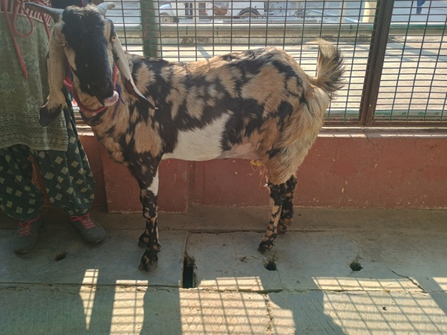
Figure 1: Doe at presentation with normal clinical status.
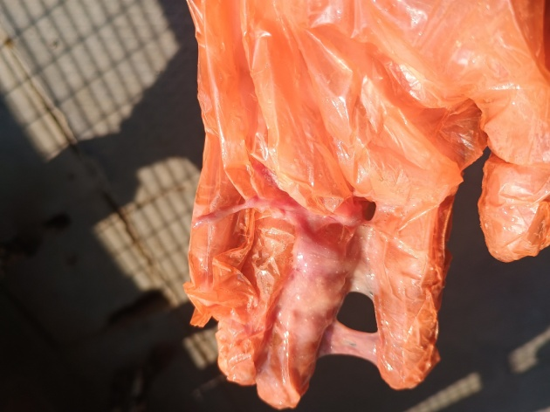
Figure 2: Vaginal discharge observed on glove during per-vaginal examination
Further evaluation of the reproductive tract was carried out using transabdominal ultrasonography. USG examination revealed absence of intrauterine fetus, with no evidence of fetal heartbeat, placentomes, or embryonic structures. The uterine lumen exhibited echogenic debris with heterogeneous echotexture, along with increased uterine wall thickness (Figure 3). These findings were suggestive of uterine pathology rather than normal pregnancy. The ovaries did not reveal any prominent abnormalities, and no distinct cystic structures were identified.
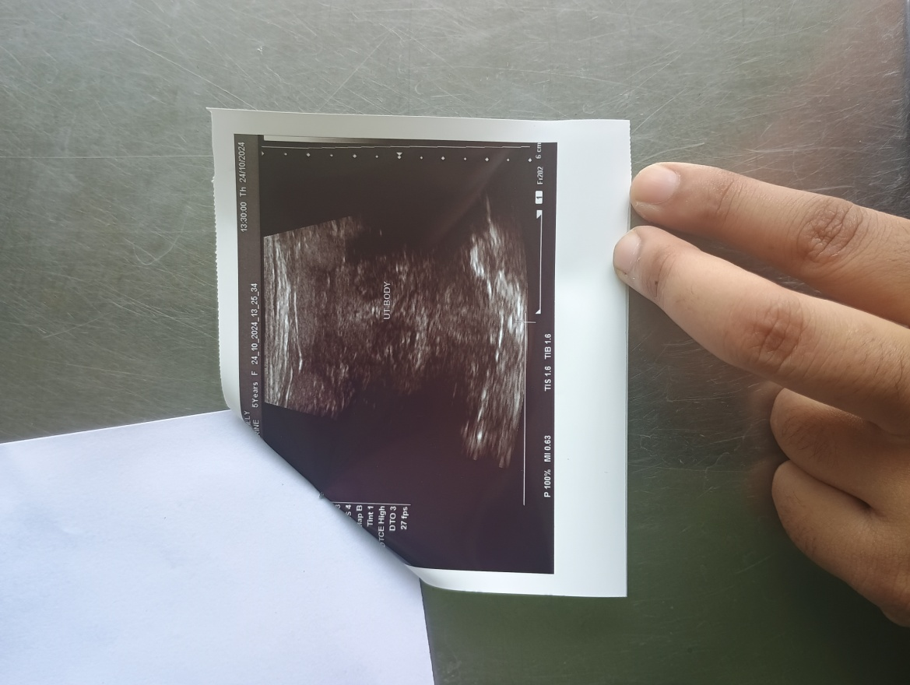
Figure 3: Ultrasonogram showing absence of fetus with echogenic uterine contents.
Based on clinical findings and ultrasonographic evaluation, the case was diagnosed as non-pregnant with evidence of uterine inflammation. The presence of mild vaginal discharge, along with ultrasonographic findings of echogenic intrauterine contents and thickened uterine wall, was indicative of endometritis. The history of presumed gestation in the absence of a fetus suggested a concurrent condition of pseudopregnancy, which may have misled the owner regarding the pregnancy status of the animal.
TREATMENT AND DISCUSSION
In the present case, therapeutic management was primarily directed towards resolution of pseudopregnancy, evacuation of uterine contents, and treatment of concurrent endometritis, with the objective of restoring normal reproductive cyclicity and improving future fertility. Based on the clinical and ultrasonographic findings suggestive of pseudopregnancy with uterine involvement, prostaglandin therapy was initiated. The doe was administered PGF₂α (Pregma®) @ 250 µg intramuscularly. Following administration, the animal exhibited clear mucoid vaginal discharge within 2–3 days, accompanied by a marked reduction in abdominal distension, indicating successful evacuation of accumulated uterine contents.
Supportive therapy was instituted to address uterine inflammation and prevent secondary complications. The treatment protocol included chlorpheniramine maleate (@ 0.5 mg/kg) as an anti-allergic agent, meloxicam (@ 1 mg/kg IM) for anti-inflammatory effects, Intacef® (ceftriaxone @ 5 mg/kg IM) as a broad-spectrum antibiotic to control uterine infection, and Tribivet® as supportive vitamin therapy to enhance recovery and metabolic status. The owner was advised to maintain hygienic conditions and to monitor for estrus signs. Breeding was recommended during the subsequent normal estrous cycle following complete recovery.
The clinical response observed in this case is consistent with the established pathophysiology of pseudopregnancy in goats, which is predominantly associated with persistent corpus luteum activity leading to prolonged progesterone dominance (Balamurugan et al., 2018). Elevated progesterone levels promote uterine glandular secretions and fluid accumulation, resulting in hydrometra or mucometra, which clinically mimics pregnancy through abdominal enlargement (Cherian et al., 2023). In the present case, although classical anechoic fluid accumulation was not predominant, the presence of echogenic debris and uterine wall thickening indicated a deviation toward inflammatory uterine pathology, supporting the concurrent diagnosis of endometritis. Administration of PGF₂α facilitates cervical relaxation, increased uterine contractility, and expulsion of accumulated contents, which explains the observed vaginal discharge and reduction in abdominal distension post-treatment. The effectiveness of prostaglandin therapy in resolving pseudopregnancy in goats has been well documented (S et al., 2020).
The presence of whitish vaginal discharge and ultrasonographic evidence of echogenic intrauterine material in this case suggests endometritis, where the cervix remains partially open, allowing drainage of uterine contents. Unlike pyometra, the absence of systemic illness, toxemia, or purulent discharge indicates a relatively mild to moderate inflammatory condition. However, if left untreated, such cases may compromise uterine environment and negatively impact fertility (Lima, 2024). Differential diagnoses considered included early embryonic loss, mucometra, and pyometra. Early embryonic mortality could explain the history of presumed pregnancy; however, the absence of placentomes and organized fetal remnants, along with uterine debris, makes this less likely (Noakes et al., 2018). Pyometra was ruled out due to the absence of systemic signs and purulent exudate. The clinical presentation, combined with therapeutic response to PGF₂α, strongly supports pseudopregnancy with secondary endometritis.
This case highlights the importance of integrating clinical examination, per-vaginal findings, and ultrasonography for accurate differentiation between true pregnancy and pathological uterine conditions in small ruminants. Reliance solely on history and abdominal enlargement may lead to misdiagnosis and delayed treatment. Overall, the prognosis in this case is favorable, provided complete uterine recovery occurs. Timely prostaglandin therapy effectively resolved the pseudopregnancy, while supportive and antimicrobial treatment aided in the management of endometritis. Restoration of normal estrous cyclicity is expected, and breeding during subsequent estrus is likely to yield improved reproductive outcomes.
REFERENCES
- Balamurugan, B., Kumar, A., Ramamoorthy, M., & Ali, A. (2018). Successful therapeutic management of hydrometra in a DOE- a case report. International Journal of Current Microbiology and Applied Sciences, 7(07), 2044–2047. https://doi.org/10.20546/ijcmas.2018.707.241
- Cherian, N., Azeez, C. P. A., Promod, K., Benjamin, E. D., & Murugan, S. S. (2023). Early diagnosis of pseudopregnancy in goats by ultrasonography and response to treatment using cloprostenol sodium. Journal of Veterinary and Animal Sciences, 54(1). https://doi.org/10.51966/jvas.2023.54.1.160-166
- Desire, S., Mucha, S., Coffey, M., Mrode, R., Broadbent, J., & Conington, J. (2017). Pseudopregnancy and aseasonal breeding in dairy goats: genetic basis of fertility and impact on lifetime productivity. Animal, 12(9), 1799–1806. https://doi.org/10.1017/s1751731117003056
- Lima, F. (2024, September 18). Endometritis in production animals. Merck Veterinary Manual. https://www.merckvetmanual.com/reproductive-system/uterine-diseases-in-production-animals/endometritis-in-production-animals
- Noakes, D. E., Parkinson, T. J., & England, G. C. W. (2018). Veterinary Reproduction and Obstetrics. Saunders.
- Radi, Z. A. (2005). Endometritis and cystic endometrial hyperplasia in a Goat. Journal of Veterinary Diagnostic Investigation, 17(4), 393–395. https://doi.org/10.1177/104063870501700418
- Scully, C. M. (2024, September 18). Pseudopregnancy in goats. MSD Veterinary Manual. https://www.msdvetmanual.com/reproductive-system/pseudopregnancy-in-goats/pseudopregnancy-in-goats
- S, S., Rs, K., & E, M. (2020). Management of Pseudopregnancyin goat in field condition –A case report.www.entomoljournal.com. https://www.entomoljournal.com/archives/?year=2020&vol=8&issue=4&ArticleId=7304

