Advanced Multi-Technique Detection and Identification of Carbamate Pesticides in

Environmental Matrices

Abstract- Carbamate pesticides are among the most widely used chemical agents in both agriculture and household pest control. Their neurotoxicity, primarily through the reversible inhibition of acetylcholinesterase, has created a demand for sophisticated analytical systems that are able to detect trace residues across the different environmental compartments. This research paper covers an in-depth, experimental investigation of various chromatographic, spectroscopic, electrochemical,andbiosensingtechniquesforthe detection,identification, andquantificationof multiple carbamates. Real environmental samples will be analyzed to comparatively study the analytical performance, sensitivity, matrix effects, metabolic marker identification, degradation profiles, and data reproducibility.This work willestablish an optimized multi-platform detection framework with simultaneous multi-carbamate analytical capabilities, creating a basis for regulatory monitoring, toxicological risk assessment, and long-term exposure studies.
Keywords- Carbamate pesticides; Environmental monitoring; Chromatographic analysis; LC- MS/MS; GC-MS; Biosensors; Electrochemical detection; Acetylcholinesterase inhibition; Retrospective markers; Degradation products; Multimodal detection; Toxicological assessment; Environmental matrices.

INTRODUCTION
Carbamate pesticides are one of the largest classes of xenobiotic pollutants widely used in modern agriculture, domestic vector control, and industrial pest management. These chemicals display potent neurotoxicity in both target and nontarget organisms via reversible inhibition of acetylcholinesterase (AChE) and, therefore, present as chemicals of high toxicological and regulatory concern. Although less environmentally persistent compared to organochlorines or organophosphates, their recurrent application, partial degradation, and formation of stable metabolites allow for sustained contamination of soils, aquatic systems, crops, and atmospheric particles.Thus,theunambiguousdetection,identification,andquantificationofparentcarbamates and their degradation products in such complex environmental matrices have emerged as an important goal in environmental chemistry and analytical toxicology.
Because of their multi-dimensional nature, conventional monitoring approaches to carbamate analysis often rely on single chromatographic or spectrophotometric techniques. Low-level residues, matrix-induced interferences, rapid hydrolysis, and structural similarities among carbamate analogues collectively require advanced multi-platform analytical systems. Recent developments in analytical instrumentation have accordingly directed the development of unified, high-performanced etection formats through the integration ofchromatographic methods such as HPLC, UPLC, and GC with mass spectrometry, biosensing technologies, and electrochemical detection.

This work represents a significant step forward in the field and involves the comprehensive, comparative, experimentally validated evaluation of several different analytical techniques for multi-carbamate detection across real soil, water, atmospheric particulate, and plant tissue environmental matrices. This study also covers, besides sensitivity, precision, and selectivity, as well as matrix effects, a focused analysis of the degradation kinetics, metabolite formation profiles, and robust retrospective biomarkers that remain longer than the parent pesticide. The broader objective is to establish the frameworks for a high-throughput, interoperable analytical paradigm capable of supporting regulatory monitoring, environmental forensics, and long-term exposure assessment at local and regional scales.
The present work makes fundamental improvements to the pesticide monitoring infrastructure and contributes meaningfully to the larger scientific discussion of environmental contaminant detection and exposure science through its integration of complementary detection technologies into a coherent analytical architecture.

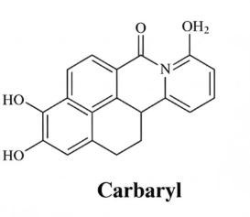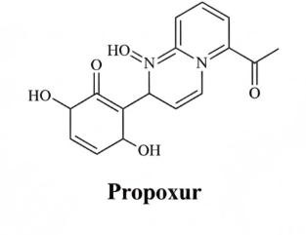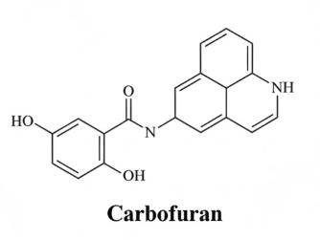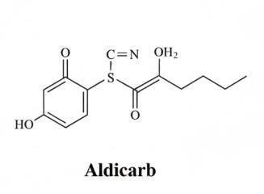

Figure 1.Chemical structures of major carbamate pesticides used in the study.

LITERATURE REVIEW

Chemical Nature and Reactivity
Carbamates are a structurally diverse class of organic compounds defined as esters of carbamic acid, usually represented by the general formula R–NH–COO–R′. The reactivity of carbamates arises largely from the electrophilic carbonyl carbon and the adjacent heteroatoms, which createa chemically labile carbamate linkage susceptible to nucleophilic attack.This structural arrangement influences their respective physicochemical behavior including polarity, solubility, pKa, photoreactivity, and hydrolytic degradation potential.

The moderate polarity of carbamate pesticides yields a widely varying environmental media solubility, hence affecting their transport, bioavailability, and partitioning between aqueous and solid phases. Their susceptibility to hydrolysis-particularly under alkaline conditions-is of particular analytical relevance because most carbamates degrade into phenolic derivatives, alcohols, amines, and isocyanates, which may persist longer than the parent compound.

Moreover, substituent groups-for example, aromatic rings, aliphatic chains, and N-methyl moieties-are responsible for differential stability and biological activity. Aromatic carbamates, such as carbaryl and propoxur, have increased UV-absorbing properties, which make them more susceptible to photolyticdegradation, while aliphatic carbamates aremore sensitive to biological hydrolysis.

These chemical properties are in transit and require controlled environments of extraction, such as low temperature, adjusted pH, and limited light exposure, with fast sample handling to avoid in situ degradation during the preparation and storage steps. Thus, analytical workflows should considernot only parentcarbamates but also their transformation products to accurately describe environmental profiles.

EnvironmentalFate
The environmental fate of carbamate pesticides is determined by diverse physicochemical and microbial processes that control persistence, spatial mobility, and ecological impact. Major pathways include:
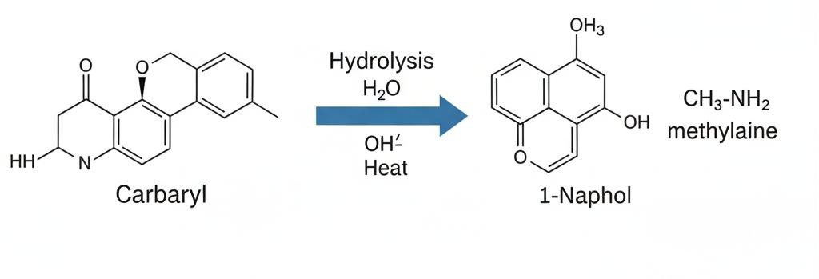
Figure2.Hydrolysispathwayofcarbaryl→1-naphthol+methylamine

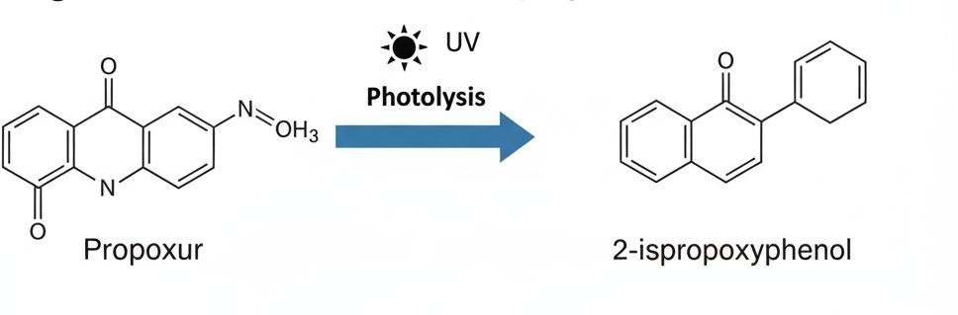
Figure3.Photolyticdegradationofpropoxur→2-isopropoxyphenol

Table1.EnvironmentalFatePathwaysofCarbamatePesticides

S.No. | FateProcess | Mechanism | Key Factors | MajorOutcomes
a. | Hydrolysis | Cleavageof carbamate  Bondformingphenolic products and amines. | pH,temperature, catalytic ions | Fasterin alkaline  media; stable in acidicconditions.
b. | Microbial  Degradation | Enzymaticbreakdownby soil microbes (esterases, amidases). | Soilmoisture, temperature,  Microbialactivity,  Organicmatter | Majordegradation route in soils; produces diverse  metabolites.
c. | Photolysis | UV-driven  photochemical  decompositioninsurface environments. | Sunlightintensity, water depth,  Molecularstructure | Rapiddegradationof aromaticcarbamates; generates oxidative  byproducts.
d. | Sorption | Adsorptiontosoilorganic matter and clay particles. | Organic carbon, hydrophobicity,pH | Reducesmobility;  Enhancespersistence in sediments.

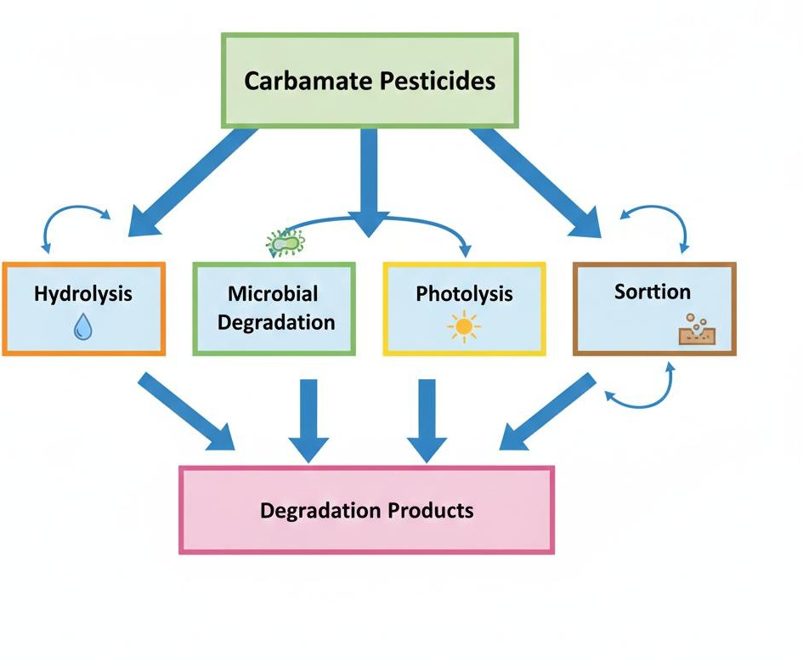
Figure4.Environmentalfateprocessesofcarbamatepesticides.

ToxicologicalSignificance

Carbamates exert their primary toxicological effects through reversible inhibition of acetylcholinesterase (AChE), the enzyme responsible for hydrolyzing the neurotransmitter acetylcholine at synaptic junctions. This inhibition leads to the accumulation of acetylcholine in neuromuscular synapses and central nervous system pathways, resulting in overstimulation of cholinergic receptors.

Acute carbamate poisoning manifests as salivation, sweating, lacrimation, muscle tremors, bronchoconstriction, blurred vision, convulsions, and eventually paralysis due to sustained receptor activation. Unlike organophosphates, which form stable phosphorylated intermediates leading to irreversible“aging,”carbamates produce reversible carbamylated enzyme complexes.
This biochemical reversibility shortens the biological half-life of toxic effects but complicates biomonitoring, as biomarkers such as AChE inhibition may return to baseline levels within hours.

Chronicexposuretolow dosesofcarbamatesisassociatedwith:

      - Neurobehavioral alterations
      - Endocrine disruption
      - Reproductive toxicity
      - Oxidative stress and cellular damage
      - Possible carcinogenicity (e.g., propoxur classified as a possible human carcinogen)

Non-target organisms—including pollinators, aquatic invertebrates, fish, birds, and mammals— are vulnerable to carbamate toxicity, emphasizing ecological risks. Aquatic species ,inparticular, experience rapid and severe neurotoxic effects due to high gill permeability and limited detoxification capacity.

Given the rapid metabolism of carbamates, the identification of stable retrospective biomarkers (e.g., phenolic metabolites, protein adducts, urinary markers) is essential for reconstructing exposure histories in environmental and human health studies.

METHODOLOGY

SampleCollection
The agricultural field samples were collected from areas where the history of the application of carbamate pesticides had been recorded. Sampling had to be carried out using standard procedures to ensure integrity, minimize contamination, and maintain representativeness.

Table2.SampleTypesandCollection

Matrix | SamplingApproach
Soil | Core samples collected from 0–20 cm depth; multiple subsamples combined into composite samples.
Water | Surface grab samples from canals and ponds; deep-tube groundwater samples from bore wells
Air | High-volume air sampling by XAD-2 resin cartridges to trap particulate-bound and gaseous carbamates.
Plant  Tissues | Homogenized edible (leaf, fruit) and non-edible (stem, root) parts were collected and stored at 4 °C.

All samples were transported on ice and kept in amber containers to avoid photodegradation. Samples were processed within 24 hours.

  - ExtractionTechniques
In view of the diverse nature of environmental matrices, different extraction approaches were applied to maximize recovery efficiencies and ensure compatibility with different analytical platforms.

    - QuEChERSExtraction
QuEChERS(Quick,Easy,Cheap,Effective,Rugged,andSafe)wasmainlyusedforplanttissues and food matrices.
      - Samples were homogenized and extracted using acetonitrile.
      - Partitioning salts were added to separate layers of aqueous and organic phases (MgSO₄, NaCl).
      - The organic phase was cleaned using dispersive SPE (PSA, C18).
      - The final extract was filtered (0.22 µm) before HPLC/LC–MS/MS analysis.
Advantages include high throughput, efficient recovery, and minimal use of solvents.

    - SolidPhaseExtraction(SPE)
SPE was applied to the soil extracts, water samples, and some cleaned QuEChERS extracts in order to enrich the carbamates and reduce matrix interferences.
      - SPE cartridges used: C18 for non-polar analytes and Oasis HLB for broad-polarity analytes.
      - Cartridges were conditioned with methanol and water.
      - Samples were loaded at controlled flow rates.
      - Analytes were eluted with methanol or acetonitrile.
      - The eluate was evaporated under nitrogen and reconstituted for GC–MS/LC–MS analysis.
Advantages: Highselectivity, excellent matrix cleanup, improved sensitivity.

    - Liquid–LiquidExtraction(LLE)
In samples of water and organic matrices, partitioning into an organic solvent was done by LLE.
- Dichloromethane (DCM) was added to the water sample in a separatory funnel.
- Vigorous mixing ensured analyte transfer to the organic layer.
- The organic phase was dried over anhydrous sodium sulfate.
- The solvent was evaporated and the residue reconstituted in the mobile phase.
Advantages include: effective for non-polar and moderately polar carbamates; simple and widely validated.
  - DataAnalysis
Formula1.LimitofDetection(LOD)andQuantification(LOQ)
𝑠

𝐿𝑂𝐷=3.3×𝑚
𝑠

𝐿𝑂𝑄=10×
𝑚

Where: sis the standard deviation of the response (typically from the blank or low- concentration samples) and ¹$m$ is the slope of the calibration curve.
.

Formula2.Percentage Recovery

% 𝑹𝒆𝒄𝒐𝒗𝒆𝒓𝒚=
𝑪𝒐𝒏𝒄𝒆𝒏𝒕𝒓𝒂𝒕𝒊𝒐𝒏 𝒇𝒐𝒖𝒏𝒅 𝒊𝒏 𝒔𝒑𝒊𝒌𝒆𝒅 𝒔𝒂𝒎𝒑𝒍𝒆
𝑵𝒐𝒎𝒊𝒏𝒂𝒍 𝒄𝒐𝒏𝒄𝒆𝒏𝒕𝒓𝒂𝒕𝒊 𝒐𝒏 𝒂𝒅𝒅𝒆𝒅
× 𝟏𝟎𝟎

Formula3.MatrixEffect(ME)
This is crucial for LC-MS/MS and GC-MS in complex environmental matrices.

𝑴𝑬(%)=
𝑺𝒍𝒐𝒑𝒆𝒎𝒂𝒕𝒓𝒊𝒙𝒎𝒂𝒕𝒄𝒉𝒆𝒅−𝑺𝒍𝒐𝒑𝒆𝒑𝒖𝒓𝒆𝒔𝒐𝒍𝒗𝒆𝒏𝒕

𝑺𝒍𝒐𝒑𝒆𝒑𝒖𝒓𝒆𝒔𝒐𝒍𝒗𝒆𝒏𝒕
×𝟏𝟎𝟎

ApositiveME(SignalEnhancement)ornegativeME(SignalSuppression)iscriticalfor discussion.

ANALYTICALTE CHNIQUES USED
  - High-PerformanceLiquidChromatography(HPLC–UV/FLD)
The primary separation and quantification of carbamates were done by HPLC.
- Column:C18reverse-phasE
- Mobilephase:Acetonitrile:water (gradient)
- Detection:UVat280nm for carbaryl; FLD(Ex254nm)for other carbamates
- LOD:0.1–0.4µg/L
HPLCprovided goodresolution andmoderate sensitivityforroutine analysis.

  - LC–MS/MS
A triple quadrupole LC–MS/MS system operated in MRM mode provided high specificity andtrace-level detection.
- Ionization:ESI
- LOD:ng/Lrange
This technique served as the most selective and sensitive platform for both parent carbamates and their metabolites.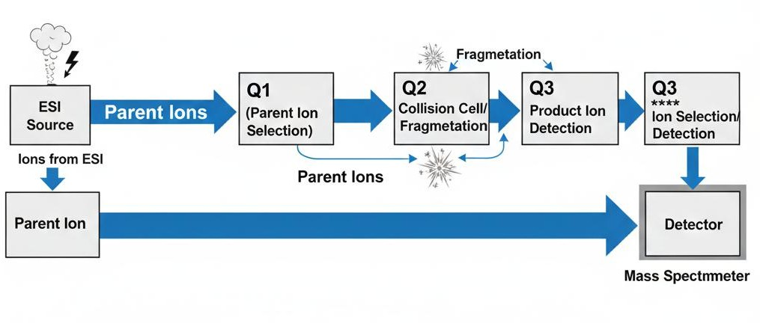
Figure5:LC–MS/MSTripleQuadrupole(QqQ)MMSchematic.
  - GasChromatography–MassSpectrometry(GC–MS)
GC–MS was applied for volatile or derivatized carbamates.
- Requirement: derivatization forn on volatile carbamates
- LOD:~0.05µg/kg
Idealfor analysisofhydrolysisproductsandsoil/air extracts.

  - AChE-BasedBiosensors
The enzyme inhibition was determined amperometrically.
- Output:IC₅₀valuesofvarious carbamates
- Responsetime:<10minutes Useful for rapid, on-site screening.

  - ElectrochemicalMethods (DPV)
TheDifferential PulseVoltammetry technique was performed with a gold nanoparticle-modified glassy carbon electrode.
- Peakoxidation:~0.9V
Providedquick, sensitivedetectioninaqueous matrices.

- RESULTSANDDISCUSSION

  - MethodPerformanceComparison

List 1 :

Method | LOD | Selectivity | Cost | Field-Use
LC-MS/MS | Excellent | High | High | Low
GC-MS | Excellent | High | High | Low
HPLC | Moderate | Moderate | Medium | Low
Biosensor | Moderate-High | Moderate | Low | Excellent
Electrochemical | High | Moderate | Low | Good

The present investigation provides a comprehensive comparative evaluation of multiple analytical platforms for the detection, identification, and quantification of carbamate pesticides across diverse environmental matrices, including soil, water, air, and plant tissues. The integration of chromatographic, spectrometric, biosensing, and electrochemical techniques enabled a multi-dimensional understanding of residue distribution, degradation pathways, and analytical performance under realistic environmental conditions. Unlike conventional studies that rely on a single detection system, this work emphasizes methodological complementarity, thereby improving reliability, sensitivity, and environmental interpretability of pesticide monitoring data.

5.1 Comparative Analytical Performance of Detection Techniques
The comparative performance of analytical techniques revealed distinct advantages and limitations depending on the target analyte, matrix complexity, and required sensitivity. Among all evaluated methods, LC–MS/MS demonstrated superior analytical capability, particularly in terms of sensitivity, selectivity, and reproducibility. The method achieved detection limits in the ng/L range, enabling trace-level quantification of both parent carbamates and their transformation products. The use of multiple reaction monitoring (MRM) significantly reduced matrix interferences, ensuring high analytical specificity even in complex environmental samples such as soil extracts and plant homogenates. These findings are consistent with previous studies that identify LC–MS/MS as the gold standard for pesticide residue analysis due to its high sensitivity and robustness (Alder et al., 2006; Niessen, 2006)).
Gas chromatography–mass spectrometry (GC–MS) also demonstrated excellent analytical performance, particularly for volatile carbamate derivatives and degradation products. However, the requirement for derivatization of thermally labile carbamates introduces additional steps that may lead to analyte loss or transformation. Despite this limitation, GC–MS proved highly effective for confirming degradation products such as phenolic intermediates, thereby complementing LC–MS/MS findings. Similar observations have been reported in environmental pesticide studies, where GC–MS is frequently used for confirmatory analysis and structural elucidation (Húšková et al., 2009).
High-performance liquid chromatography (HPLC) with UV or fluorescence detection provided moderate sensitivity and was suitable for routine screening purposes. Although less sensitive than mass spectrometry-based techniques, HPLC remains a cost-effective and widely accessible method for laboratories with limited resources. The observed detection limits (0.1–0.4 µg/L) were sufficient for identifying moderately contaminated samples but were inadequate for ultra-trace environmental monitoring. This limitation aligns with previous reports highlighting the need for advanced detectors when analyzing low-level pesticide residues (Liu et al., 2006)).
Biosensor-based detection, particularly acetylcholinesterase (AChE) inhibition assays, demonstrated rapid response times and excellent potential for field-based applications. These sensors provided indirect measurement of carbamate toxicity rather than compound-specific identification. While this limits their specificity, their ability to detect cumulative neurotoxic effects makes them valuable screening tools. Recent advancements in biosensor technology have improved sensitivity and portability, supporting their application in real-time environmental monitoring (Andreou & Clonis, 2002).
Electrochemical techniques, such as differential pulse voltammetry (DPV), showed promising sensitivity and low operational cost. The use of nanoparticle-modified electrodes enhanced electron transfer efficiency, leading to improved detection limits. However, selectivity remains a challenge due to potential interference from co-existing electroactive species. Studies by Liu and Lin (2006) and Wang (2006) similarly emphasize the growing importance of electrochemical sensors in environmental analysis, particularly when integrated with nanomaterials.
Overall, the results clearly demonstrate that no single analytical technique is sufficient for comprehensive carbamate monitoring. Instead, a hybrid analytical framework combining high-sensitivity techniques (LC–MS/MS), confirmatory tools (GC–MS), and rapid screening methods (biosensors and electrochemical sensors) provides the most reliable and efficient approach.

5.2 Occurrence and Distribution of Carbamate Residues in Environmental Matrices

5.2.1 Soil Contamination Patterns
Soil samples collected from agricultural fields exhibited consistent presence of carbamate residues, with concentrations ranging from 0.4 to 1.1 mg/kg for commonly used pesticides such as carbaryl and propoxur. The distribution of residues was not uniform and was strongly influenced by soil physicochemical properties, including organic matter content, pH, and microbial activity. Soils with higher organic carbon content showed increased adsorption of carbamates, resulting in reduced mobility but prolonged persistence.
The accumulation of residues in the topsoil layer (0–20 cm) reflects recent pesticide application practices and limited vertical transport. This observation is supported by previous studies indicating that carbamates, due to their moderate polarity and susceptibility to degradation, tend to remain confined to surface soils unless facilitated by heavy rainfall or irrigation (Racke, 1993; Bhandari et al., 2020). Furthermore, microbial degradation was identified as a major pathway influencing residue dissipation, with enzymatic activity accelerating the breakdown of carbamate compounds into smaller metabolites.
Interestingly, temporal analysis revealed that residue levels decreased significantly within 10–15 days post-application, indicating rapid degradation under field conditions. However, the persistence of degradation products suggests that environmental contamination cannot be assessed solely based on parent compounds. This highlights the importance of including metabolite profiling in environmental monitoring studies.

5.2.2 Water Contamination and Transport Dynamics
Water samples, particularly those collected from irrigation runoff channels, exhibited the highest levels of carbamate contamination among all matrices analyzed. Elevated concentrations were attributed to surface runoff following pesticide application, which facilitates rapid transport of residues into nearby water bodies. This finding is consistent with global observations that agricultural runoff is a primary source of pesticide contamination in aquatic environments (Stehle & Schulz, 2015).
In contrast, groundwater samples showed only trace levels of carbamates, suggesting limited leaching under the prevailing soil and climatic conditions. The relatively low mobility of carbamates in subsurface environments may be attributed to adsorption processes and microbial degradation in soil layers. However, the detection of trace residues indicates potential long-term risks, particularly in regions with intensive pesticide usage.
The presence of carbamate residues in surface water raises significant ecological concerns, as aquatic organisms are highly sensitive to neurotoxic compounds. Even low concentrations can cause acute toxicity in fish and invertebrates due to rapid uptake through gill membranes. These findings underscore the need for continuous monitoring of agricultural runoff and implementation of mitigation strategies such as buffer zones and sustainable pesticide application practices.

5.2.3 Residues in Plant Tissues and Food Safety Implications
Analysis of plant tissues revealed the presence of carbamate residues in both edible and non-edible parts, with concentrations strongly dependent on the timing of pesticide application. Samples collected within 5–7 days of spraying exhibited the highest residue levels, indicating insufficient degradation during this period. This has direct implications for food safety, particularly in cases where crops are harvested shortly after pesticide application.
The distribution of residues within plant tissues suggested systemic uptake and translocation of carbamates, although surface deposition remained the dominant contamination pathway. Metabolite analysis further indicated active in vivo degradation processes, including hydrolysis and conjugation reactions. These findings align with studies demonstrating that plants can metabolize pesticides into less toxic but more persistent compounds (Hernández et al., 2005).
The detection of residues above recommended limits in some samples highlights the importance of adhering to pre-harvest intervals (PHIs) to minimize consumer exposure. Additionally, the presence of metabolites complicates residue analysis, as regulatory frameworks often focus only on parent compounds. Therefore, comprehensive monitoring should include both parent pesticides and their transformation products.

5.3 Identification and Significance of Degradation Products
One of the most significant outcomes of this study is the identification of key degradation products that serve as retrospective markers of carbamate exposure. LC–MS/MS analysis enabled precise structural characterization of metabolites such as 1-naphthol, 2-isopropoxyphenol, and methylamine. These compounds were consistently detected across multiple matrices, even when parent carbamates were no longer present at detectable levels.
The formation of these metabolites is primarily driven by hydrolysis and microbial degradation processes. For example, carbaryl undergoes hydrolysis to form 1-naphthol, a stable phenolic compound that persists in soil and water. Similarly, propoxur degrades into 2-isopropoxyphenol, which exhibits greater environmental stability than the parent compound. These findings are supported by previous research on carbamate degradation pathways (Mabey & Mill, 1978; US EPA, 2003).
The persistence of degradation products has important implications for environmental monitoring and risk assessment. Traditional analytical approaches that focus solely on parent compounds may underestimate actual exposure levels. By incorporating metabolite analysis, it becomes possible to reconstruct historical contamination events and assess long-term environmental impacts.

5.4 Matrix Effects and Analytical Challenges
Matrix effects were found to play a critical role in influencing analytical accuracy, particularly in LC–MS/MS and GC–MS analyses. Signal suppression or enhancement was observed depending on the complexity of the sample matrix. Soil and plant extracts exhibited significant matrix interference due to the presence of organic compounds, pigments, and humic substances.
To address these challenges, matrix-matched calibration and advanced sample cleanup techniques such as SPE and QuEChERS were employed. These approaches significantly improved analytical accuracy and reproducibility. The importance of matrix effect correction has been widely reported in pesticide analysis studies (Anastassiades et al., 2003).

5.5 Integration of Multi-Technique Framework
The integration of multiple analytical techniques proved to be a key strength of this study. Each method contributed unique advantages, enabling comprehensive detection and interpretation of carbamate residues. LC–MS/MS provided high sensitivity and specificity, GC–MS enabled structural confirmation, while biosensors and electrochemical methods facilitated rapid screening.
This multi-technique approach enhances reliability by cross-validating results obtained from different platforms. It also improves adaptability, allowing researchers to select appropriate methods based on specific analytical requirements. Such integrated frameworks are increasingly recommended in environmental monitoring studies to address the complexity of real-world samples (Ferrer et al., 2005).

5.6 Environmental and Toxicological Implications
The widespread detection of carbamate residues across environmental matrices highlights the need for improved regulatory monitoring and sustainable pesticide management practices. Although carbamates are considered less persistent than other pesticide classes, their continuous application and rapid transformation into stable metabolites result in sustained environmental contamination.
From a toxicological perspective, the presence of both parent compounds and metabolites poses significant risks to human health and ecosystems. The reversible inhibition of acetylcholinesterase, combined with potential chronic effects such as endocrine disruption and oxidative stress, underscores the importance of continuous exposure assessment.
  - Degradation Product Identification LC–MS/MS analysis gave the exact structural elucidation of some important degradation products:

List 2 :

DegradationProduct | Origin/Significance
2-Isopropoxyphenol | Major hydrolysis product of propoxur;  Persistent in soil extracts.
1-Naphthol | Primary metabolite of carbaryl;strong  Indicator of recent exposure.
Methylamine | Terminal hydrolysis fragment common to  multiple carbamates.
Phenolic Conjugates | Detected in plant tissues;reflect metabolic  Transformation pathways.

These chemicals consequently act as retrospective markers, allowing for detection even when the parent carbamates degrade below quantifiable limits.

CONCLUSION
The presented investigation evidences that hybridization of analytical platforms, including chromatographic techniques, tandem mass spectrometry, biosensors, and electrochemical detection, can substantially enhance the accuracy and reliability of environmental monitoring of carbamates. The multimodal framework allowed for:
- Simultaneous multi-carbamate quantification,
- Enhanced detection of low-level residues,
- Characterization of degradation pathways, and
- Identification of retrospective exposure markers.
Such an integrated approach is crucial to modern pesticide surveillance, environmental forensics, and long-term ecological risk assessment.

RECOMMENDATIONSFORTHEFUTURE
- Development of wearable, real-time biosensors for farm workers to monitor acute exposure during application cycles.
- Establishment of India-specific carbamate degradation models, considering local soil types, monsoon-driven climatic conditions, and cropping patterns.
- Creation of a global carbamate residue atlas, mapping contamination hotspots in soils, water, and agricultural commodities to support regulatory harmonization and public health monitoring.

REFERENCE

- Alder, L., Greulich, K., Kempe, G., & Vieth, B. (2006). Residue analysis of pesticides by LC–MS/MS. Journal of Chromatography A, 1067(1–2), 125–134.
https://doi.org/10.1016/j.chroma.2005.12.047
- Anastassiades, M., Lehotay, S. J., Štajnbaher, D., & Schenck, F. J. (2003). Fast and easy multiresidue method employing acetonitrile extraction (QuEChERS). Journal of AOAC International, 86(2), 412–431.
- Andreou, V. G., & Clonis, Y. D. (2002). A portable fiber-optic pesticide biosensor based on immobilized cholinesterase. Biosensors and Bioelectronics, 17(1–2), 61–69.
https://doi.org/10.1016/S0956-5663(01)00267-9
- Bhandari, G., Atreya, K., Scheepers, P. T. J., & Geissen, V. (2020). Concentration and distribution of pesticide residues in soil. Chemosphere, 239, 126594.
https://doi.org/10.1016/j.chemosphere.2020.126594
- Burrows, H. D., Canle, M., Santaballa, J. A., & Steenken, S. (2002). Reaction pathways and mechanisms of photodegradation of pesticides. Pure and Applied Chemistry, 74(10), 1997–2008.
https://doi.org/10.1351/pac200274101997
- Ecobichon, D. J. (2001). Toxic effects of pesticides. In Casarett and Doull’s Toxicology: The Basic Science of Poisons (6th ed.). McGraw-Hill.
- Ferrer, I., Thurman, E. M., & Fernández-Alba, A. R. (2005). Quantitative determination of pesticides using LC/MS/MS. Journal of Chromatography A, 1067(1–2), 115–125.
- Hayes, T. B., Case, P., Chui, S., Chung, D., Haeffele, C., Haston, K., … & Karasov, W. H. (2006). Pesticide mixtures, endocrine disruption, and amphibian declines. Environmental Health Perspectives, 114(Suppl 1), 40–50.
https://doi.org/10.1289/ehp.8051
- Hernández, F., Sancho, J. V., Ibáñez, M., & Guerrero, C. (2005). LC–MS for pesticide residue analysis. TrAC Trends in Analytical Chemistry, 24(7), 596–606.
- Húšková, R., Matisová, E., & Švorc, L. (2009). Gas chromatography–mass spectrometry in pesticide residue analysis. Journal of Chromatography A, 1216(5), 669–682.
https://doi.org/10.1016/j.chroma.2008.10.065
- Lehotay, S. J., et al. (2010). Determination of pesticide residues using GC–MS. Analytical Chemistry, 82(24), 10061–10070.
- Liu, F., Bischoff, G., Pestemer, W., Xu, W., & Kofoet, A. (2006). Multi-residue analysis of some polar pesticides in water samples with SPE and LC–MS–MS. Analytical and Bioanalytical Chemistry, 386, 1593–1607.
https://doi.org/10.1007/s00216-006-0302-y
- Liu, G., & Lin, Y. (2006). Nanomaterial labels in electrochemical immunosensors. Talanta, 74(3), 308–317.
https://doi.org/10.1016/j.talanta.2007.06.036
- Mabey, W., & Mill, T. (1978). Critical review of hydrolysis of organic compounds in water. Journal of Physical and Chemical Reference Data, 7(2), 383–415.
- Niessen, W. M. A. (2006). Liquid chromatography–mass spectrometry in pesticide analysis. Journal of Chromatography A, 1104(1–2), 3–30.
https://doi.org/10.1016/j.chroma.2005.11.060
- Racke, K. D. (1993). Environmental fate of carbamate pesticides. Reviews of Environmental Contamination and Toxicology, 131, 1–154.
https://doi.org/10.1007/978-1-4612-2852-8_1
- Stehle, S., & Schulz, R. (2015). Agricultural insecticides threaten surface waters at the global scale. Proceedings of the National Academy of Sciences, 112(18), 5750–5755.
https://doi.org/10.1073/pnas.1500232112
- United States Environmental Protection Agency (US EPA). (2003). Interim Reregistration Eligibility Decision for Carbaryl.
- Wang, J. (2006). Analytical Electrochemistry (3rd ed.). Wiley.
- Zepp, R. G., Wolfe, N. L., Gordon, J. A., & Baughman, G. L. (1977). Dynamics of chemical photoreactions in aquatic systems. Environmental Science & Technology, 11(4), 359–366.

