Original Research Article

Assessment of Physicochemical Characteristics and Microbiological Quality of Fried Shrimp Sold in Rural Municipality of Loumbila

ABSTRACT
Shrimp is a crustacean found in marine and freshwater environments and is widely distributed throughout the world due to its nutritional and socioeconomic values. However, its chemical composition, rich in proteins and lipids, and its water content, make it an easily perishable food commodity and particularly susceptible to microbiological and physicochemical alterations. As part of the study, ten samples of fried shrimp were collected from different sales sites in Loumbila. Physicochemical characteristics and microbiological quality were assessed using standard analytical methods. FAMT loadings ranged from 0.29±0.12x10⁶ CFU/g to 1.83±1.29x10⁶ CFU/g. Dry matter and water content ranged from 87.23±1.25 % to 95.92±0.67 % and 4.08±0.67 % to 12.77±1.25 %, respectively. Also, acidity and pH ranged from 0.04 % to 0.12±0.01 % and 8.48±0.06 and 8.99±0.11, respectively. As for the loads of thermotolerant coliforms, Escherichia coli and Salmonella and Shigella, they were all less than 10 CFU/g with a total absence of Salmonella and Shigella in all the samples analyzed. For total coliforms, the loads were also less than 10 CFU/g except four samples EC3, EC4, EC6 and EC8, which varied from 1.12±0.21x10³ to 1.97±0.82x10³ CFU/g. The loads of yeasts and molds were also less than 10 CFU/g except samples EC3 and EC8, whose loads were respectively 1.5±0.70x10³ CFU/g and 3.5±2.1x10³ CFU/g. Most of shrimp samples analyzed were of unsatisfactory microbiological quality, EC1, EC2, EC7, and EC9 were of acceptable microbiological quality. Therefore, these fried shrimps could pose a more or less significant hazard to individuals who consumed them.
Keywords: fried shrimp, physicochemical characteristics, microbiological quality, yeasts and molds, Loumbila.
1. INTRODUCTION
Shrimp are small decapod crustaceans that live in the sea or in fresh water. Nowadays, shrimp consumption is becoming increasingly widespread in all regions of the world, and global production has been growing steadily since the advent of shrimp aquaculture in Southeast Asia in the 1960s (FAO, 2025). In 2010, global shrimp production accounted for approximately 9.6% of total aquaculture production, or about 3.8 million tonnes. According to FAO statistics, global farmed shrimp production reached approximately 4.5 million tonnes in 2017, 5.2 million tonnes in 2020 and 5.6 million tonnes in 2023 before stabilising (slightly below that of 2023) in 2024 (FAO, 2025). Shrimp are highly prized in aquaculture and commercial fishing, contributing to economic development, especially in developing countries (Faunce et al., 2006). In 2006, shrimp remained the most sought-after fishery product in terms of value, accounting for approximately 17% of the total value of international trade in fishery products (FAO, 2021). The volume of shrimp catches for all species combined represented 2 to 3% of global fisheries production (FAO, 2021). However, shrimp production is much more developed in other regions of the world than in Africa, where shrimp farming is still in its infancy. In Central Africa, particularly in Cameroon, the shrimp industry employs around 1,800 people and contributes USD 47 million to GDP, which represents around 12% of the GDP from fisheries (Trifunovic, 2023). In sub-Saharan Africa, shrimp consumption has increased by 25% over the last decade, reflecting a trend towards more diversified diets (FAO, 2021). In Burkina Faso, shrimp production is mainly focused on aquaculture. This activity mainly benefits women traders in localities such as Koubri and Loumbila (Coulibaly et al. 2019), but it also enables fishermen to generate economic income and thus helps to reduce unemployment. In Burkina Faso, most of the shrimp species exploited are of the genus Macrobrachium. However, these species are not sufficiently exploited, with only twelve (12) out of one hundred and twenty-five (125) known species of the genus Macrobrachium being exploited (KABORE et al., 2023). This low exploitation rate could be explained by the low level of knowledge about shrimp, as there are not enough studies on shrimp in Burkina Faso. However, six species have been identified and exploited in Burkina Faso (KABORE et al., 2023). In Burkina Faso, shrimp consumption is mainly supplied by local artisanal fishing in rural areas. Shrimp are generally fried before being sold to consumers by women traders in rural communities such as Koubri, Loumbila, Mogtédo, etc. However, national production of fishery products (including shrimp) remains insufficient to meet domestic demand. Indeed, average per capita consumption per year has risen from 2.4 kg in 2000 to 8.6 kg in 2022, representing a market demand of 180,000 tonnes per year, while national supply is only around 30,000 tonnes (KABORE et al., 2023). Among the commercially important crustaceans are two species of shrimp, namely the red shrimp (Aristeus antennatus) and the white shrimp (Parapenaeus longirostris), which are not only commercially important but also nutritionally important because their flesh is a source of animal protein, fatty acids and vitamins (Collomb and Mayor, 2007; Virginie et al., 2007; Ghorab, 2016). In addition, these crustaceans are an excellent source of minerals, particularly zinc, calcium, phosphorus and copper. The presence of phosphorus promotes the absorption of calcium from shrimps by the body. Shrimps are low in fat but contain cholesterol (Collomb and Mayor; 2007). In fact, the edible part of crustaceans contains on average three times more cholesterol than fish or meat (Virginie et al., 2007). In addition, some shrimps have a pink colour due to a compound called astaxanthin, which comes from the algae that these shrimps eat. This compound has anti-inflammatory properties that can reduce the risk of certain chronic diseases such as heart disease and cancer (Holthius, 1983). Studies have shown that eating shrimps can cause one or more allergic reactions, such as breathing difficulties, vomiting, diarrhoea, headaches and low blood pressure, in consumers who are intolerant to shrimps (Montus, 2024). Shrimps are highly perishable foodstuffs, as their high water content and nutritional quality are conducive to the development of microorganisms that are often responsible for food poisoning. Depending on where they are caught, some shrimps may be contaminated with heavy metals such as lead and cadmium, and a number of pathogens such as Escherichia coli due to water pollution from all kinds of waste (Maillard et al. 2018). Given the important place that shrimp occupy in the world and also the role they play in the dietary habits of Burkina Faso, it is necessary to evaluate the physicochemical and microbiological characteristics of fried shrimp sold in the rural commune of Loumbila.
2. MATERIALS AND METHODS
2.1. Sampling
Figure 1 shows the fried shrimps that were collected. Ten samples of fried shrimps were collected from ten different sites, specifically from ten prawn sellers in Loumbila. The samples were packaged in sterile bags and immediately transported to the laboratory for various microbiological and physicochemical analyses.
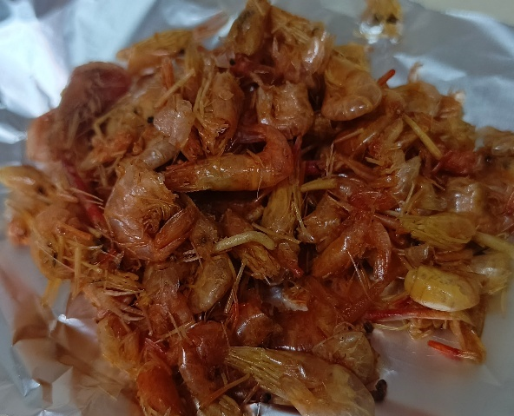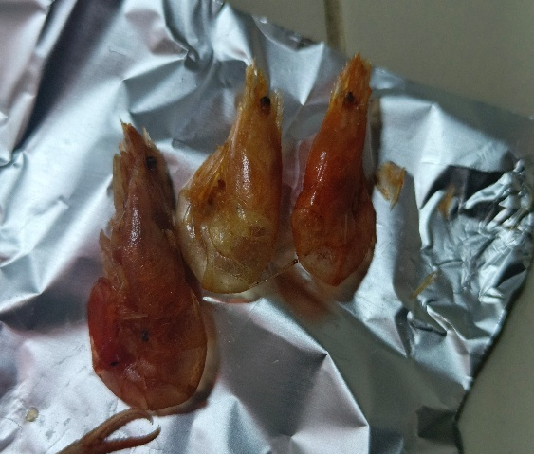
Figure 1 : Fried shrimps collected

2.2. Determination of physicochemical characteristics of shrimp samples
2.2.1. Determination of dry matter and water content
The dry matter of the samples was determined using the AOAC (1990) method, which is based on removing water from the sample by heating it in an oven under specific conditions of time and temperature. Five grams (5 g) of shrimp were placed in an empty crucible of known mass and then placed in an oven at 105 °C for 4 hours. After 4 hours, the crucible and shrimp sample were left to rest for a few minutes before being weighed again after cooling. The dry matter (DM) and water content were expressed as a percentage using respectively the following formula (1) and (2) :
% DM = $\frac{(FW-EO)}{TS}$ × 100 (1) and % H2O = 100 % - % DM
TS: Test sample; E0: Empty crucible weight; FW: Final weight (crucible + dry sample) ; % H₂O : Water content
2.2.3. Determination of acidity
Acidity was determined using the AOAC (2000) method. A mass of 5 g was weighed and added to 50 ml of distilled water contained in a flask. The mixture was homogenised for 5 minutes using a magnetic stirrer, then 10 ml of the supernatant was withdrawn using a syringe and poured into a beaker. Two drops of 1% phenolphthalein were added to the beaker containing the supernatant and the mixture was titrated with a 0.1 N sodium hydroxide (NaOH) solution. The volume V1 of sodium hydroxide added at equivalence was noted. The acidity level was expressed as a percentage using the following formula:
% AR = $\frac{N*V1*0.09}{V0}$ × 100
%AR: Acidity rate; N: Normality of soda (0.1N); V1: Volume of soda poured at equivalence; V0: Volume of supernatant taken (10ml); 0.09: Conversion factor to lactic acid equivalent
2.2.4. Determination of pH
The pH was determined using the potentiometric method (AOAC, 1990). To do this, 5 g of the sample was weighed and then placed in a flask containing 50 ml of distilled water, previously measured using a graduated cylinder. The mixture was shaken by hand for approximately 2 minutes and then left to stand for 15 minutes. Next, the pH meter electrode was immersed in the solution to take various pH measurements. The pH measurement was performed in duplicate.
2.3. Evaluation of microbiological characteristics of shrimp samples
2.3.1. Preparation of the diluent, stock solution and decimal dilutions
The diluent and stock solution were prepared and the decimal dilutions were made in accordance with ISO 6887-1 (1999).
2.3.2. Preparation of diluent
A mass of 1.26 g of sodium chloride (NaCl) was weighed using an electric balance and then added to 140 ml of distilled water, measured beforehand using a graduated cylinder. The mixture was homogenised and autoclaved at 121 °C for 15 minutes under a pressure of 1 bar. The resulting solution was used to prepare the stock solution and perform the decimal dilutions.
2.3.3. Preparation of stock solution and cascade dilution
Under aseptic conditions, next to the flame of bunsen burner, 10 g of the sample was taken using a spatula and placed in a bottle containing 90 ml of sterile physiological water. This solution represents the stock solution corresponding to dilution 10⁻¹. Thus, to perform this procedure, 1 ml of the stock solution was withdrawn using a sterile syringe and introduced into a test tube containing 9 ml of physiological saline to obtain a 10⁻² dilution. The same procedure was then repeated up to a 10⁻⁶ dilution. The cascade dilutions were performed near the flame of a Bensun burner.
2.3.4. Preparation of culture media
Each culture medium was prepared according to the manufacturer's instructions. The media used were: Plate Count Agar (PCA) (23.5 g/L), Eosin Methylene Blue (EMB) agar (37.5 g/L), Chloramphenicol Sabouraud agar (65.05 g/L), and Salmonella Shigella (SS Agar) (63.02 g/L). The quantity of media was prepared according to the number of Petri dishes to be inoculated. The necessary mass to be taken for each lyophilized medium was determined, and this mass was diluted in a quantity of distilled water according to the manufacturer's instructions. The media were placed in a boiling water bath to ensure complete dissolution before being sterilized in an autoclave at 121°C for 15 minutes under a pressure of 1 bar, except for the Salmonella Shigella (SS Agar) (63.02 g/L). After sterilization, the media were cooled to approximately 45–50°C. The deep inoculation method (1 mL) was used for the detection and enumeration of microorganisms. For each culture medium, a volume of 15–20 mL was poured into sterile Petri dishes. All manipulations were performed near the flame of a Bensun burner.
2.3.5. Enumeration of total mesophilic aerobic flora
Total mesophilic aerobic flora was enumerated according to ISO 4833 (2003). Inoculation was performed on Plate Count Agar (PCA), and the plates were then placed upside down (lid down) in an incubator set at 37°C for approximately 24 to 48 hours. After incubation, colonies were counted on all retained dilution plates.
2.3.6. Enumeration of total and thermotolerant coliforms
Total and thermotolerant coliforms were enumerated according to ISO 21528-2 (2017) and ISO 4832 (2006), respectively. Eosin Methylene Blue (EMB) agar was used for inoculation, and the plates were incubated inverted for 24 hours at 37°C for total coliforms and 44°C for thermotolerant coliforms. Colony counts were performed on all selected dilution plates.
2.3.7. Enumeration of Escherichia coli
Escherichia coli (E. coli) was enumerated according to ISO 4832(2006). To do this, 1 ml of the 10⁻³ and 10⁻⁴ dilutions was withdrawn using a syringe and inoculated deeply into sterile Petri dishes. Plates were incubated inverted at 44°C for 24 hours. Green-staining colonies were considered E. coli during enumeration.
2.3.8. Yeast and mold enumeration
Yeast and mold were enumerated on chloramphenicol Sabouraud agar according to ISO 7954 (1988). After inoculation, the plates were also incubated upside down at 30°C for 72 hours. Colonies were then counted.
2.3.9. Salmonella and Shigella testing
Salmonella and Shigella testing was performed according to ISO 6579 (2017). This involved three steps: non-selective pre-enrichment, selective enrichment, and isolation. Step 1: Non-selective pre-enrichment, A 25 g sample was weighed using an electronic balance and aseptically added to 225 mL of sterile buffered peptone water in a 500 mL Erlenmeyer flask. The resulting mixture was then incubated at 37 °C for 24 h. Step 2: Selective enrichment, a 1 mL aliquot of the pre-enriched mixture was withdrawn using a sterile syringe and transferred to a tube containing 9 mL of Rappaport Vassiliadis broth. The entire system was incubated at 37 °C for 24 h. Step 3: Isolation, this step consisted of inoculating 0.1 ml of the enrichment suspension onto Salmonella and Shigella agar (SS agar) using a 1 ml syringe to isolate Salmonella and Shigella. Finally, the incubation was carried out at 37°C for 24 hours.
2.3.10. Expression of microbiological results
The enumeration of microorganisms was performed according to ISO 7218 (2007). Petri dishes containing between 15 and 300 colonies were selected for the FAMT enumeration. The following formula was used to calculate the number N of microorganisms inoculated into the dishes of two successive dilutions:
N(CFU/g) = $\frac{∑C}{V\left(n1+0,1n2\right)d}$
For single-dilution boxes, the following formula was used :
N = $\frac{∑C}{V*n*d}$
When no colonies were observed in the boxes, the following formula was used :
N <$\frac{1}{d}$
N: total number of microorganisms expressed in colony-forming units per gram (CFU/g) of the sample; ƩC: sum of colonies counted on all retained plates from two successive dilutions; V: volume of inoculum (ml); n1: number of plates retained at the first dilution; n2: number of plates retained at the second dilution; d: rate of the first retained dilution.
2.3.11. Criteria for interpreting microbiological analysis results
The interpretation of microbiological analysis results was carried out according to FCD 2025 (Table 1). A three-class system (Satisfactory, Acceptable, and Unsatisfactory) was used for interpreting the FAMT, CT, CTh, E. coli, and L&M counts. For Salmonella and Shigella, a two-class system was used (Absence or Presence in 25 g of fried shrimp).
Table 1 : Criteria for interpreting microbiological results
Appreciations | FAMT | CT, CTh and  E. coli | L & M | SS
Satisfactory | N < 10⁴ | N < 1 | N < 10 | Absence
Acceptable | 10⁴ < N <10⁶ | 1 < N < 10 | 10 < N < 10² | -
Unsatisfactory | N ˃ 10⁶ | N ˃ 10 | N ˃ 10² | Presence
Source : FCD (2025)

Legend: FAMT: total mesophilic aerobic flora; CT: total coliforms; CTh: thermotolerant coliforms; L & M: yeasts and molds; SS: Salmonella-Shigella.

2.3.12. Data processing and statistical analysis
Microsoft Word 2019 and Excel 2019 were used for data entry, processing, and spreadsheet management. XLSTAT Pro 2019 was used for statistical data analysis. Means of the different variables were calculated using analysis of variance (ANOVA) with Tukey's test at a significance level of p = 0.05. Differences were considered significant when p < 0.05. The R software was used for principal component analysis and hierarchical cluster.
3. RESULTS AND DISCUSSION
3.1. Physicochemical characteristics of fried shrimp
Table 2 shows the results of analysis of the physico-chemical parameters of fried shrimp samples. Statistical analysis revealed a significant difference (p < 0.05) between the samples for each parameter studied.

Table 2 : Physicochemical caracteristiques of shrimp analyzed
Samples | pH | Acidity (%) | MS (%) | Water content (%)
EC1 | 8.97 ±0.07^{ab} | 0.04 ±0.01^{c} | 92.42 ±0.86^{abcd} | 7.58 ±0.86^{bcde}
EC2 | 8.72 ±0.01^{abcde} | 0.04 ±0.00^{c} | 91.93 ±0.59^{bcd} | 8.07 ±0.59^{bcd}
EC3 | 8.99 ±0.11ª | 0.04 ±0.00^{c} | 95.15 ±0.85^{abc} | 4.85 ±0.85^{cde}
EC4 | 8.81 ±0.11^{abcd} | 0.05 ±0.01^{c} | 89.47 ±1.07de | 10.53 ±1.07^{ab}
EC5 | 8.70 ±0.33^{bcde} | 0.06 ±0.01^{bc} | 89.69 ±2.87de | 10.31 ±2.87^{ab}
EC6 | 8.59 ±0.06^{cde} | 0.09 ±0.03^{ab} | 93.52 ±3.66^{abc} | 6.48 ±3.66^{cde}
EC7 | 8.83 ±0.07^{bc} | 0.12 ±0.01ª | 91.36 ±0.13^{cd} | 8.64 ±0.13^{bc}
EC8 | 8.48 ±0.06e | 0.09 ±0.01^{ab} | 95.92 ±0.67ª | 4.08 ±0.67e
EC9 | 8.71 ±0.09^{bcde} | 0.09 ±0.04^{ab} | 87.23 ±1.25e | 12.77 ±1.25ª
EC10 | 8.55 ±0.18de | 0.10 ±0.01ª | 95.39 ±2.92^{ab} | 4.61 ±2.92de
P-value | 0.0001 | 0.0001 | 0.0001 | 0.0001

Legend : pH: Potential of hydrogen; DM: Dry matter; EC: Shrimp sample. Values with the same superscript letters in the same column are not significantly different.
3.1.1. Water content and dry matter
The dry matter content of the analyzed samples ranged from 87.23 ±1.25% (EC9) to 95.92 ±0.67% (EC8), implying a low water content ranging from 4.08 ±0.67% (EC8) to 12.77 ±1.25% (EC9). These values were close to those obtained by Tremblay (2019), which ranged from 93.15 ±0.03% to 96.49 ±0.08%. These low water contents reduce the risk of microbial growth and thus allow for easy preservation of the fried shrimp.
3.1.2. Acidity and pH
The acidity levels of the analyzed samples ranged from 0.04% (EC3) to 0.12 ± 0.01% (EC7), with alkaline pH values ranging from 8.48 ± 0.06 (EC8) to 8.99 ± 0.11 (EC3). These values are slightly higher than those obtained by Xiong et al. (2025), who had values close to neutral pH, 7.01 and 7.29 ± 0.28. This could be due to the environment in which the shrimp lived.
3.2. Microbiological characteristics of fried shrimp
The results of the microbiological analysis of the fried shrimp samples are recorded in table 3. Statistical analysis revealed a significant difference between the mean values ​​of total, total coliforms, and yeasts and molds (p < 0.05).
Table 3 : Microorganisms loads of fried Shrimp
Samples | TMAF | CT | CTh | E. coli | L&M | SS
EC1 | 0.69 ±0.57 x 10^{6b} | < 10 | < 10 | < 10 | < 10 | Absence
EC2 | 0.33 ±0.24 x 10^{6b} | < 10 | < 10 | < 10 | < 10 | Absence
EC3 | 1.74 ±1.21 x 10^{6a} | 1.12 ±0.21 x 10^{3b} | < 10 | < 10 | 1.5 ±0.70 x 10^{3b} | Absence
EC4 | 1.32 ±0.74 x 10^{6ab} | 1.71 ±0.55 x 10^{3ab} | < 10 | < 10 | < 10 | Absence
EC5 | 1.24 ±0.55 x 10^{6ab} | < 10 | < 10 | < 10 | < 10 | Absence
EC6 | 1.35 ±0.78 x 10^{6ab} | 1.49 ±0.71 x 10^{3ab} | < 10 | < 10 | < 10 | Absence
EC7 | 0.29 ±0.12 x 10^{6b} | < 10 | < 10 | < 10 | < 10 | Absence
EC8 | 1.83 ±1.29 x 10^{6a} | 1.97 ±0.82 x 10^{3a} | < 10 | < 10 | 3.5 ±2.1 x 10^{3a} | Absence
EC9 | 0.89 ±0.11 x 10^{6b} | < 10 | < 10 | < 10 | < 10 | Absence
EC10 | 1.16 ±0.42 x 10^{6ab} | < 10 | < 10 | < 10 | < 10 | Absence
P-value | 0.0002 | 0.0001 | - | - | 0.0001 | -
Legend : TMAF : total mesophilic aerobic flora; CT: total coliforms; CTh: thermotolerant coliforms; L & M: yeasts and molds; E. coli: Escherichia coli; SS: Salmonella and Shigella; EC: Shrimp Sample. Values ​​with the same superscript letters in the same column are not significantly different.
3.2.1. Total mesophilic aerobic flora
TMAF loads ranged from 0.29±0.12x10⁶ CFU/g (EC7) to 1.83±1.29 x10⁶ CFU/g (EC8). Statistical analysis showed a significant difference between the mean TMAF loads (p < 0.0002). These values ​​were considerably higher than those reported by Sawadogo (2024), which ranged from 0.14±0.40x10⁶ CFU/g to 1.02±0.59x10⁶ CFU/g. Except for four samples that met the acceptable quality standard (FCD, 2025), all the remaining ten (10) samples were of unsatisfactory quality. This means that these samples did not conform to criteria of FCD (2025), which recommends a total fatty acid (TFA) count between 10⁴ and 10⁶ CFU/g for acceptable quality and less than 10⁴ CFU/g for satisfactory quality. These unsatisfactory results could be due to non-compliance with hygiene rules before, during, and/or after frying the shrimp, excessive contamination of the raw material itself, or improper storage of the already fried shrimp.
3.2.2. Total coliforms
Total coliforms counts ranged from 1.12 ± 0.21 x 10³ CFU/g to 1.97 ± 0.82 x 10³ CFU/g for samples EC3, EC4, EC6, and EC8. These values ​​did not meet the criteria of the standard (FCD, 2025), which stipulates that the total coliform count must be less than 10 CFU/g for food to be of satisfactory quality. Samples EC3, EC4, EC6, and EC8 were therefore of unsatisfactory quality. This could be explained by improper frying of these shrimp. Furthermore, the total coliform counts of all other samples were less than 10 CFU/g, thus meeting the standard's criteria for satisfactory quality (FCD, 2025). These results are likely due to frying at a very high temperature, which promotes the elimination of coliform bacteria, and also to proper storage of the already fried shrimp under appropriate hygienic conditions. Indeed, coliform bacteria are indicators of fecal contamination, usually recent.
3.2.3. Thermotolerant coliforms and Escherichia coli
The loads of thermotolerant coliforms and Escherichia coli were below 10 CFU/g. These values ​​were considered satisfactory according to the standard (FCD, 2025). Therefore, 100% of the samples analyzed were of satisfactory quality with regard to thermotolerant coliform and Escherichia coli counts. This is likely due to the high-temperature frying of the shrimp and adherence to hygiene rules during sales. Like total coliforms, thermotolerant coliforms and Escherichia coli are indicator bacteria of fecal contamination. Their presence in food reveals the presence of other groups of bacteria, often pathogenic.
3.2.4. Yeasts and molds
The loads of yeast and mold in samples EC3 (1.5 ±0.70 x 10³ CFU/g) and EC8 (3.5 ±2.1 x 10³ CFU/g) exceeded the loads recommended by the standard (FCD, 2025), which sets the yeast and mold loads at N < 10 CFU/g for satisfactory and acceptable for 10 CFU/g < N < 10² CFU/g. Samples EC3 and EC8 were therefore of unsatisfactory quality according to the standard (FCD, 2025). This could likely be due to the exposure of the already fried shrimp to dust. Apart from these two samples (EC3 and EC8), all other samples analyzed were exempt of yeast and mold contamination because their yeast and mold loads were below 10 CFU/g, and according to the standard (FCD, 2025), they were of satisfactory quality. These satisfactory results are due to the proper preservation of the already fried shrimp. Indeed, yeasts and molds are microbial agents that can cause nutritional and organoleptic alterations in food, thus limiting its shelf life. They can also secrete undesirable molecules such as mycotoxins, which can be carcinogenic when optimal conditions are met in food.
3.2.5. Salmonella and Shigella
The results of Salmonella and Shigella tests revealed their complete absence in 25 g of each shrimp sample analyzed. All samples analyzed were therefore of satisfactory quality according to the criteria established by the standard (FCD 2025), which stipulates a complete absence of Salmonella and Shigella in 25 g of a food product. These satisfactory results also comply with regulatory requirements that also recommend a complete absence of Salmonella and Shigella in food products (French legislative and regulatory guide; No. 8155 of December 10, 2000). These results could be attributed to proper handling from raw material to final product.
3.3. Overall assessment of microbiological quality of fried shrimp
Table 4 shows the results of the analysis of the microbiological parameters of each shrimp sample and the resulting overall microbiological quality. These results were determined in accordance with the criteria of the standard (FCD, 2025). Thus, according to the overall quality of the fried shrimp, it reveals that 40% of the samples are of acceptable quality and 60% are of unsatisfactory quality. There are no samples of satisfactory quality.
Table 4 : Microbiological quality of fried shrimp
Samples | TMAF | CT | CTh | E. coli | L & M | SS | Overall quality
EC1 | A | S | S | S | S | S | A
EC2 | A | S | S | S | S | S | A
EC3 | NS | NS | S | S | NS | S | NS
EC4 | NS | NS | S | S | S | S | NS
EC5 | NS | S | S | S | S | S | NS
EC6 | NS | NS | S | S | S | S | NS
EC7 | A | S | S | S | S | S | A
EC8 | NS | NS | S | S | NS | S | NS
EC9 | A | S | S | S | S | S | A
EC10 | NS | S | S | S | S | S | NS

Legend : TMAF: total mesophilic aerobic flora; CT: total coliforms; CTh: thermotolerant coliforms; L & M: yeasts and molds; E. coli: Escherichia coli; SS: Salmonella and Shigella; EC: Shrimp Sample; S: Satisfactory; A: Acceptable; NS: Unsatisfactory.
3.4. Principal component analysis and hierarchical cluster
The hierarchical cluster analysis shows that the samples are divided into two groups : the first group consists of samples EC5, EC9, EC10, EC1, EC2, and EC7; the second group consists of samples EC3, EC8, EC4, and EC6. The first group is characterized by samples with unsatisfactory overall quality, and the second group by samples with satisfactory overall quality (Figure 2).
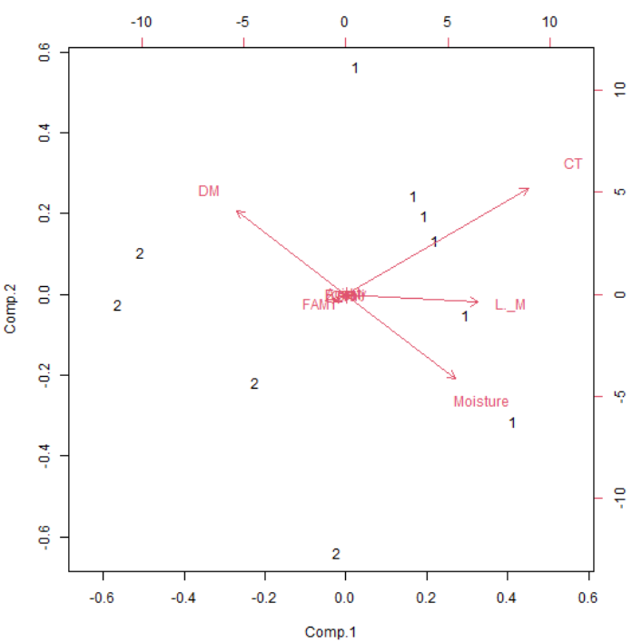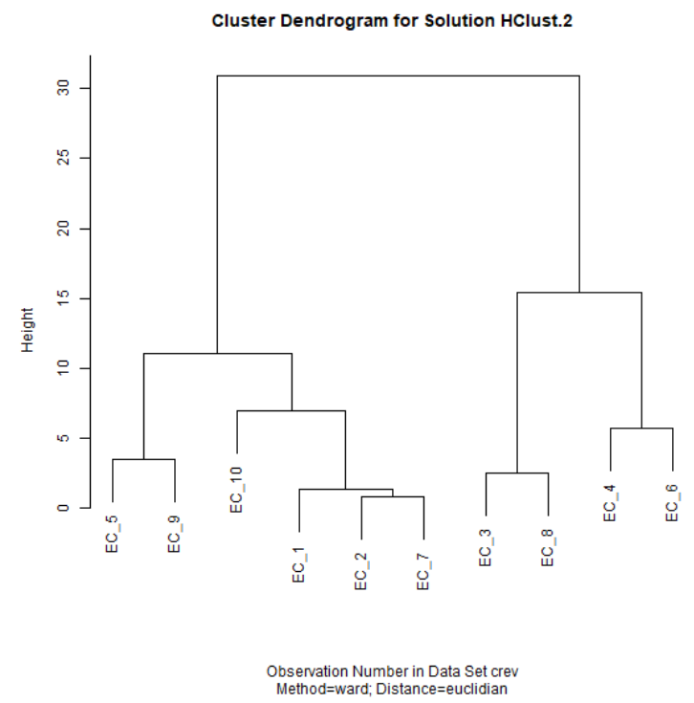
Figure 2 : Distribution of samples according to their overall quality

3.5. Correlation matrix

The correlation matrix (p<0.05) indicates a significant positive correlation between acidity and total coliforms, dry matter, and yeasts and molds (Table 5). There is also a correlation between total coliforms and acidity, yeasts and molds, moisture, and pH. A correlation exists between dry matter and acidity and total coliform fraction (TCF). There is a correlation between yeasts and molds and acidity, and between TCF. Finally, there is a correlation between moisture and TCF, yeasts and molds, and pH. A negative correlation exists between acidity and TCF, and between moisture and pH. The presence of total coliforms is negatively correlated with TCF. TCF is negatively correlated with yeasts and molds, moisture, and pH. Yeasts and molds are negatively correlated with pH. Product moisture negatively influences acidity and TCF. Finally, pH negatively influences acidity, TCF, and yeasts and molds. Looking at the correlation matrix, one could say that the fact that the pH of the shrimp is basic with low acidity would reduce the presence of germs such as yeasts and molds, FAMT, however this promotes the proliferation of total coliforms.
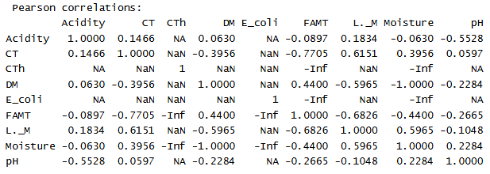
Table 5 : Correlation matrix

3.6. Influence of characteristics on samples quality
The influence of physicochemical and microbiological characteristics on shrimp quality is shown in figure 3. It appears that total coliforms and dry matter content are the parameters that most influence shrimp quality.
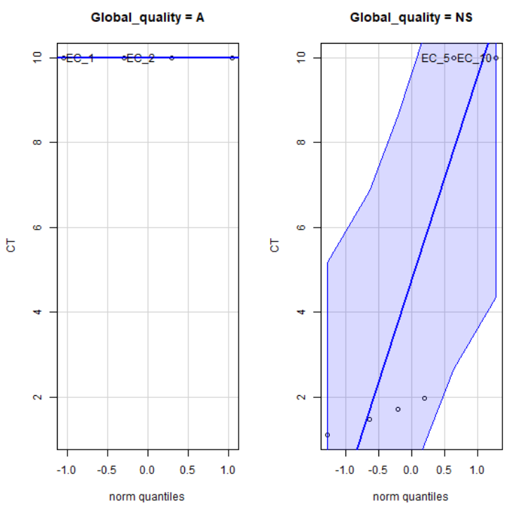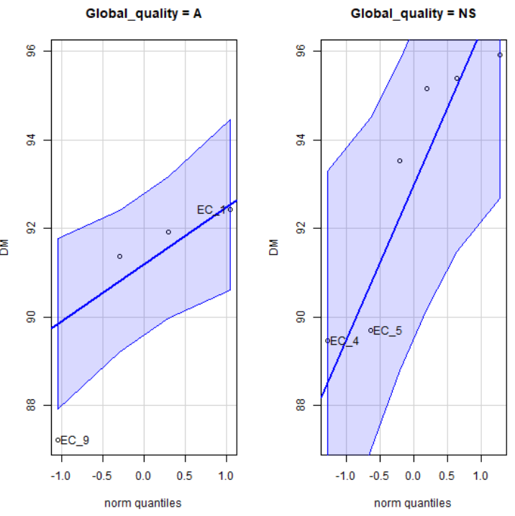
Figure 3 : Overall quality assessment based on influence of characteristics on samples quality

4. CONCLUSION
This study assessed the hygienic quality of fried shrimp in the rural commune of Loumbila by evaluating the physicochemical and microbiological characteristics of samples of fried shrimp collected from fried shrimp vendors in Loumbila. It also provided insight into the place of shrimp and the important role they play in Burkina Faso. In addition, this study enabled us to determine the pH, acidity, dry matter, and water content in terms of physicochemical parameters. The results obtained for dry matter and moisture content were acceptable, but the results obtained for pH and acidity were conducive to the growth of germs. With regard to microbiological parameters, the study counted the total mesophilic aerobic flora, total coliforms, thermotolerant coliforms, Escherichia coli, yeasts, and molds, and tested for Salmonella and Shigella in 25 g of each fried shrimp sample. The majority of samples analyzed were of unsatisfactory microbiological quality, with only four samples being of acceptable quality and none being of satisfactory quality. However, although this does not compensate for the quality defects, the total absence of Salmonella and Shigella is reassuring. Based on the results of the analysis of the parameters studied, we can state that the fried shrimp samples analyzed could pose a food safety risk to consumers.

REFERENCES
ANSES. 2012. “What are vitamins? | ANSES - French Agency for Food, Environmental and Occupational Health & Safety.” https://www.anses.fr/fr/content/que-sont-les-vitamines.
ANSES. 2013. “Proteins | ANSES - French Agency for Food, Environmental and Occupational Health & Safety.” https://www.anses.fr/fr/content/les-proteines.
ANSES. 2025. “Minerals | ANSES - French Agency for Food, Environmental and Occupational Health & Safety.” April 2013. https://www.anses.fr/fr/content/les-mineraux.
AOAC (1990). Association of Official Analytical Chemists—Official Methods of Analysis. AOAC, 16th Ed., (2). Gaithersburg, Maryland (USA).

Bauer, R. T. 2004. “Remarkable Shrimps - University of Oklahoma Press.” https://www.oupress.com/9780806135557/remarkable-shrimps/.
Brigitte Lion, Cécile Michel, and Pierre Noël. 2001. “Shrimps in the Documentation of the Ancient Near East.”
Brusca, R. C., and G. J. Brusca. 2003. “Invertebrates (2nd Edition).”
Chim, L., Lucien-Brun, H., and LeMoullac, G. (2002). Marine shrimp farming. Fisheries and Aquaculture: Towards Sustainable Aquatic Living Resources Management, in Knowledge for Sustainable Development: An Insight into the Encyclopedia of Life Support Systems, UNESCO Publishing-Eolss Publishers, Oxford, UK (II): 1059.
Sahel and West Africa Club/OECD. 2006. Sustainable Shrimp Farming in West Africa: Economic Opportunities and South-South Cooperation. Meeting Report. Regional Round Table, Conakry, Guinea.

De Grave S, Pentcheff, Crandall K.A, and Felder. 2025. A Classification of Recent and Fossil Genera of Decapod Crustaceans. Raffles Bulletin of Zoology, 21, 1-109.

Désiré Mabounda, Jean Jacques Ondo Megne, and Guy Anicet Rerambyath. 2005. Evaluation of the Contribution of the Fisheries Sector to the Gabonese Economy. June.
FAO. 2021. Shrimp Consumption in Sub-Saharan Africa.
FAO. 2025. Species Analysis Shrimp | Globefish | FAO Food and Agriculture Organization of the United Nations. Globefish. https://www.fao.org/in-action/globefish/species-analysis/shrimps/en?utm_source=chatgpt.com
FCD (2025). Guideline; Microbiological interpretation criteria.
Festy B, Hartemann P, Ledrans M, Levallois P, Payment P, and Tricard D. 2003. “Water quality. In: Environment and Public Health - Foundations and Practices.”
Holthuis, L. B. 1991. “Shrimps and Prawns of the World. An Annotated Catalogue of Species of Interest to Fisheries.”
ISO 4832. (2006). General guidelines for the enumeration of coliforms.
ISO 4833. (1991). Food microbiology; Part 1: Horizontal method.
ISO 6579. (2002). Microbiology of food and animal feeding stuffs, Horizontal method for the detection of Salmonella spp. Fourth edition. 34p.

ISO 6887-4. (2003). Microbiology of food and beverages - Preparation of stock suspension and decimal dilution samples for microbiological examination.

ISO 7218. (2015). Microbiology of food and beverages - General rules for calculating microbiological results.

ISO 7954. (1987). General guidelines for the enumeration of yeasts and molds.
Colony counting technique at 25°C.
Jost, J. P. & Post-test, Y.C. 2018. Plants that hyperaccumulate heavy metals. Edilivre Publishing.
KABORE Idrissa, KABORE Boudnoma Laetitia, BANCE Victor and OUEDA Adama. Biological Sciences, Shrimp Diversity and Abundance, Burkina Faso. Joseph KI-ZERBO University https://progres.ujkz.gov.bf/publications/4983/details?utm_source=chatgpt.com
L. B. Holthuis. 1980. "FAO Species Catalogue. Vol. 1 Shrimps and Prawns of the World. An Annotated Catalogue of Species of Interest to Fisheries." https://www.fao.org/4/ac477e/ac477e00.htm
Alvityl. 2024. "Vitamin B3 (or PP): Role and Benefits of Vitamin PP." Alvityl, October 16. https://alvityl.fr/vitamines/vitamine-b3/
LESCUYERS. 2024. "Essential Amino Acids: Our Guide." May 10. https://www.laboratoire-lescuyer.com/blog/les-acides-amines-essentiels
The Vietnam Courier 2022. “Increasing the Value of the Shrimp Sector.” lecourrier.vn, November 23. https://lecourrier.vn/augmenter-la-valeur-du-secteur-de-la-crevette/1119371.html.
L’Express de Madagascar. 2025. “FISHERIES RESOURCES - The Outlook Looks Good for the Shrimp Industry.” L’Express de Madagascar, January 4. https://www.lexpress.mg/2025/01/ressources-halieutiques-les.html.
Maillard. 2018. “Microbial Contamination of Seafood (Foodborne Pathogens and Disease).”
Montus, Eddy. 2024. “Crustacean Allergy: Symptoms, Diagnosis, and Treatment.” Accessed July 4, 2025. http://www.madietenligne.fr/blog/tout-sur-lallergie-aux-crustaces.

Nagelkerken, I., and C. H. Faunce. 2006. "The role of mangroves, seagrass beds and coral reefs as nursery areas for important coral reef fishes."
SAWADOGO, Edith. 2024. Evaluation of the hygienic quality of shrimp sold in the rural commune of Koubri.
Sidwaya, JK. 2019. "Shrimp 'made in Burkina Faso': Women at the heart of the business." Carrefour Africain, March 25. https://www.sidwaya.info/carrefour/2019/03/25/crevettes-made-in-burkina-des-femmes-au-coeur-du-business/.
Trifunovic, Stefan. 2023. Value Chain of Large Shrimp in Cameroon.
VIDAL. 2024. "Cholesterol (excess) - symptoms, causes, treatments and prevention - VIDAL." January 29. https://www.vidal.fr/maladies/coeur-circulation-veines/cholesterol.html.
Xiong, Miao, Hejiang Zhou, Rui-Xue Yu, et al. 2025. “Effects of thermal processing methods on the edible quality, nutrition, and metabolites of shrimp of Metapenaeus ensis.” Food Production, Processing and Nutrition 7 (1): 29. https://doi.org/10.1186/s43014-025-00308-1.
Yamamoto Y. et al. 1995. “Contamination in marine organisms: A review of the current status and potential health risks. Environmental pollution.”
Zalissa Soré. 2023. “Burkina Faso: Fish farming at home.” Fondazione Aurora, November. https://www.fondazioneaurora.org/fr/burkina-faso-lelevage-de-poissons-a-domicile/.

