Hierarchical Self-Assembly of Peptide Nanofibers : From Amino Acids to Therapeutic Hydrogels

Abstract
Self-assembling peptide nanofibers have emerged as a revolutionary class of biomaterials for drug delivery applications, offering unprecedented control over hierarchical structural organization spanning molecular to macroscopic length scales. This comprehensive review examines the fundamental principles, design strategies, and therapeutic applications of peptide nanofiber-based drug delivery systems, highlighting their transformative potential in modern pharmaceutical sciences. The hierarchical self-assembly process initiates with rationally designed amphiphilic peptide sequences, typically comprising 8-20 amino acids with alternating hydrophobic and hydrophilic residues, which spontaneously organize into β-sheet secondary structures through hydrogen bonding, hydrophobic interactions, and electrostatic complementarity. These molecular assemblies progressively elongate into high-aspect-ratio nanofibers with diameters of 5-50 nanometers, subsequently entangling to form three-dimensional hydrogel networks containing greater than 99% water content. The resulting materials exhibit exceptional biocompatibility owing to their amino acid composition, tunable mechanical properties matching diverse tissue environments, and complete biodegradability to non-toxic metabolic products. We systematically discuss peptide sequence design principles, including landmark EAK16 and RADA16 systems, alongside emerging computational and machine learning approaches for sequence optimization. Chemical modification strategies, hybrid system construction, and functionalization techniques enabling multi-drug loading, stimuli-responsive release, and active cellular targeting are comprehensively examined. Drug loading mechanisms encompassing physical encapsulation, chemical conjugation, surface adsorption, and guest-host interactions are analyzed alongside release kinetic models and pharmacokinetic advantages over conventional carriers. Critical evaluation of characterization methodologies, biocompatibility assessment frameworks, and regulatory considerations provides practical guidance for translational development. Clinical applications spanning cancer therapeutics, neurological disorders, infectious diseases, regenerative medicine, and protein delivery are illustrated through representative case studies demonstrating therapeutic efficacy. Finally, we identify research priorities for the next decade and assess the realistic clinical translation potential of these remarkable biomaterials for improving human health outcomes.
Keywords: Self-assembling peptides; Nanofibers; Drug delivery; Hydrogels; Hierarchical assembly; Biocompatibility; Controlled release; Regenerative medicine; Peptide amphiphiles; Nanomedicine

1. Introduction
Background on Drug Delivery Challenges
The pharmaceutical industry faces significant obstacles in delivering therapeutic agents effectively to target sites while minimizing systemic toxicity and side effects. Traditional oral administration of drugs encounters multiple barriers including hepatic first-pass metabolism, gastrointestinal degradation, and poor absorption of hydrophilic compounds. Parenteral administration, while circumventing some limitations, presents challenges related to patient compliance, injection site reactions, and rapid clearance from circulation. Approximately 40% of drugs in development pipelines exhibit poor bioavailability due to low solubility and permeability issues, classified as Biopharmaceutics Classification System (BCS) Class II and IV drugs. The delivery of macromolecular therapeutics such as proteins, peptides, and nucleic acids represents an even greater challenge, as these molecules are susceptible to enzymatic degradation, immunological rejection, and rapid renal clearance due to their size and charge characteristics. Current clinical challenges include achieving sustained therapeutic concentrations, reducing dosing frequency, minimizing adverse effects, and improving patient outcomes while reducing overall treatment costs[01,02].
Limitations of Conventional Carriers
Conventional drug delivery systems employ various polymeric and lipid-based platforms, each with inherent limitations. Synthetic polymers such as poly(lactic-co-glycolic acid) (PLGA) and polycaprolactone (PCL) provide controllable release kinetics and mechanical properties; however, they often generate inflammatory responses due to acidic degradation byproducts and exhibit limited targeting capabilities. Additionally, polymer-based nanoparticles demonstrate batch-to-batch variability, potential cytotoxicity from unreacted monomers, and concerns regarding long-term bioaccumulation in organs. Liposomal systems, while demonstrating excellent biocompatibility, suffer from limited stability in biological fluids, rapid opsonization by serum proteins, and relatively low drug loading efficiency for hydrophobic compounds. The non-specific accumulation of liposomes in the reticuloendothelial system (RES) necessitates surface modification with polyethylene glycol (PEG) to achieve prolonged circulation, adding complexity to manufacturing and potentially reducing targeting efficiency through steric hindrance. Furthermore, both polymer-based and lipid-based carriers often require toxic organic solvents during preparation, raising manufacturing and environmental concerns. Dendrimers, though offering precise molecular weight and internal cavity spaces for drug encapsulation, present challenges including high synthetic costs, limited clinical translation, and variable tissue distribution patterns. These conventional systems also demonstrate limited ability to provide active targeting while maintaining structural integrity during physiological transit[03,04,05].
Emergence of Peptide-Based Systems
Recent advances in peptide chemistry and nanotechnology have catalyzed the development of peptide-based drug delivery systems as promising alternatives to conventional carriers. Peptides inherently possess superior biocompatibility compared to synthetic polymers, as they are recognized and metabolized through natural proteolytic pathways. The ability to design peptide sequences rationally, incorporating specific functional domains for targeting, cell penetration, or therapeutic activity, offers unprecedented versatility. Early pioneering work by Zhang and colleagues demonstrated that short peptide sequences could spontaneously assemble into highly ordered nanostructures under physiological conditions, establishing the foundation for peptide nanofiber technology. Unlike synthetic polymers, peptides derived from natural amino acids exhibit minimal immunogenicity when properly designed, and their degradation products are readily metabolized through existing biochemical pathways. The modular nature of peptide design permits incorporation of multiple functionalities within a single molecular scaffold, enabling theranostic applications combining diagnostic and therapeutic capabilities. Furthermore, peptide-based systems can be produced through recombinant fermentation technologies, offering scalable manufacturing with consistent quality and reduced environmental impact compared to chemical synthesis of polymers[06,07,08].
Definition of Self-Assembling Peptide Nanofibers
Self-assembling peptide nanofibers (SAPNs) represent a class of supramolecular structures formed through spontaneous organization of rationally designed peptide sequences into highly ordered, fibrillar architectures. These structures form through non-covalent interactions including hydrogen bonding, electrostatic forces, π-π stacking, and hydrophobic interactions, resulting in β-sheet-rich conformations that stack into one-dimensional nanofibrous networks. The assembly process is characterized by thermodynamic stability, occurring spontaneously under physiological conditions of pH, ionic strength, and temperature. Unlike amyloid-related pathological nanofibers, SAPNs are engineered with precise sequence control to ensure predictable assembly kinetics, defined morphology, and reproducible bioactivity. These nanostructures typically exhibit nanometer-scale diameters (5-10 nm) with aspect ratios exceeding 1000, creating extensive surface areas suitable for drug loading and functionalization. The porous, three-dimensional network architecture permits entrapment of diverse cargo molecules and provides accessibility for biological interactions.[09,10,11]
Advantages Over Existing Technologies
Self-assembling peptide nanofibers offer multiple distinct advantages over conventional drug delivery platforms. Superior biocompatibility derives from their peptide composition, eliminating concerns of polymer-associated toxicity or lipid oxidation. Complete biodegradability through proteolytic cleavage ensures absence of long-term bioaccumulation, addressing critical safety concerns associated with persistent synthetic materials. The simplicity of assembly—requiring only dissolution in physiological buffers without organic solvents or complex processing steps—dramatically reduces manufacturing complexity and environmental impact. High drug loading capacity results from the extensive internal surface area and diverse chemical environments within the nanofiber structure, accommodating both hydrophobic and hydrophilic molecules. The ability to simultaneously incorporate targeting ligands, imaging agents, and therapeutic payloads within a single nanofiber platform enables multifunctional theranostic applications. Notably, SAPNs can be engineered to respond to specific stimuli including pH changes, enzymatic activity, or temperature variations, permitting triggered drug release at disease sites. The intrinsic cell-penetrating properties of certain peptide sequences facilitate cellular internalization without additional chemical modifications. Manufacturing through fermentation-based peptide production enables rapid, economical scale-up compared to chemical synthesis of polymeric alternatives. These combined advantages position self-assembling peptide nanofibers as a transformative technology for next-generation pharmaceutical applications, particularly for challenging therapeutic categories including protein delivery, immunotherapy, and precision medicine[12,13].
2. Fundamentals of Self-Assembling Peptide Nanofibers
2.1 Structural Characteristics
Peptide Sequences and Design Principles
Self-assembling peptide nanofibers are constructed from carefully engineered amino acid sequences that encode specific structural information within their primary sequence. The design of functional SAPNs relies on fundamental principles of peptide chemistry, whereby the spatial arrangement of amino acid residues determines the final supramolecular architecture. Rational design approaches utilize alternating hydrophobic and hydrophilic residues positioned to promote specific conformational preferences while preventing random aggregation. [21][22] The most widely studied archetypal sequence is EAK16 (AEAKAEAKAEAKAEAK), consisting of alternating glutamic acid (hydrophilic, negatively charged) and alanine-lysine pairs (hydrophobic and hydrophilic/positively charged), which demonstrates remarkable capacity for self-assembly into well-defined nanofiber structures. This peptide sequence was originally derived from natural proteins and subsequently optimized through iterative design modifications to enhance assembly kinetics and structural stability. The design principles emphasize complementary charge distribution along the peptide backbone, enabling electrostatic repulsion that maintains nanofiber integrity while permitting inter-peptide hydrogen bonding necessary for lateral association. Contemporary design strategies employ computational modeling tools including molecular dynamics simulations and energy minimization algorithms to predict assembly outcomes prior to experimental synthesis and characterization. [14,15]
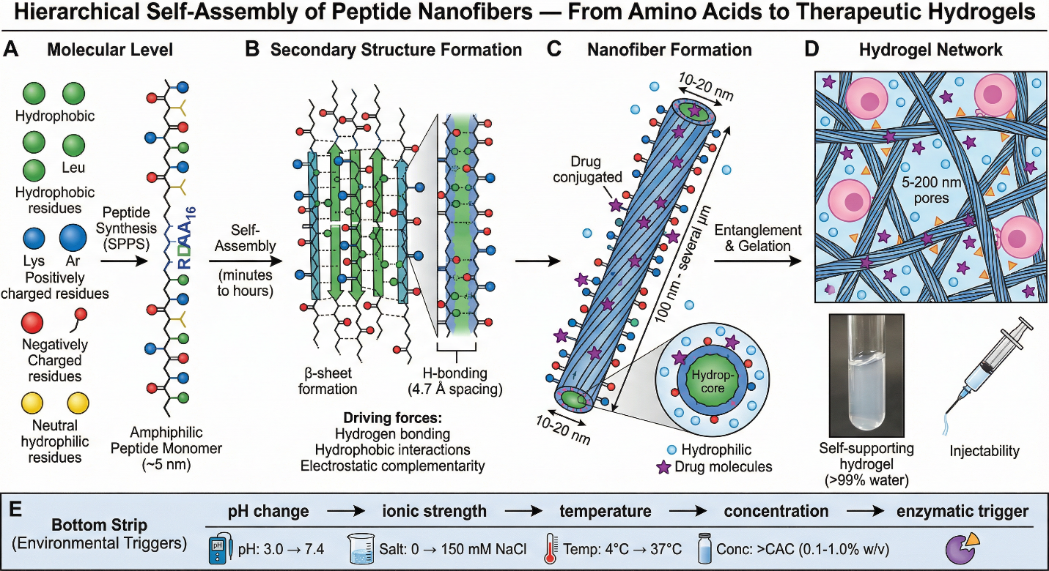
Figure 1 Hierarchical Self-Assembly of Peptide Nanofibers Multi-panel horizontal flow diagram
β-sheet and α-helix Forming Peptides
The secondary structure adopted by constituent peptides fundamentally determines nanofiber morphology and assembly behavior. β-sheet-forming peptides represent the predominant architecture in most functional SAPNs, as the extended conformation characteristic of β-sheets facilitates regular hydrogen bonding patterns between neighboring peptide molecules that drive nanofiber formation. The hydrogen bonding network in β-sheets occurs between carbonyl oxygen and amide nitrogen atoms positioned alternately along adjacent polypeptide chains, creating a planar, extended structure that naturally organizes into one-dimensional fibrils. [25][26] Peptides designated EAK16 and RAD16 (RADARADARADARADA) both preferentially adopt β-sheet conformations, as evidenced by circular dichroism spectroscopy, which reveals characteristic double minima at 215 and 235 nanometers, diagnostic of β-sheet secondary structure. In contrast, α-helix-forming peptides generally do not promote extensive nanofiber formation due to the compact, rod-like geometry of helical structures that prevents the regular lateral association necessary for robust three-dimensional networks. However, specific helix-forming sequences have been strategically designed to generate short amphipathic α-helices that subsequently associate through hydrophobic interactions, creating alternative nanofiber architectures distinct from β-sheet-based systems. The choice between β-sheet and α-helix formation depends upon specific application requirements; β-sheet nanofibers typically demonstrate superior mechanical properties and drug loading capacity, while certain α-helix-based systems exhibit more rapid assembly kinetics and enhanced biological activity. [15,16,17]
Amphipathic Peptides and Hydrophobic-Hydrophilic Balance
Amphipathic peptides possess both hydrophobic and hydrophilic regions within the same molecular structure, a characteristic that proves essential for SAPN formation and stability in aqueous environments. The spatial segregation of hydrophobic and hydrophilic residues creates a molecular polarity that drives self-assembly while maintaining colloidal stability in physiological solutions. In β-sheet-forming peptides such as EAK16, the alternating arrangement positions alanine residues (hydrophobic) and lysine-glutamic acid pairs (hydrophilic) in alternating phases along the polypeptide backbone, generating a highly amphipathic character. [29][30] This amphipathic nature permits peptide molecules to associate preferentially along hydrophobic contact surfaces while maintaining hydrophilic outer domains that prevent excessive aggregation and maintain solubility. The ratio of hydrophobic to hydrophilic surface area significantly influences nanofiber assembly kinetics and final structure; sequences with excessive hydrophobic character tend toward irreversible aggregation, while those with predominantly hydrophilic residues fail to achieve sufficient inter-molecular cohesion for stable nanofiber formation. Computational analysis of amphipathic character, calculated through hydrophobic moment calculations and surface energy assessments, provides quantitative prediction of assembly potential for novel peptide sequences. The balance between competing hydrophobic and electrostatic interactions creates the thermodynamic driving force for ordered nanofiber formation while simultaneously preventing crystalline precipitation. [18,19,20]
2.2 Self-Assembly Mechanisms
Molecular Interactions: Hydrogen Bonding and Van der Waals Forces
Self-assembly of peptide nanofibers proceeds through hierarchical engagement of multiple non-covalent interactions that collectively stabilize the final supramolecular structure. Hydrogen bonding between backbone amide groups represents the primary stabilizing force, particularly in β-sheet-forming systems where regular hydrogen bonding networks extend between adjacent peptide strands. The directionality and geometry of hydrogen bonds—specifically the linear alignment of donor-hydrogen-acceptor atoms—provides geometric constraints that enforce regular, periodic spacing between molecules and restrict assembly to geometrically defined architectures. [33][34] Computational studies employing quantum mechanical calculations demonstrate that each backbone hydrogen bond contributes approximately 4-20 kilojoules per mole of stabilization energy, with cumulative effects of numerous hydrogen bonds creating substantial overall thermodynamic stability. Van der Waals forces, arising from transient dipole-induced dipole interactions and London dispersion forces, contribute additional stabilization through non-specific attractive interactions between all atoms within van der Waals contact distance. Although individual van der Waals interactions are weak (approximately 0.4-4 kJ/mol), the numerous intermolecular contacts within densely packed nanofiber structures result in cumulative contributions exceeding those of single hydrogen bonds. The cooperative nature of these interactions means that assembly exhibits nucleation behavior, whereby initial association of few peptide molecules proves energetically unfavorable, but once critical nucleus size is achieved, further addition of peptides becomes progressively more favorable. [21,22,23]
Electrostatic Interactions and Ionic Strength Effects
Electrostatic interactions between charged amino acid residues exert critical influence over SAPN assembly dynamics and final structure. In the EAK16 peptide, glutamic acid residues carry negative charges at physiological pH while lysine residues carry positive charges, creating a regular pattern of alternating charges along the peptide backbone. These electrostatic interactions manifest as both attractive and repulsive forces; repulsion between similarly charged residues on the same peptide molecule (intramolecular) promotes extended conformations unfavorable to compact aggregation, while attractions between oppositely charged residues on adjacent peptide molecules (inter-molecular) drive nanofiber assembly. [24,25] The ionic strength of the surrounding medium critically modulates these electrostatic effects through Debye screening, whereby dissolved salts reduce the effective range of electrostatic interactions. At very low ionic strength, strong electrostatic repulsion prevents assembly; increasing ionic strength progressively screens these repulsive interactions, enabling assembly to proceed until at high salt concentrations, electrostatic effects become negligible and hydrophobic interactions dominate. Experimental studies reveal that EAK16 assembly occurs optimally at physiological ionic strength (approximately 150 millimolar sodium chloride), whereas assembly is suppressed below 50 millimolar or above 500 millimolar salt concentration. The dependence of assembly on ionic strength provides a potential regulatory mechanism for controlling nanofiber formation in vivo, as local variations in salt concentration at inflammation sites or within specific cellular compartments might modulate peptide nanofiber dynamics. [25,26]
pH-Dependent Assembly and Temperature Effects
The ionization state of amino acid residues, controlled by solution pH, profoundly influences electrostatic interactions and therefore assembly behavior. The pKa values of glutamic acid (approximately 4.3) and lysine (approximately 10.5) mean that at physiological pH 7.4, glutamic acid residues are fully deprotonated (negatively charged) while lysine residues remain protonated (positively charged), maintaining the charge alternation essential for EAK16 assembly. [26,27] Deviations from physiological pH alter this charge distribution; at pH values below 4, glutamic acid residues become protonated and uncharged, eliminating electrostatic repulsion and promoting excessive aggregation, while at pH values above 10, lysine residues become deprotonated, similarly disrupting the charge pattern. The assembly behavior exhibits bell-shaped pH dependence, with maximum assembly kinetics typically occurring within a narrow pH range (7.0-7.8 for most designed sequences). This pH sensitivity provides a potential mechanism for triggering drug release in acidic tumor microenvironments or lysosomal compartments, as peptide nanofibers would destabilize and release their cargo upon encountering pH conditions below optimal assembly range. Temperature regulates assembly kinetics through effects on molecular motion and hydrogen bonding stability. [28,29] Increasing temperature generally accelerates assembly kinetics by enhancing molecular diffusion and collision frequency, though excessively high temperatures may disrupt hydrogen bonding and promote peptide unfolding. Many SAPN systems demonstrate optimal assembly at physiological temperature (37°C), with reduced assembly efficiency at lower temperatures, a characteristic that may provide additional biological regulation mechanisms.
2.3 Nanofiber Architecture
Morphology, Diameter, Length, and Rigidity
Self-assembled peptide nanofibers exhibit remarkably uniform morphological characteristics when examined through high-resolution transmission electron microscopy. Individual nanofibers typically display diameters in the range of 5-10 nanometers, with some specially designed sequences producing narrower filaments of 3-4 nanometers. The consistency in diameter reflects the regular geometric constraints imposed by hydrogen bonding and electrostatic interactions, which enforce specific inter-molecular spacing and packing arrangements. [30,31] Nanofiber length exhibits greater variability, ranging from hundreds of nanometers to several micrometers, with length distribution influenced by assembly kinetics, peptide concentration, and environmental conditions. Atomic force microscopy studies reveal that individual nanofibers exhibit considerable mechanical rigidity, with persistence length values (a measure of rigidity) exceeding those of DNA and comparable to protein filaments such as actin. The mechanical rigidity derives from the regular hydrogen bonding networks extending along the nanofiber axis, which restrict bending and maintain extended conformations. This rigidity contributes to biological properties including cellular interaction and trafficking, as rigid nanofibers demonstrate different cellular uptake patterns and tissue distribution compared to flexible polymeric nanoparticles. The high aspect ratio (length to diameter ratio) of nanofibers, often exceeding 100-1000, creates distinctive morphological features that distinguish them from spherical nanoparticles. [29,32]
High Aspect Ratio and Surface Area Expansion
The elongated, fibrillar morphology of SAPNs results in dramatically expanded surface area compared to spherical nanoparticles of equivalent volume. Surface area calculations for 10-nanometer diameter nanofibers demonstrate that surface area to volume ratios exceed those of spherical particles by factors of 5-10, depending on nanofiber length. This expanded surface area provides substantially greater opportunity for drug loading, ligand presentation, and biological interactions. The calculation of surface area from morphological parameters (SA = π × diameter × length) shows that nanofiber surface area scales directly with length, indicating that longer nanofibers offer progressively greater capacity for functionalization and cargo binding. [32,33] The practical implications include enhanced drug loading efficiency, enabling incorporation of higher drug payloads per unit mass of nanofiber material, thereby reducing required nanofiber concentrations and potential off-target effects. Furthermore, the high aspect ratio promotes distinctive cellular interactions, as elongated structures interact differently with cellular membranes compared to spherical particles, potentially enabling more efficient receptor-mediated uptake or enhanced penetration through cellular barriers. The expanded surface area additionally facilitates multivalent binding interactions, wherein multiple targeting ligands or adhesion molecules present on the nanofiber surface engage multiple receptors on target cells, dramatically amplifying binding avidity and specificity compared to single-valent interactions. This multivalent enhancement represents a significant advantage for tumor targeting and cellular selectivity applications.
Three-Dimensional Network Formation and Porosity
Under appropriate conditions, individual nanofibers spontaneously associate into three-dimensional networks exhibiting interconnected porosity and gel-like physical properties. The formation of these networks results from irregular lateral association of nanofibers through weak electrostatic and van der Waals interactions, creating a macroscopic structure with properties intermediate between liquid solutions and solid gels. [33,34] The porosity of these networks permits diffusion of small molecules, proteins, and even cellular components through the nanofiber matrix, enabling applications as tissue engineering scaffolds and drug depots with sustained release characteristics. Scanning electron microscopy reveals that nanofiber networks exhibit pore sizes ranging from tens to hundreds of nanometers, with interconnectivity permitting nutrient diffusion and cellular ingress. The network structure exhibits physical properties including shear-thinning behavior, wherein viscosity decreases under applied mechanical stress, a characteristic particularly valuable for injectable applications requiring easy administration through small-gauge needles despite forming gel-like structures in situ. The mechanism of gel formation remains incompletely understood but appears to involve progressive incorporation of water molecules into nanofiber networks, creating hydrated gel phases with high water content (typically 95-99%) that nonetheless maintain structural integrity through peptide hydrogen bonding networks. The interconnected architecture additionally enables cell encapsulation and supports three-dimensional cell culture, with cells within nanofiber networks demonstrating enhanced differentiation and functional gene expression compared to two-dimensional culture, suggesting that nanofiber networks provide biological cues promoting cellular development and organization. [34,35]
Table 1: Fundamentals of Self-Assembling Peptide Nanofibers
Category | Key Parameter | Characteristics | Biological/Technical Significance
Structural Characteristics | Peptide Sequences | EAK16, RAD16 archetypal sequences with alternating hydrophobic-hydrophilic residues | Encode specific structural information; enable rational design and optimization
 | Secondary Structure | β-sheet and α-helix conformations | β-sheets form robust nanofibers; α-helices generate alternative architectures with different properties
 | Amphipathic Nature | Hydrophobic-hydrophilic balance in spatial distribution | Drives self-assembly while maintaining aqueous solubility; prevents excessive aggregation
Self-Assembly Mechanisms | Hydrogen Bonding | Backbone amide group interactions (4-20 kJ/mol per bond) | Primary stabilizing force in β-sheet systems; enforces geometric regularity
 | Van der Waals Forces | London dispersion forces between atoms | Cumulative weak interactions contribute significant stabilization in dense networks
 | Electrostatic Interactions | Charge alternation (Glu-/Lys+) creates repulsive-attractive patterns | Regulates assembly kinetics; provides stimulus-response capability
 | Ionic Strength Effect | Optimal assembly at ~150 mM NaCl (physiological) | Debye screening modulates electrostatic interactions; controls assembly kinetics
 | pH Dependence | Bell-shaped assembly profile (optimal pH 7.0-7.8) | Enables pH-triggered drug release in acidic environments
 | Temperature Effect | Enhanced kinetics at 37°C; optimal assembly at physiological temperature | Provides biological regulation of nanofiber dynamics
 | Nucleation-Elongation | Two-phase assembly process with critical nucleus requirement | Initial association energetically unfavorable; subsequent peptide addition favorable
Nanofiber Architecture | Diameter | 5-10 nm typical range; some designs achieve 3-4 nm | Reflects geometric constraints from hydrogen bonding and electrostatic interactions
 | Length | 100 nm to several μm; variable distribution | Influenced by assembly kinetics and environmental conditions
 | Aspect Ratio | Exceeds 100-1000 (length/diameter) | Creates distinctive morphology; influences cellular interactions
 | Mechanical Rigidity | Persistence length comparable to actin filaments | Derived from regular hydrogen bonding networks; affects cellular trafficking
 | Surface Area Expansion | 5-10 fold higher SA/V than spherical particles | Enhances drug loading capacity and ligand presentation
 | 3D Network Formation | Interconnected gel-like structures from lateral nanofiber association | Permits diffusion of molecules and cells; supports tissue engineering
 | Porosity | Pore sizes 10-100s nanometers; interconnected | Enables nutrient diffusion and cellular ingress; supports 3D culture
 | Gel Properties | Shear-thinning behavior; 95-99% water content | Suitable for injectable applications; maintains structural integrity
 | Network Interconnectivity | Progressive water incorporation into hydrogen-bonded networks | Supports cell encapsulation and enhanced differentiation

3. Design and Engineering Strategies
The translation of self-assembling peptide nanofibers from fundamental research curiosities into clinically and industrially relevant biomaterials depends critically upon sophisticated design and engineering strategies. While the inherent capacity of certain peptide sequences to spontaneously organize into well-defined nanostructures provides an elegant foundation, achieving precise control over mechanical properties, biological activity, degradation kinetics, and therapeutic functionality requires deliberate molecular-level engineering. The design landscape encompasses four interconnected dimensions: rational sequence design, chemical modifications, hybrid system construction, and surface functionalization. Each dimension offers unique opportunities to tailor nanofiber properties for specific applications, ranging from regenerative medicine scaffolds to targeted drug delivery vehicles and responsive biosensors. This section systematically examines these engineering strategies, highlighting how advances in computational design, synthetic chemistry, and materials science have collectively expanded the functional repertoire of peptide nanofiber systems, enabling increasingly sophisticated biomedical applications[35,36].
3.1 Peptide Sequence Design
The primary amino acid sequence represents the most fundamental determinant of peptide nanofiber properties, governing secondary structure formation, self-assembly thermodynamics, mechanical characteristics, and biological interactions. Early research drew extensively from naturally occurring self-assembling sequences identified in proteins and biological systems. Fragments derived from amyloid-forming proteins, silk fibroin repetitive motifs, collagen-mimetic sequences, and elastin-like polypeptides provided initial templates demonstrating that relatively short peptide sequences could encode sufficient information for hierarchical nanofiber assembly. However, natural sequences frequently exhibit limitations including uncontrolled aggregation kinetics, batch-to-batch variability, immunogenic potential, and restricted opportunities for functional customization. Consequently, the field progressively shifted toward synthetic peptide sequences designed with precise control over amphiphilicity, charge distribution, hydrophobic patterning, and secondary structure propensity, enabling systematic optimization of self-assembly behavior and material properties[36,37,38].
Contemporary peptide nanofiber design increasingly leverages computational tools for de novo sequence generation and property prediction. Molecular dynamics simulations enable researchers to model self-assembly pathways, predict intermolecular interactions, and evaluate nanofiber stability before committing to expensive synthesis and characterization cycles. Software platforms including Rosetta, GROMACS, and specialized peptide design algorithms facilitate systematic exploration of sequence-structure-property relationships, significantly accelerating the discovery of novel self-assembling motifs. Furthermore, machine learning approaches have emerged as transformative tools for sequence optimization, with deep learning models trained on experimental datasets capable of predicting self-assembly propensity, secondary structure preferences, and mechanical properties from sequence information alone. Generative adversarial networks and variational autoencoders have demonstrated capacity to propose entirely novel peptide sequences with desired self-assembly characteristics, while reinforcement learning frameworks enable iterative optimization of multiple material properties simultaneously, dramatically expanding the accessible design space beyond human intuition[39,40].
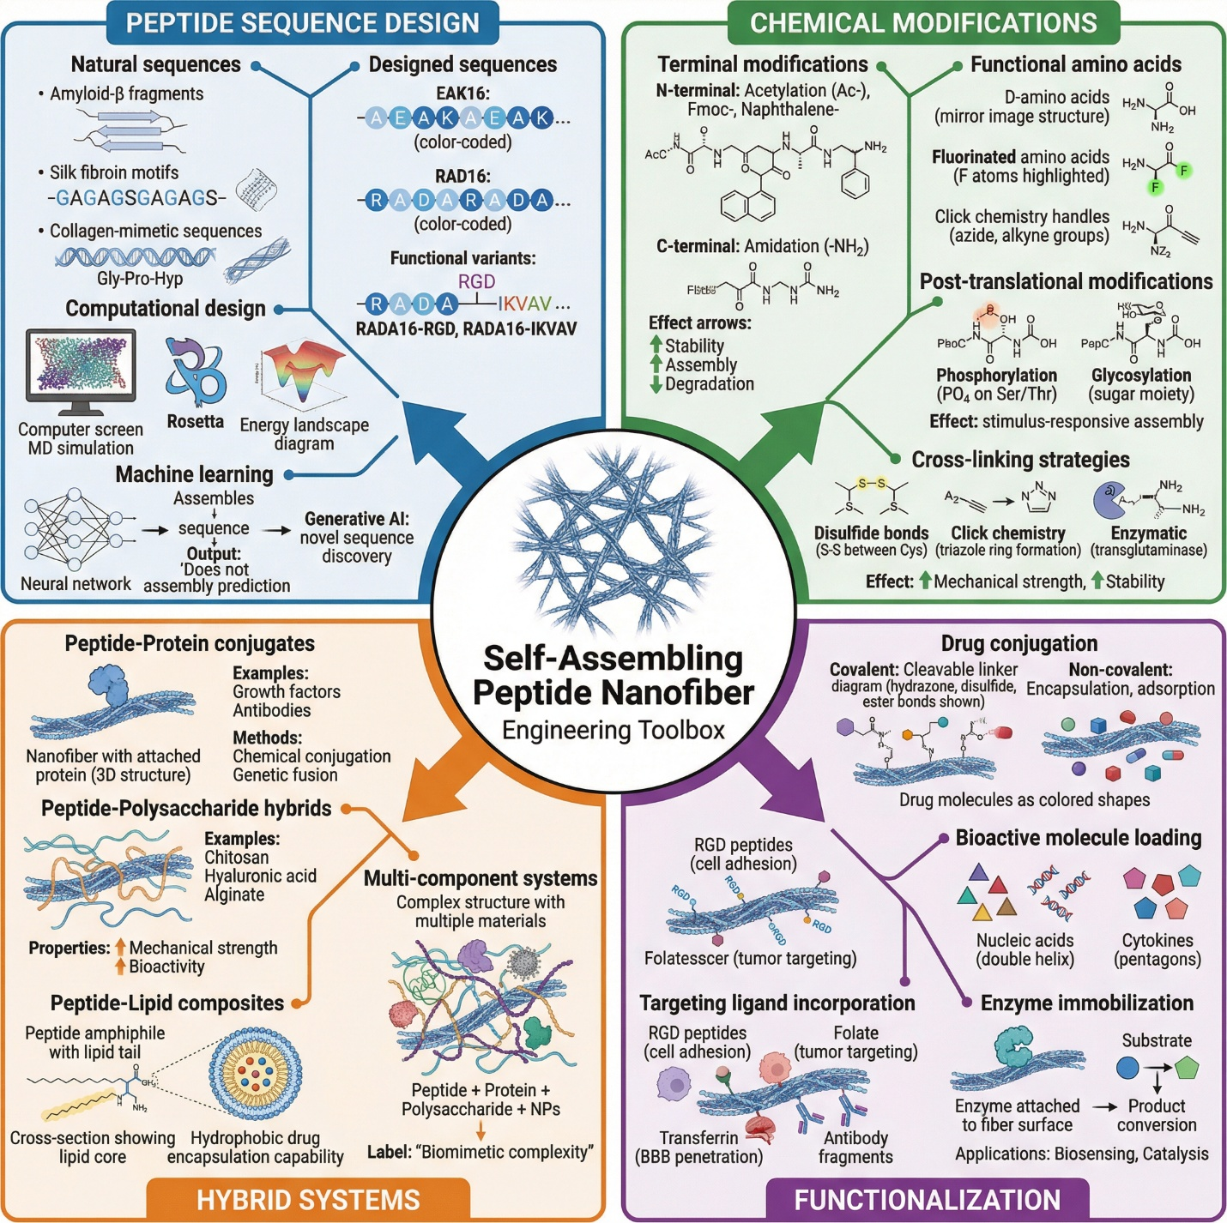
Figure 2 Design and Engineering Strategies: A Molecular Toolbox Central hub with four radiating branches
3.2 Chemical Modifications
Beyond primary sequence design, chemical modifications provide powerful post-synthetic strategies for enhancing peptide nanofiber stability, modulating assembly behavior, and introducing functional capabilities. Terminal modifications represent particularly straightforward yet impactful approaches, with N-terminal acetylation and C-terminal amidation being the most widely employed. Acetylation neutralizes the positively charged amino terminus while amidation eliminates the negative carboxyl terminus, collectively reducing terminal charge repulsion, enhancing hydrogen bonding along the nanofiber axis, improving resistance to exopeptidase degradation, and frequently strengthening self-assembly propensity. More elaborate N-terminal modifications include attachment of alkyl chains or aromatic moieties such as fluorenylmethyloxycarbonyl and naphthalene groups, which introduce additional hydrophobic driving forces for assembly, often enabling nanofiber formation at significantly lower critical assembly concentrations[39,40].
3.3 Hybrid Nanofiber Systems
Peptide-polysaccharide hybrids combine the self-assembling precision of peptides with the mechanical robustness, biodegradability, and biological activity inherent to natural carbohydrate polymers. Chitosan-peptide composites leverage the antibacterial properties and mucoadhesive characteristics of chitosan alongside peptide-mediated nanostructural organization. Hyaluronic acid-peptide conjugates exploit hyaluronan's intrinsic interactions with CD44 receptors for targeted delivery to inflammation sites and tumors, while alginate-peptide interpenetrating networks provide mechanically tunable hydrogels with independently controllable biological signaling. Peptide-lipid composites represent another important hybrid class, with peptide amphiphiles incorporating single or double hydrocarbon tails that enhance hydrophobic driving forces for assembly and create nanofibers with lipid-like cores capable of encapsulating hydrophobic therapeutic molecules. Multi-component self-assembled systems integrating peptides with multiple material classes including polymers, inorganic nanoparticles, and nucleic acids represent the frontier of hybrid nanofiber engineering, enabling construction of hierarchically organized materials with unprecedented functional complexity, stimulus-responsiveness, and multi-modal therapeutic capabilities[40,41].
3.4 Functionalization Techniques
The therapeutic and diagnostic utility of peptide nanofibers is substantially enhanced through systematic functionalization with bioactive molecules, targeting ligands, and catalytic entities. Drug conjugation to nanofibers proceeds through both covalent and non-covalent strategies, each offering distinct advantages. Covalent conjugation via hydrolytically labile ester bonds, enzyme-cleavable peptide linkers, or redox-sensitive disulfide linkages provides precise control over drug release kinetics matched to specific pathological microenvironments. Non-covalent loading approaches, including physical encapsulation within nanofiber hydrogel networks, electrostatic complexation with charged therapeutics, and hydrophobic sequestration within amphiphilic fiber cores, offer simpler preparation while preserving drug bioactivity and enabling sustained release profiles extending from days to weeks[41,42,43].
4. Drug Loading and Encapsulation
The therapeutic potential of self-assembling peptide nanofibers is fundamentally determined by their capacity to efficiently incorporate, retain, and controllably release pharmacologically active agents. Unlike conventional drug delivery platforms such as liposomes, polymeric nanoparticles, and inorganic carriers, peptide nanofibers offer unique advantages stemming from their hierarchical supramolecular architecture, tunable porosity, inherent biocompatibility, and capacity for multivalent drug-material interactions. The three-dimensional hydrogel networks formed by entangled nanofibers create microenvironments capable of accommodating diverse therapeutic payloads ranging from small hydrophobic molecules and hydrophilic biologics to macromolecular proteins and nucleic acids. However, achieving optimal therapeutic outcomes requires careful consideration of loading mechanisms, encapsulation efficiency, release kinetics, and long-term stability. This section comprehensively examines these critical parameters, discussing the physicochemical principles governing drug incorporation, analytical methodologies for characterization, mathematical models describing release behavior, and stabilization strategies ensuring therapeutic efficacy throughout storage and administration[42,43,44].
4.1 Loading Mechanisms
Drug incorporation into peptide nanofiber systems proceeds through four principal mechanisms, each governed by distinct physicochemical interactions and offering unique advantages for specific drug classes and therapeutic applications. Physical encapsulation within nanofiber networks represents the most straightforward and widely employed loading approach, wherein drug molecules become entrapped within the nanoporous architecture of the hydrogel matrix during the self-assembly process. This mechanism exploits the characteristic mesh-like structure of entangled nanofiber networks, where pore sizes typically ranging from five to two hundred nanometers create physical barriers that restrict drug diffusion while maintaining hydration and molecular accessibility. During gelation, therapeutic molecules present in the peptide solution become incorporated within interfiber spaces, fiber junctions, and water-filled channels without requiring chemical modification of either the drug or peptide component. Physical encapsulation is particularly advantageous for preserving the native bioactivity of sensitive biological therapeutics including proteins, growth factors, and enzymes, as it avoids potentially denaturing chemical reactions. The encapsulation efficiency depends critically upon the timing of drug addition relative to gelation, the rheological properties of the forming gel, drug molecular weight, and the physicochemical compatibility between the payload and the nanofiber microenvironment[44,45,46].
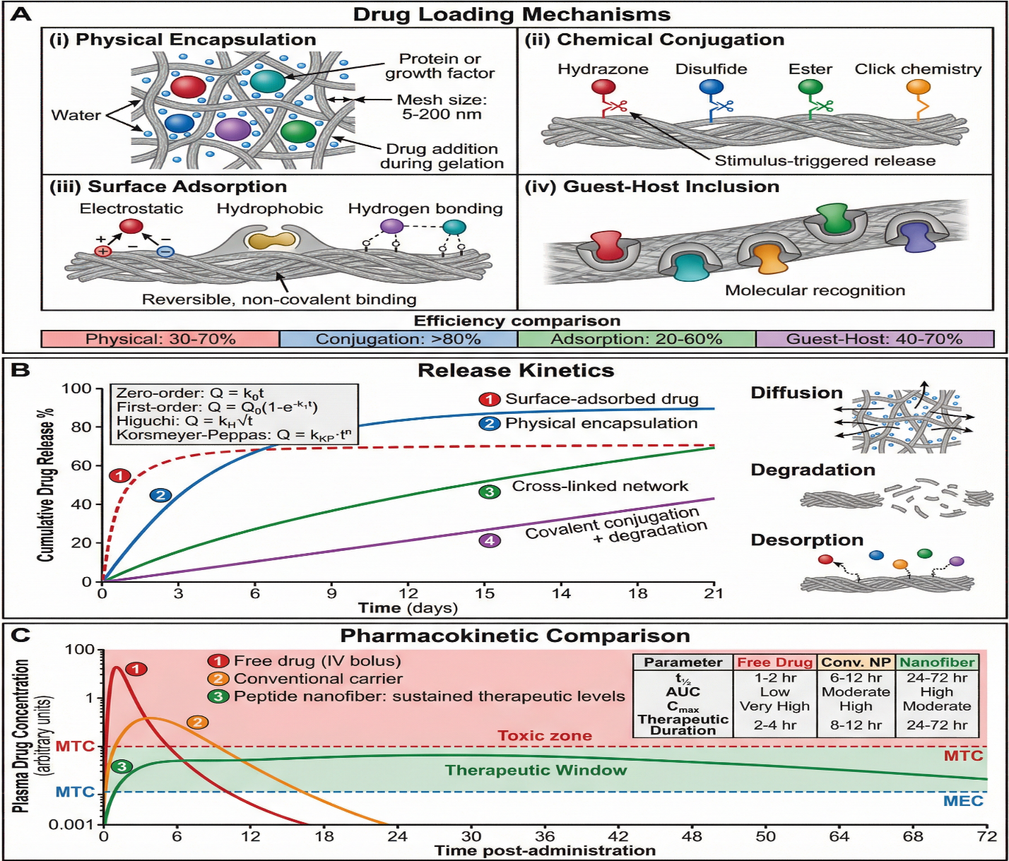
Figure 3 Drug Loading, Release Mechanisms, and Pharmacokinetic Impact Three-panel composite
4.2 Loading Efficiency and Capacity
The translational viability of peptide nanofiber drug delivery systems depends substantially upon achieving adequate drug loading efficiency and capacity to deliver therapeutically relevant doses within acceptable material volumes. Loading efficiency, defined as the percentage of initially added drug successfully incorporated into the nanofiber system, and loading capacity, representing the mass of drug per unit mass of carrier material, are governed by multiple interconnected physicochemical factors requiring systematic optimization. Drug molecular weight, hydrophobicity, charge state, and three-dimensional structure fundamentally influence interactions with the peptide nanofiber matrix, with smaller molecules generally achieving higher encapsulation within nanoporous networks while larger macromolecules may require surface adsorption or chemical conjugation approaches. The chemical complementarity between drug and peptide, including electrostatic compatibility, hydrogen bonding potential, and hydrophobic matching, profoundly impacts loading outcomes, necessitating careful selection of peptide sequences matched to specific therapeutic payloads[45,46,47].
4.3 Drug Release Kinetics
The temporal profile of drug release from peptide nanofiber systems fundamentally determines therapeutic efficacy, with release kinetics requiring careful matching to the pharmacological requirements of specific clinical applications. Most peptide nanofiber formulations exhibit biphasic release profiles characterized by an initial burst release phase followed by a sustained release period. The burst release phase, typically occurring within the first one to twenty-four hours, results from rapid dissociation of surface-adsorbed drug molecules and release of loosely entrapped payload near the hydrogel periphery. While frequently considered undesirable due to potential toxicity from supratherapeutic concentrations, controlled burst release can be therapeutically advantageous in applications requiring immediate drug action, such as wound healing or infection management. The subsequent sustained release phase involves slower drug liberation governed by diffusional transport through the nanofiber network, gradual peptide matrix degradation, and progressive desorption of more tightly bound drug molecules from internal binding sites[47,48].
4.4 Stability Considerations
Long-term stability of drug-loaded peptide nanofiber formulations represents a critical translational requirement encompassing physical integrity, chemical stability, and biological activity preservation throughout manufacturing, storage, and clinical administration. Physical stability assessment evaluates maintenance of nanofiber morphology, hydrogel mechanical properties, network homogeneity, and drug distribution uniformity over extended storage periods. Environmental stressors including temperature fluctuations, mechanical agitation, freeze-thaw cycling, and dehydration can induce nanofiber disassembly, aggregation, phase separation, or drug crystallization, compromising both material properties and therapeutic performance. Rheological monitoring, transmission electron microscopy, and dynamic light scattering provide complementary characterization of physical stability, enabling identification of degradation pathways and establishment of acceptable storage conditions.
Practical shelf-life determination follows International Council for Harmonisation guidelines, with accelerated stability studies at elevated temperature and humidity conditions providing predictive estimates of real-time stability through Arrhenius kinetic modeling. Optimal storage conditions for most peptide nanofiber formulations involve refrigerated temperatures between two and eight degrees Celsius, controlled humidity environments, protection from light exposure, and either maintenance in hydrated state or controlled lyophilization with appropriate cryoprotectants. Lyophilized formulations generally demonstrate superior long-term stability compared to hydrated preparations, though reconstitution must faithfully restore original nanofiber morphology, mechanical properties, drug distribution, and release characteristics, requiring systematic optimization of lyoprotectant composition and reconstitution protocols to ensure clinical reliability[48,49].
Table 2: Drug Loading Mechanisms in Peptide Nanofiber Systems(Section 4 — Drug Loading and Encapsulation in Peptide Nanofiber Systems)

Category | Sub-Category | Key Parameters | Details/Examples | Advantages | Limitations
4.1 Loading Mechanisms | Physical Encapsulation | Mesh size (5–200 nm); gelation timing; drug MW | Drug trapped within nanoporous hydrogel network during self-assembly; VEGF in RADA16; doxorubicin in β-sheet networks | Preserves native bioactivity; simple preparation; no chemical modification required; suitable for fragile biologics | Burst release risk; limited control over drug distribution; mesh-size dependent loading
 | Chemical Conjugation | Covalent linker chemistry; cleavage trigger; drug:peptide stoichiometry | Hydrazone bonds (acid-labile); disulfide bonds (redox-sensitive); ester bonds (hydrolytically cleavable); click chemistry (azide-alkyne); doxorubicin-hydrazone-peptide conjugates | Precise stoichiometric control; prevents premature leakage; stimulus-responsive release; site-specific attachment | Complex synthesis; may alter drug activity; potential disruption of self-assembly
 | Surface Adsorption | Electrostatic interactions; hydrophobic interactions; hydrogen bonding; surface charge density | siRNA on cationic nanofibers; curcumin hydrophobic adsorption; charged antibiotics on anionic nanofibers | High surface area utilization; simple loading; broad drug applicability; reversible binding | Weak binding; susceptible to competitive displacement; variable loading efficiency; rapid desorption
 | Guest-Host Interactions | Molecular recognition; shape complementarity; hydrophobic inclusion; supramolecular recognition | Cyclodextrin-functionalized peptide nanofibers; aromatic drug inclusion complexes; cucurbituril-based host systems | Selective binding; enhanced drug aqueous solubility; controlled stoichiometry; high specificity | Requires specialized peptide design; limited to geometrically compatible drugs; complex synthesis
4.2 Loading Efficiency and Capacity | Drug-Related Factors | MW; hydrophobicity (LogP: −3 to +5); charge state; 3D conformation | Small molecules (<500 Da) favor encapsulation; macromolecules (>50 kDa) require surface loading; LogP >2 favors hydrophobic adsorption; charge complementarity enhances electrostatic loading | Understanding drug properties enables rational selection of optimal loading mechanism | No universal loading mechanism suitable for all drug types; requires case-by-case optimization
 | Peptide-Related Factors | Concentration (0.1–5.0% w/v); sequence hydrophobicity; charge density; nanofiber morphology (diameter 5–50 nm) | Higher peptide concentration → denser network → more sites but smaller pores; hydrophobic residues enhance hydrophobic drug loading; charged residues (E, D, K, R) enhance electrostatic binding | Tunable parameters allowing optimization of loading for specific drug-peptide combinations | Competing effects between loading capacity and drug accessibility require careful balancing
 | Environmental Parameters | pH (3.0–9.0); temperature (4–60°C); ionic strength (0–500 mM NaCl); drug:peptide molar ratio (1:100 to 1:5) | pH modulates peptide assembly and drug-peptide electrostatic interactions simultaneously; lower temperature → slower assembly → more homogeneous distribution; ionic strength screens electrostatic interactions | Systematic optimization through factorial design or response surface methodology identifies optimal conditions | Interdependence of parameters complicates individual optimization; conditions must be compatible with drug stability
 | Quantification Methods | Sensitivity; specificity; sample preparation requirements | HPLC (ng/mL sensitivity; gold standard); UV-Vis spectroscopy (μg/mL; rapid; chromophore-requiring); fluorescence spectroscopy (pg/mL; for fluorescent drugs); mass spectrometry (definitive identification); TGA (total content estimation); elemental analysis (metal-based drugs) | Multiple complementary techniques provide comprehensive characterization of drug loading | Each method has specific drug requirements and limitations; sample preparation may affect accuracy
 | Loading Efficiency Range | Technique-dependent efficiency values | Physical encapsulation: 30–70%; Chemical conjugation: >80%; Surface adsorption: 20–60%; Guest-host: 40–70% | Provides benchmark values for formulation development and comparison | Efficiency highly dependent on specific drug-peptide combination and conditions
4.3 Drug Release Kinetics | Burst Release Profile | Initial release >30% within first hours; surface desorption; loosely entrapped drug | Useful for wound healing and acute infection management; common in surface-adsorbed formulations; risk of supratherapeutic toxicity | Provides immediate therapeutic action; no lag period; useful for acute clinical applications | Toxicity risk from supratherapeutic concentrations; short duration; limited control
 | Sustained Release Profile | Gradual release over days to weeks; diffusion + degradation + desorption mechanisms | Covalently conjugated drugs; densely crosslinked networks; strongly bound payloads; VEGF from PA nanofibers over 14 days | Maintained therapeutic levels; reduced dosing frequency; improved patient compliance | Complex formulation design; may delay onset of action; requires careful optimization of release rate
 | Zero-Order Kinetics | Q = k₀t; constant release rate independent of concentration | Reservoir-type architectures; surface erosion-controlled degradation; desirable for chronic disease management (diabetes, cancer) | Maintains constant drug plasma levels; ideal for narrow therapeutic window drugs | Difficult to achieve; requires sophisticated device architecture; may not be necessary for all applications
 | First-Order Kinetics | Q = Q₀(1 − e^(−k₁t)); rate proportional to remaining drug concentration | Diffusion-dominated hydrogel systems; physically encapsulated drugs; most common in simple hydrogel formulations | Simple mathematical description; predictable behavior; well-characterized mechanism | Exponentially decreasing release rate; declining therapeutic levels over time
 | Higuchi Model | Q = k_H√t; square root of time dependence | Matrix diffusion-controlled release; homogeneously distributed drug in non-degrading matrix | Mechanistically informative; widely validated for matrix-type systems | Limited to non-swelling, non-degrading systems; assumes drug concentration above solubility
 | Korsmeyer-Peppas Model | Q = k_KP·tⁿ; n = 0.5 (Fickian); 0.5 < n < 1.0 (anomalous); n = 1.0 (Case II transport) | Most practical nanofiber systems; mixed mechanism release; n value diagnostic of release mechanism | Mechanistically informative; distinguishes diffusion from matrix relaxation contributions; widely applicable | Empirical fitting; limited predictive power beyond experimental conditions; multiple parameters require careful fitting
 | Tunable Release Strategies | Structural modifications; crosslinking density; linker chemistry; mesh size control | Increasing crosslinking → slower diffusion; degradable linkers with predetermined cleavage kinetics; multi-layer architectures for sequential release; stimuli-responsive elements (pH, enzyme, redox, temperature) | Enables precise tailoring of release profile to match pharmacological requirements of specific applications | Engineering complexity increases; tuning one parameter often affects multiple release characteristics simultaneously
4.4 Stability Considerations | Physical Stability | Nanofiber morphology maintenance; mechanical property preservation; drug distribution homogeneity | Assessed by rheology (G′, G″ monitoring); TEM/SEM imaging; DLS; turbidity; visual inspection; stability stressors include temperature fluctuation, mechanical agitation, freeze-thaw cycling, dehydration | Critical for ensuring consistent therapeutic performance throughout shelf-life and administration | Physical degradation pathways are often irreversible; difficult to distinguish from chemical degradation effects
 | Chemical Stability (Peptide) | Hydrolysis; proteolytic degradation; oxidation (Met, Cys); deamidation (Asn, Gln); racemization | D-amino acid substitution (protease resistance); terminal acetylation/amidation; backbone N-methylation; crosslinking; assessed by HPLC, mass spectrometry, CD spectroscopy, FTIR; acceptance criterion: <10% degradation products | Protease-resistant peptides dramatically extend nanofiber persistence in biological environments | Complete elimination of degradation difficult; D-amino acids may slow biodegradation; crosslinking may limit responsiveness
 | Chemical Stability (Drug) | Hydrolysis; oxidation; photodegradation; isomerization; premature linker cleavage; drug-peptide side reactions | pH buffering; antioxidant addition; light protection (amber packaging); inert atmosphere; validated stability-indicating HPLC methods; acceptance criterion: >90% drug potency retained | Drug stability within nanofiber matrix often superior to free drug in solution due to protective microenvironment | Drug-peptide interactions can catalyze degradation; extraction for analysis may itself affect stability; complex stability-indicating method development
 | Biological Activity Preservation | Protein denaturation; aggregation; tertiary structure loss; receptor binding loss; enzymatic inactivation | Bioactivity assays (ELISA, cell proliferation); CD spectroscopy; DSC; binding affinity measurements; stabilizing excipients (trehalose, sucrose); mild processing conditions; acceptance criterion: >80% retained bioactivity | Peptide nanofiber matrix provides superior protection for encapsulated proteins compared to free solution formulations | Activity assays are variable and cell-dependent; correlating structural integrity with bioactivity challenging; assay sensitivity limitations
 | Shelf-Life and Storage | Temperature (2–8°C recommended); humidity control; atmosphere; packaging; reconstitution protocol | ICH-guided accelerated stability (40°C/75% RH); real-time stability (25°C/60% RH); Arrhenius modeling for shelf-life prediction; lyophilization with cryoprotectants (trehalose, mannitol, sucrose); target: minimum 12–24 months shelf-life | Systematic stability program ensures product quality and patient safety throughout distribution and use | Cold chain requirements increase manufacturing cost; lyophilization optimization is time-consuming; reconstitution must faithfully restore all material properties

5. Characterization Methods
Comprehensive characterization of self-assembling peptide nanofibers is essential for establishing structure-function relationships, ensuring reproducibility, and validating therapeutic performance. The hierarchical nature of these materials, spanning from molecular-level secondary structures to macroscopic hydrogel networks, necessitates a multi-technique analytical approach combining structural, physicochemical, biological, and pharmaceutical methodologies. This section summarizes the principal characterization techniques employed for peptide nanofiber drug delivery systems[49,50].
5.1 Structural Characterization
Visualization of nanofiber morphology relies primarily upon electron and scanning probe microscopies. Transmission electron microscopy (TEM) provides high-resolution imaging of individual nanofibers, revealing fiber diameter, length, bundling behavior, and network architecture at nanometer resolution. Negative staining with uranyl acetate or phosphotungstic acid enhances contrast for unstained peptide samples. Scanning electron microscopy (SEM) complements TEM by providing three-dimensional topographical information about hydrogel surfaces, pore structures, and fiber entanglement patterns, though sample dehydration during preparation may introduce artifacts[50,51].
5.2 Physicochemical Analysis
Dynamic light scattering (DLS) measures hydrodynamic diameters and size distributions of nanofiber assemblies in solution, though interpretation requires caution given the cylindrical geometry of nanofibers versus spherical assumptions inherent in standard analysis algorithms. Zeta potential measurements quantify surface charge characteristics critical for predicting colloidal stability, drug binding capacity, and cellular interactions, with values exceeding ±30 mV generally indicating stable dispersions. Mass spectrometry, particularly matrix-assisted laser desorption ionization (MALDI-TOF) and electrospray ionization (ESI-MS), confirms peptide molecular weights, sequence fidelity, and chemical modification integrity. Thermal analysis techniques including differential scanning calorimetry (DSC) characterize thermal transitions, melting behavior, and thermodynamic stability, while thermogravimetric analysis (TGA) quantifies water content, organic composition, and thermal degradation profiles[51,52].
5.3 Biological Characterization
Biocompatibility assessment begins with cell viability assays, where MTT and related tetrazolium-based assays quantify metabolic activity as indicators of viable cell populations following nanofiber exposure. Lactate dehydrogenase (LDH) release assays complement metabolic measurements by detecting membrane damage indicative of cytotoxicity. Cellular uptake studies employing fluorescently labeled nanofibers or encapsulated drugs, combined with confocal microscopy and flow cytometry, elucidate internalization mechanisms and intracellular trafficking pathways. Comprehensive in vitro biocompatibility testing evaluates hemolysis, complement activation, and inflammatory cytokine release, while protein adsorption studies characterize the biomolecular corona formed upon biological fluid exposure, influencing biodistribution and cellular recognition[52,53].
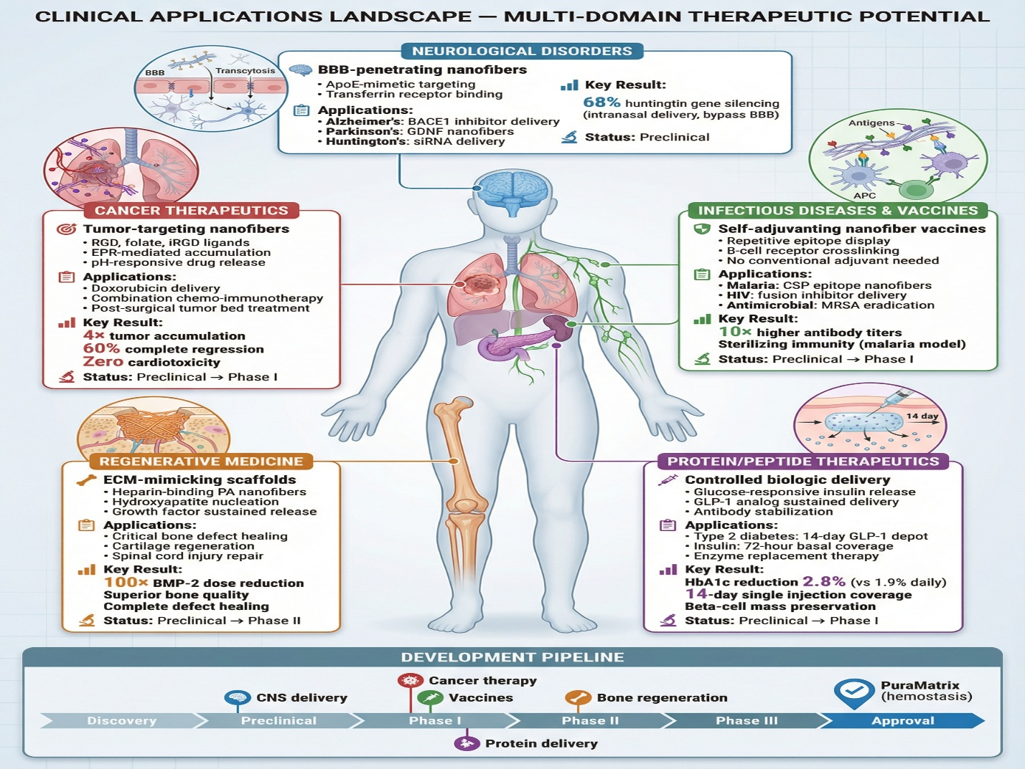
Figure 4 Clinical Applications Landscape Human body silhouette infographic
5.4 Analytical Techniques for Drug Content
Accurate drug quantification employs chromatographic and spectroscopic methodologies. High-performance liquid chromatography (HPLC) with ultraviolet or fluorescence detection provides gold-standard drug quantification with excellent sensitivity and specificity following validated extraction procedures. Liquid chromatography-mass spectrometry (LC-MS) combines chromatographic separation with mass-based identification, enabling simultaneous quantification of multiple analytes and detection of degradation products. Fluorescence spectroscopy offers rapid, sensitive analysis for intrinsically fluorescent drugs or fluorophore-labeled therapeutics, enabling real-time release monitoring. Radioisotope labeling methods using tritium, carbon-14, or iodine-125 provide exceptional sensitivity for biodistribution studies and low-concentration drug tracking, though regulatory and safety considerations limit routine application. Collectively, these complementary techniques establish comprehensive quality control frameworks ensuring consistent therapeutic performance[53,54].
6. Bioavailability and In Vivo Performance
The ultimate translational success of peptide nanofiber drug delivery systems depends fundamentally upon their in vivo performance, encompassing absorption enhancement, biodistribution characteristics, pharmacokinetic profiles, and biodegradation behavior. While in vitro characterization provides essential mechanistic insights, the complex biological environment introduces additional variables including enzymatic barriers, immune surveillance, hemodynamic forces, and physiological clearance mechanisms that collectively determine therapeutic efficacy and safety. Peptide nanofibers offer distinctive advantages over conventional drug carriers through their inherent biocompatibility, tunable degradation kinetics, and capacity to overcome biological barriers limiting drug bioavailability. Understanding how these nanostructured systems navigate the biological environment from administration site to therapeutic target is critical for rational formulation design and clinical translation. This section systematically examines the mechanisms by which peptide nanofibers enhance drug bioavailability, their biodistribution patterns across biological compartments, key pharmacokinetic parameters governing therapeutic performance, and the biodegradation pathways determining their ultimate biological fate[54,55].
6.1 Absorption Enhancement
Peptide nanofibers significantly enhance drug absorption across multiple biological barriers through several complementary mechanisms. At mucosal surfaces including gastrointestinal, nasal, pulmonary, and ocular epithelia, nanofiber systems improve drug permeability through multiple pathways. The nanoscale dimensions of peptide fibers facilitate intimate contact with mucosal surfaces, prolonging drug residence time through mucoadhesive interactions between peptide functional groups and mucin glycoproteins. Furthermore, certain peptide sequences directly modulate tight junction integrity, transiently increasing paracellular permeability for poorly absorbed hydrophilic therapeutics. Amphiphilic peptide nanofibers enhance transcellular transport by solubilizing poorly water-soluble drugs within hydrophobic fiber domains, presenting them at membrane surfaces in a form amenable to passive diffusion or active transport[55,56,57].
6.2 Biodistribution Studies
Following systemic administration, peptide nanofibers distribute across biological compartments according to their physicochemical properties, surface functionalization, and interactions with blood components. Organ-specific accumulation patterns are governed by the enhanced permeability and retention (EPR) effect in tumor tissues, active targeting ligand-receptor interactions, and the mononuclear phagocyte system-mediated clearance occurring predominantly in liver and spleen. Fluorescence imaging, positron emission tomography, and single-photon emission computed tomography using appropriately labeled nanofibers enable real-time biodistribution monitoring, revealing tissue accumulation kinetics and elimination pathways. Tumor targeting efficiency is substantially enhanced through surface functionalization with tumor-specific ligands including folate, RGD peptides, antibody fragments, and aptamers that promote selective accumulation at disease sites while minimizing off-target exposure. Clearance mechanisms include renal filtration for smaller nanofiber fragments below approximately eight nanometers, hepatic metabolism and biliary excretion for larger assemblies, and lymphatic drainage at injection sites[56,57,58].
6.3 Pharmacokinetic Parameters
Peptide nanofiber encapsulation profoundly alters the pharmacokinetic profiles of loaded drugs compared to free drug administration. Extended circulation half-lives result from protection against enzymatic degradation, reduced renal filtration due to increased hydrodynamic size, and diminished protein binding-mediated clearance. Volume of distribution is modulated by nanofiber surface properties, with hydrophilic polyethylene glycol-modified surfaces reducing non-specific tissue accumulation while targeting ligands direct preferential distribution to specific compartments. Bioavailability improvement factors vary substantially across drug classes and administration routes, with particularly dramatic enhancements reported for poorly water-soluble drugs, macromolecular biologics, and conventionally non-orally bioavailable therapeutics. Comparative pharmacokinetic studies consistently demonstrate superior area under the curve values, reduced peak plasma concentration variability, and extended mean residence times for nanofiber formulations relative to conventional carriers including liposomes, polymeric nanoparticles, and free drug solutions[57,58,59].
6.4 Biodegradation
The biodegradation of peptide nanofibers proceeds primarily through enzymatic hydrolysis of peptide bonds by tissue-specific and circulating proteases including matrix metalloproteinases, cathepsins, and serine proteases. Degradation rates are governed by peptide sequence composition, secondary structure stability, crosslinking density, and the local enzymatic environment, with β-sheet rich assemblies generally exhibiting greater protease resistance than disordered structures due to reduced substrate accessibility. The hierarchical disassembly process involves progressive shortening of nanofibers into oligomeric fragments, followed by complete hydrolysis to constituent amino acids over timescales ranging from hours to months depending on formulation design. Metabolic fate of degradation products follows natural amino acid metabolism pathways, with liberated amino acids entering cellular biosynthetic pools or undergoing oxidative catabolism. The inherent safety of amino acid degradation products represents a fundamental biocompatibility advantage of peptide nanofibers over synthetic polymer carriers, though careful attention must be paid to non-natural amino acid metabolites and chemical modification byproducts to ensure complete degradation product safety profiles[58,59,60].
7. Biocompatibility and Safety
The clinical translation of peptide nanofiber drug delivery systems requires rigorous demonstration of biocompatibility and safety across multiple biological levels, from molecular interactions to whole-organism responses. The inherent compositional similarity of self-assembling peptides to endogenous proteins and amino acids provides a fundamental biocompatibility advantage over synthetic polymer and inorganic carrier systems. Nevertheless, the unique supramolecular architecture of peptide nanofibers, combined with chemical modifications, functional conjugates, and encapsulated therapeutics, introduces potential safety considerations that demand systematic evaluation through validated in vitro and in vivo methodologies[60,61].
7.1 Cytotoxicity Evaluation
Systematic cytotoxicity evaluation of peptide nanofibers begins with standardized in vitro testing using established cell line panels representing target tissues and potential off-target organs. Primary assessment employs tetrazolium-based metabolic assays including MTT, MTS, and WST-1, supplemented by membrane integrity indicators such as lactate dehydrogenase release and live-dead fluorescent staining, providing complementary measures of cytotoxic potential. Dose-dependent effect characterization is essential, requiring exposure across multiple orders of magnitude to establish concentration-response relationships and calculate IC₅₀ values enabling meaningful comparison across formulations and cell types. The overwhelming majority of well-characterized peptide nanofiber systems demonstrate minimal cytotoxicity at therapeutically relevant concentrations, with cell viability typically exceeding eighty percent at concentrations substantially above anticipated clinical exposure levels[61,62].
7.2 Immunogenicity
The immunogenic potential of peptide nanofiber systems requires careful evaluation given that self-assembled nanostructures may present repetitive epitope patterns capable of stimulating innate and adaptive immune responses. Assessment of immune response activation begins with innate immunity evaluation, measuring complement system activation through CH50 and C3a/C5a ELISA assays, macrophage activation through cytokine profiling including tumor necrosis factor-alpha, interleukin-6, and interleukin-1beta, and toll-like receptor pathway engagement through nuclear factor kappa B reporter assays. T-cell and B-cell response characterization using peripheral blood mononuclear cell stimulation assays, lymphocyte proliferation measurements, and antibody production monitoring provides comprehensive adaptive immunity assessment[62,63].
7.3 In Vivo Safety Studies
Comprehensive in vivo safety evaluation follows internationally harmonized guidelines established by the International Council for Harmonisation, with study design determined by intended clinical application, administration route, and treatment duration. Acute toxicity assessment involves single-dose administration at multiple dose levels in rodent models, monitoring mortality, body weight changes, clinical observations, and gross pathological findings over fourteen days, enabling maximum tolerated dose determination and acute no-observed-adverse-effect level establishment[63,64].
7.4 Regulatory Considerations
The regulatory pathway for peptide nanofiber drug delivery systems navigates complex jurisdictional frameworks that classify these materials according to their primary mode of action, whether as drug products, medical devices, combination products, or advanced therapy medicinal products. Good Laboratory Practice compliance is mandatory for all non-clinical safety studies intended to support regulatory submissions, requiring documented standard operating procedures, calibrated equipment, qualified personnel, archival systems, and independent quality assurance oversight ensuring data integrity and study reproducibility. Quality-by-Design principles, as articulated in ICH Q8 through Q11 guidelines, provide a systematic framework for product and process development, beginning with comprehensive definition of the quality target product profile and identification of critical quality attributes governing clinical performance. Design space establishment through systematic process parameter investigation using design of experiments methodologies enables regulatory agencies to approve manufacturing flexibility within validated parameter ranges without requiring prior approval for each modification[63,64,65].
8. Clinical Applications and Case Studies
The versatility of self-assembling peptide nanofibers as drug delivery platforms has driven their investigation across diverse therapeutic areas, translating fundamental materials science advances into clinically meaningful interventions. Their tunable physicochemical properties, inherent biocompatibility, and capacity for multifunctional engineering have positioned peptide nanofibers as compelling candidates for addressing unmet medical needs in oncology, neurology, infectious disease, regenerative medicine, and protein therapeutics. This section examines the most significant clinical application domains, supported by representative case studies illustrating translational achievements and remaining challenges[64,65].
8.1 Cancer Therapeutics
Peptide nanofibers have emerged as sophisticated platforms for cancer drug delivery, addressing fundamental limitations of conventional chemotherapy including poor tumor selectivity, systemic toxicity, rapid drug clearance, and multidrug resistance. Chemotherapy drug delivery through peptide nanofiber encapsulation substantially improves therapeutic indices by prolonging drug circulation, enhancing tumor accumulation through EPR effect exploitation, and enabling controlled intratumoral drug release. Tumor-targeting peptide nanofibers incorporating RGD sequences, folate ligands, and tumor-penetrating peptides including iRGD and RPARPAR achieve preferential accumulation in malignant tissues while minimizing exposure to healthy organs. Combination therapy approaches leverage the multi-drug loading capacity of nanofiber systems to co-deliver chemotherapeutic agents with immune checkpoint inhibitors, photosensitizers, or gene silencing agents, producing synergistic antitumor effects unachievable with sequential monotherapy[65,66].
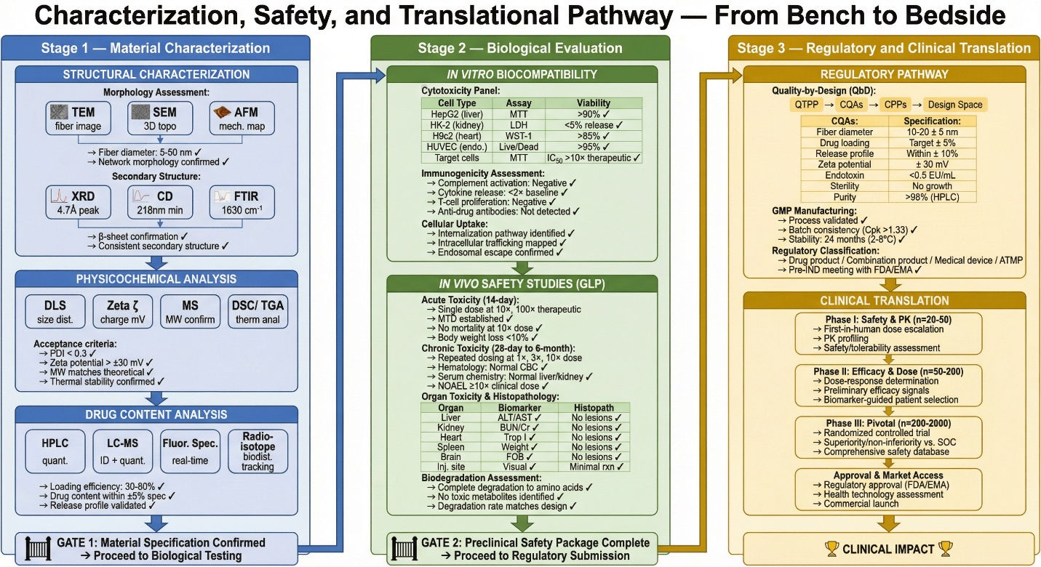
Figure 5 Characterization, Safety, and Translational Pathway Flowchart pipeline with checkpoints
8.2 Neurological Disorders
The formidable blood-brain barrier represents the central challenge in neurological drug delivery, and peptide nanofibers engineered with BBB-penetrating sequences have demonstrated remarkable capacity to transport therapeutic cargoes into central nervous system compartments. Apolipoprotein E-mimetic peptide sequences and transferrin receptor-binding motifs incorporated into nanofiber surfaces facilitate receptor-mediated transcytosis across brain endothelial cells, enabling therapeutic concentrations of otherwise impermeable agents within brain parenchyma. Alzheimer's disease protein delivery applications have explored peptide nanofibers as vehicles for delivering beta-secretase inhibitors, tau aggregation inhibitors, and neuroprotective peptides to hippocampal and cortical regions affected by neurodegeneration. Parkinson's disease therapeutics have similarly benefited from nanofiber-mediated delivery of dopaminergic neuroprotective agents, alpha-synuclein aggregation inhibitors, and neurotrophic factors including glial cell-derived neurotrophic factor directly to substantia nigra[66,67].
8.3 Infectious Diseases
Antimicrobial peptide nanofibers represent a compelling response to the global antimicrobial resistance crisis, with self-assembling systems incorporating membrane-disrupting cationic sequences demonstrating broad-spectrum bactericidal activity against multidrug-resistant pathogens including methicillin-resistant Staphylococcus aureus and carbapenem-resistant Klebsiella pneumoniae. The nanofiber architecture confers enhanced antimicrobial potency compared to monomeric peptide equivalents through multivalent membrane interaction and increased local peptide concentration at bacterial surfaces. Vaccine delivery systems exploiting peptide nanofibers have demonstrated exceptional capacity for presenting immunogenic epitopes in highly organized repetitive arrays that potently stimulate humoral and cellular immune responses, with self-adjuvanting properties eliminating requirements for conventional adjuvants carrying their own toxicity profiles. HIV therapeutics have explored peptide nanofibers for delivering broadly neutralizing antibody fragments, fusion inhibitory peptides, and antiretroviral drugs to lymphoid tissues harboring viral reservoirs[67,68].
8.4 Regenerative Medicine
Tissue engineering applications represent perhaps the most extensively developed clinical translation pathway for peptide nanofibers, with their ECM-mimicking architecture, tunable mechanical properties, and capacity for bioactive factor presentation creating ideal scaffolding environments for tissue regeneration. Bone regeneration applications have extensively employed peptide amphiphile nanofibers displaying hydroxyapatite-nucleating sequences and osteogenic growth factor binding motifs, creating mineralized scaffolds that direct mesenchymal stem cell osteogenic differentiation and support critical-size bone defect healing. Cartilage regeneration benefits from chondroitin sulfate-mimicking peptide nanofibers presenting TGF-β binding sequences that maintain chondrogenic phenotype and promote proteoglycan deposition within three-dimensional nanofiber constructs[67,68].
8.5 Protein and Peptide Therapeutics
The protection and controlled delivery of fragile protein and peptide therapeutics represents a critical application domain for peptide nanofiber systems, addressing fundamental stability and bioavailability challenges limiting the therapeutic utility of biologics. Insulin delivery systems incorporating pH-responsive peptide nanofibers have demonstrated glucose-responsive insulin release profiles matching physiological insulin secretion patterns, with subcutaneous hydrogel depots providing basal insulin coverage over seventy-two hours while releasing bolus doses in response to postprandial glucose elevations. Monoclonal antibody stabilization within peptide nanofiber matrices has demonstrated remarkable preservation of antibody structure and binding affinity under thermal stress conditions far exceeding the stability of conventional liquid antibody formulations[68,69,70].
9. Conclusion and Recommendations
Despite compelling preclinical evidence across multiple therapeutic domains, the commercialization landscape for peptide nanofiber drug delivery systems remains predominantly at early-stage development. PuraMatrix, based on RADA16 self-assembling peptide technology, represents the most clinically advanced commercialized product, finding applications in three-dimensional cell culture, tissue engineering research, and surgical hemostasis. Several peptide amphiphile-based formulations developed by Stupp and collaborators have advanced to Phase I and Phase II clinical investigations for spinal cord injury and dental pulp regeneration. The global peptide therapeutics market, currently exceeding forty billion dollars annually, provides favorable commercial context for peptide nanofiber products, though specialized manufacturing requirements, complex regulatory classification as combination products or advanced therapy medicinal products, and intellectual property fragmentation present significant commercialization barriers requiring strategic navigation.
Critical assessment of the current evidence base identifies several application areas where peptide nanofibers offer the most compelling therapeutic advantages and credible near-term clinical translation pathways. Bone and cartilage regeneration represents arguably the most mature application domain, with multiple preclinical studies demonstrating dramatic growth factor dose reductions, superior tissue quality, and clear clinical unmet need providing strong commercial rationale. Localized cancer therapy, particularly for surgically accessible tumors where injectable nanofiber depots can provide sustained chemotherapy following resection, offers a well-defined regulatory pathway and immediate clinical applicability. Vaccine delivery represents an extraordinarily promising application given the self-adjuvanting properties of peptide nanofibers, their capacity for multi-epitope presentation, and the urgent global need for improved vaccination platforms against emerging infectious diseases and cancer. Protein and peptide therapeutic stabilization and controlled release addresses the fastest-growing segment of the pharmaceutical industry, with the enormous commercial value of biologics creating powerful economic incentives for superior delivery solutions. Finally, central nervous system drug delivery represents a high-impact application where peptide nanofibers offer genuine differentiation through BBB-penetrating capability and neuroprotective scaffold formation currently unachievable with alternative carrier technologies.
Reference-
1. Mendanha K, De Andrade DX, Colherinhas G. Versatility of self-assembling A6K peptide nanomembranes under thermal variation: A molecular dynamics analysis across the 300–400 K range. Surfaces and Interfaces. 2025 Jul;69:106746. doi:10.1016/j.surfin.2025.106746
2. Wickremasinghe NC, Kumar VA, Hartgerink JD. Two-Step Self-Assembly of Liposome-Multidomain Peptide Nanofiber Hydrogel for Time-Controlled Release. Biomacromolecules. 2014 Oct 13;15(10):3587–95. doi:10.1021/bm500856c
3. Martí-Centelles R, Dolz-Pérez I, De La O J, Ontoria-Oviedo I, Sepúlveda P, Nebot VJ, et al. Two-Component Peptidic Molecular Gels for Topical Drug Delivery of Naproxen. ACS Appl Bio Mater. 2021 Jan 18;4(1):935–44. doi:10.1021/acsabm.0c01422
4. Farsheed AC, Zevallos-Delgado C, Yu LT, Saeidifard S, Swain JWR, Makhoul JT, et al. Tunable Macroscopic Alignment of Self-Assembling Peptide Nanofibers. ACS Nano. 2024 May 14;18(19):12477–88. doi:10.1021/acsnano.4c02030
5. Kumar VA, Liu Q, Wickremasinghe NC, Shi S, Cornwright TT, Deng Y, et al. Treatment of hind limb ischemia using angiogenic peptide nanofibers. Biomaterials. 2016 Aug;98:113–9. doi:10.1016/j.biomaterials.2016.04.032
6. Rubert Pérez CM, Stephanopoulos N, Sur S, Lee SS, Newcomb C, Stupp SI. The Powerful Functions of Peptide-Based Bioactive Matrices for Regenerative Medicine. Ann Biomed Eng. 2015 Mar;43(3):501–14. doi:10.1007/s10439-014-1166-6
7. Worthington P, Pochan D. The Design and Applications of Beta-Hairpin Peptide Hydrogels. In: Horkay F, Douglas JF, Del Gado E, editors. ACS Symposium Series [Internet]. Washington, DC: American Chemical Society; 2018 [cited 2026 Apr 16]. p. 139–56. Available from: https://pubs.acs.org/doi/abs/10.1021/bk-2018-1296.ch008 doi:10.1021/bk-2018-1296.ch008
8. Das A, Gnewou O, Zuo X, Wang F, Conticello VP. Surfactant-like peptide gels are based on cross-β amyloid fibrils. Faraday Discuss. 2025;260:35–54. doi:10.1039/D4FD00190G
9. Chintapula U, Yang S, Nguyen T, Li Y, Jaworski J, Dong H, et al. Supramolecular Peptide Nanofiber/PLGA Nanocomposites for Enhancing Pulmonary Drug Delivery. ACS Appl Mater Interfaces. 2022 Dec 28;14(51):56498–509. doi:10.1021/acsami.2c15204
10. Webber MJ, Berns EJ, Stupp SI. Supramolecular Nanofibers of Peptide Amphiphiles for Medicine. Israel Journal of Chemistry. 2013 Aug;53(8):530–54. doi:10.1002/ijch.201300046
11. Xu J, Li X, Li X, Li B, Wu L, Li W, et al. Supramolecular Copolymerization of Short Peptides and Polyoxometalates: toward the Fabrication of Underwater Adhesives. Biomacromolecules. 2017 Nov 13;18(11):3524–30. doi:10.1021/acs.biomac.7b00817
12. Schweitzer-Stenner R, Alvarez NJ. Short Peptides as Tunable, Switchable, and Strong Gelators. J Phys Chem B. 2021 Jul 1;125(25):6760–75. doi:10.1021/acs.jpcb.1c01447
13. Kang MK, Colombo JS, D’Souza RN, Hartgerink JD. Sequence Effects of Self-Assembling MultiDomain Peptide Hydrogels on Encapsulated SHED Cells. Biomacromolecules. 2014 Jun 9;15(6):2004–11. doi:10.1021/bm500075r
14. Koutsopoulos S. Self‐assembling peptide nanofiber hydrogels in tissue engineering and regenerative medicine: Progress, design guidelines, and applications. J Biomedical Materials Res. 2016 Apr;104(4):1002–16. doi:10.1002/jbm.a.35638
15. Aulisa L, Dong H, Hartgerink JD. Self-Assembly of Multidomain Peptides: Sequence Variation Allows Control over Cross-Linking and Viscoelasticity. Biomacromolecules. 2009 Sep 14;10(9):2694–8. doi:10.1021/bm900634x
16. Dong H, Paramonov SE, Aulisa L, Bakota EL, Hartgerink JD. Self-Assembly of Multidomain Peptides: Balancing Molecular Frustration Controls Conformation and Nanostructure. J Am Chem Soc. 2007 Oct 1;129(41):12468–72. doi:10.1021/ja072536r
17. Matson JB, Stupp SI. Self-assembling peptide scaffolds for regenerative medicine. Chem Commun. 2012;48(1):26–33. doi:10.1039/C1CC15551B
18. Kumar VA, Taylor NL, Shi S, Wickremasinghe NC, D’Souza RN, Hartgerink JD. Self-assembling multidomain peptides tailor biological responses through biphasic release. Biomaterials. 2015 Jun;52:71–8. doi:10.1016/j.biomaterials.2015.01.079
19. Galler KM, Aulisa L, Regan KR, D’Souza RN, Hartgerink JD. Self-Assembling Multidomain Peptide Hydrogels: Designed Susceptibility to Enzymatic Cleavage Allows Enhanced Cell Migration and Spreading. J Am Chem Soc. 2010 Mar 10;132(9):3217–23. doi:10.1021/ja910481t
20. Bakota EL, Sensoy O, Ozgur B, Sayar M, Hartgerink JD. Self-Assembling Multidomain Peptide Fibers with Aromatic Cores. Biomacromolecules. 2013 May 13;14(5):1370–8. doi:10.1021/bm4000019
21. Chen W, Yang S, Li S, Lang JC, Mao C, Kroll P, et al. Self-Assembled Peptide Nanofibers Display Natural Antimicrobial Peptides to Selectively Kill Bacteria without Compromising Cytocompatibility. ACS Appl Mater Interfaces. 2019 Aug 14;11(32):28681–9. doi:10.1021/acsami.9b09583
22. Colombo JS, Moore AN, Hartgerink JD, D’Souza RN. Scaffolds to Control Inflammation and Facilitate Dental Pulp Regeneration. Journal of Endodontics. 2014 Apr;40(4):S6–12. doi:10.1016/j.joen.2014.01.019
23. Kumar R, Sharma A, Singh H, Suating P, Kim HS, Sunwoo K, et al. Revisiting Fluorescent Calixarenes: From Molecular Sensors to Smart Materials. Chem Rev. 2019 Aug 28;119(16):9657–721. doi:10.1021/acs.chemrev.8b00605
24. Chen X, Wang D, Wang Z, Zhang X, Lu J, Guo P, et al. Reversible supramolecular fibril-mediated cytoprotection and target engagement for enhanced antitumor activities of natural killer cells. Chemical Engineering Journal. 2026 May;535:175638. doi:10.1016/j.cej.2026.175638
25. Schneider JP, Pochan DJ, Ozbas B, Rajagopal K, Pakstis L, Kretsinger J. Responsive Hydrogels from the Intramolecular Folding and Self-Assembly of a Designed Peptide. J Am Chem Soc. 2002 Dec 1;124(50):15030–7. doi:10.1021/ja027993g
26. Mo X, Song J, Liu X, Guo RC, Hu B, Yu Z. Redox-Regulated In Situ Seed-Induced Assembly of Peptides. Biomacromolecules. 2024 Apr 8;25(4):2497–508. doi:10.1021/acs.biomac.3c01453
27. Chen C, Zhang Y, Hou Z, Cui X, Zhao Y, Xu H. Rational Design of Short Peptide-Based Hydrogels with MMP-2 Responsiveness for Controlled Anticancer Peptide Delivery. Biomacromolecules. 2017 Nov 13;18(11):3563–71. doi:10.1021/acs.biomac.7b00911
28. Chu B, He JM, Liu LL, Wu CX, You LL, Li XL, et al. Proangiogenic Peptide Nanofiber Hydrogels for Wound Healing. ACS Biomater Sci Eng. 2021 Mar 8;7(3):1100–10. doi:10.1021/acsbiomaterials.0c01264
29. Song Y, Su Q, Song H, Shi X, Li M, Song N, et al. Precisely Shaped Self-Adjuvanting Peptide Vaccines with Enhanced Immune Responses for HPV-Associated Cancer Therapy. ACS Appl Mater Interfaces. 2021 Oct 27;13(42):49737–53. doi:10.1021/acsami.1c15361
30. Harrison TD, Yunyaeva O, Borecki A, Hopkins CC, De Bruyn JR, Ragogna PJ, et al. Phosphonium Polyelectrolyte Complexes for the Encapsulation and Slow Release of Ionic Cargo. Biomacromolecules. 2020 Jan 13;21(1):152–62. doi:10.1021/acs.biomac.9b01115
31. Wang Y, Bakota E, Chang BHJ, Entman M, Hartgerink JD, Danesh FR. Peptide Nanofibers Preconditioned with Stem Cell Secretome Are Renoprotective. Journal of the American Society of Nephrology. 2011 Apr;22(4):704–17. doi:10.1681/ASN.2010040403
32. Zhao B, Zhang Q, Yang H, Yu S, Fu R, Shi S, et al. Peptide KN-17-Loaded Supramolecular Hydrogel Induces the Regeneration of the Pulp-Dentin Complex. ACS Biomater Sci Eng. 2024 Apr 8;10(4):2523–33. doi:10.1021/acsbiomaterials.3c01376
33. Saenz G, Pogostin BH, Cole CC, Agrawal A, Chew-Martinez D, Dubackic M, et al. Nanofibrous Peptide Hydrogels Leveraging Histidine to Modulate pH-Responsive Supramolecular Assembly and Antibody Release. Biomacromolecules. 2025 Jan 13;26(1):490–502. doi:10.1021/acs.biomac.4c01296
34. Leyva-Aranda V, Singh S, Telesforo MJ, Young S, Yee C, Hartgerink JD. Nanofibrous MultiDomain Peptide Hydrogels Provide T Cells a 3D, Cytocompatible Environment for Cell Expansion and Antigen-Specific Killing. ACS Biomater Sci Eng. 2024 Mar 11;10(3):1448–60. doi:10.1021/acsbiomaterials.3c01617
35. Aggarwal N, Tamnna, Kumari P, Chopra H, Kamal MA. Nanofibers in immunomodulation. In: Nanofiber Therapeutics [Internet]. Elsevier; 2026 [cited 2026 Apr 16]. p. 227–45. Available from: https://linkinghub.elsevier.com/retrieve/pii/B9780443277450000077 doi:10.1016/B978-0-443-27745-0.00007-7
36. Zhou Y, Li Q, Wu Y, Li X, Zhou Y, Wang Z, et al. Molecularly Stimuli-Responsive Self-Assembled Peptide Nanoparticles for Targeted Imaging and Therapy. ACS Nano. 2023 May 9;17(9):8004–25. doi:10.1021/acsnano.3c01452
37. Mendanha K, Colherinhas G. Molecular Dynamics Simulations of Self-Assembled E₂ (SW)₆ E₂ Peptide Nanofibers: Implications for Drug Delivery and Biomimetic Material Design. ACS Phys Chem Au. 2025 May 28;5(3):302–15. doi:10.1021/acsphyschemau.5c00028
38. DiMaio JTM, Doran TM, Ryan DM, Raymond DM, Nilsson BL. Modulating Supramolecular Peptide Hydrogel Viscoelasticity Using Biomolecular Recognition. Biomacromolecules. 2017 Nov 13;18(11):3591–9. doi:10.1021/acs.biomac.7b00925
39. Li IC, Moore AN, Hartgerink JD. “Missing Tooth” Multidomain Peptide Nanofibers for Delivery of Small Molecule Drugs. Biomacromolecules. 2016 Jun 13;17(6):2087–95. doi:10.1021/acs.biomac.6b00309
40. Brouns JEP, Dankers PYW. Introduction of Enzyme-Responsivity in Biomaterials to Achieve Dynamic Reciprocity in Cell–Material Interactions. Biomacromolecules. 2021 Jan 11;22(1):4–23. doi:10.1021/acs.biomac.0c00930
41. Bakota EL, Wang Y, Danesh FR, Hartgerink JD. Injectable Multidomain Peptide Nanofiber Hydrogel as a Delivery Agent for Stem Cell Secretome. Biomacromolecules. 2011 May 9;12(5):1651–7. doi:10.1021/bm200035r
42. Suo H, Hussain M, Wang H, Zhou N, Tao J, Jiang H, et al. Injectable and pH-Sensitive Hyaluronic Acid-Based Hydrogels with On-Demand Release of Antimicrobial Peptides for Infected Wound Healing. Biomacromolecules. 2021 Jul 12;22(7):3049–59. doi:10.1021/acs.biomac.1c00502
43. Liu X, Tian F, Zhang Z, Liu J, Wang S, Guo RC, et al. In Vivo Self-Sorting of Peptides via In Situ Assembly Evolution. J Am Chem Soc. 2024 Aug 28;146(34):24177–87. doi:10.1021/jacs.4c10309
44. Egli J, Siebler C, Köhler M, Zenobi R, Wennemers H. Hydrophobic Moieties Bestow Fast-Folding and Hyperstability on Collagen Triple Helices. J Am Chem Soc. 2019 Apr 10;141(14):5607–11. doi:10.1021/jacs.8b13871
45. Kumar VA, Taylor NL, Shi S, Wang BK, Jalan AA, Kang MK, et al. Highly Angiogenic Peptide Nanofibers. ACS Nano. 2015 Jan 27;9(1):860–8. doi:10.1021/nn506544b
46. Zhang X, Sun W, Cao Y, Xue B, Li L, Jiang C, et al. Helical Pitch Regulates Fatigue Resistance of Fiber-Reinforced Hydrogel. ACS Appl Mater Interfaces. 2025 Oct 29;17(43):59704–14. doi:10.1021/acsami.5c17779
47. McVay B, Wolfe D, Ramamoorthy A. Functional Amyloids as Multifunctional Platforms for Targeted Drug Delivery and Immunotherapy. Langmuir. 2025 Sep 30;41(38):25849–67. doi:10.1021/acs.langmuir.5c03238
48. Esmaeilzadeh K, Farzi Molan S, Sefat F, Nadri S. Free and encapsulated stem cells for skin regeneration. Bioimpacts. 2025 Jun 25;15:30806. doi:10.34172/bi.30806
49. O’Neill N, Lima TA, Ferreira FF, Thursch L, Alvarez N, Schweitzer-Stenner R. Forbidden Secondary Structures Found in Gel-Forming Fibrils of Glycylphenylalanylglycine. J Phys Chem B. 2022 Oct 13;126(40):8080–93. doi:10.1021/acs.jpcb.2c05010
50. Pogostin BH, Linse S, Olsson U. Fibril Charge Affects α-Synuclein Hydrogel Rheological Properties. Langmuir. 2019 Dec 17;35(50):16536–44. doi:10.1021/acs.langmuir.9b02516
51. Moore AN, Perez SC, Hartgerink JD, D’Souza RN, Colombo JS. Ex Vivo Modeling of Multidomain Peptide Hydrogels with Intact Dental Pulp. J Dent Res. 2015 Dec;94(12):1773–81. doi:10.1177/0022034515600380
52. Yousefiasl S, Zare I, Ghovvati M, Ghomi M. Enzyme-Responsive Materials: Properties, Design, and Applications. In: Nazarzadeh Zare E, Makvandi P, editors. ACS Symposium Series [Internet]. Washington, DC: American Chemical Society; 2023 [cited 2026 Apr 16]. p. 203–29. Available from: https://pubs.acs.org/doi/abs/10.1021/bk-2023-1436.ch009 doi:10.1021/bk-2023-1436.ch009
53. Pi Y, Ganabady K, Celiz AD. Enzyme-responsive biomaterials for biomedical applications. Commun Mater. 2025 Nov 20;6(1):263. doi:10.1038/s43246-025-00983-0
54. Qi J, Yan Y, Cheng B, Deng L, Shao Z, Sun Z, et al. Enzymatic Formation of an Injectable Hydrogel from a Glycopeptide as a Biomimetic Scaffold for Vascularization. ACS Appl Mater Interfaces. 2018 Feb 21;10(7):6180–9. doi:10.1021/acsami.7b18535
55. Bakota EL, Aulisa L, Galler KM, Hartgerink JD. Enzymatic Cross-Linking of a Nanofibrous Peptide Hydrogel. Biomacromolecules. 2011 Jan 10;12(1):82–7. doi:10.1021/bm1010195
56. Garg S, Jana A, Gupta S, Arshi MU, Khan J, Gharai P, et al. Engineered Neuro‐Regenerative Peptide Hydrogel for Directed Neural Lineage Reprograming and Regeneration of Sciatic Nerve Injury. Adv Healthcare Materials. 2026 Jan;15(4):e03429. doi:10.1002/adhm.202503429
57. Yang Z, Wang Y, Zhu H. Emerging self-assembled peptide hydrogels for enhanced wound healing. Nanomedicine. 2025 Sep 2;20(17):2217–36. doi:10.1080/17435889.2025.2544535
58. Yokoi H, Kinoshita T, Zhang S. Dynamic reassembly of peptide RADA16 nanofiber scaffold. Proc Natl Acad Sci USA. 2005 Jun 14;102(24):8414–9. doi:10.1073/pnas.0407843102
59. Pogostin BH, Saenz G, Cole CC, Euliano EM, Hartgerink JD, McHugh KJ. Dynamic Imine Bonding Facilitates Mannan Release from a Nanofibrous Peptide Hydrogel. Bioconjugate Chem. 2023 Jan 18;34(1):193–203. doi:10.1021/acs.bioconjchem.2c00461
60. Kumar VA, Shi S, Wang BK, Li IC, Jalan AA, Sarkar B, et al. Drug-Triggered and Cross-Linked Self-Assembling Nanofibrous Hydrogels. J Am Chem Soc. 2015 Apr 15;137(14):4823–30. doi:10.1021/jacs.5b01549
61. Hussain M, Suo H, Xie Y, Wang K, Wang H, Hou Z, et al. Dopamine-Substituted Multidomain Peptide Hydrogel with Inherent Antimicrobial Activity and Antioxidant Capability for Infected Wound Healing. ACS Appl Mater Interfaces. 2021 Jun 30;13(25):29380–91. doi:10.1021/acsami.1c07656
62. Tarım BS, Tamburacı S, Top A. Development of self-assembled peptide hydrogels containing matrix-metalloproteinase degradable motifs for 3D lung cancer models. Soft Matter. 2026;22(4):936–48. doi:10.1039/D5SM00890E
63. Fink A, Ben Hur D, Wani NA, Cohen H, Segev-Zarko LA, Arnusch CJ, et al. Development of Nontoxic Peptides for Lipopolysaccharide Neutralization and Sepsis Treatment. ACS Pharmacol Transl Sci. 2024 Jun 14;7(6):1795–806. doi:10.1021/acsptsci.4c00033
64. Zheng C, Lin X, Zhou K, Yang J, Sun C, Lv L. Designing biomaterial-based oral protein drug-delivery systems for therapeutics. Materials & Design. 2026 May;265:115933. doi:10.1016/j.matdes.2026.115933
65. Xu S, Tan P, Tang Q, Wang T, Ding Y, Zhou C, et al. Design of High-Selectivity Co-Assembled Peptide Nanofibers against Bacterial Infection in Piglets. ACS Appl Mater Interfaces. 2023 May 24;15(20):24149–61. doi:10.1021/acsami.3c03758
66. Piao Z, Park JK, Jeong B. Cytogel: A Cell-Crosslinked Thermogel. ACS Appl Mater Interfaces. 2023 Apr 12;15(14):17688–95. doi:10.1021/acsami.3c01457
67. Hentzen NB, Smeenk LEJ, Witek J, Riniker S, Wennemers H. Cross-Linked Collagen Triple Helices by Oxime Ligation. J Am Chem Soc. 2017 Sep 13;139(36):12815–20. doi:10.1021/jacs.7b07498
68. Li IC, Hartgerink JD. Covalent Capture of Aligned Self-Assembling Nanofibers. J Am Chem Soc. 2017 Jun 14;139(23):8044–50. doi:10.1021/jacs.7b04655
69. Wickremasinghe NC, Kumar VA, Shi S, Hartgerink JD. Controlled Angiogenesis in Peptide Nanofiber Composite Hydrogels. ACS Biomater Sci Eng. 2015 Sep 14;1(9):845–54. doi:10.1021/acsbiomaterials.5b00210
70. Maude S, Ingham E, Aggeli A. Biomimetic Self-Assembling Peptides as Scaffolds for Soft Tissue Engineering. Nanomedicine. 2013 May;8(5):823–47. doi:10.2217/nnm.13.65

