Original Research Article
Comprehensive physicochemical characterization and bioactive profiling of Citrus sinensis peel essential oil

ABSTRACT
Introduction: The growing demand for sustainable and environmentally benign bioresources has intensified research into the valorization of agro-industrial wastes, particularly Citrus peels, which are rich in essential oils with diverse functional and biological properties. Understanding the physicochemical characteristics and bioactive composition of Citrus sinensis peel essential oil (CSPEO) is critical for establishing its structure-function relationships and potential applications.
Aim: This study aimed to comprehensively characterize the physicochemical properties and bioactive constituents of Citrus sinensis peel essential oil in order to evaluate its functional attributes and suitability as a value-added, sustainable bioresource.
Materials and Methods: Essential oil was extracted from freshly chopped Citrus sinensis peels using hydrodistillation with a Clevenger-type apparatus. The oil was characterized using ultraviolet-visible (UV-Vis) spectroscopy, Fourier-transform infrared spectroscopy (FTIR), scanning electron microscopy (SEM), X-ray diffraction (XRD), and gas chromatography-mass spectrometry (GC-MS) to assess its optical behavior, functional groups, morphology, structural organization, and chemical composition.
Results: UV-Vis analysis revealed a strong absorption maximum in the ultraviolet region around 300-320 nm with an absorbance of approximately 0.81, indicating the presence of UV-active phytochemicals. FTIR spectra showed characteristic bands corresponding to O-H stretching (3200-3600 cm⁻¹), aliphatic C-H stretching (2850-2950 cm⁻¹), and C=O stretching near 1700-1740 cm⁻¹, confirming a chemically diverse terpene-rich matrix. SEM micrographs at 9000× and 10,000× magnifications revealed a heterogeneous, porous, and irregular surface morphology. XRD patterns displayed a broad diffuse halo between 15° and 25° (2θ), confirming the predominantly amorphous nature of CSPEO. GC-MS profiling identified monoterpene hydrocarbons as the dominant constituents, with limonene-related bicyclic monoterpenes accounting for over 90% of the total composition, while minor oxygenated terpenes were present in trace amounts.
Conclusion: The integrated physicochemical and chemical analyses demonstrate that Citrus sinensis peel essential oil possesses UV-active behavior, diverse functional groups, favorable amorphous structure, and a terpene-dominated bioactive profile. These attributes collectively highlight CSPEO as a promising value-added product derived from citrus peel waste, with potential applications in eco-friendly biological control, natural product formulations, and sustainable green technologies.
Keywords: Citrus sinensis; Peel Essential Oil; Physicochemical Characterization; Bioactive Profiling; Agro-Industrial Waste Valorization
1. INTRODUCTION
Plants have long served as a rich source of bioactive compounds with diverse biological activities, including antimicrobial, antioxidant, insecticidal, and vector control properties. In recent decades, growing concerns over insecticide resistance, environmental contamination, and non-target toxicity associated with synthetic chemicals have renewed scientific interest in plant-derived alternatives for insect and vector management (Ezeike et al., 2026; Ezeike et al., 2016). Numerous secondary metabolites such as terpenoids, phenolics, alkaloids, and flavonoids have been shown to exert toxic, repellent, antifeedant, and growth-regulatory effects against insect vectors of public health importance, including Anopheles, Aedes, and Culex species. These bioactive compounds interfere with insect nervous systems, disrupt respiratory metabolism, impair cuticular integrity, and inhibit enzymatic detoxification pathways, thereby offering multi-target mechanisms that reduce the likelihood of resistance development (Isman, 2006; Regnault-Roger et al., 2012; Pavela & Benelli, 2016). The demonstrated efficacy of plant-based insecticidal agents has positioned botanical products as promising components of integrated vector management strategies, particularly in tropical and subtropical regions where vector-borne diseases remain endemic.
The exploitation of plant bioactive compounds for vector control naturally intersects with the increasing interest in agro-industrial waste valorization, particularly plant-derived residues such as fruit peels. Large quantities of agricultural by-products are generated globally from food processing industries, often posing disposal and environmental challenges. Fruit peels, although commonly regarded as waste, are now recognized as reservoirs of valuable phytochemicals, including essential oils, polyphenols, and organic acids. The utilization of these residues not only contributes to waste reduction and environmental sustainability but also supports the circular bioeconomy by transforming low-value by-products into high-value functional materials. In this context, citrus peels have attracted significant scientific attention due to their abundance, low cost, and high concentration of biologically active compounds with demonstrated pesticidal and pharmaceutical relevance (Mirabella et al., 2014; Sharma et al., 2017). Thus, agricultural waste peels represent an important link between sustainable resource management and the discovery of novel bioactive agents.
Among the diverse phytochemical resources obtained from plant wastes, essential oils occupy a central position owing to their complex chemical composition and broad spectrum of biological activities. Essential oils are volatile, aromatic mixtures predominantly composed of terpenes, terpenoids, and low-molecular-weight phenylpropanoids, synthesized by plants as part of their defense and signaling systems. These oils exhibit pronounced insecticidal and repellent properties, attributed largely to their lipophilic nature, which facilitates penetration through insect cuticles and subsequent disruption of physiological processes. Unlike synthetic insecticides, essential oils often act synergistically through multiple constituents, enhancing efficacy while reducing the risk of resistance. Their biodegradability and relatively low mammalian toxicity further underscore their suitability as eco-friendly pest control agents (Bakkali et al., 2008; Nerio et al., 2010). Consequently, essential oils derived from plant wastes are increasingly investigated as sustainable alternatives for vector control applications.
Within this group, Citrus sinensis (sweet orange) stands out as one of the most widely cultivated Citrus species globally, generating substantial quantities of peel waste during juice and food processing. The peel of C. sinensis is particularly rich in essential oil, predominantly composed of monoterpenes such as limonene, along with other bioactive constituents including linalool, β-myrcene, and α-pinene. These compounds have been associated with insecticidal, larvicidal, antimicrobial, and antioxidant activities. Several studies have demonstrated the efficacy of C. sinensis peel essential oil against insect pests and disease vectors, highlighting its potential role in environmentally friendly vector management programs (Fisher & Phillips, 2008; Giatropoulos et al., 2018). Given the vast availability of citrus peel waste, C. sinensis essential oil represents an economically viable and sustainable phytochemical resource with significant applied potential.
However, the effective utilization of C. sinensis peel essential oil in biological and industrial applications depends not only on its chemical composition but also on its physicochemical properties. Physicochemical characterization provides critical insight into the optical behavior, functional group chemistry, morphological features, and structural organization of essential oils, all of which influence stability, reactivity, and bioactivity. Techniques such as UV-visible spectroscopy elucidate electronic transitions and light absorption behavior, while Fourier transform infrared (FTIR) spectroscopy identifies functional groups and molecular interactions. Scanning electron microscopy (SEM) offers information on surface morphology and microstructural features, whereas X-ray diffraction (XRD) reveals crystallinity and phase characteristics. Collectively, these analytical approaches enable a holistic understanding of structure-property relationships that underpin biological efficacy and formulation performance (Stuart, 2004; Skoog et al., 2007). Despite their importance, such integrated physicochemical analyses remain underreported for many plant-derived essential oils.
The lack of comprehensive physicochemical data is particularly evident in studies of citrus peel essential oils, where research often emphasizes compositional profiling while neglecting structural and optical characteristics. This limitation constrains reproducibility, standardization, and rational formulation, especially for advanced applications such as nano-delivery systems and botanical insecticides. Establishing detailed physicochemical benchmarks is therefore essential for bridging the gap between fundamental characterization and applied bioactivity. In this regard, a systematic investigation that integrates spectroscopic, morphological, and crystallographic analyses with bioactive constituent profiling is critical for unlocking the full potential of Citrus sinensis peel essential oil as a sustainable resource for vector control and related applications.
2. MATERIALS AND METHODS
2.1. Materials
Fresh Citrus sinensis (sweet orange) fruits were collected from various markets and orchards across Anambra State, South Eastern Nigeria. The peels were manually separated, washed thoroughly with distilled water, and chopped into small uniform sizes. These fresh peels were immediately subjected to oil extraction without drying.
2.2. Extraction of Citrus sinensis Essential Oil
Essential oil was extracted from the freshly chopped orange peels using hydrodistillation with a Clevenger-type apparatus, following the procedure described by Ademosun et al. (2015). About 500 g of the fresh peels were placed in a 2-liter flask containing 1.5 liters of distilled water and distilled for 3 hours. The resulting essential oil was separated, dried over anhydrous sodium sulfate, and stored in amber-colored vials at 4°C until further use.
2.3. Physicochemical Characterization
2.3.1. UV-Visible Spectroscopy
The optical absorption spectra of the essential oil were determined using an ultraviolet-visible (UV-Vis) spectrophotometer (Hitachi, U-3900, Version 2J2530004, Japan). Prior to analysis, the instrument was switched on and allowed to warm up to ensure baseline stability, after which it was calibrated using analytical-grade ethanol as the blank solvent. Approximately 0.1 mL of the essential oil was diluted with ethanol to obtain a clear solution, and 3.0 mL of the diluted sample was transferred into a clean 1 cm path-length quartz cuvette. The cuvette was placed in the sample holder, and spectral scanning was carried out over a wavelength range of 300-800 nm at regular intervals of 0.5 nm. The absorbance values across the selected wavelength range were recorded automatically by the instrument’s software and were used for the interpretation of the optical properties of the essential oil (Skoog et al. 2007).
2.3.2. Fourier-Transform Infrared Spectroscopy (FTIR)
Functional group characterization of both the native essential oil and its nanoparticle formulation was carried out using a PerkinElmer Spectrum Two FTIR spectrophotometer. About 2 mg of each dried sample was finely ground, mixed with ~100 mg of spectroscopic grade KBr, and compressed into transparent pellets using a hydraulic press. The prepared pellets were then placed in the sample holder and scanned in the range of 4000-400 cm⁻¹ with a resolution of 4 cm⁻¹. The obtained spectra were analyzed to identify the characteristic functional groups (Silverstein et al., 2015; Stuart, 2005).
2.3.3. Scanning Electron Microscopy (SEM)
The surface morphology and particle size distribution of the synthesized nanoparticles were determined using a JEOL JSM-7600F SEM. A thin layer of the nanoparticle sample was mounted on an aluminum stub with double-sided carbon tape and sputter-coated with a thin film of gold under vacuum to improve conductivity. Imaging was carried out at an accelerating voltage of 15 kV, and micrographs were obtained at different magnifications to evaluate particle shape and distribution (Goldstein et al., 2018; Fultz & Howe, 2013).
2.3.4. X-Ray Diffraction (XRD)
The crystalline properties of the essential oil and its nano-formulation were analyzed using a Bruker D8 Advance diffractometer equipped with Cu-Kα radiation (λ = 1.5406 Å). Dried powdered samples were placed on a glass slide sample holder and scanned over a 2θ range of 5-80° at a scanning rate of 2°/min. The diffraction patterns obtained were compared with standard reference data to determine the crystalline phases and average crystallite size (Cullity & Stock, 2014; Pecharsky & Zavalij, 2019).
2.3.5. Gas Chromatography-Mass Spectrometry (GC-MS)
Phytochemical profiling of the essential oil and its nanoparticle formulation was conducted using an Agilent 7890A GC system coupled with a 5975C mass detector. For analysis, 1 µL of the essential oil (diluted 1:100 v/v in n-hexane) was injected in split mode (split ratio 1:20) into a capillary HP-5MS column (30 m × 0.25 mm, 0.25 µm film thickness). Helium was used as the carrier gas at a constant flow rate of 1.0 mL/min. The oven was programmed from 60°C (held for 2 min) to 280°C at a ramp rate of 10°C/min, with a final hold of 10 min. The injector, ion source, and interface temperatures were set at 250°C, 230°C, and 280°C, respectively. The mass spectra were acquired in electron impact (EI) mode at 70 eV over an m/z range of 50-600. Identification of compounds was achieved by comparing the obtained spectra with reference data from the NIST library (Adams, 2017; Sparkman et al., 2011).
2.4. Data Analysis
Analytical outputs were processed using specialized software: OMNIC for FTIR, ImageJ for SEM analysis, OriginPro for XRD data visualization, and ChemStation for GC-MS analysis.
3. RESULTS
3.1. Optical Absorption Spectrum of Citrus sinensis Peel Essential Oil (CSPEO)
The optical absorption spectrum of Citrus sinensis peel essential oil (CSPEO) exhibited a pronounced absorption peak in the ultraviolet region (300-320 nm), with a maximum absorbance of approximately 0.813 (Figure 1). This was followed by a sharp decline in absorbance and relatively low, stable values across the visible region (400-800 nm). The observed pattern indicated strong absorption of UV radiation by CSPEO, alongside minimal absorption in the visible range. This behavior suggested the presence of UV-active phytochemical constituents, such as phenolic or conjugated compounds, and confirmed the optical transparency of the oil at higher wavelengths.

Figure 1. Optical Absorption Spectrum of CSPEO
3.2. Fourier-Transform Infrared Spectroscopy (FTIR) OF Citrus sinensis Peel Essential Oil (CSPEO)
The FTIR spectrum of Citrus sinensis peel essential oil (CSPEO) revealed characteristic absorption bands corresponding to O-H stretching vibrations within the 3200-3600 cm⁻¹ region, indicative of alcohols and phenolic compounds (Figure 2). Prominent bands observed around 2850-2950 cm⁻¹ were attributed to C-H stretching of aliphatic chains, while a strong absorption peak near 1700-1740 cm⁻¹ corresponded to C=O stretching, suggesting the presence of carbonyl-containing compounds such as fatty acids and esters. Additionally, bands within the 1000-1300 cm⁻¹ range were associated with C-O stretching vibrations. Collectively, these spectral features confirmed the presence of diverse oxygenated phytochemical constituents, highlighting the chemical complexity typical of plant-derived essential oils.
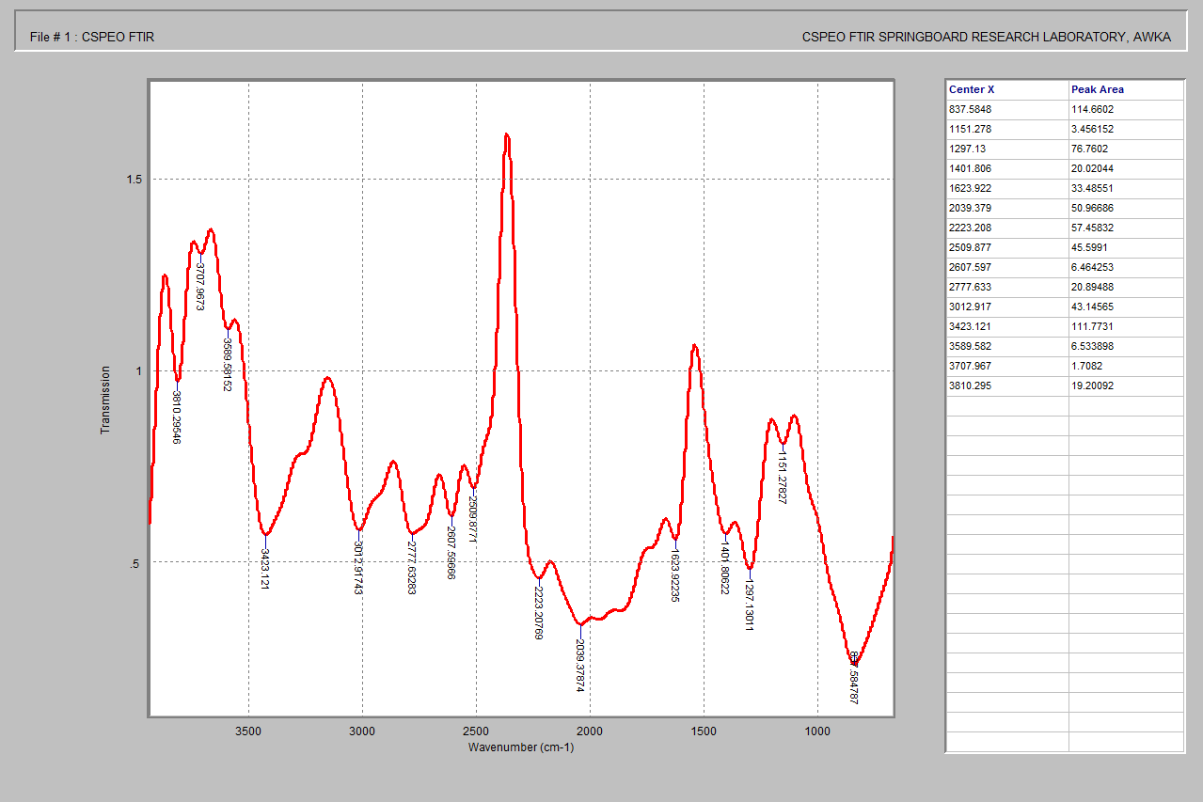
Figure 2. FTIR Spectra of CSPEO
3.3. Scanning Electron Microscope (SEM) Result of Citrus sinensis Peel Essential Oil (CSPEO)
Scanning Electron Microscope (SEM) micrographs of Citrus sinensis peel essential oil (CSPEO), obtained at magnifications of 9000× and 10,000×, revealed a highly heterogeneous surface morphology characterized by irregular porous networks, interconnected cavities, and fractured plate-like structures (Figure 3). These features indicated pronounced surface roughness and significant microstructural discontinuities. Such structural attributes are known to enhance surface area, facilitate volatilization and diffusion of bioactive constituents, and improve interaction at biological interfaces. Consequently, these properties may contribute to the observed insecticidal and vector-control efficacy of CSPEO by promoting better penetration and bioavailability of its active compounds.

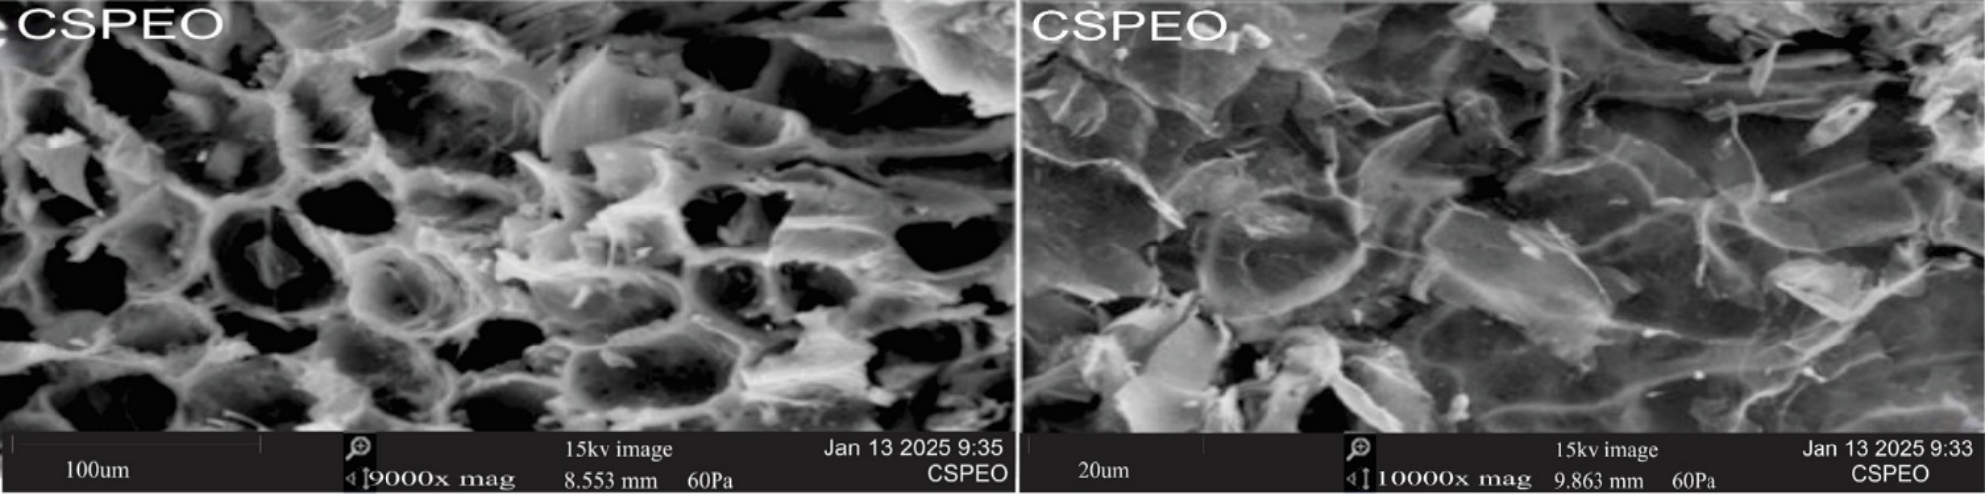

Figure 3. SEM Images of CSPEO (9000x and 10000 magnification)
3.4. XRD Results of Citrus sinensis Peel Essential Oil (CSPEO)
The X-ray diffraction (XRD) pattern of Citrus sinensis peel essential oil (CSPEO) revealed its structural characteristics and degree of crystallinity (Figure 4). The diffractogram was dominated by a broad diffuse halo centered within the low 2θ region (approximately 15-25°), indicating that CSPEO is predominantly amorphous in nature, a feature typical of plant-derived oils and organic extracts. The presence of weak, low-intensity reflections indexed to planes such as (001), (101), (111), and (122) suggested the existence of minor ordered domains or residual crystalline constituents, possibly associated with fatty acid chains or trace inorganic components. The absence of sharp and intense diffraction peaks further confirmed the lack of long-range crystalline order, implying a largely disordered molecular arrangement. Such amorphous characteristics may enhance molecular mobility, reactivity, and bioavailability in subsequent physicochemical and biological applications.
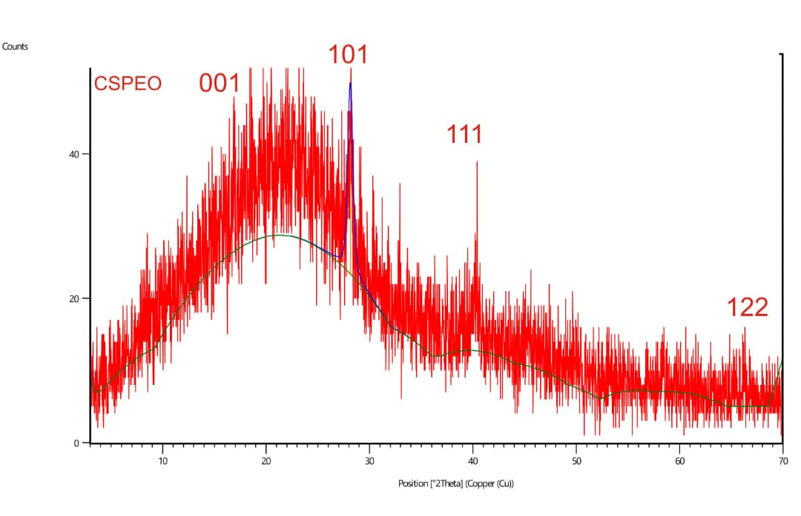
Figure 4: XRD Result for CSPEO
3.5. Bioactive Constituents in Citrus sinensis Peel Essential Oil (CSPEO)
Gas chromatography-mass spectrometry (GC-MS) analysis of Citrus sinensis peel essential oil (CSPEO) revealed a chemically rich profile predominantly composed of monoterpene hydrocarbons and oxygenated monoterpenes (Table 1). The oil was largely dominated by (1R)-2,6,6-trimethylbicyclo[3.1.1]hept-2-ene (68.25%) and D-limonene (25.70%) as the principal constituents. Minor components, including β-myrcene, linalool, α-terpineol, carvone, citral, citronellal, and several sesquiterpenes, were detected in trace amounts. This compositional profile indicated that CSPEO is primarily constituted of volatile terpenoid compounds, which are widely recognized for their diverse biological activities, including insecticidal, antimicrobial, and antioxidant properties. These findings therefore support the functional and bioactive relevance of CSPEO.

Table 1. Bioactive Constituents in CSPEO
S/N | Bioactive Constituents | Molecular Formula | Molecular Weight | Retention Time | Percentage (%)
1 | (1R)-2,6,6-Trimethylbicyclo[3.1.1]hept-2-ene | C₁₀H₁₆ | 136 | 2.153 | 0.44
2 | Bicyclo[3.1.0]hexane, 4-methylene- 1-(1-methylethyl) | C₁₀H₁₆ | 136 | 2.332 | 0.13
3 | beta. -Myrcene | C₁₀H₁₆ | 136 | 2.384 | 2.09
4 | D-Limonene | C₁₀H₁₆ | 136 | 2.655 | 25.70
5 | (1R)-2,6,6-Trimethylbicyclo[3.1.1]hept-2-ene | C₁₀H₁₆ | 136 | 2.782 | 68.25
6 | 1-Undecanol | C₁₁H₂₄O | 172 | 2.862 | 0.16
7 | Linalool | C₁₀H₁₈O | 154 | 3.024 | 1.22
8 | (E)-4,8-Dimethylnona-1,3,7-triene | C₁₁H₁₈ | 150 | 3.076 | 0.01
9 | 2-Cyclohexen-1-ol, 1-methyl-4-(1-methylethenyl)-, trans | C₁₀H₁₆O | 152 | 3.151 | 0.08
10. | cis-p-Mentha-2,8-dien-1-ol | C₁₀H₁₆O | 152 | 3.220 | 0.13
11 | Citronellal | C₁₀H₁₈O | 154 | 3.272 | 0.03
12 | 1-Nonanol | C₉H₂₀O | 144 | 3.353 | 0.01
13 | Bicyclo[2.2.1]heptane, 2,2-dimethyl-5-methylene | C₁₀H₁₆ | 136 | 3.428 | 0.01
14 | 3-Cyclohexen-1-ol, 4-methyl-1-(1-m | C₁₀H₁₈O | 154 | 3.457 | 0.05
15 | alpha.-Terpineol | C₁₀H₁₈O | 154 | 3.532 | 0.14
16 | Decanal | C₁₀H₂₀O | 156 | 3.555 | 0.13
17 | (-)-cis-Isopiperitenol | C₁₀H₁₆O | 152 | 3.583 | 0.04
18 | Cyclohexanol, 2-methyl-5-(1-methylethenyl)-, (1.alpha.,2.alpha.,5.beta.) | C₁₀H₁₈O | 154 | 3.612 | 0.01
19 | 2-Cyclohexen-1-ol, 2-methyl-5-(1-methylethenyl)-, cis | C₁₀H₁₆O | 152 | 3.676 | 0.18
20 | Carveol | C₁₀H₁₆O | 152 | 3.745 | 0.08
21 | 2,6-Octadienal, 3,7-dimethyl-, (Z) | C₁₀H₁₆O | 152 | 3.774 | 0.03
22 | D-Carvone | C₁₀H₁₄O | 150 | 3.826 | 0.15
23 | 1-Decanol | C₁₀H₂₂O | 158 | 3.907 | 0.02
24 | Citral | C₁₀H₁₆O | 152 | 3.924 | 0.04
25 | 1-Cyclohexene-1-carboxaldehyde, 4-(1-methylethenyl)-, (S) | C₁₀H₁₄O | 150 | 4.005 | 0.04
26 | Santolina triene | C₁₀H₁₆ | 136 | 4.068 | 0.02
27 | Z,Z-11,13-Hexadecadien-1-ol | C₁₆H₃₀O | 238 | 4.097 | 0.01
28 | p-Mentha-1,8-dien-7-ol | C₁₀H₁₆O | 152 | 4.120 | 0.01
29 | Bicyclo[2.2.1]heptane, 2,2-dimethy l-3-methylene-, (1R) | C₁₀H₁₆ | 136 | 4.149 | 0.01
30 | (3R,6R)-3-Hydroperoxy-3-methyl-6-(prop-1-en-2-yl)cyclohex-1-ene | C₁₀H₁₆O₂ | 168 | 4.224 | 0.02
31 | Santolina triene | C₁₀H₁₆ | 136 | 4.287 | 0.01
32 | Tetrahydrofuran, 2-isobutenyl-4-vinyl | C₁₀H₁₆O | 152 | 4.339 | 0.01
33 | Santolina triene | C₁₀H₁₆ | 136 | 4.437 | 0.01
34 | Phenylguanidine mononitrate | C₇H₉N₃ | 135 | 4.524 | 0.01
35 | .alfa.-Copaene | C₁₅H₂₄ | 204 | 4.547 | 0.04
36 | .beta.-copaene | C₁₅H₂₄ | 204 | 4.610 | 0.05
37 | Dodecanal | C₁₂H₂₄O | 184 | 4.639 | 0.02
38 | Caryophyllene | C₁₅H₂₄ | 204 | 4.801 | 0.03
39 | Germacrene D | C₁₅H₂₄ | 204 | 4.841 | 0.03
40 | (1S,5S)-4-Methylene-1-((R)-6-methylhept-5-en-2-yl)bicyclo[3.1.0]hexane | C₁₅H₂₄ | 204 |  | 0.01
41 | 1,4,7,-Cycloundecatriene, 1,5,9,9-tetramethyl-, Z,Z,Z | C₁₅H₂₄ | 204 | 4.974 | 0.01
42 | isoledene | C₁₅H₂₄ | 204 | 5.060 | 0.01
43 | Germacrene D | C₁₅H₂₄ | 204 | 5.106 | 0.03
44 | .alpha.-Farnesene | C₁₅H₂₄ | 204 | 5.147 | 0.02
45 | Alloaromadendrene | C₁₅H₂₄ | 204 | 5.181 | 0.03
46 | Epizonarene | C₁₅H₂₄ | 204 | 5.285 | 0.06
47 | 3,4-Octadiene, 7-methyl- | C₉H₁₆ | 124 | 5.389 | 0.01
48 | 2-Naphthalenemethanol, 1,2,3,4,4a,5,6,8a-octahydro-.alpha.,.alpha.,4a,8-tetramethyl-, [2R-(2.alpha.,4a.alpha.,8a.beta.)] | C₁₅H₂₆O | 222 | 5.430 | 0.01
49 | Pyridine, 4-methyl-, 1-oxide | C₆H₇NO | 109 | 5.672 | 0.01
50 | 2,6,11-Dodecatrienal, 2,6-dimethyl -10-methylene | C₁₅H₂₂O | 218 | 6.249 | 0.01
51 | trans-.beta.-Ocimene | C₁₀H₁₆ | 136 | 6.629 | 0.01
52 | 11-Hexadecenoic acid, 15-methyl-,methyl ester | C₁₈H₃₄O₂ | 282 | 10.062 | 0.01
53 | Heptadecanolide | C₁₇H₃₂O₂ | 268 | 10.408 | 0.04
54 | 9-Octadecenoic acid, (E)- | C₁₈H₃₄O₂ | 282 | 10.575 | 0.02
55 | 1-Nitro-9,10-dioxo-9,10-dihydro-anthracene-2-carboxylic acid diethylamide | C₁₉H₁₆N₂O₅ | 352 | 10.748 | 0.01
56 | 5,9-Undecadien-2-one, 6,10-dimethyl-, (Z) | C₁₃H₂₂O | 194 | 10.864 | 0.01
57 | Phenol, 2-methyl- | C₇H₈O | 108 | 12.277 | 0.06
58 | 1-Aminoethylphosphonate, 2TMS derivative | C₈H₂₄NO₃PSi₂ | 269 | 12.473 | 0.01
59 | 7,7,9,9,11,11-Hexamethyl-3,6,8,10,12,15-hexaoxa-7,9,11-trisilaheptadecane | C₁₄H₃₆O₆Si₃ | 384 | 12.716 | 0.01
60 | 2'-Hydroxypropiophenone, TMS derivative | C₁₂H₁₈O₂Si | 222 | 12.964 | 0.01
61 | Thymol, TBDMS derivative | C₁₆H₂₈OSi | 264 | 13.137 | 0.06
62 | 2'-Hydroxypropiophenone, TMS derivative | C₁₂H₁₈O₂Si | 222 | 13.546 | 0.06
63 | 2,6-Dimethyl-5-methylphenylaminopyridin-3,4-dicarboxyimide | C₁₆H₁₅N₃O₂ | 281 | 16.546 | 0.01
64 | 1,2,3-Triazol, 2-(E-4,4-dicyano-3- N-methylanilino-1,3-butadien-1-yl)-4-(methoxycarbonyl) | C₁₇H₁₄N₆O₂ | 334 | 17.140 | 0.01
65 | (3R,5aR,9S,9aS)-2,2,5a,9-Tetramethyloctahydro-2H-3,9a-methanobenzo[b]oxepine | C₁₅H₂₆O | 222 | 17.619 | 0.01

4. DISCUSSION
The comprehensive physicochemical characterization and bioactive profiling of Citrus sinensis peel essential oil have broader implications for the valorization of agro-industrial waste into functional bioresources with potential applications in biological control, pharmaceutical formulation, and green chemistry. Understanding how optical behavior, molecular functionality, microstructure, crystallinity, and chemical composition collectively influence bioactivity is essential for translating citrus peel essential oils from laboratory characterization to practical and sustainable applications.
The ultraviolet absorption behavior of CSPEO implies the presence of electronically active molecular systems capable of interacting with high-energy radiation, a property that is often linked to antioxidant and protective functions in natural products. Such UV responsiveness suggests that CSPEO may contribute to oxidative stress mitigation by absorbing harmful radiation and stabilizing reactive species. Previous studies on citrus and other terpene-rich essential oils have reported similar UV absorption characteristics, attributing them to conjugated double bonds and unsaturated terpenoid structures that enhance radical scavenging potential and chemical stability (El Asbahani et al., 2015; Miguel, 2010). This optical property therefore supports the relevance of CSPEO as a bioactive oil with potential protective and preservative roles.
The functional group composition inferred from FTIR analysis highlights a chemically versatile system with implications for biological interaction and reactivity. Oxygenated functional groups such as hydroxyls and carbonyls are known to enhance polarity and facilitate interactions with biological membranes, enzymes, and proteins. These interactions underpin many of the antimicrobial and insecticidal mechanisms associated with essential oils, including membrane disruption and metabolic interference. Similar functional profiles have been reported in citrus and terpene-based oils by Burt (2004) and Hyldgaard et al. (2012), who emphasized that functional group diversity enhances synergistic effects and broad-spectrum bioactivity. The chemical functionality observed in CSPEO therefore aligns with established structure–activity relationships for biologically active essential oils.
The heterogeneous and porous surface morphology observed under SEM has important implications for volatility, diffusion, and bioavailability of active constituents. Irregular surfaces and microstructural discontinuities increase effective surface area, which can enhance evaporation rates and facilitate contact with biological targets. This is particularly relevant for applications such as insecticidal or repellent formulations, where efficient vapor-phase or contact activity is critical. Similar morphological advantages have been reported in bio-based oil systems and plant-derived materials, where surface roughness has been linked to improved functional performance (Gyawali et al., 2015; Turek & Stintzing, 2013). Thus, the observed morphology of CSPEO supports its suitability for bioactive deployment.
The amorphous structural nature revealed by XRD analysis suggests enhanced molecular mobility and reduced structural constraints within CSPEO. Amorphous organic systems are generally associated with improved solubility, faster diffusion, and greater chemical reactivity compared to crystalline materials. These properties are advantageous in biological applications, as they facilitate rapid interaction between active molecules and target organisms. Previous investigations into plant oils and amorphous bio-organic systems have highlighted their superior performance in delivery and interaction efficiency (Yu, 2001; Hancock & Parks, 2000). The amorphous character of CSPEO therefore represents a favorable structural attribute for its functional exploitation.
The terpene-dominated chemical profile identified by GC-MS has strong implications for the biological efficacy of CSPEO. Monoterpenes and oxygenated terpenes are widely recognized as key contributors to insecticidal, antimicrobial, and antioxidant activities due to their lipophilicity and ability to interfere with cellular membranes and nervous systems. The coexistence of major and minor constituents further enhances synergistic interactions, which are known to amplify biological effects while minimizing resistance development. Similar compositional patterns have been associated with high bioactivity in citrus-derived essential oils and other aromatic plant oils (Raut & Karuppayil, 2014; Bassolé & Juliani, 2012). This chemical richness reinforces the potential of CSPEO as a multifunctional bioactive agent.
Taken together, the physicochemical attributes and bioactive composition of CSPEO demonstrate strong interdependence between structure and function. The alignment of optical, chemical, morphological, and structural properties with a terpene-rich profile underscores the importance of integrated characterization in assessing the applicability of essential oils derived from agricultural waste. These findings support the broader concept that citrus peel residues are not merely waste materials but valuable sources of functional biomolecules capable of contributing to sustainable and environmentally benign technological solutions.
5. CONCLUSION
Based on the results obtained, Citrus sinensis peel essential oil exhibits physicochemical and chemical characteristics that favor enhanced bioactivity, stability, and functional performance. The combined effects of UV-active behavior, diverse molecular functionalities, heterogeneous morphology, amorphous structure, and terpene-rich composition highlight CSPEO as a promising bioresource derived from agro-industrial waste. These attributes collectively support its potential application in eco-friendly biological control strategies, natural product-based formulations, and sustainable bioactive material development.

Ethical Statement

Ethical clearance for this study was obtained from the Nnamdi Azikiwe University Animal Research Ethics Committee (Approval Reference: NAU/AREC/2024/0093; Date of Approval: 31 July 2024).

Declaration of Competing Interest

The authors declare no competing interests.

REFERENCES
- Ezeike, A. K., Danga, S. P. Y., Ezenwa, V. C., Chukas, C. F., Ogudu, E. O., Nwosu, C. M., Ebenebe, I. N., Chukwunwejim, C. R., Oli, A. N., & Esimone, C. O. (2026). Urban evolution of insecticide resistance and susceptibility patterns of Anopheles coluzzii in southeastern Nigeria: Implications for malaria vector control. Malaria Journal, 25, 86. https://doi.org/10.1186/s12936-025-05760-5
- Ezeike, K. A., Nukenine, E. N., Yinyang Danga, S. P., & Esimone, C. O. (2016). Larvicidal effect of Lantana camara and Ocimum gratissimum leaves extracts and their isolates against Aedes aegypti larvae (Diptera: Culicidae). Journal of Mosquito Research, 6(23), 1–10. https://doi.org/10.5376/jmr.2016.06.0023
- Isman M. B. (2006). Botanical insecticides, deterrents, and repellents in modern agriculture and an increasingly regulated world. Annual Review of Entomology, 51, 45–66. https://doi.org/10.1146/annurev.ento.51.110104.151146
- Regnault-Roger, C., Vincent, C., & Arnason, J. T. (2012). Essential oils in insect control: low-risk products in a high-stakes world. Annual Review of Entomology, 57, 405–424. https://doi.org/10.1146/annurev-ento-120710-100554
- Pavela, R., & Benelli, G. (2016). Essential Oils as Ecofriendly Biopesticides? Challenges and Constraints. Trends in Plant Science, 21(12), 1000–1007. https://doi.org/10.1016/j.tplants.2016.10.005
- Mirabella, N., Castellani, V., & Sala, S. (2014). Current options for the valorization of food manufacturing waste: a review. Journal of Cleaner Production, 65, 28–41. https://doi.org/10.1016/j.jclepro.2013.10.051
- Sharma, K., Mahato, N., Cho, M. H., & Lee, Y. R. (2017). Converting citrus wastes into value-added products: Economic and environmently friendly approaches. Nutrition (Burbank, Los Angeles County, Calif.), 34, 29–46. https://doi.org/10.1016/j.nut.2016.09.006
- Bakkali, F., Averbeck, S., Averbeck, D., & Idaomar, M. (2008). Biological effects of essential oils--a review. Food and Chemical Toxicology: An International Journal Published for the British Industrial Biological Research Association, 46(2), 446–475. https://doi.org/10.1016/j.fct.2007.09.106
- Nerio, L. S., Olivero-Verbel, J., & Stashenko, E. (2010). Repellent activity of essential oils: a review. Bioresource Technology, 101(1), 372–378. https://doi.org/10.1016/j.biortech.2009.07.048
- Fisher, K., & Phillips, C. (2008). Potential antimicrobial uses of essential oils in food: is Citrus the answer? Trends in Food Science & Technology, 19(3), 156–164. https://doi.org/10.1016/j.tifs.2007.11.006
- Giatropoulos, A., Kimbaris, A., Michaelakis, Α., Papachristos, D. P., Polissiou, M. G., & Emmanouel, N. (2018). Chemical composition and assessment of larvicidal and repellent capacity of 14 Lamiaceae essential oils against Aedes albopictus. Parasitology Research, 117(6), 1953–1964. https://doi.org/10.1007/s00436-018-5892-9
- Stuart, B.H. (2004). Infrared Spectroscopy Fundamentals and Applications. J West Sussex: ohn Wiley and Sons Ltd. Pp. 1-110. https://doi.org/10.1002/0470011149
- Skoog, D.A., Holler, F.J. and Crouch, S.R. (2007). Principles of Instrumental Analysis. (6th edition), Brooks Cole, Belmont, 1039.
- Ademosun, A. O., Oboh, G., Olupona, A. J., Oyeleye, S. I., Adewuni, T. M., & Nwanna, E. E. (2015). Comparative study of chemical composition, in vitro inhibition of cholinergic and monoaminergic enzymes, and antioxidant potentials of essential oil from peels and seeds of sweet orange (Citrus sinensis [L.] Osbeck) fruits. Journal of Food Biochemistry, 40(1), 53-60. https://doi.org/10.1111/jfbc.12187
- Silverstein, R.M., Webster F.X., Kiemle D.J. and Bryce D.L. (2015) Spectrometric Identification of Organic Compounds. (8th ed.). Chi-chester: John Wiley & Sons, Ltd. Pp. 230-298
- Stuart, B.H. (2005) Infrared Spectroscopy: Fundamentals and Applications. In: Kirk-Othmer Encyclopedia of Chemical Technology. Hoboken: John Wiley & Sons, Inc.
- Goldstein, J. I., Newbury, D. E., Michael, J. R., Ritchie, N. W., Scott, J. H. J., & Joy, D. C. (2018). Scanning Electron Microscopy and X-Ray Microanalysis (4th ed.). Springer
- Fultz, B., & Howe, J. (2013). Transmission Electron Microscopy and Diffractometry of Materials (4th Edition) (public) [Computer software]. Springer. https://doi.org/10.1007/978-3-642-29761-8
- Cullity, B. D., & Stock, S. R. (2014). Elements of X-Ray Diffraction (3rd ed.). Pearson Education Limited.
- Pecharsky, V.K. and Zavalij, P.Y. (2019) Fundamentals of Powder Diffraction and Structural Characterization of Materials. (3rd Edition) Springer.
- Adams, R. P. (2017). Identification of Essential Oil Components by Gas Chromatography/Mass Spectrometry (4th ed.). Carol Stream: Allured Publishing Corporation.
- Sparkman, O. D., Penton, Z., & Kitson, F. G. (2011). Gas Chromatography and Mass Spectrometry: A Practical Guide (2nd ed.). Cambridge: Academic Press. https://doi.org/10.1016/C2009-0-17039-3
- El Asbahani, A., Miladi, K., Badri, W., Sala, M., Aït Addi, E. H., Casabianca, H., El Mousadik, A., Hartmann, D., Jilale, A., Renaud, F. N., & Elaissari, A. (2015). Essential oils: from extraction to encapsulation. International Journal of Pharmaceutics, 483(1-2), 220–243. https://doi.org/10.1016/j.ijpharm.2014.12.069
- Miguel M. G. (2010). Antioxidant and anti-inflammatory activities of essential oils: a short review. Molecules, 15(12), 9252–9287. https://doi.org/10.3390/molecules15129252
- Burt S. (2004). Essential oils: their antibacterial properties and potential applications in foods: a review. International Journal of Food Microbiology, 94(3), 223–253. https://doi.org/10.1016/j.ijfoodmicro.2004.03.022
- Hyldgaard, M., Mygind, T., & Meyer, R. L. (2012). Essential oils in food preservation: mode of action, synergies, and interactions with food matrix components. Frontiers in Microbiology, 3, 12. https://doi.org/10.3389/fmicb.2012.00012
- Gyawali, R., Hayek, S. A., & Ibrahim, S. A. (2015). Plant Extracts as Antimicrobials in Food Products: Types. In S. A. Ibrahim (Ed.), Antimicrobial Resistance and Food Safety (pp. 3–25). Academic Press. https://doi.org/10.1016/B978-1-78242-034-7.00002-5
- Turek, C. and Stintzing, F.C. (2013) Stability of essential oils: a review. Comprehensive Reviews in Food Science and Food Safety, 12, 40-53.
https://doi.org/10.1111/1541-4337.12006
- Yu L. (2001). Amorphous pharmaceutical solids: preparation, characterization and stabilization. Advanced Drug Delivery Reviews, 48(1), 27–42. https://doi.org/10.1016/s0169-409x(01)00098-9
- Hancock, B. C., & Parks, M. (2000). What is the true solubility advantage for amorphous pharmaceuticals? Pharmaceutical research, 17(4), 397–404. https://doi.org/10.1023/a:1007516718048
- Raut, J.S. and Karuppayil, S.M. (2014) A Status Review on the Medicinal Properties of Essential Oils. Industrial Crops and Products, 62, 250-264.
https://doi.org/10.1016/j.indcrop.2014.05.055
- Bassolé, I. H., & Juliani, H. R. (2012). Essential Oils in Combination and their Antimicrobial Properties. Molecules, 17(4), 3989–4006. https://doi.org/10.3390/molecules17043989

