ENHANCING VOCABULARY AND WRITING SKILLS THROUGH PICTURE TO WORDS STRATEGY AMONG GRADE 4 PUPILS OF PANGPANG INTEGRATED SCHOOL

.

ABSTRACT
This study examined the effectiveness of the Picture-to-Words Strategy in enhancing the vocabulary and writing skills of Grade 4 pupils at Pangpang Integrated School. Recognizing that vocabulary mastery is essential for reading and writing development, the intervention engaged learners in constructing and writing simple sentences using visual-based techniques. The approach aimed to strengthen language acquisition through structured image-driven learning, providing contextual support to improve comprehension, retention, and writing fluency.
Using the Input-Process-Output method, researchers conducted pre-test and post-test evaluations to measure learners’ progress. The pre-test results revealed low performance, with a mean score of 82.76 and a standard deviation of 5.73, placing pupils at the frustration level. After the implementation of the Picture-to-Words Strategy, the post-test results showed significant improvement, with a mean score of 93.45 and a standard deviation of 4.80. Statistical analysis confirmed the effectiveness of the intervention, with a t-value of -14.270 and a p-value of 0.000 at the 0.05 level of significance, indicating a meaningful difference between pre-test and post-test scores.
The findings highlight the importance of visual-based learning in literacy instruction. By integrating images with words, learners developed stronger associations, improved writing fluency, and gained confidence in communication. The study implies that teachers should adopt picture-based strategies as part of their instructional practice, while schools should embed multisensory and interactive methods into the curriculum to support diverse learners. Future research may explore the long-term impact of this strategy and its application across other subject areas, ensuring that early literacy interventions continue to build strong foundations for academic success.

Keywords: Picture-to-Words Strategy, vocabulary development, writing skills, visual-based learning, elementary education, literacy intervention, language acquisition, and differentiated instruction

- INTRODUCTION

Vocabulary development is a crucial aspect of language learning and communication, equally important as reading, writing, listening, and speaking. A strong vocabulary allows learners to express ideas clearly and understand concepts deeply, while limited vocabulary restricts comprehension and hinders progress (Torrentira, 2019). In the Philippines, poor performance in international reading assessments such as PISA highlights the urgent need to strengthen vocabulary instruction, as the country ranked 76th out of 81 nations in reading (Manihuruk, Remo, Afidah, & Machfudi, 2022). Learners often struggle with vocabulary mastery due to limited exposure, poor study habits, reliance on traditional methods, and reduced interest in learning (Afidah & Machfudi, 2022; Yuldashevna, 2023). These challenges are especially evident among young learners in rural areas, where restricted knowledge, low confidence, and minimal engagement with reading materials hinder progress.
Recognizing these issues, this study investigates the effectiveness of the Picture-to-Words Strategy, which uses visuals paired with words to enhance recall, comprehension, and writing skills. This approach is grounded in the Picture Superiority Effect in cognitive psychology, which suggests that learners retain information more effectively when visuals are paired with words. By engaging in dual encoding, pupils process both images and verbal labels simultaneously, leading to improved vocabulary acquisition and writing proficiency.
Several studies support the use of picture-based strategies in language learning. Jatmiko (2018) found that teaching vocabulary with pictures was significantly more effective than conventional methods, while Sitinjak (2023) confirmed that picture series improved vocabulary mastery among Grade VII students. Guevara-Torres and Ramírez-Ávila (2023) demonstrated that image description activities enhanced vocabulary acquisition and learner confidence. Similarly, Annisa (2019) showed that pictoword games increased motivation and vocabulary achievement, and Pelare, Piatos, and Baluyos (2025) validated the long-term retention benefits of pictoword strategies. Meehan (2022) emphasized the value of the Picture Word Inductive Model (PWIM) for vocabulary growth and writing development, while Echalico-Bermillo and Roma-Remollo (2022) found that PWIM not only improved vocabulary achievement but also enhanced students’ attitudes toward learning. Marpaung and Situmeang (2020) further reinforced the role of PWIM in vocabulary enrichment, and Tarigan, Panjaitan, Simbolon, and Damanik (2021) highlighted the effectiveness of pictures in improving writing skills.
In addition, local studies provide relevant insights into teaching and learning challenges. Casane (2024) revealed that multi-grade teachers in Northern Samar maintained positive attitudes despite challenges, emphasizing the role of resilience in overcoming instructional difficulties. Casane (2025) highlighted the importance of clear instructional strategies and reliable tools, while Casane (2026) demonstrated that targeted interventions directly improved academic outcomes. Casane and Giray (2026) underscored the importance of curriculum integration and practical activities in strengthening competencies. Collectively, these findings affirm that structured, engaging strategies such as Picture-to-Words can help Grade 4 pupils of Pangpang Integrated School strengthen vocabulary and writing proficiency, ultimately improving academic performance and confidence in language use.
Lastly, vocabulary development is essential for learners’ overall language growth and academic success. Addressing the challenges faced by pupils requires innovative and engaging approaches that go beyond traditional methods. The Picture-to-Words Strategy offers a practical solution by combining visual and verbal learning, making vocabulary acquisition more meaningful and writing skills more accessible. By implementing this strategy, educators can foster confidence, enhance literacy, and contribute to improved educational outcomes for Grade 4 pupils of Pangpang Integrated School.

Objectives

This study aimed to determine the level of vocabulary and writing skills of Grade 4 pupils in Pangpang Integrated School during the school year 2024-2025.

Specifically, it aimed to:

1. Determine the pre-test result of the participants in their vocabulary and writing skills.
2. Determine the post-test result of the participants in their vocabulary and writing skills.
3. To find out if there a significant difference between the pre-test and post-test results of the participants in their vocabulary and writing skills.

2. methodology

1. Research Design
The study employed an Input-Process-Output (IPO) action research design to evaluate the effectiveness of the Picture-to-Words strategy in enhancing vocabulary acquisition and writing skills among elementary pupils. This design allowed the researchers to systematically examine how the intervention influenced learners’ performance by analyzing inputs, processes, and outcomes.

2. Respondents
The respondents consisted of sixty-four (64) Grade 4 pupils officially enrolled at Pangpang Integrated School during the School Year 2024–2025. The sample was equally divided between two sections: 32 learners from Section Yellow Bell and 32 learners from Section Sampaguita.

3. Sampling Technique
The study utilized a complete enumeration sampling technique, wherein all available and willing participants from the defined group were included. Data collection involved administering a pre-test, post-test, and the Picture-to-Words strategy intervention to measure changes in vocabulary and writing skills.

4. Research Instruments
A researcher-made instrument was developed and subjected to validation to ensure clarity, relevance, and reliability. Subject matter experts reviewed the items to confirm that they accurately reflected the concepts under investigation and provided recommendations for refinement, thereby strengthening the instrument’s validity.

5. Data Analysis
The data were analyzed using frequency counts, percentages, and weighted mean. These statistical tools facilitated the effective interpretation of results, enabling the researchers to identify patterns, measure improvements, and draw meaningful conclusions regarding the impact of the Picture-to-Words strategy.
Fig 1 : Conceptual Framework
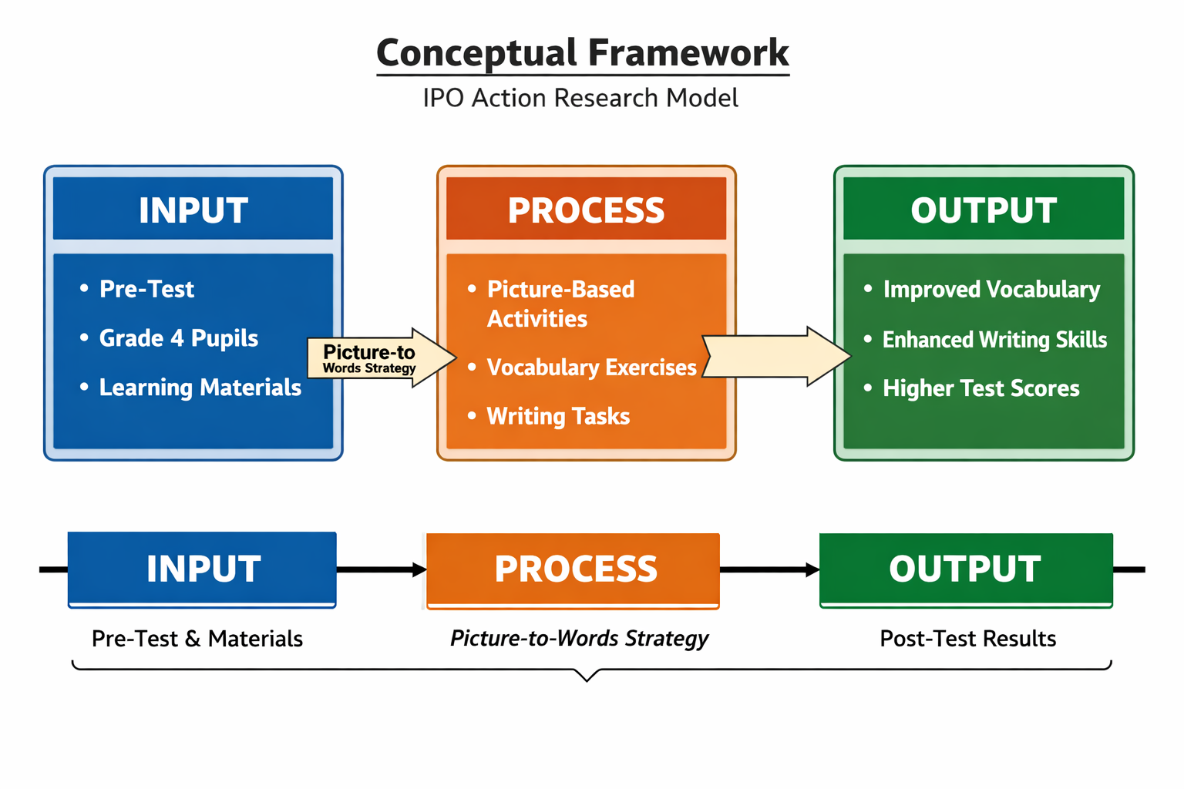

3. results and discussion

Table 1 presents the pre-test scores of the 38 respondents. Out of 180 items in the vocabulary and writing tests, 33 pupils (86.84%) showed very low proficiency, while only 5 pupils (13.16%) demonstrated higher skills. The mean score was 82.76 with a standard deviation of 5.73, placing most learners in the “frustrated” category. This indicates that the majority of pupils struggled with vocabulary and writing before the intervention.
The distribution of scores ranged from 45 to 134. Most pupils (86.84%) scored between 45 and 89, reflecting instructional or frustration levels, while only 13.16% scored between 90 and 134. These results highlight significant gaps in language development and the need for differentiated instruction to address varying levels of comprehension.
The findings emphasize the importance of strategic interventions to improve vocabulary and writing proficiency. Visual-based learning strategies, such as the Picture-to-Words Strategy, are particularly effective because they use dual encoding—linking words with images—which enhances retention and comprehension. Learners exposed to picture-based activities are more engaged and motivated, leading to better outcomes compared to traditional text-based methods.
The pre-test results of Grade 4 pupils at Pangpang Integrated School revealed that most learners struggled with vocabulary and writing, with 86.84% falling into the frustration category and only 13.16% showing higher proficiency, underscoring the need for effective interventions. Supporting studies confirm that picture-based strategies can address these gaps: Jatmiko (2018) found that teaching vocabulary with pictures was more effective than conventional methods, Annisa (2019) showed that pictoword games improved motivation and achievement, Sitinjak (2023) reported that picture media significantly enhanced vocabulary mastery, Echalico-Bermillo and Roma-Remollo (2022) demonstrated that the Picture Word Inductive Model (PWIM) increased both vocabulary achievement and positive learner attitudes, and Marpaung & Situmeang (2020) highlighted PWIM’s role in enriching vocabulary retention. These findings align with the present study, reinforcing the importance of early literacy interventions and the integration of interactive, picture-based strategies to strengthen vocabulary and writing proficiency. By applying the Picture-to-Words Strategy, educators can foster engagement, confidence, and improved language performance among elementary learners.
Overall, the pre-test findings revealed that most Grade 4 pupils struggled with vocabulary and writing. This underscores the necessity of implementing innovative strategies like the Picture-to-Words Strategy, which has the potential to significantly improve learners’ language proficiency, comprehension, and confidence.
Table 1: Pre-test Result
Scores | Frequency | Percentage | Interpretation
45 – 89 | 33 | 86.84% | Instructional or Frustration
90 – 134 | 5 | 13.16% | Frustration
Total: 38 100%
Mean: 82.763 Instructional or
Std. Dev.: 5.73 Frustration

Table 2 revealed the post-test results of the respondents in enhancing vocabulary and writing skills. Out of 38 pupils, 30 or 78.95 percent achieved a very high proficiency level, while 8 or 21.05 percent remained at a lower level. The mean score of 93.45 and standard deviation of 4.80 indicate a significant improvement compared to the pre-test, providing compelling evidence of the effectiveness of the Picture-to-Words Strategy in enhancing learners’ vocabulary and writing skills. The upward trend in scores, with most pupils (78.95%) scoring between 90 and 134, demonstrates strong mastery of vocabulary and writing concepts. This improvement suggests that the intervention successfully bridged learning gaps, particularly among those who previously showed frustration-level proficiency. Structured visual aids helped learners contextualize words, making them easier to understand and apply in writing tasks.

These findings have critical implications for elementary education, reinforcing the value of image-driven instructional techniques. The success of this strategy underscores the importance of multisensory approaches in literacy development. Supporting studies confirm this: Guevara-Torres and Ramírez-Ávila (2023) showed that image description activities enhanced vocabulary acquisition and learner confidence; Pelare, Piatos, and Baluyos (2025) validated the effectiveness of pictoword strategies in improving long-term vocabulary retention; Meehan (2022) emphasized that the Picture Word Inductive Model (PWIM) fosters both vocabulary growth and writing development; Tarigan, Panjaitan, Simbolon, and Damanik (2021) highlighted the role of pictures in improving writing fluency; and Casane (2026) demonstrated that targeted instructional interventions directly enhanced academic performance. Together, these studies align with the present findings, showing that picture-based strategies not only strengthen vocabulary mastery but also foster confidence, motivation, and improved writing skills.
Given these positive outcomes, educators are encouraged to adopt and refine picture-based learning strategies, integrating them into classroom instruction. By expanding this approach, schools can further enhance engagement, comprehension, and overall literacy development among young learners. Future research may explore additional visual-based interventions across different age groups and contexts to maximize educational impact.

Table 2: Post-test Result
Scores | Frequency | Percentage | Interpretation
45 – 89 | 8 | 21.05% | Instructional or Frustration
90 – 134 | 30 | 78.95% | Frustration

Total: 38 100%

Mean: 93.447 Instructional or

Std. Dev.: 4.80 Frustration

Table 3 confirms a significant improvement in learners’ vocabulary and writing skills after the Picture-to-Words Strategy intervention. The t-value of -14.270 and p-value of 0.000 show that the difference between pre-test and post-test scores is highly significant. The mean score increased from 82.76 to 93.45, while the standard deviation decreased from 5.73 to 4.80, indicating that learners became more consistent and accurate in their responses.
This improvement highlights the effectiveness of visual-based learning in helping pupils understand and retain language concepts. By combining words with images, learners formed stronger associations, which improved comprehension and writing fluency. Supporting studies confirm this: Annisa (2019) found that pictoword games boosted motivation and achievement; Pelare, Piatos, and Baluyos (2025) showed that pictoword strategies improved long-term retention; Echalico-Bermillo and Roma-Remollo (2022) reported that PWIM enhanced vocabulary and attitudes toward learning; Guevara-Torres and Ramírez-Ávila (2023) demonstrated that image description activities strengthened confidence and vocabulary acquisition; and Tarigan et al. (2021) emphasized that pictures improved writing skills.
Overall, the results underscore the importance of early literacy interventions and differentiated instruction. By integrating picture-based strategies with interactive activities such as storytelling, peer collaboration, and gamified vocabulary tasks, educators can foster engagement, confidence, and stronger language skills among elementary learners. The findings of this study demonstrate that the Picture-to-Words Strategy is an effective intervention for improving vocabulary and writing skills among Grade 4 pupils. The significant increase in post-test scores and the statistical analysis confirming its impact highlight the value of visual-based learning in literacy development. The implication is that teachers should adopt picture-based strategies as part of their instructional practice, as these approaches not only strengthen comprehension and retention but also foster confidence, motivation, and fluency in communication. For schools, this means integrating multisensory and interactive methods into the curriculum to better support diverse learners. Future research may further explore the long-term effects of this strategy and its application across other subject areas, ensuring that early literacy interventions continue to build strong foundations for academic success.

Table 3. Significant Difference between the Pre-test and Post-test Results
Variables | t - value | p - value | Level of Significance | Decision | Interpretation
Posttest and Pretest  Results | -14.270 | 0.000 | 0.05 | Reject Null  Hypothesis | Significant

4. Conclusion

This study demonstrated that the Picture-to-Words Strategy is an effective intervention for enhancing the vocabulary and writing skills of Grade 4 pupils at Pangpang Integrated School. The significant improvement in post-test scores, supported by statistical analysis, confirms that visual-based learning techniques foster stronger comprehension, retention, and writing fluency compared to traditional methods. By integrating pictures with words, learners were able to contextualize language more effectively, leading to increased confidence and motivation in communication.
The implication is that teachers should adopt picture-based strategies as part of their instructional practice, as these approaches not only strengthen literacy skills but also cater to diverse learning styles. For schools, this means embedding multisensory and interactive methods—such as storytelling, peer collaboration, and gamified vocabulary activities—into the curriculum to better support learners at varying proficiency levels.
Ultimately, the findings underscore the importance of early literacy interventions in building strong foundations for academic success. Future research may explore the long-term impact of the Picture-to-Words Strategy and its application across other subject areas, ensuring that visual-based learning continues to play a vital role in improving comprehension and overall educational outcomes.

References

Annisa, M. (2019). The effectiveness of pictoword game on students’ vocabulary achievement. Syarif Hidayatullah State Islamic University, Jakarta. Retrieved from https://www.academia.edu/65257590/The_effectiveness_of_pictoword_game_on_students_vocabulary_achievement

Casane, L. (2024). Teacher’s attitude and challenges in teaching multi-grade classes. International Journal of Advanced Research in Education and Society (IJARES), 6(5), 1–12. https://doi.org/10.55057/ijares.2024.6.5.21
Casane, L. L. (2025). Instructional competence, professional and personal characteristics of teachers in multigrade classes. Asian Journal of Education and Social Studies, 51(5), 817–829. https://doi.org/10.9734/ajess/2025/v51i51962
Casane, L. L. (2026). Academic performance in Edukasyong Pantahanan at Pangkabuhayan and financial literacy among students in Bachelor of Elementary Education. Asian Journal of Arts, Humanities and Social Studies, 9(1), 102–112. https://doi.org/10.56557/ajahss/2026/v9i1101
Casane, L. L., & Jr., A. L. G. (2026). Financial literacy of pre-service teachers of UEP Laoang Campus: Basis for crafting financial literacy program. Journal of Economics and Trade, 11(1), 384–393. https://doi.org/10.56557/jet/2026/v11i110459
Echalico-Bermillo, J., & Roma-Remollo, E. (2022). Picture Word Inductive Model (PWIM) on students’ vocabulary achievement and attitude. Indonesian Journal of Contemporary Education, 4(1), 19–28. https://doi.org/10.5281/zenodo.6471234
Guevara-Torres, P., & Ramírez-Ávila, M. (2023). Action-research study to improve vocabulary acquisition through picture description. YUYAY: Estrategias, Metodologías & Didácticas Educativas, 1(2), 12–24.
Jatmiko, J. (2018). The effectiveness of using picture to teach vocabulary at elementary school. In Proceedings of the International Conference on Educational Psychology and Pedagogy (ICEPP 2018) (pp. 366–371). SciTePress. https://doi.org/10.5220/0007420803660371
Manihuruk, R., Remo, A., Afidah, N., & Machfudi, M. (2022). Enhancing students’ vocabulary in Filipino language using game-based learning activity. International Journal of Research and Innovation in Social Science. Retrieved from https://rsisinternational.org/journals/ijriss/articles/enhancing-students-vocabulary-in-filipino-language-using-game-based-learning-activity
Marpaung, R., & Situmeang, R. (2020). Vocabulary enrichment through Picture Word Inductive Model (PWIM). Retrieved from https://files.eric.ed.gov/fulltext/EJ1406593.pdf
Meehan, M. (2022, December 15). The picture word inductive model: A strategy for developing vocabulary and language. Two Writing Teachers. Retrieved from https://www.middleweb.com/46687/the-picture-word-inductive-model-a-strategy-for-developing-vocabulary-and-language/
Pelare, G. B., Piatos, A. C., & Baluyos, G. (2025). Effectiveness of pictoword in enhancing vocabulary retention among Grade 8 students. International Journal of Research and Innovation in Applied Science (IJRIAS). https://dx.doi.org/10.51584/IJRIAS.2025.101100019.
Sitinjak, E. R. (2023). The effect of picture media on mastery of vocabulary at grade VII students. Journal on Education, 5(4), 2498–2506. Universitas Pahlawan Tuanku Tambusai. https://doi.org/10.31004/joe.v5i4.2498.
Tarigan, N. W. P., Panjaitan, E. E., Simbolon, P., & Damanik, J. F. (2021). Improving pupils’ writing skills by using pictures and picture method at junior high school. IDEAS: Journal on English Language Teaching and Learning, Linguistics and Literature, 9(2), 749–767. https://doi.org/10.24256/ideas.v9i2.2328.
Torrentira, A. E. (2019). Picture-word-concept association: Building vocabulary, enriching comprehension of English language learners. E-Saliksik: DepEd Research Portal. Retrieved from https://e-saliksik.deped.gov.ph

‎

