Temperature-Mediated Changes in Abscisic Acid Levels in Indian Mustard under Early, Timely and Late Sowing Environments in Doon Valley

ABSTRACT
Temperature variability associated with different sowing environments significantly influences abscisic acid level and productivity in Indian mustard (Brassica juncea L.). The present field study was conducted during the rabi seasons 2023–24 and 2024–25 in the Doon Valley, Uttarakhand, india to evaluate temperature-mediated changes in abscisic acid (ABA) levels under early, timely, and late sowing conditions. Five germplasms (Varuna, Kanti, Maya, Kranti, and Vardan) were assessed at vegetative and flowering stages. ABA was extracted from fresh leaf tissue and quantified using High-Performance Liquid Chromatography (HPLC).
Results indicated that timely sowing, associated with comparatively cooler temperature patterns (~13/5°C and ~25/9°C), consistently recorded higher ABA accumulation than early (~26/12°C) and late (~28/13°C) sowing. During 2023–24, timely sowing exhibited an average ABA level of 8.13 µg/g compared to 6.37 µg/g under early sowing. Similarly, in 2024–25, timely sowing recorded 7.62 µg/g, significantly higher than late sowing (5.30 µg/g). ANOVA confirmed a highly significant effect of sowing environment on ABA levels (F = 40.09 and 56.02; p < 0.01). Genotypic variation was evident, with Maya consistently exhibiting the highest ABA accumulation, whereas Kanti and Vardan showed relatively stable abscisic acid regulation under temperature fluctuations.
A positive association between ABA concentration and oil yield per plant was observed under timely sowing in both seasons, while oil content (%) showed minimal variation. Reduced ABA levels under early and late sowing corresponded with yield decline, suggesting that ABA-mediated physiological regulation contributes to productivity under favourable thermal conditions.
Overall, the study demonstrates that ABA biosynthesis in Indian mustard is highly temperature sensitive, and timely sowing under cooler conditions enhances hormonal accumulation and yield performance. Sowing time thus serves as a critical agronomic factor influencing hormonal dynamics and stress adaptation under field conditions.
Keywords: Abscisic Acid, Phytohormone, Temperature Stress, High-Performance Liquid Chromatography (HPLC), Analysis of Variance (ANOVA)

1.0 INTRODUCTION
1.1 Indian Mustard
Indian mustard (Brassica juncea L.) is one of the most significant edible oilseed crops in the genus Brassica and family Brassicaceae. India is the 3rd-largest producer of these oilseeds, accounting for 14% of worldwide production after Canada and China (Misra et al., 2008). In India, mustard oilseed crops are the most widely cultivated and economically important after soybeans (Misra et al., 2008). Indian mustard is primarily grown in agro-climatic zones, including the hill regions of the north-western & north-eastern regions and the plain regions of the southern region, under mixed climatic conditions, such as rainfed and irrigated agricultural systems (Misra et al., 2008). Among the several species of Rapeseed mustard, Indian mustard (Brassica juncea) is the dominant member, cultivated in 80% of areas. According to reports published by ICAR-Indian Institute of Rapeseed-Mustard Research, during FY 2023-24, Indian mustard was cultivated in 30.3% of the total oilseed area and contributed 33.2% of the overall oilseed yield in India. According to the report, rapeseed mustard recorded a high yield of 13.2 million tonnes (131.4 lakh tonnes) in FY 2023-24, exceeding the previous FY yield of 12.64 million tonnes (126.43 lakh tonnes), making it the largest oilseed-producing crop in India (ICAR–IIRMR, 2023–24). During the same FY, the productivity of Indian mustard reached approximately 1443 kg/ha, exceeding the previous FYs oilseed productivity, which was approximately 1314 kg/ha in India. Among all mustard-producing states of India, Rajasthan sustain its top position, contributing approximately 45-49 %, after Haryana 12.44 %, Madhya Pradesh 11.32%, Uttar Pradesh 10.60% and West Bengal 7.53% respectively. Overall, approximately 74% of the mustard-producing region of India is irrigated, helping to maintain a consistent yield even under unfavourable environmental conditions.

1.2 Abscisic Acid (ABA)

Abscisic acid (ABA) is a central phytohormone regulating plant growth, development, and stress adaptation. It functions as a major stress hormone because its endogenous concentration increases rapidly under adverse environmental conditions, coordinating physiological and molecular responses that enhance plant survival (Chen et al., 2020; Vishwakarma et al., 2017). In addition to its role in seed dormancy and germination, ABA regulates stomatal closure, osmotic balance, antioxidant defence, and stress-responsive gene expression (Rehman et al., 2022; Kumari et al., 2018).

1.2.1 ABA Biosynthesis and Homeostasis

ABA is synthesized via the carotenoid cleavage pathway, where 9-cis-epoxycarotenoid dioxygenase (NCED) acts as a key regulatory enzyme controlling stress-induced ABA accumulation (Chen et al., 2020; Rehman et al., 2022). Rapid upregulation of NCED transcripts under stress supports quick ABA biosynthesis and adaptive signaling (Vishwakarma et al., 2017). ABA homeostasis is further maintained through catabolic processes such as ABA 8′-hydroxylation and conjugation, allowing dynamic adjustment of hormone levels during stress and recovery (Chen et al., 2020; Rehman et al., 2022).
In addition to biosynthesis and degradation, ABA transport is actively regulated by ATP-binding cassette (ABCG) transporters that function as exporters and importers, ensuring coordinated hormonal movement between tissues (Kang et al., 2015; Chen et al., 2020). Such spatial regulation enables precise control of ABA signaling during stress adaptation.

1.2.2 Regulation of ABA under High-Temperature Stress

High-temperature stress disrupts cellular homeostasis by inducing excessive production of reactive oxygen species (ROS), leading to oxidative damage and impaired photosynthesis (Iqbal et al., 2022; Wahid et al., 2007). Under heat stress, endogenous ABA levels increase and activate stress-responsive genes, antioxidant defense systems, and osmolyte accumulation (Rehman et al., 2022; Iqbal et al., 2022).
ABA enhances thermotolerance by regulating stomatal behaviour, optimizing transpiration, and improving water use efficiency under elevated temperatures (Rehman et al., 2022). It also stimulates antioxidant enzymes such as superoxide dismutase (SOD), catalase (CAT), and ascorbate peroxidase (APX), thereby reducing ROS accumulation and maintaining redox balance (Iqbal et al., 2022; Vishwakarma et al., 2017). Additionally, ABA-mediated accumulation of compatible solutes like proline contributes to membrane stabilization and protection of the photosynthetic apparatus under heat stress (Rehman et al., 2022).
Evidence further indicates that ABA interacts with nitric oxide (NO) in regulating antioxidant metabolism and osmolyte synthesis, forming a synergistic signaling network that strengthens heat stress tolerance (Iqbal et al., 2022).

1.2.3 Regulation of ABA under Low Temperature Stress

Low temperature stress also triggers ABA accumulation and signaling responses that promote stress acclimation (Vishwakarma et al., 2017). ABA-mediated pathways regulate transcription factors and stress-responsive genes involved in osmotic adjustment and antioxidant activation (Rehman et al., 2022; Kumari et al., 2018).
Under cold stress, ABA functions as an integrator of environmental signals, linking perception mechanisms with downstream signaling components such as receptors, phosphatases, and kinases that regulate gene expression (Chen et al., 2020). Through these mechanisms, ABA enhances osmolyte accumulation, strengthens antioxidant defense, and helps maintain membrane stability under temperature extremes (Rehman et al., 2022).

1.2.4 Research Gaps

Although earlier studies clearly establish the physiological and molecular roles of ABA under controlled stress conditions, most prior research has been conducted in laboratory or growth-chamber experiments focusing on single stress factors (Sehgal et al., 2022). Limited information is available regarding field-based temperature fluctuations and their influence on endogenous ABA levels under different sowing environments in Indian mustard.

Furthermore:
- Previous studies largely emphasized drought and salinity stress (Majid et al., 2021; Nehal et al., 2018), while temperature-mediated hormonal variation under natural field conditions remains less explored.
- Most research has focused on general stress physiology, whereas comparative evaluation of multiple mustard germplasms under early, timely, and late sowing in relation to ABA biosynthesis is scarce.
- Although ABA biosynthesis pathways are well characterized (Chen et al., 2020), there is insufficient field-level validation linking seasonal temperature variation with quantitative ABA changes measured through precise techniques such as HPLC (Ciha et al., 1977).
- The interaction between low-temperature intensity and magnitude of ABA accumulation under realistic agro-climatic conditions, such as the Doon Valley, Uttarakhand, India, has not been systematically studied.

1.2.5 Study Objectives

Based on the identified gaps, the present study was undertaken with the following objectives:

- To evaluate the effect of early, timely, and late sowing environments on endogenous abscisic acid levels in Indian mustard (Brassica juncea L.) under field conditions.
- To quantify temperature-mediated changes in ABA concentration at vegetative and flowering stages using High-Performance Liquid Chromatography (HPLC) following established ABA quantification methods (Ciha et al., 1977).
- To compare genotypic variation in ABA accumulation among five mustard germplasms (Varuna, Kanti, Maya, Kranti, and Vardan) under contrasting temperature regimes.
- To assess whether low-temperature stress induces greater ABA biosynthesis than high-temperature stress under Doon Valley conditions, in alignment with previous reports describing ABA as a stress-responsive hormone (Vishwakarma et al., 2017; Rehman et al., 2022).
- To establish the importance of sowing time as a practical agronomic factor influencing hormonal stress responses, thereby contributing to improved stress adaptation strategies in Indian mustard.

2.0 METHODOLOGY
Indian mustard (Brassica juncea L.) germplasms, namely Varuna, Kanti, Maya, Kranti & Vardan, were sown in two rabi seasons, 2023-24 and 2024-25. In the first rabi season, 2023-24, germplasms were sown under a timely sowing environment (26th October 2023) and an early sowing environment (26th September 2023). In the second rabi season, 2024-25, germplasms were sown under a timely sowing environment on 30th October 2024 and a late sowing environment on 30th November 2024 at Jigyasa University (Formerly Himgiri Zee University), Sherpur, Dehradun, campus (Latitude 30.33896 ° and Longitude 77.880248 °). This area lies within the Doon Valley, which is located in the foothills of the Himalayas in Uttarakhand, between the Shivalik Hills and the Lower Himalaya, and experiences temperature drops of up to 4 °C from December to February. Optimal growth temperature is 15-25°C in Indian mustard with high photosynthetic efficiency. Temperatures outside this range may affect productivity and lead to low- or high-temperature stress, respectively. In this research, we are focusing on high and low temperature-induced biosynthesis of abscisic acid in five germplasms of Indian mustard (Brassica juncea), i.e., Varuna, Kanti, Maya, Kranti & Vardan, in vegetative and flowering stages. To analyze abscisic acid level, we had taken 100 grams of leaf samples from Varuna, Kanti, Maya, Kranti & Vardan separately on 28th November 2023 from early sown, on 20th January 2024 from timely sown, on 11th February 2025 from timely sown, and on 08th March 2025 from late sown Indian mustard (Brassica juncea L.) germplasms.

2.1 Abscisic Acid Separation and Quantification

During the research trial, abscisic acid was separated and quantified from the leaf tissue of Brassica juncea (Indian mustard) using HPLC (High Performance Liquid Chromatography), which is a very quick and precise method with minimum sample preparation. Abscisic acid was separated and quantified from leaf tissue of five germplasms of Brassica juncea, such as Varuna, Kanti, Maya, Kranti, & Vardan.

2.1.1 Sample Preparation

100 grams of fresh green leaves were collected, washed thoroughly with distilled water to remove dust & other contaminants, and then dried on blotting paper. Cleaned and dried leaves were immediately frozen in liquid nitrogen to prevent enzymatic degradation and preserve hormonal integrity prior to extraction. Grind leaves uniformly using a mechanical grinder for efficient extraction. Ground leaves powder was transferred into a clean glass beaker, and 100 mL of a methanol-water mixture was added in a 70:30 ratio. Generally, 1 mL of solvent needs to be added per gram of leaf tissue. Mixed a mixture of solvent and powdered leaf tissue using a magnetic stirrer. Sonicate the mixture for 15-30 minutes to completely break down the cell wall and for efficient extraction. Kept the mixture at room temperature for 24 hours, shaking periodically. Filtered the mixture by filter paper to remove the solid part. Centrifuged filtered mixture at 10000 rpm for 10 minutes for complete removal of the solid part. Separated the supernatant, which contains soluble compounds including abscisic acid. Evaporation of supernatant was performed under reduced pressure by rotatory evaporator to get a concentrated extract up to 5-10 ML at 40 °C. Reformed the concentrated extract by adding 1 mL of methanol. Filtered reformed sample by a 0.4µm syringe filter to separate particulate matter before HPLC injection. To set up HPLC, a mobile phase for abscisic acid analysis was prepared using 0.1% acetic acid as the aqueous phase and acetonitrile as the organic phase. For optimal separation, a C18 reverse-phase HPLC column was used. UV detector set at 254 nm. Flow rate maintained at 0.5-1.0 ML/minute. After all these setups, I injected 10 µl of the sample into the HPLC.

3.0 TEMPERATURE VARIATION
3.1 Temperature Pattern (2023-24)

The temperature pattern showed clear seasonal variation from late September to mid-October 2023, with a maximum of 35°C and a minimum of 20–22 °C. From late October to November, a cooling trend was recorded with a maximum mean of 26–29 °C and a minimum mean of 11–15 °C. The coldest period was recorded from late December to mid-January, with a maximum mean temperature of 11 to 15°C and a minimum mean temperature of 4 to 7 °C. By mid- to late February, the maximum temperature reached 26 °C, whereas the mean minimum temperature was 9–10 °C.

Table 1: Summary of Temperature Variation from 26th September 2023 to 26th February 2024 in Sherpur, Dehradun, Uttarakhand

Week N. | Date Range | Max. Mean (°C) | Min. Mean (°C) | Max. Actual (°C) | Min Actual (°C)
1 | 26th Sep.-2nd Oct.-2023 | 35.14 | 22.00 | 26.00 | 19.00
2 | 03rd -9th Oct.-2023 | 35.29 | 21.00 | 37.00 | 20.00
3 | 10th -16th Oct.-2023 | 35.00 | 20.29 | 37.00 | 16.00
4 | 17th -23rd Oct.-2023 | 30.14 | 16.43 | 32.00 | 16.00
5 | 24th -30th Oct.-2023 | 32.57 | 15.57 | 34.00 | 14.00
6 | 31st Oct.-6th Nov.-2023 | 31.00 | 15.43 | 32.00 | 13.00
7 | 07th -13th Nov.- 2023 | 28.86 | 14.00 | 31.00 | 12.00
8 | 14th -20th Nov.- 2023 | 29.00 | 12.71 | 31.00 | 12.00
9 | 21st-27th Nov 2023 | 26.00 | 11.71 | 28.00 | 9.00
10 | 28th Nov.-04th Dec.-2023 | 24.29 | 11.57 | 26.00 | 9.00
11 | 05th -11th Dec.- 2023 | 24.71 | 8.71 | 27.00 | 7.00
12 | 12th-18th Dec.-2023 | 22.29 | 7.00 | 23.00 | 6.00
13 | 19th-25th Dec.- 2023 | 22.57 | 6.57 | 25.00 | 5.00
14 | 26th Dec. -2023 to 01st Jan. -2024 | 15.14 | 8.86 | 22.00 | 7.00
15 | 2nd-8th Jan. 2024 2024 | 11.86 | 6.86 | 16.00 | 6.00
16 | 9th -15th Jan.- 2024 | 13.00 | 4.71 | 15.00 | 3.00
17 | 16th -22nd Jan.- 2024 | 13.14 | 4.86 | 17.00 | 3.00
18 | 23rd -29th Jan.- 2024 | 16.14 | 5.71 | 22.00 | 4.00
19 | 30th Jan.-05^{tth Feb.} 2024 | 20.00 | 9.86 | 23.00 | 9.86
20 | 06th -12th Feb.- 2024 | 23.00 | 6.86 | 25.00 | 5.00
21 | 13th -19th Feb.- 2024 | 26.43 | 9.14 | 30.00 | 7.00
22 | 20th -26th Feb.- 2024 | 26.00 | 10.43 | 28.00 | 8.00
Source: https://www.accuweather.com/en/in/sherpur/3008767/weather-forecast/3008767

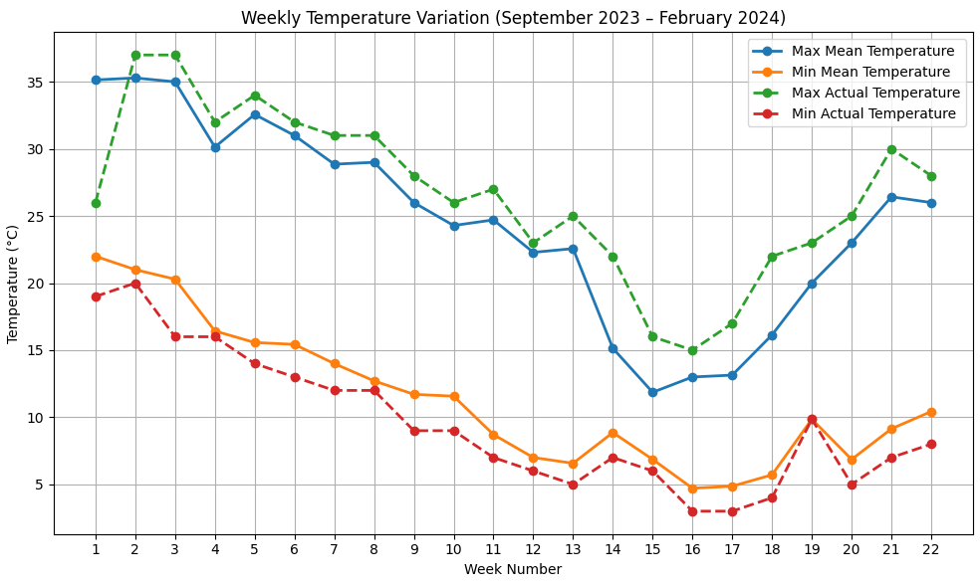

Fig. 1: Weekly temperature variation from 26th September 2023 to 26th February 2024

3.2 Temperature Pattern (2024-25)
The maximum mean temperature gradually reduced from 33.29 °C in early November and reached the lowest value during late December and early January (15–17°C); similarly, the minimum mean temperature reduced to 5–7°C from mid-December to mid-January. From mid- to late March, the mean maximum temperature increased to 34 °C, and the mean minimum temperature to 15–17 °C.

Table 2: Summary of Temperature Variation from 30th October, 2024, to 1st April, 2025, in Sherpur, Dehradun, Uttarakhand
Week N. | Date Range | Max. Mean (°C) | Min. Mean (°C) | Max. Actual (°C) | Min Actual (°C)
1 | 30th Oct. to 05th Nov.-2024 | 33.29 | 16.71 | 35 | 15
2 | 06th-11th Nov.-2024 | 29.43 | 18.14 | 31 | 17
3 | 13th-19th Nov.-2024 | 24.86 | 14.29 | 27 | 13
4 | 20th-26th Nov.-2024 | 27.43 | 10.86 | 29 | 10
5 | 27th Nov. to 03rd Dec.-2024 | 27.29 | 9.71 | 29 | 8
6 | 04th-10th Dec.-2024 | 23.57 | 8.29 | 27 | 6
7 | 11th-17th Dec.-2024 | 21.86 | 5.43 | 23 | 4
8 | 18th-24th Dec.-2024 | 20.14 | 6.86 | 23 | 5
9 | 25th-31st Dec.-2024 | 16.86 | 9.57 | 23 | 8
10 | 01st-07th Jan.-2025 | 15.43 | 8.14 | 19 | 8
11 | 08th-14th Jan.-2025 | 17.71 | 7.00 | 22 | 4
12 | 15th-21st Jan.-2025 | 19.43 | 8.57 | 25 | 6
13 | 22nd-28th Jan 2025 | 23.57 | 7.43 | 25 | 5
14 | 29th Jan.-04th Feb. 2025 | 21.86 | 9.43 | 23 | 7
15 | 05th-11th Feb. 2025 | 25.00 | 9.00 | 27 | 8
16 | 12th-18th Feb. 2025 | 25.86 | 10.14 | 28 | 9
17 | 19th-25th Feb. 2025 | 25.29 | 11 | 28 | 10
18 | 26th Feb-04th Mar. 2025 | 24.86 | 13.57 | 29 | 10
19 | 05th-11th Mar. 2025 | 28.43 | 12.86 | 29 | 8
20 | 12th-18th Mar. 2025 | 29.43 | 14.71 | 32 | 12
21 | 19th-25th Mar. 2025 | 34.14 | 15.57 | 32 | 12
22 | 26th Mar.- 01st Apr. 2025 | 34.14 | 17.14 | 32 | 12
Source: https://www.accuweather.com/en/in/sherpur/3008767/weather-forecast/3008767

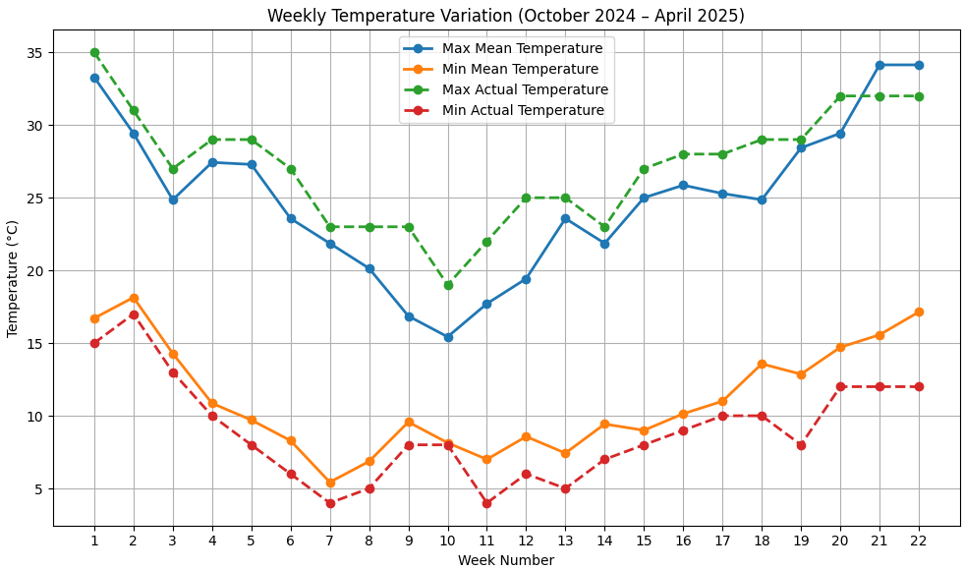

Fig. 2: Weekly temperature variation from 30th October, 2024, to 1st April, 2025

4.0 RESULT AND DISCUSSION

The present study exhibited a clear influence of sowing time–induced temperature variation on abscisic acid (ABA) accumulation in Indian mustard. Across both experimental seasons (2023–24 and 2024–25), ABA concentration was consistently higher under timely sowing compared to early and late sowing conditions. This pattern indicates a strong temperature-dependent regulation of ABA biosynthesis.

4.1 ABA Response under Early vs. Timely Sowing (2023–24)

During the 2023–24 season, timely sowing recorded significantly higher ABA (8.13 µg/g) compared to early sowing (6.37 µg/g). The timely-sown crop experienced lower night temperatures (~4.9°C), suggesting cold-induced stress signaling. ABA is widely recognized as a central stress hormone that accumulates rapidly under adverse environmental conditions, including low-temperature stress (Chen et al., 2020). Cold and dehydration-type stresses are known to induce expression of ABA biosynthetic genes such as NCED, resulting in increased endogenous ABA levels (Vishwakarma et al., 2017; Rehman et al., 2022). The higher ABA observed under timely sowing, therefore, reflects the activation of stress-responsive signaling pathways to maintain cellular homeostasis. In contrast, early sowing was associated with comparatively warmer conditions (~26/11.7°C), which may have reduced stress intensity and therefore limited ABA induction. ABA accumulation is often proportional to stress severity, particularly under dehydration and temperature-related stress (Rehman et al., 2022)

Table 03: ABA Level in 2023–24 Season (Early vs Timely Sowing)
Sowing Type | Sampling Date | ABA Level (Avg.) | Max Temp (Week) | Min Temp (Week)
Early | 28 Nov 2023 | 6.37 µg/g | ~26°C | ~11.7°C
Timely | 20 Jan 2024 | 8.13 µg/g | ~13.1°C | ~4.9°C

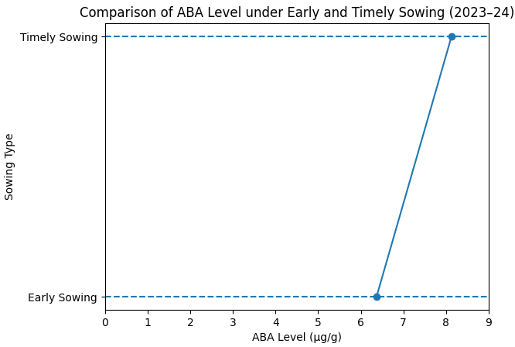

Fig. 3: Comparative analysis of abscisic acid level under early and timely sowing environments

All five germplasms showed higher ABA under timely sowing, confirming a uniform stress-induced hormonal response. However, the magnitude of reduction under early sowing differed among genotypes. Maya exhibited the highest percentage reduction (27.7%), indicating greater sensitivity to temperature variation. Genotypic differences in stress responsiveness have been widely documented in Brassica species under temperature stress (Sehgal et al., 2022). Such variation may be linked to differences in stress perception, ABA biosynthetic efficiency, and downstream signaling strength (Vishwakarma et al., 2017). Germplasms with a smaller percentage change (e.g., Vardan, 10.5%) may possess relatively stable hormonal regulation mechanisms under fluctuating temperature conditions.
Table 4: ABA (Abscisic Acid) Level in timely and early sown (2023-24) germplasms of Indian mustard (Brassica juncea L.)

Germplasms | Timely Sown (µg/g) | Early Sown  (µg/g) | % Difference (T-L)
Varuna | 8.03 | 6.58 | 14.5%
Kanti | 7.61 | 5.93 | 16.8%
Maya | 8.98 | 6.21 | 27.7%
Kranti | 8.27 | 6.43 | 18.4%
Vardan | 7.76 | 6.71 | 10.5%

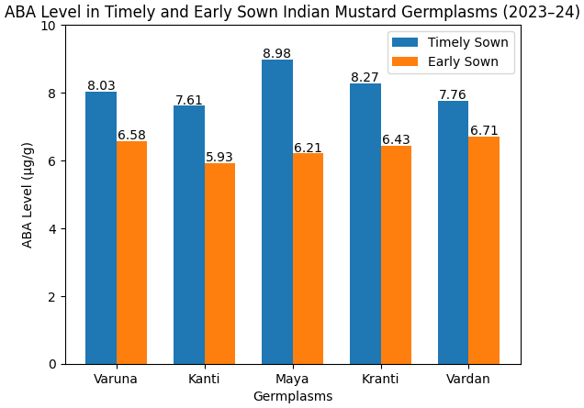

Fig. 4: Level of ABA (Abscisic Acid) in timely and early sown germplasms of Indian mustard (Brassica juncea L.)

4.2 ABA Response under Timely vs Late Sowing (2024–25)
During 2024–25, ABA (abscisic acid) levels were again higher under timely sowing (7.62 µg/g) compared to late sowing (5.30 µg/g). Late sowing coincided with higher temperature (~28.4/12.9°C), indicating reduced cold stress and possibly heat-mediated suppression of ABA biosynthesis. Heat stress is known to alter hormonal balance and oxidative status in plants (Iqbal et al., 2022). Although ABA is induced under many abiotic stresses, its regulation under high temperature can be complex and context-dependent (Majid et al., 2021). Warmer conditions during late sowing may have reduced cold-induced ABA signaling, resulting in comparatively lower accumulation.

Table 05: ABA Level in 2024-25 Season (Late vs Timely Sowing)

Sowing Type | Sampling Date | ABA Level (Avg.) | Max Temp (Week) | Min Temp (Week)
Timely | 11 Feb 2025 | 7.62 µg/g | ~25°C | ~9°C
Late | 08 Mar 2025 | 5.30 µg/g | ~28.4°C | ~12.9°C

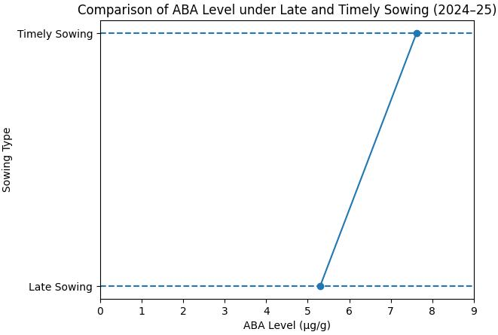

Fig. 5: Comparative analysis of abscisic acid level under timely and late sowing environments
The consolidated data from both seasons confirm that cooler temperature regimes at timely sowing stimulate ABA biosynthesis, whereas relatively warmer conditions during early and late sowing reduce endogenous ABA concentration.
Under a timely sowing environment, abscisic acid levels were 6.93 µg/g to 8.69 µg/g, with Maya having the highest level, 8.69 µg/g, followed by Varuna 7.68 µg/g, Vardan 7.17 µg/g, and Kanti 6.93 µg/g. On the other hand, germplasm sown in a late environment results in comparatively low abscisic acid levels, ranging from 5.14 µg/g to 5.51 µg/g. Kranti had the lowest abscisic acid level, 5.14 µg/g, whereas the highest level, 5.51 µg/g, was observed in Vardan, sown under a late-sowing environment. The highest abscisic acid reduction, 34.8%, was shown by Maya, indicating a high sensitivity toward low-temperature stress, followed by Kranti at 24.8% and Varuna at 24.7% under a late sowing environment. Conversely, germplasms such as Kanti and Vardan exhibited lower reductions in abscisic acid levels, 15.2% and 16.6%, respectively, indicating stability under temperature stress conditions.

Table 06: ABA (Abscisic Acid) Level in timely and late sown (2024-25) germplasms of Indian mustard (Brassica juncea L.)

Germplasms | Timely Sown (µg/g) | Late Sown  (µg/g) | % Difference (T-L)
Varuna | 7.68 | 5.21 | 24.7%
Kanti | 6.93 | 5.41 | 15.2%
Maya | 8.69 | 5.21 | 34.8%
Kranti | 7.62 | 5.14 | 24.8%
Vardan | 7.17 | 5.51 | 16.6%

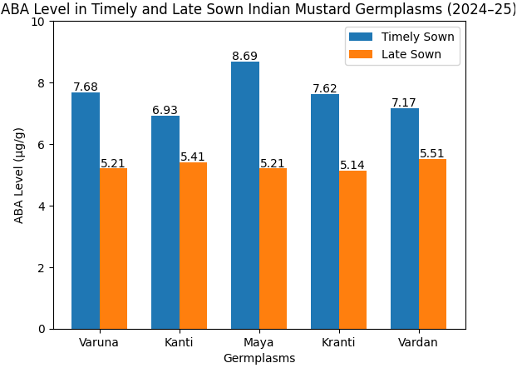
Fig. 6: Level of ABA (Abscisic Acid) in timely and late-sown germplasms of Indian mustard (Brassica juncea L.)

4.3 Overall, ABA Response under Early vs. Timely vs. Late Sowing (2023-24 & 2024-25)

The comparative trend (early vs. timely vs. late sowing) clearly exhibited temperature sensitivity of ABA accumulation in Indian mustard. ABA plays a pivotal role in stress perception, stomatal regulation, and activation of antioxidant defence mechanisms (Chen et al., 2020; Vishwakarma et al., 2017).

Table 07: Comparative Insight of ABA Level vs Temperature in Early, Timely, and Late Sowing

Sowing Type | Temperature Range at Sampling | ABA Level Trend | Inference
Early | Warmer (~26/12°C) | Low (6.37 µg/g) | Less ABA due to mild conditions
Timely | Cooler (~13/5°C & 25/9°C) | High (8.13 & 7.62 µg/g) | Higher ABA due to cold stress
Late | Warmer (~28/13°C) | Lowest (5.30 µg/g) | ABA suppression due to heat

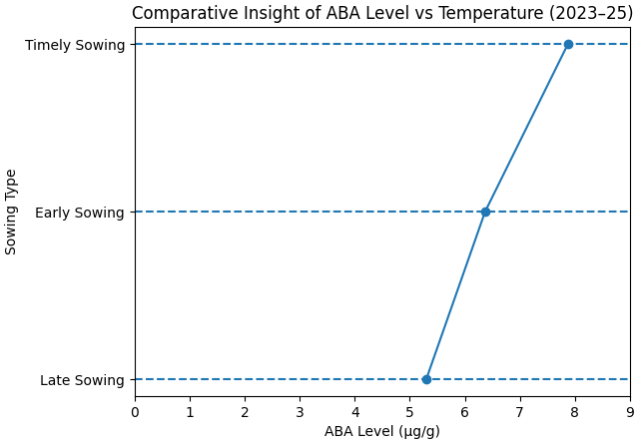

Fig. 7: Comparative analysis of abscisic acid level under timely, early, and late sowing environments
The overall discussion & results strongly support that:

- Degree of ABA level in Indian mustard means it's highly temperature sensitive.
- Timely sowing, associated with cooler conditions, significantly enhances ABA biosynthesis.
- Early and late sowing under comparatively warmer conditions suppresses ABA accumulation.
- Germplasms differ in the magnitude of ABA modulation, indicating variability in stress responsiveness.

These findings align with the established literature identifying ABA as a master regulator of abiotic stress tolerance and temperature adaptation in crops (Chen et al., 2020; Vishwakarma et al., 2017; Rehman et al., 2022).

4.4 Abscisic Acid and Oil Yield Correlation Under Early and Timely Sowing Environments (2023-24)
Abscisic acid and oil yield data indicated in Table 8 suggested a positive correlation between oil yield and abscisic acid concentration.
Under a timely sowing environment, genotypes of Indian mustard accumulate high concentrations of abscisic acid along with high oil yield per plant. For example, Maya synthesizes the highest abscisic acid at 8.98 µg/g and a high oil yield of 6.16 grams, whereas Kranti has an abscisic acid level of 8.27 µg/g and an oil yield of 5.22 grams. This indicates a positive trend between ABA and oil yield, suggesting that higher ABA levels under favourable (timely) sowing conditions may contribute to better physiological regulation and assimilate partitioning, thereby enhancing oil yield.

On the other hand, the correlation between abscisic acid level and oil content (%) is not significant due to the narrow range (40.3-41.7%).
Under an early sowing environment, the abscisic acid level decreased in all germplasm with a parallel reduction in oil yield. Kanti had the lowest ABA (5.93 µg/g) and moderate oil yield (2.81 g). Maya (6.21 µg/g) showed a low oil yield (2.52 g). Kranti (6.43 µg/g) recorded the lowest oil yield (1.74). The correlation between abscisic acid level and oil content (%) is the same as in timely sowing.
Table 8: Comparative analysis of abscisic acid (µg/g), oil content (%) and oil yield/plant (g) of germplasm of Indian mustard under timely and early sowing
Germplasms | Sowing Environment | Abscisic Acid (µg/g) | Oil Content (%) | Oil Yield/Plant(g)
Varuna | Timely Sowing | 8.03 | 40.3 | 4.22
Varuna | Early Sowing | 6.58 | 40.8 | 3.13
Kanti | Timely Sowing | 7.61 | 41.2 | 6.73
Kanti | Early Sowing | 5.93 | 40.1 | 2.81
Maya | Timely Sowing | 8.98 | 41.7 | 6.16
Maya | Early Sowing | 6.21 | 39.8 | 2.52
Kranti | Timely Sowing | 8.27 | 41.7 | 5.22
Kranti | Early Sowing | 6.43 | 40.1 | 1.74
Vardan | Timely Sowing | 7.76 | 41.2 | 4.22
Vardan | Early Sowing | 6.71 | 40.2 | 3.08
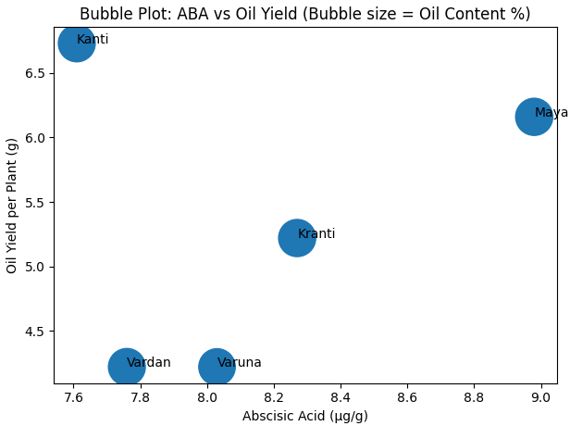
Fig. 8: Correlation between abscisic acid level, oil yield, and oil content under timely sowing (2023-24)
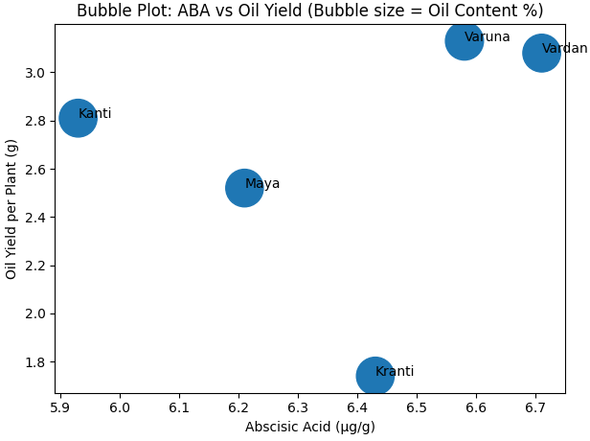
Fig. 9: Correlation between abscisic acid level, oil yield, and oil content under early sowing (2023-24)

4.5 Abscisic Acid and Oil Yield Correlation Under Timely and Late Sowing Environments (2024-25)
Abscisic acid and oil yield data indicated in Table 9 suggested a positive correlation between oil yield and abscisic acid concentration.
In 2024-25, as well, under a timely sowing environment, abscisic acid is mostly directly proportional to oil yield. Indeed, this year, Maya recorded the highest abscisic acid level (8.69 µg/g) and the oil yield (9.22 g). The ABA (abscisic acid) level in Varuna is 7.68 µg/g, and the oil yield is 9.71 grams. Kanti exhibits the lowest ABA (abscisic acid) level, 6.93 µg/g, with a lower oil yield of 8.63 grams. The correlation pattern between abscisic acid and oil content percentage is the same as above.
The same correlation pattern was observed in the late sowing environment. Varana maintained the lowest abscisic acid level of 5.21 µg/g with the lowest oil yield of 3.37 grams. The same pattern was recorded in Kranti and Vardan.
Table 9: Comparative analysis of abscisic acid (µg/g), oil content (%) and oil yield/plant (g) of germplasm of Indian mustard under timely and late sowing
Germplasms | Sowing Environment | Abscisic Acid (µg/g) | Oil Content (%) | Oil Yield/Plant(g)
Varuna | Timely Sowing | 7.68 | 42.6 | 9.71
Varuna | Late Sowing | 5.21 | 41.6 | 3.37
Kanti | Timely Sowing | 6.93 | 41.9 | 8.63
Kanti | Late Sowing | 5.41 | 38.3 | 2.99
Maya | Timely Sowing | 8.69 | 42.3 | 9.22
Maya | Late Sowing | 5.21 | 38.7 | 3.64
Kranti | Timely Sowing | 7.62 | 41.7 | 8.51
Kranti | Late Sowing | 5.14 | 38.6 | 2.62
Vardan | Timely Sowing | 7.17 | 41.8 | 9.45
Vardan | Late Sowing | 5.51 | 38.7 | 3.64
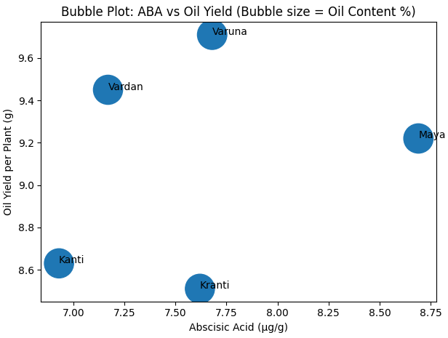
Fig. 10: Correlation between abscisic acid level, oil yield, and oil content under timely sowing (2024-25)
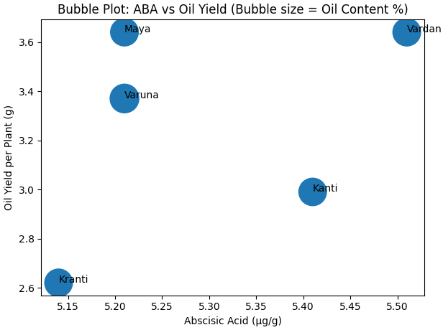
Fig. 11: Correlation between abscisic acid level, oil yield, and oil content under late sowing (2024-25)

4.6 Analysis of Variance (ANOVA)
4.6.1 ANOVA Timely Sown vs. Late Sown (2024–25)
An analysis of variance indicated a highly significant effect of the sowing environment on ABA level (p < 0.01). The mean ABA levels under timely sowing (7.62 µg/g) were significantly higher than under late sowing (5.30 µg/g), indicating a significant reduction in ABA under a warmer late-sowing environment.

Table 10: ANOVA (Analysis of Variance) Test for ABA Levels in Timely Sown and Late Sown (2024–25) Germplasm of Indian Mustard (Brassica juncea L.)

Source of Variation | SS | df | MS | F-value | p-value
Between Sowing Types | 13.479 | 1 | 13.479 | 56.02 | 0.00007
Within (Error) | 1.925 | 8 | 0.241
Total | 15.404 | 9

*SS-Sum of Square, *df-Degree of Freedom, *MS-Mean Square, *F-F-Statistic or F-Ratio, *P-value-Probability Value, *F crit-F-critical value, *ABA-Abscisic Acid

4.6.2 ANOVA Timely Sown vs. Early Sown (2023–24)

An analysis of variance indicated a highly significant effect of the sowing environment on ABA level (p < 0.01). The mean ABA levels under timely sowing (8.13 µg/g) were significantly higher than early sowing (6.37 µg/g), indicating increased ABA biosynthesis under comparatively cooler conditions.

Table 11: ANOVA (Analysis of Variance) Test for ABA Levels in Timely Sown and Early Sown (2023-24) Germplasm of Indian Mustard (Brassica juncea L.)

Source of Variation | SS | df | MS | F-value | p-value
Between Sowing Types | 7.726 | 1 | 7.726 | 40.09 | 0.00023
Within (Error) | 1.542 | 8 | 0.193
Total | 9.268 | 9
*SS-Sum of Square, *df-Degree of Freedom, *MS-Mean Square, *F-F-Statistic or F-Ratio, *P-value-Probability Value, *F crit-F-critical value, *ABA-Abscisic Acid

5.0 CONCLUSION

The present study indicated that sowing time-induced temperature variation significantly regulates abscisic acid levels in Indian mustard genotypes in field experiments in Doon Valley, Uttarakhand, India. In both the rabi seasons (2023-24 and 2024-25), timely sowing exhibited a higher abscisic acid level compared to early and late sowing. The observed increase in ABA level under timely sowing (cooler temperature regime) is strongly supported by earlier findings that ABA rapidly accumulates under low temperature through upregulation of key biosynthetic genes, such as NCED (Vishwakarma et al., 2017; Rehman et al., 2022). This suggests that ABA biosynthesis is highly temperature sensitive to temperature variations.

During 2023–24, timely sowing (mean minimum temperature ~4–5°C) resulted in significantly higher ABA (8.13 µg/g) compared to early sowing (6.37 µg/g). Similarly, in 2024–25, timely sowing (7.62 µg/g) showed markedly higher ABA than late sowing (5.30 µg/g).

The significant F-values (40.09 and 56.02, p < 0.01) confirmed a strong environmental effect on abscisic acid level. These findings indicate that cooler temperatures stimulate ABA biosynthesis, whereas relatively warm early- and late-sowing conditions reduce ABA concentration.

Genotypic differences were also evident. Maya exhibited the highest ABA (abscisic acid) levels under timely sowing (8.98 µg/g in 2023–24; 8.69 µg/g in 2024–25), while Kranti and Varuna showed greater percentage reductions under late sowing. On the other hand, Kanti and Vardan exhibited a comparatively lower percentage reduction, indicating relatively stable abscisic acid regulation under temperature variation. Furthermore, the genotypic variation observed among Varuna, Kanti, Maya, Kranti, and Vardan is consistent with earlier studies exhibiting differential stress responsiveness among Brassica germplasms under variable temperature patterns (Sehgal et al., 2022). This variability suggests inherent genetic differences in stress sensitivity and ABA biosynthetic efficiency among germplasms.

A consistent positive association between ABA level and oil yield per plant was observed under timely sowing in both seasons. Higher ABA concentration coincided with higher oil yield (e.g., Maya and Varuna under timely sowing), whereas reduced ABA under early and late sowing was associated with significant yield decline. However, oil content (%) showed minimal variation, indicating that ABA may influence yield through physiological regulation rather than altering oil percentage.

Overall, the results confirm that:
- ABA accumulation in Indian mustard is strongly influenced by sowing time and associated temperature variation.
- Cooler timely sowing environments enhance ABA biosynthesis.
- Warmer early and late sowing reduces ABA levels.
- Germplasms differ in the magnitude of ABA modulation, indicating genetic variability in stress responsiveness.
- Higher ABA levels are associated with improved oil yield under optimal sowing conditions.

Thus, timely sowing in the Doon Valley provides favourable thermal conditions that enhance ABA-mediated stress regulation and yield performance. The study establishes sowing time as a practical agronomic factor influencing hormonal dynamics and stress adaptation in Indian mustard under field conditions.
.

Disclaimer (Artificial Intelligence)

The author(s) hereby declare that NO generative AI technologies such as Large Language Models (ChatGPT, COPILOT, etc.) and text-to-image generators have been used during the writing or editing of this manuscript.

REFERENCE

Misra, A. K., Rana, J. C., Yadav, S., Bhat, K. V., & Prakash, S. (2008). Status, utilization and priorities of oilseed Brassica germplasm. Plant Genetic Resources: Characterization and Utilization, 6(1), 1–14.

ICAR–Indian Institute of Rapeseed-Mustard Research (IIRMR). (2024). Annual report 2023–24. ICAR-IIRMR, Bharatpur, Rajasthan, India.

Gupta, A., Chauhan, S., Tyagi, S. D., & Singh, S. (2023). Genetic variability, heritability, genetic advance and cluster analysis in Indian mustard (Brassica juncea L. Czern & Coss.) under timely and late sown conditions. International Journal of Plant & Soil Science, 35(19), 292–301.

Kumari, A., & Kumari, V. (2018). Genetic variability and divergence studies for seed yield and component characters in Indian mustard [Brassica juncea (L.) Czern. & Coss.] over environments. International Journal of Current Microbiology and Applied Sciences, 7(7), 3376–3388
.
Nambara, E., & Marion-Poll, A. (2005). Abscisic acid biosynthesis and catabolism. Annual Review of Plant Biology, 56, 165–185.

Kermode, A. R. (2005). Role of abscisic acid in seed dormancy and germination. Seed Science Research, 15(3), 85–95.

Zhang, S., Wang, H., & Li, J. (2018). Development and validation of an HPLC method for quantification of abscisic acid in plant tissues. Journal of Chromatography A, 1562, 1–8.

Yadav, S. K., et al. (2022). Advances in ABA-mediated stress tolerance in Indian mustard: A genomic perspective. Frontiers in Plant Science.

Singh, A., et al. (2019). Cross-talk between ABA and other phytohormones in Brassica juncea under salinity stress. Journal of Plant Growth Regulation.

Zhang, X., et al. (2020). Functional characterization of NCED genes in drought tolerance in Brassica species. Plant Physiology.

Cutler, S. R., et al. (2010). ABA signaling mechanism and roles of PYR/PYL/RCAR receptors. Nature Structural & Molecular Biology.

Liu, Y., & Zhang, L. (2020). Role of abscisic acid in plant response to low temperature stress. Plant Science, 286, 42–54.

Chinnusamy, V., & Zhu, J. (2009). Cold stress regulation of gene expression in plants. Trends in Plant Science, 14(6), 322–329.

Xu, L., & Zhang, X. (2016). Abscisic acid and cold stress response in plants. International Journal of Molecular Sciences, 17(6), 944.

Li, X., & Yang, S. (2015). Abscisic acid and cold stress in plants: The role of ABA in cold tolerance. Plant Molecular Biology, 88(2), 145–157.

Zhang, L., & Liu, Y. (2019). Role of abscisic acid in cold stress adaptation. Journal of Plant Growth Regulation, 38(2), 325–334.

Cutler, A. J., Rodriguez, P. L., Finkelstein, R. R., & Abrams, S. R. (2010). Abscisic acid: Emergence of a core signaling network. Annual Review of Plant Biology, 61, 651–679.

Pradhan, A. K., et al. (2016). Genetics and breeding for climate resilience in Indian mustard. Plant Breeding, 135(3), 255–271.

Xie, X., Wang, Y., Williamson, L., & Holroyd, G. (2006). Interaction of ABA signaling and drought tolerance. Journal of Plant Growth Regulation, 25(3), 219–229.

Seo, M., & Koshiba, T. (2002). Complex regulation of ABA biosynthesis in plants. Trends in Plant Science, 7(1), 41–48.

Mostafaei, E., Zehtab-Salmasi, S., Salehi-Lisar, Y., & Ghassemi-Golezani, K. (2018). Changes in photosynthetic pigments, osmolytes and antioxidants of Indian mustard by drought and exogenous polyamines. Acta Biologica Hungarica, 69(3), 313–324.

Rehman, R. S., Ali, M., Ali Zafar, S., Hussain, M., Pasha, A., Saqib Naveed, M., Ahmad, M., & Waseem, M. (2022). Abscisic acid mediated abiotic stress tolerance in plants. Asian Journal of Research in Crop Science, 1–17.

Nehal, N., Khan, A., Sharma, N., Tripathi, S. K., & Singh, M. (2018). Role of GA₃, SA and ABA on growth and yield of Indian mustard [Brassica juncea (L.) Czern. & Coss.] under rainfed condition. Journal of Pharmacognosy and Phytochemistry, 7(2), 199–202.

Pillai, A. J., & Walia, P. (2024). Heat stress in Indian mustard (Brassica juncea L.): A critical review of impacts and adaptation strategies. Plant Cell Biotechnology and Molecular Biology, 25(5–6), 1–11.
Sahay, S., & Gupta, M. (2018). Title not provided. Plant Archives, 18(1), 737–744.

Vishwakarma, K., Upadhyay, N., Kumar, N., Yadav, G., Singh, J., Mishra, R. K., Kumar, V., Verma, R., Upadhyay, R. G., Pandey, M., & Sharma, S. (2017). Abscisic acid signaling and abiotic stress tolerance in plants: A review on current knowledge and future prospects. Frontiers in Plant Science, 8.

Dixit, S., Grover, A., Pushkar, S., & Singh, S. B. (2022). ABA-induced SA accumulation causes higher susceptibility in Brassica juncea as compared to tolerant genotypes against A. brassicae. bioRxiv.

Majid, A., Rather, B., Masood, A., & Khan, N. (2021). Abscisic acid and nitrogen showed coordinated action on antioxidant system and osmotic adjustment to alleviate salinity inhibited photosynthetic potential in Brassica juncea L. Preprints.

Majid, A., Rather, B. A., Masood, A., Sehar, Z., Anjum, N. A., & Khan, N. A. (2021). Abscisic acid in coordination with nitrogen alleviates salinity-inhibited photosynthetic potential in mustard by improving proline accumulation and antioxidant activity. Stresses, 1(3), 162–180.

Sehgal, A., Reddy, K. R., Walne, C. H., Barickman, T. C., Brazel, S., Chastain, D., & Gao, W. (2022). Climate stressors on growth, yield, and functional biochemistry of two Brassica species, kale and mustard. Life, 12(10).

Naveen, N., Kumari, N., Avtar, R., Jattan, M., Ahlawat, S., Rani, B., Malik, K., Sharma, A., & Singh, M. (2021). Evaluation of effect of brassinolide in Brassica juncea leaves under drought stress in field conditions. Horticulturae, 7(11).

Sakpal, A., Yadav, S., Choudhary, R., Saini, N., Vasudev, S., Yadava, D. K., Ercişli, S., Marc, R. A., & Yadav, S. K. (2023). Heat-stress-induced changes in physio-biochemical parameters of mustard cultivars and their role in heat stress tolerance at the seedling stage. Plants, 12(6).

Iqbal, N., Sehar, Z., Fatma, M., Umar, S., Sofo, A., & Khan, N. A. (2022). Nitric oxide and abscisic acid mediate heat stress tolerance through regulation of osmolytes and antioxidants to protect photosynthesis and growth in wheat plants. Antioxidants, 11(2).

Wang, Q., Wang, Q., Li, S., Li, S., Li, J., Huang, D., & Huang, D. (2024). The utilization and roles of nitrogen in plants. Forests, 15(7), 1191.

