Alfalfa biostimulated with Desmodesmus sp.: a link between effluent treatment and sustainable agriculture to improve plant growth and quality
ABSTRACT
This study evaluated the application of algal biomass as a biostimulant in Medicago sativa (alfalfa). The biomass was obtained from the selection and cultivation of the microalga Desmodesmus sp., isolated from an urban river. This biomass was applied at different concentrations to alfalfa seeds: Control: irrigation with distilled water, treatments A (Ta), B (Tb), C (Tc) irrigation with 2.5% ,5% and 7.5% algal solution respectively and seedlings: control: distilled water and treatments A (Ta), B (Tb) C (Tc)5%, 10%, 15% algal solution respectively. There were no significant differences in the germination parameters The statistically significant increase in radicle length, with a p<0.001, was observed in the treatment with 2.5% and 5% algae versus the control. Fresh root weight showed a significant increase in treatment A (5%) and B (10%) with values **p < 0.01 and *p < 0.05, respectively. Root length showed a highly significant increase in plants treated with solutions A, B and C (***p<0.001). Aerial dry weight showed a significant increase in treatment A and the root dry weight in treatments A and C compared to the control. The effect was beneficial for root and root elongation, root dry and fresh biomass, and leaf dry biomass; in addition to a significant increase in photosynthetic pigments, indicating greater photosynthetic activity. These results demonstrate that native microalgae cultivated in wastewater can function as effective biostimulants in alfalfa, offering a circular bioeconomy strategy that integrates environmental remediation with agricultural productivity.

Key words: phycoremediation, Medicago sativa, microalgae.

INTRODUCTION
Microalgae are photosynthetic organisms distributed across aquatic ecosystems worldwide. Their high growth rate, low nutrient consumption, and relatively small production footprint present a promising horizon as a renewable resource with significant benefits (Olmedo Galarza, 2019; Lee, 2020).
Phycoremediation is considered an ecological, economic, and sustainable alternative to conventional treatment systems for purifying water contaminated with industrial or urban waste (Wang et al., 2017). This technique, which is based on the use of macro- and microalgae for the removal or biotransformation of contaminants (Olguín, 2003), allows for water remediation while simultaneously producing microalgal biomass with multiple applications.
Among them, its use as a bio stimulant stands out: these are products derived from organic matter that, when applied in small quantities, can stimulate the growth and development of crops under both optimal and stressful conditions (Ronga et al., 2019). According to studies, microalgae produce hormone-like effects in plants; they can induce nutrient uptake and growth by triggering the accumulation of metabolites in primary and secondary biosynthetic pathways, such as lipid and jasmonate synthesis. Microalgal polysaccharides have also improved the metabolite profile of azelaic acids, phytosterol, and other precursors in plant defense mechanisms. Among the species used as biostimulants, Desmodesmus sp. exhibits high photochemical and antioxidant activity, tolerance to eutrophic waters, and easy of cultivation, making it scalable for industrial viability (Hegewald and Braband, 2017; Yusof et al., 2023; Chovanček et al., 2023).
A study investigates the physiological and ecological responses of the benthic diatom Melosira varians to varying concentrations of domestic wastewater effluents under laboratory conditions. Effluent dilutions of 12.5%, 25%, and 50% were used to assess the species’ capacity for nutrient removal, growth, morphological alterations, and pigment composition over a 10-day period. The results demonstrated remarkable phosphate removal efficiencies (≥97%) across all treatments and a progressive nitrate removal response, reaching up to 70.59% in the highest effluent concentration. Morphometric analysis revealed significant increases in cell width and length, particularly under moderate (25%) and high (50%) effluent exposures. Chlorophyll analysis indicated a predominance of chlorophyll C and a reduction of chlorophyll B and C in response to nutrient-rich conditions, suggesting a possible shift towards heterotrophic or mixotrophic metabolism (Algozino Gudiño and Daruich,2025)
On the other hand, alfalfa (Medicago sativa L.) is the main forage species in the country and the basis of meat and milk production in the Pampean Region, thanks to its high content of protein, vitamins, and essential minerals. Due to its high economic value, its study has focused on productivity, nutritional value, and abiotic factors that cause stress to the plant, such as soil salinity, drought, and extreme temperatures (Pedranzani et al., 2022; Pacheco Insausti et al., 2022).
In this context, the present investigation studied the effect of Desmodesmus sp., cultivated in urban effluent, as a biostimulant on alfalfa plants. The absence of previous studies analyzing this interaction highlights the uniqueness of this work in linking phytoremediation with a sustainable agricultural production model.
MATERIALS AND METHODS

Sampling, isolation, and biomass microalgae
Phytoplanktonic microalgae samples were collected at different points in an urban river, following the collection techniques described by Gil et al., 2022.
To obtain the unialgal cultures, a semi-solid medium of sterile effluent and agar (8 g/L) was prepared. The microalgal samples were inoculated using a loop with the streaking for isolation method under a laminar flow hood. They were allowed to incubate at 25 ± 2 °C in a humid chamber, with an illumination of 2500 lux and a photo period for 7 days. The isolated colonies were subculture under the same conditions (Saavedra et al., 2022).
Desmodesmus sp., the isolated species, was transferred to increasing volumes of sterile effluent, starting with 20 mL and reaching 3.5 L over 32 days. The liquid cultures were maintained at 25 ± 2 °C in a humid chamber, with 2500 lux illumination and a photoperiod, under static conditions (Figure 1).
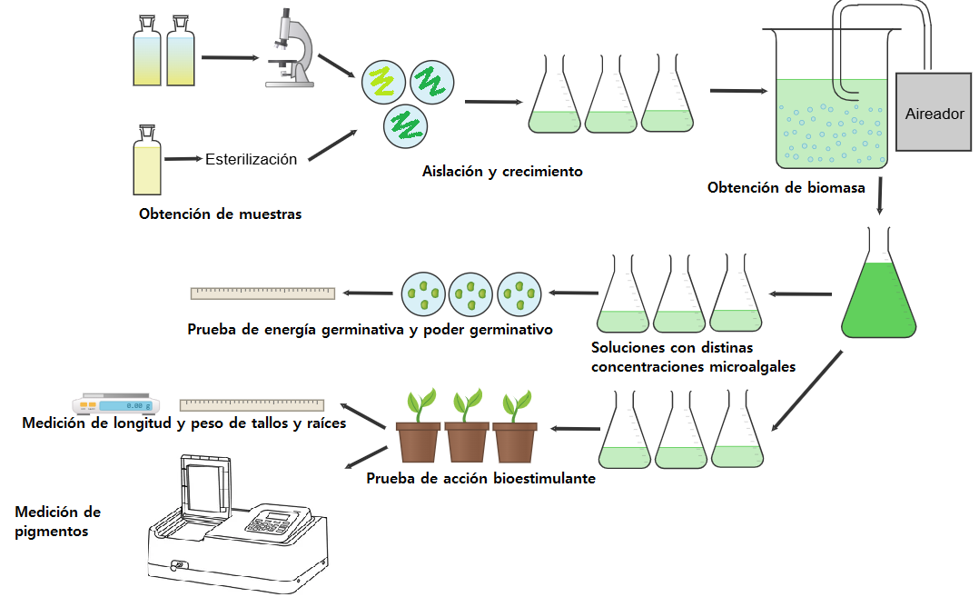

Sample collection
Isolation and cultivation
Biomass harvesting
Sterilization
Aerator
Figure 1: Isolation and culture steps of Desmodesmus sp.
- Alfalfa germination with bio stimulant Desmodesmus sp.
The test was carried out in randomized blocks with three replicates and 100 alfalfa seeds (variety 1553) per treatment, in accordance with ISTA (International Rules for Seed Testing, 2019). These were sown in Petri dishes with absorbent filter paper (at the base and on the lid) and incubated in an oven at 25 °C under sterile conditions.
The treatments consisted of:
1. Control: irrigation with distilled water.
2. Treatment A (Ta): irrigation with 2.5% algal solution.
3. Treatment B (Tb): irrigation with 5% algal solution.
4. Treatment C (Tc): irrigation with 7.5% algal solution.
To prepare the solutions for treatments A, B, and C, 2.5, 5, and 7.5 mL of algal solution of Desmodesmus sp. of the biomass obtained, were taken and brought to a volume of 100 mL with distilled water.
The seeds were watered with 3 mL of the respective solutions using a Pasteur pipette every other day for a week. After 3 and 7 days, data were collected to measure germination energy (GE) and germination power (GP), respectively. The radicle length of 5 randomly selected seedlings from each treatment was measured after 7 days of growth (Figure 2).
Germination data were statistically analyzed using one-way ANOVA followed by Dunnett's test, with *p<0.05. Root lengths were analyzed using the non-parametric Kruskal-Wallis test, with ***p<0.0001 due to the lack of normality in the data. (Figure 2)

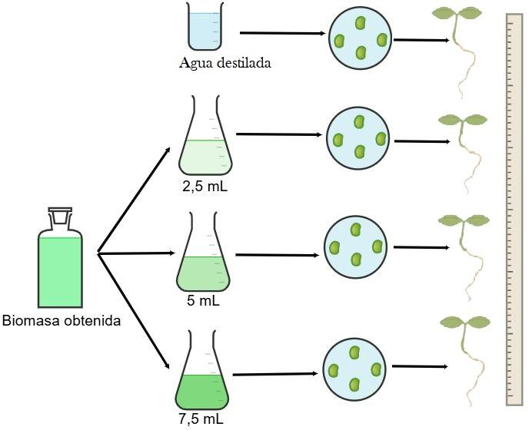

Harvested biomass
Distilled water
Figure 2: General diagram of alfalfa seed germination and root measurement of seedlings.

3. Alfalfa growth
Pre-germinated seeds were sown in pots with sterile vermiculite, in random blocks with 5 replicates and 2 seeds per pot (Figure 3). The irrigation solutions consisted of 5, 10 and 15 mL of algal solutions in 100 mL of water. The treatments consisted of irrigation with 10 mL every three days for 60 days:
● Control: distilled water.
● Treatment A (Ta): 5% algal solution.
● Treatment B (Tb): 10% algal solution.
● Treatment C (Tc): 15% algal solution.
These were incubated at 25 °C with a 16:8 light: dark photoperiod.
At the end of the experiment, the plants were removed, washed, dried, separated into aerial and root parts, and measured for length and fresh weight. The samples were then dried in an oven at 70 °C for 48 hours until constant weight and dry weight was measured.
Statistical analysis was performed using one-way ANOVA followed by Dunnett's test, with y *p<0.05 for the length of the aerial part and *p<0.001 for the root part. For fresh weight, Dunnett's test was performed with *p<0.05 and **p<0.001. Dry weight was analysed with **p<0.001 for the aerial part and *p<0.05 for the root.

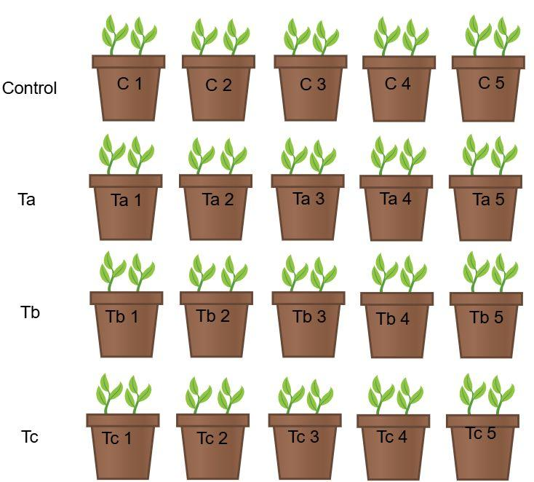

Control
Figure 3: Two germinated seeds were planted per pot, with five replicates per treatment plus the control group.

4. Measurement of photosynthetic pigments
Three plants from each treatment and control group were selected for measurement of chlorophylls a and b and carotenoids. One hundred milligrams of fresh foliage were homogenized in a mortar with 10 ml of 80% acetone (v/v). The extracts obtained were kept in test tubes at 4°C, protected from light with aluminum foil.
Absorbance was measured by spectrophotometry at 646.6 nm for chlorophyll a, 663.6 nm for chlorophyll b, and 470 nm for carotenoids. Eighty percent acetone (v/v) was used as a blank.
The data were analyzed statistically using one-way ANOVA followed by Dunnett's test, with p<0.01 and p<0.001 respectively (Figure 4).

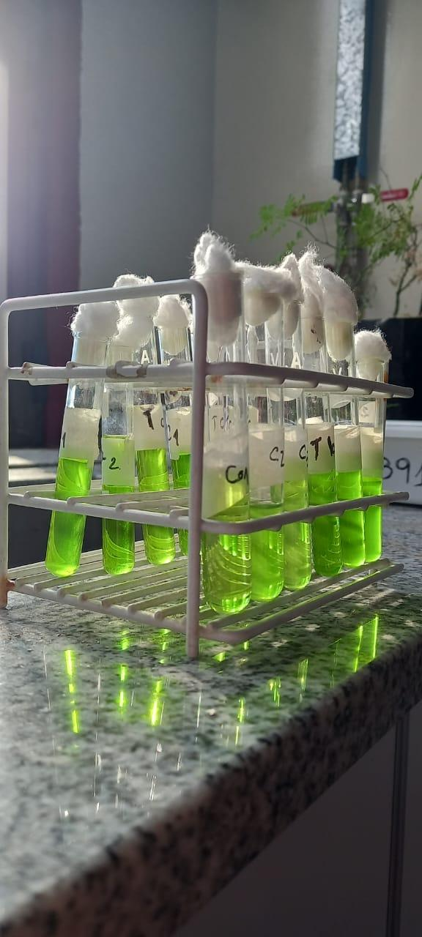
Figure 4: Homogenates for chlorophyll measurement.

RESULTS

Sampling, isolation, and biomass microalgae
The single-cell isolation of the microalga Desmodesmus sp. in semi-solid medium (Figures 5A) was confirmed by microscopic observation, identifying colonies typical of the species (Figure 5B).
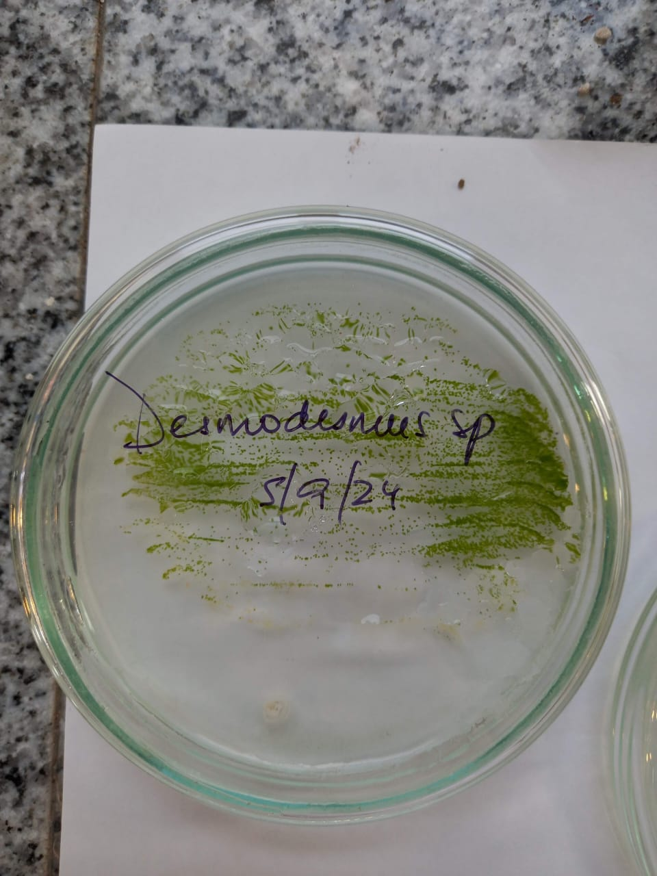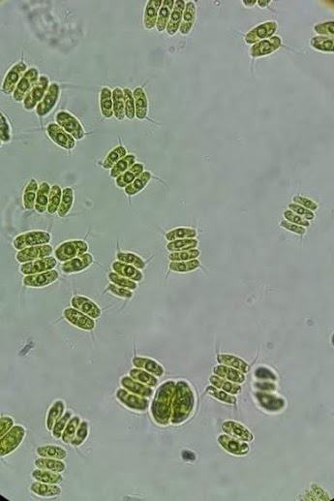

A
B
Figure 5A: Desmodesmus sp. isolated in a semi-solid medium. Figure 5B: Desmodesmus sp. under the microscope.

Figure 6 shows batch cultivation of microalgae.
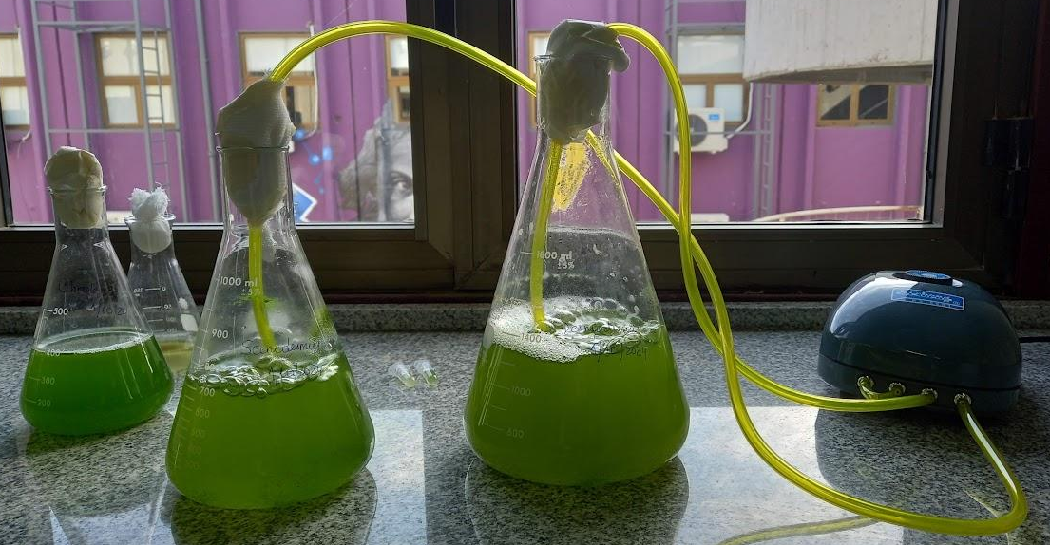
Figure 6: Batch culture of Desmodesmus sp.
The cell count enabled the growth curve to be constructed (Figure 7), showing sustained biomass growth over time.
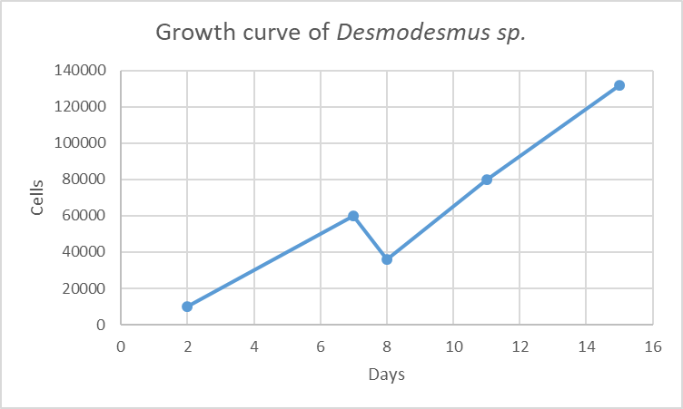
Figure 7: Growth curve of Desmodesmus sp. culture. cells/mL vs days

- Alfalfa Germination with biostimulant Desmodesmus sp.
In Table 1 and Figure 8, the germination percentages on day 3 EG) and day 7 (PG) are observed for the control, A, B and C treatments.

Table 1: Germination Energy and Germination Power.
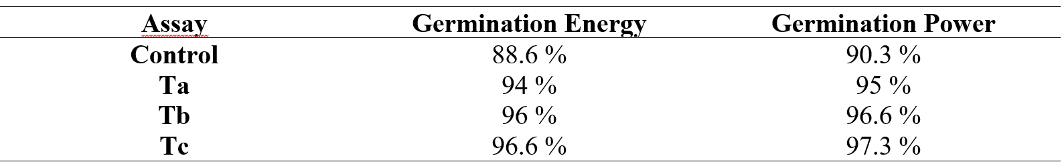
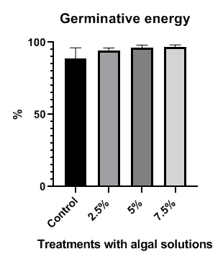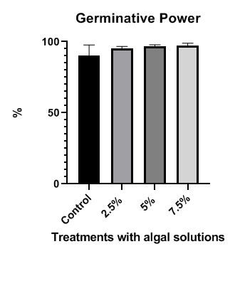
Figure 8: Percentage of germination energy (A) and germination power (B) in M. sativa (alfalfa) samples. The bars represent control and treatment values. Each point represents the mean ± SEM of 3 samples in the different treatments. Statistical analyses were performed using one-way ANOVA followed by Dunnett's test, with *p<0.05, and were compared with the corresponding maximum values ​​within each group.
The percentages of GE and GP did not show significant differences in the treatments studied compared to the control.
Figure 9: shows the statistically significant increase in radicle length, with a p<0.001, observed in the treatment with 2.5% and 5% algae versus control. The treatment with 7.5% algal concentration did not show significant differences compared to the control.
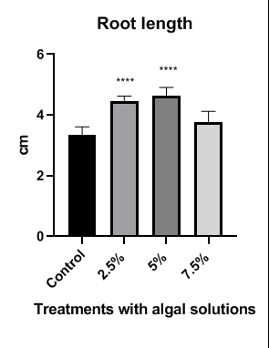

Figure 9: Root length in M. sativa (alfalfa) samples. The bars represent control and treatment values. Each point on the bar represents the mean ± SEM of 3 samples in the different treatments. Statistical analyses were performed using the non-parametric Kruskal-Wallis test, with p < 0.0001, and means were compared with the corresponding maximum values ​​within each group.
Table 2 shows the radicle lengths of the germinated seeds for the control and the three treatments
. Table 2: Radicle lengths in control, Ta ,Tb Tc treatments

Control | 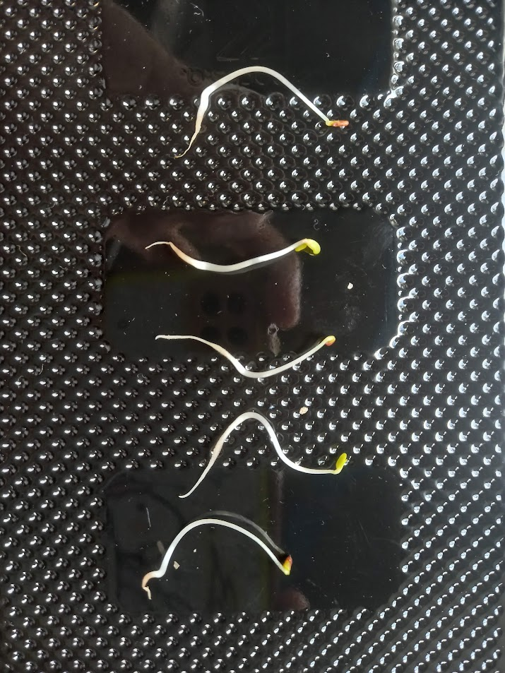
Ta | 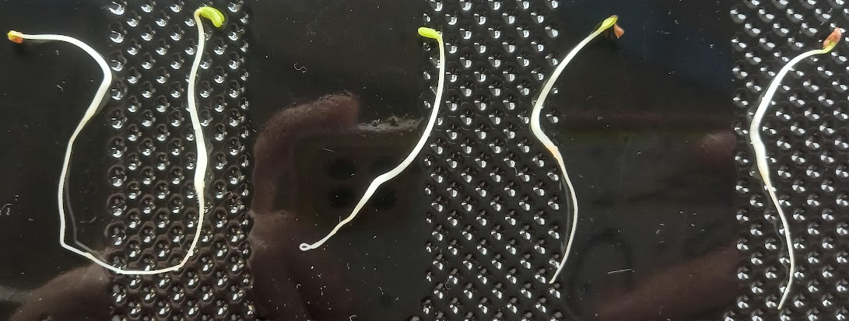
Tb | 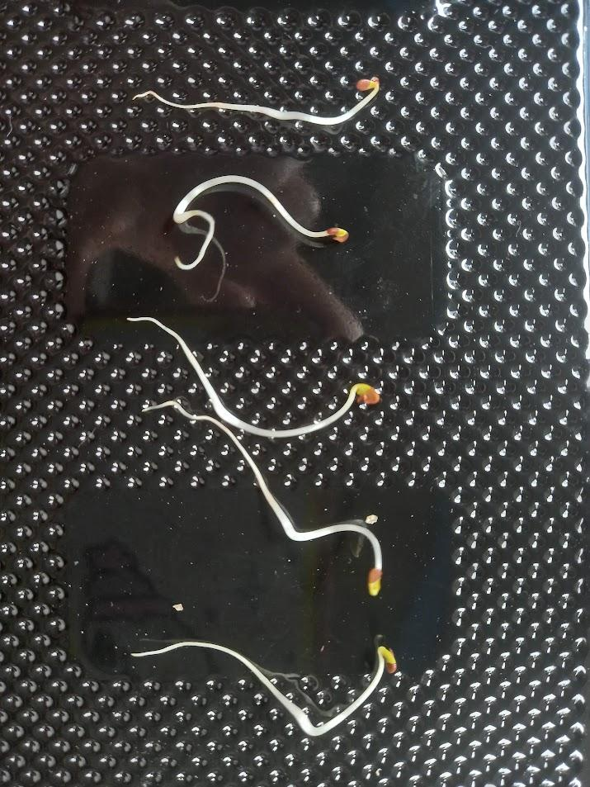
Tc | 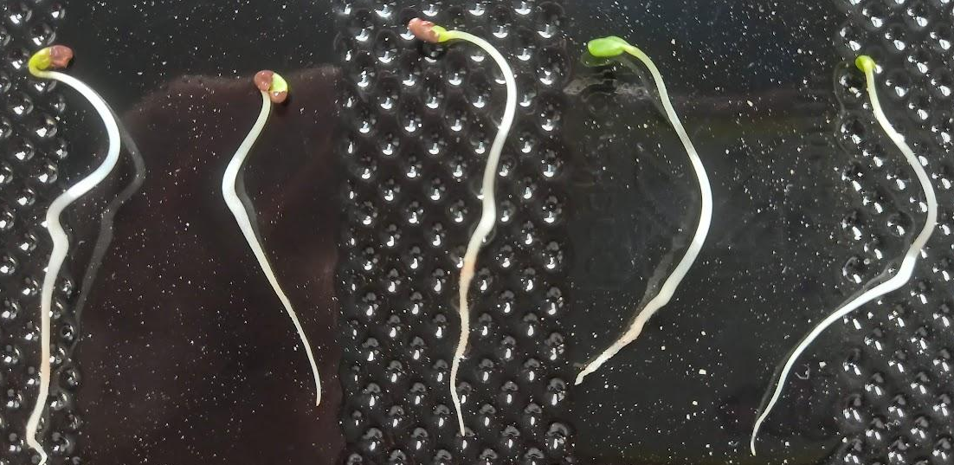

3. Alfalfa growth
Aerial and radical lengths
Figure 10A shows that the aerial length did not show a statistically significant difference between the solutions with algal treatments and the control group (p>0.005), according to Dunnet's test.
In Figure 10B, root length showed a very significant increase, with p<0.001 observed in the treatment with 5%, 10% and 15% algae versus the control. Root length showed a highly significant increase between the control group and the plants treated with solutions A, B and C (***p<0.001).

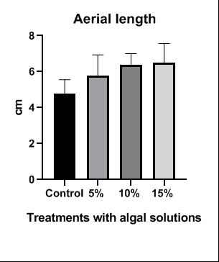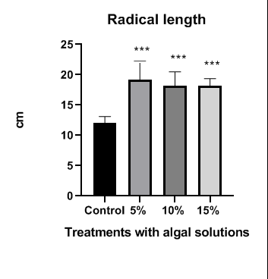
Figure 10: The bars represent the control and treatment values. Each point represents the mean ± SEM of n = 5 M. sativa samples across the different treatments. A: Shoot length of M. sativa (alfalfa). Statistical analyses were performed using one-way ANOVA followed by Dunnett's test, with p < 0.05. Means were compared to the corresponding maximum values ​​within each group. B: Root length in M. sativa (alfalfa) samples. Statistical analyses were performed using one-way ANOVA followed by Dunnett's test, with p < 0.001. Means were compared to the corresponding maximum values ​​within each group.

Fresh Aerial and Root Weight
Fresh aerial weight showed no significant differences between the control group and the treatments (Figure 11 A). Fresh root weight showed a significant increase in treatment A (5%) and treatment B (10%) compared to the control, with values **p < 0.01 and *p < 0.05, respectively. With treatment C (15%), there were no significant differences (Figure 11 B).

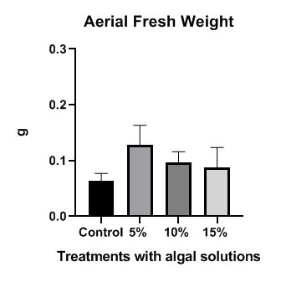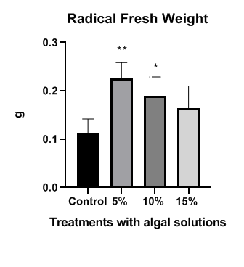
Figure 11: A: Shoot fresh weight and B: Root fresh weight in M. sativa (alfalfa) samples. Bars represent control and treatment values. Each point represents the mean ± SEM of n = 5 M. sativa samples. Statistical analyses were performed using one-way ANOVA followed by Dunnett's test, with *p<0.05 and **p<0.01. Means were compared with the corresponding maximum values ​​within each group.

Aerial Dry Weight and Root Dry Weight
Aerial dry weight (Figure 12 A) showed a significant increase in treatment A compared to the control (p<0.01). Root dry weight (Figure 12 B) showed significant differences (p<0.05) in treatments A and C compared to the control.

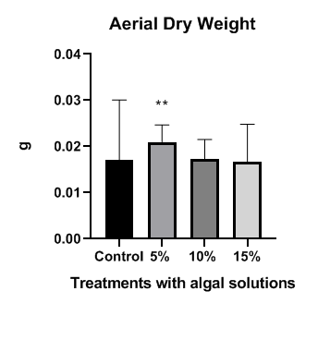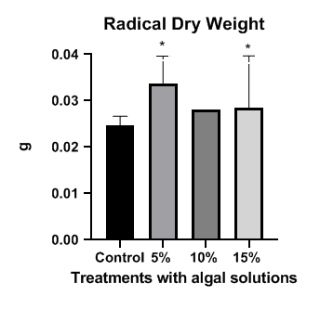
Figure 12: shoot dry weight and B: root dry weight of M. sativa (alfalfa) samples. The bars represent control and treatment values. Each point on the curves represents the mean ± SEM of n = 5 M. sativa samples in the different treatments. Statistical analyses were performed using one-way ANOVA followed by Dunnett's test, with **p<0.01 and *p<0.05 respectively, when the means shown in the figure were compared with the corresponding maximum values ​​within each group.

4. Measurement of photosynthetic pigments
Chlorophyll A, B and total
Chlorophyll A increased with the addition of the three algal treatments compared to the control. Treatment A showed a significant increase (**p<0.01) compared to the control; in treatments B and C, the increase was very significant compared to the control (***p<0.001) (Figure 13A).
Chlorophyll B increased significantly between the control and treatment A (*p<0.05), and in treatment B (10%) it was higher (**p<0.01) (Figure 13 B).
In the evaluation of total chlorophyll, there were significant increases between the control and treatments A (*p<0.05); B (*** p<0.001) and C (**p<0.01) compared to the control (Figure 13C).

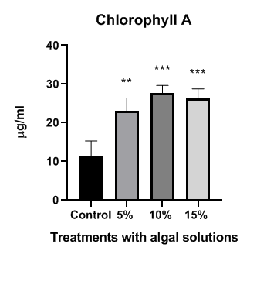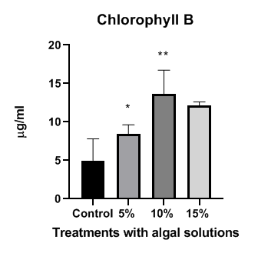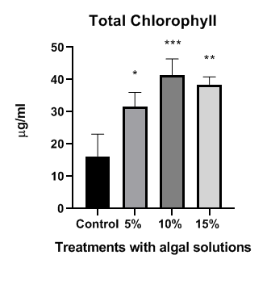
Figure 13: The bars represent the control and treatment values. Each point on the bars represents the mean ± SEM of n = 5 M. sativa samples across the different treatments. A: Chlorophyll A in M. sativa (alfalfa) samples. Statistical analyses were performed using one-way ANOVA followed by Dunnett's test, with **p<0.01 and ***p<0.001 respectively, when the means shown in the figures were compared with the corresponding maximum values ​​within each group. B: Chlorophyll B in M. sativa (alfalfa) samples. Statistical analyses were performed using one-way ANOVA followed by Dunnett's test, with **p<0.01 and *p<0.05 respectively, when the means shown in the figures were compared with the corresponding maximum values ​​within each group. C: Total Chlorophyll in M. sativa (alfalfa) samples. Statistical analyses were performed using one-way ANOVA followed by Dunnett's test, with *p<0.05, **p<0.01 and *p<0.001 respectively, when the means indicated in the figures were compared with the corresponding maximum values ​​within each group.
Carotenoids
There was a significant increase in carotenoids between the control and treatment A (*p<0.05); B and C (**p<0.01) compared to the control, showing an increase in the protection of the photosynthetic apparatus (Figure 14).
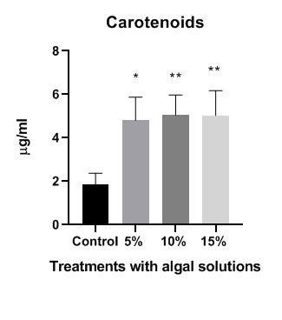
Figure 14: Carotenoids in M. sativa (alfalfa) samples. The bars represent control and treatment values. Each point on the curves represents the mean ± SEM of n = 5 M. sativa samples in the different treatments. Statistical analyses were performed using one-way ANOVA followed by Dunnett's test, with **p<0.01 and *p<0.05 respectively, when the means shown in the figures were compared with the corresponding maximum values ​​within each group.

DISCUSSION
Germination and growth
The biostimulant derived from Desmodesmus sp. cultivated in urban effluent without tertiary treatment showed a positive impact on the germination and growth of Medicago sativa L. (alfalfa). Application to the seeds promoted a significant increase in root length in the three treatments compared to the control, suggesting stimulation in root system development. Similar results were found with the application of extracts of Chlorella vulgaris and Scenedesmus quadricauda on sugar beet (Puglisi et al., 2020), and for Chlorella sp. and Anabaena sp. on Arabidopsis thaliana and other crops (Zhang et al., 2023; Moon et al., 2024). These effects are attributed to bioactive compounds that modulate auxin signaling and glucosinolate biosynthesis, such as polysaccharides, peptides, lipids and phytohormones (Kumar and Singh, 2020).
In contrast to shoot length and fresh biomass, the increase in root length and fresh biomass was highly significant compared to the control, clearly demonstrating its effect on root development. However, no previous studies examining the effect of Desmodesmus sp. on alfalfa were found, highlighting the uniqueness of our study and the importance of exploring its potential as a biostimulant in this crop.
Photosynthetic pigments.
The concentration of chlorophylls a, b, total chlorophyll and carotenoids increased significantly in the treated plants, especially at the intermediate concentration (10%). These results are similar with those observed in peppers, rocket, spinach, tomatoes and lettuce treated with microalgal extracts (Seğmen and Özdamar Ünlü, 2023; Zhang et al., 2023; Hassan et al., 2017; Abo-Basha et al., 2019; Quelal et al., 2022; Abu et al., 2022).
However, the increase in biostimulant concentration did not translate into a proportional increase in growth and pigments. This indicates a dose-dependent impact, like treatments with Chlorella and Ascophyllum nodosum in ornamental sunflowers (Santos et al., 2019; Moon et al., 2024). In fact, excessive concentrations can inhibit germination or growth (Minaoui et al., 2024), making it crucial to test a wide range of concentrations (Parađiković et al., 2019).
Overall, the results show promotion of root germination, root development and pigment synthesis in M. sativa L. with Desmodemus sp. extract. This study considers the possibility of recovering nutrients from waste and utilizing micro-algal biomass in multiple applications, making these technologies a strategic pillar for both scientific research and the development of sustainable economic activities.
CONCLUSIONS
The application of the microalgae bio stimulant significantly increased root length during germination. The roots system length, fresh weight and dry weight of M. sativa plants treated with the algal solution increased compared to the control. The foliage dry weight of M. sativa plants treated with the 5% of algal solution increased compared to the control.
Leaves showed an increase in chlorophyll A, B and total chlorophyll and carotenoids in treatment plants, so is related to increased photosynthetic activity and therefore biomass.
The use of native microalgae grown in domestic effluents proved to be an effective and sustainable strategy to stimulate the growth of Medicago sativa L.
The strategy of using effluents for microalgae cultivation not only reduces costs but also promotes the circular economy and contributes to environmental remediation. The results obtained support the development of local bio stimulants as an alternative to conventional fertilizers, opening new lines of research and application in sustainable agriculture.

Acknowledgement
This research was funded by the Secretary of Science and Technology, Consolidated Project N. 02-2523, of the National University of San Luis, San Luis, Argentina.

Conflict of Interest and ethical issues
This work respects the ethical standards of non-discrimination, non-pollution, and a healthy work environment. The data that support the findings of this study are available from the corresponding author upon reasonable request. Author(s) hereby declares that no generative AI technologies such as large language models (chatgpt, copilot, etc.) and text-to-image generators have been used during the writing or editing of this manuscript. Aren’t conflict of interest inter authors
Disclaimer (Artificial intelligence)
Option 1:
Author(s) hereby declare that NO generative AI technologies such as Large Language Models (ChatGPT, COPILOT, etc.) and text-to-image generators have been used during the writing or editing of this manuscript.

REFERENCES
Abo-Basha, D. M., Afify, R. R., Abdel-Kader, H. H. (2019). Response of spinach (Spinacia olerasea L.) to algae extract under different nitrogen rates. Middle East Journal, 8(1), 47–55.
Abu, N. J., Bujang, J. S., Zakaria, M. H., Zulkifly, S., Ali, S. (2022). Use of Ulva reticulata as a growth supplement for tomato (Solanum lycopersicum). PLoS One, 17(6), 1–19. https://doi.org/10.1371/journal.pone.0270604
Algozino Gudiño, C., Daruich, G.J. (2025) Response of the Diatom Melosira varians to Domestic Wastewater Effluents. Journal of Biology and Nature Volume 17, Issue 2, Page 73-84, 2025; Article no. JOBAN.13237ISSN: 2395-5376 (P), ISSN: 2395-5384 (O), (NLM ID: 101679666)
Chovanček, E., Salazar, J., Şirin, S., Allahverdiyeva, Y. (2023). Microalgae from Nordic collections demonstrate biostimulant effect by enhancing plant growth and photosynthetic performance. Physiologia Plantarum, 175(2), e13911. https://doi.org/10.1111/ppl.13911
Galarza, V. O. (2019). Carbohidratos y proteínas en microalgas: potenciales alimentos funcionales. Brazilian Journal of Food Technology, 22, e2019043. https://www.scielo.br/j/bjft/a/vDxNKVVFfRgTTBvz3JB9zzJ/?lang=es&format=html
Hassan, S., Ashour, M., Soliman, A. (2017). Anticancer Activity, Antioxidant Activity, Mineral Contents, Vegetative and Yield of Eruca sativa Using Foliar Application of Autoclaved Cellular Extract of Spirulina platensis Extract, Comparing to N-P-K Fertilizers.. Journal of Plant Production, 8(4), 529-536. doi: 10.21608/jpp.2017.40056
Hegewald, E. y Braband, A. (2017). A taxonomic revision of Desmodesmus serie Desmodesmus (Sphaeropleales, Scenedesmaceae). Fottea, 17(2), 191-208. doi: 10.5507/fot.2017.001
Kumar, A., y Singh, J. S. (2020). Chapter 17 - Microalgal bio-fertilizers. In E. Jacob-Lopes, M. M. Maroneze, M. I. Queiroz, &L. Q. Zepka (Eds.), Handbook of Microalgae-Based Processes and Products (pp. 445–463). Academic Press. https://doi.org/https://doi.org/10.1016/B978-0-12-818536-0.00017-8
Lee, Y. K. (2020). Microalgae biotechnology: Current trends, challenges, and prospects. Journal of Industrial Microbiology & Biotechnology, 47(12), kuaa077. https://doi.org/10.1093/jimb/kuaa077
Minaoui, F., Hakkoum, Z., Chabili, A., Douma, M., Mouhri, K., & Loudiki, M. (2024). Biostimulant effect of green soil microalgae Chlorella vulgaris suspensions on germination and growth of wheat (Triticum aestivum var. Achtar) and soil fertility. Algal Research, 82, 103655. https://doi.org/10.1016/j.algal.2024.103655
Moon, J., Park, Y. J., Choi, Y. B., Truong, T. Q., Huynh, P. K., Kim, Y. B., & Kim, S. M. (2024). Physiological Effects and Mechanisms of Chlorella vulgaris as a Biostimulant on the Growth and Drought Tolerance of Arabidopsis thaliana. Plants, 13(21), 3012. https://doi.org/10.3390/plants13213012
Olguín, E. (2003). Phycoremediation: key issues for costeffective nutrient removal processes, Biotechnology Advances. Elseiver Science, 22, pp. 81–91. https://doi.org/10.1016/S0734-9750(03)00130-7
Pacheco Insausti M.C., Zapico M. G, Gonzalez E.A., Fernández E., Gutiérrez ME., Stege P.W., Pedranzani HE (2022). Salt and Cadmium Stress Tolerance in Four Genotypes of Medicago sativa L. Avances en Investigación Agropecuaria. AIA. 2022. 26: 62-78 ISSN e -2683 1716.
Parađiković, N., Teklić, T., Zeljković, S., Lisjak, M., Špoljarević, M. (2019). Biostimulants research in some horticultural plant species—A review. Food and Energy Security, 8(2), e00162.
Pedranzani, H.E., Barzana G., Gil R., Molina Arias S., Pacheco Insausti, MC; Ruiz Lozano JM. (2022). Jasmonates, Aquaporines and nutritional response in Medicago sativa L. in symbiosis with arbuscular mycorrizae under abiotic stresses. Annals Agricultural Sciences Research .1:1-14. www.Stechnolock.com
Puglisi, I., Barone, V., Fragalà, F., Stevanato, P., Baglieri, A., Vitale, A. (2020). Effect of Microalgal Extracts from Chlorella vulgaris and Scenedesmus quadricauda on Germination of Beta vulgaris Seeds. Plants, 9(6), 675. https://doi.org/10.3390/plants9060675
Quelal, C., Nicolas, A., Salazar, U. (2022). Comparison of the Effect of Three Biofertilizers: Biol, Seaweed and Spirulina (Arthrospira platensis), on the Organic Production of Lettuce (Lactuca sativa). Retrieved December 20, 2022, from https://www.researchgate.net/profile/Alexoronel/publication/366961611_
Ronga, D., Biazzi, E., Parati, K., Carminati, D., Carminati, E., Tava, A. (2019). Microalgal biostimulants and biofertilisers in crop productions. Agronomy, 9(4), 192. https://doi.org/10.3390/agronomy9040192
Saavedra, A., Daruich, J. y Ferrari, S. G. (2022). Growth of the green microalgae Scenedesmus sp using synthetic wastewater. BiCyT - CONICET. https://bicyt.conicet.gov.ar/fichas/produccion/11882642
Santos, P. L. F., Zabotto, A. R., Jordão, H. W. C., Boas, R. L. V., Broetto, F., Tavares, A. R. (2019). Use of seaweed-based biostimulant (Ascophyllum nodosum) on ornamental sunflower seed germination and seedling growth. Ornamental Horticulture, 25(3), 231–237. https://doi.org/10.1590/2447-536X.v25i3.2044
Seğmen, E., y Özdamar Ünlü, H. (2023). Effects of foliar applications of commercial seaweed and spirulina platensis extracts on yield and fruit quality in pepper (Capsicum annuum L.). Cogent Food & Agriculture, 9(1). https://doi.org/10.1080/23311932.2023.2233733
Yusof, N. S., Zakaria, M. F., Jusoh, M., Yeong, Y. S., Wahid, E., Ahamad Zakeri, H., Yusuf, N. (2023). Freshwater microalgae Desmodesmus brasiliensis, Mychonastes timauensis, and Mychonastes ovahimbae as excellent microalgae candidates for sustainable live feeds with high-value bioactive compounds. Asia-Pacific Journal of Molecular Biology and Biotechnology, 31(4), 38–48. https://doi.org/10.35118/apjmbb.2023.031.4.05
Wang, J.H., Zhang, T.Y., Dao, G.H., Xu, X.Q., Wang, X.X., Hu, H. (2017). Microalgae-based advanced municipal wastewater treatment for reuse in water bodies. Applied microbiology and biotechnology, 101(7), 2659–2675. https://doi.org/10.1007/s00253-017-8184-x
Zhang, Z., Xu, M., Fan, Y., Zhang, L., Wang, H. (2023). Using microalgae to reduce the use of conventional fertilizers in hydroponics and soil-based cultivation. Science of the Total Environment, 912, 169424. https://doi.org/10.1016/j.scitotenv.2023.169424
International Rules for Seed Testing (2019). Obtenido de International Seed Testing Association (ISTA), Bassersdorf, Suiza. https://www.seedtest.org/en/publications/international-rules-seed-testing.html

