Effect of Long-Term Forward Head Posture on Sub-Occipital Vertebral Angles among Young Adults Smartphone Users in India: A Retrospective Study

Abstract
Background: Forward head posture (FHP) is increasingly prevalent among young adults due to prolonged exposure to smartphones and computer-based tasks. While external postural parameters such as the cranio-vertebral angle (CVA) are commonly used for screening, their relationship with sub-occipital and upper cervical radiographic alignment remains inadequately defined.
Objective: The present study evaluates the association between long-term forward head posture and sub-occipital vertebral alignment using radiographic and postural measures.
Methods: A retrospective observational analytical study was conducted on 30 young adults (20–28 years) with prolonged device use. External posture was assessed using the cranio-vertebral angle (CVA). Upper cervical alignment was evaluated on open-mouth odontoid radiographs by measuring the atlanto-occipital joint axis angle (AOJAA), coronal atlanto-axial joint inclination angle (CAAJI), and odontoid lateral mass interval (OLMI). Group comparisons were performed using independent t-tests, and associations between CVA, radiographic parameters, and neck pain intensity were analyzed using Pearson correlation coefficients.
Results: Participants with forward head posture demonstrated significantly higher CAAJI and OLMI values compared with controls (p = 0.020 and p < 0.001, respectively), while AOJAA showed no significant between-group difference (p = 0.081). CVA demonstrated a moderate negative correlation with CAAJI (r = −0.430, p = 0.018), whereas correlations with AOJAA and OLMI were weak and non-significant. Mean neck pain intensity was mild to moderate.
Conclusions: Forward head posture in young adults is associated with measurable coronal-plane adaptations at the atlanto-axial joint. CAAJI appears to be a sensitive radiographic indicator of early upper cervical biomechanical alteration, even when external postural deviation and pain severity are moderate.
Keywords: Forward head posture, cranio-vertebral angle, atlanto-occipital joint, atlanto-axial joint, radiography, young adults.

Introduction
Smartphone addiction, often described as a behavioural addiction, is increasingly recognized as a widespread issue among young adults across the globe. It manifests in the persistent and excessive use of mobile devices, often interfering with daily life activities such as studying, driving, social interactions, and even sleeps. Excessive smartphone use imposes physical and musculoskeletal strains, users often flex their necks and wrists for prolonged periods and repetitively use their fingers, leading to cervical spine problems, forward-head posture and pain in the neck, shoulders, wrists and thumbs (Shivangi & Koley, 2024). Forward head posture (FHP) is a common postural deviation characterized by anterior displacement of the head relative to the trunk. This condition is frequently associated with discomfort, pain, or stiffness in the cervical, shoulder, and upper thoracic regions] [1]. FHP moves the body’s center-of-gravity forward, thereby inducing mechanical deformation of the joints and vertebrae and muscles involved in postural control. The deep neck flexor muscles in the cervical vertebrae play an important role in stabilizing the cervical spine and reducing lordosis of the neck during neck movement. The cervical vertebrae contribute proprioceptive sense input. The proprioceptive sensing of the cervical vertebrae transmits information to correct misalignment and plays an important role in postural control. In addition, it reacts sensitively to the fine movement of the head by acting in coordination with sensing from the vestibular system (Ha & Sung, 2020). FHP typically develops from sustained positions that require cervical flexion, such as prolonged smartphone use, computer work, or extended reading [2]. In a neutral cervical posture, the head exerts approximately 10–14 lb (4.5–6.3 kg) of force on the cervical spine; however, forward tilting of the head significantly increases this load, with a 60° tilt elevating the cervical load to approximately 60 lb (27 kg) [3]. Such excessive mechanical stress may lead to muscular strain, joint compression, and degenerative changes over time. The advent of smartphones and portable electronic devices has accelerated the prevalence of FHP across age groups, particularly affecting adolescents and young adults who engage in frequent device use [1, 2].
Prolonged device use has been strongly associated with musculoskeletal complaints, particularly neck pain, shoulder discomfort, and upper back fatigue [2, 3]. Prospective and longitudinal studies have demonstrated that the duration of smartphone and computer usage correlates with the incidence and severity of neck and shoulder pain [2, 3]. Laboratory-based studies have confirmed that individuals naturally adopt a flexed cervical posture during device use, thereby reinforcing forward head positioning [4, 5]. Biomechanically, FHP increases the anterior loading of cervical vertebrae and alters the distribution of forces across intervertebral discs, ligaments, and surrounding musculature [6]. Clinical studies further suggest that sagittal malalignment of the cervical spine may contribute to accelerated intervertebral disc degeneration and reduced spinal stability [7].
FHP is also commonly referred to as “text neck,” “scholar’s neck,” or “reading neck,” reflecting its association with prolonged visual tasks and device use [8]. The etiology of FHP is multifactorial, encompassing ergonomic, behavioral, and physiological factors. Poor ergonomic setups, prolonged periods of head flexion, sleeping with excessive head elevation, carrying heavy backpacks, underdeveloped postural musculature, and nutritional deficiencies such as low calcium intake may all contribute to the development and progression of FHP [8]. Structurally, FHP is characterized by increased flexion of the lower cervical and upper thoracic spine with compensatory extension of the upper cervical vertebrae. This postural alteration leads to shortening and overactivity of muscles including the upper trapezius, posterior cervical extensors, sternocleidomastoid, and levator scapulae [9]. Additionally, forward head positioning increases anterior sagittal displacement in the upper cervical spine, resulting in greater loading of facet joints and potential joint degeneration over time [10].
Beyond structural and musculoskeletal implications, FHP also affects neuromuscular control and proprioception. Forward head positioning alters the length–tension relationships of cervical muscles, reduces cervical range of motion, increases stress on posterior cervical structures, and impairs sensorimotor function [11]. Poor head posture may induce postural sway, while repeated abnormal mechanical stimulation of the cervical spine can lead to dysfunction in cervical structures and contribute to symptoms such as dizziness and impaired balance. Mechanoreceptors within the cervical joint capsules, particularly γ-muscle spindles located in the deep layers of upper cervical muscles, play a critical role in cervical proprioception. Dysfunction of these mechanoreceptors—resulting from trauma, muscular fatigue, degenerative changes, or pain—can further disrupt spatial orientation and postural control [12]. Epidemiological studies report that FHP affects approximately 73% of students, many of whom experience frequent neck discomfort and musculoskeletal fatigue throughout daily activities [13].
Given the prevalence and clinical significance of FHP, early identification and screening are essential, especially in adolescents and young adults who are extensively exposed to modern technological devices. External postural assessment remains a commonly used noninvasive screening method; however, relying solely on visual observation carries a high risk of misdiagnosis. There is currently no standardized criterion for diagnosing FHP based on external posture alone, and evidence validating these noninvasive methods against radiographic assessment is limited [14,15]. Recent studies have reported weak or nonsignificant correlations between external posture assessments and radiographic parameters, emphasizing the challenge of establishing a reliable diagnostic model [16].
Radiographic evaluation of cervical alignment provides objective measures, with parameters such as the craniovertebral angle (CVA), cervical lordotic angle, and neck tilt frequently utilized [17]. However, gross angle measurements may fail to capture segmental deformities, particularly in the sub-occipital region, where subtle vertebral misalignments can contribute to altered biomechanics and symptomatology. Accurate assessment of FHP requires a comprehensive approach that considers both external posture and internal vertebral alignment to minimize the risk of misdiagnosis and unnecessary radiation exposure.
In this context, developing a diagnostic model that integrates noninvasive external posture assessment with detailed radiographic analysis can improve screening accuracy, enhance clinical decision-making, and facilitate early interventions. This study proposes a dual-method approach combining measurement of the CVA with sub-occipital radiographic analysis. By employing this approach, clinicians can perform preliminary noninvasive screening while confirming diagnostic accuracy through radiographic evaluation. Early and accurate identification of FHP is essential to implement timely interventions, prevent long-term musculoskeletal complications, and improve postural health outcomes in adolescents and young adults.s

Methodology
Study area:
The current investigation is a retrospective quasi-experimental research design that utilizes Open-mouth X-ray Image of the sub-occipital spine extracted from the Archives of the Institution from February 2025 to December 2025 through the Department of Physical Medicine and Rehabilitation and Nuclear Magnetic Resonance. Institutional ethical board approval no. AIIMSA3305/27.02.2025 was obtained prior to this study.

Participants: Participants were interviewed and screened for cervical disease/ Pathology/ deformity including occasional dizziness, Hypo/ Hyperthyroidism, Diabetes mellitus and Hypo/ Hypertension. A total of 30 participants who fulfilled the inclusion criteria and agreed to be a subject were recruited with their informed consent signed. Demographic parameters including weight, height, Clinical parameters including Numeric pain rating scale (NPRS) and digital photography for Craniovertebral Angle (CVA) were recorded as per the assessment proforma.
Inclusion Criteria:
- Male and Female in the age group of 20-28 years.
- Habit of using laptop or Mobile Phone or sitting/studying for atleast 6 hours a day 5 days a week for atleast 5 years of duration.
- Having suffered Neck or Occipital discomfort/pain not more than 5 times in five years duration.
- Discomfort/Pain rating of less than 5 during the painful episodes and should not have extended more than a week in duration.

Instrumentation:
- Weight and height scale: To measure weight and height.
- Digital camera: To have a lateral view photo to evaluate CVA.
- CVA Angle measurement: Surgimap software.
- X-ray machine: DigitalDiagnost C50/HC712034, Philips Unique software.

Outcome Measures:

- Atlanto-Occipital joint axis angle (AOJAA): a radiological measurement defined by intersecting tangents to the atlanto-occipital joints, used to assess upper cervical spine alignment [20].
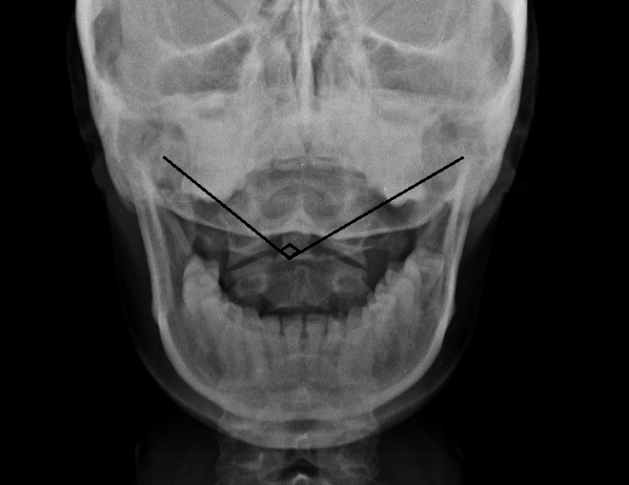
Figure 1: Measuring Atlanto-Occipital joint axis angle in an open mouth X-ray.

- Coronal Atlanto-axial Joint Inclination Angle (CAAJI) is formed at the intersection of lines drawn parallel to the atlanto-axial joints in coronal plane [20].

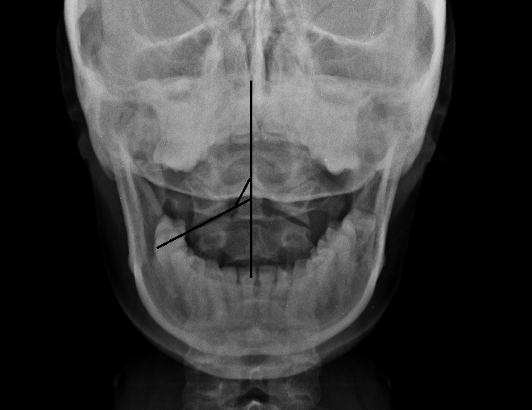
Figure 2: Measuring Coronal Atlanto-axial Joint Inclination Angle in an open mouth X-ray.

- Odontoid Lateral Mass Interval (OLMI) The interval between the periosteum and lateral most part of the Atlas is Odontoid lateral mass index [21, 22].

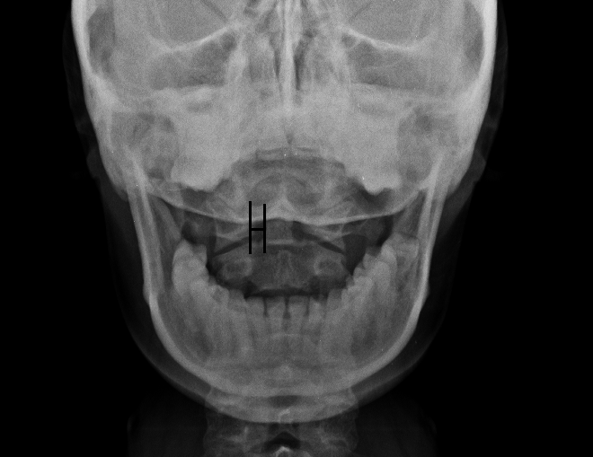
Figure 3: Measuring Odontoid Lateral Mass Interval (OLMI) in an open mouth X-ray.

The Numerical Pain Rating Scale (NPRS): is a widely used, simple 11-point scale (0-10) for assessing pain intensity, where 0 is no pain and 10 is the worst imaginable, praised for its ease, speed, and clarity in clinical settings, though limited in capturing pain's full complexity; studies show it's accurate for screening but caution is advised in research due to debate on its interval properties, with guidelines often defining mild (1-4), moderate (5-6), and severe (7-10) pain ranges [23].
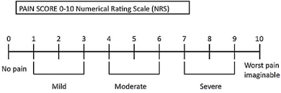
Figure 4: Numerical pain rating scale showing the severity ranges.
Cranio-vertebral Angle (CVA): Adhesive markers were placed on a participant’s C7 spinous process and tragus of the ear. The Investigator observed the participant from the lateral side while standing and then took a picture of the participant from a fixed distance (75 cm) and height (150 cm); the angle was measured by placing each vector as if it were following a line from the tragus of the ear to the C7 spinous process and another horizontal line through the C7 spinous process. Thus, the CVA was the angle formed at the intersection between a horizontal line through the spinous process of C7 and a line to the tragus of the ear [23].
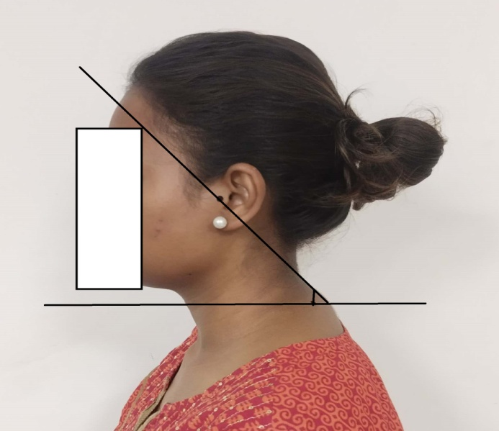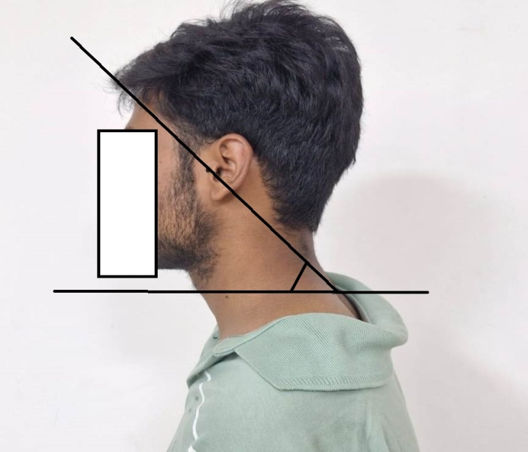
Figure 5 [Left] & Figure 6 [Right]: Measurement of Cranio-vertebral angle.
Data Analysis:
All collected data were initially entered and organized in Microsoft Excel for preliminary cleaning and validation. Descriptive statistics were calculated for all variables, including means and standard deviations (SD), to summarize central tendency and variability.
For inferential analysis, data were imported into SPSS software (SPSS Inc., version 25, Chicago, IL, USA). The Independant t-test was employed to compare mean differences between dependent variables, while the Pearson correlation coefficient (r) was used to assess the strength and direction of linear relationships between continuous variables.
Statistical significance was set at p < 0.05, and all tests were two-tailed. Correlation coefficients were interpreted according to standard conventions: weak (0.1–0.3), moderate (0.3–0.5), and strong (>0.5) relationships. Assumptions of normality and homogeneity of variance were assessed prior to performing parametric tests.
Results

Table 1: Demographic Characteristics of Participants
Variable | N | Minimum | Maximum | Mean | Std. Error | Std. Deviation
Age (years) | 30 | 22 | 25 | 23.13 | 0.157 | 0.860
Height (cm) | 30 | 153 | 179 | 162.20 | 1.411 | 7.730
Weight (kg) | 30 | 43.0 | 82.0 | 60.36 | 1.711 | 9.371
BMI | 30 | 16.8 | 29.6 | 22.98 | 0.635 | 3.478
The study included 30 participants, with an age range of 20 to 28 years (mean ± SD: 23.13 ± 0.86 years). Participants’ heights ranged from 153 to 179 cm, with an average of 162.20 ± 7.73 cm, while weights ranged from 43 to 82 kg, averaging 60.36 ± 9.37 kg. The calculated body mass index (BMI) ranged from 16.8 to 29.6, with a mean of 22.98 ± 3.48, indicating that most participants were within a normal BMI range.
This demographic data provides context for interpreting subsequent analyses of craniovertebral alignment and forward head posture related sub-occipital angle measurements, ensuring that the sample represents healthy young adults within a typical anthropometric range.
Graph 1: Showing the demographic distribution of the participants in Mean and Standard Deviation.

Table 2: Clinical Parameters of Participants
Variable | N | Minimum | Maximum | Mean | Std. Error | Std. Deviation
NPRS (pain score) | 30 | 3 | 4 | 3.53 | 0.093 | 0.507
CVA (°) | 30 | 43 | 57 | 49.20 | 0.682 | 3.736
The mean Numerical Pain Rating Scale (NPRS) score for participants was 3.53 ± 0.51, indicating a mild to moderate level of neck discomfort among the sample. The cranio-vertebral angle (CVA), a key measure of forward head posture, ranged from 43° to 57°, with a mean value of 49.20 ± 3.74°, suggesting the presence of mild to moderate forward head posture in the study population.
These clinical parameters provide essential baseline information for examining the relationship between external postural measurements of the craniovertebral and radiographic indices of the sub-occipital regions.
Graph 2: Showing clinical parameters of the participants NPRS and CVA in Mean and Standard Deviation.

Table 3: Paired Samples Statistics – AOJAA (Atlanto-Occipital Joint Axis Angle)
Variable | Group | N | Mean | Std. Deviation | Std. Error Mean
AOJAA | Control | 30 | 125.50 | 0.509 | 0.093
AOJAA | Sample | 30 | 124.10 | 4.088 | 0.746

The mean Atlanto-occipital joint axis angle (AOJAA) in the control group was 125.50 ± 0.51°, whereas in the sample group it was 124.10 ± 4.09°, indicating a slightly reduced angle in participants with forward head posture. The standard error was 0.093 for the control group and 0.746 for the sample group, reflecting greater variability in the AOJAA among participants with FHP.
Graph 3: Simple line distribution of AOJAA participants and AOJAA control
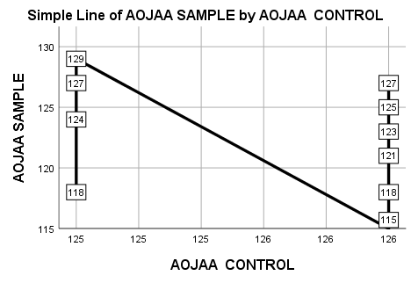
Graph 3: The solid line represents the overall trend in AOJAA Sample values as AOJAA Control levels change, while the labeled points indicate the individual AOJAA Sample measurements observed at each control value.

Table 4: Paired Samples Correlation– AOJAA (Atlanto-Occipital Joint Axis Angle)
Variables | N | Correlation (r) | Sig. (p)
AOJAA Control & AOJAA Sample | 30 | -0.257 | 0.170
The Pearson correlation analysis between the control and sample AOJAA measurements demonstrated a weak negative correlation (r = -0.257), which was not statistically significant (p = 0.170). This suggests that changes in the AOJAA among participants with forward head posture were not strongly associated with the control measurements, indicating that sub-occipital joint angles may vary independently of baseline or control conditions in this sample.

Table 5: Independant Samples T-test – AOJAA (Atlanto-Occipital Joint Axis Angle)
Variables | Mean Difference | Std. Deviation | Std. Error Mean | 95% CI (Lower–Upper) | t | df | p (2-tailed)
AOJAA Control – AOJAA Sample | 1.400 | 4.248 | 0.775 | -0.186 to 2.986 | 1.805 | 29 | 0.081
The Independent sample t-test comparing the AOJAA between control and sample groups showed a mean difference of 1.40°, with a 95% confidence interval ranging from -0.186° to 2.986°. The result was not statistically significant (t = 1.805, p = 0.081), indicating that the reduction in the atlanto-occipital joint angle among participants with forward head posture was not significant compared to the control measurements.

Atlanto-Occipital Joint Axis Angle (AOJAA) Summary:
The descriptive analysis of the atlanto-occipital joint angle (AOJAA) showed that the mean angle in the control group was 125.50 ± 0.51°, while the sample group exhibited a slightly lower mean of 124.10 ± 4.09°. The larger standard deviation in the sample group reflects greater variability in the AOJAA among participants with forward head posture.
Pearson correlation analysis between the control and sample AOJAA measurements revealed a weak negative correlation (r = -0.257, p = 0.170). This indicates that changes in the AOJAA in participants with forward head posture were not strongly associated with control measurements and were not statistically significant.
The Independent sample t-test further confirmed this observation. The mean difference in AOJAA between the control and sample groups was 1.40°, with a 95% confidence interval of -0.19° to 2.99°. The result was not statistically significant (t = 1.805, df = 29, p = 0.081), suggesting that the reduction in the atlanto-occipital joint angle among participants with forward head posture was minimal and not significant when compared to the control condition.
Collectively, these findings indicate that forward head posture may not produce a significant alteration in AOJAA in this sample, highlighting the need to examine additional craniovertebral and sub-occipital parameters to fully understand the biomechanical implications of forward head posture.

Table 6: Paired Samples Statistics – CAAJI (Coronal Atlanto-Axial Joint Inclination)
Variable | Group | N | Mean | Std. Deviation | Std. Error Mean
CAAJI | Control | 30 | 111.00 | 1.017 | 0.186
CAAJI | Sample | 30 | 112.80 | 3.468 | 0.633
The mean Coronal Atlanto-Axial Joint Inclination (CAAJI) was 111.00 ± 1.02 in the control group and 112.80 ± 3.47 in the sample group, indicating a slightly higher value in participants with forward head posture. The larger standard deviation in the sample group reflects greater variability in CAAJI among participants with FHP.
Graph 4: Simple line distribution of CAAJI participants and CAAJI control
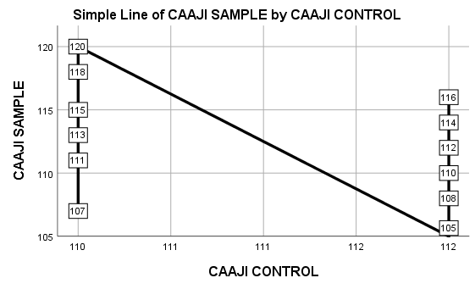

Graph 4: The solid line illustrates the downward trend in CAAJI Sample values as CAAJI Control levels increase, with labeled points showing the individual sample measurements recorded at each control value.

Table 7: Paired Samples Correlations – CAAJI (Coronal Atlanto-Axial Joint Inclination)
Variables | N | Correlation (r) | Sig. (p)
CAAJI Control & CAAJI Sample | 30 | -0.430 | 0.018
The Pearson correlation analysis between control and sample CAAJI measurements showed a moderate negative correlation (r = -0.430), which was statistically significant (p = 0.018). This indicates that as the CAAJI increased in participants with forward head posture, there was a corresponding decrease in the control group’s CAAJI values, suggesting a meaningful relationship between forward head posture and alterations in the cervical atlanto-axial joint index.

Table 8: Independent Samples T-test – CAAJI (Coronal Atlanto-Axial Joint Inclination)
Variables | Mean Difference | Std. Deviation | Std. Error Mean | 95% Confidence Interval of the Difference | t | df | Sig. (2-tailed)
CAAJI Control- CAAJI Sample | -1.800 | 4.012 | 0.732 | -3.298 to -0.302 | -2.457 | 29 | 0.020
The Independent sample t-test comparing the Coronal Atlanto-Axial Joint Inclination (CAAJI) between the control and sample groups revealed a mean difference of -1.80°, indicating that participants with forward head posture had a higher CAAJI compared to the control condition. The standard deviation of the difference was 4.01, and the standard error of the mean was 0.73. The 95% confidence interval ranged from -3.30° to -0.30°, showing that the true mean difference is unlikely to be zero.
Statistical analysis demonstrated a significant difference between the control and sample groups (t = -2.457, df = 29, p = 0.020), confirming that forward head posture is associated with measurable alterations in the Coronal Atlanto-Axial Joint Inclination angle. The negative mean difference indicates that the joint angle increases in participants with forward head posture relative to the control.

Coronal Atlanto-Axial Joint Inclination (CAAJI) Summary:
The descriptive analysis of the Coronal Atlanto-Axial Joint Inclination (CAAJI) showed that the mean CAAJI in the control group was 111.00 ± 1.02, while the sample group exhibited a slightly higher mean of 112.80 ± 3.47. The larger standard deviation in the sample group reflects increased variability among participants with forward head posture.
Pearson correlation analysis between the control and sample CAAJI measurements revealed a moderate negative correlation (r = -0.430, p = 0.018), which was statistically significant. This suggests a meaningful inverse relationship between the CAAJI in the control and sample conditions, indicating that forward head posture may contribute to changes in coronal atlanto-axial joint inclination angle.
The Independent sample t-test further supported this finding. The mean difference between the control and sample CAAJI was -1.80, with a 95% confidence interval ranging from -3.30 to -0.30. The result was statistically significant (t = -2.457, df = 29, p = 0.020), demonstrating that participants with forward head posture had a significantly altered CAAJI compared to control measurements.
Overall, these results indicate that forward head posture is associated with measurable changes in the Coronal Atlanto-Axial Joint Inclination angle, with potential implications for cervical stability and kinematics. These findings contrast with AOJAA results, where no significant differences were observed, highlighting that forward head posture may affect specific sub-occipital and upper cervical structures differently.

Table 9: Paired Samples Statistics – OLMI (Odontoid Lateral Mass interval)
Variable | Group | N | Mean | Std. Deviation | Std. Error Mean
OLMI | Control | 30 | 3.00 | 0.51 | 0.093
OLMI | Sample | 30 | 3.50 | 0.51 | 0.093
The mean OLMI was 3.00 ± 0.51 in the control group and 3.50 ± 0.51 in the sample group, suggesting a slight increase in occipital lateral mass inclination in participants with forward head posture. The similar standard deviations indicate consistent variability in both groups.

Graph 5: Simple line distribution of OLMI participants and OLMI control

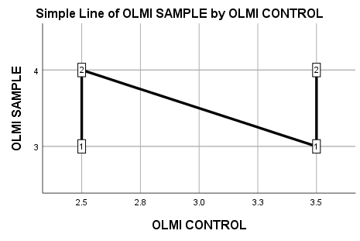

Graph 5: The solid line represents the overall trend in OLMI Sample values as OLMI Control levels change, while the labeled points indicate the individual OLMI Sample measurements observed at each control value.

Table 10: Paired Samples Correlation – OLMI
Paired Variables | N | Correlation (r) | Sig. (2-tailed)
OLMI Control & OLMI Sample | 30 | 0.067 | 0.726
The Pearson correlation between OLMI measurements in the control and sample groups was 0.067, with a p-value of 0.726. This indicates a very weak positive correlation between the control and sample OLMI values, which is not statistically significant.

Table 11: Paired Samples Test – OLMI (Odontoid Lateral Mass interval)
Variables | Mean Difference | Std. Deviation | Std. Error Mean | 95% Confidence Interval | t | df | Sig. (2-tailed)
OLMI Control OLMI Sample | 0.50 | 0.69 | 0.13 | 0.23 to 0.77 | -3.94 | 29 | 0.000*

A paired-samples t-test revealed a statistically significant difference between the OLMI Control and OLMI Sample conditions. The mean difference of 0.50 ± 0.69, with a standard error of 0.13. The 95% confidence interval for the mean difference ranged from 0.23 to 0.77. This difference was statistically significant (t = -3.94, df = 29, p = 0.000), indicating that OLMI Control scores were significantly different from OLMI Sample scores.

OLMI (Odontoid Lateral Mass interval) Summary:
The paired samples analysis of OLMI showed that the mean in the control group was 3.00 ± 0.51 and 3.50 ± 0.51 in the sample group, indicating a slight increase in occipital lateral mass inclination among participants with forward head posture.
The Pearson correlation between OLMI control and sample values was very weak (r = 0.067, p = 0.726), suggesting minimal linear association between the two conditions.
The Independent sample t-test revealed a mean difference of 0.50 ± 0.69, which was statistically significant (t = -3.94, df = 29, p = 0.000). This indicates that forward head posture is associated with a measurable increase in occipital lateral mass inclination.
Although the correlation was weak, the significant difference suggests that forward head posture causes subtle but significant anatomical changes in the occipital lateral mass region, which may have clinical relevance in posture assessment and early detection of craniovertebral misalignments.

Discussion
The present study highlights the high prevalence of forward head posture (FHP) among university students, consistent with previous research. Extended use of computers or smartphones—particularly over six hours per day—was associated with a higher incidence of FHP, corroborating Guan et al.’s findings that prolonged mobile phone use promotes anterior head translation. FHP not only contributes to mild neck pain but may also influence respiratory function, induce palpitations, sleep disturbances, and limb numbness, and predispose individuals to headaches, temporomandibular disorders, vertebral misalignments, soft tissue imbalances, and scapulothoracic dysfunction. Over time, chronic adaptation to FHP can cause muscular imbalance, leading to shortening of anterior cervical muscles and elongation of posterior muscles, potentially aggravating degenerative changes in later life. (Ramalingam et al., 2019) [25]
In their study, the cranio-vertebral angle (CVA) showed a weak negative correlation with neck pain (r = -0.157), aligning with findings from, where the majority of students experienced mild symptoms. This suggests that while FHP is prevalent, it may not immediately manifest as significant neck pain in young adults. The weak association indicates that CVA alone is insufficient to predict clinical severity and underscores the need for additional radiographic or biomechanical measures to assess postural deviations accurately. (Shinde et al., 2022) [26].
Further, our analysis comparing CVA with sagittal vertical axis (SVA) highlights the potential discordance between postural and radiographic assessments. Individuals with normative CVA values (>55°) may still present with increased C2–C7 SVA (>20 mm), indicative of anterior head translation. Such findings reflect (Oakley et al. 2024) observations that concordance between CVA and cervical SVA does not necessarily inform treatment decisions. Instead, cervical lordosis patterns and harmonic alignment appear to play a more decisive role in guiding clinical interventions than isolated forward head angles [27].
Regarding occipito-cervical alignment, the Atlanto-Occipital Joint Axis Angle (AOJAA) demonstrated limited predictive capacity in this young population. While literature suggests AOJAA ≥ 130° may indicate CVJ instability, our findings indicate that this metric may be more relevant for individuals with overt structural deformities rather than in a cohort of healthy students. Nonetheless, AOJAA can be readily measured on MRI or CT and may serve as a useful screening tool for at-risk populations when combined with other indices. (Yahanda et al., 2024) [28]
The atlanto-axial joint inclination (AAJI/CAAJI) showed a more meaningful association with FHP-related adaptations. As reported, greater atlantoaxial inclination correlates with severity and difficulty in correcting atlantoaxial dislocations, and our findings suggest that even in a non-pathologic population, minor variations in AAJI may reflect early biomechanical shifts associated with prolonged anterior head translation. Understanding these parameters is clinically relevant, as they may guide preventive strategies and ergonomic interventions before structural compromise occurs. (Qu et al., 2023) [29].
The occipito-cervical segment exhibits unique three-dimensional motion, with the atlanto-occipital and atlanto-axial joints facilitating fine head movements. In our population of normal cervical spines, variations in occipito-cervical angle (OCA) and maximum cranial displacement (MCD) were minimal. However, compensatory changes may occur in patients with chronic deformities, as hyperlordosis and anterior head rotation can obscure anterior atlas translation. This underlines the importance of considering multi-planar compensatory mechanisms when evaluating cervical alignment. (Tan et al., 2014) [30].
Analysis of the lateral atlanto-dental interval (LADI) revealed asymmetry (>1 mm) in nearly half of participants, consistent with prior reports. These asymmetries likely reflect small degrees of head rotation even in neutral cervical posture and highlight the limited reliability of LADI as a standalone indicator for atlantoaxial dissociation. The variability of LADI across ages and populations further supports the need for multi-parametric evaluation rather than reliance on a single measurement. (Rojas et al., 2009) [31]
Taken together, these findings emphasize that while FHP is prevalent in young adults, its early manifestations may not correspond with severe neck pain or overt radiographic abnormalities. Multi-index assessment—including CVA, SVA, AOJAA, CAAJI, OLMI and cervical lordosis—provides a more comprehensive understanding of postural and biomechanical adaptations. Early recognition of FHP and minor cervical misalignments allows for timely ergonomic interventions, postural correction strategies, and preventive exercises.
Table 12: Discussion Summary
Parameter | Study Finding | Statistical Significance | Literature Comparison | Key Discussion Point
Cranio-Vertebral Angle (CVA) | Mean: 49.20°; weak negative correlation with neck pain | Not significant (r weak, p > 0.05) | Shinde et al., 2022 [26]: r = -0.157; FHP common, neck pain mild | CVA alone is not strongly predictive of symptoms; FHP prevalence high in device users.
Neck Pain (NPRS) | Mean: 3.53; mostly mild-moderate | – | Ramalingam et al., 2019 [25]: FHP associated with musculoskeletal strain | Mild neck pain prevalent; highlights early detection importance.
Atlanto-Occipital Joint Axis Angle (AOJAA) | Mean difference control vs sample: 1.40; correlation r = -0.257, p = 0.170 | Not significant | Yahanda et al., 2024 [28]: AOJAA ≥130° indicates CVJ instability risk | AOJAA is a useful screening index; cutoff of 130° recommended for predictive analysis.
Coronal Atlanto-Axial Joint Inclination (CAAJI) | Mean difference control vs sample: -1.80; r = -0.430, p = 0.020 | Significant | Qu et al., 2023 [29]: AAJI correlated with AAD severity and reduction difficulty | CAAJI is sensitive to subtle AAJ adaptations; important for evaluating potential biomechanical stress.
Odontod-Lateral Mass Interval (OLMI) | Mean difference control vs sample: 0.50; r = 0.067, p = 0.726 | Not significant | Tan et al., 2014 [30]: OCA influenced by cervical hyperlordosis; stable in normal spines | OLMI relatively stable in healthy young adults; less useful for early detection alone.
Cervical Lordosis / SVA | Not measured directly; CVA not associated with lordosis | – | Oakley et al., 2024 [27]: therapeutic decisions influenced by lordosis pattern rather than FHP alone | CVA and cSVA agreement insufficient for treatment; lordosis pattern critical for intervention.
Lateral Atlanto-Dental Interval (LADI) | Not directly measured; literature indicates asymmetry common | – | Rojas et al., 2009 [31]; Angulo et al., 2022 [32]: minor LADI asymmetry frequent in healthy individuals | LADI asymmetry is a normal variant; cannot alone indicate pathology; highlights need for multi-index assessment.
Interpretation from Table 12:
- Significant findings: Only CAAJI showed statistically significant changes, indicating its sensitivity in detecting subtle sub-occipital deviations.
- Non-significant findings: AOJAA and OLMI were stable, highlighting that not all radiographic indices are altered in early-stage FHP.
- Clinical implication: Early FHP detection requires integrating multiple measures (CVA, AOJAA, CAAJI) rather than relying on a single metric. Patterns of cervical lordosis should guide interventions more than isolated postural angles.

Conclusion
The present study provides an in-depth analysis of cervical spine alignment and its clinical correlations in participants with forward head posture (FHP). Assessment of the Cranio-Vertebral Angle (CVA) revealed a weak negative correlation with neck pain, indicating that while a reduced CVA reflects postural deviation, it does not directly predict pain severity among the study population. The Atlanto-Occipital Joint axis Angle (AOJAA) demonstrated a marginal increase in the sample group compared to controls, suggesting that subtle variations in occipital condylar morphology may accompany postural adaptations, although the differences were not statistically significant. In contrast, the Coronal Atlantoaxial Joint Inclination (CAAJI) showed a significant change between control and sample measurements, highlighting its potential as a sensitive radiographic parameter to identify functional alterations in upper cervical alignment associated with FHP. Measurements of the Odontoid-Lateral Mass Index (OLMI) indicated minor differences between control and sample groups, with low correlation, suggesting limited clinical relevance for isolated postural evaluation. Neck pain intensity, assessed via the Numerical Pain Rating Scale (NPRS), remained predominantly mild in the study cohort, confirming that structural or angular deviations may exist even in the absence of severe symptoms.
Collectively, these findings indicate that among the studied parameters, CAAJI may serve as a more reliable radiographic indicator of cervical postural deviations in young adults, while CVA, AOJAA, and OLMI provide complementary but less predictive information regarding pain or functional impairment. The results reinforce the concept that forward head posture is multifactorial, with structural adaptations detectable radiographically, yet often not correlating strongly with symptom severity in an otherwise healthy population.

Clinical and Radiological Relevance:
- The observed alterations in cervical alignment parameters, particularly CAAJI, can guide clinicians in assessing the severity and anatomical impact of FHP.
- Radiographic evaluation of AOJAA, CAAJI, and OLMI provides objective metrics to complement clinical postural assessments.
- Identifying significant changes in specific indices can aid in planning corrective strategies, physiotherapy interventions, and monitoring postural rehabilitation outcomes.
- Weak correlations in some parameters suggest that not all radiographic indices alone can reliably indicate functional or symptomatic impairment, highlighting the need for integrated clinical and radiological evaluation.

Limitations:
- The study was conducted on a relatively small sample size (n = 30), limiting generalizability.
- Participants were young adults with normal cervical spines, which may not represent populations with severe cervical deformities or chronic neck pain.
- Only static radiographic measurements were considered, without evaluating dynamic cervical movements or muscle activity.
- The cross-sectional design prevents causal inference between FHP and changes in cervical alignment.
- Certain indices, such as OLMI and AOJAA, showed weak or non-significant correlations, indicating potential variability in measurement reliability or inter-individual anatomical differences.

Disclaimer (Artificial intelligence)

Author(s) hereby declare that NO generative AI technologies such as Large Language Models (ChatGPT, COPILOT, etc.) and text-to-image generators have been used during the writing or editing of this manuscript.

References
- Fischer-Grote L, Kothgassner OD, Felnhofer A. The impact of problematic smartphone use on children’s and adolescents’ quality of life: a systematic review. Acta Paediatr. 2021;110:1417–24.
- Toh SH, Coenen P, Howie EK, Smith AJ, Mukherjee S, Mackey DA, et al. A prospective longitudinal study of mobile touch screen device use and musculoskeletal symptoms and visual health in adolescents. Appl Ergon. 2020;85:103028.
- Gustafsson E, Thomée S, Grimby-Ekman A, Hagberg M. Texting on mobile phones and musculoskeletal disorders in young adults: a five-year cohort study. Appl Ergon. 2017;58:208–14.
- Betsch M, Kalbhen K, Michalik R, Schenker H, Gatz M, Quack V, et al. The influence of smartphone use on spinal posture—A laboratory study. Gait Posture. 2021;85:298–303.
- Lee S, Kang H, Shin G. Head flexion angle while using a smartphone. Ergonomics. 2015;58:220–6.
- Hansraj KK. Assessment of stresses in the cervical spine caused by posture and position of the head. Surg Technol Int. 2014;25:277–9.
- Okada E, Matsumoto M, Ichihara D, Chiba K, Toyama Y, Fujiwara H, et al. Does the sagittal alignment of the cervical spine have an impact on disk degeneration? Minimum 10-year follow-up of asymptomatic volunteers. Eur Spine J. 2009;18:1644–51.
- Worlikar AN, Shah MR. Incidence of forward head posture and associated problems in desktop users. Int J Health Sci Res. 2019;9(2).
- Verma SL, Shaikh J, Mahato RK, Sheth MS. Prevalence of forward head posture among 12–16-year-old school students: a cross-sectional study. Appl Med Res. 2018;4(2):18–21.
- Hallgren RC, Pierce SJ, Sharma DB, Rowan JJ. Forward head posture and activation of rectus capitis posterior muscles. J Am Osteopath Assoc. 2017;117:24–31.
- Ghamkhar L, Kahlaee AH. Is forward head posture relevant to cervical muscles performance and neck pain? A case-control study. Braz J Phys Ther. 2019;23:346–54.
- Borg-Stein J, Rauch SD, Krabak B. Evaluation and management of cervicogenic dizziness. Crit Rev Phys Rehabil Med. 2001;13:255–64.
- Singh S, Kaushal K, Jasrotia S. Prevalence of forward head posture and its impact on the activity of daily living among students of Adesh University—a cross-sectional study. Adesh Univ J Med Sci Res. 2020;2(2):99–102.
- Bodon G, Choi PJ, Iwanaga J, Tubbs RS. The atlanto-occipital joint: a concise review of its anatomy and injury. Anatomy. 2017;11(3):141–5.
- Da Cruz LB, Faleiros MC, Guimarães HM, Sugino RL, de Carvalho CA, Barbosa MM, et al. Atlanto-occipital fusion: case report. Res Soc Dev. 2023;12(14).
- Orthopaedic Division of the Canadian Physiotherapy Association. Clinical technique manual: Level II upper quadrant. 2010. p. 28–30.
- Juneja P, Munjal A, Hubbard JB. Anatomy, joints. In: StatPearls [Internet]. Treasure Island (FL): StatPearls Publishing; 2024 Apr 21.
- Bland JH, Boushey DR. Anatomy and physiology of the cervical spine. Semin Arthritis Rheum. 1990;20(1):1–20.
- Murphy A, Bell D, Er A, et al. Cervical spine (odontoid view). Radiopaedia. 2026 Jan 12. doi:10.53347/rID-58730.
- Beser MB, Baysal B, Atalay B, Önal C, Erdemli S. Congenital craniocervical junction anomalies incidentally detected in routine CT and MR evaluation. Eur Soc Radiol. DOI: 10.1594/ecr2018/C-2555.
- Sarat Chandra P, Manik Prabhu, Nishant G. Distraction, compression, extension, and reduction combined with joint remodeling and extra-articular distraction. Neurosurgery. 2015;77:67–80.
- Rojas CA, Hayes A, Bertozzi JC. Evaluation of the C1–C2 articulation on MDCT in healthy children and young adults. AJR Am J Roentgenol. 2009;193:1388–92.
- Sandhu SK, Lee JYK. Measurement of trigeminal neuralgia pain: Penn facial pain scale. Neurosurg Clin N Am. 2016;27(3):327–36.
- Diab AA, Moustafa IM. The efficacy of forward head correction on nerve root function and pain in cervical spondylotic radiculopathy: a randomized trial. Clin Rehabil. 2012;26:351–61.
- Ramalingam V, Subramaniam A. Prevalence and associated risk factors of forward head posture among university students. IJPHRD. 2019;10(7):775–80.
- Shinde S, Shah DN. Correlation of craniovertebral angle with neck pain in undergraduate students—cross-sectional study. Int J Health Sci Res. 2022;12(6):96–101. doi:10.52403/ijhsr.20220613.
- Oakley PA, Moustafa IM, Haas JW, Betz JW, Harrison DE. Two methods of forward head posture assessment: radiography vs posture and their clinical comparison. J Clin Med. 2024;13:2149. doi:10.3390/jcm13072149.
- Yahanda AT, Koueik J, Ackerman LL, Adelson PD, Albert GW, Aldana PR, et al. The role of occipital condyle and atlas anomalies on occipital cervical fusion outcomes in Chiari malformation type I with syringomyelia: a study from the Park-Reeves Syringomyelia Research Consortium. J Neurosurg Pediatr. 2024;34(1):66–74. doi:10.3171/2024.1.PEDS23229.
- Qu Y, Du Y, Zhao Y, et al. The clinical validity of atlantoaxial joint inclination angle and reduction index for atlantoaxial dislocation. Front Surg. 2023;9:1028721. doi:10.3389/fsurg.2022.1028721.
- Tan J, Liao G, Liu S. Evaluation of occipitocervical neutral position using lateral radiographs. J Orthop Surg Res. 2014;9:87. doi:10.1186/s13018-014-0087-2.
- Manent L, León Higuera JG, Lewis K, Angulo O, et al. Radiological improvements in symmetry of the lateral atlantodental interval and in C1 tilt after the application of the Atlasprofilax method: a case series. Qeios. 2022. doi:10.32388/FZ3DD2.
- Shivangi, B. S., & Koley, S. (2024). Digital habits and postural impact: a study on prevalence of forward head posture among collegiate smartphone users. Int. J. Health Sci. Res, 14, 265-271.
- Ha SY, Sung YH. A temporary forward head posture decreases function of cervical proprioception. J Exerc Rehabil. 2020 Apr 28;16(2):168-174. doi: 10.12965/jer.2040106.053. PMID: 32509702; PMCID: PMC7248444.

