Original Research Article
Promoting Well-Being and Academic Success in the University Learning Environment using the PERMA Model

.
ABSTRACT

Background: In the past, educational institutions prioritized subjects like technology, agriculture, and business, often neglecting mental well-being, contributing to rising youth mortality rates in the 21st century. Positive Psychology (PP) has emerged as a critical framework for fostering individual strengths, positive outlooks, and personal growth in learning environments.
Methodology: This study applies Seligman’s Positive Emotion, Engagement, Relationships, Meaning, and Accomplishment (PERMA) model, incorporating a health component, to evaluate mental wellness among 231 undergraduate and postgraduate students (mean age = 22.65) from three Indian universities.
Results: Results indicate strong correlations between general well-being and life satisfaction, with moderate correlations to growth mindset and physical well-being. Positive Emotion showed strong associations with happiness (r = 0.642) and contentment (r = 0.553), while Engagement, Relationships, Meaning, and Accomplishment correlated with relevant constructs like feeling excited (r = 0.446), feeling loved (r = 0.450), sense of purpose (r = 0.537), and achieving goals (r = 0.499). Moderate correlations across PERMA elements suggest they are related yet distinct, supporting the model’s internal consistency, convergent, and discriminant validity.
Conclusion: The PERMA model proved robust for assessing well-being in university settings, highlighting the need for holistic interventions balancing academic achievement with social and emotional support to enhance student well-being and academic success.

Keywords: Positive Psychology (PP), PERMA Model, Well-Being, Academic Success, University Students, Mental Health

1. INTRODUCTION

Modern university education can be demanding and stressful, as most students juggle academic pressure alongside loneliness, peer pressure, financial strains, relationships, family responsibilities, and work commitments (Vasileiou et al., 2019; Lan et al., 2023; Chaudhry et al., 2024). According to the National Institute of Mental Health (NIMH), as reported by Hossain et al. (2020), high rates of mental health problems, including stress (39.1%), anxiety (48.2%), and depression (34.5%), often lead to suicide, drug and substance abuse, raising concerns for student well-being. Studies show children who learn in stressful or dangerous environments may suffer long-lasting impairments in memory and attention (Ulrich-Lai et al., 2009; Danese & McEwen, 2012; Dehghani et al., 2024). With a focus on Indian universities, Statista reports the country has the most universities in the world, with an estimated 5,350 institutions, followed by 3,300 in Indonesia and 3,200 in the United States. The number of universities has opened the room for a higher number of students to enroll, and thus has given an increase in mental health problems in universities. Some students find ways to cope with these problems or constraints, but those who are unable to cope eventually experience depression. Govorova et al. (2020) highlight student well-being as crucial for effective learning. As a result, PP aims to promote building a life of meaning and purpose beyond just surviving, thereby aiding the treatment of mental health issues (David et al., 2024; Kaya & Tanrıverdi, 2024).
It provides the basis for Seligman's multidimensional well-being theory, comprising five elements (Seligman, 2018). The Positive Emotion, Engagement, Relationships, Meaning, and Accomplishment (PERMA) model posits that the building blocks of well-being are divided into five elements, including positive emotions, engagement, positive relationships, meaning, and accomplishment. Positive emotion refers to the feelings of joy, pleasure, and hope, which foster successful learning, and engagement refers to the psychological state of flow, being absorbed in an activity regardless of the outcome. Positive relationships are seen as the foundation of societal life. Gable et al. (2018) suggest that classrooms with high-quality positive interactions between lecturers and students show positive learning outcomes. The fourth element, meaning, refers to seeking purpose and a sense of direction in life, which is built into the student's educational journey. The last element is accomplishment, which involves an understanding of competency, setting and achieving attainable goals that can improve happiness and help students flourish in their lives. The framework offers a combination of cognitive, hedonic, and eudaimonic happiness, each independently defined and measured, and has been applied in different studies and settings across various countries.
Several studies have explored the PERMA model for well-being assessment. Iasiello et al. (2017) examined the model using data from 3,047 South Australian adults, with one individual per household, and found higher scores in Relationships, Meaning, and Positive Emotions than in similar studies in other regions, such as Australia/New Zealand, the United Kingdom, and the United States. Hidayat et al. (2018) applied the model to 274 Indonesian students of math education, identifying similarities in student perceptions across cultures but differences in absolute perception constructs. Yang and Mohd (2021) investigated the model's use in a Chinese university setting, demonstrating its effectiveness in helping teachers understand student emotions and monitor learning through exploratory factor analysis (EFA). Further applications of the model have been documented in Germany (16), the United Arab Emirates (Lambert D’raven & Pasha-Zaidi, 2016), and the United States (Umucu, 2020). Despite its potential, the PERMA model remains underutilized in exploring student wellness within the Indian university sector. A study by Pradhan and Jandu (2023) utilized the PERMA model to investigate the connections between conscientiousness, emotional intelligence, and flourishing within the Indian higher education. The study revealed a positive association between conscientiousness and both flourishing and emotional intelligence. However, it's important to note that higher levels of conscientiousness did not guarantee favorable well-being outcomes. The components of emotional intelligence demonstrated a positive impact on overall wellness, promoting a positive outlook on life and enhancing the ability to cope with mental health challenges effectively. Makhmur and Rath (2022) utilized the PERMA model to assess the differences in PERMA dimensions between diabetic and non-diabetic individuals, as well as between genders, in a sample of 120 participants. The study found that individuals with diabetes reported lower overall positive well-being than those without, and that female participants scored higher on the overall PERMA dimensions than males. The findings revealed that each PERMA element served as an indicator of overall wellness, highlighting potential deficits in engagement, relationships, and goal progression among diabetic patients. Another survey by Shaji et al. (2023) examined happiness among 30 nuns to evaluate it within the consecrated community, not among university students. This research gap motivates our study, which utilizes the PERMA model to assess students' success across three Indian universities comprising domestic and international students doing their undergraduate and postgraduate studies.
We hypothesize that cultural and religious differences between domestic and international students will influence PERMA well-being dimensions. Additionally, we expect gender differences, with females prioritizing Relationships due to greater emphasis on social support, like in Shaji et al. (2023) and Kneavel (2021), and males emphasizing Accomplishment due to societal expectations of success (Kendler, 2005). The study evaluates the model’s validity and reliability by examining how PERMA elements, individually and collectively, influence student wellness and happiness. Through surveys and experiments, we aim to identify the strongest predictors of well-being and assess differences between male and female students, as well as domestic and international students, to inform holistic interventions in Indian higher education (Lupart, 2004).
Until the well-being theory by Schueller and Seligman (2010), which employed a holistic view of pleasure, meaning, relationships, and engagement to show individual satisfaction, happiness, and well-being, previous studies have examined life satisfaction and happiness using different dimensions. For instance, Peterson et al. (2005) focused on individual strengths and virtues in promoting well-being. Other theories, such as Lopez's (2011) exploration of the role of gratitude in well-being and its positive impact on overall life satisfaction, and Vella-Brodrick et al.'s (2009) examination of the impact of PP interventions with multiple interventions like mindfulness, strengths, and positive reflections, have contributed to the field. Lastly, Heady et al. (2010) examined the role of work in well-being and its contribution to accomplishment and engagement. These studies collectively lay the foundation for Seligman's work, providing a broader approach that incorporates multiple dimensions.
Student well-being is crucial to effective learning and should be encouraged across university and college settings to improve the education sector (Matthewman, 2018). Huppert and So (2013) argue that there are theoretical and practical reasons for approaching well-being as a multidimensional construct, as it can be better defined by multiple measures that do not ignore other aspects of well-being. With this understanding, measuring well-being as a multidimensional construct in positive education, this study uses the PERMA model proposed by Seligman (2018), following the approach of Norrish et al. (2013). This study aims to evaluate students’ well-being using the PERMA model through a survey administered across three universities to determine whether this model can be supported in a sample of students across Indian Universities. As highlighted, the model has been applied across different universities and backgrounds, but remains underexplored in the Indian education setting to date.
This study investigates the associations between various PERMA elements and student success and well-being. By incorporating a health component into the five-factor model, we examine how these elements individually and collectively influence overall wellness and happiness among students. A series of experiments was conducted to compare differences between males and females and between domestic and international students. The objectives of this study were as follows:
- To assess student (domestic and international) success and wellness in Indian universities using the PERMA model with a health component, determining its validity and reliability as a measure of wellness.
- To understand the role of well-being factors (as measured by the PERMA model) in male and female students' overall happiness and success.
- To evaluate the properties of the model as a tool to assess student well-being, hypothesizing that the items would demonstrate a good fit and identify the strongest predictors of wellness.
2. METHODOLOGY

This study used a quantitative, cross-sectional survey design to assess students' well-being and academic achievement. The PERMA framework by Seligman (11) was used as a theoretical framework. This study examines students' well-being using Seligman's PERMA framework, which includes Positive Emotions, Engagement, Relationships, Meaning, and Accomplishment. The data used in this study were collected from 231 students (Indian and international) across three Indian universities. The sampling technique used was stratified random sampling to ensure representation across academic programs. Data collection was carried out using an online survey, Google Forms, with ethical approval. The demographics consisted of age (18 - 25), gender distribution, academic level (undergraduate & postgraduate), nationality, course, etc. Participation was voluntary, and responses were recorded anonymously to ensure confidentiality and reduce response bias. Before participation, respondents were informed about the study's purpose and provided electronic informed consent. The instrument used was the PERMA Profiler by Martin Seligman, revised by Butler & Kern (2016), consisting of 23 items on an 11-point Likert scale ranging from 0 (never) to 10 (always). The survey link was shared with students via institutional communication channels and remained open for 5 weeks, allowing participants to complete it at their convenience.
The statistical tool used for descriptive and inferential statistics is the Statistical Package for Social Sciences (SPSS). For data cleaning, two responses were excluded from the final analysis due to incomplete answers, suggesting participants may not have read all the questions properly. Additional exploratory analysis methods, including Cronbach's alpha, factor loadings, and correlation coefficients, were employed to assess internal consistency and interrelationships among variables. A total of 23 items were selected and distributed across the five latent variables: Positive Emotion (10 items), Engagement (3 items), Relationships (3 items), Meaning (3 items), and Accomplishment (4 items). Table 1 presents the specific items used in this study for each element of the PERMA model. Descriptive statistics were employed to describe the distribution of scores across the various PERMA domains. Following this, inferential statistical procedures were conducted to investigate potential differences between groups based on nationality and gender. To examine these group differences, independent-samples t-tests were employed, and Welch’s t-tests were used when unequal sample sizes between Indian and international students necessitated them. The relationship among the core PERMA variables was evaluated using Pearson correlation analysis, and Ordinary Least Squares (OLS) regression was used to investigate predictors of happiness among students. All statistical associations and differences were assessed using two-tailed tests, with p < 0.05 as the threshold for statistical significance.

Table 1. Individual items for the five elements of PERMA

Factor / Item | Response Option | Alpha
Positive Emotion  In general, how often do you feel joyful?  In general, how do you feel positive?  Taking all things together, how happy would you say you are?  In general, how often do you feel anxious?  In general, how do you feel angry?  In general, how often do you feel sad?  How lonely do you feel in your daily life?  In general, how would you say your health is?  How satisfied are you with your current physical health?  Compared to others of your same age and sex, how is your health? | 0 = Terrible to 10 = Excellent | 0.7517  0.6608
Engagement  How often do you become absorbed in what you are doing?  How often do you lose track of time while doing something you enjoy?  In general, to what extent do you feel excited and interested in things? | 0 = Never to 10 = Always | 0.2286
Relationships  To what extent do you receive help and support from others when you need it?  How satisfied are you with your personal relationships?  To what extent do you feel loved? | 0 = Never to 10 = Always | 0.7060
Meaning  In general, to what extent do you lead a purposeful and meaningful life?  In general, to what extent do you feel that what you do in your life is valuable and worthwhile?  To what extent do you generally feel you have a sense of direction in your life? | 0 = Never to 10 = Always | 0.7718
Accomplishment  How much of the time do you feel you are making progress toward accomplishing your goals?  In general, to what extent do you feel contented?  How often do you achieve the important goals you have set for yourself?  How often are you able to handle your responsibilities? | 0 = Never to 10 = Always | 0.6632

As shown in Table 1, Cronbach's alpha values indicate the internal consistency and relatedness of items within each latent variable. All values are acceptable except for engagement. Positive emotion shows an alpha of 0.7517, indicating good internal consistency. Similarly, negative emotions have an alpha of 0.6608. Engagement, however, has the lowest value at 0.2286, suggesting the items might not effectively measure the same construct. The low reliability of the engagement scale may be due to differences in how students interpret absorption and interest in academic settings, especially among students from different cultures. Relationships, meaning, and accomplishment all demonstrate good alpha values of 0.7060, 0.7718, and 0.6632, respectively.

3. results and discussion

This study evaluated student well-being across three Indian universities using the Positive Emotion, Engagement, Relationships, Meaning, and Accomplishment (PERMA) model, incorporating a health component, to examine differences between domestic and international students and gender-based variations. Data were collected from 231 students (198 Indian, 85.7%; 33 international, 14.3%) using the PERMA Profiler (scale: 0–10). Descriptive statistics, group comparisons, and inferential analyses were conducted to assess the five PERMA dimensions and their associations with well-being. Across all participants, the highest mean score was observed in Accomplishment ($M = 6.86$, $SD = 1.99$), indicating strong self-perceived achievement, while Relationships yielded the lowest score $(M = 6.26$, $SD = 2.37$), suggesting weaker social connections. Positive Emotion ($M = 6.62$, $SD = 2.15$), Engagement ($M = 6.55$, $SD = 1.82$), and Meaning ($M = 6.62$, $SD = 2.05$) showed moderate scores, reflecting balanced well-being in these domains (see Table 2).

Table 2. Descriptive Statistics
 | N | Mean | Std. Deviation
Positive Emotion Average | 231 | 6.6184 | 2.15275
Engagement Average | 231 | 6.5483 | 1.82401
Relationships Average | 231 | 6.2626 | 2.37037
Meaning Average | 231 | 6.6248 | 2.04931
Accomplishment Average | 231 | 6.8644 | 1.99150
Valid N (listwise) | 231

Table 3. Nationality Differences (International vs. Indian Students)

Nationality | Frequency | Percent
Indian | 198 | 85.7
International | 33 | 14.3

Comparisons between Indian and international students were conducted using Welch’s independent samples t-tests to account for unequal group sizes and revealed notable differences (Indian: $n = 198$; International: $n = 33$). International students reported significantly higher Positive Emotion ($M = 7.62, SD = 1.63$) compared to Indian students ($M = 6.45, SD = 2.19$),$t(58.72) = -3.61$, $p = .001$, indicating greater happiness among international students with a 95% confidence interval (CI) $[0.52, 1.82]$. Similarly, international students scored higher in Meaning ($M = 7.62, SD = 1.62$) than Indian students ($M = 6.46, SD = 2.07$), $t(61.80) = -3.65$, $p< .001$, $95\% CI [0.53, 1.79]$, suggesting a stronger sense of purpose. Engagement was also significantly higher among international students ($M = 7.09, SD = 1.29$) than Indian students ($M = 6.46, SD = 1.89$), $t(61.60) = -2.41$, $p = .019$), $95\% CI [0.11, 1.15]$. No significant differences were found for Relationships ($t \left(53.20\right)= -1.46, p = 0.148$) and Accomplishment ($t(56.53) = -0.70$, $p = .542$), indicating comparable levels of satisfaction, social connections, and pride in achievements between groups (see Table 4).

Table 4. Group differences between domestic and international students

PERMA Domain | Indian (Mean) | International (Mean) | Indian (Std) | International (Std) | t-value | p-value
Positive Emotion | 6.45 | 7.62 | 2.19 | 1.63 | -3.61 | .001
Engagement | 6.46 | 7.09 | 1.89 | 1.29 | -2.41 | .019
Relationships | 6.18 | 6.74 | 2.43 | 1.96 | -1.46 | .148
Meaning | 6.46 | 7.62 | 2.07 | 1.62 | -3.65 | .001
Accomplishment | 6.83 | 7.06 | 2.04 | 1.70 | -0.70 | .542

Gender differences were examined across the PERMA dimensions using independent t-tests, with the sample comprising 61.9% male and 38.1% female students (see Figure 1). No significant differences emerged between males and females in Positive Emotion ($M = 6.72$, $SD = 2.17$ $vs.$ $M = 6.45$, $SD = 2.13$; $F(1,229) = 0.35$, $p = .362$), Engagement $(M = 6.58, SD = 1.88 vs. M = 6.50, SD = 1.74; F(1,229) = 0.09, p = .734),$ Relationships $(M = 6.37, SD = 2.35 1 vs. M = 6.09, SD = 2.41; F(1,229) = 1.08, p = .399)$, Meaning $(M = 6.61, SD = 2.04 vs. M = 6.65, SD = 2.07; F(1,229) = 0.49, p = .877)$, or Accomplishment $(M = 6.91, SD = 2.09 vs. M = 6.78, SD = 1.84; F(1,229) = 0.42, p = .632)$. These findings suggest that males and females experienced similar levels of happiness, engagement, social connections, purpose, and achievement (see Table 5). The unequal group sizes, particularly the smaller international student sample, represent a limitation but do not undermine the study’s findings. These results highlight the PERMA model’s utility for assessing student well-being, with significant differences in Positive Emotion and Meaning between Indian and international students, whereas gender-based comparisons showed no notable differences.

Table 5. Gender differences

PERMA Domain | Male (Mean) | Female (Mean) | Male (SD) | Female (SD) | f-value | p-value
Positive Emotion | 6.72 | 6.45 | 2.17 | 2.13 | .347 | .362
Engagement | 6.58 | 6.50 | 1.88 | 1.74 | .089 | .734
Relationships | 6.37 | 6.09 | 2.35 | 2.41 | 1.076 | .399
Meaning | 6.61 | 6.65 | 2.04 | 2.07 | .486 | .877
Accomplishment | 6.91 | 6.78 | 2.09 | 1.84 | .420 | .632
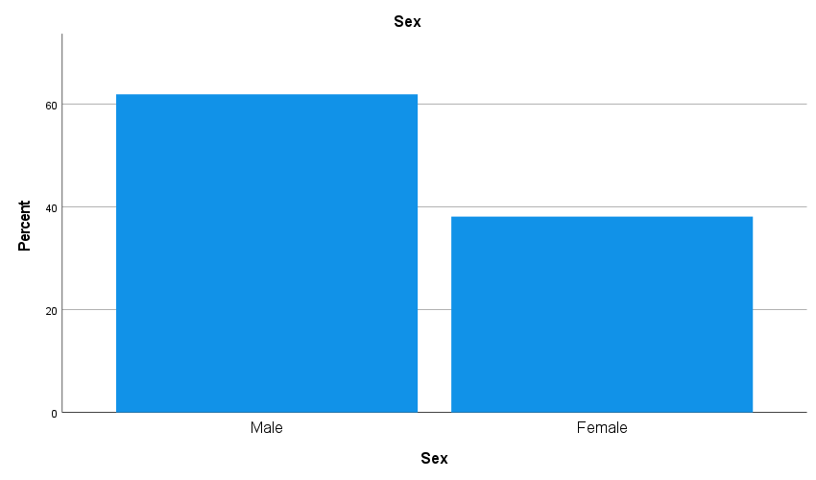
Fig. 1. Frequency distribution of the male (61.9%) and female (38.1%) students

The initial analysis assessed the relationships among variables for each item using Pearson's correlation coefficient, as in Watanabe et al. (2023) and Ryan et al. (2023). These correlations also confirmed internal consistency, similar to the Cronbach's alpha values reported in the previous subsection. For positive emotion, strong correlations were observed with "feeling positive" ($r = 0.403$), "happiness" ($r = 0.642$), and "feeling contented" ($r = 0.553$), supporting the positive emotion construct. Engagement showed moderate correlations with other engagement-related items: "feeling excited and interested in things" ($r = 0.446$) and "absorption and losing track of time" ($r = 0.132$). However, the correlation with the latter item suggests it may not be a strong measure of engagement.
Relationships demonstrated moderate to strong correlations with "feeling loved" ($r = 0.450$) and "satisfaction with personal relationships" ($r = 0.308$), supporting the construct, although this might vary across contexts. Meaning showed a strong correlation with "feeling valuable and worthwhile" ($r = 0.537$) and "accomplishment and having a sense of direction" (r ≈ 0.519). Accomplishment had strong correlations with other accomplishment-related items, such as "achieving important goals" ($r = 0.499$), "feeling valuable and worthwhile" (0.552), and "leading a purposeful and meaningful life" ($r = 0.523$). There was also a moderate correlation with "health-related items" ($r = 0.425$), which is reasonable given the potential link between progress and health. The high correlations within each factor suggest that the items within each factor reliably measure the same construct. Equally, the low correlations between items across different factors (e.g., positive vs negative emotion) support discriminant validity, indicating that the factors are distinct. Moderate correlations across different factors (e.g., positive emotion and meaning) suggest that these constructs are related and contribute to overall well-being while remaining distinct. Overall, these findings provide strong evidence for internal consistency, convergent validity, and discriminant validity of the PERMA constructs. We also used an Exploratory Factor Analysis (EFA) to estimate factor loadings, identify items that load highly on each factor, and explain the variance accounted for by each factor (Watkins, 2018; Martín-Díaz & Fernández-Abascal, 2024). Table VI presents the factor-loading analysis of how each item loads onto the different factors.
Table 6. Factor loading analysis of selected items

Item | Factor 1 | Factor 2 | Factor 3 | Factor 4 | Factor 5
How much of the time do you feel you are making progress toward accomplishing your goals? | 0.6061 | 0.2644 | 0.2559 | 0.1565 | 0.0258
How often do you become absorbed in what you are doing? | 0.1629 | 0.2063 | 0.2208 | 0.4461 | 0.1187
In general, how often do you feel joyful? | 0.2470 | 0.6632 | 0.2552 | 0.2765 | -0.0747
In general, how often do you feel anxious? | -0.0500 | 0.0076 | -0.0740 | 0.1967 | 0.5694
How often do you achieve the important goals you have set for yourself? | 0.4795 | 0.2081 | 0.2667 | 0.4287 | 0.1237
In general, how would you say your health is? | 0.2087 | 0.2212 | 0.8137 | 0.2495 | 0.0405
In general, to what extent do you lead a purposeful and meaningful life? | 0.5612 | 0.2062 | 0.2361 | 0.3964 | 0.0233
To what extent do you receive help and support from others when you need it? | 0.2871 | 0.4406 | 0.0895 | 0.1303 | 0.0530
In general, to what extent do you feel that what you do in your life is valuable and worthwhile? | 0.6512 | 0.2459 | 0.1514 | 0.1949 | 0.0513
In general, to what extent do you feel excited and interested in things? | 0.2340 | 0.2276 | 0.1092 | 0.6416 | 0.0666
How lonely do you feel in your daily life? | -0.0320 | -0.1492 | 0.0909 | -0.0013 | 0.4896
How satisfied are you with your current physical health? | 0.3408 | 0.2781 | 0.6768 | 0.0286 | -0.0168
In general, how do you feel positive? | 0.4450 | 0.2256 | 0.2656 | 0.2336 | -0.1546
In general, how do you feel angry? | 0.0408 | 0.0634 | -0.0184 | 0.0411 | 0.5726
How often are you able to handle your responsibilities? | 0.3434 | 0.1761 | 0.1666 | 0.5400 | 0.0591
In general, how often do you feel sad? | 0.0466 | 0.0020 | -0.0162 | -0.0822 | 0.7696
How often do you lose track of time while doing something you enjoy? | 0.1381 | 0.2408 | 0.0562 | 0.1355 | 0.2066
Compared to others of your same age and sex, how is your health? | 0.2110 | 0.1558 | 0.6151 | 0.2689 | -0.0071
To what extent do you feel loved? | 0.1274 | 0.7645 | 0.1255 | 0.2191 | -0.0027
To what extent do you generally feel you have a sense of direction in your life? | 0.5171 | 0.2074 | 0.1493 | 0.4131 | 0.0137
How satisfied are you with your personal relationships? | 0.2579 | 0.5648 | 0.2099 | 0.0941 | -0.1108
In general, to what extent do you feel contented? | 0.5516 | 0.4625 | 0.1548 | 0.1317 | 0.0252
Taking all things together, how happy would you say you are? | 0.4049 | 0.5169 | 0.2349 | 0.1526 | -0.1020

Examination of individual item loadings showed a strong loading of 0.6061 on factor 1 for the question "How much of the time do you feel you are making progress toward accomplishing your goals?" This indicates a significant contribution to the sense of accomplishment and goal achievement. Similar strong loadings on factor 1 were observed for the questions "In general, to what extent do you lead a purposeful and meaningful life" (0.5612) and "How often do you achieve the important goals you have set for yourself?" (0.4795), albeit with a moderate loading for the latter. Questions such as "In general, how often do you feel joyful?", "To what extent do you receive help and support from others when you need it?" "To what extent do you feel loved?" "How satisfied are you with your personal relationships", and "Taking all things together, how happy would you say you are?" all exhibited strong and moderate loadings on factor 2, suggesting their relationship to their respective constructs. Other questions showed strong and moderate loadings on factors 3 to 5, indicating some overlap but primarily relating to their respective constructs. This study provides empirical support for the PERMA model using factor analysis across a series of experiments. The results demonstrate that the five elements of the PERMA model are interrelated and contribute to student well-being. Notably, variables such as accomplishment and meaning emerged as strong predictors of well-being within the student sample. Additionally, positive emotion was found to be positively associated with student well-being.

4. DISCUSSION

Based on our hypothesis, we observed significant differences in the PERMA domains between international and Indian students. Males were expected to prioritize accomplishment more, as it aligns with societal perceptions of success, while females were likely to value relationships more, given their focus on social support and connections. This research examined the well-being of Indian students (n=198) in comparison to that of international students (n=33) utilizing the PERMA model. International students scored significantly higher on positive emotion (p=.004) and meaning (p=.003), supporting our hypothesis, although there was no difference in accomplishment (p=.542). Engagement and relationship scores were comparable for both groups. The higher levels of Positive Emotion and Meaning among international students may be attributed to differences in acculturation support systems. This report also provides validation of Kern et al.’s (2016) findings on cross-cultural factors in the PERMA profiler. Although still relevant, the null finding in the Engagement, Relationship, and Accomplishment scores could be due to the sample limitation (n=33 international students). It is recommended that universities focus on providing mentorship to Indian students, as this could enhance their positive emotions and sense of purpose in life. It is recommended that future research incorporate more diverse sampling and longitudinal designs to provide more comprehensive insights (Basistha & Bhuyan, 2015).
Contrary to our hypotheses, our study found no significant gender differences in any of the PERMA structures, with all demonstrating p > 0.05, unlike the findings of Chaplin (2015) and Zhao et al. (2022), where women were shown to report higher emotional dependency on relationships, and men emphasized autonomy and achievement. The study objectives were to assess the role of each PERMA component and its reliability as measures of wellness. The first set of experiments utilized OLS regression to examine how the PERMA factors collectively influence students' self-reported happiness (Craven & Islam, 2011). The R² score of 0.539 (adjusted R² of 0.498) indicates that all the considered factors were strong predictors of happiness. The individual coefficients represent the expected change in student wellness for a one-unit increase in the respective predictor while controlling for all other variables. Some of the questions emerged as significant predictors, such as 'How much of the time do you feel you are making progress toward accomplishing your goals?' with a coefficient of 0.2283 (p = 0.002), suggesting a significant association between perceived progress and higher levels of happiness. Additionally, the question 'In general, how often do you feel joyful?' yielded a coefficient of 0.4025 (p < 0.001), indicating a strong, significant positive relationship between joy and happiness. Another significant predictor was 'In general, how do you feel positive?' with a coefficient of 0.1407 ($p = 0.023$), indicating a significant association with happiness.
The OLS regression analysis revealed that the PERMA factors exhibited varying degrees of influence on predicting happiness, with positive emotions emerging as the most significant contributor. Positive emotions accounted for 46.1% of the variance in happiness (R² = 0.461), making it the strongest predictor among all PERMA dimensions. Joyful experiences (β = 0.524, p < 0.001) and overall positivity (β = 0.242, p < 0.001) were both significant, indicating that frequent positive experiences are strongly associated with greater happiness. This suggests that interventions aimed at enhancing positive emotions may have the greatest effect on well-being. Accomplishments and relationships also played significant roles in predicting happiness, explaining 31.1% (R² = 0.311) and 28.0% (R² = 0.280) of the variance, respectively. Feelings of progress toward goals (β = 0.427, p < 0.001) and achievement of important goals (β = 0.221, p < 0.001) were key drivers of happiness in the accomplishment dimension, emphasizing the importance of goal setting and attainment for well-being. Similarly, social relationships, including receiving help and support (β = 0.158, p < 0.01), satisfaction with personal relationships (β = 0.156, p < 0.01), and feeling loved (β = 0.222, p < 0.001), contributed significantly to happiness, emphasizing the importance of strong, supportive social networks for well-being.
Interestingly, the model found that negative emotions (R² = 0.004) had no significant impact on happiness, suggesting that, while they may be present, their influence on overall well-being is not as pronounced as that of positive experiences. Additionally, engagement (R² = 0.120), meaning (R² = 0.250), and health (R² = 0.223) each contributed moderately to happiness. Engagement in absorbing activities (β = 0.253, p < 0.001), a sense of purpose (β = 0.272, p < 0.001), and satisfaction with current health (β = 0.25, p < 0.01) were all positively associated with happiness, reinforcing the notion that leading a fulfilling life involves a balance of mental, emotional, and physical well-being.
This study's results indicate that most students scored moderately across all PERMA constructs, yet their scores were lower compared to those reported in the study by Khaw and Kern (2014). Another evident observation is students' tendency to choose the middle response option on the 10-point rating scale, reflecting a moderate response style (Lee & Wu, 2008). This contrasts with Western individuals, who often exhibit an extreme response style, and aligns with previous findings suggesting cultural differences in response styles (Harzing et al., 2009). Most students demonstrated moderate levels of positive emotion and engagement, which aligns with the overall tendency to select midpoint options on the rating scale, suggesting a balanced yet unenthusiastic state of well-being. Responses to relationship-related questions, such as "feeling lonely" and "feeling sad," showed variability, suggesting a mix of positive and negative emotions. This heterogeneity is typical in high-pressure environments where academic and personal achievements may be prioritized over deep social connections. This finding is particularly pertinent in Asian educational settings, where academic excellence often overshadows social well-being.
Students reported relatively high scores on items related to accomplishments and a meaningful life, suggesting that many respondents perceive achievement and purpose as substantial contributors to their well-being. This emphasis on accomplishment and meaning likely reflects cultural values prioritizing educational and personal success as indicators of a well-lived life. The students reported high levels of self-perceived health and contentment, consistent with the notion that subjective well-being is closely linked to self-reported health (Pressman, 2005; Diener & Chain, 2011). This positive assessment of health and contentment is expected, given India's cultural emphasis on exercise, herbal remedies, and a healthy diet. Despite overall positive indicators, there were significant reports of student anger. This suggests underlying stressors that may be affecting their emotional well-being. The high performance and competitive nature of the academic environment could be contributing factors to these feelings of anger.
The study also examined the average PERMA scores of male and female students across different dimensions. Female students exhibited slightly lower average scores than male students in health-related questions. Female students tended to feel more loved but reported feeling sad, angry, and anxious more frequently than male students. Overall, male students tended to report higher well-being across most aspects of the PERMA model than female students, except for meaningful life and certain emotional metrics, as shown in Figure 2. Figure 3 compares the overall PERMA scores for domestic and international students. However, it's important to note that the sample of domestic students was larger than that of international students.

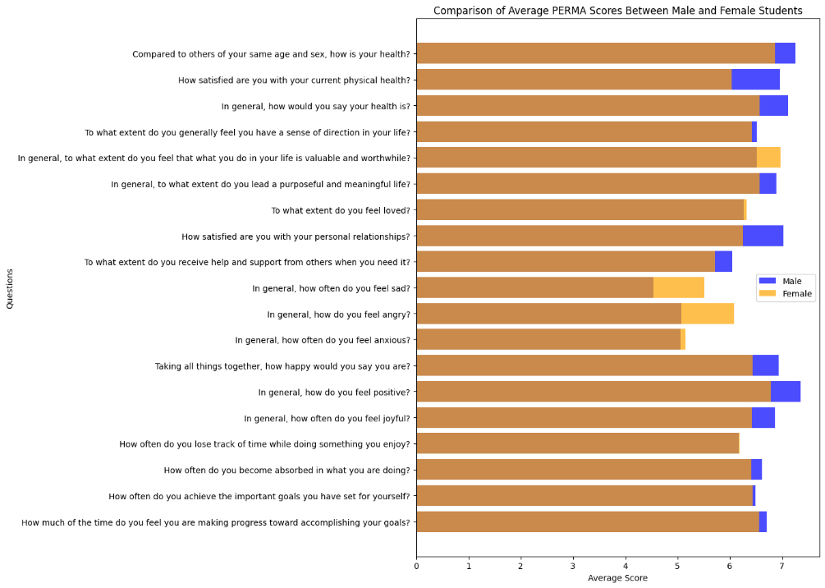
Fig. 2. Comparison of Average PERMA Scores Between Male and Female Students

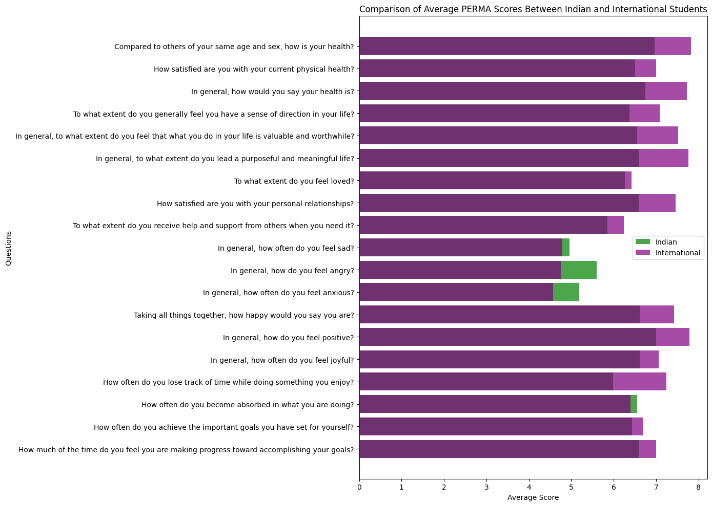
Fig. 3. Comparison of Average PERMA Scores Between Domestic and International Students

A limitation of this study is the relatively small sample size of international students ($n = 33$), which may limit the generalizability of nationality-based comparisons and introduce potential selection bias. International participants were drawn from specific institutional contexts and may not fully represent the broader international student population in India. To evaluate statistical sensitivity, a post-hoc power analysis was conducted using observed effect sizes from Welch’s t-test comparisons. The significant differences observed for Positive Emotion, Meaning, and Engagement achieved statistical power exceeding the recommended threshold of 0.80, indicating adequate sensitivity for detecting medium-sized effects. Nevertheless, unequal group sizes may have reduced the ability to detect smaller effects, and future studies should aim for larger and more balanced international samples. Another limitation is that the low internal consistency of the Engagement subscale indicates that inferences about this dimension should be made with caution and may reflect contextual/cultural differences in the conceptualization of engagement. One possible explanation is differences in how students across cultures conceptualize engagement-related notions such as absorption, interest, and involvement in academic activities.

5. Conclusion

While students generally exhibit moderate levels of well-being across the PERMA constructs, it is important to note that cultural nuances play a crucial role in shaping their responses. These results also demonstrate the effectiveness of the PERMA model in measuring well-being and enabling individuals from different cultures to understand one another and cultivate positive interactions. Student well-being is a multifaceted construct that significantly impacts academic performance, social interactions, and overall life satisfaction. In high-performance environments, especially within Asian educational settings, there is a pronounced focus on academic achievement, which may overshadow other crucial aspects of well-being, leading to the high prevalence of mental health concerns, anxiety, depression, and stress among students. This study examines the applicability of the PERMA model to the Indian education sector, exploring how each element – positive emotion, engagement, relationships, meaning, health and accomplishment affects student well-being. Students generally scored moderately across all PERMA constructs, with higher scores in areas related to accomplishments and meaning, highlighting the importance of these elements in their perception of well-being. The results also show high levels of health and contentment levels reflecting the positive impact of ingrained practices of healthy living. There were also mixed responses to relationship-related questions and notable reports of anger, indicating potential stressors affecting students' social and emotional well-being. The findings underscore the importance of a comprehensive approach to well-being, encompassing multiple dimensions, as demonstrated by the PERMA model. Future studies could explore potential differences in the PERMA model's applicability across subgroups, such as students from different countries, and the development of support programs to identify student vulnerabilities and foster well-being.

INFORMED ConsenT

Informed consent was obtained from all individual participants included in the study.

Ethical approval

In accordance with international and university standards, the authors have provided written ethical approval.

DISCLAIMER

The authors hereby declare that NO generative AI technologies such as Large Language Models (ChatGPT, COPILOT, etc.) and text-to-image generators have been used during the writing or editing of this manuscript.

References

Vasileiou K., Barnett J., Barreto M., Vines J., Atkinson M., Long K., Bakewell L., Lawson S., Wilson M., 2019, Coping with loneliness at university: A qualitative interview study with students in the UK, Mental Health & Prevention, 13, 21–30. https://doi.org/10.1016/j.mhp.2018.11.002
Lan Z., Liu H., Huang X., Wang Q., Deng F., Li J., 2023, The impact of academic pressure and peer support on adolescents’ loneliness: A polynomial regression and response surface analysis, Psychology Research and Behavior Management, 16, 4617–4627. https://doi.org/10.2147/PRBM.S435977
Chaudhry S., Tandon A., Shinde S., Bhattacharya A., 2024, Student psychological well-being in higher education: The role of internal team environment, institutional, friends and family support and academic engagement, PLoS One, 19(1), e0297508. https://doi.org/10.1371/journal.pone.0297508
Hossain M.M., Tasnim S., Sultana A., Faizah F., Mazumder H., Zou L., McKyer E.L., Ahmed H.U., Ma P., 2020, Epidemiology of mental health problems in COVID-19: A review, F1000Research, 9, 636. https://doi.org/10.12688/f1000research.24457.1
Ulrich-Lai Y.M., Herman J.P., 2009, Neural regulation of endocrine and autonomic stress responses, Nature Reviews Neuroscience, 10(6), 397–409. https://doi.org/10.1038/nrn2647
Danese A., McEwen B.S., 2012, Adverse childhood experiences, allostasis, allostatic load, and age-related disease, Physiology & Behavior, 106(1), 29–39. https://doi.org/10.1016/j.physbeh.2011.08.019
Dehghani Y., Hoseini F.S., Jamshidi F., 2024, The effects of easy minds program on working memory and selective attention in students with math learning disabilities, International Journal of Disability, Development and Education, 71(4), 620–632. https://doi.org/10.1080/1034912X.2022.2140782
Govorova E., Benítez I., Muñiz J., 2020, How schools affect student well-being: A cross-cultural approach in 35 OECD countries, Frontiers in Psychology, 11, 431. https://doi.org/10.3389/fpsyg.2020.00431
David R., Singh S., Mikkilineni S., Ribeiro N., 2024, A positive psychological approach for improving the well-being and performance of employees, International Journal of Productivity and Performance Management, 73(9), 2883–2900. https://doi.org/10.1108/IJPPM-12-2022-0618
Kaya R., Tanrıverdi D., 2024, The effect on mental well-being, life attitude and depression levels of positive psychology program applied to patients diagnosed with depression, Current Psychology, 43(1), 119–131. https://doi.org/10.1007/s12144-023-04244-6
Seligman M.E.P., 2018, PERMA and the building blocks of well-being, The Journal of Positive Psychology, 13(4), 333–335. https://doi.org/10.1080/17439760.2018.1437466
Gable S.L., Reis H.T., Impett E.A., Asher E.R., 2018, What do you do when things go right? The intrapersonal and interpersonal benefits of sharing positive events, Relationships, Well-Being and Behaviour, –, 144–182.
Iasiello M., Bartholomaeus J., Jarden A., Kelly G., 2017, Measuring PERMA+ in South Australia, the State of Wellbeing: A comparison with national and international norms, Journal of Positive Psychology and Wellbeing, 1(2), 53–72.
Hidayat R., Habibi A., Saad M.R., Mukminin A., Wan Idris W.I., 2018, Exploratory and confirmatory factor analysis of PERMA for Indonesian students in mathematics education programmes, Pedagogika, 132(4), 147–165.
Yang L., Mohd R.B., 2021, Exploratory and Confirmatory Factor Analysis of PERMA for Chinese University EFL Students in Higher Education, International Journal of Language Education, 5(2), 51–62. https://ojs.unm.ac.id/ijole/index
Wammerl M., Jaunig J., Mairunteregger T., Streit P., 2019, The German version of the PERMA-Profiler: Evidence for construct and convergent validity of the PERMA theory of well-being in German-speaking countries, Journal of Well-Being Assessment, 3(2), 75–96. https://doi.org/10.1007/s41543-019-00021-0
Lambert D’raven L., Pasha-Zaidi N., 2016, Using the PERMA model in the United Arab Emirates, Social Indicators Research, 125(3), 905–933. https://doi.org/10.1007/s11205-015-0866-0
Umucu E., Wu J.R., Sanchez J., Brooks J.M., Chiu C.Y., Tu W.M., Chan F., 2020, Psychometric validation of the PERMA-profiler as a well-being measure for student veterans, Journal of American College Health, 68(3), 271–277. https://doi.org/10.1080/07448481.2018.1546182
Pradhan R.K., Jandu K., 2023, Evaluating the impact of conscientiousness on flourishing in the Indian higher education context: Mediating role of emotional intelligence, Psychological Studies, 68(2), 223–235. https://doi.org/10.1007/s12646-022-00712-4
Makhmur S., Rath S., 2022, PERMA dimensions of well-being among diabetic and non-diabetic adults: Evidence from two diabetic care hospitals in Odisha, Psychological Studies, 67(4), 468–479. https://doi.org/10.1007/s12646-022-00677-4
Shaji D.T., Rema M.K., Rodrigues H.C., 2023, Happiness among consecrated community in India: A PERMA model study, Research Square, PREPRINT (1), 1-21. https://doi.org/10.21203/rs.3.rs-3670395/v1
Kneavel M., 2021, Relationship between gender, stress, and quality of social support, Psychological Reports, 124(4), 1481–1501. https://doi.org/10.1177/0033294120939844
Kendler K.S., Myers J., Prescott C.A., 2005, Sex differences in the relationship between social support and risk for major depression: A longitudinal study of opposite-sex twin pairs, American Journal of Psychiatry, 162(2), 250–256. https://doi.org/10.1176/appi.ajp.162.2.250
Lupart J.L., Cannon E., Telfer J.A., 2004, Gender differences in adolescent academic achievement, interests, values and life‐role expectations, High Ability Studies, 15(1), 25–42. https://doi.org/10.1080/1359813042000225320
Schueller S.M., Seligman M.E.P., 2010, Pursuit of pleasure, engagement, and meaning: Relationships to subjective and objective measures of well-being, The Journal of Positive Psychology, 5(4), 253–263. https://doi.org/10.1080/17439761003794130
Peterson C., Park N., Seligman M.E.P., 2005, Orientations to happiness and life satisfaction: The full life versus the empty life, Journal of Happiness Studies, 6(1), 25–41. https://doi.org/10.1007/s10902-004-1278-z
Lopez S.J. (Ed.), 2011, The Encyclopedia of Positive Psychology, John Wiley & Sons, 442-448.
Vella-Brodrick D.A., Park N., Peterson C., 2009, Three ways to be happy: Pleasure, engagement, and meaning—Findings from Australian and US samples, Social Indicators Research, 90(2), 165–179. https://doi.org/10.1007/s11205-008-9251-6
Headey B., Schupp J., Tucci I., Wagner G.G., 2010, Authentic happiness theory supported by impact of religion on life satisfaction: A longitudinal analysis with data for Germany, The Journal of Positive Psychology, 5(1), 73–82. https://doi.org/10.1080/17439760903435232
Matthewman L.J., Jodhan-Gall D., Nowlan J., O'Sullivan N., Patel Z., 2018, Primed, prepped and primped: Reflections on enhancing student wellbeing in tertiary education, Psychology Teaching Review, 24(1), 67–77.
Huppert F.A., So T.T.C., 2013, Flourishing across Europe: Application of a new conceptual framework for defining well-being, Social Indicators Research, 110(3), 837–861. https://doi.org/10.1007/s11205-011-9966-7
Norrish J.M., Williams P., O'Connor M., Robinson J., 2013, An applied framework for positive education, International Journal of Wellbeing, 3(2), 147–161.
Butler J., Kern M.L., 2016, The PERMA-Profiler: A brief multidimensional measure of flourishing, International Journal of Wellbeing, 6(3), 1–48. https://doi.org/10.5502/ijw.v6i3.526
Watanabe K., Kawakami N., Shiotani T., Adachi H., Matsumoto K., Imamura K., Yamagami F., Fusejima A., Muraoka T., Kagami T., 2018, The Japanese workplace PERMA-Profiler: A validation study among Japanese workers, Journal of Occupational Health, 60(5), 383–393. https://doi.org/10.1539/joh.2018-0050-OA
Ryan J., Curtis R., Olds T., Edney S., Vandelanotte C., Plotnikoff R., Maher C., 2019, Psychometric properties of the PERMA Profiler for measuring wellbeing in Australian adults, PLoS One, 14(12), e0225932. https://doi.org/10.1371/journal.pone.0225932
Watkins M.W., 2018, Exploratory factor analysis: A guide to best practice, Journal of Black Psychology, 44(3), 219–246. https://doi.org/10.1177/0095798418771807
Martín-Díaz M.D., Fernández-Abascal E.G., 2024, Multidimensional Measure of Well-Being, Translation, Factor Structure, Measurement Invariance, Reliability and Validity of the PERMA-Profiler in Spain, Applied Research in Quality of Life, 19(5), 2503–2538. https://doi.org/10.1007/s11482-024-10342-9
Kern M.L., Benson L., Steinberg E.A., Steinberg L., 2016, The EPOCH measure of adolescent well-being, Psychological Assessment, 28(5), 586–597. https://psycnet.apa.org/doi/10.1037/pas0000201
Basistha B., Bhuyan K., 2024, The PERMA Model in Practice: Exploring Life Satisfaction and Wellbeing, Inspa Journal of Applied and School Psychology 6(1), 463-473
Chaplin T.M., 2015, Gender and emotion expression: A developmental contextual perspective, Emotion Review, 7(1), 14–21. https://doi.org/10.1177/1754073914544408
Zhao D., Li G., Zhou M., Wang Q., Gao Y., Zhao X., Zhang X., Li P., 2022, Differences according to sex in the relationship between social participation and well-being: A network analysis, International Journal of Environmental Research and Public Health, 19(20), 13135. https://doi.org/10.3390/ijerph192013135
Craven B.D., Islam S.M., 201 1, Ordinary least-squares regression, The SAGE Dictionary of Quantitative Management Research, –, 224–228.
Khaw D., Kern M., 2014, A cross-cultural comparison of the PERMA model of well-being, Undergraduate Journal of Psychology at Berkeley, 8(1), 10–23.
Lee S.J., Wu C.H., 2008, Comparing the level of positive tendency in a life satisfaction evaluation between Chinese and Western people, Social Indicators Research, 89(1), 147–156. https://doi.org/10.1007/s11205-007-9227-y
Harzing A.W., Baldueza J., Barner-Rasmussen W., Barzantny C., Canabal A., Davila A., Espejo A., Ferreira R., Giroud A., Koester K., Liang Y.K., 2009, Rating versus ranking: What is the best way to reduce response and language bias in cross-national research?, International Business Review, 18(4), 417–432. https://doi.org/10.1016/j.ibusrev.2009.03.001
Pressman S.D., Cohen S., 2005, Does positive affect influence health?, Psychological Bulletin, 131(6), 925–971.
Diener E., Chan M.Y., 2011, Happy people live longer: Subjective well-being contributes to health and longevity, Applied Psychology: Health and Well-Being, 3(1), 1–43. https://doi.org/10.1111/j.1758-0854.2010.01045.x

https://www.statista.com/statistics/918403/number-of-universities-worldwide-by-country/

