Microplastic Removal in Urban Wastewater: A Systematic Review of Treatment Technologies, Efficiency Determinants, and Environmental Fate
Abstract
Microplastics have emerged as pervasive contaminants in aquatic environments, with urban wastewater treatment plants acting as major pathways for their entry into receiving water bodies. Although conventional wastewater treatment processes remove a substantial proportion of microplastics, complete elimination remains challenging, and the mechanisms underlying removal variability are not fully understood. This study presents a structured review of microplastic removal technologies in urban wastewater, synthesizing evidence on treatment approaches, reported removal efficiencies, and emerging research trends. A systemic literature search across major academic databases identified approximately 250 records, of which 19 studies met the inclusion criteria following staged screening and focused full-text assessment. The findings indicate that conventional wastewater treatment systems achieve median removal efficiencies of approximately 85–90%, primarily through sedimentation and sludge partitioning, yet residual microplastics persist in treated effluents. In contrast, advanced and hybrid treatment technologies consistently exceed 90% removal efficiency, with some studies reporting near-complete removal under optimized conditions. However, removal performance is strongly influenced by particle characteristics, including size, morphology, and polymer type, rather than treatment technology alone. Importantly, a significant proportion of microplastics is transferred from the aqueous phase into sludge, suggesting that current systems function as redistribution pathways rather than definitive removal solutions. This review provides a system-level perspective on microplastic removal and highlights the need for full-scale validation of emerging technologies, methodological standardization, and comprehensive assessment of microplastic fate to support effective wastewater management strategies.
Keywords: Microplastics; wastewater treatment; removal efficiency; advanced treatment technologies; sludge fate.

1. Introduction
Plastic pollution has become a defining environmental challenge of the twenty-first century, with microplastics emerging as a particularly pervasive and complex component of this global crisis. Microplastics, commonly defined as plastic particles smaller than 5 mm, originate from both the fragmentation of larger plastic debris and the direct release of manufactured microscopic particles used in industrial and consumer products(Karak et al., 2025; Lawal et al., 2025). Due to their small size, persistence, and resistance to biodegradation, microplastics are widely distributed across environmental compartments, including marine systems, freshwater bodies, soils, and even the atmosphere(Cavazzoli et al., 2025). Their ubiquity has raised significant concerns regarding ecological disruption and potential human health risks through exposure pathways such as water, food, and air(Jolaosho et al., 2025; Maurya & Kumar, 2026).
Urban wastewater systems are now recognized as a major conduit for microplastics entering aquatic environments(Fältström & Anderberg, 2020). Domestic and urban activities, including the laundering of synthetic textiles, personal care product usage, and degradation of plastic materials, contribute substantially to the continuous release of microplastics into municipal wastewater streams(Ali & Khan, 2026; Talukdar et al., 2024) . Wastewater treatment plants (WWTPs) therefore represent a critical control point in the environmental pathway of microplastics(Faauma et al., 2026). While these systems are not specifically designed to target microplastic particles, they play a pivotal role in intercepting and reducing their discharge into receiving water bodies(Sadia et al., 2022).
Existing evidence suggests that conventional wastewater treatment processes, including primary sedimentation, secondary biological treatment, and tertiary polishing, can remove a substantial proportion of microplastics. Reported removal efficiencies frequently exceed 80%, yet complete elimination is rarely achieved(Chalaris et al., 2023). Residual microplastics are consistently detected in treated effluents, indicating that current systems function as partial barriers rather than definitive solutions. Furthermore, a significant fraction of microplastics is transferred from the aqueous phase into sewage sludge, raising concerns about secondary environmental release through sludge disposal and reuse practices(Das et al., 2025; Faauma et al., 2026). These findings underscore the complexity of microplastic removal and highlight the need for a more nuanced understanding of treatment performance.
In response to these limitations, a growing body of research has focused on advanced and emerging treatment technologies, including membrane filtration, electrocoagulation, adsorption-based systems, and hybrid treatment configurations. These approaches aim to enhance removal efficiency through improved particle capture, aggregation, or physicochemical interactions. While many studies report high removal efficiencies under controlled conditions, the evidence remains fragmented across different technologies, treatment scales, and methodological approaches. Variability in sampling strategies, analytical techniques, and reporting metrics further complicates cross-study comparison and limits the ability to draw generalizable conclusions.
A critical limitation of the existing literature is its predominant focus on reporting removal efficiencies without adequately examining the underlying mechanisms driving variability. In particular, the extent to which reported removal reflects true elimination versus phase transfer into sludge is often overlooked. Additionally, there is limited integration of findings across conventional, advanced, and hybrid treatment systems within a unified analytical framework. As a result, it remains unclear which technologies offer the most effective, scalable, and sustainable solutions for microplastic mitigation in urban wastewater systems.
Addressing these gaps requires a systematic and integrative synthesis of the available evidence. A systematic review approach provides a transparent and reproducible framework for evaluating the literature, enabling the consolidation of findings across diverse studies and facilitating critical comparison of treatment technologies and performance outcomes. Such an approach is essential for advancing understanding beyond descriptive reporting and toward a more mechanistic and system-level interpretation of microplastic removal.
Therefore, this study aims to systematically synthesize current evidence on microplastic removal in urban wastewater treatment systems. Specifically, the objectives of this review are to (i) identify the treatment technologies employed for microplastic removal, (ii) evaluate reported removal efficiencies across different systems and operational conditions, and (iii) examine emerging research trends and key knowledge gaps. By integrating findings across studies and treatment scales, this review seeks to provide a clearer understanding of the capabilities and limitations of existing technologies and to inform future research and policy strategies for mitigating microplastic pollution in urban wastewater systems.

2. Methodology
2.1 Study Design
This study was conducted as a systematic review in accordance with the Preferred Reporting Items for Systematic Reviews and Meta-Analyses (PRISMA 2020) guidelines. The objective was to synthesize existing evidence on microplastic removal technologies in urban wastewater treatment systems using a transparent, structured, and reproducible approach.
2.2 Search Strategy
A comprehensive literature search was conducted across three major academic databases: PubMed, Dimensions, and Google Scholar. The search was performed between January 2020 and March 2026 and was limited to studies published in English. The objective of the search was to identify studies addressing microplastics in wastewater treatment systems and their removal using various treatment technologies.
Database-specific search strategies were developed and adapted to reflect differences in indexing systems and search functionalities.
For PubMed, the following search string was used:
(“microplastics” OR “microplastic particles”) AND (“wastewater treatment” OR “wastewater treatment plant” OR “WWTP”) AND (“removal efficiency” OR “removal” OR “filtration” OR “membrane” OR “electrocoagulation” OR “adsorption”)
For Dimensions, a similar keyword-based search was applied:
“microplastics” AND “wastewater treatment” AND (“removal efficiency” OR “treatment” OR “filtration” OR “membrane” OR “electrocoagulation” OR “adsorption”)
For Google Scholar, a simplified search strategy was used due to platform limitations:
“microplastics wastewater treatment removal”
The search yielded a total of 250 records, including 150 records from Dimensions, 60 records from PubMed, and 40 records from Google Scholar. All retrieved records were exported and compiled into a single dataset for subsequent screening.
2.3 Study Selection Process
The study selection process followed a structured multi-stage screening procedure consistent with PRISMA guidelines. Initially, a total of 250 records were identified through database searching. Duplicate records were removed, resulting in 220 unique articles. These records were then screened based on their titles and abstracts to assess their relevance to microplastic occurrence and removal in wastewater treatment systems.
During this initial screening stage, 160 records were excluded because they did not directly address the research focus or lacked sufficient relevance. The remaining 60 articles were retrieved for full-text assessment. Each full-text article was evaluated against predefined eligibility criteria to determine its suitability for inclusion in the review.
A total of 41 articles were excluded at the full-text stage. The reasons for exclusion included lack of focus on wastewater treatment systems, absence of evaluation of microplastic removal technologies, classification as review articles or editorials, and insufficient reporting of removal efficiency or relevant data. Following this process, 19 studies met all inclusion criteria and were included in the final synthesis. The overall study selection process is presented in Figure 1 using a PRISMA 2020 flow diagram.
2.4 Eligibility Criteria
The inclusion and exclusion criteria applied during study selection are summarized in Table 1.
Table 1. Inclusion and exclusion criteria for the study

Criterion Type | Inclusion Criteria | Exclusion Criteria
Study type | Peer-reviewed journal articles | Reviews, editorials, opinion papers
Language | English | Non-English publications
Study focus | Microplastics in wastewater treatment systems | Studies not related to wastewater systems
Outcomes | Reports removal efficiency, treatment performance, or fate of microplastics | No data on removal efficiency or treatment performance
Study scale | Laboratory, pilot, or full-scale studies | Studies lacking empirical or experimental basis
Data quality | Provides sufficient quantitative or qualitative data | Insufficient or unclear data

2.5 Data Extraction
Relevant data were systematically extracted from each of the included studies. Extracted information included study location, scale of operation, type of treatment technology employed, reported removal efficiencies, and key findings related to microplastic characteristics such as size, morphology, and polymer type. Additional information on operational conditions and treatment performance was also recorded where available.
2.6 Data Synthesis
The extracted data were synthesized using a qualitative approach to identify patterns and trends across the included studies. Treatment technologies were grouped into major categories, including conventional wastewater treatment processes, advanced treatment systems, electrochemical methods, adsorption-based technologies, and hybrid configurations. This categorization enabled comparative analysis of removal performance and facilitated the identification of key factors influencing microplastic removal efficiency.
3. Results
3.1 Study Selection
The literature search yielded approximately 250 records across the selected databases. After removal of duplicates, 220 unique records remained and were screened based on titles and abstracts.
A total of 160 records were excluded at this stage due to lack of relevance to microplastics in wastewater treatment. The remaining 60 articles were retrieved for full-text assessment.
Following full-text evaluation, 41 articles were excluded because they did not meet the inclusion criteria, including lack of focus on wastewater treatment, absence of removal technology evaluation, or insufficient data on removal efficiency. Ultimately, 19 studies were included in the final synthesis. The study selection process is summarized in Figure 1.
Figure 1 shows PRISMA 2020 flow diagram illustrating the systematic study selection process. The diagram shows the identification of 250 records across databases, removal of duplicates, screening stages, and final inclusion of 19 studies based on predefined eligibility criteria.
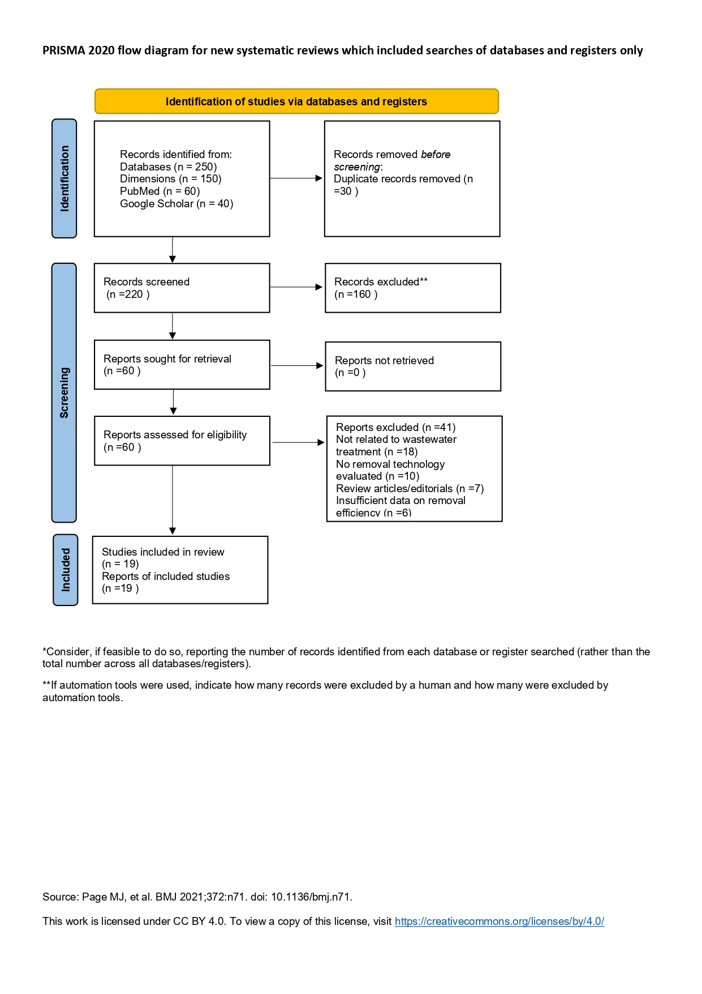
Fig. 1 PRISMA 2020 flow diagram for new systematic reviews
3.2 Study Characteristics
The included studies represent a diverse body of evidence encompassing full-scale wastewater treatment plants, pilot-scale systems, and laboratory-based experimental investigations across multiple geographic regions. As summarized in Table 2, the majority of studies were conducted at full scale, reflecting real-world treatment conditions, while a substantial proportion of laboratory studies focused on emerging technologies such as electrocoagulation, adsorption, and hybrid systems.
Table 2. Characteristics of Included Studies on Microplastic Removal in Urban Wastewater (n = 19)
Study | Country | Study type | Treatment technology | Removal efficiency (%) | Key findings
AlShamaileh & Alzoubi (2025) | Jordan | Full-scale | Municipal WWTP | ~62 | Partial removal observed; reduction from influent to effluent
Conley et al. (2019) | USA | Full-scale | Municipal WWTPs (3 plants) | 85–97 | High removal, though residual discharge persists
Contreras-Llin & Diaz-Cruz (2024) | Spain | Full-scale | Managed aquifer recharge with reactive barriers | >90 | Reactive barriers enhanced retention
Liu et al. (2020) | Denmark | Pilot | Biofiltration polishing stage | ~79 | Improved removal in tertiary stage
Flores-Munguía et al. (2023) | Mexico | Full-scale | Conventional WWTPs (3 plants) | 82–98 | Consistent removal across stages
Bayo et al. (2021) | Spain | Full-scale | Tertiary (oxidation ditch, filtration, UV) | ~64 | Fibers less efficiently removed
Mahmoudnia et al. (2023) | Iran | Laboratory | Electrocoagulation | ~82.5 | Effective aggregation and removal
Le et al. (2023) | Vietnam | Full-scale | CAS, SBR, tertiary systems | >80 | Performance varies by configuration
Chen et al. (2025) | China | Full-scale | Municipal WWTP | 73–86 | Seasonal variability observed
Zhu et al. (2025) | China | Full-scale | Municipal WWTP | up to ~99 | Efficiency depends on size and polymer
Setiadewi et al. (2026) | Indonesia | Full-scale | Municipal WWTP | >90 | High removal across treatment stages
Alnasrawy (2026) | Iraq | Laboratory | Banana peel adsorption | 97.5–>99 | Low-cost adsorbent highly effective
Iordachescu et al. (2024) | Mediterranean | Full-scale | Advanced WWTP | 99–99.95 | Near-complete removal achieved
Indhur et al. (2025) | International | Laboratory | Magnetic nanocomposites | 83–92 | High efficiency, reusable materials
Mohd Napi et al. (2023) | Malaysia | Laboratory | GAC filtration | up to 95.5 | Strong tertiary treatment potential
Perren et al. (2018) | Switzerland | Laboratory | Electrocoagulation reactor | up to ~99 | Highly effective under optimized conditions
Li et al. (2024) | China | Full-scale | Tertiary WWTPs (3 plants) | 76–91 | Significant reduction across stages
Akarsu et al. (2021) | Turkey | Pilot | Electrocoagulation + membrane | ~100 | Near-complete removal achieved
Kim & Park (2021) | South Korea | Laboratory | Electrocoagulation + carbon | ~90 | Aggregation enhances filtration
Across the included studies, microplastic characterization commonly relied on microscopy combined with spectroscopic confirmation techniques such as Fourier-transform infrared spectroscopy, enabling reliable identification of dominant polymer types including polyethylene, polypropylene, and polyethylene terephthalate (Flores-Munguía et al., 2023; Setiadewi et al., 2026). Despite methodological differences, a consistent pattern was observed in particle morphology, with fibers and fragments representing the predominant forms across influent and effluent samples.

A key cross-study observation is the strong influence of particle size on removal performance. Larger particles were consistently removed more efficiently across treatment stages, whereas smaller particles remained detectable in treated effluents, indicating limitations in current treatment systems(Liu et al., 2020).
The methodological quality of the included studies was evaluated across key domains, including sampling design, identification methods, and reporting transparency, as summarized in Table 3.
Table 3: Quality assessment of included studies based on sampling design, identification methods, and reporting transparency.
Study | Sampling design | Identification method | Reporting transparency | Overall quality
AlShamaileh & Alzoubi (2025) | Moderate | FTIR | Moderate | Moderate
Conley et al. (2019) | High | FTIR | High | High
Contreras-Llin & Diaz-Cruz (2024) | High | FTIR | High | High
Liu et al. (2020) | Moderate | FTIR | High | High
Flores-Munguía et al. (2023) | High | FTIR | High | High
Bayo et al. (2021) | High | Microscopy + FTIR | High | High
Mahmoudnia et al. (2023) | Moderate | Microscopy | Moderate | Moderate
Le et al. (2023) | High | FTIR | Moderate | High
Chen et al. (2025) | High | FTIR | High | High
Zhu et al. (2025) | Moderate | FTIR | Moderate | Moderate
Setiadewi et al. (2026) | High | FTIR | Moderate | High
Alnasrawy (2026) | Moderate | Microscopy | Moderate | Moderate
Iordachescu et al. (2024) | High | FTIR | High | High
Indhur et al. (2025) | Moderate | Spectroscopy | Moderate | Moderate
Mohd Napi et al. (2023) | Moderate | Microscopy | Moderate | Moderate
Perren et al. (2018) | Moderate | Microscopy + FTIR | High | High
Li et al. (2024) | High | FTIR | High | High
Akarsu et al. (2021) | Moderate | Microscopy | Moderate | Moderate
Kim & Park (2021) | Moderate | Microscopy | Moderate | Moderate
As shown in Table 2, studies employing spectroscopic techniques such as FTIR or Raman spectroscopy generally demonstrated higher analytical reliability and were classified as high quality. In contrast, studies relying solely on visual identification were associated with greater uncertainty. Full-scale studies tended to exhibit stronger sampling designs, while laboratory-based studies often showed greater variability in reporting transparency. These methodological differences were considered in interpreting removal efficiencies across studies.
3.3 Treatment Technologies for Microplastic Removal (RQ1)
The included studies encompass a wide range of treatment technologies, which can be broadly categorized into conventional wastewater treatment systems, tertiary and advanced processes, electrochemical methods, adsorption-based systems, and hybrid treatment configurations.
As illustrated in Figure 2, microplastic removal in wastewater treatment systems occurs across multiple stages, with a significant proportion transferred from the aqueous phase into sludge rather than being completely eliminated.
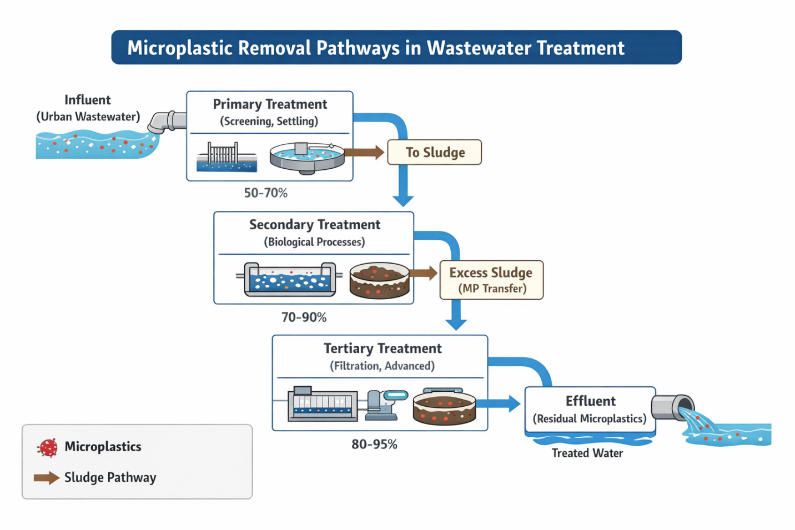
Figure 2. Conceptual pathways of microplastic removal and redistribution in urban wastewater treatment systems.
The figure illustrates the movement of microplastics through primary, secondary, and tertiary treatment stages, highlighting that a significant proportion is transferred from the aqueous phase into sludge, while residual particles remain in treated effluent. This emphasizes that reported removal efficiencies often reflect phase transfer rather than complete elimination.

Conventional wastewater treatment plants remain the most widely investigated systems. Across full-scale studies, removal efficiencies ranged from approximately 62% to 97%, with most studies reporting values above 80% (AlShamaileh & Alzoubi, 2025; Chen et al., 2025; Conley et al., 2019; Li et al., 2024). These systems primarily rely on physical separation mechanisms such as sedimentation and sludge partitioning, which result in substantial but incomplete removal of microplastics.
Tertiary and advanced treatment processes demonstrated improved performance. Biofiltration systems enhanced particle retention, particularly for larger particles (Liu et al., 2020), while advanced treatment configurations incorporating coagulation, flocculation, and filtration achieved removal efficiencies exceeding 99% (Iordachescu et al., 2024). Reactive barrier systems further highlighted the importance of material composition in enhancing microplastic retention(Contreras-Llin & Diaz-Cruz, 2024).
Electrochemical processes, particularly electrocoagulation, consistently demonstrated high removal efficiencies ranging from approximately 82% to over 99% depending on operational conditions (Mahmoudnia et al., 2023; Perren et al., 2018). These systems enhance removal by promoting particle aggregation, facilitating subsequent separation.
Adsorption-based technologies and emerging materials represent a rapidly evolving research area. Granular activated carbon achieved removal efficiencies up to 95.5% (Amirah Mohd Napi et al., 2023), while magnetic nanocomposites demonstrated removal efficiencies exceeding 90% (Indhur et al., 2025). Biowaste-derived adsorbents, such as banana peel materials, achieved removal efficiencies above 97% in real wastewater, highlighting their potential as sustainable alternatives(Alnasrawy, 2026.)
Hybrid systems combining multiple treatment processes consistently demonstrated superior performance. Electrocoagulation integrated with membrane filtration achieved near-complete removal approaching 100% (Akarsu et al., 2021), while combined electrocoagulation and activated carbon systems further enhanced removal efficiency(Kim & Park, 2021).

3.4 Removal Efficiencies Across Technologies (RQ2)
A quantitative synthesis of the included studies reveals a clear gradient in removal performance across treatment types. The median reported removal efficiency for conventional wastewater treatment systems is approximately 85% to 90%, despite a wider reported range of 62% to 97% (AlShamaileh & Alzoubi, 2025; Conley et al., 2019; Flores-Munguía et al., 2023). In contrast, advanced and hybrid treatment systems consistently achieved removal efficiencies exceeding 90%, with several studies reporting values approaching or reaching complete removal(Akarsu et al., 2021; Iordachescu et al., 2024).
Importantly, these reported removal efficiencies do not necessarily reflect complete elimination of microplastics from the treatment system. Across the included studies, a substantial proportion of microplastics is retained through phase transfer from the aqueous phase into sewage sludge rather than being fully removed. Based on the synthesized evidence, sludge partitioning accounts for a major share of the reported 85–90% removal in conventional systems, indicating that these values primarily represent redistribution within the treatment process rather than definitive removal from the environment.

Electrochemical and adsorption-based systems also demonstrated high removal efficiencies, typically ranging between 82% and 99% under optimized conditions(Amirah Mohd Napi et al., 2023; Mahmoudnia et al., 2023) . However, these results are predominantly derived from laboratory-scale studies and may not fully reflect real-world performance.
Variability in removal efficiency across studies is strongly influenced by particle characteristics and operational conditions. Particle size emerged as the most significant determinant, with larger particles more readily removed across all systems, while smaller particles persisted in treated effluents(Liu et al., 2020). Particle morphology also influenced removal efficiency, with fibrous microplastics exhibiting greater resistance compared to fragments(Bayo et al., 2023).
Polymer type further contributed to variability, as low-density polymers such as polyethylene and polypropylene were more likely to remain suspended and evade removal processes(Flores-Munguía et al., 2023). Operational parameters such as pH, current density, and contact time significantly influenced the performance of electrochemical and adsorption-based systems(Mahmoudnia et al., 2023). These findings indicate that removal efficiency is best understood as a system-level outcome influenced by both particle properties and treatment conditions.
Overall, a clear performance gradient is observed across treatment categories. Conventional systems typically achieve removal efficiencies in the range of 62–97% (median ~85–90%), whereas advanced and hybrid systems consistently exceed 90%, with several studies reporting near-complete removal. Electrochemical and adsorption-based technologies fall within an intermediate-to-high range (approximately 82–99%), although these findings are largely derived from laboratory-scale studies. This comparison highlights that while advanced systems demonstrate superior removal efficiency, their performance advantage must be interpreted alongside considerations of scale, cost, and operational feasibility.

3.5 Research Trends and Knowledge Gaps (RQ3)
The evidence synthesized in this review highlights a clear shift in research focus toward advanced and hybrid treatment technologies capable of achieving higher removal efficiencies. This trend reflects growing recognition of the limitations of conventional wastewater treatment systems in addressing microplastic pollution.
However, a significant proportion of studies on emerging technologies are conducted at laboratory scale, with limited validation under real-world conditions (Indhur et al., 2025). This gap raises important questions regarding scalability and long-term operational feasibility.
Methodological variability remains a major challenge across studies. Differences in sampling design, particle size thresholds, and analytical techniques limit comparability and may contribute to inconsistencies in reported removal efficiencies. This issue is particularly relevant for smaller microplastics and nanoplastics, which remain difficult to detect and quantify.
Another critical gap relates to the fate of microplastics within treatment systems. While removal from wastewater is frequently reported, several studies indicate that microplastics accumulate in sludge rather than being fully eliminated(Iordachescu et al., 2024) . This introduces a secondary pathway for environmental contamination and highlights the need for a more comprehensive assessment of microplastic fate.
4. Discussion
The findings of this systematic review demonstrate that while substantial progress has been made in improving microplastic removal from urban wastewater, current treatment systems remain inherently limited in achieving complete and sustainable elimination. Across the included studies, conventional wastewater treatment plants consistently achieved high but incomplete removal efficiencies, typically exceeding 80% yet rarely approaching total removal (Chen et al., 2025; Conley et al., 2019; Flores-Munguía et al., 2023). This pattern reflects the reliance of conventional systems on physical separation mechanisms such as sedimentation and sludge partitioning, which facilitate particle retention but do not result in complete removal from the treatment system.
This review advances current understanding of microplastic removal in urban wastewater systems by moving beyond descriptive reporting of removal efficiencies toward a mechanistic and system-level interpretation of treatment performance. By integrating evidence across conventional, advanced, and hybrid treatment technologies, the analysis demonstrates that removal efficiency is not an intrinsic property of a given technology, but rather a function of interactions between microplastic characteristics and treatment processes. In particular, particle size, morphology, and polymer properties emerge as dominant determinants of removal outcomes across treatment systems. This perspective provides a more nuanced framework for evaluating wastewater treatment performance and addresses a key limitation in the existing literature, which often reports removal efficiencies without considering the underlying mechanisms driving variability.
Despite the high removal efficiencies reported across many studies, these values should be interpreted with caution. A key limitation in the current evidence base is the reliance on removal efficiency as the primary performance metric, which often does not distinguish between true elimination and phase transfer into sludge. As a result, treatment systems may appear highly effective while still contributing to secondary environmental contamination through sludge disposal pathways. This highlights a critical gap in existing research, where insufficient attention is given to the full life-cycle fate of microplastics beyond the aqueous phase.

A critical insight emerging from this synthesis is that conventional wastewater treatment systems function primarily as redistribution pathways rather than definitive removal solutions. While a substantial proportion of microplastics is removed from the aqueous phase, a significant fraction is transferred to sludge (Iordachescu et al., 2024). This distinction has important environmental implications, as sludge disposal practices may reintroduce microplastics into terrestrial and aquatic systems. The widespread emphasis on removal efficiency in the literature therefore risks overestimating the effectiveness of current treatment systems if the fate of microplastics beyond the liquid phase is not considered.
The transition toward advanced and hybrid treatment technologies reflects increasing recognition of the limitations of conventional systems. Technologies such as electrocoagulation, membrane filtration, and adsorption-based systems demonstrate markedly higher removal efficiencies, often exceeding 90% and in some cases approaching complete removal under optimized conditions (Akarsu et al., 2021; Amirah Mohd Napi et al., 2023; Perren et al., 2018). Unlike conventional systems, these technologies actively modify particle properties through aggregation, adsorption, or physicochemical interactions, thereby enhancing removal performance. Hybrid systems, in particular, consistently outperform single-process approaches, suggesting that process integration is a key determinant of effective microplastic removal (Akarsu et al., 2021; Kim & Park, 2021).
Despite these promising developments, a substantial gap remains between laboratory-scale performance and real-world applicability. Many advanced technologies, including nanocomposite adsorption systems and biowaste-derived adsorbents, have been evaluated primarily under controlled experimental conditions(Alnasrawy, 2026; Indhur et al., 2025). While these studies report high removal efficiencies, their scalability, operational stability, and cost-effectiveness in full-scale wastewater treatment systems remain uncertain. This disconnect highlights a critical need for pilot-scale and full-scale validation to assess the feasibility of implementing these technologies in practice.
The analysis also underscores the central role of microplastic characteristics in determining treatment performance. Particle size consistently emerges as the most influential factor, with larger particles more readily removed across all treatment systems, while smaller particles persist in treated effluents(Liu et al., 2020). Morphological differences further complicate removal, as fibrous microplastics exhibit lower settling velocities and reduced capture efficiency compared to fragments (Bayo et al., 2023). Polymer type also influences removal behavior, particularly for low-density materials such as polyethylene and polypropylene, which are more likely to remain suspended in the water column(Flores-Munguía et al., 2023). These findings highlight the need for treatment strategies that account for the physicochemical diversity of microplastics rather than relying solely on process optimization.
Another key challenge identified in this review is the lack of methodological standardization across studies. Variations in sampling protocols, particle size thresholds, and analytical techniques limit comparability and may contribute to inconsistencies in reported removal efficiencies(Khan & Zaidi, 2025). Studies employing spectroscopic techniques such as Fourier-transform infrared spectroscopy or Raman spectroscopy provide more reliable identification of microplastics, whereas those relying solely on visual identification may be subject to misclassification bias(Villegas-Camacho et al., 2025). Addressing this issue will require the development of standardized methodologies to enable more consistent and comparable assessment of treatment performance.
From a practical perspective, the findings of this review have important implications for both technology development and policy. The superior performance of advanced and hybrid treatment systems suggests that upgrading existing wastewater infrastructure will be necessary to achieve meaningful reductions in microplastic discharge. However, such upgrades must be balanced against considerations of cost, energy demand, and operational complexity, particularly in low- and middle-income settings. In this context, low-cost and sustainable solutions such as biowaste-derived adsorbents offer a promising alternative, although further validation is required to confirm their effectiveness under real-world conditions(Alnasrawy, n.d.; Mutegoa, 2024).
Taken together, the evidence indicates that effective microplastic removal cannot be achieved through isolated improvements in individual treatment processes. Instead, it requires a shift toward integrated system design, incorporation of particle-specific considerations, and a broader evaluation of microplastic fate across treatment and disposal pathways. By reframing microplastic removal as a system-level challenge rather than a technology-specific problem, this review provides a more comprehensive foundation for guiding future research and informing wastewater management strategies.
Importantly, the apparent superiority of advanced and hybrid systems is primarily based on controlled experimental conditions, and direct comparison with full-scale conventional systems remains limited. This disparity underscores the need for standardized performance metrics and full-scale validation studies to enable more meaningful cross-technology comparisons.

5. Limitations of the Review
This review is subject to several limitations. First, the included studies exhibit considerable heterogeneity in methodology, including differences in sampling strategies, analytical techniques, and reporting metrics, which may affect comparability across studies. Second, the inclusion of both laboratory-scale and full-scale studies introduces variability in reported performance, as laboratory conditions may not fully reflect real-world operational complexities. Third, some studies lacked detailed reporting on particle size distribution, polymer composition, and operational parameters, limiting the ability to perform deeper quantitative comparisons. Finally, although efforts were made to include only peer-reviewed studies, publication bias toward positive results may influence the overall assessment of treatment performance.

6. Conclusion
Microplastic removal in urban wastewater treatment systems has advanced significantly, yet remains incomplete and uneven across technologies. Conventional treatment processes provide substantial but insufficient removal, while advanced and hybrid systems demonstrate the potential for near-complete elimination under optimized conditions. However, the effectiveness of these technologies is strongly influenced by particle characteristics and operational factors, and their scalability remains uncertain.
Addressing the challenge of microplastic pollution in wastewater requires a coordinated approach that integrates technological innovation, methodological standardization, and systems-level thinking. Without such an approach, current treatment systems will continue to act as partial barriers rather than definitive solutions to microplastic contamination.
Conflicts of interest: The authors declare no competing interests.
Disclaimer (Artificial intelligence)

Author(s) hereby declare that NO generative AI technologies such as Large Language Models (ChatGPT, COPILOT, etc.) and text-to-image generators have been used during the writing or editing of this manuscript.

REFERENCES
- Akarsu, C., Kumbur, H., & Kideys, A. E. (2021). Removal of microplastics from wastewater through electrocoagulation–electroflotation and membrane filtration processes. Water Science and Technology, 84(7), 1648–1662. https://doi.org/10.2166/wst.2021.356
- Ali, A., & Khan, M. Z. (2026). Textile microplastics in wastewater: A critical review of removal and carbonization technologies. C, 12(1). https://doi.org/10.3390/c12010024
- Alnasrawy, S. T. (2026). Microplastic removal from treated wastewater utilizing ecofriendly biowaste adsorbent. Environmental Progress & Sustainable Energy, e70370. https://doi.org/10.1002/ep.70370
- AlShamaileh, E., & Alzoubi, M. (2025). Microplastics removal efficiency in wastewater treatment plants in Jordan. Science Progress, 108(3), 00368504251376048. https://doi.org/10.1177/00368504251376048
- Amirah Mohd Napi, N. N., Ibrahim, N., Adli Hanif, M., Hasan, M., Dahalan, F. A., Syafiuddin, A., & Boopathy, R. (2023). Column-based removal of high concentration microplastics in synthetic wastewater using granular activated carbon. Bioengineered, 14(1). https://doi.org/10.1080/21655979.2023.2276391
- Bayo, J., López-Castellanos, J., Olmos, S., & Rojo, D. (2023). A holistic approach on the impact of microplastic discharge from wastewater treatment plants to the neighboring environment in Southeast Spain. Water Research, 244, 120516. https://doi.org/10.1016/j.watres.2023.120516
- Chalaris, M., Gkika, D. A., Tolkou, A. K., & Kyzas, G. Z. (2023). Advancements and sustainable strategies for wastewater treatment: An overview. Environmental Science and Pollution Research, 30(57), 119627–119653. https://doi.org/10.1007/s11356-023-30891-0
- Chen, X., Li, Y., Lu, K., Liang, X., Jin, K., Ao, T., Zhang, L., Lv, J., Dou, Y., & Duan, X. (2025). Spatiotemporal distribution characteristics and removal efficiency of microplastics in a wastewater treatment plant. Water, 17(17). https://doi.org/10.3390/w17172614
- Conley, K., Clum, A., Deepe, J., Lane, H., & Beckingham, B. (2019). Wastewater treatment plants as a source of microplastics to an urban estuary: Removal efficiencies and loading per capita over one year. Water Research X, 3, 100030. https://doi.org/10.1016/j.wroa.2019.100030
- Contreras-Llin, A., & Diaz-Cruz, M. S. (2024). Microplastic removal in managed aquifer recharge using wastewater effluent. Environmental Pollution, 342, 122967. https://doi.org/10.1016/j.envpol.2023.122967
- Das, B. K., Das, S., Kumar, V., Roy, S., Mitra, A., & Mandal, B. (2025). Microplastics in ecosystems: Ecotoxicological threats and strategies for mitigation and governance. Frontiers in Marine Science, 12. https://doi.org/10.3389/fmars.2025.1672484
- Faauma, N. I., Guo, Y., Li, W., Wen, W., & Jiang, B. (2026). Beyond removal: A critical review of microplastic mass flux, in-plant transformation, and elimination in wastewater treatment plants. Molecules, 31(5). https://doi.org/10.3390/molecules31050798
- Fältström, E., & Anderberg, S. (2020). Towards control strategies for microplastics in urban water. Environmental Science and Pollution Research, 27(32), 40421–40433. https://doi.org/10.1007/s11356-020-10064-z
- Flores-Munguía, E. J., Rosas-Acevedo, J. L., Ramírez-Hernández, A., Aparicio-Saguilan, A., Brito-Carmona, R. M., & Violante-González, J. (2023). Release of microplastics from urban wastewater treatment plants to aquatic ecosystems in Acapulco, Mexico. Water, 15(20). https://doi.org/10.3390/w15203643
- Indhur, R., Kumar, A., Bux, F., & Kumari, S. (2025). Efficient microplastic removal from wastewater using functionalized nanocomposites. Journal of Environmental Chemical Engineering, 13(4), 117145. https://doi.org/10.1016/j.jece.2025.117145
- Iordachescu, L., Papacharalampos, K., Barritaud, L., Denieul, M.-P., Plessis, E., Baratto, G., Julien, V., & Vollertsen, J. (2024). Microplastics in an advanced wastewater treatment plant: Sustained and robust removal rates unfazed by seasonal variations. Microplastics and Nanoplastics, 4(1), 18. https://doi.org/10.1186/s43591-024-00097-3
- Jolaosho, T. L., Rasaq, M. F., Omotoye, E. V., Araomo, O. V., Adekoya, O. S., Abolaji, O. Y., & Hungbo, J. J. (2025). Microplastics in freshwater and marine ecosystems: Occurrence, sources, and mitigation strategies. Ecotoxicology and Environmental Safety, 294, 118036. https://doi.org/10.1016/j.ecoenv.2025.118036
- Karak, P., Parveen, A., Modak, A., Adhikari, A., & Chakrabortty, S. (2025). Microplastic pollution: A global environmental crisis impacting ecosystems and human health. International Journal of Environmental Research and Public Health, 22(6). https://doi.org/10.3390/ijerph22060889
- Khan, A. L., & Zaidi, A. A. (2025). Separation and detection of microplastics in human exposure pathways: Challenges and emerging solutions. Journal of Xenobiotics, 15(5), 154. https://doi.org/10.3390/jox15050154
- Kim, K. T., & Park, S. (2021). Enhancing microplastics removal from wastewater using electrocoagulation and activated carbon filtration. Processes, 9(4). https://doi.org/10.3390/pr9040617
- Lawal, O. P., Njoba, C. F., Olorunkosebi, M. T., et al. (2025). Microplastics as emerging reservoirs of antimicrobial resistance: Clinical relevance and environmental mechanisms. Journal of Clinical and Experimental Investigations, 16(4), em00852. https://doi.org/10.29333/jcei/17401
- Li, Y., Qin, T., Bai, X., et al. (2024). Occurrence and removal of microplastics in tertiary wastewater treatment plants: A case study of three plants in China. Processes, 12(4). https://doi.org/10.3390/pr12040803
- Liu, F., Nord, N. B., Bester, K., & Vollertsen, J. (2020). Microplastics removal from treated wastewater by a biofilter. Water, 12(4). https://doi.org/10.3390/w12041085
- Mahmoudnia, A., Mehrdadi, N., Baghdadi, M., & Moussavi, G. (2023). Simultaneous removal of microplastics using electrocoagulation. Environmental Science and Pollution Research, 30(24), 66195–66208. https://doi.org/10.1007/s11356-023-26971-w
- Maurya, P., & Kumar, R. (2026). Emerging threat of microplastics across environmental matrices and management strategies. Discover Sustainability, 7(1), 225. https://doi.org/10.1007/s43621-025-02510-0
- Mutegoa, E. (2024). Efficient techniques and practices for wastewater treatment: An update. Discover Water, 4(1), 69. https://doi.org/10.1007/s43832-024-00131-8
- Perren, W., Wojtasik, A., & Cai, Q. (2018). Removal of microbeads from wastewater using electrocoagulation. ACS Omega, 3(3), 3357–3364. https://doi.org/10.1021/acsomega.7b02037
- Sadia, M., Mahmood, A., Ibrahim, M., et al. (2022). Microplastics pollution from wastewater treatment plants: Challenges and removal techniques. Environmental Technology & Innovation, 28, 102946. https://doi.org/10.1016/j.eti.2022.102946
- Setiadewi, N., Soewondo, P., & Henny, C. (2026). Microplastic removal and characteristics in municipal wastewater treatment facilities. Applied Environmental Research, 48(1), 1–12. https://doi.org/10.35762/AER.2026005
- Talukdar, A., Kundu, P., Bhattacharya, S., & Dutta, N. (2024). Microplastic contamination in wastewater: Sources, detection, and remediation. Science of the Total Environment, 916, 170254. https://doi.org/10.1016/j.scitotenv.2024.170254
- Villegas-Camacho, O., et al. (2025). FTIR-based microplastic classification: Analytical advancements. Recycling, 10(2). https://doi.org/10.3390/recycling10020046

