Diversity and Distribution of Soil-Borne Fungi in the Agricultural Field of Sagar District, Madhya Pradesh

.
ABSTRACT

Soil is defined as a layer of weathered rock that, along with organic matter, contains essential minerals and nutrients. Soil contains a variety of fungi that have an impact on crop health and soil fertility. The use of chemical fertilizers on agricultural plants has a negative influence on both the environment and human health. In a survey of three different farms in Chaturbhata village of Sagar district, three soil samples were analysed using the serial dilution technique. The results revealed that 19 fungal species were isolated through the agar plate method. This study was conducted to assess the prevalence of soil-borne fungi in the agricultural soils of Sagar district of Madhya Pradesh. Soil samples were collected from cultivated fields, and fungal isolations were obtained using serial dilution methods. The major genera identified included Aspergillus, Penicillium, Fusarium, Mucor, Rhizopus, Drechslera, Cladosporium, Humicola, etc. Among these, Fusarium and Rhizopus are known pathogenic fungi. This study provides baseline information on the soil mycoflora of Sagar district, highlighting both beneficial and pathogenic fungal groups. Such knowledge is essential for understanding soil health, managing soil-borne diseases, and promoting sustainable agricultural practices in the region

Keywords: Farm soils, soil-borne fungi, soil sample and soil microorganism.

1. INTRODUCTION

The varied agricultural landscape of Sagar District in Madhya Pradesh provides a rich context for studying these soil-borne fungal communities. A thorough understanding of their diversity and distribution is essential for sustainable agriculture in the region. This knowledge can guide targeted interventions to promote beneficial fungi while mitigating the impact of pathogenic species, ultimately enhancing crop yields and the overall health of the agricultural system.
Soil is defined as a layer of weathered rock that, along with organic matter, contains essential minerals and nutrients (Sylvia et al.,2005; Toma & Abdulla, 2012). Soil serves as a vital habitat for the growth of all living organisms, including plants, animals, and microorganisms. It possesses excellent moisture-retention capacity while ensuring adequate aeration. Among the microorganisms thriving in soil, fungi represent the dominant group (Rane and Gandhe, 2006; Akhtar et al., 2022).
Fungi, classified under the kingdom Myceteae, have a global distribution (Benson, 2002; Toma & Abdulla, 2012; Tedersoo, L., et al., 2014). They may grow in any environment that supports life. Fungal microscopic cells typically grow as long threads or strands known as hyphae. The hyphae push their way between rocks, roots, and soil particles (Garrett, 2013). The distinguishing characteristics of this group are that they are eukaryotic, non-photosynthetic, lack tissue differentiation, possess a cell wall made of chitin or other polysaccharides, and reproduce by spores (sexual or asexual) (Hartigan, 2011; Manoharachary et al., 2016; Nguyen, N. H., et al., 2016). Along with bacteria, fungi are crucial decomposers in the soil food web and provide significant benefits in the areas of water dynamics, nutrient cycling, and disease control (Akhtar et al., 2022; Zhan, C., 2024).
Based on how they obtain energy, soil fungi can be categorized into three basic functional groups: pathogens, mutualists, and decomposers (Carris, 2012). Decomposers are in charge of breaking down dead organic matter. In return for carbon, a source of energy, mutualist fungi will invade plant roots and give the plant nutrients. Disease is caused by pathogens, or demise when they settle and consume living creatures such as nematodes or plant roots (Tugel et al., 2000; Brady & Weil, 2002). Certain soil fungus has the ability to harm both people and animals. Keratinophilic fungi are most likely to thrive and occur in soils that are rich in keratinous material (Akhtar et al., 2022; Ingham, 2007; Hawksworth, D. L., & Lücking, R., 2017).
The environment and human health are severely impacted by the usage of chemical fertilizers on agricultural plants. Finding different methods to boost plant productivity while preserving the soil has been the focus of recent study (Yuvaraj and Ramasamy,2020). Numerous fungi that are connected with plants are well known for their capacity to promote plant growth, and soil-borne microorganisms have the ability to penetrate roots and form endophyte populations in plants. However, it is still unclear how these microbes and plants are related (Vimal et al., 2017; Chaudhary, N. 2023). Fungi are microorganisms that can break down complicated chemical compounds into simpler forms, dissolve insoluble phosphate, and produce phytohormones. Additionally, it has been shown that endophytic fungi give plants tolerance to heat, salt, drought, and disease (Lewis & Lowenfels, 2010).
Soybeans, wheat, chickpeas, and pulses are among the many crops farmed in the agricultural Sagar district in central India (Singh, 2022; Chaudhary, 2022; Pathak, P. 2023). This area's soils are home to a variety of microbial communities that are crucial to soil fertility and plant growth. On the other hand, little is known about the kind and distribution of soil fungi in this area's agricultural fields (Varma, P. 2022; Pathak, P. 2023).

Therefore, the purpose of this study was to investigate the variety and distribution of fungus present in the soils of agricultural fields in Madhya Pradesh's Sagar area. The identification of fungal species found in soils will yield important insights into the ecological roles of both harmful and benign fungi. Better soil management, sustainable crop production, and enhanced soil health in agricultural ecosystems can all benefit from such knowledge.

2. material and methods

Experiment site- The present study was carried out in the Laboratory of Microbial Technology and Plant Pathology, Department of Botany, Dr. Hari Singh Gour Vishwavidyalaya, Sagar (M.P.).
Sample collection- Soil samples were collected from three different locations in 2023 for the detection of soil fungi. The samples were obtained from agricultural fields of Chaturbhata village in Sagar district. Soil was collected from a depth of 15 cm and placed in small sterilized polythene bags for further laboratory analysis.
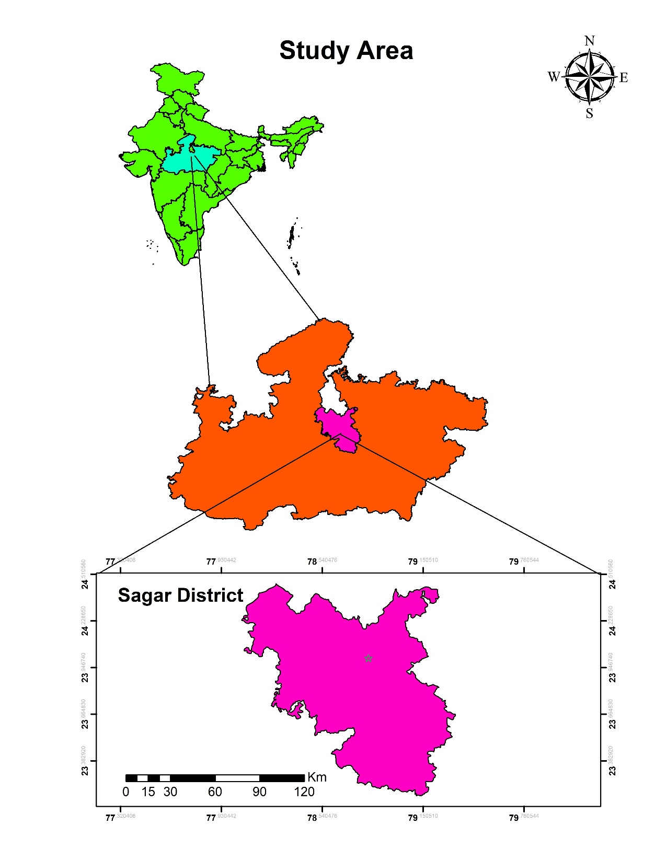Fig 1. Map of Sample collection site
Sample collection site
Preparation of different growth media
Composition of growth media- The word “culture” is typically used to describe intentional growth in a lab. Thus, microbes are grown in vitro. The term “culture media” refers to the appropriate materials utilized to prepare a substrate which microbes will consume in a scientific setting.
List 1 : Growth media Composition
The medium is filled in conical flasks, flasks are plugged with non-absorbent cotton and sterilized in an autoclave at 121 °C (15 Ib/ sq inch pressure) for 15-30 minutes. All media were sterilized in an autoclave at 15 Ib at 121 °C for 30 min. (Onuorah, 1982; Chaudhary, 2022).
Isolation of soil fungi using the serial dilution method
One of the most commonly used techniques is the serial dilution method. This technique is based on the principle that when a sample containing microorganisms is cultured, individual microorganisms develop into distinct colonies. Therefore, the number of colonies that appear on a Petri dish corresponds to the number of viable microorganisms present in the original sample (Aneja, 2012; Oza & Mankad, 2017).
1g of soil was added to 10ml of distilled water to create a soil suspension for the purpose of isolating the fungal population. A 0.5ml quantity of the produced solution was plated and placed over the recently made Potato Dextrose Agar (PDA) media after it had been serially diluted. After that, the inoculation plates were incubated for three to seven days at 28±1°C (Muhibuddin et al., 2011; Chaudhary, 2022).
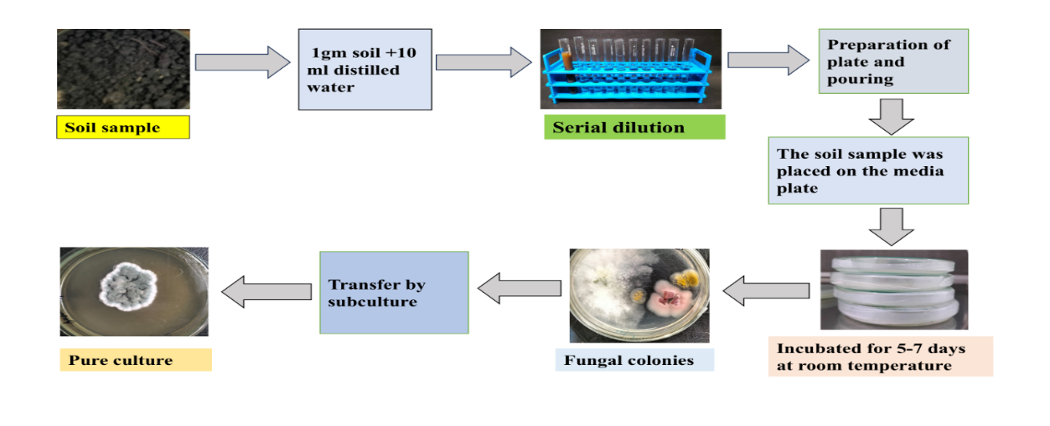
Fig 2: Procedure of the Serial Dilution method
Slide preparation
Fungal cells can be stained using Lacto-phenol cotton blue stain. Three main components are required for its preparation: cotton blue, which stains the chitin in the fungal cell wall; lactic acid, which preserves the fungal structure; and phenol, which acts as a disinfectant by killing any living organisms. The samples were first immersed in a drop of alcohol. Afterward, two drops of Lacto-phenol cotton blue stain were added, and the slides were examined under a microscope (Toma and Abdulla, 2012; Basu, 1980; Oza and Mankad, 2017). Lactophenol cotton blue staining was used to prepare the sides and both macroscopic and microscopic morphological characteristics were observed to identify the fungi (Rajankar et al., 2007; Ronhede et al., 2005; Pathak, 2023).
Identification of fungi
The identification of isolation fungi up to the genus and species level was carried out based on macro-morphological and micro-morphological characteristics, using standard manuals of fungi such as Manual of soil fungi (Gilman,1998), Illustrated genera of imperfect fungi (Barnett, 1965), Hyphomycetes (Subramanian,1971), Dematiaceous hyphomycetes (Ellis, 1971,1976), Microfungi on land plants (Ellis and Ellis, 1985), Microfungi on miscellaneous substrates (Ellis and Ellis, 1988), and the Artificial identification key (Ellis, 1971, 1976).

3. results and discussion

The mycoflora in the above areas of Sagar district is highly diverse. The objective of the present study was to obtain more information about the diversity of mycoflora present in these locations. Therefore, these areas were surveyed to collect soil samples.
Table 1: fungal species isolated from the soil collected from different parts of Sagar district.

Isolating and identifying soil-borne fungi from several Sagar agricultural fields was the main aim of the current study. In this research, soil samples from different areas were collected and then subjected to serial dilution. Finally, the diluted samples were poured onto PDA and MEA media. After 3 to 7 days of incubation, the isolated fungal colonies were identified (Pathak, 2023). An interesting and rare observation in this study was that many incubated petri plates contained multiple types of fungi within a single plate. These fungi differed in their morphological characteristics, and each fungal colony exhibited a distinct colour, which is rarely seen.
The colour, texture, drainage, moisture content, pH, organic matter and micro or macro nutrients of the soil vary depending on the location; these factors all have an impact on the variety of mycoflora (Guleri et al., 2012). The nutrients of the soil are affected by soil pH due to reactions with soil particles and other nutrients (Akhtar et al., 2022). Generally, the number of species of fungi decreases with the increase in depth of soil, as the necessary organic matter present on the surface of the soil is required for fungal growth. The present study also showed that different physico-chemical properties of the soil of any crop affect the growth of mycoflora. So, it is necessary to study the physico-chemical properties of soil and the relation of mycoflora.
Fungal flora isolated from the soil and their microscopic image
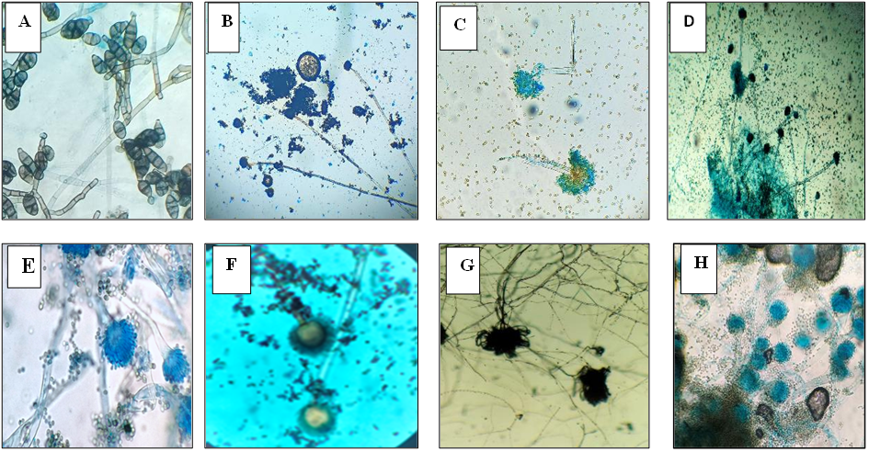

Figure 3(A-H): A = Alternaria sp.; B= Aspergillus niger; C = Aspergillus sp., D = Aspergillus oryzae; E= Aspergillus flavus; F= Aspergillus sp.; G= Aspergillus sp.; H=Aspergillus fumigatus on PDA and MEA culture plate and microscopic image, respectively.
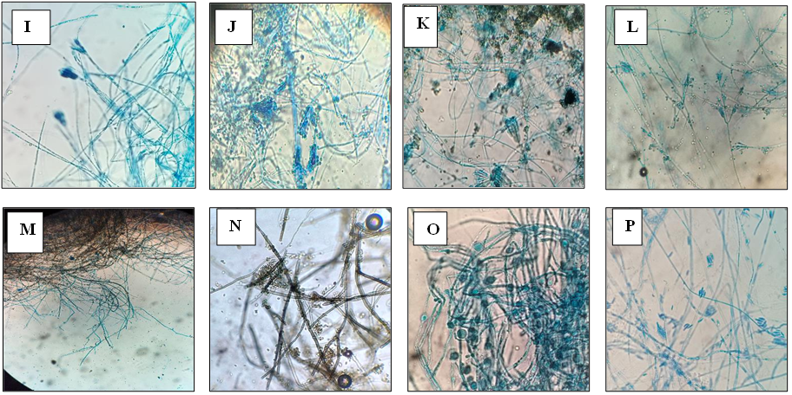
Figure 3(I-P): I = Penicillium chrysogenum.; J= Penicillium citrinum; K =Penicillium sp; L = Purpureocillium lilacinum; M= Drechslera sp; N= Cladosporium sp.; O= Humicola; P=fusarium sp.; on PDA and MEA culture plate and microscopic image, respectively
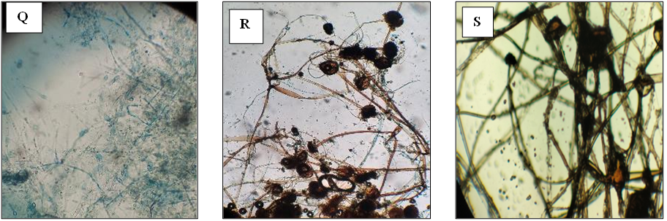
Figure 3(Q-S): Q = Fusarium oxysporum f. sp. cubense; J= Penicillium citrinum; R = Rhizopus stolonifera; S = Mucor hiemalis, on PDA and MEA culture plate and microscopic image, respectively.
Table 1 shows the 19 fungal species that were found during the present study. To isolate the fungus, the serial dilution method was used. Using the proper keys, the isolated fungal species was further identified. As the data suggests, the isolated organism belongs to Zygomycota and Ascomycota.
Two species belong to Zygomycota (Rhizopus stolonifera, Mucor hiemalis), and 17 species belong to Ascomycota (Alternaria sp., Aspergillus niger, Aspergillus sp., Aspergillus oryzae, Aspergillus flavus, Aspergillus sp., Aspergillus sp., Aspergillus fumigatus, Penicillium chrysogenum, Penicillium citrinum, Penicillium sp, Purpureocillium lilacinum, Drechslera sp, Cladosporium sp., Humicola, fusarium sp., FOC.
Among these, Aspergillus niger was the most prevalent species obtained in all the soil samples. Penicillum sp was the second most frequent fungal species recorded from three soil samples. Rhizopus stolonifera and Mucor hiemalis colonies on a culture plate were very fast growing and was the second most frequent fungal species. All fungal sp. Less frequent fungal species.
Trichoderma species are known for their ability to biologically control a variety of plant-borne fungi, which makes their presence in soil samples extremely important. They are crucial for improving soil health and preventing plant diseases that spread with the soil. All of the soil samples contained several harmful fungi, such as Fusarium and Alternaria. These fungi cause diseases that can cause significant crop losses, including as wilt, root rot, and leaf spot.
Numerous environmental factors, including soil moisture, organic matter content, temperature, and crop rotation, may have an impact on the variety of soil-borne fungi found in this study. Numerous research has shown similar findings, indicating that a range of fungal communities are supported by agricultural soils. Overall, the study's findings show that a variety of soil-borne fungi can be found in Sagar district's agricultural soils. The existence of both dangerous and helpful fungi emphasizes how crucial it is to comprehend soil microbial diversity for better soil management and sustainable farming methods.

4. Conclusion

The present study successfully documented the significant diversity of soil-borne mycoflora across various agricultural fields in the Sagar district. By employing serial dilution and cultivation on PDA and MEA media, 19 distinct fungal species were isolated and identified, highlighting the region's rich microbial profile. The isolated fungi belong to two primary phyla: Ascomycota (17 species) and Zygomycota (2 species). This indicates that Ascomycota is the dominant fungal group in the local agricultural soil. Dominant Species: Aspergillus niger was identified as the most prevalent species, appearing consistently across all soil samples. Other frequent isolates included Penicillium sp., Rhizopus stolonifera, and Mucor hiemalis, the latter two being noted for their rapid growth rates in culture. Environmental Influence: The study confirms that the diversity and distribution of these fungi are intrinsically linked to the physico-chemical properties of the soil, such as pH, organic matter, and moisture content. The observed decrease in fungal species at greater soil depths further suggests that surface-level organic matter is a critical driver for mycofloral growth. Morphological Diversity: The research highlighted a rare and interesting occurrence of multiple, distinctly colored fungal colonies within single petri plates, reflecting a high level of inter-species competition and coexistence in the natural soil environment. In conclusion, the agricultural soils of Sagar district harbor a diverse fungal community dominated by the genus Aspergillus. Understanding this microbial landscape is essential, as these fungi play a vital role in soil health and nutrient cycling. Future research should focus on the specific correlations between individual soil nutrients and the presence of these fungal species to optimize crop management and soil fertility.

Competing interests

No Competing Interests

Consent (where ever applicable)

No Need

Ethical approval (where ever applicable)

No Need

Disclaimer (Artificial intelligence)

Author(s) hereby declare that NO generative AI technologies such as Large Language Models (ChatGPT, COPILOT, etc.) and text-to-image generators have been used during the writing or editing of this manuscript.

References

- Akhtar, R., Showkat, S., & Saini, N. (2022). Isolation and identification of soil-borne fungi from agricultural fields of Dehradun, India. International Journal of Environmental Science, 4, 60–65.
- Aneja, K. R. (2012). Experimental microbiology, plant pathology and biotechnology (4th ed.). New Age International Publishers.
- Basu, P. K. (1980). Production of chlamydospores of Phytophthora megasperma and their possible role in primary infection and survival in soil. Canadian Journal of Plant Pathology, 2(2), 70–75.
- Benson, H. J. (2002). Microbiological applications: Laboratory manual in general microbiology (8th ed.). McGraw-Hill.
- Brady, N. C., & Weil, R. R. (2002). The nature and properties of soils (13th ed.). Prentice Hall.
- Carris, L. M., Little, C. R., & Stiles, C. M. (2012). Introduction to fungi. The Plant Health Instructor. https://doi.org/10.1094/PHI-I-2012-0426-01
- Chaudhary, N. (2022). A study on characterization of spent mushroom compost to control wilt disease caused by Fusarium oxysporum f. sp. pisi in Pisum sativum L. [Doctoral dissertation, Dr. Hari Singh Gour Vishwavidyalaya].
- Chaudhary, N. (2023). A study on characterization of spent mushroom compost to control wilt disease caused by fusarium oxysporum f. sp. pisi in pisum sativum L. [Doctoral dissertation, Dr. Hari Singh Gour Vishwavidyalaya].
- Ellis, M. B. (1971). Dematiaceous hyphomycetes. Commonwealth Mycological Institute.
- Ellis, M. B. (1976). More dematiaceous hyphomycetes. Commonwealth Mycological Institute.
- Ellis, M. B., & Ellis, J. P. (1985). Microfungi on land plants: An identification handbook. Croom Helm.
- Ellis, M. B., & Ellis, J. P. (1988). Microfungi on miscellaneous substrates: An identification handbook. Croom Helm.
- Garrett, S. D. (2013). Soil fungi and soil fertility: An introduction to soil mycology. Elsevier.
- Guleri, S., Bhandari, B. S., & Saxena, S. (2012). Soil mycoflora of some selected agroforestry areas of Doon Valley. Annals of Forestry, 20(2), 193–199.
- Hartigan, P. J. (2011). Fungi associated with disease. In Veterinary microbiology and microbial disease (pp. 413–469). Wiley-Blackwell.
- Hawksworth, D. L., & Lücking, R. (2017). "Fungal diversity revisited: 2.2 to 3.8 million species." Microbiology Spectrum.
- Ingham, E. R. (2007). Soil biology primer. USDA Natural Resources Conservation Service.
- Lewis, W., & Lowenfels, J. (2010). Teaming with Microbes: The Organic Gardener's Guide to the Soil Food Web, Revised Edition (p. 220). Timber Press.
- Manoharachary, C., Tilak, K. V. B. R., Mallaiah, K. V., & Kunwar, I. K. (2016). Mycology and microbiology: A textbook for UG and PG courses. Scientific Publishers.
- Muhibuddin, A., Addina, L., Abadi, A. L., & Ahmad, A. (2011). Biodiversity of soil fungi on integrated pest management farming system. Agrivita, 33(2), 111–118.
- Nguyen, N. H., et al. (2016). "How informative is the fungal internal transcribed spacer (ITS) region for species-level diversity estimation?" Molecular Ecology.

- Onuorah, O. M. O. (1982). Studies on the elicitation of lucerne of Medicago sativa L. phytoalexins by Verticillium spp. [Doctoral dissertation, University of Wales].
- Oza, K., & Mankad, A. (2017). Fungal diversity in Gujarat University campus in different seasons. International Journal of Science and Research (IJSR), 6(7), 1958–1959.
- Pathak, P. (2023). Role of spent mushroom compost as a bioprotectant against soil-borne pathogen Fusarium oxysporum on Solanum lycopercicum L. [Doctoral dissertation, Dr. Hari Singh Gour Vishwavidyalaya].
- Rajankar, P. N., Tambekar, D. H., & Wate, S. R. (2007). Study of phosphate solubilization efficiencies of fungi and bacteria isolated from saline belt of the Purna river basin. Research Journal of Agriculture and Biological Science, 3(6), 701–703.
- Rane, G., & Gandhe, R. V. (2006). Seasonal distribution of soil fungi from forest soils of Jalgaon district, Maharashtra. Zoos' Print Journal, 21(9), 2407–2409.
- Ronhede, S., Jensen, B., Rosendahl, S., Kragelund, B. B., Juhler, R. K., & Aamand, J. (2005). Hydroxylation of the herbicide isoproturon by fungi isolated from agricultural soil. Applied and Environmental Microbiology, 71(12), 7927–7932.
- Subramanian, C. V. (1971). Hyphomycetes: An account of Indian species, except Cercosporae. Indian Council of Agricultural Research.
- Sylvia, D. M., Fuhrmann, J. J., Hartel, P. G., & Zuberer, D. A. (2005). Principles and applications of soil microbiology. Pearson Education.
- Tedersoo, L., et al. (2014). "Global diversity and geography of soil fungi." Science.
- Toma, F. M., & Abdulla, N. Q. F. (2012). Isolation, identification and seasonal distribution of soilborne fungi in different areas of Erbil Governorate. Journal of Advanced Laboratory Research in Biology, 3(4), 246–255.
- Tugel, A., Lewandowski, A., & Happe-vonArb, D. (Eds.). (2000). Soil biology primer. Soil and Water Conservation Society.
- Varma, P. (2022). Pulses for Food and Nutritional Security of India. Springer.

- Vimal, S. R., Singh, J. S., Arora, N. K., & Singh, S. (2017). Soil-plant-microbe interactions in stressed agriculture management: a review. Pedosphere, 27(2), 177-192.

- Yuvaraj, M., & Ramasamy, M. (2020). Role of fungi in agriculture. Biostimulants in plant science, 1, 1-12.
- Zhan, C. (2024). Microbial decomposition and soil health: Mechanisms and ecological implications. Molecular Soil Biology, 15.

