Harnessing Generative AI for Robust Predictive Analytics in Modern Agriculture

.
ABSTRACT

Modern agriculture faces mounting pressures from climate variability, resource scarcity, and the need to sustainably feed a growing population. Predictive analytics supports anticipatory decision-makings in yield forecasting, pest and disease modeling, irrigation scheduling, and resource optimization, yet traditional discriminative models often struggle with data scarcity, class imbalance, and the inability to simulate novel conditions. Generative artificial intelligence (GenAI) including diffusion models, GANs, VAEs, and large vision-language models addresses these limitations by synthesizing realistic data, generating diverse scenarios, and integrating multimodal inputs to produce robust, probabilistic predictions especially in data-constrained smallholder systems. This review examines recent applications of GenAI in agricultural predictive analytics, covering crop yield estimation, pest and disease forecasting, climate impact simulation, smart irrigation, and soil/resource optimization. Real-world implementations demonstrate improved forecast accuracy and generalization through synthetic augmentation, while a dedicated future vision outlines scalable deployment. Key challenges include hallucinations, computational demands, biases, limited explainability, privacy risks, and unequal access, raising ethical concerns around over-reliance and the digital divide. Future progress depends on hybrid generative-discriminative systems, lightweight edge models, farmer-centered validation, and transparent governance. Responsibly deployed, GenAI can amplify human judgment and local knowledge, advancing anticipatory, resilient, and sustainable agriculture for food security and climate adaptation.

Keywords: Generative AI, predictive analytics, precision agriculture, diffusion models, crop yield prediction, pest forecasting, data augmentation, sustainable farming

1. INTRODUCTION

Modern agriculture faces unprecedented pressures from climate variability, resource scarcity, and the urgent need to feed a growing global population while maintaining environmental sustainability (Khatri et al., 2024). By 2050, the world will need to produce more food than it does today, yet arable land and freshwater resources continue to decline due to urbanisation, soil degradation, and extreme weather events (Hossain et al., 2020). Predictive analytics has become a cornerstone for shifting from reactive to anticipatory farming practices supporting critical tasks such as crop yield forecasting, pest and disease outbreak modelling, irrigation scheduling, and precision resource management (Vinod et al., 2024). These tools are increasingly essential for optimising inputs, minimising losses, and enhancing resilience in highly variable agroecosystems. Yet traditional discriminative machine learning models including random forests, support vector machines, and convolutional neural networks frequently struggle with real-world agricultural data challenges (Araújo et al., 2023). These include severe data scarcity and class imbalance in smallholder systems (common across South Asia, sub-Saharan Africa, and Latin America), noisy or incomplete sensor inputs from heterogeneous field conditions, and limited ability to simulate plausible future scenarios under novel climate stresses or rare pest events (Amulothu et al., 2024). Conventional approaches excel at pattern recognition on abundant, balanced datasets but perform poorly when confronted with sparse, imbalanced, or high-dimensional data typical of smallholder farming and dynamic environmental conditions (Miftahushudur et al., 2025). Consequently, they often yield unreliable forecasts, particularly for extreme events and long-term planning, leaving farmers and policymakers with insufficient decision support in an increasingly uncertain climate.
Generative artificial intelligence (GenAI) represents a fundamental shift in agriculture by enabling techniques such as generative adversarial networks (GANs), diffusion models, and large vision-language models to synthesize realistic synthetic data and generate diverse "what-if" scenarios. These technologies seamlessly integrate multimodal inputs including satellite imagery, IoT time-series data, and text advisories to augment sparse datasets and produce more robust explainable predictions (Gebreab et al., 2024). Diffusion models have demonstrated superior performance in crop growth simulation, remote-sensing image enhancement, and data augmentation for yield prediction tasks, outperforming traditional GANs in stability and visual fidelity under complex field conditions (Zangana et al., 2025). Computer-vision pipelines augmented with generative models have measurably improved yield forecasting accuracy by creating diverse training samples that better represent real-world variability. Large vision and language models further enable context-aware, multimodal reasoning that bridges raw sensor data with actionable agronomic insights across diverse cropping systems (Zhu et al., 2025).
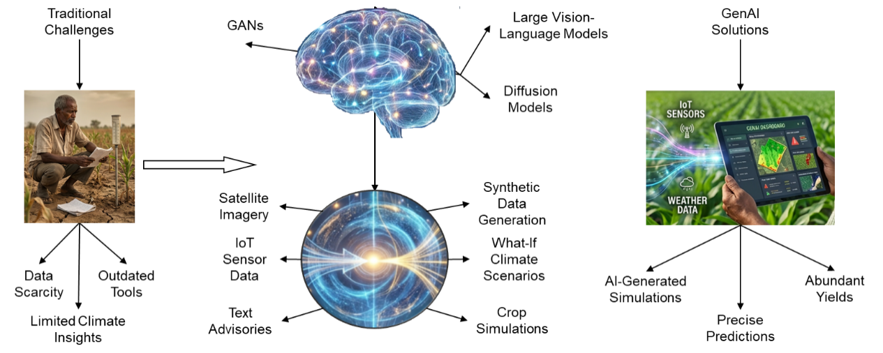
Fig 1. System architecture of GenAI-enhanced predictive analytics for agriculture

The transformation of traditional agriculture to GenAI solutions fundamentally changes how fragmented and sparse field data are turned into coherent as well as forward-looking intelligence. The generative core augments and simulates data (as shown in Figure 1 by means of the glowing neural network and fusion orb) to provide farmers with practical predictions for yield, pest risk, weather impact, and irrigation needs (Das et al., 2026), This moves beyond simple pattern recognition to generative simulation, making agriculture truly anticipatory and resilient in an era of accelerating climate uncertainty. This review synthesises developments from recent years on the application of generative AI to predictive analytics in modern agriculture. It examines how these models address longstanding limitations of conventional approaches, evaluates evidence from global implementations (with emphasis on both large-scale and smallholder contexts), and identifies technical, ethical, and adoption barriers. The paper has three main objectives: (1) to clarify the mechanisms through which GenAI augments traditional predictive workflows; (2) to critically assess real-world performance and impacts across key applications including smart irrigation; and (3) to outline responsible pathways toward scalable, equitable, and sustainable deployment in near future.

2. generative ai and predictive analytics background

Predictive analytics in agriculture involves the use of data-driven models to forecast future states or outcomes, such as crop yields, pest outbreaks, soil nutrient dynamics, or weather impacts on production (Kumar et al., 2024). These forecasts enables precision decisions that optimize inputs, reduce risks, and enhance sustainability in highly variable field environments. In recent years, predictive analytics has gained critical importance as climate change intensifies uncertainty and smallholder systems face increasing resource constraints (Sivakumar, 2006). Historically, predictive tasks have relied almost exclusively on discriminative models as these models learn decision boundaries to map inputs directly to outputs such as classifying diseased versus healthy plants or regressing for yield estimates (Ajith et al., 2025). Common discriminative approaches include support vector machines, random forests, and deep convolutional neural networks trained on labeled agricultural data from sensors, satellites, or drones (Zualkernan et al., 2023). While effective when large and balanced are available as these models often fail in real-world agricultural settings characterized by severe data scarcity, class imbalance, noisy sensor readings, and domain shifts across climate or crop varieties (Chettri et al., 2026). Generative AI (GenAI), in contrast, models the joint probability distribution of data, enabling the creation of new samples that resemble the training distribution. Core GenAI families relevant to agriculture include Generative Adversarial Networks (GANs), which pit a generator against a discriminator to produce realistic synthetic images or time-series; Variational Autoencoders (VAEs) for latent-space representations and reconstruction; Diffusion models, which iteratively denoise data to generate high-fidelity outputs and emerging large multimodal models that integrate text, images, and sensor sequences (Rasool et al., 2023; Zhu et al., 2025).
Unlike discriminative models that focused solely on conditional prediction (P(y|x)) and generative models capture the full data-generating process (P(x,y)) allowing them to synthesize plausible scenarios, augment sparse datasets, and simulate unobserved conditions are critical in agriculture where labeled field data are often limited, imbalanced, or expensive to collect (Paul & Machavaram, 2025), while in predictive contexts GenAI addresses several longstanding limitions of traditional discriminative approaches as illustrated in table 1. Discriminative models perform well on abundant and balanced data but degrade significantly under data scarcity and domain shifts or extreme events. GenAI mitigates these issues through three primary mechanisms: data augmentation (creating synthetic crop images for rare diseases), scenario generation (simulating yield responses under hypothetical droughts or heatwaves), and imputation (filling gaps in sensor time-series) (Majumder et al., 2024). Recent evidence shows that diffusion models, in particular, offer superior stability and visual fidelity compared to GANs in agricultural image synthesis leading to measurable improvements in downstream prediction accuracy for tasks such as pest detection, yield forecasting, and climate impact assessment (Xue et al., 2026).

Table 1. Comparison of Discriminative and Generative Models in Agricultural Predictive Analytics
Aspect | Discriminative Models | Generative Models (GenAI) | Key Advantage in Agriculture
Core Objective | Learn P(y|x) | Learn P(x) or P(x,y) | Enables scenario simulation and “what-if” analysis
Data Requirements | Large, labelled, balanced datasets | Works with sparse or unlabeled data | Addresses smallholder data scarcity
Strengths | Fast inference, high accuracy on known data | Robust to shifts, excellent augmentation | Better generalization under climate variability
Limitations | Poor on rare events or missing data | Higher computational cost, hallucination risk | Requires validation for field reliability
Key Techniques | SVM, RF, CNN | GANs, VAEs, Diffusion, Multimodal LLMs | Diffusion outperforms GANs in crop imagery

3. generative ai applications in predicitive analytics for agriculture

Generative AI has transitioned from a supplementary tool for data augmentation to a core enabler of direct predictive tasks in agriculture, particularly where traditional models falter due to sparse, noisy, or imbalanced real-world data (Chen et al., 2024). By learning underlying data distributions and synthesizing realistic samples, scenarios, and imputations, GenAI facilitates more accurate, probabilistic forecasting under uncertainty and variability (Min et al., 2025). This capability is especially valuable in agriculture, where environmental heterogeneity, limited labeled samples from field trials, and sudden stressors (e.g., extreme weather or emerging pests) often degrade conventional predictive performance. Through mechanisms like iterative denoising (in diffusion models) or adversarial refinement (in GANs), GenAI generates high-fidelity synthetic data that bridges gaps in historical records, enabling downstream models to train on richer, more representative datasets and produce forecasts with greater confidence intervals and reduced variance (Min et al., 2025; Pallottino et al., 2025).
3.1 Crop Yield Prediction and Growth Simulation
Crop yield prediction remains one of the most critical yet challenging predictive tasks in agriculture, as yields depend on intricate interactions among genetics, management practices, soil properties, and dynamic environmental factors (Saha et al., 2025). Traditional discriminative models often overfit to limited historical data, struggling to generalize across seasons, regions, or novel stress combinations. Generative AI addresses this by simulating entire growth trajectories and generating synthetic yield scenarios under hypothetical conditions (Rathore et al., 2025). Diffusion models, in particular, excel here due to their stable training dynamics and ability to produce high-fidelity temporal sequences of crop development stages—from emergence to maturity—while incorporating variables like soil moisture, temperature fluctuations, and nutrient availability. These models outperform GANs in generating biologically plausible simulations as shown in figure 2, especially under stress conditions such as prolonged drought, heat waves, or nutrient deficiencies, where data scarcity is acute. For instance, by progressively denoising noisy growth patterns derived from sparse field trials, diffusion approaches create diverse synthetic trajectories that capture realistic variability, leading to enhanced regression accuracy in downstream yield estimators (Min et al., 2025; T. Wang et al., 2026).
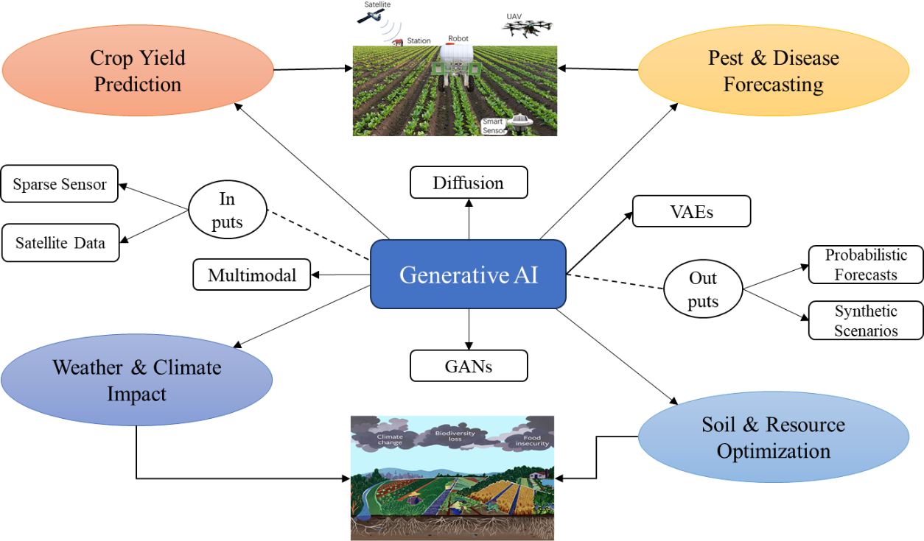
Fig 2. GenAI-Enhanced Applications in Agriculture Predictive Analytics
In smallholder-dominated systems—prevalent in regions like South Asia and sub-Saharan Africa—GenAI's "what-if" scenario generation proves particularly transformative. Farmers can explore alternative management practices such as adjusted planting dates, fertilizer regimes, or irrigation schedules through synthesized outcomes, supporting anticipatory planning and risk mitigation without requiring extensive real-world experimentation (Jamal et al., 2023). This not only improves forecast reliability but also empowers resource-constrained producers to optimize limited inputs for higher resilience and productivity, aligning predictive analytics with sustainable intensification goals (Pallottino et al., 2025). Recent multimodal generative frameworks further integrate satellite imagery with textual advisories to refine yield projections, offering uncertainty-aware distributions that aid climate-adaptive decisions (Srivastava et al., 2025). Overall, GenAI elevates yield prediction from deterministic point estimates to probabilistic distributions, providing farmers with uncertainty-quantified insights essential for adaptive decision-making in volatile climates.
3.2 Pest and Disease Outbreak Prediction
Pest and disease outbreaks represent acute threats to agricultural productivity, often causing rapid, widespread losses if not detected early (Eziamaka & Nnajiofor, 2025). Predictive modeling in this domain suffers from severe class imbalance—healthy plant images vastly outnumber rare symptomatic ones and the emergence of novel pathogen strains or pest behaviors under changing climates (Ali et al., 2024). Generative AI mitigates these issues by creating balanced, diverse datasets of infected or infested plant images, enabling classifiers to learn robust decision boundaries. Diffusion-based augmentation stands out for generating high-quality, varied synthetic examples of rare disease symptoms or pest damage patterns, significantly reducing false negatives in early detection systems. This results in more reliable early-warning frameworks that identify emerging threats before they reach epidemic levels, allowing timely interventions like targeted spraying or resistant variety deployment (Iqbal, 2025; Javed et al., 2025). GAN variants complement this by simulating temporal progression dynamics, such as lesion expansion or insect population growth over days or weeks, producing probabilistic risk maps for regional migration or outbreak escalation. These synthetic progressions help models anticipate how outbreaks might evolve under different weather or management scenarios, enhancing spatial-temporal forecasting (Babanejaddehaki et al., 2025). In practice, such applications translate to reduced crop losses, lower pesticide use through precision targeting, and improved biosecurity, particularly in smallholder farms where manual scouting is labor-intensive and error-prone. By enriching training data with realistic variations, GenAI boosts classifier precision and recall, fostering proactive rather than reactive pest and disease management, with recent vision-language integrations enabling explainable severity estimates and automated prescriptions (Iqbal, 2025).
3.3 Weather and Climate Impact Forecasting
Weather and climate variability profoundly influence agricultural outcomes, yet predictive models often suffer from incomplete or low-resolution environmental inputs, especially in data-sparse rural areas (Adeleke Aturamu et al., 2021). GenAI integrates multimodal sources—such as satellite time-series, ground sensors, and text-based advisories—to synthesize comprehensive weather-crop interaction scenarios. Diffusion models excel at super-resolving coarse remote-sensing imagery and imputing missing variables such as localized precipitation or temperature extremes, thereby enriching input quality for downstream predictive tasks like climate stress impact on yields or irrigation demand. This enables robust forecasting of extreme events, where the traditional scarcity of high-resolution historical extremes hampers accuracy (Kow et al., 2025). By generating probabilistic ensembles of future conditions (e.g., drought severity or flood likelihood), GenAI provides farmers with uncertainty-quantified forecasts, supporting adaptive strategies like adjusted sowing windows or crop insurance decisions. In multimodal setups, models fuse visual (satellite) and textual (advisory) data to simulate crop responses under compounded stresses, offering actionable insights for climate-smart agriculture. This shift toward generative simulation strengthens resilience against unpredictable patterns, particularly benefiting vulnerable regions facing intensified extremes, with emerging downscaling techniques improving localized impact predictions for precision resource allocation (Abdelmoaty et al., 2025).
3.4 Soil Health and Resource Optimization Prediction
Soil health underpins long-term productivity, but sparse sensor coverage and temporal variability make accurate prediction of nutrient dynamics, moisture levels, or depletion risks difficult (Owusu et al., 2026). Generative approaches, including variational autoencoders and diffusion models, impute missing readings from limited sensor networks and simulate long-term soil profiles under alternative practices (e.g., cover cropping, reduced tillage). These synthetic profiles enable predictive analytics for fertilizer recommendations, irrigation scheduling, and water/nutrient use efficiency, anticipating depletion or degradation before visible symptoms emerge (Kumari et al., 2025; Schweng et al., 2026). In variable environments, GenAI generates diverse scenarios that account for interactions among soil type, weather, and management, promoting sustainable allocation by minimizing over-application of inputs. This reduces environmental footprint like nutrient runoff while maintaining yields, aligning with regenerative goals. For smallholders, such tools democratize access to precision insights, transforming reactive soil management into proactive, data-informed stewardship, with AI-driven digital soil mapping enhancing resolution for targeted interventions (Schweng et al., 2026). Overall, GenAI shifts predictive analytics toward generative simulation, offering greater resilience in low-data or high-uncertainty agricultural settings. It enables probabilistic scenario-rich forecasts that empower adaptive sustainable decision-making. Yet rigorous validation against real-world outcomes remains essential for building trust and ensuring deployment at scale.
3.5 Soil Health and Resource Optimization Prediction
Smart irrigation represents one of the most practical and high-impact applications of generative AI in predictive analytics, directly addressing water scarcity and inefficient resource use that affect over majority of global agricultural land (Islam, 2025). Traditional irrigation scheduling relies on static rules or basic sensor thresholds, often resulting in over- or under-watering. Generative models overcome these limitations by synthesizing realistic soil moisture patterns, imputing missing sensor data, and generating probabilistic forecasts of crop water demand under varying climate scenarios. Diffusion and GAN-based approaches, for example, create synthetic high-resolution moisture maps from sparse UAV or satellite imagery, enabling precise, zone-specific irrigation recommendations that can reduce water consumption while maintaining or improving yields. Multimodal generative frameworks further integrate real-time IoT soil moisture data with weather forecasts and crop growth simulations to produce dynamic irrigation schedules. These systems not only predict when and how much water to apply but also simulate long-term water stress scenarios, supporting proactive decisions such as deficit irrigation or automated valve control (Ray & Majumder, 2024). In smallholder and water-stressed regions, GenAI-powered smart irrigation chatbots and edge-deployed models deliver actionable advice in local languages, democratizing access to precision water management. In general, this application transforms irrigation from a reactive practice into a predictive, sustainable process, aligning perfectly with the paper’s core theme of using generative simulation to enhance resilience in data-constrained agricultural systems (Weingram et al., 2025).

4. real-world implementations and pilots

While generative AI remains largely in exploratory and pilot phases for agricultural predictive analytics, several implementations demonstrate its practical value in addressing data limitations and enhancing forecast reliability (Oluwafunmi Adijat Elufioye et al., 2024). These efforts often combine GenAI with existing data pipelines like satellite imagery, IoT sensors to generate synthetic samples or scenarios, leading to improved model performance in field-like conditions (Manoj et al., 2025). In Indian smallholder contexts, GenAI frameworks have been piloted for predictive advisory systems, integrating multilingual LLMs with local sensor and weather data to forecast yields and optimize inputs. These pilots show gains in decision accuracy and cost reduction, particularly for resource-constrained farms, though scalability depends on infrastructure improvements (Camps-Valls et al., 2025). Diffusion model-based pilots have advanced crop growth simulation and yield prediction by generating high-fidelity synthetic trajectories under variable stresses (e.g., drought or nutrient shifts). Reviews of these implementations report superior stability over GANs, with downstream predictive models achieving better generalization when trained on augmented datasets from real agricultural imagery (X. Wang et al., 2026). For pest and disease prediction, diffusion and GAN pilots augment imbalanced image datasets, creating diverse synthetic examples of rare symptoms to train classifiers as described in figure 3. Field-oriented pilots demonstrate enhanced early-warning accuracy, reducing false negatives in outbreak forecasting, though real-world validation highlights the need for domain-specific fine-tuning to minimize (Amulothu et al., 2024).
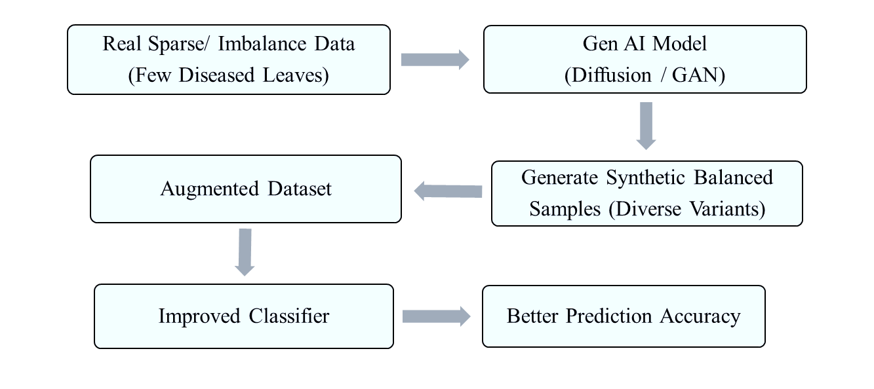
Fig 3. Data Augmentation Pipeline for Crop Disease or Pest Prediction
Multimodal GenAI pilots combine vision-language models with satellite and ground data for climate impact forecasting, imputing missing variables and simulating crop responses to extreme weather. These efforts improve probabilistic predictions for irrigation and resource needs, with evidence of better robustness in heterogeneous environments. In broader smart agriculture pilots, GenAI supports soil health forecasting by generating synthetic profiles for sparse sensor networks, aiding predictive recommendations for fertilizer and water use. Results indicate efficiency gains, but pilots underscore challenges in integrating with legacy systems and ensuring outputs align with ground truth (Sapkota et al., 2025). These implementations illustrate GenAI's shift toward practical, predictive utility in agriculture, often yielding 10–30% improvements in forecast metrics via augmentation. However, most remain at pilot scale, with limited long-term field trials; success hinges on hybrid approaches (GenAI + discriminative models) and rigorous validation to build farmer trust.
5. discussions

The integration of generative artificial intelligence into predictive analytics represents one of the most promising yet underexplored frontiers in contemporary agriculture (Bharambe et al., 2024). Generative AI (GenAI) transcends traditional discriminative approaches, which merely classify or regress from observed patterns. Instead, it actively constructs plausible realities such as synthetic growth trajectories, balanced disease datasets, imputed environmental variables, and simulated resource scenarios thereby enriching predictive capacity in environments where real data are inherently sparse, noisy, or temporally limited (Wu & Xie, 2025). This generative paradigm shift is particularly salient in agriculture, a domain defined by irreducible uncertainty: seasonal variability, microclimatic heterogeneity, emergent biotic threats, and the compounding effects of climate change. By enabling probabilistic forecasting rather than deterministic point estimates, GenAI aligns predictive tools more closely with the stochastic nature of farming, offering farmers not just predictions but distributions of outcomes that better inform risk-aware decision-making (Shahriar et al., 2025). A central strength lies in GenAI's capacity to democratize precision analytics for smallholder systems, where data poverty has long perpetuated yield gaps and vulnerability. The ability to generate "what-if" scenarios for yield under alternative agronomic practices, simulate pest progression for early regional alerts, or downscale coarse climate inputs for localized irrigation advice empowers resource-constrained producers to adopt anticipatory strategies without prohibitive field experimentation. This is no trivial contribution: in many developing contexts, even modest improvements in forecast reliability—through synthetic augmentation—can translate to reduced input waste, lower environmental externalities, and incremental gains in food security (Paul & Machavaram, 2025).
Moreover, the multimodal nature of recent generative architectures (fusing imagery, time-series, and textual advisories) begins to bridge the semantic gap between raw sensor feeds and actionable agronomic insight, moving predictive analytics closer to human-like reasoning in complex agroecosystems (Sapkota et al., 2025). Yet this promise must be tempered by critical reflection on the method's limitations and systemic implications. Generative models, while powerful in synthesis, remain vulnerable to propagating artifacts—hallucinated disease patterns, implausible growth curves, or biased resource simulations—that could mislead rather than enlighten. Such risks are amplified in high-stakes agricultural decisions, where erroneous forecasts may lead to over- or under-application of inputs, financial loss, or ecological harm (Javed et al., 2025). Explainability remains a persistent concern: the latent spaces of diffusion or multimodal models are notoriously opaque, complicating traceability of why a particular probabilistic forecast emerged. For farmers and extension agents, who often operate with limited technical literacy, black-box outputs undermine trust and adoption. Furthermore, the computational footprint of training and inference poses equity challenges; edge-compatible lightweight variants are emerging, but access to sufficient GPU resources, stable connectivity, and maintenance expertise remains unevenly distributed, potentially widening rather than narrowing the digital divide between large-scale and smallholder operations (Pallottino et al., 2025).
From a broader sustainability perspective, GenAI's role in predictive analytics invites nuanced evaluation. On one hand, optimized resource forecasts and stress simulations support precision practices that minimize overuse of water, fertilizers, and pesticides—contributing to regenerative goals and climate resilience. On the other hand, the energy demands of generative training and the risk of over-optimistic synthetic scenarios (e.g., underestimating extreme tail events) could inadvertently reinforce unsustainable intensification if not rigorously validated against ground truth across diverse agroecological zones (Senthil et al., 2025). Ethical considerations further complicate deployment: data ownership in shared generative pipelines, potential biases embedded in training corpora as mentioned in table 2 that under-represent marginalized farming systems, and the deskilling risk if over-reliance supplants experiential knowledge all warrant deliberate governance. Therefore, the trajectory of GenAI in agricultural prediction hinges on hybrid architectures that tie the knot of generative creativity with discriminative reliability—using synthetic data to pre-train or augment, then refining with real-world grounding for verifiable performance. Advances in controllable generation (e.g., conditioned on expert priors or uncertainty estimates) and federated learning could enhance privacy and inclusivity, while domain-specific fine-tuning on diverse, representative agricultural corpora would mitigate hallucination risks (J. Li et al., 2023). Equally important is interdisciplinary collaboration: agronomists, data scientists, ethicists, and farmers must co-design validation protocols, interpretability interfaces, and deployment pathways that prioritize equity and real-world utility over technological novelty (M. Li et al., 2026). In sum, generative AI does not merely augment predictive analytics in agriculture; it redefines the epistemological basis of forecasting—from observation-bound inference to distribution-aware simulation.
Table 2. Key prospects and pitfalls of generative AI in agricultural predictive analytics
Dimension | Prospects (Strengths & Opportunities) | Pitfalls (Limitations & Risks) | Implications for Future Development
Predictive Robustness | Probabilistic forecasts; overcomes data scarcity | Hallucinations & artifacts | Controllable generation & rigorous validation
Smallholder Equity | "What-if" scenarios for anticipatory planning | Computational demands & digital divide | Lightweight models & farmer co-design
Sustainability Impact | Precision resource use; climate-resilient planning | High energy use; over-optimistic scenarios | Energy-efficient architectures & bias audits
Explainability & Trust | Multimodal fusion → actionable insights | Opaque latent spaces | Post-hoc interpretability & hybrid pipelines
Ethical & Systemic | Amplifies human judgment for adaptive systems | Data ownership issues, biases, deskilling risk | Transparent governance & federated learning
Note: Summary of core prospects and pitfalls of generative AI in predictive analytics for agriculture, highlighting balanced pathways toward responsible, impactful deployment.
Realizing its transformative potential requires moving beyond proof-of-concept pilots toward rigorous, inclusive, and transparent integration. Only then can GenAI fulfill its promise as a resilient partner in the quest for sustainable, adaptive, and equitable food systems amid accelerating global change. Generative AI is projected to become the backbone of fully autonomous, edge-computed smart farming systems in the near future as the diffusion and multimodal models will run directly on low-cost farm devices. These models will deliver real-time farm-specific predictions for yield, pest risk, climate impact, and irrigation needs with the lowest error margins. Integrated digital twins powered by GenAI will allow virtual testing of entire cropping seasons, which will enable more water savings and reduction in chemical inputs globally. While smallholder farmers in developing regions will interact with conversational GenAI advisors in local languages as they will receive personalized and uncertainty-aware recommendations via simple smartphones. Indeed, federated learning will ensure data privacy as it will also continuously improve models across regions. For the development of policy, governments and organizations are expected to mandate explainable GenAI standards, which are also expected to provide open agricultural datasets. The shift from data augmentation to generative simulation will mature into proactive, resilient, and inclusive agricultural systems. These systems will be capable of feeding billions of people sustainably under climate constraints.
6. challenges and ethical considerations

Despite the promising advances of generative AI in agricultural predictive analytics, several technical, practical, and ethical hurdles must be addressed before widespread, reliable adoption can occur. One of the most persistent technical limitations is the risk of hallucinations—the generation of plausible but factually incorrect outputs. In predictive contexts, this can manifest as synthetic crop images depicting impossible disease patterns, fabricated yield trajectories under unrealistic climate conditions, or overly optimistic resource forecasts. Such errors, even if infrequent, erode trust among farmers and extension agents who rely on accurate predictions for high-stakes decisions. Computational demands represent another major barrier. Training and fine-tuning diffusion models, large multimodal architectures, or GAN variants requires substantial GPU resources and energy, which are often inaccessible in rural or developing regions. Inference latency can also hinder real-time applications, such as on-device pest detection or immediate irrigation recommendations, particularly when models are deployed on low-power edge devices common in smallholder farms.
Data-related challenges remain critical. Generative models inherit and can amplify biases present in training datasets—such as under-representation of certain crop varieties, soil types, or farming practices from specific geographic or socioeconomic contexts. This risks producing predictions that perform poorly or unfairly disadvantage marginalized farming communities. Moreover, the quality of synthetic data is only as good as the real data it learns from; noisy, incomplete, or outdated inputs can propagate errors into generated scenarios, undermining the very purpose of augmentation. Explainability and interpretability pose ongoing difficulties. While discriminative models often allow inspection of feature importance or decision paths, many generative architectures function as black boxes. Farmers and agronomists need to understand why a model predicts a particular yield drop or pest risk, yet the complex latent spaces of diffusion or multimodal models make post-hoc explanations challenging and sometimes unreliable. From an ethical standpoint, over-reliance on generative predictions could deskill farmers by reducing direct observation and experiential judgment, potentially weakening long-term resilience in unpredictable environments. Privacy concerns arise when models are trained on farm-level sensor or yield data; even anonymized datasets can reveal sensitive information about production scales, land use, or economic status if not carefully protected.
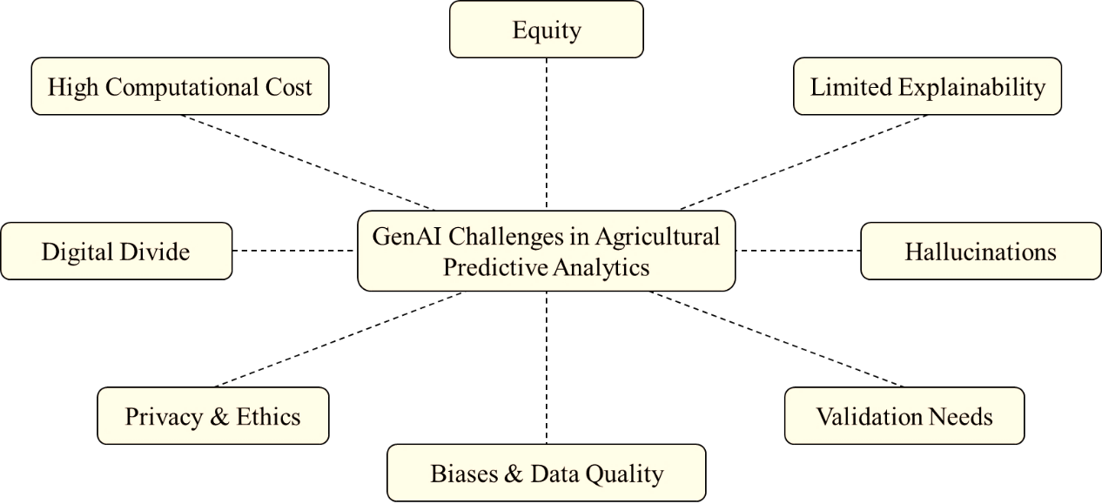
Fig 4. Challenges of GenAI in agricultural predictive analytics
Equity and accessibility issues are particularly pronounced. The digital divide—limited internet connectivity, smartphone penetration, and technical literacy in many rural areas—means that the benefits of generative AI may disproportionately accrue to larger, better-resourced operations, widening existing gaps rather than closing them. Finally, validation remains a fundamental challenge. Most generative applications in agriculture are still at pilot scale, with limited long-term, multi-season, multi-location field trials. Without rigorous, transparent benchmarking against ground truth under real-world variability, it is difficult to confidently assess whether synthetic augmentation genuinely improves predictive performance or merely creates an illusion of robustness. Addressing these challenges as shown in figure 4, will require hybrid approaches that combine the strengths of generative and discriminative models, investment in lightweight and explainable architectures, robust bias audits, farmer-centered co-design, and clear governance frameworks to ensure generative AI serves as a supportive tool rather than a replacement for human judgment and local knowledge.
7. conclusion

Generative artificial intelligence marks a significant advancement in predictive analytics for modern agriculture. By shifting from pattern recognition to data synthesis, scenario simulation, and multimodal reasoning, GenAI effectively overcomes longstanding limitations of traditional models—particularly data scarcity, class imbalance, and the inability to anticipate rare or novel conditions. These capabilities enhance forecasting accuracy for crop yields, pest and disease risks, climate impacts, smart irrigation scheduling, and resource optimization, delivering tools that are better suited to variable and data-constrained environments such as smallholder farming systems. Real-world implementations and the newly added focus on smart irrigation illustrate tangible progress. Diffusion-based augmentation improves classifier performance on imbalanced datasets, multimodal models support probabilistic climate and irrigation forecasting, and synthetic growth trajectories enable anticipatory decision-making. These developments point toward more resilient and creative predictive systems capable of supporting sustainable intensification under growing climate and resource pressures.
Nevertheless, substantial challenges persist. Hallucinations in generated outputs, high computational requirements, inherited biases, limited explainability, privacy risks, and unequal access threaten reliability and equity. Over-dependence on synthetic predictions without rigorous validation could weaken farmer judgment and long-term adaptability. The digital divide further risks concentrating benefits among larger operations, potentially widening rather than narrowing disparities. The most viable path forward involves hybrid architectures that combine generative creativity with discriminative reliability, alongside lightweight models suitable for edge deployment, farmer-centered design, bias mitigation, and transparent governance. A specific future vision predicts fully autonomous, edge-computed systems delivering real-time, personalized predictions with high accuracy and equitable access across regions. Generative AI should function as a supportive partner—not a substitute—for human expertise, local knowledge, and empirical observation. If developed responsibly and deployed inclusively, GenAI can help shift agriculture toward more anticipatory, efficient, and sustainable practices. Achieving this will require sustained interdisciplinary collaboration across agronomy, computer science, ethics, policy, and—crucially—the active involvement of farming communities themselves. Only through such collaboration can the technology realize its full potential to support a more food-secure and climate-resilient future.

disclaimer (artificial intelligence)

Author(s) hereby declares that NO generative AI technologies such as Large Language Models (ChatGPT, COPILOT, etc.) and text-to-image generators have been used during writing or editing of this manuscript.
Competing interests

All Authors have declared that no competing interests exist.

References

Abdelmoaty, H. M., Papalexiou, S. M., Mamalakis, A., Singh, S., Coia, V., Hairabedian, M., Szeftel, P., & Grover, P. (2025). Generative Adversarial Networks for Downscaling Hourly Precipitation in the Canadian Prairies. Journal of Geophysical Research: Machine Learning and Computation, 2(4). https://doi.org/10.1029/2025jh000678
Adeleke Aturamu, O., Anthony Thompson, O., & Olabimpe Banke, A. (2021). FORECASTING THE EFFECT OF CLIMATE VARIABILITY ON YAM YIELD IN RAINFOREST AND GUINEA SAVANNAH AGRO-ECOLOGICAL ZONE OF NIGERIA. Journal of Global Agriculture and Ecology, 11(4).
Ajith, S., Vijayakumar, S., & Elakkiya, N. (2025). Yield prediction, pest and disease diagnosis, soil fertility mapping, precision irrigation scheduling, and food quality assessment using machine learning and deep learning algorithms. In Discover Food (Vol. 5, Number 1). https://doi.org/10.1007/s44187-025-00338-1
Ali, F., Rehman, A., Hameed, A., Sarfraz, S., Rajput, N. A., & Atiq, M. (2024). Climate Change Impact on Plant Pathogen Emergence: Artificial Intelligence (AI) Approach. In Plant Quarantine Challenges under Climate Change Anxiety. https://doi.org/10.1007/978-3-031-56011-8_9
Amulothu, D. V. R. T., Rodge, R. R., Hasan, W., & Gupta, S. (2024). Machine learning for pest and disease detection in crops. In Agriculture 4.0: Smart Farming with IoT and Artificial Intelligence. https://doi.org/10.1201/9781003570219-6
Araújo, S. O., Peres, R. S., Ramalho, J. C., Lidon, F., & Barata, J. (2023). Machine Learning Applications in Agriculture: Current Trends, Challenges, and Future Perspectives. In Agronomy (Vol. 13, Number 12). https://doi.org/10.3390/agronomy13122976
Babanejaddehaki, G., An, A., & Papagelis, M. (2025). Disease Outbreak Detection and Forecasting: A Review of Methods and Data Sources. In ACM Transactions on Computing for Healthcare (Vol. 6, Number 2). https://doi.org/10.1145/3708549
Bharambe, U., Mahato, M., Durbha, S., & Dhavale, C. (2024). Exploring Opportunities of Generative Artificial Intelligence for Sustainable Soil Analytics in Agriculture. In Sustainable Development and Geospatial Technology: Applications and Future Directions: Volume 2 (Vol. 2). https://doi.org/10.1007/978-3-031-65703-0_2
Camps-Valls, G., Fernández-Torres, M. Á., Cohrs, K. H., Höhl, A., Castelletti, A., Pacal, A., Robin, C., Martinuzzi, F., Papoutsis, I., Prapas, I., Pérez-Aracil, J., Weigel, K., Gonzalez-Calabuig, M., Reichstein, M., Rabel, M., Giuliani, M., Mahecha, M. D., Popescu, O. I., Pellicer-Valero, O. J., … Williams, T. (2025). Artificial intelligence for modeling and understanding extreme weather and climate events. In Nature Communications (Vol. 16, Number 1). https://doi.org/10.1038/s41467-025-56573-8
Chen, Y., Yan, Z., & Zhu, Y. (2024). A comprehensive survey for generative data augmentation. Neurocomputing, 600. https://doi.org/10.1016/j.neucom.2024.128167
Chettri, K., Sen, B., & Ghosal, P. (2026). Deep learning for precision agriculture: a systematic review of methods, challenges, and future directions. In Knowledge and Information Systems (Vol. 68, Number 1). https://doi.org/10.1007/s10115-025-02625-w
Das, A., Thakur, R. M., Mondal, S., Mukhopadhyay, S., & Debnath, S. (2026). Deep Learning in Managing Crop Production Under a Changing Climate. In Deep Learning in Plant Science and Agricultural Biotechnology. GB: CABI. (pp. 179–199). https://doi.org/10.1079/9781836991120.0010
Eziamaka, A.-E. C., & Nnajiofor, O. R. (2025). The Role of Digital Technologies in Advancing Plant Pathology in Africa. Asian Journal of Plant and Soil Sciences, 10(1), 12–25. https://doi.org/10.56557/ajopss/2025/v10i1113
Gebreab, S., Musamih, A., Salah, K., Jayaraman, R., & Boscovic, D. (2024). Accelerating Digital Twin Development With Generative AI: A Framework for 3D Modeling and Data Integration. IEEE Access, 12. https://doi.org/10.1109/ACCESS.2024.3514175
Hossain, A., Krupnik, T. J., Timsina, J., Mahboob, M. G., Chaki, A. K., Farooq, M., Bhatt, R., Fahad, S., & Hasanuzzaman, M. (2020). Agricultural Land Degradation: Processes and Problems Undermining Future Food Security. In Environment, Climate, Plant and Vegetation Growth. https://doi.org/10.1007/978-3-030-49732-3_2
Iqbal, A. (2025). Comprehensive AI framework for automated classification, detection, segmentation, and severity estimation of date palm diseases using vision-language models and generative AI. Frontiers in Plant Science, 16. https://doi.org/10.3389/fpls.2025.1710188
Islam, F. A. S. (2025). Groundwater Pollution and Contamination: Sources, Impacts, Management, and the Integration of AI/ML for Future Solutions. Research Journal in Civil, Industrial and Mechanical Engineering, 2(2). https://doi.org/10.61424/rjcime.v2i2.307
Jamal, A., Cai, X., Qiao, X., Garcia, L., Wang, J., Amori, A., & Yang, H. (2023). Real-Time Irrigation Scheduling Based on Weather Forecasts, Field Observations, and Human-Machine Interactions. Water Resources Research, 59(12). https://doi.org/10.1029/2023WR035810
Javed, K., Smagghe, G., Wang, Q., Javed, H., & Wang, Y. (2025). Artificial intelligence in crop protection: Revolutionizing agriculture for a sustainable future. Information Processing in Agriculture. https://doi.org/10.1016/j.inpa.2025.12.003
Khatri, P., Kumar, P., Shakya, K. S., Kirlas, M. C., & Tiwari, K. K. (2024). Understanding the intertwined nature of rising multiple risks in modern agriculture and food system. Environment, Development and Sustainability, 26(9). https://doi.org/10.1007/s10668-023-03638-7
Kow, P. Y., Wang, Y. T., Chang, Y. W., Lee, M. H., Yao, M. H., Chang, L. C., & Chang, F. J. (2025). AI-driven weather downscaling for smart agriculture using autoencoders and transformers. Computers and Electronics in Agriculture, 232. https://doi.org/10.1016/j.compag.2025.110129
Kumar, R., Channi, H. K., & Banga, H. K. (2024). Data Analytics in Agriculture: Predictive Models and Real-Time Decision-Making. In Smart Agritech: Robotics, AI, and Internet of Things (IoT) in Agriculture. https://doi.org/10.1002/9781394302994.ch7
Kumari, K., Mirzakhani Nafchi, A., Mirzaee, S., & Abdalla, A. (2025). AI-Driven Future Farming: Achieving Climate-Smart and Sustainable Agriculture. In AgriEngineering (Vol. 7, Number 3). https://doi.org/10.3390/agriengineering7030089
Li, J., Xu, M., Xiang, L., Chen, D., Zhuang, W., Yin, X., & Li, Z. (2023). Large Language Models and Foundation Models in Smart Agriculture: Basics, Opportunities, and Challenges. ArXiv E-Prints.
Li, M., Basit, A., Javed, A., Song, X., & Ge, Y. (2026). Generative artificial intelligence and ChatGPT in agriculture supply chain management: a systematic literature review and future research agenda. British Food Journal, 128(13). https://doi.org/10.1108/bfj-05-2025-0720
Majumder, S., Khandelwal, Y., & Sornalakshmi, K. (2024). Computer vision and Generative AI for yield prediction in Digital Agriculture. Proceedings of the 2nd IEEE International Conference on Networking and Communications 2024, ICNWC 2024. https://doi.org/10.1109/ICNWC60771.2024.10537337
Manoj, H. M., Shanthi, D. L., Lakshmi, B. N., Archana, K. J., Venkata Naga Jyothi, E., & Archana, K. (2025). AI-driven drone technology and computer vision for early detection of crop disease in large agricultural areas. Scientific Reports, 16(1). https://doi.org/10.1038/s41598-025-32384-1
Miftahushudur, T., Sahin, H. M., Grieve, B., & Yin, H. (2025). A Survey of Methods for Addressing Imbalance Data Problems in Agriculture Applications. Remote Sensing, 17(3). https://doi.org/10.3390/rs17030454
Min, X., Ye, Y., Xiong, S., & Chen, X. (2025). Computer Vision Meets Generative Models in Agriculture: Technological Advances, Challenges and Opportunities. In Applied Sciences (Switzerland) (Vol. 15, Number 14). https://doi.org/10.3390/app15147663
Oluwafunmi Adijat Elufioye, Chinedu Ugochukwu Ike, Olubusola Odeyemi, Favour Oluwadamilare Usman, & Noluthando Zamanjomane Mhlongo. (2024). AI-DRIVEN PREDICTIVE ANALYTICS IN AGRICULTURAL SUPPLY CHAINS: A REVIEW: ASSESSING THE BENEFITS AND CHALLENGES OF AI IN FORECASTING DEMAND AND OPTIMIZING SUPPLY IN AGRICULTURE. Computer Science & IT Research Journal, 5(2). https://doi.org/10.51594/csitrj.v5i2.817
Owusu, A. E., Fosua, B. V., Abubakar, A. W., Hagan, S. K., & Matthew, A. (2026). The Application of Artificial Intelligence in Transforming Agriculture in Ghana: A Systematic Review of Empirical Evidence, Impacts, and Scaling Constraints. Journal of Global Agriculture and Ecology, 18(1), 79–94. https://doi.org/10.56557/jogae/2026/v18i110223
Pallottino, F., Violino, S., Figorilli, S., Pane, C., Aguzzi, J., Colle, G., Nerio Nemmi, E., Montaghi, A., Chatzievangelou, D., Antonucci, F., Moscovini, L., Mei, A., Costa, C., & Ortenzi, L. (2025). Applications and perspectives of Generative Artificial Intelligence in agriculture. In Computers and Electronics in Agriculture (Vol. 230). https://doi.org/10.1016/j.compag.2025.109919
Paul, A., & Machavaram, R. (2025). Generative AI in agriculture 4.0: Applications, challenges, and integration in the Indian context. Food and Humanity, 5. https://doi.org/10.1016/j.foohum.2025.100889
Rasool, S., Husnain, A., Saeed, A., Gill, A. Y., & Hussain, H. K. (2023). Harnessing Predictive Power: Exploring the Crucial Role of Machine Learning in Early Disease Detection. JURIHUM : Jurnal Inovasi Dan Humaniora , 1(2).
Rathore, S., Yadav, A., Mukherjee, R., Sharma, M., & Kalyan, R. (2025). Generative AI for Environmental and Atmospheric Sensing. In Progress in Optical Science and Photonics (Vol. 36). https://doi.org/10.1007/978-981-95-1561-5_7
Ray, S., & Majumder, S. (2024). Water management in agriculture: Innovations for efficient irrigation. Modern Agronomy; Sil, P., Chhetri, P., Majumder, S., Santosh, DT, Eds, (July).
Saha, S., Kucher, O. D., Utkina, A. O., & Rebouh, N. Y. (2025). Precision agriculture for improving crop yield predictions: a literature review. In Frontiers in Agronomy (Vol. 7). https://doi.org/10.3389/fagro.2025.1566201
Sapkota, R., Qureshi, R., Usman Hadi, M., Zohaib Hassan, S., Sadak, F., Shoman, M., Sajjad, M., Ali Dharejo, F., Paudel, A., Li, J., Meng, Z., Shutske, J., & Karkee, M. (2025). Multi-Modal LLMs in Agriculture: A Comprehensive Review. IEEE Transactions on Automation Science and Engineering, 22. https://doi.org/10.1109/TASE.2025.3612154
Schweng, S., Bernardini, L., Keiblinger, K., Kaul, H.-P., Jr., I. F., Lukač, N., Del Ser, J., & Holzinger, A. (2026). What can artificial intelligence do for soil health in agriculture? Computer Science Review, 59. https://doi.org/10.1016/j.cosrev.2025.100832
Senthil, G. A., Suganthi, S. U., Prinslin, L., Selvi, R., & Prabha, R. (2025). Generative AI in Agri: Sustainability in Smart Precision Farming Yield Prediction Mapping System Based on GIS Using Deep Learning and GPS. Procedia Computer Science, 252. https://doi.org/10.1016/j.procs.2024.12.038
Shahriar, S., Corradini, M. G., Sharif, S., Moussa, M., & Dara, R. (2025). The role of generative artificial intelligence in digital agri-food. In Journal of Agriculture and Food Research (Vol. 20). https://doi.org/10.1016/j.jafr.2025.101787
Sivakumar, M. V. K. (2006). Climate prediction and agriculture: Current status and future challenges. Climate Research, 33(1). https://doi.org/10.3354/cr033003
Srivastava, A. K., Halder, K., Shi, Y., Han, L., EI Shawi, R., Timko, J., Zheng, W., Zhao, G., Alsafadi, K., Singh, M., Behrend, D., Gaiser, T., & Ewert, F. (2025). Advancing Crop Yield Predictions: The Potential of Diffusion Models in Machine Learning for Agriculture. EGU General Assembly 2025, Vienna, Austria. https://doi.org/10.5194/egusphere-egu25-16009
Vinod, V. C., S., A. H., & Albaaji, G. F. (2024). Precision farming for sustainability: An agricultural intelligence model. Computers and Electronics in Agriculture, 226. https://doi.org/10.1016/j.compag.2024.109386
Wang, T., Tong, R., Xu, T., Li, Y., & Chen, Y. (2026). Artificial intelligence in plant science: from image-based phenotyping to yield and trait prediction. Frontiers in Plant Science, 16. https://doi.org/10.3389/fpls.2025.1732979
Wang, X., Choi, D., Adams, D., Ahn, J., Balmant, K., Dias, R., Messina, C. D., Muñoz-Carpena, R., Whitaker, V. M., Yu, H., Yu, Z., Zhao, C., & Li, C. (2026). Artificial intelligence-powered plant phenomics: Progress, challenges, and opportunities. In Plant Phenome Journal (Vol. 9, Number 1). https://doi.org/10.1002/ppj2.70060
Weingram, A., Cui, C., Lin, S., Munoz, S., Jacob, T., Viers, J., & Lu, X. (2025). A definition and taxonomy of digital twins: case studies with machine learning and scientific applications. Frontiers in High Performance Computing, 3. https://doi.org/10.3389/fhpcp.2025.1536501
Wu, Y., & Xie, L. (2025). AI-driven multi-omics integration for multi-scale predictive modeling of genotype-environment-phenotype relationships. In Computational and Structural Biotechnology Journal (Vol. 27). https://doi.org/10.1016/j.csbj.2024.12.030
Xue, Y., Li, J., & Chen, T. (2026). Applications of Image Recognition in Intelligent Agricultural Engineering: A Comprehensive Review. Agriculture, 16(5), 496. https://doi.org/10.3390/agriculture16050496
Zangana, H. M., Li, S., & Wani, S. (2025). Diffusion Models for Agricultural Imaging: A Systematic Review of Methods, Applications and Future Prospects. Impact in Agriculture, 1. https://doi.org/10.65500/agriculture-2025-003
Zhu, H., Qin, S., Su, M., Lin, C., Li, A., & Gao, J. (2025). Harnessing large vision and language models in agriculture: a review. In Frontiers in Plant Science (Vol. 16). https://doi.org/10.3389/fpls.2025.1579355
Zualkernan, I., Abuhani, D. A., Hussain, M. H., Khan, J., & ElMohandes, M. (2023). Machine Learning for Precision Agriculture Using Imagery from Unmanned Aerial Vehicles (UAVs): A Survey. In Drones (Vol. 7, Number 6). https://doi.org/10.3390/drones7060382

